Community Support Fund
Final outcomes summary for the projects completed in 2018-19
Project contents
3MBS Fine Music Melbourne Hardware Replacement 1
The Age Music Victoria Awards 2018 2
Eltham Girl Guide Hall Refurbishment 3
Scammell Reserve Pavilion Redevelopment 4
Barwon Heads Community Hall Upgrade 5
Her Heart 6
Project Respect 7
St Michael’s Church Heating System Replacement 11
2019 Midsumma Pride March 11

3MBS Fine Music Melbourne Hardware Replacement
This project allowed for an upgrade to the hardware and software of 3MBS’s broadcast studio, which is used by the radio station’s 200 volunteers.

The final outcomes of this project are:
- increased useability of the broadcast studio – measurable through the number of days the studio is not used due to faults;
- increased number of listeners – measurable through the results of National Listener Survey;
- enhanced capacity for production – measurable through the number of programs that can be produced ahead of schedule; and
- increased reliability for live-to air performances – measurable through the number of times a program is delayed due to equipment failures.

Overall, the technical investment provides a more reliable transmission service, a greater diversity of programs and a stronger connection with local musicians through the increased provision of live-to-air performances.

Fundraising and engagement with listeners, sponsors, subscribers and donors will be enhanced through an improved, reliable broadcasting and communication system that will help 3MBS remain independent and sustainable for the long term.

The station’s 200 volunteers will have hardware and resources that are reliable and efficient. The new equipment will provide the volunteers at 3MBS with better access to their system which allows them to create programs from home using their own devices to integrate with the radio station’s programming and production facilities. Importantly, this will enable the volunteers to participate in the life of the station regardless of mobility challenges and therefore assist in attracting and retaining volunteers.

Securing of 3MBS’s financial and sustainability and productivity will enable them to continue to offer ongoing social participation to volunteers and deliver the supportive companionship of music to listeners.

The CSF funding support has been acknowledged by the radio station on their website as well as through temporary signage on their upgraded studio.

Below are some photos provided by 3MBS:

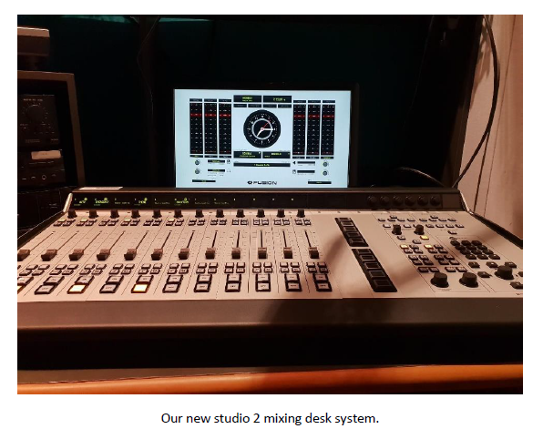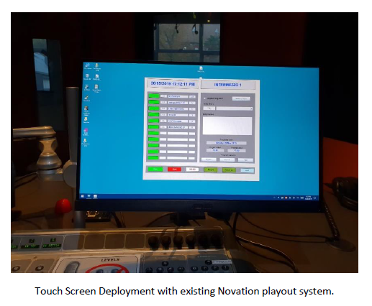

Disclaimer: The information above is provided by the Department of Jobs, Precincts and Regions.

The Age Music Victoria Awards 2018
The aim of this project was to build upon the Victorian Government’s support of the Victorian contemporary music sector.

The CSF funding was awarded via the recipient organisations to two leading Victorian artists at The Age Music Victoria Awards 2018, which was held at the Melbourne Recital Centre on 21 November 2018.

The specific awards and recipients were:
- The Premier’s Prize for the Best Victorian Album of 2018 awarded to Ms Courtney Barnett; and
- The Premier’s Prize for the Best Victorian Breakthrough Act of 2018 awarded to Baker Boy.

Both of the winning artists are extremely hard working and constantly touring. They both achieved huge success internationally and domestically in 2018. These cash prizes offered a rare opportunity for the winning musicians, recognising their achievements and supporting them to make more music, continue to tour and maintain career momentum.

The Hon Martin Foley MP, Minister for Creative Industries attended and spoke at the award ceremony. The CSF funding support was acknowledged in the Music Victoria’s 2018 report on The Age Music Victoria Awards.

Disclaimer: The information above is provided by the Department of Jobs, Precincts and Regions.

Eltham Girl Guide Hall Refurbishment
In May 2018, Girl Guides Victoria were awarded a grant of $150 000 from CSF in 2018-19 to fully refurbish the Eltham Girl Guides Hall. The hall was originally a World War II Army Drill Core Hall located on the grounds of Melbourne University. In 1964, Melbourne University gifted and relocated the hall to the Girl Guides current premises in Eltham where it has been utilised to its full capacity ever since. The Eltham Girl Guides Hall was in desperate need of refurbishment as it had not had any major works undertaken since its establishment in 1964.
The CSF grant has ensured the Eltham Girl Guides Hall can meet the requirements of the local girl guides and achieve its full potential as a community and youth facility. The refurbishment has brought the Hall and its internal facilities up to modern standards enabling the Eltham Girl Guides to use a safe and modern facility, create additional opportunities for the leadership group and volunteers to provide and host further activities and programs to the local Gumnuts, Brownies, Guides, Rangers and Olaves, as well as attracting further membership and use throughout the Nillumbik community.
Works to fully refurbish the Eltham Girl Guides Hall included:
- removing asbestos throughout the hall and replacing affected areas with new materials (affected areas encompassed the walls, ceiling, flooring, kitchen and bathrooms);
- insulating, relining, and repainting the walls and ceilings;
- full renovation of the kitchen and bathrooms, including a minor remodel of the layout to incorporate a shower recess and additional storage room;
- replacement of floor coverings, damaged doors and door frames, pinboards and light fittings throughout the hall;
- renovation and provision of new cupboards and shelving units in the existing storage facilities within the hall;
- repairing, and replacing where necessary, damaged roofing, guttering, and downpipes;
- installation of a solar electric hot water system;
- external painting and installation of appropriate signage;
- minor landscaping works to create a safe and level exit path for the community;
- preservation of the significant mural which now hangs as historic artwork in the fully refurbished Hall.
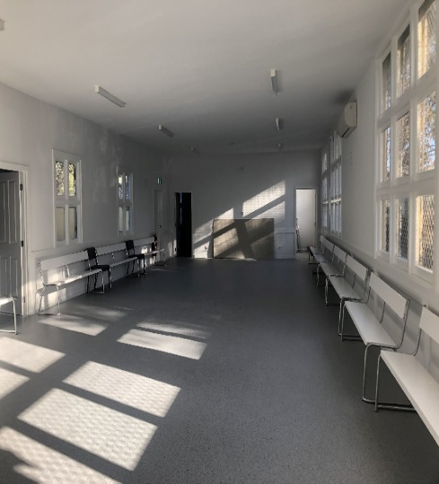
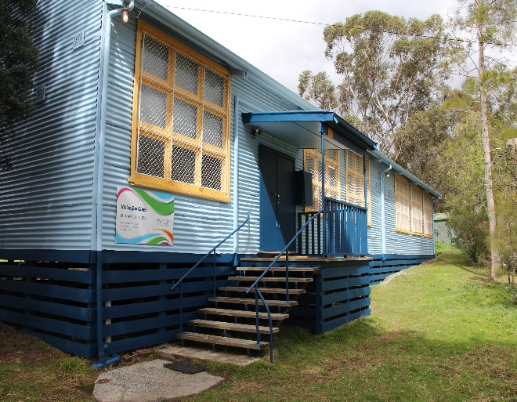
This project was successfully delivered by Girl Guides Victoria, the Eltham Girl Guides Support Group and Linea Constructions in partnership with the Victorian Government through the CSF. The CSF funding acknowledgement was made through a signage displayed on site.
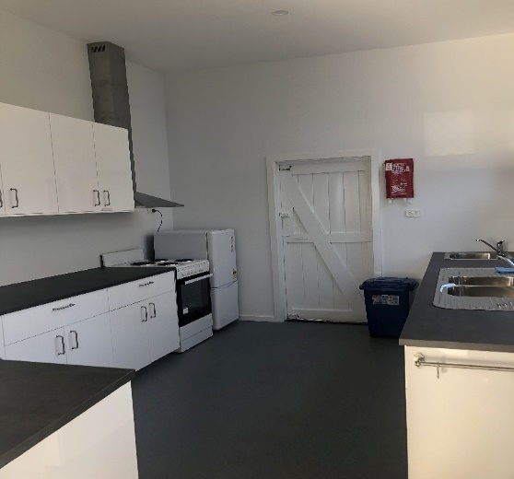

Disclaimer: The information above is provided by the Department of Environment, Land, Water and Planning.

Scammell Reserve Pavilion Redevelopment
The development of a new community sports pavilion at the Scammell Reserve has included four change rooms and amenities, social space, meeting rooms, undercover area, canteen, multipurpose area to meet the needs of the tenant clubs and the local community.

Access to the reserve and facilities was previously limited prior to the development of a pavilion. The construction of the pavilion and the surrounding amenities (including female friendly facilities) has made the facilities more accessible to all people and has increased the programming and participation outcomes.

The Scammell Reserve currently serves four tenant clubs across multiple sports, including the South Oakleigh Bowling Club, Oakleigh Amateur Football Club, Oakleigh Dragons Junior Football Club and Emmanuel South Oakleigh Cricket Club. This project will allow for more sporting and community events to be held here. The addition of female friendly amenities has also helped the tenant clubs increase female participation by having more attractive and accessible amenities and facilities.

The CSF funding support was acknowledged through a project plaque displayed on site.

Below are some photos provided for this project:
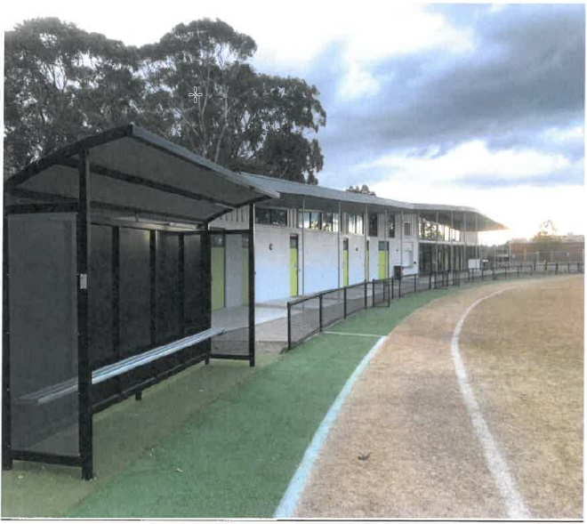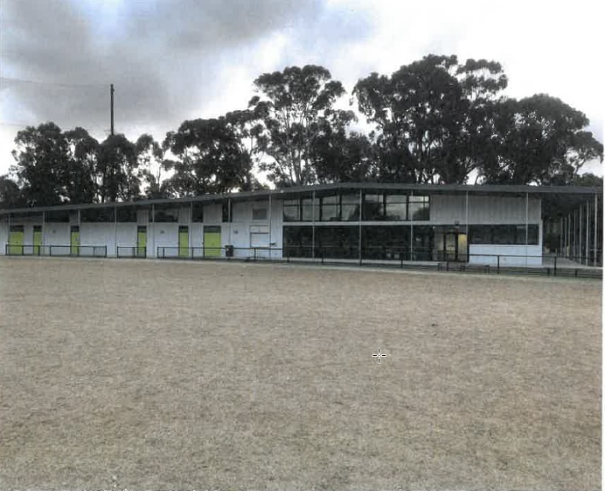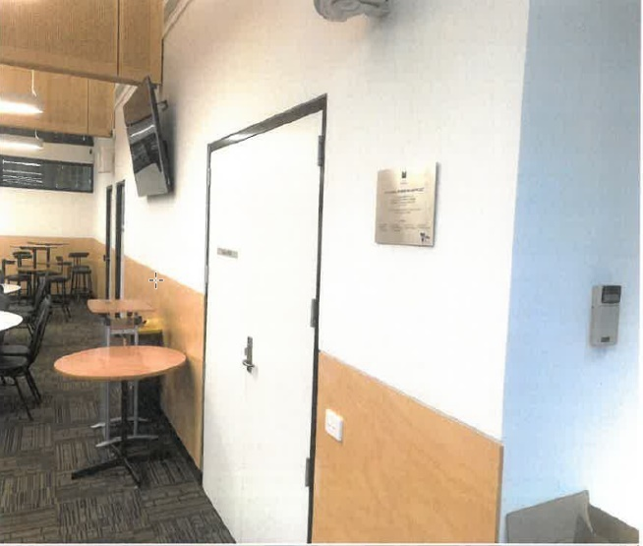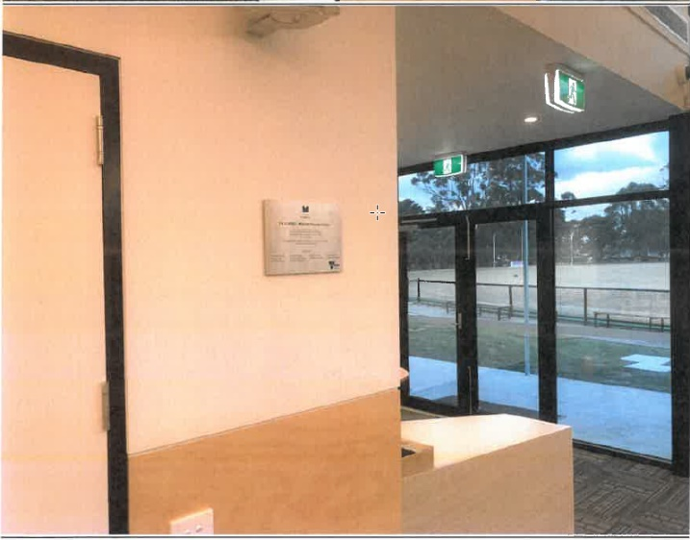

Disclaimer: The information above is provided by the Department of Jobs, Precincts and Regions.

Barwon Heads Community Hall Upgrade
This project has refurbished and upgraded the Barwon Heads Community Hall, including replacing the timber floor, extending the stage and building a new stairway.

The floor in the Barwon Heads Community Hall was uneven and recognised as an Occupational Health and Safety problem. New materials (including concrete stumps, new joists and bearers as well as spotted gum floorboards) have alleviated the safety issue and prolonged the life of the Community Hall in providing benefits to the community into the future.

This project was a positive collaboration between the steering committee, engineering firm, builders and contractors. The upgraded Community Hall was opened by the Hon Lisa Neville MP, Member for Bellarine on 7 September 2018. The CSF funding support was acknowledged through a signage display.

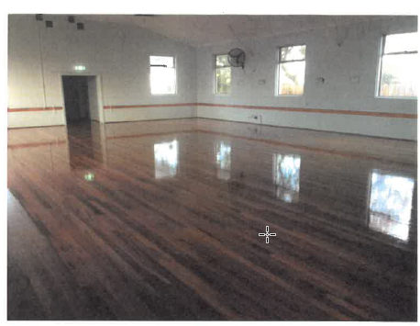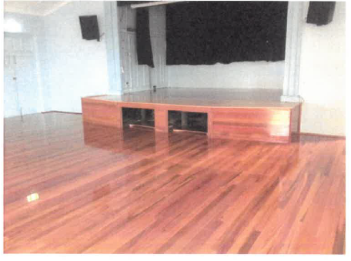
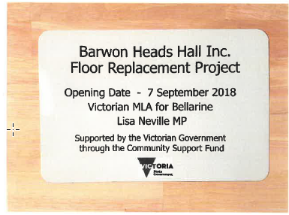

Disclaimer: The information above is provided by the Department of Jobs, Precincts and Regions.

Her Heart
Her Heart, a Melbourne-based not-for-profit organisation that is committed to work with women to raise awareness of heart disease. Her Heart designs and delivers campaigns that underpin the four key pillars:

- Awareness: raising awareness of heart disease in women of all ages
- Education: educating women around the prevalence, risk factors and symptoms of heart disease in women
- Research: completing further research around attitudes, behaviours and uptake on prevention
- Advocacy: national action on women and heart disease, advocacy and policy.

As a result of CSF funding in 2018-19, Her Heart has delivered:

- the Her Heart Women’s Heart Health Survey to measure awareness across different age cohorts. The survey tested awareness, messaging and channels and supports Her Heart to deliver activities and campaigns that have an impact;

- a range of print and digital resources including a heart health checklist to guide discussions with health professionals, a family history sheet to generate a conversation with loved ones, evidence-based factsheets, case studies, videos, and relatable editorial content based on real stories from those living and supporting loved ones with heart disease; and

- community bulletins and newsletters to the Her Heart community driving targeted education and awareness, promoting activities and events, publishing original content and promoting other related women’s initiatives.

- multiple awareness campaigns including:
- Valentine’s Day/Her Heart Day that encouraged women to make simple changes for long term health benefits
- the Family Histree campaign designed to prompt the start of a conversation about family risk factors
- the Let’s Chat campaign which promoted the importance of starting/having a conversation about women’s bigger killer, and dispelling the misconceptions that heart disease is a male problem
- the Know the Difference campaign to bring attention to the difference in signs and symptoms between genders and highlight the heart attack symptoms in women
- the Did You Know campaign that encouraged women to book a heart health check.

- a brand awareness strategy and media/PR campaign that secured coverage across print, online, TV and radio; and

- The establishment of an Ambassadors and Champions program to drive awareness on prevention and encourage continuing discussions among women and health professionals.

The CSF funding support was acknowledged via the Her Heart website.

Disclaimer: The information above is provided by the Department of Health and Human Services.

Project Respect
Project Respect is an organisation that supports women who work in the sex industry through a variety of outreach, education and support projects.
The projects have engaged and provided intensive support to women who wish to leave the sex industry and, also provided opportunities for women to increase and diversify their employment and skills.
All project outcomes, deliverables and performance measures have been completed, met or exceeded.

Table 1 below provides a status of the project outcomes and actions and Table 2 provides a summary of the performance measures achieved. The two tables draw on information from the workplan, progress reports and data collection.

Table 1
Project Outcomes and Actions

Status of Project Outcomes | Project Deliverables | Status
Staff employed | Program is appropriately staffed | Completed
Women in the sex industry are aware of non-discriminatory support available to increase job-readiness skills | Undertake initial promotion and engagement for the project using existing knowledge and networks.  Develop a communications and engagement strategy to communicate the work of Project Respect to other areas of the sex industry. | Completed
Increased collaboration between Project Respect and other community support organisations | Comprehensive list of complementary community programs.  Use the list of complementary programs to formalise referral pathways to supportive and relevant service providers.  Develop a method to collect information regarding project outcomes for participants to enable program evaluation and review. | Completed
Partner organisations actively incorporate women in the sex industry into planning and service provision | Develop a training plan and associated tools to support partner organisations being able to include women within the sex industry into the services they provide.  Training delivered to six organisations and approximately 150 frontline workers. | Completed
Women who wish to reduce their hours or transition out of the industry are supported to do so | Ensure there are effective methods to engage with women who work in the sex industry, record their interest in receiving support to leave the industry and link them with support service organisations. | Completed

Table 2
Performance Measures

Performance Measure | Target | Outcomes | Status
Women are made aware of program and access to service. | 300 women per year | 646 | Exceeded
Link women to services which holistically and sustainably support individual needs. | 10 women per year | 22 women, 96 referrals | Exceeded
Education and training delivered to local service providers. | 3 service providers per year | 31 | Exceeded
Provide information to brothels regarding the program. | 25 brothels per year | 88 brothels, 202 visits | Exceeded
Support individuals to exit, transition or reduce hours from the sex industry if they wish to and increase job readiness skills. | - 5 women per year enter into education or training  - 5 women per year are provided with intensive one-to-one support in job readiness  - 5 individuals find alternative employment per year (10 in total) | 15  20  9 | Exceeded  Exceeded  Not Met
Increase collaboration and strengthen new referral pathways to support services. | - 5 partnerships per year with organisations delivering job ready programs  - 10 support services are contacted per year for warm referral pathways. | 24 informal partnerships  8 Formal partnerships  39 services/93 warm referrals | Exceeded  Exceeded

Women’s Experience Survey

Project Respect undertook a program satisfaction survey with women engaged in the program. Eight women participated in the survey, 14 women were unable to be contacted or did not wish to participate in the survey. The satisfaction survey found:
- 8 women indicated they were very happy with the program.
- 5 women indicated the program assisted them to achieve their goals.
- 2 women indicated they were unable to achieve their goals due to travel related issues, limited resources and the length of time it took to engage with the referral agency.
- 1 woman indicated she was not satisfied with the organisation she was referred to by Project Respect.
- The program was knowledgeable about the sex industry and provided sensitive, respectful and a non-judgemental service.
- Majority of responses indicated that the service was able to provide appropriate referrals and resources.

Key Challenges

Many women, particularly women trafficked for sexual exploitation have complex histories, and various forms of trauma, which they are still processing. The stability of women’s lives impacted on their ability to engage in the program. While they wished to transition to other forms of employment, a number of women were experiencing housing distress or at risk of homelessness, family violence and mental health issues.

While women were wishing to transition from the industry, there were structural issues which impeded their ability to do so:
- Inability to find other forms of employment that provide the flexible working hours provided by the sex industry.
- Lower wages in other forms of employment.
- Having to pay for childcare due to changed working hours.
- Inability to access certain programs or services due to eligibility requirements such as visa restrictions.
- Overarching stigma and discrimination which is still very prevalent, whether intentionally or due to a lack of awareness.

Women on temporary visas, including women trafficked, faced additional barriers:
- Experiencing significant trauma and mental health issues.
- Language proficiency and cultural differences.
- Ineligibility to receive government supports such as Centrelink, higher education loan schemes and childcare subsidies.
- Lack of family or social supports to assist them in the transition process.

Gaps and Needs Identified

- Supported housing
Housing is a significant issue for many women with experience in the sex industry. There were 12 women engaged in the program who struggled to successfully engage in the program and maintain a transition from the industry due to housing insecurity, risk of homelessness and unaffordable housing. Compounding this were structural barriers which prevented women from being able to access Centrelink payments, housing and other support services. This impeded their ability to transition from the industry or maintain the transition.

- Including Brokerage Funding
A barrier for many women to engage, or make a sustainable transition was financial constraints. From lack of funds for a myki card to travel to appointments, to course training fees to undertake a specific course that would develop their skills and capabilities. Any future program should include brokerage funding to support individual client needs.

- Further research on the cycle of transitioning
There is very little research available about the cycle of transitioning for women in the sex industry. Research that is currently available is generally focused on women involved in street-based work, rather than brothel based or the informal sector. In addition to this, longitudinal research on women who have transitioned from the industry needs to be undertaken. As observed in this program, as women move further away from the industry, they begin to understand their experience of being in the industry differently. Longitudinal research would assist in understanding the needs of women involved in the sex industry in Australia.

- Embedding Evaluation of Women’s Wellbeing
An evidenced informed evaluation or assessment tool to measure client health and wellbeing outcomes should be embedded in any future program.

Disclaimer: The information above is provided by the Department of Health and Human Services.

St Michael’s Church Heating System Replacement
This project has replaced the 75 year old heating system at the St Michael’s Church in Kalorama to provide a more efficient, safe and reliable heating system for all those visiting the Church.
All the project works below were completed on time and delivered under budget:
- electrical work under the Church to install an outlet for Boiler ignition;
- excavation of trenches to allow new gas and water lines to be laid under the Church and laying of new gas and water lines;
- installation of floor hydronic heating system; and
- installation of insulation over the floor hydronic heating system.

Disclaimer: The information above is provided by the Department of Premier and Cabinet.

2019 Midsumma Pride March
The Midsumma Festival Inc is a not for profit organisation registered with the Australian Charities and not-for-profits Commission.
Midsumma Pride March 2019 is an important event for Lesbian, Gay, Bisexual, Transgender and Intersex and Questioning (LGBTIQ) communities and their allies and is vital to the expression of LGBTIQ culture in Victoria.
CSF funding was provided to assist Midsumma Festival Inc with additional security costs associated with operating the 2019 Midsumma Pride March, in response to Victoria Police’s call for extra security due to Melbourne security incidents in 2017 and 2018.

Disclaimer: The information above is provided by the Department of Premier and Cabinet.

