Financial Management Compliance Report
Template Instructions for the 2018-19 reporting period
    - Legislative compliance reporting and attestation requirements
Direction 5.1.2 of Standing Directions 2018 under the Financial Management Act 1994 (the Directions) requires Agencies to conduct an annual assessment of compliance with all applicable requirements in the FMA, these Directions, the Instructions and including relevant mandatory Framework requirements. Direction 5.1.3 also requires the Internal Audit function to conduct a detailed review of the Agency’s compliance over the period specified in their strategic internal audit plan under Direction 3.2.2.2(b).
Instruction 5.1, Clause 1.1 requires Portfolio Agencies to annually provide a compliance report to the Portfolio Department (see Compliance reporting deadlines for 2018-19 below).
Instruction 5.1 Clause 1.2 requires this compliance report to include relevant information drawn from the annual assessment of financial management compliance under Direction 5.1.2, and the detailed periodic review of financial management undertaken by the internal audit under Direction 5.1.3, on:
    - the level of compliance achieved;
    - Compliance Deficiencies, including planned and completed remedial actions and timeframes;
    - the significant compliance risks of the Agency; and
    - a summary of the plan for the detailed period review of financial management compliance under Direction 5.1.3(c).
These are covered in sections 1-4 of the attached template.
Direction 5.1.6 and Direction 3.5.3 require notification of Material Compliance Deficiencies and significant and systemic Fraud Corruption and Other Losses to relevant parties, as soon as practicable, when the Agency becomes aware. For completeness please tick ‘no’ if a nil response (section 5 of template).
A progress update on actions taken by the Agency to prepare for the commencement of transitional Directions under Direction 1.4 (section 6 of template). This section now only applies to those Agencies without a qualified CFO and transitioning to the Central Banking System.
The Audit Committee must review and approve the compliance report before it is provided to the Portfolio Department under Instruction 5.1, Clause 1.3 (section 7 of template).
A summary table of the compliance assessment, review and reporting requirements is on page 4.
The requirement for an Agency’s Responsible Body to attest to compliance in their Annual Report (Direction 5.1.4) first commenced in the 2017-18 financial year. The prescribed form is set out in Instruction 5.1 Clause 2.2. and the 2018-19 Model Financial Report (to be issued in first half of 2019). The annual report attestation is in addition to this compliance report provided to Portfolio Department’s (see Annual report attestation below).
    - Compliance reporting deadlines for 2018-19
The due dates for providing the Compliance Report depends on an Agency’s annual reporting period:
- For Agencies with an annual reporting period of 1 July to 30 June it is due by 15 September following the financial year reviewed.
- For agencies with an annual reporting period of 1 January to 31 December it is due by 15 March following the calendar year reviewed.
The compliance report covers all applicable Directions and Instructions for the entire reporting period, including Asset management accountability and Risk management framework and processes. Please note these frameworks have mandatory requirements within their respective documents that need to be considered individually. For example, the Asset Management Accountability Framework (AMAF) requirements are listed in Appendix 1 of the AMAF document.
    - General instructions for completing the compliance report
Please undertake the following: | Done Y/N
Delete the instruction and summary pages and sample template when finalising the report.
Do not delete any sections in the report and include N/A or Nil response as necessary.
Add rows in template tables where required.
An Audit committee meeting or an out of session review be scheduled before the report is endorsed and submitted to the Portfolio Department by the due date.
The report be attached to a covering letter signed by the Agency Accountable Officer and addressed to the Department Secretary with the relevant Portfolio Compliance Manager copied in.
    - Compliance Report template
The Compliance Report template (Page 10) has been developed to assist Portfolio Agencies in reporting to Portfolio Departments for 2018-19. The blank template should be used by the Agency for completing the compliance report. The template should only be adjusted if necessary. A template sample covering letter is also attached on Page 14.
The sample populated template (page 5), includes examples in coloured italics (red) in the relevant tables, indicating the level of detail required.
    - Annual report attestation
The Standing Directions require formal attestation statements in Agency annual reports. In the current 2018-19 reporting period, the requirements differ slightly depending on the agency's annual reporting date. For all Agencies only one attestation disclosure is required within the 2018-19 annual report.

30 June 2019 reporting date Agencies
For the period 1 July 2018 to 30 June 2019 – Agencies must complete a full year attestation statement (for the entire period of the relevant year) in relation to all applicable Directions and Instructions as required and in the form prescribed by Instruction 5.1, Clause 2.2.
However, please note for Direction 4.2.4 – Public construction accountability and Direction 3.7.2.1 - Central Banking System and Eligible Financial Assets attestation is as at 30 June 2019 (as per Instruction 5.1, Clauses 2.5 and 2.6).

31 December 2018 reporting date Agencies
For the period 1 January 2018 to 31 December 2018 – Agencies must complete a full year attestation statement (for the entire period of the relevant year) in relation to all applicable Directions and Instructions as required and in the form prescribed by Instruction 5.1, Clause 2.2.
However, please note Direction 4.2.4 – Public construction accountability and Direction 3.7.2.1 - Central Banking System and Eligible Financial Assets do not require attestation in the 2018 annual report as Instruction 5.1, Clauses 2.5 and 2.6 provides for a first attestation with these Directions as at 30 June 2019. This attestation will be covered in the 2019 annual report of these Agencies.

Summary of compliance assessment, review and reporting requirement: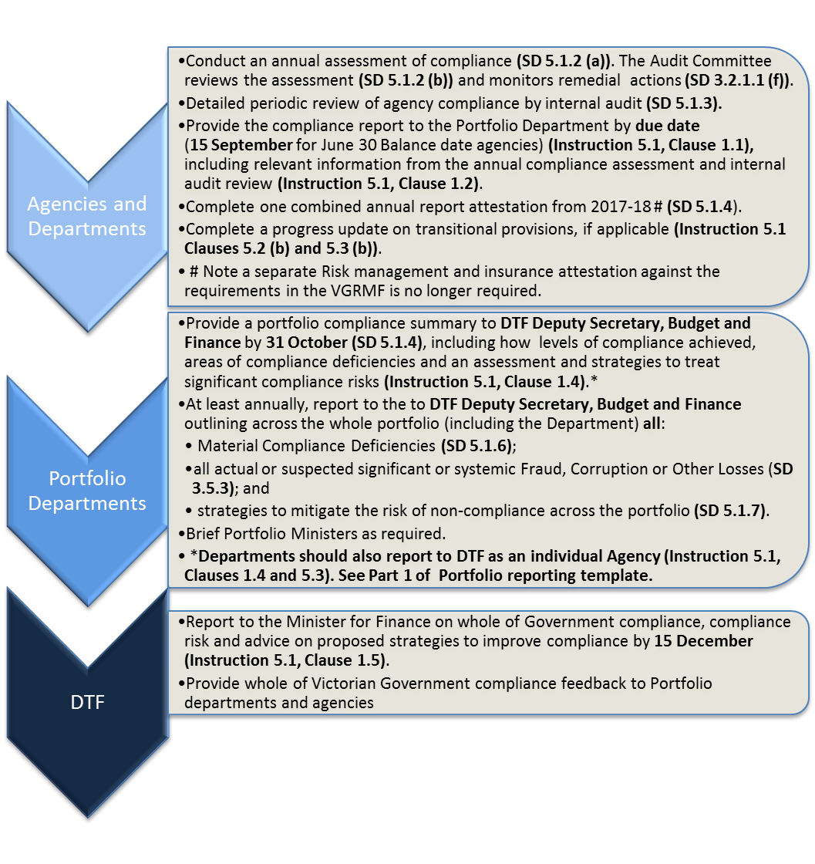

Sample Financial Management Compliance Report (Examples in red)
for the financial year ending 30 June 2019
Portfolio Agency: Victorian Data Authority
Portfolio Department: Technology and Innovation

Section 1: Process undertaken to achieve level of compliance (Instruction 5.1 Clause 1.2(a))
In accordance with the Directions and Instructions the following has been achieved for the compliance year (tick as appropriate): | Yes
An annual assessment of compliance has been completed.
The Audit Committee has reviewed the assessment.
A detailed periodic review (see Section 4) has been undertaken by the Internal Audit (IA) function.
Compliance for each mandatory requirement is being effectively managed.
Any unacceptable risk relating to these requirements has been treated appropriately.
Compliance with all applicable requirements has been achieved, with the exception of those items identified in Section 2.
The Audit Committee has reviewed and monitored remedial actions taken to address Compliance Deficiencies.
The attestation statement for the compliance year, to be included in the annual report, has been completed by Ms Joanna Smith, Board Chair on behalf of Victorian Data Authority in the prescribed form.
The Audit Committee has reviewed the attestation made by the Responsible Body.

Additional comments (if required e.g. where a process has not been undertaken):

Section 2: All Compliance Deficiencies, including planned and completed remedial actions and timeframes (Instruction 5.1, Clause 1.2(b))
In the following table detail all compliance deficiencies identified in the current compliance year, whether the deficiency is material, and the planned and completed remedial actions and timeframes. Include the relevant Direction, Instruction and Framework mandatory requirement number, clause reference and name (as applicable) in Column 1. Multiple deficiencies can be listed for frameworks e.g. highlight individual AMAF reference number and deficiency etc.
Direction, Instruction or Framework reference No. and name/title of the specific requirement | Details of the Compliance Deficiency | Is it a Material Compliance Deficiency? | Remedial actions and timeframes (planned and completed)
Instruction 3.4 – Internal control system, clauses 2.1(b) – Cash and 4.1 – Managing cash | A policy relating to Cash handling was not finalised and implemented for the whole compliance year | ☐ | A policy was drafted and finalised in May XXXX and disseminated to relevant staff in June XXXX
Direction 3.5 – Fraud, Corruption and Other Losses, clause (b) – Policy on prevention and management | No policy for FC&OL prevention and management was developed or in place during the entire compliance period |  | A policy will be drafted and implemented during the XXXX year
Direction 4.2.3 – Asset management accountability – AMAF Ref No. 3.2.2 – Asset management strategy | The asset management strategy is still being developed | ☐ | The strategy will be finalised and implemented by December XXXX
Direction 4.2.3 – Asset management accountability – AMAF Ref No. 3.4.3 – Information management | An appropriate asset information management system (AIMS) is still being developed | ☐ | Documenting and refining core rules for an updated AIMS is underway. Implementation expected to be complete by February XXXX

Section 3: The significant compliance risks facing the Agency (Instruction 5.1, Clause 1.2(c))
In the following table identify and detail three or more key areas of the Directions and Instructions that represent a significant compliance risk to the Agency, why the risk is significant and the strategies to manage the risk. A significant compliance risk has the potential for both financial and/or reputational loss due to failure to comply with the Directions and Instructions. A significant compliance risk is not necessarily a deficiency (which is an actual instance of non-compliance), however, compliance deficiencies may be an indicator of a compliance risk.
Significant compliance risks (Direction or Instruction area) | Why the risk represents a significant risk to the Agency | Key strategies to ensure these significant risks are being managed effectively
Direction 4.2.3 – Asset management accountability | The Agency has a high number of operational assets requiring regular maintenance to ensure customer service delivery is not significantly impacted by an outage |  | The Agency has effectively operating asset strategies, plans and performance monitoring systems in place to reduce or prevent service disruptions due to inadequate functioning of assets
Direction and Instruction 3.7.1 - Business continuity planning (BCP) | A major business disruption would significantly impact on the Agency’s suppliers and clients. |  | The Agency has implemented and regularly communicates and tests BCP and IT Disaster Recovery processes with staff.
Direction and Instruction 3.6 - Purchasing and pre-paid debit cards | The Agency has a high number of Purchasing card (PC) users for the efficient payment of accounts in regional offices. |  | Staff with a purchasing card receive annual refresher training on policy and processes and IA review sample PC transactions compliance yearly.

Section 4: Detailed periodic review of financial management compliance (Direction 5.1.3(c) and Instruction 5.1, Clause 1.2(d))
Complete the following table with the requirements that were reviewed by Internal Audit in this current compliance year and are planned to be reviewed in the next compliance year as part of the periodic detailed compliance review program under Direction 5.1.3(c) (Instruction 5.1, Clause 1.2(d)).
Note: This section only requires coverage of activity relating to the FMA Standing Directions and Instructions, not other areas outside this scope. The following provides an example of the minimum level of detail required, however, more specific details can be included as necessary.
2018-19 (Internal audit reviews undertaken in current compliance year) | 2019-20 (Internal Audit planned reviews for next compliance year)
Direction 2.5 – Delegations of responsibilities | Direction 3.1 – Effective financial governance
Direction/Instruction 3.4 – Internal control system (covering revenue, cash, bank accounts, expenditure and payroll) | Direction/Instruction – 3.5 Fraud, Corruption and Other Losses
Direction 4.2.3 – Asset management accountability | Direction 4.1 – Planning and managing performance
Direction/Instruction 5.1 – Financial management compliance | Direction/Instruction 3.7 – Managing risks – Business continuity planning
Direction/Instruction 3.6 – Purchasing and prepaid debit cards (reviewed annually as a high compliance risk – see Section 3) | Direction/Instruction 3.6 – Purchasing and prepaid debit cards (reviewed annually as a high compliance risk – see Section 3)

Section 5: Ad hoc Agency notifications required by Directions 5.1.6 and Direction 3.5.3
- Notification of any Material Compliance Deficiencies
Direction 5.1.6 – The Accountable Officer must notify the Responsible (Portfolio) Minister and, for Portfolio Agencies, the Accountable Officer of their Portfolio Department (Secretary), of any Material Compliance Deficiency, and of planned and completed remedial action as soon as practicable.
Has your Agency notified any Material Compliance Deficiencies to the Portfolio Minister and Department Secretary during the compliance year?
Yes |  | please provide details of any Material Compliance Deficiencies notified and remedial actions taken in the table below.
No | ☐ | please go to Section 5 (b).

Direction, Instruction or Framework reference No. and name/title of specific requirement. | Date have notified or will notify Portfolio Minister/ Department Secretary | Material Compliance Deficiency details | Planned and completed remedial actions by Agency
Direction 3.5.1 – Fraud, Corruption and Other Losses (FC&OL), clause (b) – policy on prevention and management | Notified Minister of Innovation and Secretary, Department of Innovation and Technology on (date). | No policy for FC&OL prevention and management has been developed or in place during the entire compliance XXXX year. | A policy will be drafted and implemented across the agency in the XXXX year.

- Notification of all actual or suspected Significant or Systemic Fraud, Corruption or Other Losses incidents during the compliance year
Direction 3.5.3 – Where an Agency is made aware of an actual or suspected Significant or Systemic Fraud, Corruption or Other Loss, the Accountable Officer must:
- notify, as soon as is practicable, the Responsible (Portfolio) Minister, Audit Committee, Portfolio Department and Auditor-General of the incident and remedial action to be taken;
- ensure that the persons notified are kept informed about the incident, including the outcome of investigations; and
- ensure that the Agency takes appropriate action to mitigate against future Fraud, Corruption and Other Losses.
Has your Agency notified any significant or systemic incidents to the relevant parties above during the compliance year?
Yes |  | please provide details of any significant or systemic incidents notified and remedial actions taken in the table below.
No | ☐ | please go to Section 6.

SPECIFY AGENCY DOLLAR THRESHOLD FOR SIGNIFICANT OR SYSTEMIC INCIDENTS
Money $5,000 Property $50,000

Relevant Direction or Instruction Name and No. (if applicable) | Date notified or will notify the Responsible Portfolio Minister and other parties | Date and details of actual or suspected Significant or Systemic Fraud, Corruption or Other Losses | Progress or outcome of investigation and action to mitigate against future Fraud, Corruption or Other Losses by Agency
Instruction 3.4 – Internal Control System, Clause 5 Managing Expenditure | 20 February XXXX | On 4 January XXXX, a fraudulent change of supplier banking details and false invoices was instigated by an external party, resulting in a money loss of $10,550. | Incident reported to police on 10 January after initial internal review and currently still under police investigation. Accounts payable internal controls strengthened with assistance of the Peoples Bank to mitigate future risk.

Section 6: Progress update on actions taken by the Agency to prepare for commencement of transitional Directions, if applicable (Direction 1.4)
For Directions that are subject to transitional arrangements, of which Agencies are not already compliant with as at the relevant date, the following provides an update on the progress to prepare for commencement.
Note: This section is only applicable agencies without a qualified CFO as at 1 July 2016 or transitioning to the Central Banking System.
Applicable |  | please provide details in the table below.
Not Applicable | ☐ | please go to Section 7

Transitional Direction | Actions taken in current YTD (2018-19) | Actions to be taken next YTD (2019-20)
Direction 2.4.5(a)(ii) - CFO qualifications | Advertised for qualified CFO | CFO appointment expected by July XXXX
Direction 3.7.2.1 - Central Banking System and Eligible Financial Assets | N/A | N/A

Section 7: Review and approval by the Audit Committee (Instruction 5.1, Clause 1.3)
The Victorian Data Authority Audit Committee or (Responsible Body, where an Audit Committee exemption has been provided) has reviewed and approved the XXXX compliance report.

Signed
Aldo Wright
Chair of Audit Committee
25 August 2019

Financial Management Compliance Report
for the financial year ending [INSERT DATE/YEAR]
Portfolio Agency: [INSERT YOUR PORTFOLIO AGENCY NAME]
Portfolio Department: [INSERT YOUR PORTFOLIO DEPARTMENT NAME]

Section 1: Process undertaken to achieve level of compliance (Instruction 5.1 Clause 1.2(a))
In accordance with the Directions and Instructions the following has been achieved for the compliance year (tick as appropriate): | Yes
An annual assessment of compliance has been completed. | ☐
The Audit Committee has reviewed the assessment. | ☐
A detailed periodic review (see Section 4) has been undertaken by the Internal Audit function. | ☐
Compliance for each mandatory requirement is being effectively managed. | ☐
Any unacceptable risk relating to these requirements has been treated appropriately. | ☐
Compliance with all applicable requirements has been achieved, with the exception of those items identified in Section 2. | ☐
The Audit Committee has reviewed and monitored remedial actions taken to address Compliance Deficiencies. | ☐
The attestation statement for the compliance year, to be included in the annual report, has been completed by [name of member of the Responsible Body] on behalf of [name of the Responsible Body] in the prescribed form. | ☐
The Audit Committee has reviewed the attestation made by the Responsible Body. | ☐

Additional comments (if required e.g. where a process has not been undertaken):

Section 2: All Compliance Deficiencies, including planned and completed remedial actions and timeframes (Instruction 5.1, Clause 1.2(b))
In the following table detail all compliance deficiencies identified in the current compliance year, whether the deficiency is material, and the planned and completed remedial actions and their timeframes. Include the relevant Direction, Instruction and Framework mandatory requirement number, clause reference and name (as applicable) in column 1. Multiple deficiencies can be listed for frameworks e.g. highlight individual AMAF reference number and deficiency etc.
Direction, Instruction or Framework reference No. and name/title of the specific requirement | Details of the Compliance Deficiency | Is it a Material Compliance Deficiency? | Planned and completed remedial actions and timeframes
[Insert Ref No and details] | [Insert details] | ☐ | [Insert details and dates]
 |  | ☐
 |  | ☐

Section 3: The significant compliance risks facing the Agency (Instruction 5.1, Clause 1.2(c))
In the following table identify and detail, if applicable, key areas of the Directions and Instructions that represent a significant compliance risk to the Agency, why significant and the strategies to manage the risk. A significant compliance risk has the potential for both financial and/or reputational loss due to failure to comply with the Directions and Instructions. A significant compliance risk is not necessarily a deficiency (which is an actual instance of non-compliance), however, compliance deficiencies may be an indicator of a compliance risk.
Significant compliance risks (Direction or Instruction area) | Why the risk represents a significant risk to the Agency | Key strategies to ensure these significant risks are being managed effectively
[Insert details] | [Insert details] | [Insert details]

Section 4: Detailed periodic review of financial management compliance (Direction 5.1.3(c) and Instruction 5.1, Clause 1.2(d))
Complete the following table with the requirements that were reviewed by Internal Audit in this current compliance year and are planned to be reviewed in the next compliance year as part of the periodic detailed compliance review program under Direction 5.1.3(c) (Instruction 5.1, Clause 1.2(d)).
Note: This section only requires coverage of activity relating to the FMA Standing Directions and Instructions, not other areas outside this scope. The Direction area (number and title) is the minimum level of detail required, however, more specific details can be included as necessary.
{Current year} (Internal audit reviews undertaken in current compliance year) | {Next year} (Internal audit planned reviews for next compliance year)
[Insert details] | [Insert details]

Section 5: Ad hoc Agency notifications required by Directions 5.1.6 and Direction 3.5.3
- Notification of any Material Compliance Deficiencies
Direction 5.1.6 – The Accountable Officer must notify the Responsible (Portfolio) Minister and, for Portfolio Agencies, the Accountable Officer of their Portfolio Department (Secretary), of any Material Compliance Deficiency, and of planned and completed remedial action as soon as practicable.
Has your Agency notified any Material Compliance Deficiencies to the Portfolio Minister and Department Secretary during the compliance year?
Yes | ☐ | please provide details of any Material Compliance Deficiencies notified and remedial actions taken in the table below.
No | ☐ | please go to Section 5 (b).

Direction, Instruction or Framework reference No and name/title of specific requirement. | Date have notified or will notify Portfolio Minister/ Department Secretary | Material Compliance Deficiency details | Planned and completed remedial actions by Agency
[Insert Ref No, and details, if applicable] | [Insert date] | [Insert details] | [Insert details]

- Notification of all actual or suspected Significant or Systemic Fraud, Corruption or Other Losses incidents during the compliance year
Direction 3.5.3 – Where an Agency is made aware of an actual or suspected Significant or Systemic Fraud, Corruption or Other Loss, the Accountable Officer must:
- notify, as soon as is practicable, the Responsible (Portfolio) Minister, Audit Committee, Portfolio Department and Auditor-General of the incident and remedial action to be taken;
- ensure that the persons notified are kept informed about the incident, including the outcome of investigations; and
- ensure that the Agency takes appropriate action to mitigate against future Fraud, Corruption and Other Losses.
Has your Agency notified any significant or systemic incidents to the relevant parties above during the compliance year?
Yes | ☐ | please provide details of any significant or systemic incidents notified and remedial actions taken in the table below.
No | ☐ | please go to Section 6.

SPECIFY AGENCY DOLLAR THRESHOLD FOR SIGNIFICANT OR SYSTEMIC INCIDENTS
Money [Add $ threshold] Property [Add $ threshold]

Relevant Direction or Instruction Name and No. (if applicable) | Date notified or will notify the Responsible Portfolio Minister and other relevant parties | Date and details of actual or suspected Significant or Systemic Fraud, Corruption or Other Losses | Progress or outcome of investigation and action to mitigate against future Fraud, Corruption or Other Losses by Agency
[Insert Ref no and details, if applicable] | [Insert date] | [Insert date and details] | [Insert details]

Section 6: Progress update on actions taken by the Agency to prepare for commencement of transitional Directions, if applicable (Direction 1.4)
For Directions that are subject to transitional arrangements, of which Agencies are not already compliant with as at the relevant date, the following provides an update on the progress to prepare for commencement.
Note: This section is only applicable to agencies without a qualified CFO as at 1 July 2016 or those transitioning to the Central Banking System.
Applicable | ☐ | please provide details in the table below.
Not Applicable | ☐ | please go to Section 7

Transitional Direction | Actions taken in current YTD (2018-19) | Actions to be taken next YTD (2019-20)
Direction 2.4.5(a)(ii) - CFO qualifications  (SD 1.4.2) | [Insert details] | [Insert details]
Direction 3.7.2.1 - Central Banking System and Eligible Financial Assets  (SD 1.4.6) | [Insert details] | [Insert details]

Section 7: Review and approval by the Audit Committee (Instruction 5.1, Clause 1.3)
The [Insert name of Agency] Audit Committee or Responsible Body (where an Audit Committee exemption has been provided) has reviewed and approved the {Year} compliance report.
Signed
[Insert Name]
[Insert title e.g. Chair/Member of Audit Committee/Responsible Body]
[Insert Date]

Template covering letter to Financial Management Compliance Report
[INSERT LETTERHEAD]

[Insert date]

[Insert Secretary’s full name]
Secretary
[Insert Department name]
[Insert address]
MELBOURNE VIC 3000/1/2

Dear [Insert title and surname]

Financial management compliance report [Insert financial year]
In accordance with Direction 5.1.2 of the Standing Directions 2018 under the Financial Management Act 1994 (FMA) (the Directions) an annual assessment of compliance with all applicable requirements in the FMA, the Directions and accompanying Instructions has been conducted for the [Insert] financial year.
I can confirm that the attached compliance report has been reviewed and approved by the [Insert name of committee] in accordance with Instruction 5.1, Clause 1.3 and is now submitted for your attention.

Yours sincerely

[Insert Accountable Officer name]
[Insert Position title]
[Insert Portfolio Agency name]

CC
[Insert Portfolio Department Compliance Officer name]
[Insert Position title]
[Insert Department name]

Note:
Letter must be addressed to the Department Secretary and CCed to the Department Portfolio Compliance Manager

Transitional arrangements are currently in place in respect to, Direction 1.4.2 CFO qualifications (SD 2.4.5) and Direction 1.4.6 Central Banking System and Eligible Financial Assets (SD 3.7.2.1)
A ‘Compliance Deficiency’ means an attribute, condition, action or omission that is not fully compliant with an applicable requirement in the FMA, Standing Directions and/or Instructions.
A ‘Material Compliance Deficiency’ means a Compliance Deficiency that a reasonable person would consider has a material impact on the Agency or the State's reputation, financial position or financial management.
‘Significant or Systemic’ is defined in the Direction 1.6 and Instructions 3.5 and 3.6 also require Agencies to define value thresholds for ‘significance’ in relation to Fraud, Corruption and Other Losses, and in relation to purchasing and prepaid debit cards, respectively.
A ‘Compliance Deficiency’ means an attribute, condition, action or omission that is not fully compliant with an applicable requirement in the FMA, Standing Directions and/or Instructions.
A ‘Material Compliance Deficiency’ means a Compliance Deficiency that a reasonable person would consider has a material impact on the Agency or the State's reputation, financial position or financial management.
‘Significant or Systemic’ is defined in the Direction 1.6 and Instructions 3.5 and 3.6 also require Agencies to define value thresholds for ‘significance’ in relation to Fraud, Corruption and Other Losses, and in relation to purchasing and prepaid debit cards, respectively.

