Investment Management Standard 2017
Technical Guide for Facilitators
Benefits Definition workshop

The Secretary
Department of Treasury and Finance
1 Treasury Place
Melbourne Victoria 3002
Australia
Telephone: +61 3 9651 5111
Facsimile: +61 3 9651 2062
dtf.vic.gov.au

Authorised by the Victorian Government
1 Treasury Place, Melbourne, 3002

© State of Victoria 2017
You are free to re-use this work under a Creative Commons Attribution 4.0 licence, provided you credit the State of Victoria (Department of Treasury and Finance) as author, indicate if changes were made and comply with the other licence terms. The licence does not apply to any branding, including Government logos.

Copyright queries may be directed to IPpolicy@dtf.vic.gov.au

ISBN 978-1-925551-41-9
Published May 2017

If you would like to receive this publication in an accessible format please email information@dtf.vic.gov.au

This document is also available in Word and PDF format at dtf.vic.gov.au

Contents
Purpose of this document 1
What are the differences between IMS edition 5.0 and IMS 2017? 1
1. Context for the Benefit Definition workshop 3
1.1 Is a dedicated Benefit Definition workshop required? 4
1.2 Timing of the Benefit Definition workshop 4
2. Benefit Definition workshop 5
2.1 Purpose of a Benefit Definition workshop 5
2.2 Responsibility of the facilitator 6
2.3 Who should be there? 7
2.4 What preparation is required? 7
2.5 Before the workshop 8
2.6 At the workshop 9
2.6.1 Setting up the whiteboard 9
2.6.2 Structuring the workshop 9
2.6.3 Timing 9
2.6.4 Set expectations 10
2.7 After the workshop 16
2.8 Templates, examples and other resources 17
Appendix 1: 16 Questions – Investment decision-maker’s checklist 18
Appendix 2 - Shaping new investments using the IMS 20
Appendix 3: Fictional – Benefit Management Plan 22
Appendix 4: Design guidelines – Benefit Management Plan 26
Appendix 5: KPI input sheet 28
Appendix 6: Sample email – before the Benefit Definition workshop 29
Appendix 7: Checklist – Benefit Definition workshop 30
Appendix 8: Sample agenda for a Benefit Definition workshop 31
Appendix 9: Benefit framework 32
Appendix 10: Checklist for good KPIs and related measures, baselines and targets 34
Appendix 11: Difference between risk and uncertainty 35
Appendix 12: Sample email – after the Benefit Definition workshop 36
Appendix 13: Quality assessment form – Benefit Management Plan 37

Purpose of this document
This is the second of four guidance documents within the ‘shape a new investment’ series of IMS Technical guides for facilitators. It primarily targets facilitators and provides practical guidance on how to lead a successful initiative-level Benefit Definition workshop, and prepare supporting documentation which is consistent with the Investment Management Standard (IMS) Version 6.0.
This guidance assumes users have read and understood the IMS – its principles, practices and the theory on which it is built. (The IMS is available at the investment management website, www.dtf.vic.gov.au/infrastructure-investment/investment-management-standard.) It also assumes that users are familiar with the guidance material for the Problem Definition workshop.
Section 1 outlines the context and objectives for the Benefit Definition workshop.
Section 2 describes how facilitators should approach, conduct, and conclude the workshop.
Appendices contains additional materials which may be useful for facilitators.

What are the differences between IMS edition 5.0 and IMS 2017?
IMS 2017 is the first update to the IMS since 2013. Over this period there has been an increased focus on the planning and delivery of infrastructure investments, and on using real options analysis to manage related uncertainty. In response, the Department of Treasury and Finance has updated its ‘Investment Lifecycle and High Value/High Risk’ (HVHR) framework to provide advice on incorporating real options analysis when developing business cases and procurement strategies. The related guidelines are available at www.dtf.vic.gov.au/investment-lifecycle-and-high-value-high-risk-guidelines/stage-1-business-case.
The 2017 update reflects these changes and includes several enhancements to refine the workshop process and the development of an Investment Logic Map (ILM), and the other documents in the IMS suite. These incorporate the feedback and experiences of both those involved in the workshops and the end-users of ILMs. The major changes are:
- more detailed advice on preparing for a workshop;
- clearer definition of the preferred participant types for each workshop;
- greater and more explicit consideration of uncertainty during the workshops including identifying investments which may need real options analysis;
- increased focus on determining the quality and availability of evidence throughout the workshop process;
- a reshaped and more robust Benefit Definition workshop which tests alignment with Government policy, or other relevant strategic drivers, and focuses on the integrity of KPIs and measures;
- restructure of the Response Definition and Solution Definition workshops to clarify the objectives of each and to ensure both are more intuitive, robust and make a valuable contribution to decision-making;
- consequential changes to the supporting documentation for all the workshops; and
- amendments to the 16 questions – decision-maker’s checklist (Appendix 1) to include more consideration of uncertainty and reflect the changes described above.

    - Context for the Benefit Definition workshop
The ability to select the investments that provide the most benefit to society is a key component of good government. This is often a complex exercise requiring the contributions of many people, each of whom bring their specialist skills and perspectives.
The Investment Management Standard (IMS) is a process for applying simple, common-sense ideas and practices that help organisations direct their resources to deliver the best outcomes from their investments. The IMS addresses many of the issues that arise during investment decision-making, and aligns with the HVHR business case guidelines and templates.
In the context of the IMS and these guidance documents, investment is defined as ‘the commitment of the resources of an organisation with the expectation of receiving a benefit’.
The IMS helps decision-makers determine whether:
    - there is a real, evidence-based problem that needs to be addressed now;
    - the benefits which will be delivered through successfully addressing the problem are of high value to the organisation and the community;
    - the benefits’ KPIs are meaningful, measurable and attributable to the investment and are worth tracking and reporting;
    - the way the problem will be addressed is strategic, feasible, and innovative;
    - the solution is likely to be delivered within time and budget constraints; and
    - the solution can be applied flexibly to manage and respond to uncertainty and adapt to changing conditions and demand.
The IMS includes a set of 16 questions (the Investment Decision-maker’s Checklist) which address the four IMS elements - problem, benefits, response and solution. Each element asks key questions that enable decision-makers to make sensible and informed investment decisions. The depth of enquiry for each question will depend on the scale and complexity of the investment. These questions correlate with key elements of the Victorian government full business case template and aid business case writers and assessors.
The relevant questions that the Benefit Definition workshop should explore and help to answer are:
Table 1: Investment decision-maker’s checklist – benefits
Benefits – Investment decision-maker’s checklist
Have the benefits that will result from fixing the problem been adequately defined? | Yes | Maybe | No | Not sure
Are the benefits of high value to the Government? | Yes | Maybe | No | Not sure
Are the KPIs SMART and will they provide strong evidence that the benefits have been delivered? | Yes | Maybe | No | Not sure
Have the sources of uncertainty and key dependencies critical to benefit delivery been considered? | Yes | Maybe | No | Not sure

The IMS practices are focused on the early stages of shaping investments and on the evidence required to understand and validate the investment need or problem, articulate the benefits that will be delivered, and shape a robust indicative solution (Appendix 2-Shaping a new investment using the IMS). The practices also enable the tracking of benefits and support evaluation of the effectiveness of the investment.
      - Is a dedicated Benefit Definition workshop required?
A detailed consideration and validation of benefits and KPIs, some of which were initially described in the ILM generated in the Problem Definition workshop, is vital to understanding the value that an investment will deliver. This will test the strength of the argument and influence the design and focus of the response and solution needed to deliver the benefits and KPIs.
In organisations with a mature and well-understood benefits framework, a dedicated Benefit Definition workshop may not be necessary. The conversation around value and targets will still be needed but the foundational work around KPIs, measures and data sources will already have been done.
For most investments, however, a formal Benefit Definition workshop is a worthwhile exercise which ensures that the investor, and the organisation more broadly, clearly understands the scale of the intended benefits, and the timeframes with which they need to be delivered.
      - Timing of the Benefit Definition workshop
The interval between the Problem Definition and Benefit Definition workshops workshop is usually between two and four weeks. A decision on the most appropriate interval will need to consider several factors including the:
    - robustness of the evidence base for the problem statements in the draft ILM;
    - extent to which benefits and KPIS have been developed in the Problem Definition workshop;
    - maturity of the organisation’s benefit management framework;
    - scale and complexity of the investment;
    - availability of dedicated resources to prepare for the workshop; and
    - stage of the budget process.
For example, if the:
    - organisation has a well-established benefit management framework and the evidence-base for the problem statements is well-developed, the interval between the workshops can be as short as one to two weeks;
    - organisation is at an early stage of the budget process (e.g. it is preparing a strategic assessment), an interval of two to three weeks is appropriate. This should allow sufficient time for consultation and feedback, and to undertake some investigation of the value of the proposed benefits and KPIs. In such cases, the workshop’s output is likely to undergo more detailed analysis during the preparation of the business case; or

    - decision to prepare a full business case has already been made, it is imperative that the evidence-base underpinning the problem statements is robust and well-understood before the Benefit Definition workshop. Without this understanding, it is unlikely that valuable KPIs and measures can be developed and refined in the time available, particularly if the organisation does not have a well-established benefit management framework. Critically, there needs to be an understanding of the current state and sufficient existing data sets to establish baselines for the measures. In such situations, a longer interval of four weeks or more may be needed.
The facilitator will need to manage the investor’s expectations in respect of timing as the workshop will be significantly less valuable if the participants, and organisation, are not ready. This can undermine the momentum and focus that has been established in the Problem Definition workshop and leave workshop participants with reduced confidence in the investment, and the IMS process.
Taking the opportunity to ‘pause and verify’, and make sufficient time for the pre-workshop preparation described 2.4, should ensure this confidence is maintained.
    - Benefit Definition workshop
      - Purpose of a Benefit Definition workshop
The preceding Problem Definition workshop focused primarily on determining the problem driving consideration of a new investment. The Benefit Definition workshop assumes that the workshop group has completed the Problem Definition workshop, and focuses on determining the value to the organisation and community if the problem is solved.
Specifically, the workshop will:
    - address what evidence is needed to demonstrate that the problems have been successfully resolved and the desired benefits delivered;
    - confirm an investment’s KPIs;
    - determine what measures will be used to assess the delivery of the KPIs;
    - set current baselines, targets, and timelines for these measures;
    - allocate responsibility for delivering the benefits; and
    - set out how the KPIs and measures will be tracked and reported.
The place of this discussion within the ‘line of enquiry’ that underpins the IMS is depicted in Figure 1 which also describes the three individual steps within the discussion.
Figure 1: Line of enquiry – Benefit Definition workshop
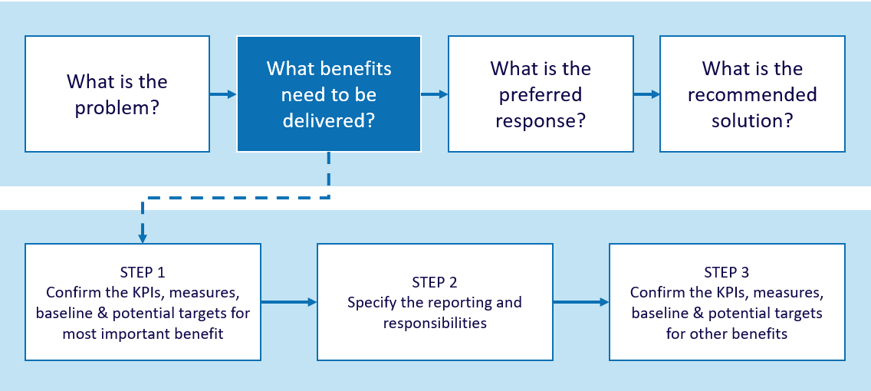

For investments requiring resources over the medium-long term (especially large infrastructure and assets), an assessment of how uncertainty of different future scenarios may impact the way the benefits are defined or realised is an important element of this workshop. Where participants identify significant uncertainty about how the future may turn out, you should consider and record its potential impacts on investment success.
The key output of this workshop is agreement from the investor and key participants as to the benefits that an investment will deliver, and the evidence that will be required to prove that they have been delivered.
This information is captured in the form of a Benefit Management Plan (BMP) which is made up of a Benefit Map and a Benefit Profile. The Benefit Map outlines the Benefits, KPIs, Measures, Baseline and Target values. The Benefit Profile is statement of reporting data and responsibilities. (See Appendix 3)
      - Responsibility of the facilitator
It is your responsibility to help the participants develop the most compelling, evidence-based case for investment that they can.
To be successful, you must:
    - try to ensure the right people will be attending and that two hours has been allocated for the discussion;
    - ensure that preparatory work regarding the current evidence base and indicative KPIs has been undertaken by a benefit specialist, or another nominated person (see sections 2.3 and 2.4);
    - conduct the discussion according to the guidance provided in this document; and
    - finalise the discussion and the BMP within 48 hours.
You should refer to Design guidelines – Benefit Management Plan (Appendix 4) for some tips on preparing a high-quality BMP.
      - Who should be there?
The key person is the investor who owns the business problem and who will be responsible for delivering the benefits if the investment is funded. Participants from the previous workshop, who have the deepest knowledge of the problem environment (including relevant Government policy) and supporting evidence should also attend. Others who should be added to the group at this stage include:
    - a senior finance person, if they were not a participant in the first workshop. They generally bring a useful understanding of data integrity and reliability to the discussion;
    - a benefit specialist who has expertise in KPI design and understands what is possible in terms of data collection and analysis. This person may be part of the Program Management Office or a member of the corporate strategy and reporting team;
    - material data owners who will be responsible for providing the key data for the measures; and
    - the business case developer (if already identified), who can learn more about the potential investment and act as a common-sense check of the discussion.
It is not always useful for all the external participants in the Problem Definition workshop to continue to the Benefit Definition workshop but this will depend on the nature of the investment and its interdependencies.
The most effective group size usually ranges from six to eight, depending upon the nature of the investment.
      - What preparation is required?
Preparation is vital to the success of this workshop. This makes it different from the Problem Definition workshop, for which no specific preparation is required. For the Benefits Definition workshop, however, it is critical that the participants (and the organisation) present with an explicit understanding of:
    - what is going wrong or what needs are not being met now, or into the future;
    - why is it happening;
    - how bad is it; and
    - who and what are, or will be, affected.
There are three main stages to the pre-workshop preparation:
    - Evidence Substantiation: If there has been inadequate evidence substantiation in the Problem Definition workshop, or subsequently, this will have an obvious corollary in a lack of rigour in KPIs and measures in the Benefit Definition workshop. If evidence is weak, the workshop group may need to invest more time and effort in understanding the current or projected state. In some instances, this may highlight that there is insufficient evidence available to build a business case now but the investor could commission research to develop evidence to support a case in the future.
The type of evidence needed will usually cover both the:
      - external environment (e.g. forecasts and projections, demand pressures, demographic and population changes, technological developments); and
      - internal operating environment (e.g. performance evaluation and reporting, capacity and capability assessment and availability, suitability and condition of resources including physical assets, service design and alignment).
    - Value Understanding: If there are gaps in understanding about what the organisation, Government, or community values, or if these values cannot be measured, it will be hard to tell a compelling story for the investment. In preparing for the Benefit Definition workshop, the facilitator should make sure that the investor is clear about the wider environmental drivers, the target groups that the organisation serves, the alignment of the investment with the organisation’s strategic intent, and any significant internal or external performance targets and timeframes that must be met.
    - KPI Review: The Problem Definition workshop should have identified a suite of indicative KPIs but it is unlikely that these will have been fully interrogated during the workshop. Before the Benefit Definition workshop, the investor should charge the organisation’s benefit specialist, or another participant from the first workshop, to complete a review of the indicative KPIs and identify potential measures. This review should determine whether these KPIs are meaningful, measurable, and primarily attributable to the investment. This will provide a good starting point for the workshop which, otherwise, may lack focus.
The KPI input sheet (Appendix 5) is a useful way to capture KPI and measurement data and will usually take one to four hours to complete. It is not necessary for actual baselines and targets to be set at this stage. It is, however, critical that the facilitator sees the KPI input sheet prior to the workshop as this will ensure they understand the organisation’s state of readiness and can tailor the workshop accordingly.
The Benefit Definition workshop will be significantly less effective if the workshop group cannot either substantiate the evidence for the problems or clearly articulate the value of the benefits. The facilitator should be prepared to provide this advice to the investor, if required.
      - Before the workshop
Ensure the investor is attending the workshop and assist them to identify any additional participants who should attend.
Confirm the investor has undertaken all required preparation, as outlined in Section 2.4.
Enlist the support of the benefit specialist or whoever is reviewing the draft benefits and KPIs and preparing the KPI input sheet.
Ask the investor to send an email outlining the purpose of the discussion to the participants attaching the:
    - current ILM; and
    - KPI input sheet, if it has been completed.
You may find it helpful to tailor the Sample email – before the Benefit Definition workshop (Appendix 6) and provide this to the Investor.
Make sure that the venue has been reserved 30 minutes prior to the start of the workshop, can accommodate the number of participants comfortably and has a suitably sized whiteboard. It is often useful to have a flip chart available as well.
      - At the workshop
        - Setting up the whiteboard
Arrive 30 minutes prior to the workshop and draw the Benefit Map on the left-hand side of the whiteboard. Include the elements that were identified during the Problem Definition workshop.
Make sure that you have copies for circulation of the latest versions of the ILM and KPI Input Sheet (if available), and your own copy of the whiteboard workings from the Problem Definition workshop. The benefits and KPIs may change because of the workshop but these documents provide useful starting points.
On the right-hand side of the whiteboard, or on a flip chart, list the data fields from the Benefit Profile and complete the reporting and responsibilities profile for each KPI.
        - Structuring the workshop
The structure for this workshop is simple. Once you have completed the introduction and reviewed the problem statements, start with the most important benefit. Define its KPIs, measures, baseline, targets, and enter the relevant fields in the Benefit Profile. Then consider the interim targets; source, forum, reporting timeframes and responsibilities to complete the Benefit Profile whiteboard.
Once this is completed move on to the benefit with the next highest weighting and repeats the process. If time becomes short there are some elements of the Benefit Profile that can be completed off-line as part of the feedback process. Your responsibilities before, during and after the workshop are summarised in Checklist –Benefit Definition workshop (Appendix 7).
        - Timing
Manage time carefully. In most instances the benefit discussion and data capture should last about 100–110 minutes. If you do have any time remaining use this to focus on expanding the range of candidate interventions, in preparation for the Response Definition workshop, the next in the IMS suite.
Appendix 8 provides a Sample agenda for a Benefit Definition Workshop.
        - Set expectations
It is a good idea to set some general expectations at the start of the workshop:
    - you expect people to be at the workshop for the full two hours;
    - phones should be turned off, including messaging and email; and
    - polite behaviour within the group is expected but this should not compromise the robust and probing nature of the discussion. This is a workshop where you expect high levels of participation and contribution from those at the table.

Step 1: Set the scene
Set the context and objective of the workshop, the roles of each participant, the approach, the time criteria and your role. You should aim to create a climate of robust and open discussion within a two hour ‘time-box’.
Why are we here?
In the Problem Definition workshop, we roughly defined the benefits and associated KPIs that this investment will be delivering. At this workshop we will be revisiting those benefits in an attempt to further develop, refine and validate them. We will be developing a Benefit Management Plan (BMP). The BMP has two components, a Benefit Map and a Benefit Profile. The BMP will allow you to track, report and evaluate the delivery of expected benefits.
Hand out a copy of the ‘Example – benefit management plan’.
This is to demonstrate the outcome sought in this discussion. (This may not be necessary if the participants have previously participated in a similar discussion that produced a BMP. Examples can be found at www.dtf.vic.gov.au/investmentmanagement.)
A BMP is a short document that specifies the benefits an investment will need to deliver to address an identified problem successfully. It includes the measures to be used as evidence that the benefits have been delivered. These measures are initially used to select the most suitable response to the problem. The BMP also defines the dates when the benefits are expected to be delivered, who is responsible for their delivery and how they will be reported.
What is my role?
You will remember that my role as the facilitator is to be content free. My aim is to help you tell the best investment story that is possible, achievable and can be supported by verifiable evidence. It is in this workshop where we are focusing on testing and developing a strong evidence-based case that I will really challenge you to identify the most compelling evidence that can be sensibly gathered to support your KPIs.
The investor’s role
As the investor you are most important person in the room. This is your forum and you are responsible for delivering the benefits claimed for this investment. Final decisions around KPI measures and targets for this investment will be directed to you.
Benefit specialist
The benefit specialist has done some preliminary work around the KPIs that we identified in the first workshop. Their observations regarding the suitability of the KPIs based on an analysis of the data that is currently available and whether they satisfy our key criteria of being ‘meaningful, measurable and attributable’, and reflect value for effort required, will be important in this discussion. The benefit specialist has also explored how clearly these benefits and KPIs reflect the strategic objectives or priorities in the organisation’s benefit framework.
Benefit data provider
We also have a person/people who have been identified as the custodian(s) of data that will be required as evidence that a KPI has been met.
Many of you were participants in the Problem Definition workshop. You have been selected to participate because you know most about this investment, and its impact, and it is your insights that will help to shape and bring rigour to this investment story.

Step 2: Review the problem
Hand out copies of the ILM that was developed in the Problem Definition workshop. Ask the investor to use this to explain the problem and the benefits that any solution will be required to deliver. Allow a brief discussion so that everyone is clear about the need and has the opportunity to refine the problem statements. Make any changes or amendments that arise from this discussion.
It is unlikely that participants will identify a new problem at this stage. More often the discussion may highlight additional causes and effects rather than new problems. However, if a new problem is identified it must be unpacked in the usual way with cause and effect being described and validated. The facilitator will need to adjust the weightings. This will increase the time pressure on the workshop and you may need to reduce some of the later work on the Benefit Profile to compensate.

Step 3: Confirm the benefits and select KPIs, measures and targets
This step focuses on determining and articulating the benefits, KPIs, measures and targets that will demonstrate that value has been successfully delivered.

Benefit
Benefit statements should provide an obvious connection to the government’s or the organisation’s outcomes but be set in the context of the organisational or local impact. The Benefit framework (Appendix 9) illustrates this important alignment between the high-level enterprise benefits and specific investment benefits.
DTF defines a benefit as the value the investment will provide to the organisation, its clients, customers or other stakeholders. Benefits are normally positive consequences of successfully responding to the identified problem. Each benefit is supported by one or two KPIs.
A benefit needs to pass three tests, that it:
    - has removed or mitigated the defined problem, specifically a cause or effect, and is aligned to the outcomes valued and articulated by the organisation;
    - is supported by up to two KPIs that are meaningful, measurable and attributable to the investment; and
    - it is cost-effective, i.e. the effort required to track the benefit and the KPIs are commensurate with the value and insight that they provide.
A maximum of four benefits is allowed but typically two or three benefits are identified in an ILM.

Key Performance Indicators
When your benefits have been confirmed it is time to define the KPIs, measures, baselines and targets.
A KPI is an indicator which, together with its associated measures and targets, provides the evidence that expected benefits have been delivered. It helps determine whether the target group/community is ‘better off’ because of the investment.
There should be no more than eight KPIs but four to six are typically sufficient. Ideally, KPIs should be outcome rather than output or activity focused. Where there is no practical way to measure an outcome, a proxy or indirect indicator may be used. These are often more output focused and should be used judiciously.
A good KPI is:
    - meaningful – it is a reasonable indicator that the benefit has been delivered. It is clear how the investment contributes to the benefit;
    - attributable – the investment is the most likely reason for a change in this indicator; and
    - measurable – there is an existing baseline and it is cost-effective to measure progress against this baseline. The indicator can be expressed as an increase, or decrease, that shows improvement over time against the baseline.
Use existing data sets when establishing KPIs as far as practically possible, assuming they provide good measurement for the KPI. These may be organisational datasets, or other comparable performance data that can be accessed nationally or internationally. Appendix 10 includes a Checklist for KPIs and related measures, baseline and targets.
Ask the benefit specialist to hand out the KPI input sheet (it may have been previously circulated) and to provide their observations regarding each benefit and its KPIs, candidate measures, baselines and targets. They should offer an assessment of whether the KPIs are meaningful, measurable and attributable. The data source and ease of retrieval will be part of this report.
Start the discussion by focussing on the most important benefit.
Key questions for each benefit and its KPIs and measures
- Which of the KPIs listed in the KPI input sheet are you most prepared to hold up as the strongest evidence that you have delivered the benefit?
- Is it clear who will gain from the changed performance of the KPI?
- What measures are most relevant to validating that the KPI has been met?
- Can these measures be easily captured?
- Do the measures fall into categories of quantity, quality, timeliness or cost?
- How can these be described e.g. percentage, number, rating, proportion?
- Is one measure sufficiently informative or will two measures provide clearer evidence for the delivery of the KPI?
- Will the measures used for a KPI need to change over the reporting period, i.e. as different stages of delivery or maturity are reached?
- Do you currently have a baseline for the measures or can one be easily established? What date or period is being used to set this baseline?
- If you don’t have a baseline, then how can you establish a target and date or period for delivery? Is there a target that has been set externally? Will you invest resources in establishing the baseline?
- Is it useful to identify one or more interim targets to demonstrate progress or incremental benefit delivery?
- Is achievement of any of the benefits, KPIs or measures, contingent on significant interdependencies?
- Is uncertainty likely to materially impact any of the proposed benefits?
- Where will you get the information to support this measure?
- Where will you report or publish your performance against this KPI? Who will be interested in knowing about this? Will it have an interest for external stakeholders, Government, the media?
- When will you start reporting against this KPI?
- How frequently will you report?
- When will the organisation or other stakeholders no longer be interested in hearing about the performance of this KPI as it relates to this investment?
- Who will be responsible for reporting your performance against this KPI?

Once you have confirmed each KPI and established its measures, baselines and targets it may be useful to test them using the Checklist for KPIs and related measures, baseline and targets (Appendix 10). Figure 2 illustrates the alignment between problem, benefit, KPI, measure, baseline and target.
Figure 2: Alignment of problem, benefit, KPI, measure, baseline and target
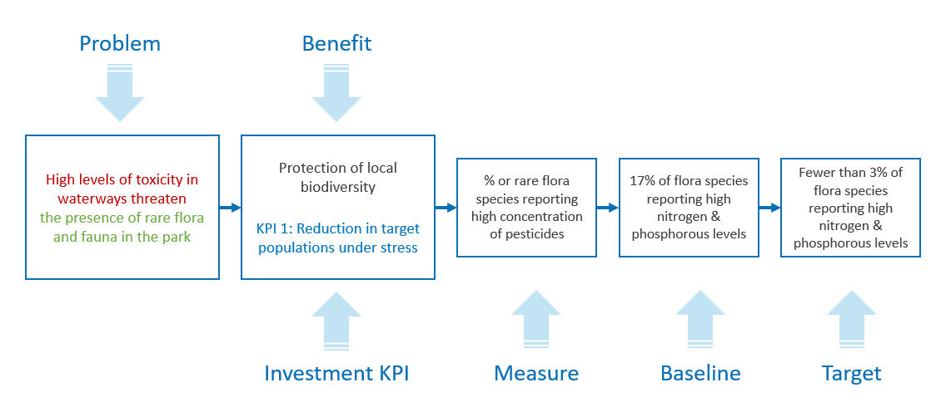

Benefit Profile
You should now complete the major fields in the Benefit Profile. If time is short, the profile information from the least important Benefit and its KPIs can be completed outside the workshop.
It is important to consider whether setting interim targets will demonstrate the incremental delivery of value. This is particularly relevant for investments with a long investment lifecycle. The source field refers to the data that enables tracking of the KPI. The forum field refers to the channel where performance against the KPI will be communicated/shared. The reporting timeframe describes the frequency and duration of reporting. It is important to be realistic about timeframes. They must not be too onerous in practice and should be suitably spaced to identify real change between reporting points. The reporting responsibility field outlines the person and position which will be responsible for gathering the performance information. Nominating a position increases the likelihood that the tracking activity will occur.
Finally, a new field, uncertainty/Interdependencies provides the opportunity to test whether external factors and interdependencies may have a significant impact on the achievement of the KPI and its target measures.
Investors are required to consider the potential impacts of uncertainty on any proposal, regardless of the investment type. Considering the impacts of uncertainty is a good investment management practice and can benefit any proposal. By arming Government to anticipate change and respond advantageously to prevailing conditions we can minimise Government’s obligations under negative conditions and take advantage of opportunities. Appendix 11 Difference between risk and uncertainty clarifies the scope and differences between risk and uncertainty and how they are managed within the IMS workshops.

Discuss again whether any of the proposed benefits are contingent on any interdependencies. Ask if the delivery and realisation of any of the proposed benefits could be affected by changing exogenous circumstances (e.g. by evolving demographics, economics, technology, or changing environmental, social, political or industry factors). If this is the case:
    - any material uncertainty should be captured within the BMP and further considered in subsequent workshops; and
    - where there is significant uncertainty in relation to achieving investment benefits, and the proposal is asset-related, the facilitator should highlight the potential need for real options analysis in the Benefit Profile.
It will probably not be possible to adequately consider how externalities or alternative future states may impact benefits realisation within the BMP. However the IMS should be used to identify those projects that will need real options analysis and highlight further work required outside the IMS process. Real options analysis is unlikely to be required for non-asset related proposals.
    - Participants should consider whether they undertake IMS workshops 3 and 4 as inputs to real options analysis, or simply move to real options analysis at this point.
The role of the IMS is to identify uncertainty and its impacts on an investment and, where those impacts are potentially significant, recommend further investigation. DTF highly recommends agencies engage suitably qualified and experienced consultants to support this work.
Once the Benefit Profile is completed, distribute the weighting associated with the benefit between its KPIs. This should indicate the relative contribution that each KPI will make to the delivery of this benefit, and the relative contribution that each KPI makes to the overall assessment of benefit delivery. It is important to complete this profile for the major KPIs as it gives confidence that the case for the investment is strong.
Repeat this approach until the KPIs for each benefit have been defined and the data to support them has been collected. Print, copy or photograph the workshop output as you proceed.
The case for the investment may be unclear if the workshop cannot:
    - settle on a suite of KPIs;
    - define the KPIs, measures and at least have indicative baselines and targets for their most significant benefit; or
    - agree a reasonable process to get the KPIs and measures quickly.
In this situation, the investor may decide to pause and investigate further or not proceed at all.

Step 4: Review the benefits – reality check
Ask the questions, “would achieving the identified benefits justify the scale of investment that would be needed to deliver these benefits?” and, ‘’are these benefits and the KPIs of real interest to Government, or other funders?” These provide a common-sense check to your work and allows you to validate the wording of the benefits and the logic of the investment story.
    - Check that the measures are output, rather than simply activity, based with an internal focus. Activity based measures are often not of interest to funders or key stakeholders, even if they appear to be linked with KPIs that are. It is common to have to replace at least some of the measures with those that fall out of the Cost-Benefit Analysis, if one is done as part of the business case development.
    - Having more compelling measures at this stage will reduce the need for later rework. A good test is to ask the group, “Are some of the targets those that a Minister or CEO would be eager to put in a media release and that the community or shareholders would be pleased to hear about?”
Obtain agreement to any changes that will be required to the wording of the benefits in the ILM and the wording to be used in the BMP.

Step 5: Finalise the workshop
Advise the participants that within 24 hours they will be provided with version 1.0 of the BMP. This will contain observations of the quality of the plan and any suggestions for improvement. They will be asked to provide suggested changes within 24 hours. Within a further 24 hours you will distribute version 1.0.
      - After the workshop
As with all workshops of the IMS, it is important to wrap-up the Benefit Definition workshop without delay.

Within 24 hours:
    - update the existing ILM to reflect any agreed changes and to depict the benefits and their KPIs. This will be version 2.0;
    - download the current version of the BMP format from the Investment Management website and populate it with the data collected to create version 1.0 of the BMP. Create the Benefit Map and complete the Benefit Profile;
    - as soon as possible after the workshop, send all participants your version 1.0 BMP with your comments as to its current quality and how it might be improved. Include the version 2.0 ILM and, if you think it would be helpful, copies of the whiteboard images from the workshop; and
    - in the email, ask that participants provide feedback (and copy to all other participants) with suggested changes within 24 hours and that you will make amendments and provide them with version 1.0 within 24 hours of that time – see Sample email – after the Benefit Definition workshop (Appendix 12).
You can assess the resulting BMP’s effectiveness using the Quality assessment form – Benefit Management Plan (Appendix 13). This form need not be completed each time a Benefit Definition workshop is held, but is required for facilitator accreditation and re-accreditation.

Within 48 hours:
    - consider the feedback received to version 1.0 of the BMP and amend as necessary. If no feedback is received finalise the BMP as you think best; and
    - send an email to all participants with an updated ILM version 2.0 and version 1.0 of the BMP. Highlight that the BMP will need to be reviewed when the solution has been developed to validate the benefits that the specific solution will provide (if different to those sought).

Prior to the Response Definition workshop:
You should advise the investor about next steps including preparation for the Response Definition workshop. This should cover any additional work needed on the KPIs and their measures to get the most value out of this next workshop. Further advice for facilitators on the preparation needed for the Response Definition workshop is provided in the next technical guide document in this series.

During business case development and beyond:
The Benefit Definition workshop is largely designed to support the development of a preliminary business case. A full business case, particularly one prepared for a HVHR investment is likely to require a detailed measures validations exercise to confirm that the measures and their details are still valid in line with Stage2: Prove guideline and the Sustainable Investment Guidelines https://www.dtf.vic.gov.au/investment-lifecycle-and-high-value-high-risk-guidelines/stage-1-business-case
The project team or business case writer should update all IMS documents to reflect the new analysis and understanding which emerges during business case development. This may change the description, weighting or measurement of benefits. If major changes occur, the BMP will need to be reviewed more comprehensively. The failure to update IMS documents has been regularly reported in Gateway Reviews and has often undermined confidence in the case for investment.
If the proposed investment is funded, the BMP that has been created should be reviewed at set intervals during the investment either in conjunction with the ILM, or separately. Regular reviews are likely to take place at meetings of the project’s governance body.
      - Templates, examples and other resources
The templates and examples are available for download at www.dtf.vic.gov.au/investment-management-standard/facilitator-guidance-and-templates.

Appendix 1: 16 Questions – Investment decision-maker’s checklist
The 16 questions (the Investment Decision-Maker’s Checklist) are a set of prime questions that any decision-maker should have answered before funding an investment. The depth of enquiry for each question will depend on the scale and complexity of the investment. These questions can be asked, in part or in their entirety, at various stages in the investment management process to test the robustness of the IMS workshop document suite and the business case, if developed.
The 16 questions correlate with key elements of the Victorian government full business case template and aid business case writers and assessors. The focus for the Benefit Definition workshop is questions 5-8.
Figure 3: 16 Questions - Investment decision maker's checklist
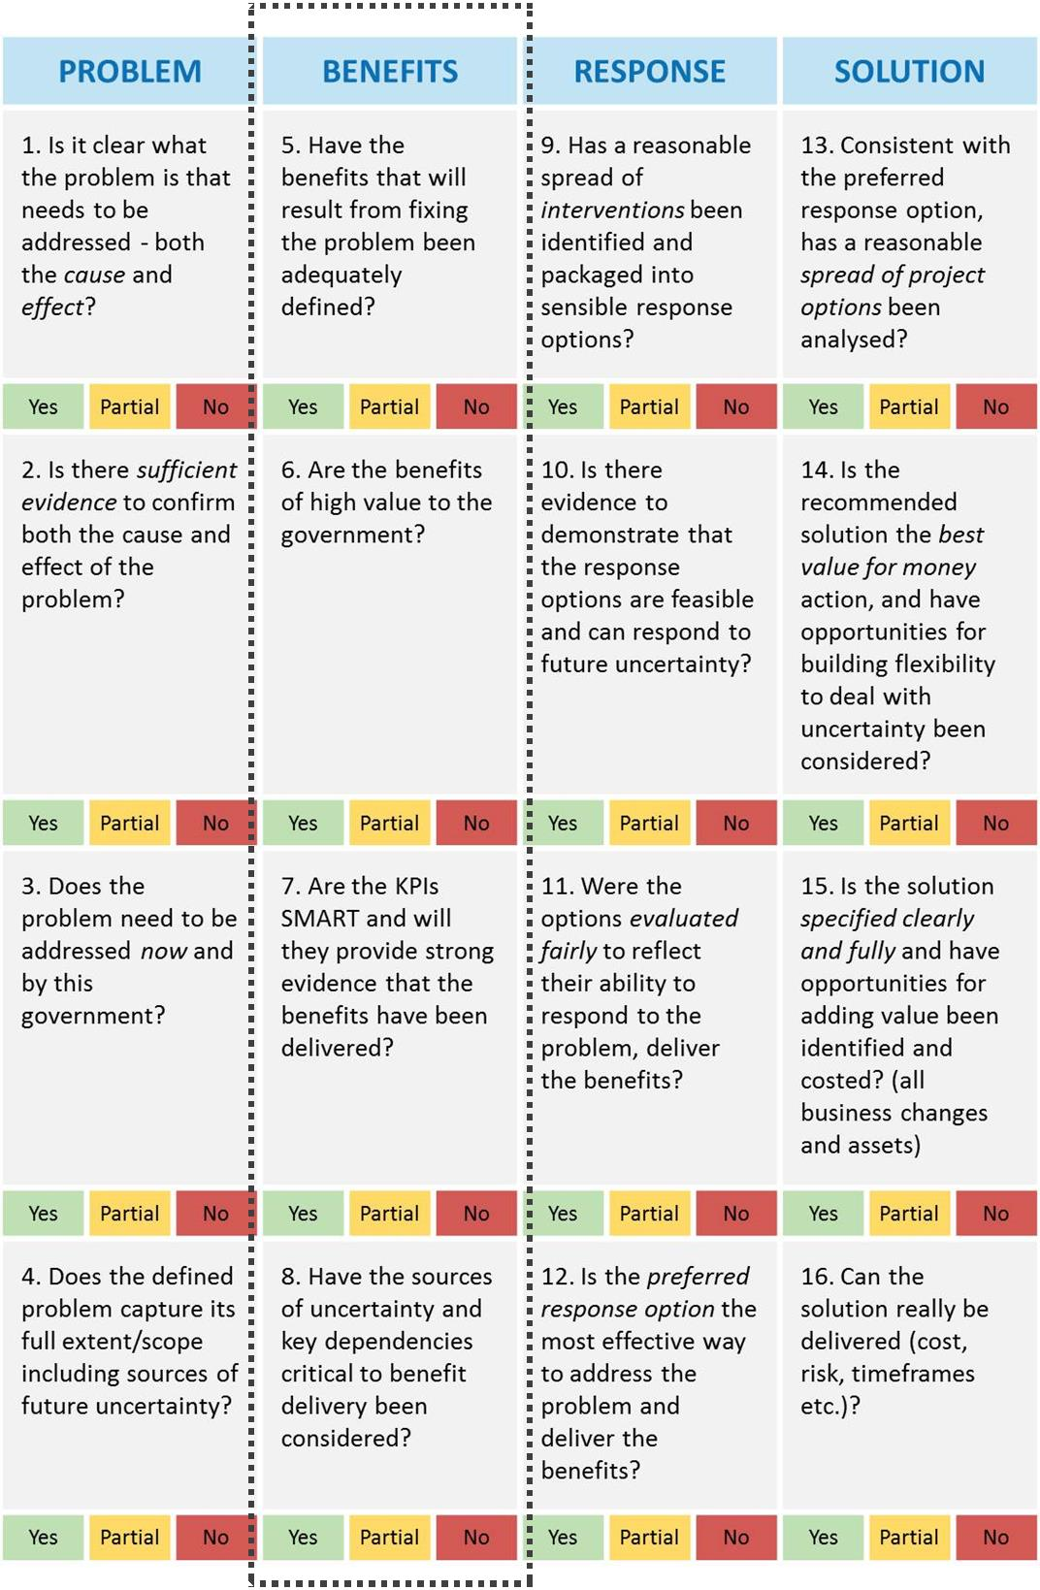

Appendix 2 - Shaping new investments using the IMS
The Victorian Government’s Investment Management Standard (IMS) establishes a set of simple practices that enable organisations to select the investments that matter most and shape and implement them so they deliver the maximum benefit and best value for money. The practices can also be used to help prioritise investments, develop policy, evaluate programs and improve the effectiveness of an organisation.
The IMS supports a way of thinking characterised by evidence-based discussion, robust logic and simple storytelling. It brings together the best thinkers on a subject to discuss and shape new investments in two-hour facilitated discussions (workshops) to address the four questions that are fundamental to investment decision making:
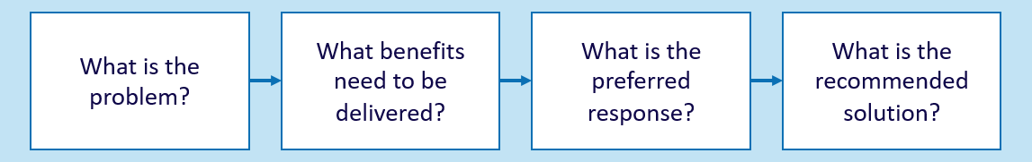
The number of workshops required is determined by the nature of an investment. Large and complex investments might require four separate workshops that would produce four documents critical to establishing a sound business case. Small and simple investments might require just one or two workshops and would produce an Investment Logic Map (ILM) and a Benefit Management Plan. The four workshops are described below.
PROBLEM
Successful investments are made as a considered reaction to an identified or emerging problem. This workshop focuses on:
- defining the problem that need to be addressed;
- validating that the problem is real; and
- specifying the benefits that will result from addressing the problem.
The output of this workshop is the first version of an Investment Logic Map (ILM) with the problems and benefits defined.
BENEFIT
Investments are often shaped with little understanding of the benefits expected to be produced. This workshop will:
- identify the KPIs, measures, targets and timelines that the investment will need to deliver; and
- specify how the delivery of the benefits will be measured and reported.
The output of this workshop is a Benefit Management Plan (BMP) including a Benefit Map and Benefit Profile.
RESPONSE
Business cases for new investments often fail to consider the full range of things that could be done to address the identified problem. This workshop will:
- explore the interventions that could deliver the expected benefits;
- formulate and evaluate a mix of response options; and
- assess response options and potentially select the preferred response.
The output of this workshop is a Response Options Analysis Report (ROAR).
SOLUTION
This workshop ensures that a solution is developed which is consistent with the foundations established in previous workshops. This workshop will:
- confirm the preferred response and the interventions it contains;
- identify and evaluate the changes and assets that are required to implement the preferred response and deliver the benefits;
- define a recommended solution; and
- identify cost range, timeframe for project and benefit delivery, key risks, uncertainties, dis-benefits and critical assumptions associated with the recommended solution.
The output of this workshop is an Investment Concept Brief (ICB).

Appendix 3: Fictional – Benefit Management Plan
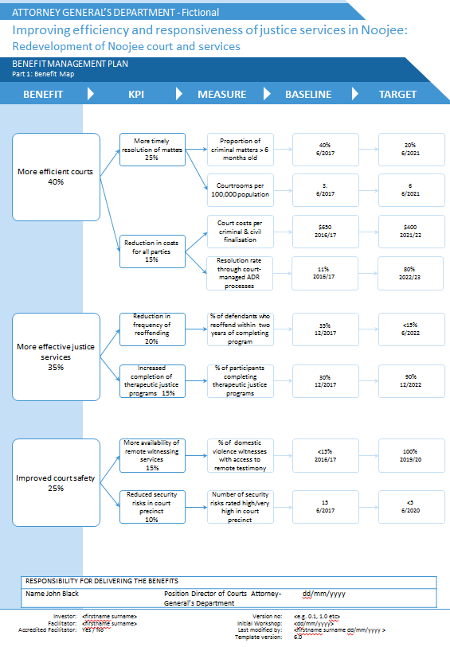
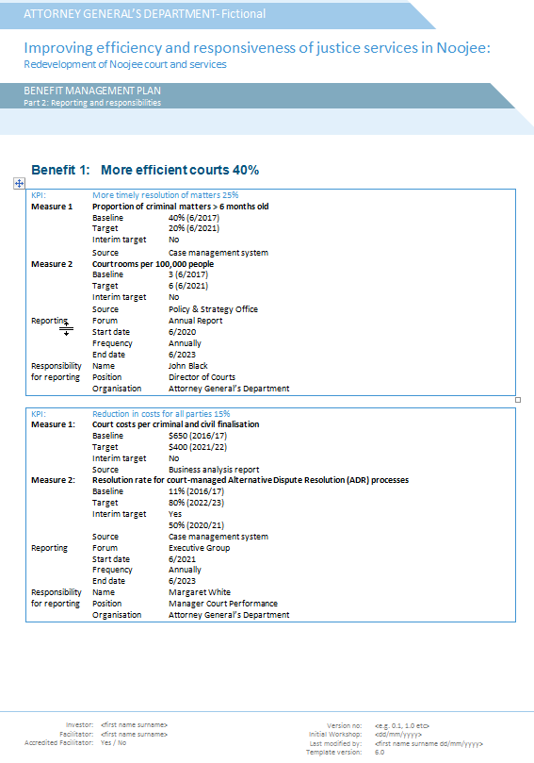

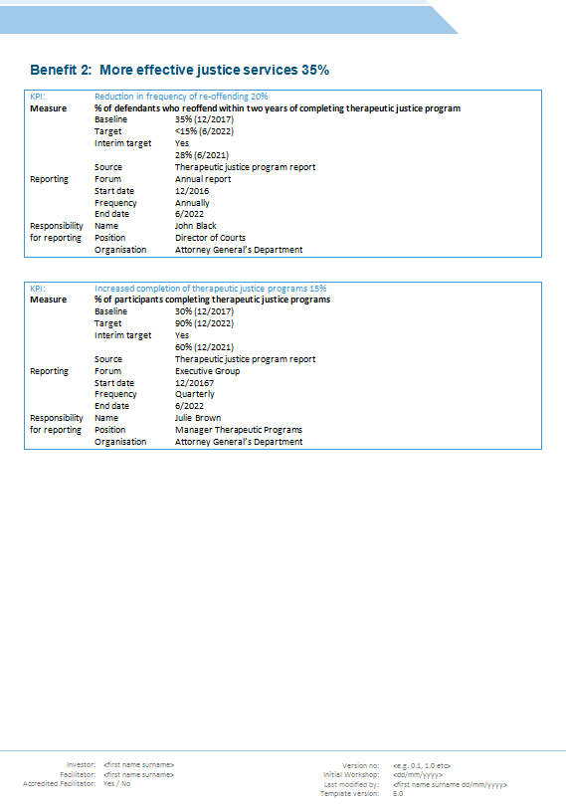

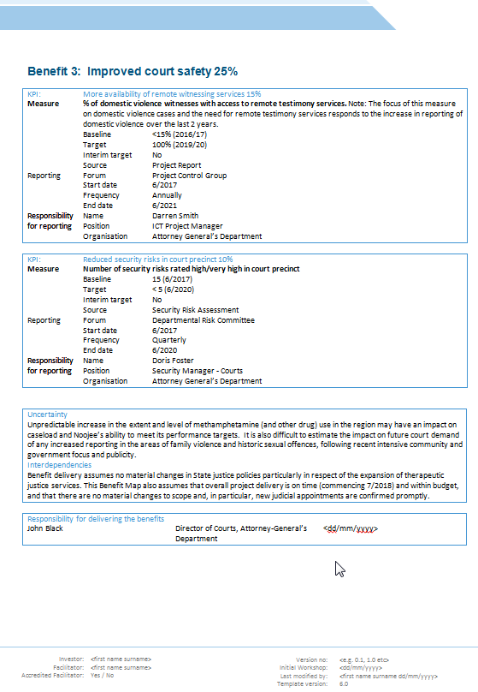

Appendix 4: Design guidelines – Benefit Management Plan
The function of a BMP is to articulate the outcomes that will be delivered by a successful investment. These design guidelines have been developed to assist facilitators develop high-quality BMPs. Their use will help ensure your BMP effectively communicates the value proposition inherent in the investment and identifies the key management, tracking and reporting responsibilities in a simple and cost-effective way.
Item | Practice |  | Reason
Template |  | Always use the current BMP templates. Do not alter the templates. Current templates can be found at www.dtf.vic.gov.au/investmentmanagement. |  | Formats continue to improve to make them more useful as communication tools and contain better information.
Use of words |  | Be brief, clear and specific in your statements. |  | This forces precision in the words used to convey value. It also maintains clarity and consistency when reading the BMP.
KPIs |  | KPIs must be included for each benefit.  At least one KPI is required as evidence of the delivery of each benefit.  No more than two KPIs should be selected for an initiative-level investment.  Program level investment may have up to 4 KPIs per benefit.  Re-distribute the percentage associated with each benefit to their related KPIs. The percentage will indicate the relative importance of each KPI to overall benefit delivery (e.g. benefit = 60% KPI, 1 = 40% and KPI 2 = 20%) |  | Gives credibility that the claimed benefits are achievable. It also focuses the group on determining the most important KPIs that this investment is going to achieve.
Measures |  | Each KPI must have one or two measures. Higher weighted KPIs may have two measures whereas one measure is sufficient for lower weighted KPIs. Typically measures fall into those characterised by quality, quality, cost and timeliness |  | Identifies the focus of what will be measured in demonstrating the achievement of the KPI.
Baseline |  | Each measure should have a baseline indicating what will be used as a starting point for a given area of performance and the date or period of this starting point. Both the baseline measurements and date that the baseline is taken from must be included. |  | Provides a clear mechanism to demonstrate the improvement or value that will be delivered by the investment as measured by the gap between the baseline and target.
Target |  | Each KPI must have a target and date when the target will be reached. These should be consistent with the expected milestones or staging of actual project delivery. This may need to be revisited once the solution is determined. |  | Quantifies the level of improvement that will be delivered as a result of the investment.  Interim targets communicate the incremental value and area of change that will be delivered across the lifecycle of the investment.
Source |  | The data source for each measure is identified here. |  | Provides certainty that the relevant data is available to track progress on the KPI.
Forum |  | Each KPI should have a nominated channel where performance against the KPI will be communicated/shared. |  | Provides accountability and opportunity to enhance organisational knowledge.
Start, frequency and end of reporting |  | Identify:  - Start date – when reporting on benefit and KPI performance will occur.  - Frequency – how often reporting will occur – typically six-monthly, annually or biennially.  - End date – when reporting on benefit and KPI performance associated with this investment will cease. This may be some time after the investment is implemented. |  | Identifies the reporting timeframe and frequency.
Responsibilities |  | There should be no more than one person assigned to the roles of:  - benefits manager; and  - reporting manager. |  | Identifies those responsible for delivering the BMP.
Uncertainty/  Critical inter-dependencies |  | Note the nature of external factors that could impact on benefit delivery. |  | Can act as a trigger for a real options workshop during business case development
Completing the control fields |  | Ensure the document control fields have been completed, including the names of the:  - investment;  - department/agency/ organisation;  - investor; and  - facilitator |  | Provides legitimacy and accountability to the investment.

Appendix 5: KPI input sheet
BENEFIT NAME:
Candidate KPI | Candidate measures | Evaluate (H/M/L) |  |  | Baseline value | Target value | Comment
Candidate KPI | Candidate measures | Meaningful | Attributable | Measurable | Baseline value | Target value | Comment

Appendix 6: Sample email – before the Benefit Definition workshop
[Greeting]
You may (or may not) be aware of the business need we have in relation to [investment name] and the thinking we have been doing to shape an investment that will respond to that need. Consistent with the Victorian Government’s Investment Management Standard we have already held an ‘Identify the problem’ discussion, which defined the problem, and outlined the benefits that this investment will be required to deliver.
We will now be holding a two-hour Benefit Definition workshop that will validate the benefits we plan to deliver and will identify the key performance indicators (KPIs) that will provide the best evidence that the benefits have in fact been delivered. An output of this discussion will be the first version of a Benefit Management Plan that will be used over the life of the investment. For those investments that will be going through the Gateway Review process, a strong and accurate Benefit Management Plan is expected.
Preparation is required to ensure that we have the most effective and efficient outcome from the workshop. Please review the ILM that was developed in the first workshop. In particular, you should be confident that you understand:
- what is going wrong or what needs are not being met now or into the future;
- why is it happening;
- how bad is it; and
- who and what are, or will be, affected.
The type of evidence needed may involve:
- external environment (e.g. forecasts and projections, demand pressures, demographic and population changes, technological developments); and
- internal operating environment (e.g. performance evaluation and reporting, capacity and capability assessment and availability, suitability and condition of resources including physical assets, service design and alignment).
This understanding will be critical to developing compelling KPIs and good mechanisms for measuring and tracking performance. We have already commenced an initial review of KPIs and this is attached. Please review this before the workshop and come prepared to support or replace these with more compelling KPIs and/or measures.
The discussion will be held as follows:
- Date:
- Time:
- Venue:
The result of this exercise will be a Benefit Management plan [example].
Your role in this would be as [role]. Please let me know if you are able to attend.
If you would like to read more about the benefits and practices of this approach you should refer to www.dtf.vic.gov.au/investmentmanagement.
[Investor sign off]

Appendix 7: Checklist – Benefit Definition workshop
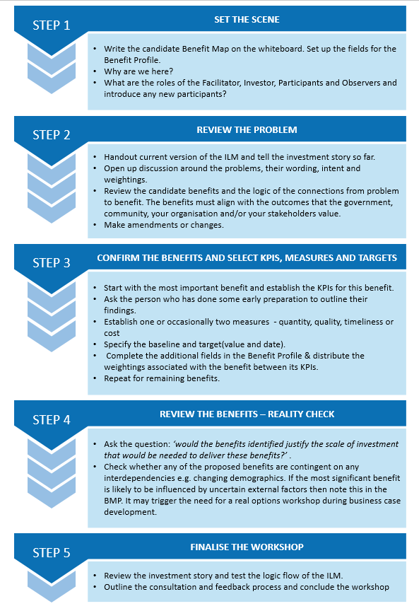

Appendix 8: Sample agenda for a Benefit Definition workshop
Before the workshop
15–20 minutes | Set up the whiteboard
At the workshop
5 minutes | Introduction and outline of purpose and role
5–10 minutes | Review of ILM
90 minutes | Benefit discussion and documenting KPIs measures, baseline and targets, as well as Benefit Profile fields
5-10 minutes | Review and test the value proposition described in the Benefit Map
5 minutes | Conclusion and next steps

Appendix 9: Benefit framework
Each time an organisation makes an investment there is an expectation that some form of benefit will be returned. It therefore follows that the ability to design investment solutions that provide the maximum benefits, and to be able to confirm that these planned benefits are delivered, is critical to every organisation. To do this, agencies need to be able to articulate the benefits they will provide, define how they will be measured, or measure the benefits that are ultimately delivered?
Historically there has been an inability within large organisations to define how each individual investment contributes to the primary benefits that are the point of the organisation’s existence.
It is typical and appropriate that everyone within, say a police force, believes their individual investment will provide the benefit of ‘reduced crime’ and everyone in an education department will claim theirs will result in ‘better learning outcomes’. But there has generally been limited ability to describe the specific contribution an individual investment makes to, ‘reducing crime’ or achieving ‘better learning outcomes’.
The benefits framework that is illustrated has been found to be effective at addressing this longstanding problem.
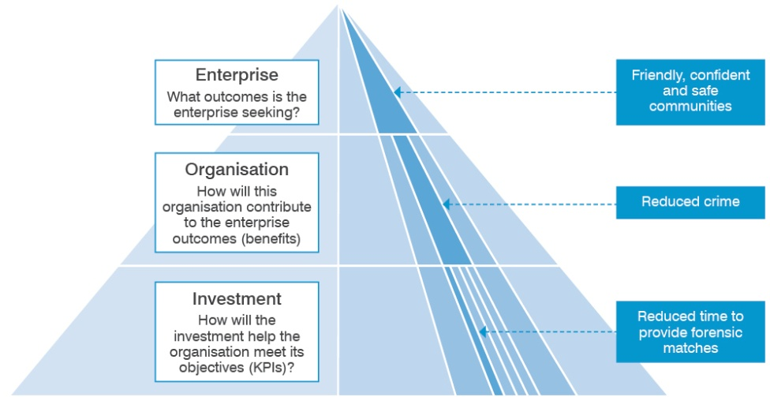
The framework is a three-level structure that links the contribution of an individual investment to the outcomes the enterprise is seeking.
In the example depicted here, at the enterprise level, the government is seeking to create ‘friendly, confident and safe communities’. To this end it sets benefits and targets that must be met at the organisation level – in this example, the police force is required to ‘reduce crime’.
At the investment level it is necessary to demonstrate how a particular investment will contribute to the benefits sought by the organisation. In the example, the forensic science division is seeking an investment to improve forensic management practices, acquire state-of-art forensic software and to renew its aged computer system. In return for this investment it claims that it will ‘reduce crime’. The evidence to support this claim is a reduction in the time taken to provide forensic matches by 30 per cent, and to obtain 20 per cent more forensic matches.

The head of the police force is then left to determine:
- how significant will meeting the targets associated with these KPIs be to a reduction in crime?
- would the claimed KPIs and their targets be directly attributable to the proposed investment?
- would the likely impact on crime reduction be worth the cost of the proposed investment?
This benefit framework is used as the basis for considering the validity of potential benefits during the development of ILMs.

Appendix 10: Checklist for good KPIs and related measures, baselines and targets
A good quality KPI should meet these criteria:
Criteria | Description | Yes/No
Meaningful | Is it a reasonable indicator that the benefit has been delivered? Is it clear how the investment contributes to the benefit?
Attributable | Is the investment the most likely reason for a change in this indicator?  Would this change in the indicator occur without the investment succeeding?  Is the indicator influenced by external factors outside the control of the investment?
Measurable | Is there an existing baseline and is it cost-effective to measure progress against this baseline?  Can the indicator be expressed as an increase or decrease that shows improvement over time against the baseline?  Does the measure reflect a unit or output dimension of either quantity, quality, timeliness, cost?  Is the baseline available?  It is a reasonable reflection of the current or forecast situation if nothing is done to address it?  Is the target realistic and achievable? Does it represent a meaningful improvement against the baseline?
Available | Will data be available in a timely manner – at least annually and over the entire forward estimates period?  Does it already exist?  Is it sufficiently robust?
Comparable | Does the indicator allow for comparisons over time, between target groups, across organisations, jurisdictions, competitors?
Verifiable | Is the methodology and process for data collection and indicator reporting clearly documented?  Are processes in place to maintain performance records to a standard which allows an independent auditor to verify integrity?
Outcome focused | Is this a positive change that government, organisation, community want? Outputs are the drivers of outcome performance rather than the result.

Appendix 11: Difference between risk and uncertainty
Risk is a variance (either positive or negative) from an expected outcome.
- Risks usually apply to the delivery of a project.
- They are inside the project team’s control to minimise and mitigate to achieve the defined scope and expected benefits.
The Response Definition and Solution Definition workshops identify the key risks related to achieving an investment’s benefits, for further analysis in the business case.
In comparison, uncertainty is an event or change in conditions.
- Uncertainties usually relate to the investment need or problem.
- They are usually external factors outside the project team’s control.
- They can result in a different future state to that anticipated or assumed in the business, and can impact the need for an investment and can require a change in response.
These events include technological developments, major shifts in markets and economic conditions, the behaviour of other organisations, demographic and societal structures, or the natural environment. If such events occur they can have both positive and negative impacts on benefit delivery.
The key uncertainties related to the delivery of an investment’s benefits should be noted in the Benefit Management Plan and then explored further in the Response Definition and Solution Definition workshops. High levels of uncertainty will be further analysed and documented during the preparation of the business case.

Appendix 12: Sample email – after the Benefit Definition workshop
Sample email – after the Benefit Definition workshop
[Greeting]
Thanks for your participation at yesterday’s Benefit Definition workshop for [investment name]. I have attached version 1.0 of the Benefit Management Plan that we produced. I ask that you review this draft and provide me with any suggested amendments by close of business today. I will then make any necessary changes and have version 1.0 to you by close of business tomorrow.
…my observations
[any observations on the investment itself or the process and any suggestions that might improve the case for the investment or the strength of the investment concept brief]
…about Benefit Management Plans
A Benefit Management Plan is a powerful document. It gives credibility to an investment proposal by providing compelling evidence that the benefits claimed are real, can be measured and will be delivered. A Benefit Management Plan is living document that will be used as a primary reference by the governance body of an investment. As an investment proceeds it will be changed to reflect the prevailing view of the benefits that can realistically be delivered and measured.
[Facilitator sign off]

Appendix 13: Quality assessment form – Benefit Management Plan
The purpose of this form is to assist an investor, facilitator or anybody with an interest to assess the quality of a BMP that was developed under the IMS. It tests the quality through six simple questions.
Test 1: On reading the Benefits Map would a layperson be able to understand the KPIs that this investment has nominated? | Assessment:  YES / NO / MAYBE
Any comments?
Test 2: Would the indicators that are nominated in the Benefits Map genuinely contribute to the claimed benefits and can they reasonably be attributable to this investment? | Assessment:  YES / NO / MAYBE
Any comments?
Test 3: In the Benefits Profile, are the baseline values, target measures and target dates clear and defined in a way that can be measured? | Assessment:  YES / NO / MAYBE
Any comments?
Test 4: If the ultimate benefit targets are very long term, does the Benefits Profile contain interim KPIs that would indicate progress towards the ultimate indicators/benefits? | Assessment:  YES / NO / MAYBE
Any comments?
Test 5: Have those people responsible for making the BMP succeed been nominated in both name and job title:  A senior executive responsible for delivering the benefits?  Someone to report progress against the BMP? | Assessment:  YES / NO / MAYBE
Any comments?
Test 6: Has a reporting schedule in the Benefits Profile been defined and is it reasonable? | Assessment:  YES / NO / MAYBE
Any comments?
How do you rate this BMP? | Assessment:  SATISFACTORY / UNSATISFACTORY
Any comments?

Further detail on the facilitator training course, in which this guidance is used, can be found at www.dtf.vic.gov.au/investment-management-standard/investment-management-facilitator-training-and-accreditation.
Real options analysis is an investment evaluation and decision-making framework which introduces more flexibility to the management of infrastructure projects that are significantly affected by uncertainty. It assists Government make investments that are more adaptable over time and better able to meet the community’s evolving needs.
Previously the Strategic Response Options Analysis workshop
The VicRoads Benefit Management Framework is an excellent example of one such resource to aid the identification, monitoring and evaluation of benefits and can be found at vic.gov.au/transport-benefit-management-framework
Public value is defined as the value that a public organisation contributes to society and is considered the equivalent of shareholder value in the commercial sector. See Moore, Mark and Sanjeev Khagram. 2004. On Creating Public Value: What Business Might Learn from Government about Strategic Management Corporate Social Responsibility Initiative Working Paper No. 3. Cambridge, MA: John F. Kennedy School of Government, Harvard University.
Workshop discussions can help identify policy requirements and synergies. For example, IMS workshops may identify potential value creation and value capture opportunities within a proposal, or projects that can contribute to Victoria’s Climate Change Adaptation Plan. Consideration of these opportunities will be important in defining benefits as well as option analysis and solution design.
Refer also to the DTF Performance Management Framework, March 2016: dtf.vic.gov.au/resource-management-framework#from-1-january-2026

