Construction Supplier Register (CSR)

Master Supplier Checklist
This master checklist consolidates the three key supplier tasks: New Application, Annual Review, and Expired Document Upload.
The Construction Supplier Register (CSR) is an open pre-qualification scheme for suppliers of construction works and construction services seeking to deliver Victorian Government construction projects.

Before You Start
If you’re a new applicant, please refer to sections 1 and 3.
If you’re an existing supplier, please refer to sections 1 and 2.
This checklist is provided to help you prepare before submitting your application through the CSR Supplier Portal.
Please ensure all mandatory documents are downloaded, completed, signed, dated, and ready for upload prior to starting your application.
Applications will be rejected if mandatory OHS criteria documentation, signed Deed Poll when applicable or completed referee reports x 2 are missing.

Section 1 - Master Checklist
Checklist Item | Requirement | Completed / Attached
Business details | Full ASIC Extract including Company Directors OR ABN Extract if sole trader/Partnership. | ☐
BPC registration | Current Company and individual director BPC registration relevant to the CSR category sought. | ☐
Relevant registrations/ and or qualifications and memberships | Building Practitioner Registration (BPC/BLA), where applicable  Professional Engineers Registration (PE), where applicable, Including BPC building endorsement  Architects Registration (ARBV), where applicable | ☐
Public Liability Insurance | Certificate of Currency for Public Liability Insurance (PL) | ☐
Professional Indemnity Insurance | Certificate of Currency for Professional Indemnity (PI) | ☐
“Construct only” letter - Works suppliers Only | "Construct only" declaration (works suppliers only, ASIC Director‑signed), if PI insurance is not applicable. Refer to section 3 for suppliers that do not hold PI Insurance | ☐
Fair Jobs Code | Fair Jobs Code Pre‑assessment Certificate (required if seeking a project limit for $1 million and above)  Apply for Fair Jobs Code Pre‑assessment Certificate | ☐
WorkCover | - WorkCover Premium Notice (Including Industry Rate) Refer to Annex 1  - WorkCover Certificate of Currency | ☐
Financial Statements – Works suppliers only | Latest stand-alone finalised financial statements for the entity applying | ☐
Project History | CSR portal updated with completed construction projects, minimum three completed projects per category | ☐
Two Independent Referee checks | Two completed independent referee checks  Referee Report Template. | ☐
Signed CSR Deed Poll - Category‑Specific Documents | - Land Remediation Deed Poll  - Engineering‑related Deed Poll  - Asbestos Inspection & Hygiene Deed Poll | ☐
OHS Eligibility Criteria | ISO 45001:2018 certificate (to satisfy criteria 1-10) as well as providing Criteria 11 and 12  OR  ZIP folder of evidence for OHS eligibility criteria 1 – 12  Detailed Guide on the mandatory OHS management criteria | ☐
Agreement & Consent | Completed and signed Agreement & Consent Form (Director‑signed)  Agreement & Consent Form template | ☐
Low Value works suppliers | Low Value Works Financial standing form:  Download the form | ☐
Industrial Relations form | Complete the Industrial Relations management self-assessment if applicable.  Download the self-assessment | ☐

Section 2 - Expired document upload/submitting documentation for Annual Review – Quick reference guide (Help and Support)

- Click here to download guidance on updating expired certificates

- Click here to view video on Annual Review - Supplier - Update Project History

Upload supporting documentation/files – Login → My account details →
RELATED tab → FILES section → Add files.

Step 1: Login → My account details → RELATED tab

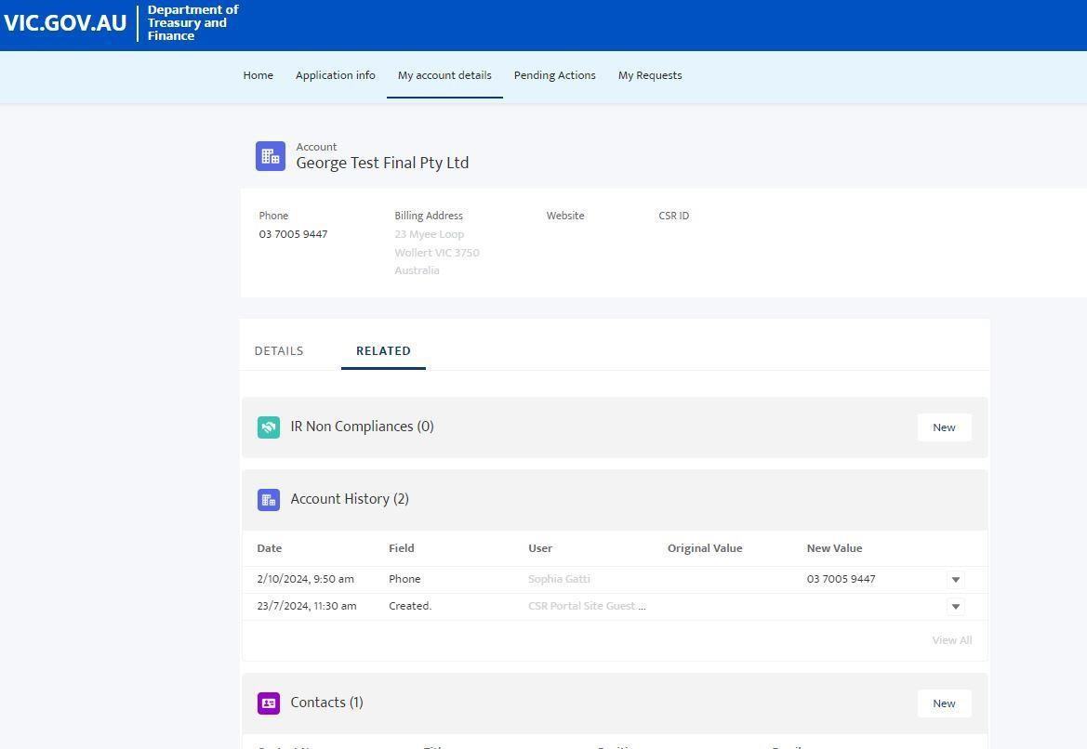

Step 2: Scroll down to FILES section → click “Add Files”
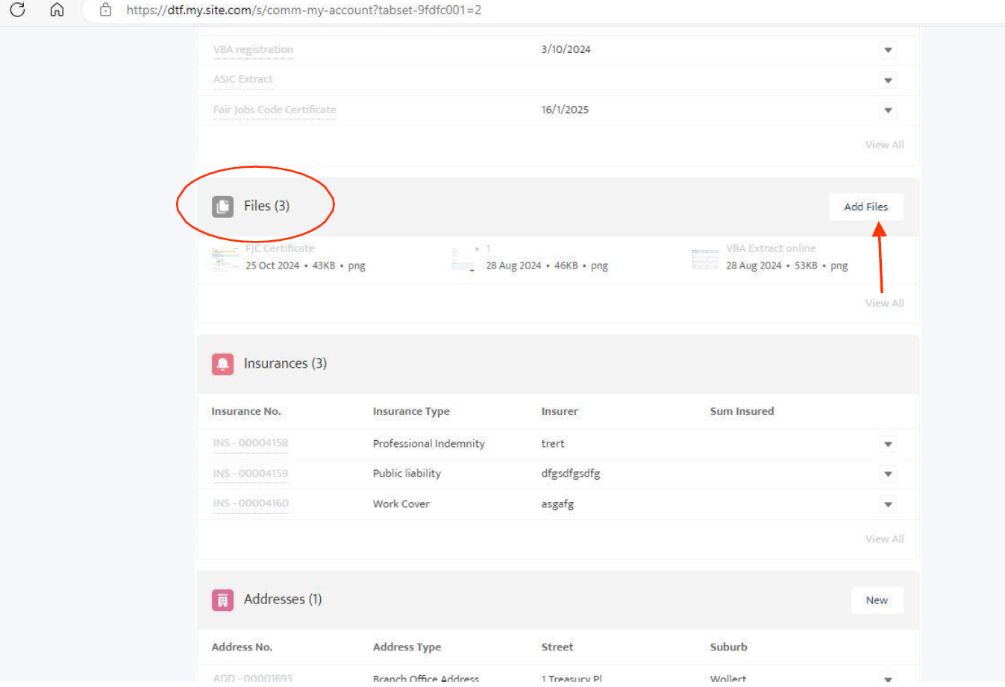

Step 3: Upload Files → that have been prepared and signed as per checklist provided
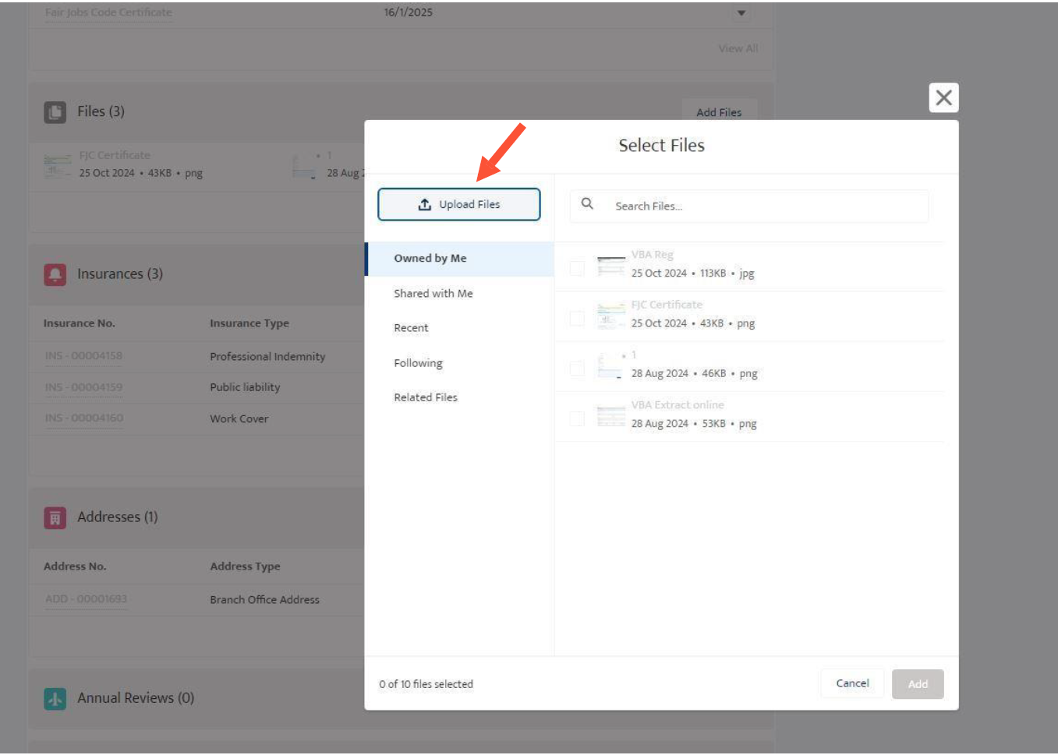

Section 3 - Sample Criterion 11 Declaration (OHS – Enforcement Activity)

Template 1 OHS Criterion 11 - Declaration of no Enforcement Activity
To be provided on company letterhead.
To Construction Supplier Register
This letter confirms that [Supplier Legal Name] has had no relevant inspectorate or regulatory activity, notices, or prosecutions as defined under Criterion 11 of the CSR Occupational Health and Safety requirements.
Signed:
[Director Name]
[Position]
[Date]
---------------------------------------------------------------------------------------------------------------------------------------------------
Template 2 OHS Criterion 11 - Declaration of Enforcement Activity
To Construction Supplier Register
This letter is provided in accordance with Criterion 11 of the Construction Supplier Register (CSR) Occupational Health and Safety (OHS) requirements.
This letter confirms that [Supplier Legal Name] has been subject to the following relevant inspectorate or regulatory activity as defined under Criterion 11:
- Regulatory authority: [e.g. WorkSafe Victoria]
- Type of activity: [e.g. Improvement Notice, Prohibition Notice, Infringement Notice, prosecution]
- Date(s) issued: [DD/MM/YYYY]
- Brief description of the matter:
[Short factual summary of the circumstances leading to the notice or action]
Where applicable, corrective actions taken by [Supplier Legal Name] include:
- [e.g. rectification of identified issues]
- [e.g. implementation of revised safety procedures]
- [e.g. completion of required training or audits]
Signed:
[Director Name]
[Position]
[Date]

OHS Criteria 11 definition

The supplier of Works’ response to enforcement activity, where there has been enforcement activity within the past 24 months or issues raised by any WorkSafe Victoria, Environment Protection Authority, Energy Safe Victoria or other relevant inspectorate and/or HSR including:
- prohibition notices;
- improvement notices;
- written directions;
- provisional improvement notices issued by a HSR;
- activities relating to an incident notified to WorkSafe Victoria under Part 5 of the Occupational Health and Safety Act 2004; and
- any prosecution commenced by WorkSafe Victoria or completed, within the period.

Where there has been enforcement activity, copies of relevant documents relating to the enforcement activity or issues raised including:
- WorkSafe Victoria or WorkSafe Victoria Entry Reports and notices;
- notices from other relevant bodies;
- HSR provisional improvement notices;
- summonses and particulars of charges or other documents detailing alleged offences;
- documents relating to outcome of prosecution; and
- provide documents showing the action taken by the supplier of Works to correct deficiencies identified in the notices or proceedings.

Template 3 “Construct only” letter

Dear Construction Supplier Register,
Subject: Construct Only
This letter serves to confirm that [Supplier Legal Name] is a “construct only” supplier and does not engage in any consulting or advisory services as part of our offerings. We do not hold Professional Indemnity (PI) insurance as we do not undertake any design responsibilities or enter into Design and Construct Contracts for government works in which we are engaged. Our scope of work is limited strictly to construction tasks under our engagement terms.
We trust this confirmation suffices for your requirements.
Thank you for your attention to this matter.
Signed:
[Director Name]
[Position]
[Date]

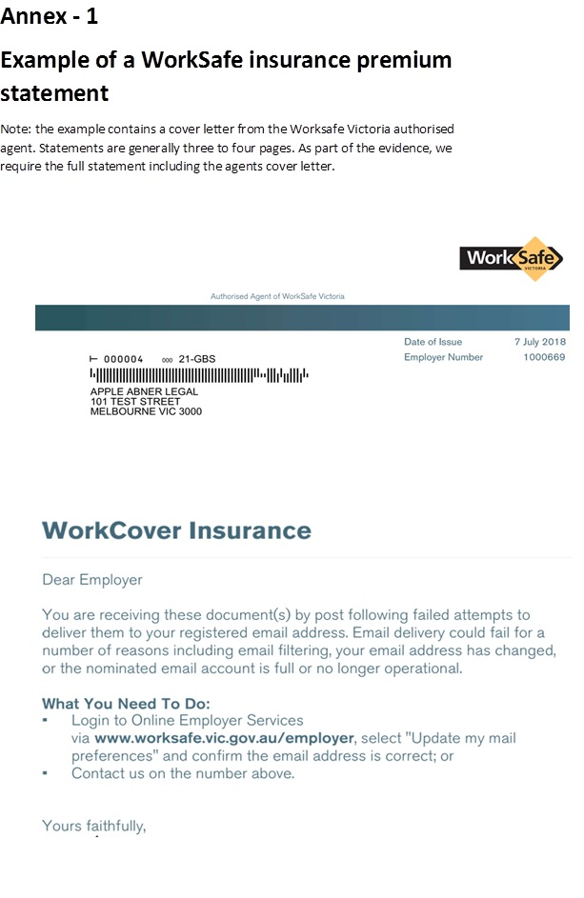

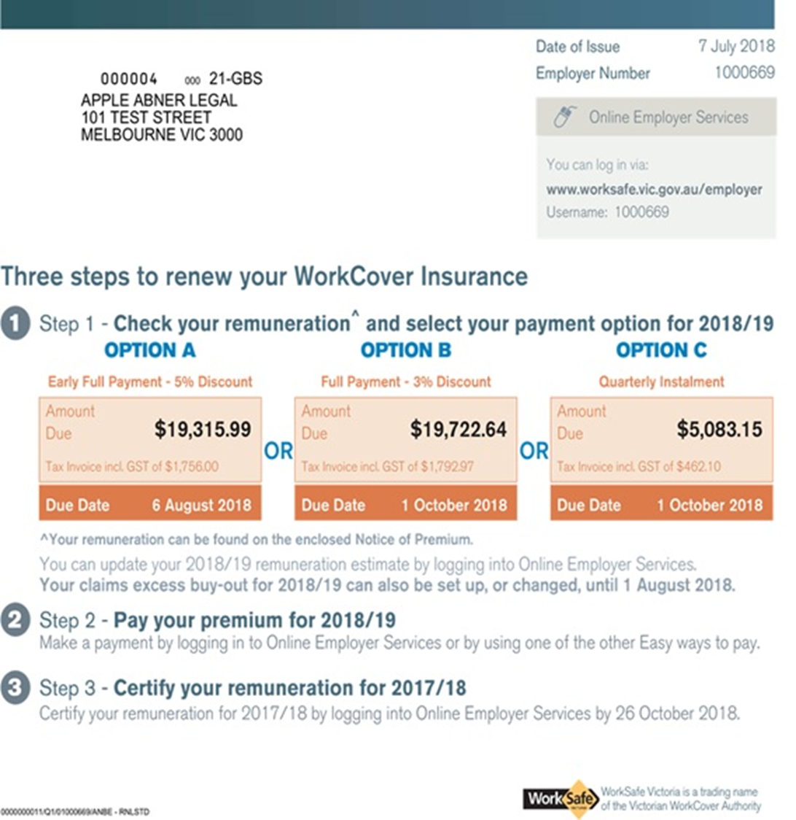

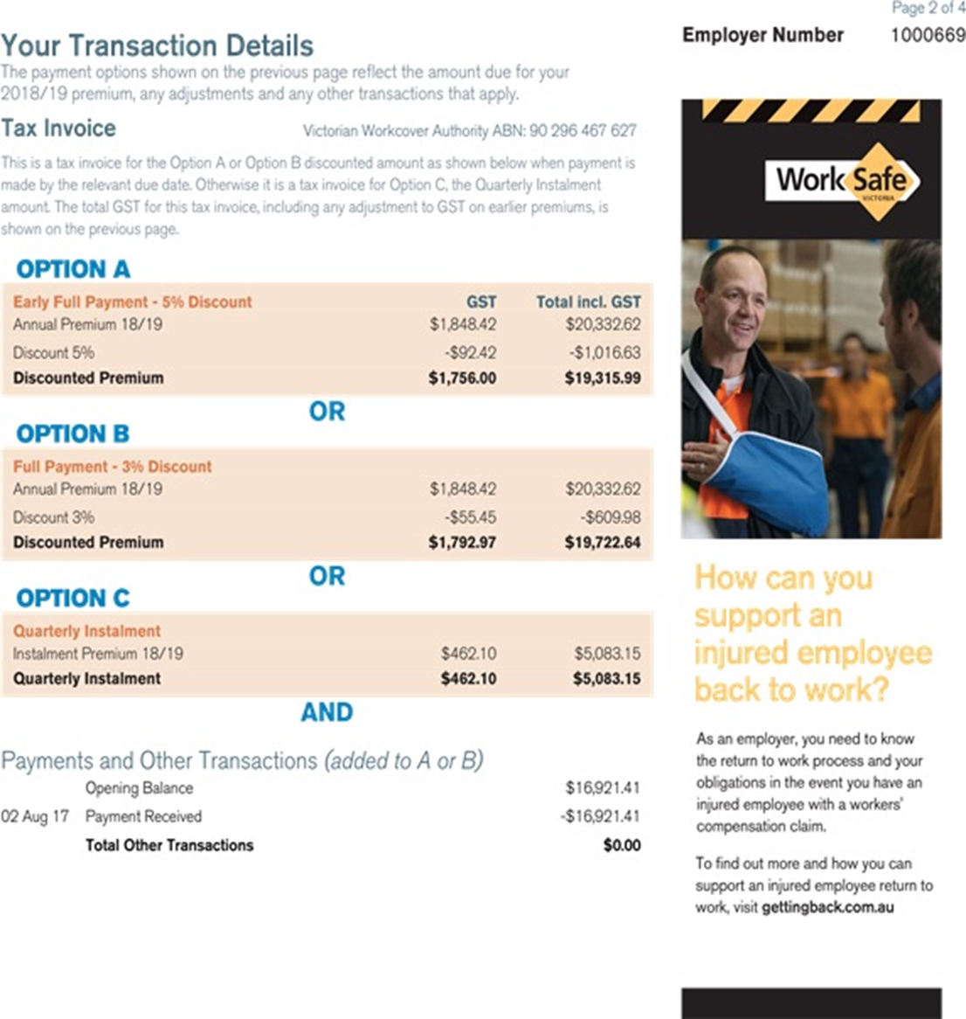

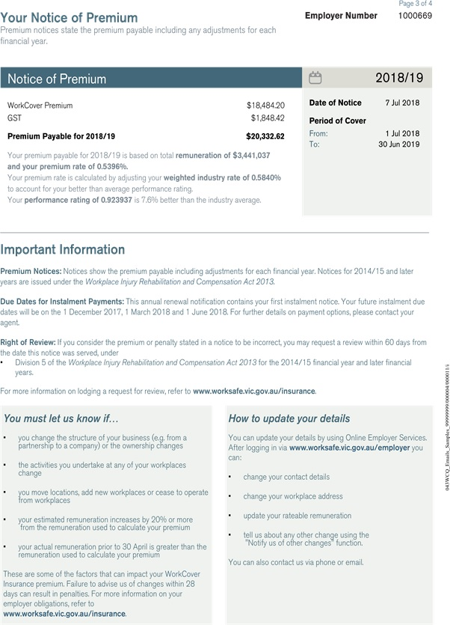

The copyright in this Master checklist is owned by the State of Victoria (Department of Treasury and Finance).
© State of Victoria 2025


You are free to re-use this New applicant checklist under a Creative Commons Attribution 4.0 licence, provided you credit the State of Victoria (Department of Treasury and Finance) as author, indicate if changes were made and comply with the other licence terms. The licence does not apply to any branding, including Government logos.
Copyright queries may be directed to IPpolicy@dtf.vic.gov.au

