Updated december 2025
Effective from 1 January 2026

The Resource Management Framework Part 1 of 2 – Main document
For Victorian Government departments and certain agencies

The Secretary
Department of Treasury and Finance
1 Treasury Place
Melbourne Victoria 3002
Australia
Telephone: +61 3 9651 5111
dtf.vic.gov.au

Authorised by the Victorian Government
1 Treasury Place, Melbourne, 3002

© State of Victoria 2025

You are free to re-use this work under a Creative Commons Attribution 4.0 licence, provided you credit the State of Victoria (Department of Treasury and Finance) as author, indicate if changes were made, and comply with the other licence terms. The licence does not apply to any branding, including Government logos.

Copyright queries may be directed to IPpolicy@dtf.vic.gov.au.

ISBN 978-1-925551-60-0 (PDF/online/MS word)
Published December 2025

If you would like to receive this publication in an accessible format, please email information@dtf.vic.gov.au.

This document is available in Word and PDF format at dtf.vic.gov.au

Contents
Introduction 1
Purpose 1
Legal status 1
Applying and complying with the RMF 2
Commencement, DTF role and currency 3
Structure 3
Changes to the RMF since the July 2025 published version 5
Part A: The Integrated Management Cycle 11
The legal and policy framework 14
1. Goal-setting and purpose 32
1.1 Specifying departmental objectives and objective indicators 33
1.1.1 Specifying departmental objectives 33
1.1.2 Specifying departmental objective indicators 33
1.1.3 Reviewing departmental objectives and indicators 33
1.1.4 Changes to departmental objectives and indicators 33
1.2 Specifying outputs and performance measures 36
1.2.1 Specifying outputs and performance measures 36
1.2.2 Reviewing outputs and performance measures 36
2. Planning 40
2.1 Long-term planning 42
2.1.1 Long-term planning 42
2.2 Medium-term planning 44
2.2.1 Timing and coverage for medium-term planning 44
2.2.2 Medium-term plan content 44
2.2.3 Publishing the medium-term plan 44
2.3 Department performance statements 46
2.3.1 Content required in department performance statements 46
2.3.2 Annual review of department performance statements 46
2.3.3 Performance measure footnote requirements 46
2.3.4 Approval 46
2.4 Short-term planning 50
3. Resource allocation – funding policies 51
3.1 The State budget 52
3.2 Funding outputs 53
3.2.1 Output investment proposals considerations 53
3.3 Varying the budgeted output funding mix 58
3.3.1 General requirements 58
3.3.2 Varying the levels of output funding between outputs 58
3.3.3 Varying the mix of outputs in excess of five per cent of revenue per output 59
3.4 Varying the output price 61
3.5 Funding assets 61
3.5.1 Asset investment proposals considerations 61
3.5.2 Order of funding for approved asset investments 62
3.5.3 Replacing assets 62
3.5.4 TEI changes 62
3.5.5 Ongoing reporting 62
3.6 High Value High Risk (HVHR) capital budgeting arrangements 66
3.6.1 Additional reporting requirements during project delivery 66
3.6.2 Graduated access to risk and contingency provisions 66
4. Resource allocation – legal mechanisms 69
4.1 Appropriation of certain revenue and asset proceeds – section 29 of the FMA 71
4.1.1 Commonwealth grants provided for specific purposes 71
4.1.2 User charges 72
4.1.3 Asset sales 72
4.2 Commonwealth grants – section 10 of the FMA 78
4.2.1 Conditions for accessing section 10 of the FMA 78
4.2.2 Managing requests under section 10 of the FMA 78
4.3 The Trust Fund and trust accounts 79
4.3.1 Creating a trust account 79
4.3.2 Reviewing trust accounts 79
4.3.3 Varying expenditure from trust accounts 79
4.3.4 Specific requirements for the Treasury Trust Fund 80
4.3.5 Closing trust accounts 80
4.4 Treasurer’s Advance for urgent and unforeseen claims 87
4.4.1 Managing requests for Treasurer’s Advance 87
4.4.2 Reporting on Treasurer’s Advance expenditure 87
4.4.3 Restrictions on Treasurer’s Advance 87
4.5 Central contingencies 91
4.5.1 Managing requests to access central contingencies 91
4.5.2 Reporting expenditure from central contingencies 91
4.5.3 Restrictions on central contingencies 91
4.6 Supplementation under section 35 of the FMA 93
4.6.1 Managing requests for supplementation under section 35 of the FMA 93
4.6.2 Reporting supplementation under section 35 of the FMA 93
4.7 Borrowing against future appropriation – section 28 of the FMA 96
4.7.1 Managing requests to borrow against future appropriation under section 28 of the FMA 96
4.7.2 Reporting on section 28 of the FMA expenditure 96
4.8 Transfers between items of departmental appropriation – section 30 of the FMA 99
4.8.1 Managing appropriation transfers under section 30 of the FMA 99
4.8.2 Reporting expenditure under section 30 of the FMA 99
4.9 Carryover of unused appropriation – section 32 of the FMA 100
4.9.1 Managing requests for carryover of appropriation 100
4.9.2 General carryover approval conditions and limits 101
4.9.3 Specific conditions for carryover for output appropriation 101
4.10 Access to previously appropriated amounts under section 33 of the FMA 104
4.10.1 Managing applications for previously appropriated amounts 104
4.10.2 Process and requirements for section 33 of the FMA 104
4.10.3 Reporting on expenditure under section 33 of the FMA 105
4.11 Public Account advances – section 37 of the FMA 107
4.11.1 Managing requests for Public Account advances under section 37 of the FMA 107
4.11.2 Reporting expenditure under section 37 of the FMA 107
4.12 Departmental surpluses 109
4.12.1 Application of departmental surpluses 109
4.13 Depreciation and depreciation equivalent 110
4.13.1 Use of depreciation equivalent for approved asset investment 110
4.13.2 Accessing depreciation equivalent before any ATNAB appropriation 110
4.13.3 Depreciation equivalent for asset revaluations 110
4.13.4 Depreciation equivalent for portfolio agencies 110
4.14 Long service leave (LSL) and long service leave equivalent 113
4.14.1 Valuation of balances of accumulated long service leave 113
4.14.2 Including estimated annual LSL expense in output costs 113
4.14.3 LSL equivalent 113
4.14.4 Transferring LSL balances between departments 113
4.14.5 Funding long service leave when LSL equivalent is exhausted 113
4.15 Funding of interest on service concession arrangements and leases (capitalised interest balances) 115
4.15.1 Recognising and accounting for capitalised interest balances 115
5. Accountability 118
5.1 Output performance report 121
5.1.1 Frequency and timing of the output performance report 121
5.1.2 Requirements for the output performance report to support the revenue certification claim invoice 121
5.1.3 Other information requirements for the output performance report 121
5.2 Asset investment report 123
5.2.1 Frequency and timing of the asset investment report 123
5.2.2 Submitting quarterly asset phasings 123
5.2.3 Reporting on each asset project 123
5.2.4 Asset investment report 123
5.3 Revenue certification 125
5.3.1 Requirements for the revenue certification claim invoice 125
5.3.2 Treatment of appropriation revenue 125
5.3.3 Certification of funding for depreciation (depreciation equivalent revenue) 125
5.4 Financial monthly reporting 128
5.4.1 Monthly feed requirements 128
5.4.2 Other requirements 128
5.5 Cash flow forecasting 129
5.5.1 Daily forecasting requirements for funds held in the Public Account 129
5.5.2 Monthly forecasting requirements for funds held in the Public Account 129
5.5.3 Other forecasting requirements 129
5.6 Cash management and reconciliation 130
5.6.1 Monthly cash transaction reconciliation requirements 130
5.7 Establishment or abolition of certain entities – section 8B of the FMA 133
5.7.1 Establishment or abolition of an entity requirements 133
6. Evaluation 135
6.1 Evaluating lapsing programs 137
6.1.1 Evaluating lapsing programs seeking continued funding 137
6.1.2 Questions to address in the evaluation of lapsing programs 138
6.1.3 Budget submissions requesting continued funding from completed evaluations 138
6.2 Funding reviews 142
6.3 Process for the creation of the fourth-year estimates in the State Resource Information Management System (rollover) 143
Part B: Other budget policies and the accounting framework supporting budget management 145
7. Other budget policies 145
7.1 Hypothecation arrangements 145
7.1.1 Instructions on hypothecation arrangements 145
7.1.2 Criteria for the consideration of hypothecation arrangements 145
7.2 Payments on behalf of the State (POBOS) appropriation 147
7.2.1 Managing requests for POBOS appropriation 147
7.2.2 Reporting on POBOS expenditure 147
7.3 Annual leave 148
7.3.1 Transfer of annual leave between departments 148
7.4 Redundancy payments 149
7.4.1 Treatment of separation packages (encompassing Voluntary Departure Packages (VDPs) and Targeted Separation Packages (TSPs)) 149
7.4.2 Treatment of significantly large redundancy programs 149
7.4.3 Treatment of related long service leave payouts on separation packages (including VDPs and TSPs) 149
8. The accounting framework supporting budget management 150
8.1 The State Administration Unit 150
8.2 The SAU inter-entity account dissection 153
8.2.1 SAU inter-entity account dissection requirements and time frames 153
8.2.2 Specific end of year requirements 153
8.2.3 Machinery of government changes requirements 153
8.2.4 Resolution of issues 153
8.3 Policy and non-policy journal entries in SRIMS 155
8.4 The Victorian Government Chart of Accounts 157
8.5 Contributed capital 159
8.5.1 Contributed capital reconciliation requirements and time frames – actuals 159
8.5.2 Contributed capital journal entry reconciliation requirements – estimates 159

Introduction

Purpose
The Resource Management Framework (RMF) is a governance and operational framework for public sector accountability for the investment of public resources.
The RMF helps Victorian Government departments to understand and apply the legal and policy framework that underpins resource management, budgeting and reporting processes.
The RMF includes mandatory requirements, supplementary requirements and guidance for departments on specific topics.

Legal status
The RMF is issued by the Deputy Secretary, Budget and Finance Division at the Department of Treasury and Finance (DTF). The RMF is mandated for departments by direction of the Minister for Finance in the Standing Directions 2018 under the Financial Management Act 1994 (Standing Directions). Under Standing Direction 4.3, the RMF is mandated for portfolio departments, but specific provisions of the RMF can also be mandated for other agencies, to the extent stated in the RMF.
This means that the RMF is not mandatory for an agency that is not a portfolio department, unless there is a provision of the RMF that states explicitly that it is mandatory for such an agency.
The provision of this edition of the RMF that is mandatory for other agencies as well as portfolio departments is Section 2.3 ‘Department Performance Statements’. This provision is mandatory for all entities with separate appropriations in annual Appropriation Bills, i.e. all portfolio departments, Court Services Victoria (CSV) and the integrity agencies listed below:
- The Victorian Auditor-General’s Office (VAGO)
- The Office of the Ombudsman
- The Independent Broad-based Anti-corruption Commission (IBAC)
- The Victorian Inspectorate.
Figure 1 illustrates how the RMF fits into the broader financial management framework for Victorian public sector agencies.
Figure 1: The Resource Management Framework within Victoria's Financial Management Framework
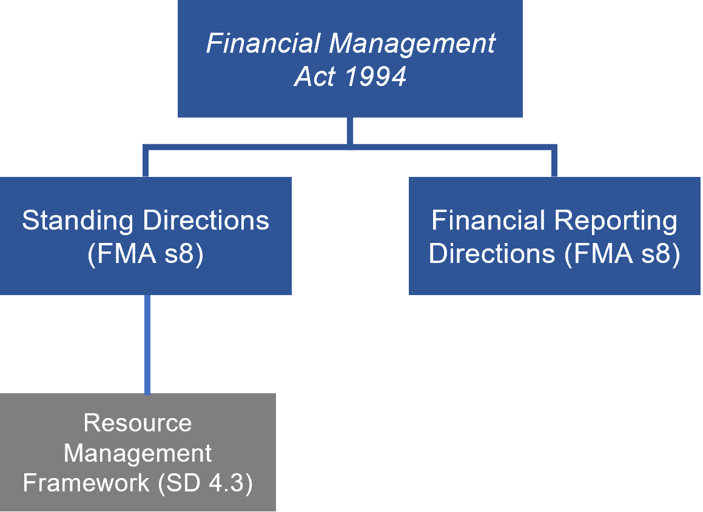

Applying and complying with the RMF
As stated earlier, the RMF is mandatory for all portfolio departments and for other agencies where specifically stated. Where service delivery is done by another agency on behalf of an agency to which section 2.3 of the RMF applies, the agency for which section 2.3 is mandatory must include that service delivery within its RMF obligations. For example, where a department has a lapsing program being delivered on its behalf by a portfolio agency, the department must ensure it applies the requirements of section 6.1: Evaluating lapsing programs.
The Financial Management Act 1994 (FMA) requires departments and Victorian public sector agencies to comply with financial management requirements.
While the Standing Directions only mandate that the RMF applies to departments and other agencies specified by the RMF, other agencies subject to aspects of the FMA (and hence also aspects of the Standing Directions and Instructions) are expected to comply with the RMF’s related requirements as far as is practicable. For example, an agency that has monthly reporting obligations should comply with section 5.4: Financial monthly reporting.
The Accountable Officer of each department must ensure the RMF is applied by complying with the mandatory requirements.
The Accountable Officer may delegate implementation of certain RMF requirements to departmental officers (unless otherwise instructed in the requirement). However, departments should note that ultimate accountability for any delegated requirements still remain with the Accountable Officer.
Departments and specified agencies are subject to the compliance requirements of the Standing Directions regarding the RMF. This includes public attestation of compliance in annual reports. Refer to Standing Directions 4.1 and 5.1 for more information.
Under the Standing Directions 2018, Standing Direction 5.1.4(b) provides that compliance attestation must relate to compliance for the entire period of the relevant financial year. Section 8B of the FMA is a new legislative requirement that took effect in August 2025 and is now reflected in RMF Section 5.7. In addition, two mandatory requirements relating to current practice in funding assets have been formalised in RMF 3.5.4 and 3.5.5. An additional requirement is inserted to RMF 6.1.1(c) lapsing programs under $20 million funded through the Early Intervention Investment Framework (EIIF).
For the 2025-26 financial year, compliance with these new requirements will be assessed and attested to as at 30 June 2026, rather than for the entire reporting year. Notwithstanding this compliance attestation transition adjustment, departments are expected to take all reasonable steps to achieve compliance with these new requirements as soon as practicable.
It is expected that agencies using public resources should manage and account for those resources transparently, consistently with stated government policies, and, as far as possible, consistently with other agencies.
The RMF should be read in conjunction with the FMA, the Standing Directions, Financial Reporting Directions, and any DTF Information Requests issued, where relevant.
Other agencies are not bound by the RMF but may voluntarily adopt it where relevant.

Commencement, DTF role and currency
This RMF is effective from 1 January 2026.
DTF manages and implements the RMF on behalf of the Deputy Secretary, Budget and Finance Division. If you have any questions or would like to provide feedback on the RMF please email financial.frameworks@dtf.vic.gov.au.
The RMF may be amended and reissued from time to time. Departmental Chief Finance Officers (CFOs) will be notified by DTF of any new releases of the RMF. When notified, it is expected that department CFOs (or their delegates) liaise with their portfolio agencies regarding any relevant changes to the RMF. Please also check the DTF website to ensure you are working with the latest version.

Structure
The RMF comprises two documents – a ‘main’ document (this document) and an ‘attachments’ document. The ‘attachments’ document can be accessed via the DTF website.
The main RMF document incorporates two parts:
- Part A: The Integrated Management Cycle
- Part B: Other budget policies and the accounting framework supporting budget management.
The chapters within the RMF have three components:
- Mandatory requirements that require attestation by the Accountable Officer
- Supplementary requirements (in selected sections) that do not require attestation
- Guidance.
The sections are presented as follows:
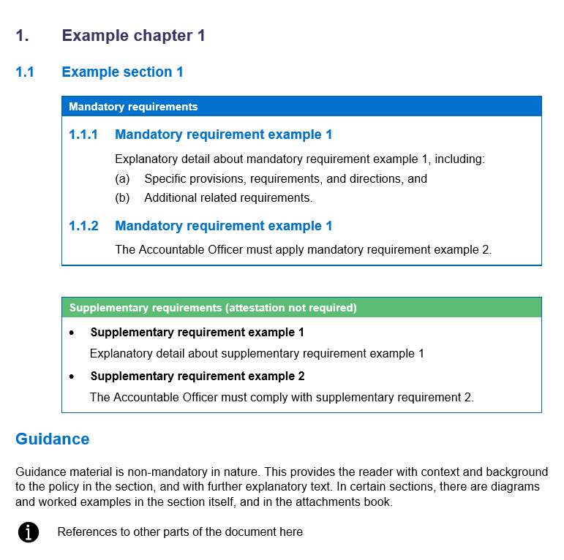

Changes to the RMF since the July 2025 published version
This version of the RMF includes both policy updates and minor clarifications, as outlined below:
Table A: Policy changes following the amendments to the FMA*
Section | Topic | Nature of revisions
Section 5.7 | Establishment or abolition of certain entities – section 8B of the FMA | Insertion of new mandatory requirements and guidance to incorporate the new FMA provisions under section 8B of the FMA.
Attachment 16 | Guidance for establishment or abolition of certain entities – section 8B of the FMA | Insertion of a new attachment that includes detailed information on the context, processes and requirements of section 5.7, including a sample letter and case scenarios to assist agencies in meeting compliance obligations. (Refer to RMF Part 2 of 2 – Attachments).
Multiple sections | Removal of references to warrants | Deletion of references to warrants across the whole document
Section 4.10 | Access to previously appropriated amounts under section 33 | Insertion of guidance to clarify process with the removal of warrants and the impact of funding draw down to operating result.
* DTF is in the process of testing the remaining financial management reform policies and adjusting the settings as they are implemented. These additional policy updates will further align the RMF with the Financial Management Legislation Amendment Act 2025 (Financial Management Reform) and will be embedded in the RMF once the initial rollout has been evaluated. Further work is also underway to refine the guidance for policies that are impacted by the removal of warrants, which will be reflected in the future iterations of the RMF.
Table B: Other changes to the RMF
Section | Topic | Nature of revisions
Introduction | Applying and complying with the RMF | Insertion of information on the adjusted compliance attestation period relating to the new mandatory requirements for Establishment or abolition of certain entities – section 8B of the FMA and Funding assets
Table 1 | Definitions | Insertion of definition of total estimated investment (TEI)
Section 3.5 | Funding assets | Insertion of mandatory requirement 3.5.4 to include TEI changes approval requirement and mandatory requirement 3.5.5 to include ongoing reporting of asset investment program.
Sections 4.4, 4.5 and 4.6 | Treasurer’s Advance | Insertion of additional guidance to clarify the funding use of Treasurer’s Advance (TA) and how TA information is reported publicly.
Section 6.1 | Evaluating lapsing programs | Insertion of mandatory requirement 6.1.1(c)(ii) for lapsing programs under $20 million funded through the Early Intervention Investment Framework (EIIF).
Section 6.3 | Process for creation of the fourth-year estimates in the State Resource Information Management System (rollover) | Insertion of additional guidance for considerations in creating rollover year.

Definitions
Note: The definitions in the FMA and the Standing Directions 2018 under the FMA also apply to this document.
Table 1: Definitions
Term | Definition
Additions to the Net Assets Base (ATNAB) | An appropriation that provides for an increase in the assets of a department’s statement of financial position.
Administered item | Generally refers to a department not having the capacity to benefit from that item in the pursuit of the entity’s objectives or to deny or regulate the access of others to that benefit.
Appropriation | An authority given by an Act of Parliament to draw certain sums out of the Consolidated Fund, now or at some future point in time, for the purposes stated, up to the limit (if any) of the amount in the particular Act.
Carryover | Occurs where an annual appropriation amount for the previous year was not fully applied and where the Treasurer has approved the application of the remaining amount in the next financial year, under section 32 of the FMA. Special or standing appropriations are not impacted by the carryover provisions.
Competitive neutrality | Involves achieving a fair market environment by removing or offsetting any competitive advantages or disadvantages due to public ownership of the government business.
Consolidated Fund | The Government’s primary financial account, established by the FMA, that receives all Consolidated Revenue under the Constitution Act 1975 and other moneys as defined in section 9 of the FMA.
Contributed capital | The recognition and reporting of the investment by the State in departments and their portfolio agencies, as reflected in a department’s financial statements.
Controlled item | Generally refers to the capacity of a department to benefit from that item in the pursuit of its objectives and to deny or regulate the access of others to that benefit.
Department | A department existing by virtue of an order made under section 10 of the Public Administration Act 2004.
Departmental objectives | A department’s contribution to the Government’s aspirations for the State of Victoria. They reflect the effects or impacts that Government, through departments, seeks to have on the community and other key stakeholders. They are usually set with a medium to long term (i.e. four years or more) timeframe. The departmental objectives describe the department’s contribution to Government objectives.
Departmental objective indicators | A piece of data that demonstrates progress towards the achievement of a department’s objectives, and how they have impacted the Government’s agenda over the medium to long term. Indicators provide evidence to support measurement and management of performance.
Depreciation | The systematic allocation of the cost or fair value of an asset over its useful life.
Depreciation equivalent asset investment funding | The quantum of funds equal to actual depreciation expense, which is included in a department’s output revenue and is reserved for asset investment in its portfolio.
Equity investment in controlled agencies | Refers to the Government’s equity investment in a department and other controlled agencies of the State, in its capacity as owner (See Contributed Capital definition).
Financial Management Act 1994 (FMA) | One of the key pieces of legislation underpinning the financial management framework of Victoria. The purposes of this Act are:  - to improve financial administration of the public sector  - to make better provision for the accountability of the public sector  - to provide for annual reporting to the Parliament by departments and public sector agencies.
Gender impact assessment | An assessment of the effects that a policy, program or service may have on persons of different genders; and states how the policy, program or service will be developed or varied in order to either:  - promote gender equality  - address gender inequality, or  - meet the needs of persons of different genders.  A gender impact assessment should take into consideration gender and, if practicable, intersectional analysis.  Defined in section 9 of the Gender Equality Act 2020.
High-Value-High-Risk (HVHR) projects | A budget-funded asset project that is determined by government to be either:  - high risk using DTF’s risk assessment tool, the Project Profile Model (PPM)  - medium risk using the PPM with a total estimated investment (TEI) cost between $100 million and $250 million  - low risk using the PPM with a TEI over $250 million  - otherwise identified by government as warranting the additional rigour for HVHR projects.
Intersectional analysis | Analysis of policy or decision making which takes into account that gender inequality, and other forms of inequality, may be compounded by disadvantage or discrimination that a person or group of people may experience on the basis of any of the following:  - Aboriginality  - Age  - Disability  - Ethnicity  - Gender identity  - Race  - Religion  - Sexual orientation.  This approach is aligned with subsection 9(2)(c) of the Gender Equality Act 2020.  Further resources are available from the Commission for Gender Equality in the Public Sector: https://www.genderequalitycommission.vic.gov.au/applying-intersectionality
Lease | A contract, or part of a contract, that conveys the right to use an asset (the underlying asset) for a period of time (lease term) in exchange for consideration.
Long service leave equivalent | The quantum of funds equal to actual long service leave expense, which is included in a department’s output revenue and is reserved for paying out long service leave entitlements drawn down by employees.
Long service leave expense | A non-cash cost that recognises long service leave accrued by employees during the reporting period.
National Partnership payments (NPs) | A type of Commonwealth grant for a specific purpose (i.e. paid by the Commonwealth to support the delivery of specific projects, facilitate reforms, or reward jurisdictions that deliver on nationally significant reforms). See also Specific Purpose Payments (SPPs) definition.
Outputs | The final products, or goods and services produced or delivered by, or on behalf of, a department or public agency to external customers/recipients. Outputs include products and services delivered to the community (e.g. education, health services), or products and services provided to other departments (e.g. services provided by the Victorian Public Sector Commission to support the public sector).
Output price | The amount the Government agrees to pay for the provision of an output with specified attributes.
Payments on behalf of the State (POBOS) | An appropriation that provides for payments to be made on behalf of the State. The department making the payment has no direct control with respect to the quantity of outputs delivered.
Probability (P-) values –  P50, P60, P90 costs | P-values are assigned to projects to indicate the likelihood of the occurrence of that total project cost. For example, a P50 cost is the project cost with sufficient contingency to provide 50 per cent likelihood that this cost would not be exceeded. A P90 cost is the project cost with sufficient contingency to provide 90 per cent likelihood that this cost would not be exceeded.
Provision for long service leave | An obligation (liability) of a department to its employees for accrued outstanding long service leave.
Provision of outputs | Delivery of goods or services by or on behalf of an authority or public agency.
Public Account | The Government’s principal bank account. All cash transactions relating to the Consolidated Fund, the Trust Fund and Advances under sections 36 and 37 of the FMA are processed through the Public Account.
Revenue certification | The process where a department submits an invoice to support the appropriation revenue provided for outputs delivered and asset funding provided.
Right-of-use asset | An asset that represents a lessee’s right to use an underlying asset for the lease term.
Rollover | The process of creating a new estimate year to the end of the last existing estimates year.
Service concession asset (including an intangible asset) | An asset (other than goodwill) to which the operator has the right of access to provide public services on behalf of the grantor (e.g. the State, a department or an agency) in a service concession arrangement that either:  - the operator constructs, develops, upgrades or replaces major components, or acquires from a third party or is an existing asset of the operator  - is an existing asset of the grantor, including a previously unrecognised identifiable intangible asset and land under roads, or an upgrade to or replacement of a major component of an existing asset of the grantor.
Special (or Standing) Appropriations | Used for ongoing payments that need to be made independently of the Government’s annual budget priorities. Special appropriations represent a standing authority and do not lapse each year as annual appropriations do but remain in force until amended or repealed by Parliament.
Specific Purpose Payments (SPPs) | A type of Commonwealth grant for a specific purpose. National Specific Purpose Payments (National SPPs) are paid annually by the Commonwealth in key service delivery sectors. See also National Partnership payments (NPs).
State Administration Unit (SAU) | The SAU serves two primary functions:  - as a mechanism for recording transaction flows and balances in the Public Account  - a means of capturing certain relationships and balances between the Government (with DTF as the ‘corporate head office’) and departments (such as Contributed Capital balances).
State Resource Information Management System (SRIMS) | SRIMS is the State’s central ledger, which supports DTF in its ‘head office’ role in being able to provide the Government with financial and performance information from departments and agencies to support whole of government decision making and accountability obligations.
Surplus/deficit | Arises when the operating revenue generated by a department is greater/less than the department’s operating expenses for a particular accounting period. This is also known as the net result from transactions (net operating balance).
Temporary Advance | An advance provided by the Treasurer under section 35 of the FMA to a Minister to enable them to meet urgent claims in the current budget year before parliamentary sanction is obtained.
Total estimated investment (TEI) | The amount of capital expenditure required to complete asset works, which excludes any associated operating costs such as maintenance expenses and finance lease costs.
Treasurer’s Advance | An annual appropriation to the Treasurer to meet urgent expenditure claims that were unforeseen at the time of the Budget. Amounts advanced under this authority are reported to and sanctioned by the Parliament in a subsequent year’s annual Appropriation Bill.
Trust accounts | Separate accounts in the Trust Fund, which contain moneys set aside for specific purposes. The specific purpose for the establishment of each trust account is defined by the Minister, pursuant to sections 19 or 23 of the FMA, or is contained in a separate statute.
Trust Fund | Forms part of the State's Public Account, along with the Consolidated Fund. The Trust Fund encompasses a number of specific purpose accounts for funds that are not subject to parliamentary appropriation.
User charges | Receipts that satisfy the following criteria:  - the receipt originates from payments made voluntarily for goods and services provided, and the payments made  - the benefits gained by the user can be clearly linked to the cost of providing the products and services.
Working accounts | A trust account facility (under section 23 of the FMA) designed to provide departments with direct access to user charge receipts for those activities conducted on a cost recovery or commercial basis separately from core departmental operations.

Part A: The Integrated Management Cycle
Figure 2: The Integrated Management Cycle
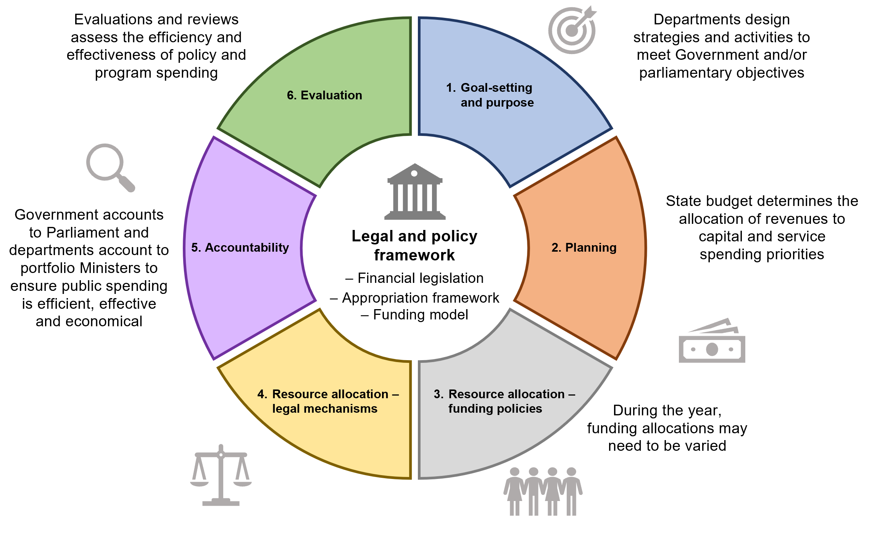
The Integrated Management Cycle (IMC) is a process cycle that summarises the main phases of the goal setting, planning and allocation of resources by the Government and departments, and the accountability and review associated with the use of those resources.
The six phases of the IMC are:
- Goal-setting and purpose
- Planning
- Resource allocation – funding policies
- Resource allocation – legal mechanisms
- Accountability
- Evaluation.
Underpinning the IMC is a legal and policy framework that supports financial management in Victoria.

Roles and responsibilities
The IMC operates effectively when each of the areas of government and the VPS plays their role. Roles and responsibilities are explained below.

Treasurer
The Treasurer is responsible for tabling the annual State budget, which includes department performance statements and the Appropriation Bill. The Treasurer also applies the amount of appropriation that the Minister for Finance certifies for each department as part of the revenue certification process at the end of each financial year.

Minister for Finance
The Minister for Finance is responsible for performance management from a whole of government perspective and plays a number of roles in the IMC and the related activities of departments, including:
- specifying the minimum requirements for performance management
- on behalf of the Government, reaching final agreement with relevant Ministers on their department performance statements, including departmental objectives, indicators, outputs and performance measures
- specifying reporting requirements for the annual report of operations, including reporting performance
- the annual revenue certification process.

Portfolio Ministers
Portfolio Ministers ensure their respective portfolios contribute to the achievement of government objectives and priorities by approving portfolio-specific content in the department performance statement in the budget papers. Portfolio Ministers then report performance against these statements in departmental annual reports (including the report of operations).
Portfolio Ministers are responsible for the performance of their portfolios.

Parliament
Parliament holds executive government to account for its overall performance and plays a crucial role in authorising the annual Appropriation Bill following the annual budget.
In particular, the parliamentary committee system provides a way of achieving greater public input into issues being considered by the Parliament.
To strengthen accountability and transparency for performance management, the Public Accounts and Estimates Committee (PAEC), at the invitation of the Minister for Finance, reviews output performance measures that departments propose to discontinue or substantially change through the annual budget process.

Departmental Secretaries (Accountable Officer)
Departmental Secretaries support Portfolio Ministers in achieving the Government’s objectives and priorities (including oversight of departments and departmental portfolio public agencies). This is done through performance management activities, such as approving departmental plans, delivering outputs to the agreed performance standards, and supporting Portfolio Ministers to develop the department performance statement, medium-term plan and annual report.

Departmental Chief Finance Officers
Departmental Chief Finance Officers (CFOs) support the Accountable Officer with oversight for financial management, performance and sustainability of the department’s portfolio and the State. They provide strategic advice and options to support informed decision-making and organisation strategy concerning the department. They also have a responsibility to ensure any funding requests impacting the department and its agencies, where practicable, are cost-accurate, and meet the operational needs of the department and its portfolio.

Portfolio departments (departments)
Departments support their Secretary and Portfolio Ministers in achieving the Government’s objectives and priorities. This is done through appropriate performance management activities, such as portfolio planning, delivering outputs to the agreed performance standards and preparing annual reports.

Public agencies
Public agencies determine and undertake appropriate performance management activities, deliver services in line with plans and the body’s powers and functions, and prepare the annual report. Where the requirements of the RMF are inconsistent with requirements in an agency’s establishing legislation, the latter takes precedence to the extent of the inconsistency.

Department of Treasury and Finance
The Department of Treasury and Finance (DTF) provides support to the Minister for Finance in the agreement and publication of the department performance statements in the budget papers. This includes reviewing the relevance of output measures, departmental objectives and indicators. DTF also provides advice to the Minister for Finance on the quality of departmental objectives, indicators, outputs and measures published in department performance statements.
DTF does not determine the content of final department performance statements. The department performance statement is an agreement between the Minister for Finance (on behalf of Government) and the relevant Portfolio Minister, based on their respective departments’ advice.
DTF also reviews departmental output performance and provides analysis to the Government on key areas of service delivery that constitute performance risks for government and recommends how to address these performance issues. As part of this assessment, DTF provides advice on revenue certification to the Minister for Finance and the Treasurer.
DTF supports the Minister for Finance in the ongoing management of the RMF through consultation with key stakeholders.

The legal and policy framework
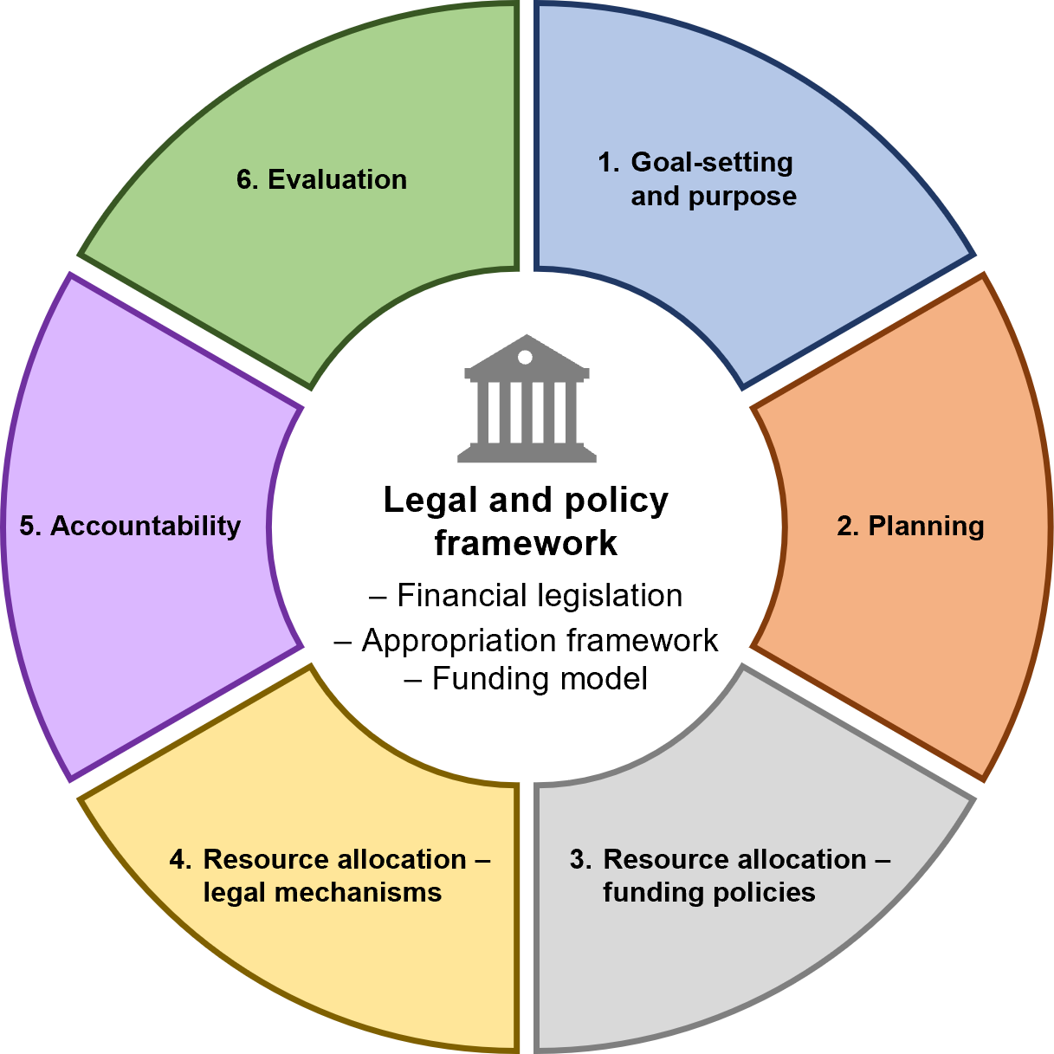

Overview
The IMC is underpinned by a legal and policy framework.

Legal context for the collection and appropriation of public moneys
Governments collect and spend public money to provide essential goods and services to the community. To undertake this process, legal authority is required from Parliament.
The Constitution Act 1975 (the Constitution), together with other legislation, establishes a framework for the collection of public money (revenue), the prudent management of finances, and the spending of public money (expenditure).
The Government collects revenue through taxes, fees for services, sales of assets, and other receipts (e.g. Commonwealth goods and services tax grants). The Constitution and the FMA (section 9(2)) prescribe that generally all such revenue must first go into the Consolidated Fund. The primary exceptions to this are:
- revenue earned by entities who are authorised by law to raise, retain and spend their own funds
- revenue which is required by law to be paid into an account other than the Consolidated Fund.
Section 92 of the Constitution provides the power for Parliament to appropriate revenues from the Consolidated Fund. This revenue may be appropriated to specific purposes as legislated by Parliament.
Parliament may only appropriate public money on the initiative of the Government. In particular, the Constitution:
- requires that any money Bill be preceded by a message from the Governor
- requires that an annual Appropriation Bill deals only with appropriation
- permits the Consolidated Fund to be drawn.

Financial management legislation
While the Constitution provides broad powers for government to use public money, there are laws that govern the use of that money, and the accountability processes government is obliged to satisfy. For public money to be spent for any purpose, there must be lawful authority to spend it for that purpose.
The three principal pieces of legislation that underpin Victoria’s resource management frameworks are the:
- Financial Management Act 1994
- Audit Act 1994
- annual Appropriation Acts.
Figure 3: Interaction of financial and other legislation.
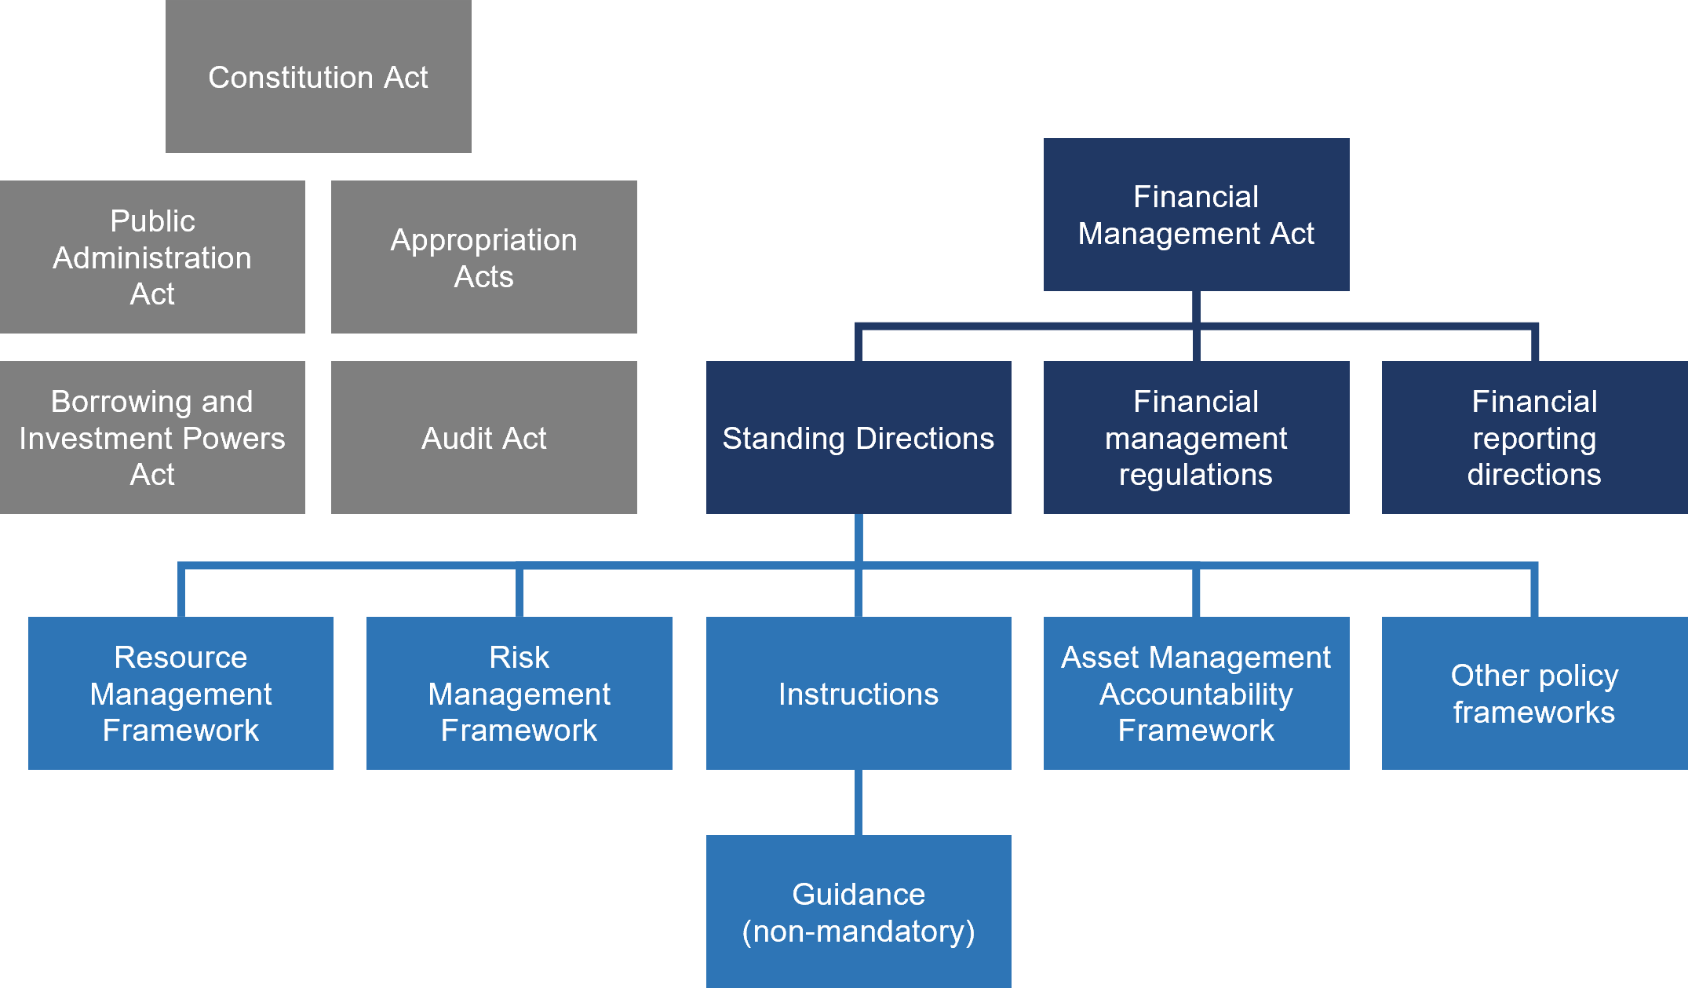

Financial Management Act 1994
The Financial Management Act 1994 (FMA) underpins Victoria’s financial management framework. It provides for the use of public money, the accountability processes and subordinate legislation that departments and agencies must comply with.
Its key elements:
- relate to the financial administration of money coming into the hands of the Government
- prescribe the collection, management and expenditure of, and the subsequent accounting and reporting to the Parliament for money, public property and other property
- establish and define the scope of the Public Account, including the Consolidated Fund and the Trust Fund
- include financial responsibility and budget management provisions.
Section 40 of the FMA relates to the Government’s commitment to output management by providing that a separate statement must accompany the annual Appropriation Bills, detailing:
- the goods and services produced or provided by each department
- a description of the funds available to each department during the period
- the estimated receipts of the department
- such other information as the Minister determines.
These requirements are met through the content of the annual budget papers, in particular Budget Paper No. 3 Service Delivery (BP3) and Budget Paper No. 5 Statement of Finances (BP5).

Audit Act 1994
The Victorian Auditor-General is an independent officer of the Victorian Parliament, appointed under the Constitution to conduct and report on financial and performance audits in the Victorian public sector.
The Audit Act 1994 governs the powers and functions of the Victorian Auditor-General. The Act establishes the legal framework governing the ongoing role and functions of the Auditor-General. This Act identifies the statutory powers and responsibilities of the Victorian Auditor-General. It provides the authority for the Victorian Auditor-General to:
- conduct annual financial statement audits of public sector agencies
- review and report on the estimated financial statements
- undertake performance audits in the public sector, which encompass assessments of the economy, efficiency and effectiveness of the management of public resources by the Government or individual government agencies
- examine the use of public grants received by both private and public sector organisations
- determine the efficiency, effectiveness and economy of the services or functions that are delivered through contracts with private or not-for-profit providers (associated entities) through 'follow-the-dollar’ performance audits.

Annual Appropriation Acts
An appropriation is an authority given by the Parliament to draw certain sums out of the Consolidated Fund, now or at some future time, for the purposes stated, up to the limit of the amount in the particular Act. It authorises the Government to use money from the Consolidated Fund, but it also restricts the expenditure to the particular purpose specified by the appropriation. No money may be drawn from the Consolidated Fund unless there is an appropriation authorising the drawing.
The annual Appropriation Act:
- provides the Treasurer with the authority to commit money from the Consolidated Fund, up to a specified amount
- sets out how much of that specified amount may be applied to each appropriation-funded entity and the purpose(s) for which that funding is provided.

Other legislation
The Public Administration Act 2004 and the Borrowing and Investment Powers Act 1987 support the financial management framework.

Public Administration Act 2004
The Public Administration Act 2004 (PAA) reflects the Government’s objective that the fundamental role of the public service is to serve the public interest. The PAA demonstrates the Government’s commitment to:
- sustain an effective and impartial public service
- protect public employment from politicisation by reaffirming and promoting the principles of merit and equity
- promote the highest standards of public service conduct and integrity thereby strengthening public confidence and trust in government
- drive improvements in the integrated delivery of government services
- promote career opportunities in the public sector by ensuring a more coherent approach to workforce management and professional development
- ensure the public sector workforce is capable of delivering high-quality services to the Victorian community, both now and into the future
- promote standards of good governance in public agencies
- clarify the accountability relationship of public agencies to a responsible Minister who, in turn, is accountable to Parliament.

Borrowing and Investment Powers Act 1987
The Borrowings and Investment Powers Act 1987 provides statutory authorities with the power to borrow and invest in a wide range of financial products, and to access the financial arrangements required to effectively manage their debt and investment portfolios.

Victoria’s appropriation framework
Financial management is concerned with the sourcing, distributing and management of public money, to ensure funds are used appropriately and efficiently. Effective financial management allows for the continued delivery of public goods and services.
Figure 4 illustrates Victoria’s appropriation framework, which ensures accountability and transparency of how public money is being used. The Constitution and FMA provide clear rules for how money is managed and accounted for.
Figure 4: Appropriation framework
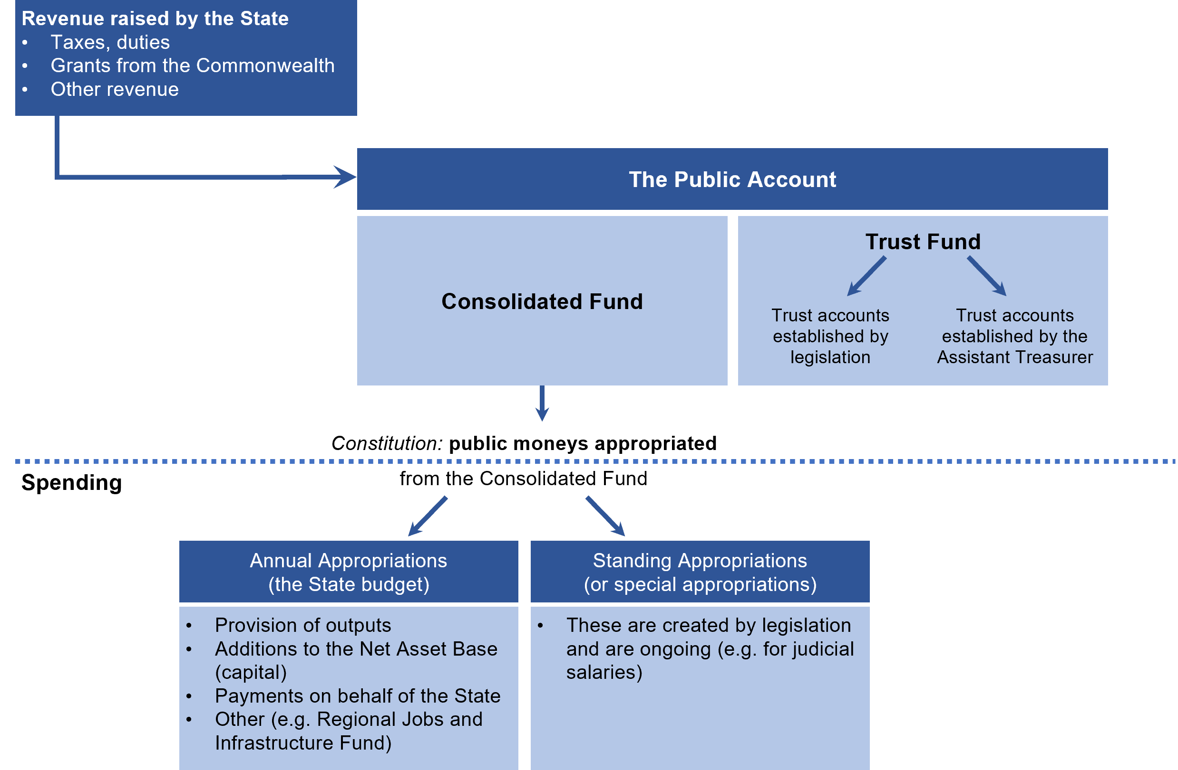

In legislation, and supporting Victoria’s financial management framework, are the concepts of:
- the Public Account
- Consolidated Fund
- the Trust Fund.

The Public Account
The Public Account is the Government’s official bank account. The Public Account holds the cash balances of the Consolidated Fund and the Trust Fund. The State’s financial transactions are primarily conducted through the Public Account (see Figure 5).
Accounting arrangements – comprise a centrally managed account linked to departmental bank accounts (generally via the State Administration Unit).
 Section 8.1: The State Administration Unit
Banking arrangements – are determined by the State’s cash and banking arrangements. These are a pool of accounts with a major financial institution, and form part of the State’s Central Banking System (CBS).
Figure 5: Representations of the Public Account
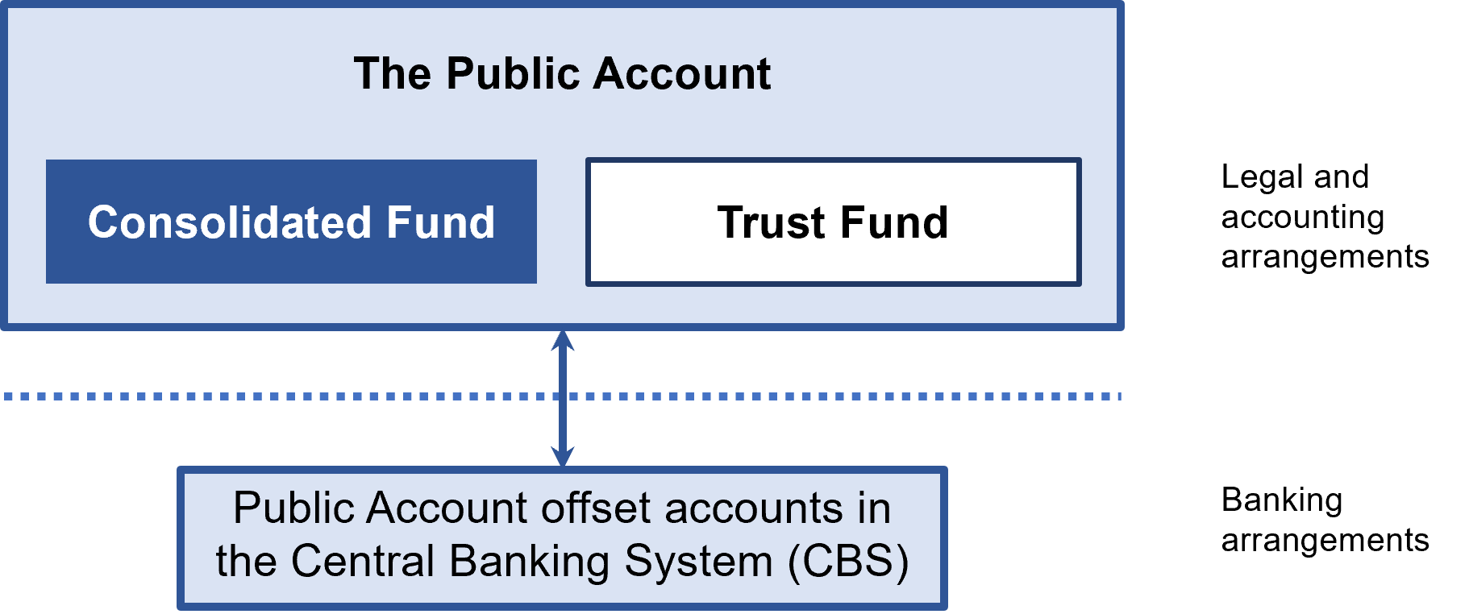

Section 5: Accountability, Section 5.6: Cash management and reconciliation

The Consolidated Fund
The Consolidated Fund is the Government’s primary financial account in the Public Account. Under the Constitution, the Consolidated Fund receives all revenue from which appropriations by Parliament are made.
Parliament appropriates money on a departmental basis annually from the Consolidated Fund for the following purposes:
- To produce or procure goods and services (output provision)
- To produce/buy capital items (asset investment)
- To make payments on behalf of the State
- As specified by other legislation.
The main types of appropriation are:
- Annual (as in the Annual Appropriation Act), including section 29 of the FMA
- Treasurer’s Advance
- Special (as per relevant legislation).

Annual appropriations
The Appropriation Acts provide the Government with a record of what it is legally entitled to draw down from the Consolidated Fund for each financial year (other amounts may also be drawn down under special appropriations). Departmental appropriations, and similar appropriations for Parliament, are set out in Schedule 1 of the Appropriation Acts.
There are three main types of appropriation that may be issued from the Consolidated Fund annually:
- Provision of outputs appropriation
This appropriation is issued from the Consolidated Fund for payment for output delivery.
Section 3.2: Funding outputs
- Additions to the net asset base appropriation
Additions to the net asset base (ATNAB) appropriation is issued from the Consolidated Fund for investment in assets. Under the State’s funding framework, this appropriation is only provided when other funding sources for asset investment are exhausted.
Section 3.5: Funding Assets
- Payments on behalf of the State
Payments on behalf of the State (POBOS) is an appropriation that provides for payments over which a department has no direct control and which is not related to delivery of output activity (classified as administered activity). This can include payments relating to an activity which a department administers or conducts on behalf of the whole state, e.g. expenses incurred through the funding of the National Disability Insurance Agency as part of the Victoria’s contribution to the National Disability Insurance Scheme.
Section 7.2: Payments on behalf of the State (POBOS) appropriation

The concept of appropriation limits
Appropriation limits are the maximum amounts able to be legally drawn from the Consolidated Fund for any given item of appropriation. These limits are set by the appropriation amount included in the Appropriation Act.
However, departments should note that:
- appropriations do not limit the operating expenses incurred by departments
- expenses incurred by departments will give rise to liabilities and obligations that departments are legally bound to meet as payments fall due
- when appropriation limits have been reached, the Government is legally unable to commit additional funding to meet payments related to a department’s expenses.

Section 29 Financial Management Act 1994 – Annotated Revenue
The Appropriation Act also provides for the application of section 29 of the FMA, whereby departments on behalf of their relevant Minister may apply to the Treasurer to retain certain types of revenue/receipts from third parties.
Section 4.1: Appropriation of certain revenue and asset proceeds – section 29 of the FMA

Treasurer’s Advance
As published in the annual Appropriation Act and in the DTF schedule, an Advance to Treasurer, or Treasurer’s Advance (TA) is appropriated to be applied at the Treasurer’s discretion to meet any urgent or unforeseen claims. A schedule of items of expenditure is submitted for parliamentary authority in a subsequent year’s Appropriation Bill.
Section 4.4: Treasurer’s Advance for urgent and unforeseen claims

Special (or Standing) Appropriations
Special appropriations are created by explicit provisions in legislation. A special appropriation provides authority to draw on the Consolidated Fund to spend money for one or more specified purposes, for example, to fund a particular project or function.
Examples of special appropriations in the FMA are section 28 (borrowing against future appropriation) and section 33 (access to previously appropriated amounts).
Special appropriations that are ongoing and applied repeatedly over more than one year are also referred to as 'standing appropriations'.

Use of annual appropriation versus special appropriation
Generally, a special appropriation may be included in legislation when:
- it is important to demonstrate the independence of an agency from Parliament and the executive by providing for automatic payment of the remuneration of its officeholders (e.g. the salaries of judges and the Victorian Auditor-General are included in the Constitution)
- it is desirable to create a legal entitlement to money, which is to be provided in all instances that satisfy specific criteria
- it is necessary to demonstrate the State’s ability to meet its financial obligations independently of annual parliamentary approval of funds (e.g. the repayment of loans)
- unique circumstances exist that would be difficult to accommodate in annual Appropriation Bills.

Disclosure and accountability
The Public Account disclosure in the budget papers provides a list of estimated special appropriation expenditure for the year. Note that increases in special appropriation expenditure beyond these estimates do not require government approval.
Section 4: Resource allocation – legal mechanisms

The Trust Fund
In the Public Account, the Trust Fund encompasses a number of accounts for funds that are not subject to parliamentary appropriation, such as:
- accounts created by legislation for specific purposes
- accounts to record specific purpose payments from the Commonwealth for on-passing by the State to third parties
- accounts facilitating the receipt and disbursement of private funds held by the State in trust.
Trust accounts are operated by departments. Unlike the Consolidated Fund, no appropriation is required to authorise spending from a trust account.
Section 4.3: The Trust Fund and trust accounts

Other funding sources
A department’s revenue base may also consist of funds received and held outside the Public Account, such as third-party revenue held in separate bank accounts by schools.
In addition, other general government sector portfolio agencies are created on a ‘stand-alone’ basis such that they are able to generate and retain certain additional revenues without the requirement to pay it to the Consolidated Fund. However, many of these agencies are reliant on appropriated funds transferred from their department to deliver the Government’s outputs or services, such as hospitals, TAFEs and certain transport-related agencies.
Government-owned businesses that generate their own operating revenue, such as water authorities, are subject to different governance and oversight, and are outside the scope of the RMF.

Victoria’s resource management policies
Victoria’s financial management legislation is supported by resource management policies and concepts that underpin public sector financial management. These policies support improved management of public sector resources, enabling the Government to better meet its objectives, while ensuring efficiency and effectiveness.

Allocating and managing resources
A key role of government is to provide essential goods and services to the community. To provide these goods and services, the Government collects and spends public moneys. While the Constitution Act provides broad powers for Parliament to appropriate public moneys, specific laws (such as the FMA) govern the use of these moneys and the accountability processes that the Government is obliged to satisfy.
The Government is responsible under section 23C of the FMA for establishing and maintaining a ‘budget and reporting framework that is consistent with the principles of sound financial management’. Therefore, to ensure accountability and transparency to the public for the use of public moneys, there are budgeting, financial management and reporting accountability processes in place.

The Departmental Funding Model
Victoria has a system that devolves responsibility to portfolio ministers and departments to manage a global budget in delivering certain agreed outputs, which in turn are aligned to departmental objectives. This is known as the Departmental Funding Model (DFM).
Under the DFM, the Government contracts the delivery of goods and services to departments. Departments have flexibility in the way services are delivered but must account for the delivery of these services. This is an incentive for departments to perform and improve service delivery over time.
The DFM contains the concepts of outputs, objectives, and their associated indicators and performance measures. These are explained further in Figure 6, which illustrates the relationship between objectives and outputs, and the activities and inputs that contribute to outputs.
Figure 6: Performance management concepts
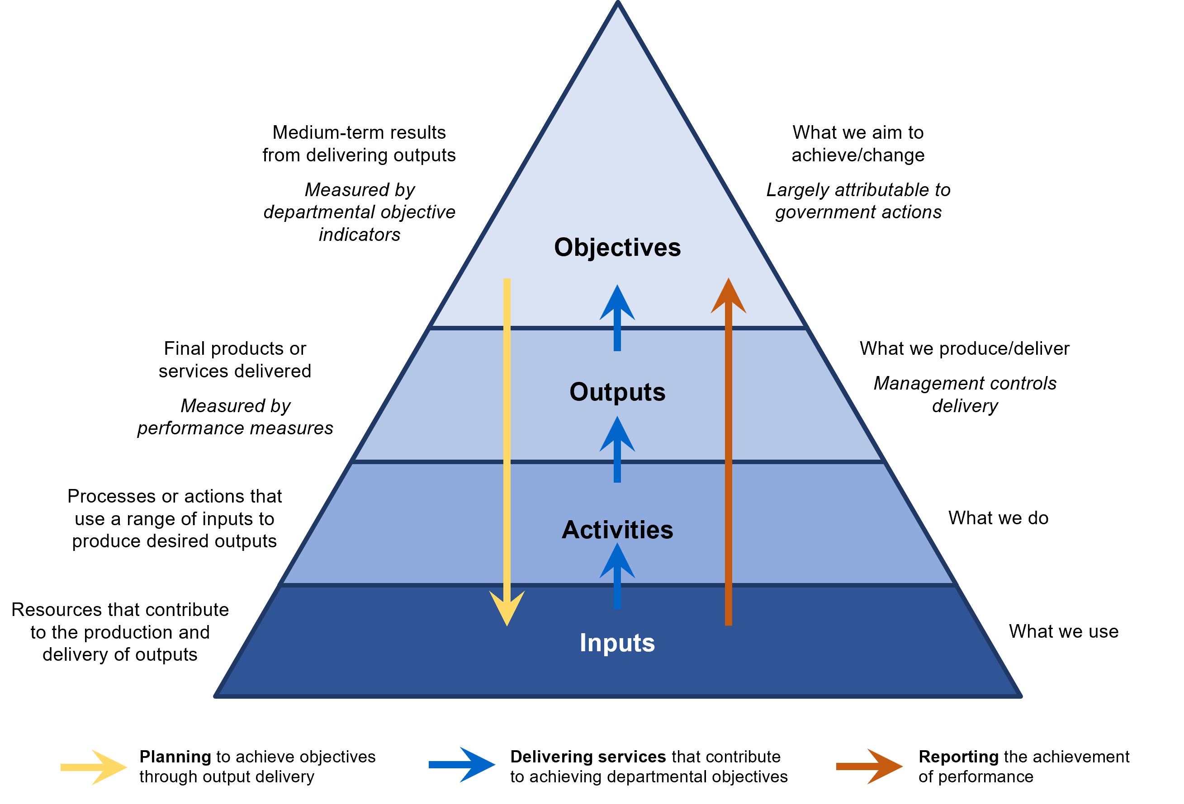

To ensure that Government priorities are being met, departments need to:
- determine how the activity of the department contributes to departmental objectives
- determine what and how to deliver on these objectives
- manage the delivery of outputs appropriately to meet these objectives.

Program Budgeting
To support the Government’s fiscal objectives and ongoing efforts to improve Victorian public sector financial management, the DFM is being enhanced through the introduction of an internal -to -government reform called Program Budgeting.
Program Budgeting will provide greater internal-to-government visibility and understanding of departmental expenditure and performance, strengthening central government’s ability to re-allocate resources in line with service delivery priorities and whole-of-government objectives, while retaining departmental flexibility to manage how services are delivered.
Program Budgeting is currently not a formal product of the DFM. There is no immediate change in the operation of the model as outlined in the RMF. Departments should refer to the Program Budgeting Transitional Guidance for further information.

Gender responsive budgeting
Gender responsive budgeting builds on the requirements of the Gender Equality Act 2020 (GE Act) and incorporates them into the Budget process to understand the gender impacts of proposals and consider the gender impacts of decisions about the allocation of available resources. Both the GE Act and the FMA require gender impact assessments for policies, programs or services that have a direct and significant impact on the public.
The Government considers that any request to spend, reallocate or raise government funds that requires the approval of Cabinet, a Cabinet Committee or the Treasurer is significant (given it is significant enough for ministers to lodge the request). Therefore, for such requests the key test becomes one of whether the impact on the public is direct. As a general principle, government funds are used to provide services to the people of Victoria. Therefore, most requests for funding will be seeking to provide some service or benefit to the public and the ‘direct’ component of the test would be met.
For existing programs or activities, any requests to Cabinet, a Cabinet Committee or the Treasurer for additional or renewed funding, are considered a review and therefore require a gender impact assessment (GIA). This could include requests to change the scope of the original decision, add new components to the activity, expand the services, or change the nature of the activity. Variations such as changing the source of funding without changing the activity’s purpose/intent are not intended to be captured.
The intent of GIA changes in the RMF is to reflect these policy positions. It is not intended for more than one GIA to be conducted for any single policy proposal or funding request, noting that the GIA may be updated and evolve over the course of the development of a policy proposal. Initially, mandatory requirements have been introduced for requests through the budget process and through Treasurer’s Advances, and options to extend this to other avenues to request changes to funding will be considered in the future.

Interactions with appropriations
Providing funding for the delivery of outputs was introduced in the mid-1990s. Funding outputs align with the State’s appropriation framework, where a global appropriation funds the ‘provision of outputs’, which the Treasurer allocates to departments, which then allocate to individual outputs in line with government priorities.
Before this, Victoria appropriated funding for the detailed input costs of government programs. Figure 7 demonstrates how Victoria’s funding has evolved from being input-based to output-based.
Figure 7: From input-based funding to output-based funding
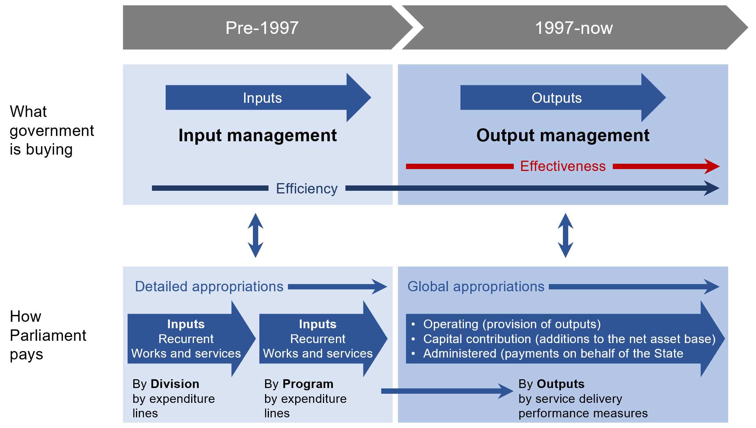

Accrual output budgeting framework
Victoria operates an accrual output budgeting framework that supports and intersects with the DFM. The DFM has the Government paying a ‘price’ (or providing parliamentary appropriation) for the delivery of outputs, where the price includes funding for accrued expenses (i.e. expenses that have been incurred but not necessarily paid (or payable) in cash).
The accrual output budgeting framework comprises the following components that are covered in more detail in later sections of this document:
- access to prior appropriation balances via section 33 requests
- the concept of an output surplus
- the funding of depreciation (depreciation equivalent)
- the concept of the funding of expenses on an accrual basis (payables), and the funding of long service leave (long service leave equivalent)
- the funding of interest accretion on leases (capitalised interest balances)
- the State Administration Unit (SAU).
- Access to prior years’ appropriation in the SAU inter-entity account (section 33 of the FMA requests)
If appropriation funding was provided for accrual expenses in previous years (not the current year), departments may be able to access these amounts by having their Portfolio Minister write to the Treasurer to request access to those balances, under section 33 of the FMA.
Section 4.10: Access to previously appropriated amounts under section 33 of the FMA
- Output surpluses
An output surplus may occur if a department is able to deliver on an output for less than the price (or appropriation funding) received for delivering the output.
The ability to earn an output surplus is intended to incentivise departments to be as efficient as possible in delivering outputs. If the surplus is generated in the same year as the appropriation revenue provided, then departments can use this output surplus for other expenditure, provided it meets the parameters set out in this Resource Management Framework.
Section 4.12: Departmental surpluses
- Funding of depreciation expense (depreciation equivalent)
Depreciation is an accrual accounting concept that apportions, or allocates, the cost of an asset over its useful life. Under the accrual output budgeting framework, depreciation expense is charged as an operating expense within departmental output costs. Depreciation expense is also funded by appropriation built into output prices. This appropriation funding is known as depreciation equivalent.
There is no cash outflow associated with depreciation expense as the cash outflow occurs when the asset is purchased. Under the framework, the depreciation equivalent is retained in the Consolidated Fund in the SAU inter-entity account, available as a funding source for future government-approved asset investment.
Section 4.13: Depreciation and depreciation equivalent
- Funding of payables and employee entitlements
Under the accrual output appropriation framework, Parliament appropriates amounts to fund departmental expenses, regardless of whether they have been paid for in cash or not. The payment of expenses in cash is a timing issue in the case of payables or long service leave. For example, when an employee goes on long service leave, the expense has already been charged or recorded, but the cash associated with the expense is only paid when the employee is on leave. Up until this point, the cash is retained in the SAU’s inter-entity account.
Section 4.14: Long service leave (LSL) and long service leave equivalent
- Funding of interest on service concession arrangements and leases (capitalised interest balances)
Under accounting standards, departments incur (non-cash) interest expense on the liability associated with service concession and other lease arrangements in the lead-up to commercial acceptance.
Departments recognise revenue that funds this interest expense, so that they do not incur a loss in output delivery by incurring the interest expense. Departments are funded for the revenue by additional appropriation, which is retained in each department’s SAU inter-entity account balance in the Consolidated Fund.
These amounts are known as ‘capitalised interest balances’. Funds are drawn down from these balances to fund the service payments for service concession arrangements after asset completion, until these amounts are exhausted. The SAU dissection report separately discloses and accounts for the amounts of capitalised interest balance.
This funding approach is similar to the funding of depreciation expense and the accumulation of depreciation equivalent in the SAU inter-entity account.
Section 4.15: Funding of interest on service concession arrangements and leases (capitalised interest balances)
- The State Administration Unit (SAU)
The SAU is a key feature of the State’s accrual output budgeting framework. The SAU formalises arrangements between departments and DTF (as the ‘Corporate Office’ for the State of Victoria) from an accounting and reporting perspective for accrual output management.
The SAU’s ‘inter-entity account’ notionally ‘holds’ or records the appropriated but undrawn appropriation amounts for each department in the Consolidated Fund. These amounts are recognised as financial assets (receivables) in departmental balance sheets. The funds are available for paying accrual expenses as they fall due, funding future asset investment, or else consist of surpluses generated from efficient output delivery.
Section 8.1: The State Administration Unit

The following table summarises these aspects of the framework:
Table 2: Summary table of components of accrual output budgeting framework
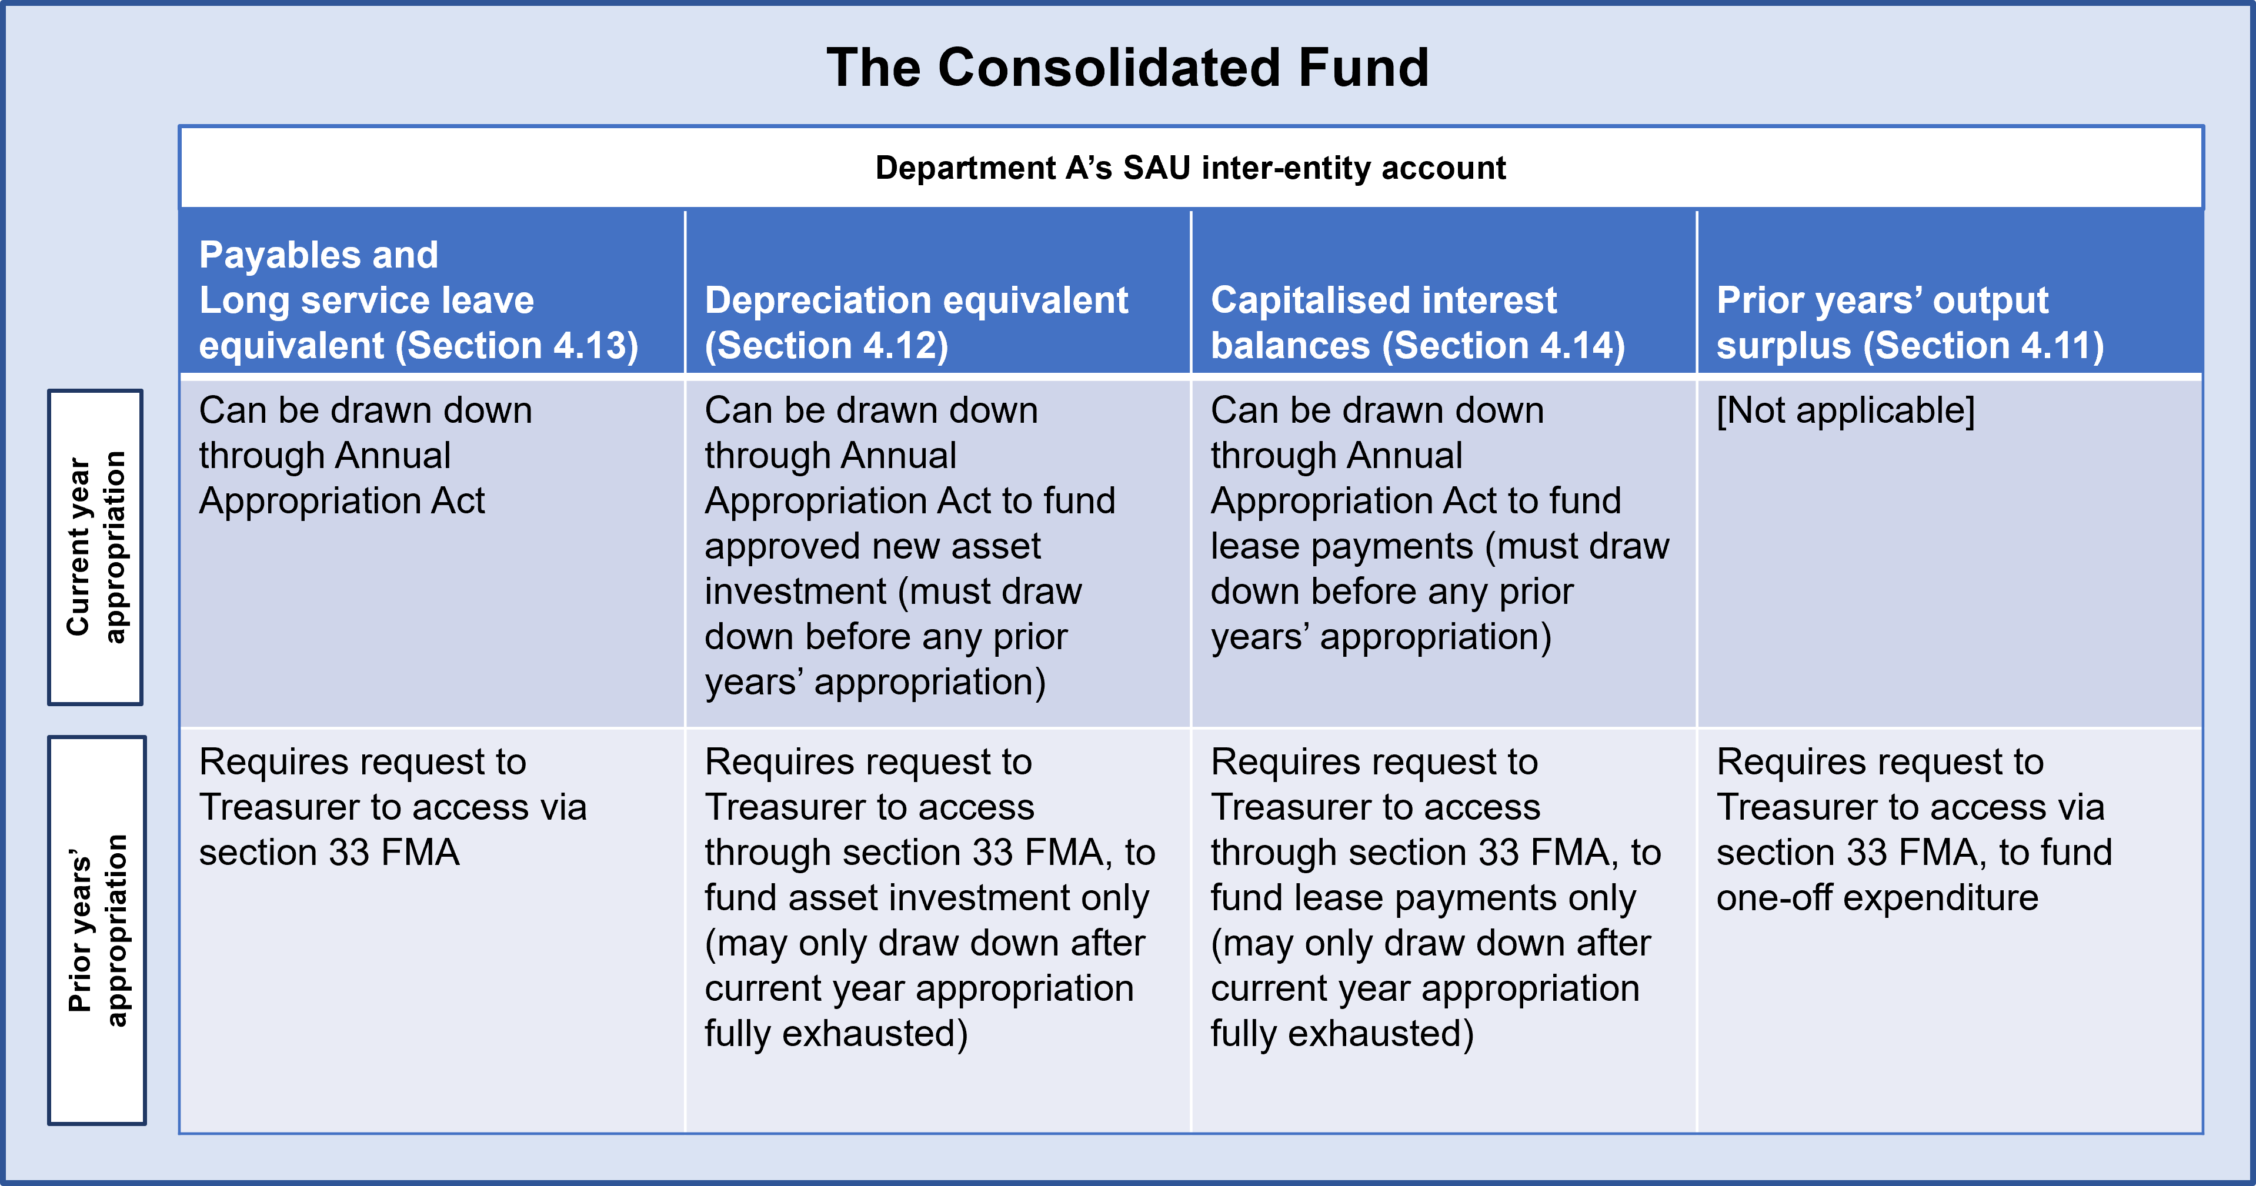

Accountability for performance
Under section 40 of the FMA, the Government must report to Parliament on:
- the management of the State’s resources
- the performance of departments.
As the Government is ultimately accountable for the State’s finances, departments are required to monitor and report on the management of service delivery performance.
Section 3.2: Funding outputs
Within the output framework there are critical roles and processes that are described throughout the RMF. These processes have been summarised in the tables below.

Planning
Performance measures are used in the planning stage to assist government in making resource allocation decisions, specifically how many units (or additional units) of goods or services can be delivered at what cost. Performance measures are used to ensure the delivery of outputs, and as a mechanism for accountability over government spending by specifying what the Government wants to achieve.
Section 1.2: Specifying outputs and performance measures
Process | Accountable Officers | Government Ministers | Parliament
Planning | Specify performance measures that provide a meaningful mix that assesses service effectiveness and efficiency.  Mandatory requirement (MR): 1.2.1  Set targets that are challenging but possible.  Section 2.3  Ensure department performance statements include performance measures and targets.  MR: 2.3.1  Conduct an annual review of performance measures and targets to ensure continued relevance.  1.2.2 and 2.3.2 | The Minister for Finance writes to Portfolio Ministers with recommendations for improving the DPS.  Portfolio Ministers endorse the DPS, then the Minister for Finance approves.  Section 2.3:  Portfolio Ministers write to the Treasurer for approval of carryover.  MR: 4.9.1  Portfolio Ministers approve material changes to performance measures.  MR: 3.3.1 | Public Accounts and Estimates Committee (PAEC) reviews and reports on performance measures.

Carryover
Carryover is the process of applying unused annual appropriation from one financial year into the following financial year. Carryover requests may be required where service delivery (and the achievement of associated performance measure/s) are pushed out from one financial year to the next.
Process | Accountable Officers | Government Ministers | Parliament
Carryover | Discuss carryover requests with DTF before any correspondence on the request is prepared.  Ensure requests for carryover are accompanied with proposed adjustments to output and financial performance targets.  MR: 4.9.1 | The Treasurer assesses carryover requests and determines which to approve.  MR: 4.9.1

Revenue certification
Departments are required to submit an invoice twice a year for the purposes of certifying their revenue. The invoices are used to assess actual performance against agreed performance measures. Revenue certification is contingent on the successful delivery of output performance.
Process | Accountable Officers | Government Ministers | Parliament
Revenue certification | Submit an invoice to DTF to request the certification of revenue in conjunction with the output performance report.  MR: 5.3.1 | The Minister for Finance advises the Treasurer to formally apply the amount of appropriation revenue to be recognised by the department.  Section 5.3

Reporting
Performance measures are internally reported and monitored in output performance reports and publicly reported in budget papers and annual reports. Performance measures should be able to be used to identify trends over time, benchmarking across departments and against other jurisdictions.
Process | Accountable Officers | Government Ministers | Parliament
Reporting | Report performance measures against targets in department performance statements.  MR: 2.3.1  Include footnotes noting any changes between years and explanations.  MR: 2.3.3  Submit output performance report biannually to DTF, which includes actual performance against targets and an explanation of major variances.  MR: 5.1  Disclose requirements in annual report.  Standing Directions: Direction 5.2 | Revenue certified by the Minister for Finance based on reported output performance measures against targets.  Output performance reports to the Minister for Finance.  Section 5.1 | PAEC investigates and publishes reports that make recommendations for improvement to the performance framework.

- Goal-setting and purpose
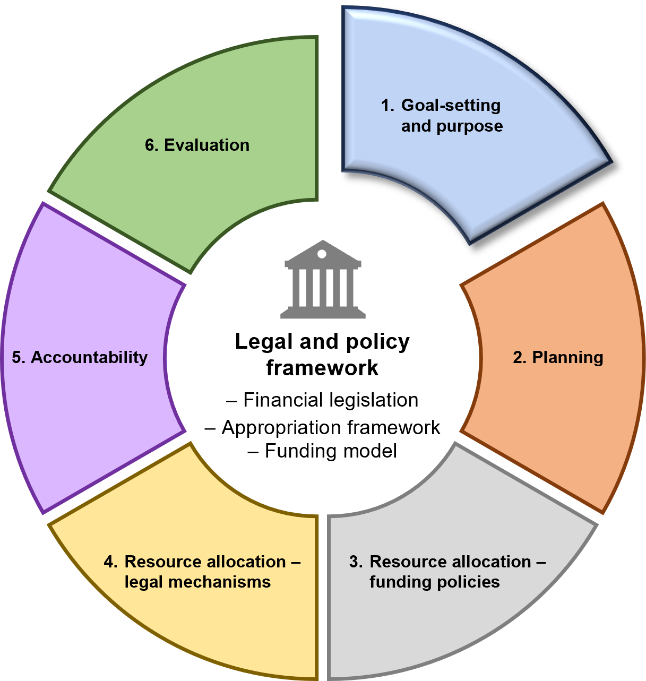

Overview
The first stage of the IMC is goal-setting and purpose.
This section guides departments in the specification of quality performance information to support Government objectives, in two parts:
- specifying departmental objectives and objective indicators
- specifying outputs and performance measures.
  - Specifying departmental objectives and objective indicators
Mandatory requirements
    - Specifying departmental objectives
The Accountable Officer must ensure departmental objectives:
- align with government objectives and priorities
- have a clear and direct link with outputs
- represent the totality of the department’s output budget
- only cover those responsibilities the department is funded to execute.
    - Specifying departmental objective indicators
The Accountable Officer must ensure departmental objective indicators:
- demonstrate the contribution of departmental outputs to the achievement of the objective through performance data
- use existing and comparable data series, and use data that is regularly available
- identify the baseline
- are reported in the department’s annual report in line with the Financial Reporting Directions and the Model Report for Victorian Government Departments.
    - Reviewing departmental objectives and indicators
The Accountable Officer must ensure:
- an annual review of the department’s objectives and indicators is conducted, to assess continued relevance
- any changes to departmental objectives and indicators are only made annually as part of the budget process (in department performance statements).
    - Changes to departmental objectives and indicators
If objectives and indicators are changed, the Accountable Officer must include in the budget papers an explanation as to why such changes have been made. Circumstances under which changes are required may include (but not limited to):
- machinery of government changes
- changes in the Government’s strategic direction
- a change in Government
- other reasons as determined by the Government of the day.

Guidance

Specifying departmental objectives
Departments need to be clear about what they are trying to achieve and that this aligns with government objectives. Establishing departmental objectives and strategies while planning helps a department focus on achievable goals and reach the best possible results from the resources available. It is important departmental objectives cover the department’s portfolio of responsibilities.
Departmental objectives should clearly identify:
- what the intended achievement is
- who the beneficiaries are
- the desired quality of the achievement
- a medium-term timeframe.
Useful departmental objectives clearly articulate the intended results of output delivery. Therefore, departmental outputs must have a clear link to departmental objectives.
Departmental objectives are not individual activities or strategies. Departments have the flexibility to explore alternative service delivery strategies (where appropriate) in order to achieve departmental objectives.
Departmental objectives reflect results that may be attributed to one or more government output or service.
Departmental objectives are progressively worked towards over a number of years.
Where an output delivers goods and services to other departments and agencies (i.e. internal to government), the objective should reflect this impact.
Departmental objectives and objective indicators are expected to reflect the actions outlined in that Department’s response to the 2021 VAGO audit Measuring and Reporting Service Delivery.
Attachment 1: Further guidance for developing departmental objectives

Specifying departmental objective indicators
Each departmental objective requires a set of indicators to monitor progress and demonstrate achievement of that objective. Indicators should be established to cover key aspects of each objective. Indicators should also provide information to influence decision making.
Trends in objective indicators will help demonstrate the department’s outputs are contributing to long-term Government objectives.
Good quality departmental objective indicators:
- provide a coherent link between a single objective and its supporting outputs
- indicate the impact that output delivery is having on the community and is thereby helping to achieve departmental objectives
- measure the results of Government action, rather than external factors
- remain relevant over the medium to long term so progress can be tracked and compared
- are free of perverse incentives and balanced with other departmental objective indicators
- ideally rely on existing, regularly updated data streams.
Attachment 2: Further guidance for developing departmental objective indicators

Accountability
Portfolio Ministers are accountable for departmental performance in the delivery of departmental objectives.
Departmental objectives are included in the following key reporting and accountability documents:
- Budget Paper No. 3, Service Delivery – Department Performance Statements
- departmental medium-term plans
- departmental annual reports.
If departmental objectives change, the Accountable Officer is responsible for including an explanation as to why the objectives have changed for inclusion in the budget papers.
  - Specifying outputs and performance measures
Mandatory requirements
    - Specifying outputs and performance measures
The Accountable Officer must ensure:
- the identification of outputs required to best achieve departmental objectives
- the specification of a meaningful mix of quality, quantity, timeliness and cost performance measures for each output that assess:
  - service efficiency and effectiveness
  - all major activities of the output.
- the impacts of any major policy decisions (i.e. to fund a new initiative or change the level of service) are reflected in updated performance measures
- all departmental operating costs are allocated to outputs
- any outputs and performance measures created enable meaningful comparison and benchmarking over time
- the data and methodology underpinning performance measures are available to DTF on request.
    - Reviewing outputs and performance measures
The Accountable Officer must ensure:
- an annual review of the department’s outputs and performance measures is conducted, to assess continued relevance
- any changes to departmental outputs and performance measures are only made annually as part of the budget process (in department performance statements).

Guidance

Defining outputs
Departmental outputs are products and services that are either:
- delivered to the community by, or on behalf of, a department or agency (e.g. education, health services)
- provided to other departments (e.g. services provided by the Victorian Public Service Commission to support the public sector).
The cost of delivering each output is identified when determining the output price in line with the Departmental Funding Model.
Departmental outputs and output performance measures are expected to reflect the actions outlined in that Department’s response to the 2021 VAGO audit Measuring and Reporting Service Delivery.
Section 3.2: Funding outputs

Level at which outputs should be specified
An output should capture the full activities and costs that make up a service that a department delivers.
An output should not be so large that it reduces transparency and accountability. Outputs should be specified at a level that will:
- assist the Government in understanding and deciding on the outputs to be delivered
- provide transparent and effective reporting to Parliament and stakeholders
- enable the Government to determine whether the goods and services delivered provide value and contribute to departmental objectives.
Attachment 3: Further guidance for developing outputs

Specifying output performance measures and targets
Output performance measures specify a department’s expected service delivery performance each year. Performance measures are the building blocks of the accountability system that drives continuous improvement and is the basis for the certification of departmental revenue (see section 5.3).
Good quality output performance measures:
- help the Government to make informed decisions about allocating resources
- allow departments to develop and assess standards of service delivery in line with Government expectations
- allow Parliament and the public to scrutinise and assess government performance and spending of public funds
- drive continuous improvement through analysis of historical performance and negotiation of agreed targets from year to year.
Output performance measures should enable meaningful comparison and benchmarking over time, across departments and against other jurisdictions. For example, the interaction between two different measures (e.g. the number of services provided versus the hours per service) could provide an indication of a potential trade-off between the quantity and quality of the service.
Each output performance measure has an associated one-year target that stipulates the Government-agreed standard of service delivery for that year, as a level of quantity, quality, timeliness and cost.
Occasionally, a performance measure may be changed when there is a clear case that the replacement is a better measure. Typically, targets should be revised to reflect increases or decreases in funding, historical overachievement, or productivity gains resulting from continuous improvement.
Changes to departmental outputs and performance measures should only be made annually as part of the budget process and be reflected in department performance statements.
Attachment 4: Further guidance for developing performance measures

Accountability
The content of department performance statements in the budget papers is a requirement of section 40 of the FMA for the annual Appropriations Bill to be accompanied by departmental statements of goods and services (i.e. outputs).

Data and methodology underpinning performance measures
Departments should maintain complete and up to date Data Output Methodologies (also known as a ‘Data Dictionary’) for all objective indicators and output performance measures. A Data Output Methodology is a centralised repository of information about the data presented. This centralised repository helps to support common understanding of terms, data and interpretations.
Data output methodologies should include all relevant factors to provide sufficient detail on how that data is calculated.
The data output methodology should be updated routinely and regularly maintained to reflect changes made to the database.
Attachment 4 of the RMF includes a checklist and criteria for best-practice performance measurement characteristics. The checklist should be used to assess the quality of each output performance measure and determine whether the set of performance measures achieves a faithful representation of the output performance.
A data output methodology template is provided on the DTF website and is intended as a guide for departments seeking to create a data output methodology.
Data Output Methodology template: www.dtf.vic.gov.au/planning-budgeting-and-financial-reporting-frameworks/resource-management-framework

- Planning
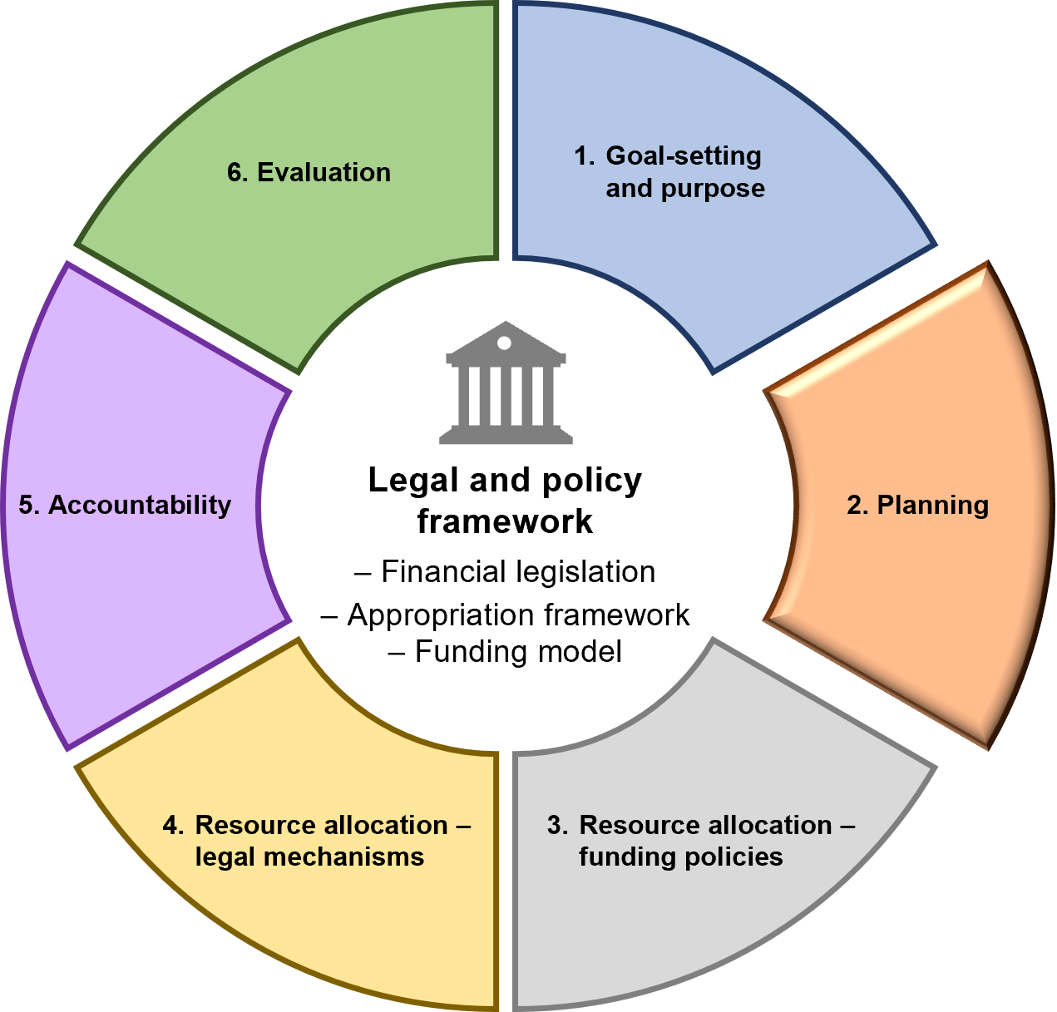

Overview
The second stage of the IMC is planning.
In this stage, the Government of the day sets out:
- how it will go about achieving its objectives and delivering outputs (through planning processes)
- how it will hold each department to account for delivering its outputs to achieve government objectives (department performance statements).
This section covers the following topics for this stage of the cycle:
- Long-term planning
- Medium-term planning
- Department performance statements
- Short-term planning.

Planning overview
Planning enables the Government, Ministers and departments to prepare for future opportunities and challenges and drive improved service delivery. Planning helps identify what is required to deliver services and infrastructure to achieve desired results.
Planning involves:
- aligning a department’s strategic direction with government policy objectives and priorities and/or Parliament’s objectives set out in enabling legislation
- assessing whether current departmental activities and outputs efficiently, effectively, and economically contribute towards achieving departmental objectives and government priorities
- developing strategies to deal with opportunities and risks to improve results for Victorians.

Managing risk is integral to planning and departments should refer to the Victorian Government Risk Management Framework, which describes minimum risk management requirements.

Table 3: Components of a comprehensive planning framework
Components of a comprehensive planning framework
Long-term planning  five years plus | Process to identify the long-term environment facing the department, and formulate the department’s high-level, long-term strategy for contributing to achieving the Government’s broad objectives and sustainable service delivery. | Mandatory requirements  refer section 2.1
Medium-term planning four years | Process to formulate the department’s strategies to deliver services over the medium term to achieve departmental objectives, guided by government objectives and priorities. | Mandatory requirements  refer section 2.2
Department performance statements | Articulates the goods and services (and output performance measures) the department will deliver.  Articulates the medium-term impacts on departmental objectives (via departmental objective indicators) the outputs are expected to achieve. | Mandatory requirements  refer Section 2.3
Short-term planning  one year | Process to formulate how the department intends to deliver outputs. | Good practice  refer section 2.4

  - Long-term planning
Mandatory requirements
    - Long-term planning
- The Accountable Officer must undertake long-term planning (five years plus) to assess the future operating environment, demand pressures and understand future service delivery and infrastructure needs.
- All departmental long-term planning must be supported by appropriate modelling and scenario analysis.

Guidance
The Accountable Officer should maintain sound governance arrangements for long-term planning. Long term is defined as a minimum time horizon of five years (i.e. beyond the forward estimates period).
Long-term planning seeks to:
- assess the future operating environment and demand pressures, and to understand future service delivery and infrastructure needs
- identify strategies to deal with challenges or risks within fiscal constraints
- pursue the department’s desired objectives
- identify opportunities to reform and improve service delivery efficiency
- address service delivery performance, financials and asset investments.
Departments that already undertake long-term planning (or equivalent) are not required to undertake additional planning to meet Mandatory Requirement 2.1.1.
To meet the mandatory requirements, departments should undertake fit-for-purpose long-term planning. Production of a physical plan is not necessary. Rather, departments should focus on demonstrating long-term planning activities have been undertaken, which are suitable to the circumstances of the department. Demonstration of compliance with these requirements can be evidenced by planning activities, or plan/s.
Periodic review of long-term plans if significant events occur (such as a change in government) is recommended.

Sample case study: Local government long-term planning in WA
Western Australia is an example of good practice. Local governments are required to prepare a 10-year strategic plan with an accompanying financial plan.
The strategic plan:
- establishes the community’s vision for the local government’s future, including aspirations and service expectations
- drives the development of local government area/place/regional plans, financial plans, resourcing and other informing strategies, including workforce, asset management and services.
To develop the financial plan, local government:
- undertakes data gathering, identification of data sources and indices, and refers to up-to-date asset management plans, workforce plans and other existing plans and strategies
- develops an initial 10-year model comprising revenue, expenditure and capital works without any changes to current policy – based on the current year’s annual budget
- agrees a range of assumptions that can be used in the development of alternative models (covering variables such as estimated growth and demographic changes, inflation forecasts, alternative rate increases, likely interest rate movements, debt funding options and alternative service delivery).

The Queensland Department of Health’s Guide to health service planning offers substantial guidance for health services planning, which departments could use as a reference in undertaking long-term service planning, while noting priorities can be different in different sectors.
Departments may undertake department-wide planning or plan for only one or multiple sectors. Where sector-specific planning activities are undertaken, the department should ensure planning activities are consistent. Where appropriate, links to other sector planning should be documented.

Modelling and scenario planning
Modelling and scenario planning help departments identify strategies to address future service needs.
Analysis of whether current services provide the best mix of strategic responses to meet the Government’s priorities should lead to the development of alternative scenarios. This includes reform of service delivery, such as introduction of contestability or commissioning. Over time, these reforms should be developed to the point they are ready for government consideration and, when approved, should feed into medium-term planning processes. Long-term planning can help departments measure the change in priorities they aim to achieve in the longer term.
Tip
Scenario planning involves modelling the impact of various responses from a service delivery and financial perspective over a time horizon. For example, departments delivering large infrastructure programs are likely to require longer planning horizons. Critical considerations in long-term planning include demographic changes, service demand growth, revenue projections and financial sustainability of services.
Modelling and scenario analysis should include estimated budgetary and financial projections. It should also document data sources, unit cost, population growth and demand pressure assumptions.
In line with Standing Direction 2.4.6.2, the departmental CFO may be asked to provide DTF with modelling and scenario analysis supporting long-term planning. This information may be requested in support of departmental funding requests through the annual budget process. Such a request will typically be made in writing by the Minister for Finance or the Secretary of DTF.
  - Medium-term planning
Mandatory requirements
    - Timing and coverage for medium-term planning
The Accountable Officer must prepare a medium-term plan, covering a rolling four-year period (budget and forward estimates), consistent with government objectives, priorities and budget decisions.
    - Medium-term plan content
As a minimum, the medium-term plan must contain the following:
- A description of the nature and scope of the department’s functions
- Strategic direction
- Overview of operating environment
- The department’s objectives and indicators
- The key challenges impacting on the department’s ability to achieve its objectives
- Key initiatives the department will implement to achieve its objectives
- The department’s asset, workforce and financial outlook
- Approved asset investment programs and targets over the next four financial years
- Approved use of accumulated State Administration Unit surplus balances on additional services and infrastructure
- Linkages in planning across government(s) and key stakeholders the department will engage with to ensure efficient, effective, economical and timely delivery on policies and priorities.
    - Publishing the medium-term plan
The Accountable Officer must approve and publish the medium-term plan on the department’s website. The Accountable Officer must ensure the medium-term plan is refreshed every year to reflect changes in Government objectives and priorities on or before 31 August.

Guidance
Consistent with the requirements for agency planning under Standing Direction 4.1.1(a) to (d), medium-term planning helps departments identify and deliver outputs and infrastructure that will contribute to efficient, effective, economical and timely achievement of departmental objectives and delivery of government priorities over the medium term (budget and forward estimates).
Much of the content of the medium-term plan will be consistent from one year to the next. However, some sections may require an update to reflect new key initiatives, challenges or priorities facing the department. Departments may structure their medium-term plan to best suits their needs.
The medium-term plan can be published online in the format preferred by the department (e.g. Word, PDF or interactive web format).
Attachment 5: Overview of medium-term planning process

Defining key initiatives
There are two types of key initiatives that should be outlined in a department’s medium-term plan:
- New programs or projects the department or Minister has chosen to fund internally to achieve a specific purpose
- Specific programs or projects detailed in the Budget, Budget Update or Pre-Election Budget Update. These can include ‘asset initiatives’, ‘output initiatives’, ‘revenue initiatives’, ‘revenue foregone initiatives’ and ‘expenditure reduction initiatives’.
The expected outcomes of all key initiatives should be described.

Link to the annual report
Achievement against key initiatives, departmental objective indicators and output measures identified in the department performance statement and medium-term plan is reported in a department’s annual report. The annual report is a key accountability mechanism for Parliament, as it provides data and analysis to assess whether departments have met their annual and medium-term goals.
Objective indicators increase focus on medium-term performance in the annual report. Reporting performance against indicators enables departments to demonstrate continuous improvement in the overall effectiveness of services. Publication of the medium-term plan provides a ‘clear line of sight’ between planned and actual performance.
Section 5: Accountability
The Model Report for Victorian Government Departments (refer to the DTF website)
Statement of Expectations Framework for Regulators (refer to the DTF website)

  - Department performance statements
Mandatory requirements
    - Content required in department performance statements
The Accountable Officer must ensure department performance statements include at a minimum:
- departmental objectives and objective indicators
- outputs with associated descriptions
- associated quantity, quality, timeliness and cost output performance measures and targets (output tables)
- departmental mission statements
- any discontinued outputs and performance measures
- an output cost summary table that lists the total cost of outputs
- any other information requested in a DTF Information Request.
    - Annual review of department performance statements
The Accountable Officer must undertake an annual review and assessment of the department’s outputs, output structures and associated performance measures in consultation with DTF, to assess continued relevance and robustness.
    - Performance measure footnote requirements
The Accountable Officer must include the footnote disclosure listed below in the department performance statements (where applicable):
- All new performance measures
- All renamed/edited performance measures
- Replacement or consolidation of performance measures
- All proposed discontinued measures/outputs, which include performance measures:
  - previously reported that are proposed to be discontinued in the budgeted financial year
  - with changes in source data/methodology used to measure target or changes in unit of measurement, which renders past performance history incomparable
  - that have been reclassified (i.e. quality, quantity or timeliness).
- Any complex measures where having an explanatory footnote would assist readers to understand the measure and its purpose
- All movements in targets (including output costs) between years
- All significant movements between targets and expected outcomes (including output costs and movements in comparison to previous years).
    - Approval
The Accountable Officer must ensure the department performance statements are endorsed by the relevant Minister(s) before submission to the budget process.
Supplementary requirements (attestation not required)
Specific application of this section to certain agencies
This section applies to all departments and those agencies that are funded through separate schedules in the annual Appropriation Bills, as determined by the Treasurer.

Guidance
Department performance statements describe the Government objectives (measured by suitable performance indicators) that departments seek to achieve over the medium term, together with the outputs funded to achieve these objectives.
Department performance statements are published in BP3 as part of the annual budget process. Section 40 of the FMA is the primary authority for the publication of outputs and associated performance measures in department performance statements, which states:
The Minister [the Treasurer] must prepare, in association with the annual Appropriation Bills, a statement of information under departmental headings setting out:
- a description of the goods and services to be produced or provided by each department during the period to which the statement relates, together with comparative information for the preceding financial year.

Output performance measures disclosure requirements
The output tables in department performance statements present output performance measure information in the following four columns:
- The coming year’s budget target
- The expected outcome for the previous budget year
- The previous year’s budget target
- The actual outcome for the most recently ended financial year.

Discontinuing or substantially changing output performance measures
If a performance measure does not meet good practice criteria, it may be changed, discontinued or replaced with a better measure.
Performance measures may change substantially due to:
- machinery of government changes
- a shift in focus of the service
- development of improved measures
- the establishment of new data sets, which can collect different information.
Performance measures may be discontinued because:
- they are no longer relevant due to a change in government policy or priorities and/or departmental objectives
- projects or programs have been completed, substantially changed, or discontinued
- milestones have been met
- funding is not provided in the current budget for the continuation of the initiative
- improved measures have been identified for replacement.
A current measure should not be discontinued when it is the sole indicator of an attribute (e.g. quality) of the output, or where there has been underperformance.
Proposed discontinued output performance measures are annually reviewed by the Public Accounts and Estimates Committee (PAEC). Once it completes its review, PAEC makes recommendations to the Government on whether the measure should be discontinued or reinstated. Although departments are not required to apply PAEC recommendations, departments are encouraged to include detailed footnotes to explain any departures from PAEC’s recommendations. Performance should continue to be measured and reported for lapsing programs funded internally through reprioritisation.
Performance measures can be replaced by a more appropriate measure where the new measure provides more meaningful information to Parliament and the public.
Section 6.1: Evaluating lapsing programs

Estimating expected output performance measure outcomes
When estimating expected outcomes for reporting purposes, departments should:
- track performance over time (on a quarterly or monthly basis) to support estimation
- use year-to-date data as a starting point for estimation
- consider annual trends in previous years and relevant external factors
- check with service delivery areas as to whether there are any risks to achieving the target and ascertain a likely expected outcome
- request explanations for any expected variances and validate.

Performance measure footnotes
Footnotes assist in communicating changes in performance measures, or changes in how measures are reported, to ensure performance can be measured consistently over time.
Where the actual performance result varies from the target by more than five per cent, an explanatory footnote should be included, where possible, to explain the factors contributing to the variance. The footnote should explain why performance was over/under the target, regardless of whether these factors were within the department’s scope of influence or not.
It is not sufficient to state that targets were not met or exceeded due to reduced or increased demand, or revised projections. The reasons for changes in demand should be outlined where possible.
Hypothetical examples of sound variance explanations include:
- The 20XX-YY expected outcome is higher than the 20XX-YY target as unexpected restrictions on scientific fieldwork enabled staff to instead produce a higher number of peer-reviewed journal articles.
- The 20XX-YY expected outcome is lower than the 20XX-YY target due to changes in Commonwealth Government guidelines that resulted in reduced demand.
Attachment 6: Department performance statements – performance measure footnotes guidance

Output structures and changes to outputs
Under FMA section 40, the Treasurer is responsible for approving departmental output structures and changes to departmental outputs. This responsibility can be (and has been) delegated to other Ministers, such as the Minister for Finance, or done by a relevant Cabinet committee.

Producing the department performance statements
As part of the process in producing department performance statements, departments submit budget funding proposals to DTF for negotiation and agreement on the price, quantity, quality and timeliness measures for each output being reported.
Therefore, any negotiations on the efficiency and effectiveness of outputs should occur during the budget process.
Department performance statements should include measures and targets that are challenging (to the extent they represent value for money) but achievable. Targets should not be aspirational goals.
Departments should also consider the contribution of departmental portfolio agencies in the development of department performance statements.
DTF reviews department performance statements as part of the budget process. DTF then advises the Minister for Finance on whether to approve the final determination of the outputs and associated performance measures.

Review by the Public Accounts and Estimates Committee
After the budget papers are published, the Government invites the Public Accounts and Estimates Committee (PAEC) to review performance measures that are proposed to be substantially changed or proposed to be discontinued, to ensure these measures are receiving a high level of scrutiny. Departments are informed of the outcomes of PAEC’s review, and updates to BP3 Appendix A are reflected by DTF on the Government’s budget website.
Departments must provide the necessary footnotes and associated targets and estimated outcomes for measures that are proposed to be discontinued, as these measures may be reinstated at PAEC’s request. If a measure listed in BP3 Appendix A is continued, a current year target is identified to ensure continuity of reporting and transparency in the publication of performance information.
  - Short-term planning

Guidance
Short-term planning goals are published in the annual department performance statement (specifically the outputs/deliverables and performance measures), which provides the basis for annual performance reporting on the delivery of outputs that contribute to departmental objectives.
Internally, business planning determines operational processes, staffing arrangements and budgets allocated to achieve the relevant performance goals for the year.
Departments could also oversee the development of more specific plans for portfolio agencies to assist in implementing departmental strategies to deliver the agreed outputs consistent with the requirements for agency planning under Standing Direction 4.1.1(a) to (d).
- Resource allocation – funding policies
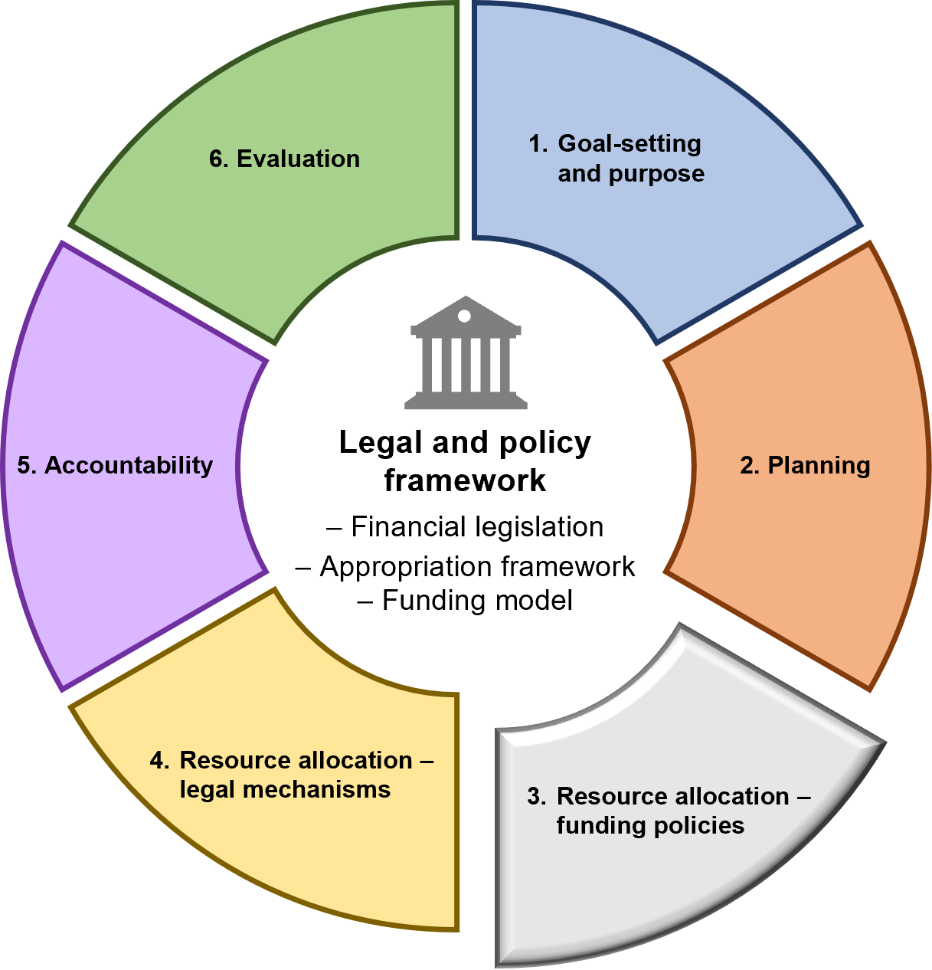

Overview
The third stage of the IMC is resource allocation – funding policies.
This stage explains the major funding policies that support the State’s financial management:
- The State budget
- Funding outputs (and the Departmental Funding Model)
- Varying the budgeted output funding mix
- Varying the output price
- Funding assets.

  - The State budget
The State budget is the primary planning mechanism for determining the level and priorities for government spending. The budget process allows the Government to assess proposals and make decisions about the allocation of available resources.
The budget has two components that support the Government’s request to Parliament to appropriate money from the Consolidated Fund for the upcoming financial year.

Appropriation Bills
The Government must pass an Appropriation Bill through Parliament to use public money from the Consolidated Fund. This Bill outlines the amount of public money appropriated to each department for outputs, assets, payments on behalf of the State, and other appropriations specified in the Bill. A separate Appropriation Bill is also submitted for the Parliament itself.

Budget papers
Section 40 of the FMA requires detail of the goods and services to be delivered with the appropriation. The budget papers also describe the Government’s fiscal strategy, the State’s overall budget position and the objectives of each department’s service delivery.

The role of Cabinet and Cabinet committees in the budget process
Cabinet is the principal decision-making body of the Government. It consists of all Ministers of the Crown and the Cabinet Secretary. The Premier, as the leader of the Government, is the chair of Cabinet.
Each Government will designate a committee responsible for making budget decisions on behalf of Cabinet. This committee is responsible for considering all output, revenue, asset investment and financing proposals submitted by departments on behalf of Ministers for the development and delivery of the State budget. This committee usually comprises the Premier, the Treasurer, the Minister for Finance, and often, other Ministers.
DTF supports this committee’s budget deliberations by providing process management and secretariat support, and information, advice and recommendations, in conjunction with the Department of Premier and Cabinet.
DTF leads the preparation of the budget papers when the committee finalises its budget decisions.

Tabling the Budget
Usually on the first Tuesday in May each year, the Treasurer introduces the Appropriation Bills to Parliament to appropriate public money and presents the annual budget papers. These documents outline Victoria’s budget position, detail how the Government will spend the public money it expects to collect over the next year, and request approval from the Parliament to use public money for that year.

Gender responsive budgeting
Gender responsive budgeting builds on the requirements of the Gender Equality Act 2020 (GE Act) and incorporates them into the budget process to understand the gender impacts of proposals and consider the gender impacts of decisions about the allocation of available resources.
Section 9 of the GE Act, which came into effect on 31 March 2021, requires a defined entity to undertake a gender impact assessment when developing or reviewing any policy of, or program or service provided by, the entity that has a direct and significant impact on the public.
However, Victorian Government departments preparing funding proposals are subject to particular gender impact assessment requirements. For departments, ‘direct and significant’ should be interpreted as requiring a gender impact assessment whenever the request impacts the public and seeks additional resources from Cabinet, a Cabinet committee or the Treasurer.
Departments should undertake a gender impact assessment for both new policies, programs or services as well as those coming up for review, for output, asset and combined output/asset proposals.
  - Funding outputs
Mandatory requirements
    - Output investment proposals considerations
When coordinating the lodgement of funding requests as part of the annual budget process on behalf of the relevant Ministers, portfolio departments and agencies, the Accountable Officer must:
- make all reasonable efforts to comply with annual budget process guidance and requirements as communicated by DTF, including conducting a gender impact assessment considering the impact of the proposal through gender analysis and, if practicable, intersectional analysis
- prior to lodgement, ensure that the relevant CFO reviews and signs off that the costs outlined in the proposal are a robust estimate of the cost of the department and/or portfolio agencies delivering the proposed activity.

Guidance

Budget process and Cabinet committee consideration
Annually, Cabinet committees are responsible for considering all output investment and financing proposals submitted by departments on behalf of Ministers for the development and delivery of the State budget.
Output funding proposals are evaluated and approved by Cabinet committees during budget deliberations.
DTF supports this committee’s budget deliberation process by communicating annual budget process guidance and requirements to departments, including timelines and templates.
The budget papers reflect the outcome of Cabinet and committee decisions, including the purpose of the investment, and approved funding over the forward estimates.
Departments are bound by any funding restrictions and policy intent applied by the relevant Cabinet committee. If a Minister or department wishes to alter the intention of a funding decision, including reallocation to fund alternative activity, a new funding proposal will need to be considered by the relevant Cabinet committee.
Departments should undertake a gender impact assessment for both new policies, programs or services as well as those coming up for review, including output, asset and combined output/asset proposals. The gender impact assessment should be undertaken early in the development of new policies, programs or services and not left until they are seeking budget funding.

Format and content of output investment proposals
Output investment proposals should be supported by a business case that includes sufficient documentation and analysis to support the proposal.
Departments are expected to comply with DTF’s business case template, which is regularly revised to ensure it reflects government policies and priorities for investment decision making.
Output funding proposals are assessed by central agencies, with recommendations made to the relevant Cabinet committee on the merits of each proposal.
DTF will consider the robustness of supporting information as part of its role advising the Government on investment decisions.

The role of the Chief Finance Officer (CFO)
CFOs are responsible for oversight of the financial management, performance and sustainability of a department and for providing strategic advice and options to support informed decision making and organisation strategy concerning the department. Given this responsibility, departmental CFOs are expected to ensure that a funding proposal represents an accurate reflection of the costs of department, or its portfolio agencies, delivering on the intention of the funding proposal.
When funding is requested for two or more departments, the CFO of the department leading the funding proposal should obtain confirmation from the CFOs of the other department(s) that their components of the funding proposal accurately reflect their share of any relevant costs.

The Departmental Funding Model
The Departmental Funding Model (DFM) underpins Victoria’s devolved output-based system, in which Government funds departments for the delivery of outputs, rather than funding inputs. Departments are ‘paid’ an agreed ‘price’ by Government for each output (an ‘output price’) based on an agreed level of quantity, quality and timeliness performance measures.
The DFM requires departments to fully manage all costs within an agreed ‘price’ for services and be accountable for controlling costs.
The DFM is based on the following principles:
- A clear focus on service delivery: Departments are paid a price to deliver agreed outputs to specified performance standards. If these standards are met, the output price will be paid by Government.
- Simplicity in setting estimates: Price is set by agreed formulas to provide departments with certainty about forward revenue levels.
- Allocating responsibility for productivity and risk where they are best managed: Departments are responsible for managing costs within the price paid by government. Departments have flexibility (within normal legal and policy parameters) in how they manage costs/inputs to deliver outputs within total revenue earned.
- Departmental revenue for the provision of outputs: The sum of amounts paid by Government for all of the department’s outputs and may be applied to meet any costs associated with the delivery of outputs.
- Base output price: Determined and varied in line with government output decisions as part of ongoing budgetary processes and escalated through indexation to maintain alignment with movements in either the rate of inflation or in line with government policy.
Section 3.3: Varying the budgeted output funding mix
Attachment 7: The Departmental Funding Model (DFM)
Attachment 8: Applying the correct appropriation accounts in SRIMS as part of the DFM

Output management and variations to funding
Departmental funding for outputs assumes that output specifications and associated performance measures remain constant over the life of the output across the forward estimates.
Government will generally not increase the price it pays for outputs for the upcoming budget year when the budget has been set. Departments are expected to manage the expenses associated with the delivery of the agreed outputs within this annual funding envelope.
However, the Government may agree to change the output price it pays for outputs in exceptional circumstances, such as when the Government agrees (outside and within the annual budget process) to a change in the quantity, quality and timeliness characteristics of an output.
Variations may occur within the annual funding allocation that involve either:
- the increase in production of one output, and the reduction of another output
- the introduction of a new output/s that were not in the department’s original budget.
Section 3.3: Varying the budgeted output funding mix
Section 3.4: Varying the output price

Outputs that are partly externally funded
When the department provides outputs that are partly externally funded, the following principles and rules apply:
- The output is disclosed and reported as the total product or service consumed by the public (not only the part the government funds)
- When a section 29 of the FMA agreement or trust account arrangement is in place, the revenue receivable must be treated as departmental revenue
- The budgeted net output price (revenue received from the Government) must be determined by:
- estimated total accrual cost of the output; less
- estimated revenue from external users/buyers of the product/service.
- If actual revenue exceeds actual expenses, departments may retain the surplus
- If actual revenue is less than the budgeted revenue, under the DFM, departments must fund the deficiency from internal sources, unless the deficiency is caused by a decrease in demand from factors outside the department’s control or otherwise determined. If this occurs, the department may submit a request on behalf of the relevant Minister for supplementary funding.
Section 4: Resource allocation – legal mechanisms

Products or services provided by an external provider
When a department provides outputs delivered by an external provider, the following principles and rules apply:
- The output must be specified as the Government’s contribution to the service delivery, in terms of any performance measures negotiated with the provider, which forms the basis of payment by the Government
- The output price must be the price negotiated by the Government with the external provider, which may be either a total amount, or based on quantities delivered.

Relationship between appropriation funding and the DFM
Departmental annual appropriations are made on an accrual and global basis for each department. From this global allocation of funds, departments are responsible for managing their own budgeting and expenditure, including budgeting for their portfolio agencies, in line with the principles of the DFM.
The appropriation provided for an output may be equated with the ‘price’ paid by the Government for delivery of an output. However, outputs may also be partially funded by third party revenue obtained external to government.
Departments should ensure they are able to identify the individual revenue streams associated with the provision of outputs and be able to provide this information to DTF on request. The revenue streams may include:
- application of annual appropriations for provision of outputs, including any section 29 of the FMA revenue
- other revenue generated by the department to offset costs of output delivery including Trust Fund receipts, or receipts from outside of the Public Account
- special appropriations provided for output provision.
Global appropriations provide departments with flexibility to adjust to pressures and to respond to changed circumstances within the spending limit provided. However, significant changes to output delivery and/or new policy decisions require approval from the Government.
Section 3.3: Varying the budgeted output funding mix

Accountability mechanisms
A department’s Minister(s) and Secretary are accountable to the Cabinet and Parliament for ensuring the department’s resources are sufficient to enable it to meet all payments as and when they fall due.
Therefore, departments retain responsibility for monitoring the extent of application of appropriations, informed by the Minister for Finance’s certification, and the Treasurer’s application of revenue.
  - Varying the budgeted output funding mix
Mandatory requirements
    - General requirements
The Accountable Officer must:
- ensure that estimates for the budget and forward estimates for outputs within SRIMS are accurate, up to date and align with the budgeted output mix as contained in BP3 and other approved variations
- ensure the relevant Minister approves any material changes in the budgeted output mix (in terms of quantity, quality, timeliness and cost)
- advise DTF as soon as practicable, when the relevant Minister has approved changes to the budgeted output mix
- ensure any budgeted output mix changes are:
  - compatible with meeting the Government’s objectives
  - linked to departmental objectives as defined in the department’s medium-term plan and business plans.
- ensure any changes to the budget output mix must not result in increased or ongoing future demand pressures that will exceed the department’s forward estimates (unless agreed by the Treasurer/the relevant Cabinet committee).
    - Varying the levels of output funding between outputs
The Accountable Officer must comply with the following:
- For any new funding over the forward estimates period approved by Cabinet or the relevant Cabinet committee (and approved during the current Government’s term of office) – this funding must not be reallocated to another output and/or be used to fund any activity not covered by the initial funding decision without the explicit written approval of Cabinet or the relevant Cabinet committee, or the joint approval of the Treasurer and Minister for Finance (refer Mandatory Requirement 3.3.3 also).
- For existing funding in the forward estimates – changes may be made to the budgeted output levels as contained in BP3, of up to five (5) per cent of the revenue for any individual output.
    - Varying the mix of outputs in excess of five per cent of revenue per output
Before changes are made to the budgeted output mix, the Accountable Officer must ensure that:
- the relevant Minister writes to both the Treasurer and the Minister for Finance to obtain joint approval for any output mix changes, or the establishment of new outputs, in excess of five (5) per cent of individual output revenue
- DTF is advised in the department’s next biannual output performance report and formally state that the change complies with the conditions outlined in Mandatory Requirement 3.3.1.

Guidance
Relevant Cabinet committees may make funding decisions to support the delivery of government policy. As a result, departments are bound by any funding restrictions and policy intent applied by the relevant Cabinet committee.
Generally, under the framework, departments have been allowed to vary their output funding mix during the budget year for various reasons which could include:
- responding to unanticipated events (e.g. unforeseen demand changes)
- technological innovations
- the adjustment of required output quality targets
- in response to specific Government policy decisions (such as the imposition of savings).
However, as a result of recent reforms aimed at strengthening the robustness of the financial framework, and improving visibility and accountability to the Government, departments need to note the following.
For new funding approved by Cabinet or the relevant Cabinet committee – as per Mandatory Requirement 3.3.2(a), departments may only reallocate funds from one output to another, and/or move funds to another activity not previously covered by the initial funding decision, if there is explicit written approval of Cabinet or the relevant Cabinet committee, or the joint written approval of the Treasurer and Minister for Finance.
Note 1: Mandatory Requirement 3.3.2(a) is intended to apply to all decisions made during a government’s entire tenure in office. For example, if a government was elected in 2016, then re-elected in 2020, this requirement applies to all decisions made by that government since 2016, where practical to do so. DTF will work with departments on a case-by-case basis on the application of this requirement.
Note 2: Mandatory Requirement 3.3.2(a) operates within the concept of materiality for reporting in the framework - only changes meeting the materiality threshold are required to be submitted for approval.
Subject to consultation with the relevant departmental relationship manager within DTF, it is not expected that departments need to seek approval to move minor amounts of funding between initiatives, whether within the same output or across different outputs, in a given year to manage cash flow, provided the total funding envelope for each individual initiative over its lifespan is not exceeded.
The concept of materiality extends to non-financial parameters in instances where specific objectives, which may be time-limited, are meant to be achieved with the funding provided. However, if a department is provided funding to achieve a specific objective within a limited timeframe, and the objective is no longer relevant in a subsequent year, departments will require approval to reallocate this funding, irrespective of its financial materiality.
For all other existing funding in the forward estimates – as per Mandatory Requirement 3.3.2(b), departments may make changes to the budgeted output mix as contained in BP3 by up to five (5) per cent of the revenue for any individual output, subject to the following:
- changes to revenue earned for output provision must not exceed the total appropriation available for that purpose in Schedule 1 of the Appropriation Act
- changes must be compatible with meeting the Government’s priorities, including the implementation of agreed initiatives of the relevant Cabinet committee
- changes can be linked to departmental objectives as defined in the department’s plans
- changes cannot result in increased or ongoing future demand pressures that will exceed the department’s forward estimates, unless previously approved by the Treasurer or the relevant Cabinet committee.
Changes to the budgeted output mix published in BP3 above five per cent of individual output revenue (including the establishment of new outputs) must be first approved by the relevant Minister, the Treasurer, and the Minister for Finance before the changes can be made by a department.
Where a request(s) has been made to the Treasurer and Minister for Finance to vary the output mix in excess of five per cent under Mandatory Requirement 3.3.3, and it is determined that this request(s) would significantly impact on the policy intent of a funding decision, the Treasurer and Minister for Finance reserve the right to recommend that the request(s) instead be considered by the Cabinet or the relevant Cabinet committee.
Carryover
Within an appropriation year, where no approval has been provided to reallocate or change the intent of a specific government funding decision and related output appropriation remains unapplied at the end of the financial year, the relevant Minister may seek approval from the Treasurer to carry over unspent appropriation under section 32 of the FMA. Any unapplied appropriation that is not approved to carry over and not deemed a surplus will lapse.
  - Varying the output price
Policy decisions to review the price paid for existing outputs, or to introduce new outputs, are decisions for Government. Departmental appropriation revenue will vary in line with future policy decisions.
Price may also be adjusted or modified through a review of output price.
Where departments believe that cost pressures in an output may impact the ongoing viability of service delivery, departments may submit a business case on behalf of the relevant Minister to the relevant Cabinet committee to explain if the cost pressure:
- cannot be sustained within the total departmental price, to the extent that service delivery is adversely affected
- is a result of factors outside the control of the department
- is not a result of service/quality expansion and/or demand growth (these issues will continue to be considered in the context of the Government's policy decision framework).
Section 4: Resource allocation – legal mechanisms
  - Funding assets
Mandatory requirements
    - Asset investment proposals considerations
On behalf of the relevant Minister, the Accountable Officer must:
- comply with annual budget process guidance and requirements as communicated by DTF, including presenting asset proposals in a current and completed business case template
- ensure that, before a proposal is submitted for consideration, the relevant CFO reviews and signs-off that the costs outlined in any proposals
- describe how a proposed asset investment is the most effective and efficient means of supporting the delivery of departmental outputs and meets government objectives.
The proposal must also consider:
- any alternatives such as:
  - leasing
  - outsourcing and/or private provision
  - private provision and/or solutions requiring no new assets.
- the whole-of-life costs of the asset, including:
  - costs involved with re-adapting the asset to meet changing demands
  - associated ongoing operating expenditure estimates for any base and estimated service uplift benefits/costs.
- the implications on output provision performance (quantity, quality, timeliness, revenue and expense) of the investment.
    - Order of funding for approved asset investments
The Accountable Officer must ensure the department’s approved asset investment program is funded by drawing down from the following funding sources in the specified order below:
- where relevant, funds provided by the Commonwealth (usually directed to a specific project or category of projects)
- where relevant, net proceeds of asset sales accessed under a section 29 agreement (may be directed to a specific project or category of projects)
- current year depreciation equivalent balance, and if these funds are exhausted, then use
- prior years depreciation equivalent balances held in the SAU inter-entity account; and then, if these funds are exhausted, then use
- any Additions to the Net Asset Base (ATNAB) appropriation.
    - Replacing assets
The Accountable Officer must ensure an asset is not replaced unless:
- options to address demand have been considered
- doing so is consistent with the department's asset investment planning, long-term service planning and government priorities.
    - TEI changes
The Accountable Officer must ensure that any changes to a project’s or program’s approved TEI is approved by the Treasurer. All changes to project TEIs require the Minister to write to the Treasurer for approval.
    - Ongoing reporting
The Accountable Officer must review approved cashflows at each Budget and Budget Update publication to ensure that the reported cashflows are up to date. All changes to approved cashflows require the Minister to write to the Treasurer for approval.

Guidance
This section should be read in conjunction with the Asset Management Accountability Framework, which seeks to ensure public assets are managed with consideration for their whole lifecycle costs and to optimise service delivery outcomes. The framework establishes a number of mandatory requirements and provides guidance on good practice for asset management.

Departmental investment prioritisation and approval
Departments are expected to allocate sufficient funding to maintain their assets within their allocated budget. Where service delivery objectives can be improved through additional investment, funds can be sought through the budget process for consideration against other investment priorities.

Content of asset investment proposals
DTF recommends the Investment Management Standard (IMS) be used to shape a major investment in the early planning stage. The IMS is a process for applying simple ideas and practices that help organisations direct resources to deliver the best outcomes from their investments.
Asset investment proposals should be supported by a business case that includes sufficient documentation and analysis to support the proposal.
Departments are expected to comply with DTF’s business case template, which is annually revised to ensure it reflects government policies and priorities for investment decision making.
The investment lifecycle and High Value High Risk guidelines provide comprehensive guidance to assist in the development of the full business case.
Departments must ensure any funding proposals for asset investment have considered:
- alternative funding sources that may offset the cost of a proposal, provided the funding source is relevant to the proposal being considered
- that any contingency calculations included in a proposal are well developed and robust.
These asset investment proposals are assessed by central agencies, with recommendations made to the relevant Cabinet committee on the merits of each proposal.

Project funding held in contingency
Further information on the use and allocation of project funding to be held in contingency is in section 3.6: High Value High Risk capital budgeting arrangements.

The role of the Chief Finance Officer (CFO)
CFOs are responsible for oversight of the financial management, the performance and sustainability of a department and for providing strategic advice and options to support informed decision making and organisation strategy concerning the department. Given this responsibility, departmental CFOs are expected to ensure, to the best of their knowledge, that a funding proposal represents an accurate reflection of the costs of department, or its portfolio agencies, delivering on the intention of the funding proposal.

Cabinet process
Asset investment proposals are evaluated and approved by Cabinet committees during budget deliberations.
The budget papers reflect the outcome of Cabinet decisions, including the purpose of the investment, approved funding and cash flows over the forward estimates.
Following budget deliberations, the Treasurer’s approval is required to adjust project cash flows.
Cabinet committees are expected to approve major scope changes if a department wishes to make scope variations that impact the business case benefits approved as part of the investment decision.

DTF’s role in determining asset funding decisions
DTF will consider the robustness of supporting information as part of its role advising the Government on investment decisions. For asset funding proposals, this may include information derived from Asset Information Management Systems and asset management strategies.

Funding approved asset proposals
Asset investment decisions are made by the Government. Funding for those decisions is a consequential but secondary consideration. Asset investments decisions can be funded from a variety of sources, which are to be drawn down in the following order:
- Commonwealth funds for specific projects: If such funds are received, these must be applied against these projects as the priority source of funding
- Net proceeds from asset sales: These proceeds may be used to fund asset investment, provided they have been subject to a section 29 of the FMA agreement. Where a purchase of a new asset involves the trade-in of an existing asset, the use of the proceeds from the trade-in to fund the assets will require section 29 approval
- Depreciation equivalent in the SAU inter-entity account: These funds comprise the balance held by each department in its SAU inter-entity account for current and prior years’ unspent depreciation equivalent revenue
- Additions to the Net Asset Base (ATNAB) appropriation funding: Should the first three sources be insufficient to fund the department’s approved investment program, the provision of additional ATNAB appropriation by the Government may be required.
The order of the drawdown of funds used to fund asset investment is also listed in the mandatory requirements of this section.
Note: Departments must not use the balances of these sources of funds to determine future potential asset investment opportunities. That is, surplus balances in these fund sources does not let departments draw down on these funds to fund asset investment that has not gone through an explicit government approval process.
Section 4.1: Appropriation of certain revenue and asset proceeds – section 29 of the FMA
Section 4.13: Depreciation and depreciation equivalent

Departmental asset investment program
Asset investment spending during any budget year will consist of:
- the first year’s expenditure on new major asset investments approved by the relevant Cabinet committee to be started in the budget year
- estimated annual cash flows for those assets approved by government in previous years’ investment programs.

Managing growth in the asset base
Where additional capital funding is approved that leads to a material increase in the total value of depreciable assets, departments are responsible for ensuring output revenue remains sufficient to meet the costs of asset management that support output delivery.
This may be achieved by:
- agreeing with government that additional outputs will be produced from additional appropriation revenue
- increasing revenue from non-appropriation sources
- negotiating increases in output prices.

Ongoing reporting of asset investment program
Departments are required to update their forward estimates biannually for the Budget and Budget Update publications. All variations to the capital program should be submitted to your DTF relationship manager (including updates to the ASSAM documents where appropriate) with appropriate supporting documentation.
  - High Value High Risk (HVHR) capital budgeting arrangements
Mandatory requirements
    - Additional reporting requirements during project delivery
During a HVHR project’s delivery phase, the Accountable Officer must provide DTF with periodic performance reporting to reconcile and demonstrate appropriate use of risk and contingency provisions, including:
- an updated risk register
- a contract variation register
- updated cost to complete estimate
- changes in benefits to be delivered
- a change control log
- other project documents that provide detail on the use of risk and contingency provisions.
    - Graduated access to risk and contingency provisions
At any stage during the project’s delivery phase, the Accountable Officer may, on behalf of the relevant Minister, request access to the excess risk provision held centrally, by providing sufficient supporting information, including items referenced in section 3.6.1.
Supplementary requirements (attestation not required)

High Value High Risk Projects budgeting principles
The following principles and conditions apply to High Value High Risk (HVHR) capital projects:
- Project budgets are released incrementally over a project’s lifecycle
- The risk and contingency budget provision is reset at contract award when the estimated costs and risks associated within a project are better understood
- A proportion of project risk and contingency provisions are held centrally until required
- Unused budget from completed projects is retained by the Treasurer or reallocated to other government priorities.

Staged release of project budgets
Funding is released incrementally during a project’s lifecycle as follows:
- Project approval: Project budget is typically set at a P90 estimate (or equivalent). Development, procurement and early works funding is released to the delivery agency (10 per cent or an identified amount) with the balance held in central contingency.
- Contract award: Project risk and contingency provision is reset and the project funding up to the P60 estimate (or equivalent) is released to the delivery agency with the balance held in central contingency if or until required.
- Project completion: A full reconciliation of project expenditure will occur, and all unused project budget is either:
  - retained (for outstanding claims or warranties)
  - reallocated to other government priorities
  - returned to the Consolidated Fund.

Guidance
Procedures are in place to increase oversight and accountability for High Value High Risk (HVHR) capital projects. Funding for these projects will be released incrementally during a project’s lifecycle.
Enhanced reporting requirements during project delivery, including in support of requests for release of the balance of contingency above P60, will enable a more considered response to the occurrence of inherent risks, and increases transparency and financial controls within a HVHR project.

Process for release of funding on HVHR projects
Project funding is released to a department and/or delivery agency at the following stages of its lifecycle:
Project approval
- Development funding is released to the delivery agency to complete planning, procurement and early works based on an amount identified by the department or 10 per cent of the project budget.
- Balance of project funds are held in central contingency pending finalisation of procurement process.
Contract award
- The Minister seeks approval to award a contract(s), either at a relevant Cabinet committee or via a letter to the Treasurer, with supporting information on the procurement assessment, including:
- reconciliation of project costs incurred to date
- revised estimate of remaining State costs to deliver project
- detailed project budget summary (including contract value)
- up to date and costed risk register for all State retained risks
- an assessment of State retained risk including updated P50, P60 and P90 risk estimates (or equivalent)
- a report detailing all inputs and outputs into the simulation/risk estimation.
- Delivery funding of up to the P60 estimate (or equivalent) is released to the delivery agency with the balance of project funds held in central contingency.
- The project funding that is above the P60 estimate remains in central contingency and is available to allocate to the project should it be required.
- Where there is an additional funding requirement, the Treasurer may direct the project to be referred to the Budget and Finance Committee for funding consideration.
- Where a project is procured utilising multiple packages, the staged release only applies to major project packages.
Delivery phase
- At any stage during the delivery phase, the Accountable Officer, on behalf of the relevant Minister, may write to the Treasurer seeking the release of the excess risk provision held in central contingency with supporting information on the funding requirement, including:
- A copy of the change control log (CCL)
- A copy of the contract variation register (CVR)
- A copy of an updated risk register cross referencing realised risks in the CCL and CVR
- An updated estimated cost to complete
- Advice on any changes in project benefits to be delivered.
- Where there is an additional funding requirement or change to project scope, the project may be referred to the relevant Cabinet committee for funding consideration.
Project completion
- As part of the Gate 5: Readiness for service Gateway review, the delivery agency is to submit a full project budget reconciliation to DTF.
- Outstanding claims and warranties are identified and provisioned for in the balance of project funds held in central contingency (if required).
- Any remaining balances or surplus funding held by the department is returned to the Consolidated Fund.
- Any remaining funding held in the central contingency is available for reallocation to other government priorities, or else is returned to the Consolidated Fund.

- Resource allocation – legal mechanisms
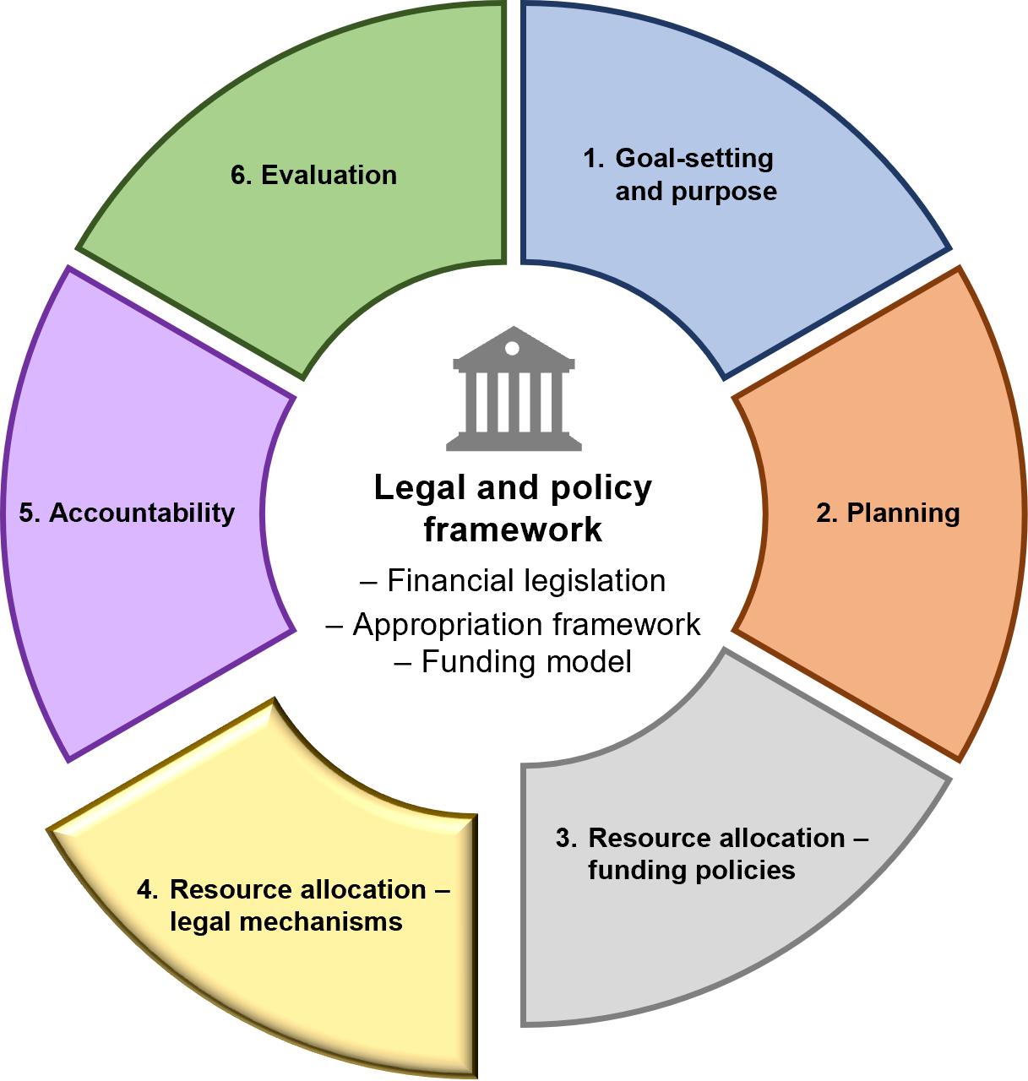

Overview
The fourth stage of the IMC is resource allocation – legal mechanisms.
This section outlines the legislation associated with managing departmental funding and obtaining additional funding. This legislation works alongside the principles of the DFM, asset funding policies, and other financial policies.

Legal mechanisms to manage funds
Possible arrangements include:
- retaining fees and charges revenue from the delivery of outputs, Commonwealth grants for specific purposes, and receipts from the disposal of surplus assets under section 29 of the FMA arrangement (see also section 4.1)
- accessing Commonwealth grants under section 10 of the FMA (see section 4.2)
- trust account arrangements – circumstances when a trust account arrangement may be suitable are outlined in section 4.3.

Legal mechanisms to request additional funds
The source of the additional funding, if approved, will be determined by the Treasurer considering the requirement to manage the overall parliamentary appropriation authority available to the Government, and within the parameters of the DFM. Possible sources of funding may include:
- supplementation through a Treasurer’s Advance under the Appropriation Act (see section 4.4)
- supplementation through a Temporary Advance under section 35 of the FMA (see section 4.6)
- borrowing against future appropriation under section 28 of the FMA
(this is a Special Appropriation provision) (see section 4.7)
- carryover of unused prior years appropriations under section 32 of the FMA (see section 4.9)
- access to balances in a department’s State Administration Unit (SAU) inter-entity account
(see section 4.10)
- access to a Public Account advance under section 37 of the FMA (see section 4.11)
- payments of awards for salaries and related costs under section 3(2) of the annual Appropriation Act.
Each of these mechanisms requires the approval of the Treasurer or relevant Cabinet committee. Departments should not assume an application to access one of these funding sources will guarantee receipt of that source of funding.
The conditions and processes for applying for most of these sources of supplementary funding are detailed in Sections 4.4 to 4.14.

Other mechanisms for varying funding
Transfer of appropriation within a department – Departments (on behalf of the relevant Minister) may also request transfers to or from other appropriation items (purposes) for that department, with the approval of the Treasurer under section 30 of the FMA.
Machinery of government changes – The Government may choose to transfer administrative responsibilities and appropriation authority between departments, under administrative arrangements ordered by the Governor in Council under the Administrative Arrangements Act 1983. Refer to the Victorian public sector operating manual on machinery of government changes issued October 2016 for more information (available on the DTF website).
Section 4.8: Transfers between items of departmental appropriation – section 30 of the FMA

The role of the Chief Finance Officer (CFO)
- CFOs are responsible for oversight of the financial management, the performance and sustainability of a department and for providing strategic advice and options to support informed decision making and organisation strategy concerning the department. Therefore, each section in this chapter includes mandatory requirements for CFO review and sign-off on supplementary funding requests.
- When funding is requested for two or more departments, the CFO of the department leading the funding proposal should obtain confirmation from the CFOs of the other department(s) that their components of the funding proposal accurately reflect their share of any relevant costs.
  - Appropriation of certain revenue and asset proceeds – section 29 of the FMA
Mandatory requirements
    - Commonwealth grants provided for specific purposes
- The Accountable Officer may lodge a request with DTF to access payments from the Commonwealth for specific purposes by one of the following means:
  - a section 29 agreement
  - utilising section 10 of the FMA.
- The Accountable Officer must discuss these options with DTF before submitting a request.
- The Accountable Office must ensure the relevant CFO is provided an opportunity to review and sign-off the costs outlined in the proposal before being submitted.
- For Commonwealth expenditure accessed via a section 29 agreement, if access to those funds is required beyond a financial year, the balance may be made available in the following year (subject to a department meeting section 32 of the FMA carryover requirements).
- The carrying over of a section 32 carryover (i.e. into a second year) is not permitted under the FMA. The Accountable Officer must only recognise/claim what they have drawn down and spent to this point in time. If applicable, the Accountable Officer on behalf of the relevant Minister may apply for access to the remaining funds by submitting a request to the Treasurer or as part of a budget bid for the relevant Cabinet committee to consider.
- The Accountable Officer must ensure funds from the Commonwealth have been deposited with DTF before accessing the appropriation.
- If the output or asset investment is delivered by the State for less than the funds provided by the Commonwealth, the excess funds may only be applied to finance activities outlined in each Commonwealth agreement. The Accountable Officer must liaise with the Commonwealth on the application of any excess funds and obtain agreement from the relevant Cabinet committee or the Treasurer.
    - User charges
- The Accountable Officer must lodge a request with DTF to establish a section 29 agreement for user charges (fee for service).
- Eligible user charge estimates must be agreed with DTF on an unchanged policy basis, i.e. each agreement shall be based on the expected level of receipts from the implementation of existing policies at current prices.
- Unless the service is new and unfunded, the agreed estimate is deducted from the gross appropriation to arrive at a net appropriation to which section 29 applies.
    - Asset sales
- The Accountable Officer of a department wishing to retain the proceeds earned from disposal of an asset or class of assets must:
  - lodge a business case with DTF regarding the disposal
  - request the relevant Cabinet committee or Treasurer’s approval (on behalf of their relevant Minister) for annotation of the proceeds to their Additions to the Net Asset Base (ATNAB) appropriation.
- The impact on the balance sheet from the asset disposal and revenue retention must be discussed with DTF before finalisation of the business case.
- The Accountable Officer must record all returns of capital to the Consolidated Fund (e.g. asset sales) in the administered entity of the department to reflect the return of the asset back to Government (i.e. DTF).

Guidance
Under normal circumstances, money received by the State for any purpose must be credited to the Consolidated Fund (under section 9 of the FMA).
However, section 29 of the FMA provides the legal authority, in conjunction with the Appropriation Act, for amounts received relating to certain receipts/revenue to be credited or annotated to a departmental appropriation item. Section 29 ‘deems’ these amounts to be appropriated for the purposes of those items.
Access to these amounts is subject to a section 29 agreement between the relevant Minister making the request, and the Treasurer.
The types of revenue (receipts) that may be considered in a section 29 agreement are:
- Commonwealth specific purpose grant revenue
- specific purpose revenue from municipal councils
- revenue from outputs (relating to user charges but excluding regulatory fees)
- receipts from asset sales.

Establishment of section 29 agreements
The following steps should be followed in developing section 29 agreements:
- Departments are to advise DTF in writing of the amount and nature of the revenue they wish to be annotated to the department’s appropriation and complete a schedule listing each revenue item for inclusion in the agreement to support the request. This schedule outlines:
  - the previous year’s revised revenue estimate amount – this is the outturn estimate, or total actual revenue (if known) for the revenue item
  - the agreed revenue estimate amount – this is the total amount estimated to be received under the agreement in the given financial year. This amount should be reviewed and agreed each year as part of each section 29 agreement.
- The CFO is expected to review and sign-off the costs outlined in the request before being submitted by the relevant Minister
- The relevant Minister then submits a formal request to the Treasurer seeking agreement
- The Treasurer may then choose to approve (or not approve) each revenue item proposed for inclusion in a section 29 agreement.
Other things to note about section 29 agreements:
- Such agreements only apply to departments
- The agreements increase a department’s annual appropriation by the actual revenue recognised (or in the case of asset sales – the actual receipt of the cash) rather than the estimated amount noted in an agreement
- For user charges, any increases in revenue that are the result of the application of competitive neutrality principles may be retained by the department (i.e. on an unchanged policy basis)
- The appropriation item must specify section 29 of the FMA in the Appropriation Act for a given year, otherwise an agreement cannot apply.
As section 29 is an annual appropriation, all section 29 agreements lapse at the end of the financial year and are therefore required to be renewed on an annual basis.

User charges
When a section 29 agreement for user charges is reached as part of the budget process, the appropriation for the particular item in the Appropriation Act is reduced by the amount estimated to be received from the source of revenue identified in the section 29 agreement.

Where estimated revenue is exceeded
If a department exceeds the agreed revenue estimate, the appropriation is increased to the value of the additional revenue and is available to the department. This revenue may be used for any purpose consistent with the appropriation item and the department’s agreed objectives and/or asset investment program.
However, there are different types of revenue arrangements under section 29 of the FMA.

Commonwealth specific purpose grant revenue, and specific purpose revenue from municipal councils
Departments should not claim revenue under a section 29 arrangement if those funds are not needed in the year to meet costs incurred. If access to excess revenue from these sources of funds is required in the following financial year, departments may apply for carryover of these funds subject to the approval of the Treasurer. Alternatively, departments may apply to access these funds through section 10 of the FMA.
Section 4.2: Commonwealth grants – section 10 of the FMA
Section 4.9: Carryover of unused appropriation – section 32 of the FMA

Revenue from outputs (relating to user charges)
In some cases, departments could exceed the revenue estimate for user charges but will not have spent the additional revenue by the end of the year. For example, if there is an overcollection of user charges relative to the expenditure incurred, this may result in a surplus that will accrue in a department’s SAU inter-entity account. Departments may then apply for access to these surpluses in a subsequent year subject to the approval of the Treasurer.
Section 4.11: Public Account advances – section 37 of the FMA

Receipts from asset sales
Departments may only draw down on the actual cash received from an asset sale and only to the extent required in the current year to fund cash outflows for approved investments. Any unspent receipts at year end are then subject to section 32 carryover.

Accounting for section 29 revenue
The accounting treatment for the recognition of section 29 revenue flows is depicted in Figure 8.
Figure 8: Accounting for recognition of section 29 revenue flows
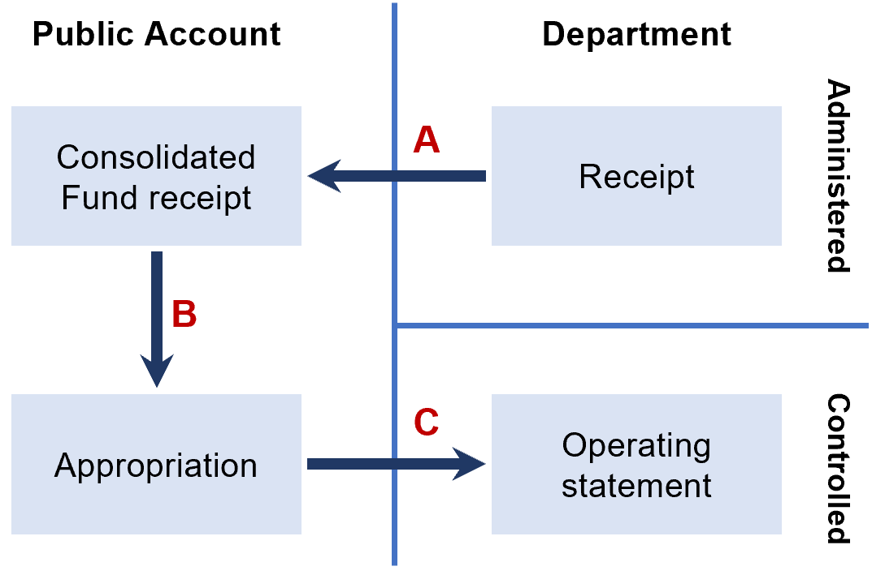
Step A: All cash received by a department is recognised as administered and is required under section 9 of the FMA to be paid into the Consolidated Fund. Normal accounting standards are applicable for revenue recognition by the State.
Step B: If the revenue relates to user charges, Commonwealth grants, and/or sales of non-current physical assets, and a section 29 agreement is in place, the relevant appropriation item is increased accordingly.
Step C: The Treasurer may apply the appropriation. The department then recognises the revenue as controlled.

Specific purpose payments from the Commonwealth (refer Mandatory Requirement 4.1.1)

Eligibility
The Commonwealth Government provides grants to the states for specific purposes under section 96 of the Commonwealth Constitution.
Section 29 agreements for Commonwealth grants received for specific purposes are arranged at the start of each financial year, or on the receipt of the grants from the Commonwealth.
There are currently two types of tied Commonwealth grants for specific purposes: Specific Purpose Payments (SPPs) and National Partnership Payments (NPs). These grants are received into the Consolidated Fund first (with the exception of Health Reform grants) and then appropriated.
Commonwealth grants that do not qualify for a section 29 agreement include:
- grants provided for on-passing paid directly into a trust account, including the National Health Reform Agreement, which is subject to a separate process
- general purpose grants paid into the Consolidated Fund.
Not all specific purpose payments are for State budget programs. A substantial proportion of these are for on-passing to other parties, such as non-government schools and local government authorities. In most of these cases, the State simply acts as a vehicle for distributing the Commonwealth funds via a trust account in the Trust Fund. In addition, a number of other relatively small Commonwealth grants are paid direct to specific trust accounts in the Trust Fund and similarly are not subject to appropriation.

Application (revised under the accounting standards changes)
Commonwealth grants received for specific purposes (SPPs or NPs) that are paid to the Consolidated Fund are to be included in section 29 agreements. Commonwealth grants paid directly into a trust account are excluded from such arrangements.
Under accounting standards AASB 15 and 1058, if transactions occur in an enforceable agreement with another party and that agreement includes sufficiently specific performance obligations, revenue can only be recognised when the entity has fulfilled its performance obligation. Previously, revenue recognition was allowed when funds were received, regardless of whether performance obligations had been fulfilled.
Under AASB 1058, revenue can only be recognised on capital projects in line with the construction profile of the asset. Departments need to ensure the revenue accessed under section 29 has in fact been earned, in the same reporting period as it is claimed. This is unlikely to be the case where advance payments for capital projects to agencies are made, for example.

User charges (refer Mandatory Requirement 4.1.2)

Eligibility
A section 29 arrangement for user charges may be established to provide departments with access to revenue they generate from the sales of goods and services (outputs).
Section 29 agreements for user charges are not mandatory. Such arrangements are only established by agreement on an annual basis between the relevant Minister and the Treasurer.
User charges need to be carefully distinguished from other forms of revenue such as regulatory fees (also classified in accounting terms as user charges), fines, dividends, interest and taxes as these are not eligible for retention. Care needs to be taken in making this distinction, as in some cases there is a fine line between regulatory fees and other user charges.
The following criteria should be used in determining whether a revenue item is a valid user charge:
- The revenue should stem from payments made voluntarily for goods and services provided
- The payments made and the benefits gained by the user can be clearly linked to the provision of the products and services.
Regulatory fees on the other hand are characterised by one or more of the following:
- They are compulsory and serve primarily as an instrument of government policy
- They generally reflect the granting of a privilege or right to undertake a regulated activity.

Application
Section 29 agreements are based on the principle of applying current prices.
The ‘current price’ of the base amount does not automatically mean existing prices are indexed by the forecast Consumer Price Index (CPI). Depending on the nature of the service, this may need to be determined on a case-by-case basis.
DTF’s cost recovery guidelines, available on the DTF website.

Goods and services tax
Under the provisions of the Commonwealth A New Tax System (Goods and Services Tax) Act 1999, fees and charges paid to a government department are deemed to be subject to the goods and services tax (GST).
Departments should refer to Division 81 of the Commonwealth Act to identify any Victorian Government fees and charges that are excluded from GST.
Given Victorian public sector departments and agencies are registered separately for GST purposes, they should regularly review the fees and charges, as they will individually be responsible for the management and remittance of GST to the Australian Tax Office.
Note that when preparing a section 29 agreement, the revenue items that comprise the agreement will be exclusive of GST.

Receipts from asset sales (refer Mandatory Requirement 4.1.3)

Eligibility
The cash proceeds from the sale of departmental controlled (not administered) physical assets may be accessed through a section 29 agreement.
The Treasurer must agree to:
- the proposed sale of the particular asset or class of assets
- the amount derived from the sale to be annotated to the department’s ATNAB appropriation if only a portion of the proceeds are to be annotated.
A department wishing to use a section 29 agreement for asset sales, should include any proposal to dispose of assets or class of assets in their budget funding business cases for new asset investment.
Departments are encouraged to think broadly about possible opportunities for asset disposal as part of any asset initiative development.

Application
Timing issues associated with accessing the proceeds of sale will be unique to each situation. Where the proceeds of sales are to be applied to asset replacement, there may be a need to arrange an advance of funds to cover the period before sale proceeds become available.
Other issues may include:
- the change of accounting treatment regarding the asset (e.g. a non-current physical asset may have a different value when converted to an asset held for resale)
- the estimate of anticipated proceeds
- the impact of actual proceeds being different to the estimate
- responsibility for the costs associated with the disposal
- interest by other agencies in acquiring the asset in question.
Discussions will be held with each department on the configuration of balance sheets in the context of budget formulation. At this time, the options for asset disposal and the opportunity for the retention of proceeds will be discussed and tested.
  - Commonwealth grants – section 10 of the FMA
Mandatory requirements
    - Conditions for accessing section 10 of the FMA
If applicable, the Accountable Officer, may (on behalf of the relevant Minister) make an application for a special appropriation to access Commonwealth funds under section 10 of the FMA if one or more of the following conditions apply:
- it is a new Commonwealth agreement established during the year
- if it is likely funds will be required to be accessed beyond the next financial year.
    - Managing requests under section 10 of the FMA
The Accountable Officer must ensure:
- all options for accessing payments from the Commonwealth are discussed with DTF before submitting a request
- the relevant CFO is provided an opportunity to review and sign-off the costs outlined in the proposal before being submitted
- funds from the Commonwealth have been deposited into the Consolidated Fund before accessing the appropriation
- a letter from the relevant Minister to the Treasurer seeking access to Commonwealth funds under section 10 of the FMA includes:
  - the reasons for the request
  - the quantum being sought to access
  - appropriate supporting documentation from the Commonwealth
  - how the funding request aligns with Government objectives
  - adjustments to output and financial performance targets arising from the request.

Guidance
Section 10 of the FMA provides a special appropriation for access to Commonwealth grants paid into the Consolidated Fund.
Governor in Council approval is required for a section 10 FMA request.
Appropriate supporting documentation should be maintained and provided to DTF for each section 10 FMA application in each year. This helps demonstrate that the Commonwealth funding received is available for the intended purpose outlined in the agreement with the Commonwealth.
  - The Trust Fund and trust accounts
Mandatory requirements
    - Creating a trust account
- When a trust account is being created through legislation, the Accountable Officer must inform DTF about its impending creation and advise DTF when it is established to process the requirements to administer and report on the trust account.
- When a trust account is proposed to be set up under the Minister for Finance’s powers under the FMA, the Accountable Officer must submit a letter of request from the relevant Minister to the Minister for Finance, who will then consider the proposed trust account.
    - Reviewing trust accounts
- The Accountable Officer must maintain and periodically review its trust accounts to determine if there is a continued need for each trust account and that the appropriate amounts are in it.
    - Varying expenditure from trust accounts
- The Accountable Officer must submit a letter from the relevant Minister to the Treasurer to request any material variations to budgeted expenditure from a trust account. This requirement does not apply however if the proposed variation has already been considered by either:
  - the relevant Cabinet committee
  - the Treasurer, if the Treasurer administers the trust account.
- The Accountable Officer must ensure that no such variation is made unless it has been approved by the relevant Cabinet committee or the Treasurer.
    - Specific requirements for the Treasury Trust Fund
- The Accountable Officer must not set up new arrangements in the Treasury Trust Fund unless it is for its original and intended purpose (i.e. the recording and accounting for unclaimed and unidentified moneys held by departments)
- The Accountable Officer must undertake a regular review of their activity in the Treasury Trust Fund to ensure inappropriate balances do not build up in the Treasury Trust Fund
- The Accountable Officer must ensure moneys left unclaimed or unidentified in the Treasury Trust Fund after a period of seven years are transferred to the Consolidated Fund.
    - Closing trust accounts
The Accountable Officer must:
- request the Minister for Finance to close a trust account when the purpose for which it was created no longer exists
- ensure any residual money from closing a trust account is credited to another trust account or to the Consolidated Fund, as directed by the Minister for Finance.

Supplementary requirements (attestation not required)
For the inter-departmental trust account
- Grants provided to one portfolio department may be transferred to and held in the inter-departmental transfer trust account for use by another portfolio department for the funding of a specific initiative or program.
- This trust account must not hold any physical assets and must not be overdrawn
- Moneys left unspent from the inter-departmental transfer trust account after three years must be returned to the Consolidated Fund.

Guidance
The Trust Fund forms part of the State’s Public Account as a separate and discrete component from the Consolidated Fund. Part 4 of the FMA (sections 19 to 23) covers the Trust Fund.
Trust accounts in the Trust Fund may be established by either:
- an Act of Parliament, under legislation for a specific purpose
- the Minister for Finance, under section 19(1) of the FMA (defining the purpose for which they are established), following a request from a department.
A trust account established by a statute will be restricted to the purposes set out in that statute.
Trust accounts are usually established for the use of a single department, although in some instances a trust account may be accessed by more than one department or may be generic in nature.
Trust Fund and trust account in government finance are often confused with a trust in property and estate law.
A trust is a structure under which the legal ownership of property (which may be cash, real estate or any other kind of lawful property) is vested in a party (a company or natural person/s), called a ‘trustee’. The trustee holds the property on behalf of one or more other parties, called the beneficiary/ies. The beneficiary/ies are the equitable owner/s of the trust property. Trustees have a legal obligation, termed a ‘fiduciary duty’, to manage the trust property solely for the benefit of the equitable owners.
A fund is a ledger account in which money is held for a specified purpose or set of purposes. The balance of the fund may be held as cash in a specific fund bank account, or as part of a more general bank account, or in other forms of investment.
A trust body is ‘a body (including a trustee or trustees) who or which, or any office the holder of which, is charged with the control or management of any trust, fund, account or superannuation scheme which is established by an Act or enactment or by the Governor in Council or a Minister’. A trust body is an entity (which may be a natural person or persons) with a fiduciary duty to manage financial assets.
In contrast, a trust account is a ledger which records an amount that may legally be drawn (if the conditions applying to the trust account are met) from the section of the Public Account which represents the Trust Fund (the Consolidated Fund comprises the rest of the Public Account). Money in a trust account may be held under a fiduciary duty and hence is in that sense held ‘in trust’, but only very rarely will there be a trust in a legal sense, i.e. an arrangement under which legal ownership is vested in appointed trustees.
If a trust account is set up to support an activity, policy, program or service which meets the requirements under the GE Act, a gender impact assessment will be required. This might occur prior to the request to establish a trust account, as part of the approval of the new activity, or as part of the same request if the activity and trust account are being proposed in a combined request. If a gender impact assessment has already been undertaken, an additional one is not required for the purposes of establishing a trust account.
A trust account is not a trust body, and is not in itself able to own property, incur liabilities, enter into contracts, or do any other thing that a legal person may do. This includes trust accounts established under section 19 of the FMA.
The Trust Fund comprises the following types of accounts.

State Government trust accounts
Established to record the receipt of certain State funds and their disbursement for specified purposes. These include trust accounts established to record the receipt and disbursement of State revenues, which are hypothecated (through special appropriations) to particular purposes, e.g. gaming revenue is hypothecated for the provision of health services.

Commonwealth and joint Commonwealth and State accounts
Established to record the receipt and disbursement of specific purpose payments from the Commonwealth Government, which are on-passed by the State to other organisations (such as non-government schools and local government). These accounts are generally established to comply with Commonwealth legislation or specific agreements with the Commonwealth.

Specific purpose operating accounts
Established to essentially quarantine commercial activities in departments from the rest of the department’s business. They include:
- specific purpose trust accounts established under section 19 of the FMA
- working accounts established under section 23 of the FMA
- trust accounts established under specific legislation.

Treasury Trust Fund, agency and deposits accounts
Some of the larger accounts in this category are the Victorian Government Solicitor’s Trust Account, Estate Agents Guarantee Trust Account, Conservation Agency Trust Account, Finance Agency Trust Account, and Public Works Agency Trust Account.
Revenue in Treasury Trust Fund includes:
- unidentified money and unpresented cheques
- suspense accounts established for accounting purposes
- working accounts established for departmental commercial and service units
- the inter-departmental transfer trust account
- accounts established to facilitate the receipt and disbursement of private funds held by the State in trust. These moneys may include bequests, donations, prizes, scholarships and research grants. This is generally in the form of a genuine fiduciary trust, which can be either administered or controlled by the State and mostly involves management of money provided by a member or members of the public for a specific purpose.
The specific purpose for the establishment of each trust account is either defined by the Minister for Finance (under section 19 of the FMA) or is contained in a separate statute.

The inter-departmental transfer trust account (SRIMS authority code 4740)
This trust was established in mid-June 2017 to facilitate the transfer of moneys (grants) from one portfolio department to another.
This trust account is not meant to hold assets apart from money and, similar to other trust accounts, cannot be overdrawn.
Revenue other than grants (e.g. the retention of revenue generated from sales of goods and services) should utilise alternative legal or funding mechanisms to access those funds (e.g. section 29 of the FMA).
The Minister for Finance may direct any unspent moneys, when the purpose of the grant has been fulfilled, be remitted back to the Consolidated Fund.

Criteria to consider when requesting the creation of a trust account
A department should consider the following criteria when requesting the creation of a new trust account:
Criterion 1 – Purpose of the proposed trust account
- What is the purpose of the intended trust? (It should be clearly explained)
- Could an existing trust account be used for the required purpose?
- Given the flexibility of the appropriations framework, would a section 29 arrangement suffice?
Criterion 2 – A need to quarantine/set aside the money from the rest of the department’s operations
- Are the moneys being held under a fiduciary duty to an external party?
Is it likely to be a long-term arrangement?
- Is there legislation that prescribes such an arrangement be set up (e.g. pursuant to a Commonwealth Act)?
- Are there other agreements or arrangements in place that require having such moneys separated in the Public Account?
- Without a specific trust account, would existing financial management systems be inadequate to clearly separate the external party transactions from core departmental business?
Departments should also consult DTF at the earliest opportunity to determine the appropriateness of any proposed trust account arrangement.

Note on trust accounts established under section 19(1) of the FMA
Departments need to be aware that the establishment of a trust account under section 19(1) of the FMA does not provide automatic authority for that trust account to receive funds into it. While the Minister for Finance can set terms and conditions for a trust account, section 19(1) section of the FMA does not provide any power for the Minister for Finance to direct funds into a trust account and therefore does not extend to over-riding any other provisions of the FMA.
Therefore, unless specific arrangements apply, revenues received by departments must be paid into the Consolidated Fund, under section 9(2) of the FMA. Other enabling legislation is then required to move funds from the Consolidated Fund into a trust account.
Examples (but not an exhaustive list) of possible authority are appropriations under:
- Section 29 of the FMA
- Section 10 of the FMA (where the Commonwealth defines the purpose of the funding).

Interest earned from trust accounts
Money which the trust account generates from interest is money raised ‘by or on behalf of the State’. This means that the interest will be paid into the Consolidated Fund, unless an appropriate authority is in place, such as a legislative provision, that will allow interest payments to be paid directly into the trust account, rather than the Consolidated Fund. This needs to be considered when a new trust account is established.
Examples of these provisions include:
- Section 271G of the Marine Safety Act 2010, which states ‘There must be paid into Better Boating fund … all money that is received from the investment of money in the Better Boating Fund’
- Section 8(1) of the Victorian Future Fund Act 2023, which states ‘The following are to be credited to the Victorian Future Fund … (s) all money received from the investment of money in the Victorian Future Fund‘.

Investment of money in trust accounts
Section 21 of the FMA provides that the Minister for Finance may invest money standing to the credit of a trust account, but interest on money invested can only be credited to the trust account if the money is a deposit under section 20, or if crediting of interest is provided for in specific legislation.
The investment of funds held in a trust account is subject to the Standing Directions or specific legislation.

Management of moneys in trust accounts
Trust accounts must not be overdrawn at any time, unless this is specifically permitted by legislation. Otherwise, commitments to expenditure may only be made from a trust account where there is sufficient cash available in the trust account to cover the expected payments.
If a payment is required to be made that would result in a trust account becoming overdrawn when this is not permitted by legislation, an advance or other legally available source of funds must be sought as soon as practicable before the payment is made so the trust account is not overdrawn. If some or all of the amounts held in a trust account have been invested, these investments are only considered to be available to pay expenditure if fully liquid (e.g. at-call investments). Note it is not appropriate to incur an interest expense on funds obtained to cover any shortfalls in a trust account without the Treasurer's agreement.
Departments manage their trust accounts, with proposed revenue and expenditure for each trust account incorporated into their budgetary plans for each year. Departments may draw from a trust account in accordance with their approved budget without approval from the Treasurer or the relevant Cabinet committee being required (unless such a requirement is specified under legislation).
However, if a department becomes aware that a material variation to budgeted expenditure from a trust account will be necessary or is considered desirable, the Accountable Officer is required to obtain approval for the variation from either the relevant Cabinet committee or the Treasurer.
DTF will advise each department from time to time of the amount that is considered to be a material variation with respect to each trust account managed by the department.

Accounting for trust accounts
Each specific trust account is identified by a unique trust authority (i.e. the third segment of the whole of government chart of accounts) and contains ledger accounts, which can potentially record revenue, expenses, investments, assets and liabilities (i.e. the full range of natural accounts) for certain departmental activities.

Change in purpose of trust accounts
Minister for Finance approval is required to change the purpose of a trust account, unless that change of purpose has been legislated.

Renaming of trust accounts
Trust accounts may be renamed to better reflect their purpose. The approval of the Minister for Finance is not required for this to occur, although DTF should be notified of the details of the intended change.

Process for the closure of a trust account
The FMA authorises the Minister for Finance to make a direction to close a trust account where appropriate. However, a trust account established by statute is to be closed by further legislation, or by the means, if any, specified in the statute.
Where a trust account has been created by legislation that does not provide a means of closing that trust account, or of dealing with any residual balance, the legislation will need to be amended.

Reporting on trust accounts
For reporting purposes trust accounts fall into two categories:
- Controlled trust accounts: where the responsible department can make decisions about how the funds are used
- Administered trust accounts: for which decisions about how the funds in the accounts are used are made outside the department. The department’s responsibility for these trust accounts is limited to processing the trust account’s receipts and payments.
The assessment of whether a trust account is deemed to be controlled or administered is entirely the responsibility of the department concerned. As such, decisions will be subject to audit review, they should consult with their relevant director at the Victorian Auditor-General’s Office in the determination of the appropriate classification.
The financial transactions and balances of accounts in the Trust Fund are reported in the financial reports of the administering departments.
A high-level summary of these transactions and balances is also included in the State’s annual Financial Report. Departments are required to report on both categories of trust accounts in their audited financial statements.

Specific trust accounts – further details

Departmental working accounts
Departmental working accounts in the Trust Fund provide a means of giving departments direct access to user charge receipts for those activities conducted on a commercial basis separately from core departmental activities. Section 23 of the FMA governs the establishment and operation of departmental working accounts.
The main requirements for a departmental working account are that:
- the activity is done by a discrete business unit, operating to a business plan and producing its own set of accounts
- the charges applying to the activity comply with the Competitive Neutral Pricing Policy
- provision is made for a dividend on any profit component, to be repaid to the Consolidated Fund.

The Treasury Trust Fund
The Treasury Trust Fund was originally established under the Audit Act 1958 to facilitate the recording and accounting for unclaimed and unidentified moneys held by departments.
However, over time the uses of the Treasury Trust Fund have expanded beyond this purpose without clear direction. Therefore, the use of the Treasury Trust Fund is strictly monitored by DTF.
To assist in meeting the needs of cross-departmental activity/program delivery and emerging Trust Fund needs, the inter-departmental transfer trust account has now been established to manage grant transfers between departments. This trust account should be used in place of the Treasury Trust Fund when transferring such amounts between departments.
  - Treasurer’s Advance for urgent and unforeseen claims
Mandatory requirements
    - Managing requests for Treasurer’s Advance
The Accountable Officer must ensure:
- all requests for Treasurer’s Advance made by ministerial correspondence to the Treasurer are discussed with DTF, including the quantum of funding sought, details of any gender impact assessments and, if practicable, intersectional analysis undertaken, before any correspondence is prepared for the request
- the relevant CFO is provided an opportunity to review and sign-off the costs outlined in the proposal before being submitted
- a letter from the relevant Minister to the Treasurer seeking a Treasurer's Advance includes:
  - the reasons for the funding request, including whether the request is urgent and/or unforeseen
  - the quantum of the funding sought
  - confirmation that there are no other sources available to fund the request
  - how the funding request aligns with government objectives adjustments to output and financial performance targets arising from the request
  - an outline of the results of any gender impact assessment, or the reasons why one was not required
  - funding variations previously approved by the Treasurer or the relevant Cabinet committee for the program or output seeking an advance.
- requests for funding in the current financial year being made by submission to a Cabinet or Cabinet committee include the information specified in (c) above, within the appropriate template, and costings prepared in accordance with guidance provided in this section and agreed with DTF before lodging the submission.
    - Reporting on Treasurer’s Advance expenditure
All expenses and obligations to which any Treasurer’s Advance is applied must be reported in the financial year in which the advance was made.
    - Restrictions on Treasurer’s Advance
Any unapplied component of a Treasurer’s Advance in a given year lapses at the end of the year. The Accountable Officer is not permitted to carry over a Treasurer’s Advance to the following year.

Guidance

Definition
Consistent with the Integrated Management Cycle (IMC), departments are expected to plan for the coming year and set budgets accordingly. However, at times situations will arise that were not factored into the annual budget.
The Treasurer’s Advance (TA) represents a specific appropriation made available to the Treasurer each year as part of the annual Appropriation Act, to meet any ‘… urgent claims that may arise before parliamentary sanction is obtained’. Parliamentary sanction is obtained through the tabling in a subsequent financial year’s annual Appropriation Bill, which includes a schedule outlining all payments made against TA in that previous financial year.
Urgent claims are those where issues have become known to departments, or where spending by a department has become necessary, after the Appropriation Bill for that year was finalised, and for which a funding is needed within the same financial year. (i.e. a response cannot wait until a future financial year). The most common reasons for urgent funding to be required are to respond to emergencies (natural disasters, pandemics, etc) or to respond to other external events (e.g. a Commonwealth Government decision, action or requirement).
The Treasurer, or the relevant Cabinet committee, may also approve in-principle TA to address unforeseen issues, with a final decision made by the Treasurer as part of year-end processes. Unforeseen issues are those where either:
- they are outside the department’s control and could not reasonably have been predicted by a department during the annual planning process
- the scope unexpectedly exceeds departments’ expectations due to factors outside the department’s control
- the timing unexpectedly changes due to factors outside the department’s control.

Treasurer’s Advance also includes central contingencies (refer to RMF 4.5 for details). Central contingencies for outputs and assets are outlined in the notes of the estimated financial statements. These are categorised by ‘output milestone’, ‘future services demand allocation’ and ‘provision of unforeseen circumstances’ for outputs and by ‘asset milestone’ and ‘future growth allocation for assets’.

Costings information to be provided to DTF
- Except in rare circumstances, costings should be presented in a spreadsheet format, with all calculations, formulae and assumptions visible and accessible, including source raw data.
- Unit prices and quantities should be clearly set out and justified
- Staffing costs are to be derived using standard costing methodologies such as DTF’s standard costing model for VPS staff
- All other models/methodologies and assumptions are to be agreed with DTF prior to use
- Financial implications should be presented across the forward estimates period and should include ongoing costs (if necessary).

Conditions
TA capacity is limited to the amount that appears in Schedule 1 of the Appropriation Act under DTF. As such, the Treasurer will initially only provide approval in-principle for successful funding requests. The final source of funding for this supplementation will be reviewed by DTF and confirmed by the Treasurer towards the end of the financial year, considering total TA capacity and other available sources of departmental appropriation authority.
TA may be applied to output or asset funding requests. This is determined by the Treasurer, informed by advice from DTF.

Reporting
Accountability for use of the TA is met through:
- the presentation of a summary of each year’s expenditure in the State’s annual Financial Report, which is tabled in the Parliament after the end of each financial year
- the next year’s Appropriation Act.

Application and assessment process
A Minister may apply for budget supplementation from TA through one of two mechanisms (refer to Figure 9):
- by submitting a letter of request to the Treasurer
- through policy proposals or additional financial support sought through the relevant Cabinet committee submissions. Where these are approved by Government, TA is the mechanism used to increase the department or agency’s appropriation limit for the funding component required within the current financial year (or in some cases following year – if the Appropriation Bill for that year has already passed).
In either case, each request is assessed by DTF and advice is provided to the Treasurer or the relevant Cabinet committee. In the case of a direct request via letter from Minister, the Treasurer will then determine whether to fund the request. For submissions to the relevant Cabinet committee, when the Government makes the policy decision to fund a new initiative, in-principle approval for TA is reflected in the estimates, subject to a final assessment of available funding sources (as per Mandatory Requirement 4.4.1(c) (iii)) at year end, and a final decision by the Treasurer. The ultimate funding source will often, but not always, be TA.
Any requests to the relevant Cabinet committee for additional funding within a financial year should be discussed with DTF and costings agreed by DTF, as required in relevant Cabinet committee submission templates.
Figure 9: Budget supplementation mechanisms to utilise Treasurer’s Advance
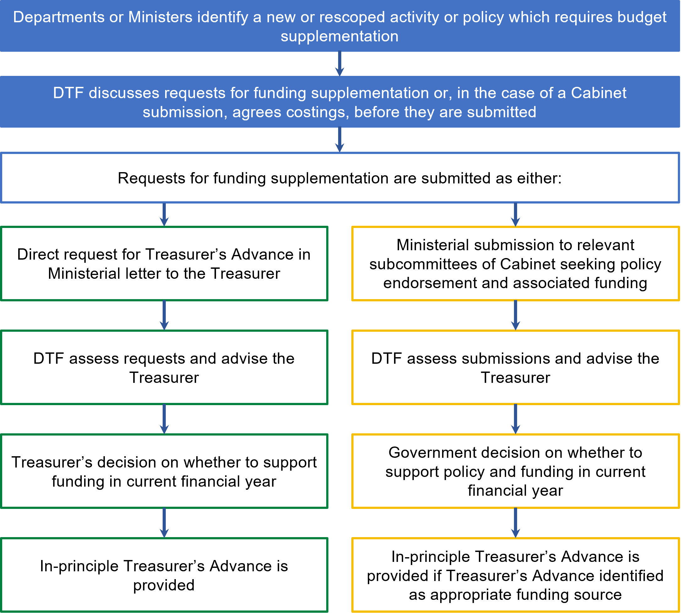

Additional notes
- A TA request is for funding in the current financial year only. If changes in funding are required in the other forward estimates years, this should be foreshadowed in the TA request and a submission should then be made as part of the annual budget process. Proposals considered by Cabinet or the relevant Cabinet committee which include impacts on forward estimates years will result in adjustments to the estimates if the proposal is approved.
- For requests for TA to access previously approved funding held in contingency, please refer to section 4.5.
Section 4.5: Central contingencies

Approval notification
Where Treasurer’s Advance is approved directly by the Treasurer, approval will be confirmed by return correspondence to the Minister making the request. Where Treasurer’s Advance funding is approved by Cabinet, or the relevant Cabinet committee, the committee minutes will confirm the decision. Departments will need to make contact with DTF to confirm the administrative arrangements required to implement the decision.
DTF will also advise the department on the following if the funding request is approved:
- the source of the funding
- the revenue limit
- adjusted output and financial performance targets (if relevant).
  - Central contingencies
Mandatory requirements
    - Managing requests to access central contingencies
In requesting access to funding from central contingencies for previously approved government funding decisions, the Accountable Officer must ensure the request documentation to DTF includes:
- the reasons and context for the request
- the quantum of the funding sought
- reference to the Government decision to support the request
- how the funding request aligns with government priorities
- proposed adjustments to output and financial performance targets arising from the request
- any funding variations previously approved by the Treasurer or the relevant Cabinet committee for the program or output.
    - Reporting expenditure from central contingencies
All expenses and obligations to which any funding from central contingency is applied, if related to funding from the Treasurer’s Advance, must be reported in the financial year in which the funding was provided.
    - Restrictions on central contingencies
Any unapplied component of funding from central contingency from a Treasurer’s Advance in a given year lapses at the end of the year. The Accountable Officer is not permitted to carry over contingency funding sourced from Treasurer’s Advance to the following year.

Guidance

Definition
Central contingencies are provisions established by the Government for future expenditure which have not yet been allocated to specific departments. These contingencies are held and managed by DTF. Central Contingencies are mostly funded through the Treasurer’s Advance and are considered a special category of the TA.
Government may set aside central contingencies to provide for:
- service growth
- new initiatives in future budgets
- government decisions which for various reasons are not recorded in the relevant department’s or agency’s financial statements at that time
- future cost pressures
- urgent and unforeseen expenditure.
Central contingencies for outputs and assets are outlined in the notes of the estimated financial statements. These are categorised by ‘output milestone’, ‘future services demand allocation’ and ‘provision of unforeseen circumstances’ for outputs and by ‘asset milestone’ and ‘future growth allocation for assets’. Treasurer’s Advance forms a part of the central contingencies.

Application and assessment process
When a request is made to the Treasurer or relevant Cabinet committee for the release of budget funding held in central contingency, advice is provided by DTF to the Treasurer or the relevant Cabinet committee.
The Treasurer or the relevant Cabinet committee will decide whether to approve the release of the central contingency to the relevant Minister.

Approval notification
Departments will be advised if the release from the central contingency is approved.

Reporting
Accountability for use of the Treasurer’s Advance, in the context of the central contingencies, is also met through the presentation of a summary of each year’s expenditure in the State’s annual Financial Report, which is tabled in the Parliament after the end of each financial year.
  - Supplementation under section 35 of the FMA
Mandatory requirements
    - Managing requests for supplementation under section 35 of the FMA
The Accountable Officer must ensure:
- all requests for supplementation under section 35 of the FMA are discussed with DTF, including the quantum of funding sought, before any correspondence is prepared for the request
- the relevant CFO is provided an opportunity to review and sign-off the costs outlined in the proposal before being submitted
- a letter from the relevant Minister to the Treasurer seeking supplementation under section 35 of the FMA includes:
  - the reasons for the funding request
  - the quantum of the variation sought
  - confirmation that there are no other sources available to fund the request
  - how the funding request aligns with government objectives
  - adjustments to output and financial performance targets arising from the request
  - funding variations previously approved by the Treasurer or the relevant Cabinet committee for the program seeking the supplementation.
    - Reporting supplementation under section 35 of the FMA
All expenses and obligations to which any section 35 of the FMA request is applied must be reported in the financial year in which the supplementation was provided.

Supplementary requirements (attestation not required)
Restrictions on Temporary Advance
- If any component of a section 35 of the FMA supplementation in a given year remains unapplied (i.e. unspent) at the end of the financial year, it may only be carried over to the following year with the approval of the Treasurer (section 35(4) of the FMA).

Guidance

Definition
Section 35 of the FMA authorises the Treasurer to issue funding out of the Public Account to enable a Minister to meet urgent claims in the current budget year. Such urgent claims for budget supplementation may include funding required for additional output and asset investment initiatives approved by the relevant Cabinet committee.
Parliamentary sanction is required for this funding pursuant to the specific wording of section 35 itself. This is addressed in a subsequent year’s Appropriation Bill.
In a single budget year, the Treasurer is only authorised under section 35 to issue temporary advances of up to 0.5 per cent of the total amount appropriated by the annual Appropriation Act (the main bill) for that year.

Conditions
The Treasurer will initially only provide approval in-principle for successful funding requests under section 35. The final source of funding for this supplementation will be reviewed by DTF at the end of the financial year, considering other available sources of departmental funding.
The Treasurer is only able to approve section 35 advances in the year they apply. Advances cannot be approved after the end of the financial year.

Reporting
Accountability for use of section 35 is met through:
- the presentation of a summary of each year’s expenditure in the State’s annual Financial Report, which is tabled in Parliament after the end of each financial year
- the following year’s Appropriation Act (for section 35 funding arising late in a financial year after the figures for the following financial year’s Appropriation Bill have been set, the accountability will be through the subsequent year’s Appropriation Act).

Application and assessment process
A Minister may apply for budget supplementation from section 35 by submitting a letter of request to the Treasurer.
Each request is assessed by DTF and advice is provided to the Treasurer. The Treasurer will determine whether to fund the request.

Approval notification
The Treasurer will provide return correspondence to the Minister making the request.
DTF will also advise the department on the following if the funding request is approved:
- The source of the funding
- The revenue limit
- Adjusted output and financial performance targets (if relevant).

The difference between a Treasurer’s Advance and supplementation under section 35 of the FMA
A TA and supplementation under section 35 of the FMA provide the Government with two sources of (almost identical) additional funding to supplement the budget in a given year. The key difference is that the TA appropriation is accounted for in the budget estimates and the Annual Appropriation Bill (under the Treasury and Finance portfolio), whereas funding legally available under section 35 is generally not included in the estimates.
In practice, this has meant section 35 has been used to fund capital expenditure (which does not impact the operating statement), while Treasurer’s Advance is usually reserved for both operating (output) expenditure and capital (asset) expenditure. Note there is no provision in the FMA or elsewhere that precludes section 35 being used to fund operating expenditure, or TA being used to fund capital expenditure.
DTF will determine the final funding sources and seek approval from the Treasurer accordingly to use this section of the FMA.

  - Borrowing against future appropriation – section 28 of the FMA
Mandatory requirements
    - Managing requests to borrow against future appropriation under section 28 of the FMA
The Accountable Officer must ensure:
- all requests for borrowing against future appropriation are discussed with DTF, including advising of the quantum of the funding sought, before any correspondence is prepared for the request
- the relevant CFO is provided an opportunity to review and sign-off the costs outlined in the proposal before being submitted
- a letter from the relevant Minister to the Treasurer seeking supplementation from section 28 of the FMA, includes:
  - the reasons for the funding request, including how the request aligns with the specific requirements of section 28. Specifically:
    - why it is considered prudent and advantageous to expend the money in the current financial year
    - why the benefit of that allocation will accrue, or continue, in the next financial year.
  - the quantum of the additional funding sought
  - that there are no other sources available to fund the request (or demonstrate there is an inability to redeploy existing resources to meet assessed requirements)
  - how the funding request aligns with government objectives
  - adjustments to output and financial performance targets arising from the request
  - funding variations previously approved by the Treasurer or the relevant Cabinet committee for the program seeking the advance.
    - Reporting on section 28 of the FMA expenditure
All expenses and obligations to which any section 28 of the FMA advance is applied must be reported in the financial year in which the advance(s) was made.

Guidance

Definition
Section 28 of the FMA requires authorisation from the Governor in Council, on the recommendation of the Treasurer, to supplement, i.e. to add additional amounts to a department’s annual appropriations.
Section 28 supplementation is deemed a special appropriation

Conditions
For a section 28 request to be approved, the FMA states the Treasurer must not recommend the allocation to the Governor in Council unless the Treasurer is ‘satisfied this allocation is for a prudent and advantageous purpose in the current financial year, and the benefit will accrue, or continue, in the next financial year’. Typically, this may apply to new capital projects or to capital projects that have been brought forward for continuation or completion. A successful justification for expenditure on outputs would be more difficult to sustain.
Under section 28 an amount issued must not exceed three per cent of the department’s total (gross) annual appropriation for the year. The total available across all departments is 0.5 per cent of the total annual appropriation for that year.

Reporting
Accountability for use of section 28 is also met through the presentation of a summary amount in the State’s annual Financial Report, which is tabled in Parliament after the end of each financial year.

Application and assessment process
A Minister may apply for budget supplementation from section 28 of the FMA by submitting a letter of request to the Treasurer.
Each request is assessed by DTF and advice is provided to the Treasurer. The Treasurer will determine whether to recommend the funding proposal to the Governor in Council for approval.

Approval notification
The Treasurer will provide return correspondence to the Minister making the request. DTF will also advise the department on the following if the funding request is approved:
- the source of the funding
- the revenue limit
- adjusted output and financial performance targets (if relevant).

The difference between a ‘bring forward’ of appropriation under section 28 of the FMA and a payment from the Public Account under section 37 of the FMA
A ‘bring forward’ (which, as indicated earlier, is really a supplementation) of appropriation under section 28 of the FMA and an advance from the Public Account under section 37 of the FMA each provide the Government with additional funding to supplement the budget in a given year. Neither of these funding sources are budgeted for in the budget estimates.
There are five main differences between section 28 and section 37 which departments need to consider before requesting either:
- Section 28 provides a standing appropriation to issue money, whereas a payment from the Public Account under section 37 has the characteristics of an advance, which must be repaid at a future time, from funds recouped by the entity
- Section 28 may only be used if the Treasurer is satisfied that the benefits from spending the money now will accrue or continue in the next financial year, whereas amounts issued under section 37 do not have this constraint
- Section 37 may only be used if the entity has incurred an obligation to make a payment and the payment is not conditional on anything else occurring other than the passage of time, whereas amounts issued under section 28 do not have this constraint
- Section 28 is limited to three per cent of the requesting department's current annual appropriation (and limited to 0.5 per cent of the State's annual appropriation). There is no limit on the amount that may be issued under section 37
- Interest is payable (at the Treasurer's discretion) on amounts issued under section 37, whereas interest is not payable on amounts issued under section 28.
DTF will consider these factors and the impacts on the financial statements of the department and the State in advising the Treasurer on the use of either section.

  - Transfers between items of departmental appropriation – section 30 of the FMA
Mandatory requirements
    - Managing appropriation transfers under section 30 of the FMA
The Accountable Officer must ensure:
- all requests for transfers are discussed with DTF, including advising of the quantum of the transfer sought, before any correspondence is prepared for the request
- the relevant CFO is provided an opportunity to review and sign-off the costs outlined in the proposal before being submitted
- a letter from the relevant Minister to the Treasurer seeking agreement to transfer amounts between appropriation items under section 30 of the FMA includes:
  - the reasons for the request
  - the quantum of the variation sought
  - there are no other sources or mechanisms available
  - how the request aligns with government objectives
  - adjustments to output and financial performance targets arising from the request
  - other variations previously approved by the Treasurer or the relevant Cabinet committee for the programs affected.
    - Reporting expenditure under section 30 of the FMA
All expenses and obligations to which any section 30 transfer is applied must be reported in the financial year in which the transfer was made.

Guidance

Definition
Section 30 of the FMA enables the relevant Minister, with consent from the Treasurer, to transfer an amount from one annual appropriation item to another in the current year, up to the limit appropriated in that year.

Conditions
For a section 30 request to be approved, the relevant Minister must demonstrate:
- the amount of appropriation being transferred is no longer required for the original purpose for which it was appropriated
- the amount otherwise available in the appropriation to which the funds are being transferred is insufficient to fund the initiative/project.

Reporting
Accountability for use of section 30 is also met through the presentation of a summary amount in the State’s annual Financial Report, which is tabled in Parliament after the end of each financial year.

Application and assessment process
Transfer requests must be in the form of a letter from the relevant Minister addressed to the Treasurer.
Each request is assessed by DTF and advice provided to the Treasurer. The Treasurer will determine whether to consent to the request.

Approval notification
The Treasurer will provide return correspondence to the Minister making the request. DTF will also advise the department if the transfer request is approved.
  - Carryover of unused appropriation – section 32 of the FMA
Mandatory requirements
    - Managing requests for carryover of appropriation
The Accountable Officer must ensure:
- all requests for carryover are discussed with DTF, including the quantum of the carryover sought, before any correspondence is prepared for the request
- the relevant CFO is provided an opportunity to review and sign-off the costs outlined in the proposal before being submitted
- a letter from the relevant Minister to the Treasurer seeking approval to carryover unspent appropriation under section 32 of the FMA, includes:
  - the quantum of the carryover sought (for any output, ATNAB and Payments on Behalf of the State (POBOS) appropriation)
  - the reasons for the carryover request. This must include an explanation of why the carryover is sought, as well as information to justify its approval. Explanations must also include the identification and details of specific programs or projects that have resulted in the request
  - adjustments to output and financial performance targets arising from the request
  - the application of any prior year’s carryover on the programs or projects that form part of the request.
    - General carryover approval conditions and limits
- Under the FMA, only the Treasurer is permitted to carry over unapplied appropriation into the following year. The Treasurer assesses each carryover request and makes the final decision as to whether to approve each request.
- Carryovers into the following budget year can only be considered where the appropriation has not already been applied.
- Any unapplied appropriation not approved for carryover will lapse.
- A department is not permitted to carry forward again an amount already carried over from a preceding year.
- The Accountable Officer must follow any additional criteria developed by DTF that will be used to assess and inform advice to the Treasurer on carryover requests.
    - Specific conditions for carryover for output appropriation
- Any carryover request cannot exceed the difference between revenue certified and total appropriation provided in a financial year.
- A carryover request shall not be granted if either:
  - the department’s revenue for the year has been fully certified
  - the Treasurer determines the request does not comply with an assessment made under criteria specified by DTF (refer Mandatory Requirement 4.9.2(e)).

Supplementary requirements (attestation not required)
Carryover limit policy
The Accountable Officer is not permitted to apply for carryover of unapplied output appropriation that is more than three (3) per cent of the total (gross) appropriation for that item, unless the Treasurer directs otherwise.
Assessment criteria for carryover requests – primary assessment principles
Departments should note that carryover requests are first assessed by DTF on the following primary assessment principles:
A1. Specific Government funding decisions – requests that relate to a specific funding commitment made by the relevant Cabinet committee will be accepted by DTF for further assessment. However, this is contingent on the source of funding, that is:
- new funding – would satisfy this principle
- reprioritisation of existing funding – would not satisfy this principle, as this would represent an effective increase in base funding, without a corresponding increase in output delivery.
A2. Tied to Commonwealth Government funding – requests that relate to Commonwealth Government funding through a National Partnership Agreement or equivalent, that requires Cabinet endorsement, will be accepted by DTF for further assessment.
A3. Third party revenue tied to other section 29 FMA agreements – requests that relate to revenue received from thirds parties and subject to an existing section 29 agreement will be assessed by DTF on a case-by-case basis to verify cash flow requirements.
Departments are required to meet principle A1 (and principles A2 and A3, if applicable). If these principles, where applicable, are met, then DTF will undertake further analysis of the request under the secondary assessment principles listed below.
Assessment criteria for carryover requests – secondary assessment principles
B1. Employee-related and other operating expenses – these expenses should not be carried over by departments for ongoing programs but may be considered for carryover if they relate to fixed-term (lapsing) programs. Carryover requests will not be supported for initiatives that the Government has decided should not continue.
Funding for the awarding of legal costs will only be supported when an outcome has been determined.
B2. History of repeated carryover requests – programs or projects that have a history of prior carryover requests will be carefully reviewed by DTF e.g. similar requests being made over three or more years. DTF will monitor programs where standard practice is to withhold milestone payments for delivery of multi-year grant projects by third parties.
B3. Output performance measure delivery – requests associated with under-delivery against performance measures (either output or other reported indicators) will be carefully considered. DTF will progress such requests where it is clear and certain that under-delivery will be corrected in the forthcoming financial year.
B4. Accumulated demand – carryover requests relating to demand funding should demonstrate the extent to which such demand accumulates into the forthcoming financial year, and where there is capacity to meet any demand that does accumulate.
B5. Contractual commitments – in situations where funding is contractually committed, departments should demonstrate whether milestones will be achieved in the forthcoming financial year, and whether there are any penalties for non-payment.
B6. Asset-related implementation delays – such requests should demonstrate how likely implementation will catch-up in the forthcoming financial year. If unlikely, this may be appropriately addressed by upgrading project cash flows in the forward estimates.
B7. Alternative available funding sources – alternative and available funding sources should be explored by departments before carryover requests are made, for example using unallocated capacity in discretionary (non-trust) funds.

Guidance

Definition of carryover
A carryover arises when amounts appropriated annually for departments or the Parliament, which remain unapplied at the end of one financial year, are approved by the Treasurer for application in the following financial year (i.e. amounts are ‘carried over’ and deemed added to the appropriation for the following financial year). This approval is granted under the authority of section 32(1) of the FMA.
The carryover provisions do not apply to special or standing appropriations.

General carryover guidance

Provision of output appropriation
Where a department has delivered less than its budgeted quantity of outputs, but the outputs actually delivered have been provided within the budgeted unit cost, the department on behalf of the relevant Minister may apply to the Treasurer for approval for the remainder of the appropriation to be carried over to a subsequent year.
DTF will assess any requests for carryover against the department’s revenue certification claim and the Government’s priorities to ascertain whether the request is reasonable.

Additions to the net asset base (ATNAB) appropriation
Where a department’s capital investment program has proceeded more slowly than originally budgeted, a department may seek the Treasurer’s approval to carry over the unapplied appropriation specific to the delayed projects. Appropriation associated with a capital project that is to be discontinued is not usually eligible for carryover. The unapplied appropriation associated with such projects normally lapses, unless the Treasurer authorises otherwise.
Requests for carryover of unapplied appropriation for additions to the net asset base are considered on a case-by-case basis.

Payments made on behalf of the State (POBOS) appropriation
A department on behalf of the relevant Minister may apply to the Treasurer for a carryover related to the deferral of any payments made on behalf of the State.
Requests for carryover of unapplied appropriation for payments made on behalf of the State are considered on a case-by-case basis.

Contrasting carryover with the definition of a surplus
Where a department fully delivers the outputs funded by provision of output appropriations, and the output expenses are less than its revenue, the difference is recognised as a surplus on the provision of outputs.
Departments retain this surplus in their State Administration Unit receivables account and may apply to use it in a future financial year to increase the quantity or quality of outputs provided, subject to the approval of the Treasurer.
In contrast, a carryover implies a department has been unable to use the full appropriation amount in its output delivery, so there has been under-delivery of the output. It is the Government’s prerogative whether to fund the output shortfall in the following financial year, or alternatively to apply the funds to the delivery of an additional output initiative.

Update of budgets with carryover estimates
Departments should include any forecast appropriation carryover estimates in their annual budgets. They should also review and, if required, revise appropriation carryover estimates during each update of the budget.
  - Access to previously appropriated amounts under section 33 of the FMA
Mandatory requirements
    - Managing applications for previously appropriated amounts
Access to previously appropriated amounts under section 33 of the FMA may be granted for one of the following:
- Use of prior years’ surpluses
- Long service leave (LSL) funding accumulated in prior years
- Payment of outstanding creditors or other accrued obligations
- Depreciation equivalent funding accumulated in prior years (for funding asset investment only)
- Capitalised interest balances accumulated in prior years (to fund the principal component of service payments associated with service concession arrangements or leases).
    - Process and requirements for section 33 of the FMA
The Accountable Officer must ensure:
- all FMA section 33 requests are discussed with DTF, including quantum of the funding sought, before any correspondence is prepared for the request
- the relevant CFO is provided an opportunity to review and sign-off the costs outlined in the proposal before being submitted
- a letter from the relevant Minister to the Treasurer or the relevant Cabinet committee to access one of the sources of funding in Mandatory Requirement 4.10.1 under FMA section 33 includes:
  - the reasons for the funding request
  - the quantum of the funding sought
  - how the purpose of the funding request aligns with government objectives
  - adjustments to output and financial performance targets arising from the request.
    - Reporting on expenditure under section 33 of the FMA
All expenses and obligations to which any section 33 of the FMA is applied must be reported in the expenses and payments of the financial year in which the amount was made available.

Supplementary requirements (attestation not required)
Assessment criteria for section 33 FMA requests
Requests for access to SAU inter-entity account balances under section 33 of the FMA will be assessed by DTF against the primary and secondary principles below.
Primary assessment principles
A1. Previous consideration by the relevant Cabinet committee – proposals previously considered by the relevant Cabinet committee, and subsequently not approved during the current term of the Government, will not be reconsidered.
A2. Immediate need / operational efficiency – requests will only be considered outside of the budget process, if the request either:
  - relates to an immediate need for funding
  - clearly demonstrates that operational efficiencies will be delivered (e.g. certain IT projects).
Any other requests relating to significant policy or service delivery reform, or ongoing programs, are to be lodged by the Accountable Officer on behalf of the relevant Minister, for the consideration of the relevant Cabinet committee through a formal budget process.
A3. Relevant and complete supporting information – requests will only be considered if a business case that complies with budget submission requirements is provided.
A4. For fixed-term projects only – requests for such projects will not be considered if funding is sought for ongoing expenditure. If the request relates to asset investment, the department is responsible for funding any associated output expenditure (excluding any depreciation expense).
If the primary assessment principles above are satisfied, further consideration of any requests will be done by DTF using the secondary assessment principles below:
Secondary assessment principles
B1. Priority of Government – DTF will consider whether the request relates to a formal government commitment (or other public commitment).
B2. Contractual commitment – DTF will consider whether the proposal relates to any contractual commitment between the Government and any third parties.
B3. Relationship to specific government funding decision – requests relating to a specific funding commitment of the Government through the relevant Cabinet committee will be considered further by DTF.
B4. Alternative available funding sources – DTF will only consider requests if any alternative and available funding sources have been explored (e.g. unallocated capacity in discretionary (non-trust) funds).
B5. Output performance measure delivery – DTF will carefully consider requests that seek to address under-delivery against performance targets (output measures or other reported indicators).
B6. Performance history of related requests – DTF will consider the outcomes of any previously approved requests that are related or linked to any new requests.

Guidance

Overview
Section 33 of the FMA provides a special appropriation to access the accumulated balances (of prior years’ appropriation) in a department’s SAU inter-entity account. This section provides the legal authority to draw down on these funds to fund departmental expenditure.
Section 33 of the FMA is required to access appropriation from prior years because the authority to draw down on annual appropriation is tied to each year’s annual Appropriation Act. Without this section, appropriation provided for in prior years cannot be drawn down from the Consolidated Fund beyond the year it is appropriated in.
Previously, a warrant was required for section 33 requests. With the removal of warrants, the authorisation remains with the Treasurer. However, a distinction can be made between amounts being drawn from a department’s SAU account to meet government-approved liabilities incurred in previous years which have now become due, and amounts being drawn from prior years’ accumulated surpluses to fund new spending. The first is to drawdown funds from the SAU that has been set aside to pay for accrued expenditure incurred in prior years for Government approved expenditure, whereas the second draws down SAU surpluses generated from prior years where the Government has not yet provided approval of the expenditure. Both instances will have impact on fiscal aggregates.
For specific guidance on when section 33 of the FMA may be used, refer to the following sections:
- Departmental surpluses (section 4.12)
- Depreciation equivalent balances (section 4.13)
- Long Service Leave (LSL) equivalent balances (section 4.14)
- Capitalised interest balances (section 4.15).
  - Public Account advances – section 37 of the FMA
Mandatory requirements
    - Managing requests for Public Account advances under section 37 of the FMA
The Accountable Officer must ensure:
- all requests for funding under section 37 of the FMA are discussed with DTF, including the quantum of funding sought, before any correspondence is prepared for the request
- the relevant CFO is provided an opportunity to review and sign-off the costs outlined in the proposal before being submitted
- a letter from the relevant Minister to the Treasurer for advances under section 37 of the FMA includes:
  - the reasons for the request
  - the quantum of the amount sought
  - there are no other sources available to fund the request
  - how the funding request aligns with government objectives
  - adjustments to output and financial performance targets arising from the request
  - supporting cash flow projections over the forward estimates and the proposed source of funds to meet the repayment schedule with expected timeframes
  - funding variations previously approved by the Treasurer or the relevant Cabinet committee for the program seeking the advance.
    - Reporting expenditure under section 37 of the FMA
All expenses and obligations to which any section 37 of the FMA is applied must be reported in the financial year in which the advance(s) was made.

Guidance

Definition
Section 37 of the FMA enables the advancing of funds from the Public Account, to be repaid at a later point in time.
The differences between advances from the Public Account under section 37 of the FMA and a supplementation of appropriation under section 28 of the FMA are outlined in Section 4.7.

Conditions
The Treasurer’s approval is required for a section 37 Public Account advance, which will provide the authority to draw down on the funds.
Before a section 37 advance is provided, the agency seeking the advance must already have incurred a definite obligation to pay money.
This existing obligation may be either:
- contractual
- statutory
- another form of commitment recognised as binding even though it might not be legally enforceable (e.g. a Commonwealth-State agreement).
The existing obligation cannot be:
- power to make a discretionary payment
- conditional on anything else occurring other than the passage of time, such as a construction milestone. However, this condition does not preclude recourse to legal resolution of any dispute over whether the other party has met its obligations (e.g. that the quality or quantity of services delivered under a contract did not meet the contract requirements).
The agency is required to repay the section 37 advance from a third-party source.
That source could include:
- future revenue generated by normal ongoing provision of goods or services to clients
- other external sources.
The source cannot include:
- future revenue streams that are contingent on a future decision by government to provide additional funding.
Such an advance may be used as temporary (short-term) funding pending receipt of other external revenues, such as in the following circumstances (not a definitive list):
- To pay the outstanding bills of a department or public agency
- To bring forward funding of an investment or initiative that realises savings at a later point in time.
Repayment of the advance is required, and interest may be charged on such advances.
Departments should also review and, if required, revise estimates during each update of the budget, noting the Treasurer’s approval is required for any deviations from the agreed repayment schedule.
  - Departmental surpluses
Mandatory requirements
    - Application of departmental surpluses
Subject to compliance with the procedures set out at section 4.10, a departmental surplus on the provision of outputs may be applied at the discretion of the Accountable Officer, provided the use of the departmental surplus is one-off in nature and does not give rise to any future year commitment or customer expectations of future commitment.

Guidance
Output appropriation is provided to departments by the Government as payment for the production of agreed outputs. Under this funding model, the Government pays a ‘price’ to departments (recognised as revenue) for delivery of outputs. If a department produces outputs for less cost than the revenue provided, it records a surplus on these outputs, which is included in the balance of the department’s SAU inter-entity account.
The department may apply to the Treasurer to access and apply that surplus to other spending proposals under section 33 of the FMA. This is intended to act as an incentive to departments for delivering outputs for less than the agreed ‘price’. The range of purposes to which a surplus may be applied is not limited as long as departments comply with the broad parameters set out in the mandatory requirements.
This guidance should be read in conjunction with section 4.10 (access to previously appropriated amounts under section 33 of the FMA).

The contrast with carryover
Carryover occurs when an annual appropriation amount for the previous year was not applied, and the Treasurer has approved the application of this amount in the following year. This implies under-delivery of the outputs concerned, whereas a surplus is the difference in appropriation revenue achieved above the cost of delivery of an output.
Figure 10: Contrasting output surplus with carryover
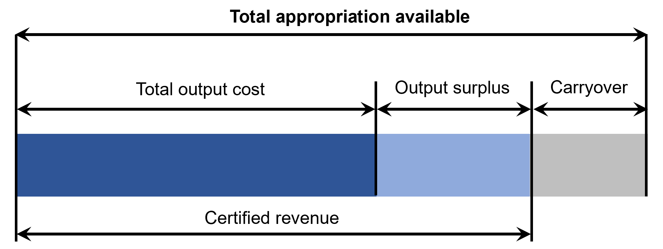
  - Depreciation and depreciation equivalent
Mandatory requirements
    - Use of depreciation equivalent for approved asset investment
The Accountable Officer must only use depreciation equivalent to fund asset investment (which includes minor capital works programs but excludes maintenance) that has been approved by the relevant Cabinet committee or the Treasurer.
    - Accessing depreciation equivalent before any ATNAB appropriation
In alignment with Mandatory Requirement 3.5.2, the Accountable Officer must fully draw down any depreciation equivalent funding in the department’s State Administration Unit (SAU) inter-entity account, to fund asset investment, before accessing any Additions to the Net Asset Base appropriation.
    - Depreciation equivalent for asset revaluations
The Accountable Officer must ensure that a letter is sent from the relevant Minister to the Treasurer to request an increase in a department’s depreciation equivalent (appropriation) funding, to account for any increase in depreciation expense following asset revaluations.
    - Depreciation equivalent for portfolio agencies
If informed by a decision of the Government, a department may transfer depreciation equivalent funding for Government-approved capital projects in portfolio agencies as a capital grant expense to the agency concerned. The receiving agency will recognise the grant as revenue.

Supplementary requirements (attestation not required)
Depreciation on administered assets
- Depreciation on an administered asset must be recorded in a department’s administered entity.
- A department must not include depreciation on an administered asset in departmental controlled operating costs for budgeting or reporting purposes.
- Depreciation equivalent asset investment funding does not apply to the acquisition of an administered asset.
- If an administered asset is required to be replaced or enhanced, funding must be sought as part of a submission.

Guidance

Definition of depreciation equivalent
Depreciation equivalent is the amount of appropriation revenue equal to actual depreciation expense for a given year. As depreciation is a non-cash expense, this amount remains undrawn in the Consolidated Fund but is initially recognised notionally for the department in its SAU receivable account until expended on approved capital investment items.

What is the purpose of depreciation equivalent?
The purpose of depreciation equivalent revenue is to preserve the net asset value of the department by providing a source of asset investment funding. Both the Appropriation Act and section 33 of the FMA for accumulated prior year unspent balances require that expenditure can only be made on fixed assets.
Under accrual budgeting principles, depreciation equivalent is one of the primary sources of funds available for asset investment, along with:
- proceeds of net asset sales (generally accessed under a section 29 agreement)
- Additions To the Net Asset Base (ATNAB) appropriation funding.
Other sources of funding include Commonwealth (section 29 agreement) or other third-party revenues (generally through ATNAB or revenue of portfolio agencies, such as TAFEs or hospitals).
Refer to section 3.5 for more information on the funding of assets, and the order in which the fund sources should be accessed.
There is no direct link between depreciation equivalent and the renewal and replacement requirements in a department’s physical asset base. However, the intent of depreciation equivalent is to be a primary contributor to sustain asset investment requirements.

How does a department access its depreciation equivalent balance?
A department may only access depreciation equivalent to fund approved asset investment programs determined by the Government.
Current year’s depreciation equivalent revenue – may be accessed by a department to fund approved asset investment.
Prior year’s depreciation equivalent balances – a department may submit a request to the Treasurer to access this balance in its SAU account under section 33 of the FMA.
For instructions on the application of a section 33 request, please see section 4.10 (access to previously appropriated amounts under section 33 of the FMA).
Note where a department has prior years’ depreciation equivalent balances available, these balances should be applied to asset investment before accessing their ATNAB appropriation.

Depreciation on administered assets
Administered assets are managed by a department on behalf of the State. Departments should maintain accounting records of depreciation on administered assets in the same way as their controlled assets.
However, depreciation on administered assets is not associated with departmental output delivery, therefore it is not included in output costs.
When an administered asset is to be replaced or enhanced, an amount for asset investment should be sought as part of the overall appropriation for administered items.

Transfer of depreciation equivalent to agencies
Generally, depreciation equivalent revenue should not be applied to government-controlled agencies outside the general government sector.

Impact of asset revaluations
As part of an asset revaluation process, the accumulated depreciation associated with the asset being revalued is ‘written back’ into the accounts. There is no impact however on the existing depreciation equivalent balances in a department’s SAU inter-entity account.

Other information on depreciation equivalent

What is the difference between depreciation and depreciation equivalent?
Depreciation expense refers to the non-cash expense charged to an agency’s accounts to represent the allocation of an asset’s cost over its useful life. As this expense has no associated cash outflow, the depreciation equivalent revenue included as part of a department’s output appropriation funding remains in the Consolidated Fund. Being part of the revenue earned by a department for the year, it is recorded as a receivable in the department’s SAU inter-entity account, pending drawdown from the Consolidated Fund for approved asset investment purposes.

What is the difference between depreciation equivalent and accumulated depreciation?
There is no direct link between accumulated (i.e. unspent) depreciation equivalent in the SAU (which is an asset), and accumulated depreciation, which captures the written-down value of assets in the balance sheet (a contra-asset).
Attachment 9: Depreciation equivalent – Asset funding sourced from provision of outputs appropriation diagram
FRD 119A: Transfers through Contributed Capital
Note to this edition:
The recognition, treatment and use of depreciation equivalent, particularly in relation to the funding of assets in portfolio agencies, is being reviewed by DTF. DTF will consult with departments as revised policies are developed.
  - Long service leave (LSL) and long service leave equivalent
Mandatory requirements
    - Valuation of balances of accumulated long service leave
The Accountable Officer must ensure:
- the accumulated long service leave (LSL) provision is estimated in line with the reporting provisions set out in AASB 119
- any variation to the liability is brought to account as a revaluation of the liability at 30 June each year, split between its components of ‘transaction’ and ‘other economic flows’
- the gain or loss on revaluation of the LSL provision is included in ‘other economic flows’ in the departmental operating statement.
    - Including estimated annual LSL expense in output costs
Estimated annual LSL expense (i.e. the amount expensed as a transaction in a department’s controlled operating statement) must be included in calculating the total estimated output costs of a department.
    - LSL equivalent
- An LSL equivalent amount is recognised in the SAU inter-entity account when an actual LSL expense is first recognised.
    - Transferring LSL balances between departments
- When employees are transferred between departments as a result of a machinery of government change, the accumulated liability and the full amount of LSL equivalent balances in the SAU must be transferred between the two departments
- For all other transfers of employees between departments (e.g. due to job transfers, promotions etc.), only the accumulated liability is transferred between the two departments. The LSL equivalent balances in the SAU are not transferred.
    - Funding long service leave when LSL equivalent is exhausted
- The Accountable Officer must ensure sufficient LSL equivalent is included in budgeting processes, to cover any expected upcoming LSL payouts
- When a department’s expected LSL payout in a particular budget year is estimated to exceed the funds available in its SAU inter-entity account, departments may seek additional supplementation by providing a submission to the relevant Cabinet committee for consideration.

Supplementary requirements (attestation not required)
Other long service leave principles
- Any revaluation or write-back of long service leave (LSL) that has been classified as an ‘other economic flow’ does not change the LSL equivalent amounts in the SAU inter-entity account
- LSL equivalent accumulates as a financial asset in a department’s SAU inter-entity account, until used to fund LSL payouts.

Guidance

LSL provision
Accumulated LSL provisions for employees are a liability on each department’s balance sheet. The LSL entitlement expense starts to accumulate when an employee completes a prequalifying period with a department. In each accounting period an operating expense is recognised, which progressively increases the corresponding accumulated liability.
Generally, under existing public sector employment conditions, employees are entitled to three months LSL after 10 years of service, which can be accessed on a pro rata basis after seven years of service.
LSL represents an obligation (or a liability) of the department to its employees and any LSL outstanding at the end of each reporting period is accrued.
Theoretically, the LSL entitlement starts when an employee starts with a department. However, in practice, an LSL expense is financially recognised when an employee completes a prequalifying period of service (although generally the legal obligation to pay out LSL does not start until an employee has achieved seven years’ continuous service).

LSL equivalent
The component of a department’s revenue stream, equal to actual LSL expense incurred by an employee, becomes the amount of LSL equivalent available to a department, recognised in its SAU balance. This amount is set aside notionally in the Consolidated Fund for the purposes of paying out LSL when required.

Drawdown of cash to fund LSL payouts
Cash payments for LSL, regardless of the period to which the liability relates, will be met by drawing against the LSL equivalent balance in the SAU inter-entity account. It may be some years before payment is due, and in that time the balance in the SAU inter-entity account should have increased sufficient to cover the amount due in cash. If, because of an unexpected demand for LSL payouts, there is insufficient LSL equivalent balance available, the department will need to apply for additional funding to cover the expected cash shortfall.
Payment to employees will draw down against the department’s LSL provision when either:
- employees choose to use their LSL entitlement after it matures (through the taking of leave, or via a monetary payout)
- employees cease employment with the Victorian public service and their employment agreement entitles them to a monetary payout of part or all of their accrued benefit.
Departments do not need to apply to access LSL equivalent accumulating in the SAU inter-entity account to pay out LSL unless the drawdown of cash for this purpose leaves the SAU closing balance at 30 June lower than the year’s opening balance at 1 July. In this latter case, approval is required under section 33 of the FMA to access the prior year’s SAU balance.
For instructions on the application of a section 33 request, please see section 4.10 (access to previously appropriated amounts under section 33 of the FMA).

Transferring employees between departments
Adjustments of LSL obligations relating to employees transferred between departments may be affected as an annual adjustment covering net transferred entitlements of all transferred employees.
Attachment 10: Pro-forma journal entries for long service leave transactions
Attachment 11: Representation of long service leave transactions
AASB 119 Employee Benefits
FRD 17B Wage Inflation and Discount Rates for Employee Benefits
  - Funding of interest on service concession arrangements and leases (capitalised interest balances)
Mandatory requirements
    - Recognising and accounting for capitalised interest balances
The Accountable Officer must:
- include the capitalised interest balances in the SAU inter-entity account in the department’s budget year and forward estimates years
- record and account for the capitalised interest balances separately in their SAU dissection reports.

Supplementary requirements (attestation not required)
Use of capitalised interest balances
The Accountable Officer must ensure that accumulated capitalised interest balances are used only for the principal component of any service payments associated with a service concession arrangement or lease.
Funding of service concession arrangements in agencies
Where a service concession arrangement is recorded in an agency, the Accountable Officer of the portfolio department shall draw down the appropriation revenue funding the interest into the department’s SAU inter-entity account. The Accountable Officer shall only pass on funding to the agency for the principal component of the service payments when commercial acceptance has occurred.

Guidance

Definition and funding of interest expense on service concession arrangements
The accounting standard AASB 1059 Service Concession Arrangements: Grantors requires departments to progressively recognise service concession arrangements (such as Public-Private Partnerships (PPP)) during the construction phase. This means that a service concession asset needs to be progressively recorded over the construction period, alongside an associated liability.
Departments will also incur (non-cash) interest expense on the liability associated with the service concession arrangement in the lead-up to commercial acceptance.
This interest expense is a non-cash expense. Under departmental funding arrangements, departments recognise revenue for this interest expense, so that they do not incur a loss in output delivery by incurring the interest expense. Departments are funded for the revenue by additional appropriation, which is retained in each department’s State Administration Unit (SAU) inter-entity account balance in the Consolidated Fund.
These amounts in each department’s SAU inter-entity account are known as the ‘capitalised interest balance’. Funds are drawn down from this balance to fund the service payments for service concession arrangements after asset completion, until these amounts are exhausted. The SAU dissection separately discloses and accounts for the amounts of capitalised interest balance.
This funding approach is similar to the funding of depreciation expense and the accumulation of depreciation equivalent in the SAU inter-entity account.
Note that an accumulation of capitalised interest funding in the SAU inter-entity account can occur when a finance lease is first established, and the amounts paid on the principal in some years will be less than the interest expense on that lease.

Depreciation on service concession arrangements
Depreciation expense for service concession arrangements should only start on the completion of the asset, therefore there should not be any depreciation expense incurred during the construction period.

Funding the components of lease payments
The components of services payments on finance leases generally consist of principal amounts, interest, and operating costs. As stated earlier, interest incurred (during the construction phase) is funded through appropriation that builds up in a department’s SAU inter-entity account, to be used to fund the principal component of future service payments.
The other components of service payments (i.e. interest and operating costs) however are funded through the usual annual appropriations provided to departments.
There may be some instances where the interest expense recognised in a department’s or agency’s operating statement for a lease will exceed the actual cash lease payments in a given year. This may be due to the contractual arrangements of the lease.

- Accountability
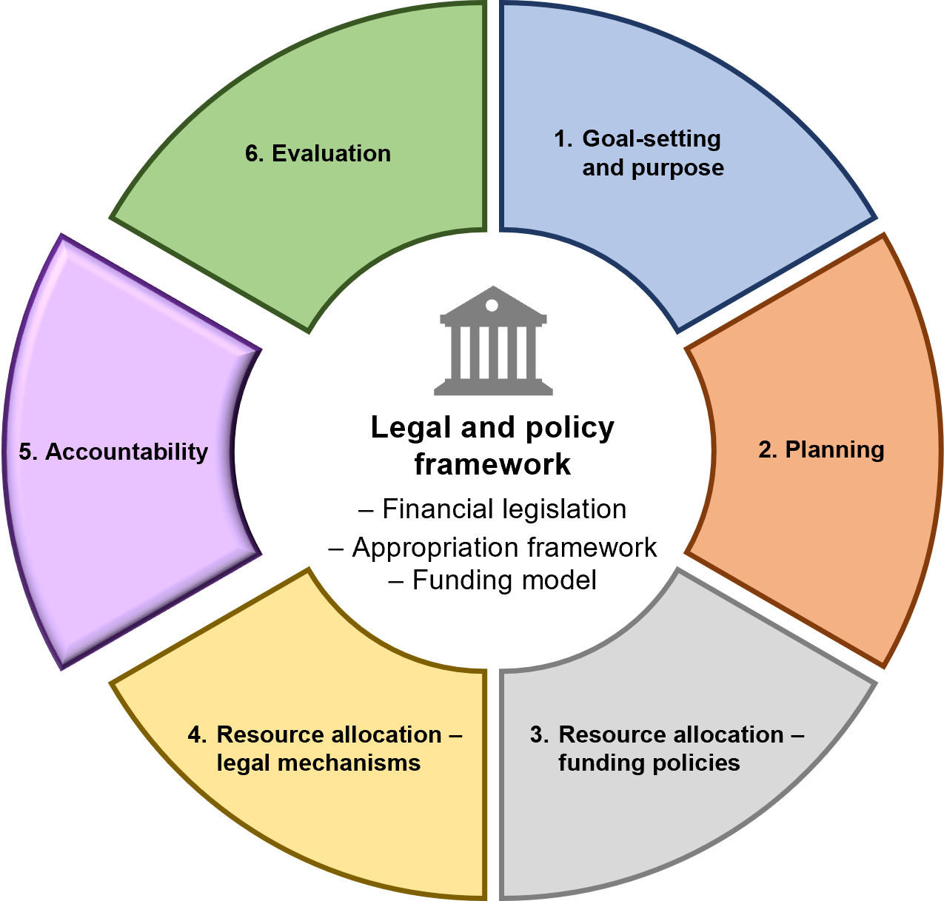

Overview
The fifth stage of the IMC is accountability.
DTF is responsible for supporting the Treasurer and the Minister for Finance in discharging their accountability to Parliament for:
- the overall financial and performance management of the State
- the Government’s reporting obligations under the FMA.
Departments are responsible for:
- providing quality and timely information to assist in resource allocation processes
- supporting departmental secretaries and Portfolio Ministers during parliamentary estimates hearings
- providing DTF with information in accordance with DTF Information Requests through budget and performance management processes
- appropriate financial management and reporting on the resources it uses and controls, to ensure expenditure is efficient and effective
- establishing their own internal performance reporting arrangements to assess delivery performance against plan and budget, and progress towards achieving the department’s objectives.
To assist DTF in its accountability and advisory roles, departments are required to comply with data and reporting requirements. Data submission to DTF for these purposes is usually provided through the State Resource Management System (SRIMS), or through other mechanisms as advised by DTF.
There are two reporting categories:
- External reporting – reporting to Parliament and the general public in budget papers and departmental annual reports
- Internal reporting – reporting on output performance and asset reporting, for monitoring and revenue certification purposes, and monthly reporting and cash forecasting. This is the focus of this stage of the IMC.

Internal reporting and accountability
The performance measurement reporting and accountability arrangements discussed below provide information to aid Government decision making on resource allocation and delivery.

Output performance report
The output performance report provides analysis and discussion on the progress of delivery of departmental outputs and their associated performance measures and targets against targets published in Budget Paper No. 3, Service Delivery.
The aim of the output performance report is to provide information to the Government to improve results, and to hold output managers to account.
Output performance monitoring occurs formally through six-monthly reports.

Asset investment report
The asset investment report provides information to Government on the progress of delivery of significant asset projects in the State. This includes determining if targets are being met.
Assessment of the Government’s asset investment program occurs through quarterly reports.

Revenue certification
As an extension of the concept of Government paying a ‘price’ for services delivered, departments are required to submit an ‘invoice’ to Government to support the appropriation revenue provided to departments for outputs delivered and asset funding provided. This is known as the revenue certification process.
The invoice is submitted with accompanying output performance, and quarterly asset investment reports, to support the revenue claim.
The revenue claimed is reviewed by DTF, and the final amounts are certified by the Minister for Finance and applied by the Treasurer at the end of the financial year.

Monthly reporting
DTF is responsible for generating a monthly financial report from September to June each financial year.
The purpose of the monthly financial report is to provide Ministers and the DTF executive with analysis of key fiscal aggregates and information on specific line items of financial statements regarding the performance of the general government sector during the reporting period.

Cash flow forecasting and cash management
DTF’s role is to monitor and manage the cash flow requirements for the Public Account, through information obtained from departments. This assists DTF in managing the budget, the State’s level of borrowings, its investments, and its risk profile.
Appropriate management of the Public Account assists to:
- ensure there is enough cash available to service bills
- identify and appropriately invest any surplus funds to maximise returns to the State, or to identify funding deficits for appropriate action
- detect any unusual activity/movements and act where required.

The Central Banking System
Victoria operates the Central Banking System (CBS), which centralises the State’s funds and bank accounts. It aims to improve the State’s working capital management and help manage its investment portfolio and borrowings.
The Standing Directions specifically requires departments and general government sector agencies to hold all surplus funds in the CBS.

  - Output performance report
Mandatory requirements
    - Frequency and timing of the output performance report
The Accountable Officer must submit an output performance report biannually (i.e. for the six months ended 31 December and the 12 months ended 30 June) to DTF to support its revenue certification invoice claim, within the timeframes in the DTF Information Request.
    - Requirements for the output performance report to support the revenue certification claim invoice
The Accountable Officer must include the following information in the output performance report to support the revenue certification claim invoice (see section 5.3):
- A table listing revenue claimed against target for each output
- A table listing actual performance compared with target for each output (for all agreed quantity, quality, timeliness and cost measures)
- Comments and discussion on any major variances between actual output performance and target output performance.
    - Other information requirements for the output performance report
The Accountable Officer must also include in the output performance report:
- key strategic performance issues – significant emerging issues or risks that are material to the performance of the department and portfolio, and those issues currently being addressed that are likely to impact on key government priorities
- major budget commitments and follow-up issues – progress on specific budget commitments and initiatives, and reporting on other issues the relevant Cabinet committee has requested
- progress against efficiency targets – progress made in the achievement of efficiency targets endorsed by the Government
- prior year’s carryover – detail on the use of these carryover amounts from the previous financial year, identified by outputs affected
- upcoming year’s carryover – information on expected carryover amounts for June. This must include identification of the outputs that are affected by the carryover
- hypothecated trust accounts – with balances and/or annual revenue streams of $25 million or more, unless alternative reporting arrangements are in place
- machinery of government changes – information on their impact and implementation during the financial year
- any changes to the annual output mix that have occurred during the year.

Guidance
The output performance report provides information to inform:
- reporting to the relevant Cabinet committee on the output performance of departments and highlighting key service delivery issues at a whole of government level. This may include:
- implementation of key business strategies and initiatives
- financial and service delivery performance
- the identification of budget pressures and emerging risks to future performance or the budget outlook.
- recommendations to the Treasurer and the Minister for Finance on the amount of revenue which should be certified for each department based on their reported output performance against targets.
Section 5.3: Revenue certification
Departments should consider informing the governing body responsible for monitoring their departmental performance (e.g. the Senior Executive Group) during the financial year.
Output performance reporting specifically should:
- identify performance trends, gaps and risks
- facilitate the implementation of mitigation strategies and corrective actions, if required
- cover both the financials and non-financials and the interrelationships between them to enable integrated performance information to be reported.
Output performance monitoring should be conducted for all levels and types of plans (e.g. corporate, operational and financial plans).
Departments should consider informing the relevant Minister of significant risks when they become aware of any of the following:
- significant variations to strategies compared to plan
- significant variations to targets compared to plan
- any financial or non-financial (including reputational) developments which may materially impact the department or the Government.

DTF assessment of the output performance report and revenue certification claim invoice
On receipt of each revenue certification invoice, DTF assesses actual departmental output performance against agreed performance measures based on output delivery.
In the event that assessment at output level may be deemed inappropriate, DTF and the department may agree on alternative, suitable and appropriate performance information that could be used as the basis for revenue certification.
Revenue claimed by departments is deemed to be certified if outputs meet or exceed their agreed quantity, quality, timeliness and other agreed performance measures at year end. Revenue paid into trust accounts may be certified ahead of service delivery.
Where actual performance data for the six months to December is not available due to time lags the following applies:
- estimated performance is based on actual performance for three months of the year and estimated performance for the remaining three months or some other measure agreed between DTF and departments
- if actual performance data becomes available subsequently, and materially varies from that previously estimated, any resulting revenue adjustment is taken onto the department’s books at the end of financial year.
Where actual performance data is not available at year-end due to time lags, the following applies:
- estimated performance is based on actual performance for nine months of the year and estimated performance for the last quarter or some other measure agreed between DTF and departments
- if actual performance data becomes available after the financial statements have been audited/published and materially varies from that previously estimated, any resulting revenue adjustment is taken onto the department’s books in the following financial year.
  - Asset investment report
Mandatory requirements
    - Frequency and timing of the asset investment report
The Accountable Officer must submit an asset investment report on a quarterly basis to DTF, within the timeframes in the DTF Information Request.
    - Submitting quarterly asset phasings
The Accountable Officer must ensure departmental quarterly phasings for asset investment projects are agreed between DTF and departments within the first quarter of each financial year, or as specified in a DTF Information Request.
    - Reporting on each asset project
The Accountable Officer must provide the following information in an asset investment report for each asset:
- Asset project name
- Funding source
- Phasings of quarterly expenditure
- Key milestone dates
- Any other relevant information such as the type of work.
    - Asset investment report
The Accountable Officer must provide information on:
- issues relating to the overall progress and outlook on specific major asset projects including progress on the annual investment program, both in terms of project delivery and financial expenditure
- the progress and delivery of all investment projects being done by the Government (as listed in Budget Paper No. 4, State Capital Program)
- the source of funds used to fund asset investment, including:
  - depreciation equivalent funding
  - Additions to the Net Asset Base (ATNAB) appropriation (which may include revenue from a section 29 arrangement)
  - revenue from the Commonwealth
  - other third-party revenue sources.

Guidance
The asset investment report provides DTF with a department’s overall asset investment program on a quarterly basis. This information is then complied by DTF to inform:
- reporting to the relevant Cabinet committee on the progress of capital projects
- recommendations to the Treasurer and the Minister for Finance on the amount of revenue that should be certified (the ATNAB amounts).
  - Revenue certification
Mandatory requirements
    - Requirements for the revenue certification claim invoice
- The Accountable Officer must submit an invoice to DTF to request certification of revenue from the following sources:
  - Provision of outputs appropriation (including any section 29 of the FMA revenue) – for delivery of outputs assessed against agreed performance measures
  - Additions to the Net Asset Base (ATNAB) appropriation (including any section 29 of the FMA revenue)
  - Payments on behalf of the State (POBOS) appropriation – for activity conducted on behalf of the state.
- The Accountable Officer must submit a revenue certification invoice to DTF biannually for the following time periods:
  - one for the six months ending 31 December – the provisional invoice
  - one for the 12 months ending 30 June – the final invoice.
- The Accountable Officer must sign each invoice before lodgement with DTF (cannot be delegated).
- The revenue certification invoice claim must be submitted in conjunction with the relevant output performance report.
    - Treatment of appropriation revenue
Following certification of revenue, the Accountable Officer must recognise and report appropriation revenue in line with accepted accounting standards.
    - Certification of funding for depreciation (depreciation equivalent revenue)
The Accountable Officer must only request certification of funding for depreciation expense up to the actual amount incurred in any given year (not the budgeted amount). Any budgeted funding for depreciation that is in excess of the actual depreciation expense in a given year shall lapse and remain uncertified.

Supplementary requirements (attestation not required)
Unused depreciation equivalent revenue funding is not permitted to be reallocated to fund other non-depreciation output expenditure.

Guidance
A revenue certification invoice claim is required to be submitted by a department twice a year.

Invoice submitted for the six months ending 31 December
This invoice is provided for noting only. A department may post the full value of the revenue claim to its revenue account in this period, but the amount is subject to subsequent verification (and potential alteration).

Overall process
On receipt of each invoice, DTF assesses:
- actual departmental output performance against agreed performance measures based on output delivery
- asset investment issues regarding the ATNAB component of funding used
- any administered issues by considering the POBOS component of funding.
DTF then provides advice to the Minister for Finance regarding the department’s invoice and whether any adjustments should be made, more specifically:
- invoice for the six months ending 31 December – DTF advises the Minister for Finance if there are any issues including under performance which may have an impact on revenue certification at 30 June
- invoice for the 12 months ending 30 June – DTF advises the Minister for Finance on whether the invoice should be accepted as submitted.
Revenue claimed by departments may be rejected when outputs do not meet their performance measures and/or service delivery has not occurred. This means that the final revenue certified may be less than the invoiced amounts received from departments.
On the basis of this advice, the Minister for Finance advises the Treasurer to formally apply (or note, in December) the amount of appropriation revenue to be recognised by the department.

Specific issues

Actual versus estimated data
In some circumstances, revenue certification for the year will not be based on actual performance data due to time lags in data availability and therefore an estimate will need to be provided.
This estimated performance should refer to actual performance over the latest 12-month period (e.g. April to March) for which full data is available, together with the estimated impact in the final months of the year of any reasonably certain factors which will have a material effect on performance.
This means that end-of-financial year (i.e. annual) revenue could be certified, and audited, on the basis of performance data estimated in good faith. Assuming actual data becomes available only after the financial statements have been audited and published, then any revenue adjustment will be taken onto the department’s books in the following financial year.

Carryover
Where a department has delivered less than its budgeted quantity of outputs, but the outputs actually delivered have been provided within the budgeted unit cost, the department may apply to the Treasurer for approval for the remainder of the appropriation to be carried over to a subsequent year.
Section 4.9: Carryover of unused appropriation – section 32 of the FMA

Trust accounts
Revenue paid into trust accounts may be certified ahead of service delivery, provided that the revenue transfer is consistent with the requirements of the Appropriation Act.
In line with the appropriate use of trust accounts, such revenue is not necessarily matched to expenditure in any particular year, which may result in balances being carried into the following year.

Certification of funding for depreciation (depreciation equivalent)
Under the funding model, appropriation funding is provided for actual depreciation expense. If budgeted depreciation equivalent exceeds actual depreciation expense, departments cannot use the excess appropriation to fund other non-depreciation expenditure.
Any budgeted funding for depreciation which is in excess of the actual depreciation expense for the year shall lapse and remain uncertified.
While output price (total appropriation) is often viewed as amounts that funds all expenditure (cash and non-cash costs alike), in practice, funding is provided only for depreciation up to the amount of total actual depreciation expense for the year, and this amount is then only available for funding future asset investment.
If there is insufficient capital funding for departmental capital commitments in a given year due to the lapsing of uncertified depreciation equivalent revenue, then the Accountable Officer, on behalf of the relevant Minister, may write to the Treasurer to seek supplementary or alternative funding arrangements.
If actual depreciation equivalent revenue is higher than the budgeted amount (and fully certified), the department’s depreciation equivalent balance in the SAU is increased. This means that less Additions to the Net Asset Base (ATNAB) appropriation (if any) is then needed by the department to fund its capital program.

  - Financial monthly reporting
Mandatory requirements
    - Monthly feed requirements
Each month, the Accountable Officer must:
- provide a draft trial balance data submission in SRIMS, within five business days after the end of the month being reported on
- finalise and approve that trial balance submission (mentioned above) in SRIMS within seven days after the end of the month being reported on
- provide commentary/explanations, with CFO sign-off on both controlled and administered items, within 10 working days after the end of the month being reported on the following:
  - variations between budgeted and actual results
  - variations comparing the current year to the previous year
  - any other significant factors which have influenced the reported results.
    - Other requirements
The Accountable Officer must provide appropriate documentation to DTF, as stated in the relevant DTF information request.

Guidance
DTF produces a monthly financial report from September to June each financial year. This report provides Ministers and the DTF executive with analysis of key fiscal aggregates and information on specific line items of financial statements regarding the performance of the general government sector during the reporting period.
The quality of the advice provided to Government on the financial performance and position of the State is dependent on the quality and timeliness of the data and analysis submitted by departments. Departments are expected to work closely with their DTF contacts in providing data and analysis of a sufficiently high standard to deliver this outcome.
  - Cash flow forecasting
Mandatory requirements
    - Daily forecasting requirements for funds held in the Public Account
- By 11:00am each business day, the Accountable Officer must:
  - update the latest cash flow forecasts (Revised figures) in the State Resource Information Management System (SRIMS)
  - provide in writing to the Treasury Corporation of Victoria (TCV) a breakdown in the daily cash flow forecasts and commentary on any material variations ($20 million and above) between Revised figures and Beginning of the Month (BOM) estimates.
- By 2:00pm each business day, the Accountable Officer must notify in writing to TCV any daily cash flow change greater than $20 million. This includes any inter-departmental transfers (payments to and from another department).
    - Monthly forecasting requirements for funds held in the Public Account
- By the fifth business day of each month, the Accountable Officer must provide the following 12-month cash flow forecasts (Beginning of Month estimates) to DTF via SRIMS:
  - a rolling daily cash flow forecast for the next two months ahead (months 1 and 2)
  - a rolling monthly cash flow forecast for the remaining months ahead (months 3 to 12).
- The monthly cash flow forecasts must be reviewed and authorised by the departmental CFO before being provided to DTF.
- By the 10th business day of each month, the Accountable Officer must provide to DTF reasons for any material variations between:
              - the latest cash flow forecasts and the prior month’s cash flow forecasts
              - the cash flow forecasts and actuals
              - any other information requested by DTF.
    - Other forecasting requirements
- The Accountable Officer must notify TCV in writing:
  - if a future cash flow change of more than $100 million is known
  - of any future inter-departmental transfers.
- The Accountable Officer may be required to provide DTF with reasons for any material variations between the latest cash flow forecasts and those provided in July each year (based on the budget).

Guidance
During the last week of each month, departments update their cash flow estimates for the next 12 months by the fifth working day of the following month.
The forecasts comprise the cash requirements for their expenditure bank account(s), and the receipts to revenue bank account(s).
As the financial year progresses, cash flow forecasts will deviate. Departments are requested to update these forecasts in a timely manner by advising DTF of any deviations from forecasts.
It is advised that departments prepare forecasts of their cash flow for each month consistent with their departmental annual cash flow statements published in Budget Paper No. 5, Statement of Finances (BP5).
As the cash flow statements in BP5 may include transactions outside of the Public Account, departments will need to remove these transactions from their monthly cash flow forecasts before submitting them to DTF.

  - Cash management and reconciliation
Mandatory requirements
    - Monthly cash transaction reconciliation requirements
- At month end, the Accountable Officer must reconcile all cash transactions with Treasury Corporation of Victoria (TCV) for the calendar month with their respective departmental general government bank account statements.
- The reconciliation under (a) must be completed in time for the following timelines to be met:
  - by the fifth business day of the new month: all departmental account transactions must be claimed and processed into the cash ledger and reconciled to the department’s end of month bank statement
  - by the 10th business day of the new month: departments must submit a monthly reconciliation between its actuals and cash ledger for specified accounts via email to cashmanagement@dtf.vic.gov.au.

Supplementary requirements (attestation not required)
Daily cash transaction recording requirements
- The Accountable Officer must claim and process the daily departmental general government bank account transactions in the cash ledger by no later than close of business three days after the entry has been loaded into SRIMS.

Guidance
The cash ledger and actuals ledger balances must align. The following diagram shows the requirements at a high level:
Cash ledger in SRIMS | Must agree | Actuals ledger in SRIMS

The central State Administration Unit (SAU) reconciliation relies on the accuracy of this reconciliation.
Attachment 12: Template for cash and actuals reconciliation in SRIMS
The template for cash and actuals reconciliation in SRIMS provides the monthly reconciliation template to be used at the calendar month end. The template aims to assist departments to balance data and to identify any reconciling items before submitting their SRIMS feed to DTF. This reconciliation is authorised by each department’s Chief Finance Officer.

Additional information

The Central Banking System
The State of Victoria operates a centralised system of cash management comprising the accounts held within the Public Account, and other accounts outside of the Public Account (known as the Non-Public Account), and other trust account investments held external to the Public Account. This grouping of accounts is held within the Central Banking System (CBS).
The arrangement requires departments and general government sector agencies to hold surplus funds in the CBS. The CBS enables the cash management requirements of the general government sector to be centrally managed and reduces interest expense as borrowings can be minimised.
In certain circumstances or in line with legislative requirements, departments and agencies can invest funds with the Treasury Corporation of Victoria or the Victorian Fund Management Corporation.

TCV and the Victorian Funds Management Corporation’s (VFMC) role in the State’s cash management and investment
TCV is the central financing authority for the State of Victoria and is the interface between the State and the wholesale financial markets. TCV’s borrowing programs provide financing liquidity for the State and its authorities.
To maintain sufficient cash flow in the Public Account, DTF may borrow funds from TCV to meet its daily expenditure commitments. If there are surplus funds within the Public Account, these funds are managed and invested into short-term investments within the CBS, or with TCV or VFMC, to optimise returns to the State.
The State’s cash management arrangements are summarised in the following diagram:
Figure 11: Cash management arrangements in Victoria
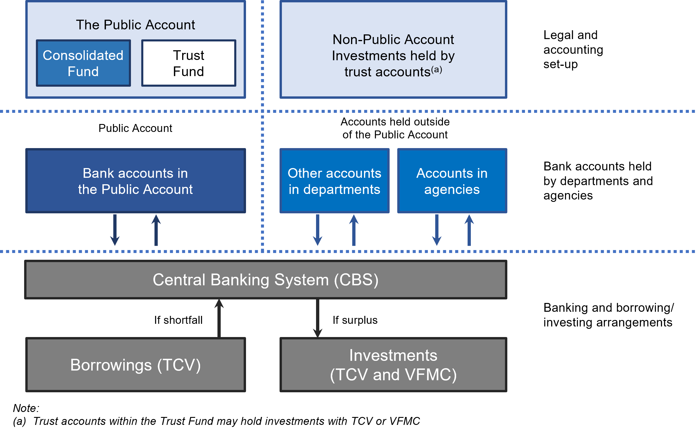

  - Establishment or abolition of certain entities – Section 8B of the FMA
Section 8B of the FMA requires the relevant Minister who is proposing to establish or abolish an existing body, office or trust body (an entity) to consult with the Minister for Finance (the Minister administering section 8B) before the entity is established or is to be abolished. Section 8B also requires notice of the establishment or abolition of an entity to be published in the Government Gazette.
Mandatory Requirements
    - Establishment or abolition of an entity requirements
When supporting and advising the relevant Minister on the establishment and abolition of an entity, the Accountable Office must ensure full compliance with section 8B of the FMA.
The Accountable Officer must ensure that:
- the portfolio department consults with DTF once there is a significant likelihood that the proposal will proceed, prior to the formal establishment or abolition of the entity.
- the relevant Minister is provided with the necessary information and support needed to consult with the Minister for Finance before the entity is established or abolished, and this correspondence is documented for public record.
- a notice of the establishment or abolition of the entity by a Minister is published in the Government Gazette by the relevant Minister and
- the Victorian Auditor-General’s Office and the Victorian Public Sector Commission are provided with a copy of the notice of establishment or abolition.

Establishment or abolition of an entity - consultation and notification guidance
When pursuing the establishment of a new entity, stakeholders should continue to follow the process outlined by the Victorian Public Sector Commission (VPSC) and set out in the Premier’s Circular No. 2013/2: Creation and Review of Non-Departmental Entities and supporting policy document.
While the policy rationale underpinning a proposal to establish or abolish an entity, including stakeholder engagement, are responsibility of the relevant Minister, section 8B of the FMA requires the relevant portfolio department to notify DTF of any proposed establishment or abolition. This is to ensure there is adequate consideration of the associated financial management requirements when seeking to establish an entity. Consultation with DTF is also a requirement when seeking to abolish an entity to ensure the fact that an entity no longer exists, or has been renamed, or has had its functions re-allocated to one or more other entities, is reflected properly in budgeting and financial reporting.
Alongside the legislated consultation requirements, DTF strongly encourages the portfolio department to undertake adequate internal consultation across its policy, finance, legal, and other relevant areas when developing the business case for the establishment or abolition of an entity.
Stakeholders seeking to establish or abolish an entity should be aware of the financial management compliance requirements associated with entities. Different classifications of entities have different compliance requirements to scale proportionately to the classification of entity. For further detail, refer to Attachment 16 in RMF Part 2: Attachments.
The portfolio department’s finance team should be able to provide early internal engagement and awareness on the nature of financial management requirements for each type of entity. For an overview of the different entity types, refer to Section 2: Public sector terms explained.
Figure 12: Consultation overview when seeking to establish or abolish an entity

For detailed guidance on the consultation process, please refer to the Resource Management Framework Part 2 of 2 Attachments, available on the DTF website.

- Evaluation
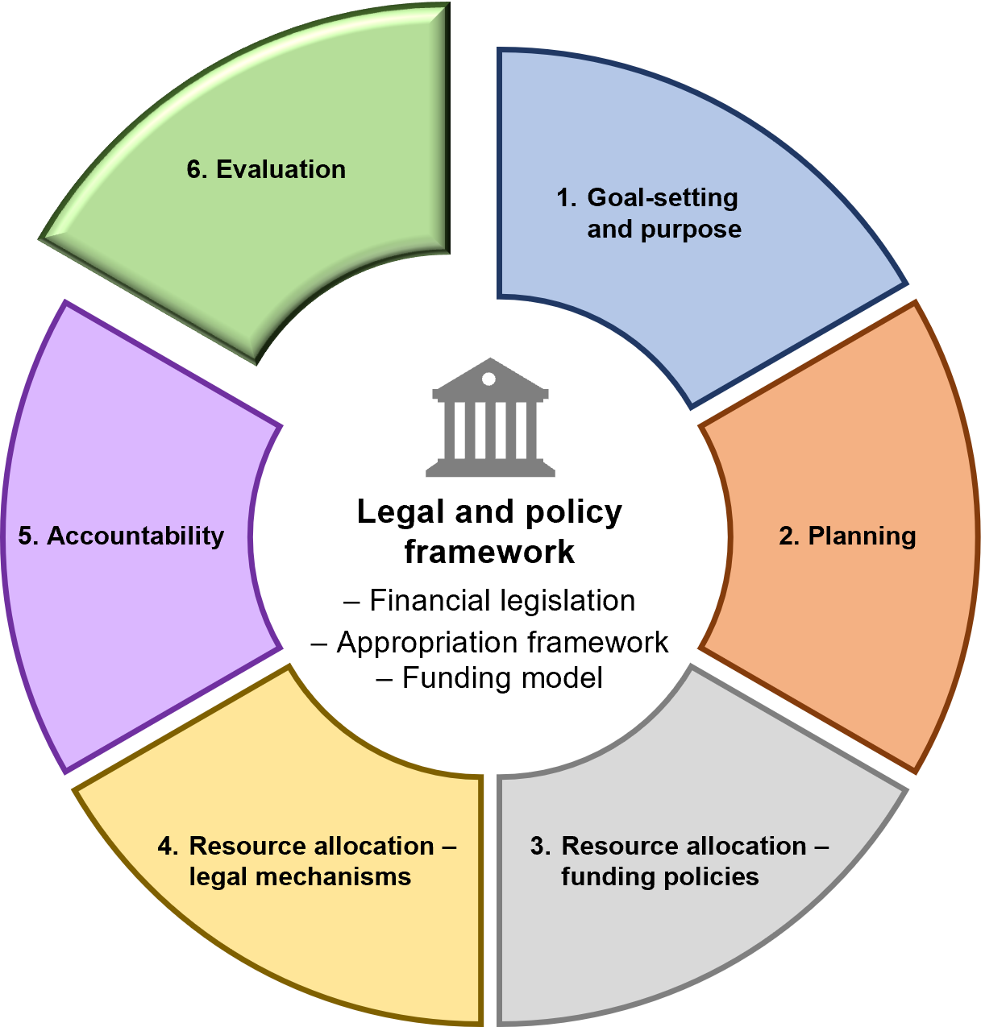

Overview
The sixth stage of the IMC is evaluation. This section outlines the lapsing programs, funding reviews and rollover policies.

Purpose of evaluations
Evaluations are an objective and systematic way of reporting on the contribution a program has made to the achievement of stated goals, outputs and desired objectives. Evaluations seek evidence of the actual performance of a policy or program, during or after its implementation.
An evaluation should generate information that is credible and useful for decision making and program improvement processes.
Evaluations should also recommend appropriate actions, including whether the programs remain the best policy response, or align with government priorities. A culture of evaluation and continuous improvement assists in designing future programs.
Departments should regularly review the base funding of outputs to ensure that public spending on outputs remains efficient and effective. These reviews should systematically consider the continued relevance of the outputs delivered to achieve outcomes for Victorians, and the appropriateness of the price paid for these services. Consideration of alternative methods of service delivery should be considered as part of these reviews and provide information for long and medium-term planning.

What to consider in conducting evaluations
Departments should consider in conducting evaluations:
- the uses for which the evaluation is intended
- the main stakeholders who have an interest in the evaluation findings
- when the information is needed
- the resources available to conduct an evaluation.
Determining these factors will impact on what tools, methods and approaches to use in evaluations.

Four common stages to an evaluation
There are a number of approaches to evaluations, but these are four stages common to all approaches:
- Defining the purpose – Defining what the program is and what needs to be evaluated
- Planning – Deciding what evidence needs to be collected, and how it will be collected and used
- Conducting the evaluation – Study, making decisions: collecting the evidence, analysing and assessing the findings, making recommendations
- Disseminating – Using the findings and recommendations of the evaluation.

Why conduct evaluations?
In an environment of competing priorities and limited resources, evaluations are an important way to assist government, departments and managers to achieve desired policy outcomes and demonstrate value-for-money. Well-designed evaluations can strengthen public sector efficiency, effectiveness and accountability by:
- enhancing the ability to achieve government priorities and policy outcomes
- strengthening resource allocation planning and decision making
- assessing and improving the performance and impact of service delivery
- demonstrating results as part of accountability to key stakeholders.
A culture of evaluation and continuous improvement can also assist future program design and management by encouraging the ongoing capture and transfer of learnings from individual programs.

When planning should start for evaluations
Evaluation planning should start at the initial stages of developing a policy or program business case.
Data for an evaluation can be collected at the early planning stage of a new policy or program once clear objectives have been identified for that program. Asking key evaluation questions during planning can help determine program objectives, especially since it may not always be easy to identify clear program objectives at this early planning stage.
It can also be useful at the program planning stage to develop a logical model or causal relationship between the program and the outcomes to be achieved. This will make it easier to identify how the intended policy or program objectives or outcomes will be achieved. These program plan elements should help to determine what information will be needed for the evaluation.
- Attachment 13: Planning, designing and conducting effective evaluations
- Investment Management Standard, available on the DTF website
  - Evaluating lapsing programs
Mandatory requirements
    - Evaluating lapsing programs seeking continued funding
The Accountable Officer must ensure that:
- evaluations of lapsing programs (if required after discussions with DTF) are completed within 12 months of when the funding is due to lapse
- for programs with total funding of $20 million or more:
  - DTF endorses the evaluation scope and terms of reference before it starts (in consultation with the Department of Premier and Cabinet)
  - for programs with funding for two years or more, the evaluation report is submitted to DTF by the last Friday in October of any given year, before a submission requesting continued funding for the program is lodged
  - for programs with funding for less than two years, the evaluation report is submitted to DTF as part of the submission requesting continued funding for the program.
- for programs with total funding of less than $20 million, either:
  - an evaluation report
  - annual outcomes reporting that provides evidence of program impact and outcomes (relevant to initiatives funded through the Early Intervention Investment Framework (EIIF) only)
  - appropriate evidence that clearly demonstrates efficient and effective achievement of the program’s objectives
- is provided to DTF as part of the submission requesting continued funding for the program
- when requested by DTF, that either:
  - a draft report (or other review materials) for an evaluation is provided to DTF
  - DTF is provided with appropriate opportunities to be involved in any steering committee or other governance arrangement that oversights the direction of an evaluation
- the evaluation is conducted by a person or party who is independent of the area that has delivered the program.
    - Questions to address in the evaluation of lapsing programs
The Accountable Officer must ensure evaluation reports for lapsing programs address these seven questions:
- Justification/problem: What is the evidence to support the continued need for the program, and what is the role for Government in delivering this program?
- Effectiveness: What is the evidence of the program’s progress toward its stated objectives and expected outcomes, including alignment between the program, its output (as outlined in BP3), departmental objectives and Government priorities?
- Funding/delivery: Has the program been delivered within its scope, budget, expected timeframe, and in line with appropriate governance and risk management practices? What were the challenges in delivery of the program? How were these challenges addressed?
- Efficiency: Has the department demonstrated efficiency in the delivery of the program?
- Risk: What would be the impact of ceasing funding for the program (e.g. service impact, jobs, community) and what strategies have been identified to minimise negative impacts?
- If funding is continued: Reassess funding required to deliver the program using data collected through service delivery. Does the initial funding allocated reflect the true cost required to deliver the program?
- If funding is continued: What level of efficiencies could be realised?
    - Budget submissions requesting continued funding from completed evaluations
The Accountable Officer must include in the submission:
- what impacts will result if funding to the program were to cease
- strategies to minimise negative impacts where appropriate
- alternatives should funding not be approved
- the efficiencies that could be realised if ongoing funding was approved
- a gender impact assessment.

Guidance

Definition
A lapsing program is a program to deliver services (output-related) that is funded for a specified time period only (and not ongoing in nature). Programs of a ‘one-off’ or a time-specific nature (e.g. funding provided for specific events) are considered ‘fixed-term’ and do not fall under the definition of a ‘lapsing program’.
Pilot programs test the potential of a program to contribute towards government objectives on a longer-term basis and should therefore be evaluated as a lapsing program to determine whether funding should continue.

A. General information for all evaluations

Conducting an evaluation
Evaluations of lapsing programs must assess the effectiveness and efficiency of the program and provide evidence-based information to inform the Government’s decision making.
An evaluation approach should reflect the program’s size, complexity, profile and associated risks. The potential costs and benefits of evaluation approaches and designs, including the decision to use an internal or external evaluator, should also be considered.
The program evaluation should be conducted in line with the principles outlined in the National Statement on Ethical Conduct in Human Research, and any legal obligations, such as section 9 of the Gender Equality Act 2020 (GE Act). Program evaluation should consider the effects the program may have on persons of different genders and should also, if practicable, consider intersectionality. The evaluation may also consider relevant academic thinking and national and international practices to program delivery (i.e. such as through a literature review).
As the GE Act requirement for gender impact assessments came into effect on 31 March 2021, programs funded before that date might not have completed a gender impact assessment for the initial funding proposal. However, a lapsing program evaluation should include a gender impact assessment regardless of whether one has been conducted previously. If gender impacts were not incorporated in the original program funding request, they should be considered as part of any new request for funding and should be assessed as part of the evaluation to support the new funding request.

Required level of independence of evaluator
The evaluator is not required to be external to the department or the VPS. The evaluator is only required to be someone not involved in the direct delivery of the program. For example, the program could be peer-reviewed by another team within the department.
The evaluation should however be project-managed independently of the program delivery area.
For evaluations by a third party, contractual arrangements should allow scope for DTF, or its nominee, to engage in discussions with, and receive briefings from, the third party on methodology, assumptions and the final report.

Evaluation reports criteria
As general principles, evaluation reports should:
- provide a clear description of the purpose and context of the evaluation
- address key evaluation questions clearly and succinctly, and provide findings with detailed analysis
- avoid the use of jargon
- disclose who reviewed the program and their relationship to the department and the program
- clearly outline data and data collection methodologies used
- provide results of the evaluation that are based on evidence directly resulting from the program (i.e. results are not to be based on other data outlined in pilots or similar programs in Victoria or from other jurisdictions)
- clearly state the challenges or failings that may have adversely affected the delivery of the program and responses to the challenges
- provide conclusions that reflect those determined by or agreed with the evaluator
- provide recommendations that are clear, practical, realistic, rigorous and able to be implemented, including a focus on how the program could run more efficiently and effectively in the future.
- Attachment 14: Guidance on lapsing program evaluations
- Attachment 15: Additional guidance on lapsing programs evaluations –
quantifying the effect of programs

Assessing effectiveness using program evaluation models
An evaluation of the effectiveness of a program should be conducted based on the principles of the Neyman-Rubin Causal Model (NRCM), which sets out a quantitative approach to evaluating cause and effect. This helps ensure that the review only captures improvements in outcomes that result from the program, and excludes the effect of other, non-program influences on outcomes. Guidance on the NRCM and associated program evaluation techniques is provided by the World Bank in Impact Evaluation in Practice.
Impact Evaluation in Practice guide, available on the World Bank website

Evaluation report structure
The evaluation report should be structured with the following sections:
- An executive summary (suggested no more than three pages)
- Introduction and context
- Methodology, design and data
- Key findings
- Key conclusions
- Recommendations.
Evaluation reports should be fit-for-purpose relative to the scale of the lapsing program.

Evaluation report size and length
For evaluations of programs with total funding greater than $20 million, evaluation reports should be no longer than 30 pages (not including any appendices).
For evaluations of programs with total funding less than $20 million, if an evaluation report is prepared, then that report should be no longer than 10 pages (not including any appendices).
Note that the number of pages listed above are suggestions only to provide guidance to departments as to approximate sizing of reports.

Evaluation criteria as part of a policy proposal/business case
Evaluation criteria and data requirements should be established during the initial stages of developing a policy or program proposal (i.e. evaluation strategy as part of business case submissions) to ensure adequate information is available to evaluate performance and success.

Other matters
Note that requests for continued funding of lapsing programs that do not comply with the requirements in this section may not be supported by DTF for Cabinet committee consideration.

B. Specific information for programs over $20 million and funded for two or more years
Departments should note that the threshold for program evaluations requiring terms of references has been lifted from $5 million to $20 million in this version of the RMF. This has been done to enable DTF to better target the evaluations to be reviewed, and to reduce the compliance burden on departments.
The new requirement for the submission of an evaluation report for these programs by the last Friday in October of each year will assist in informing the early stages of the budget process and setting budget capacity.

Data requirements for evaluation of programs of $20 million or more
For programs of this size, cost and complexity, more sophisticated approaches for the collection of data are likely to be needed (e.g. research, primary data collection and complex analytical models).
Data may include, but not be limited to, quantitative data collection methods (e.g. data such as Australian Bureau of Statistics census data) and quantitative analysis methods (e.g. numerical observations and categories, cost benefit and statistical analysis).
Qualitative data collection methods (e.g. open-ended interviews, direct observation or written documents) and analysis methods (identifying themes, concepts and patterns from the data) should also be considered as part of an evaluation.
Note to this edition:
Departments are strongly encouraged to apply the NRCM where it is appropriate to do so, particularly in reviews of larger programs, and in reviews where quantitative analysis has been done. Departments should also note that the application of the NRCM may be mandatory in the future, to continue improving the standard of evaluations across Government.
Further guidance to departments on how to apply the NRCM can be found in Attachment 15: Additional guidance on evaluating lapsing programs.

C. Outcomes reporting for programs under $20 million with at least two years’ worth of reporting
Where a program has generated two full years’ worth of EIIF outcomes reporting, departments may elect to rely upon this reporting as a valid alternative to preparing a separate evaluation report.
Such an approach is appropriate provided that the two years of outcomes reporting deliver sufficient evidence of efficient and effective achievement of the program’s objectives. Outcomes reporting should also reflect robust measurement against program objectives, as outlined in the EIIF framework.
Where departments elect to use this approach, they must ensure all seven questions under section 6.1.2 are addressed between the EIIF outcomes reporting and their budget submission to government.
This supplementary method supports evidence-based decision making while avoiding duplication and additional administrative burden where high-quality evidence gathering processes already exist.
  - Funding reviews
The requirements and guidance for funding reviews are currently under review. Departments will be advised when this policy is updated.
  - Process for the creation of the fourth-year estimates in the State Resource Information Management System (rollover)

Guidance
The budget numbers in SRIMS consist of a budget year and three estimates years, known collectively as the forward estimates. At the end of each year, these forward estimates are ‘rolled over’, and a new estimates year is added at the end of the forward estimates period. This is known as the rollover year.
This process in SRIMS typically occurs in October/November (after the finalisation of the State’s annual Financial Report). These estimates are intended to capture the known funding for programs relevant to the State in that particular financial year, as well as estimates from non-policy changes, such as the receipt and use of own-source revenue, and other estimates updates based on the best available knowledge at a point in time.

Explanation of the forward estimates
The ‘forward estimates’ consist of the current year, the following year, plus three additional years.
For example, the current forward estimates consist of the following years:
Current year | Next Budget year | Budget year + 1 | Budget year + 2 | Budget year + 3
2024-25 | 2025-26 | 2026-27 | 2027-28 | 2028-29
Once the 2025-26 budget year starts (1 July), it becomes the new current year, the budget years get ‘rolled forward’ by one, which then creates the requirement for the new budget year (i.e. the rollover year).
Current year | Budget year | Budget year + 1 | Budget year + 2 | Budget year + 3  (rollover year)
2025-26 | 2026-27 | 2027-28 | 2028-29 | 2029-30

The rollover creation process
Currently, the rollover and creation of a new estimates year is carried out by DTF each year as part of the budget update process in November.
This involves the following steps:
- DTF copies over the estimates (movements) from the previous year into the new year created in SRIMS.
- DTF then processes journal entries to adjust these estimates for any Departmental Funding Model (DFM) indexation and General Efficiency Dividend (GED). These adjustments are applied to each department’s appropriation revenue item, with the associated expense amount for the new year allocated to the Indexation Adjustment Account (86999).
- Departments are then required to submit journals for items that need to be adjusted and also to reallocate the amount from the Indexation Adjustment Account to appropriate expense accounts.

Timing
The revised rollover process begins in October (after finalisation of the annual Financial Report) and is usually completed by the end of January.
List of items to consider in a rollover process
Below is a list of items for departments to consider when completing a rollover and creation of the new forward estimates year. Note this is not an exhaustive list and is intended to be a guide only.
Table 4: Considerations in creating rollover year
Item | Comments
Ensuring the removal of sunsetting initiatives | DTF will review all journal entries to ensure that lapsing programs have been removed.
Changes to Special Appropriation – examples include hypothecated revenue, judicial salaries and Electoral Commission appropriation | DTF will check the amounts posted are reasonable in terms of growth over the forward estimates (relative to actuals and existing forward estimates) and will request an explanation if the estimates look significantly different to what is expected.  Note some special appropriations substantially vary in line with the underlying purpose (e.g. Electoral Commission).
Commonwealth grants and associated expenditure/capital | These adjustments will be reviewed on a case by case basis.
Indexation for any fixed price items (e.g. contracts) | Departments should have a record of all fixed price items. DTF will check the reasonableness of indexation applied.
Employee entitlements | Departments must check the entitlements on the balance sheet are reasonable and advise DTF on the validity of the estimate.  Departments may need to review the number of pay periods for the estimate year to determine estimated changes to accruals.
Any movements in current and non-current items | Departments are required to check for items that are split between current and non-current that appear to fluctuate between years, e.g. finance leases.
Any revaluations to balance sheet | Refer to FRD 103E which outlines the asset revaluation schedule for departments.
Any asset purchases or sales | Reconciliation of capital expenditure estimates and specific projects/programs will be required for the creation of each estimates year.
Trust fund cash balances and associated revenue and expenses | Departments should ensure any movements in cash balances align with movements in interest revenue and expense accounts.
Reallocation of DFM/GED balance from Indexation Adjustment Account (86999) to the appropriate expense accounts | When adjustments have been made, the account should be zero.
Aligning capital cash flows with approved capital budgets | Departments should ensure that cash flows associated with specific capital projects are updated to align with approved capital budgets. This includes aligning with ASSAM documents where applicable.
Any (other) items from the long-term commitments database | Departments should include initiatives of a cyclical nature (for example, the costs associated with holding an election).

Part B: Other budget policies and the accounting framework supporting budget management
- Other budget policies
These policies form part of the broader financial management framework and supplement the IMC.
  - Hypothecation arrangements
Mandatory requirements
    - Instructions on hypothecation arrangements
The Accountable Officer must discuss with DTF any proposal it considers could potentially be funded through a hypothecation arrangement.
    - Criteria for the consideration of hypothecation arrangements
The Accountable Officer must consider each of the following criteria in a hypothecation proposal:
- Criterion 1 – Clear superiority over alternative arrangements
  - Why a hypothecation arrangement is superior in the set of circumstances?
  - What alternative arrangements have been considered?
  - The reasons why the alternative arrangements have not been deemed suitable for adoption?
  - What differences in outcomes alternative arrangements would likely produce?
- Criterion 2 – Links to whole of government priorities
  - What key government priority does the proposal hope to achieve and how will it do this?
  - Are the proposed spending initiatives likely to remain a government priority over the next four to five years?
  - What flexibility is there to adapt the funding to any future changes in Government priorities?
- Criterion 3 – Clear link between, and stability of, revenue sources and expenditure
  - Demonstrate a clear link between the new revenue source and proposed expenditure
  - State the anticipated size and timing of the expenditure and revenue streams, and how the streams will vary over time
  - Explain any risks associated with the forecasting of the revenue and expenditure streams.
- Criterion 4 – Regular review process
- Each proposal must incorporate a formal review mechanism and sunset clause.

Guidance

Definition
Hypothecation is the linking of specific expenditure requirements with particular revenue sources, either through legislation (hard hypothecation), or through government policy alone (soft hypothecation). There may be some instances where such an arrangement is desired in directing certain revenue streams towards a particular program or initiative, such as the hypothecation of revenue from roads safety initiatives towards the funding of roads infrastructure (through the Better Roads Victoria Trust Account).

Comment on hypothecation arrangements
As a general rule, unless otherwise determined by the Government, expenditure is not tied to specific revenue sources, in order to provide the Government with maximum flexibility in the way it chooses to allocate resources to meet its objectives. Also, depending on their design, hypothecation arrangements may also lead to less scrutiny being placed on projects, services or programs, and may lead to an inefficient and ineffective allocation of resources if Government priorities change over time.
If a hypothecation arrangement is to be considered, departments should consider a soft hypothecation arrangement. These arrangements are more flexible, can be amended through government policy, and are typically broader in their application. The revenue for such hypothecation arrangements should flow through the Consolidated Fund, and not to trust accounts or other funds or accounts outside the Public Account.
  - Payments on behalf of the State (POBOS) appropriation
Mandatory requirements
    - Managing requests for POBOS appropriation
The Accountable Officer must ensure:
- all requests for POBOS funding are discussed with DTF, including advising of the quantum of the funding sought, before any correspondence is prepared for the request
- a letter from the relevant Minister to the Treasurer seeking POBOS funding includes:
  - the reasons for the funding request, including an explanation of why the funding is sought, and supporting information to accompany the request
  - the quantum of the funding sought
  - the source of the funding (e.g. Treasurer’s Advance or other revenue source).
    - Reporting on POBOS expenditure
All expenses and obligations to which any POBOS is applied must be reported in the financial year in which the advance was made.

Guidance

Definition of POBOS appropriation
POBOS appropriation is provided to enable a department to make non-discretionary payments. These are payments for which the department is not receiving goods or services in return (and therefore such payments are not related to output delivery). The department is also not authorised to vary the terms and conditions under which such payments are made.
This may also include payments relating to an activity which a department administers or conducts on behalf of the whole state, e.g. expenses incurred through the funding of the National Disability Insurance Agency, as part of the Victoria’s contribution to the National Disability Insurance Scheme.

Use of POBOS funding
POBOS appropriation may only be used to fund the administered expenses or administered capital payments of a department.
All payments made under a POBOS appropriation are treated as administered payments of the department. However, not all administered payments are covered by a POBOS appropriation. Some administered payments can be funded through a special appropriation or a trust account.
Any new proposal for an administered payment to be funded from a POBOS appropriation will usually relate to an agreement or legislation determined as a whole of government initiative.
Funding will be determined by the relevant Cabinet committee.
If additional POBOS funding is required, supplementary funding must be sought through the other legislative mechanisms available, such as:
- Treasurer’s Advance
- an advance under section 28 of the FMA
- or an advance under sections 35, 36 or 37 of the FMA.
Section 30 of the FMA allows funding to be moved between POBOS and another appropriation item for a department (i.e. provision of outputs or Additions to the Net Asset Base appropriation). However, a department would need to provide clear reasons for such a transfer and explain how it would impact on the department’s output and asset delivery.
  - Annual leave
Mandatory requirements
    - Transfer of annual leave between departments
- The Accountable Officer must ensure that when employees are transferred between departments as a result of a machinery of government change, the accumulated liability and any SAU balances associated with the annual leave are transferred between the two departments.
- For all other transfers of employees between departments (e.g. due to job transfers, promotions etc.), only the accumulated liability is transferred between the two departments. The SAU balances associated with any annual leave liabilities are not transferred.

Accrued leave versus provided leave
For financial reporting purposes, an employee’s annual leave should be accrued to reflect the service period served by the employee. Accrued leave may differ from provided leave if an entity provides the total annual leave entitlement to its employees in advance (e.g. at the beginning of the reporting period).
When an entity accrues annual leave, it should recognise an expense (employee benefits) and a liability (provision for annual leave). The annual leave accrual should be inclusive of the latest pay rate and any applicable leave loading. For part-time employees, the annual leave accrual may be calculated pro rata of the full-time annual leave entitlement.

On-costs
Similarly, an entity should accrue for on-costs, such as payroll tax and workers’ compensation insurance. On-costs should be recognised as liabilities, when the employment service to which they relate, has occurred. Note that provisions for on-costs are to be disclosed separately from provisions for employee benefits.

Relevant materials

VPS manuals
- Victorian public sector operating manual on machinery of government changes
- Section 4.14 – Long service leave (LSL) and long service leave equivalent
  - Redundancy payments
Mandatory requirements
    - Treatment of separation packages (encompassing Voluntary Departure Packages (VDPs) and Targeted Separation Packages (TSPs))
The Accountable Officer must treat separation packages (encompassing VDPs and TSPs) as operating expenses.
    - Treatment of significantly large redundancy programs
If a department wishes to implement a redundancy program that will require significant one-off expenditure above normal operating costs, it may choose to either:
- make a business case to the Government for additional funds to enable it to meet the expenditure incurred
- apply to use its accumulated surplus.
    - Treatment of related long service leave payouts on separation packages (including VDPs and TSPs)
Any related long service leave payout must be disconnected from the separation package (VDP or TSP) and accounted for separately as per the mandatory section in the long service leave section.

Guidance
Redundancy payments are operating expenses. Therefore, for budgeting purposes, the cost of planned separations of staff contributing to output delivery must be included in the costing of the relevant outputs.
Redundancies, whether voluntary or targeted, must be implemented in accordance with government employee relations policies and legislation.
Since separation payments do not give rise to any ongoing asset of the department, they should be expensed through the operating statement rather than treated as an investment. If the amounts involved are sufficiently large to have a material effect on the department’s operating result, note disclosures may be required.
- Section 4.14 – Long service leave (LSL) and long service leave equivalent
- The accounting framework supporting budget management
  - The State Administration Unit

What is the State Administration Unit (SAU)?
One of the most significant financial management reforms in the late 1990s was the move from cash to an accrual-based appropriation budgeting and reporting regime. This meant that the State’s financial reports (operating statements) began to reflect revenues earned, regardless of whether cash has been received, and expenses incurred, but not necessarily paid (or payable) in cash.
To implement these reforms, the State Administration Unit (SAU) was established and became operational on 1 July 1998.
The SAU serves as:
- an accounting mechanism for capturing and recording transaction flows and balances in the Public Account
- a means of capturing certain relationships and balances between the Government (with DTF as the ‘corporate head office’) and departments (through Contributed Capital balances), from an accounting and reporting perspective.
- Note the SAU is not a separate legal entity in its own right.

The components of the SAU
The SAU consists of three components:
- SAU inter-entity accounts
- SAU branch ledger
- SAU head office/central component.

1. The SAU inter-entity account(s)
This SAU component is most relevant to departments.
The SAU inter-entity account comprises each department’s appropriated but unspent (not yet drawn down from the Consolidated Fund) balance of funds that are available to it in the Public Account, sourced from non-cash expenditure (such as depreciation) or liabilities for expenditure not yet paid for i.e. accrued expenses and long service leave.
- These balances are represented in departmental balance sheets as financial assets.
In the State’s ledger the SAU inter-entity transactions are effected through three receivables accounts:
- Account 45000 – SAU Inter-entity (Consolidated Fund)
- Account 45500 – Trust Fund Inter-entity (Trust Fund)
- Accounts 47xxx and 48xxx (where x is a placeholder for a digit) – other SAU related transfers.
These accounts are used in each department’s controlled entity.
Departments are required to submit a half-yearly dissection report to DTF to explain the movements and balances in its SAU inter-entity accounts.
- Section 8.2 – The SAU inter-entity account dissection

2. The SAU branch ledger
This SAU component records the administered transactions of each department, such as:
- payments on behalf of the State (various amounts in the annual Appropriation Act or grants on-passed through the trust fund from the Commonwealth to an entity outside of the Victorian Government)
- the amount invested by government in its controlled agencies (other than the core departments)
- revenue received on behalf of the State and paid to a central agency (such as tax revenue)
- In the State’s ledger, the SAU branch ledger is represented in department’s accounts by the x100 entity in each department.

3. The SAU head office/central agency component
This SAU component records the transactional flows between departments and the Public Account. It may also record transactions that do not functionally or operationally belong to a particular department.
In the State’s ledger, this component of the SAU is represented by the entity 9200 ‘State Administration Unit’. This component is visible to, and maintained centrally by, DTF. Departments are generally not involved in the workings of this component of the SAU.
The three components of the SAU are also represented in Figure 13.
Figure 13: The State Administration Unit diagram
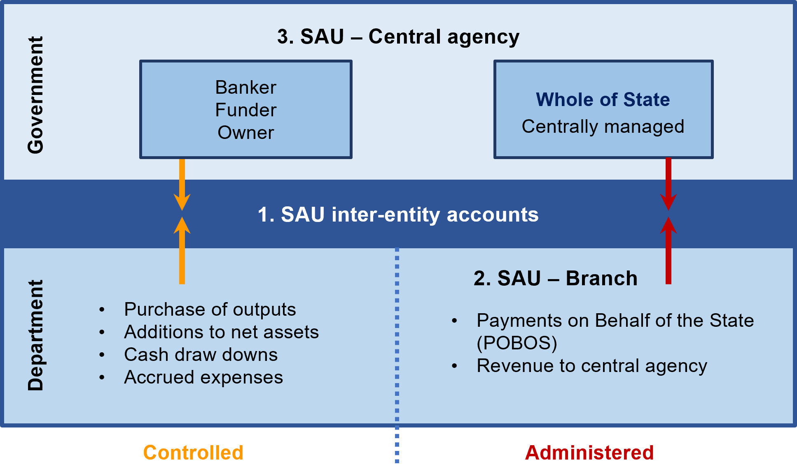

How the three components of the SAU interact
The following section seeks to explain the SAU’s workings through a hypothetical set of transactions.
Table 5: Sample SAU transactions
Transaction/event | Entity | Account | Amount
Receipt of taxation revenue by DTF (administered entity) | 7100 (SAU branch ledger) | 6xxxx (Revenue) | -1000
Submission of tax revenue to Consolidated Fund (via SAU) | 7100 (SAU branch ledger) | 90500 | +1000
Receipt of taxation revenue by the SAU | 9200 (SAU central agency) | 70570 | -1000
Recognition of funds in the State’s  bank account | 9200 (SAU central agency) | 10230 (Bank) | +1000
Funds appropriated for expenses (cash items)
Drawdown from bank account | 9200 (SAU central agency) | 10230 (Bank) | -200
Transfer to department | 9200 (SAU central agency) | 86500 | +200
Appropriation drawn down by department | Controlled Dept. Entity | 71200 | -200
Expense incurred | Controlled Dept. Entity | 86000 | +200
Funds appropriated for expenses (non-cash items)
Drawdown from bank account | 9200 (SAU central agency) | 10230 (Bank) | -400
Transfer to department | 9200 (SAU central agency) | 86500 | +400
Appropriation drawn down | Controlled Dept. Entity | 71200 | -400
Funds appropriated for expenses (non-cash items)
Increase in departmental SAU inter-entity account | Controlled Dept. Entity | 45000  (SAU inter-entity account) | +400
Depreciation expense incurred | Controlled Dept. Entity | 81xxx | +400
Recognition of accumulated depreciation (contra-asset) | Controlled Dept. Entity | 2xxxx | -400

  - The SAU inter-entity account dissection
Mandatory requirements
    - SAU inter-entity account dissection requirements and time frames
The Accountable Officer must:
- undertake a SAU inter-entity account dissection twice a year
- complete the SAU dissection template
- ensure the relevant CFO certifies the SAU inter-entity account dissection and forward it to DTF
- provide the dissection in line with the timeframes advised in DTF Information Requests.
    - Specific end of year requirements
- The SAU inter-entity account dissection must be provided to the Victorian Auditor-General’s Office and DTF as part of the end of year process, together with the final draft of the department’s annual report
- The date for delivery of the dissection to the Victorian Auditor-General’s Office must be negotiated between each department and its auditors.
    - Machinery of government changes requirements
When machinery of government changes occur, the SAU inter-entity account dissection must be updated by affected departments as at the date of the machinery of government change. A copy of the dissection must then be provided to DTF within timeframes determined by DTF.
    - Resolution of issues
The Accountable Officer must resolve any issues/variances identified by DTF in a timely manner.

Guidance
The SAU inter-entity account comprises each department’s appropriated but unspent (not yet drawn down) funds and other amounts that are available to it in the Public Account. This may include balances payable from the Consolidated Fund or cash held by DTF on behalf of Trust Accounts in the Trust Fund.
The purpose of the SAU inter-entity account dissection is for departments to:
- manage the application of appropriation funding provided
- ensure legal and administrative requirements are met
- identify and verify unspent depreciation equivalent to be applied against asset initiatives during the current year, and in the out years, contained in the forward estimates
- identify unspent levels of long service leave (LSL) equivalent to be applied to fund future drawdowns on the provision for LSL
- identify and verify the surplus on the provision of outputs, which will be available for application against future initiatives, following the Treasurer’s approval
- identify departmental obligations to pay employee entitlements, creditors and other commitments since 1 July 1998, for which output appropriation has been certified but not drawn.
The SAU inter-entity account dissection process helps DTF to verify that:
- legal and administrative requirements have been met
- the unspent component of the depreciation equivalent is available for future application towards asset investment/replacement when formulating the forward estimates
- the surplus on the provision of outputs is available for application against initiatives to be approved by the Treasurer.

The SAU inter-entity dissection – template and additional notes
Departments are required to submit a regular dissection report to DTF to explain the movements and balances in this account. This is required to satisfy legal, audit and budget monitoring requirements.
The template consists of five tabs:
- Statement C1 – Dissection of departmental SAU inter-entity balances in the Consolidated Fund (controlled entities)
- Statement C2 – Reconciliation of Controlled SAU to appropriation
- Statement C3 – Reconciliation to departmental operating statement
- Statement C4 – Reconciliation to departmental financial statements
- Statement A1 – Reconciliation of Administered SAU to appropriation.
Please also note the following about the SAU dissection:
- Only the controlled entities in a department require both a dissection (refer Statement C1) and reconciliations. However, a reconciliation of movements in the Administered Entity SAU inter-entity account to appropriations is also required (refer Statement A1)
- As Trust Fund transactions do not flow through the Consolidated Fund, these are not included in Statement C1, but are included in Statement C4
- Reconciliations of Controlled and Administered Appropriations in the SAU are required – refer to Statement C2 (controlled) and Statement A1 (administered).
For more information on how to populate the SAU dissection template, please contact DTF.
SAU dissection template, available on SRIMS

Reporting on the SAU inter-entity account (account 45000) dissection
The SAU inter-entity account balance dissection must be reconciled to the relevant financial statements to ensure the integrity of the information provided.
The SAU inter-entity account is considered a current receivable amount in the financial statements, as it is expected departments will draw down on the bulk of their appropriations within a 12-month period. Consequently, there is no requirement to remeasure this receivable to present value terms.
Note inter-entity account 45500 represents cash held in Trust Accounts and is available on demand to settle trust fund payables. As such, it is reported as Cash at Bank in departmental financial statements.
  - Policy and non-policy journal entries in SRIMS

Introduction
The primary aim of the forward estimates in SRIMS is to provide reliable aggregate and departmental budget estimates based on Government’s existing policies. The forward estimates in SRIMS enhances the Government’s capacity to make effective medium and long-term budget decisions.
The forward estimates in SRIMS operates on a four-year cycle, which is integrated with the budget process. When the estimates have been published in the budget papers they are rolled forward, with estimates for a new fourth year added.
As part of the annual budget and budget update processes, departments may submit budget journal entries to update their budget and forward estimates in SRIMS for approval by DTF.
Section 6.3: Process for the creation of the fourth-year estimates in the State Resource Information Management System (rollover)

Policy and non-policy journal entries
The budget journal entries submitted by departments to adjust the forward estimates, are identified and tracked as either ‘policy’ or ‘non-policy’, explained further below.

Policy journal entries
Policy journals entries reflect government decisions. These journal entries should be attributable to a Cabinet committee, Treasurer or ministerial decision that supports the estimate adjustment. Policy decisions also include decisions to provide a department with additional budget supplementation.
A policy journal entry will allow a department to post variations to appropriation accounts.
Examples of SRIMS policy journals include (but are not limited to):
- decisions from budget deliberations or new initiatives
- Treasurer's Advance decisions
- section 37 Public Account advances.
Departments may only increase their appropriation by applying for supplementation under the relevant legislation or policy and obtaining approval from the Treasurer or the relevant Cabinet committee.

Non-policy journal entries
A non-policy journal entry reflects largely administrative and all other changes. A non-policy journal does not allow for a variation of appropriation amounts.
Examples of non-policy SRIMS journals include:
- reallocations between expense accounts
- machinery of government changes (as these have no impact on whole of government aggregates)
- changes to third party revenue estimates
- asset revaluations/devaluations.

  - The Victorian Government Chart of Accounts
Supplementary requirements (attestation not required)
The Victorian Government Chart of Accounts
The Accountable Officer is required to map their chart of accounts to these segments in the Victorian Government Chart of Accounts (VGCoA) in SRIMS:
- Entity
- Account
- Authority
- Output
- Related party.
Mandated segments for direct mapping to the Victorian Government Chart of Accounts in SRIMS
- The Accountable Officer, as part of the VGCoA project, is required to adopt the following segments into their own (departmental) chart of accounts, which then map into the VGCoA in SRIMS:
- Entity
- Account
- Authority
- Output.
- The Accountable Officer must ensure that for each of the above mandated segments, an additional element in their chart of accounts must be included to be used to record the SRIMS account that the departmental segment maps to. The segment is required to be set to a mandatory setting, to ensure the SRIMS chart of accounts segment is always populated when any new segments that map to the SRIMS chart are created.

Guidance
The VGCoA comprises a common set of segments or codes used in combination by government departments and agencies in the submission of data to DTF. The collection of financial and performance data under the VGCoA structure supports consistent planning, monitoring and reporting across government. The VGCoA is used in SRIMS.
The VGCoA consists of the following five segments:
- Entity – Identifies the accounting or individual legal entity. This segment provides for the ‘sectorisation’ of transactions into government reporting groups (e.g. the general government sector)
- Account – Identifies the transaction type or nature of each transaction. This segment forms the basis of financial (accounting) statements
- Authority – Identifies the legal authority for transactions (revenue or expenses) within the Public Account (includes the Consolidated Fund and the Trust Fund). This segment forms the basis for reporting on the Public Account
- Output – Identifies the services or tasks being done in the delivery of agreed outputs. This segment provides information for performance and service delivery reporting requirements
- Related party – Identifies the counterparty to a transaction within government.

The whole of government Chart of Accounts project
A project was done several years ago on the VGCoA to address consistency issues between departments and DTF. After extensive consultation, final agreement was reached by departmental CFOs on the design and implementation of a common Chart of Accounts, mandating the four segments that departments are required to adopt, being:
- Entity
- Account
- Authority
- Output.
In addition, departments are also required to adopt these business-specific segments:
- Cost centre – identifies management/budget responsibility business units, or physical locations
- Project – identifies a temporary set of tasks or initiatives, may be used for asset projects in reporting to DTF.
These segments are not required to be mapped in SRIMS. However, these segments underpin departmental management reporting and supports easier data transfers in the event of any machinery of government changes.
The following table summarises the mapping requirements:
Segment | Segment length (characters) | Requirement to adopt | Mapping to SRIMS
Entity | 3 | Mandatory | Mandatory
Account | 5 | Mandatory | Mandatory
Authority | 4 | Mandatory | Mandatory
Output | 5 | Mandatory | Mandatory
Cost centre | 4 | Mandatory | Not required
Project | 5 | Mandatory | Not required

  - Contributed capital
Mandatory requirements
    - Contributed capital reconciliation requirements and time frames – actuals
- The Accountable Officer must reconcile the contributed capital/equity investment balances twice a year.
- The contributed capital/equity investment reconciliations must be certified by the relevant Chief Finance Officer (CFO) and provided to DTF as per the instructions in the relevant DTFIR.
    - Contributed capital journal entry reconciliation requirements – estimates
The Accountable Officer must ensure that if it submits any estimate variations that require the recognition of contributed capital, then the corresponding matching journal entries are also done by the agency in which they are recognising the contributed capital.

Outline of contributed capital reconciliation process

Departmental
The contributed capital/equity investment outflows to agencies must reconcile as per below:
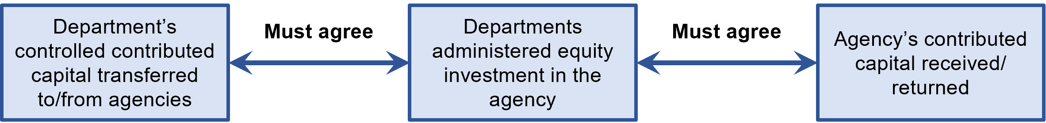

Transaction flows
The contributed capital transactions flow through the following statements:
            - Departmental administered items note (note this part is not reported)
            - Administered items – on behalf of the State (DTF Annual Report). DTF reports the State’s investment in all its controlled entities, as an administered asset
            - General government cash flow statement shown as a net contribution to other sectors of Government balance sheet
            - Annual Financial Report (whole of State) – eliminated.

Relevant materials

Accounting standards
- AASB 1004 Contributions
- Interpretation 1038 Contributions by Owners Made to Wholly-Owned Public Sector Entities

Financial reporting directions
- FRD 119A Transfers through Contributed Capital

VPS manuals
- Model Report for Victorian Government Departments
- Victorian public sector operating manual on machinery of government changes

For all attachments referred to in this document, please refer to the Resource Management Framework Part 2 of 2 Attachments, available on the DTF website.

This section is intended to emphasise the role of the portfolio department CFO in its portfolio and within the State’s financial management framework, which would include oversight over all funding requests put to Cabinet. It is expected that departments are compliant with these requirements from 1 July 2022 onwards.
The Consolidated Fund and the Trust Fund make up the Public Account, which may be viewed as a set of bank accounts owned and operated by the Government.
Refer section 63 of the Constitution Act 1975.
Refer section 64 of the Constitution Act 1975.
There are also funds that sit outside the Public Account, such as bank accounts that sit with statutory and other agencies.
Regardless of whether departments have access to sufficient appropriations to meet such obligations.
For example, judicial salaries have a special appropriation to ensure salaries are not at the discretion of the Government, thus maintaining the independence of the judiciary from government.
‘Government objectives and priorities’ means: in relation to Independent Offices the functions and/or objectives for which they were established as specified in their establishing legislation.
In the case of outputs that solely deliver policy advice to the Government, qualitative descriptions rather than data series may be used.
See footnote 12.
Comparability of performance over time should be taken into account when considering changes.
Addresses Recommendation 24, p187 and Recommendation 27, p192 of the Public Accounts and Estimates Committee’s Report on the 2016-17 Budget Estimates, Chapter 9: Performance Management.
Where possible, across departments and against other jurisdictions.
Comparability of performance over time should be taken into account when considering changes.
Available on the DTF website.
In meeting the medium-term planning requirements, the terms corporate plan and strategic plan are interchangeable.
Including assessing the future supply market, such as changing service delivery models, new entrants and market disruptions.
Data sources could include the ABS and DataVic.
‘Significant’ means a five per cent variance (increase or decrease), or a change that may be of public interest.
Departmental outputs and their associated quantity, quality, timeliness and cost measures represent an agreement on the goods and services the department intends to deliver in the financial year, in alignment with Government objectives.
Performance measures are used to assess output delivery as part of the revenue certification process (see section 1.2 for more information).
DTF will assist departments to elevate the capability and authority of the CFO role where it is required and appropriate. It is expected that departments are fully compliant with these requirements from 1 July 2022 onwards.
Such as employee expenses, maintenance costs, lease payments etc.
Before the changes are made by the department.
DTF will then advise the Treasurer and the Minister for Finance whether the change complies with all of these conditions.
In this context, ‘minor’ means amounts small enough that they would not materially affect the total cost of delivering the output in that financial year.
This is adjusted for any approved supplementary funding provided through Treasurer’s Advance, or the carryover of unapplied appropriation from the previous year.
It is expected that departments are compliant with these requirements from 1 July 2022 onwards.
With written approval from DTF, a department may vary the order in which these funding sources are applied.
Available on the DTF website.
Available on the DTF website.
Available on the DTF website.
A department may also use its retained surpluses on the provision of outputs to fund asset investment, subject to the provisions of approval under section 33 of the FMA.
The frequency of reporting is agreed between DTF and the responsible delivery department or agency, taking in account the project’s risk and complexity.
This section should be read in conjunction with the Investment Lifecycle and High Value High Risk Guidelines and the Risk, Time, Cost and Contingency technical guidelines available on the DTF website.
There are no changes to the current practices for asset investment proposal considerations, including the development of project budgets contained in business cases.
This excludes Parliament and Court Services Victoria which operate under section 31 and section 31A of the FMA, respectively.
Note that the Treasurer’s approval of a formal request from the relevant Minister is required to establish a section 29 agreement.
For guidance on setting prices, refer to the Cost Recovery Guidelines, available on the DTF website.
Such returns will also be adjusted in the SAU as a reduction in the Government’s investment in its agencies.
The ‘State’ as used here means only entities such as Portfolio Departments that do not have their own distinct legal capacity. This does not include entities such as Public Non-Financial Corporations or Public Financial Corporations.
Unless by or under an Act it may be paid into another fund (such as an account in the Trust Fund, or an account operated by a statutory authority).
It should also be noted that for section 29 of the FMA to be applicable, there must be a provision included against the relevant item in Schedule 1 of the annual Appropriation Act. If such a provision is not included in the Appropriation Act, then section 29 cannot be applied in the financial year covered by the Appropriation Act.
These are Goods and Services Tax (GST) grants, GST transitional grants and national competition policy payments.
For example, the Conservation, Forests and Lands Act 1987 provides for the Conservation, Forests and Lands Stores Suspense Account (section 22(1)); and the Conservation, Forests and Lands Plant and Machinery Fund (section 23(1)).
With the repeal of the Act in 1994, the FMA includes provision for the continuation of all existing trust funds and now provides the legal authority for the continuing operation of the Treasury Trust Fund consistent with its original purpose.
Output and asset contingencies are disclosed in Budget Paper No. 5, Statement of Finances.
Output and asset contingencies are disclosed in Budget Paper No. 5, Statement of Finances.
The Appropriation Bill for Parliament is not included in the calculation. Section 35 of the FMA does not appropriate the amount, it is section 7 of a subsequent year’s Appropriation Bill (the main Bill) that does so. Since the following year’s appropriation is submitted to the Parliament before the end of the financial year, the amounts presented for ratification are delayed until the following year’s Bill. There is no equivalent schedule in the Bill for Parliament.
Although the section heading Appropriation for borrowing against future appropriation suggests that section 28 authorises the bringing forward of funding from future appropriations to the current year, there are no actual future year appropriations from which amounts can be brought forward. The amounts shown in the forward estimates in the budget papers for future years do not have the status of appropriations, as they have not been enacted into law by Parliament.
Note, this only applies to appropriation items in the annual Appropriation Bill and does not apply to special appropriations.
The assessment criteria will not be applied where departments seek to access their SAU balances for purposes that are administrative in nature, such as: - access to long service leave funding accumulated in prior years - payment of outstanding creditors or other accrued obligations.
A departmental surplus is not to be confused with an operating surplus. An operating surplus occurs when revenue exceeds expenses in a department, which may include revenue and expenses that are not output-related (e.g. revenue from the sale of assets).
Depreciation equivalent accumulated in the current year must be accessed before any prior year’s depreciation equivalent
Section 33(2) of the FMA only permits depreciation equivalent balances to be used to fund asset investment
This excludes any subsequent recognition of gains or losses on revaluation of the LSL provision arising from the changes in present value resulting from the discount (bond) rate applied.
Provided the existing funding requirements for such assets are funded from appropriation.
Departments are often responsible for collating and submitting information on behalf of portfolio agencies.
There are certain exemptions to this requirement, outlined in the Standing Directions.
Also refer to Financial Reporting Direction FRD 8D Consistency of budget and financial reporting (January 2016).
Not limited to performance against output performance measures.
The monthly financial report is produced from September onwards, therefore monthly feeds for July and August are not required.
Unless other instructions are provided via a DTF Information Request.
Treasury Client Services can be contacted via email at TreasuryClientServices@tcv.vic.gov.au
Treasury Client Services can be contacted via email at TreasuryClientServices@tcv.vic.gov.au
Treasury Client Services can be contacted via email at TreasuryClientServices@tcv.vic.gov.au
Material variations are variations of either 10% or greater, or $100 million or greater, determined by whichever threshold is reached first.
Treasury Client Services can be contacted via email at TreasuryClientServices@tcv.vic.gov.au
Material variations are variations of either 10% or greater, or $100 million or greater, determined by whichever threshold is reached first.
Total program funding relates to funding provided over the four years (if applicable) before the date at which the program is scheduled to lapse.
Evaluation reports referenced in section 6.1.1 must address the seven questions outlined in section 6.1.2. Additional guidance on the individual components of the seven questions can be found in Attachment 14: Guidance on lapsing programs evaluations of the Resource Management Framework - Part 2 of 2 - Attachment document.
At least two years’ worth of EIIF annual outcomes reporting must be provided for lapsing programs adopting this reporting methodology, and the annual outcomes should be accompanied by responses to the seven questions outlined in section 6.1.2.
Such as changes in output performance measures.
If consultants are engaged to conduct evaluations of lapsing programs, they are bound by Cabinet confidentiality.
Independence does not mean that the evaluation needs to be done by parties external to the department. It may be conducted by another area within the department as a peer review, as long as that party was not involved in that program’s delivery.
May also include grants.
Available on the National Health and Medical Research Council website.
For further guidance, please refer to the website of the Commission for Gender Equality in the Public Sector Gender Impact Assessment Hub | Commission for Gender Equality in the Public Sector (genderequalitycommission.vic.gov.au), or contact your DTF relationship manager or the GRB team at genderresponsivebudgeting@dtf.vic.gov.au
If funding is required for output delivery, it must be funded from appropriation for the provision of outputs.
This coincides with the Mid Year and annual financial reporting requirements. A departmental CFO may decide to complete inter-entity account dissections at more frequent intervals for internal management and control purposes.
This coincides with the mid-year and annual financial reporting requirements.
The certified contributed capital/equity investment reconciliations are required to support acquittal of balances as required by the Victorian Auditor-General’s Office.
If there is insufficient time to undertake the matching process between a department and its agency, then the department must provide an explanation to DTF and come to an agreement.

