Victorian Government Climate-related Risk Disclosure Statement 2025

ACKNOWLEDGEMENT
OF COUNTRY

We acknowledge and respect Victorian Traditional Owners as the original custodians of Victoria’s lands and waters, their unique ability to care for Country and deep spiritual connection to it. We honour Elders past and present whose knowledge and wisdom has ensured the continuation of culture and traditional practices. We are committed to genuinely partner, and meaningfully engage, with Victoria’s Traditional Owners and Aboriginal communities to support the protection of Country, the maintenance of spiritual and cultural practices and their broader aspirations in the 21st century and beyond.

‘lim-ba nindee thana warn-ga-ilee’
(Preserve our Dreaming Lore) – Gunnai Language
Bitja (Dixon Patten Jnr) Yorta Yorta, Gunnai,
Gunditjmara and Dhudhuroa of Bayila Creative

The Secretary
Department of Treasury and Finance
1 Treasury Place
Melbourne Victoria 3002
Australia
Telephone: +61 3 9651 5111
dtf.vic.gov.au

Authorised by the Victorian Government
1 Treasury Place, Melbourne, 3002

© State of Victoria 2025

You are free to re-use this work under a Creative Commons Attribution 4.0 licence, provided you credit the State of Victoria (Department of Treasury and Finance) as author, indicate if changes were made and comply with the other licence terms. The licence does not apply to any branding, including Government logos.

If you have copyright queries or would like to receive this publication in an accessible format email information@dtf.vic.gov.au

ISSN 3083-4570 - Online (pdf/word)
Published September 2025

This document is available in Word and PDF format at dtf.vic.gov.au

Contents
Foreword 1
About this disclosure 3
Overview 4
1. Governance and legislation 6
1.1 Strong and stable system of government 6
1.2 Climate action built into legislation 7
1.3 Fit-for-purpose climate governance 11
2. Strategy 16
2.1 Climate-related risks and opportunities for Victoria 16
2.2 Economic and fiscal impacts from climate change 26
2.3 The Victorian Government’s roadmap for climate action to achieve net zero emissions 28
2.4 Building climate resilience 33
2.5 Ensuring prosperity and realising economic opportunities from climate action 35
3. Risk management 38
3.1 Identifying and prioritising climate-related risks and opportunities 38
3.2 The Government’s overarching approach to managing risk 40
4. Working with our partners and communities 42
4.1 Progressing Aboriginal self-determination in Victoria and working with Traditional Owners 42
4.2 Working with Victorian communities 46
4.3 Partnering with Australian and international governments 50
5. Metrics and targets 53
5.1 Reducing emissions in government operations 53
5.2 Ambitious interim emissions reduction targets for Victoria 55
5.3 Strong and achievable energy targets for Victoria 59
6. Next steps for Victoria 62
Abbreviations and acronyms 63

Foreword

The Victorian Government remains a proud leader on climate action.
We were the first Australian jurisdiction to release, in 2022, a public sector climate-related disclosure in line with the recommendations of the G20 Financial Stability Board’s Taskforce on Climate-related Financial Disclosures. Other jurisdictions have since followed suit.
We are pleased to continue that leadership with the release of the Victorian Government Climate-related Risk Disclosure Statement 2025.
This disclosure sets out the Government’s ambitious action on climate change, and how it considers climate-related risks and opportunities in strategy and decision-making. It captures significant advancements in the Government’s climate and energy agenda, and reflects evolving sustainability reporting standards.
We have continued to strengthen our climate action commitments, setting an ambitious emissions reduction target of 75–80 per cent below 2005 levels by 2035, and bringing forward Victoria’s net zero emissions target to 2045 – placing Victoria among the leading jurisdictions globally for emissions reduction.
We have legislated stronger renewable energy targets, including renewable generation targets of 65 per cent by 2030 and 95 per cent by 2035, and storage targets of at least 2.6 gigawatts (GW) by 2030 and 6.3 GW by 2035. Victoria has also legislated offshore wind generation targets of at least 2 GW by 2032, 4 GW by 2035 and 9 GW by 2040.
Climate action remains a priority of the Government – now more than ever. The latest available science shows Victoria is experiencing increasingly frequent and intense extreme weather events, and Victoria’s climate has warmed by at least 1.2°C since national records began in 1910.
We recognise the impacts of climate change are felt differently across regions and communities. The Victorian Government is committed to partnering with First Peoples and local communities during the transition to a net zero, climate-resilient economy.
Equally, we acknowledge that climate change presents a potential challenge to the Victorian economy and the Government’s fiscal position. We are working to understand and better manage the nature and magnitude of these risks over the medium and long term.
By releasing this disclosure, we affirm our commitment to providing transparency to the community and investors about how we are managing climate-related risks, in line with global best practice. We are committed to continuously improving the disclosure over time and releasing periodic updates.


Jaclyn Symes MP The Hon. Lily D’Ambrosio MP
Treasurer Minister for Climate Action
Minister for Industrial Relations Minister for Energy and Resources
Minister for Regional Development Minister for the State Electricity Commission

About this disclosure

The Victorian Government Climate-related Risk Disclosure Statement 2025 (the disclosure) outlines the Victorian Government’s approach to understanding, managing and monitoring risks and opportunities for its operations and for the State of Victoria, related to our changing climate.
This marks the second disclosure released by the Victorian Government, building on the first disclosure released in October 2022. The disclosure outlines the Government’s enduring policy frameworks and actions, while highlighting new initiatives and improvements in the Government’s understanding of climate-related risks and opportunities over 2023 and 2024.
The Government recognises that both the international and domestic standards for climate disclosures continue to evolve. This includes the release of the International Sustainability Standards Board’s disclosure requirements in June 2023, and the release of the Australian Accounting Standards Board’s (AASB) sustainability reporting standards in 2024. The International Public Sector Accounting Standards Board is developing disclosure standards for the public sector, and the AASB is considering the application of AASB S2 to the public sector context.
This disclosure is informed by the latest available Australian standards, adapted to support whole of government level reporting. Consistent with Victoria’s first disclosure, this includes key themes of governance, strategy, risk management and metrics and targets, and aspects of climate-related risk management that are unique to the public sector context. This framework is consistent with that set out originally in recommendations of the G20 Financial Stability Board’s Taskforce on Climate-related Financial Disclosures, which have since been adopted within the International Sustainability Standards Board Standards (IFRS S1 and S2) and the AASB Standards (AASB S1 and S2).

Overview

Climate-related risks include risks associated with the physical impacts of climate change, and risks from the transition to a climate-resilient, net zero emissions economy. This statement describes these risks to Victoria and how the Victorian Government is managing them as a climate action leader.

Governance and legislation
Victoria has a strong and stable system of government and culture of public accountability. Climate legislation creates whole of government oversight, shared accountability and devolved responsibilities to build climate resilience and transition to net zero emissions. Since the 2022 disclosure, Victoria has strengthened legislative commitments to climate action and supporting the energy transition, as well as whole of government oversight of climate action by government officials through the Victorian Secretaries’ Board.

Strategy
Victoria has a comprehensive roadmap for climate action, as outlined in the Climate Change Strategy. The strategy includes interim emissions reduction targets, adaptation priorities and emissions reduction pledges for key sectors of the economy. The Government has strengthened its understanding of climate-related risks and opportunities for Victoria, releasing the 2024 Climate Science Report and new analysis on the potential economic and fiscal impacts of climate change.

Risk management
Victoria’s ongoing management of climate risk is underpinned by a legislated five-yearly cycle that incorporates the latest science and builds ambition over time. This is supported by entity-level climate risk management practices, tools and guidance, and the Victorian Government Risk Management Framework.

Working with our partners and communities
Ensuring a just transition and taking advantage of climate-related opportunities requires partnerships between all tiers of government, Traditional Owners, institutions, communities and businesses, as well as other jurisdictions. The Government supports community-led action and draws on expertise and knowledge from across the state and from other jurisdictions, to help ensure the benefits of climate action are shared and no one is left behind.

Metrics and targets
Victoria has a robust approach to setting, monitoring and reporting on emissions reduction and renewable energy targets, supporting it to achieve net zero emissions by 2045. Victoria reduced statewide emissions by 31.4 per cent between 2005 and 2023, within the range of the 2025 target of 28-33 per cent below 2005 levels, and has legislated targets to reduce emissions by 45-50 per cent below 2005 levels by 2030 and 75-80 per cent by 2035.
The Government has strengthened its renewable energy targets, legislating targets of 65 per cent renewable generation by 2030 and 95 per cent by 2035. The Government also legislated energy storage and offshore wind energy targets.

Next steps
The Government will continue to strengthen its understanding and management of climate-related risks and opportunities. The Department of Treasury and Finance and the Department of Energy, Environment and Climate Action will continue to work to understand and assess the economic and fiscal impacts of climate change on the Victorian economy. They will also review how the Government is approaching climate-related risk disclosure, to ensure alignment with government priorities and evolving international and national standards.

    - Governance and legislation
The Victorian Government’s legislative and regulatory frameworks support the effective management of climate-related risks and opportunities, with strong governance arrangements ensuring appropriate processes, controls and procedures are in place to monitor and oversee management.

      - Strong and stable system of government
Victoria has a strong and stable system of government that provides for effective management of climate-related risks and opportunities, including appropriate governance, legislative and regulatory frameworks.

Victoria’s institutional strength
Victoria has a parliamentary system based on democratic elections and the Westminster system of government. The Commonwealth Constitution determines the allocation of roles and responsibilities between the Commonwealth and the states and territories. The rule of law and a culture of public accountability support strong, stable and transparent governance. This institutional strength provides the foundation for effective and responsive policy-making to support climate action.

Victorian Government decision-making
The Victorian Government has a well-established system to support its decision-making on the significant climate-related issues facing the state.
The Cabinet is the principal decision-making body for the Government. It comprises all Victorian Government Ministers, with the Premier as the chair, and makes decisions on significant matters of policy and legislation, including those relevant to climate change. Well-established arrangements and principles for the operation of the Cabinet ensure effective and responsive decision-making. There is a rigorous process to ensure that all proposals Ministers take to the Cabinet for its consideration are evidence-based, fit-for-purpose and represent a coordinated whole of government perspective.
The Cabinet, through a budget focused sub-committee, also makes decisions about how to allocate funding. In the lead-up to deliberations for the 2024-25 Budget, the Government added a requirement that all spending proposals prepared for a decision as part of annual budget processes need to provide information on how they may impact emissions reduction commitments and/or the State’s resilience to climate change. This has strengthened consideration of climate-related risks and opportunities in the Government’s spending decisions.

Clear responsibility and accountability
As well as being members of the Cabinet, Ministers are responsible to Parliament for implementing government decisions and policy within their portfolio areas and for the performance of their departments and agencies. The Minister for Climate Action is responsible for the climate action portfolio and engages colleagues and the Cabinet on climate-related issues.
All other Ministers contribute to the development and implementation of climate policy through their roles as:
- members of the Cabinet, contributing to government decisions
- lead or supporting Ministers for Victoria’s seven climate-change Adaptation Action Plans across key systems such as education and primary production
- lead or supporting Ministers for whole of government and sector-based emissions reduction pledges.
      - Climate action built into legislation
The Government has legislated its climate-action policy objectives and continues to strengthen these obligations. Victoria was one of the first jurisdictions in the world to legislate a net zero emissions target. Enshrining these objectives in legislation helps provide policy and investment certainty and strengthens transparency and accountability.
Other Victorian legislation also supports consideration and management of climate change, including through public sector financial and risk management requirements which require reporting and disclosure of climate information.

Climate Action Act 2017
Victoria’s Climate Action Act 2017 (Climate Action Act), previously the Climate Change Act, provides the overarching legislative framework for managing climate risks and opportunities arising from climate action. The Climate Action Act establishes a five-yearly cycle for climate action policy development, which mandates the development of interim emissions reduction targets, emissions reduction pledges, a Climate Change Strategy, Adaptation Action Plans, and a Climate Science Report. This cycle embeds continuous improvement in the Victorian Government’s approach to climate action, ensuring policy settings are responsive to evolving challenges and incorporate the best available climate science.
The Climate Action Act prescribes roles and responsibilities for the Premier, the Minister for Climate Action and other nominated Ministers for the various plans, strategies and pledges, as well as requirements for the public release and/or tabling in Parliament of those documents (Figure 1). This creates a model of shared accountability, transparency and ownership across government for the achievement of climate change objectives.
The Climate Action Act requires the Government to endeavour to ensure that any decision made, and any policy, program or process implemented by the Government appropriately considers climate change, where relevant. The Act also mandates that decision makers of certain decisions or actions have specific regard for climate change considerations outlined in the Act.

Figure 1: Legislative framework, roles and responsibilities under the Climate Action Act
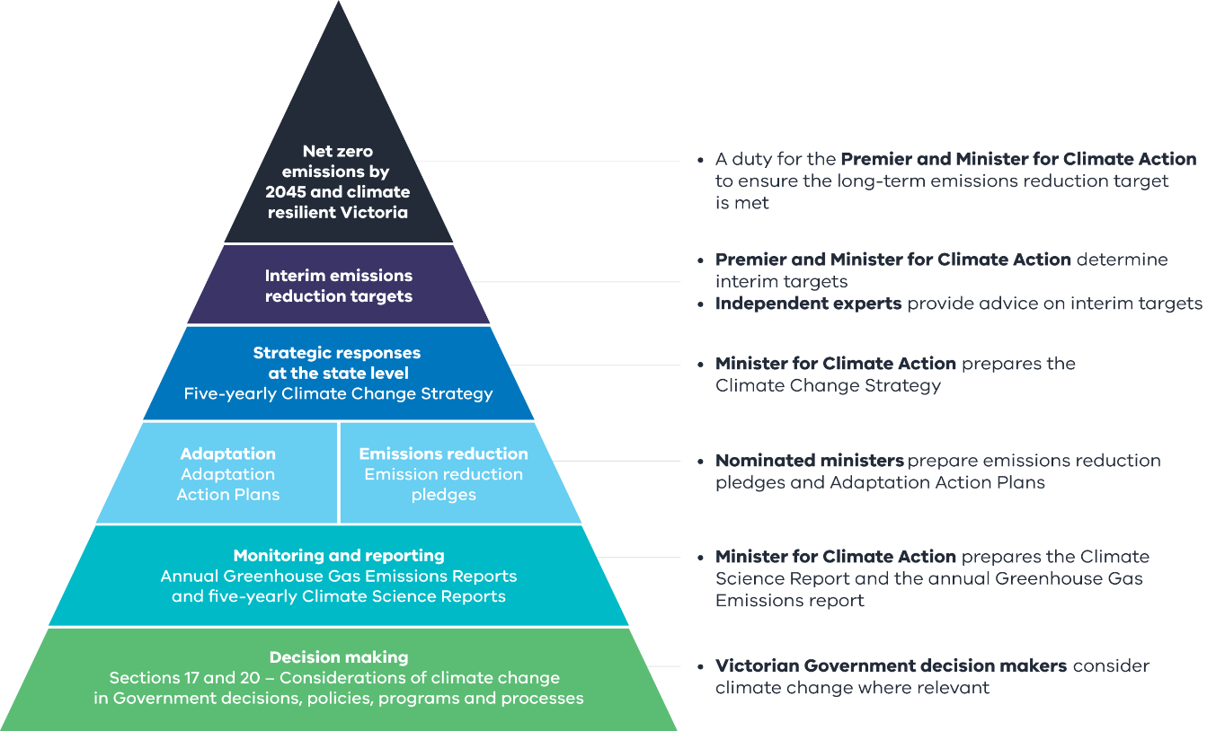

Strengthening climate action and facilitating the energy transition over 2023 and 2024

Victoria has strengthened legislative commitments to climate action and to supporting the energy transition since the Government’s fist climate-risk disclosure in 2022. The Climate Change and Energy Legislation Amendment (Renewable Energy and Storage Targets) Act 2024 included amendments to:
- bring forward by five years the long-term target for net zero emissions from 2050 to 2045, and legislate interim emissions reduction targets for 2025, 2030, and 2035 under the Climate Action Act 2017
- provide for express consideration of climate change in land-use and development decisions made under the Planning and Environment Act 1987
- introduce offshore wind energy generation and energy storage targets under the Renewable Energy (Jobs and Investment) Act 2017 (Renewable Energy Act)
- increase the renewable-energy target for 2030 to 65 per cent under the Renewable Energy Act
- introduce a new renewable-energy target of 95 per cent for 2035 under the Renewable Energy Act.
The Government has also enshrined in the Victorian Constitution the State Electricity Commission (SEC), a government-owned renewable-energy company which will support Victoria’s transition to net zero emissions through participating in the generation, storage and supply of renewable energy in Victoria, as well as supporting household electrification and Victoria’s clean energy workforce.

Case study: Embedding climate action into the planning system
In March 2024, the Government passed legislative reforms which make two significant amendments to the Planning and Environment Act 1987 (the Act) in order to strengthen climate-change considerations in the State’s planning system. This includes a new overall objective of the planning framework of the Act that provides for consideration of Victoria’s climate-change polices and obligations when decisions are made about the use and development of land.
The reforms also include a new duty for planning authorities to consider climate change, including Victoria’s emissions reduction targets and any significant risks, when preparing a planning scheme or planning scheme amendment. The Minister for Planning will issue Ministerial Directions that define the scope of what planning authorities must consider under the new duty. It will be supported by guidance materials which provide information on how to consider the impacts of climate change.

Reporting and risk management under the Financial Management Act 1994
The Government uses legislation to set high standards for financial and risk management practices by its agencies. These standards are achieved through the Standing Directions 2018, which require government departments and public bodies to comply with mandatory risk management and insurance requirements as set out in the Victorian Government’s Risk Management Framework (the Framework). As a high-level framework that covers all risk, the Framework also applies implicitly to climate-related risks. The Standing Directions are issued under the Financial Management Act 1994 (Financial Management Act) and Chapter 3 Riskmanagement refers to the Framework.
The same legislation supports Financial Reporting Direction (FRD) 24 Reporting of environmental data by government entities, which requires specified Victorian Government entities to disclose information on aspects of their energy and resource consumption and environmental performance, as well as their approach to managing climate-related risks and opportunities. This includes environmental indicators for greenhouse gas emissions and underlying activity data such as energy consumption and production, transportation, stationary fuel use, waste, building energy performance and sustainable procurement. Annual environmental reporting supports departments and public sector entities to reduce emissions and manage climate-related risks, and informs the preparation and delivery of the whole of Victorian Government emissions reduction pledge. Further information about FRD 24 can be found in Chapter 5 Metrics and targets.

General obligations
A range of other legislation establishes general obligations on decision makers in the Victorian public sector to ensure they consider and address the risks and opportunities of climate change.
- The Public Administration Act 2004 requires boards of public entities to inform responsible Ministers and Secretaries of major risks, and to put in place risk management systems to address those risks, and requires board directors to exercise care, diligence and skill in the performance of their duties. Guidance on the duties and responsibilities of boards and board directors of Victorian Government entities is available on the Join a Public Board website. This includes specific guidance on ‘Directors’ Duties with respect to Climate Risk.‘
- The General Environmental Duty under the Environment Protection Act 2017 requires all Victorians, including public-sector decision-makers, to eliminate and reduce risk of harm to people and the environment from pollution or waste (including greenhouse gas emissions) so far as reasonably practicable. The Environment Protection Authority has issued a guideline to support organisations, including public sector decision-makers, to fulfill the General Environmental Duty by assessing and taking steps to minimise their greenhouse gas emissions.
- Consideration of climate change is also required under a range of other Victorian legislation, including for example:
  - Circular Economy (Waste Reduction and Recycling) Act 2021
  - Flora and Fauna Guarantee Act 1988
  - Great Ocean Road and Environs Protection Act 2020
  - Local Government Act 2020
  - Marine and Coastal Act 2018
  - Transport Integration Act 2010
  - Yarra River Protection (Wilip-gin Birrarung murron) Act 2017
      - Fit-for-purpose climate governance
The Government continues to improve decision-making processes to ensure that its departments and agencies address climate risks.
The Victorian public sector includes the Victorian Public Service, as well as Victorian public entities such as public hospitals and emergency services and special bodies like the Victorian Ombudsman and Victoria Police. All areas of the public sector have an important role in climate-related risk and are discussed in this disclosure. For the purposes of this disclosure the terms ‘entities’ and ‘agencies’ are used interchangeably to refer to departments, entities they are responsible for (portfolio entities) and other government bodies.

Figure 2. Structure of the Victorian public sector
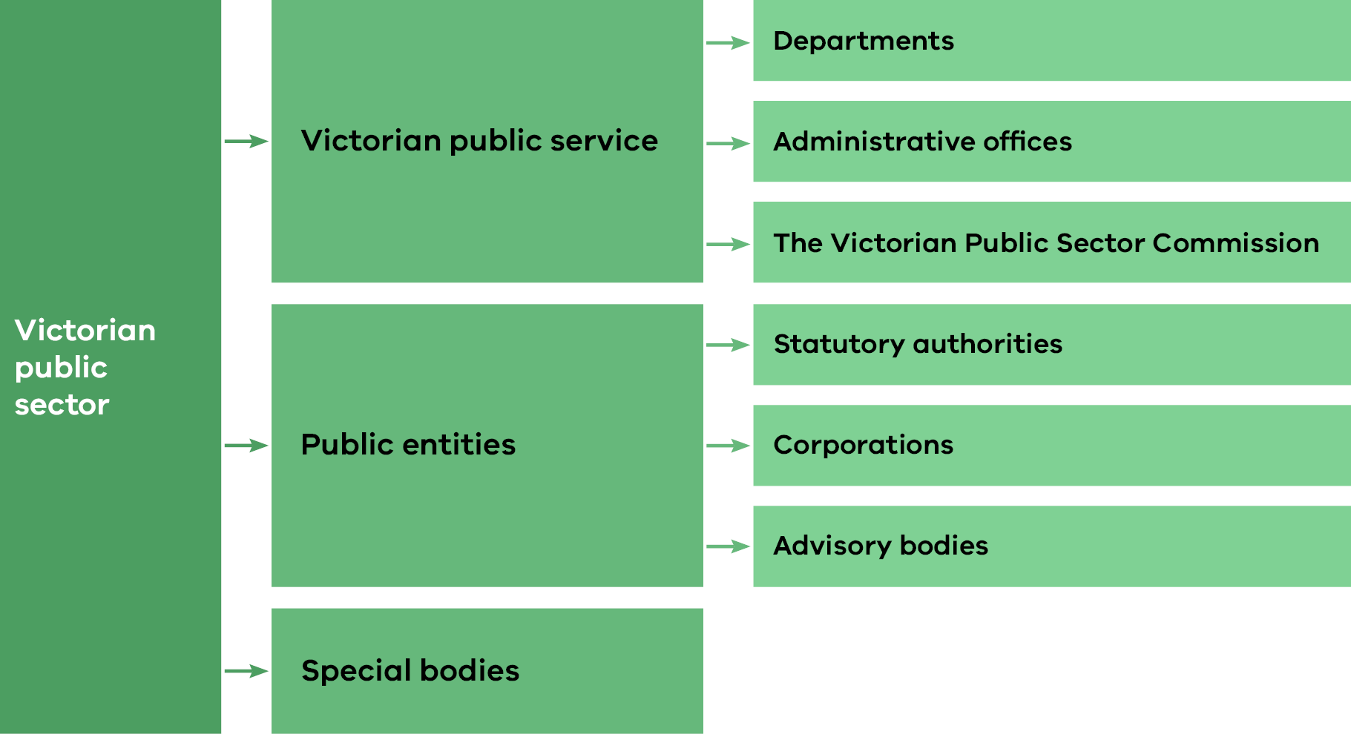

Departments and agencies
Each department and agency are responsible for identifying, assessing and managing all risks to which they are exposed, including climate-related risks. Ministerial Standing Direction 3.2 Oversight and assurance requires that all departments and agencies appoint an audit committee to provide independent assurance that the risk and control environment is operating effectively. The Victorian Government Risk Management Framework sets out the responsibilities of the audit committee, which include considering the agency’s risk profile and assessing the effectiveness of the agency’s risk-management framework. Departments and agencies prepare corporate plans that outline their current operating environment and key challenges, which can include climate-related risks and issues. Further detail on supporting procedures and policies is provided under Chapter 3 Risk management.

Victorian Secretaries’ Board
The Victorian Secretaries’ Board (VSB) provides strategic whole of government oversight by senior officials on progress towards Victoria’s climate-change objectives. The VSB helps ensure that the Victorian Public Service is on track to meet its climate-related commitments and that entities have the capabilities necessary to understand and manage climate-related risks.
The VSB comprises the Secretaries of each department, the Chief Commissioner of Police and the Victorian Public Sector Commissioner (see Figure3). Its role is to coordinate policy initiatives across the public sector and promote leadership and information exchange. The VSB’s role with respect to climate risk is further discussed in Chapter 3.

Figure 3: Victorian Secretaries’ Board membership
Secretary  Department of Premier and Cabinet | Secretary  Department of Treasury and Finance | Secretary  Department of Education | Secretary  Department of Jobs, Skills, Industry and Regions
Secretary  Department of Energy, Environment and Climate Action | Secretary  Department of Government Services | Secretary  Department of Justice and Community Safety | Secretary  Department of Families, Fairness and Housing
Secretary  Department of Transport and Planning | Secretary  Department of Health | Victorian Public Sector Commissioner | Chief Commissioner of Police

Emergency management governance
As Victoria’s climate continues to change, effective emergency management is helping to keep the community safe and protect assets and infrastructure. Victoria’s emergency management strategies acknowledge the role of climate change in increasing the frequency, severity and duration of natural disasters in Victoria, and commit to action to improve the State’s resilience. Arrangements for dealing with natural disasters are governed by the Emergency Management Act 1986 and Emergency Management Act 2013.
The State Emergency Management Plan sets out actions to be taken before, during and after an emergency. It specifies the roles and responsibilities of agencies to ensure a coordinated approach.
Emergency Management Victoria is responsible for coordinating development of whole of government policy for emergency management in Victoria. In 2022, Emergency Recovery Victoria was established as a state body to coordinate state relief and recovery activities. Both bodies support the Emergency Management Commissioner, who is responsible for coordinating emergency preparedness, response and recovery.
The Inspector General for Emergency Management provides assurance to the Government and community on emergency management arrangements and fosters continuous improvement.
The State Crisis and Resilience Council provides emergency management policy and strategy advice to the Government. Its membership consists of the secretaries of all government departments, the Chief Executive Officer of the Municipal Association of Victoria, the Emergency Management Commissioner, the Chief Executive of Emergency Management Victoria and the Chief Commissioner of Victoria Police and includes the Inspector General for Emergency Management and the Chief Executive of Emergency Recovery Victoria as observers.

Building skills and competencies in the Victorian public sector
The Government has mechanisms in place to ensure its public entities have the appropriate skills and competencies to respond to climate-related issues, including:
- VSB oversight of climate action: The VSB has overseen action by departments to lift climate-risk maturity, including the preparation of guidance to support departments to undertake climate-risk assessments and to plan emissions reductions from their own operations. Further information on the VSB’s role in climate action and building climate-risk maturity across the Victorian Government is included in Chapter 3.
- Program-specific governance arrangements: Key commitments under the Climate Action Act 2017 such as emissions reduction pledges and Adaptation Action Plans are supported by ministerial accountabilities and executive level interdepartmental forums, which ensure that government entities have the skills and capabilities to meet their commitments.
- Climate Change Risk Management Service: Launched in 2021, the Climate Change Risk Management Service provides resources to help government organisations consider and address climate-change risks. These resources have been developed for government risk professionals by the Victorian Managed Insurance Authority in partnership with the Department of Energy, Environment and Climate Action.

Integrating Traditional Owners’ rights and interests into climate governance
Victorian legislation acknowledges Traditional Owners’ distinct cultural and legal rights to self-determine decisions and outcomes for Country, as well as respecting their deep and ongoing connections to Country and Sea Country as original custodians. Legislative frameworks recognising Traditional Owners’ rights include the Aboriginal Heritage Act 2006, the Charter of Human Rights and Responsibilities Act 2006, and the Traditional Owner Settlement Act 2010 and, at a national level, the Native Title Act 1993 (Cth). The Government has also established a legal commitment to negotiating Treaty as a pathway to further recognition, through the Advancing the Treaty Process with Aboriginal Victorians Act 2018. Climate-change governance may be a topic subject to Treaty negotiations.
The Government is committed to partnering with Traditional Owners and Aboriginal communities to ensure their cultural, ecological and economic values and expertise are integrated into climate-change adaptation planning.
See Chapter 4.1 Progressing Aboriginal self-determination in Victoria and working with Traditional Owners for further information on how the Government is progressing Aboriginal self-determination and working towards genuine engagement and meaningful partnerships with First Peoples and Traditional Owners on climate action.

    - Strategy
This chapter provides information on the climate-related risks and opportunities that could impact Victoria’s environment, community and economy, and the Government’s strategy for responding to them.

      - Climate-related risks and opportunities for Victoria

The Government continues to invest in robust and up-to-date climate science and data to inform decision-making. Victoria’s Climate Science Report 2024 includes updated climate projections for Victoria and reviews from leading academic institutions and experts on climate hazards, such as droughts, bushfires, floods, heatwaves and sea-level rise.

Improved evidence base
The Government draws on a strong evidence base of the best available science to anticipate the significant climate-related risks and opportunities that are expected to affect Victoria. This evidence base has improved since the Government’s previous disclosure in 2022. Victoria’s Climate Science Report 2024 builds on the first report published in 2019 and incorporates user feedback from the inaugural report. Key improvements include climate projections based on the latest generation of global climate models, a deeper understanding of the latest science on climate hazards of significance to Victoria, and guidance on applying climate science in decision-making.

Climate Science Information: Modelling advancements
Climate science and modelling advancements have enhanced climate information and projections. Climate projections provide information on plausible climate conditions decades to centuries into the future to support decision-making, planning and adaptation.
The Government has continued to build on investments in climate projection data, guidance and tools, including Victorian Climate Projections 2024 (VCP24), the Victorian Water and Climate Initiative, and a range of other programs.
Victoria’s Climate Science Report 2024 adds to the suite of climate projections for Victoria, with VCP24 based on the sixth generation of global climate modelling, coupled with the Model Intercomparison Project Six, which underpins the Intergovernmental Panel on Climate Change’s (IPCC) Sixth Assessment Report.
The VCP24 projections include a plausible low and high climate scenario for Victoria in the form of shared socio-economic pathways, consistent with the latest IPCC report. These downscaled models provide climate information at more regional and local levels that are useful for decision-making and planning in Victoria.
Source: Victoria’s Climate Science Report 2024

Victoria’s changing climate
Victoria’s climate has warmed since the 19th century, becoming drier in recent decades and experiencing more frequent and intense climate hazards. As global greenhouse gas emissions increase, these changes are projected to continue.
Victoria’s climate is shaped by large-scale climate drivers (such as El Niño–Southern Oscillation), seasonal influences and weather systems. It varies across regions and from year to year and from decade to decade. Despite these natural variations, the long-term warming trend is evident in Victoria’s climate.
Victoria’s climate has warmed by about 1.2°C since national records began in 1910, and by around 1.4°C since the pre-industrial era. This is slightly higher than the global average rise of 1.1°C since the pre-industrial era. The number of hot days per decade has increased, and heatwaves have become hotter and more frequent.
Victoria’s average rainfall has decreased in all seasons except summer, with a more than 10 per cent decline in cool-season rainfall over the past 30 years. The most extreme rainfall events have increased, especially short-duration extreme rainfall.
Victoria is expected to continue to become hotter and have a drier cool season.

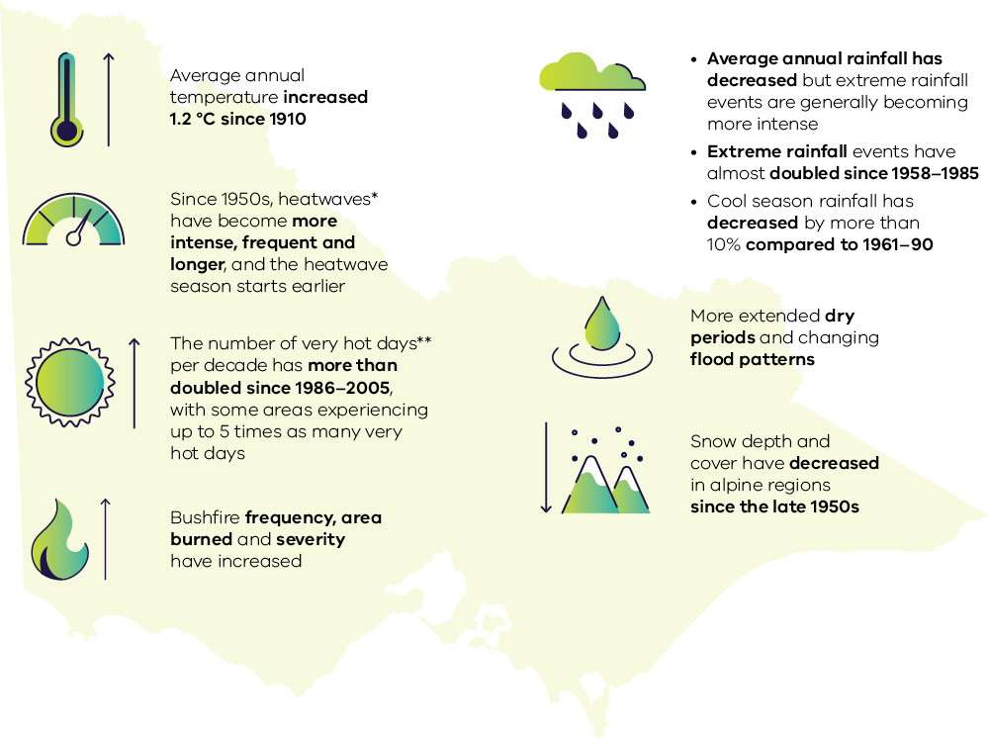
Source: Victoria's Climate Science Report 2024
Notes:
* A heatwave is defined as at least three consecutive days above the 95th percentile of daily average temperatures.
** Very hot days are defined as days with daily maximum temperature exceeding the 99.9th percentile.

Victoria’s average temperature is projected to continue to warm over the rest of the 21st century. Warming is projected to be greater under higher global emissions scenarios. Average temperatures will only stabilise if global emissions reach net zero. Victoria is also virtually certain to experience hotter and more frequent hot days.
While future changes in rainfall are less certain, Victoria is expected to continue to become drier during the cool season and may experience more extreme rainfall events. Despite these long-term trends, cooler and wetter periods will still occur in the future due to natural variations in the climate.

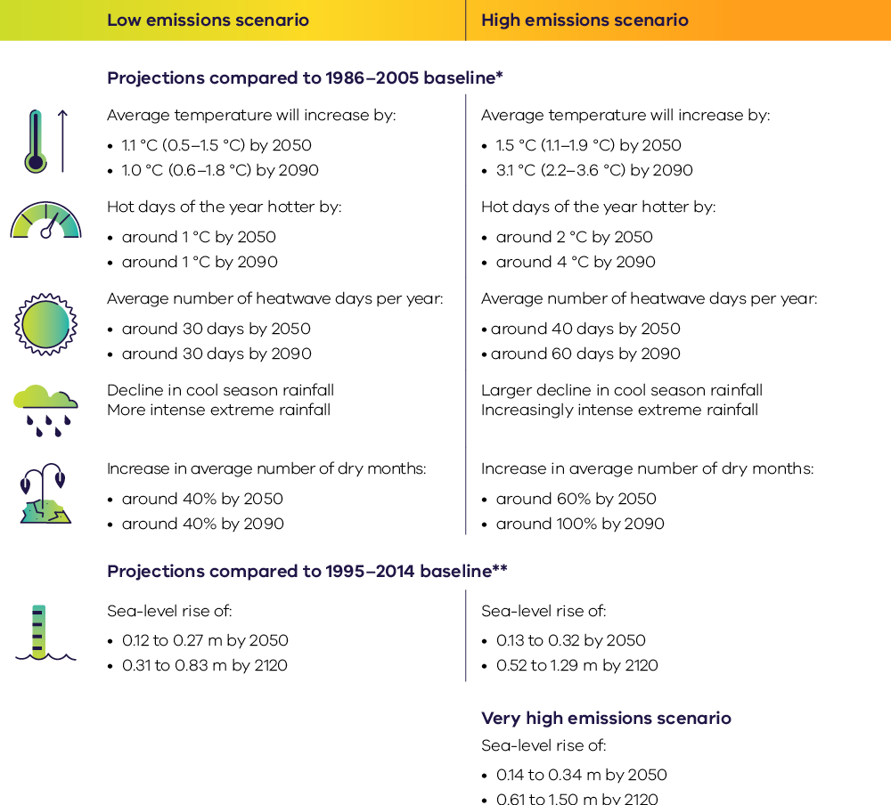
Source: Victoria's Climate Science Report 2024
Notes:
* Downscaled CMIP6 projections, based on plausible low (SSP1-2.6) and high (SSP3-7.0) emissions scenarios. Average temperatures are given as the median followed by the range. Hot days are defined as days with daily maximum temperature exceeding the 99th percentile. Heatwave days are defined as three consecutive days with daily average temperature exceeding the 95th percentile. A dry month is defined as a month below the 10th percentile in average monthly precipitation.
** CMIP6 projections, based on low (SSP1-2.6), high (SSP3-7.0) and very high (SSP5-8.5) emissions scenarios. Sea level is lowest and highest as taken from the Melbourne, Warrnambool or Gabo Island locations from projected changes (17–83 per cent uncertainty range). Very high emissions scenario provided as additional CMIP6 sea-level rise projections study available for Victoria.

Hazards identified for Victoria
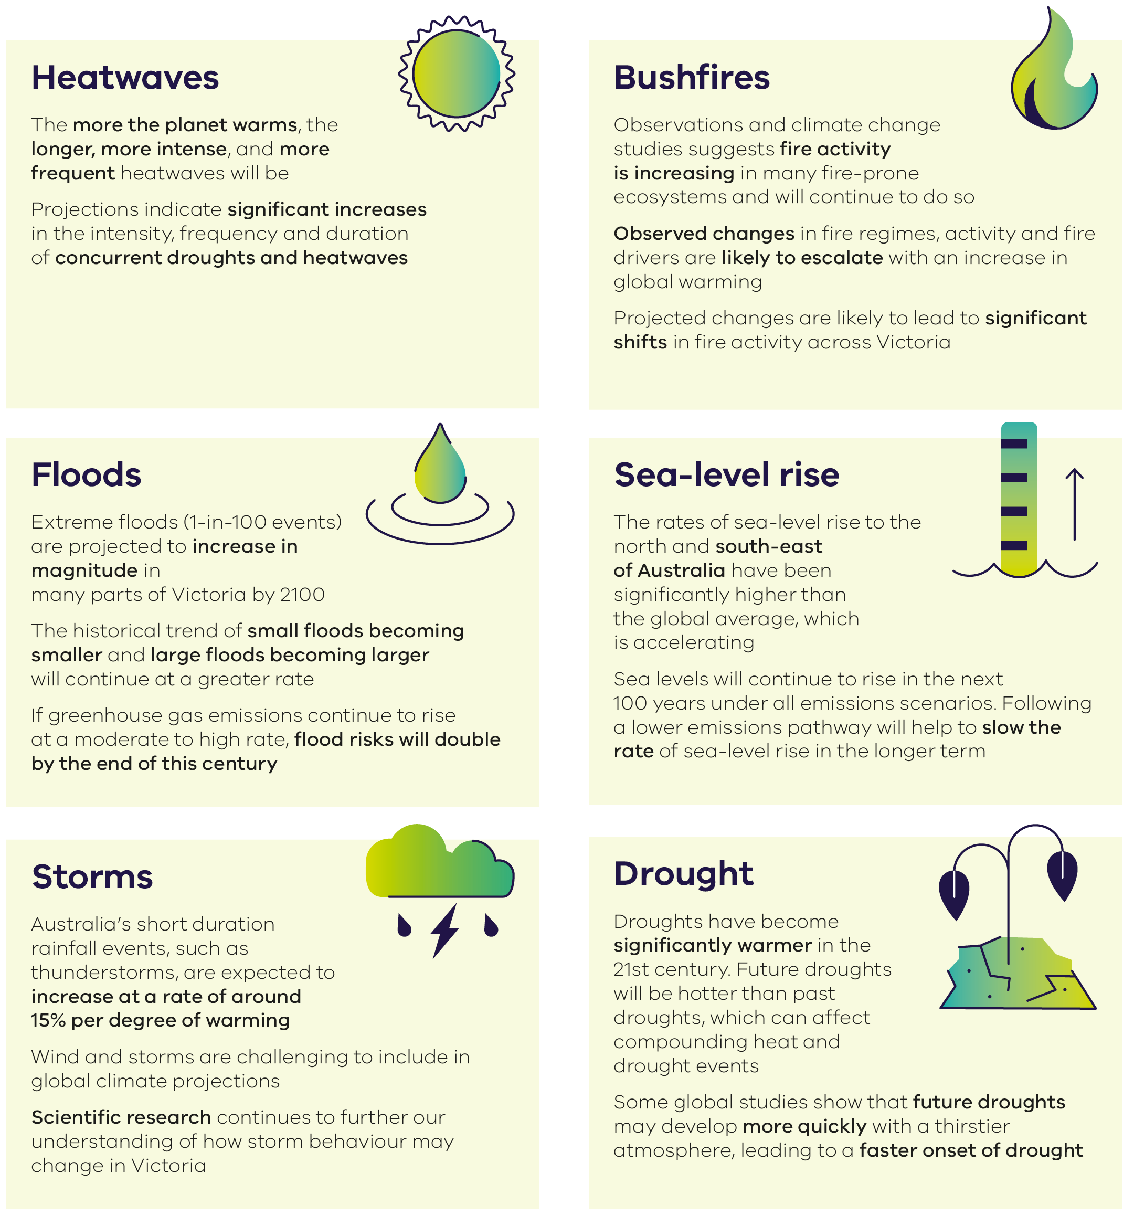
Victoria’s changing climate affects naturally occurring hazards in various ways. Common and damaging climate hazards include floods, heatwaves and extreme heat, drought, bushfire and sea-level rise. The historical trend of small floods in Victoria becoming smaller, and large floods becoming larger, is likely to continue at a greater rate.
Heatwaves are expected to increase in intensity, frequency and duration in Victoria as the climate continues to warm. Drought duration and intensity may increase, and fire weather severity, area burnt and fire intensity are projected to increase, with changes dependent on the location. Sea-level rise around Victoria’s coastline is expected to accelerate and continue to the end of the 21st century and well beyond.

Climate science in decision-making
Climate science and modelling advancements have enhanced Victoria’s climate information and projections. Climate science helps Victorian businesses, the community, and the government understand and adapt to the current and future climate.
The climate experienced in the past is no longer a good indicator of the climate we can expect in the future. Consideration of the latest climate science about likely future changes is therefore critical to good governance and decision-making. This will assist Victorians to plan and respond to the effects of climate change. The Government publishes information online to help local governments, businesses and communities make decisions about climate risk.
Practical applications by the Victorian Government of climate science information include:
- the publication of the Victorian Climate Science Report every five years, which describes how our climate is changing and includes local-scale climate projections
- Victoria’s Future Climate Tool, which provides public access to local-scale climate projections to the 2090s, to help inform decision-making
- using research findings to support the water sector to assess climate-change impacts on our water resource availability
- using observational data to minimise current exposure to climate change
- applying climate projections to inform medium and long-term adaptation strategies
- understanding climate hazards to prepare and respond to extreme weather.
The 2024 Victorian Climate Science Report includes expanded content on decision-making, intended to support use and application of the climate science Chapter 5 Applying climate science in decision-making.

Case study: Parks Victoria improves the climate readiness of Conservation Action Plans

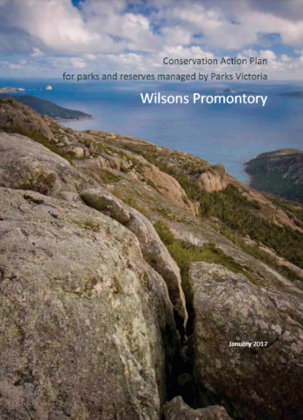
Background
At Parks Victoria, Conservation Action Plans provide a basis for strategic landscape-scale conservation planning. Plans have been developed or are in development for 18 planning areas covering Victoria’s terrestrial and marine parks and reserves. Parks Victoria has developed an approach to climate change scenario planning to enhance the coverage of climate adaptation actions in Conservation Action Plans.
Scenario planning is a method that is increasingly employed to incorporate future climate uncertainty into climate adaptation planning. Typically, it involves the identification of multiple plausible climate futures, which are used to generate divergent future narratives. These capture the uncertainty around future climate impacts and can inform strategic planning, decision-making and engagement.

Climate science
Parks Victoria’s approach to scenario planning draws strongly on the projections provided by Victoria’s Future Climate Tool and interactive spatial tool which provides detailed climate projections for Victoria from six global climate models using both moderate and high emissions scenarios. The approach has been developed to support the Conservation Action Plan program at Parks Victoria, and to address some of the challenges which commonly limit the development and uptake of scenario-planning.
One of the cornerstones of Parks Victoria’s approach is the use of machine-learning methods to quantify the similarities among the full set of available climate models, across both emissions scenarios and more than 20 climate variables. This permits the selection of a manageable subset of highly divergent climate model emissions scenario combinations. These serve as the basis for climate futures in the scenario planning process in a more objective and reproducible way than other methods.
Other key elements used by Parks Victoria include:
- a structured and systematic approach to elicit expert knowledge (through workshops) to build scenario narratives that assist with engagement and understanding of vulnerability
- a process of stress-testing goals and actions to help translate narratives into climate-smart strategies. Planning has been based on projected changes in climate to 2050, which aligns well with the 15-year outlook for Parks Victoria’s conservation action plans.

Science informing climate-ready actions and adaptation improvements
The implementation of scenario-planning integrates with well-established Conservation Action Plan processes and has helped Parks Victoria to identify, for several key landscapes, climate-ready goals, low-regret actions, and instances where current adaptation options may not be sufficient or feasible to mitigate climate impacts. More broadly, the work underscores the benefits that can be achieved by using approaches such as scenario planning to facilitate data-driven decision-making in the management of protected areas.

Case study: Understanding the vulnerability of school infrastructure and assets to severe weather to inform management strategies

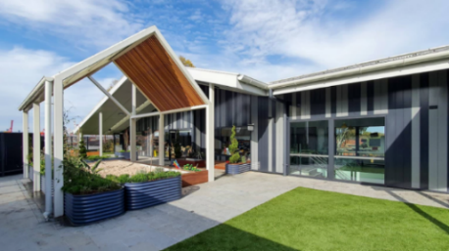
Background
The Department of Education studied the risks of extreme weather events to the education system. The study specifically looked at the risks of climate hazards to school infrastructure based on geographical region, and identified initial mitigation and adaptation considerations to reduce these risks for each established zone.

Climate risk assessment and school assessment management
The Department’s Climate Risk Assessment and School Asset Management study applied the 2019 Victorian Climate Projections to inform a risk assessment for seven shocks or stressors that pose a high or extreme risk to Victorian school infrastructure. These included an increase in temperature, drought, bushfire, storms, intense rainfall, sea level rise and civil infrastructure failure. The projections were selected based on regional specificity, consideration of seasonal patterns, and their ability to replicate historical climate data. Risk assessments were completed for 2030 (short-term), 2050 (medium-term) and 2070 (long-term) time horizons, given the long-term life of school assets. The assessment adopted a worst-case greenhouse gas emissions scenario with little to no mitigation leading to very high global emissions and temperature rises.

Science informing risk management and resilience
The study has allowed the Department to develop a better understanding of climate risk across the portfolio, informing the Department’s work to build climate resilience across the asset base.

Case study: Understanding the vulnerability of health services to severe weather and development of adaptation options

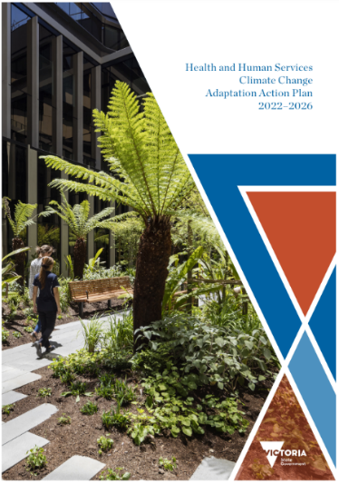
Background
Following the October 2022 floods, the Department of Health commissioned climate risk assessments for six regional hospitals to understand the specific vulnerability of health services to severe weather events.

Assessing climate risk
The assessment involved mapping region-specific historic temperature and weather trends to future climate scenarios. Historic data was compared to projections data for 2030 and 2050 under two scenarios: one involving moderate efforts to reduce emissions, and another representing a worst-case scenario with little to no mitigation. Climate projections were consolidated from the Commonwealth Scientific and Industrial Research Organisations Climate Change in Australia Murray Basin Cluster and the Loddon Campaspe Regional data in the 2019 Victorian Climate Projections. The Electricity Sector Climate Information tools were also used.

Science informing risk management and adaptation
This assessment found health services are vulnerable to climate change due to the direct impacts to infrastructure and indirect impacts to service delivery. These impacts may be compounded by potential supply-chain disruptions and the reduced availability of health service staff during severe weather events (due to disrupted access routes and the need for staff to manage risks to their own health, family and property).
The assessment proposed a range of potential adaptation options for infrastructure and service delivery. This will inform the Department of Health’s work to build resilience across the Victorian public health sector.

Climate-related threats to social, economic and environmental systems

Climate change presents risks to statewide systems that are critical for the functioning of Victoria’s economy and society, such as transport and primary production, built environment, energy, health, housing and water. Taking steps now to support each of these systems to adapt will reduce the impact on the health of people and ecosystems and minimise economic disruption. The Government is working to understand climate-change risks, support the most vulnerable people and assets, and prioritise solutions that will protect essential systems and services.
The Government is supporting each of the systems in Figure 4 to adapt to the impact of climate change through Adaptation Action Plans. More information about these plans can be found in Chapter 2.3.

Figure 4: Key challenges for seven statewide systems
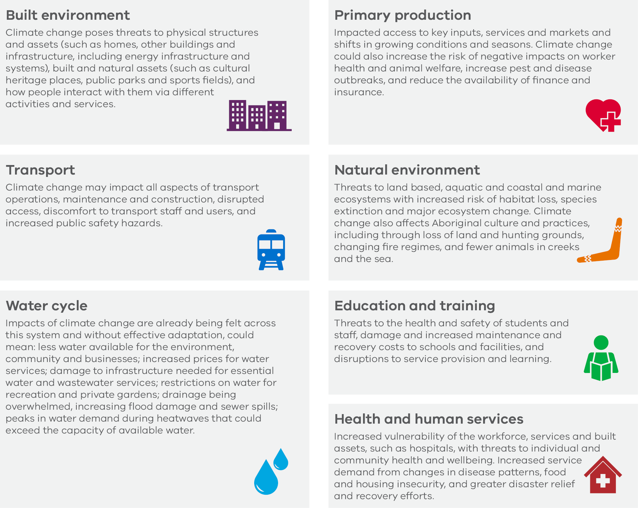

      - Economic and fiscal impacts from climate change

Current and potential impacts on Victoria’s economy and fiscal position
Climate-related physical and transition risks and opportunities may materially affect the Victorian economy and the Government’s fiscal position, and these risks present a challenge to the Government’s long-term fiscal and strategic planning.
The physical risks associated with climate change could result in substantial expense to government. For example, increased incidence of extreme weather events could translate to significant and often unforeseen spending on disaster relief and recovery efforts. This could include support for affected communities, additional resourcing for emergency management services, or funding to repair and replace damaged infrastructure. It may also necessitate expenditure on adaptation or mitigation measures to minimise exposure to physical risks arising from repeat events, such as funding to build or adapt infrastructure or other assets to higher specifications. Well planned investments in assets and infrastructure can deliver long-term cost savings and benefits.
Climate change challenges health and human services which in turn has economic consequences. For example, heatwaves are the leading cause of weather-related deaths in Australia and may increasingly threaten both worker safety and productivity in weather-exposed industries, as well as increase emergency department presentations and hospital admissions. Taking steps now to build resilience reduces the impacts on the health of people and ecosystems and minimises economic disruption.
The transition to a net zero emissions economy presents both economic and fiscal challenges. Research commissioned by the Government for Victoria’s 2035 Climate Target Supporting Analysis projected Victorian gross state product (GSP) to be $63 billion higher overall (net present value 2022–2070) if Victoria meets the 2035 target and there is strong global action than in a scenario where neither act. Consistent with past trends, the modelling projects that Victoria’s economy, employment and wages will continue to grow strongly while meeting the 2035 target.
The global transition to net zero emissions will change demand patterns for goods and services and impact the competitiveness of some Victorian industries. This may present challenges for businesses and communities in emissions-intensive industries that need to transition as part of the net zero emissions economy. The Government is committed to supporting industry transition to net zero emissions, including affected workers and communities. Action to support communities is further outlined in Chapter 4.2 Working with Victorian communities.
Climate change also presents challenges for the financial sector. Insurers are already facing rising claims for more frequent and severe weather-related events, exacerbating insurance affordability pressures for households and organisations. The financial sector may also have lending exposures to sectors affected by the downside risks of the transition such as emissions-intensive industries.

Case study: Physical risks of climate change for government assets
In 2022-23, the Victorian Funds Management Corporation (VFMC) conducted scenario-based climate hazard analysis across 73 assets within its property portfolio, as part of VFMC’s integrated environmental, social and governance approach. The analysis was designed to provide a foundational understanding of the portfolio’s vulnerability to the physical effects of climate change. Nine individual climate hazards were considered over two time horizons (2030 and 2050). The analysis demonstrated that, despite the absence of any aggregate risk scores beyond ‘moderate’, some assets are potentially vulnerable to individual climate events during the time horizon of investment. In response to these findings, VFMC has now requested that managers prepare risk monitoring, management and adaptation plans.

The Government is continuing to build an understanding of the effects of climate-related risks on Victoria’s economy and the Government’s fiscal position. The following case study outlines the estimated fiscal and economic impacts of the 2022 October floods.

Case study: Economic and fiscal impacts of the October 2022 floods
The estimated short-term economic costs of the October 2022 floods in Victoria were published in the 2023-24 Budget. The gross economic costs of these floods were estimated to be around $900 million in 2022-23, or about 0.2 per cent of Victoria’s gross state product, with losses concentrated in Victoria’s agriculture industry. Funding decisions disclosed in in the 2023-24 and 2024-25 budgets for disaster relief and recovery expenditure relating to the October 2022 floods totalled about $1.7 billion in 2022-23 and almost $350 million in 2023-24. This included funding to:
- provide emergency management and community support for short-term relief and recovery
- provide grants to eligible businesses, primary producers, not-for-profits and community organisations
- coordinate clean-up activities.

Key actions supporting adaptation and resilience are discussed further in Chapter 3 Risk management.

      - The Victorian Government’s roadmap for climate action to achieve net zero emissions

The Government is taking ambitious action on climate change, having achieved its 2020 emissions reduction target, and is on track to achieve Victoria’s 2025 interim emissions reduction target of 28–33 per cent below 2005 levels. The Government is continuing to build in consideration of the climate-related risks and opportunities outlined in Chapters 2.1 and 2.2 above as part of its strategy and decision-making.

Shaping Victoria’s climate strategy
The Government continues to implement its 2021 Climate Change Strategy, which sets out a roadmap for reducing emissions and building resilience to the impacts of climate change over the 2021-25 period. This involves:
- transitioning Victoria to a clean energy future that will create jobs, cut costs for households and businesses and strengthen the State’s energy system
- investing in innovative technologies, such as zero-emissions vehicles and renewable gases, and partnering with businesses and communities to set Victoria up for their adoption
- recognising and safeguarding the role of the State’s natural environment in reducing emissions, and ensuring farmers are well placed to adopt new technologies and practices that reduce emissions
- supporting Victorian businesses and communities to cut emissions
- Building Victoria’s climate resilience and strengthening the ability to withstand and recover from extreme weather events.
The next five-year Climate Change Strategy will be prepared in 2025 for the 2026–30 period.

Emissions reduction targets
The Government has legislated targets that provide a clear path to net zero emissions. The Government has brought forward its long-term legislated net zero emissions target from 2050 to 2045. The interim targets to reduce the State’s emissions from 2005 levels are:
- 15–20 per cent by 2020
- 28–33 per cent by 2025
- 45–50 per cent by 2030
- 75–80 per cent by 2035.
Under the Climate Action Act the Government is required to set the emissions reduction target for 2040 by 31 March 2028.
These ambitious targets and other complementary targets and metrics are set out in further detail under metrics and targets in Chapter 5.

Emissions reduction pledges
The Government has developed pledges which outline the actions it is taking to cut emissions from six sectors of the economy and from the Victorian Government’s own operations. The first pledge period is from 2021 to 2025, with pledges for 2026 to 2030 to be prepared in 2025 alongside the next Climate Change Strategy.

Figure 5: Overview of Victoria’s 2021–25 emissions reduction pledges
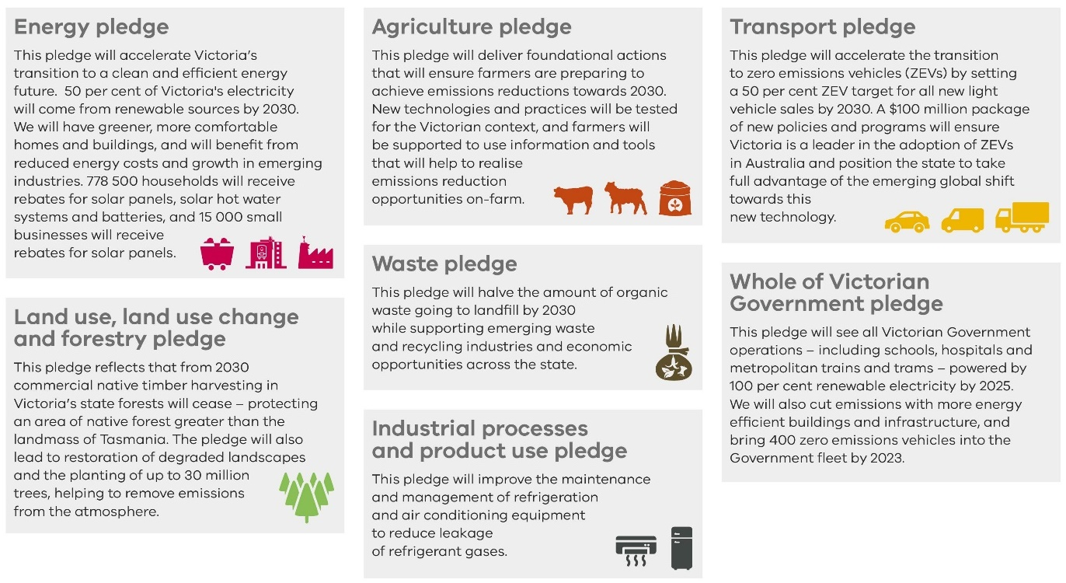

More ambitious renewable-energy targets
Victoria’s electricity sector accounted for 46.2 per cent of Victoria’s net greenhouse gas emissions in 2023. To reduce Victoria’s greenhouse gas emissions and address energy transition risks, the Government has legislated targets and is planning for, facilitating, and delivering a significant expansion of renewable energy. These targets are detailed in Chapter 5.3.

Delivering renewable energy targets
To deliver the renewable-energy generation and energy storage required to replace retiring coal-fired power stations, the Government is taking action, as set out in Cheaper, Cleaner, Renewable: Our Plan for Victoria’s Electricity Future, including:
- supporting the building of energy storage – like the Victorian Big Battery – to support the ongoing supply of affordable and reliable renewable electricity
- supporting the development of Victoria’s offshore wind energy industry through the establishment of Offshore Wind Energy Victoria
- VicGrid’s proactive and coordinated approach to planning and developing Victoria’s electricity transmission will modernise the electricity grid and connect Victoria’s Renewable Energy Zones to the electricity grid. This includes investing $480 million in 12 projects across the state to augment the transmission network, reduce constraints, and support the connection of renewable energy projects. VicGrid engages landholders, communities and Traditional Owners in decision-making to minimise impacts on communities and the environment and ensure benefits are shared fairly
- improving planning and approval processes to support better and more timely outcomes for renewable energy projects, including through the new Development Facilitation Program to provide an expedited planning process for eligible projects, reforms to speed up Victoria’s Environmental Effects Statement process, and the delivery of new, clear biodiversity guidelines
- re-establishing the State Electricity Commission (SEC) as a government-owned renewable energy company to invest in renewable energy and storage projects, support households to go all-electric, and help build Victoria’s renewable energy workforce. The SEC is investing an initial $1 billion to accelerate the transition by delivering 4.5 GW of new renewable-energy generation and storage by 2035. Investments announced to date include $245 million to deliver the 600 MW Melbourne Renewable Energy Hub battery, and $370 million towards the SEC Renewable Energy Park – Horsham. These projects are expected to be operational in late 2025 and 2027, respectively.

Supporting Victorian households and businesses to reduce reliance on fossil gas
In December 2024, the Government released Victoria’s Gas Substitution Roadmap Update 2024, building on the Government’s strategic plan to decarbonise the gas sector. The Update outlines new actions to support the State’s transition away from fossil gas, including:
- releasing draft regulations for consultation to progressively electrify Victorian homes and many commercial buildings
- consulting on proposed additional minimum energy efficiency standards for renters and rooming houses to deliver more energy-efficient homes
- releasing an Industrial Renewable Gas Guarantee Directions Paper to test options for developing a renewable gas sector
- increasing transparency in the gas market by making local consumption data from gas distribution businesses publicly available. This will improve our understanding of how fossil gas consumption is evolving both locally and across the state to support evidence-based decisions about the future of gas networks.
The Government is also helping existing homes and businesses use less gas and switch to cheaper, low-emission electric options through the Solar Homes Program and the Victorian Energy Upgrades program, and the SEC’s electric home planner.

Victorian Energy Upgrades
Since it was established in 2009, the Victorian Energy Upgrades program has provided incentives to more than 2.4 million households and 179 000 businesses to install energy-efficient products. On average, households that undertake energy efficiency upgrades under the program are estimated to save $110 and businesses save $3 700 on their annual energy bills. Under the program, households can access incentives to replace gas appliances with electric ones. Since the activity was introduced in June 2023, over 35 000 households replaced inefficient gas space heating. Over the same time, over 41 000 households have replaced inefficient gas hot water systems.

Solar Homes
In 2018, the Government launched its 10-year $1.3 billion Solar Homes Program. The program aims to provide 778 500 rebates to support Victorian households to install photovoltaic panels, efficient hot water and battery systems. Since 2018, the Solar Homes Program has approved over 400 000 solar photovoltaic, hot water and battery system rebates and loans, adding over 2.1 GW of generating capacity and 234 megawatt hours (MWh) of storage capacity. As of December 2024, the Solar Homes Program has also reduced carbon dioxide equivalent emissions in the National Electricity Market by an estimated 2.1 million tonnes from solar photovoltaic systems.

State Electricity Commission
The SEC is offering solutions to help Victorians understand their home energy use and switch to all-electric appliances. As part of developing the SEC’s one-stop shop for households, the SEC is piloting a new digital home planner – a free, user-friendly platform that walks users through a short survey about their home and energy usage and then tailors a plan to cut their energy bills through progressively going all-electric. It includes suggestions for suitable appliances, indicative costs, return on investment, government rebates, and emissions reductions. Households in the Cities of Ballarat, Casey and Merri-bek can also connect with SEC-endorsed installers that service their local area. Residents in Ballan can also compare heat pump hot water products and connect with installers. The process makes it easier for households to go all-electric, from planning through to installation.

Managing the transition away from fossil fuels
As Victoria’s ageing coal-fired power stations retire, they are being replaced by a pipeline of renewable generation and storage projects. The Government is taking action to ensure a safe, reliable and secure electricity supply is maintained as this energy transition takes place.
One of these actions is the nation-leading Structured Transition Agreements which secure the closure dates of the Yallourn and Loy Yang A coal-fired power stations, following approaches from their respective owners. Through these agreements, Yallourn will close in 2028, and Loy Yang A will close in 2035. These agreements incentivise improved reliability of the assets until their closure dates and significantly reduce the risk of unplanned retirement. This boosts market confidence that these large power stations are closing to a defined schedule with long notice periods, providing signals to investors to deliver replacement renewable and energy storage capacity in time. These confirmed closure dates also provide assurances to the community in respect of the transition timetable.
      - Building climate resilience
The Government is taking steps to adapt to the impacts of climate change using a comprehensive, evidence-based approach. This incorporates planning for critical statewide systems that support the wellbeing of Victorians, their environment and the economy.

Adaptation Action Plans
The Government has prepared Adaptation Action Plans (AAPs) for 2022-26 across seven systems specified in the Climate Action Act, to ensure Victoria’s current and future climate resilience. These systems include Built Environment, Education and Training, Health and Human Services, Natural Environment, Primary Production, Transport and the Water Cycle.
The plans are guiding government action and can help institutions, businesses and individuals take informed action to respond to the risks and opportunities of the changing climate. Each plan sets out:
- the challenges of climate change for each system
- the extensive work already underway
- the key priorities for the next five years.
The next set of AAPs are due to be delivered in 2026, in line with requirements of the Climate Action Act. Development will incorporate lessons learnt from the first set of AAPs and will incorporate an evaluation of their effectiveness in improving resilience across the seven statewide systems.

Recent investments in adaptation and resilience
The Government continues to invest in adaptation and resilience, across some of the State’s most vital assets and resources.
Victoria’s water supply is critical to the State’s prosperity, and its protection continues to be a priority as the climate continues to become drier and the State experiences periodic floods. In the 2024-25 Budget, the Government announced $11.6 million over four years to fund the ‘Maintaining water cycle climate action: Becoming net zero and disaster ready’ to implement the Water Cycle AAP and future-proof the water cycle system.
The Victorian Government is also partnering with the Australian Government to continue the Future Drought Fund that supports farmers and communities to build resilience to drought in Victoria’s agricultural regions. In the 2024-25 Budget, the Victorian Government committed $10.2 million over four years to continue the program.
With the projected increase in natural disasters, the 2024-25 Budget committed a further $114.9 million over four years to support Victorians in emergencies. This includes funds for the forest firefighting workforce to assist in the response to emergency events; critical bushfire and emergency asset maintenance and replacement, to support rapid response to emergencies; investment in emergency management information and warning systems; and bushfire risk reduction.

Grants programs
The Victorian Government is partnering with the Commonwealth Government to access investment under the Disaster Ready Fund and National Partnership Agreement for projects which address and mitigate the physical and social impacts of disasters.
The Commonwealth Government is providing up to $1 billion nationally through the Disaster Ready Fund over the five-year period commencing 1 July 2023. Funding provided under the Fund must be matched by equal contribution from project leads – typically state or local governments.
Disaster Ready Fund Round One 2023-24 awarded over $26 million to 31 projects in Victoria. Disaster Ready Fund Round 2 awarded over $37 million to 34 projects in Victoria.
In 2022-23, the Victorian Government also facilitated and administered $4.5 million for 31 risk and resilience projects and an additional $5.1 million for 18 State and Regional Priority Projects funded through the National Partnership Agreement.
Over 2022–24, the Victorian Government provided $2.8 million in grants to land managers for strategic coastal adaptation planning. An additional $9.0 million in resilience projects are also being delivered over 2023–2026, funded by the Commonwealth Government’s Coastal and Estuarine Risk Mitigation Program grants.

Integrating climate change into fiscal planning
The Victorian Government has strengthened the integration of climate change into its decision-making with the implementation of climate budgeting for the first time as part of the 2024-25 Budget process. This involves more explicitly considering the impact of budget proposals on emissions and/or climate resilience as part of the budget decision-making process. The Government will continue to improve this process, including by building capability within departments to assess and quantify potential climate-related risks and opportunities of budget proposals. This supports the Government’s legislative obligations under the Climate Action Act by ensuring that any decision made by the Government and any policy, program or process developed or implemented by the Government appropriately accounts for climate change if it is relevant.
      - Ensuring prosperity and realising economic opportunities from climate action
The global transition to net zero emissions can support lower energy costs, facilitate more efficient allocation of private and public capital and resources, boost innovation and the development of new products, and create new job opportunities in emerging industries like renewable energy. The Government is acting to ensure the state’s economy can take advantage of these opportunities as Victoria transitions to a net zero emissions and climate-resilient economy.

Creating jobs, skills and supply chains in renewable energy
The Clean Economy Workforce Development Strategy 2023–2033 is a 10‑year planning and investment framework to prepare the state’s workforce for a net zero emissions future. It provides a foundation for the training pathways needed to meet the growing demand for skills as Victoria moves towards net zero emissions by 2045. Implementation of the strategy is overseen by the Clean Economy Workforce Skills Interdepartmental Committee. The Victorian Skills Plan 2024 provides further detail on actions to support jobs and skills in renewable energy.
The Government is also:
- delivering the Victorian Energy Jobs Plan to complement the Clean Economy Workforce Development Strategy
- delivering and the Women in Energy Strategy alongside the Victorian Energy Jobs Plan to help support women’s full and equitable participation in the renewable energy transition
- working closely with the energy industry and training providers to establish greater energy-focused training, to help retain existing industry workers and attract new workers to the energy sector
- developing energy-specific education infrastructure for schools, TAFE and other training providers, including the 2023-24 Budget Investment of $116 million to build six new Tech Schools to improve hands-on learning for students in science, technology, engineering and mathematics. This includes $10 million for a Clean Energy Equipment Fund which enables Tech Schools to purchase high-quality industry-standard equipment and develop the associated learning programs to teach students about the renewable energy career pathways available
- attracting, training and upskilling workers with the delivery of renewable energy training centres including the Wind Worker Training Centre, and delivering Solar Victoria’s Training and Workforce Development program.

Investing government funds sustainably
The Victorian Funds Management Corporation (VFMC) continues to manage climate risk across its portfolio of investments. VFMC manages funds of more than $85 billion (as at 30 June 2024) for 31 Victorian public authorities and related organisations. VFMC integrates material economic, social and governance factors, including climate change, into its whole-of-portfolio approach to investing across and within all asset classes.
VFMC adopts a management approach that utilises levers at the company level, across the whole portfolio and at a systemic market-wide level.
To support VFMC’s ambition of net zero greenhouse gas emissions within its portfolio by 2050, VFMC undertakes climate-focused activities including:
- engagement with investee companies on their decarbonisation efforts and transition pathways
- allocating capital towards climate-positive investments that provide strong financial returns and help drive the economy’s transition towards net zero emissions
- management and monitoring of stranded asset risks within the portfolio.
As part of VFMC’s Investment Stewardship Policy, an investment exclusion was introduced in 2023 whereby VFMC will exclude companies that generate power through thermal coal which constitutes greater than 10 per cent of aggregate revenue and do not appear to be transitioning away from this. This is in addition to the existing exclusion on companies primarily involved in the production and mining of thermal coal. These exclusions will assist VFMC to mitigate growing climate-based market risks.
Case study: VFMC portfolio alignment with net zero emissions
VFMC’s approach to aligning its investment portfolio with net zero emissions was featured by the United Nations-backed Principles for Responsible Investment in June 2023. The VFMC sought to better understand its climate-related risks and opportunities at a broader portfolio level, focusing its initial efforts on the Australian listed-equity component of its portfolio. The VFMC:
- estimated the emissions profile of the portfolio across Scope 1, 2 and 3 to form a baseline assessment
- analysed the individual company-level emissions trajectories based on historical and forecast emissions
- actively engaged with heavy-emitting companies that were material holdings within its portfolio to influence greater commitment to climate action.

Victoria’s Sustainability Bond
Treasury Corporation of Victoria (TCV) continues to grow its issuance under the Sustainability Bond Framework, first launched in September 2021. Issuance under this Framework supports the State’s initiatives in green and social assets and expenditure programs. These programs support the transition to a low-carbon and climate-resilient economy and deliver positive social outcomes for Victorian communities.
The total amount on issue has grown to $7.8 billion face value ($6.7 billion cash value) as at 30 June 2024, up from $4.3 billion as reported in the Government’s previous disclosure in 2022. The bond is backed by an asset/expenditure pool of eligible projects with a total estimated investment of $16.9 billion. Of the total issuance in 2023-24, 45.6 per cent is allocated towards green projects including renewable energy, energy efficiency, clean transportation infrastructure and sustainable water and wastewater management. Key examples of projects funded by TCV include the $1.3 billion Solar Homes Program, the $2.4 billion High-Capacity Metro Trains Project and the Government’s $540 million investment in enabling infrastructure for the Renewable Energy Zones program.
TCV obtains independent verification and assurance to ensure compliance with its own Sustainability Bond Framework and the International Capital Markets Association Green Bond Principles, Social Bond Principles, Sustainability Bond Guidelines and, where relevant, Climate Bond Standards. TCV will review its Sustainability Bond Framework and seek opportunities to grow sustainable bond issuances. TCV aims to continue to support the Government to deliver to its climate action and initiatives.

    - Risk management
The Government continues to have robust processes and policies to identify, assess, prioritise and monitor climate-related risks at state level and across the Victorian public sector.
The Government is working to strengthen a positive risk culture across all departments and agencies in relation to climate-related risks and opportunities. The Government is continually developing tools, guidance and resources to support departments and agencies to consider climate change in their risk identification and management.

      - Identifying and prioritising climate-related risks and opportunities

Monitoring, reporting and building the evidence base for climate action
Climate-related risks and opportunities are identified, assessed and managed through the five-yearly climate action policy development cycle established in legislation (see chapter 1.2). The Climate Action Act requires the ongoing monitoring and reporting of climate-related risks and opportunities including through the provision of ‘climate science’, ‘annual greenhouse gas emissions’ and ‘end of interim target period’ reports. These reports contribute to an evidence base that supports the Government to deliver climate actions legislated under the Act, including five-yearly Climate Change Strategies, emissions reduction pledges, and Adaptation Action Plans.

Entity-level climate risk maturity
Since 2023, the Government has strengthened climate risk management by departments. Departments undertake periodic climate-risk maturity self-assessments, which are collated and reported to the Victorian Secretaries’ Board (VSB). In undertaking self-assessments, departments consider their maturity against key criteria: ‘governance and leadership’; ‘strategy’; ‘climate-related risk assessment standards’; ‘risk integration and management’; ‘capability and resources’; and ‘evaluation and learning’. The collated results are analysed and reported to VSB, helping to identify actions to improve maturity, enabling continuous improvement in climate risk management.
In 2024, the Department of Energy, Environment and Climate Action (DEECA) developed guidance to support all government departments to undertake climate risk assessments focused on assessing physical risks to departments’ assets and optimising asset investment. The guidance leverages the suite of materials developed as part of the Commonwealth Government’s Climate Risks and Opportunities Management Program, which itself reflects and operationalises best-practice benchmarks for organisational climate-risk management and disclosure under new international and Australian accounting standards.
DEECA’s guidance on climate risk assessment contributes to a range of tools and guidance developed to support identification of climate-related risks and opportunities, as set out in Table 1.

Table 1: Tools and guidance for government departments and other entities
Tool/Guidance | Description
Financial Reporting Direction 24 guidance | Certain government entities must publicly report environmental data under FRD 24. This includes emissions reporting, as well as disclosure of organisations’ approach to the management of climate risks and opportunities. Guidance has been developed to support departments and agencies to report against these requirements, including model report content demonstrating the appropriate scope of information to be included.
Cross-government Climate Action Community of Practice | The Climate Action Community of Practice aims to build capability among departments in climate risk, facilitate interdepartmental collaboration to embed climate change considerations in decision-making, showcase leading practice, and foster innovation across the Victorian public sector.
Climate science report | The Victorian Government has invested in climate science to equip climate policy practitioners with ‘decision-useful’ information and resources.
Climate Change Risk Management Service | Launched in 2021, the Climate Change Risk Management Service provides resources to help government organisations consider and address climate change risks. These resources have been developed for government risk professionals by the Victorian Managed Insurance Authority in partnership with DEECA.
Portfolio emissions planning guidance | Guidance to support departments and agencies to develop portfolio emissions plans, taking action to reduce emissions from government operations.
Guidance for department-level climate risk assessment | To support departments’ actions on climate change, and build their climate-risk maturity, DEECA has developed guidance to support departments to undertake climate risk assessments.
Climate budgeting | Departments are provided a template (and guidance) to fill in and attach to budget submissions as part of the State’s annual budget process. This supports departments to identify proposals which are likely to have a material impact on Victoria’s climate action objectives, and to estimate this impact.

      - The Government’s overarching approach to managing risk

The Government also takes into account climate change in its overarching risk-management frameworks and procedures.
The Victorian Government Risk Management Framework (the Framework) sets out the minimum risk-management requirements in the Victorian public sector. It applies to departments and public bodies covered by the Financial Management Act. All other agencies are encouraged to adopt the Framework to enhance their risk-management practices. All risks, including climate risks, are treated within this Framework.
Climate change and its effects are represented on risk registers across the Victorian Government. This supports coordinated whole of Victorian Government climate action by requiring departments to consider climate change as it relates to their assets and operations Departments manage their agency-level climate-related risks in line with established risk-management processes, embedded as part of compliance with the Framework.
The Framework is designed to allow flexibility in the approach to risk management, allowing each department to determine the most effective way to manage their climate-related risks. Departments are encouraged to engage with the Victorian Managed Insurance Authority’s risk advisory body to bring a whole of government perspective to risks and identify gaps in management.
Other risk-management documents, that apply to a range of risks beyond climate, support departments to integrate climate change risks into their overall risk management process. This is outlined in Table 2 below.

Table 2: Tailored Other guidance to support departments and other entities
Guidance | Description
Investment Lifecycle and High Value High Risk Guidelines: Business Case | Published by the Department of Treasury and Finance (DTF), the Investment Lifecycle and High Value High Risk Guidelines set out the issues that agencies should consider when preparing a business case for investment for projects that are above $10 million in value, and/or classified as high-risk. Agencies should consider climate change - including opportunities to reduce Victoria’s emissions, and actions that can be taken to adapt to the effects of climate change and increase the resilience of Victoria’s service delivery capability and supporting assets.
Sustainable Investment Guidelines | Published by DTF, the Sustainable Investment Guidelines supports project teams to incorporate environmental, social and economic sustainability in Victorian Government infrastructure investments. It is consistent with sustainability best practice and government priorities and policies.
Asset Management Accountability Framework | Published by DTF, the Asset Management Accountability Framework provides a structure for managing risks to government assets, supporting agencies to consider relevant risks (including climate change) in implementing the Framework’s requirements and recommendations across the asset lifecycle.

    - Working with our partners and communities
The Government recognises the knowledge, expertise and experience of Victorian communities and the importance of their participation in the transition to a net zero future. By partnering and working with communities, the Government is working to ensure it values and incorporates community knowledge and perspectives through the transition to a net zero emissions and climate-resilient economy.
The Government acknowledges that climate change will have significant impacts on Traditional Owners, as their health and wellbeing is intricately connected to the health of Country. Among the impacts to Country, climate change also poses a risk to cultural heritage sites, and affects the ability of Traditional Owners to practise culture and heal Country. Achieving a just transition means accounting for these varied impacts and ensuring the needs of communities are factored into government decision-making. This is consistent with a policy objective of the Climate Action Act to support communities most at risk of the impact of climate change, and promote social justice and intergenerational equity.
      - Progressing Aboriginal self-determination in Victoria and working with Traditional Owners

The Government acknowledges and respects Victorian Traditional Owners as the original custodians of Victoria’s lands and waters. Traditional Owners’ deep knowledge of Country has been cultivated through the sustainable management of Victorian landscapes for tens of thousands of years and can contribute to both climate change mitigation and adaptation. In the face of colonisation and dispossession, Victoria’s Aboriginal communities remain diverse and resilient, with deep and ongoing connections to Country.
The Government acknowledges Traditional Owners’ distinct cultural and legal rights. These are recognised in Victorian frameworks and legislation, including:
- Charter of Human Rights and Responsibilities Act 2006, which recognises the right to maintain ‘distinctive spiritual, material and economic relationships with the land and waters and other resources with which they have a connection under traditional laws and customs.’
- Traditional Owner Settlement Act 2010, which provides for the recognition of rights of Traditional Owners over public land, including for decisions on the use and development of natural resources and land
- Aboriginal Heritage Act 2006, which provides for the protection of Aboriginal cultural heritage and Aboriginal intangible heritage in Victoria by recognising and empowering Traditional Owners as protectors of their cultural heritage on behalf of all Victorians
- The Victorian Aboriginal Affairs Framework, which is the Victorian Government’s overarching framework for working with Aboriginal Victorians, organisations and the wider community. It commits government to significant structural and systemic transformation and sets out whole of government self-determination enablers and principles. A key guiding principle of the Victorian Aboriginal Affairs Framework includes decision-makers respecting the right to free, prior and informed consent and individual choice, and prioritising the transfer of decision-making power to Aboriginal people in areas that will affect their communities.
The Government has further committed to progressing Aboriginal self-determination, guided by the Victorian Government Self-Determination Reform Framework. The Victorian Government’s commitment to Treaty, reflected in the Advancing the Treaty Process with Aboriginal Victorians Act 2018, through both statewide and Traditional Owner Treaties, enables Traditional Owners to take a leading role in decision-making on matters that directly affect their lives. The Victorian Government recognises the First Peoples’ Assembly of Victoria as the democratically elected body tasked with negotiating Statewide Treaty, with the potential to advance outcomes that place Traditional Owners at the centre of caring for land, skies, and waters. This is supported by Victoria’s Yoorrook Justice Commission truth-telling process, which acknowledges historical and ongoing systemic injustices experienced by First Peoples, including injustices in relation to land, sky and waters, and economic life.
The Government must uphold Traditional Owners’ rights on Country, and this extends to the Government’s decision-making on climate-related issues and actions.

Harnessing Traditional Owner expertise and Aboriginal self-determination to address climate change
The Victorian Government is committed to further progressing Aboriginal self-determination and working towards genuine engagement and meaningful partnerships with First Peoples and Traditional Owners. The Government recognises and values Traditional Owners’ intrinsic connection to Country and their significant cultural and ecological knowledge of how to care for Country.
The Government’s land and water management approach is informed by Traditional Owner voices, articulated in the Water is Life: Traditional Owner Access to Water Roadmap (2022), the Marine and Coastal Strategy 2022, Message from Traditional Owners, the Victorian Traditional Owner Cultural Landscapes Strategy (2021) and the Victorian Traditional Owner Cultural Fire Strategy (2020). These partnerships recognise the value of Traditional Owners’ connection to Country and provide for greater involvement in decision-making over public land and waters, as well as strategic alignment between government policy and Traditional Owner Caring for Country documents.
Traditional Owners are also exercising their rights through the joint management of public land – where, through governance and resourcing, Traditional Owner groups are having a direct effect on what is happening on the ground. There are multiple legal mechanisms which support Traditional Owners to exercise their legal rights, and partner with government on the management of public land, most notably, the Traditional Owner Settlement Act 2010 (Vic), and the Native Title Act 1993 (Cth).

Caring for Country Partnership Forums
In 2020, the Department of Energy, Environment and Climate Action (DEECA) established the Statewide Caring for Country Partnership Forum (SCfCPF) in partnership with formally recognised Traditional Owner Corporations, as a Traditional Owner-led mechanism to hold DEECA accountable for implementing Pupangarli Marnmarnepu ‘Owning our Future’ Aboriginal Self-Determination Reform Strategy 2020-2025.
The SCfCPF provides formally recognised Traditional Owner Corporations with a forum for their representatives to engage with senior executives from DEECA and other government agencies, to set and progress matters of high importance to them in an active effort to transfer relevant decision-making powers and resources back to Traditional Owners and Aboriginal Victorians. This includes DEECA’s commitment to systemic reform that respects Aboriginal decision-making, leadership, and self-governance.
The SCfCPF also aligns with the Victorian Government’s Self-Determination Reform Framework, the Victorian Aboriginal Affairs Framework, and the National Agreement on Closing the Gap which highlights the need for Traditional Owner-led mechanisms to monitor and evaluate the implementation of government policies to ensure government is accountable to the community.
The SCfCPF has adopted the following strategic priorities:

Enablers to Self-Determination
- Self-determining governance and accountability
- Intellectual property and Indigenous data sovereignty.

Programmatic
- Energy
- Water as life-giving
- Cultural fire
- Climate action and biodiversity.

Benefits-sharing for affected Traditional Owners and First Peoples
Under both the Victorian Transmission Investment Framework, and through Offshore Wind Energy Victoria (OWEV), the Government is working with First Peoples to co-design the sharing of benefits with First Peoples through the energy transition and ensure their rights and interests are embedded in decision-making.
Through the Victorian Transmission Investment Framework, this involved early and ongoing engagement, and providing support and resources, to ensure Traditional Owners have the capacity to participate in the planning and co-design process. This arrangement will aggregate payments from new renewable-energy generation and transmission projects to provide dedicated benefits for Traditional Owners of Land and Sea Country who are affected by Renewable Energy Zones areas and related electricity transmission corridors.
First Peoples will have control over how the funds are spent, supporting self-determination. VicGrid is providing Traditional Owners with funding to build internal capability to fully participate in the energy transition. Further information on the Renewable Energy Zone Community Energy Funds is set out in Chapter 5.2.
For offshore wind, OWEV is working with Traditional Owner Corporations whose communities are affected by offshore wind energy development, to ensure they can provide input on the development of the industry.

Economic Opportunities and Partnerships
The Traditional Owner Settlement Act 2010 (Vic) provides a framework for the recognition of Traditional Owner rights in Victoria, and financial and land management packages.
The Victorian Government’s Social Procurement Framework sets out specific objectives for departments and agencies to improve economic opportunities for Victorian Aboriginal people through government procurement.
Yuma Yirramboi is the Victorian Government and Aboriginal Victorians’ shared vision to generate greater individual and collective wealth for Aboriginal Victorians. This Strategy sets out a long-term, coordinated, and sustained approach to increasing Aboriginal wealth and prosperity through the support of Traditional Owners, Aboriginal entrepreneurs and businesses, community organisations and individuals, in order to realise Aboriginal Victorians’ individual and collective economic and employment aspirations.

      - Working with Victorian communities

Supporting local communities affected by the energy transition
The Government is committed to ensuring that the closures of coal-fired generators are managed effectively to mitigate impact on the Latrobe Valley community and workers, and support a just transition.
Since 2016, the Latrobe Valley has received private and government investment of almost $1.5 billion, which has contributed to the creation of more than 4 000 additional jobs through major projects and business support in the region. Regional Development Victoria continues to play a central role in supporting affected workers and businesses through targeted economic development and investment facilitation. This includes overseeing the delivery of key projects initiated through the former Latrobe Valley Authority, which is ensuring alignment with key regional priorities and strategies, as outlined in the Gippsland Regional Plan, Gippsland Regional Economic Development Strategy and Gippsland 2035.
The Government is also making sure the communities, landowners and Traditional Owners that host crucial energy infrastructure benefit from the energy transition. A dedicated fund for community energy projects, called the Renewable Energy Zone (REZ) Community Energy Funds, will be created for each of the State’s renewable energy zones. Communities will be able to apply for funds for projects that improve power supply, lower energy bills and create energy jobs.

Case study: Certainty and transition support for Loy Yang A power station workers
In 2023 the Government entered a Structured Transition Agreement with energy company AGL relating to Loy Yang A coal-fired power station. This agreement provides for a scheduled closure date of 30 June 2035 and workforce transition arrangements, providing certainty and supporting workers affected by Victoria’s transition to a net zero economy. It also secures a $50 million Community and Economic Development Fund to be directed to repurpose the site and for initiatives to benefit the community. This agreement builds on existing government support for Yallourn workers and plans for the Latrobe Valley region’s transition.

Decisions on investments from the funds will be made in consultation with local and regional communities in each area. Financial inflows to the Renewable Energy Zone Community Energy Funds will come from payments by developers of new generation projects in these zones and mandatory financial contributions from transmission companies. The aim is to ensure communities benefit in a meaningful and lasting way, based on their vision for the region and their priorities for action to achieve it.
In 2024, the Government introduced landholder payments for communities hosting new transmission infrastructure. Eligible landholders are now offered $200 000 per kilometre of a typical easement area of new transmission infrastructure hosted, paid in annual instalments over 25 years and indexed to inflation. These payments are in addition to existing compensation arrangements covered under the Land Acquisition and Compensation Act 1986 and the Traditional Owner Settlement Act 2010 (Vic).

Sharing the opportunities of climate action
Current government policies ensure all Victorians can share in the benefits of reducing emissions, such as reduced energy costs. Some examples include:
- $329.7 million in State and Commonwealth funding for the Energy Efficiency in Social Housing Program to support upgrades in at least 32 000 public, community and Aboriginal housing properties
- introducing local energy networks at five new social housing apartment complexes constructed by Homes Victoria, including integrated solar photovoltaic systems, delivering the benefit of renewable energy to renters, with a guarantee to provide the cheapest electricity deal available
- the introduction of minimum energy efficiency standards for heating, cooling, insulation, hot water, shower heads and draught proofing in all rental homes in Victoria, helping tenants save on their energy bills while also reducing emissions
- supporting the installation of solar photovoltaic, efficient electric hot water and solar battery systems in Victorian homes through the 10-year, $1.3 billion Solar Homes Program
- Supporting the delivery of 100 Neighbourhood Batteries across Victoria. The grants for the 100 Neighbourhood Batteries Program play a crucial role in enhancing renewable energy storage capacity and energy resilience within local communities
- Victorian schools saving $63 million on energy bills and more than 110 000 tonnes of greenhouse gas emissions, through the Resource-Smart Schools Program since 2008.

Case study: Resilient service delivery in the face of climate change

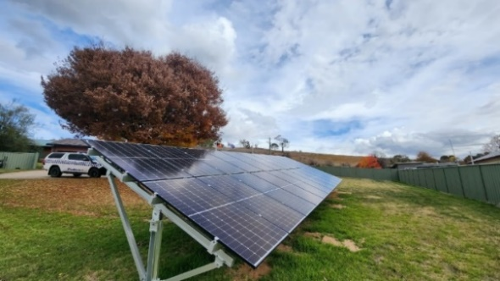
Background
Bushfires and extreme weather events have the potential to disrupt electricity networks and supply. During the 2019-2020 bushfires in Victoria, around 1 000 km of powerlines were affected, and 7 500 AusNet customers in Omeo, Corryong and Mallacoota were without power, road access, telecommunications, and water supplies.

Partnering to deliver improved energy outcomes
After the 2019-2020 summer bushfires, the Victorian Government funded the Community Microgrids and Sustainable Energy Program. Through the program, AusNet and Mondo worked together to design solutions which would support rural communities when the electricity network is impacted.
Victoria Police agreed to participate in the program to improve community and site resilience for Omeo, Mallacoota and Corryong Police Stations and communities during emergencies.
AusNet own and maintain the electricity distribution network in the region and were the program delivery lead on this project. RACV Solar installed and commissioned the hardware including solar panels, battery systems and backup diesel generators at key essential services sites, community facilities, and local businesses. In Mallacoota, the township can also form a town-wide microgrid, maintaining electricity supply through a large battery and backup generator operated by AusNet. Residential and business solar, battery and hot water systems work in conjunction with AusNet’s assets to maintain a stable supply of power. A similar solution is currently under construction in Corryong thanks to the support of the Victorian and Australian governments. All these elements work together to increase the security of power supplies, energy self-sufficiency and community resilience.

Improving energy security through microgrids
The microgrid platform uses weather warnings and forecasts to predict when there is an increased likelihood of power outages and coordinate community energy resilience. If an outage is likely, the platform can remotely control customers’ systems to ensure the batteries are charged, helping to maximise local energy storage. During an outage, customers will have a limited energy supply for key circuits until the batteries run out of power, and generators (where installed) can then take over.
If emergencies in grid power failure occur in future, then essential services sites, community facilities, and local businesses can be powered off-grid for days or weeks, utilising solar power, stored battery power and the backup diesel generator. The battery stores energy, while solar power is continually generated during daylight, and the diesel generator turns on when solar is not available and the battery stores are exhausted. This means that the assets and services can be powered when climate-related extreme weather events such as storms and bushfires cause grid electricity outages.
For example, the system at the Omeo Police Station was fully operational during a recent planned outage, and during an unplanned outage caused by a storm in September 2024. The station maintained power using battery-stored solar power, without using the diesel generator.
The back-up systems at Omeo, Mallacoota and Corryong include a network of 17 buildings that provide crucial services to the community, including Country Fire Authority stations, local council buildings, community refuge centres, medical centres and banks. As part of the program, there are also 47 residential solar and battery systems installed across Omeo and Corryong, and an additional 18 residential hot water systems in Mallacoota. This means more resilient communities during climate-related emergency events.

Co-benefits for participants
Participants in the program are also gaining financial benefits. During normal operation, solar power fills the battery to capacity and supplies the buildings with electricity. Once the battery is full, excess power generated from solar panels is discharged to the electricity grid and a credit goes on participants’ electricity bill. For the several months that the systems have been operating, total solar power generated at the three police stations has been sufficient to power the stations and export more power to the grid than needed to be imported. The Omeo and Mallacoota police stations are demonstrating the capacity to run as net zero emissions operations.
Microgrids are improving the security of power supplies to police stations and other key community services. Not only is there greater security of energy supply, but participating organisations are saving on electricity costs, while supporting communities to become more resilient.

Supporting Victorian communities to recover

Victoria is already experiencing the impacts of climate change and further impacts are inevitable. We know that early adaptation can reduce these impacts, and that is why the Government is acting now to minimise these impacts and is striving to reduce the significant costs of recovery from climate-related events where feasible.
- The 2023-24 Budget captured the $1.7 billion that was allocated in 2022-23 to meet the emergency response and recovery needs of communities affected by the October 2022 floods. This included $150 million over four years for state coordinated cleanup activities, and $9.4 million for a Council Priority Betterment Program to improve the resilience of essential public assets like roads, bridges and footpaths damaged as a direct result of the flood event
- The Victorian Government is partnering with the Commonwealth Government to continue the Future Drought Fund that supports farmers and communities to build resilience to drought in Victoria’s agricultural regions and in the 2024-25 Budget allocated $10.2 million over four years for this purpose
- The Victorian Government will continue working closely with the Commonwealth Government to manage the costs of responding to emergencies, as outlined in Chapter 2.4.

      - Partnering with Australian and international governments

The Victorian Government continues to partner with jurisdictions within Australia and overseas to progress climate action. Victoria leverages these partnerships to influence the national energy and climate-change reform agenda, and to inspire ambitious global climate action.
Victoria continues to work with the Commonwealth and state and territory governments through the Energy and Climate Change Ministerial Council to drive collaborative, joined-up national action that is sensitive to local priorities, drives innovation and maximises ambition. This includes engagement with the Commonwealth Government on the development of its Net Zero Plan, which will be underpinned by six sectoral decarbonisation plans aiming to guide the national transition to a net zero economy, and Australia’s first National Climate Risk Assessment and National Adaptation Plan to assist governments, industry and communities to embed adaptation action across Australia’s economy and society.
Victoria is also partnering with the Commonwealth Government through a Renewable Energy Transformation Agreement to accelerate private sector investment in renewable-energy projects. The agreement is expected to support delivery of at least 5.0 GW of generation and 1.7 GW of storage capacity by 2030. The Victorian Government is also working closely with the Commonwealth Government’s Net Zero Economy Authority to ensure strategic alignment of priorities for the net zero transition of the Latrobe Valley and Gippsland region.
The Under2 Coalition is the world’s largest network of subnational governments committed to reaching net zero emissions by 2050 or earlier. The Victorian Government has been a member of the Under2 Coalition since 2016 and signed the Under2 Memorandum of Understanding in 2021 to demonstrate its commitment to emissions reductions. The Under2 Coalition supports climate action in Victoria through networking and knowledge-sharing activities with other subnational jurisdictions, by communicating the effectiveness of subnational climate action to the global community, and by advocating for increased support to subnational governments to enable their climate leadership.
The Net Zero Futures Policy Forum is an initiative of the Under2 Coalition to maintain an international network of jurisdictions with ambitious net zero emissions targets. The network includes Australian states and territory governments, and the governments of Wales and Scotland, to collaboratively address the practical challenges of achieving net zero emissions. Victoria has been a founding member of the Forum since 2022.
The Mediterranean Climate Action Partnership aims to support subnational government leaders facing shared climate challenges in mediterranean regions (defined as having similar climates defined by distance from the equator) to deploy effective climate adaptation actions at pace and scale, reduce greenhouse gas emissions, and protect the regions’ people. It focuses on building resilience to three climate hazards – wildfires, extreme heat and drought. Victoria became one of the partnership’s 14 inaugural members in December 2023 at the United Nations Climate Change Conference COP28 in Dubai, signing up to MCAP’s Statement of Commitment.

Case study: Taking a collaborative approach to climate change action in the health sector

Background
In February 2024 Climate Health Victoria (CHV) was established as a new unit within the Department of Health to drive climate action across the health sector. CHV is delivering a program of work across three priority areas – mitigation, adaptation and collaboration.

Collaboration across the health sector
Within the Victorian health sector, CHV is leading the delivery of collaborative projects. In 2024, CHV completed a project working with the Victorian Health Building Authority and health services to assess climate risks at six regional hospitals impacted by the 2022 floods. CHV has subsequently received three grants from Emergency Management Victoria to build on these assessments:
- Working with Victorian health services, CHV is developing guidance and tools to enable them to assess and better manage their climate risk
- CHV is working with the cemetery sector to assess climate risks and develop a best-practice guidance to manage them
- Partnering with the Victorian Aboriginal Community-Controlled Health Organisation, CHV is assessing climate risks at Aboriginal community-controlled health organisations and identifying opportunities to improve infrastructure resilience.

Collaboration within government
CHV is working with agencies across the Victorian, Commonwealth and other state and territory governments. Examples of collaborative approaches and outcomes being delivered by CHV include:
- work with the Australian Commission for Safety and Quality in Health Care to develop and trial a climate and sustainability module. Seventeen Victorian health services represented a large proportion of entities participating in the trial
- a partnership with the Victorian Department of Education to deliver the Climate Resilient Education project, which was successful in receiving Commonwealth Government funding through the Disaster Ready Fund Round 2
- regular engagement with both Safer Care Victoria and HealthShare Victoria to improve the adoption of climate-positive actions in clinical practice and procurement.
CHV is supporting Department of Health representation on the Mediterranean Climate Action Partnership and is working closely with the Commonwealth Department of Health and Aged Care on the delivery of the National Health and Climate Strategy.

    - Metrics and targets
The Government has a robust approach to setting, monitoring and reporting on emissions reduction and renewable-energy targets that provide a credible pathway to meet the State’s legislated target for net zero emissions by 2045.

      - Reducing emissions in government operations
The Government has developed targets and reporting guidelines that support action to reduce emissions from government operations.

Government operations emissions reduction targets and metrics
The Government has continued progressing emissions reduction commitments outlined in the whole of Victorian Government emissions reduction pledge 2021-2025 under the Climate Action Act. The Government has either delivered or is on track to deliver these commitments by 2025 and is preparing for the upcoming 2026-30 whole of government pledge.

Table 3: Status for the whole of Victorian Government emissions reduction pledge
Target | Status
100 per cent renewable electricity for government operations | On track  - From July 2025, 100 per cent of eligible Victorian Government sites will be powered by the SEC.  - Victorian water corporations are required to source 100 per cent of their electricity from renewable sources by 2025 under the Statement of Obligations (Emission Reduction) issued by the Minister for Water in 2022.
Improved government building and infrastructure sustainability | Complete  - Government Accommodation, Carpool and Library Services has updated policies, processes and governance arrangements to target more sustainable buildings and those with Green Lease schedules.  - Department and building authority guidelines and design handbooks have been updated to require that new buildings and fit-outs embed environmentally sustainable design.  - As part of delivering Victoria’s Gas Substitution Roadmap, the Government announced in 2023 that all new government buildings, including new schools and hospitals, will be built as all-electric.  - Since its establishment in 2009, the Greener Government Buildings program has facilitated $310 million in energy efficiency and renewable-energy projects across 53 projects. Combined, these projects are estimated to achieve annual savings of $47 million, abate more than 180 000 tonnes of greenhouse gases per year and avoid over $90 million in capital costs. In the 16 years of operations, Greener Government Buildings has supported upgrades to 600 buildings, reduced government emissions by 16.9 per cent and saved over $250 million in addition to the avoided capital costs. There are 404 schools taking part in this program under the Greener Government School Buildings program, which supports the installation of solar-power systems and energy-efficiency improvements  - On-site solar generation capacity at health services increased from 17 Megawatt peak (MWp) to 19 MWp in 2023-24.
400 Zero Emissions Vehicles (ZEVs) in government fleet over two years | Complete  - All 400 ZEVs have been delivered and associated charging stations installed in government-owned and leased buildings in metropolitan and regional Victoria. The Government has committed to transition its fleet of passenger vehicles and vans to ZEVs by 2035.
All new public buses zero emissions from 2025 | On track  - 52 Zero Emission Buses (ZEBs) were trialled from 2022, and the Government has released the ZEB Transition Plan in 2024 to meet this commitment and outline a plan to transition the entire fleet of public buses to ZEBs.

Portfolio emissions reduction planning
Departments are preparing portfolio emissions reduction plans to help inform development of the 2026-30 whole of Victorian Government emissions reduction pledge and support further emissions reductions from government operations. Planning will identify key emissions sources and options to address them, defining priorities, and reporting on progress.
Emissions-reduction planning will be an iterative process supporting improvement over time and promoting strategic consideration of emissions reduction alongside other organisational priorities, such as service delivery objectives and corporate planning.

Improved reporting and monitoring
The Government’s commitment to reducing government emissions is supported by ongoing improvements to reporting of environmental data and emissions by departments and public entities. In 2022, FRD 24: Reporting of environmental data by government entities was updated to require all government entities subject to the Standing Directions under the Financial Management Act to report on a range of environmental and sustainability indicators in their annual reports from 2022-23 onwards.
This includes environmental indicators for greenhouse gas emissions and underlying activity data such as energy consumption and production, transportation, stationary, fuel use, waste, building energy performance, and sustainable procurement.
Annual environmental reporting supports departments and public-sector entities with the information they need to monitor and reduce emissions and to manage climate-related risks. The emissions and activity data that is generated through annual reporting informs the preparation and implementation of the whole of Victorian Government emissions reduction pledge.
The updated FRD 24 includes a requirement for departments and administrative offices to disclose their approaches to understanding and managing climate-related risks and opportunities. The FRD 24 Guidance encourages entities to model their disclosure on global best practice such as the International Financial Reporting Standards (IFRS) S1 General Requirements for Disclosure of Sustainability-related Financial Information and S2 Climate-related Disclosures.
      - Ambitious interim emissions reduction targets for Victoria
The Climate Action Act requires the Government to set five-yearly interim emissions reduction targets for the State’s greenhouse gas emissions relative to the greenhouse gas emissions level in 2005, and with each interim target constituting a greater emissions reduction than the previous one.

Setting interim targets
The Climate Action Act specifies the dates by which the interim emissions reduction targets must be determined. Interim targets have now been legislated for 2025, 2030 and 2035. The Premier and Minister for Climate Action are required to determine the emissions reduction target for the period 1 January 2036 to 31 December 2040 by 31 March 2028.
The Climate Action Act requires the Minister for Climate Action to obtain appropriately qualified, independent, expert advice before determining interim targets, including interim target recommendations, indicative trajectories to achieve the long-term emissions reduction target, potential emissions reduction opportunities across the economy to achieve the targets, and any other matters that the Minister for Climate Action in consultation with the Premier considers appropriate.
In 2023, the Government formally set its latest interim emissions reduction target for 2035, informed by an Independent Expert Panel chaired by Martijn Wilder AM. The expert advice was tabled in Parliament and published online providing transparency and accountability to the community and investors.

Reviewing, monitoring and reporting on interim targets
The Government measures and monitors progress against Victoria’s emissions reduction targets through detailed data on greenhouse gas emissions. It reports progress against these targets in its annual Victorian Greenhouse Gas Emissions Report, as required by the Climate Action Act.
Emissions data for the report are sourced from the State and Territory Greenhouse Gas Inventories and released by the Commonwealth Department of Climate Change, Energy, Environment and Water. This emissions data is prepared consistent with internationally agreed rules, and methods are continuously improved in response to new data, improved science and review by international experts.
The Government is also required to prepare and publish a report within two years of the end of each interim target period. The first report will be due by the end of 2027. The report must detail the total amount of the State’s greenhouse gas emissions for the five-year period, and whether the interim emissions reduction target has been achieved. It must also contain an assessment of progress towards the long-term 2045 target. If the interim emissions reduction target has not been achieved, the report must explain why and must contain a statement of any implications from not meeting the target on subsequent interim targets.

Victoria’s progress against emissions reduction targets
The National Greenhouse Gas Inventory 2023 data for Victoria shows the state has cut emissions by almost a third since 2005. In 2023, Victoria’s total net emissions were 84.2 million tonnes of carbon dioxide equivalent (Mt CO₂-e), which is 31.4 per cent below 2005 levels (see Figure6).

Figure 6: Victoria’s net greenhouse gas emissions, 2005 to 2023

Victoria achieved its 2020 emissions reduction target. Victoria is also currently within the range of Victoria’s 2025 interim emissions reduction target of 28–33 per cent below 2005 levels (see Figure 7).
Figure 7: Victoria’s emissions reduction targets progress
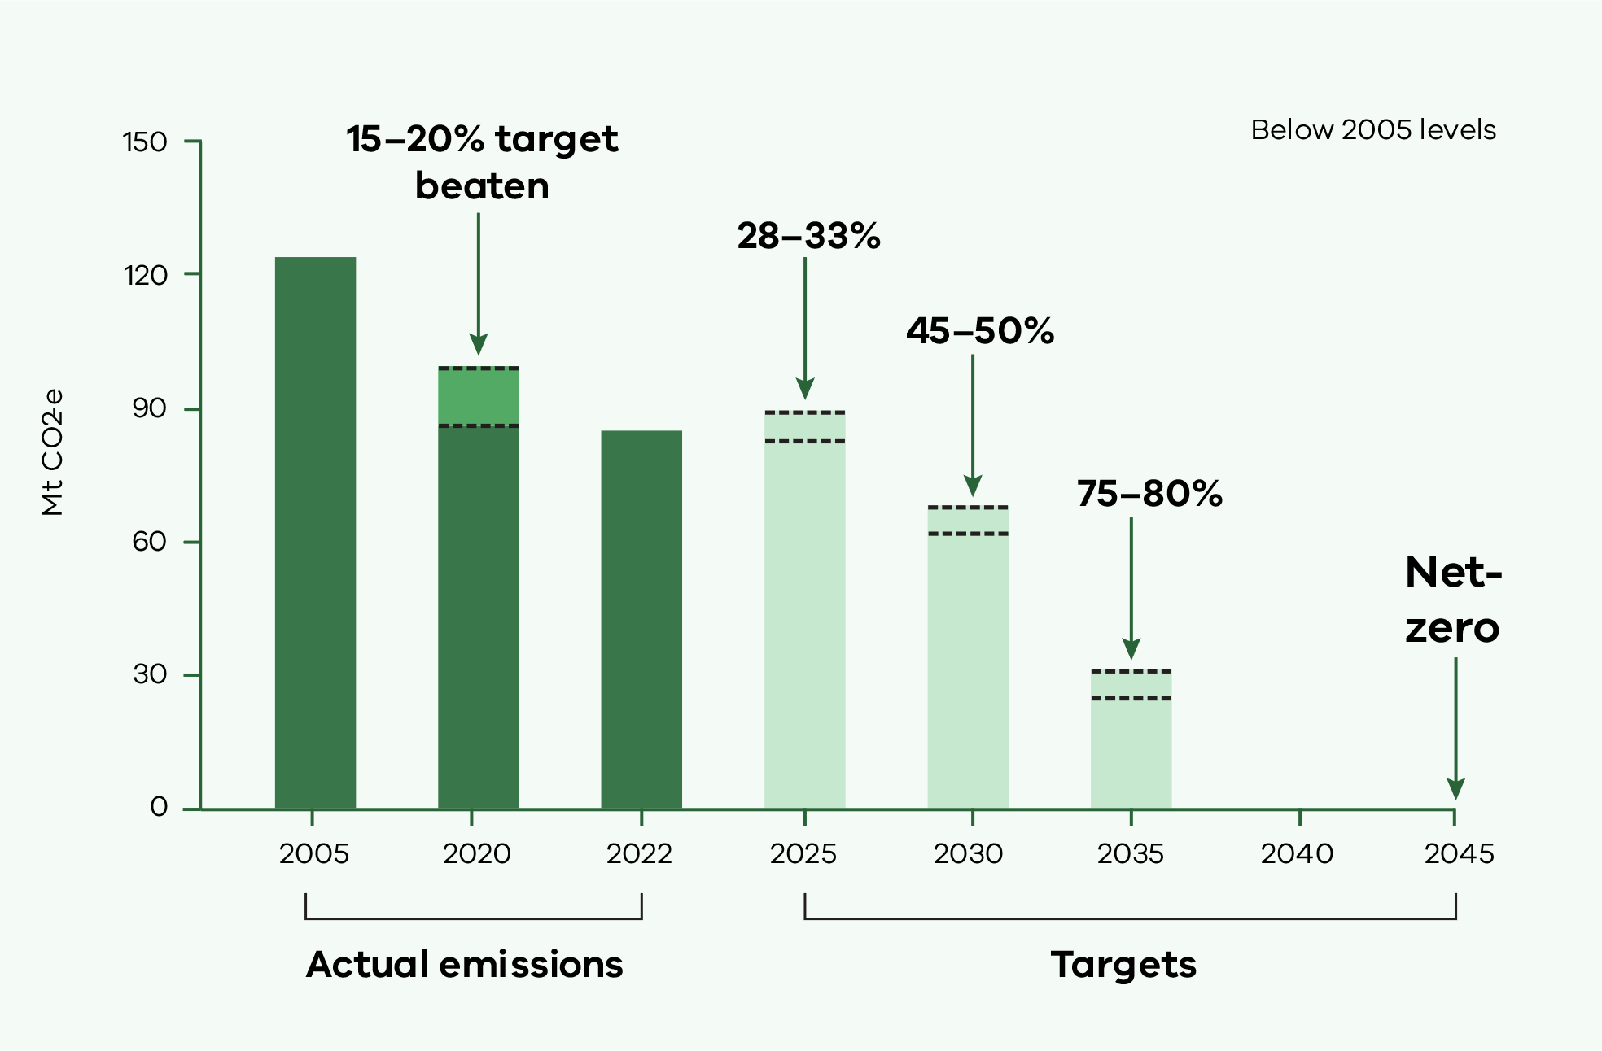

The emissions intensity of the Victorian economy continues to fall faster than net emissions. Victoria’s emissions per dollar of gross state product (GSP) fell by 56.4 per cent between 2005 and 2023.
Table 4: Victoria’s greenhouse gas emissions reductions from 2005 base year
 | 2005 | 2023 | Reduction from 2005
Total emissions (Mt CO₂-e) | 122.7 | 84.2 | 31.4 per cent
Emissions intensity (kg CO₂-e per $ of GSP) | 0.34 | 0.15 | 56.4 per cent
Per capita emissions (tCO₂-e per person) | 24.6 | 12.3 | 49.8 per cent
Source: DTF analysis of Australian Bureau of Statistics and DCCEEW data

Victoria’s emissions by sector
Victoria’s 2023 emissions originated from electricity generation (46.2 per cent), transport (26.1 per cent), fuel combustion (16.8 per cent), agriculture (18.1 per cent), industrial processes and product use (4.4 per cent), fugitive emissions from fuels (2.3 per cent) and waste (3.9 per cent) (see Figure 8). Land use, land use change and forestry provided net sequestration of 15 Mt CO₂-e (–17.9 per cent). This means the sector removed more greenhouse gases than it generated.

Figure 8: Total net emissions and emissions by sector and energy sub-sector – Victoria, 2005 to 2023
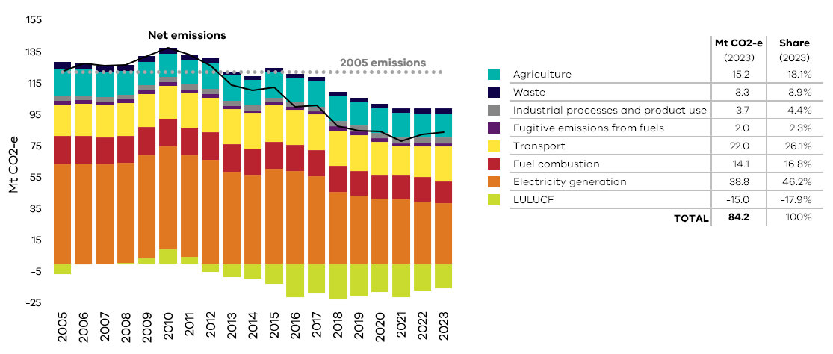
Source: State and Territory Greenhouse Gas Inventories, DCCEEW 2025

Key contributors to the fall in emissions between 2005 and 2023 were electricity generation, where emissions fell by 24.6 Mt CO₂-e (64.0 per cent of the change in total net emissions), and the land-use, land use change and forestry (LULUCF) sector, which increased net sequestration by 8.8 Mt CO₂-e (22.7 per cent of the change in Victoria’s total net emissions).
Further information regarding the sources of Victoria’s emissions, can be found in the Victorian Greenhouse Gas Emissions Report 2022, and National Greenhouse Gas Inventory 2023 data for Victoria.

      - Strong and achievable energy targets for Victoria

Victorian renewable-energy targets

Victoria’s renewable energy transition is supported by a strong legislative foundation. In early 2024, the Government legislated:
- Renewable energy targets of 65 per cent renewable-electricity generation by 2030 and 95 per cent by 2035, building on Victoria’s existing target of 40 per cent by 2025
- energy storage targets of at least 2.6 GW of energy storage capacity by 2030 and at least 6.3 GW by 2035
- offshore wind energy targets of at least 2 GW of offshore wind generation capacity by 2032, 4 GW by 2035 and 9 GW by 2040.

25 per cent | 40 per cent | 65 per cent | 95 per cent
renewable electricity by 2020 (achieved) | renewable electricity by 2025 | renewable electricity by 2030 | renewable electricity by 2035

Victoria’s new renewable energy targets build upon Victoria’s existing renewable energy target of 40 per cent renewable electricity generation by 2025 and its previous target of 25 per cent by 2020, which has been achieved.
Victoria’s renewable energy targets will be supported by the Government’s offshore wind and energy storage targets. Victoria has world-class offshore wind resources. The Government’s energy storage targets will provide reliable, zero-emissions firming capacity – energy supply that can be activated to top-up supply in the electricity grid - as Victoria’s ageing coal generation is replaced with new intermittent renewable capacity like wind and solar.

Victoria is progressing against renewable energy targets
Victoria’s renewable electricity generation has tripled since 2014-15 to reach 38 per cent renewable electricity generation in 2023-24, putting Victoria on track to achieve its 2025 renewable energy target of 40 per cent renewable generation (see Figure 9).
Figure 9: Renewable electricity generation in Victoria, 2014-15 to 2023-24

Source: NEM Review, Metered generation (as generated) (to 2021/22) and NEO-point, Generation (thereafter); except for bioenergy (based on DCCEEW, Australian Energy Statistics) and DEECA estimates of small generators

Greenhouse gas emissions from large-scale electricity generation
Greenhouse gas emissions from large-scale electricity generation has moderated since 2022, declining from 39 Mt carbon-dioxide-equivalent (CO₂-e) in 2021-22, to 38 Mt CO₂-e in 2022-23. There has been a total reduction of over 20 Mt CO₂-e since 2014-15 (see Figure10).
Figure 10: Greenhouse gas emissions from electricity generation in Victoria, 2014-15 to 2022-23

Source: Clean Energy Regulator, Scope 1 emissions reported by Victorian electricity generators, Electricity sector emissions and generation data, various years.

    - Next steps for Victoria

The Government will continue to strengthen its understanding and management of climate-related risks and opportunities, with short to medium-term priorities including:
- continuing to strengthen the Government’s understanding and assessment of the impacts of climate change on the Victorian economy and on the financial performance and position of the State. This could include an assessment of the impact of a selection of risks over different time periods and under different climate scenarios
- reviewing how the Government is approaching climate-related risk disclosure, to ensure alignment with government priorities and evolving international and national climate reporting standards. This includes establishing the objectives of climate-related risk disclosure and assessing Victoria’s current reporting regime against other jurisdictions and national and international standards
- updating Victoria’s Climate Change Strategy to set the course for reducing emissions and strengthening climate resilience for the next five years
- preparing the next set of Adaptation Action Plans (2027–2032) to address climate change risks to seven statewide systems as required by the Climate Action Act
- improving the application of climate science to policymaking, such as through the updated Victoria’s Future Climate Tool, which now includes the Victorian Climate Projections 2024
- bolstering climate-risk maturity within departments and entities to support the effective identification, assessment and management of climate-related risks.

Abbreviations and acronyms
Abbreviation/  acronym | Definition
AASB | Australian Accounting Standards Board
AAP | Adaptation Action Plan
CHV | Climate Health Victoria
COP28 | 2023 United Nations Climate Change Conference
CSIRO | Commonwealth Scientific and Industrial Research Organisation
DCCEEW | Department of Climate Change, Energy, Environment and Water (Commonwealth)
DEECA | Department of Energy, Environment and Climate Action (Victoria)
DTF | Department of Treasury and Finance (Victoria)
FRD | Financial Reporting Direction
GW | Gigawatt
IPCC | Intergovernmental Panel on Climate Change
LULUCF | Land use, land-use change and forestry
Mt CO2-e | Million tonnes of carbon dioxide equivalent
MWh | Megawatt hours
MWp | Megawatt peak
RCP | Representative Concentration Pathway
SCfCPF | Statewide Caring for Country Partnerships Forum
SEC | State Electricity Commission
TAFE | Tertiary and Further Education
tCO2-e | Tonne of carbon dioxide equivalent
TCV | Treasury Corporation Victoria
VFMC | Victorian Funds Management Corporation
VMIA | Victorian Managed Insurance Authority
VSB | Victorian Secretaries’ Board

Further information about Victoria’s changing climate can be found in Victoria’s Climate Science Report 2024, accessible via Victoria’s changing climate
This estimate assumes the rest of the world takes action to reduce emissions and limit global warming to well below 2 degrees Celsius on pre-industrial levels by 2100.
National Greenhouse Gas Inventory 2023 data for Victoria, Commonwealth Government Department of Climate Change, Energy, the Environment (DCCEEW), 2025
This figure does not include Commonwealth co-funding.
Figures exclude co-contributions by project leads.
Investment Stewardship Policy, Victorian Funds Management Corporation 2023.
Initiatives cost-shared with the Commonwealth Government under the Disaster Recovery Funding Arrangements.
This figure does not include Commonwealth co-funding.
National Greenhouse Gas Inventory 2023 data for Victoria, Commonwealth Government Department of Climate Change, Energy, the Environment (DCCEEW), 2025
Electricity emissions reported by the Clean Energy Regulator only include large-scale generators connected to the electricity grid. It excludes electricity generation by large industrial facilities which also contribute to electricity emissions reported in the State and Territory Greenhouse Gas Inventories.

