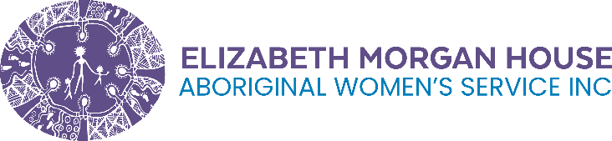
Elizabeth Morgan House Aboriginal Women’s Service
Embedding Outcomes Thinking in Aboriginal Community Controlled Services
September 2025
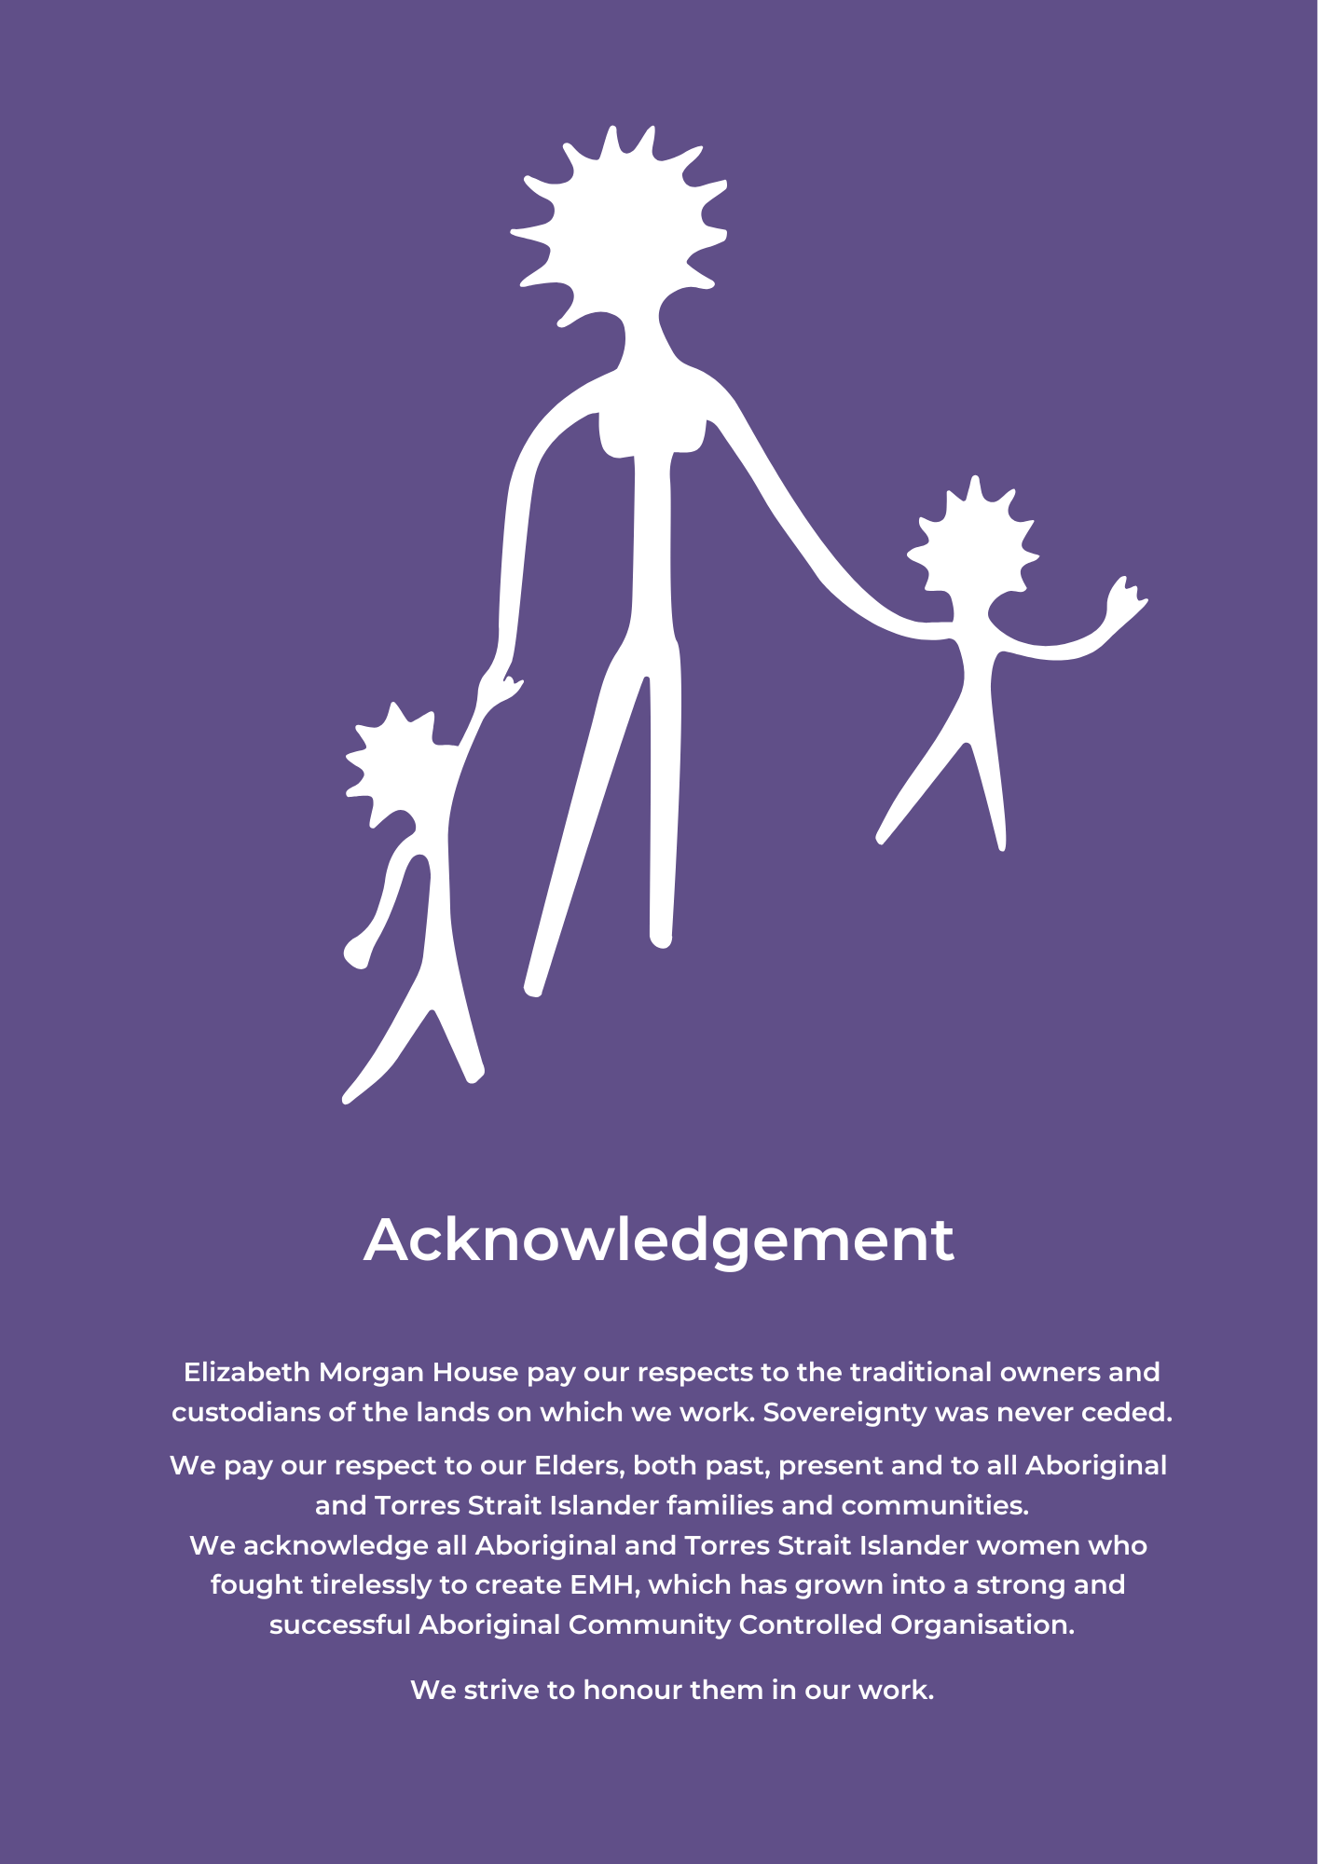
`

Project summary
Elizabeth Morgan House Aboriginal Women's Service (EMH) completed a 12-month project to establish dedicated data and outcomes capability within the organisation. Funded through the Victorian Government's Empowerment Fund, administered by the Department of Treasury and Finance, the initiative laid the groundwork for sustainable, culturally grounded outcomes measurement in services supporting Aboriginal women and their families impacted by family violence, homelessness, and justice system involvement.
EMH used the investment to build internal capability and systems for long-term sustainability. A key milestone was the creation and recruitment of a Data and Outcomes Lead position, providing oversight and expertise for implementing outcomes frameworks in Aboriginal community-controlled services.

Key achievements/findings
- Recruited a dedicated Data and Outcomes Lead, embedding internal expertise for culturally appropriate outcomes measurement.
- Developed customised thinking frameworks and resources through intensive co-design, tailored to EMH’s programs, client journeys, and cultural practices.
- Integrated tools into existing workflows, enabling outcomes reflection through routine activities like case noting and client planning.
- Created resources that reflect EMH’s practice language, staff expertise, and the complex intersections of trauma, cultural connection, and systems navigation.
- Supported data sovereignty and cultural integrity, aligning outcomes measurement with Aboriginal-led perspectives on change and healing.
- Built infrastructure and capability that will continue beyond the funding period.

Insights

Learnings for the organisation
The project has enabled EMH to implement outcomes measurement that supports rather than disrupts frontline practice. The Data and Outcomes Lead provides ongoing support, helping refine approaches and maintain alignment with organisational values.
- Staff engagement was strengthened through co-design, reducing resistance to data collection and change.
- Culturally appropriate tools are being rolled out in to support service quality and demonstrate impact.

Learnings for the broader social services sector
The project shows the value of investing in internal capability and culturally grounded tools to support meaningful outcomes measurement.
- Strategic investment in infrastructure builds lasting capacity.
- Aboriginal-led approaches offer models for evidence-based practice that maintain cultural integrity.

Enquiries
EMH is open to collaboration with other Aboriginal Community Controlled Organisations seeking to strengthen outcomes measurement. For details on EMH’s co-design process, tools, and strategic approach, contact info@emhaws.org.au.

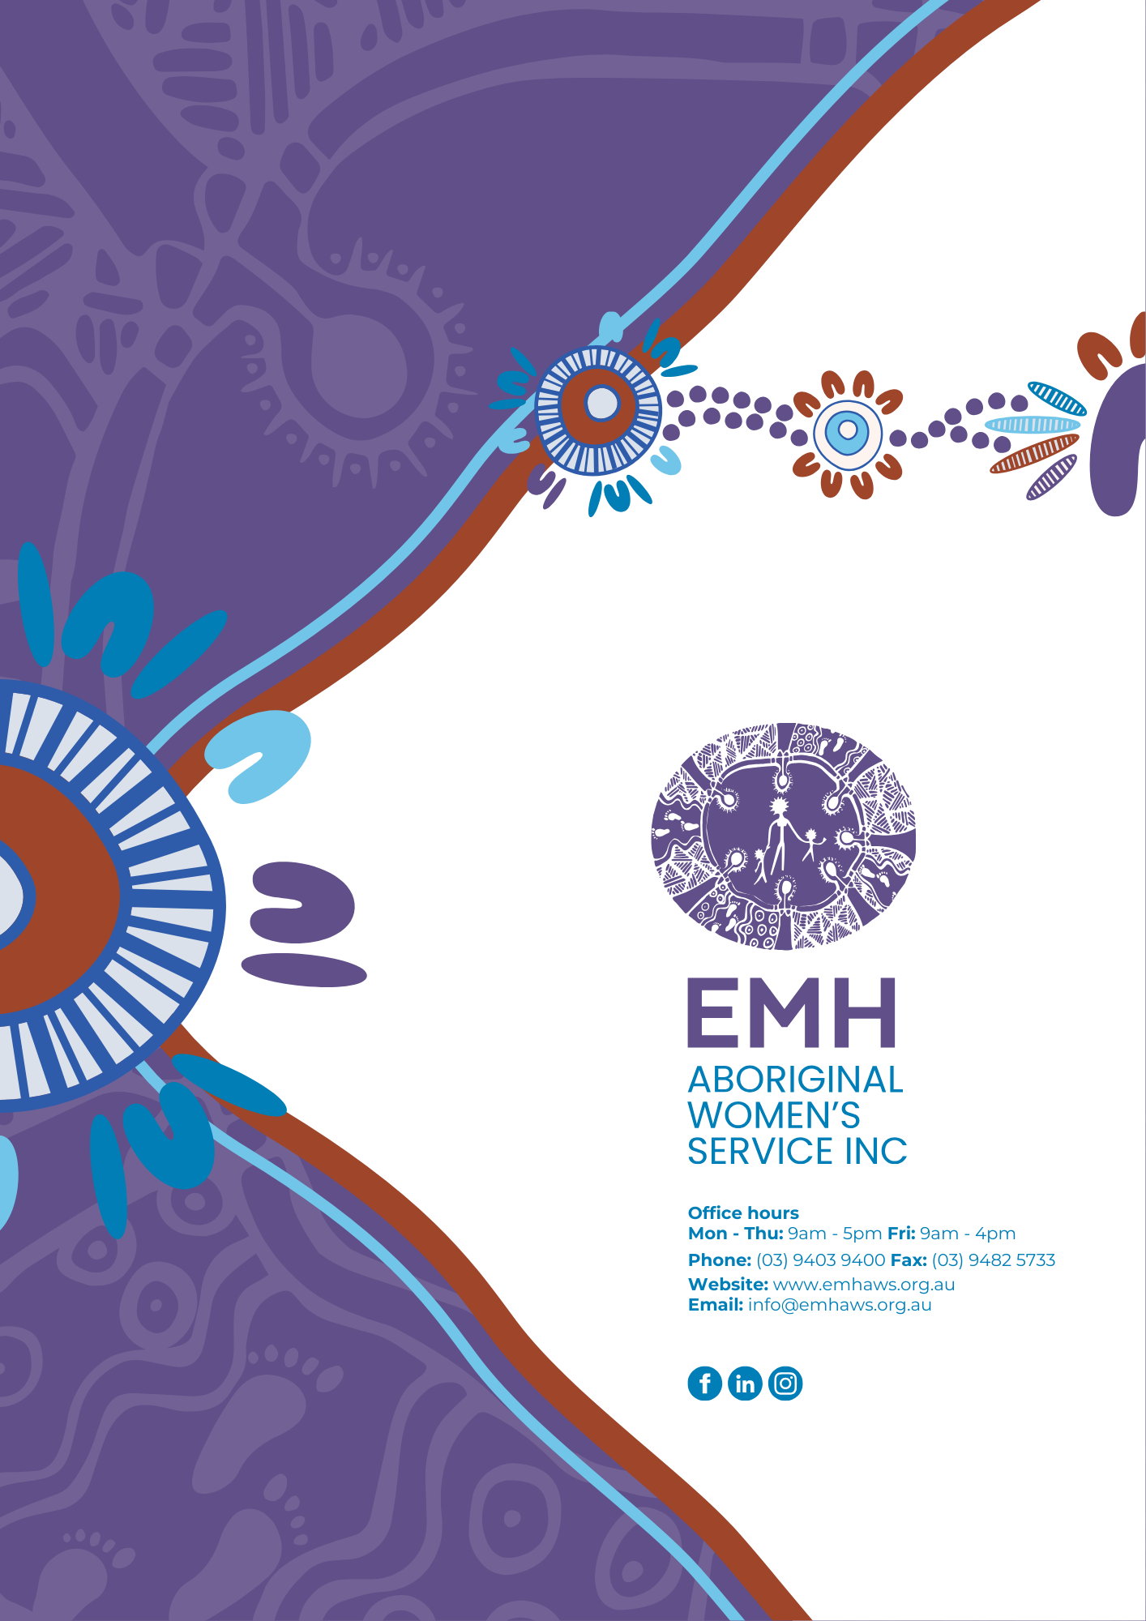
Contact Us

