Online Reporting Platform (ORP)
Complete Initial Attestation
04 JULY 2025

Complete Initial Attestation 1
Audience 1
Pre-requisites 1
Email notifications 1
Support 1
Steps 2

Complete Initial Attestation
This guide demonstrates how a Candidate completes initial attestation.

Audience
- Review team Leader
- Review Team Member

Pre-requisites
- Candidate’s Availability up to date
See user guide: Manage Gateway Review Availability
- Gateway Unit Analyst initiated contact with Candidate

Email notifications
You may receive email notifications from Shibumi related to this process. To avoid missing communications flag Shibumi as a trusted sender in your email application.

Support
For support email gateway.helpdesk@dtf.vic.gov.au.

Steps
Step | What to Do
Have you accessed ORP and been directed to Summary screen via emailed link?
Yes | Go to step 5.
No | Go to next step.

Login to ORP.
Home Page displays:
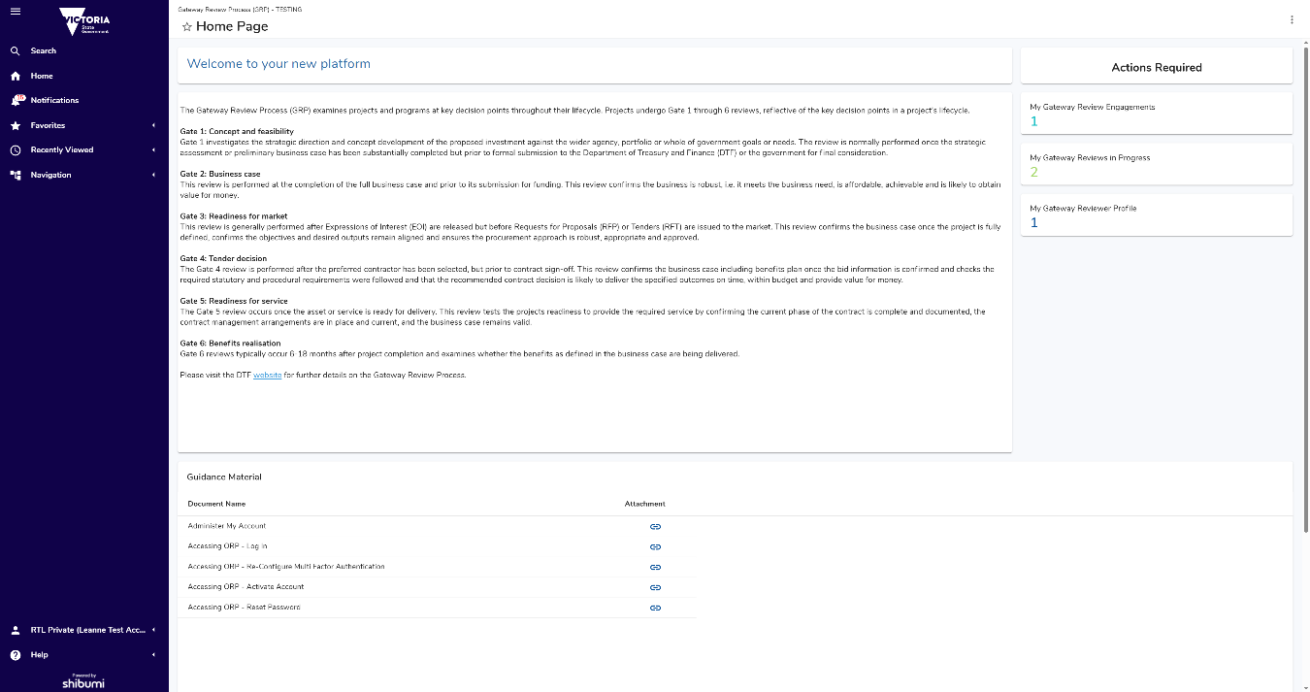
 | Home Page  Access to the home page is managed by the Gateway Unit. If you do not see a screen like above contact a Gateway Unit Analyst. Note: Information displayed is unique to your Role, and what Projects and Gates you’re assigned to.
Show/Hide Left Navigation Menu
Click hamburger menu, represented by three horizontal lines, top left of screen to show/hide left navigation menu.
Click: My Gateway Review
My Gateway Review screen displays:
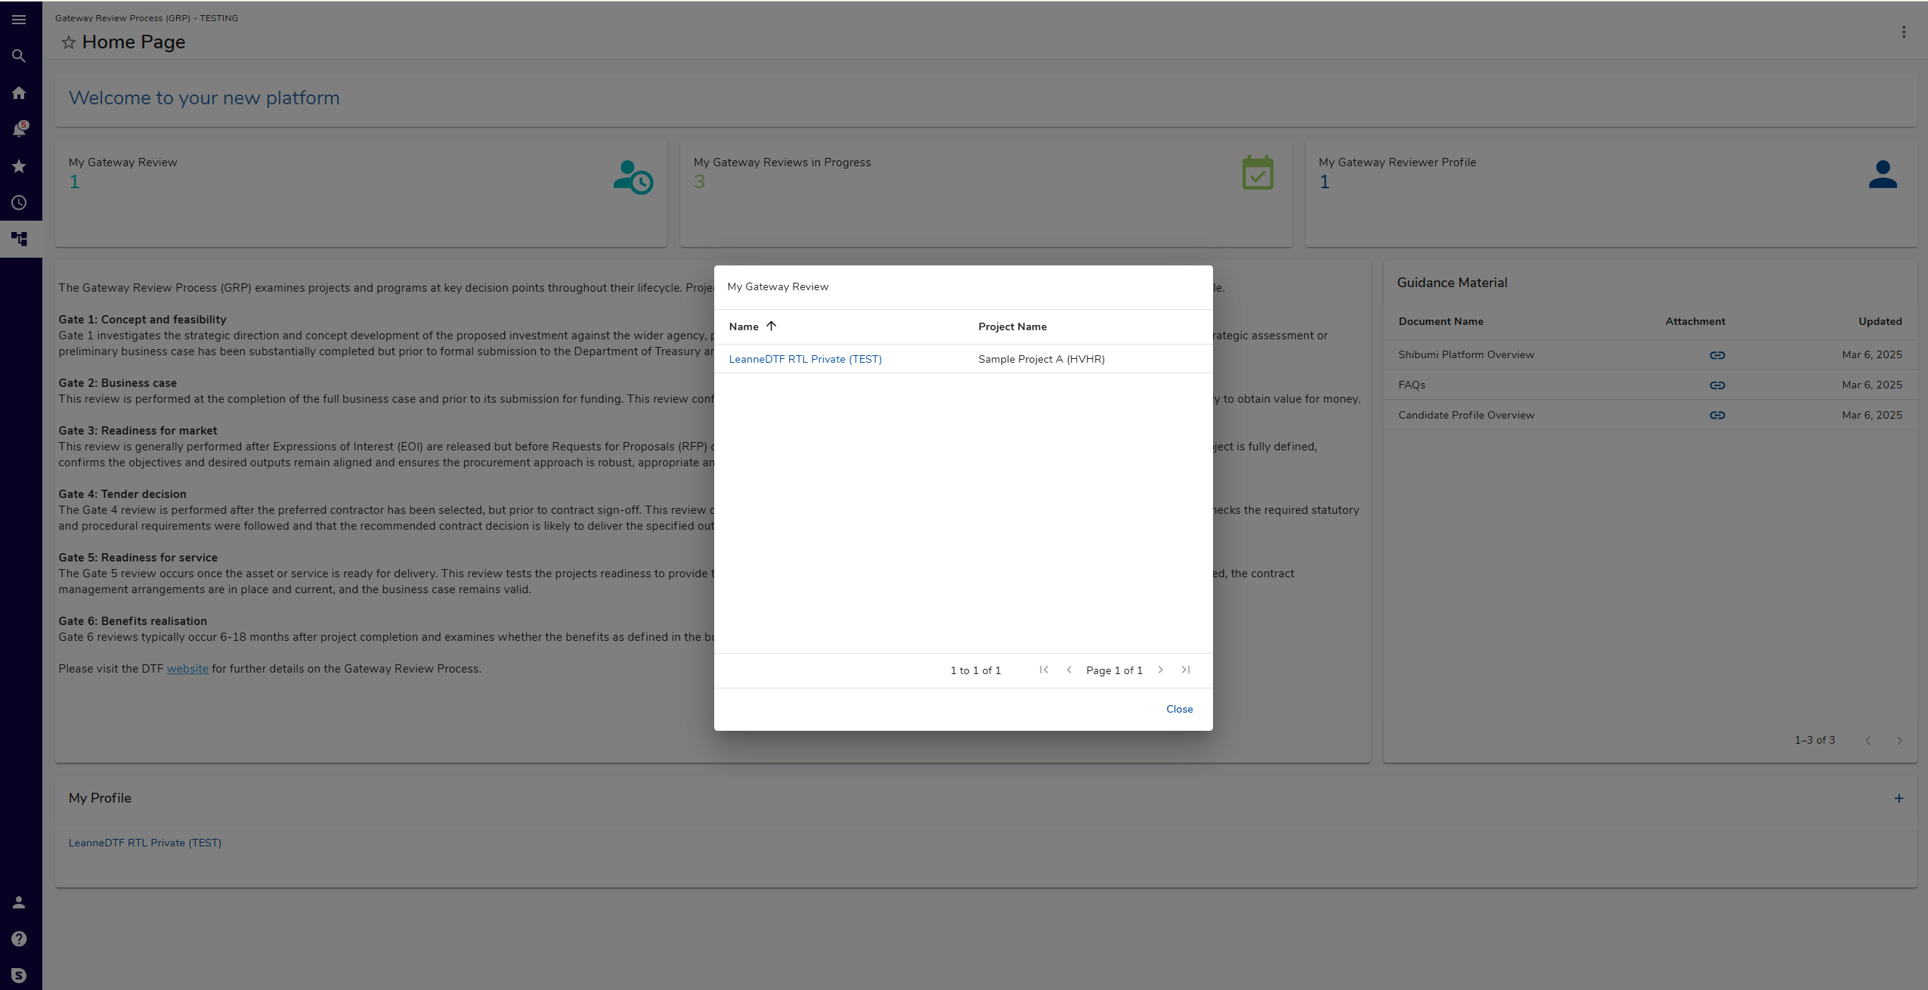
Select relevant Project.
Summary screen displays:
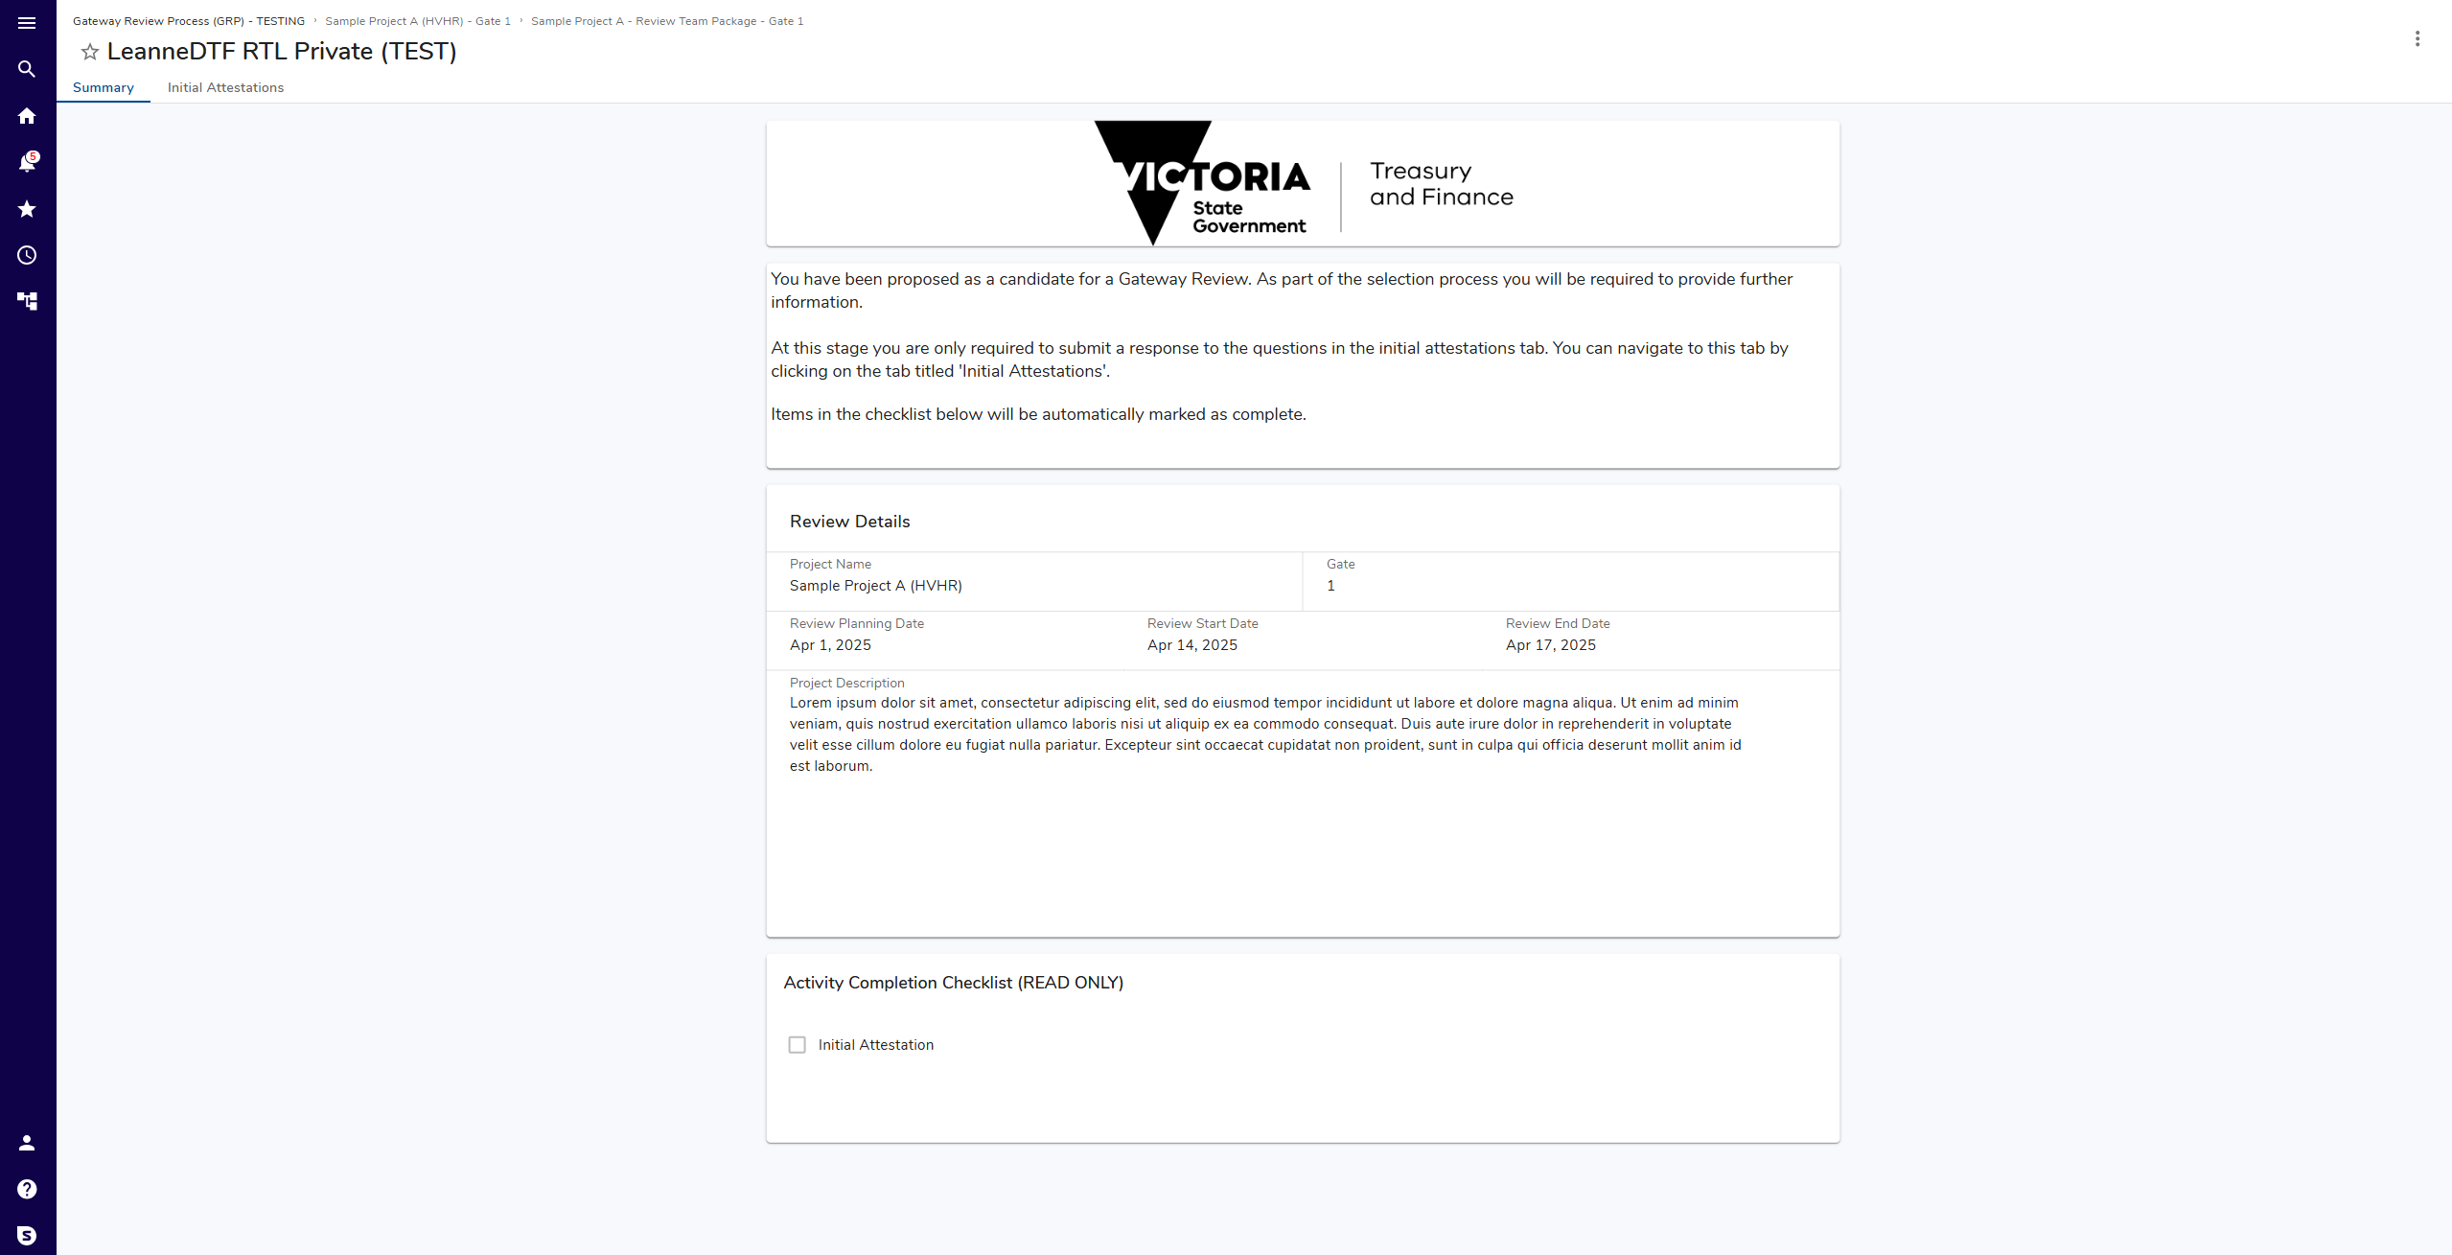
 | Review Summary.
In top navigation menu, click: Initial Attestations
Initial Attestations screen displays:
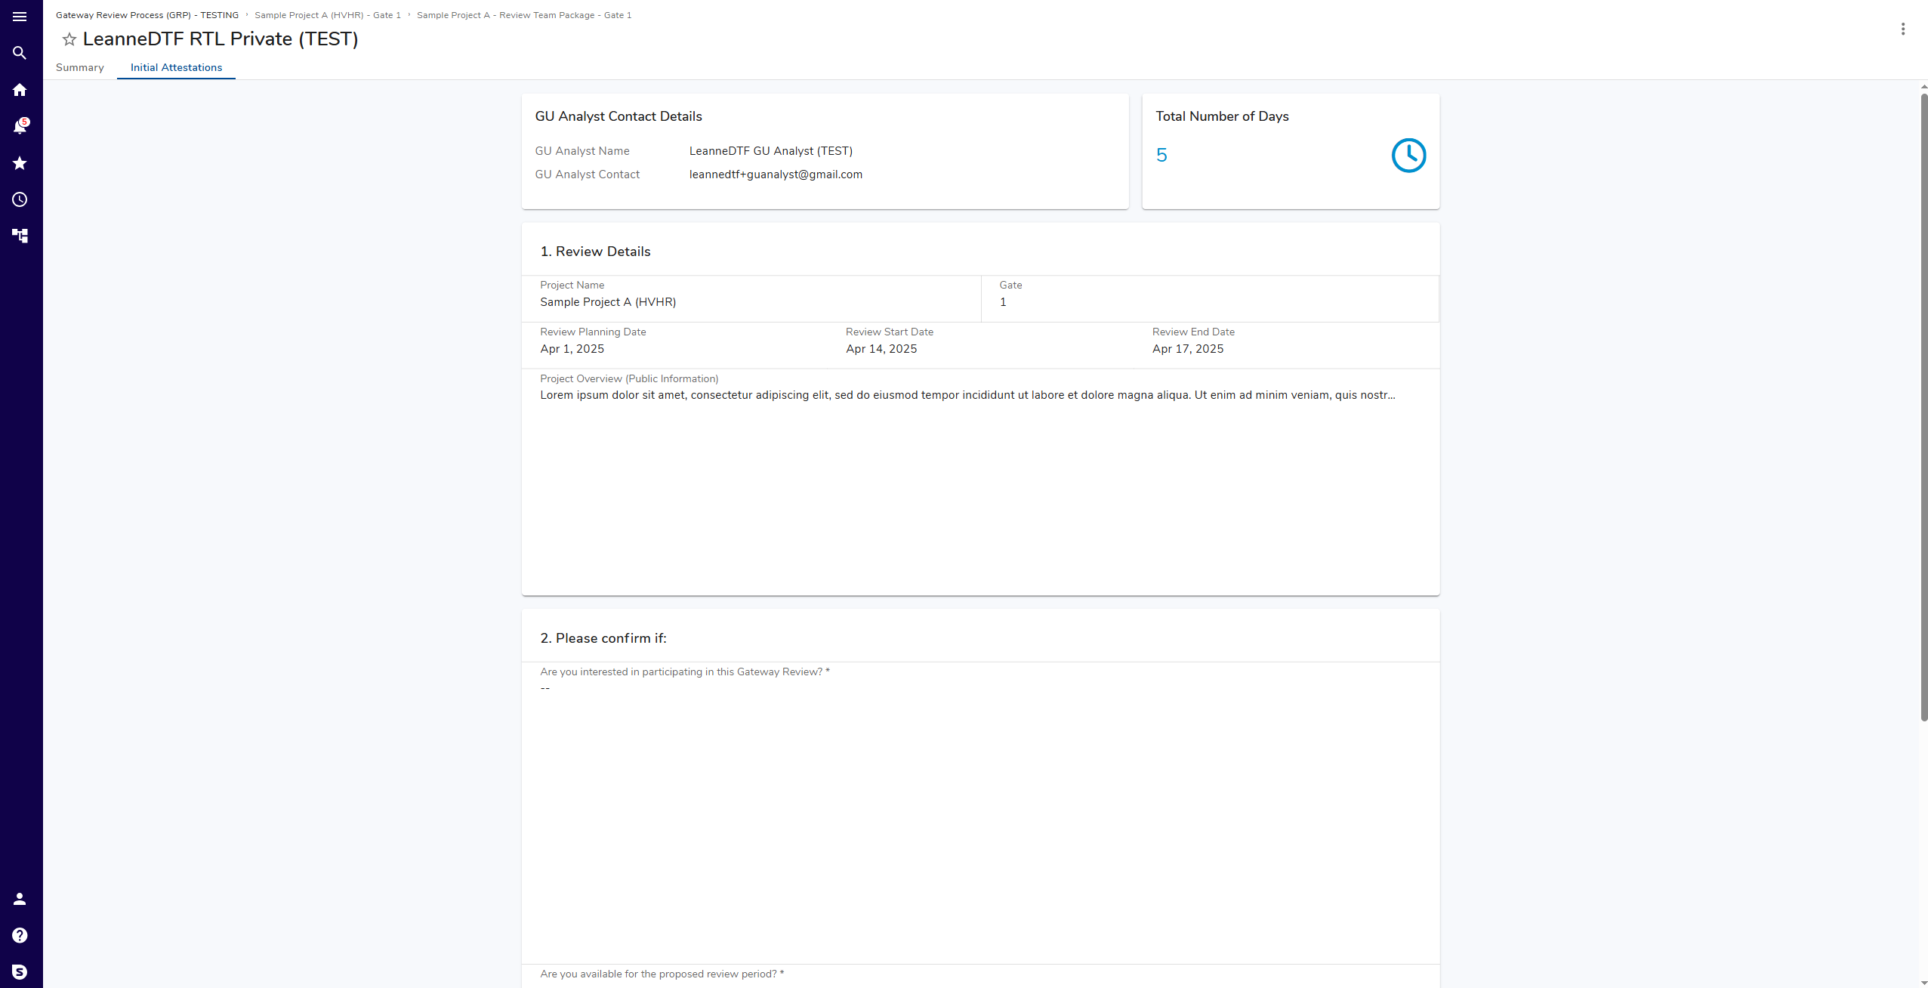
Adding and Editing data
Hover over a panel or field and click  to edit.
Where button is crossed out, this denotes fields you are not permitted to edit.
Saving data
After clicking edit, buttons to Save or Cancel data selection and entry displays on the top right of a panel being edited.
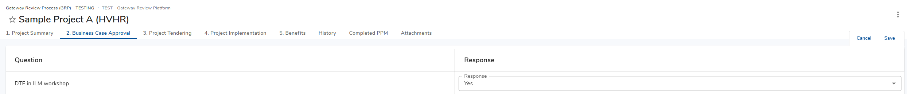
Data will be lost if not saved before navigating to new screen or closing ORP.
ORP will prompt “There are unsaved changes.” to avoid data loss.
Once data is saved, you may navigate away from any screen or close ORP and return to continue work later.
 | Asterisk denotes mandatory field.
Complete panels
- 1. Review Details
- 2. Please confirm if
 | Click: Save
 | In panel 3. Submit Response, click: Submit
 | Submit button will not enable until panels 1 and 2 complete and saved.
Next steps
- Gateway Unit Analyst reviews submission and progresses selection

