Online Reporting Platform (ORP)
Complete Engagement Documentation
04 JULY 2025

Complete Engagement Documentation 1
Audience 1
Pre-requisites 1
Email notifications 1
Support 1
Part 1: Navigate to Engagement Documents 2
Part 2: Complete Conflict of Interest 4
Part 3: Complete Commitment Letter 6
Part 4: Complete Deed of Confidentiality 8
Part 5: Complete Contract 11
Part 6: Verify completion 14

Complete Engagement Documentation
This guide demonstrates how a Candidate completes Engagement Documentation.
You are an active Candidate in the ORP Gateway Reviewer Portal (GRP); have been approved to participate in a Gateway Review; and received notification from the ORP to complete Engagement Documentation.

Audience
- Review Team Leader
- Review Team Member

Pre-requisites
- Initial Attestation complete
- Gateway Unit Analyst issued instruction to complete documents

Email notifications
You may receive email notifications from Shibumi related to this process. To avoid missing communications flag Shibumi as a trusted sender in your email application.

Support
For support email gateway.helpdesk@dtf.vic.gov.au.

Part 1: Navigate to Engagement Documents
Step | What to Do
Did you access Summary screen via link in within ORP?
Yes | Proceed to Part 2. Complete Conflict of Interest.
No | Go to next step.

Login to ORP.
Home Page displays:
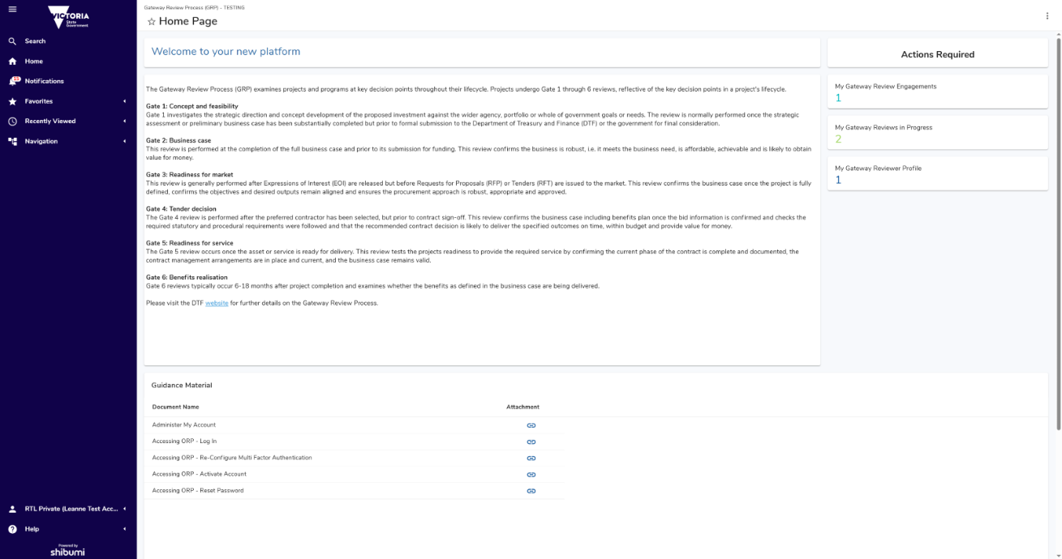
 | Home Page  Access to the home page is managed by the Gateway Unit. If you do not see a screen like above contact a Gateway Unit Analyst. Note: Information displayed is unique to your Role, and what Projects and Gates you’re assigned to.
Show/Hide Left Navigation Menu
Click hamburger menu, represented by three horizontal lines, top left of screen to show/hide left navigation menu.
Click: My Gateway Review
My Gateway Review screen displays:
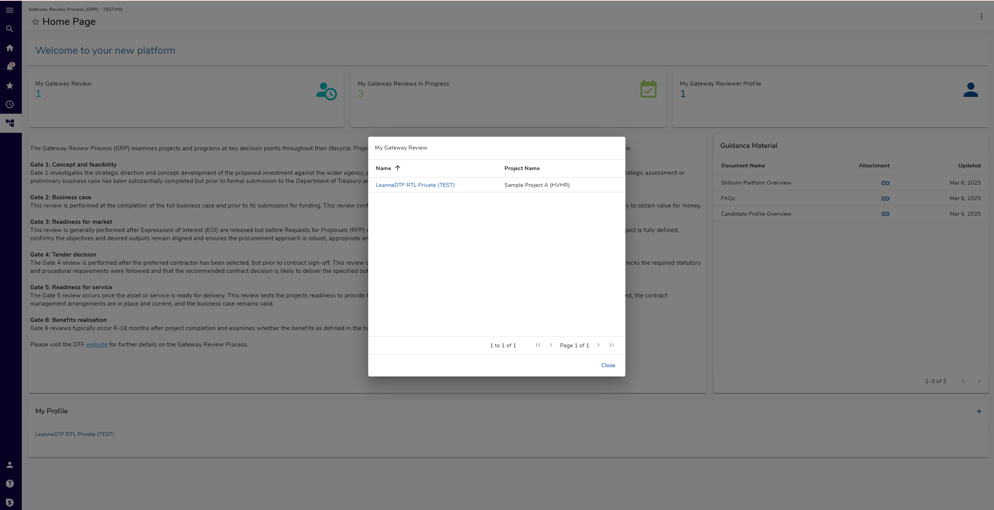
Click: Name.
Summary screen displays:
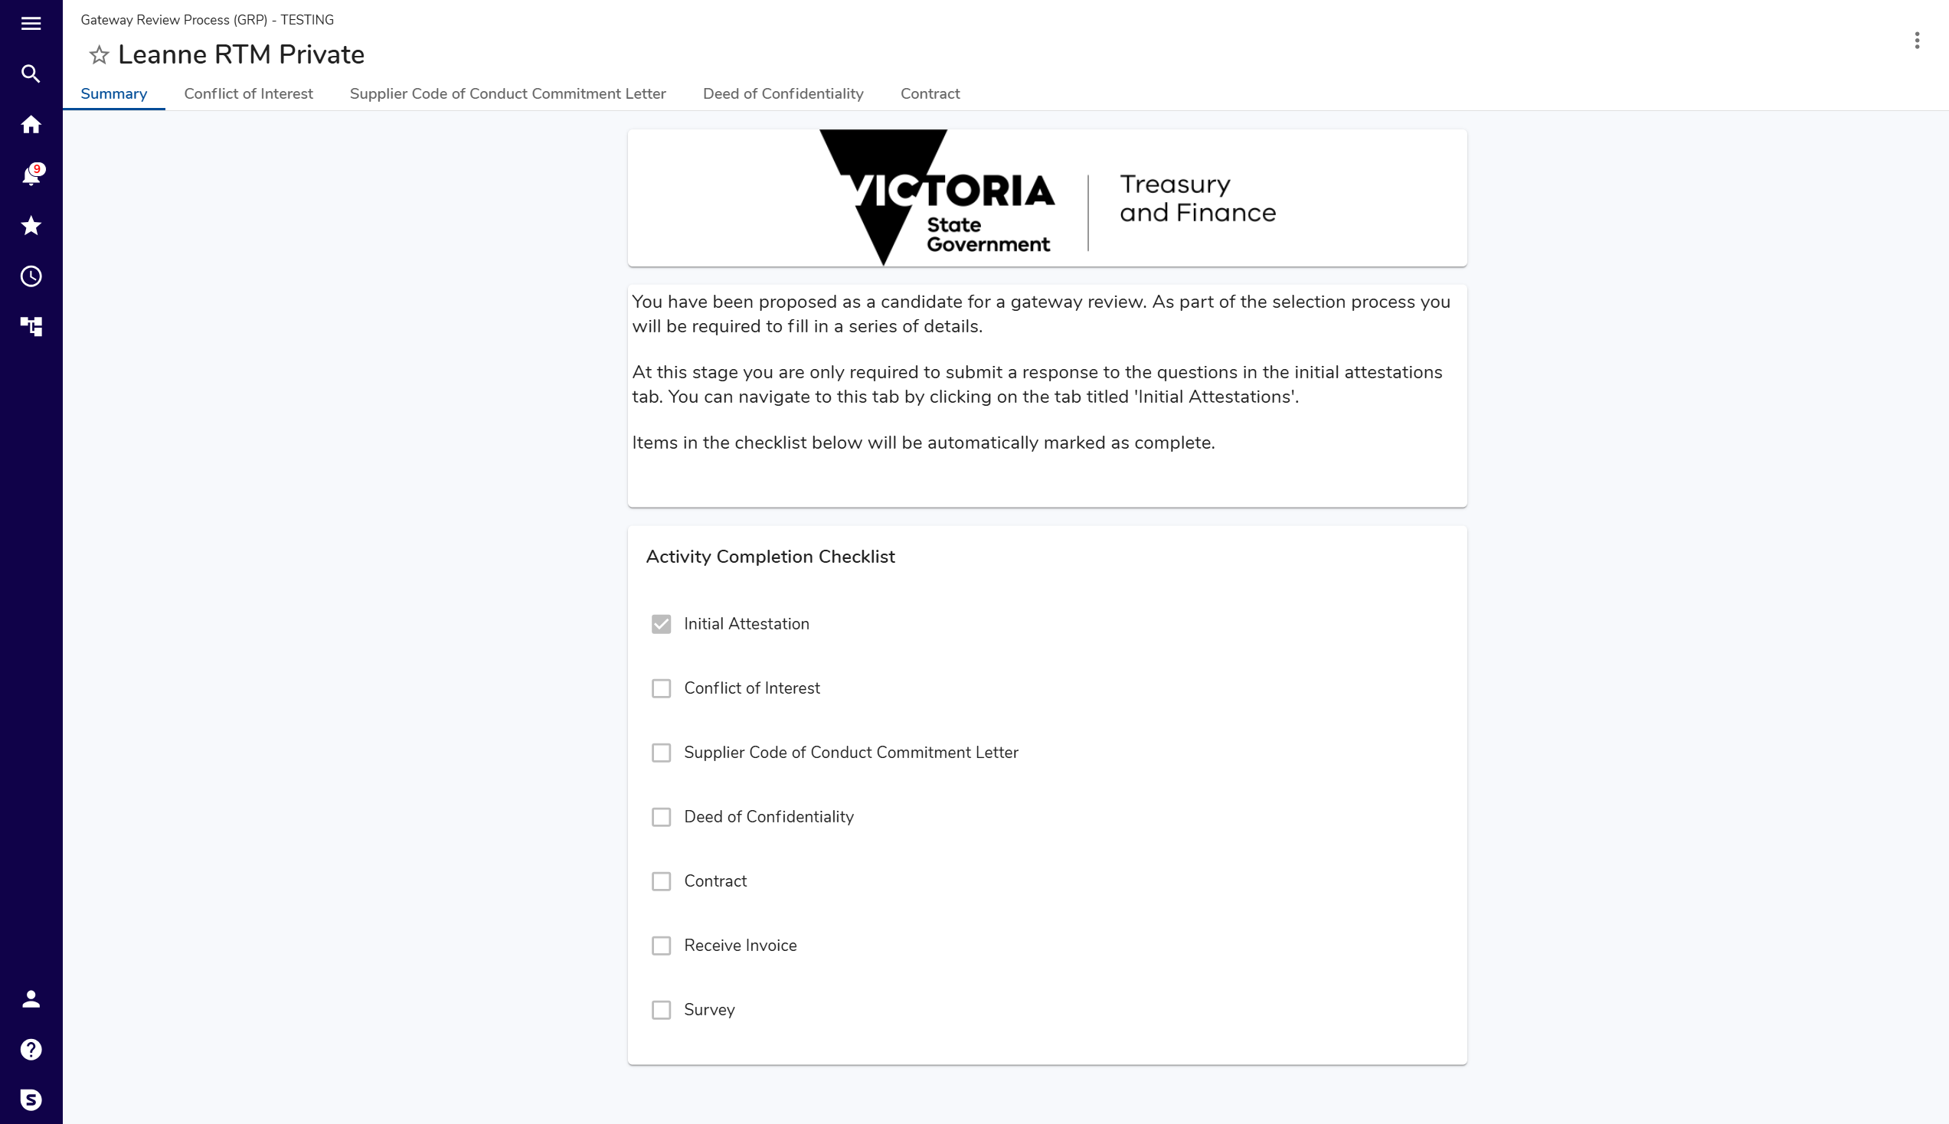
Activity Completion Checklist
- Activities differ based on role.
- Automatically updates as forms completed.

Part 2: Complete Conflict of Interest
Step | What to Do
In top navigation menu, click: Conflict of Interest
Conflict of Interest screen displays:
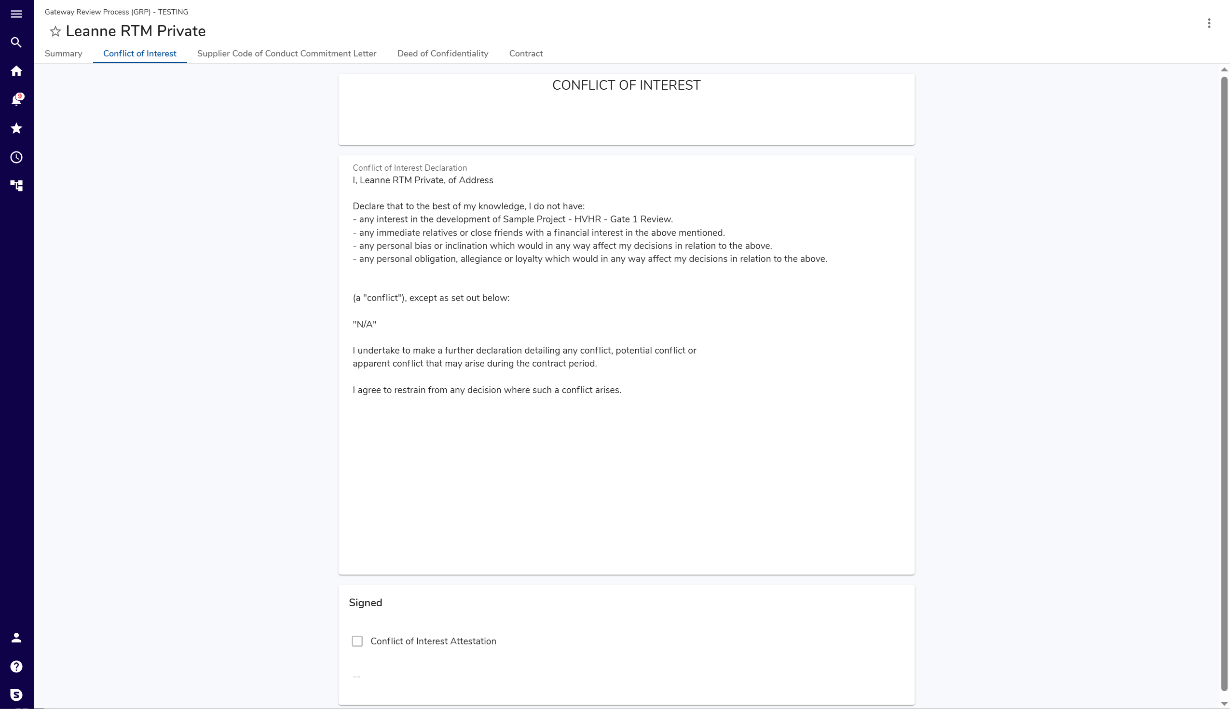
Adding and Editing data
Hover over a panel or field and click  to edit.
Where button is crossed out, this denotes fields you are not permitted to edit.
Saving data
After clicking edit, buttons to Save or Cancel data selection and entry displays on the top right of a panel being edited.
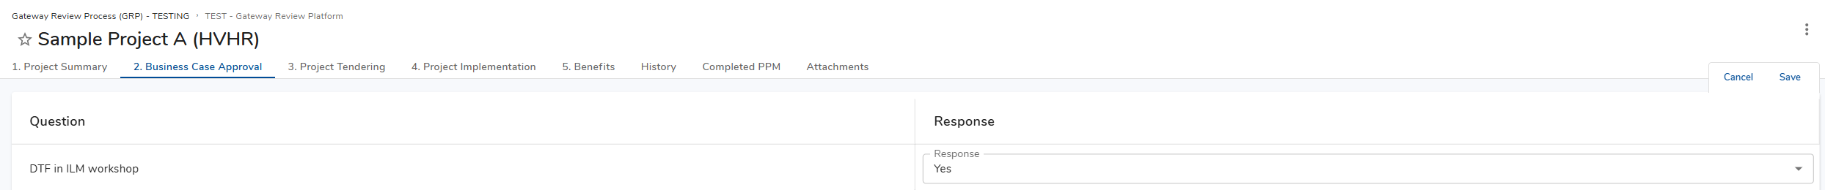
Data will be lost if not saved before navigating to new screen or closing ORP.
ORP will prompt “There are unsaved changes.” to avoid data loss.
Once data is saved, you may navigate away from any screen or close ORP and return to continue work later.
 | Asterisk denotes mandatory field.
 | Where available for download, attachments are denoted by a link symbol:
 | Review Conflict of Interest Declaration.
 | Complete panel Signed.
 | Click: Save
 | Signature auto populated based on your profile.
Are you a VPS Employee?
Yes | Proceed to Part 5: Complete Contract.
No | Proceed to Part 3: Complete Supplier Code of Conduct Commitment Letter.

Part 3: Complete Commitment Letter
Step | What to Do
In top navigation menu, click: Supplier Code of Conduct Commitment Letter
Supplier Code of Conduct Commitment Letter screen displays:
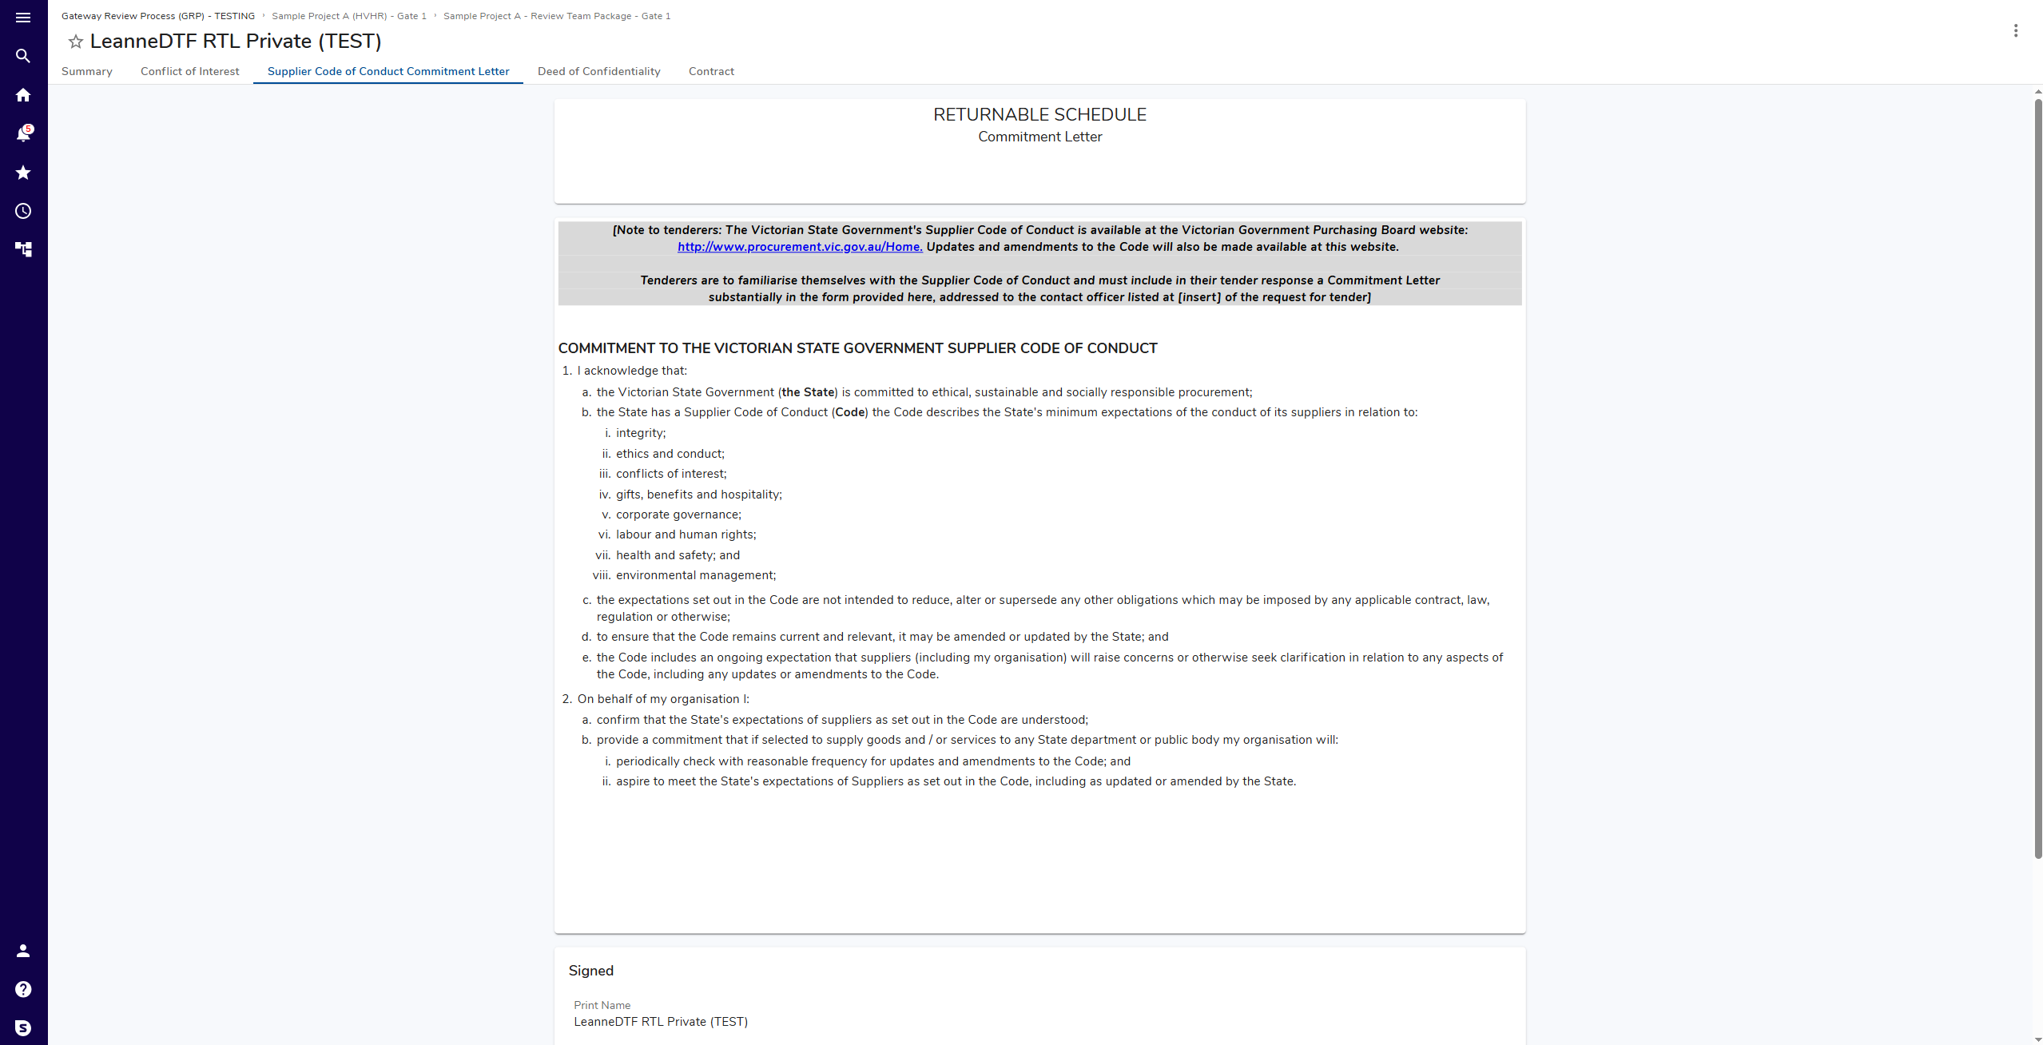
Adding and Editing data
Hover over a panel or field and click to edit.
Where button is crossed out, this denotes fields you are not permitted to edit.
Saving data
After clicking edit, buttons to Save or Cancel data selection and entry displays on the top right of a panel being edited.
Data will be lost if not saved before navigating to new screen or closing ORP.
ORP will prompt “There are unsaved changes.” to avoid data loss.
Once data is saved, you may navigate away from any screen or close ORP and return to continue work later.
 | Asterisk denotes mandatory field.
 | Where available for download, attachments are denoted by a link symbol:
 | Review Commitment to the Victorian State Government Supplier Code of Conduct.
 | Complete panel Signed.
 | Click: Save
 | Signature auto populated based on your profile.

Part 4: Complete Deed of Confidentiality
Step | What to Do
In top navigation menu, click: Deed of Confidentiality
Deed of Confidentiality screen displays:
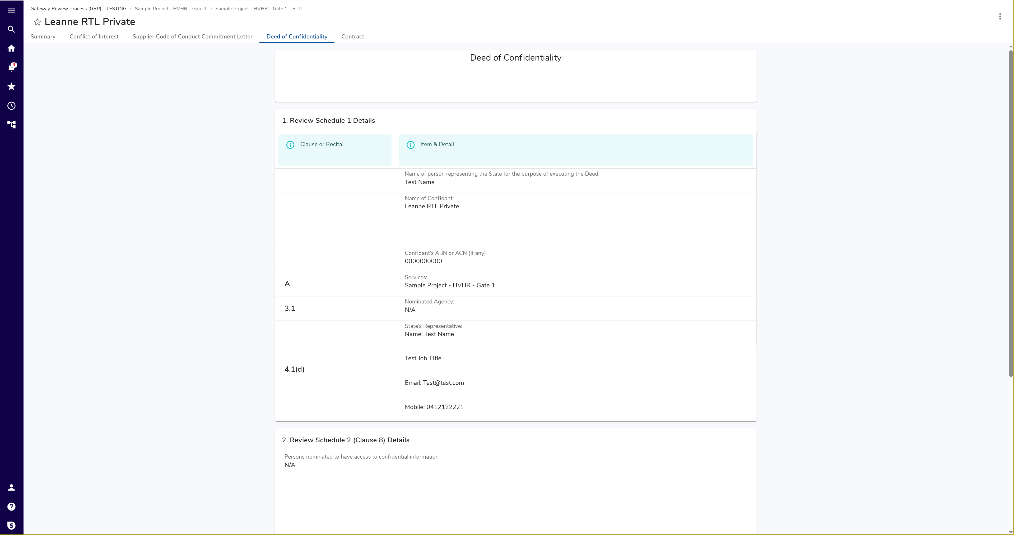
Adding and Editing data
Hover over a panel or field and click to edit.
Where button is crossed out, this denotes fields you are not permitted to edit.
Saving data
After clicking edit, buttons to Save or Cancel data selection and entry displays on the top right of a panel being edited.
Data will be lost if not saved before navigating to new screen or closing ORP.
ORP will prompt “There are unsaved changes.” to avoid data loss.
Once data is saved, you may navigate away from any screen or close ORP and return to continue work later.
 | Asterisk denotes mandatory field.
 | Where available for download, attachments are denoted by a link symbol:
 | Review panel 1. Review Schedule 1 Details.
 | Review panel 2. Review Schedule 2 (Clause 8) Details.
 | Navigate to panel 3. Generate Deed of Confidentiality
 | Click: Generate Deed of Confidentiality
 | Refresh browser to display generated document.
 | Navigate to panel 4. Download Deed of Confidentiality
Click: Attachment
Deed downloads via browser to local device.
 | Review, sign, and scan completed deed.
Hover over panel 5. Upload Signed Deed of Confidentiality, click: Edit
Upload Signed Deed of Confidentiality button displays:
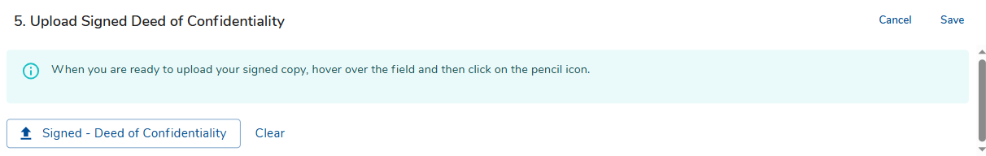
Click: Upload Signed Deed of Confidentiality
File Browser displays:
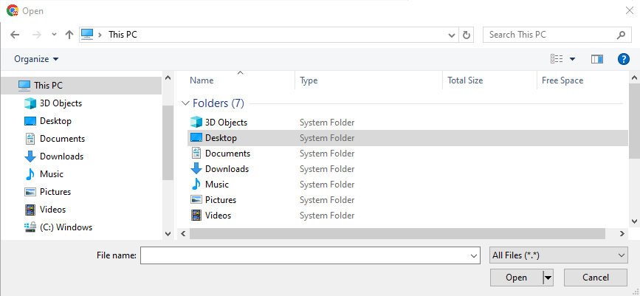
 | Navigate to and select signed copy of deed.
Click: Open
Screen updates to display uploaded file:
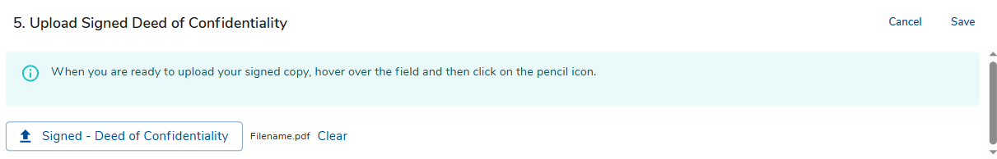
Correct document uploaded?
Yes | Go to next step.
No | - Click: Clear  - Repeat steps 11 - 13.

 | Click: Save

Part 5: Complete Contract
Step | What to Do
In top navigation menu, click: Contract
Contract screen displays:
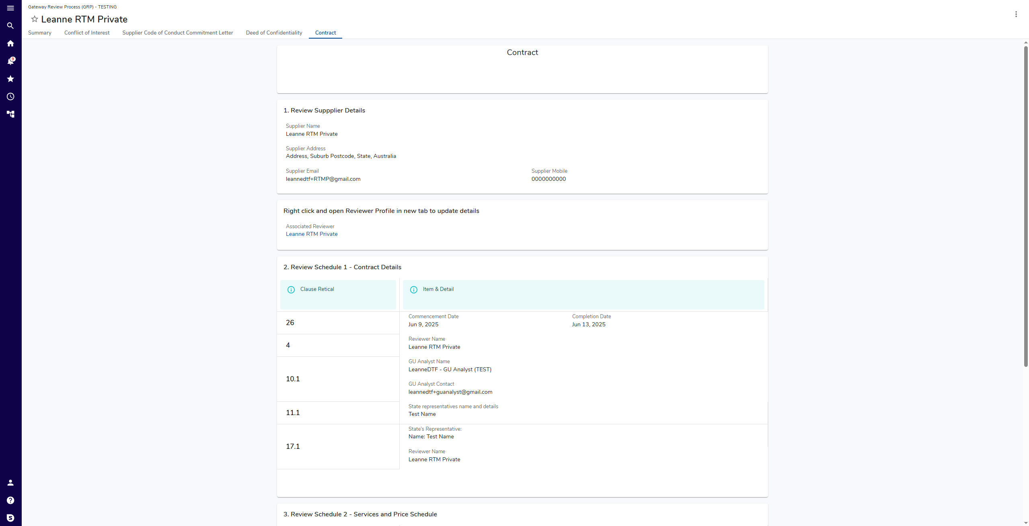
Adding and Editing data
Hover over a panel or field and click to edit.
Where button is crossed out, this denotes fields you are not permitted to edit.
Saving data
After clicking edit, buttons to Save or Cancel data selection and entry displays on the top right of a panel being edited.
Data will be lost if not saved before navigating to new screen or closing ORP.
ORP will prompt “There are unsaved changes.” to avoid data loss.
Once data is saved, you may navigate away from any screen or close ORP and return to continue work later.
 | Asterisk denotes mandatory field.
 | Where available for download, attachments are denoted by a link symbol:
 | Review panel 1. Review Supplier Details.
Are Supplier details correct?
Yes | Go to next step.
No | - Navigate to section Right click and open Reviewer Profile in new tab to update details.  - Right-click Associated Reviewer.  Reviewer Profile opens in new tab.  - Update relevant details.  See user guide: Manage Gateway Reviewer Profile.

 | Review panel 2. Review Schedule 1 Contract Details.
 | Review panel 3. Review Schedule 2 Services and Price Schedule.
Are Contract, Services, and Price details correct?
Yes | Go to next step.
No | Contact Gateway Unit for assistance before proceeding.

 | Navigate to panel 4. Download/Upload Contract.
Your contract has been prepared by the Gateway Unit.
Where available for download, attachments are denoted by a link symbol:
Click: Attachment
Contract downloads via browser to local device.
 | Review, sign, and scan completed document.
In panel 4. Download/Upload Contract., click: Edit.
Signed - Contract button displays:
Click: Signed - Contract
File Browser displays:
 | Navigate to and select scanned signed copy of your Contract.
Click: Open
Screen updates to display uploaded file:
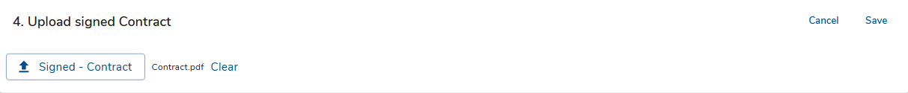
Correct document uploaded?
Yes | Go to next step.
No | Click: Clear  Repeat steps 11 -13.

 | Click: Save

Part 6: Verify completion
Step | What to Do
In top navigation menu, click: Summary
Summary screen displays:
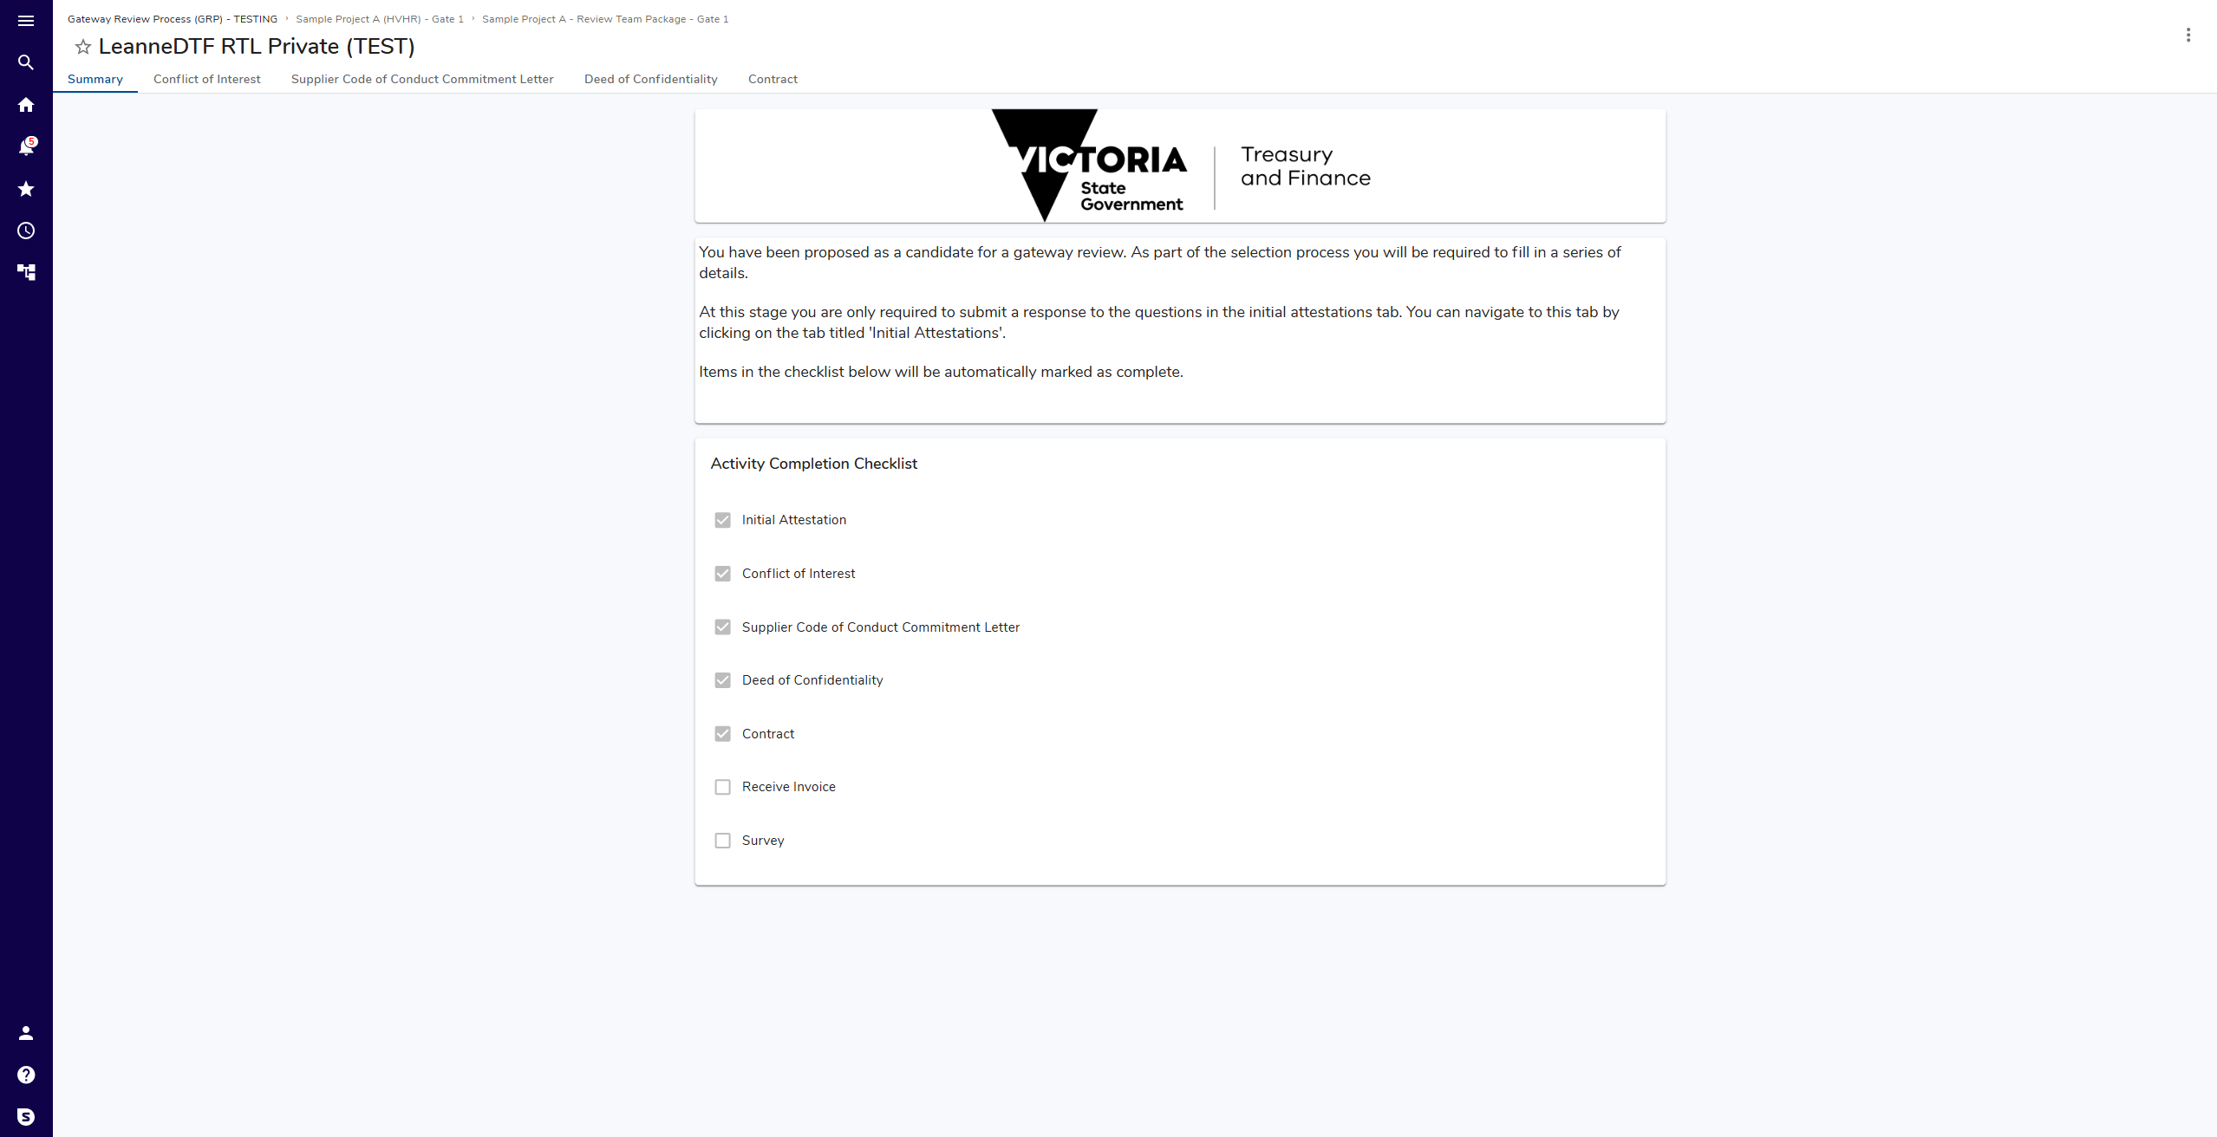
Activity Completion Checklist
- Activities differ based on role.
- Automatically updates as forms completed.
Ensure all items except Invoice and Survey marked complete..
Where required item unchecked, return to that form and complete.
Next steps
Gateway Unit Analyst reviews submission and progresses selection.

