Online Reporting Platform (ORP)
Reset Password
04 JULY 2025

Reset Password 2
Audience 2
Foreword 2
Context 2
Pre-requisites 2
Support 2

Reset Password
This guide demonstrates how existing users with active accounts reset their password.
I.e., You’ve forgotten your password, or are presented message “The email address or password you provided does not match our records.” and need to reset it.

Audience
All users

Pre-requisites
- User has completed registration
See User Guide: Activate Account

Email notifications
You may receive email notifications from Shibumi related to this process. To avoid missing communications flag Shibumi as a trusted sender in your email application.

Support
For support email gateway.helpdesk@dtf.vic.gov.au.

Steps
Step | What to Do
Follow emailed link or navigate to: https://ap.shibumi.com/shibumi/login
Log In screen displays:
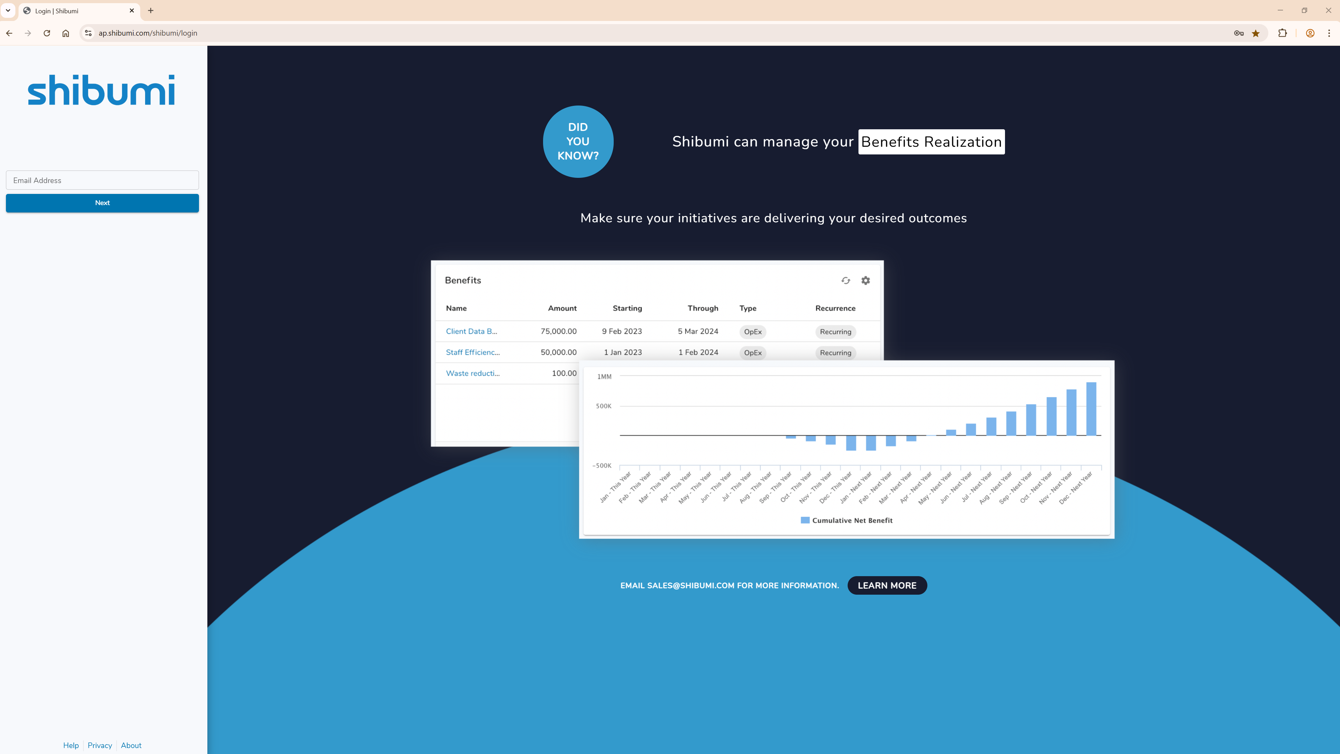
 | Type Email address.
Click: Next
Sign-in screen displays:
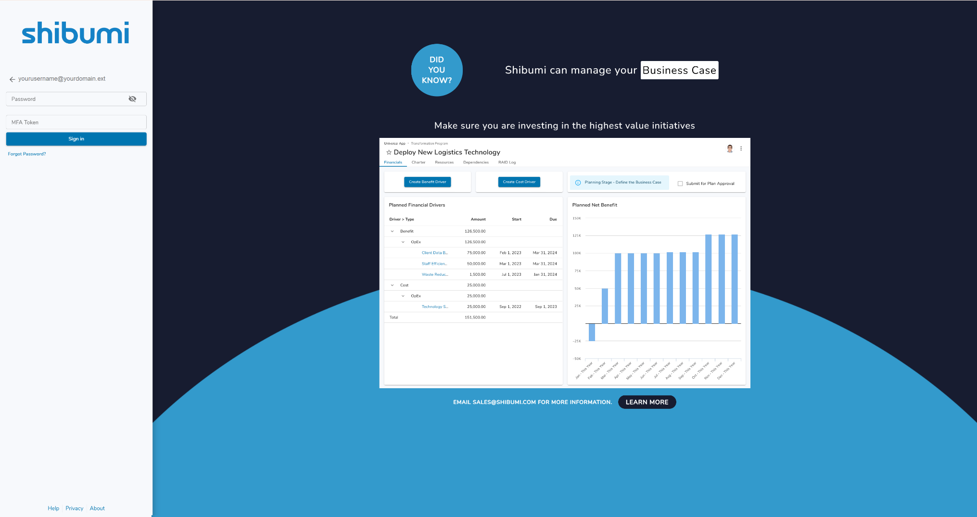
Click: Forgot Password?
Notification message displays:
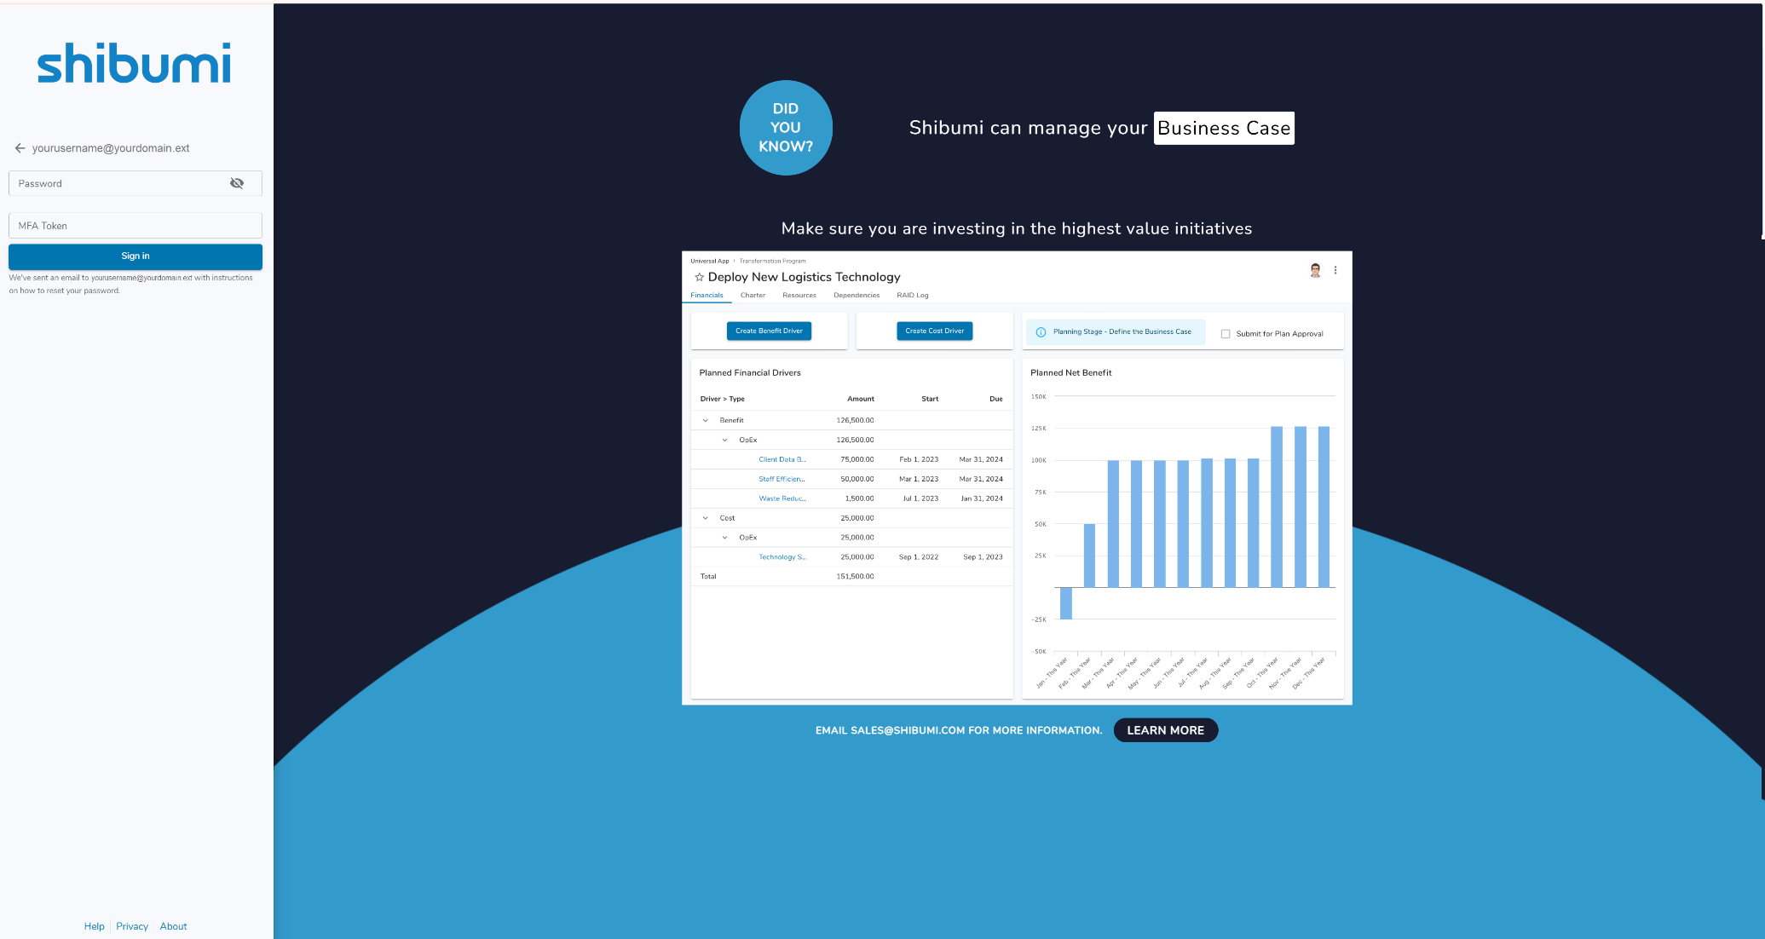
Note: An email has been sent to your email address with instructions on how to reset your password.
Navigate to your email inbox and open email.
Email message displays:
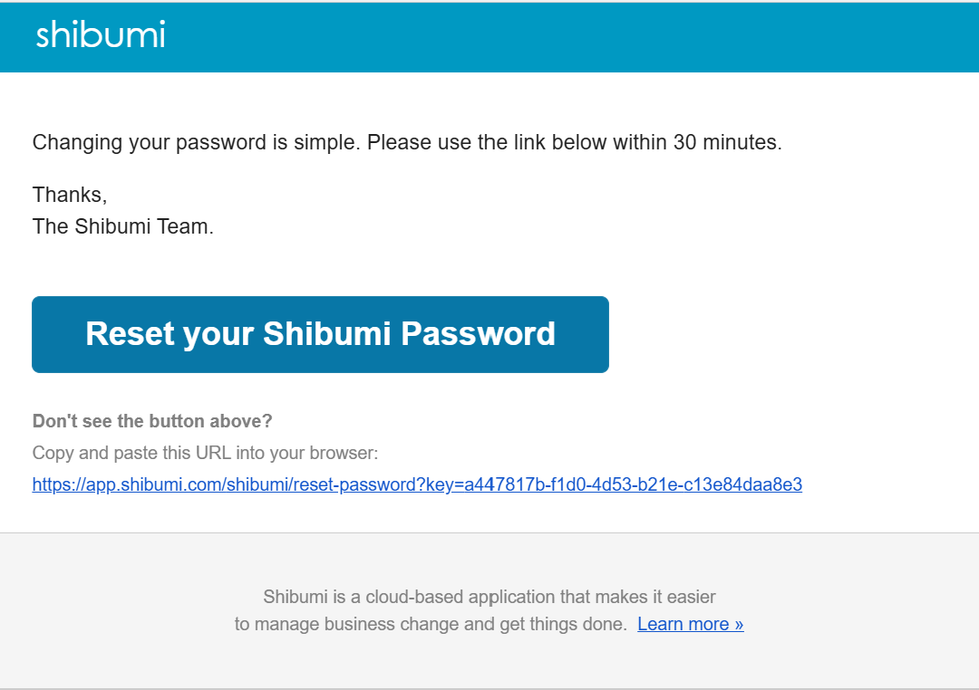
Copy and paste link into your browser, or click: Reset your Shibumi Password
Reset password screen displays:
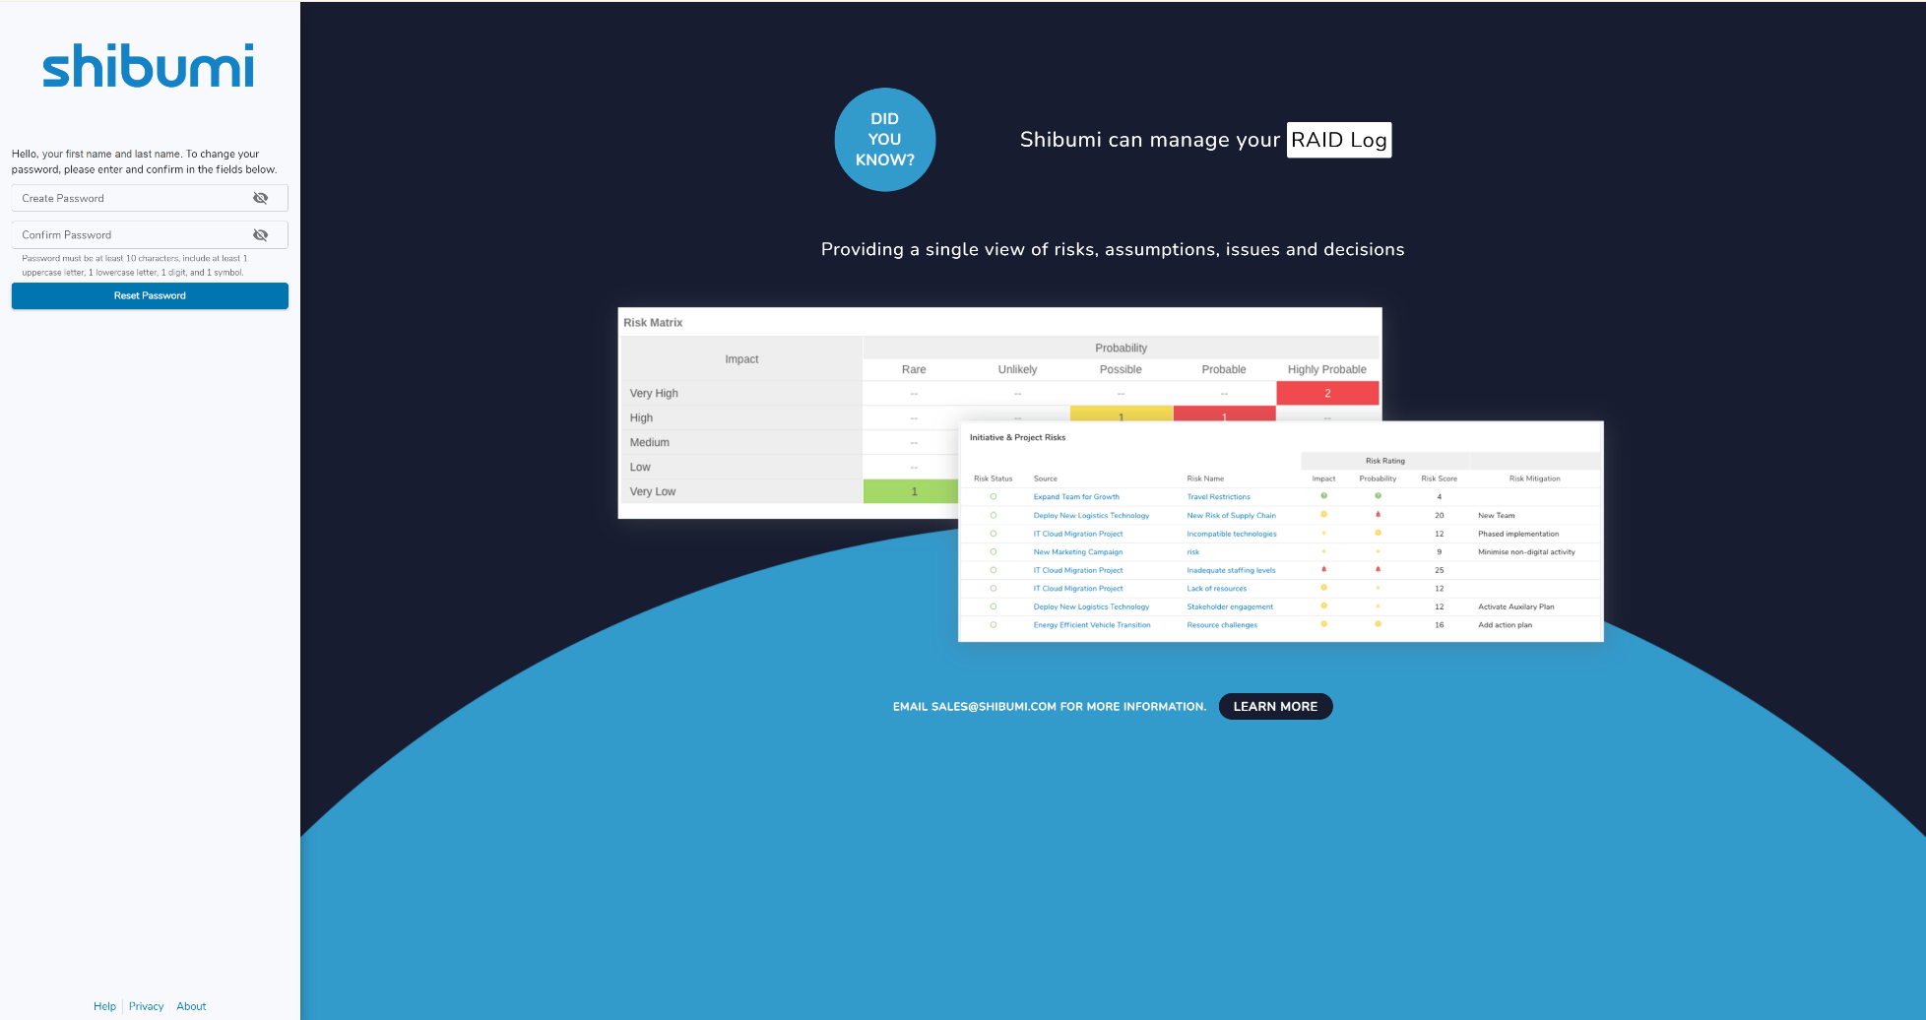
 | In Create Password field, type new password.
 | Password requirements  - Password must be at least 10 characters, include at least 1 uppercase letter, 1 lowercase letter, 1 digit, and 1 symbol.  - You are not able to reuse any of your previous 5 passwords.
 | In Confirm Password field, re-type new password.
Click: Reset Password
Log In screen displays:
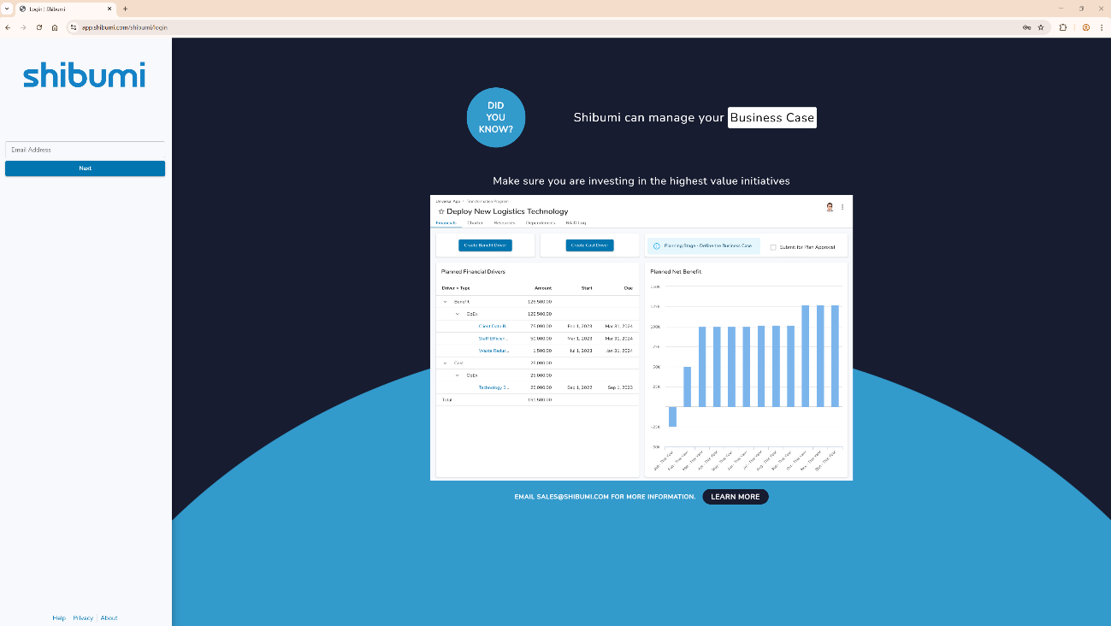
 | For assistance logging in, see User Guide: Log In to ORP.

