Online Reporting Platform (ORP)
Log In to ORP
04 JUly 2025

Log In to ORP 2
Audience 2
Pre-Requisites 2
Email notifications 2
Support 2
Steps 3

Log In to ORP
This guide demonstrates how existing users with active accounts login to the ORP.

Audience
All ORP users

Pre-Requisites
- User account pre-exists and active
See user guide: Accessing ORP - Activate Account

Email notifications
You may receive email notifications from Shibumi related to this process. To avoid missing communications flag Shibumi as a trusted sender in your email application.

Support
For support email gateway.helpdesk@dtf.vic.gov.au.

Steps
Step | What to Do
Navigate to: https://ap.shibumi.com/shibumi/login
Login screen displays:
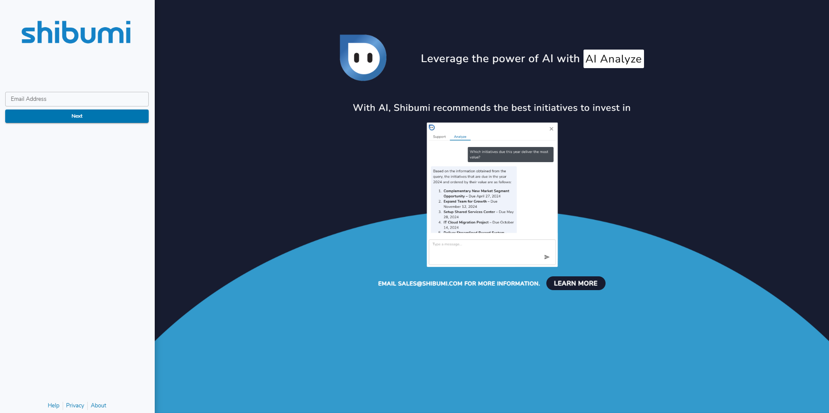
 | Type Email address.
 | Click: Next
Which screen do you see?
Home Page | You’re a VPS user accessing ORP via a recognised network. You were authenticated via Single Sign-On during log in.  You are now logged in.
Password Request | Your access to ORP is authenticated by Two Factor Authentication. You need to enter the Password and Multi Factor Authentication (MFA) Token your created when you activated your account.  Go to next step.

 | In Password field, type your password.
 | In MFA Token field, type current code displayed in your Authenticator App.
 | Click: Sign in
Did message “The email address or password you provided does not match our records.” present?
Yes | See user guide: Accessing ORP - Reset Password.
No | Home Page displays:

 | Home Page  Access to the home page is managed by the Gateway Unit. If you do not see a screen similar to above contact a Gateway Unit Analyst.  Information displayed is unique to your Role, and what Projects and Gates you’re assigned to.
Following log in users may be presented privacy notification. This message will continue to display until accepted.
