CLIENT PATHWAYS REPORT 3

Engagement in education and the labour market, and state government service interactions for 15-25-year-olds born overseas.

Young multicultural Victorians at risk of unemployment

ACKNOWLEDGEMENT   
OF COUNTRY

The Victorian Department of Treasury and Finance acknowledges that Aboriginal and Torres Strait Islander peoples are the First Peoples and Traditional Custodians of Australia, and the oldest continuing culture in human history. We proudly acknowledge Victoria’s Aboriginal communities and recognise the value and ongoing contribution of Aboriginal people and communities to Victorian life. We pay our respect to Elders past and present and emerging.

As we work to ensure Victorian Aboriginal communities continue to thrive, the Government acknowledges the invaluable contributions of generations that have come before us, who have fought tirelessly for the rights of their people and communities towards self-determination. We reflect on the continuing impact of government policies and practices and recognise our responsibility to work together with and for Aboriginal and Torres Strait Islander peoples towards improved cultural, social and economic outcomes.

Aboriginal artwork ‘lim-ba nindee thana warn-ga-ilee’ (Preserve our Dreaming Lore) – Gunnai Language


‘lim-ba nindee thana warn-ga-ilee’   
(Preserve our Dreaming Lore) – Gunnai Language

Bitja (Dixon Patten Jnr) Yorta Yorta, Gunnai,   
Gunditjmara and Dhudhuroa of Bayila Creative

Department of Treasury and Finance   
1 Treasury Place  
Melbourne, Victoria, 3002 Australia

Telephone: +61 3 9651 5111   
dtf.vic.gov.au

Authorised by the Victorian Government   
1 Treasury Place, Melbourne, 3002

© State of Victoria 2024



You are free to re-use this work under a Creative Commons Attribution 4.0 licence, provided you credit the State of Victoria (Department of Treasury and Finance) as author, indicate if changes were made and comply with the other licence terms. The licence does not apply to any branding, including Government logos.

Copyright queries may be directed to [information@dtf.vic.gov.au](mailto:information@dtf.vic.gov.au)

ISBN 978-1-923295-00-1

Published December 2024

If you would like to receive this publication in an accessible format please email [information@dtf.vic.gov.au](mailto:information@dtf.vic.gov.au)

This document is available in PDF format at dtf.vic.gov.au



Section 1

Preamble

Executive summary and findings from the literature review

# Context for the third Client Pathway report

This is the third in a series of Client Pathways reports.

Each report focuses on selected cohorts to inform future policy and program design, particularly relating to the Victorian Government’s Partnerships Addressing Disadvantage and Early Intervention Investment Framework (EIIF) programs.

Client Pathways was agreed as part of the *2023‑24 Budget* to identify specific service system needs and improve effectiveness of early intervention. Further information about the project is available on the EIIF website: Early Intervention Investment Framework, Department of Treasury and Finance Victoria (<https://www.dtf.vic.gov.au/early-intervention-investment-framework/client-pathways-reports>). If you would like to get in touch regarding this report or the Client Pathways project, please contact [earlyintervention@dtf.vic.gov.au](mailto:earlyintervention@dtf.vic.gov.au)

## Introduction

This report brings together multiple data sources to develop a picture of young multicultural Victorians who are at risk of unemployment.

Due to the challenges around both defining multicultural communities for the purpose of data extraction and analysis, and the lack of linked data between the Commonwealth and Victorian governments, a multistep approach was taken to examine the experiences of these young people.

The Department of Treasury and Finance used data from the Australian Bureau of Statistics (ABS) 2021 Census1 to explore the distribution of young multicultural Victorians (15-25 years) in terms of engagement in education and employment, and socio-economic disadvantage2,3. This defined the Local Government Areas (LGAs) where young multicultural Victorians were at most risk of being unemployed.

Data from the Victorian Social Investment Integrated Data Resource (VSIIDR) was used. It comprises linked administrative data, capturing how Victorians use selected government health, human services, education and justice services. Linked administrative data can be used to examine generalised and de-identified client pathways through service systems to inform practical decisions about service and policy design. It is not known which of these young people was unemployed, only that they lived in an LGA where young multicultural Victorians were at risk of being unemployed. Service usage in 2022 was examined, the year of most recent complete data in the VSIIDR dataset at the time of analysis in 2024.

COVID-19 is likely to have impacted the need for, and access to, services in 2021 and 2022. Data has not been adjusted to account for the impacts of COVID-19.

This report may be used to inform proposals for future Partnerships Addressing Disadvantage, and/or new investments through the EIIF.

## Report structure

The report has four sections.

1. Executive summary and findings from the literature review 2
2. Demographics of young multicultural Victorians 6
3. Young multicultural Victorians at risk of unemployment 14
4. Service interactions for young people in select LGAs 21

1 <https://www.abs.gov.au/census/guide-census-data>

2 <https://www.abs.gov.au/statistics/people/people-and-communities/socio-economic-indexes-areas-seifa-australia/latest-release#overview>

3 [https://www.abs.gov.au/statistics/detailed-methodology-information/concepts-sources-methods/socio-economic-](https://www.abs.gov.au/statistics/detailed-methodology-information/concepts-sources-methods/socio-economic-indexes-areas-seifa-technical-paper/2021) [indexes-areas-seifa-technical-paper/2021](https://www.abs.gov.au/statistics/detailed-methodology-information/concepts-sources-methods/socio-economic-indexes-areas-seifa-technical-paper/2021)

# Executive Summary

The third Client Pathways report examined the characteristics and service use of multicultural young people (defined as 15–25-year-olds born overseas in non-main English-speaking countries for this purpose) who were at risk of unemployment.

The 2021 Census counted 171 919 young multicultural Victorians originating from 156 countries. Approximately one third were born in China and India, approximately half came from the next 23 countries, and the remaining 15 per cent were from a further 131 countries.

The literature review highlights barriers to employment for multicultural communities including education levels, English proficiency, visa status and stigma, and emphasises the benefits to individuals, communities and government of employment.

Census data revealed that young multicultural Victorians were more likely to be studying and have higher levels of educational attainment than their non-multicultural peers. It also found that young multicultural Victorians were frequently living in relatively more disadvantaged metropolitan areas.

Detailed analysis were applied to young people from eight metropolitan LGAs (figure 1) with higher levels of unemployment and socioeconomic disadvantage. These account for 89 673 (52 per cent) of the young multicultural Victorians.

Figure 1: LGAs selected

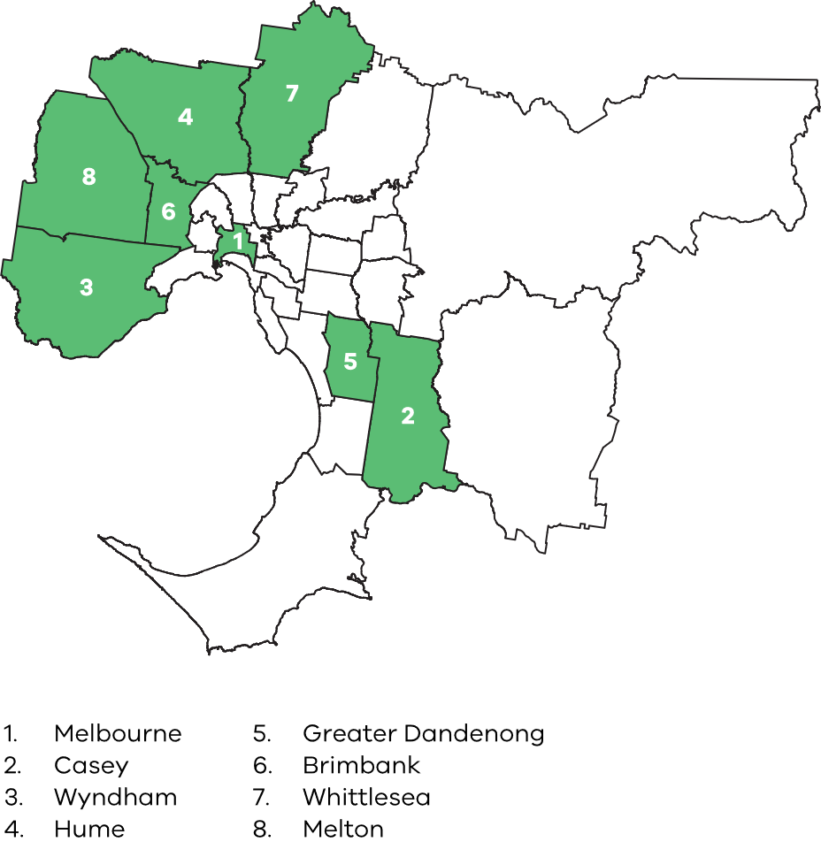

Data from the Victorian Social Investment Integrated Data Resource (VSIIDR) was used to explore state government service usage for young multicultural Victorians at risk of unemployment living in these LGAs. Key data insights showed that:

* Compared with all young people in the VSIIDR dataset and all young multicultural Victorians, young multicultural Victorians living in these LGAs often have more interactions with clinical mental health services, homelessness and family violence services and Youth Justice and adult corrections services
* The magnitude of service interactions for young multicultural Victorians in these LGAs most closely reflects the service interactions of other young people living in the same LGA. However, young multicultural Victorians living in these LGAs have:
  + more clinical health interactions less child protection interactions
  + fewer interactions with child protection
  + interactions with adult corrections, Youth Justice, family violence and homelessness services which vary by LGA
* Service use by young multicultural Victorians in these LGAs relative to all other cohorts considered was relatively highest in:
  + Mental health: Melbourne, Greater Dandenong, Casey and Brimbank
  + Youth Justice and adult corrections: Brimbank and Wyndham
  + Family violence: Melbourne, Wyndham, and Brimbank.

For both Census and VSIIDR data, this report presents cohort averages which may hide service use trends or experiences of disadvantage within sub-groups, including people entering Australia on humanitarian visas or from specific countries. The analysis also does not capture people who identify as part of a multicultural community but were born in Australia or another English speaking country. Census data has a surplus of multicultural people in the 20-25 age range relative to VSIIDR, likely including international students. In contrast, VSIIDR data captures people who have interacted with Victorian government services, which may beless likely for international students on temporary visas. These limitations affect the insights drawn from this analysis, and results should be treated with caution.

# Literature review

The multicultural community is highly diverse and has varied employment experiences. While there are consistent themes in the challenges multicultural young people face in employment, experiences differ for those who have education, skills and qualifications, and whether these were obtained in Australia or elsewhere [2], compared to those who do not [3].

In terms of income earning opportunities, in 2019‑20, the proportion of migrants in Australia aged 15-64 years who reported income was 6 percentage points less than that of those in the total population. Across migrant groups, humanitarian migrants appear to show the worst outcomes with just 49 per cent reporting any income for the year, with length of tenure in Australia as a key determinant. In particular, only 26 per cent of humanitarian migrants who had lived in Australia for less than five years earned an income. This rose to 57 per cent for those who had been in Australia for more than 10 years [4]. Other studies report median incomes of migrants well below all taxpayers, even after 10 years of first arrival.

Additionally, second generation migrants appear to have better employment participation rates, converging with the total population [1].

In 2021, close to 30 per cent of the young people in Australia were temporary students, and another 30 per cent were permanent skilled migrants. Additionally, 18 per cent of visa holders held either permanent humanitarian or temporary bridging visas [5, 6].

Studies show that members of multicultural communities experience some internal and external pressures that are different to those in mainstream population groups. These include wanting to take every opportunity to learn, succeed and give back [3], the need to support family in Australia and overseas [3] and high parental aspirations [7].

Themes reported in the literature regarding difficulties associated with young multicultural people finding and maintaining employment include:

Language: Lack of English proficiency creating barriers to integration in education and the workplace [8]

Education**:** Disengagement in education in Victoria, and disrupted education in former countries [3].

Not completing Year 12 is associated with lower incomes and higher rates of unemployment [9], however humanitarian migrants who completed secondary and tertiary education prior to immigration were less likely to be employed after two years compared with those who arrived with no education [2]

Contributors to non-portable social capital include barriers erected by trade and professional organisations and employer opinions [2]

Stigma: Young multicultural people report stigma, ostracization and racism [3] from employers regarding ability to perform the job, due to English skills and lack of local experience and qualifications [2, 8]. They can also face the assumption that migrants will fill unskilled roles where this may not be consistent with their skills and experience [2, 8]

Visa status: Visa status and type for humanitarian migrants can interfere with their ability to participate in work [10].

In interviews with refugee young people, the Centre for Multicultural Youth identified a lack of integration between employment support, welfare support and as a challenge for some people in the multicultural community [3]. This was also identified by the Federation of Ethnic Communities’ Council of Australia (FECCA) who reported that:

* Services designed to upskill participants like government subsidised registered training organisations and introductory TAFE courses may not provide a pathway to employment [8]
* Inflexible systems and services inadequately manage the complex trade-off between taking time to enhance English proficiency and being available to work and earn an income [8].

There are significant benefits associated with being employed including better health, stronger social networks, a sense of identity and belonging, and fewer interactions with the justice system [3].

Victoria’s Youth Justice Strategic Plan recognises the overrepresentation of specific culturally and linguistically diverse groups, and includes work to identify and address issues contributing to this overrepresentation [11].

Disadvantages associated with being unemployed include poor mental health and increased prevalence of alcohol and substance use disorders [12]. Studies have shown that unemployment can lead to mental health disorders, and that mental health disorders can lead to unemployment [12].

This is a particular challenge for humanitarian migrants who may have poor mental health from prior trauma which is then exacerbated by lack of employment [3]. Building a New Life in Australia reports that of 2 277 humanitarian arrivals interviewed, 33 per cent experienced or witnessed at least three of the following: war or conflict, political or religious persecution, extreme living conditions, violence, and imprisonment or kidnapping [13].

Reference list for literature review available at end of report.



Section 2

Demographics of young multicultural Victorians

# Terminology in this report

This report uses the phrase ‘young multicultural Victorians’, defined as those aged 15-25 years who were born overseas, in countries other than those classified by the ABS as ‘main English-speaking countries’1

This project recognises that this group is a subset of young multicultural Victorians. Other common measures of multicultural Victorians not used include combinations of place of birth, place of parents’ birth, Indigenous status, English proficiency and preferred language2,3. This project has prioritised a definition that can be consistently used across VSIIDR and Census data4.

FOOTNOTES

1 Main English-speaking countries are Canada, the Republic of Ireland, New Zealand, South Africa, the United Kingdom (England, Scotland, Wales, Northern Ireland) and the United States of America. People born in these countries who identify as being part of a multicultural community, such as Māori people in New Zealand, are not captured as multicultural Victorians in this analysis.

2 Excluding second generation Australians and those who identify as being part of a multicultural community from the definition of young multicultural Victorians will impact the service interaction averages. Including these groups in the total cohort may narrow the differences between the cohorts if their service interactions more closely reflect the born overseas cohort.

3 The report examines government service interactions in 2022 for people born overseas and aged 15-25 in 2022, regardless of how long they have been in Australia. Some may have migrated as 1-year-olds up to 24 years earlier, and others will have migrated as 24-year-olds one year earlier. Their needs and service interactions are likely to be very different, which has not been controlled for.

4 Individuals with no stated birthplace in VSIIDR are considered not born overseas, so the sum of those born overseas and those not born overseas equals the total number of 12-25-year-olds in VSIIDR. Data extracted from the Census only includes people with a birthplace.

# Young multicultural Victorians – comparison of VSIIDR and Census data

This report brings together multiple data sources to develop a picture of young multicultural Victorians who are at risk of unemployment. It leverages Census data to identify unemployment and socio-economic disadvantage and uses VSIIDR data to understand service interactions for people living in those locations.

The VSIIDR dataset includes 125 820 individuals aged 15-25 in 2022 who were born in a non-main English speaking country. The 2021 Census includes 171 919, 15-25s in Victoria (including 171 with no usual address or offshore/shipping), a further 37 per cent (figure 2).

Young women comprise 49 per cent of the multicultural cohort, which is the same as the total 15–25-year-old population in VSIIDR and the Census.

The difference likely reflects that VSIIDR only captures people who have interacted with a state government service. For example, international students and other temporary visa holders may have not interacted with a government service and therefore not captured in VSIIDR but were counted in the Census. There is also a temporal difference between the datasets (VSIIDR is based on the 2022 calendar year and Census captured data in August 2021).

In VSIIDR, the age distribution of young multicultural Victorians is stable between 15 and 21 at around 10 000 for each age. It then increases each year up to 16 700 for 25-year-olds (Figure 2). The Census includes a much higher number of people aged 20–25-years, around 26 000 for 25-year-olds (figure 2). For the non-multicultural population, the counts at each age are relatively stable using both Census and VSIIDR data, however there are more non-multicultural Victorians in VSIIDR than the Census data.

While VSIIDR does not document when people arrived in Victoria (or Australia), it is possible to identify when they first appear in the dataset.

75 per cent of the total cohort had interacted with a service at age 16 (figure 3), while only 50 per cent of the multicultural Victorians had. 75 per cent of multicultural Victorians had interacted with a service at age 20, whereas this was 91 per cent of the non-multicultural population.

Figure 2: Comparison of data sets: Age at Census in 2021 and VSIIDR in 2022

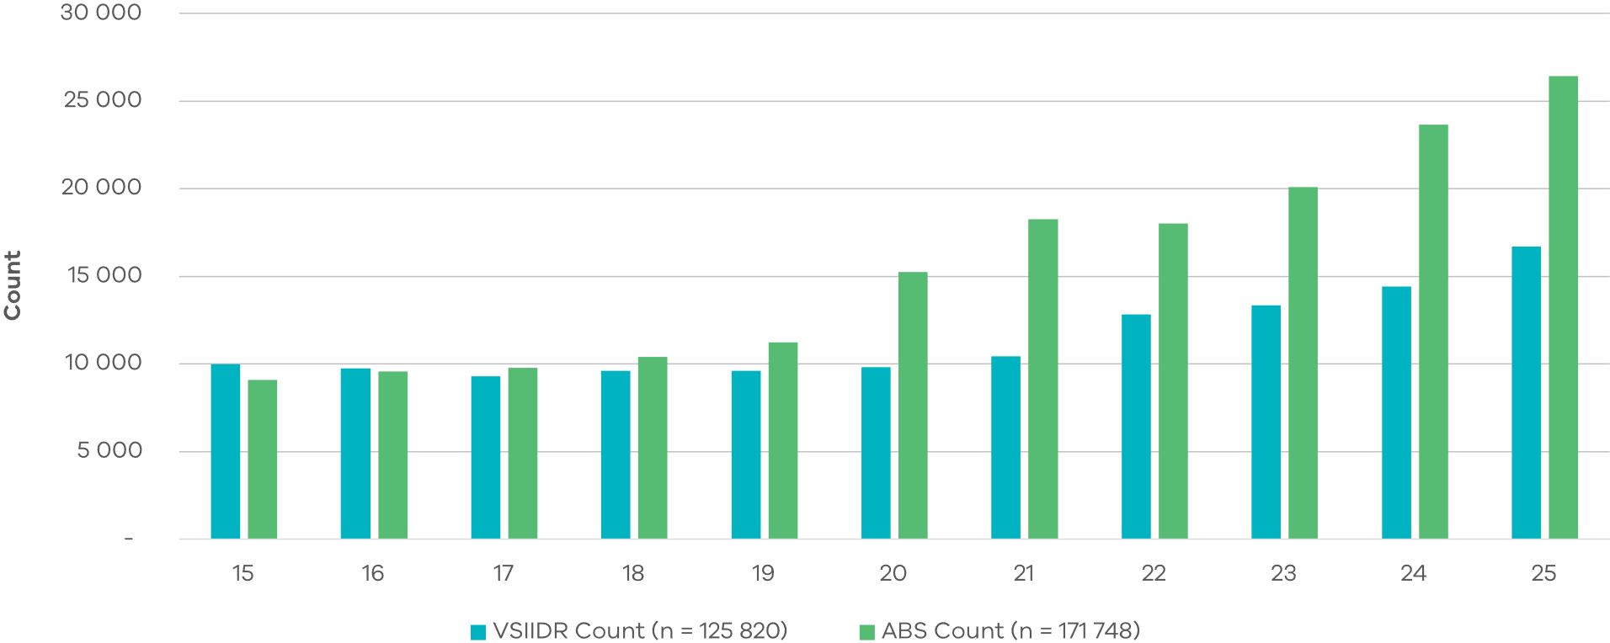

Figure 3: Difference in age of first service accessed for all 15-25-year-olds in VSIIDR and those born overseas

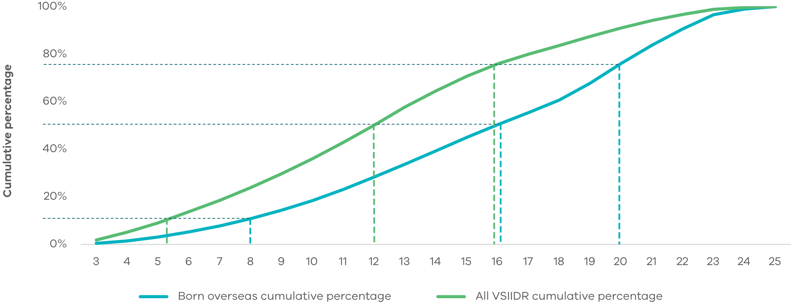

A third of people in the Census were born in India or China, with a further 50 per cent of people born in 23 countries (figure 4). The remaining 15 per cent are drawn from 131 countries, taking the total to 156 countries. This demonstrates the enormous diversity of young multicultural Victorians.

Figure 4: Birth countries for 15-25-year-olds born overseas

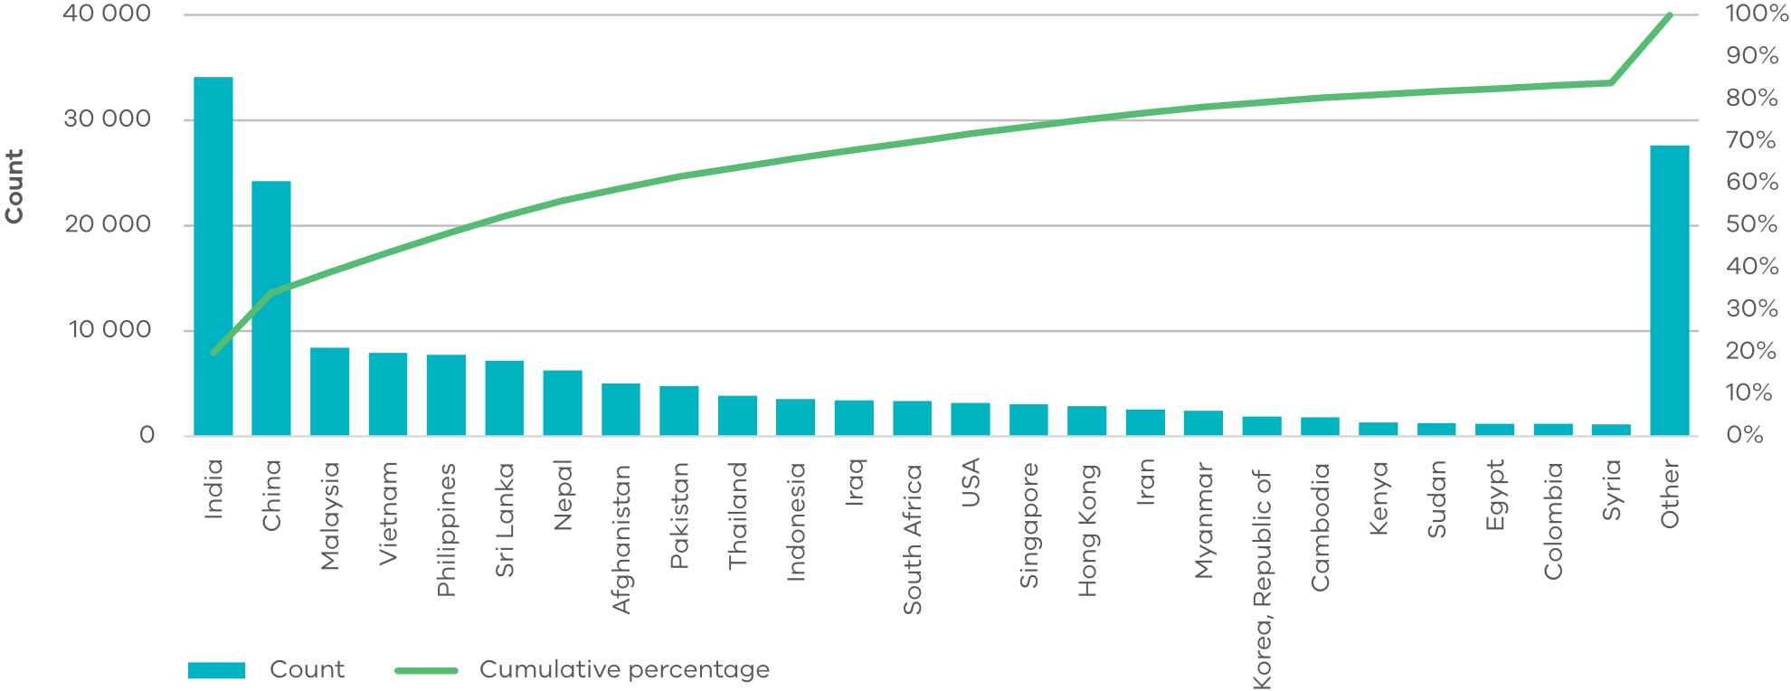

There is similar diversity in the range of languages spoken.

In the Census, young multicultural Victorians report 146 languages used at home (of a possible 218 non-Indigenous languages), with 17 per cent reporting English (figure 5). The next most common were Mandarin (16 per cent) and Punjabi (7 per cent), which are consistent with the reported birth places. 79 511 people (47 per cent) reported using one of the top 10 non-English languages at home. An additional 38 158 young people born in Victoria also report using those languages at home.

In contrast, in VSIIDR using a slightly different measure of preferred language, young people reported 214 preferred languages, with English recorded as the preferred language for 55 per cent (figure 6). Seven languages account for 15 per cent of preferred language, and the remaining 207 languages comprise 30 per cent of preferred languages.

It is unclear if these differences reflect the distinct measures, how they are captured (self-reported in the Census or by a service provider in VSIIDR), or the known cohort differences between the two datasets.

Figure 5: Language spoken at home by young multicultural Victorians from Census

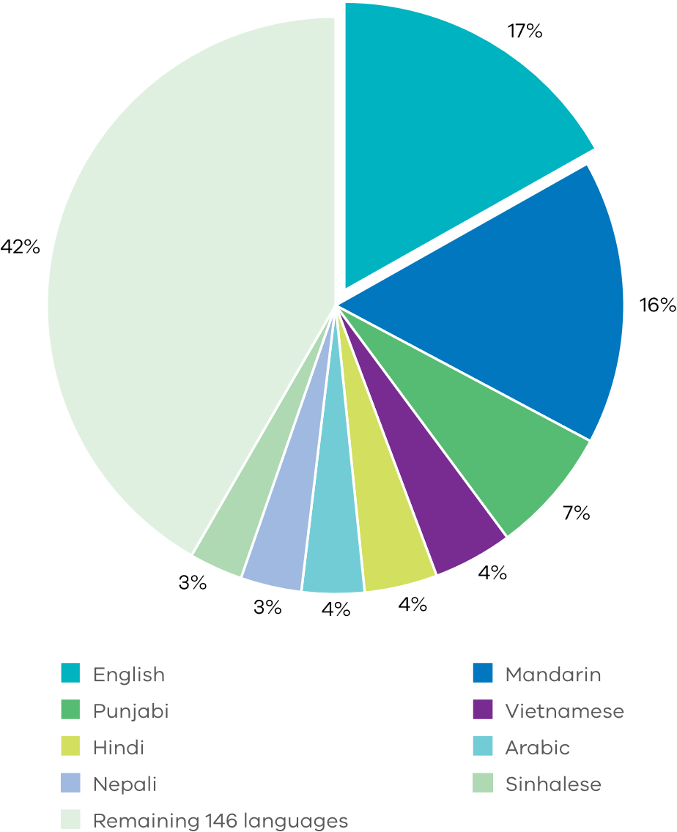

Figure 6: Preferred language of young multicultural Victorians in VSIIDR dataset

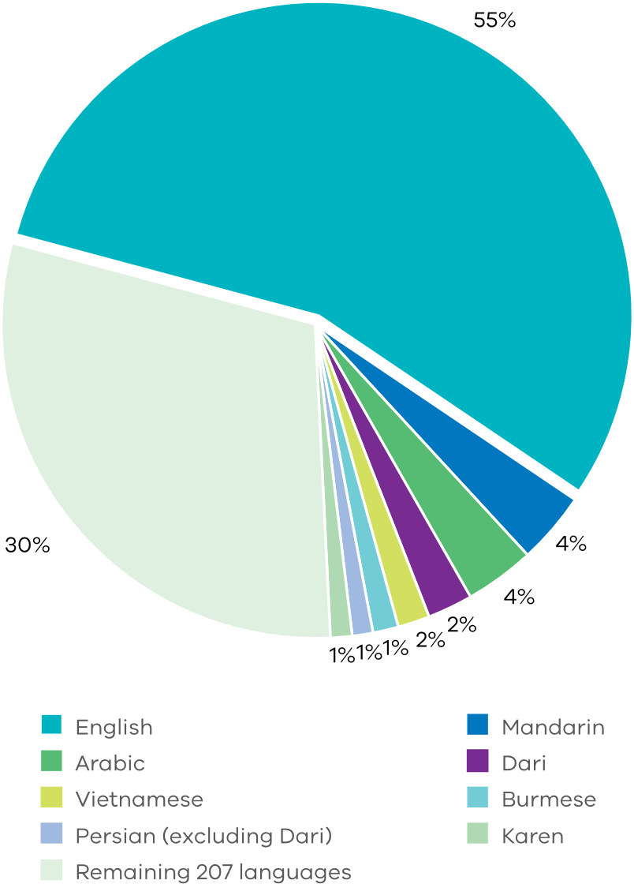

# Young multicultural Victorians living in each LGA

Multicultural youth are concentrated in the Metropolitan Melbourne (93 per cent) (figure 7), and in particular, in central Melbourne and the growth corridors (figure 8). Together, the 10 LGAs with the most multicultural young people account for 64 per cent of all young multicultural Victorians.

Figure 7: Victorian LGAs by total 15–25-year-old multicultural population

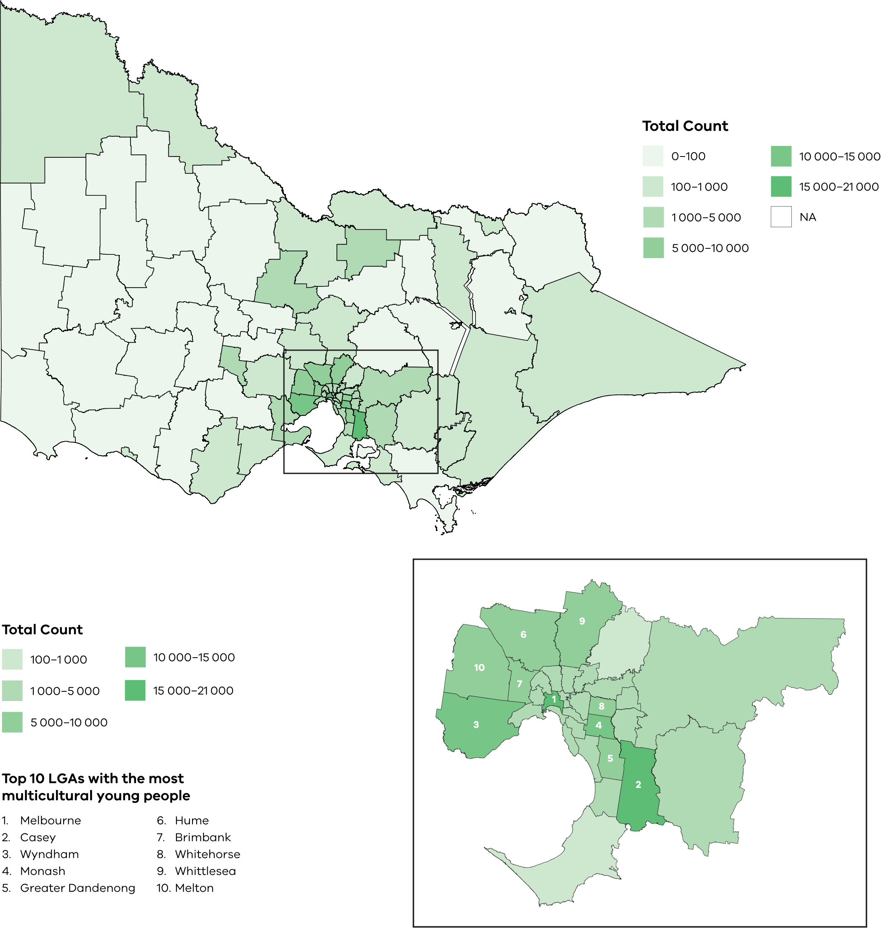

Data from 2021 Census, Australian Bureau of Statistics



Section 3

Young multicultural Victorians at risk of unemployment

# Distribution of young multicultural Victorians at risk of unemployment

This analysis examined the geographic distribution of both unemployed multicultural young people and relative disadvantage, as measured by the 2021 Socio-Economic Indexes for Areas (SEIFA) Index of Relative Socio-Economic Disadvantage (IRSD), to identity areas where multicultural youth are at high risk of unemployment. It found only a small overlap (Greater Dandenong, Brimbank and Hume) between the 10 most disadvantaged LGAs and the 10 LGAs with the largest population of unemployed young multicultural Victorians.

Unemployed young multicultural Victorians, defined in this report as those who reported being unemployed and not studying, were disproportionately located in metropolitan Melbourne, consistent with the distribution of young multicultural Victorians generally.

### Select LGAs with high risk of unemployment for young multicultural Victorians

Eight metropolitan LGAs, listed in figure 8, with both higher counts of unemployed young multicultural Victorians and relative disadvantage were selected for deeper analysis in this report.

Together these LGAs represent 52 per cent of all, and 57 per cent of unemployed young multicultural Victorians.

In the select LGAs, Census data shows young multicultural Victorians represent 35 per cent of the population. This is much higher than the proportion in the VSIIDR dataset (16 per cent), indicating a further deviation between VSIIDR and Census data. As noted earlier in this report, this may reflect that certain migrants, such as international students are underrepresented in the VSIIDR dataset, and that those without a birthplace recorded have been counted in the non-multicultural cohort.

Figure 8: Select LGAs by total 15–25-year-old multicultural population unemployed

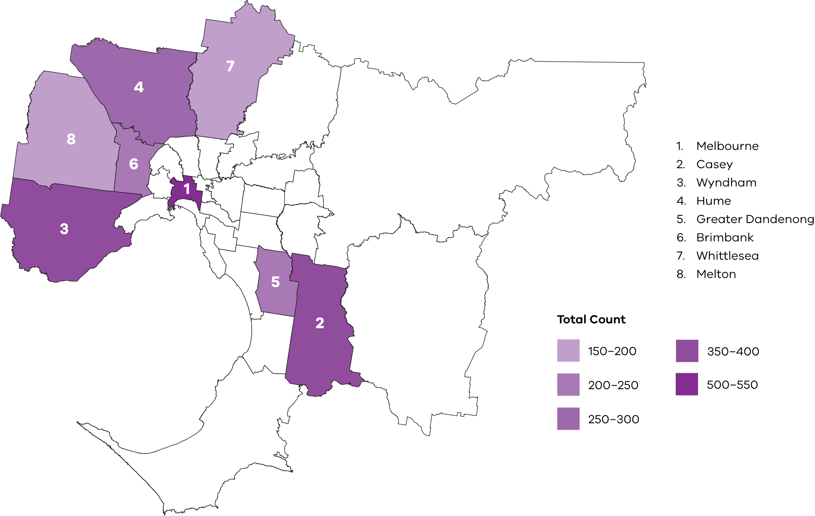

Data from 2021 Census, Australian Bureau of Statistics

# Distribution of young multicultural Victorians at risk of unemployment

In the 2021 Census 14 640 young multicultural Victorians reported being unemployed (i.e. not employed and seeking part- or full-time work).

Of these, 4 ,118 were also not engaged in education.

The select LGAs (table 1) all have a youth unemployment rate greater than the state average. All but one (Greater Dandenong) have a young multicultural unemployment rate above the state average, and in Melbourne, Hume and Victoria generally, young multicultural Victorians are overrepresented amongst the unemployed.

This highlights the varied experience across the select LGAs and the higher levels of unemployment of both multicultural and non‑multicultural young people in these areas.

Table 1: Number of young multicultural Victorians and unemployment rates in select LGAs

|  |  |  |  |  |
| --- | --- | --- | --- | --- |
| Local government area | Young multicultural non-student unemployed Victorians | Young multicultural non‑student Victorians total1 | Youth unemployment rate2 (high to low) | Young multicultural Victorians unemployment rate3 |
| Hume | 267 | 2 906 | 12.3% | 13.0% |
| Wyndham | 371 | 4 096 | 12.0% | 11.4% |
| Brimbank | 223 | 2 727 | 11.6% | 10.6% |
| Greater Dandenong | 248 | 3 474 | 11.2% | 9.3% |
| Melton | 158 | 1 756 | 11.2% | 11.5% |
| Whittlesea | 178 | 1 984 | 10.3% | 10.2% |
| Casey | 371 | 4 820 | 9.7% | 9.9% |
| Melbourne | 524 | 5 518 | 9.0% | 10.9% |
| Victoria | 4 118 | 51 946 | 8.6% | 9.7% |

Data from 2021 Census, Australian Bureau of Statistics

1 Young multicultural non-student Victorians = total number of young multicultural Victorian non-students aged 15-25 in LGA

2 Youth unemployment rate = number of unemployed non-students aged 15-25/number of non-students aged 15-25 in the labour force

3 Young multicultural Victorian unemployment rate = number of unemployed young multicultural Victorian non-students aged 15-25/number of young multicultural Victorian non-students aged 15-25 in the labour force.

People who did not report their employment status in the Census data are excluded from the analysis.

# Young people’s engagement in education and employment

Across Victoria young multicultural Victorians were approximately 10 per cent more likely to be in some form of study and less likely to be working and not studying compared with other Victorians (columns 1 and 2 versus 3 and 4 of figure 9).

In the eight select LGAs, young multicultural Victorians had similar study, work and unemployment patterns to their peers across the state (column 1 versus 2).

However, the difference between multicultural and non-multicultural young Victorians was greater within the select LGAs (column 1 versus 3), than for the state as a whole (column 2 versus 4). This was primarily because non-multicultural people in these LGAs are relatively less likely to be studying, and more likely to be working or unemployed, than their counterparts across the state.

The lower unemployment in the multicultural population in the select LGAs (column 1 versus 3) indicates that the multicultural population is differently affected by socio-economic disadvantage in those areas. The high proportion of international students and skilled migrants (some on sponsored visas) in the dataset may contribute to the higher rates of studying and lower unemployment rates among the young multicultural population.

Figure 9: Employment and Education Status

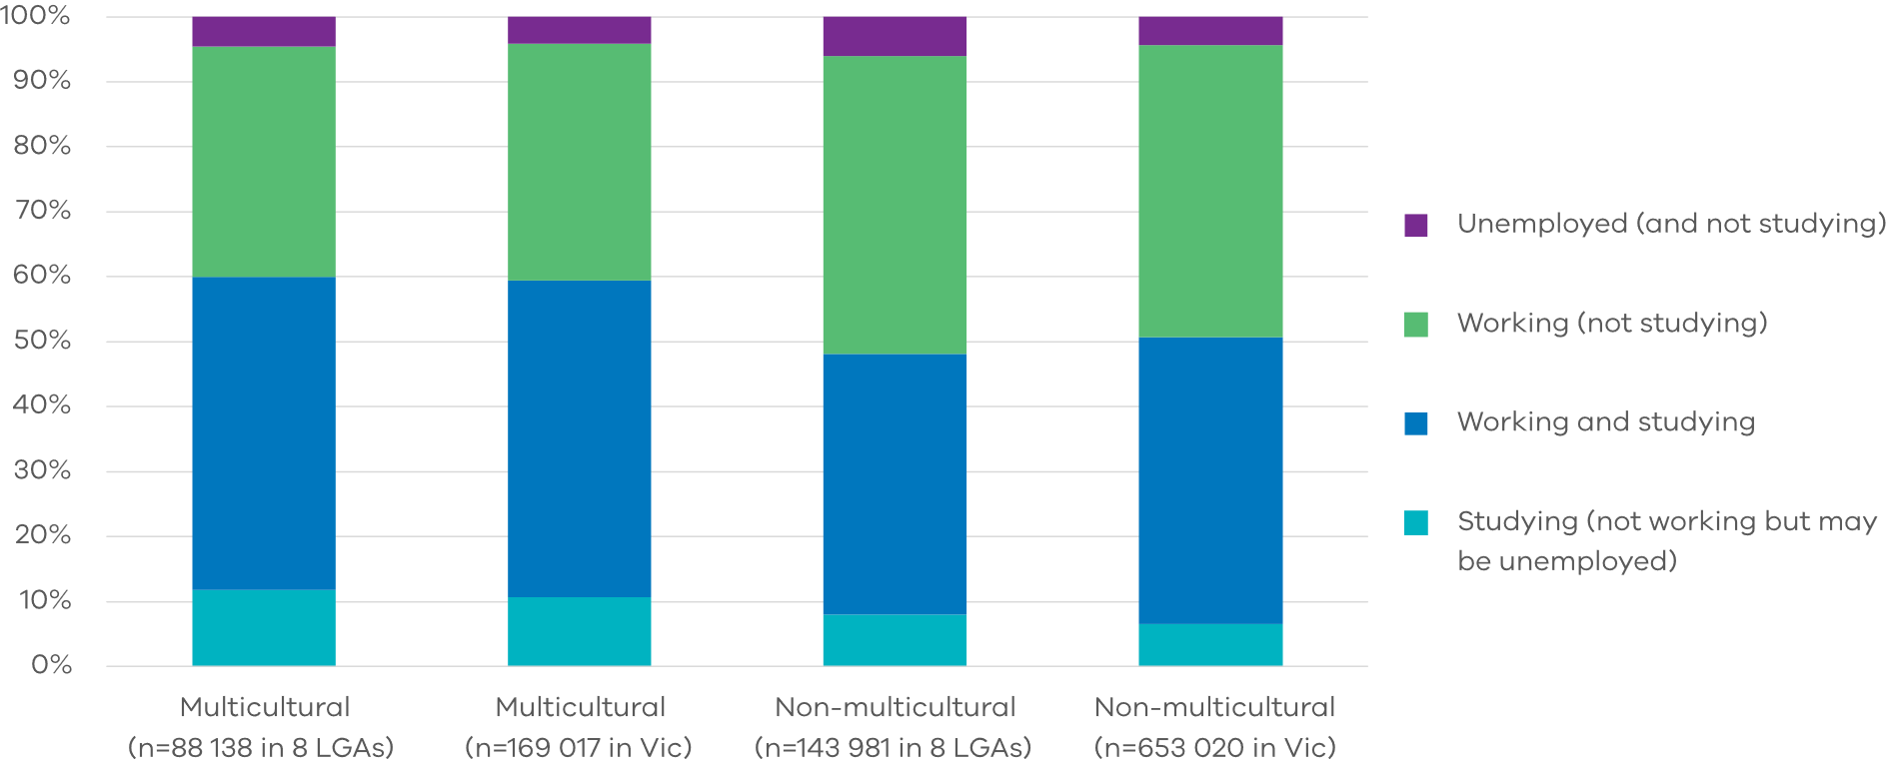

# Young people’s engagement in education

### Highest level of educational attainment for 25-year-olds

By the age of 25, multicultural Victorians were more likely to have bachelor and postgraduate level qualifications, and non-multicultural Victorians were more likely to have secondary and certificate level education (figure 10). This may reflect the older age distribution of young multicultural Victorians and the presence of international students and skilled migrants with relatively higher levels of education than the non-multicultural population.

### School enrolment for 15‑17‑year‑olds

The share of 15-17-year-olds not recorded as being in secondary or tertiary education (including VET) was 4.6 per cent for multicultural Victorians and 6.4 per cent for non-multicultural Victorians.

The literature review highlighted that not completing Year 12 is associated with lower incomes and increased unemployment. At the aggregate level, there is a higher share of early school leavers among non-multicultural young Victorians.

It also highlighted that humanitarian migrants who completed secondary and tertiary education prior to immigration also experienced increased unemployment after two years, compared to humanitarian migrants who never attended school.

Figure 10: Highest level of educational attainment for 25-year-olds in Victoria

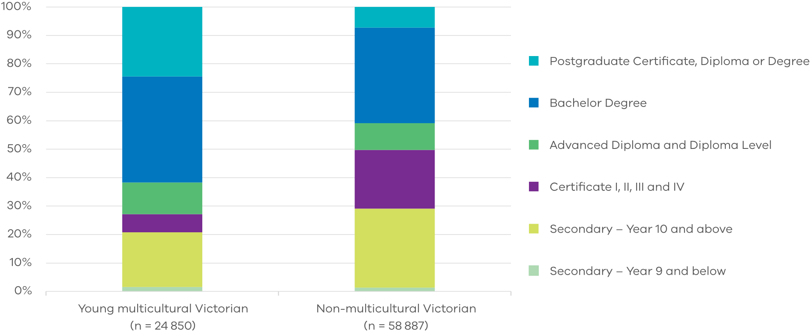



Section 4

Service interactions for young people in select LGAs

# Service usage trends for select LGAs – methodology and considerations

In the remainder of this report VSIIDR data was used to explore interactions with state government services in 2022. Service interactions of all young people in Victoria has been set as a baseline and compared against:

* young multicultural Victorians
* all young Victorians in living in select LGAs (including multicultural and non-multicultural Victorians)
* young multicultural Victorians, living in select LGAs.

Youth Justice and adult corrections measures have been aggregated to account for people ageing out of the Youth Justice system. While this loses the nuance of differences between Youth Justice and adult corrections, it is adequate for understanding the intensity of interactions relative to other cohorts aggregated the same way.

## Interpreting the data

This analysis sought to understand how service interactions varied between young multicultural and other Victorians, and between geographical locations. The findings do not imply causality.

There are many interacting factors, including areas with many young multicultural Victorians also experiencing high levels of disadvantage (at least relative to other parts of metropolitan Melbourne).

The following analysis examines use of Victorian government services based on where a person was born and where they lived in 2022. Analysis was conducted based on where the person lived, not where the service was delivered.

Unless otherwise stated, interactions relate to young people 15-25 years old. Note that scale is different on the Melbourne and Brimbank charts to show the very high service interactions.

The analysis does not include data on employment, tertiary education and migration status, as this is not systematically captured in the VSIIDR dataset.

Care must be taken in interpreting the results, as some multicultural Victorians were too old to access certain service systems when they migrated to Australia. For example, the average age for a first child protection report is 7 years old, yet 92 per cent of multicultural Victorians who were 15-25 years old in 2022 were not captured in VSIIDR as 7-year-olds (figure 3).

Table 2: Example of indexing using acute clinical mental health care in the Melbourne LGA

|  |  |  |  |  |
| --- | --- | --- | --- | --- |
|  | 15–25-year-olds: all | 15–25-year-olds: multicultural young people Victoria | 15–25-year-olds: all Melbourne LGA | 15–25-year-olds: multicultural young people Melbourne LGA |
| Average nights in acute clinical mental health care | 0.097 | 0.148 | 0.726 | 1.757 |
| Index | 1 | 1.5 | 7.5 | 18.1 |

# Service interactions for young people living in select LGAs

Across the eight select LGAs, the VSIIDR dataset includes 65 147 15–25-year-olds who interacted with a government funded service, of which 10 477 (16 per cent) were born overseas.

Figure 11 shows interactions with universal services applicable to all ages, and figure 12 shows the interactions for services specific to children. Key insights show that:

* Across the state, young multicultural Victorians have similar service interactions to the total 15-25-year-old population (dashed teal relative to solid teal line). Given that a significant proportion of this group holds skilled migrant or student visas, where pre-requisites include health1 and character2 tests, generally low levels of interaction across health and justice seem reasonable. The largest deviations are in nights spent in family violence accommodation (around double), and child protection reports made, nights in out of home care and school absences (less than half)
* Young multicultural Victorians in the select LGAs have a similar pattern of service use relative to all young multicultural Victorians, but the magnitude is much greater across all services (dashed blue relative to dashed teal line)
* Young multicultural Victorians in the select LGAs relative to all young people in the select LGAs have (dashed blue relative to solid blue):
  + more interactions with clinical mental health services (slightly higher proportion of people, more intense service use), nights in homelessness (slightly higher proportion of people, similar intensity of service use) and family violence accommodation (slightly higher proportion of people, slightly more intense service use), and interactions with Youth Justice and adult corrections (higher proportion of people, slightly more intense service interactions)
  + about the same number of interactions with alcohol and other drug services and emergency department presentations
  + less interactions with child specific services including child protection reports made (much lower proportion of children, expected as many will have arrived as older children and adolescents), nights in out of home care (lower proportion of children similar to child protection, and less intense service use) and school absences (lower proportion of children, and fewer absences).

Figure 11: Eight LGAs and Victoria: service interactions for 15-25-year-olds in 2022

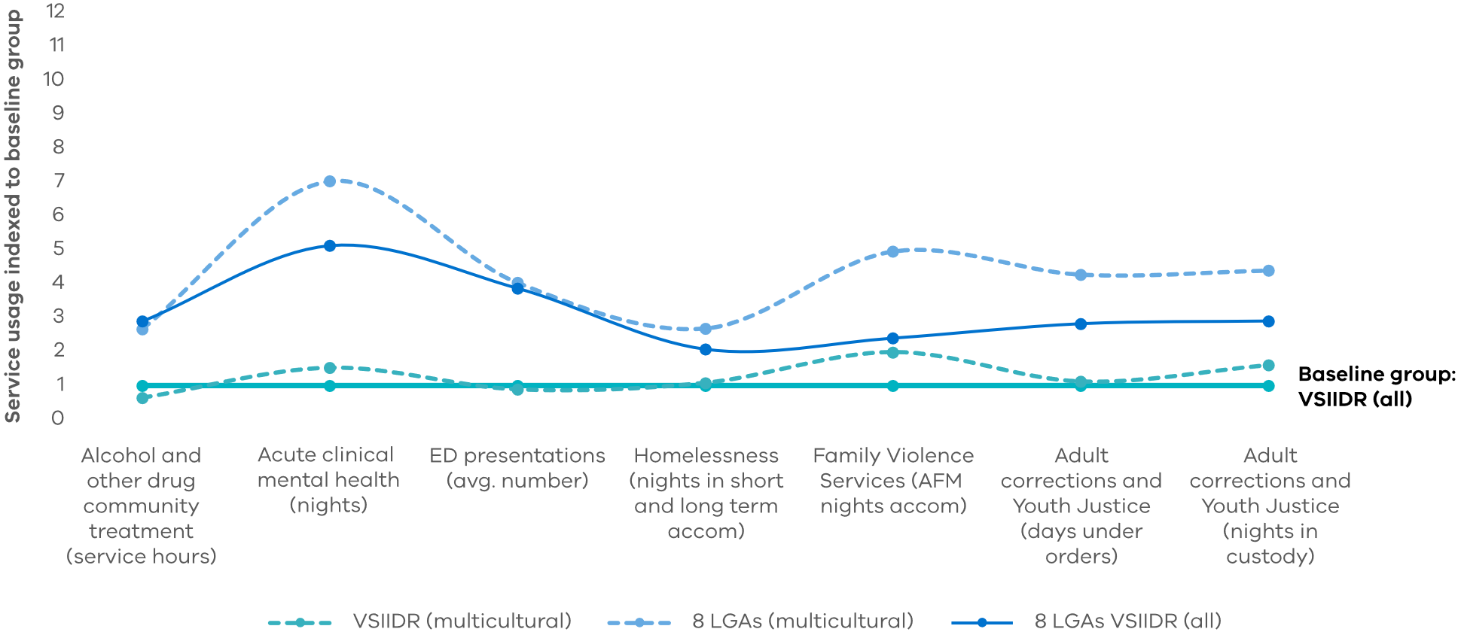

Figure 12: Eight LGAs and Victoria: service interactions for 15-17-year-olds in 2022

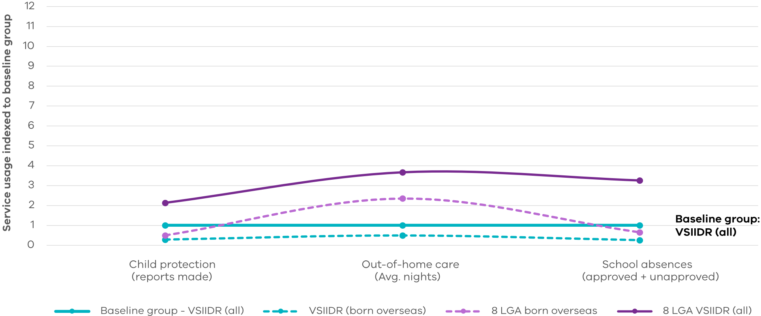

1 https://immi.homeaffairs.gov.au/help-support/meeting-our-requirements/health

2 https://immi.homeaffairs.gov.au/help-support/meeting-our-requirements/character

# Insights by service type for the select LGAs

Across the select LGAs average service use varies by service type. The LGAs with the highest service use, relative to the all 15–25-year-olds in Victoria reference group, were:

* Mental health: Melbourne, Greater Dandenong, Casey and Brimbank
* Youth Justice and adult corrections: Brimbank and Wyndham
* Family violence: Melbourne, Wyndham, Brimbank and Whittlesea
* Alcohol and drug treatment: Melton

Key trends for each service type:

* Acute clinical mental health:Young multicultural people living in Melbourne, Brimbank, Whittlesea, Greater Dandenong and Casey had much higher average service use than others in their LGA. Those living in Wyndham had about the same service use, and those living in Hume had lower service use than other young people in their LGA
* Alcohol and other drug treatment:In most LGAs multicultural Victorians had similar or less interactions with alcohol and drug treatment than other young people in the LGA. In Melton, multicultural Victorians had twice as many interactions
* Youth Justice and Correction days under orders and nights in custody:Young multicultural people living in Brimbank and Wyndham had more interactions than other young people in their LGA. Those living in Casey had about the same as other young people in their LGA. Those living in Melbourne, Melton, Whittlesea and Greater Dandenong had more days under corrective orders and less nights in custody
* Homelessness accommodation:Young multicultural people living in Melbourne, Hume, Wyndham, Melton and Whittlesea spent more nights in homeless accommodation than other young people in their LGA. Those in Brimbank had about the same, and in Greater Dandenong and Casey they had fewer nights in homeless accommodation
* Family Violence accommodation for affected family member:Young multicultural people living in Melbourne, Hume and Wyndham, Brimbank, Melton and Whittlesea spent more nights in homeless accommodation than other young people in their LGA. Those in Greater Dandenong and Casey had fewer nights in family violence accommodation.
* Education:As noted earlier, based on Census data (noting the larger and older cohort) young multicultural Victorians wherever they lived were more likely to be studying and less likely to be working, and young multicultural Victorians in select LGAs appear more like young multicultural Victorians across the state, rather than other young people in their LGAs.

In contrast, based on VSDIIR data young multicultural Victorians living in select LGAs interact with government services at much higher rates than young multicultural Victorians across Victoria. This data indicates both a ‘place-based’ and a ‘multicultural’ influence.

Service interactions are displayed separately for each LGA on the next pages.

# Service interactions for each LGA

### Melbourne

The VSIIDR dataset includes 3 398 15–25-year-olds living in Melbourne who interacted with a government service, of which 596 (18 per cent) were born overseas.

When compared with all 15–25-year-olds living in Melbourne, multicultural Victorians generally had more interactions with clinical mental health, family violence accommodation for the affected family member, and homelessness accommodation. Days spent under corrective orders were similar and nights in custody were lower (figure 13).

### Brimbank

The VSIIDR dataset includes 5 902 15–25-year-olds living in Brimbank who interacted with a government service, of which 829 (14 per cent) were born overseas.

Multicultural Victorians living in Brimbank had roughly 14 times as many nights in family violence accommodation as the affected family member, and nights in custody, and around three times as many as the broader Brimbank youth population. They also had higher alcohol and other drug and acute mental health treatment interactions (figure 14).

Figure 13: Melbourne LGA and Victoria: service interactions for 15-25-year-olds in 2022

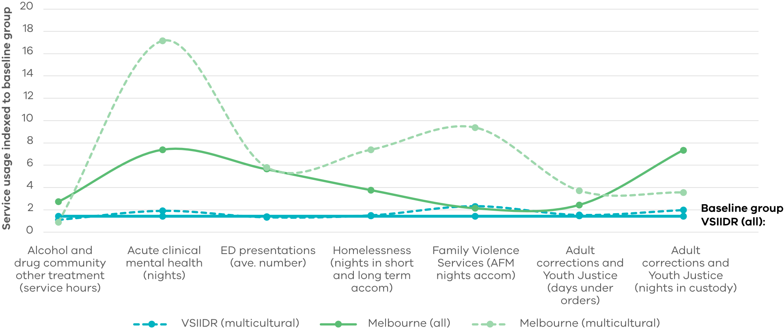

Figure 14: Brimbank LGA and Victoria: service interactions for 15-25-year-olds in 2022

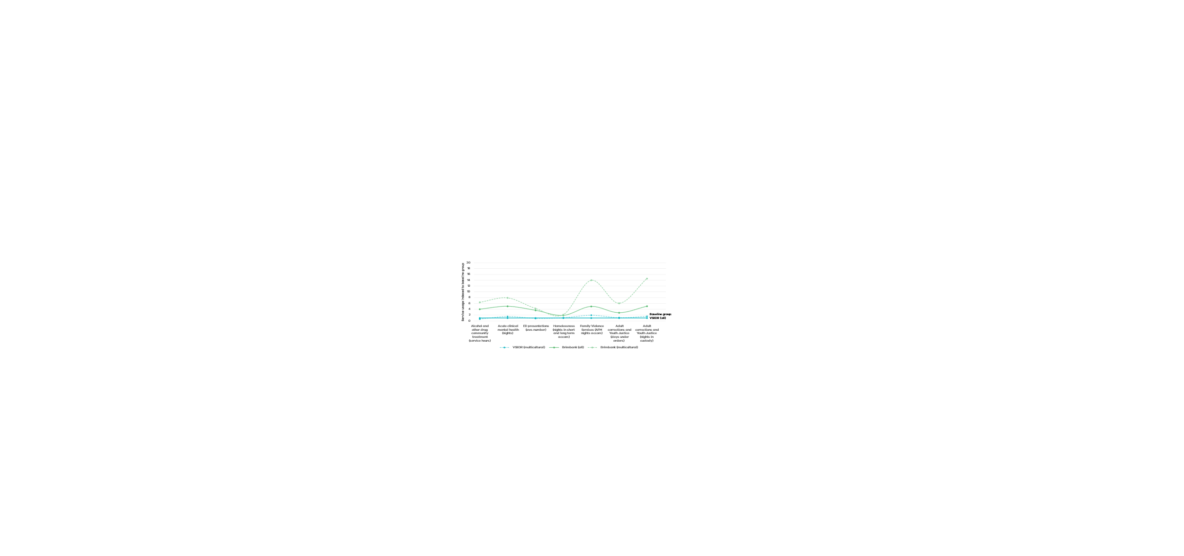

### Hume

The VSIIDR dataset includes 11 766 15–25-year-olds living in Hume who interacted with a government service, of which 1 926 (16 per cent) were born overseas.

Multicultural Victorians living in Hume had a service interaction pattern reflective of the larger multicultural population, but in most cases amplified to more closely match the Hume (all) population.

The major deviations were the higher number of nights in family violence accommodation as the affected family member and nights in custody (figure 15).

### Wyndham

The VSIIDR dataset includes 9 720 15–25-year-olds living in Wyndham who interacted with a government service, of which 1 568 (16 per cent) were born overseas.

Similar to Hume, the profile of service use reflected the larger multicultural population, but amplified, in this case to significantly more interactions with family violence as the affected family member, nights in custody and days under orders (figure 16).

Figure 15: Hume LGA and Victoria: service interactions for 15-25-year-olds in 2022

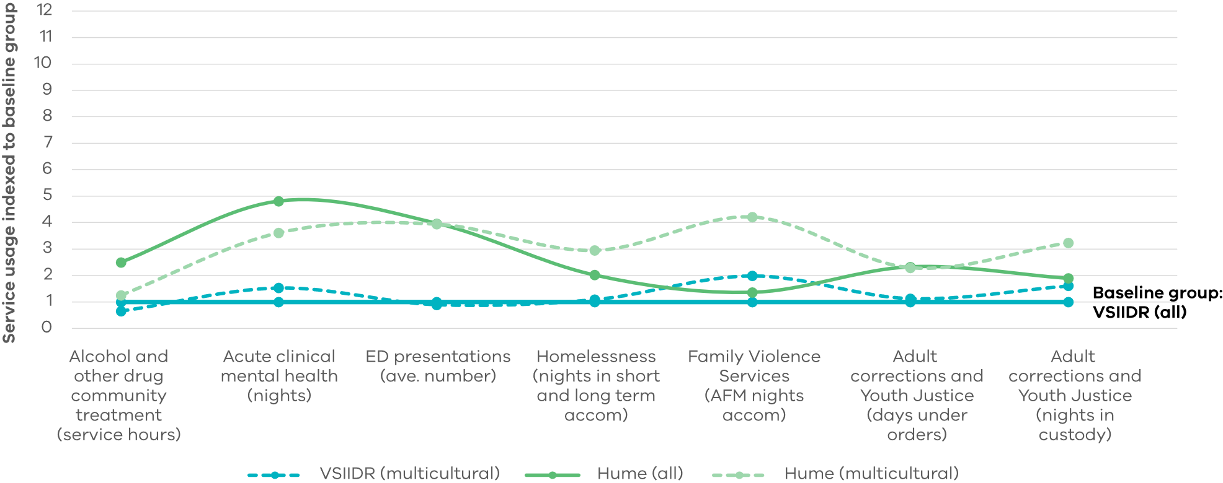

Figure 16: Wyndham and Victoria: service interactions for 15-25-year-olds in 2022

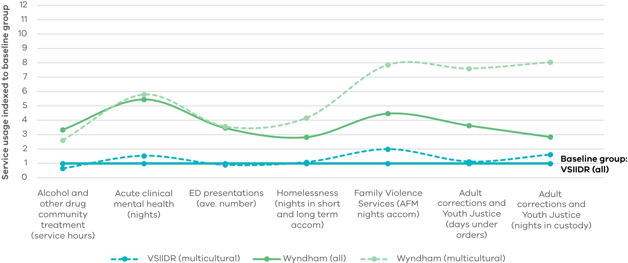

### Melton

The VSIIDR dataset includes 6 947 15–25-year-olds living in Melton who interacted with a government service, of which 857 (12%) were born overseas.

Young multicultural Victorians living in Melton had a service use pattern most different to all the other LGAs under consideration, with high alcohol and other drug treatment and low acute clinical mental health and family violence. This may reflect the services accessible to the people in Melton rather than the need (figure 17).

### Whittlesea

The VSIIDR dataset includes 14 101 15–25-year-olds living in Whittlesea who interacted with a government service, of which 1 063 (12%) were born overseas.

In contrast to those in Melton, young multicultural Victorians living in Whittlesea use more acute clinical mental health care and family violence accommodation than their peers in the LGA (figure 18).

Figure 17: Melton LGA and Victoria: service interactions for 15-25-year-olds in 2022

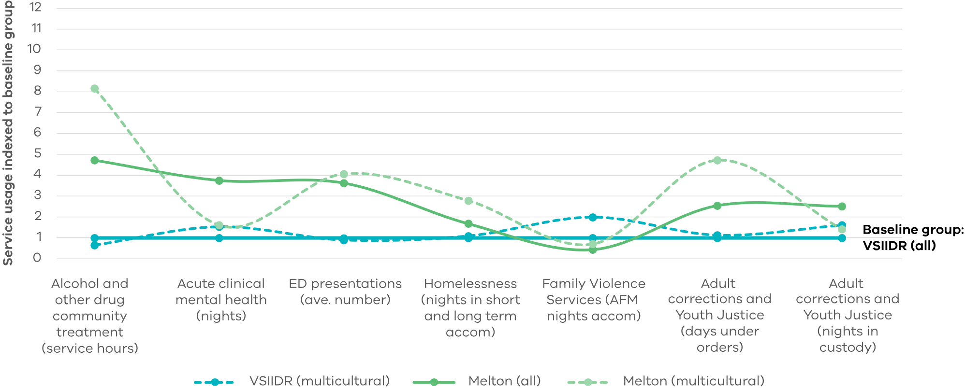

Figure 18: Whittlesea LGA and Victoria: service interactions for 15-25-year-olds in 2022

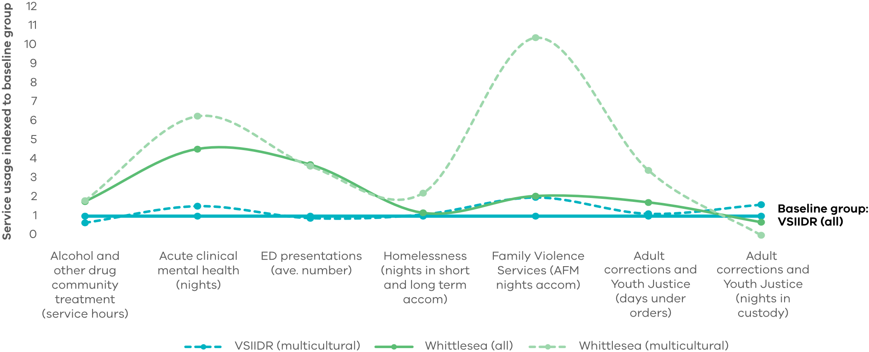

### Greater Dandenong

The VSIIDR dataset includes 4 465 15‑25‑year‑olds living in Greater Dandenong who interacted with a government service, of which 1 176 (26%) were born overseas.

Compared to the total multicultural population of 15–25-year-olds, those living in Greater Dandenong have more interactions with government services except for family violence accommodation for the affected family member. However, when compared with all 15–25-year-olds living in Greater Dandenong, multicultural Victorians generally had lower use of government services, with the exceptions being justice and clinical mental health services (figure 19).

### Casey

The VSIIDR dataset includes 14 101 15‑25‑year‑olds living in Casey who interacted with a government service, of which 2 462 (18%) were born overseas.

Young multicultural Victorians living in Casey have service interactions which reflect the broader multicultural community (out-of-home care, homelessness), reflect the broader Casey community (nights in custody and days under order, ED presentations), with acute clinical mental health interactions being particularly high (figure 20).

Figure 19: Greater Dandenong LGA and Victoria: service interactions for 115-25-year-olds in 2022

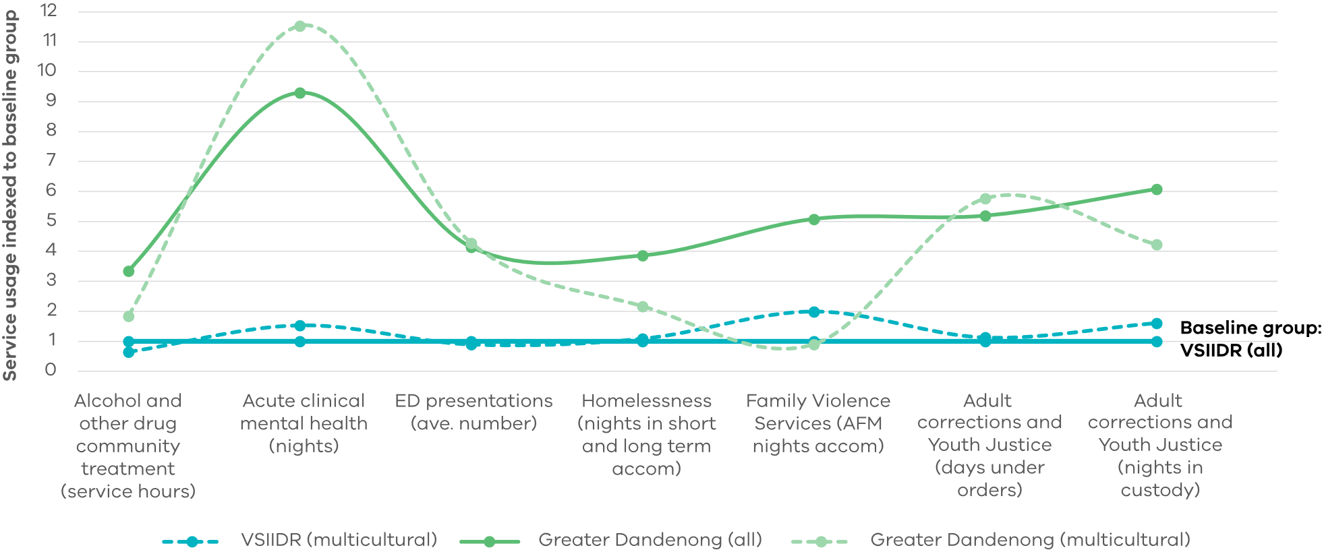

Figure 20: Casey LGA and Victoria: service interactions for 15-25-year-olds in 2022

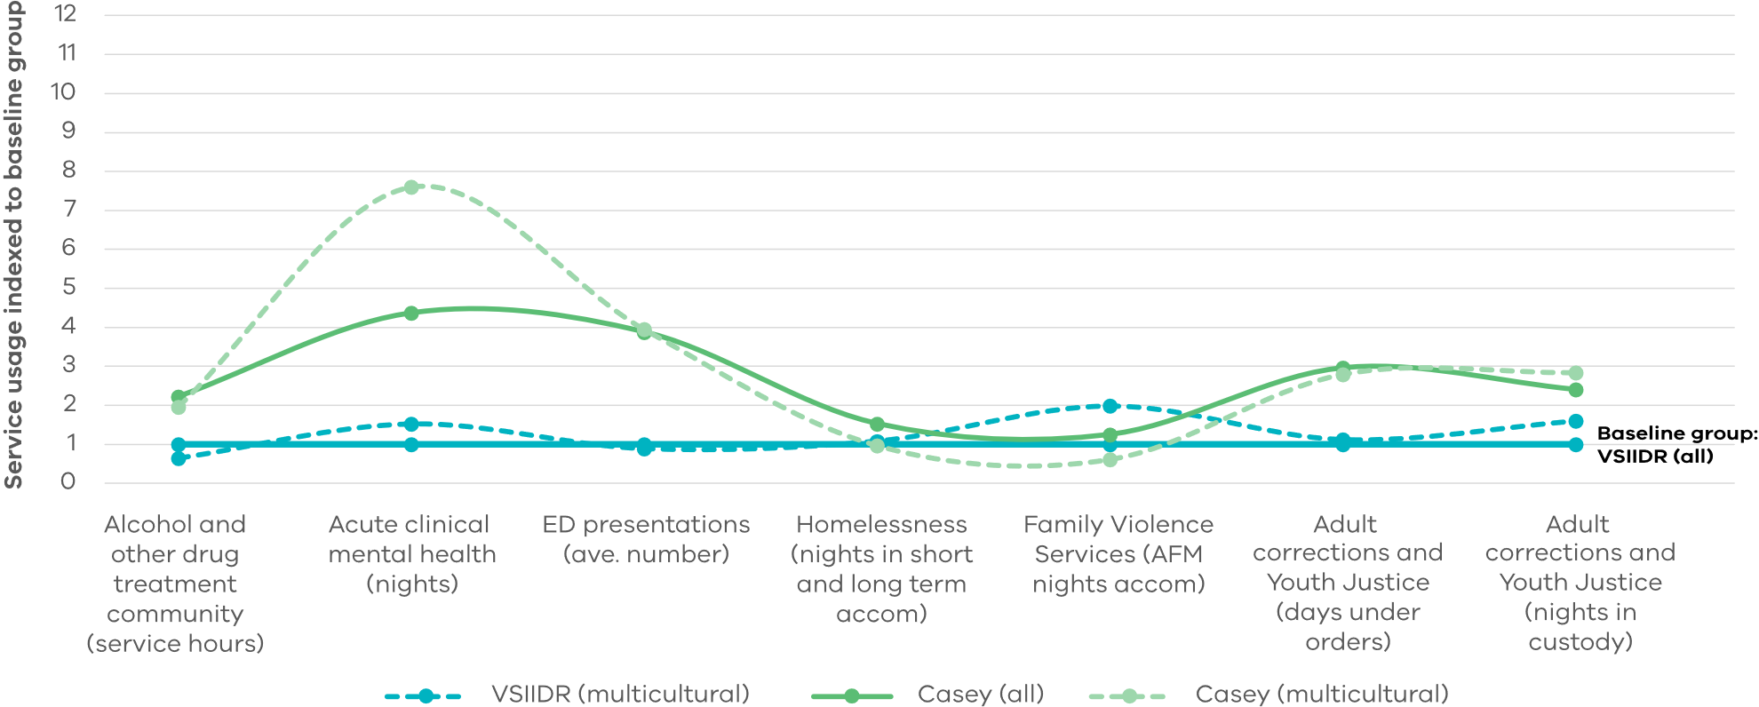

# Data limitations, extensions and possible uses

### Data limitations

This report uses two main datasets, the ABS 2021 Census and VSIIDR and touches on data from the Australian Census and Temporary Entrants Dataset and the Australian Census and Migrants Dataset.

VSIIDR spans Victorian government service interactions in health, human services, education and justice. It does not include data on areas of Commonwealth responsibility, the key ones in this instance being employment, tertiary education and migration data (date of arrival and visa status).

While each dataset has been individually useful to the analysis, state and Commonwealth data are not linked, preventing fully comprehensive insights.

Counting average service in VSIIDR use allows for comparison between cohorts. However, recorded service interactions capture services delivered, not the need for services (which may not be met due to supply constraints).

There are noteworthy differences between the Census and VSIIDR data, including:

* The number and age breakdown of the 15‑25-year-old multicultural Victorians differs, indicating that over a third of the 21–25-year-olds in the Census data have not had a service interaction to appear in the VSIIDR data. If these people were in VSIIDR but contributing no interactions, average service for the multicultural Victorians would be lower.
* The temporal difference between the datasets (VSIIDR data 2022 calendar year and Census data August 2021).
* VSIIDR has more non-multicultural Victorians (approx. 940 000) compared with the Census (approx. 660 000). Some of this is likely due to imperfect linking. This could occur for multiple reasons, including a person giving a full name to one service and a preferred name to another service, or an error in data entry. This spreads the same service usage over more people, reducing averages.
* Difference which would be expected in service interactions between those who have been in Victoria since birth, and those who arrived as a child or young adult such as some of the migrants being too old for child protection services.

Service interactions have been indexed relative to a baseline comparator group of all 15-25-year-olds in VSIIDR and compared with multiple cohorts. Indexing has allowed comparison across services measured in different units.

While data was drawn from the latest Census in 2021, and VSIIDR in 2022, insights may already be dated.

Data has not been adjusted to account for the widespread impacts of COVID-19 across various sectors including justice, mental health, employment and school engagement. These likely impacted the need for, and access to, services in 2021 and 2022.

Limitations of ABS Table Builder meant that the number of multicultural Victorians aged 15‑25-years varied between 161 017 and 171 919 when examining different characteristics individually (such as age, country of birth, education and employment).

### Extensions and possible uses

This report may be useful to inform:

* Proposals for future Partnerships Addressing Disadvantage
* New investments through the EIIF
* Future research studies.

Valuable extensions of this work for richer and more nuanced analysis to inform program and policy development would include:

* Expanding the definition of multicultural from born overseas in a non-main English speaking country to include cultural identity and second and subsequent generation Australians
* Considering migration status including visa status and date of arrival in Australia
* Considering employment status
* Using a construct of community other than LGA, to better separate the experience of young multicultural people from their LGA
* Analysing Commonwealth unit record data using Person Level Integrated Data Asset (PLIDA).

# Literature review references

[1] Department of Immigration and Citizenship (2011). A Significant Contribution: the Economic, Social and Civic Contributions of First and Second Generation Humanitarian Entrants - Summary of Findings. Australian Government, Canberra. ISBN: 978-1-921662-05-8, [https://immi.homeaffairs.](https://immi.homeaffairs.gov.au/settlement-services-subsite/files/economic-social-civic-contributions-booklet.pdf) [gov.au/settlement-services-subsite/files/economic-social-](https://immi.homeaffairs.gov.au/settlement-services-subsite/files/economic-social-civic-contributions-booklet.pdf) [civic-contributions-booklet.pdf](https://immi.homeaffairs.gov.au/settlement-services-subsite/files/economic-social-civic-contributions-booklet.pdf)

[2] Cheng, Z., Wang, B.Z. & Taksa, L. (2021) Labour Force Participation and Employment of Humanitarian Migrants: Evidence from the Building a New Life in Australia Longitudinal Data. J Bus Ethics 168, 697–720 (2021). [https://doi.org/10.1007/](https://link.springer.com/article/10.1007/s10551-019-04179-8) [s10551-019-04179-8](https://link.springer.com/article/10.1007/s10551-019-04179-8)

[3] Centre for Multicultural Youth (2014). Making it work: Refugee Young People and Employment. CMY: Melbourne, [https://www.cmy.net.au/resource/making-it-work-refugee-](https://www.cmy.net.au/resource/making-it-work-refugee-young-people-employment/) [young-people-employment/](https://www.cmy.net.au/resource/making-it-work-refugee-young-people-employment/)

[4] Australian Bureau of Statistics. (2024). Migrant settlement outcomes. ABS. [https://www.abs.gov.au/statistics/people/](https://www.abs.gov.au/statistics/people/people-and-communities/migrant-settlement-outcomes/latest-release) [people-and-communities/migrant-settlement-outcomes/](https://www.abs.gov.au/statistics/people/people-and-communities/migrant-settlement-outcomes/latest-release) [latest-release](https://www.abs.gov.au/statistics/people/people-and-communities/migrant-settlement-outcomes/latest-release)

[5] Australian Bureau of Statistics. (2021). Australian Census and Temporary Entrants Integrated Dataset. ABS. [https://www.](https://www.abs.gov.au/about/data-services/data-integration/integrated-data/australian-census-and-temporary-entrants-integrated-dataset-acteid) [abs.gov.au/about/data-services/data-integration/integrated-](https://www.abs.gov.au/about/data-services/data-integration/integrated-data/australian-census-and-temporary-entrants-integrated-dataset-acteid) [data/australian-census-and-temporary-entrants-integrated-](https://www.abs.gov.au/about/data-services/data-integration/integrated-data/australian-census-and-temporary-entrants-integrated-dataset-acteid) [dataset-acteid](https://www.abs.gov.au/about/data-services/data-integration/integrated-data/australian-census-and-temporary-entrants-integrated-dataset-acteid)

[7] Australian Bureau of Statistics. (2021). Australian Census and Migrants Integrated Dataset. ABS. [https://www.abs.gov.au/](https://www.abs.gov.au/about/data-services/data-integration/integrated-data/australian-census-and-migrants-integrated-dataset-acmid) [about/data-services/data-integration/integrated-data/](https://www.abs.gov.au/about/data-services/data-integration/integrated-data/australian-census-and-migrants-integrated-dataset-acmid) [australian-census-and-migrants-integrated-dataset-acmid](https://www.abs.gov.au/about/data-services/data-integration/integrated-data/australian-census-and-migrants-integrated-dataset-acmid)

[7] Ziaian, T., Puvimanasinghe, T., Miller, E., de Anstiss, H., Esterman, A., Dollard, M., & Afsharian, A. (2021). Family influence on refugee youth education and employment aspirations and choices. Journal of Family Studies, 29(1), 115–133. [https://doi.org/1](https://doi.org/10.1080/13229400.2021.1879898) [0.1080/13229400.2021.1879898](https://doi.org/10.1080/13229400.2021.1879898)

[8] Federation of Ethnic Communities’ Councils of Australia (undated) Community perspectives on settlement issues affecting new and emerging communities in rural and regional Australia: a case study of the Iraqi, Afgan, Congolese and Sudanese communities in Shepparton, Victoria. FECCA, Canberra, [https://fecca.org.au/wp-content/uploads/2015/06/](https://fecca.org.au/wp-content/uploads/2015/06/FECCA-Rural-and-Regional-report-June-2015-00000002.pdf) [FECCA-Rural-and-Regional-report-June-2015-00000002.pdf](https://fecca.org.au/wp-content/uploads/2015/06/FECCA-Rural-and-Regional-report-June-2015-00000002.pdf)

[9] Centre for International Research on Education Systems (2015). Educational opportunity in Australia 2015: Senior school years, school completion uneven across Australia, Mitchell Institute Victoria University, Melbourne, [https://www.vu.edu.au/](https://www.vu.edu.au/mitchell-institute/educational-opportunity/senior-school-years-school-completion-uneven-across-australia) [mitchell-institute/educational-opportunity/senior-school-](https://www.vu.edu.au/mitchell-institute/educational-opportunity/senior-school-years-school-completion-uneven-across-australia) [years-school-completion-uneven-across-australia](https://www.vu.edu.au/mitchell-institute/educational-opportunity/senior-school-years-school-completion-uneven-across-australia)

[10] Van Kooy, J and Butler, C. (2021). Disrupted CALD Youth Employment Transitions: A Mixed-Methods Study. AMES Australia Research & Policy Unit, NSW, van_KooyButler- Disrupted_CALD_youth_employment_transitions-a_mixed- methods_study.pdf (wildapricot.com).

[11] Department of Justice and Community Safety (2020). Youth Justice Strategic Plan 2020-2030, Victorian Government, Melbourne, [https://files.justice.vic.gov.au/2021-06/Youth%20](https://files.justice.vic.gov.au/2021-06/Youth%20Justice%20Strategic%20Plan_0.pdf) [Justice%20Strategic%20Plan_0.pdf](https://files.justice.vic.gov.au/2021-06/Youth%20Justice%20Strategic%20Plan_0.pdf). ISBN 978-1-922262-25-7

[12] Nolte-Troha C, Roser P, Henkel D, Scherbaum N, Koller G, Franke AG. (2023). Unemployment and Substance Use: An Updated Review of Studies from North America and Europe. Healthcare (Basel). 2023;11(8):1182. Published 2023 Apr 20. [doi: 10.3390/healthcare11081182](https://www.mdpi.com/2227-9032/11/8/1182)

[13] Edwards B, Smart D, De Maio J, Silbert M, Jenkinson R. (2018). Cohort Profile: Building a New Life in Australia (BNLA): the longitudinal study of humanitarian migrants. International Journal of Epidemiology. 2018, 20-20h, [doi: 10.1093/ije/dyx218](https://academic.oup.com/ije/article/47/1/20/4582318)

The authors acknowledge the Victorian Government Library Service for their assistance in the literature search.



dtf.vic.gov.au