CLIENT PATHWAYS REPORT 2

Government service interactions before and after first accessing alcohol and other drug treatment in 2019

Experience of young people accessing alcohol and other drug treatment in Victoria

ACKNOWLEDGEMENT   
OF COUNTRY

The Victorian Department of Treasury and Finance acknowledges that Aboriginal and Torres Strait Islander peoples are the First Peoples and Traditional Custodians of Australia, and the oldest continuing culture in human history. We proudly acknowledge Victoria’s Aboriginal communities and recognise the value and ongoing contribution of Aboriginal people and communities to Victorian life. We pay our respect to Elders past and present and emerging.

As we work to ensure Victorian Aboriginal communities continue to thrive, the Government acknowledges the invaluable contributions of generations that have come before us, who have fought tirelessly for the rights of their people and communities towards self-determination. We reflect on the continuing impact of government policies and practices and recognise our responsibility to work together with and for Aboriginal and Torres Strait Islander peoples towards improved cultural, social and economic outcomes through the Early Intervention Investment Framework.

Aboriginal artwork ‘lim-ba nindee thana warn-ga-ilee’ (Preserve our Dreaming Lore) – Gunnai Language


‘lim-ba nindee thana warn-ga-ilee’   
(Preserve our Dreaming Lore) – Gunnai Language

Bitja (Dixon Patten Jnr) Yorta Yorta, Gunnai,   
Gunditjmara and Dhudhuroa of Bayila Creative

Department of Treasury and Finance   
1 Treasury Place  
Melbourne, Victoria, 3002 Australia

Telephone: +61 3 9651 5111   
dtf.vic.gov.au

Authorised by the Victorian Government   
1 Treasury Place, Melbourne, 3002

© State of Victoria 2024



You are free to re-use this work under a Creative Commons Attribution 4.0 licence, provided you credit the State of Victoria (Department of Treasury and Finance) as author, indicate if changes were made and comply with the other licence terms. The licence does not apply to any branding, including Government logos.

Copyright queries may be directed to [information@dtf.vic.gov.au](mailto:information@dtf.vic.gov.au)

ISBN 978-1-923295-01-8

Published December 2024

If you would like to receive this publication in an accessible format please email [information@dtf.vic.gov.au](mailto:information@dtf.vic.gov.au)

This document is available in PDF format at dtf.vic.gov.au

Section 1

Preamble

Executive summary and findings from the literature review

# Context for the second Client Pathway report

This is the second in a series of Client Pathways reports. Each report focuses on selected cohorts to inform future policy and program design, particularly relating to the Victorian Government’s Partnerships Addressing Disadvantage and Early Intervention Investment Framework (EIIF) programs.

Client Pathways was agreed as part of the *2023-24 Budget* to identify specific service system needs and improve effectiveness of early intervention. Further information about the Client Pathways project is available on the EIIF website: [dtf.vic.gov.au/funds-programs-and-policies/early-](https://www.dtf.vic.gov.au/early-intervention-investment-framework/client-pathways-reports) [intervention-investment-framework](https://www.dtf.vic.gov.au/early-intervention-investment-framework/client-pathways-reports)/client- pathways-reports. If you would like to get in touch regarding this report or the Client Pathways project, please contact [earlyintervention@dtf.vic.gov.au](mailto:earlyintervention@dtf.vic.gov.au)

## Introduction

This report investigates the acute service usage of young people seeking alcohol and other drug (AOD) support and treatment with co-occurring needs. It uses data from the Victorian Social Investment Integrated Data Resource (VSIIDR). VSIIDR comprises linked administrative data, capturing how Victorians use selected government health, human services, education and justice services. Linked administrative data can be used to examine generalised and de-identified client pathways through service systems to inform practical decisions about service and policy design.

It does not include data on Commonwealth funded services such as the National Disability Insurance Scheme supports, primary care, headspace (mental health support including AOD) or some services for young Aboriginal Victorians such as Bunjilwarra (a 20-bed residential AOD service).

It also does not capture data where brief interventions are conducted at anonymous services like needle exchanges or any AOD services delivered in corrections facilities.

The report focuses on service usage for a cohort of young people who used AOD services for the first time in 2019; 2019 was selected as the base year as AOD reporting changed significantly in 2018.

Non-AOD service use is examined from 2015 through to 2022. This report does not seek to assess the efficacy of AOD treatments as analysis does not relate to specific programs, with effectiveness better measured through program evaluations and outcomes tracking through the EIIF.

Note the analysis period includes the COVID-19 years. COVID-19 is likely to have impacted service delivery as well as drug use patterns. For example, remote learning affected school absences and justice system interactions. Excluding COVID-19 years would have affected the recency of the data and limited the length of analysis.

This report may be useful to inform proposals for future Partnerships Addressing Disadvantage, research studies and/or new investments through the EIIF.

## Report structure

The report has four sections.

1. Executive summary and findings from the literature review 5
2. AOD service descriptions and cohort demographics 7
3. Use of other services by AOD service clients 13
4. Use of other services by AOD service clients with co-occurring needs 21

# Executive Summary

The second Client Pathways report examined the service usage of young people (12-25 years old) accessing AOD treatment, focusing on those who first accessed treatment in 2019.

Consistent with broader research on young people accessing AOD treatment, key data insights include:

* 3 172 12–25-year-olds accessed AOD treatment and support for the first time in 2019. New entrants represented 60 per cent of the total young people in AOD treatment. This is similar to service usage in subsequent, COVID-19 impacted, years
* Approximately:
  + one third of these young people were female
  + 5 per cent were Aboriginal or Torres Strait Islander Victorians
  + 8 per cent were born overseas
* 2 193 people underwent community-based treatment, with an average of 1.1 episodes each lasting an average of 88 days. 262 people underwent bed-based treatment, with an average of 1.2 episodes each, lasting an average of 33 days
* Young people accessing AOD treatment interacted with other government services more frequently than the general population. They were most overrepresented in nights in custody (39 times, in part reflecting that over a third of AOD service clients come via referrals from the justice system) and use of mental health services (28 times)
* Interaction with most other government services peaked within a year of the first AOD treatment. This includes school absences, child protection reports, nights in out‑of‑home care, nights in homelessness and family violence accommodation, emergency department visits and interactions with the justice system
* Young men and women accessing AOD treatment interacted with other government services differently. Young men were more likely to have justice interactions. Young women were more likely to have interacted with mental health, child protection, and out‑of‑home care services, as well as public housing, homelessness and family violence accommodation
* Young people accessing AOD treatment who have also had justice interactions use slightly more of most services than the general AOD cohort, but have many more justice interactions
* Young people accessing AOD treatment who have previously used mental health services had high levels of interactions with all services except justice services.

This research used the VSIIDR data which captures most Victorian Government funded social service usage.

As stated, this report does not seek to assess the effectiveness of AOD treatments as analysis does not relate to specific programs. This is better measured through specific program evaluations and outcomes tracking through the EIIF where applicable.

# Literature review

A literature scan identified a significant body of research covering experiences and risk factors leading up to AOD treatment, treatment factors contributing to success for young people, and trajectories post AOD treatment.

### Experiences and risk factors leading up to adolescent AOD treatment

It is common for young people entering AOD to have experienced the following:

* Co-occurring mental health needs, including self-harm and suicide attempts [1, 2]
* Being arrested, appearing in court and experiencing unstable housing[1-3]
* Lifetime trauma exposure
  + A study of 905 12–24-year-olds attending an outpatient clinic in Brisbane found higher trauma prevalence in females, same sex attracted and Indigenous youth. Trauma was associated with earlier initiation of AOD use, higher rates of drug use, higher levels of psychological distress and lower ratings of quality of life [4]
  + For females, this may extend to child protection involvement, family conflict and disconnection, access to social support and exposure to neglect and abuse [2]
* Young people from refugee backgrounds face additional challengesplacing them at heightened risk of experiencing AOD problems, and likely require consideration of this in the treatment model [5, 7]
* Outside of those seeking AOD treatment, longitudinal cohort studies have shown cannabis use at least weekly in 17-year-olds is associated with school non-completion, university non-enrolment and degree non-attainment [7]. School truancy and hyperactivity and inattention in school and being female are associated with binge drinking [8].

### During adolescent AOD treatment

* Residential treatment reflects a small proportion of AOD treatment for young people in Victoria [9]
* Small studies exploring factors young people identify as contributors to the success of their treatment include elements that enhance motivation for change, coping and emotional regulation, provide recreational alternatives to substance use and improving family relationships and home environments. Another study found regular exercise as part of the program contributed to the establishment of a healthy routine, positive perceptions about appearance, improved sleep and interpersonal relationships and a sense of accomplishment [11]. Genuine and trauma informed service providers were also reported to be important [12].

### After adolescent AOD treatment

Linked data from over 3 000 participants in the Program for Adolescent Life Management (PALM), a residential AOD treatment program for 13–18-year-olds in a therapeutic community in New South Wales, has been used to provide up to 16 years of follow up. This found:

* Improved criminal conviction trajectories for those with multiple convictions prior to PALM [3]
* Significantly lower rates of hospitalisation for physical injury, mental health problems, substance use disorder, and organic illness.

The effect of treatment on physical injury was significantly greater for clients with a prior criminal conviction [13]

* Mortality rates similar to those referred, but who did not attend PALM, at 4-12 times that of the general population [14].

(Full references for literature review at end of report.)



Section 2

AOD service descriptions and cohort demographics

# AOD support and treatment data description

AOD support and treatment has been categorised as:

* Initial support: Includes assessment, brief interventions and bridging support while awaiting entry into a treatment program. Not all people who receive initial support go on to treatment, and this would be expected to be lower in subsequent years if people are already linked into services
* Community-based treatment: Includes counselling, day programs, ante and post-natal support, non-residential withdrawal, outdoor therapy, youth outreach, pharmacotherapy and care and recovery coordination
* Bed-based treatment:Includes residential withdrawal and residential rehabilitation including preadmission engagement.

Most treatment or support was delivered in the community. In 2019, of those who received treatment beyond initial support, 93 per cent received community-based treatment and 11 per cent received bed-based treatment. Some received both as shown in the Venn diagram. Sixteen per cent of people underwent more than one type of support or treatment. Of those who received initial support, only 35 per cent progressed on to community and/or bed-based treatment. This shows that there is not a defined or linear pathway. AOD treatment and support are based on both individual needs and service availability, and moving between service types is common but not required.

This report takes the AOD provider understanding of ‘community-based treatment’, which is treatment delivered while the person continues to live in their usual place of residence. From a Corrections perspective, community treatment includes all treatment provided outside of custody. This report focuses on the 3 172 young people who received treatment outside of custody.

Across all treatment types, service use declined substantially by the second year, with episodes of community-based treatment down 80 per cent and bed-based care down 50 per cent (figure 1).

The share of young people still engaged with state funded AOD services one year after accessing initial support was 23.8 per cent, and after four years was 6.3 per cent.

This analysis uses the Victorian Alcohol and Drug Collection (VADC) dataset, which was found to have data quality limitations in a Victorian Auditor‑General’s report in 20221. Protected industrial action also affected the collection of AOD and mental health data in 2020 and 2021.

1 <https://www.audit.vic.gov.au/sites/default/files/2022-10/20221006-Victoria%27s-Alcohol-and-Other-Drug-Treatment-Data.pdf?>

Figure 1: Number of 12-25-year-olds who accessed each type of AOD support and treatment

Initial  
823

Community  
1 702

Bed  
135

75

21

31

382

Total = 3 172

Table 1: Average service usage by treatment type

|  |  |  |  |
| --- | --- | --- | --- |
| Treatment type | Number of service clients (2019) | Average number of episodes per person (2019) | Average number of days per episode (2019) |
| Initial support | 1 260 | 1.10 | 15 |
| Bed-based | 262 | 1.18 | 32 |
| Community2 | 2 193 | 1.09 | 88 |

2 While average episode duration is higher for community-based treatment, intensity is lower. The length is measured from the service start date to service end date, for instance 88 days could be weekly counselling sessions for 12 weeks.

Figure 2: AOD support and treatment episodes indexed to 2019, 12-25-year-olds

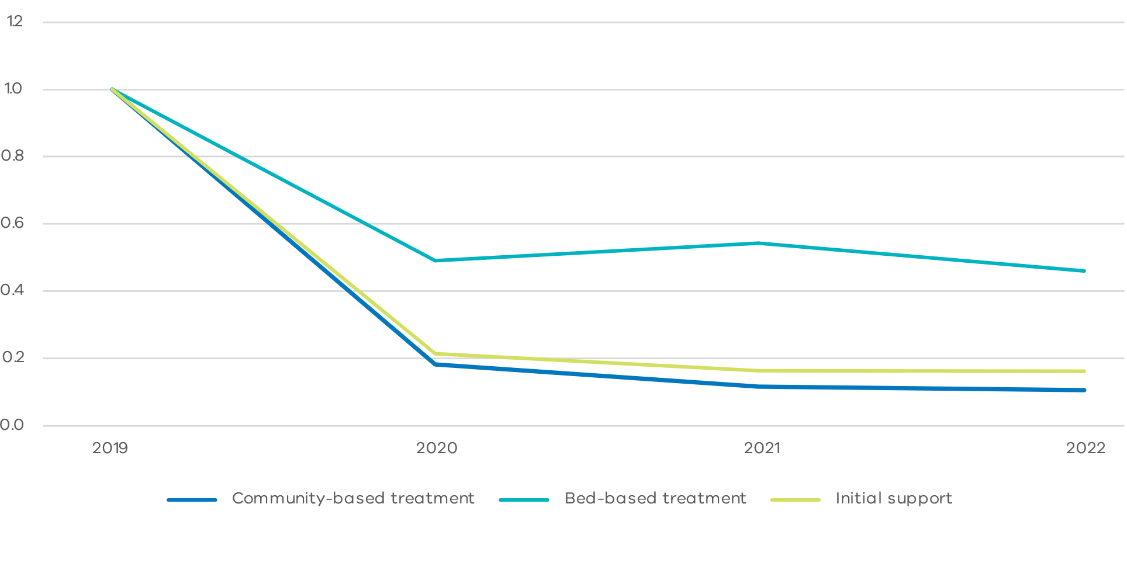

# Clients of AOD treatment in 2019

Over 3 000 young people (12-25 years) accessed AOD treatment for the first time each year over the last four years, with a relatively consistent trend over this period (figure 3). A further 2 000 were repeat clients. More historic data is unavailable due to a change in data collection in 2018, however this shows that the number of young people accessing AOD treatment did not change substantially during COVID-19 public health restrictions.

* This report focuses on the 3 172 people who accessed treatment for the first time in 2019 (as defined as individuals who never appeared in the Alcohol and other Drug Information System (ADIS) dataset dating back to the mid-2000s, and whose first appearance in the VADC dataset was in 2019). There are approximately 1.4 million 12–25-year-olds in the dataset for 2019. This cohort represents 0.2 per cent of that population
* Young people were more likely to seek treatment as they aged and the average age of first-time treatment was 21 years. However, some people first sought treatment at young as 12 years old (figure 4). Where relevant, data has been displayed separately for the younger (12‑17) and older (18-25) sub-cohorts
* 59 per cent were male, 33 per cent female (8 per cent other or not reported). This was consistent with the gender profile of those who received community-based treatment, however females received almost half (47 per cent) of the bed-based services
* 5 per cent identified as Indigenous, despite comprising less than 2 per cent of the 12‑25‑year‑old general population in VSIIDR
* 10 per cent of the cohort were born overseas, relative to 12 per cent of the general 12–25-year-old population in VSIIDR
* 62 per cent of clients self-referred to AOD services and the remaining 38 per cent were referred through a justice pathway including correction, drug treatment or supervision orders, court or police diversion programs, parole or prison release requirements, and youth justice orders. For the 12–17-year-old sub-cohort, this was 22 per cent (42 per cent of 18-25s)
* 22 per cent of those who sought AOD treatment were either homeless or at risk of becoming homeless.1 This increased to 33 per cent for bed-based treatment.

1 Definition for at risk of becoming homeless: https://meteor. aihw.gov.au/content/401065#:~:text=Definition%3A,that%20can%20contribute%20to%20homelessness (aihw.gov.au)

Figure 3: Number of 12-25-year-olds accessing AOD treatment and support in Victoria

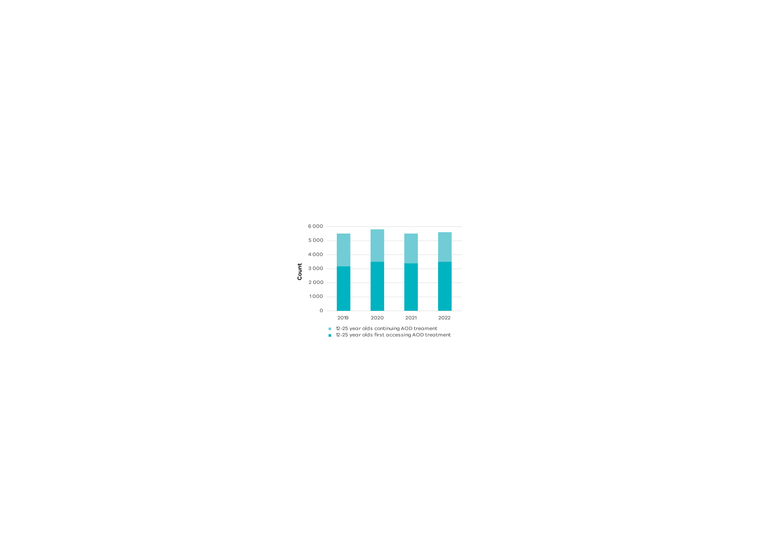

Figure 4: Age at first AOD treatment in 2019

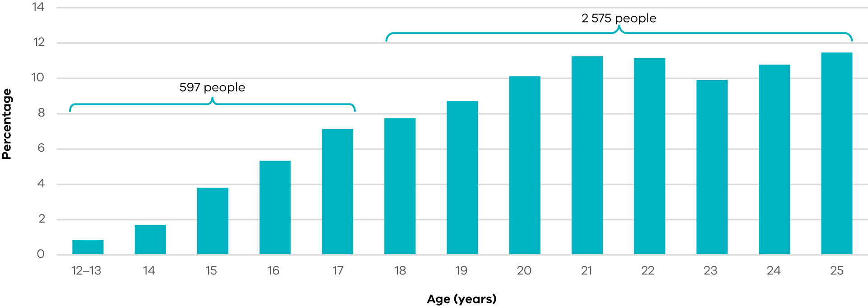

# Service interactions by gender

Females comprised about one third of the total 12-25-year-olds who underwent AOD treatment in 2019. Relative to males, females had more mental health treatment, Emergency Department (ED) presentations, child protection reports, spent more nights in out‑of‑home care, used more homelessness and family violence accommodation, and spent more time in public housing (figure 5).

In 2019, females also underwent AOD treatment at a younger age with 12-17-year-olds comprising 24 per cent of the total female cohort compared with 17 per cent of the male cohort (Table 2).

Males were more likely to have police interactions as the offender, corrections orders and nights in custody (figure 5). According to the data counted in VSIIDR, only men are clients of family violence (perpetrator) services.

This is consistent with Mitchell et al.’s 2016 findings that despite young men representing two thirds of those undergoing treatment, young women experience more psychosocial co-occurring needs, and young men experience higher rates of criminal justice involvement [2]. It also grows the evidence base linking AOD misuse in young women with child protection involvement, alluded to by Mitchell [2].

The different co-occurring needs between males and females indicate different opportunities to intervene.

Table 2: AOD clients by age and gender

|  |  |  |  |  |
| --- | --- | --- | --- | --- |
|  | 12-17s | 18-25s | Total | % 12-17s |
| Female | 239 | 768 | 1 007 | 24% |
| Male | 349 | 1 649 | 1 998 | 17% |

Total does not equal 3 172 as 8 per cent of the population had ‘other’ or no gender recorded. This analysis excludes those people.

Figure 5: Service usage in 2019 relative to 12-25 AOD total cohort

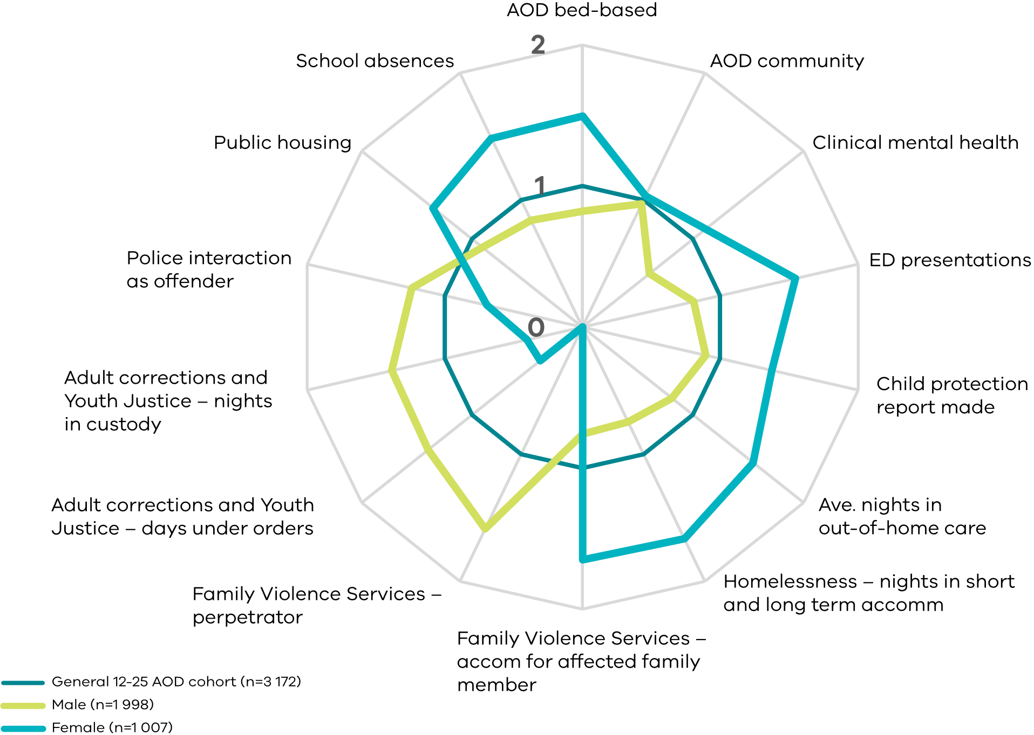



Section 3

Use of other services by AOD service clients

The following analysis looks at people who first accessed AOD services in 2019, then looks at their prior and subsequent service usage

This aims to understand what was occurring in the lives of these people before, during and after treatment

Figure 6: Example chart showing indexing service interactions relative to 2019

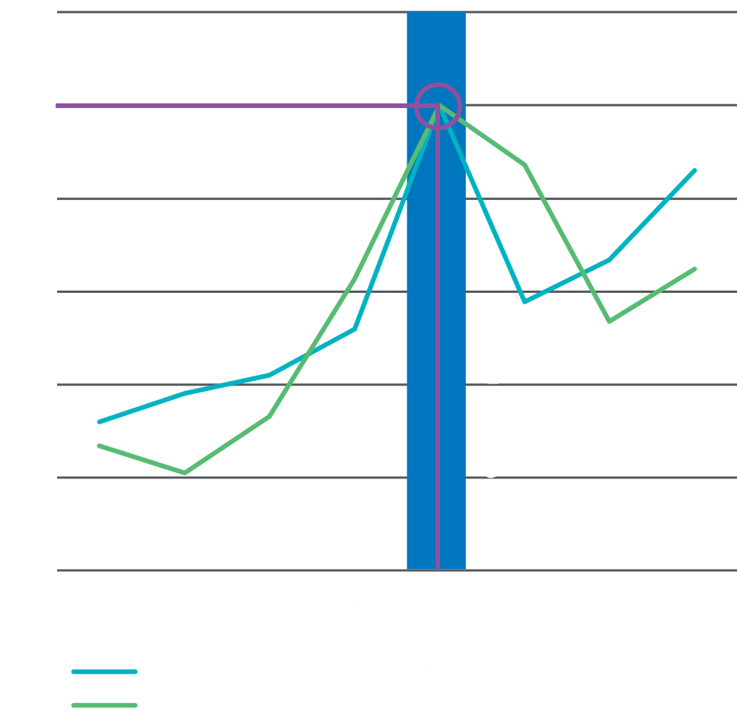

These charts are all indexed so service usage in 2019 is equal to 1. In the pre- and post- treatment years, >1 reflects increased use of that service, and <1 reflects reduced use of that service.

All charts use VSIIDR administrative data, analysed 2024.

# Non-AOD service usage relative to the general 12-25 population (in 2019)

12–25-year-olds receiving AOD treatment for the first time have more interactions with other state government services relative to the general 12‑25‑year‑old population (figure 7):

* 56 times as many school absences
* 39 times more nights in custody and days under corrections orders. Given more than a third of the cohort accessing AOD did so via any sort of mandatory or non-mandatory referral from Victoria Police, adult corrections or the Youth Justice system, this is not unexpected
* 29 times more usage of family violence services for perpetrators
* 28 times more usage of mental health services
* 11 times more nights spent in short- and long-term homelessness accommodation

While still high, usage of family violence programs for affected family members, emergency departments and nights spent in out‑of‑home care are all less than 10 times as high as the general youth population.

Figure 7: Service usage for 12-25-year-olds who underwent first AOD treatment in 2019 relative to all 12-25-year-olds in VSIIDR

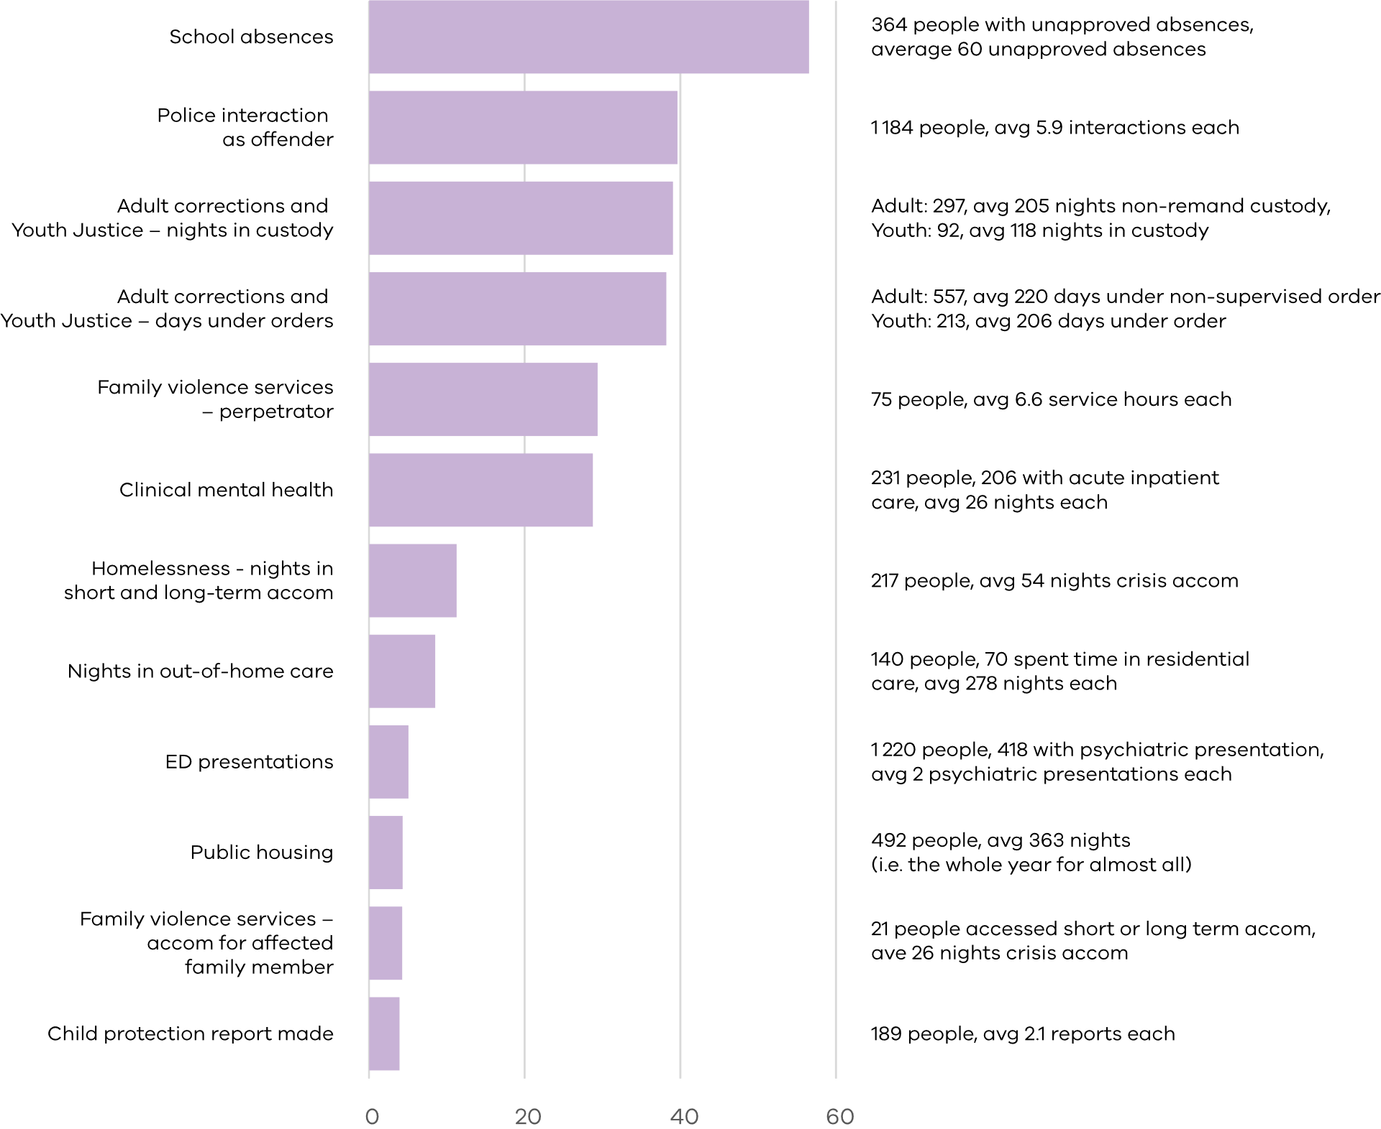

# Youth Justice, adult corrections and police interactions

Police interactions as the offender increased before they accessed AOD treatment for the first time, peaked during the year they first received AOD treatment, and then decreased (figure 8).

Adult corrections and Youth Justice followed similar trends. Community orders peak a year after initial AOD treatment, possibly due to delays associated with COVID-19 (figure 9).

Youth Justice interactions would be expected to decline as the young people became adults, so average youth and adult corrections orders and nights in custody were summed before indexing relative to 2019.

Along with COVID-19 driven changes, changes to the Youth Justice system including an increased focus on diversions would be expected to result in a reduction in service use over time.

Further data and insights around adult corrections and Youth Justice are presented in section 4.

Figure 8: Police interactions resulting in conviction indexed to 2019, 12-25-year-olds

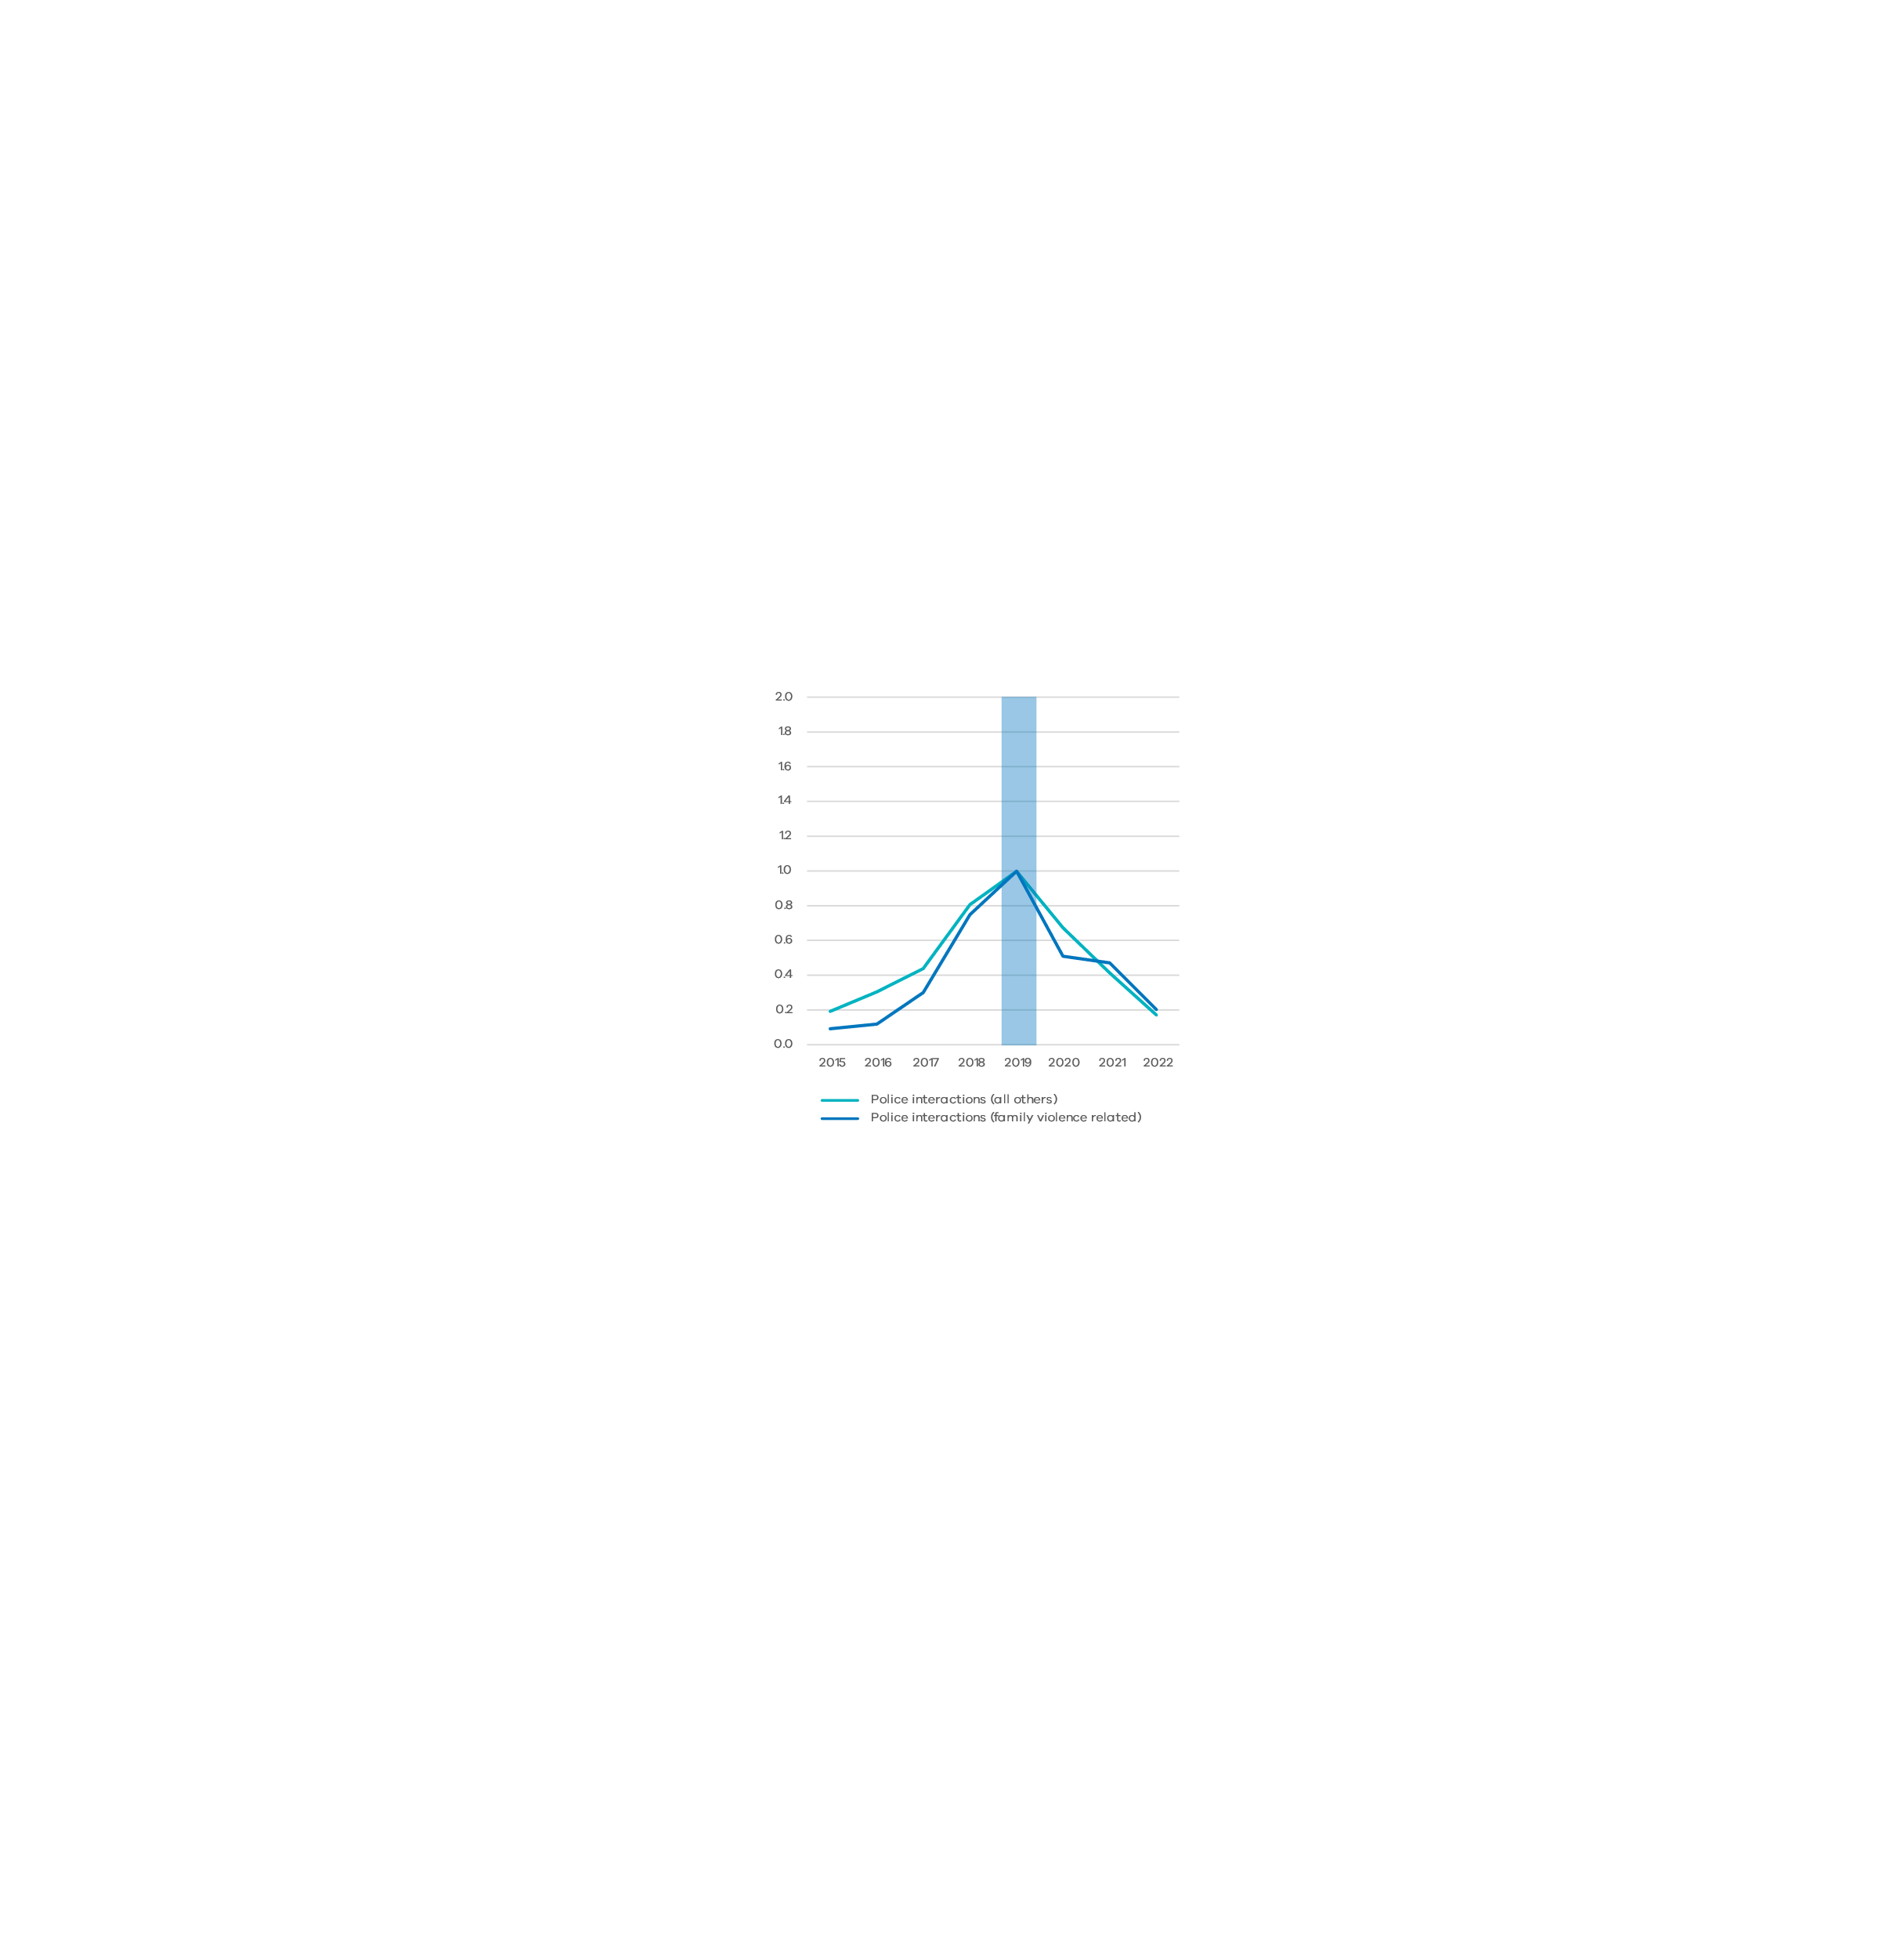

Figure 9: Days under community orders and in custody indexed to 2019, 12-25-year-olds

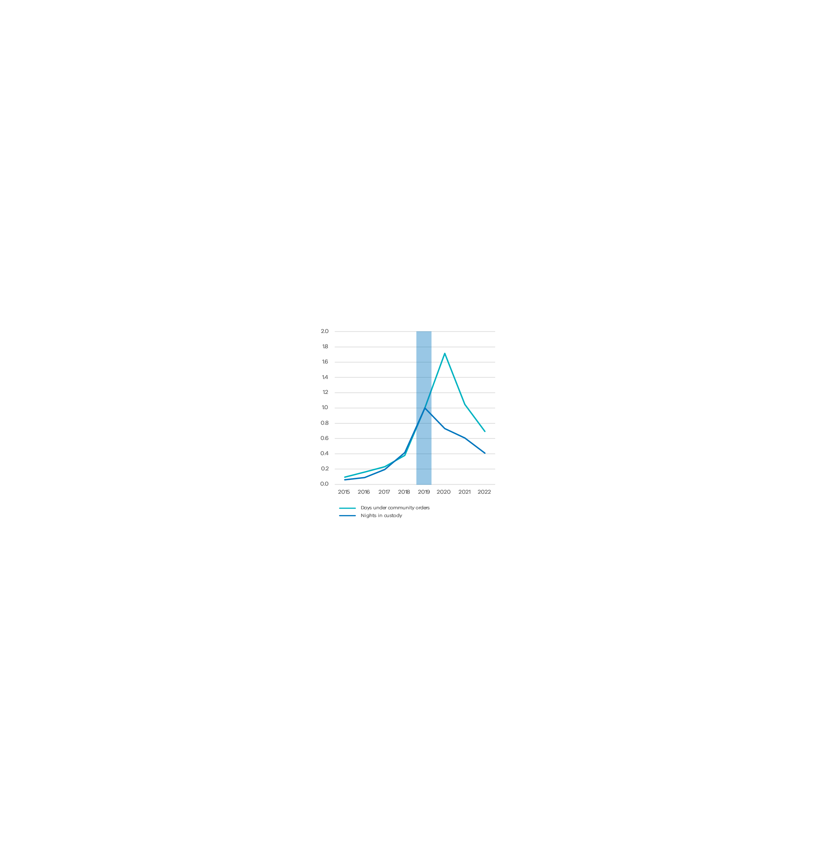

# Emergency department and clinical mental health

All types of state government funded clinical mental health care service usage rose ahead of seeking AOD treatment. The state government funds and delivers mental health services directly, but funds specialist providers to provide AOD services.

Emergency Department (ED) presentations peaked in 2019 for this cohort for almost all presentation types. Psychiatric and poisoning (including AOD overdose) presentations increased the most rapidly to the 2019 peak, then decreased the most rapidly. While the literature reports self-harm and suicide attempts [1, 2], this analysis was limited to categories of ED presentation.

Injury, illness and other presentations were higher than psychiatric and poisoning presentations leading up to AOD treatment then peaked the following year in 2020. This increased usage does not reflect the general trend of Victorian ED utilisation over the period of COVID-19 public health restrictions in 2020, where total presentations reduced 5 per cent from 2019 figures1. By 2021, this trend is following the general ED utilisation trend.

1 <https://www.pc.gov.au/ongoing/report-on-government-services/2024/health/public-hospitals>

Figure 10: Clinical mental health care indexed to 2019, 12-25-year-olds

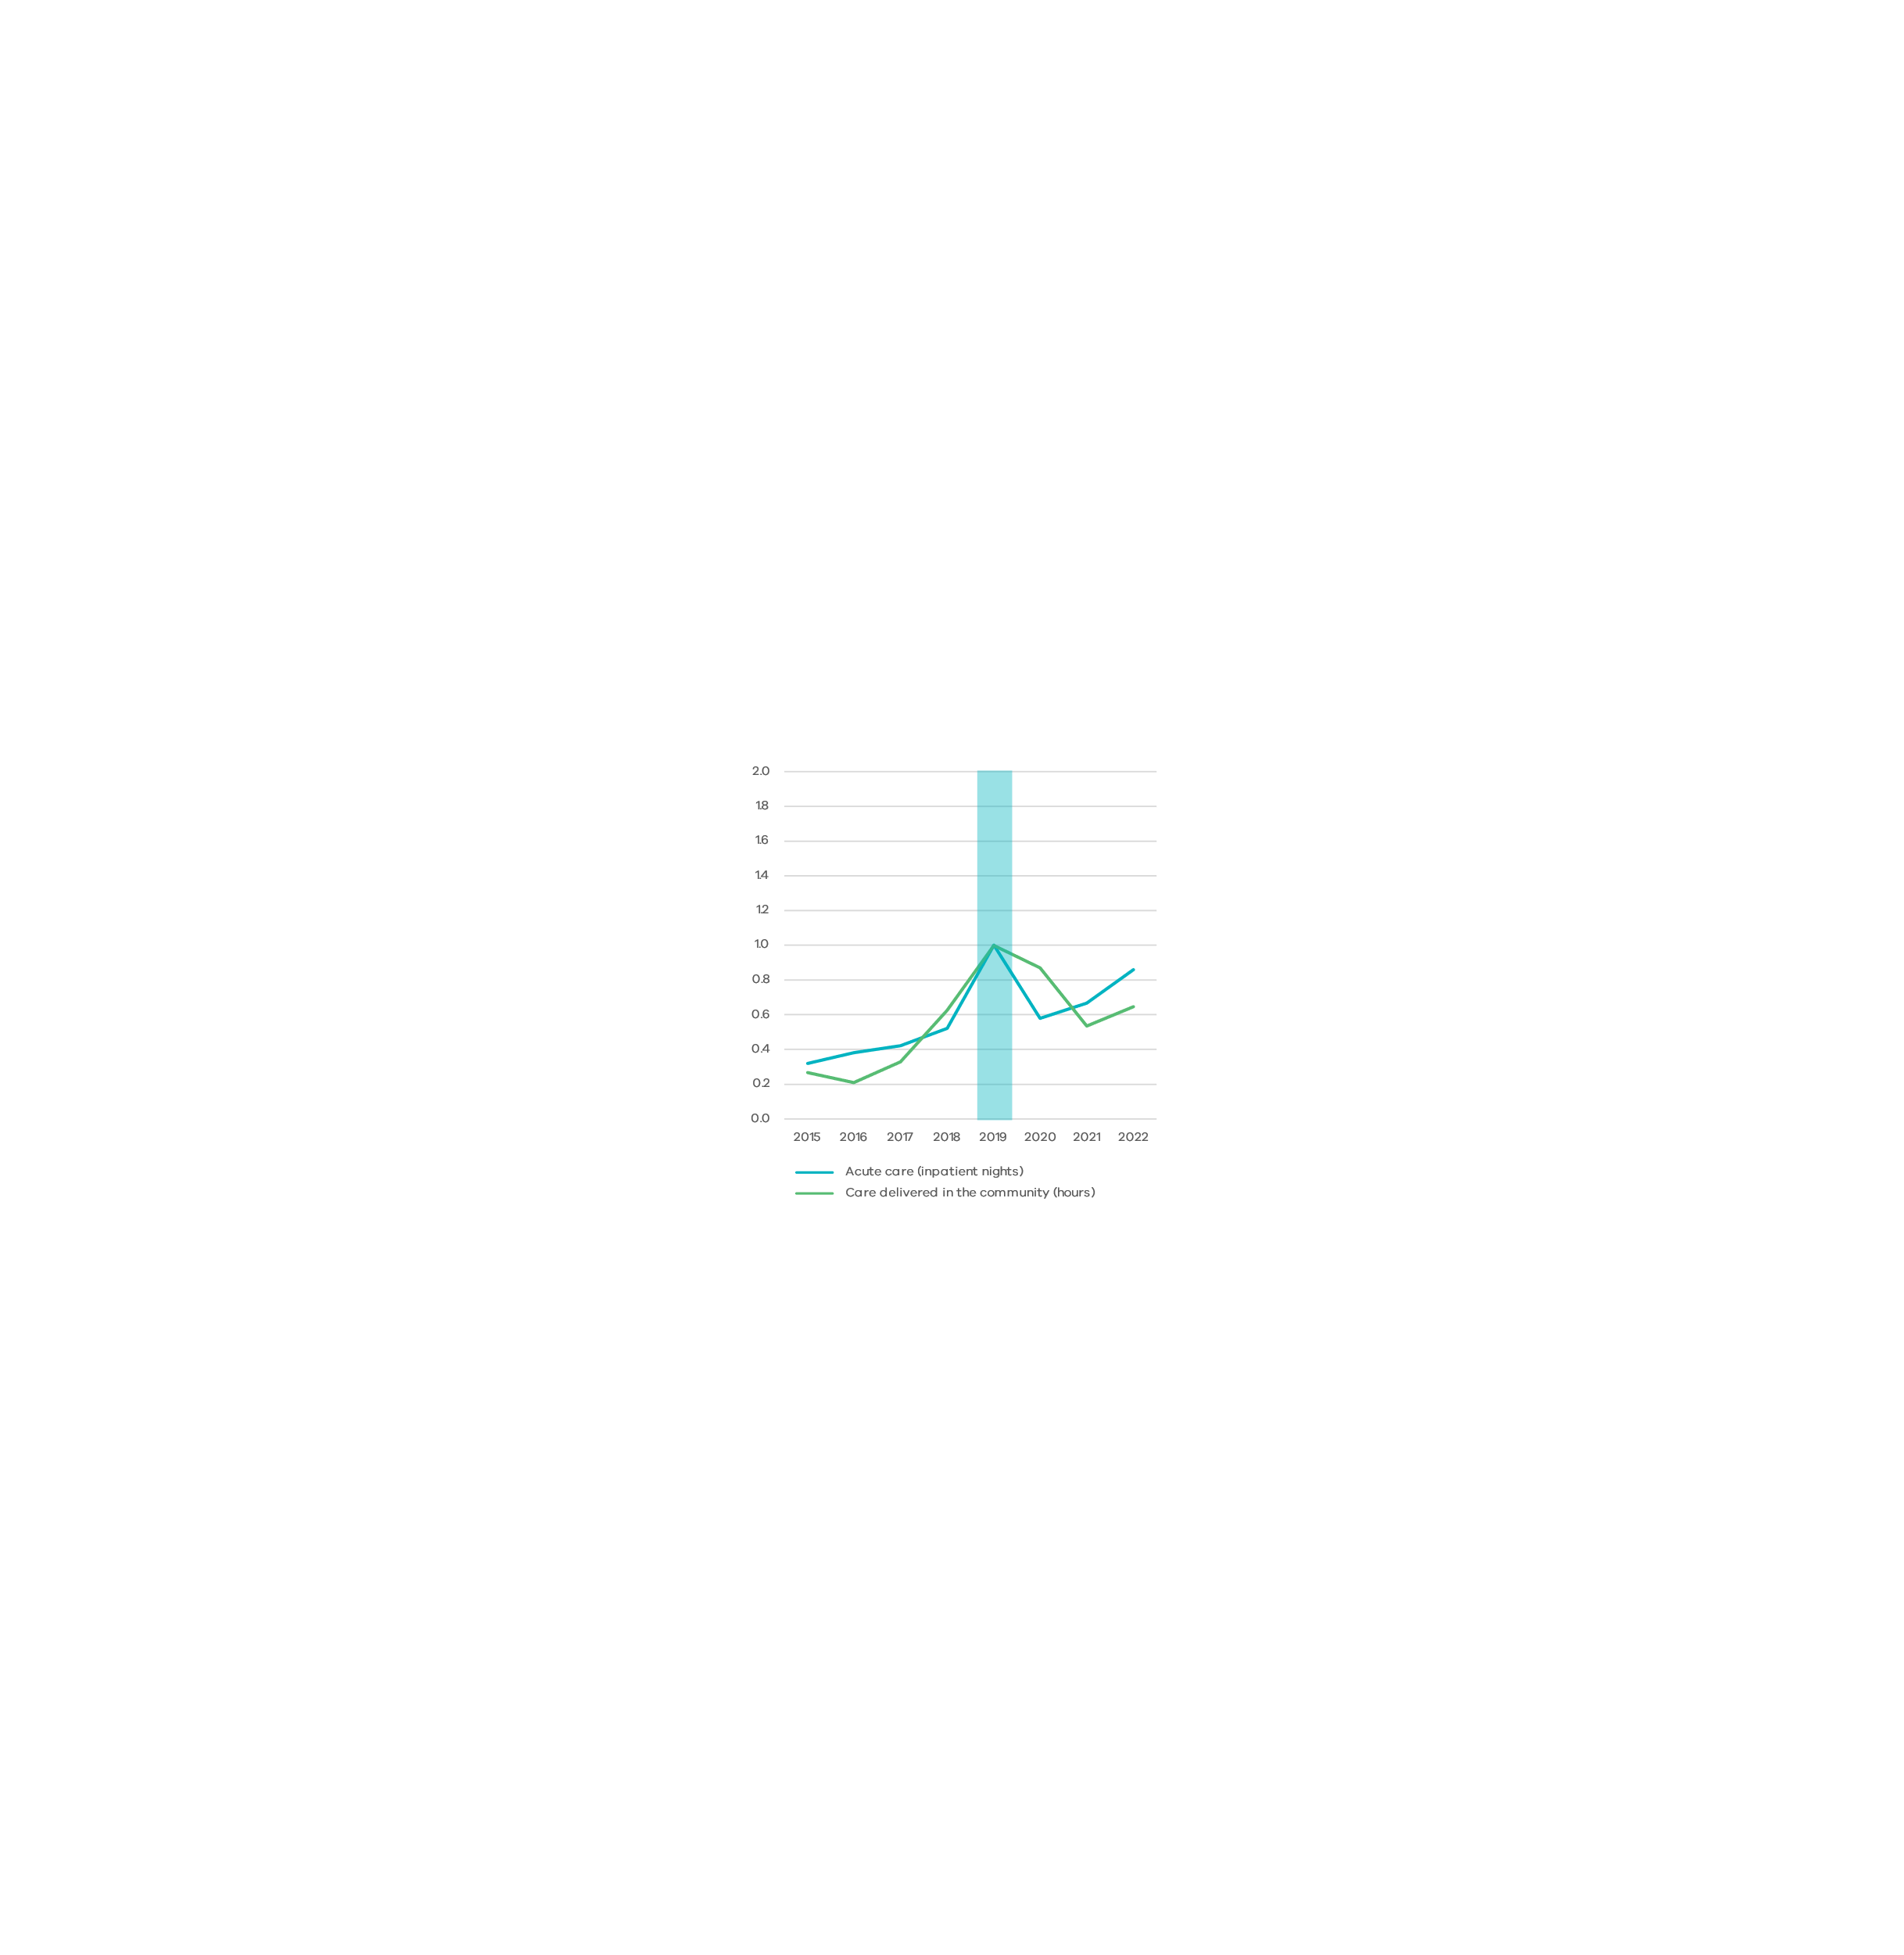

Figure 11: ED presentations indexed to 2019, 12-25-year-olds

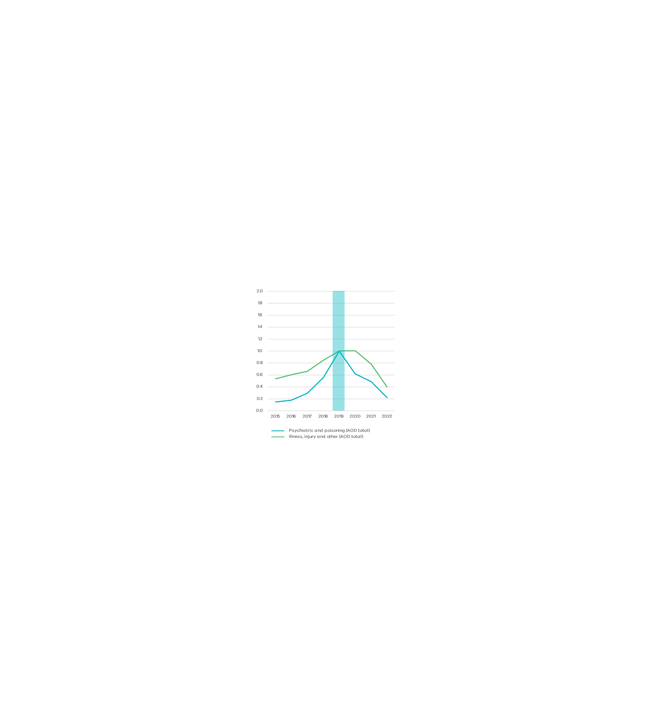

# Child protection, out‑of‑home care, and school absences for 12-17-year-olds

The data was examined for the sub-cohort of people who were aged 12-17 in 2019 when they first accessed AOD treatment. The average age of this group in 2019 was 16 years and comprised 597 (of the total 3 172) individuals.

This study examined the total average use for the cohort without excluding them as they age out of the school, child protection, and out‑of‑home care systems, which is a limitation of the analysis.

Declining usage of all these services post AOD treatment in 2019 should not be interpreted as success of the treatment.

School absences were high in all the years leading up to and including the year treatment was accessed. Absences steadily increased in this cohort from 17 days of absences in 2015 (when their average age was 12) to 54 days in 2019. Chronic school absence is defined as more than 20 days per year1.

This is consistent with other research showing AOD usage is correlated with reduced education attendance. Weekly use or more of cannabis has been associated with school and university non-completion [7] and truancy has been associated with binge drinking [8].

Reports to child protection and subsequent child protection orders also increased steadily over the period leading up to AOD treatment. The number of nights spent in residential out‑of‑home care increased, while nights in all other out‑of‑home care decreased.

1 <https://content.sdp.education.vic.gov.au/media/schools-guide-to-attendance-2441>

Figure 12: School absences indexed to 2019, 12‑17-year-olds



Figure 13: Child protection services indexed to 2019, 12-17-year-olds



Figure 14: Nights spent in out‑of‑home care indexed to 2019, 12-17-year-olds

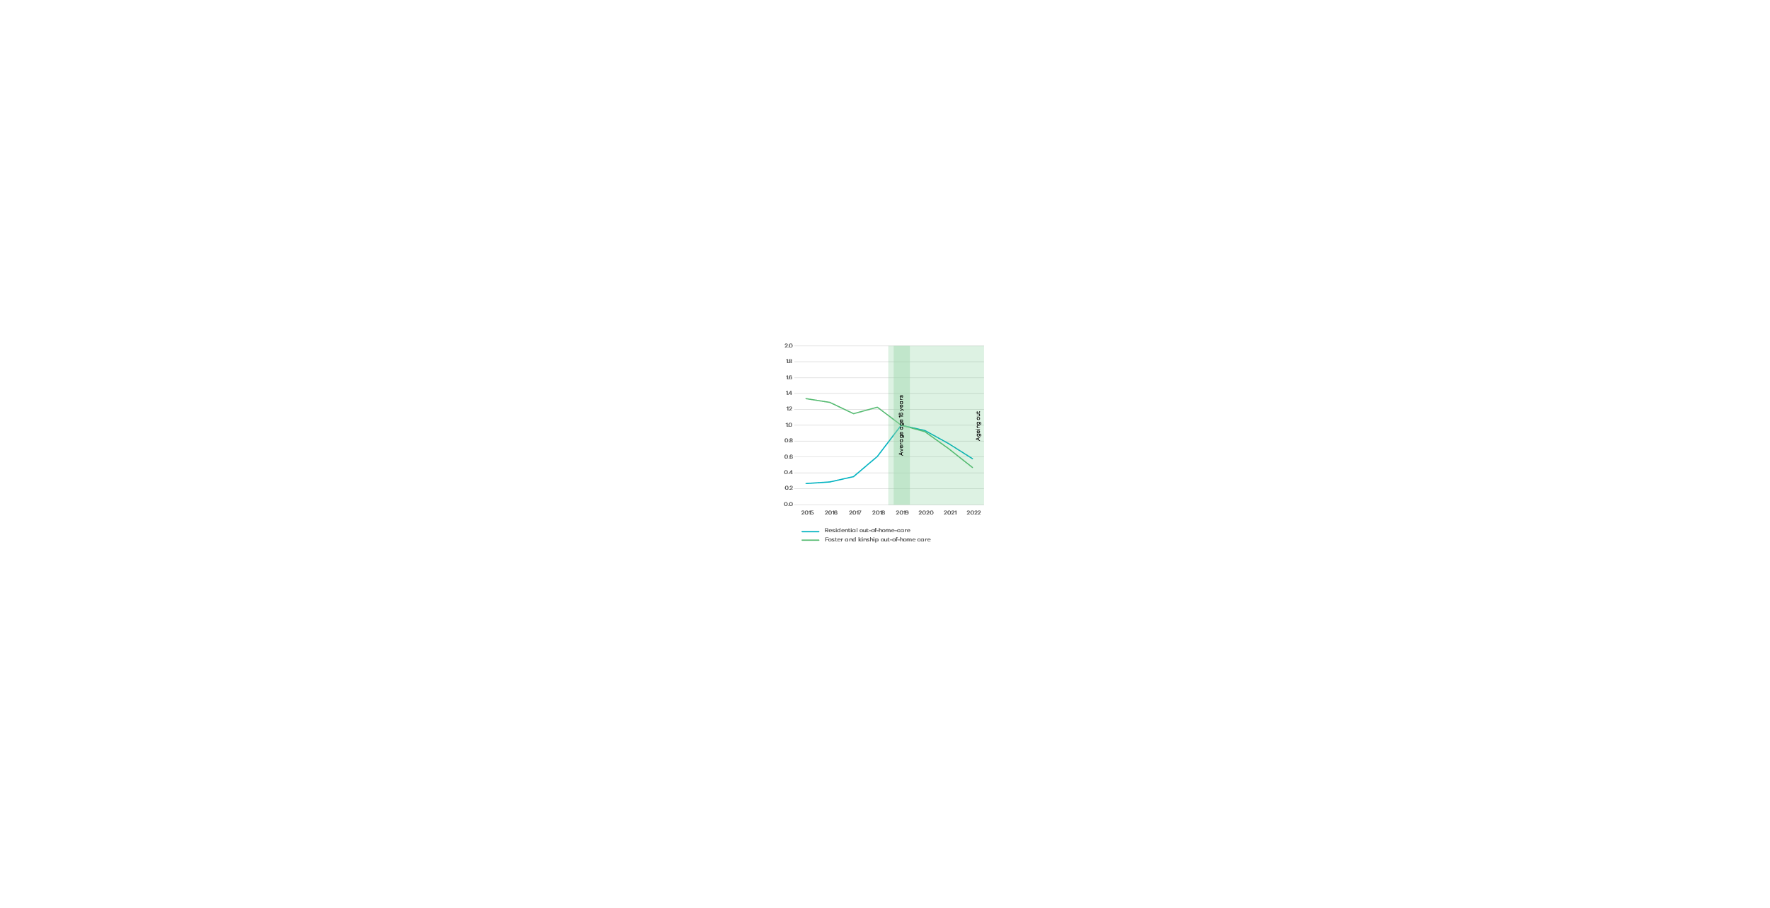

# Homelessness

At the same time out‑of‑home care usage was decreasing post AOD treatment, homelessness for the cohort who were 12-17-years-old in 2019 was increasing. Nights in crisis accommodation (still considered homeless) increased slightly then remained relatively flat, while nights in post-crisis social housing (not homeless) almost tripled in the three years since first undergoing AOD treatment.

For the sub-cohort aged 18-25-years-old in 2019, use of homelessness accommodation (crisis and long term), peaked a year after AOD treatment then started declining again. Within two years usage of crisis accommodation was lower than before AOD treatment, and while gradually trending down, usage of post-crisis social housing has positively remained higher than before AOD treatment.

This data is consistent with the literature that it is common for young people seeking AOD treatment have experienced unstable housing [1].

Figure 15: Nights in out‑of‑home care and homelessness accommodation indexed to 2019, 12-17-year-olds

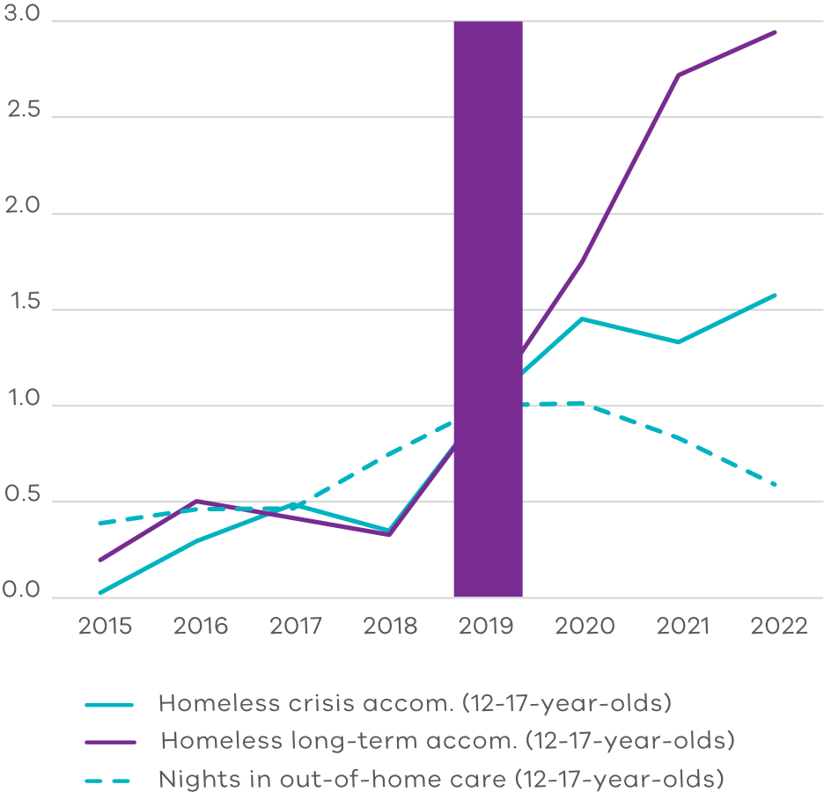

Figure 16: Nights in homelessness accommodation indexed to 2019, 18‑25‑year‑olds

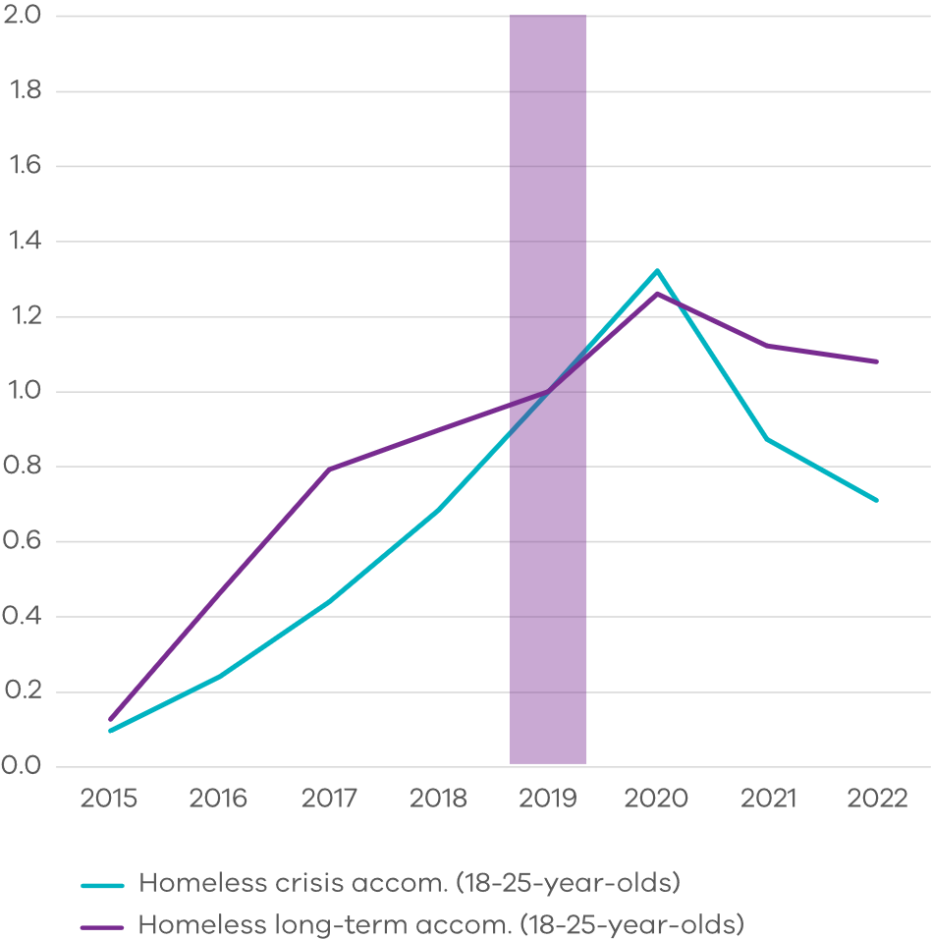

# Family Violence Services

### Family Violence Services – Affected Family Member

In the years leading up to accessing AOD treatment, people accessed higher levels of family violence crisis and long-term accommodation as the affected family member than after first AOD treatment.

### Family Violence Services – Perpetrator

As the person perpetrating violence, family violence service usage peaked in the year AOD treatment was first accessed, and then reduced. This aligns with police interactions as a family violence perpetrator.1

1 This service is only relevant for adults. 12-18 year olds access Adolescent Violence in the Home interventions, distinct from perpetrator interventions.

Figure 17: Family Violence services for the affected family member indexed to 2019, 12‑25‑year-olds

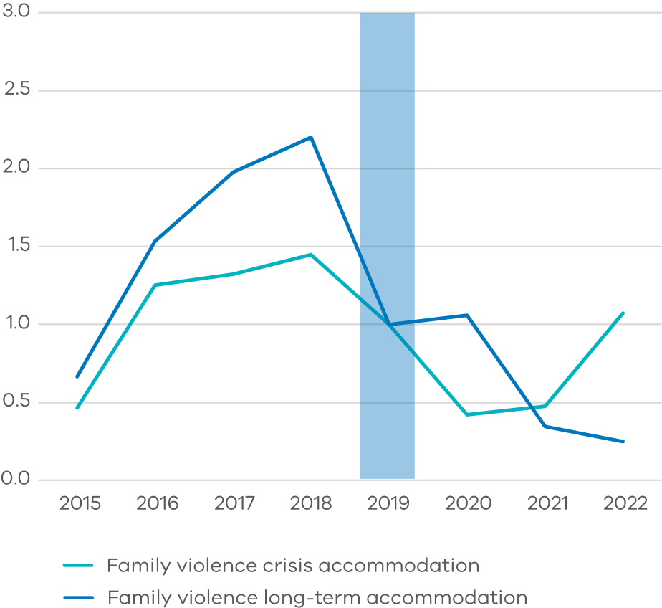

Figure 18: Police interactions resulting in conviction, 12-25-year-olds and family violence services for perpetrators indexed to 2019, 18-25-year-olds

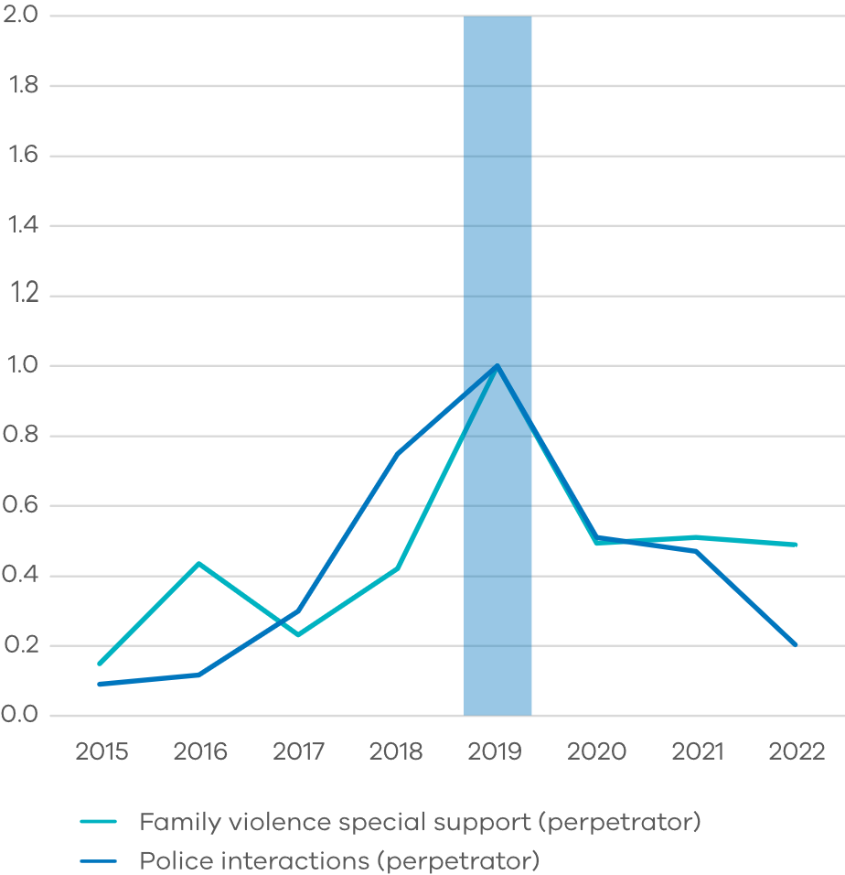



Section 4

Use of other services by AOD service clients with co-occurring needs

### AOD and Mental Health AOD and Justice

# Experience of people with co-occurring justice and mental health needs

As shown in figure 5 (page 12), of individuals aged between 12 and 25 years, those accessing AOD services interacted with mental health and adult corrections and Youth Justice services more frequently than the general population.

Specifically examining the clients with co-occurring needs highlights how they differ from the general AOD population, population (figure 19).

This service usage is indexed relative to the general 12–25-year-old AOD cohort. Relative to the cohort of 12–25-year-olds seeking AOD treatment:

* The AOD and Justice cohort had around double the justice and family violence service usage as the perpetrator, more nights in out‑of‑home care, and less clinical mental health treatment and nights in family violence accommodation
* The AOD and mental health (MH) cohort had higher usages of all services; however usage is particularly high for ED presentations, child protection reports made, nights in out‑of‑home care, and nights in homelessness accommodation. Their interaction with justice services was higher than the AOD total cohort, but less than the average of those in the AOD and Justice cohort.

The next pages detail changes in service use for these cohorts over time.

Table 3: Cohorts with mental health and justice co-occurring needs

|  |  |  |  |  |
| --- | --- | --- | --- | --- |
| Number of people | 12-17s | 18-25s | Total | % of total AOD cohort |
| AOD and MH | 129 | 526 | 655 | 21%1 |
| AOD and Justice | 312 | 1 406 | 1 718 | 54% |

1 If people who used a category of community mental health services which transitioned to the NDIS and ceased reporting in 2020 are included, the proportion increases to 30 per cent. 21 per cent also reflects only those who have accessed state funded mental health care, which will be less than the total who have mental health care needs.

Figure 19: Service usage in 2019 relative to 12-25 AOD total cohort

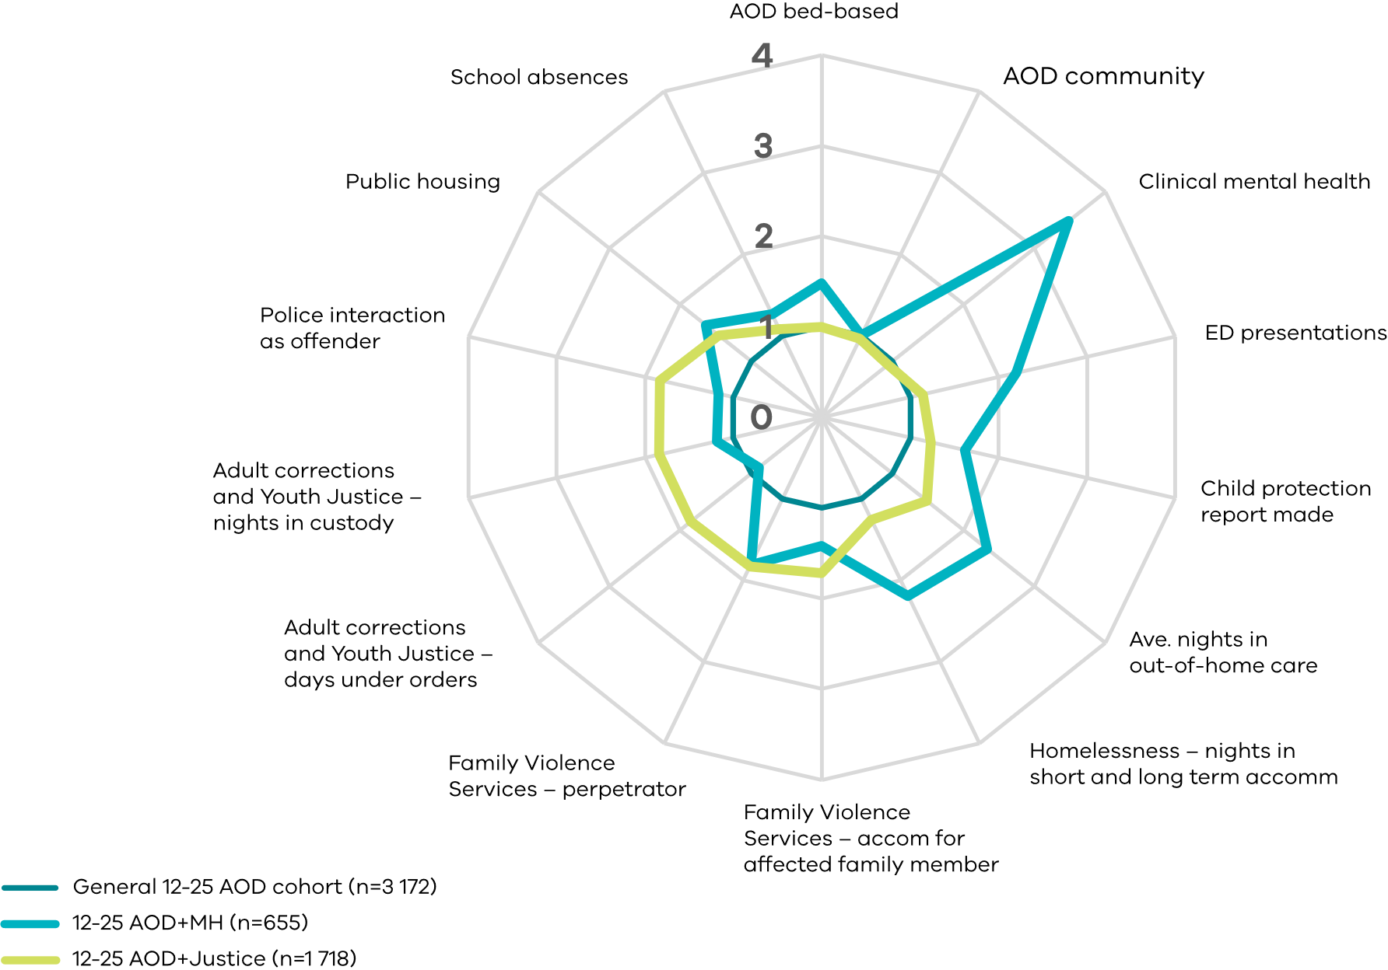

Cohorts are defined as 12–25-year-olds who first accessed AOD treatment or support in 2019 **who also had**:

* **12-25 AOD and MH**: a clinical mental health interaction any time up to and including 2019
* **12-25 AOD and Justice**: a justice (any of community order supervised/non-supervised, custody remand/non-remand or youth justice custody/order) or police interaction as the offender any time up to and including 2019.

# AOD clients who also accessed mental health treatment

A total of 21 per cent of people accessing AOD for the first time had accessed clinical mental health care in their lifetime. Of these:

* 98 per cent accessed services in the community for mental health
* 31 per cent also accessed acute mental health inpatient care
* 9 per cent also accessed prevention and recovery inpatient care (this can be used as a step down between acute inpatient care and home).

Relative to all young people accessing AOD services, those with co-occurring mental health needs:

* Spent more nights in out‑of‑home car**e** with an increase in residential care in the years leading up to AOD treatment concurrent with a decrease in foster, kinship and permanent care. After first accessing AOD treatment, usage of out‑of‑home care reduced, however remained well above the general 12-25 AOD cohort (figure 20).
* Spent more nights in short- and long-term homeless accommodation. After first accessing AOD treatment, nights spent in the more stable long-term homelessness accommodation remains high, while crisis accommodation reduces (Figure 22).
* Had more community orders and less nights in custody in the youth justice system than the average for the 12-25 AOD cohort. In the adult corrections system, those with co-occurring mental health needs have slightly more community orders and nights in custody than the average for the 12-25 AOD cohort (figure 23).
* Had more presentations to the ED than the average for the 12-25 AOD cohort for all types of presentation. The gap was widest from the year before to the year after first AOD treatment (figure 24).

Figure 20: Nights spent in residential and all other out‑of‑home care (average), AOD total cohort and AOD and MH cohort, 12-25-year-olds

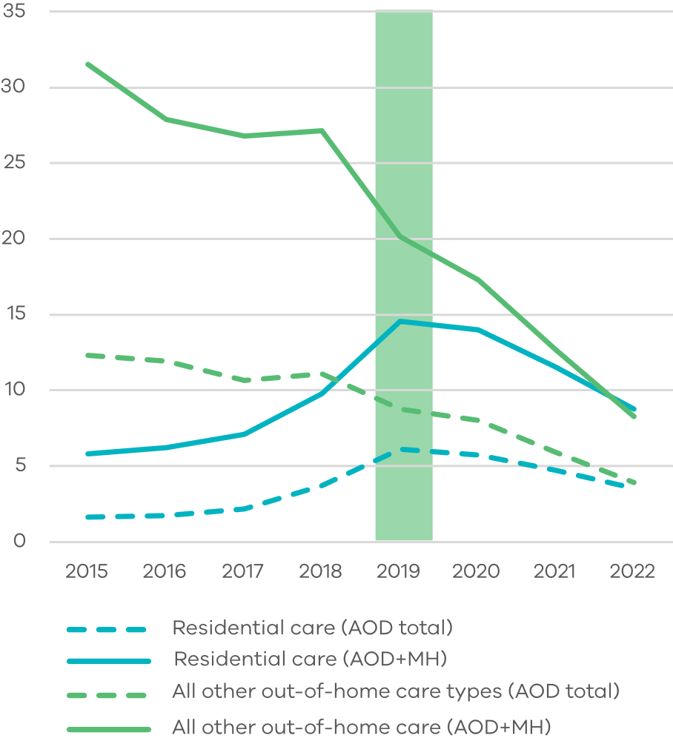

Figure 21: Clinical mental health care, AOD total cohort and AOD and MH cohort, 12‑25‑year-olds

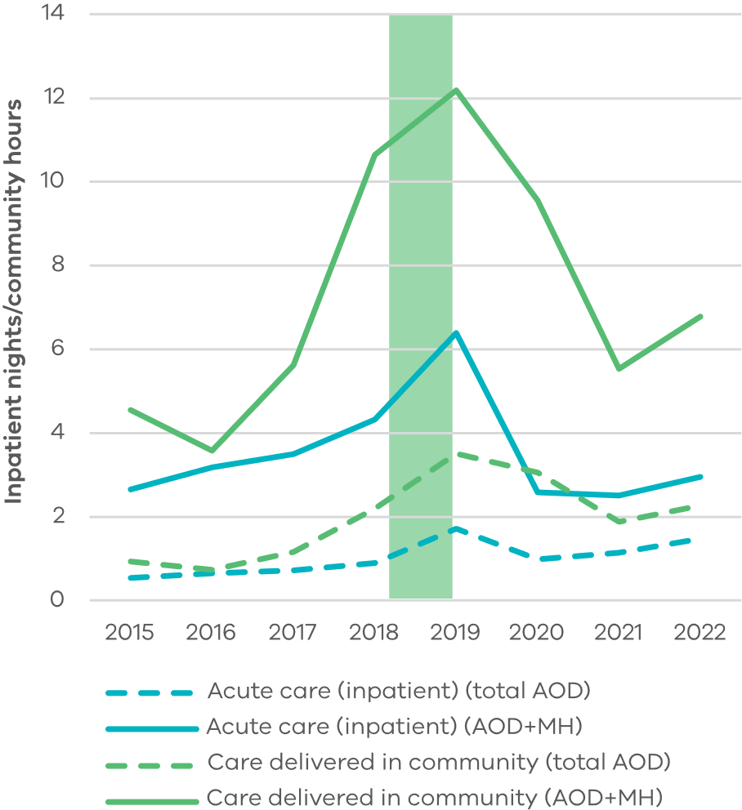

Figure 22: Nights of short and long-term homelessness accommodation (average) AOD total cohort and AOD and MH cohort, 12‑25‑year-olds

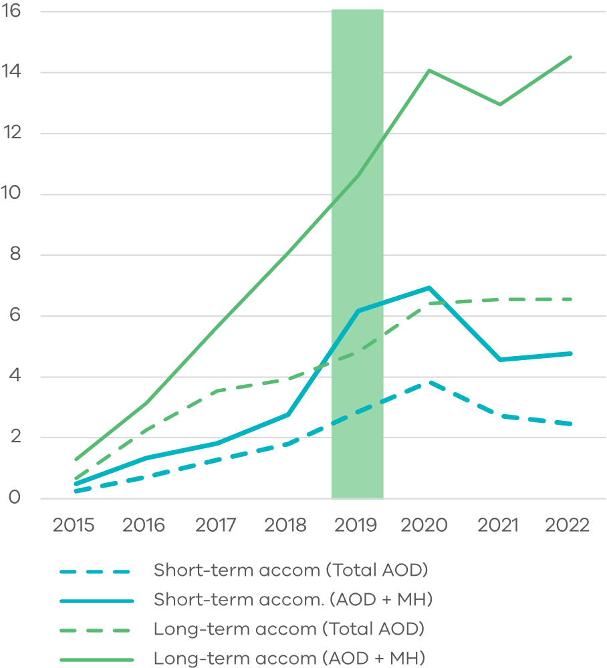

Figure 23: Nights in custody (average), AOD total cohort and AOD and MH cohort, 12‑25‑year-olds

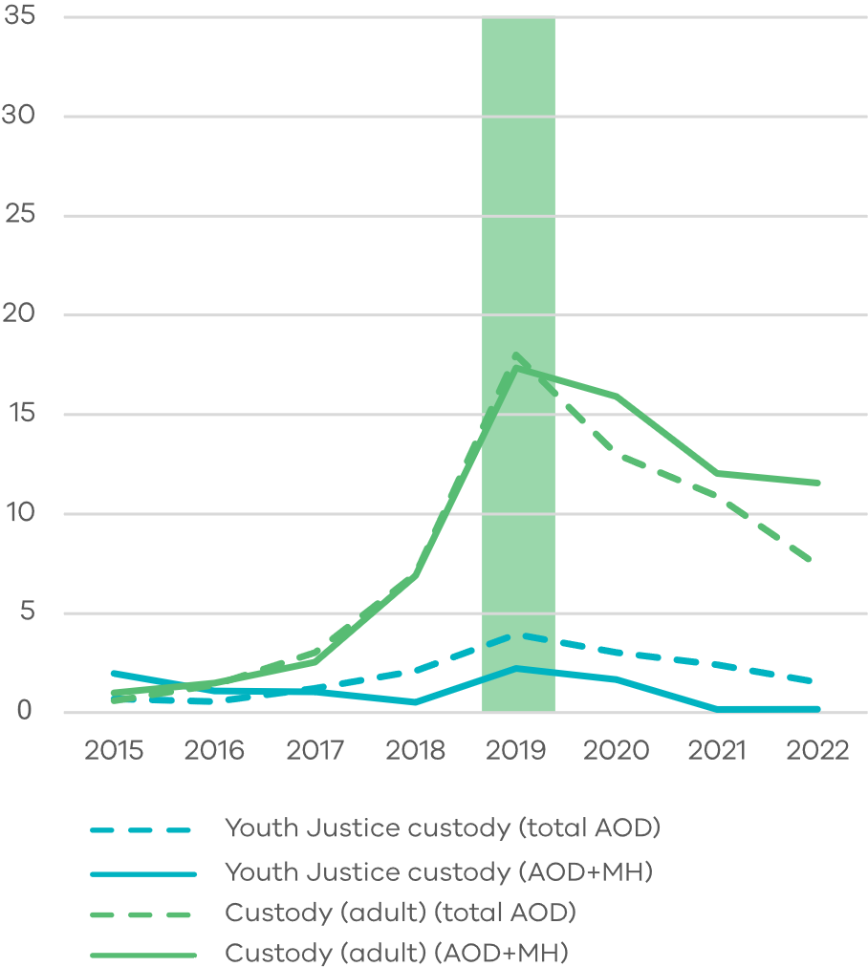

Figure 24: Emergency Department presentations (average) AOD total cohort and AOD and MH cohort, 12-25-year-olds

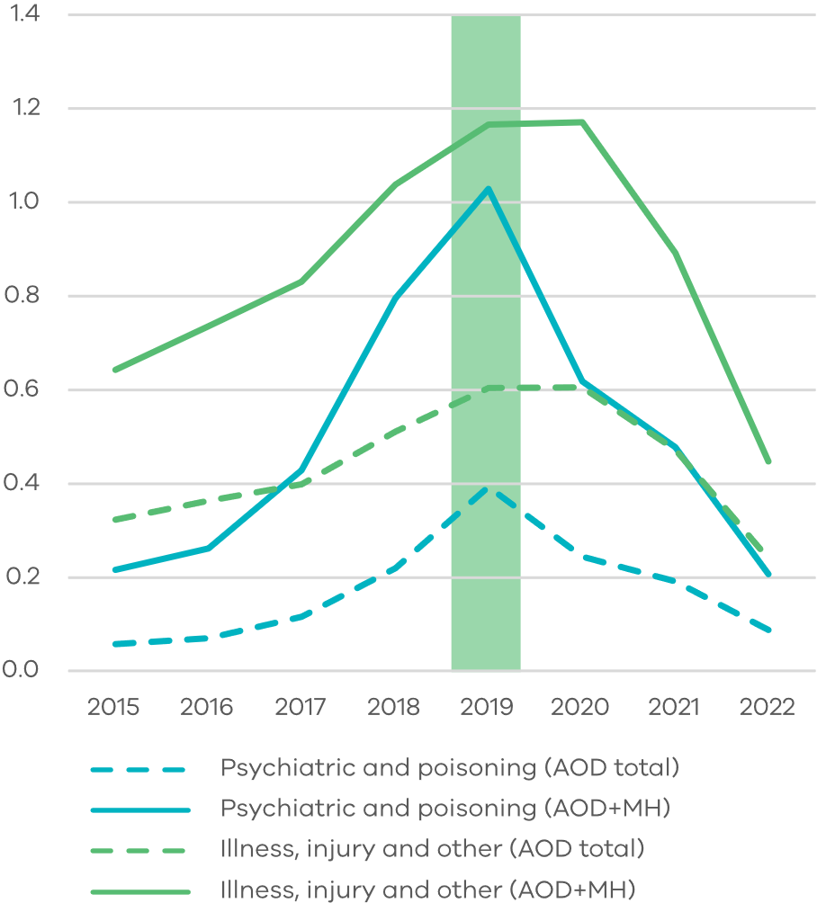

# AOD clients who also had justice interactions

Of the 3 172 12–25-year-olds who underwent AOD treatment in 2019, 54 per cent also had some contact with police, justice or youth justice in the years leading up to and including 2019. These high rates are consistent with the literature [1-3].

Relative to the total 12-25 AOD average, young people who also had police and justice interactions:

* Accessed a similar amount of clinical mental health care in the years leading up to their first AOD treatment in 2019, though less was in acute bed-based care. Trends after first AOD treatment were again similar to the 12-25 AOD cohort, however more time was spent in acute bed-based care than the 12-25 AOD cohort (figure 26).
* Spent more nights in out‑of‑home care with a rapid increase in residential care in the years leading up to AOD treatment. The AOD and Justice cohort more closely resembled the total 12-25 AOD cohort than the AOD and MH cohort (figure 25).
* Spent more nights in short- and long-term homeless accommodation leading up to AOD treatment in 2019. Long-term homeless accommodation usage continued to rise after AOD treatment, while crisis accommodation usage fell (figure 27).
* Had slightly more Youth Justice community orders and nights in custody. (figure 28).
* Had far more community orders and nights in custody, in the adult Corrections system (figure 28).

Figure 25: Nights spent in residential and all other out‑of‑home care (average), AOD total cohort and AOD and Justice cohort, 12-25-year-olds

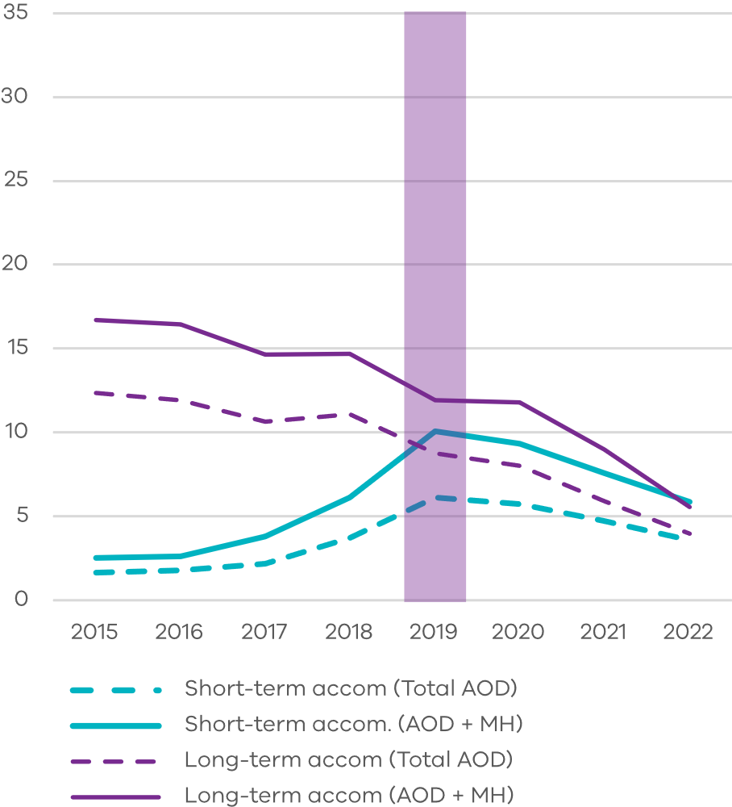

Figure 26: Clinical mental health care, AOD total cohort and AOD and Justice cohort, 12‑25-year-olds

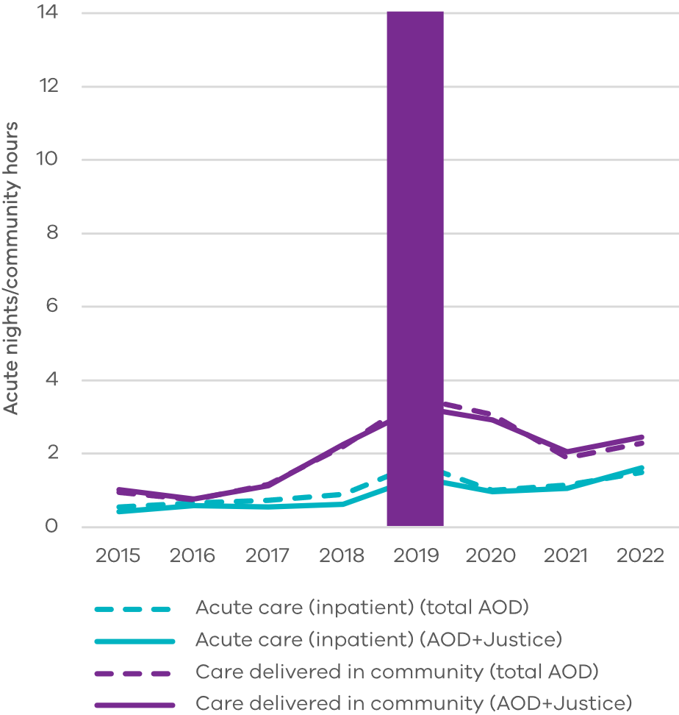

Figure 27: Nights of short and long-term homelessness accommodation (average) AOD total cohort and AOD and Justice cohort, 12‑25-year-olds

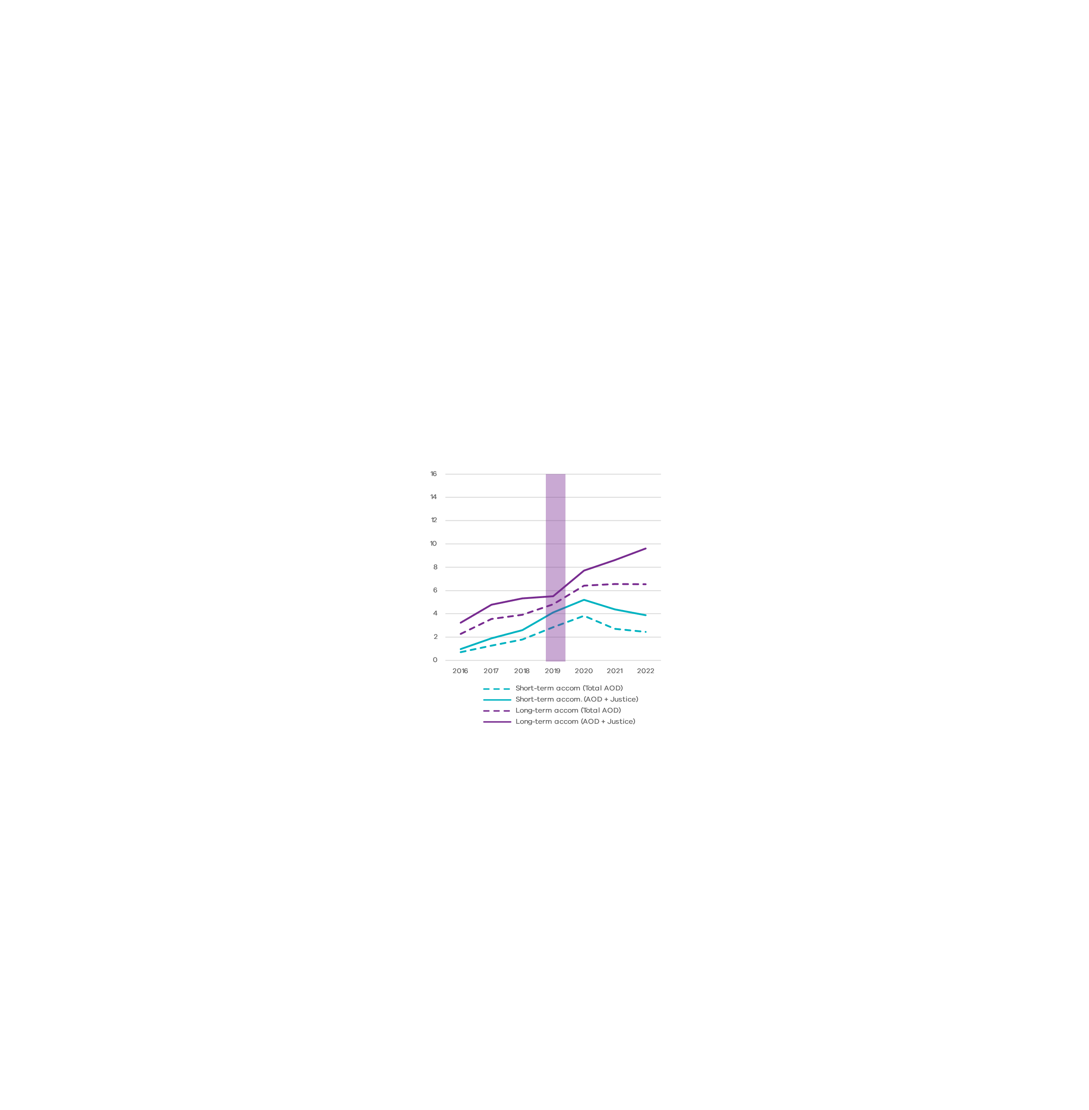

Figure 28: Nights in custody (average), AOD total and AOD and Justice cohort, 12‑25‑year‑olds

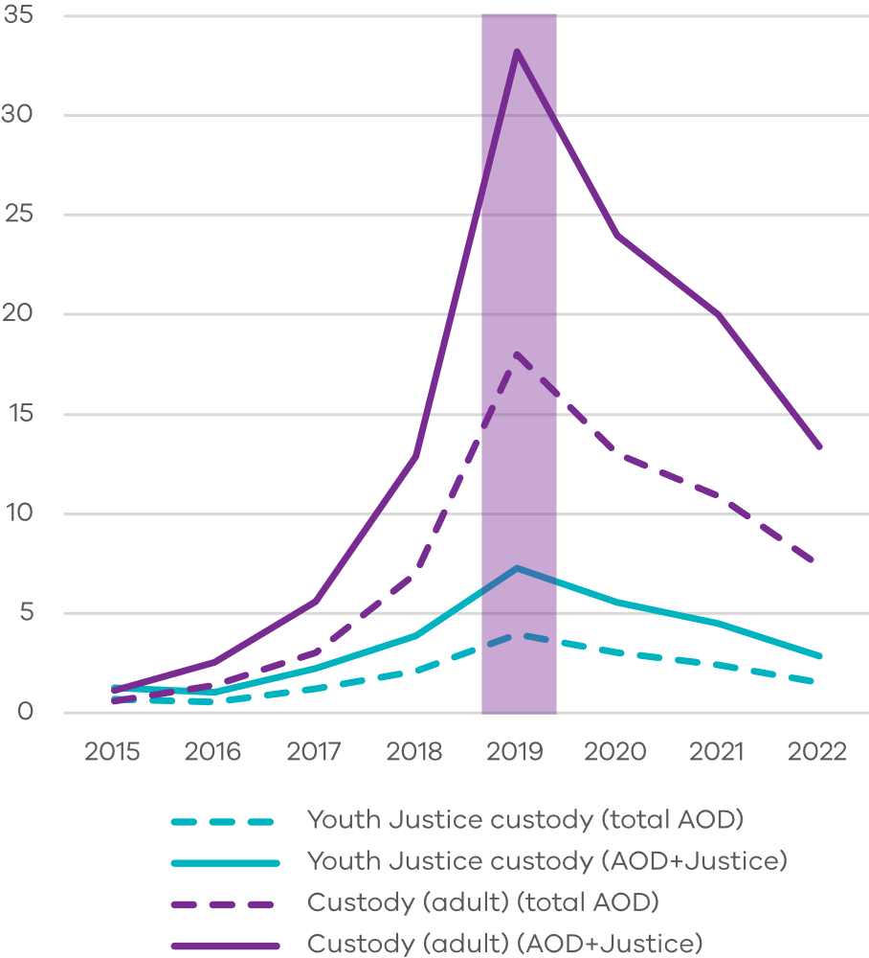

Figure 29: Emergency Department presentations (average) AOD total cohorts and AOD and Justice cohort, 12-25-year-olds

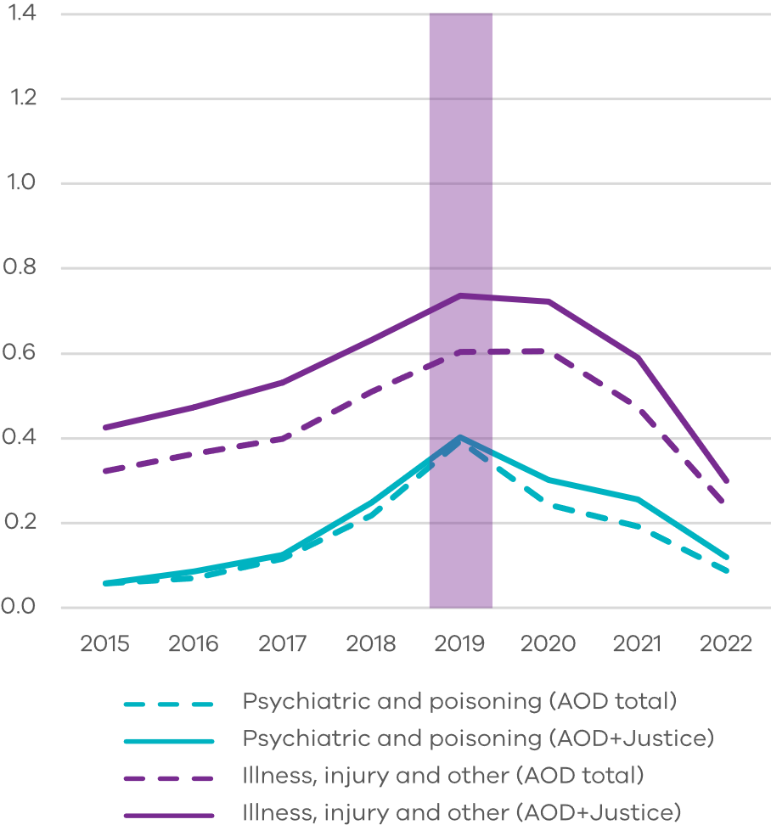

# AOD and justice for those undergoing forensic and voluntary AOD treatment

This analysis starts with all the people who had a community order or custody episode in the period 2015-2019 and underwent AOD treatment for the first time in 2019. It examines the justice interactions, split by the 62 per cent who underwent treatment voluntarily by self‑referral, and the 38 per cent who underwent AOD treatment after any referral through the justice sector. This has been called the ‘forensic’ pathway, and includes correction, drug treatment or supervision orders, court or police diversion programs, parole or prison release requirements, and youth justice orders. This is more aligned with AOD terminology, and less aligned with a Corrections definition of mandatory treatment.

It shows that for adults, those who were referred to AOD treatment via the justice system were responsible for slightly more of the justice interactions, however the two groups were similar (figures 30 and 32).

This is different in the Youth Justice system, where most of the justice interactions were for those people who were referred to AOD treatment via the Youth Justice system (figures 31 and 33).

These counts are smaller than in previous report sections, as they only count those with a justice interaction in 2019 rather than those with lifetime prior justice interactions.

Figure 30: Average number of adult custody episodes (n = 297), 18-25-year-olds

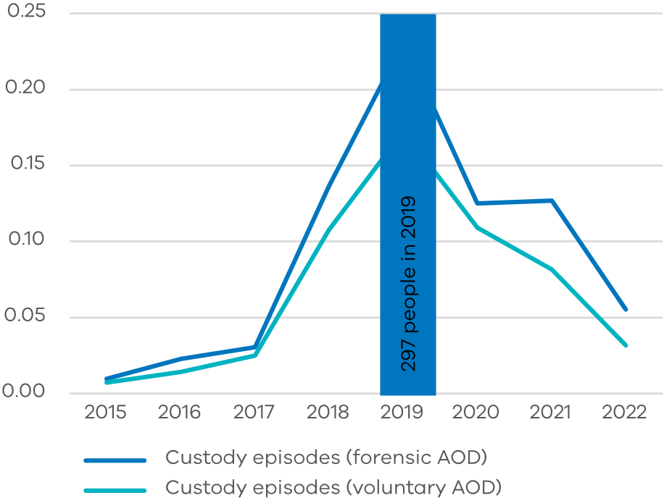

Figure 31: Average number of Youth Justice custody episodes (n = 222), 12-17-year-olds

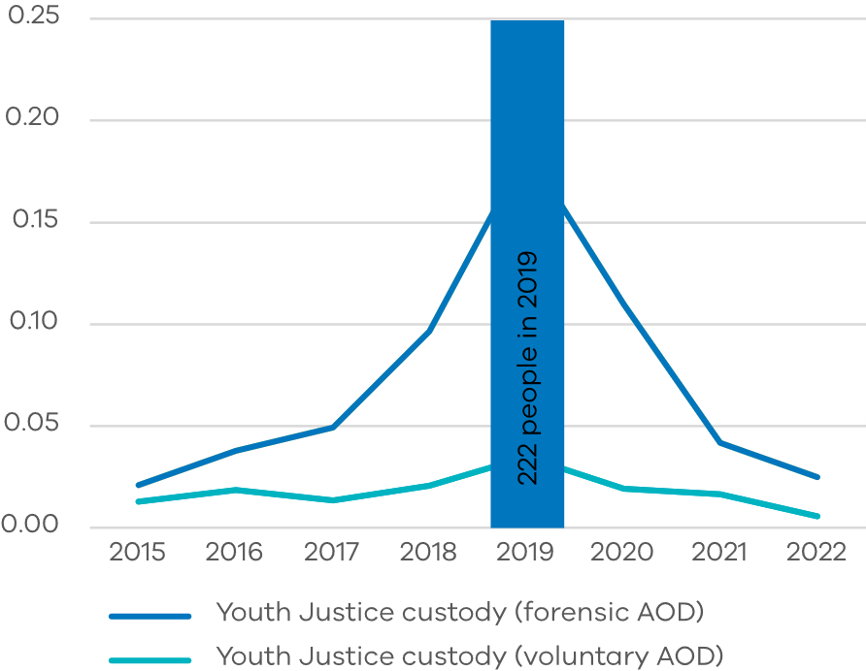

Figure 32: Average number of adult community orders (n = 557), 18-25-year-olds

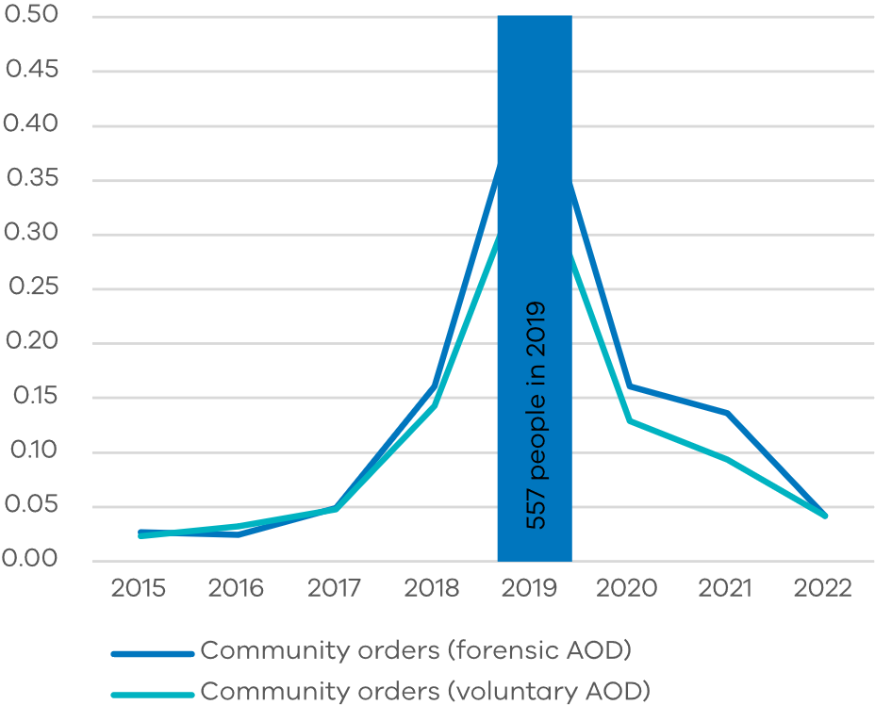

Figure 33: Average number of Youth Justice orders (n = 213), 12-17-year-olds

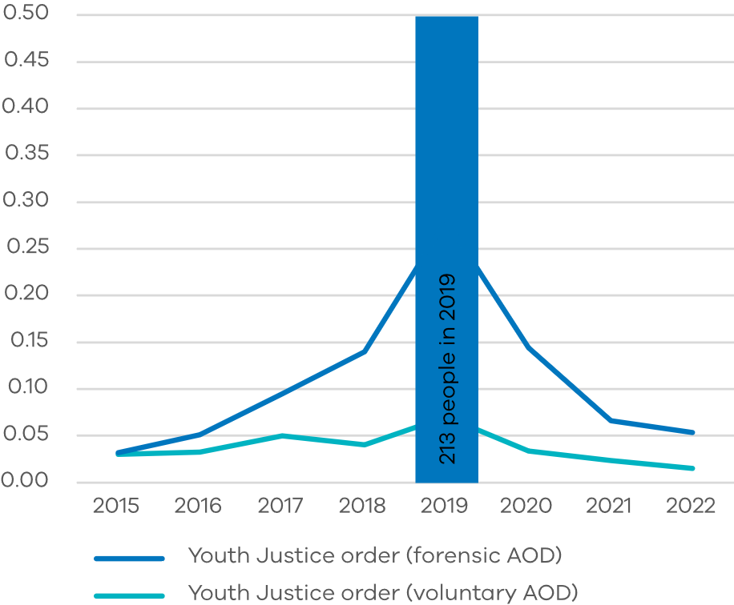

# Data limitations, extensions and possible uses

## Data limitations

This report uses data from the Victorian Social Investment Integrated Data Resource (VSIIDR)1,2 including service usage across 45 state government data tables spanning health, human services, education and justice. It does not include data:

* on Commonwealth funded services such as the NDIS disability supports, primary care, headspace or some services for young Aboriginal Victorians such as Bunjilwarra
* where brief interventions are conducted at anonymous services like needle exchanges
* where AOD services are provided inside corrections facilities.

The Victorian Alcohol and Drug Collection (VADC) was a key dataset used. However, it was found to have data quality limitations in a Victorian Auditor General’s report in 20223. Protected industrial action also affected the collection of AOD and mental health data in 2020 and 2021.

The linked data itself is also subject to imperfect linking. For instance, where a person gives a full name to one service and a preferred name to another service, or a typing error occurs in data entry, or a person feels more comfortable disclosing different genders to different service providers.

This will make it appear as though there are more people, but less service usage for those affected.

2019 was selected as the base year for the analysis as AOD reporting changed significantly in 2018.

Non-AOD service use is examined from 2015 through to 2022. The analysis period includes the COVID-19 years. COVID-19 is likely to have impacted AOD usage patterns and service delivery across services, however this analysis did not attempt to control for COVID-19 effects. Limitations have been highlighted where appropriate. Excluding COVID-19 years would have affected the recency of the data and limited the length of analysis.

Service usage was indexed relative to 2019 for several reasons. It gives a picture of how service use across systems changed before and after seeking AOD treatment, it allows comparison across measures where units differ, and it allows statements such as ‘5 times the use compared with…’.

This report does not seek to assess the effectiveness of AOD treatments as analysis does not relate to specific programs.

## Extensions and possible uses

This report may be useful to inform:

* proposals for future Partnerships Addressing Disadvantage
* new investments through the EIIF
* future research studies.

While this report largely compares average service usage across different sub-cohorts of AOD treatment clients, further analysis of absolute service usage for those who used specific services would give additional context and better answer questions around whether averages are driven by a few people with very high service usage, or many people with low service usage. This would be particularly helpful in areas where the cohort ‘ages out’ of services relating to children.

Controlling for COVID-19 effects would be a useful extension of the analysis.

This data shows that most young people do not have ongoing engagement with state funded AOD treatment. The data does not indicate whether this is supply or demand driven, and additional insights may be gained as the VADC matures.

1 <https://vahi.vic.gov.au/ourwork/data-linkage>

2 [https://www.monash.edu/__data/assets/pdf_file/ 0018/2033190/centre-for-victorian-data-linkage-may-2019.pdf](https://www.monash.edu/__data/assets/pdf_file/%200018/2033190/centre-for-victorian-data-linkage-may-2019.pdf). Additional insights may be gained as the VADC matures.

3 <https://www.audit.vic.gov.au/sites/default/files/2022-10/20221006-Victoria%27s-Alcohol-and-Other-Drug-Treatment-Data.pdf?>

# Literature review references

1. Nathan, S., K. Maru, M. Williams, K. Palmer, and P. Rawstorne. 2020. “Koori Voices: Self-Harm, Suicide Attempts, Arrests and Substance Use among Aboriginal and Torres Strait Islander Adolescents Following Residential Treatment.” Health & Justice 8(1):1–13.
2. Mitchell, Penelope F., Jozica J. Kutin, Kathryn Daley, David Best, and Andrew J. Bruun. 2016. “Gender Differences in Psychosocial Complexity for a Cohort of Adolescents Attending Youth-Specific Substance Abuse Services.” Children & Youth Services Review 68:34–43.
3. Whitten, T., Cale, J., Nathan, S., Williams, M., Baldry, E., Ferry, M., Hayen, A. 2023. “Influence of a residential drug and alcohol program on young people’s criminal conviction trajectories.” Journal of Criminal Justice 84: 102026. [https://doi.org/10.1016/j.](https://doi.org/10.1016/j.jcrimjus.2022.102026) [jcrimjus.2022.102026](https://doi.org/10.1016/j.jcrimjus.2022.102026)
4. Kelly, John & Harrison, Robert & Palmer, Alison. (2016). Trauma and youth alcohol and drug use. Findings from a youth outpatient treatment service. Journal of Applied Youth Studies. 1. 58-76.
5. Posselt, Miriam, Nicholas Procter, Cherrie Galletly, and Charlotte Crespigny. 2015. “Aetiology of Coexisting Mental Health and Alcohol and Other Drug Disorders: Perspectives of Refugee Youth and Service Providers.” Australian Psychologist 50(2):130–40.
6. Horyniak, Danielle, Peter Higgs, Shelley Cogger, Paul Dietze, Tapuwa Bofu, and Girma Seid. 2014. “Experiences of and Attitudes Toward Injecting Drug Use Among Marginalized African Migrant and Refugee Youth in Melbourne, Australia.” Journal of Ethnicity in Substance Abuse 13(4):405–29
7. Silins, Edmund, David M. Fergusson, George C. Patton, L. John Horwood, Craig A. Olsson, Delyse M. Hutchinson, Louisa Degenhardt, Robert J. Tait, Rohan Borschmann, Carolyn Coffey, John W. Toumbourou, Jake M. Najman, Richard P. Mattick, and Cannabis Cohorts Research Consortium. 2015. “Adolescent Substance Use and Educational Attainment: An Integrative Data Analysis Comparing Cannabis and Alcohol from Three Australasian Cohorts.” Drug & Alcohol Dependence 156:90–96.
8. Champion, Katrina Elizabeth, Emma Louise Barrett, Tim Slade, Maree Teesson, and Nicola Clare Newton. 2017. “Psychosocial Factors Associated with Adolescent Substance Use: A Longitudinal Investigation.” Advances in Dual Diagnosis 10(4):142–54.
9. Australian Institute of Health and Welfare 2024. “Alcohol and other drug treatment services in Australia: early insights.” AIHW, Canberra. https://[www.aihw.gov.au/reports/alcohol-other-drug-](http://www.aihw.gov.au/reports/alcohol-other-drug-) treatment-services/alcohol-other-drug-treatment-services- aus/contents/key-findings/clients
10. Myers, Bronwyn, Kim Johnson, Warren Lucas, Rajen Govender, Ron Manderscheid, Petal Petersen Williams, and J. Randy Koch. 2019. “South African Service Users’ Perceptions of Patient-Reported Outcome and Experience Measures for Adolescent Substance Use Treatment: A Qualitative Study.” Drug and Alcohol Review 38(7):823–30. [doi: 10.1111/dar.12996](http://onlinelibrary.wiley.com/doi/10.1111/dar.12996).
11. More, Alissa, Ben Jackson, James A. Dimmock, Ashleigh L. Thornton, Allan Colthart, and Bonnie J. Furzer. 2018. “‘It’s like a Counselling Session ... but You Don’t Need to Say Anything:’ Exercise Program Outcomes for Youth within a Drug and Alcohol Treatment Service.” Psychology of Sport & Exercise 39:1–9.
12. Hawke, Lisa D., Kamna Mehra, Cara Settipani, Jaqueline Relihan, Karleigh Darnay, Gloria Chaim, and Joanna Henderson. 2019. “What Makes Mental Health and Substance Use Services Youth Friendly? A Scoping Review of Literature.” BMC Health Services Research 19(1):257. [doi: 10.1186/s12913-019-4066-5](https://bmchealthservres.biomedcentral.com/articles/10.1186/s12913-019-4066-5).
13. Whitten, T., Cale, J., Nathan, S., Bista, S., Ferry, M., Williams, M., Rawstorne, P., & Hayen, A. (2022). Hospitalisation following therapeutic community drug and alcohol treatment for young people with and without a history of criminal conviction. Drug and alcohol dependence, 231, 109280. [https://doi.](https://doi.org/10.1016/j.drugalcdep.2022.109280) [org/10.1016/j.drugalcdep.2022.109280](https://doi.org/10.1016/j.drugalcdep.2022.109280)
14. Bista, S., Nathan, S., Rawstorne, P., Palmer, K., Ferry, M., Williams, M., & Hayen, A. (2021). Mortality among young people seeking residential treatment for problematic drug and alcohol use: A data linkage study. Drug and alcohol dependence, 228, 109030. <https://doi.org/10.1016/j.drugalcdep.2021.109030>

With thanks to the Victorian Government Library Service for conducting the literature search.



dtf.vic.gov.au