Accounting policy update – newsletter

Edition No. 48

June 2025

This biannual newsletter highlights areas of importance in public sector financial reporting. Please distribute to both budget and financial reporting areas of Victorian public sector entities.

### Inside this edition

Overview 1

Key updates 2

Key reminders for year-end 3

Australian Accounting Standards update 6

Team member profiles 8

How to contact us 9

# Overview

In this newsletter, we highlight a few recent financial reporting updates that are relevant to Victorian public sector entities and provide several important reminders for our 30 June year-end reporters.

Key updates covered in this newsletter include:

* release of the 2024-25 Tier 1 and Tier 2 Model Reports
* release of updated Guidance on the application of FRD 103
* recent AccPol Technical Training for the Victorian public sector
* an update on sustainability reporting developments.

Key reminders for year-end include:

* related party ministerial declarations and related party note disclosures
* yearly and half-yearly valuation assessments for 30 June and 31 December year-end reporters respectively
* annual attestations required under the Standing Directions for 30 June year-end reporters
* key financial publication dates for the whole of State.

We would also like to take the opportunity to introduce a couple of new members in the Accounting Policy team.

# Key updates

## Release of the 2024–25 Tier 1 Model Report for Victorian Government Departments

The 2024-25 *Model Report for Victorian Government Departments* (the Tier 1 Model Report) was released in May 2025 and can be found at the following link:

[www.dtf.vic.gov.au/2024-25-model-report](http://www.dtf.vic.gov.au/2024-25-model-report)

The Tier 1 Model Report has been split into three parts:

* Part One: Introduction and the model report of operations
* Part Two: Model financial statements
* Part Three: Guidance and appendices.

Overall, there have been very few changes, with some relatively minor updates made to the Report of Operations, which includes: updated guidance on the disclosure of Commercial-in-Confidence grants; modifications to the disclosure of reviews and studies expenditure; and a new disclosure of social procurement activities.

For further information on the changes, please refer to the [*Summary of Changes to the Model Report*](https://www.dtf.vic.gov.au/sites/default/files/2025-05/2024-25-Summary-of-Changes.pdf) document.

## Release of the 2024–25 Tier 2 Model Financial Report for Victorian public sector entities

The 2024-25 *Tier 2 Model Financial Report for Victorian public sector entities* (the Tier 2 Model Report) was released in February 2025 and can be found at the following link:

[www.dtf.vic.gov.au/2024-25-model-report](http://www.dtf.vic.gov.au/2024-25-model-report)

The Tier 2 Model assists Tier 2 entities with the planning and preparation of their 30 June 2025 financial statements in accordance with the Tier 2 disclosure requirements in AASB 1060 *General Purpose Financial Statements – Simplified Disclosures for For-Profit and Not-for-Profit Tier 2 Entities*.

For further information on Victoria’s differential reporting framework, please refer to FRD 101 [*Application of Tiers of Australian Accounting Standards*](https://www.dtf.vic.gov.au/sites/default/files/2024-10/FRD-101-Application-of-Tiers-of-Australian-Accounting-Standards.docx)and the [guidance](https://www.dtf.vic.gov.au/sites/default/files/2024-10/Guidance-on-the-application-of-FRD-101-Application-of-Tiers-of-Australian-Accounting-Standards.docx) accompanying FRD 101.

## Updated Guidance on the application of FRD 103 Non-financial physical assets

DTF has recently published updated [*Guidance on the application of FRD 103 Non-financial physical assets*](https://www.dtf.vic.gov.au/sites/default/files/2025-06/Guidance-on-the-application-of-FRD-103-Non-financial-physical-assets-%28June-2025%29.docx)to incorporate the clarificatory amendments to AASB 13 [*Fair Value Measurement*](https://www.aasb.gov.au/admin/file/content105/c9/AASB13_08-15_COMPdec22_01-24.pdf) arising from AASB 2022-10 [*Amendments to Australian Accounting Standards – Fair Value Measurement of Non-Financial Assets of Not-for-Profit Public Sector Entities*](https://aasb.gov.au/admin/file/content105/c9/AASB2022-10_12-22.pdf) and guidance on the subsequent measurement of ROU assets arising from market leases.

## AccPol Technical Training

AccPol ran two days of financial reporting technical training for the sector in May 2025, which covered a range of topics, including understanding the key Victorian Financial Reporting Directions (FRDs), fair value measurement, tips on how to tackle a technical accounting issue and sustainability reporting. The session also benefited from guest speakers from the Australian Accounting Standards Board and the Valuer-General Victoria.

The training was run in-person and virtually in a hybrid format, with approximately 350 attendees joining on both days.

A copy of the presentation slides and recordings have been distributed to all attendees.

## Sustainability reporting

The Commonwealth Treasury’s [changes to the Corporations Act](https://www8.austlii.edu.au/cgi-bin/viewdb/au/legis/cth/num_act/tlamiaoma2024742/) last year may require some Corporations Act entities within the Victorian public sector to apply AASB S2 [*Climate-related Disclosures*](https://standards.aasb.gov.au/aasb-s2-sep-2024) depending on the size and nature of the entity. Based on our outreach to date, we understand that there are no Victorian public sector entities in Group 1. However, there may be entities that are caught under Groups 2 and 3.

For the broader Victorian public sector (i.e. all other entities not caught by the Corporations Act), implementation of climate reporting (including AASB S2) is a jurisdictional policy decision.

The Victorian Government has been active in this area, voluntarily publishing a whole of government level climate disclosure statement (the first government in the country to do so) and expanded environment reporting at entity level in accordance with FRD 24 [*Reporting of Environmental Data by Government Entities*](https://www.dtf.vic.gov.au/sites/default/files/2024-10/FRD-24-Reporting-of-environmental-data-by-government-entities.DOCX).

DTF and the Department of Energy, Environment and Climate Action (DEECA) are currently in the process of considering the Victorian approach to AASB S2, having regards to existing reporting requirements, user needs and cost/benefits among other things.

We will continue to keep the sector informed on any significant progress and developments in this area.

# Key reminders for year-end

## AASB 124 *Related Party Disclosures*

### Ministerial declarations for the 30 June 2025 reporting period

To support the preparation of public sector financial reports, information consistent with the requirements of AASB 124 *Related Party Disclosures* is collected twice each financial year from cabinet ministers for our 31 December and 30 June year-end reporters.

Note that the second submission covering the period from 1 January 2025 to 30 June 2025 is expected to be completed by July 2025.

Consistent with previous reporting periods, where any transactions are reported, DTF will provide the relevant information extracted from ministerial declarations to the relevant portfolio departments, to share with their relevant agencies to assess whether the related party transactions warrant disclosure in the entities’ annual financial report.

Entities are reminded that under the agreed protocols, consultation is required with the relevant minister(s) and DTF where disclosures are proposed, before they can be finalised in your annual financial report.

### Remuneration of key management personnel

Ministers’ remuneration and allowances are set by the *Parliamentary Salaries and Superannuation Act 1968*. Consistent with prior financial years, this ministerial remuneration disclosure will be reported within the State’s *Annual Financial Report*. When preparing annual financial reports, please ensure references to the information on ministers’ remuneration is referenced to the State’s *Annual Financial Report*.

### Movements in key management personnel for departments and agencies

For 30 June year-end reporters, entities are reminded to include in their related party note to the financial report, information relevant to movements of all key management personnel (KMP). This includes disclosing any ministerial portfolio changes that have occurred during the reporting period, as well as any relevant executive appointments and departures during the year, who meet the definition of a KMP for the purposes of AASB 124.

Departments and agencies are responsible for ensuring the completeness and accuracy of the related party information disclosed in their financial reports and co-ordinating the collection of executive KMP declaration certificates.

### Guidance information

A declaration certificate, checklist and comprehensive guidance are included on DTF’s website to assist entities to comply with AASB 124. Please refer to the following link to access this information.

[www.dtf.vic.gov.au/financial-reporting-policy/aasb-124-related-party-disclosures](http://www.dtf.vic.gov.au/financial-reporting-policy/aasb-124-related-party-disclosures)

## Valuation assessments

Entities with a 30 June 2025 reporting date are reminded to ensure they have conducted their year-end valuation assessments.

Entities would have already conducted their 2024-2025 interim valuation assessments using the 2024 calendar VGV indices, which were released in December 2024 as a preliminary indicator, to assess how the fair values have moved for the period.

Entities will need to finalise their valuation assessments using the relevant indices released at the end of May 2025.

In instances where the cumulative year-end fair value movement is greater than 40 per cent, this would automatically trigger an interim formal valuation, and entities would need to liaise with the VGV and VAGO as soon as practical.

Entities with a 31 December 2025 reporting date are encouraged to perform their interim valuation assessments using the latest indices to determine if an interim material movement has occurred to trigger an interim formal valuation, or close to triggering an interim formal valuation which may require closer monitoring for year-end.

It is important when using the indices that entities look at the classification of their land in their last formal valuation and also discuss with VGV as necessary to ensure use of the appropriate indices.

The Valuer-General’s land and building indices can be found at the following links.

[www.dtf.vic.gov.au/financial-reporting-policy/valuer-general-land-indices](http://www.dtf.vic.gov.au/financial-reporting-policy/valuer-general-land-indices)

[www.dtf.vic.gov.au/valuer-general-building-indices](https://www.dtf.vic.gov.au/valuer-general-building-indices)

Victorian Government agencies should contact their portfolio department in the first instance for the login details to access these indices.

## Standing Directions – annual report attestation

The Standing Directions 2018 under the *Financial Management Act 1994* (2018 Standing Directions) require a formal financial management compliance attestation statement in an agency’s annual report. Agencies with a 30 June reporting date must complete an attestation statement for the period 1 July 2024 to 30 June 2025 covering all applicable Standing Directions and Instructions as required and prescribed by Instruction 5.1, clause 2.2.

The *2018 Standing Directions* are available on the DTF website. Please refer to the following link.

[www.dtf.vic.gov.au/financial-management-government/standing-directions-2018-under-financial-management-act-1994](http://www.dtf.vic.gov.au/financial-management-government/standing-directions-2018-under-financial-management-act-1994)

If you have any further queries on the Standing Directions, please direct your queries to the DTF Financial Frameworks team mailbox: [standing.directions@dtf.vic.gov.au](mailto:standing.directions@dtf.vic.gov.au).

## Wage inflation and discount rates

DTF publishes the wage inflation and discount rates quarterly for the September, December and March quarters. Rates are then released monthly for the months of April, May and June. The most recently published rates should be used to remeasure an agency’s employee provision balance for the current year.

Wage inflation rates reflect current economic assumptions made in the preparation of the *Victorian State Budget*. The discount rates are representative of the yields earned on Commonwealth Treasury bonds.

The annual discount rate is currently at 4.301 per cent and has remained relatively stable during the 2024‑2025 reporting period. Based on the estimates published in the *2025-26 Victorian State Budget*, the wage inflation rate is currently at 4.25 per cent. There have also been minimal movements noted in the wage inflation rate during the 2024-25 reporting period.

Current and historical data for the wage inflation and discount rates are available on the DTF website at the following address.

[www.dtf.vic.gov.au/financial-reporting-policy/wage-inflation-and-discount-rates](http://www.dtf.vic.gov.au/financial-reporting-policy/wage-inflation-and-discount-rates)

If agencies wish to use an alternative discount or wage inflation rate, they are required to seek approval from the Minister for Finance beforehand and consult with VAGO. This is in accordance with FRD 17 [*Wage Inflation and Discount Rates for Employee Benefits*](https://www.dtf.vic.gov.au/sites/default/files/2024-10/FRD_17_Wage_inflation_and_discount_rates_for_employee_benefit.DOCX).

## Resource Management Framework

The Resource Management Framework (RMF) outlines mandatory requirements for Victorian government departments, to assist them in understanding and implementing the legislative and administrative policies for the State’s financial management framework. The RMF aims to help entities understand the financial management framework to use when goal setting, planning, budgeting, and delivering services to support them in meeting their legislative requirements.

The current RMF can be found at the following link.

[www.dtf.vic.gov.au/planning-budgeting-and-financial-reporting-frameworks/resource-management-framework](http://www.dtf.vic.gov.au/planning-budgeting-and-financial-reporting-frameworks/resource-management-framework)

## Key financial publication dates for the State of Victoria

This is a reminder that the State’s *Annual Financial Report* (AFR) is required to be tabled in Parliament by no later than 15 October 2025 for the 2024-25 reporting period.

To assist with planning, departments and material entities should follow the financial reporting timelines specified in the [2025 DTF Information Request](https://www.dtf.vic.gov.au/dtf-information-requests-vps-resources). Departments and material entity financial reports will need to be completed ahead of these dates to allow the State’s AFR to be prepared, audited, and transmitted to Parliament by its legislated date of 15 October 2025.

As with every reporting cycle, entities should take steps to ensure that the information provided to auditors and for consolidation into the State’s AFR is comprehensive, complete, and has been subject to robust quality assurance procedures.

The legislative due dates for other publications (including mid-year and quarterly financial reports) are included in the *Financial Management Act 1994* (FMA). The FMA is available to view at the following address.

[www.legislation.vic.gov.au/in-force/acts/financial-management-act-1994/067](http://www.legislation.vic.gov.au/in-force/acts/financial-management-act-1994/067)

# Australian Accounting Standards update

Since the release of our December 2024 newsletter, there have been no new Australian Accounting Standards issued which impact the Victorian public sector. We have included below some standard-setting developments relevant to the Victorian public sector.

## AASB Exposure Draft (ED) SR2 *Amendments to Greenhouse Gas Emissions Disclosures*

The AASB has recently been consulting on proposed amendments to AASB S2.

In April 2025, the International Sustainability Standards Board (ISSB) published an ED proposing targeted amendments to IFRS S2 *Climate-related Disclosures* that would provide relief to ease application of requirements related to the disclosure of greenhouse gas emissions in response to market feedback.

AASB ED SR2 [*Amendments to Greenhouse Gas Emissions Disclosures*](https://www.aasb.gov.au/admin/file/content105/c9/AASBEDSR2_04-25.pdf) incorporates the ISSB ED to facilitate obtaining Australian stakeholders’ feedback to inform the AASB’s submission to the ISSB on its proposals.

AASB ED SR2 was open for a 30-day comment period and closed on the 2 June 2025.

## Refresh your knowledge: Updates to going concern educational material to reflect latest developments by the IFRS Foundation

The IFRS Foundation has recently published an updated version of its [educational material](https://www.ifrs.org/content/dam/ifrs/supporting-implementation/educational-materials/going-concern-2025.pdf) to support the consistent application of IFRS Accounting Standards related to going concern assessments.

The educational material is intended to support understanding and consistent application of the Standards but does not change or add to existing requirements. It simply explains how the going concern assessments can apply to a range of situations.

# Team member profiles

We would like to introduce a few new team members who have recently joined the Accounting Policy team.

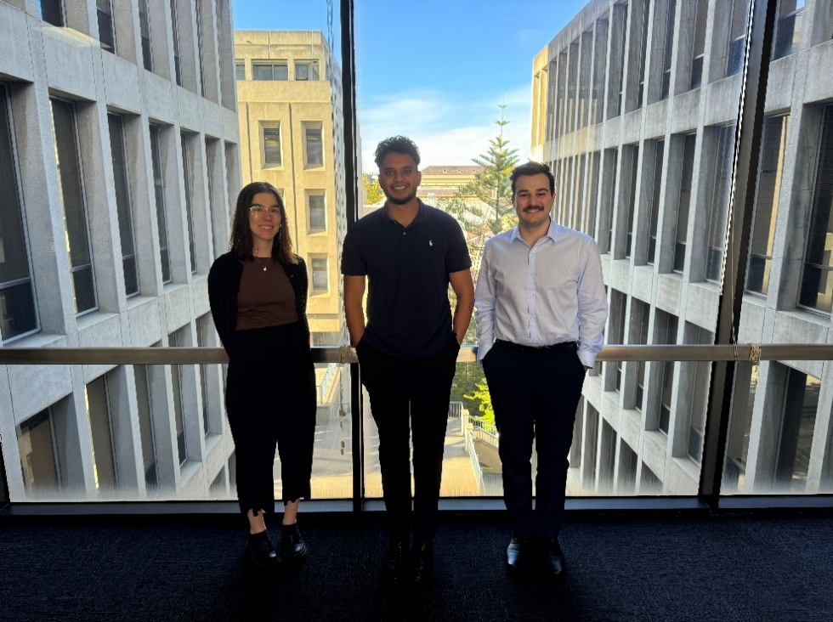

|  |  |  |  |  |  |  |
| --- | --- | --- | --- | --- | --- | --- |
|  | | | **Role:**  Georgia Culmsee  Senior Analyst  **Favourite Food:**  Pad Thai  **Favourite Holiday Destination:**  Spain. The scenery and architecture are so beautiful and unique, and I definitely want  to go back. | | | **Day in the life of working in AccPol:**  Each day working in AccPol comes with its own unique opportunities. I am exposed to a variety of different tasks, including facilitating training sessions, developing new accounting frameworks, quality reviews of DTF publications and ad hoc accounting advisory for the Victorian public sector. Going into work and facing new and exciting challenges each day keeps me engaged and supports me in evolving my skills. I also get to work alongside a great team every day and enjoy a coffee and chat from time to time. |
|  | | | | | | |
| **Role:**  Jai Sharma  Analyst  **Favourite Food:**  Love a good butter chicken and naan bread  **Favourite Holiday Destination:**  Wherever, just as long I have good vibes with me | **Day in the life of working in AccPol:**  Good energy and great work ethic. Our team is filled with accounting pros who are not only experts in their field but also supportive and collaborative. We have a variety of work to keep things interesting and new while still maintaining areas of huge growth and development. But more importantly, we are more than just numbers, we’re a team of foodies and adventure-seekers who love discovering the latest local restaurants and coffee spots. We’ve mastered the art of working hard and playing harder, and believe in enjoying the journey just as much as the destination. |  | | **Role:**  Spencer Anastassiou  Graduate  **Favourite Food:**  Chicken Katsu Curry  **Favourite Holiday Destination:**  Queenstown NZ – Amazing scenery and Fergburger (best burger  you will ever have) | **Day in the life of working in AccPol:**  Working in AccPol is a dynamic environment, since starting in February I've had the opportunity to work on a variety of different fun and challenging tasks. Some of these include calculating the wage Inflation and discount rates, preparing technical training slides, updating the team on technical accounting developments and managing the AccPol mailbox to respond to queries from across the public sector. The team are all amazing to work with and have been incredibly supportive in developing my skills. | |

# How to contact us

## AccPol mailbox

When directing accounting policy enquiries to DTF at [accpol@dtf.vic.gov.au](mailto:accpol@dtf.vic.gov.au), **departments** are requested to support their questions with the facts and with clear referencing to Accounting Standards, FRDs and other authoritative pronouncements related to their queries.

**Other entities** are requested to contact their portfolio department in the first instance to resolve any accounting policy issues.

## Useful websites

**AASB** – [aasb.gov.au](http://www.aasb.gov.au/) for information on AASB pronouncements, discussion papers and ED publications.

**IFRS Foundation** - [ifrs.org](https://www.ifrs.org/) for information on global accounting and sustainability developments.

**International Public Sector Accounting Standards Board (IPSASB)** – [ipsasb.org](https://www.ipsasb.org/) for information on IPSASB and IPSAS pronouncements.

## DTF website

**The DTF website (for all internet users)** – [www.dtf.vic.gov.au](http://www.dtf.vic.gov.au/) covers FRDs and guidance, Model Reports, wage inflation and discount rates etc. From the menu on the top of the home page, users should select Financial management of government, then Financial reporting policy.

**VPS users** should contact their portfolio department in the first instance for the login details to access the information relating to the Valuer General land and building indices.

For assistance with technical difficulties using the DTF website, e.g. broken links, please contact the DTF web team via email at [dtfweb@dtf.vic.gov.au](mailto:dtfweb@dtf.vic.gov.au)

## About the Accounting Policy Update

The Accounting Policy Update is published by the Accounting Policy team of DTF twice a year. The aim of the newsletter is to highlight changes in financial reporting requirements affecting public sector entities, outlining any financial reporting related policy decisions reached by DTF and to inform readers of other developments that are under consideration by the standard-setters.

Disclaimer: No responsibility is taken for any action(s) taken based on information contained in this Newsletter nor for any errors or omissions in that information.

Accounting Policy Update   
ISSN 2205‑4014

© State of Victoria 2025

[](http://creativecommons.org/licenses/by/3.0/au/)

You are free to re‑use this work under a [Creative Commons Attribution 4.0 licence](http://creativecommons.org/licenses/by/4.0/), provided you credit the State of Victoria (Department of Treasury and Finance) as author, indicate if changes were made and comply with the other licence terms. The licence does not apply to any branding, including Government logos.

Copyright queries may be directed to [IPpolicy@dtf.vic.gov.au](mailto:IPpolicy@dtf.vic.gov.au).