May 2025

Guidance on Adopting Model Legislative Provisions

Delegations Guidance Note

# How this document helps you

This document has been written for legislative and policy officers working with the Office of the Chief Parliamentary Counsel (OCPC) on new or amended legislative provisions in regulatory schemes.

The Department of Treasury and Finance (DTF) has prepared this document in collaboration with OCPC and in close consultation with departments and regulators. This document does not a provide a ‘one size fits all’ or mandated approach, but guides policymakers through the conceptual and legislative considerations to make it easier to develop legislative provisions suited to your needs and aligned with best practice.

DTF has partnered with OCPC to develop a clause bank of Model Legislative Provisions. This guidance note accompanies that clause bank and is focused on delegations, to promote consistency across Victoria’s regulatory environments.

# Delegations

Policymakers may seek to delegate decision-making authority within their legislation. This may occur for efficiency purposes and based on the risk which a particular legislative regime may seek to mitigate.

Delegations can range in scope from broad to narrow depending on the:

1. person or persons to whom a primary authority or decision-maker may delegate functions and powers
2. functions and powers that may be delegated, or
3. purposes for which functions and powers may be delegated.

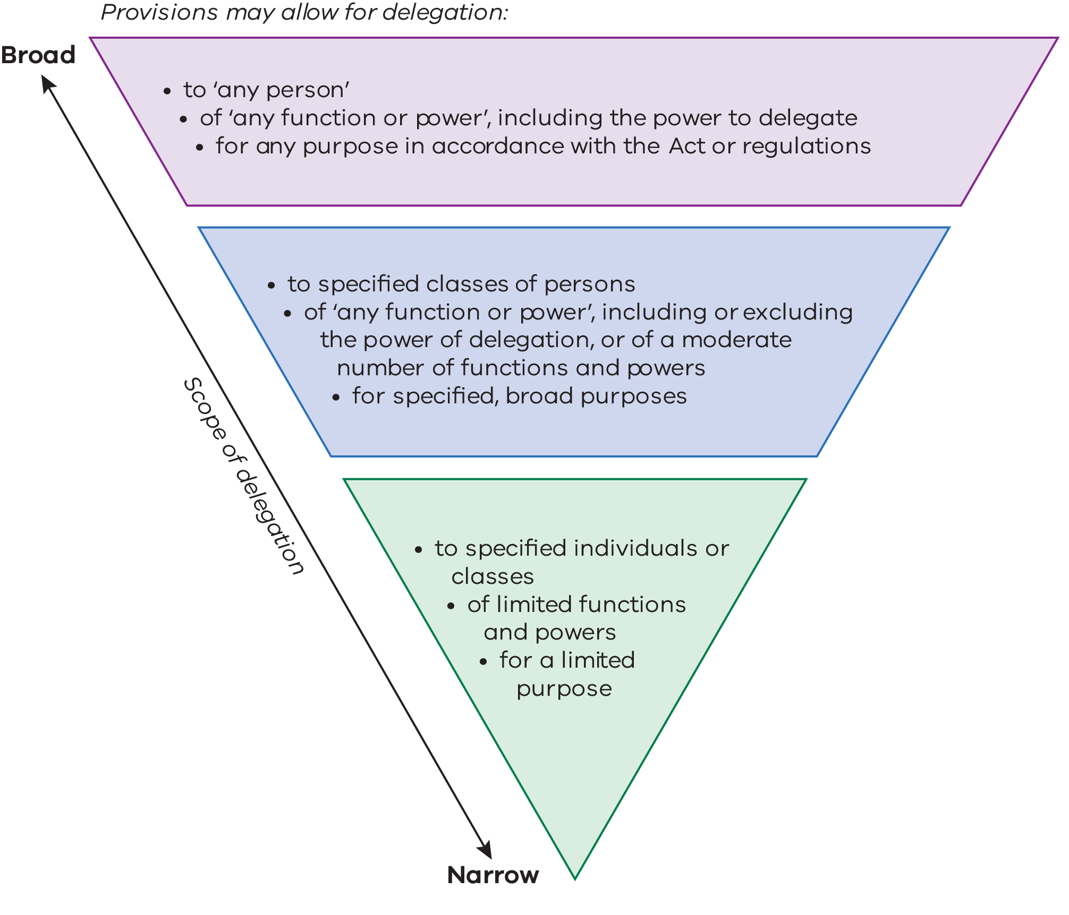

The appropriate scope of delegation varies depending on the functions and powers for delegation, and can be decided with reference to best practice principles below.

|  |  |  |
| --- | --- | --- |
| **Badge Tick with solid fill**  **Magnifying glass with solid fill** | Clear purpose in practice  Proportionality in practice | A narrower delegation may be appropriate where:   * the function being delegated is the function of decision making, and the decision requires the decision-maker (including any delegate) to hold specialised knowledge, skills and expertise.   + In such circumstances, it may not be appropriate for delegation to ‘any person’ or to broad classes of persons. It may be more appropriate to specify the particular persons or narrow classes of persons who possess the requisite knowledge, skills or expertise to make the delegated decision. * the functions or powers being delegated are exercised or performed in relation to high-risk activities (such as owning firearms, or voluntary assisted dying). |

The examples below demonstrate what broad, medium and narrow delegations may look like in practice.

### Broad

|  |  |
| --- | --- |
| Example | Under section 500 of the *Workplace Injury Rehabilitation and Compensation Act 2013*, WorkSafe Victoria may delegate any of its functions or powers to ‘any person’. A delegate of WorkSafe Victoria may further subdelegate functions or powers, subject to and with the approval of WorkSafe Victoria. |

### Medium

|  |  |
| --- | --- |
| Example | Under section 25 of the *Disability Service Safeguards Act 2018*, the Disability Worker Registration Board of Victoria may delegate any of its functions or powers, other than the power of delegation, to:   * a member of the Board * the Commissioner * an employee of the Commission, or * a committee established under section 19 of the Act. |

### Narrow

|  |  |
| --- | --- |
| Example | Under section 112F of the *Firearms Act 1996*, the Chief Commissioner may delegate the power to make a firearm prohibition order to specified persons (e.g. Deputy Commissioner) and classes of persons (e.g. a person who has the rank of commander). |

|  |  |
| --- | --- |
| Example | Under section 113 of the *Voluntary Assisted Dying Act 2017*, the Secretary may delegate their powers to determine an application for a voluntary assisted dying permit (or to amend a permit) to a specified class of persons, being a person or class of persons employed under Part 3 of the *Public Administration Act 2004*. |

Provisions allowing a primary authority or decision-maker to delegate their functions and powers also specify the mechanism of that delegation. Most commonly, a primary authority or decision-maker may delegate functions or powers ‘by instrument’ or ‘in writing’.

|  |  |  |
| --- | --- | --- |
| **Eye Scan with solid fill** | Objective and future-proofed in practice | Policymakers should balance the need to ensure provisions are technology-agnostic to the extent possible and against the need for instruments of delegation remain robust and capable of providing proof of the delegation. |

Policymakers should engage with OCPC to ensure their intended delegations are appropriate and fit for purpose.