# **Treasury Theatre booking request form**

**email: treasurytheatre@dtf.vic.gov.au**

Welcome to the Treasury Theatre, a cutting-edge venue situated at Lower Plaza, 1 Macarthur Street, East Melbourne. This state-of-the-art facility is offered for hire to Victorian Government departments and agencies, as well as external groups in exchange for a nominal fee.

## Location

### Map

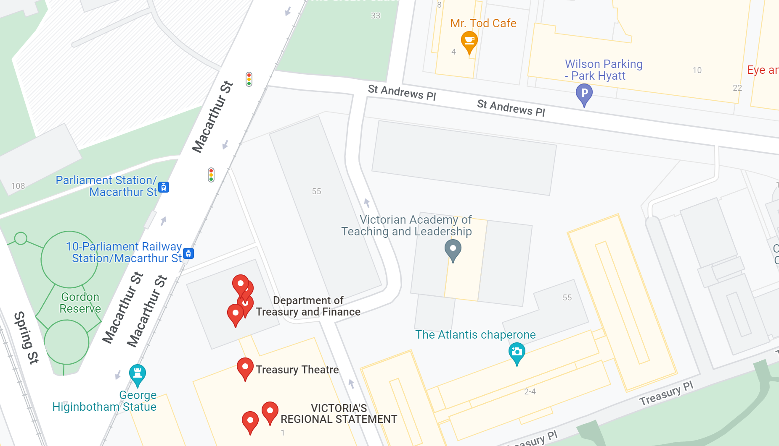

### Public transport

The Treasury Theatre is conveniently located a short walking distance of Parliament Station. Route 109, 11 and 12 trams and free City Circle trams have stops located near Parliament Station and at the corner of Spring and Collins Streets. Access to the theatre entrance is via stairs leading down from the Upper Plaza at street level, outside 1 Macarthur Street.

### Inclusion and accessibility

We are dedicated to ensuring a welcoming experience for all attendees. Wheelchair users can access the theatre through our Spring Street entrance (as shown below). Wheelchair lift access and ramps are in place to facilitate smooth navigation through the auditorium.

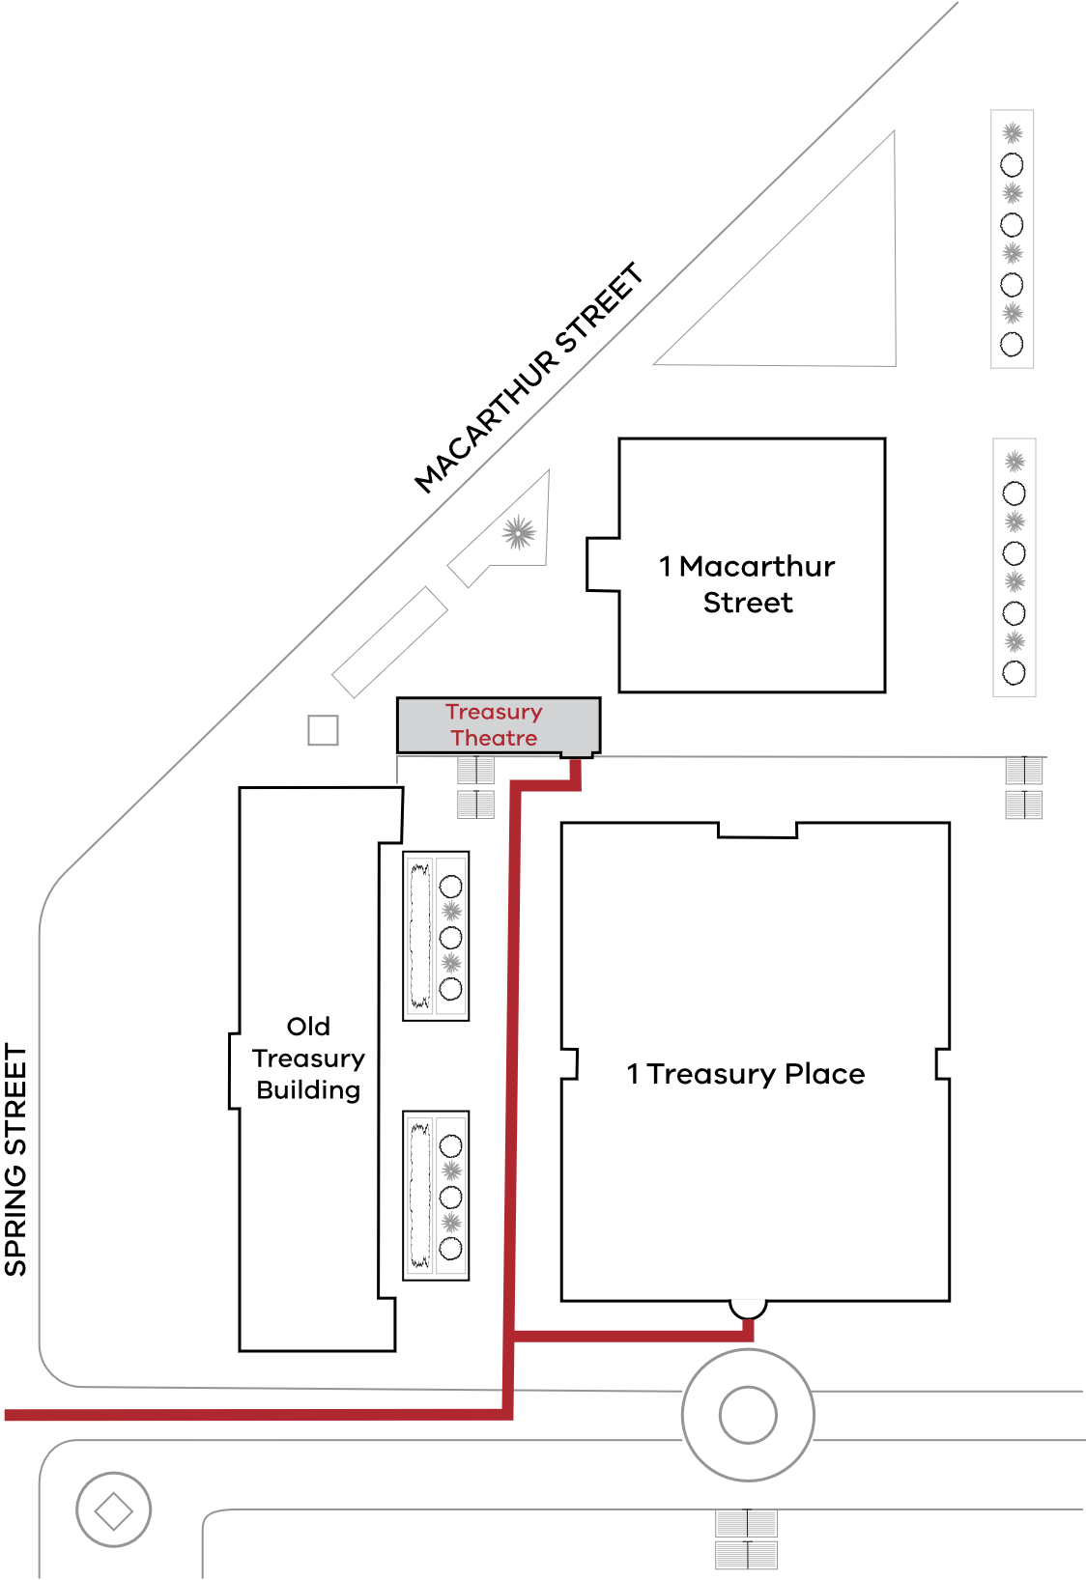

The auditorium is equipped with a state-of-the-art audio loop system. Designed to ensure accessibility for all, audio loop technology delivers crystal-clear sound directly to your hearing aids or assistive listening devices.

### Access to the theatre

The Security office at 1 Macarthur Street (to the right of the theatre entrance) will provide the event organiser with an access pass for the theatre at the start of the venue hire period.

## Theatre capacity

The auditorium can seat up to 216 guests, ensuring everyone enjoys a clear view of the stage. The spacious function area accommodates up to 153 standing guests, perfect for networking events and receptions.

## Hours of operation

Monday to Friday from 8am to 11pm, and on Saturdays, Sundays, and public holidays from 8am to 6pm. For times outside of these hours, arrangements can be made upon request.

## Schedule of rates

All rates are GST inclusive and are valid as at 24 July 2023

|  | Theatre hire (hourly rate) |
| --- | --- |
| Monday to Friday 8am–6pm | $230.00 |
| Monday to Friday 6pm–11pm | $340.00 |
| Saturday | $340.00 |
| Sunday | $340.00 |
| Public holidays | $340.00 |

## Function and bar area

Enhance your event experience with a reception in our open and inviting function area. A food preparation space equipped with fridges, dishwashers, storage, and ample bench space is available to meet your catering requirements.

Any required glassware, crockery, or cutlery must be arranged by the event organiser and removed at the conclusion of the event hire.

The venue also includes well-maintained and conveniently located toilet facilities for the comfort and convenience of your guests.

## AV equipment and technical support

A range of equipment is provided at the venue. This includes a full HD screen, theatre-quality speakers, a versatile webcam with pre-sets and manual pan-zoom, a podium microphone, portable and lapel microphones, console-controlled lighting and sound volume, HDMI input for laptops, broadcast free TV channels, screen mirroring in the refreshments area and the ability to connect your own laptop.

When their booking is confirmed, event organisers will receive a guide on how to use the theatre’s audio-visual system. Organisers who prefer to hire a technician to operate the audio-visual equipment, may do so at their own cost.

Technician support is available through Melbourne Audio Visual Event Specialists   
Phone: 03 9429 2058  
Web: <https://mav.com.au/about/>

**Technician Service Options:**

**Pre-Booked Technician:** Available at $240 per hour +GST, with a minimum 3-hour charge.

**Urgent Call-Out (No Pre-Booking):** Available at $240 per hour + GST, with a minimum 3-hour charge ($720 + GST minimum).

## Additional fees

A cleaning fee will be incurred if the venue is not left in a satisfactory condition immediately after the event. Also, please be aware that taking food or beverages into the auditorium is strictly forbidden.

## Parking

On-street paid parking and paid car parks (such as Wilson Parking Park Hyatt) are available within walking distance.

## Bookings

For all bookings and enquires please email treasurytheatre[@dtf.vic.gov.au](mailto:carbookings@dtf.vic.gov.au).

Tentative bookings created in our system are valid for a period of five business days, during this time you will need to complete and submit this form to confirm your booking. Failure to do this will result in the booking being cancelled in our system.

Cancelling or changing hours must be done in writing to treasurytheatre@dtf.vic.gov.au. Bookings may be cancelled up to four business days prior to the event without charge. The DTF Landlord reserves the right to cancel a booking without charge for hazardous, health or legal reasons, or if a senior Victorian Government official requires the theatre for a briefing or media conference. Event organisers will receive notification of cancellation.

## Catering

Event organisers are responsible for organising all catering services for their event. Caterer access to the theatre is possible by prior arrangement. Event organisers must provide the caterer’s contact information, including driver’s name, vehicle registration number and delivery and pickup times at least seven days prior to the event. Hospitality and reception areas must be cleaned of all rubbish and restored to their original state after use.

## Please note that

* We highly recommend that event organisers schedule a complimentary session to familiarise themselves with the theatre and its equipment prior to their event.
* Event organisers are required to obtain a liquor licence if any alcohol is to be served at the event.
* Report issues to: [treasurytheatre@dtf.vic.gov.au](mailto:treasurytheatre@dtf.vic.gov.au).

## Before you leave the venue

Event organisers must adhere to the following responsibilities:

* Ensure all areas of the venue are cleared of rubbish and restored to their original condition after use, as we do not have resources for interim clean-ups between events.
* Place all used glasses and jugs in the dishwasher and turn on.
* Ensure the air conditioning remains on in the Bio-box, as it is crucial for maintaining optimal conditions for the equipment housed within.
* Return all microphones and lapels to their charging stations, ensuring the charging indicator light is flashing.
* Turn off all lights and screens throughout the venue.
* Keep the screen curtains open to prevent the screen from overheating.

## Event details

|  |
| --- |
| Event name |
| Event date |
| Start time (includes set up time) |
| Finish time (includes pack up time) |
| The following audio-visual equipment is available at the venue. Any additional equipment must be outsourced at the organiser’s own cost.   * 1 x lectern with in-built microphone * 1 x HD screen * Ceiling-mounted stage lighting * 1 x ceiling-mounted data projector * 1 x web-enabled camera * 1 x wireless presenter’s remote * 2 x roving microphones * 2 x lapel microphones * 1 x multi-regional DVD player * 1 x central audio visual and lighting control system * Speaker system in the auditorium and function area * 1 x media screen in function area |
| Number of guests attending event (Mandatory field for Fringe Benefit Tax purposes)  Total number (approx.) Click or tap here to enter number of guests attending.  Victorian Government employees Click or tap here to enter number of guests attending.  Non-government employees Click or tap here to enter number of guests attending. |
| In case of emergency, will any of your guests require assistance to evacuate the building?  Yes  No  Unknown at time of booking |

## Victorian Government (internal) – billing information

|  |  |
| --- | --- |
| Contact (event organiser) | Click or tap here to enter text. |
| Victorian Government department/agency | Click or tap here to enter text. |
| ABN | Click or tap here to enter text. |
| Business unit | Click or tap here to enter text. |
| Address | Click or tap here to enter text. |
| Phone/mobile number | Click or tap here to enter text. |
| Finance contact | Click or tap here to enter text. |
| Finance phone number | Click or tap here to enter text. |
| Finance email | Click or tap here to enter text. |

## Financial delegate approval

**Mandatory field – must be completed and signed to confirm booking.**

|  |  |
| --- | --- |
| Financial delegate name | Click or tap here to enter text. |
| Position | Click or tap here to enter text. |
| Phone | Click or tap here to enter text. |
| Email | Click or tap here to enter text. |

I hereby approve the use of Treasury Theatre for this event. I agree to the technician service fees and will be invoiced accordingly if an emergency call-out is required.

|  |  |
| --- | --- |
| Signature |  |
| Charge code: | Click or tap here to enter text. |

## Organisations external to Victorian Government – billing information

|  |  |
| --- | --- |
| Business name | Click or tap here to enter text. |
| ABN | Click or tap here to enter text. |
| Address | Click or tap here to enter text. |
| Phone | Click or tap here to enter text. |
| Finance contact | Click or tap here to enter text. |
| Finance phone | Click or tap here to enter text. |
| Finance email | Click or tap here to enter text. |

## Department of Treasury and Finance – Land and Property

Office Use Only

|  |
| --- |
| Booking  Accepted  Declined  Reason booking has been declined  ……………………………………………………………………………………………………………………………….…….……………………………………………………………  ……………………………………………………………………………………………………………………………….…….…………………………………………………………… |