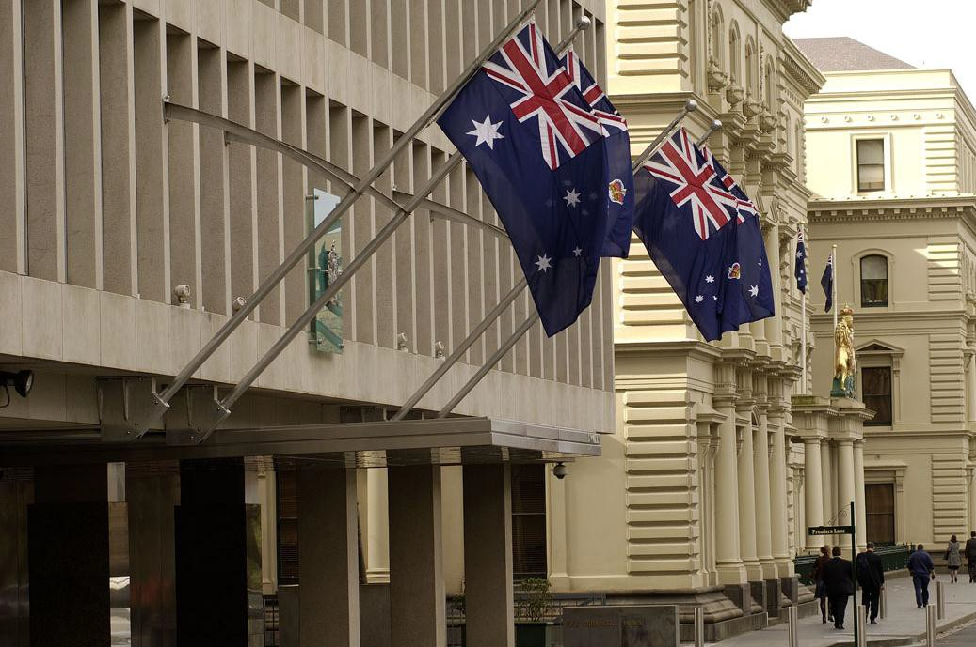

Treasury Reserve
Guidelines for filming and photography, May 2014 1

Treasury Reserve
Guidelines for filming and photography
2014

Treasury Reserve is a much sought after location for filming and photography. The Department of Treasury and Finance (DTF) supports filming and photography where it is compatible with government values, fosters realistic visitor expectations of Treasury Reserve and is consistent with government objectives.
The guidelines are set out below.

1.0 Purpose

The Treasury Reserve – Guidelines for filming and photography are designed to facilitate film, television and multimedia productions on or at Treasury Reserve while protecting the interests and operations of Treasury Reserve. The document provides a framework for media producers and includes objectives, guidelines and pricing structures.

  - Key objectives

Several key objectives have been identified as follows:

- to protect the locations, buildings, effects and assets of Treasury Reserve and Treasury Reserve tenants;
- to minimise the impact of filming and photography on Treasury Reserve operations;
- to ensure filming and photography is undertaken efficiently for the Production Company; and
- to facilitate the promotion of Victoria as a film-friendly location.

  - Context and scope

This document relates directly to filming and photography on or at Treasury Reserve. The scope includes filming of any locations, buildings both interior and exterior, but excludes tourist photography. Filming and photography includes both still and motion footage and filming in any recognisable form.

Definitions

Production Company producers of any multimedia productions

Facilities Manager the Department of Treasury and Finance’s Facilities Manager, DTZ
Production Company Staff all cast, crew, volunteers, subcontractors,
employees or individuals associated with the Production Company

Treasury Reserve the area set out in the attached map
Treasury Reserve Users tenants, contractors, visitors, and the general public.

2.0 Guidelines

The following guidelines have been developed to ensure that the key objectives are achieved. Adherence to these guidelines will contribute to a positive outcome for the Department of Treasury and Finance as owner, Treasury Reserve users and the Production Company. All communication in relation to applications covered by this document is to be with the Department of Treasury and Finance’s Facilities Manager:

Please email the DTZ Facility Manager on dtf.propertyadministration@ugllimited.com
with your expression of interest for utilising the facility for filming and photography.

Following your email the Application and Agreement forms will be emailed back to you to fill out.

Once the forms are filled out please email back for your application to be considered.

  - Notification

A minimum of seven days’ notice is to be given to the Facilities Manager for all filming and photography applications to be processed. This should be done via a Treasury
Reserve - Application for filming or photography.

  - Filming and photography locations

The proposed location and specific areas for filming and photography, and timing/scheduling must be set out in the Treasury Reserve - Application for filming or photography. No filming on Treasury Reserve beyond what appears in the Treasury Reserve - Application for filming or photography shall take place without the prior agreement of the Facilities Manager. Changes in timing or location due to circumstances beyond the control of the Facilities Manager shall not take place without prior agreement with the Facilities Manager.

Insurances

All Production Companies are required to provide evidence of appropriate insurance including public liability and damage and loss as set out in this document. Insurance documents should accompany the Treasury Reserve - Application for filming or photography. Approval for filming or photography will not be granted if these documents are not sighted.

Public liability

The Production Company must provide a Certificate of Currency, noting the interests of the Department of Treasury and Finance, for public liability insurance of not less than AUD$10,000,000.

Indemnity

The Production Company agrees to indemnify the Department of Treasury and Finance in respect of any loss suffered by them caused by the Production Company or the Production Company Staff.

Working with tenants, visitors and the general public

Disruption to Treasury Reserve Users needs to be kept to a minimum. Therefore, detailed activities of filming and photography locations and needs must be stated on the Treasury Reserve - Application for filming or photography, so that effects on operations may be analysed and if necessary, alternate options discussed.
It is essential that Production Company Staff conduct themselves with courtesy, sensitivity and consideration of the needs of Treasury Reserve Users at Treasury Reserve locations whilst filming.

The Production Company must also stay in constant liaison with the Facilities Manager to ensure that Treasury Reserve Users are treated in a positive manner and to ensure that activities are undertaken in accordance with the terms and conditions as specified in the Treasury Reserve - Guidelines for filming or photography, the Treasury Reserve - Application for filming or photography, and the Treasury Reserve - Location agreement for filming or photography.

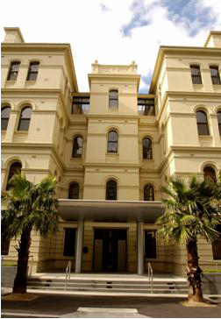
Production Company Staff should not, under any normal circumstances or without the express permission of the Facilities Manager, approach Treasury Reserve staff members.

Smoking

Smoking is not permitted in any internal or external area of Treasury Reserve except in an area that is designated by mutual agreement between the Facilities Manager and the Production Company.

Cast and crew responsibility

The conduct and behaviour of all Production Company Staff is the responsibility of the Production Company. The Department of Treasury and Finance will not take any responsibility for misconduct or poor behaviour of

any Production Company Staff. All Production Company Staff must stay within the locations specified in the Treasury Reserve - Application for filming or photography whilst on Treasury Reserve.

Physical assets

All physical assets located within Treasury Reserve are to be treated with the utmost care. No tape, adhesive, nails, tacks or other substance or material is to be affixed to any surface (either interior or exterior) without prior authorisation from the Facilities Manager.

Equipment

The Department of Treasury and Finance accepts no responsibility for damage to, or loss of, any equipment brought onto, or left at, Treasury Reserve by the Production Company, prior to, during or after filming or photography.

All power leads from equipment must be secured by an appropriate method that does not entail the taping or affixing to any surface (including external surfaces), unless otherwise instructed to do so by the Facilities Manager.

It is the responsibility of the Production Company to supply all necessary equipment including all lighting requirements and power leads.
Reasonable care must be taken at all times when setting up and dismantling equipment, to ensure safety of persons and protection of Treasury Reserve property.

Sound

Sound vibration from equipment and noise levels, must at all times be kept to a reasonable level as determined by the Facilities Manager.

Removal, disturbance or relocation of property

No fittings, furnishings or objects not belonging to the Production Company are to be moved without the prior consent of the Facilities Manager.

Post-filming inspection

At the conclusion of filming or photography the Production Company will, in a timely manner, ensure that all Treasury Reserve property is reinstated to its original condition to the satisfaction of the Facilities Manager and that all of the Production Company’s property and all rubbish is removed from the site.
Prior to the departure of the Production Company after each day’s filming is completed, the Facilities Manager, together with a representative of the Production Company, will undertake a site inspection to ensure compliance with this clause.
A report/checklist, to be signed by both the Facilities Manager and the Production Company’s representative, must be completed as part of the site inspection, and particularly note and agree those actions that are required by the Production Company to address any areas of concern and rectification and timing thereof.

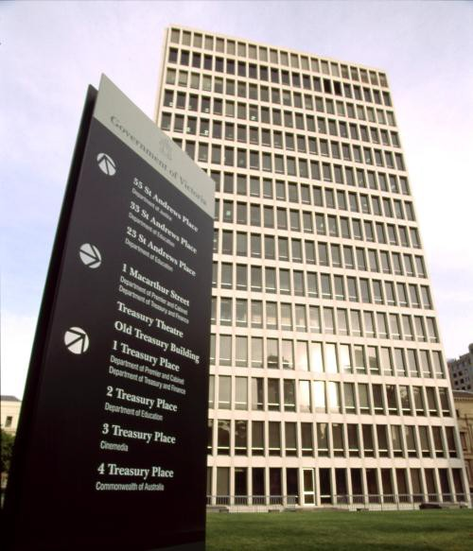
Compensation for damage or loss

The Production Company will be liable to cover any reasonable costs, to the satisfaction of the Facilities Manager, or provide full compensation for any loss or damage to the locations, buildings, both interior and exterior.
In the case of loss or damage the Production Company will accept the decision of the Facilities Manager as to the reasonableness of the cost of making good any damage or as to the amount of full compensation.

Safety

The highest level of work safety will need to be adhered to by all Production Companies whilst filming at Treasury Reserve. The Department of Treasury and Finance requires all productions to prepare a safety report in regard to the proposed filming activities at Treasury Reserve in accordance with the relevant film and television codes and the key Victorian occupational, health and safety acts. A copy of the proposed safety report must be attached to the Treasury Reserve - Application for filming or photography, with the final safety report made available to the Facilities Manager at least three (3) days prior to filming.

Use of images

Images of Treasury Reserve may only be used for the purposes stated on the Treasury Reserve - Application for filming or photography. Unauthorised use of images is not permitted under any circumstances.

Digitally altering images

Unless approved in writing by the Facilities Manager, digitally altering any image of any part of Treasury Reserve or any property belonging to Treasury Reserve is not permitted, except for enhancement of an image by altering the light, colour or shade.

Parking, production, and technical space

Parking space on Treasury Reserve is strictly limited and cannot be guaranteed. All parking, production and technical space required for filming must be stated and specified within the Treasury Reserve - Application for filming or photography. Permission for additional areas that are required, and not included within Treasury Reserve, must be sought through the relevant governing bodies.

Signing of documentation

An authorised representative of the Production Company must sign all documentation including the Treasury Reserve - Application for filming or photography, the Treasury Reserve - Location agreement for filming or photography and any damage reports completed by the Facilities Manager.

Supervision

The Facilities Manager will appoint, if it deems necessary, a supervisor as the primary point of contact for location filming and photography during production set up, pack up, as well as during filming or photography.

The role of the supervisor is to ensure that the agreed guidelines and conditions are followed, and to ensure the safety and the integrity of Treasury Reserve and its contents. The cost of supervision will be at the Production Company’s expense.

Security

The Production Company must at all times while on, or in dealing with matters affecting the Treasury Reserve, comply with all relevant security policies, procedures and instructions as directed by the Facilities Manager.

The Production Company must be aware that due to the dynamic nature of security-related risks on Treasury Reserve, events or incidents may occur which require an immediate change in arrangements or cessation of use of the Treasury Reserve by the Applicant. In such instances, the Applicant must obey all lawful instructions given by the Facilities Manager, Victoria Police or other authorised persons.

The Facilities Manager may also, if it deems necessary, require a registered security guard of its choice on location at all times during production set up and pack up, as well as during filming. The cost of this security will be at the Production Company’s expense.

Failure to comply with these guidelines

Failure by the Producer to comply with any provision in the Treasury Reserve - Application for filming or photography or the Treasury Reserve - Guidelines for filming or photography shall entitle DTF to immediately terminate the Treasury Reserve - Location agreement for filming or photography in which case the Producer’s rights to film on the Treasury Reserve are immediately withdrawn.

Sensitive / offensive issues

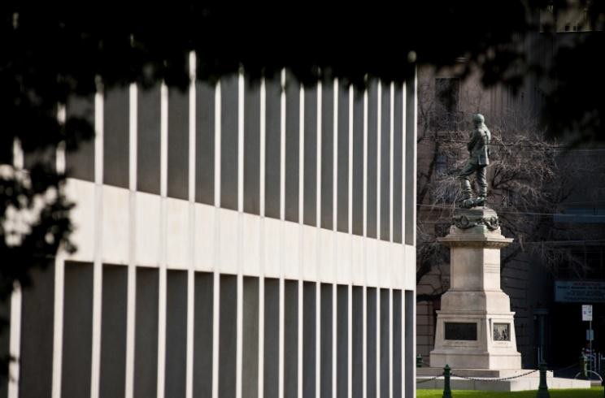
Any issue(s) in relation to the content of what is being filmed or how it is going to be used, which could be considered sensitive or offensive to the Victorian Government or to Treasury Reserve Users is to be detailed in an attachment to the Treasury Reserve - Application for filming or photography and is to be discussed with the Facilities Manager prior to approval being granted. Sensitive or offensive issues would include nudity, violence, smoking, content with political or racial implications.

3.0 Fees

If the Treasury Reserve - Application for filming or photography is approved by the Department of Treasury and Finance the appropriate fee must be paid upon submission of the signed Treasury Reserve - Location agreement for filming or photography, which shall be at least 72 hours prior to the initial date of filming.

A bond may be applied based on an assessment of risk to, or adverse impact on, Treasury Reserve and its occupants, and to ensure that the Production Company follows the terms and conditions in the Treasury Reserve - Location agreement for filming or photography. The value of the bond will be based on the duration of the proposed filming or photography, but the minimum would generally be the equivalent of the half-day fee.
Fees are charged at a flat rate of $880.00 (inclusive of GST) per full day, or $440.00 (inclusive of GST) per half day (5 hours) or part thereof. Fees will not be refunded other than in situations where filming is delayed or prevented as a result of circumstances beyond the control of the Facilities Manager.
A bond, if applied, will be returned to the Production Company within 14 days, if not required under the terms of sections 2.13 and 2.14.

Additional costs

The fees exclude the cost of any supervision and security and any other additional costs deemed necessary by the Facilities Manager and pre-agreed with the Production Company. These costs shall be at the Production Company’s expense and will be charged at the current Government contract rate.

Fee waiver

Fee waivers may apply in the following circumstances:

- student films and photography;
- documentaries and educational films;
- projects related to charitable or civic activities;
- film-making for news and current affairs purposes;
- filming for personal interest of an amateur nature; and
- weddings and other personal celebrations.
If location fees are waived, charges may still be payable for additional costs such as insurance, security, supervision and the moving or relocation of physical items. Any Production Company seeking to have fees waived must attach a written submission to the Treasury Reserve - Application for filming or photography stating the rationale for the fee waiver request.

Treasury Reserve precinct

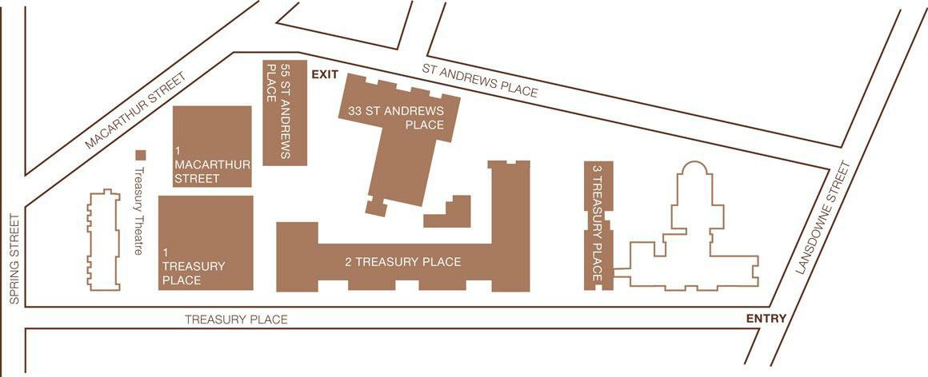

Treasury Reserve - Guidelines for filming or photography, are available online at
www.dtf.vic.gov.au

Treasury Reserve - Application for filming or photography and Treasury Reserve - Location agreement for filming or photography is supplied once an email is sent to:

dtf.propertyadministration@ugllimited.com

Published by the Department of Treasury and Finance © State of Victoria 2014
This publication is copyright. No part may be reproduced by any process except in accordance with the provisions of the Copyright Act 1968.
Published May 2014

