Investment Management Standard 2017
A guide for Victorian government departments and agencies

The Secretary
Department of Treasury and Finance
1 Treasury Place
Melbourne Victoria 3002
Australia
Telephone: +61 3 9651 5111
Facsimile: +61 3 9651 2062
dtf.vic.gov.au

Authorised by the Victorian Government
1 Treasury Place, Melbourne, 3002

© State of Victoria 2017
You are free to re-use this work under a Creative Commons Attribution 4.0 licence, provided you credit the State of Victoria (Department of Treasury and Finance) as author, indicate if changes were made and comply with the other licence terms. The licence does not apply to any branding, including Government logos.

Copyright queries may be directed to IPpolicy@dtf.vic.gov.au

ISBN 978-1-925551-02-0
Published May 2017

If you would like to receive this publication in an accessible format please email information@dtf.vic.gov.au

This document is also available in Word and PDF format at dtf.vic.gov.au

Contents

Table of Contents
Information for users 1
1. Introduction 2
1.1 What is the purpose of the Investment Management Standard (IMS) Guide? 2
1.2 What is the IMS? 2
1.3 What is the IMS ‘line of enquiry’? 3
1.4 What are the differences between IMS edition 5.0 and IMS 2017? 3
1.5 When should the IMS be used? 4
1.6 What is the link between investment management and project management? 4
1.7 Who should use this guide? 5
2. Key IMS principles 6
2.1 Introduction 6
2.2 Pooling knowledge – the IMS workshop suite 6
2.3 Depicting the investment story – the Investment Logic Map 7
2.4 Defining the benefits – the Benefit Management Plan 8
2.5 Keeping track of project complexity and fuzziness 9
2.6 The IMS and service and asset planning 12
3. IMS workshops and document suite 13
3.1 Investment Management workshop suite 13
3.1.1 Problem Definition Workshop 13
3.1.2 Benefit Definition Workshop 13
3.1.3 Response Definition Workshop 13
3.1.4 Solution Definition Workshop 14
3.2 Documents produced 14
Investment Logic Map 14
Benefit management plan 15
Response options analysis report 15
Investment concept brief 15
3.3 Number of workshops 15
3.4 Timing of workshops 17
3.5 Addressing risk and uncertainty 17
3.6 Addressing relevant policy levers 18
3.7 Engaging the key players 19
3.8 Preparation 19
Problem Definition workshop 20
Benefit Definition workshop 20
Response Definition workshop 20
Solution Definition Workshop 20
3.9 Selecting a facilitator 20
3.10 Piecing it all together – a systems view of the IMS 21
4. Investment Management Standard practices 23
4.1 Shaping a new investment 23
Intent 23
4.2 Prioritising investment proposals 27
Intent 27
Business context 27
Benefits of using this practice 27
General approach 27
4.3 Developing a new policy 30
Intent 30
Business context 30
Benefits of using this practice 31
General approach 31
The steps in developing new policy 31
4.4 Monitoring and measuring the delivery of benefits 31
Intent 31
Business context 31
Benefits of using this practice 32
General approach 32
The steps in monitoring and measuring the delivery of benefits 32
4.5 Evaluating a program of investment 34
Intent 34
Business context 34
Benefits of using this practice 34
General approach 34
The steps in evaluating a program of investment 35
4.6 Refocusing an organisation to improve its effectiveness 36
Intent 36
Business context 36
Benefits of using this practice 36
General approach 36
4.7 Monitoring an organisation’s outcomes 39
Intent 39
Business context 39
Benefits of using this practice 39
General approach 39
The steps in monitoring organisational outcomes 40
5. Support in adopting the practices 42
5.1 Getting started 42
5.2 How to become an accredited facilitator 42
5.3 Ongoing support for facilitators 43
5.4 Templates, examples and case studies 43
Appendix 1: 16 Questions - Investment decision-makers’ checklist 44
16 Questions – Investment decision-makers’ checklist 45
Appendix 2: Fictional IMS suite of documents 46
Investment Logic Map 46
Benefit Map – Benefit Management Plan 47
Benefit Profile – Benefit Management Plan 48
Response Options Analysis Report 51
Investment Concept Brief 57
Appendix 3: Benefit framework 58
Glossary 60
Further information 65

Information for users
The Victorian Government’s Investment Management Standard (IMS) is on the Department of Treasury and Finance’s website (www.dtf.vic.gov.au/investmentmanagement). This site has all current practices, definitions and templates and a wide range of examples and tools.
This IMS Guide summarises the key contents of the website for those people who require a hard copy. It does not contain all the information available on the website and is updated less frequently.
DTF will update this Guide from time to time to reflect significant changes in the IMS. The date of the current update is shown on the front cover.

    - Introduction
      - What is the purpose of the Investment Management Standard (IMS) Guide?
This Investment Management Standard (IMS) Guide:
    - overviews the IMS for new and returning users;
    - illustrates how the IMS fits with other Victorian Government investment processes; and
    - describes the main uses of the IMS practices.
The IMS supports the general needs of government departments, agencies, stakeholders, and others who have a fundamental interest in achieving benefits, and resolving problems. It is particularly, although not exclusively, targeted at those developing business cases as part of the Victorian Government budget cycle.
The supporting IMS Technical guides for facilitators contain more detailed information to support IMS workshop facilitators.
      - What is the IMS?
The IMS is a process for applying simple, common-sense ideas and practices that help organisations direct their resources to achieve the best outcomes from their investments. It supports Government to identify and select the investments that provide the most benefit to society.
When first developed, Government largely used the IMS to help shape individual investments. It can now support all the primary investment decision-making functions of an organisation including:
    - shaping a new investment;
    - prioritising investment proposals;
    - developing new policy;
    - monitoring and measuring the delivery of benefits;
    - evaluating a program of investment;
    - refocusing an organisation to improve its effectiveness; and
    - monitoring an organisation’s outcomes.
Consequently The IMS broadly defines investment as:
‘the commitment of the resources of an organisation with the expectation of receiving a benefit’.
The Victorian State Government sector widely uses the IMS, and it has been adopted (either wholly or in part) in many other jurisdictions as well as by commercial, academic and not-for-profit organisations.
The IMS practices can be applied to any investment, whatever its type, complexity, or cost and is aligned with the Victorian Department of Treasury Investment Lifecycle and High Value/High Risk (HVHR) framework, business case guidelines and templates.
      - What is the IMS ‘line of enquiry’?
The IMS is underpinned by a ‘line of enquiry’ (Figure 1) which helps decision-makers determine whether:
    - there is a real, evidence-based problem that needs to be addressed now;
    - the benefits which will be delivered through successfully addressing the problem are of high value to the organisation and the community;
    - the benefits’ KPIs are meaningful, measurable and attributable to the investment and are worth tracking and reporting;
    - the way the problem will be addressed is strategic, feasible, and innovative;
    - the solution is likely to be delivered within time and budget constraints; and
    - the solution can be applied flexibly to manage uncertainty and adapt to changing conditions and demand.
Figure 1: IMS line of enquiry
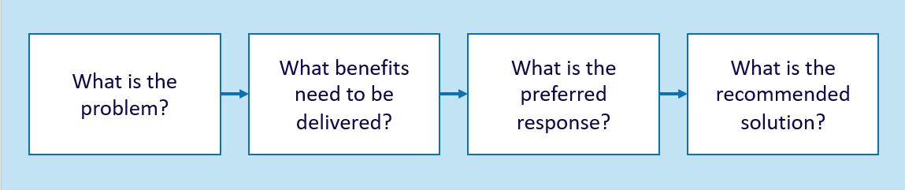
The IMS workshop suite is critical to pursuing this line of enquiry. There are between one and four IMS workshops that develop a shared, evidence-based ‘investment story’, and generate the IMS document suite, including an Investment Logic Map. The number of workshops is determined by the scale, risk and complexity of the problem, and the investment proposal. This Guide describes these workshops in more detail.
      - What are the differences between IMS edition 5.0 and IMS 2017?
IMS practices are not static but continue to evolve and improve. This 2017 update is the latest evolution of the Standard, and is the first IMS review since 2013.
Over this period there has been an increased focus on improving the planning and delivery of infrastructure investments, and on using real options analysis to manage related uncertainty. In response, the Department of Treasury and Finance has updated its HVHR framework to provide advice on incorporating real options analysis when developing business cases and procurement strategies.
The 2017 update reflects these changes and includes several enhancements to refine the workshop process and the development of the IMS document suite. These incorporate the feedback and experiences of both those involved in the IMS workshops and the ILM end-users. The major changes are:
    - more detailed advice on preparing for a workshop;
    - clearer definition of the preferred participant types for each workshop;
    - greater and more explicit consideration of uncertainty during the workshops including identifying investments which may need real options analysis;
    - increased focus on determining the quality and availability of evidence throughout the workshop process;
    - a reshaped and more robust Benefit Definition workshop which tests alignment with Government policy, or other relevant strategic drivers, and focuses on the integrity of KPIs and measures;
    - restructure of the Response Definition and Solution Definition workshops to clarify the objectives of each and to ensure both are more intuitive, robust and make a valuable contribution to decision-making;
    - consequential changes to the supporting documentation for all the workshops; and
    - amendments to the 16 questions – Investment decision-makers’ checklist (Appendix 1) to include more consideration of uncertainty and reflect the changes described above.
      - When should the IMS be used?
The IMS is targeted at the earlier stages of investment development where there is the greatest ability to influence and improve outcomes, and drive maximum value for the effort and resources invested. However, the IMS is applicable at all stages of an investment, as illustrated in Table 1.
Table 1: IMS and investment stages
Stage of investment | Use
Planning | To analyse and/or create a proposal (including development of a project, program or policy).  To develop a funding submission for government consideration (e.g. strategic assessment, preliminary business case, full business case).  To build organisational skills in investment management practices or facilitate investment proposal development.
Delivery | To promote better investment and project management at a high level, and to coordinate investment functions and improve organisational efficiency or productivity.
Evaluation | To support the monitoring and evaluation of investments, projects or programs.  To support the measurement of the success of an investment.
      - What is the link between investment management and project management?
Investment management and project management are complementary disciplines that, together, enable investors to shape and implement successful investments. The different emphases of each are illustrated in Table 2.
Table 2: Alignment between investment and project management
Investment Stage | Investment Management questions | Project Management questions
Planning | Is the logic for the planned investment clear?  Is there a sound case to invest?  Have we defined the best solution?  Have we considered how to respond to uncertainty? | Do we have the resources to deliver the solution?  Do we understand risks to project delivery?
Delivery | Does the problem still exist and do we still care about it?  Do we need to reassess how we measure benefit delivery?  Do we need to re-shape the investment to respond to exogenous changes or increased uncertainty? | Will the project complete within budget?  Will it deliver to its planned schedule?
Evaluation | Were the intended benefits delivered? | Were the expected products or services delivered?
      - Who should use this guide?
This IMS guideline targets both internal and external stakeholders to the public sector, as well as those who provide services to the public sector. The supporting technical guides target facilitators who conduct the IMS workshops and produce the outputs of those workshops. The IMS guidelines are designed to be useful for those with varying levels of investment knowledge and a range of requirements.

    - Key IMS principles
      - Introduction
The IMS is grounded on three principles:
    - The best way to pool knowledge is through an informed discussion that brings together those people with the most knowledge of a subject;
    - The ‘investment story’ is best depicted on a single page using language and concepts that can be understood by a lay person; and
    - Each investment should have clearly defined benefits that align with the outcomes the organisation is seeking.
These principles drive the design and purpose of three critical elements of the IMS, the:
    - IMS workshop suite;
    - Investment Logic Map; and
    - Benefits Management Plan.
      - Pooling knowledge – the IMS workshop suite
Many organisations use complex and compliance-based processes to standardise and increase the rigour in shaping new investments. While providing considerable value, these processes often fail to harness the full range of knowledge available to the organisation. The IMS workshop suite enables discussions which are:
    - Informed – they require the investor (the person who has the business problem and will be responsible for achieving the benefits) and those with the most knowledge of the operating environment, the strategic priorities of the organisation, and its stakeholders to participate;
    - Evidence-based – each statement in the investment story must be supported by evidence. Typically, this evidence is already available and simply needs to be gathered in advance and applied in the workshops to build a robust case;
    - Decisive - the practices are structured to address a sequence of decisions that are fundamental to the potential investment. It is not possible to move along the IMS ‘line of enquiry’ (Figure 1) without substantively concluding the previous stage;
    - Focused – each discussion is no longer than two hours. This has been found to be short enough period to obtain the time commitment of senior people, and a long enough period to extract, and agree, an investment story;
    - Immediate – the workshop outputs are concluded within 48 hours of the workshop. During this period the decisions made are circulated and any outstanding matters are discussed and resolved using electronic channels;
    - Clear – the story of the investment is told in plain English and using concepts that can be understood by a lay person; and
    - Facilitated – an independent facilitator is responsible for providing appropriate advice in respect of workshop preparation, evidence requirements, process, and participants; extracting and telling the investment story in a way that will maximise its value to the organisation; and generating the workshop outputs in approved templates.
      - Depicting the investment story – the Investment Logic Map
The logic expressed in business cases is often not sufficiently robust. Some strongly articulate the need to invest but cannot explain how they arrived at the proposed solution. Others describe the solution in detail but fail to identify, or substantiate, any real impetus for change. Many do not describe the investment’s expected benefits, or how these benefits will be measured.
The IMS identifies four primary elements of an investment proposal (problem, benefit, response, and solution) and connects these in a stream of logic (Figure 2). Each of these elements has a dedicated workshop in the IMS workshop suite.
Figure 2: IMS logic flow- the four elements of an investment story
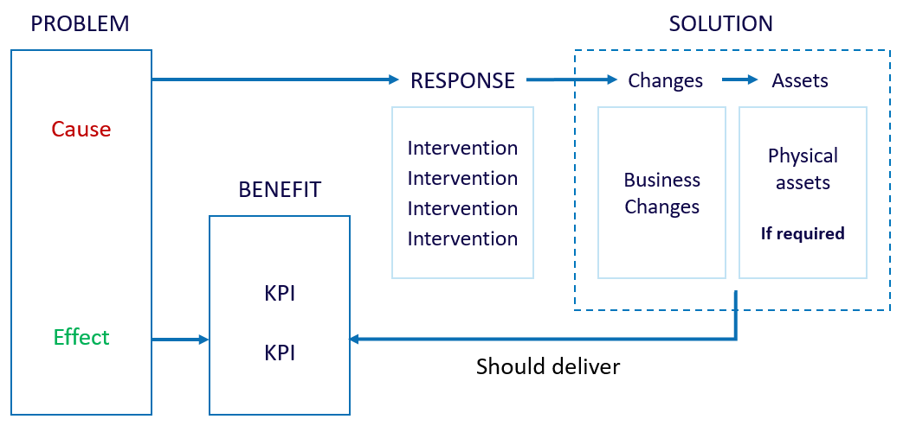
An Investment Logic Map (ILM) depicts this logic stream on a single page, using language and concepts that are understandable to a lay person (Figure 3). This is the printed equivalent to the 30-second elevator discussion when you are asked, ‘Tell me about your investment?’.
Figure 3: Investment Logic Map (extract)
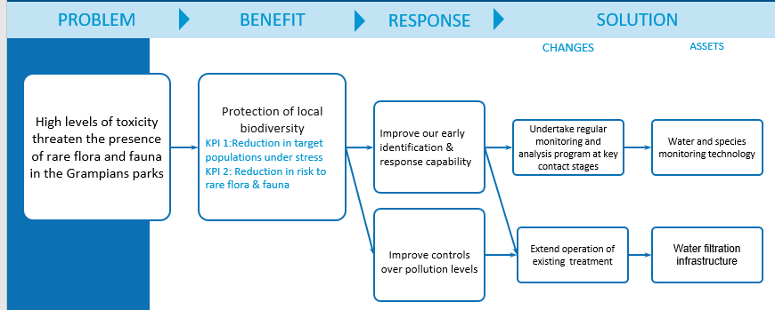
There are three versions of the ILM with each one communicating the story at a different level – for an individual investment, for a program of investment and for an entire organisation.
Other documents support an ILM, including a Benefit Management Plan, Response Options Analysis Report, and Investment Concept Brief (See Appendix 2 for an example of an initiative level suite of documents). The most important of these is the Benefit Management Plan, which is described in more detail in the next section.
If an investment proceeds, the project team should update all IMS documents to reflect any new analysis and understanding which emerges during business case development. Gateway Reviews have regularly reported the failure to update IMS documents and has often undermined confidence in the case for investment.
      - Defining the benefits – the Benefit Management Plan
The only reason an organisation makes an investment is to achieve outcomes. It is therefore critical that organisations can select and shape investments which provide the best possible outcomes, and can subsequently demonstrate that they have actually achieved these outcomes.
Within the IMS, these outcomes are the investment’s benefits and KPIs. These must drive the solution rather than the solution defining what is achievable. This focus on delivering public value is the IMS’ critical point of difference.
The IMS starts by clearly defining the problem, or impetus for investment, and then focuses on the benefits that will be achieved through successfully addressing the problem. Each benefit is supported by KPIs that will provide the evidence that the benefits are ultimately delivered, and the problem has been adequately addressed.
It is not enough, however, just to identify a KPI. The IMS also requires investors to specify how the KPI will be measured and to establish baselines and targets for these measures (Figure 4).
Figure 4: Alignment of problem, benefit, KPI and measure
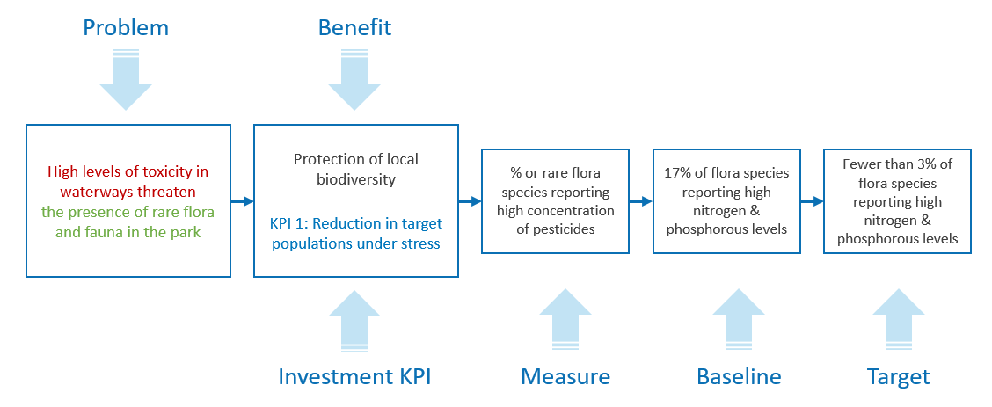

Clearly defining the KPIs and their measures is a necessary precursor to identifying the types of interventions that will comprise the investment. For example, in Figure 4, it is important to select interventions that will reduce concentrations of pesticides to the extent required to improve the presence of flora and fauna in the park.
A Benefit Definition Workshop (the second workshop in the IMS workshop suite – see Section 3) is used to identify the KPIs, measures, baselines and targets that must be achieved if the effect of the problem is to be mitigated. This workshop produces the first iteration of the Benefit Management Plan (BMP) that, like the ILM, will evolve as the investment develops (See Appendix 2 for an example of a Benefit Management Plan).
Within large organisations it is often difficult to define how each individual investment contributes to the organisation’s primary rationale, and to see the alignment between an investment and the organisation’s existing performance measures. The benefit framework (see Appendix 3) is a three-level structure that links the contribution of an individual investment to the outcomes the enterprise is seeking. This framework demonstrates a line of sight from investment level indicators to the benefits an organisation aims to achieve, and then to the outcomes sought by government.
      - Keeping track of project complexity and fuzziness
Investment decisions are typically complex. There are a range of internal and external factors that can influence why a problem exists, and when and how to best address it. The IMS’s explicit function is to distil the core elements of a problem and communicate a clear and simple investment story. Its value is its ability to present a complex issue in an uncomplicated way that is easily-digested by the investor, Government or other stakeholders. It is a simple investment overview that can help the Investor or Government decide if the problem or service need is sufficient to warrant further consideration, such as business case development.
The investor, and those shaping the argument for investment, will naturally make a range of assumptions when distilling a project to its core elements. During IMS workshops, participants are likely to discuss a wide range of factors that could impact an investment. By design, the final IMS products will largely distil these elements to produce a clear, simple narrative that will not always convey the uncertainty that underpins it.
Whilst it may be acceptable practice to develop an investment for an assumed future state at the investment conceptualise (preliminary business case) stage, the final business case must robustly test these assumptions and provide options for managing them.
One of the most significant changes introduced in this 2017 IMS update relates to how it treats uncertainty. This reflects a greater emphasis on dealing with uncertainty throughout the Victorian Government’s broader investment management practices.
Under previous editions of the IMS, participants were not explicitly required to consider how uncertainty impacts their investment (although it was commonly discussed within the workshops). Where the discussion did raise issues relating to how external forces may impact a problem or response, this discussion trail was sometimes lost from the investment logic or narrative as the IMS template provided nowhere to record it. Where participants identified significant uncertainty in an investment strategy, they typically defined this uncertainty from a risk perspective. This did not necessarily ensure the subsequent business case addressed it effectively.
Under the 2017 edition, DTF requires participants to consider uncertainty during each IMS workshop. Participants should consider how their investment may be impacted by uncertainty, and how the preferred response might change if assumptions don’t hold or future conditions do not unfold as expected.
    - Requirement: If uncertainty is identified during any workshop, this should be captured within the workshop outputs, and must be considered, tested and addressed in the business case (if the proposal proceeds to that stage).
This requirement relates to any type of investment proposal. Early consideration of how changing circumstances may impact the optimal response to achieve benefits can benefit any project type. By designing an investment to anticipate change and/or respond advantageously to changing conditions, an organisation can minimise its, or government’s, obligations under negative conditions, and take advantage of opportunities.
DTF has made this framework change to recognise the critical influence uncertainty can have on investment success. DTF also recognises that the IMS, as a stand-alone product, explicitly and by design does not address significant uncertainty. The preferred option and alternatives identified in the solution definition workshop assume an expected future state, making it difficult to explore alternative investment trajectories and real options within the set of IMS process. If significant uncertainty is identified a different set of tools may be needed to inform investment options.
    - Requirement: If the uncertainty identified is significant, and the proposal is asset-related, DTF expects departments to undertake real options analysis to inform business case development.
Important note: Although agencies are required to consider the impacts of uncertainty on non-asset based investments, they are not required to undertake real options analysis as part of the business case for these proposals. Non-asset based investments generally allow government greater flexibility to adapt an investment strategy in response to changing conditions. Uncertainty impacting on these types of proposals can generally be adequately managed through strategic planning or taking managerial decisions during implementation.

At what point should departments undertake real options analysis to help deal with uncertainty?
Where appropriate, real options analysis should be undertaken as early in the investment lifecycle as possible. Ideally, once government has committed to developing a business case for the investment, real options analysis should be undertaken as an integral input to business case development. However, there is no set point at which it should be considered within the IMS framework.
In some instances, the investor may identify that the investment need is subject to uncertainty to such an extent that real options analysis could help define the problem and benefits. High cost, infrastructure investments with a long investment lifecycle typically fall into this category. In other instances, there could be value in going through the first three or four workshops, and using the outputs to inform real options analysis.
Whilst the IMS does not provide the tools to address uncertainty itself, in clearly articulating the investment problem it provides the starting point for any real options analysis. The IMS therefore remains a valid and useful tool for investment decision-making, including for those investments impacted by significant uncertainty.
Real options analysis of an investment should document:
    - The investment need, including how demand might change in response to an event or altered conditions;
    - The expected benefits, including how these might change given different future states;
    - Response options, including responses to alternative investment trajectories and future states; and
    - The preferred solution(s), including assessing under what conditions this solution would be sub-optimal, an alternative approach would be preferred, and/or the investment would be regretted.
Where real options analysis is undertaken, this should be used to inform the business case and would require the IMS outputs to be updated.
If participants do not identify significant uncertainty during the four IMS workshops, and real options analysis has not been identified as being warranted, the group must undertake a feedback loop at the end of the fourth workshop as a final check that real options need not be considered. These are:
    - Requirement: At the end of the Solution Definition workshop, review the Decision-Maker’s Checklist and test:
      - Has the investment need been correctly defined – are we considering the right problem?
      - Under what conditions would the preferred solution be a sub-optimal response?
      - Under what conditions would an alternative investment strategy be preferred?
      - Under what conditions would we regret this investment?
Section 3.5 of this Guide outlines how to consider uncertainty in each of the four IMS workshops.
      - The IMS and service and asset planning
The purpose of the IMS is to confirm that there is a real investment need, and that this need should be addressed now and by this government. Not only should we confirm that there is a problem, we should also confirm that investing to resolve the problem aligns with Government’s evolving service delivery priorities and medium-long term service planning. Any asset investments should align with the Government’s medium-long term asset planning, aligning service delivery demands to the asset portfolio required to meet that demand, and should comply with the Victorian Government’s Asset Management Accountability Framework. They should consider the whole-of-asset-lifecycle, not only asset procurement and implementation, but also ongoing operation, maintenance and end-of-life requirements.
Option analysis for prudent investment requirements should consider each of the following types of investment solutions:
- Non-asset options: to deliver new or additional service capacity without creating the need for additional assets, including but not limited to:
  - demand management alternatives, such as pricing structures
  - changing regulations or policies
- Existing asset solutions: using operational and non-operational assets to meet the need, including but not limited to:
  - re-purposing assets;
  - improving, optimising and re-examining operations and maintenance strategies to improve productivity and performance of current assets;
  - improving the performance of assets through modification/upgrade, enhancement, life extension, sustainability, de-bottlenecking and supply chain strategies.
- New asset acquisition: only investing in developing or procuring new assets that are required to support service delivery objectives;
- Market-based solutions: Market based solutions use market mechanisms such as pricing, property rights and competition to solve common problems. Some examples of market based solutions are:
  - Pricing to manage demand e.g. user charges.
  - Introducing competition into government service delivery e.g. through private sector provision.
  - Restructure purchasing or service delivery arrangements to replicate incentive structures operating in markets.
- applying lessons from the performance of the existing asset base when considering new investment; and
- making evidence based investment decisions realising lowest whole-of-life cost and best value for money outcomes.
Note: Each solution option may require a combination of assets and non-assets in order to deliver the strategic response.
The preferred option should demonstrate that the optimum solution aligns to service whole-of-life benefits.

    - IMS workshops and document suite
      - Investment Management workshop suite
There are four workshops in the IMS suite:
        - Problem Definition Workshop
Successful investments are a considered reaction to an identified or emerging problem. This workshop focuses on:
    - defining the problem that needs to be addressed;
    - validating that the problem is real; and
    - specifying the benefits that will result from addressing the problem.
For investments requiring resources over the medium-long term (especially assets), an assessment of how uncertainty of different future scenarios may impact the way the problem is defined is an important element of this workshop. Where a workshop group identifies significant uncertainty about how the future may turn out, you should consider and record its potential impacts on investment success.
The output of this workshop is the first version of an ILM with the problems and benefits defined.
        - Benefit Definition Workshop
Investments are often shaped with little understanding of the benefits expected to be produced. This workshop will:
    - identify the KPIs and measures and potentially targets and timelines that the investment will need to deliver; and
    - specify how the delivery of the benefits will be measured and reported.
For investments requiring resources over the medium-long term (especially assets), an assessment of how uncertainty on different future scenarios may impact the way benefits are defined and realised is an important element of this workshop. Where a workshop group identifies significant uncertainty about how the future may turn out, you should consider and record its potential impacts on investment success.
The output of this workshop is a Benefit Management Plan (BMP) made up of a Benefit Map and Benefit Profile.
        - Response Definition Workshop
Business cases for new investments often fail to consider the full range of things that Government can do to address the identified problem. This workshop will:
    - explore the interventions that could deliver the expected benefits and KPIs;
    - formulate and evaluate a mix of response options;
    - consider interventions and options that focus on managing demand, improving productivity as well as changing supply; and
    - assess response options and select the preferred response for the expected future state.
For projects requiring resources over the medium-long term (especially assets), an assessment of how effectively each response option deals with uncertainty is an important element of this workshop. The workshop group should consider what circumstances would lead to the preferred response being ineffective or inappropriate, and where a different response would be preferable.
The output of this workshop is a Response Options Analysis Report (ROAR).
        - Solution Definition Workshop
This workshop ensures that attendees develop a solution that is consistent with the foundations established in previous workshops. This workshop will:
    - confirm the preferred response (following cost and timeframe assessment) and the interventions it contains;
    - identify and evaluate the changes and assets that are required to implement the preferred response and deliver the benefits;
    - define a recommended solution for the expected future state;
    - confirm the circumstances (change in condition or an event) where the preferred response may be inadequate or inappropriate, and the triggers requiring a change in response;
    - identify cost range, timeframe for project and benefit delivery, key risks and uncertainties, dis-benefits and critical interdependencies associated with the recommended solution; and
    - consider any policy levers and policies that may impact this solution and identify any action or areas to investigate further as the project progresses.
At the end of this stage, the workshop group should review the problem definition to confirm you have identified the right investment need, and that the preferred solution is likely to support this need given a range of alternative future scenarios. The group should consider whether there are any conditions in which: the preferred solution may be sub-optimal; you would prefer a different approach; or you would regret the selected solution.
The output of this workshop is an Investment Concept Brief (ICB).
After each workshop, the facilitator updates the other IMS documents in the suite to ensure that they reflect the current ‘investment story’.
      - Documents produced

Investment Logic Map
A single-page depiction of the logic that underpins a single investment. It represents an ‘agreed investment story’ that is created through the structured discussion of the workshop. It is written in plain English in a way that will allow a layperson to understand the language and the concepts. It provides the core focus of an investment and is modified to reflect changes to the logic throughout its lifecycle.

Benefit management plan
A short document that specifies the benefits an investment will need to deliver to successfully address an identified problem. There are two parts in a Benefit Management Plan. The benefit map and the benefit profile. Together they document the KPIs, measures, baselines and targets to be used as evidence that the benefits have been delivered. The Benefit Management Plan also defines the dates the benefits are expected to be delivered, who is responsible for their delivery and how they will be reported.

Response options analysis report
A document that explains the logic used to identify which response option would best address the identified problem and achieve the expected benefits in the assumed future state. This will describe the options and interventions that workshop group considered and why they selected the preferred option. The options will demonstrate consideration of demand, productivity and supply responses. It will also indicate whether any of the response options are subject to significant uncertainty and would prove ineffective if different scenarios prevail, and/or interdependencies that require further analysis. This applies particularly to infrastructure investments. This document will also record whether you will need to undertake real options analysis, should the investment proceed to business case.

Investment concept brief
A two-page document that depicts the logic underpinning an investment and identifies the likely costs, risks and uncertainty, disbenefits, interdependencies and deliverables of the proposed solution and the extent to which solution strategies need to contemplate the impact of uncertainty on the project. The ICB is used to summarise the merits of an investment and so allow decision-makers to prioritise competing investments before proceeding to a business case.
      - Number of workshops
While size and complexity are primary factors in determining how many workshops you will need, all discussions of initiative-level investments must follow the same ‘line of enquiry’ (Figure 1) as they develop their investment stories.
Some investments may only require one or two workshops, whereas other, more complex investments may need up to four workshops. In the case of an investment that only requires one or two workshops, each element of the line of enquiry is covered but in a faster and less rigorous manner, usually producing only an ILM and BMP.
Some of the typical factors affecting investment complexity are illustrated in Table 3.

Table 3: Factors affecting investment complexity
Cost | Cost is usually a good proxy for general complexity, as is a wide range of potential costs.
Risk and uncertainty | The higher the risk or the more uncertain the external environment, the more complex the investment. Section 3.4 provides some more guidance on how the IMS workshop suite considers risk and uncertainty.
Solution certainty | In some cases, (usually very low cost investments), there is a known, or ‘best likely’ solution that is unlikely to be challenged. The more possible solutions, the more complex the investment decision.
Stakeholder profile | The larger the number of individual stakeholder groups, the harder it will be to both develop the investment, and ensure its success. This will increase the investment’s risks and the complexity around benefit delivery and measurement.
Public accountability | The greater the public interest and/or accountability of the investment, the more important it is that the investment logic is robust and evidenced.
Benefit maturity | Defining the benefits that a successful investment will deliver is pivotal to the IMS practices. Not all organisations have well-developed benefit measurement practices and, if they do not, there will need to be a much greater focus on developing KPIs and measures of value during the workshop process
Agencies can use these factors as a guide to determine whether an investment is likely to be low, medium or high complexity and how many workshops will be required. Investments that fall under the Victorian Government’s HVHR framework will almost inevitably require all four workshops, as will many other investments that are funded through Victorian Government budget processes.
Table 4 outlines how the complexity of an investment determines the number of IMS workshops, and the suite of documents produced.
Table 4: Workshops and their products
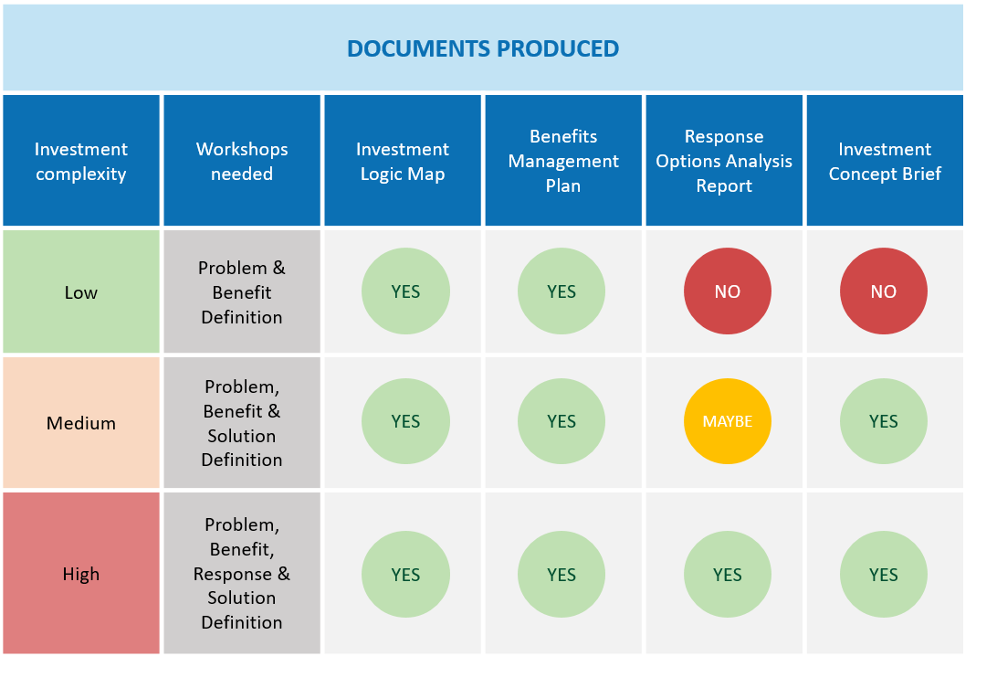
      - Timing of workshops
The IMS workshops are often held at around two-weekly intervals. Experience has shown that, in most cases, this provides sufficient time for the thinking of the previous workshop to be absorbed and preparation for the next workshop undertaken, and is not so distant that the momentum is lost.
Timing is dependent on the scale and complexity of the investment, and the stage in the budget cycle. Where there is increased accountability, risk, scale and cost, the time between workshops can range between 2-8 weeks, particularly for the Response and Solution definition workshops.
It is highly recommended that agencies only use accredited facilitators to run the workshops for the more important investments. Evidence shows they are more likely to produce a quality result.
Whatever the time interval, it is important that the investor (or nominated workshop participant) complete the essential preparation and validate the relevant evidence before moving on to the next workshop. Failure to do this will undermine the quality of the next workshop’s output, and the robustness of any future business case.
      - Addressing risk and uncertainty
Within the suite of IMS workshops the key concepts of ‘risk’ and ‘uncertainty’ are explored in different ways. The terms both refer to situations where the knowledge of outcomes is incomplete or imperfect. However, whilst practitioners sometimes use these terms interchangeably, they refer to slightly different concepts.
Risk is a variance (either positive or negative) from an expected outcome.
    - Risks usually apply to the delivery of a project.
    - They are inside the project team’s control to minimise and mitigate to achieve the defined scope and expected benefits.
The Response Definition and Solution Definition workshops identify the key risks related to achieving an investment’s benefits, for further analysis in the business case.
In comparison, uncertainty is an event or change in conditions that can impact investment success.
    - Uncertainties usually relate to the investment need or problem.
    - They are usually external factors outside the project team’s control.
    - They can result in a different future state to that anticipated or assumed in the business case, which in turn can impact the need for an investment or the benefits that are likely to be realised and can require a change in response.
These events include technological developments, major shifts in markets and economic conditions, the behaviour of other organisations, demographic and societal structures, or the natural environment. If such events occur, they can have both positive and negative impacts on benefit delivery.

It is important that the IMS process is used to identify, explore and capture any uncertainty related to the investment. This can be further explored during business case development, if the investment proceeds. A suitable approach for considering uncertainty during each of the IMS workshops is described below:
    - Problem Definition workshop – consider the organisation’s operating environment and the expected future state where this problem exists. Is it characterised by pronounced uncertainty? Are there any external factors outside the control of the organisation that could significantly impact the cause, effect likelihood and severity of the problem or the need or demand for change? Consider the conditions or future state in which the investment need or problem materially changes.
    - Benefits Definition workshop – consider whether realising any of the proposed benefits may be materially affected by uncertainty. Would the need for a benefit, or your ability to achieve that benefit, be materially different in different future scenarios? Is achievement of any of the benefits, KPIs or measures, contingent on significant interdependencies?
    - Response Definition workshop – consider the operating environment and supply markets. Would any of the response options become unfeasible if circumstances changed? Under what different scenarios or conditions would response options be inadequate or inappropriate? What are the triggers for changing the response? Are any of the interventions contingent on material interdependencies? Will this affect the need for, or approach to, the investment?
    - Solution Definition workshop – consider the operating environment and supply markets. Are there any external conditions or uncertainties that would lead to the preferred solution being inadequate or inappropriate, and where we might regret the investment approach? Are there any external conditions or uncertainties that could impact on the deliverability of the recommended solution? What are the triggers for a change in response? Does the recommended solution need the flexibility to respond to uncertainty?
If the answer to any of the above questions is ‘yes’ and the investment relates to significant infrastructure investment, it is likely that the investment could benefit from real options analysis undertaken during the business case preparation. This will focus on building as much flexibility and adaptability as possible into the investment response and solution. DTF highly recommends agencies engage suitably qualified and experienced consultants to support this work.
The role of the IMS is to identify uncertainty and its impacts on an investment and, where those impacts are potentially significant, recommend further investigation, Real options analysis is outside the scope of the IMS. DTF highly recommends agencies engage suitably qualified and experienced consultants to support this work.
      - Addressing relevant policy levers
The IMS workshops focus on prosecuting a core problem, and identifying a clear set of defined benefits and interventions that respond to that problem. Whilst it is not the intent of the IMS to consider in detail how a proposed investment aligns with broader policy levers, workshop discussions can help identify policy requirements and synergies. For example, IMS workshops may identify potential value creation and value capture opportunities within a proposal, or projects that can contribute to Victoria’s Climate Change Adaptation Plan. Considering these opportunities will be important in defining benefits as well as option analysis and solution design.
Where this occurs the IMS documents, in particular the ICB, should capture these additional proposal details and they should be further explored when developing the business case.
      - Engaging the key players
The investor is the most crucial participant in any IMS workshop. For the purposes of the IMS, the investor is not the funder but the person who owns the business problem and will be responsible for delivering the benefits. The investor may also be known as the senior responsible officer or sponsor.
Ensuring the investor engages early in a project, and continues to participate throughout all stages of its development, reduces the likelihood of investment failure and mitigates the risk that potentially good investments are never funded because the investor just does not understand what they are about.
The IMS workshop discussions are structured to address the issues of most importance (and interest) to an investor. This allows them to hear all arguments and confidently take ownership of the investment.
Other workshop participants are those people with the most knowledge of the organisation’s problems, and the stakeholders who will be important to the success of the investment. It is the investor’s responsibility to identify the participants. The investor should bring together people who understand the problem, operational environment, and have the required specialist skills to answer the key questions associated with each IMS workshop.
For very complex problems and investments, the workshops will usually need senior executives with strategic responsibilities for key operational areas. For less complex investments, there may be a higher proportion of operational staff.
      - Preparation
To ensure that an IMS workshop is useful and efficient it is important that all participants, including the investor, understand the intent of the workshop and the expectations of participants. Each workshop in the IMS suite has a specific focus and preparation is required for each workshop. It is the role of the facilitator to work with the investor and nominees to ensure the workshop preparation is appropriate. The guidance below summarises the more detailed information included in the IMS Technical guides for facilitators, for each of the workshops.

Problem Definition workshop
    - Participants should bring a depth of understanding about the issues and be very familiar with any existing relevant materials such as: briefing papers, background reports, external reviews, internal management reports etc. They should be able to refer authoritatively to this evidence during the workshop. A key part of this workshop is to confirm that evidence exists to substantiate the problem.

Benefit Definition workshop
    - It is critical that the investor, participants (and the organisation) present with an explicit understanding of the wider environmental drivers, the organisation’s strategic intent and any significant internal or external performance targets and timeframes that they must achieve.
    - Evidence will need to be substantiated during this workshop and will usually need to cover both the external and internal operating environments. If evidence is weak, you may need to spend more time and effort to understand the current or projected state.
    - The indicative KPIs identified in the Problem Definition workshop should be reviewed prior to the benefit workshop to determine whether these KPIs are meaningful, measurable, and primarily attributable to the investment. This will provide a good starting point for the workshop which, otherwise, may lack focus.

Response Definition workshop
    - This workshop will not succeed unless there is a clear and common understanding and agreement about the problems, benefits and KPIs. KPIs specified in the Benefit Map should be confirmed and are as developed as possible with baselines determined and indicative targets set.
    - Participants should review the list of potential interventions provided by the facilitator and begin to think about overall responses from the least complex (do minimum) to the most complex and far-reaching as well as demand, productivity and supply based interventions.

Solution Definition Workshop
    - Prior to this workshop, it is vital that the project team compiles and circulates cost and timeframe data for each of the response options to the facilitator and all workshop participants. Costs and timeframes can still be ‘best estimates’, but some rigour should have been applied to both in the period since the Response Definition workshop.
    - Ideally a ‘best likely’ solution that describes the preferred response option is prepared, together with the rationale for its selection and the set of change and assets needed for implementation. This preferred option may alter once the project team assesses the cost and timeframe data, and the solution will need to be redefined.
      - Selecting a facilitator
IMS workshop facilitation requires experience in managing diverse and sometimes frank conversations. While the IMS practices are simple to understand, facilitating them to get the best outcomes is not simple at all. For this reason, DTF has established an accreditation process to give investors a level of confidence in the facilitators they use. A list of currently accredited facilitators is available at http://www.dtf.vic.gov.au/Investment-Planning-and-Evaluation/Investment-professionals-toolkit/Book-an-investment-management-standard-facilitator
Whether using an external or in-house facilitator, a key characteristic of good IMS facilitation is being ‘content-free’. This means that the facilitator must demonstrate independence in questioning and shaping the case for investment. They must be willing to test all elements of the investment story from problem to solution. This delivers a more robust and compelling story and better outcomes.
Not all agencies will have in-house accredited facilitators. Some large organisations that have a high need for the IMS workshops have several accredited facilitators on their staff. Others might only have one, or none. As the cost of engaging external accredited facilitators is low in the context of the overall investment value, this is the preferred route for many organisations.
      - Piecing it all together – a systems view of the IMS
Within organisations, investment decisions are usually made at three levels:
    - organisation level – these decisions affect the organisation’s overall direction and outcomes;
    - program level – these decisions affect programs or portfolios of individual investments; and
    - initiative level – these decisions affect individual investments, both asset and non-asset based
While these levels should naturally connect, they are often managed using entirely different processes, in different forums, and using different language. By applying IMS practices, including its workshop suite, across all levels of decision making, as illustrated in Figure 5, an organisation can achieve a much closer alignment within its decision-making. The logic of a single investment can also easily be tested within the broader organisational context.
Figure 5, on the next page, also illustrates how a set of foundation questions or areas of enquiry, are common to all three levels of investment. This ensures that an organisation can achieve consistent understanding, language, priority, and direction its entire decision-making.
Chapter 4 of this Guide provides more information on the practices and application of the IMS when applied to initiative, program and organisation investment decisions. The IMS Technical guides for facilitators are specifically focused at the initiative level workshops. However, the fundamentals of facilitation for the initiative level investments can be applied quite successfully to program and organisation level discussions.
Figure 5: Integrated view of IMS practices
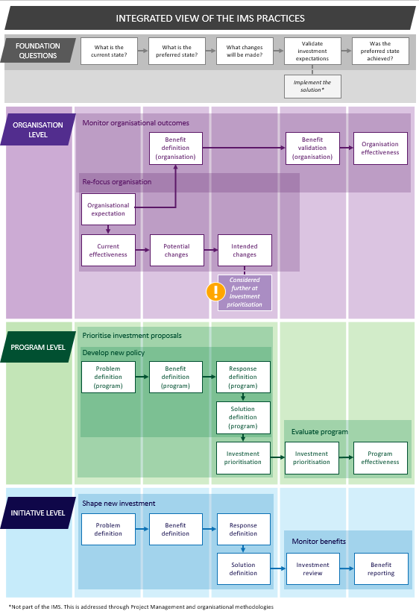
    - Investment Management Standard practices
The Investment Management Standard is adaptable and can support a wide range of functions that organisations undertake to improve the way they plan, operate and manage new investments and evaluate performance. Table 5 outlines a mix of common functions and the related IMS practice. This chapter explores these practices in greater detail.
Table 5: Alignment between IMS workshop levels and IMS practices
Investment Level | IMS Practice
Initiative | Shaping a new investment
Initiative | Monitoring and measuring the delivery of benefits
Program | Prioritising investment proposals
Program | Developing new policy
Program | Evaluating a program of investment
Organisation | Refocusing an organisation to improve its effectiveness
Organisation | Monitoring organisational outcomes

      - Shaping a new investment

Intent
Shapes an investment that will deliver the maximum benefit to the organisation.

Business context
The only reason an organisation makes an investment is to obtain some benefit – either through solving a problem or taking a new opportunity.
Most organisations have adopted the business case as the way that potential investments articulate and justify the case for an investment. In common practice, business case documents have a strong focus on the planned solution However, it is critical that the business case adequately describes the problem, explores the response options and specifies the benefits that the investment will produce.
The Victorian Government has defined these in the form of the 16 questions investment decision checklist (Appendix 1), which provides the foundation for investment decision making. It has aligned its business case format to these questions. This practice aims to guide the identification and analysis of information required to address the ‘16 questions’.

Benefits of using this practice
The Victorian Government has successfully used this practice to:
    - shape investments that are more strategic and drive better outcomes;
    - establish the logic and key content of the business case;
    - reduce the time and cost taken to develop business cases; and
    - improve the chances that an investment will be funded.

General approach
This practice is suitable for investments of any type, scale or complexity. Irrespective of the complexity they will all be required to follow the same ‘line of enquiry’ as they develop their respective investment stories. However, the number of informed discussions (workshops) required will be different. Very large or complex investments will require four workshops that will produce four documents that are key to a business case. Small investments may be able to complete the investment story in just one or two workshops. They would only produce an Investment Logic Map and a Benefit Management Plan.
Figure 6 depicts the four steps involved in this practice.
Figure 6: The steps in shaping a new investment
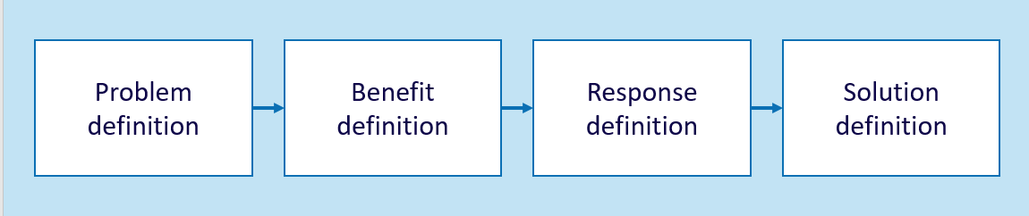

The steps in shaping a new investment:
Problem definition
The purpose of this first workshop is to answer the following questions:
                - What is the problem that is driving us to consider a new investment (both the cause and effect)?
                - Is there evidence to confirm both the cause and effect of the problem?
                - Is the operating environment characterised by uncertainty that could significantly impact the cause, effect, likelihood or severity of the problem or the need or demand for change?
                - What benefits can the organisation expect in successfully responding to the problem?
The people attending this workshop should be:
    - the investor, the accountable person;
    - those people the investor identifies that understand the problem(s) and can provide the evidence that will validate that the identified problem(s) are real.
The number of people involved will typically be between 6 and 8, or up to 10-12 for very complex projects. Approximately 60% of the participants in the Problem Definition workshop should be retained in subsequent workshops. This allows for the introduction of new people with specialist skills in the other workshops.
The output of this workshop will be an Investment Logic Map (initiative).
Benefit definition
This workshop will establish the basis for success of the investment in the form of the first draft of a Benefit Management Plan, which you will need to amend as the investment is shaped. It should define:
                - the KPIs and measures that demonstrate that the identified problems have been properly addressed? It will source current baseline data and ultimately set the target values and timelines for these measures?
                - whether the realisation of any of the proposed benefits may be materially affected by uncertainty or contingent on significant interdependencies?
                - who will be responsible for delivering the benefits?
                - how will the benefits be tracked and reported?
The people attending this workshop should be:
    - the investor;
    - some of those people who participated in the previous workshop who have most knowledge of the problem environment;
    - a benefit specialist who has expertise in KPI design and understands what is possible in the subject area;
    - material data providers who will be responsible for providing the data to determine whether the investment has delivered the benefits.
The number of people involved is typically between 6 and 8, or up to 10-12 for very complex projects.
The output of this workshop is a Benefit Management Plan (initiative).
Response definition
This workshop aims to explore a broad range of potential responses options and decide which one is preferred. It should answer the following questions:
                - What are the options that Government could take to deliver the identified KPIs (and respond to the problem)?
                - What high level actions interventions are required for each option?
                - Do the options and interventions explore ways to change demand, improve productivity and change supply?
                - Are any of the interventions contingent on material interdependencies that will affect the need for, or approach to, the investment?
                - Would any of the response options become unfeasible or sub-optimal if circumstances changed?
                - Which response option is likely to be the most suitable (based on the benefits delivered, risks and uncertainty, dis-benefits and interdependencies)? The solution workshop will explore cost and time considerations.
                - What are the triggers for changing a response?
The people attending this workshop should be:
    - the investor;
    - some of those people who participated in the previous workshops who have most knowledge of the problem environment;
    - a strategist who can act as the ‘custodian of the strategic direction’ of the organisation;
    - an innovator and an implementer who can test both the breadth of the proposed interventions and their feasibility.
The number of people involved is typically between 6 and 8, or up to 10-12 for very complex projects.
This workshop attempts to identify the range of interventions that can address the problem and deliver the desired benefits.
To help participants think more broadly than any preconceived ideas they may have of what a solution may look like, a structured series of questions can help draw out a fuller range of potential interventions. In an environment of constrained resources, it is critical that the range of interventions considered includes those that can manage demand for services, as well as those that can improve the productivity of the existing service delivery.
Workshop participants should first consider:
    - What options does the Government have to manage demand for a service? This could include user charging, rationing or queueing.
    - What options does the Government have to increase the productivity of the existing service? This could include options such as removing seats in trains, or traffic treatments that improve the flow of vehicles.
Once the viability of options to manage demand and improve the productivity of existing investments have been considered, if there is a residual requirement for further services or investment, then supply side options can be considered:
    - What options does the Government have to increase the level of service provision through new investment in assets or programs.
The output of this workshop is a Response Options Analysis Report (initiative).
Solution definition
The three previous workshops established the need for an investment, the preferred response and the circumstances under which this proposed response may not be feasible or adequate. It is now necessary to specify a solution consistent with the response – a case of a problem driving a solution. To do that, this workshop must answer the following questions:
                - Has the preferred response changed based on new cost and timeframe data?
                - What is the preferred response now?
                - What business changes will you need to undertake to implement the preferred response?
                - What assets (if any) will be required to support these business changes?
                - Will the defined solution (expressed as the changes and assets) deliver the investment KPIs identified in the Benefit Management Plan?
                - What costs, timeframes, risks and uncertainty, critical dependencies and dis-benefits are associated with the defined solution?
                - What are the triggers that could require a solution change?
Once participants have identified a preferred solution, you must reconsider the initial problem definition and confirm that you are addressing the right problem, and that the solution is feasible, smart and delivers the benefits and KPIs.
The people attending this workshop should be:
    - the investor;
    - some of those people who participated in the previous workshops who have most knowledge of the problem environment;
    - the strategist and innovator from the previous workshop
    - an implementer who would be involved in the implementation of any solution and would benefit from understanding its intent.
The number of people involved is typically between 6 and 8, or 10-12 for very complex projects.
The output of this workshop is an Investment Concept Brief (initiative).
      - Prioritising investment proposals

Intent
Enables decision-makers to understand and prioritise investment proposals within a portfolio or program of work that addresses a broader strategic set of problems and benefits.

Business context
Most organisations operate an annual budget and planning cycle where the need for new investment or changed investment priorities is considered, potential investments proposals are identified, and decisions are made as to how the budget will be spent. These decisions are often within the context of a portfolio or program of work. The people charged with making these decisions require a clear understanding of the challenges to the organisation (now and into the future), the benefits that need to be delivered and agreed criteria to evaluate competing bids. Without this shared understanding and common assessment criteria, investment decisions are more difficult and often less certain.

Benefits of using this practice
Organisations that have used this practice have found it provides a range of benefits including:
    - better engagement of senior executives and key stakeholders;
    - improved articulation of the need for new investment or a change to current investment priorities and the establishment of strong prioritisation criteria;
    - substantial reduction in the number of ‘irrelevant’ investment ideas;
    - better investment solutions; and
    - time and cost efficiencies.

General approach
Figure 7 depicts the five steps involved in this exercise. Steps 1, 2 and 3 establish the need, the benefits and KPIs which are key criteria for selecting the best investments and the preferred response. Step 4 defines how the response should be put into effect and informs additional assessment criteria including cost, timeframe, risk and uncertainty, disbenefit and interdependencies. When candidate investments have been shaped, step 5 uses the criteria developed in step 2 and 4 to prioritise them and make investment decisions.
Figure 7: The steps in prioritising investment proposals
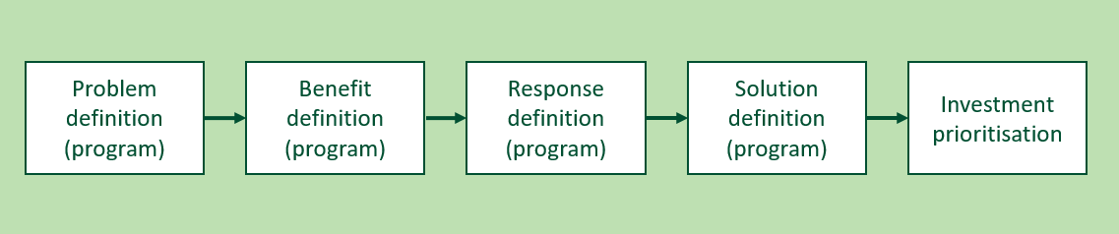

Problem definition (program)
The first step to establishing an informed investment program is to identify an organisation’s current priorities and future challenges.
When developing new policy, it is necessary to first establish an agreed understanding of the problem the policy must address.
This workshop can address either of these needs and should answer the following questions:
                - What needs or challenges is this [organisation/portfolio/policy] facing over the next period (e.g. 5–10 years) that will require us to consider new investment or change our current investment priorities?
                - Is there evidence to confirm both the cause and effect of the problem?
                - Is the operating environment characterised by pronounced uncertainty that could significantly impact the cause and effect of the problem or the need or demand for change?
                - What benefits can the organisation expect by successfully responding to the needs/problems?
The people attending this workshop should be:
    - the investor, the accountable person;
    - those people, invited by the investor, who understand the problem(s) and can provide the evidence that will validate that the identified problem(s) are real
    - key stakeholders who will be important to giving effect to any identified investment.
The number of people involved will typically be between 6 and 10, depending on the nature of the investment. The subsequent workshops should retain approximately 60% of Problem Definition workshop participant. This allows for the introduction of new people with specialist skills in the other workshops.
The output of the workshop will be an Investment Logic Map (program).

Benefit definition (program)
This step establishes the criteria that will enable candidate investments to be prioritised based on their relative ability to deliver the benefits that are sought, and should answer the following questions:
                - What are the KPIs that an investment must deliver before it can claim to have delivered the sought benefits?
                - What measures should be considered for each of the KPIs?
                - Will uncertainty or significant contingent interdependencies materially affect Government’s ability to achieve any of the proposed benefits?
                - Will the KPIs and measures effectively demonstrate that the solution has properly addressed the identified problems (service gaps or new priorities)
                - What plain-English ‘public value messages’ could be made when each benefit has been delivered?
The people attending this workshop should be:
    - the investor;
    - some of those people who participated in the previous workshop who have most knowledge of the problem environment;
    - senior finance representative
    - a benefit specialist who has expertise in KPI design and understands what is possible in the subject area;
    - material data providers who will be responsible for providing the data to determine whether the investment has delivered the benefits.
The output of this discussion should produce a Benefit Management Plan (program). It will identify benefits, KPIs and Measures. At this stage, the BMP should provide a high order framework for setting priorities and assessing investment proposals. The workshop group will need to define baseline data, target values and timelines for specific measures outside this workshop.
The number of people involved is typically between 6 and 10.
Response definition (program)
This workshop aims to explore a broad range of potential response options and decide which one is preferred. It should answer the following questions:
                - What are the options that Government could take to deliver the identified KPIs (and respond to the problem)?
                - What high level actions interventions are required for each option?
                - Do the options and interventions explore ways to change demand, improve productivity and change supply?
                - Are any of the interventions contingent on material interdependencies that will affect the need for, or approach to, the investment?
                - Would any of the response options become unfeasible if circumstances changed?
                - Which response option is likely to be the most suitable (based on the benefits delivered, risks and uncertainty, dis-benefits and interdependencies)? The solution workshop will explore cost and time considerations.
The people attending this workshop should be:
    - the investor;
    - some of those people who participated in the previous workshops who have most knowledge of the problem environment;
    - a strategist who can act as the ‘custodian of the strategic direction’ of the organisation;
    - an innovator and an implementer who can test both the breadth of the proposed interventions and their feasibility.
The output of this workshop is a Response Options Analysis Report (program).
The number of people involved is typically between 6 and 10.
Solution definition (program)
This step provides what is often a ‘missing link’ – an activity where policy and strategy are directly translated into a balanced set of actions and investments. This discussion focuses on identifying and shaping large work packages rather than individual initiatives. It should answer the question:
                - Considering the cost and time data has the preferred response changed?
                - What is the preferred response now?
                - What packages of work (set of initiatives) will be most effective at implementing the preferred response and delivering the expected benefits?
                - What assets (if any) will be required to support these work packages?
                - Will the defined solution (expressed as work packages) deliver the investment KPIs identified in the Benefit Management Plan?
                - What costs, timeframes, risks and uncertainty, critical dependencies and dis-benefits are associated with the defined solution?
The people attending this workshop should be:
    - the investor;
    - some of those people who participated in the previous workshops who have most knowledge of the problem environment;
    - the strategist and innovator from the previous workshop
    - an implementer who would be involved in the implementation of any solution and would benefit from understanding its intent.
The output of this workshop is an Investment Concept Brief (program) that reflects the expected ranges regarding time, costs, dis-benefits, risks, etc. (the quality will depend on how well they are understood at the time).
The number of people involved is typically between 6 and 10.
Investment prioritisation
In this workshop the workshop group considers and prioritises candidate investments against the criteria developed in previous steps. You should invite relevant investors (sponsors) to outline the case for their individual investment, ideally using an ICB as a starting point and answer questions from the workshop group. This group is generally senior decision-makers. Over a 2-hour period you will consider and assess approximately 8-10 investments. The workshop should answer the question:
    - Using the criteria developed earlier, how do the candidate investments rank against one another?
The people attending this workshop should be:
    - the investor;
    - those people who share responsibility for investment decision-making in this organisation/portfolio;
    - investment analysts.
The output of this workshop is a completed and agreed prioritised investment list, known as a Service Logic and Investment Prioritisation (SLIP).
The number of people involved is typically between 6 and 10.
      - Developing a new policy

Intent
Defines the need for new policy and specifies the best response.

Business context
The ability to identify the changing needs of society and develop policy or strategy that will best respond to these needs is central to good government. Government practitioners must develop policy with a full and shared understanding of the need, and full comprehension of the broader implications of the policy on delivery of benefit and implementation requirements.

Benefits of using this practice
This practice will assist policy developers to:
    - engage with those people who most understand the need for new policy;
    - develop policy responses that are evidence-based, innovative and practical;
    - mobilise those investments that will best align with the intent of the policy; and
    - establish the criteria to evaluate whether the policy, when implemented, is successful.

General approach
Figure 8 depicts the four steps involved in this exercise. These steps are the same as those undertaken to prioritise investments. Project teams can use the practice to develop policy within an organisation or across the whole of government. Each step represents a workshop.
Figure 8: The steps in developing new policy
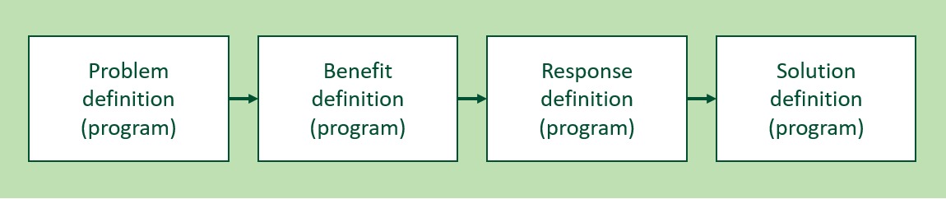

The steps in developing new policy
                - Problem definition (program)
                - Benefit definition (program)
                - Response definition (program)
                - Solution definition (program)
The previous section: Prioritise investment proposals outlines all these steps. The physical output of these discussions is a suite of program level documents that include an Investment Logic Map, Benefit Management Plan, Response Options Analysis Report and Investment Concept Brief.
      - Monitoring and measuring the delivery of benefits

Intent
Provides a continuous focus on benefits during the implementation of an investment and determines whether the expected benefits have been delivered.
Determines whether changing conditions or events that would trigger a need to change response options have been met, and a real option(s) can now be exercised.

Business context
The only reason an organisation makes an investment is to obtain some benefit. This is therefore the prime consideration of investment decision-makers when considering an investment proposal. For this reason, people seeking new funding for their proposed investment must articulate the benefits the investment is expecting to deliver.
Once a project team receives investment funding, they inevitably become focused on project delivery challenges and stresses, the focus on benefits is often lost. This is exacerbated by the difficulty in measuring and tracking benefits and evaluating the real effectiveness of an investment. Monitoring and tracking benefit throughout the lifecycle of the investment is critical to benefit realisation.

Benefits of using this practice
Using this practice will:
    - drive more benefit from a funded investment;
    - validate the success of a completed investment;
    - provide lessons that will inform the shaping of future investments; and
    - support better decision making.

General approach
There are two steps involved, as depicted in Figure 9. However, they do assume that a Benefit Management Plan has been previously developed using the practice ‘Shape a new investment’.
Figure 9: The steps in monitoring and measuring the delivery of benefits
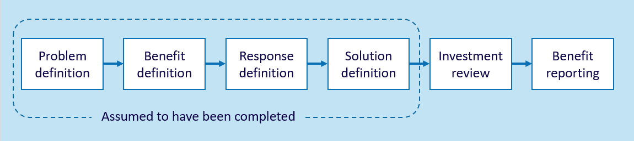

The steps in monitoring and measuring the delivery of benefits

Investment review
This discussion allows the investor to validate the original assumptions, or consider how uncertainty has challenged and changed them, at various stages during the implementation and to amend the Benefit Management Plan or the solution to ensure the investment delivers maximum benefit. The Investor should answer the following questions:
                - Will implementing the planned investment solution deliver the originally expected benefits?
                - Could Government adapt its investment strategy to take advantage of opportunities and deliver additional benefits?
                - Are there issues or circumstances that have emerged or changed in nature or scale that will compromise the delivery of benefits?
The people attending this workshop should be:
    - the investor;
    - people who have most knowledge of the problem environment and are subject matter experts;
    - a strategist;
    - a benefit specialist;
    - the project manager.
The number of people involved is typically between 6 and 8.

Benefit reporting
The benefit framework that underpins the IMS, and the creation of Benefit Management Plans as a normal practice, make it both practical and cost-effective to track the delivery of the planned benefits. This discussion should answer the question:
                - Is the investment delivering the KPIs consistent with the Benefit Management Plan?
This step is a desktop exercise undertaken by the benefit specialist rather than a group exercise using the workshop process.
The benefit specialist then submits the resulting benefit report to the forum(s) specified in the Benefit Management Plan. This approach is repeated throughout the period specified in the Benefit Management Plan.
The physical outputs of these two steps are:
    - amendments to or validation of the Benefit Management Plan and the Investment Logic Map; and
    - a benefit report.

      - Evaluating a program of investment

Intent
Provides an understanding of whether the outcomes sought by a program of investment were actually achieved.

Business context
Government organisations continually develop new policy that aims to address an existing or emerging unmet need of society. Implementing the policy often requires a significant commitment of resources and takes a long time. There is always a risk that the original need has changed or the original interventions no longer make sense in a changed environment. This practice validates the ongoing need for the program and its design and, once the investment is complete, evaluates its effectiveness.
The knowledge gained in this exercise then informs the development of future policy.

Benefits of using this practice
This practice will assist those people involved in program evaluation to:
    - understand the logic that formed the foundation of the investment program;
    - direct or re-direct resources to ensure the policy intent is met;
    - evaluate the overall effectiveness of a program; and
    - provide new knowledge to those people responsible for developing policy.

General approach
There are two steps involved in this exercise and these are depicted as the last steps in Figure 10. This practice assumes that a policy framework has been previously established using the practice Prioritise investment proposals (steps 1 to 5 below).
Figure 10: The steps in evaluating a program of investment
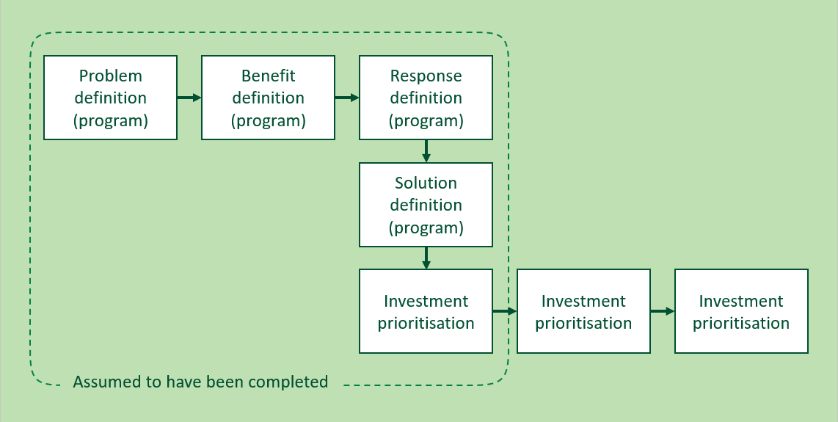

The steps in evaluating a program of investment

Benefit validation
Based on the expectations established earlier (at either the prioritise investments or develop policy stage) this step will assess whether the program is on track to deliver the expected benefits. The outcomes of this assessment might be to modify the program either in some detail or substantially – the investor may even decide to discontinue the program if the need has changed, the original assumptions are no longer valid or the benefits being delivered no longer justify the scale of investment needed.
In this discussion the following questions should be answered:
                - Is the original need for this program still valid today?
                - Has the scale and scope of the need for this program changed?
                - Are the expected program benefits still relevant and valuable to the organisation?
                - Are there events outside the control of the organisation that are having an impact, positive and negative, on benefit delivery?
                - Are the expected benefits being delivered as planned?
                - Are the attributes of project design, implementation or contractual arrangements still relevant, flexible and the best approach to benefit delivery?
                - Can Government make any changes that can improve the relevance or effectiveness of the program?
The people attending this workshop should be:
    - the investor;
    - those people who participated in the previous workshops who have most knowledge of the problem and operational environment, financial and delivery performance metrics;
    - a benefit specialist;
    - investment analysts.
The number of people involved Is typically between 6 and 10.
As appropriate, the project team or facilitator should produce new versions of any of the investment management documentation.

Program effectiveness
This discussion should occur when the majority of the expected benefits have been delivered.
Questions to answer are:
                - Did this program satisfactorily address the ‘problem’ upon which it was founded?
                - To what degree did the program deliver the expected benefits? And how valuable are the delivered benefits to the organisation?
                - Was the selected response option an effective way to address the need?
                - Was the program delivered to both time and budget expectations?
                - How successfully was the program managed?
                - What lessons should be recorded to inform future decision making and program design?
                - How will these lessons be used?
The people attending this workshop should be:
    - the investor;
    - those people who participated in the previous workshops who have most knowledge of the problem and operational environment, financial and delivery performance metrics;
    - a benefit specialist;
    - people responsible for implementing the program
The number of people involved Is typically between 6 and 10.
The physical outputs of these steps are:
    - as required, changes to the investment management documentation; and
    - a program evaluation report that also lists the lessons learned for future program design and management.
      - Refocusing an organisation to improve its effectiveness

Intent
Establishes a shared understanding of why an organisation exists, assesses its current effectiveness and identifies the changes that could make it more effective.

Business context
It’s easy for an organisation to keep doing the same things this year as it did last year and the year before. It worked then, so why shouldn’t it work now? But is the need the same now as it used to be? Is the external environment the same or have new influences emerged? What outcomes is the organisation now creating and what value are these to government, the community and other stakeholders? What functions does it undertake and how do these contribute to the outcomes?

Benefits of using this practice
This practice can be used to:
    - enable the people responsible for steering an organisation to restate its mission and make the changes needed to improve its effectiveness and reset its direction; and
    - allow teams to establish a strong sense of ownership of an organisation’s direction and empower them to work innovatively to that direction.

General approach
Figure 11 depicts the four steps involved in this exercise. An organisation does not need to complete every step to obtain value but may elect to do just the first, or steps 1–3. As each step builds on the previous one, they must be done sequentially. How far an organisation goes depends on what it is seeking to achieve.
Figure 11: The steps in refocusing an organisation to improve its effectiveness
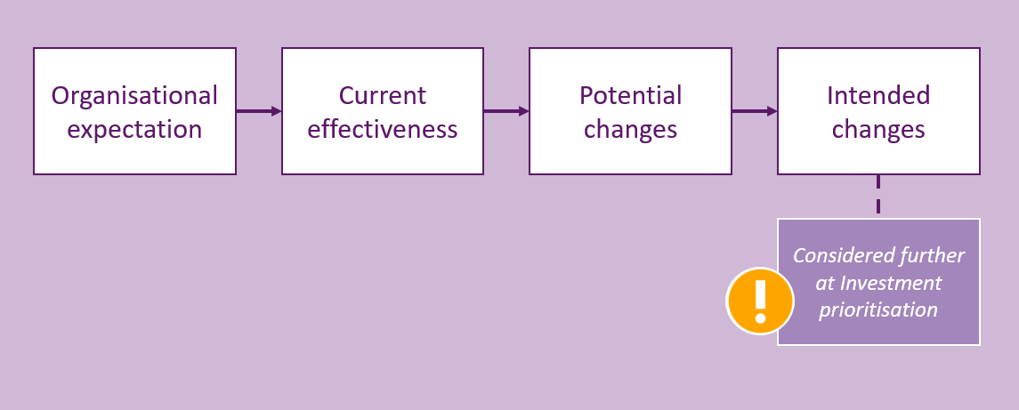

The steps in refocusing an organisation to improve its effectiveness
As with all discussions of the IMS, the most important outcome is that the key people have come together, shared their thinking and agreed to the ‘investment story’. At the end of the discussion they are all ‘on the same page’.

Organisational expectation
This discussion will elicit the logic that underpins the organisation’s existence. Workshop participants should answer the following questions:
                - What is the need that this organisation exists to meet?
                - What benefits is the organisation required to provide to its stakeholders?
                - What response is the organisation taking to respond to the need and deliver the benefits?
                - What functions should the organisation undertake to put the interventions into effect?
The participants will spend most of the discussion time identifying and articulating the organisation’s need to exist. When the participants have agreed this need, they must then define the benefits that its stakeholders expect the organisation to deliver, and the interventions it will take to respond to the need. Finally, they must define the way the organisation should respond in terms of its functions.
The people attending this workshop should be:
    - The investor. They are the high-level executive responsible for delivering the outcomes of the organisation. If applied at whole-of-department level, this would be the Secretary or CEO. This person would bring together those who understand the expectations of the organisation and the best strategic and organisational responses;
    - heads of the various divisions within the organisation;
    - people involved in strategically steering the organisation;
    - those who understand outcome expectations and are involved in outcome reporting;
    - other people who can contribute to the discussion and will be instrumental in owning and implementing the decisions (stakeholders and key staff).
The number of people involved will probably be between 8 and 15, depending on the size of the organisation.
The output of this workshop will be an Investment Logic Map (organisation).

Current effectiveness
Using the organisational expectations defined in the previous workshop, participants will assess of the organisation’s current performance effectiveness. This will then provide the basis for identifying the changes they could make to improve the organisation’s effectiveness.
Participants should answer the following questions during the discussion:
                - What activities are currently being undertaken under each of the identified functions?
                - What impact is each of the individual activities having?
                - Overall, how effective is each function?
The people attending this workshop should be:
    - the investor;
    - heads of the various divisions within the organisation;
    - strategists and policy people who understand the cause and effect of various activities;
    - key staff who will be instrumental in owning and implementing the decisions made;
    - people who monitor and measure the organisation’s outcomes.
The number of people involved will probably be between 8 and 15, depending on the size of the organisation.

Potential changes
This discussion will identify the changes that could be made to improve the organisation’s effectiveness. It should answer the following:
                - What new activities or changes to existing activities could significantly improve the effectiveness of the organisation?
                - What would be the relative merit of each of these?
The people attending this workshop should be:
    - the investor;
    - all participants from the previous (Current effectiveness) discussion;
    - strategists and policy people who understand the cause and effect of various activities;
    - key staff who will be instrumental in owning and implementing the decisions made;
    - innovators not directly connected to the previous exercises (or even to the organisation) who might bring different insights and innovations to the discussion.
The number of people involved might again be between 8 and 15, depending on the size of the organisation.

Intended changes
This discussion will decide what changes will be either implemented or progressed towards possible implementation (such as the development of a business case). Changes requiring new funding may be directed to, and considered as part of, the organisation’s program of new investment. It should answer:
                - What changes should be made to improve the effectiveness of the organisation?
                - How will these changes be progressed?
The people attending this workshop should be:
    - the investor;
    - people within the organisation who are responsible for the outcomes of the organisation and for making the major resource decisions;
    - investment analysts/advisers or other people who can provide the decision-makers with objective information about the changes being considered.
The number of people involved will be determined by the breadth of the changes being considered and the size of the organisation’s decision-making body.
The physical output of all the Refocus an organisation to improve its effectiveness discussions is a document titled ‘Organisation effectiveness’.
      - Monitoring an organisation’s outcomes

Intent
Establishes a shared understanding of why an organisation exists, defines the measures and targets to be used as evidence of its success and monitors its progress against those measures.

Business context
Organisations use a range of reporting methods to provide confidence to themselves and their stakeholders that they are on the right track. These include corporate plans, business plans, annual reports and monthly reports. These documents usually focus on things that can be easily measured but often provide poor evidence that valued outcomes are being achieved.

Benefits of using this practice
This practice will:
    - support a cyclic program that validates whether an organisation or its parts are delivering benefits of high value to the organisation;
    - help shape and support programs that enable an organisation to gauge the impact of any part of the organisation and then validate or adjust organisational strategies; and
    - reduce the ambiguity of terms and measures used across an organisation in corporate planning and reporting.

General approach
Figure 12 depicts the four steps involved in this exercise. The first two steps define why the organisation needs to exist and how it is responding to this need. A set of measures and targets are then established to provide evidence of its success. The third step (benefit validation) is conducted as part of a corporate cycle to determine whether the outcomes are being delivered as expected. Step 4 is also a cyclic exercise that questions whether the responses taken by the organisation to deliver the outcomes are the most effective or if it should adopt different approaches.
Figure 12: The steps in monitoring organisational outcomes
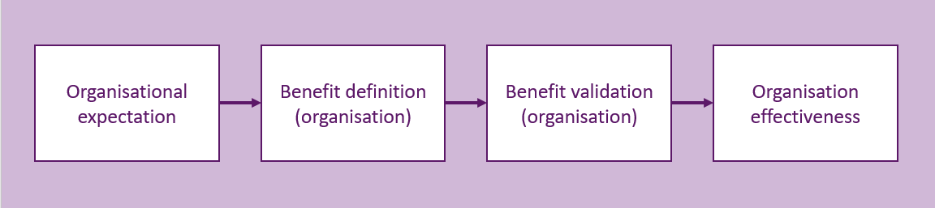

The steps in monitoring organisational outcomes

Organisational expectation
The discussion is outlined in the previous section, ‘Refocus an organisation to improve its effectiveness’.

Benefit definition (organisation)
This step defines the outcomes the organisation is expected to deliver and specifies the measures that will be used as evidence the outcomes are ultimately delivered. Workshop participants should answer the following questions:
                - What benefits must Government deliver to successfully respond to the need specified in the previous workshop?
                - What KPIs with their measures and timelines will provide the evidence that Government has delivered the benefits?
                - How will Government measure, monitor and report benefit delivery?
The people attending this workshop should be:
    - the investor;
    - heads of the various divisions within the organisation;
    - people involved in strategically steering the organisation;
    - people with responsibility for corporate reporting;
    - benefit specialists.
The number of people involved might again be between 8 and 15, depending on the size of the organisation.
The output of this discussion will be an Outcome Management Plan (organisation).

Benefit validation
Based on the outcome expectations established earlier, this step will assess whether the progress in delivering the benefits is proceeding to plan. It will then decide what actions should be taken to increase the rigour of the outcome monitoring process or improve the organisation’s outcomes. Participants should answer the following questions:
                - Are the measures defined in the outcome management plan being delivered as planned?
                - Which measures need to be reported and in what forum should this happen?
                - What changes should be made to the outcome management plan to drive better outcomes or increase accountability?
The people included should be the same as in the previous workshop – Benefit definition (organisation).
The result of the discussion will be agreed changes to the Outcome Managed Plan (organisation).

Organisation effectiveness
This is an ongoing cyclic exercise that allows selected functional units of an existing organisation (a division, branch or even a team) to be evaluated in terms of the contribution they are making to the organisation’s outcomes.
It should answer the following questions:
                - What contribution has the selected functional unit made to the organisation’s outcomes over the selected period?
                - What interventions were used by the unit and how effective was each of these?
                - What organisational response was used and were these the most effective?
                - What changes could be made to improve the organisation’s effectiveness to deliver the expected outcomes?
This session should involve the same people as the previous discussion: Benefit validation (organisation).
Executed properly, this practice will bring together a diverse mix of people from across the organisation and should provide clarity of the purpose of the organisation to its employees and stakeholders.

    - Support in adopting the practices
This chapter provides information about how to access more support and resources for those people considering applying some or all of the IMS practices.
      - Getting started
The value of the IMS can be gauged early, as each workshop should clearly deliver informed discussion and greater clarity around the key questions that shape investments. To deliver the most value to the organisation, management should educate and skill staff in relation to IMS practices, and embed IMS discussions into internal and external resource allocation processes.
Channels for support include:
    - IMS overview and IMS facilitator training. This training can be utilised by potential workshop participants or those responsible for preparing business cases, as well aspiring facilitators. The training will provide all attendees with a solid understanding of how the IMS is applied. There is a cost for this training and can be booked online at <www.facilitatortraining.com.au>.
    - The IMS introduces some new terms, concepts, documents and roles that some people may not be familiar with. The Investment Management website and this document contains a glossary that covers:
      - abbreviations;
      - general terms;
      - IMS documents; and
      - roles.
    - These are also good fictional examples of the documents that are produced.
Having people who are competent to facilitate informed discussions is critical to the success of the IMS. For this reason, DTF has designed a process to train, test and accredit investment management facilitators. DTF strongly advises investors using the IMS practices to use only accredited facilitators.
      - How to become an accredited facilitator
The process of becoming an accredited facilitator aims to test a person’s understanding of the theory behind the standard and the way they apply it as a facilitator. A facilitator training course is available and is highly recommended to build knowledge and skills. However, it is not a mandatory prerequisite for accreditation. What is mandated is that potential facilitators submit at least three examples of completed Investment Logic Maps with feedback from the investor, and that at least two have demonstrated the necessary level of competence. Aspiring facilitators are required to familiarise themselves with the accreditation process. The document How to become an accredited facilitator provides full details of the process and the costs involved. This also defines the requirements for re-accreditation by existing facilitators. (Visit the Investment Management website for more details.)
      - Ongoing support for facilitators
While the theory behind the workshops that generate ILMs is simple, their facilitation requires a lot of knowledge and skill. Added to this, the evolving nature of the IMS practices mean that facilitators need to share experiences and ensure they are operating to the current standard.
To support facilitators, the Investment Management website provides the following resources:
    - IMS Technical guides for facilitators provide guidance on what facilitators should do before, during and after each facilitated discussion.
    - Examples of documents that facilitators are expected to produce are provided.
    - The set of templates used to produce the documents is available on the DTF website at http://www.dtf.vic.gov.au/Investment-Planning-and-Evaluation/Investment-professionals-toolkit/Investment-management-products
      - Templates, examples and case studies
The templates, examples and case studies for the above outlined and listed practices are available for download at http://www.dtf.vic.gov.au/Investment-Planning-and-Evaluation/Investment-professionals-toolkit/Investment-management-products

Appendix 1: 16 Questions - Investment decision-makers’ checklist
What are the prime questions that any decision-maker should have answered before funding an investment?
The IMS includes a set of 16 questions (the Investment Decision-Maker’s Checklist) which address the four IMS elements - problem, benefits, response and solution. This is a useful resource for decision-makers although the depth of enquiry for each question will depend on the scale and complexity of the investment. These questions correlate with key elements of the Victorian government full business case template and aid business case writers and assessors.
These questions can be asked, in part or in their entirety, at various stages in the investment management process to test the robustness of the IMS workshop document suite and the business case, if developed.

16 Questions – Investment decision-makers’ checklist
Table 6: 16 Questions – The Investment Decision-makers’ checklist
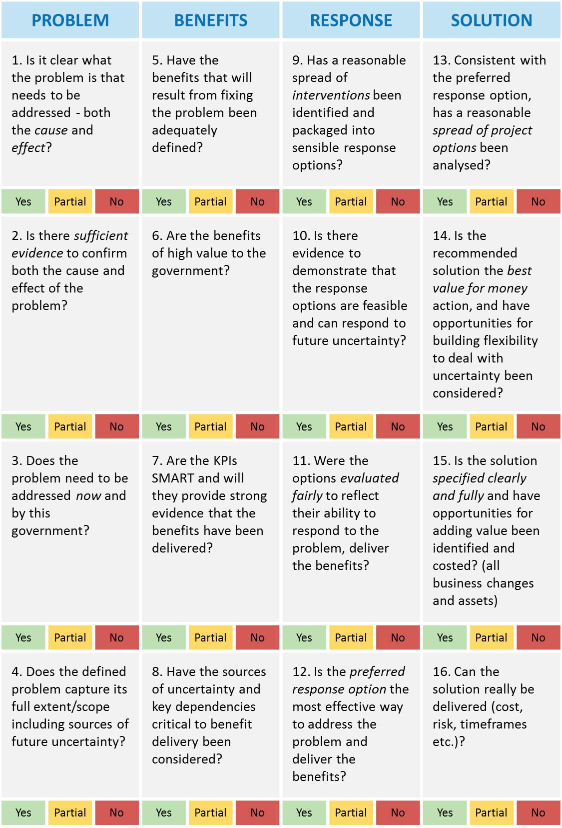

Appendix 2: Fictional IMS suite of documents

Investment Logic Map
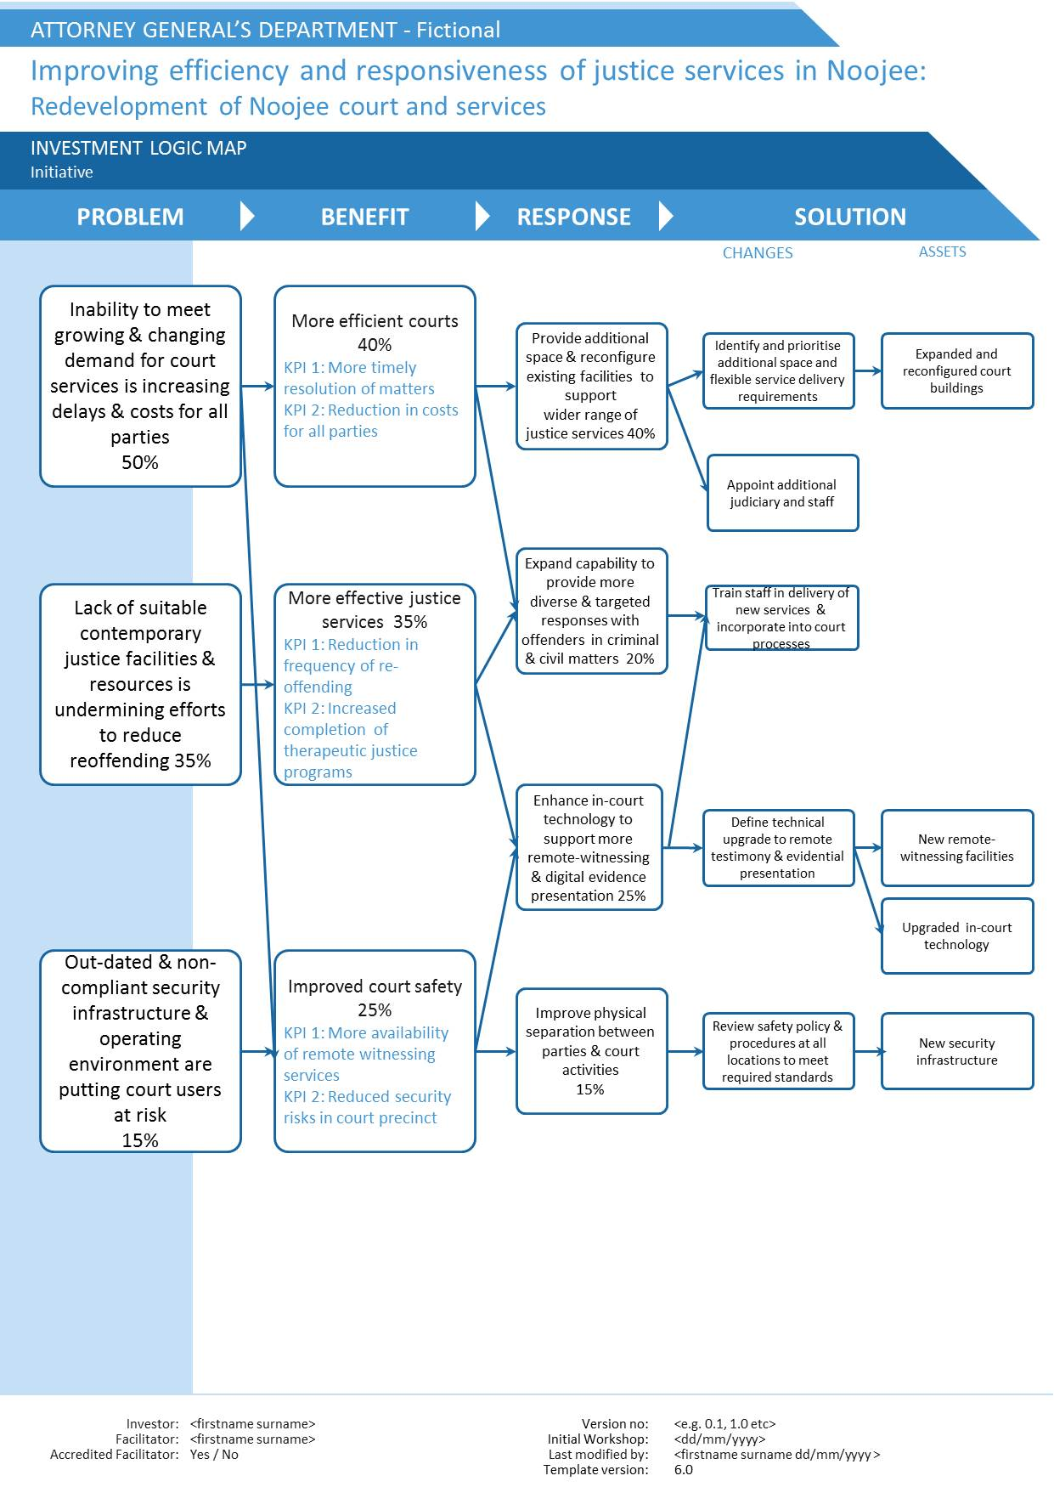

Benefit Map – Benefit Management Plan
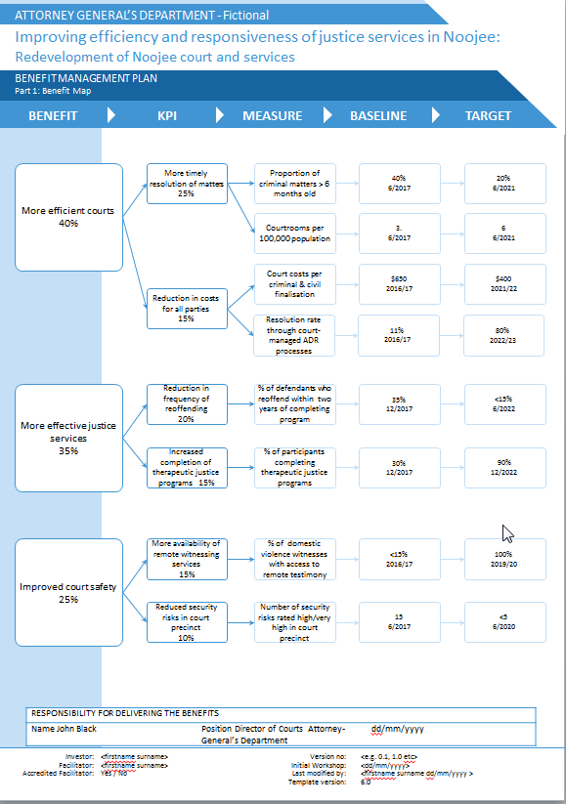

Benefit Profile – Benefit Management Plan
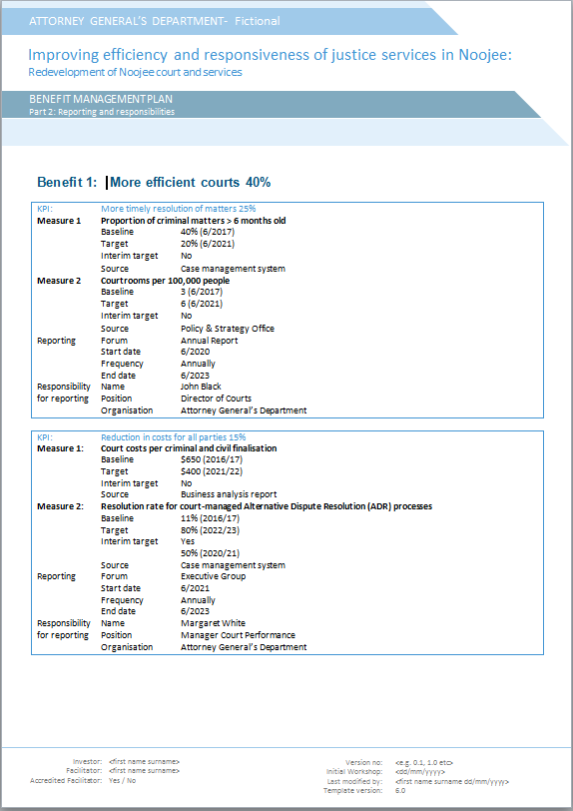
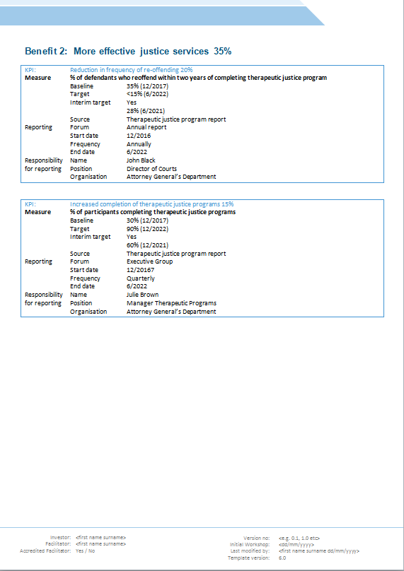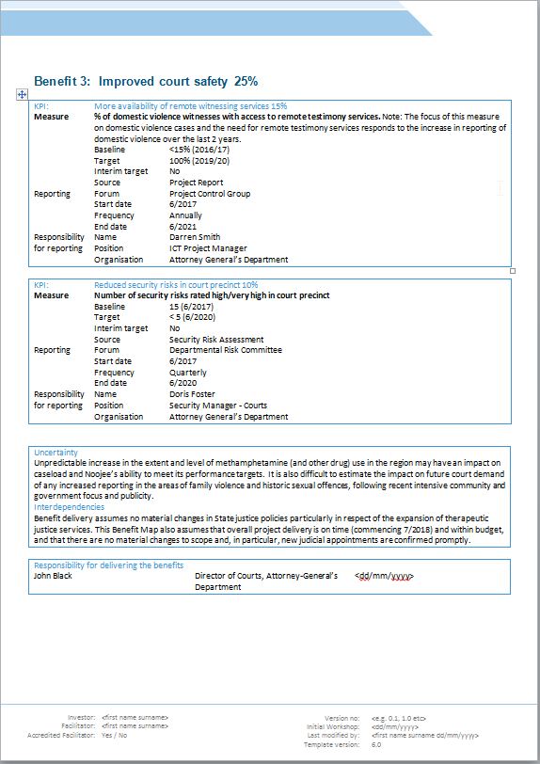

Response Options Analysis Report
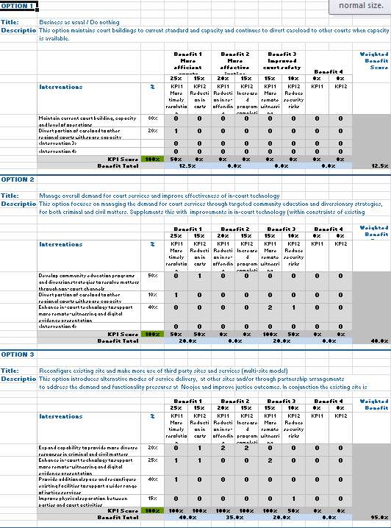

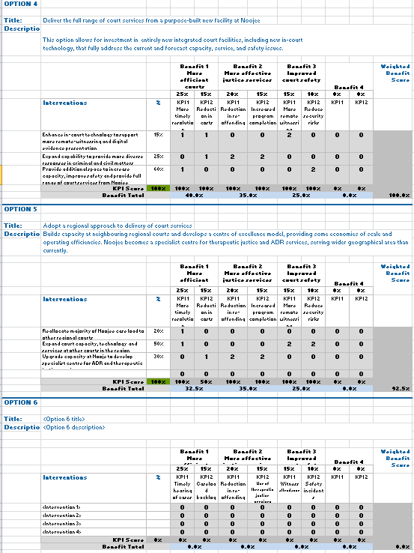

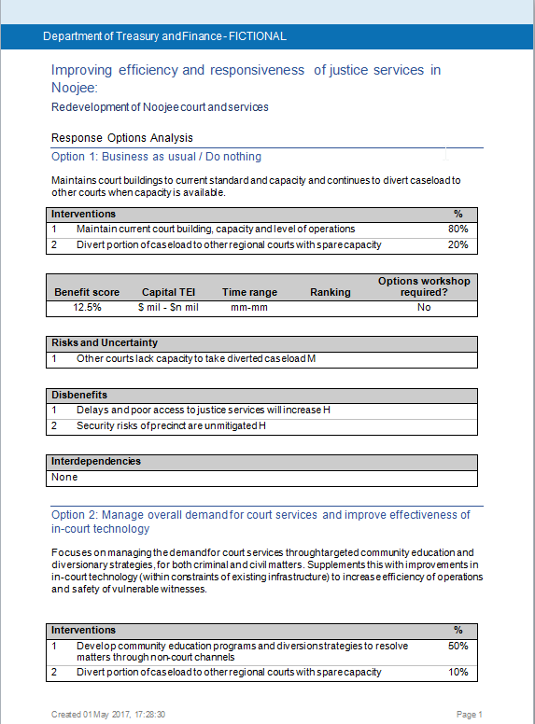
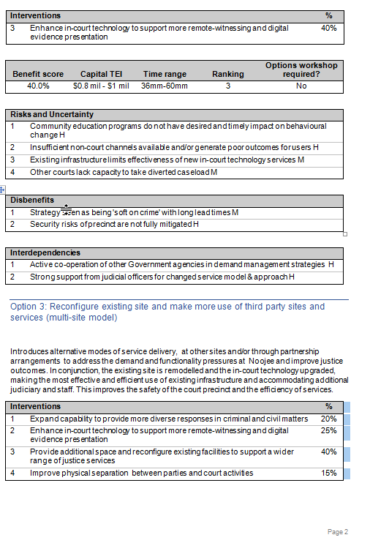
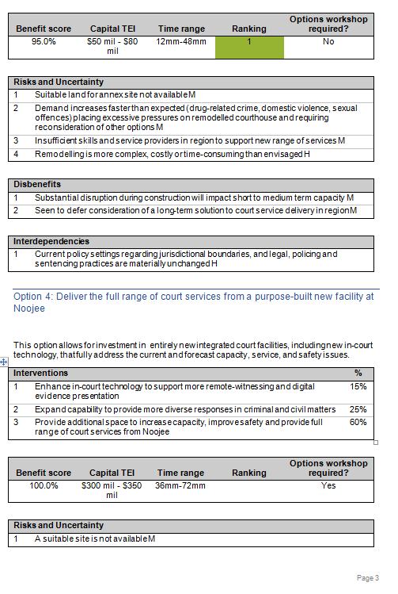

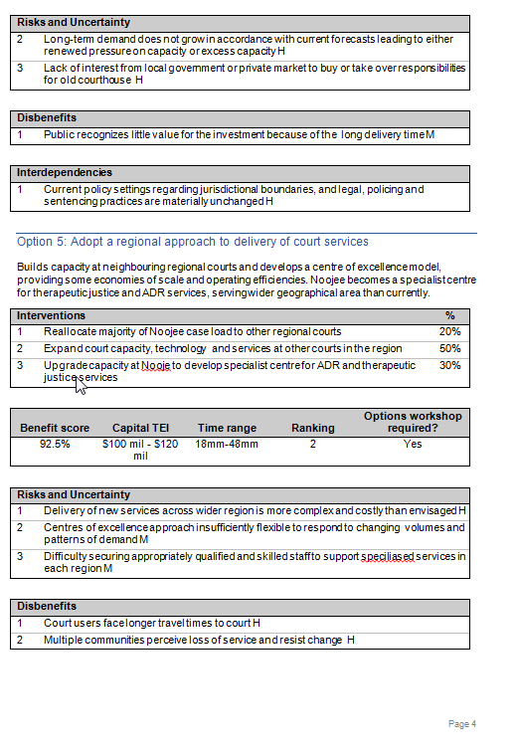

Investment Concept Brief
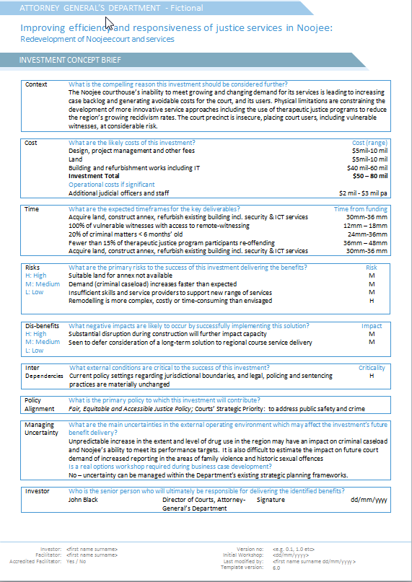

Appendix 3: Benefit framework
Each time an organisation makes an investment there is an expectation that some form of benefit will be returned. It therefore follows that the ability to design investment solutions that provide maximum benefits and to be able to confirm that the expected benefits were delivered is critical to every organisation.
Why is it then that very few investments are able to articulate the benefits they will provide, to define how they will be measured or to actually measure the benefits that are ultimately delivered?
In taking a fresh look at the problem of benefit management, it seems that within large organisations there has been an inability to define how each individual investment contributes to the primary benefits that are the point of the organisation’s existence.
It is typical and appropriate that everyone within, say Victoria Police, believes their individual investment will provide the benefit of ‘reduced crime’ and everyone in Education will claim theirs will result in ‘better learning outcomes’. But until now there has been limited ability to describe the contribution of an individual investment to ‘reducing crime’ or to achieving ‘better learning outcomes’.
The benefits framework that is depicted below has evolved has been found to be effective at addressing this longstanding problem.
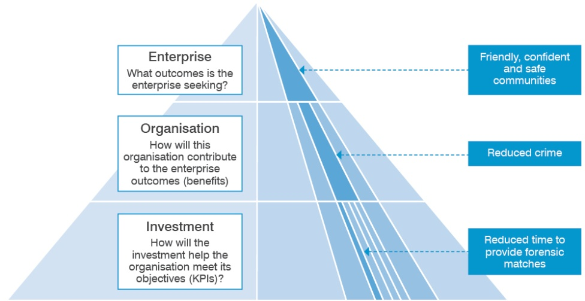
The framework is a three-level structure that links the contribution of an individual investment to the outcomes the enterprise is seeking.
In the example depicted here, at the enterprise level, the government is seeking to create ‘friendly, confident and safe communities’. To this end they set benefits and targets that must be met at the organisation level – in this case the police are required to ‘reduce crime’.
At the investment level it is necessary to demonstrate how a particular investment will contribute to the benefits sought by the organisation. In the fictional example we are using here, the team of forensic scientists are seeking an investment to improve forensic management practices, acquire state-of-art forensic software and to renew their aged computer system. In return for this investment they claim they will ‘reduce crime’. Their evidence to support this claim is that they will reduce the time it takes to provide forensic matches by 30 per cent and obtain 20 per cent more forensic matches.
The head of the police organisation is then left to decide the following:
- How significant will meeting the targets associated with these KPIs be to a reduction in crime?
- Would the claimed KPIs and their targets be directly attributable to the proposed investment?
- Would the likely impact on crime reduction be worth the cost of the proposed investment?
Any KPI selected must be meaningful, attributable and measurable.

Glossary
Accredited facilitator: Someone who has demonstrated their ability to lead the informed discussions of the IMS and has been accredited by the Victorian Government to do so.
Appraisal: The process of defining objectives, examining options and weighing up the costs, benefits, risks and uncertainties of those options before a decision is made.
Asset option: An asset option is a means of satisfying service needs by investing in existing assets or creating new assets.
Asset strategy: Sets the direction and communicates up-front the assumptions and decisions about levels of service and who provides them; is the means by which an entity proposes to manage its assets over all phases of their lifecycle to meet service delivery needs most cost-effectively.
Assets: Service potential or future economic benefits controlled by an entity (e.g. a department) as a result of past transactions or other past events. Assets may be physical (e.g. plant, equipment or buildings) or non-physical (e.g. financial investments). Assets may also be current (having a store of service potential which is consumed in one year or less) or non-current (having a store of service potential that is consumed over a period of more than one year).
Base case: The base case is a realistic option that involves the minimum expenditure to sustain existing standards of service delivery or to achieve previously agreed service standards. Therefore, the base case does not always mean ‘do nothing’; rather it is the minimum essential expenditure option (e.g. carrying out obligatory works to meet safety and health regulations).
Benefit data provider: A person who has been identified as the custodian of data that will be required as evidence that a KPI has been met.
Benefit management plan: A short document that specifies the benefits an investment will need to deliver to successfully address an identified problem. It includes the measures to be used as evidence that the benefits have been delivered. These measures are initially used to select the most suitable response to the problem. The BMP also defines the dates the benefits are expected to be delivered, who is responsible for their delivery and how they will be reported.
Benefit Map: A one-page document that depicts the logical connection of an investment’s benefits to the KPIs, measures and targets.
Benefit reports: A report for the investor that depicts the status of the delivery of the benefit compared with the original expectations.
Benefit specialist: A person who has expertise in the definition, management and evaluation of the benefits of an investment. People responsible for program evaluation have this expertise.
Benefit: The value that the investment will provide to the organisation or its customers. Benefits are normally a positive consequence of responding to the identified driver. Each claimed benefit must be supported by key performance indicators that demonstrate the investment’s specific contribution to the identified benefit.
Business case developer: A person with responsibility for developing the business case for a potential investment.
Business case: A document that forms the basis of advice for executive decision making for an asset investment. It is a documented proposal to meet a clearly established service requirement. It considers alternative solutions, and identifies assumptions, benefits, costs and risks. The development of the business case is based on the logic in the Investment Logic Map.
Candidate investment list: A list of the investments that are to be considered and prioritised based on their ability to respond to the needs of an investment program.
Candidate investment list template
Capital expenditure: Expenditure involved in creating or upgrading assets.
Cost-benefit analysis: Cost-benefit analysis is a technique that can express in a comparable (monetary) way the net effect of the costs and benefits associated with an investment proposal.
Dis-benefit: A negative impact that might occur as a direct consequence of implementing a particular solution.
Driver: The reason that action needs to be considered at this time. Drivers are normally couched in negative terms such as ‘Climate change is demanding new ways of living in Australia’. A driver should capture the essence of what is broken and the consequences.
Economic cost (or opportunity cost): The value of the most valuable of alternative uses.
Evaluation: The process of defining objectives, examining options and weighing up the costs and benefits before a decision is made to proceed.
Financial analysis: An investment evaluation technique that is confined to the cash-flow implications of alternative options and is undertaken from the perspective of the individual department or agency or government as a whole.
High Value and/or High Risk (HV/HR) projects: These are projects that have a Total Estimated Investment (TEI) of equal to or greater than $100 million, are classified as ‘High Risk’ using the Gateway Project Profile Model (this tool), or are nominated by the government as being part of the HV/HR process.
Impact: The cost, benefit or risk (either financial or socioeconomic) rising from an investment option.
Implementer: Someone who has experience and a practical sense of what is possible and can help shape, scope, analyse and quantify a potential solution.
Innovator: A person with the experience and skills to question whether a proposed solution has considered the current best thinking and practices.
Investment analyst: Someone who will analyse the case for investing in a particular proposal and will provide advice to the investment decision-makers.
Investment concept brief: A two-page document that depicts the logic underpinning an investment and identifies the likely costs, risks and uncertainty, dependencies and deliverables of the proposed solution. It is used to summarise the merits of an investment and so allow decision-makers to prioritise competing investments before proceeding to a business case.
Investment Logic Map: A simple single-page depiction of the logic that underpins an investment. It represents an ‘agreed investment story’ that is created in an informed discussion. It is written in plain English in a way that will allow a layperson to understand the language and the concepts. It provides the core focus of an investment and is modified to reflect changes to the logic throughout its lifecycle.
Investment Management Standard: A best-practice approach applied over the life of an investment that aims to reduce the risk of investment failure, provide greater value-for-money and drive better outcomes. It has been designed to enable the investor to shape and control investments throughout their lifecycle.
Investment review: Formal scheduled periodic reviews that aim to confirm that the logic for an investment remains valid.
Investment: The expenditure of funds intended to result in medium to long-term service, or financial benefits rising from the development or use of infrastructure or assets by either the public or private sectors. A single investment proposal may contain a number of related investment expenditures addressing the same service need.
Investor: The person who has an identified business problem (or opportunity), who will be responsible for making or advocating an investment decision, and who will ultimately be responsible for delivering the expected benefit. This person is often referred to as the ‘senior responsible owner’ or SRO.
Interdependency: These are key policies, assumptions, capabilities and circumstances that need to be in place to facilitate and/or justify the proposed investment.
Key performance indicator (KPI): A measure that has been selected to demonstrate that a benefit expected from an investment has been delivered. The KPI must be directly attributable to the investment.
Lifecycle cost: Lifecycle cost is the total cost of an item or system over its full life. It includes the cost of development, production, ownership (operation, maintenance, support), and disposal, if applicable.
Objective: The high-level action (or intervention) that is proposed as the response to the identified driver. This intervention must be framed within the context of the organisation’s purpose.
Options analysis: A process in which a range of options (both asset and non-asset) are evaluated. The most cost-effective options are then selected for more detailed evaluation through a business case.
Organisation effectiveness: A document that articulates why the organisation exists, its current effectiveness and the changes that will be made to improve its effectiveness.
Organisation outcome assessment: A report that contains an assessment of the contribution a selected functional unit has made to an organisation's outcomes over a selected period. This will include a judgement of the effectiveness of the interventions that were adopted to deliver the expected outcomes and the changes that could be made to improve the impact of the unit.
Outcome management plan: A document that specifies the benefits that an organisation is expected to deliver and the measures, baseline and target dates and values that will provide the evidence the benefits have been delivered. It also specifies the forum for reporting progress, the frequency of reporting and responsibility for reporting.
Outcome(s): In the government’s output/outcome framework, outcomes equate to benefits.
Prioritised investment list: A list of candidate investments that are prioritised on the basis of their ability to respond to the needs of an investment program. This is Part 4 of the Service Logic and Investment Prioritisation (SLIP) document.
Program evaluation report: A report that makes an assessment of the effectiveness of a program of investment. The assessment is based on the benefits the investment delivered compared to those defined in the Benefit Management Plan at the time the investment decision was made. To inform future investment decisions, the report also provides an assessment of the effectiveness of the response in responding to the problem and of the way the program was managed.
Project lifecycle: The stages of an asset lifecycle between the identification of the need and the delivery and handover of an initiative.
Project manager: The person who is responsible for implementing all or part of the solution.
Proposal: An idea for a policy, program or project that is under development and appraisal
Real option: the right–but not the obligation–for an investor to undertake certain business initiatives and actions in the future to optimise the opportunities and risks of an investment over its lifecycle and mitigate the risks that an investment will be regretted. Real options do not eliminate the change of regret but seeks to limit the extent of the regret.
Real options analysis: Real options analysis is an investment evaluation and decision-making framework which introduces more flexibility to the management of infrastructure projects that are significantly affected by uncertainty. It assists Government make investments that are more adaptable over time and better able to meet the community’s evolving needs.
Residual value: The net value applied to the asset at the end of the investment lifecycle or evaluation period; this may result in either a positive or a negative value.
Resources: Labour, materials and other inputs used to produce outputs.
Revenue: Inflows or other enhancements, or savings in outflows, of service potential or future economic benefits in the form of increases in assets or reductions in liabilities of the entity (other than those relating to contributions by owners) that result in an increase in equity during the reporting period.
Risk: Risk is often characterised by reference to potential events, consequences, or a combination of these and how they can affect the achievement of objectives. Risk is often expressed in terms of a combination of the consequences of an event or a change in circumstances, and the associated likelihood of occurrence.
Scenario analysis: Scenario analysis is a procedure for providing the decision-maker with some information about the effect of risks and uncertainties on an investment. In a scenario analysis, a set of critical parameters and assumptions that define a particular scenario are identified and varied to reflect a best-case and a worst-case scenario.
Service Logic and Investment Prioritisation (SLIP): A document that comprises the output of the program level workshops and describes how candidate investments have been prioritised based on their ability to respond to the problem and deliver the benefits.
Social benefit: The estimated direct increase in the welfare of society from an economic action. It is the sum of the benefit to the agent performing the action, plus the benefit accruing to society as a result of the action.
Social cost: The estimated direct total cost to society of an economic activity. It is the sum of the opportunity costs of the resources used by the agent carrying out the activity, plus any additional costs imposed on society from the activity.
Strategic assessment: The phase of the project lifecycle during which a need is translated, where justified, into a proposal where outcomes, purpose, critical success factors and the level of strategic alignment are clearly defined.
Response options analysis (SOA): A document that explains the logic used to identify which response would best address the identified problem and deliver the expected benefits. This will describe the interventions that were considered, how these were grouped to form a range of response options and why the preferred option was selected.
Strategist: A person with the background and skills who can act as the ‘custodian of the strategic direction’ at the informed discussions of the IMS.
Subject matter expert: A person who has expert knowledge of the problem area being discussed or the most effective responses to the problem.
Uncertainty: external factors that are difficult to predict or estimate their impact with confidence on government investment, benefit delivery and project implementation. These events include technological developments, major shifts in markets and economic conditions, the behaviour of other organisations, political orders, demographic, societal structures, or the natural environment.
Value management: Value management is a technique that seeks to achieve optimum value for money, using a systematic review process. The essence of value management is a methodical study of all parts of the product or system to ensure that essential functional requirements are achieved at the lowest total cost. Value management examines the functions required from a product, functions actually performed, and roles of the product’s components in achieving the required level of performance. Creative alternatives which will provide the desired functions better or a lower cost can also be explored.
Weighting and scoring: A technique that assigns weights to criteria, and then scores options in terms of how well they perform against those weighted criteria. Weighted scores are summed, and then used to rank options.

Further information
For more information, please write to the Investment Management team in DTF at investmentmanagement@dtf.vic.gov.au.

IMS Technical guides for facilitators cover the Problem Definition, Benefit Definition, Response Definition and Solution Definition workshops. These are available on the Support for Investment Management Standard facilitators page.
Real options analysis is an investment evaluation and decision-making framework which introduces more flexibility to the management of infrastructure projects that are significantly affected by uncertainty. It assists Government to make investments that are more adaptable over time and better able to meet the community’s evolving needs.
The related guidelines are available at www.dtf.vic.gov.au/Investment_Planning-and-Evaluation.
Information about real options analysis and associated tools is contained in DTF’s ‘Investing under uncertainty’ technical supplement to the Investment Lifecycle Guidelines.
A complete ILM will be produced if only one workshop is being undertaken. This is usually done for very simple, low risk and low cost investments.
The Victorian Government has developed Victoria’s Value Creation and Capture Framework aimed at getting better value for the community from all future infrastructure projects. More detail on this framework is available at http://www.dpc.vic.gov.au/index.php/news-publications/value-creation-and-capture-framework .
Victoria’s Climate Change Adaptation Plan lays out the government’s plan to help the State meet the challenges and act on the opportunities for climate change. http://www.dpc.vic.gov.au/index.php/news-publications/value-creation-and-capture-framework .
Templates and supporting tools: http://www.dtf.vic.gov.au/Publications/Investment-planning-and-evaluation-publications/Lifecycle-guidance/Templates-and-supporting-tools.

