Victoria’s Economic Bulletin

Volume 1: December 2017

Table of contents

[Secretary’s foreword 1](#_Toc501096291)

[Income inequality in Victoria: Evidence from the HILDA Survey (2001-2015) 2](#_Toc501096292)

[Overview 2](#_Toc501096293)

[1. Income inequality in an international context 3](#_Toc501096294)

[2. Income inequality trends in Victoria 8](#_Toc501096295)

[3. Trends in capital and labour income 10](#_Toc501096296)

[4. Conclusion 12](#_Toc501096297)

[What drives wage dispersion in Victoria? Evidence from the HILDA Survey (2001–2015)1 14](#_Toc501096298)

[Overview 14](#_Toc501096299)

[1. Related literature: possible explanations for rising wage dispersion 15](#_Toc501096300)

[2. HILDA Survey 16](#_Toc501096301)

[3. Wage dispersion in Victoria at the individual level 17](#_Toc501096302)

[4. Unemployment and wage dispersion 21](#_Toc501096303)

[5. ‘Ability bias’ and propensity score matching 22](#_Toc501096304)

[6. Conclusion 23](#_Toc501096305)

[The value of economic access 26](#_Toc501096306)

[Overview 26](#_Toc501096307)

[1. How does Melbourne compare? Economic access across Melbourne 27](#_Toc501096308)

[2. Economic access as a function of travel time and transport infrastructure 29](#_Toc501096309)

[3. Quantifying the value of increased access 31](#_Toc501096310)

[4. Conclusion 35](#_Toc501096311)

[Developments in the GST pool 37](#_Toc501096312)

[Overview 37](#_Toc501096313)

[1. The goods and services liable for GST 38](#_Toc501096314)

[2. International comparison 40](#_Toc501096315)

[3. Historical growth in the GST pool 42](#_Toc501096316)

[4. Explaining more recent trends 43](#_Toc501096317)

[5. The outlook for GST pool growth 49](#_Toc501096318)

Secretary’s foreword

### By David Martine

The Department of Treasury and Finance (DTF) provides robust and impartial advice to the Victorian Government about the State’s economic, commercial, financial, budget and resource management. Our analysis supports decisions on the most effective ways government funding can be used to make Victoria a better place to live, now and into the future.

Victoria’s economy is broadly equivalent to the size of a small OECD (Organisation for Economic Cooperation and Development) nation. Indeed, measured in terms of real gross domestic product (GDP) in 2016, it would be ranked 26th among the 35 OECD member nations, about the size of Hungary and larger than the economies of Iceland, Finland, Luxembourg and New Zealand.[[1]](#footnote-1) There are, however, relatively few economic research publications that focus on economic trends in Victoria. This research volume, *Victoria’s Economic Bulletin*, is designed to provide one such contribution.

DTF has been investing in the Department’s analytical and research capability. This volume provides a snapshot of some of the staff research being undertaken. By publishing it we hope to contribute to the broader public policy debate on important economic questions. We also hope to highlight important trends driving change in the Victorian economy.

The articles in this volume are summaries of research in progress. They are produced by authors to increase awareness about important economic and social trends.[[2]](#footnote-2) In this edition, two articles focus on trends in household income. The first discusses trends in income inequality and highlights how Victoria compares with the rest of Australia, and with other OECD economies. The second article discusses wage dispersion and factors driving differences in individuals’ wages in the cross-section and over time. The third article discusses the value of economic access, one ingredient for ensuring Victoria’s continued prosperity. The fourth discusses trends in GST revenue.

The Department plans to publish this volume twice a year. I hope the articles provide some insight into the research being undertaken and, perhaps more importantly, start a wider conversation on research into the Victorian economy.

**David Martine**

Secretary

Income inequality in Victoria:  
Evidence from the HILDA  
Survey (2001-2015)[[3]](#footnote-3)

### By Ana Marija Dabo and Valéry Dugain

ABSTRACT

This paper examines income inequality trends in Victoria using the Household, Income and Labour Dynamics in Australia (HILDA) survey.[[4]](#footnote-4) The income gap between the Victorians in the highest income decile and the lowest decile has widened since 2001. On the other hand, inequality appears to have decreased in the middle of the income distribution over the same period. A distinguishing feature of the Victorian experience is the strong growth in incomes across nearly all education levels, which is not the case in all advanced economies.

# Overview

Many economies have recently witnessed some rise in the popularity of inward-looking domestic policies and trade protectionism in their political landscapes. Some analysts explain the success of the recent populist narrative with increasing resentment against progressive values and globalisation (*The Economist*, 2016). Others, however, view rising economic inequality as the primary underlying cause (Inglehart and Norris, 2016). Economic inequality refers to the uneven distribution of income or wealth within an economy’s population. For example, a highly unequal economy is one where a small portion of the population holds a large share of total income or wealth. Many advanced economies that have experienced strong growth have also experienced greater income and wealth inequality (OECD, 2016).

The impact that inequality has on living standards, however, is harder to determine. For instance, the most recent period of rising income inequality in Australia coincided with a period of sustained economic growth, making the overall social welfare implications unclear (Fletcher and Guttman, 2013). Most economists agree that excessive inequality can be detrimental to economic and social outcomes (Australian Council of Social Service, 2015). An unequal distribution of resources can lead to a reduction in economic activity as fewer people have the means to purchase goods and services, invest and start new businesses. In modern societies where inequality is high, more people tend to rely on government transfers to meet their basic needs. Economic inequality can undermine social cohesion and institutions of civil society.

The observed rise in income inequality in the OECD since the early 1980s is often explained by the rise of knowledge-intensive service industries, technological automation, the decline of the manufacturing sector and the erosion of labour unions (Inglehart and Norris, 2016). Technological change has benefited the income growth of highly skilled, educated labour, while less educated workers have experienced slower wages growth in some sectors (Freeman, 1995; Atkinson, 2007). This paper examines inequality in an international context before analysing income inequality trends in Victoria. Using data from the HILDA Survey, the paper also discusses trends in capital and labour income inequality.

# 1. Income inequality in an international context

Income inequality can be measured in different ways using different data sources and different definitions of income. When comparing income inequality internationally and nationally over time, it is important to be aware of these differences as individual measures can provide an incomplete picture. The Gini coefficient is the most common measure of income inequality in an international context due to the simplicity of its computation.[[5]](#footnote-5) The value of the Gini coefficient ranges between zero and one, where zero indicates complete income equality and one complete income disparity.

The Gini coefficient as a measure of income inequality has several limitations. First, it can be sensitive to changes in the definition of income, which can lead to differences in inequality rankings across countries. Second, the Gini coefficient is a relative measure of income inequality and does not capture absolute differences in income levels. As a result, the Gini coefficient can indicate a lower level of income inequality even in situations where all incomes in a society decrease. Finally, the Gini coefficient fails to identify where inequality occurs in the income distribution.

As a result, two countries with very different income distributions can still have the same Gini coefficient. Figure 1 shows the Gini coefficient using disposable income for several OECD economies.[[6]](#footnote-6)

Despite unemployment rates declining and improved labour market conditions since the global financial crisis (GFC), income inequality using this measure remains elevated in many OECD countries, including Australia.

When comparing across countries, a country’s position can be significantly affected by its social transfer system. For instance, most market economies with smaller social transfer systems, such as Australia, the United Kingdom (UK) and the United States (US), have higher Gini coefficients, but have also experienced stronger economic growth since the GFC. Countries such as Portugal and Greece, on the other hand, have experienced quite dramatic labour market downturns during the GFC and persistently high unemployment, but have lower income inequality due to larger transfer systems directed towards people with low income.

According to the Gini coefficient, the level of income inequality in Australia (0.34) is slightly above the OECD average (0.32), but has remained constant since 2007.

Some countries at the lower end of the spectrum, such as Iceland, have seen a significant reduction in inequality since 2007. Other countries, such as the US, experienced further increases from an already high level of inequality over the same period.

Figure 1. Gini coefficient of disposable income inequality  
(in 2014 or latest year, 2010 and 2007, total population)

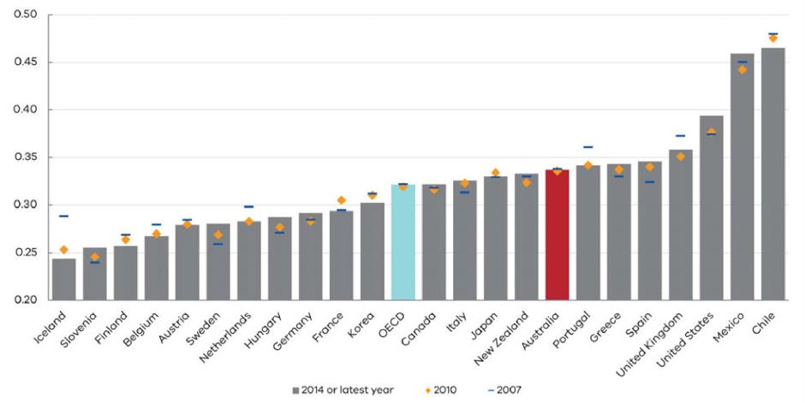

Note: The Gini coefficient is a standard measure of income inequality ranging from 0 (perfect equality) to 1 (perfect inequality).

Source: OECD Income inequality database.

BOX 1. INTERNATIONAL EXPERIENCE ON THE RELATIONSHIP BETWEEN INEQUALITY AND GROWTH

International evidence on the relationship between income inequality and economic growth remains inconclusive. One argument in the existing literature is that inequality can positively affect growth through stimulating innovation and entrepreneurship (Lazear and Rosen, 1981), raising savings and investment (Kaldor, 1957; Kuznets, 1955) and facilitating human capital accumulation (Saint-Paul and Verdier, 1993). Others, however, argue that inequality has adverse effects through political instability that crowds out investment (Alesina and Perotti, 1996) and that it can undermine the social consensus needed for successful adaptation to economic shocks (Rodrik, 1999). The inability of talented low-income individuals to accomplish their full potential can restrict growth (Galor and Zeira, 1993) and create redistributive pressures (Okun, 1975). Since labour income is the largest share of total income, a considerable body of international literature focuses on the distribution of wage income as a driver of overall income inequality. Some attribute the rise in income inequality in advanced economies since the 1980s to rising wages of executives and CEOs (Atkinson and Leigh, 2007; Lemieux, 2011). The common view, however, is that strong growth in wages in the top of the income distribution is more generally related to increases in the demand for skilled labour due to technological change and globalisation (Freeman, 1995; Atkinson, 2007). Technological change associated with the computerisation of the workplace and declines in the relative importance of repetitive, routine tasks has benefited highly skilled, educated people in the labour force disproportionately (Doiron, 2012).

Inequality in labour income or wage inequality is a major factor in explaining overall income inequality since labour income represents the largest share of overall income. While some level of inequality can be attributed to individual characteristics, excessive wage inequality can lead to adverse social and economic consequences, including reduced household consumption, lower rates of economic growth and strains on social cohesion.

Another measure of income inequality is the D9/D1 ratio, which measures the ratio of income between the ninetieth and tenth percentiles of the income distribution. These point-to-point estimates allow for a comparison at the upper and lower tails of the income distribution, rather than across the whole distribution like the Gini coefficient.

Figure 2 shows the change in the D9/D1 ratio between 2001 and 2015 for selected OECD countries for wages. Australia is located around the OECD average. Most countries shown in the figure have experienced a rise in wage inequality since 2001 based on this ratio, including Australia. However, wage inequality in some countries remained constant (for example, the UK and Japan) or even decreased (Hungary).

Educational attainment is considered to be one of the main determinants of income, and therefore of income inequality (Mincer, 1974; Becker, 1994; Leigh, 2008; Watson, 2011).

Figures 3A and 3B compare the real median total income in Victoria, Australia and the US for different educational levels over the period 2001-2015. Total income denotes gross income before taxes and is used instead of wage income to ensure comparability with the US data. Due to different data reporting practices, however, some educational categories are not directly comparable. Education premiums are expressed relative to the lowest educational level, which is Year 11 or below for Victoria and Australia, and below ninth grade for the US.

While real median income for all educational levels has stagnated for more than a decade in the US (in some cases falling in real terms), Australian and Victorian incomes grew substantially.

The highest growth in absolute terms in Victoria was recorded among those who hold an advanced diploma or a diploma, with their total real income increasing by 29 per cent. In Victoria (and Australia in general), even the real incomes of the least educated (Year 11 or below) recorded strong growth of nearly 24 per cent from 2001 to 2015.

At face value, these data suggest that part of the story in the US may not be about inequality per se, but due to slow growth in income overall. In contrast, the Australian and Victorian experience has been different with stronger growth in incomes across almost all education levels. This could reflect many factors including different wage setting regulations,[[7]](#footnote-7) greater protection for those on the minimum wage, and the fact that a commodity price boom may have helped offset declines in labour demand in sectors like manufacturing.

Figure 2. Decile ratios of real gross earnings (2001-2015) (D9/D1 ratio)

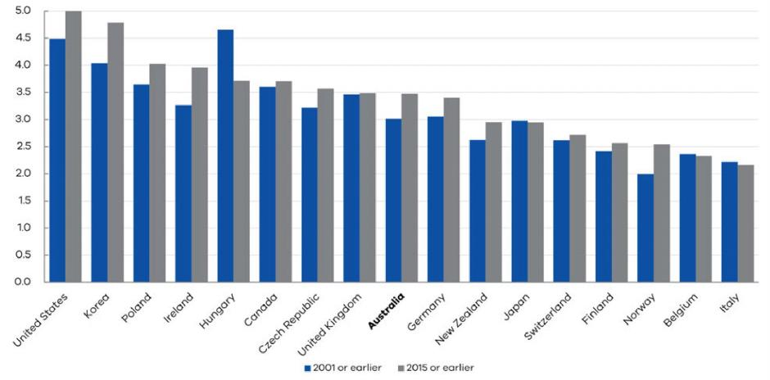

Note: The D9/D1 ratios are calculated using the upper limit of the first decile and the lower limit of the tenth decile (or the upper limit of the ninth decile). Income is based on real gross earnings of full-time employees.

Source: OECD Earnings database

Figure 3. Real median total income per educational level (Employed individuals aged 25 and over)  
(A) Real median total income premium by education level

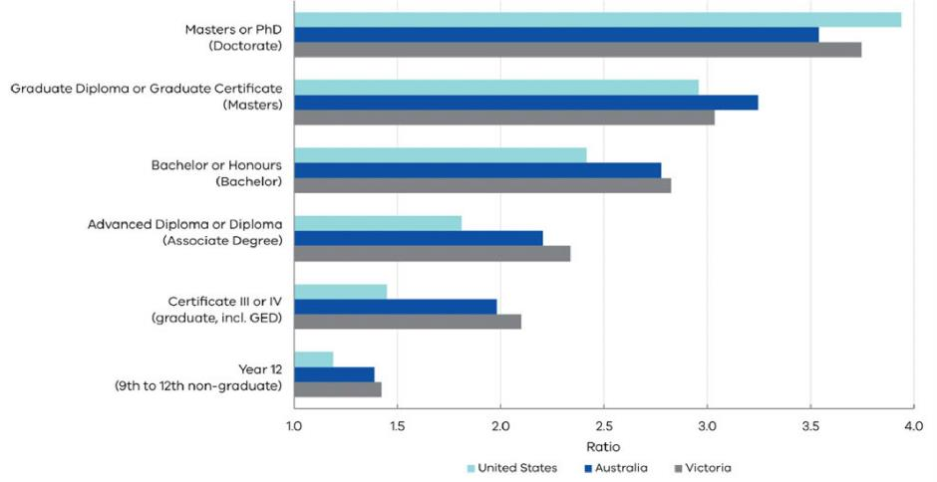

Note: Ratio of income relative to lowest education level (Year 11 or below for Victoria and Australia, below 9th grade for the US).

(B) Real median total income growth (2001-2015)

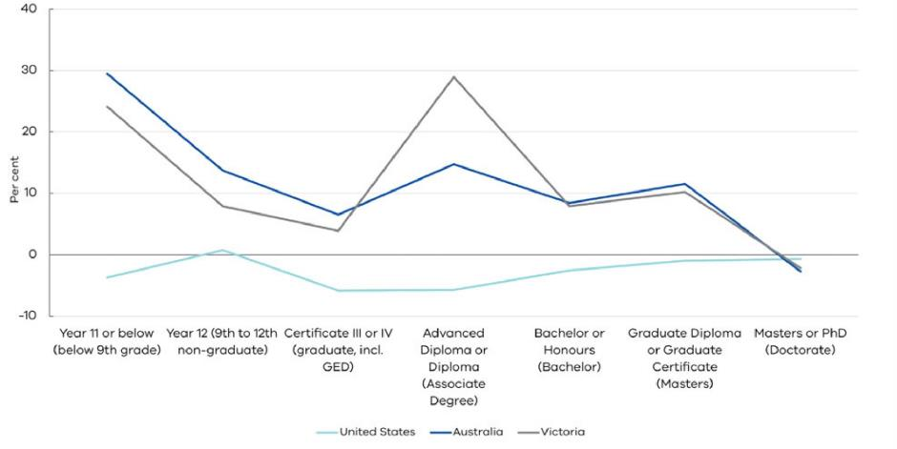

Note: Real median total income is deflated using each country’s consumer price index from 2001.

Source: U.S Census Bureau and HILDA database.

# 2. Income inequality trends in Victoria

To better understand income inequality trends in Victoria, this paper also uses data from the HILDA Survey. The survey is a nationally representative household-based panel study that provides an insight into the lives of the same group of Australians aged 15 and over through time.

Three broad areas are surveyed in this unique longitudinal study each year: economic and subjective wellbeing, labour market experiences and family dynamics. Within these areas, the survey asks questions about education, current and past employment, job search experiences, income, health and wellbeing, child care, housing, family background, marital history and family formation.

Each wave also has special questionnaire modules, covering topics such as wealth, retirement and fertility plans.[[8]](#footnote-8) There are more than 17 000 Australians included in the survey, out of which about 4 000 are from Victoria.[[9]](#footnote-9)

A range of income information is collected in each wave of the survey. This paper focuses on total disposable income (total income after receipt of government benefits and deduction of income tax) since this is the most relevant definition of income for supporting consumption choices. Total disposable income includes labour income (such as wages, salaries and supplements) and capital income (such as interest, dividends, royalties and rental income net of expenses). It is important to note, however, that this measure does not directly account for differences in costs such as electricity, fuel or rent, which can significantly affect individual’s consumption patterns.

## Trends in real disposable income

Several studies have investigated income inequality trends in Australia and Victoria. Wilkins (2014), for instance, compares income inequality estimates from the Survey of Income and Housing (SIH) data provided by the Australian Bureau of Statistics (ABS) and the HILDA Survey. When using a range of measures, there is evidence to suggest that overall income inequality has risen.

While there is no single measure of changes in inequality, few data sources indicate that inequality is decreasing. Using the HILDA data, Chatterjee, Singh and Stone (2016) have found rising wage inequality since the 2000s. Other recent empirical studies have found similar trends (Greenville, Pobke and Rogers, 2013; Whiteford, 2013). In Figure 4, the D9/D1 ratios are presented as log indices highlighting changes in income inequality in Victoria and Australia during the 2001–2015 period. As previously mentioned, this ratio measures the income gap between the ninetieth and the tenth percentile (Figure 4A), while the D7/D3 ratio considers differences in income between the seventieth and the thirtieth percentile (Figure 4B). Figure 4 suggests income inequality is increasing between the tails of the income distribution (D9/D1), but decreasing in the middle of the income distribution (D7/D3). Following the end of the GFC period, inequality growth in the D9/D1 ratio accelerated with two large spikes in 2010 and 2012.

Figure 4. Real disposable income decile ratios for Victoria and Australia (Index of log ratio, 2001=1)

|  |  |
| --- | --- |
| (A) D9/D1 ratio | (B) D7/D3 ratio |
|  |  |

Note: The log D9/D1 and D7/D3 ratios are calculated using the median income of each decile.

Source: HILDA database and author calculations.

In Figure 5, individuals in the sample are grouped into five income categories or ‘quintiles’, based on the level of their real disposable income. In 2001 and 2015, the sample median (located at the median of the third quintile) is lower than the sample average, indicating positive skewness of the income distribution towards the higher end. However, lower income quintiles experienced stronger growth in incomes relative to higher income quintiles. For example, the first and second quintiles saw 60 and 47 per cent real median disposable income increases between 2001 and 2015, while the fourth and fifth quintiles increased by 26 and 33 per cent. Median income increased by 35 per cent over the same period.

Figure 5. Real median disposable income across quintiles in Victoria (2001 and 2015), 2015 dollars

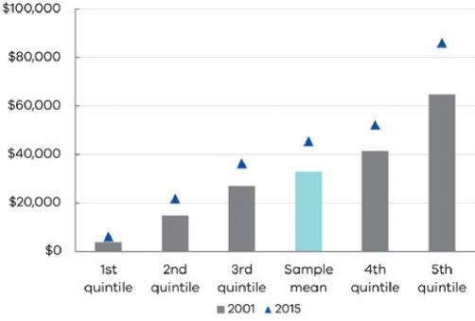

Source: HILDA database and author calculations.

# 3. Trends in capital and labour income

Several factors could be driving the observed increase in inequality at the tails of the income distribution. These include demographic changes, changes in the size and distribution of other types of income (like capital), government policy changes and labour market trends. It is estimated the proportion of the population aged 65 years or more will increase from around one in seven persons in 2012 to one in four persons by 2060 in Australia (Productivity Commission, 2013). Population ageing, as reflected through longer life expectancy and lower fertility, could change the distribution of the population in different income deciles (Doiron, 2012), and directly affect income and asset values (Brooks, 2006). However, considering the slow pace of demographic change, these effects are unlikely to explain short-run changes in income inequality.

Capital income growth, however, seems to play an important role for the income gap widening in Victoria. Capital income is defined as the sum of interest, dividends, royalties and rental income net of expenses.[[10]](#footnote-10) Over the period 2001-2015, the average real capital income of the lowest quintile fell (though it still rose in nominal terms), while the average real capital income of the 2nd and the 3rd quintile also grew more slowly relative to the higher income quintiles (Figure 6). One explanation for this could be that individuals with lower disposable income are less likely to hold substantial levels of wealth in equity or investment housing, for example, and so have not benefited from the strong capital growth observed in those asset classes.

Wage inequality is also a significant driver of income inequality (Whiteford, 2013). As shown in Figure 7, wage and income inequality growth have followed a similar pattern since 2006.[[11]](#footnote-11) Wage inequality has increased in many OECD countries since the 1980s and this is typically explained by the growing demand for skilled workers, compared to unskilled workers (Atkinson, 2007; Lemieux, 2011). These factors are thought to be important for Australia and Victoria too. Since 2011, wage inequality in Victoria has remained broadly stable, while overall income inequality has been more volatile. This divergence is driven by volatility in capital income growth, which is affected by volatility in financial markets (for example, the European debt crisis) and in income from property (for example, due to significant changes in interest rates and the demand for housing).

Another important explanation for wage inequality is an individual’s occupation. Box 2 classifies occupations requiring different levels of skills using the AUSEI06 score (McMillan, Beavis and Jones, 2009). Comparing real wage income growth among the four groups of occupations, the labour market picture in Victoria is similar to that observed internationally (Figure 8).

Figure 6. Effective annual growth rate of real capital income across quintiles in Victoria (2001 to 2015)

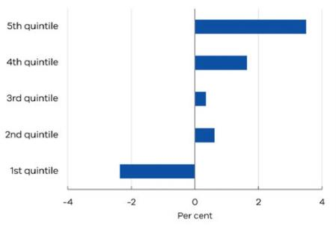

Source: HILDA database and author calculations.

|  |  |
| --- | --- |
| Figure 7. Real wage and real disposable income decile ratios for Victoria (2001 to 2015)  (Index of log ratio, 2001=1) | Figure 8. Real median wage income for occupations requiring different skill levels  (2001 to 2015), 2015 dollars |
|  |  |
| Note: For total disposable income, the log D9/D1 ratio is calculated using median income. For wage income, mean income is used as median wage income in the first decile is zero.  Source: HILDA database and author calculations. | Source: HILDA database and author calculations. |

Non-manual low-skilled, medium-skilled and high-skilled occupations show steady real wages growth since 2001, while real wages growth for manual low-skilled occupations has been a little slower. The observed wage dispersion for different occupations strongly correlates with changes in the Victorian industry composition. Shares in the total value added of industries such as manufacturing, agriculture and mining have shown significant declines from the early 1990s. In contrast, knowledge-intensive industries, such as financial and insurance services, professional, scientific and technical services, have seen their shares in total value added increase in the same period.

In addition to wages, the distribution of wage income also depends on whether individuals are employed. Overall income inequality changes can be driven by both changes in the wage of those who are in paid employment (the ‘wage effect’), and changes in employment status (the ‘employment effect’).

The ‘employment effect’ can either take the form of involuntarily becoming a casual or a part-time employee, or becoming unemployed altogether. These effects are investigated in further detail in a companion paper, ‘What Drives Wage Dispersion in Victoria? Evidence from the HILDA Survey (2001‑2015)’, which is also in this volume.

BOX 2. THE AUSTRALIAN SOCIOECONOMIC INDEX 2006 (AUSEI06)

The Australian Socioeconomic Index 2006 (AUSEI06) is used to differentiate between occupations requiring varying levels of skills (McMillan, Beavis and Jones, 2009). The scaling of occupations in AUSEI06 begins with the notion that occupations provide the means of converting one’s human capital (education) into monetary outputs (income). The occupational scores range from 0 (low status) to 100 (high status). The scale is used to distinguish between four groups: manual low-skilled (scores <30); non-manual low-skilled (30.01-50); medium-skilled (50.01-70); and high-skilled (>70.01).

Manual low-skilled occupations include labourers, cleaners and laundry workers, drivers, machine operators and food preparation assistants. Non-manual[[12]](#footnote-12) low-skilled occupations typically include sales assistants, carers, receptionists and some entry level hospitality, retail and service managers. The third group represents occupations with medium-level skills, such as specialist, retail and service managers, engineering, ICT and science technicians and, health and welfare support workers, but also lower-to-medium level business, human resource and marketing professionals. High-skilled occupations include health, business, human resource, marketing, engineering, design, science and technology professionals, high-level specialist managers, as well as general managers and chief executives.

# 4. Conclusion

This paper discusses income inequality trends in Victoria using data from the HILDA Survey. On several measures, income inequality has widened since 2001. On the other hand, inequality appears to have decreased in the middle of the income distribution over the same period.

The observed rise in income inequality reflects changes in labour and capital income. Consistent with patterns observed internationally, real wage growth for some low-skilled occupations has been slower than real wage growth for medium and high-skilled occupations. Unlike other economies, though, total disposable income has been growing steadily across almost all educational levels in Victoria.

Faster growth in real capital income in the highest income quintiles has also contributed to the widening of the overall real income gap. Individuals in the lower income quintiles typically do not hold significant levels of wealth through equity or investment housing and thus have not benefited from the strong capital growth observed in those asset classes.

Future work could consider the distribution of wealth and consumption, which also provide information on economic inequality. Wealth is important as it can be used to insulate against short-term shocks to income and it has inter‑generational implications. Consumption, on the other hand, is important because people’s living standards depend on the amount of goods and services they consume.

Finally, to get a more thorough picture of inequality trends, further work could also consider income mobility as it indicates how easy it is for individuals’ circumstances to change or whether inequality entrenches significant economic disadvantage

## References

Alesina, A., & Perotti, R. (1996). Income Distribution, Political Instability, and Investment. *European Economic Review*, vol. 40 no.6, pp. 1203-1228.

Atkinson, A. B. (2007). The Distribution of Earnings in OECD Countries. *International Labour Review*, vol. 146 no. 1-2, pp. 41-60.

Atkinson, A. B., & Leigh, A. (2007). The Distribution of Top Incomes in Australia. *Economic Record*, vol. 83, no. 262, pp. 247-261.

Australian Council of Social Service (ACOSS). (2015) *Inequality in Australia*.

Becker, G. (1994). *Human Capital: A Theoretical and Empirical Analysis with Special Reference to Education*. The University of Chicago Press.

Brooks, R. (2006). Demographic Change and Asset Prices. In *RBA Annual Conference Volume*. Reserve Bank of Australia.

Chatterjee, A., Singh, A., & Stone, T. (2016). Understanding Wage Inequality in Australia. *Economic Record*, vol. 92, no. 298, pp. 348- 360.

Cheung, S. L. (2006). *Credentials and Learning in the Labour Market for Young Australians*. Doctoral dissertation, Faculty of Economics and Business, The University of Sydney.

Cully, M. (2005). *What It’s Worth: Establishing the Value of Vocational Qualifications to Employers. A National Vocational Education and Training Research and Evaluation Program Report*. National Centre for Vocational Education Research, Australia.

Doiron, D. (2012). Income Inequality: A Review of Recent Trends and Issues. *Academy Proceedings*, vol. 2, Academy of Social Sciences in Australia.

Fletcher, M., & Guttmann, B. (2013). Income Inequality in Australia. *Economic Round-Up*, vol. 2, pp. 35-54.

Freeman, R. B. (1995). Are Your Wages Set in Beijing?, *The Journal of Economic Perspectives*, vol. 9, no. 3, pp. 15-32.

Galor, O., & Zeira, J. (1993). Income Distribution and Macroeconomics. *The Review of Economic Studies*, vol. 60, no. 1, pp. 35-52.

Greenville, Pobke & Rogers (2013), Trends in the Distribution of Income in Australia. Productivity Commission Staff Working Paper.

Inglehart, R., & Norris, P. (2016). Trump, Brexit, and the Rise of Populism: Economic have-nots and Cultural Backlash. Faculty Research Working Paper Series, Harvard University.

Kaldor, N. (1957). A Model of Economic Growth. *The Economic Journal*, vol. 67, no. 268, pp. 591-624.

Kuznets, S. (1955). Economic Growth and Income Inequality. *The American Economic Review*, pp. 1-28.

Lazear, E. P., & Rosen, S. (1981). Rank-Order Tournaments as Optimum Labour Contracts. *Journal of Political Economy*, vol. 89, no. 5, pp. 841-864.

Leigh, A. (2008). Returns to Education in Australia. *Economic Papers: A Journal of Applied Economics and Policy*, vol. 27, no. 3, pp. 233-249.

Lemieux, T. (2011). Wage Inequality: A Comparative Perspective. *Australian Bulletin of Labour*, vol. 37, no. 1, p. 2.

McMillan, J., Beavis, A., & Jones, F. L. (2009). The AUSEI06: A New Socioeconomic Index for Australia. *Journal of Sociology*, vol. 45, no. 2, pp. 123-149.

Mincer, J. (1974). *Schooling, Experience and Earnings*. New York: National Bureau of Economic Research.

OECD (2016), Income Inequality Remains High in the Face of Weak Recovery, Income Inequality Update, *Centre for Opportunity and Equality (COPE)*.

Okun, A. (1975). *Efficiency and Equity: The Big Trade-Off*. Washington, DC: Brookings Institution.

Preston, A. (1997). Where Are We Now with Human Capital Theory in Australia? *Economic Record*, vol. 73, no. 220, pp. 51-78.

Productivity Commission. (2013). *An Ageing Australia: Preparing for the Future*, Commission Research Paper, Canberra.

Rodrik, D. (1999). Where did all the Growth Go? External Shocks, Social Conflict, and Growth Collapses. *Journal of Economic Growth*, vol. 4, no. 4, pp. 385-412.

Ryan, C. (2002). *Individual Returns to Vocational Education and Training Qualifications: Their Implications for Lifelong Learning*. National Centre for Vocational Education Research.

Saint-Paul, G., & Verdier, T. (1993). Education, Democracy and Growth. *Journal of Development Economics*, vol. 42, no. 2, pp. 399- 407.

The Economist. (2016). The Politics of Anger. *The Economist*, 2 July 2016. Retrieved from: [www.economist.com/news/](http://www.economist.com/news/)leaders/21701478-triumph-brexit-campaign-warning-liberal-international-order-politics

Watson, I. (2011). Education, Earnings and the Labour Market. *Report for Skills Australia*.

Watson, N., & Wooden, M. (2001). The HILDA Survey: An Introduction. *Australian Social Policy*, 2001-02, pp. 79-100.

Whiteford, P. (2013). *Australia: Inequality and Prosperity and their Impacts in a Radical Welfare State*. Crawford School of Public Policy, Australian National University.

Wilkins, R. (2014). Evaluating the Evidence on Income Inequality in Australia in the 2000s. *Economic Record*, vol. 90, no. 288, pp. 63-89.

What drives wage dispersion in Victoria? Evidence from the HILDA Survey (2001–2015)[[13]](#footnote-13)1

### By Ana Marija Dabo and James Hansen

ABSTRACT

This paper examines the determinants of wage dispersion in Victoria using the Household, Income and Labour Dynamics in Australia (HILDA) Survey.[[14]](#footnote-14) Several econometric models are used to assess wage dispersion between groups with different educational levels and occupations. Higher levels of education and more skilled occupations are associated with higher wage premiums, although these premiums are found to be decreasing over time. When controlling for education, skills, occupation and other individual characteristics, there is evidence to suggest that the urban-rural wage gap is closing, while the gender wage gap has persisted over time.

# Overview

Rising income inequality in recent decades has received increasing attention in public debate. The analysis in a companion paper Income Inequality in Victoria: Evidence from the HILDA Survey (2001‑2015), which is also in this volume, suggests that Australia and Victoria have experienced a widening of income distribution, although the changes have not been as dramatic as in other advanced economies. Much of the discussion has focused on inequality in labour income (wages) since this represents the largest share of individual income. Individual wage dispersion has been extensively studied in the context of human capital theory where education, training and work experience are seen as investments in human capital (Schultz, 1961; Mincer, 1974; Becker, 1994). A large body of literature from different countries and over different time periods has shown that more highly educated individuals earn higher wages and are less likely to experience unemployment (Pereira and Martins, 2001; Bonjour et al., 2003; Kedir, 2008).

According to the human capital theory (for further detail, see Box 1), rising wage dispersion can be attributed to technological change, which has increased the productivity of more educated workers relative to the productivity of less educated workers. Consequently, the demand for more productive workers has led to higher wages for this group (Galbraith, 1998).

This paper examines the determinants of wage dispersion in Victoria over the period 2001–2015. Using individual-level data from the HILDA Survey, a unique longitudinal survey of households, several econometric models are estimated to assess wage dispersion across different educational levels, skills and occupations.

The results show that higher levels of education have a positive and significant effect on wage dispersion, although the education premium is decreasing over time. There is evidence to suggest that the urban-rural wage gap in Victoria is closing, while the gender wage gap has persisted over time. The results further suggest that unemployment spells have a negative effect on an individual’s wage and that this effect is stronger the longer an individual remains unemployed.

# 1. Related literature: possible explanations for rising wage dispersion

Several explanations have been offered for the increase in wage dispersion in recent decades. The most common view is that skill-biased technological change (SBTC), through the increased use of computers, has lowered the relative demand for low-skilled workers and raised demand for high-skilled workers (Johnson, 1997). According to some studies, Australia responded to technological advancement through an increased creation of high-skill jobs (Keating, 2003).

The original SBTC hypothesis is further refined by Autor, Levy and Murnane (2003) who introduced an important distinction between routine and skilled tasks. Routine tasks could be completed by computers in many industries, occupations and education groups.

For instance, computerisation of the workplace eliminated the need for workers performing non-cognitive routine tasks (for example, repetitive work in assembly lines), but also cognitive routine tasks (such as basic clerical jobs). In the Australian context, there is some evidence that job polarisation associated with a reduction in routine tasks and an increased need for skilled tasks has contributed to the rise in wage dispersion observed in the 1980s and 1990s (Coelli and Borland, 2016). Globalisation, trade and offshoring are also thought to be important in advanced economies (Freeman, 1995; Firpo, Fortin and Lemieux, 2010).

Unskilled workers are vulnerable to international competition because their jobs can be performed by workers in emerging market economies at a lower cost. Other demand-side explanations include the erosion of traditional labour market institutions (such as unions and minimum wage regulations), which affect inequality at the lower end of the wage distribution (Freeman and Katz, 1995).

On the other hand, changes in the salary structure for high-income earners (such as CEO performance bonuses) are seen as a contributor to the rise in inequality at the higher end of wage distribution (Atkinson and Leigh, 2007; Lemieux, MacLeod and Parent, 2009).

One of the main supply-side explanations for increasing wage dispersion is given by Goldin and Katz (2008). In their view, the education wage premium increases when growth in demand (technology) is outpacing growth in supply (education). Relatively slower growth in the rate of supply of highly educated workers is seen as one of the main reasons for higher wage dispersion in the United States since the 1980s, as measured by the wage gap between secondary and tertiary educated workers.

BOX 1. THE HUMAN CAPITAL THEORY

The concept of human capital refers to the set of individual attributes that characterise one’s ability to contribute toward production. Human capital includes education, skills, work experience, health and other individual characteristics such as motivation, work ethic and social capital. Human capital theory posits that education, training and work experience are forms of investment made by an individual that yield economic and social returns in the future (Schultz, 1961; Mincer, 1974; Becker, 1994). Hourly wages are typically seen as an indicator of labour productivity since the latter cannot be directly measured (Forbes, Barker and Turner, 2010). Empirical evidence suggests that investment in human capital such as education plays a major role in explaining the distribution of wage income in Australia (Preston, 1997; Ryan, 2002; Cully 2005; Cheung, 2006; Leigh, 2008 and Watson, 2011).

# 2. HILDA Survey

To examine the determinants of wage dispersion in Victoria and whether it has been changing over time, this paper uses the 15 waves of the HILDA Survey. The survey is a unique, nationally representative longitudinal study that follows the same group of individuals aged 15 and over.

Three broad areas are covered by the survey each year: economic and subjective well-being, labour market experiences and family dynamics. There are more than 17 000 Australians included, of which about 4 000 are from Victoria. For this paper, the sample is restricted to working‑age individuals (25 to 64 years old) to ensure the respondents had sufficient time to complete their education (Leigh, 2008).[[15]](#footnote-15) The average hourly wage, expressed in a logarithmic form, is the dependent variable of interest. Education, years of paid labour market experience, demographic characteristics, industry, occupation and gender are used to explain each individuals’ wage.

The Australian Socioeconomic Index 2006 (AUSEI06), ranging from 0 (low status) to 100 (high status), is used to differentiate between occupations requiring different skill levels (McMillan, Beavis and Jones, 2009). The scale is used to distinguish between four groups: manual low-skilled (scores <30);[[16]](#footnote-16) non‑manual low-skilled (30-50);[[17]](#footnote-17) medium-skilled (50-70);[[18]](#footnote-18) and high-skilled (>70).[[19]](#footnote-19) Another set of indicators, the Australian and New Zealand Standard Classification of Occupations (ANZSCO), groups occupations into managers; professionals; technicians and trades people; community and personal service workers; administrative and clerical workers; sales workers; machinery operators and drivers; and labourers (ABS, 2006). Box 2 discusses the econometric methodology estimating wage dispersion.

BOX 2. ECONOMETRIC METHODOLOGY FOR ESTIMATING WAGE DISPERSION

Early models of wage dispersion use regressions of wage income as a function of education and labour market experience (Mincer, 1974). However, several econometric issues were subsequently noted with this estimation strategy. First, data on wages are only available for people who are employed, which raises the possibility of sample selection bias. When working-age individuals choose to remain out of the labour market because their reservation wage is higher than the wage offered by employers, this could bias the resulting Mincer estimates. For example, the role of education in influencing wage dispersion may be over‑estimated if less educated individuals are more likely to remain out of the labour force.

Heckman selection models are one approach used to control for the fact that not all individuals are employed. A ‘selection’ equation is first estimated to predict labour market participation, followed by a main ‘wage’ equation that includes an adjustment factor for the effects of selection into the observed sample. Ideally, the specification of the ‘selection’ equation includes variables that affect the probability of labour force participation, but not the wage itself. In the Heckman selection models presented in Figures 1 to 5, age, gender, marital status and number of children aged 0-4 and 5-14 years are used to predict labour force participation (Watson, 2011).

In addition to the decision to participate in the labour force, wage estimates can be biased when unobserved individual characteristics that are correlated with the regressors in the model are omitted from the specification. A classic example is ‘ability bias’, which refers to the possibility that some individuals possess higher ability (such as higher cognitive ability or aptitude) that helps them to complete higher levels of education and earn higher wages. If ability is not controlled for, and education levels are correlated with ability, then a positive wage differential would be mistakenly attributed to education. Another approach to controlling for ‘ability bias’ is propensity score matching. This technique is discussed in further detail in Section 5 and suggests the estimates of the education wage premium tend to decrease once selection into higher education based on ability is accounted for.

# 3. Wage dispersion in Victoria at the individual level

Figure 1 shows wage premiums for different educational levels, skills and occupations, based on the Heckman selection model (Heckman, 1976). The estimated wage coefficients should be interpreted relative to a benchmark, which is year 11 or below for education, manual, low skills and labourers for occupation. The models also control for paid labour market experience, gender, whether the respondent lives in a major city, union membership, whether the respondent is a casual worker and migrant status.

Higher levels of education (bachelor or honours, graduate diploma or graduate certificate,[[20]](#footnote-20) and Masters or PhD) have a positive and significant effect on wage dispersion, while those with lower education levels such as Certificate III and IV are found to be weakly significant.[[21]](#footnote-21) On the other hand, wages of those who completed an advanced diploma and a diploma,[[22]](#footnote-22) or year 12 only are not found to be statistically different from those who completed year 11 or below (Figure 1).[[23]](#footnote-23)11 For example, a female professional living in a major city, with 10 years of paid working experience and a bachelor degree is predicted to earn $65 196 per annum, which roughly equals $3.1 million of lifetime earnings. In contrast, a male labourer living in rural area, with 20 years’ paid working experience and a Certificate III or IV is predicted to earn $47 100, translating into $1.9 million over a lifetime.[[24]](#footnote-24)

Figure 1. Wage premiums in Victoria over the period 2001-2015

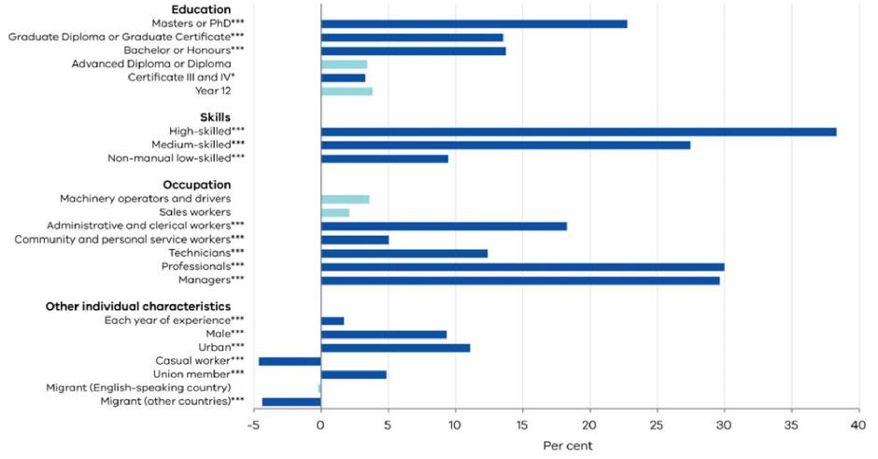

Notes: Significant at the 99 per cent level (\*\*\*), 95 per cent (\*\*) and 90 percent (\*) level of significance. Lightly shaded bars represent the results that are not statistically significant. Skills and occupation are included in separate specifications to avoid multicollinearity.

Source: HILDA database and author calculations

Figure 2 reports how the estimated wage premiums associated with education have changed over time, estimated by interacting each education category with annual time dummies. Higher levels of education show a broad decline in the extent to which they contribute to individual wage dispersion.

While those who have completed a Masters or a PhD were predicted to have a 32 per cent higher wage in 2001, the wage premium decreased to 22 per cent by 2015 (Figure 2A). Similarly, the wage premium of those who have completed a bachelor or honours degree decreased from 15 per cent in 2001 to 13 per cent in 2015. In effect, differing education levels may be contributing to less wage dispersion at the individual level.

Declines in the return to higher education could reflect longer-term structural factors, including differences in demand for certain types of graduates, their quality and the overall increase in the supply of graduates completing university degrees, particularly Masters and PhD (Figure 2B). Occupation, using the skills-based definition (McMillan, Beavis and Jones, 2009), appears to be even more important for explaining wage dispersion at the individual level.

Holding education and other individual characteristics constant, high-skilled occupations (such as health and education professionals, and high-level managers) were predicted to have a 38 per cent higher wage in 2015 relative to manual, low-skilled occupations.

The comparison of wage premiums over time in Figure 3A shows that the wage differential between manual, low-skilled occupations, medium-skilled and high-skilled occupations decreased in the years preceding the global financial crisis (GFC) and has remained broadly unchanged since. On the other hand, the wage premium for non-manual, low-skilled occupations relative to manual, low-skilled occupations steadily declined for much of the sample.

Professionals and managers have the highest wage premiums and their wage differential, relative to labourers, has remained broadly constant over the period 2001–2015 (Figure 3B). Machinery operators and drivers have significantly increased their wage premium over time and were predicted to have 7 per cent higher wages in 2015. In contrast, the wage premium for sales workers has shown a significant decrease and has become negative in recent years.

Figure 2. Wage premiums and course completion for different educational levels over time (2001–2015)

|  |  |
| --- | --- |
| (A) Wage premiums | (B) Course completion (index, 2001 = 100) |
|  |  |

Note: Wage premiums are measured relative to the Year 11 and or below.

Source: HILDA database, Department of Education and author calculations.

Figure 3. Wage premiums by skills level and for different occupations over time (2001–2015)

|  |  |
| --- | --- |
| (A) Skills levels | (B) Occupations |
|  |  |

Note: (A) Wage premiums are measured relative to the manual, low-skilled occupations. (B) Wage premiums are measured relative to labourers.

Source: HILDA database and author calculations.

Figure 4. Wage premiums for males and urban workers over time (2001-2015)

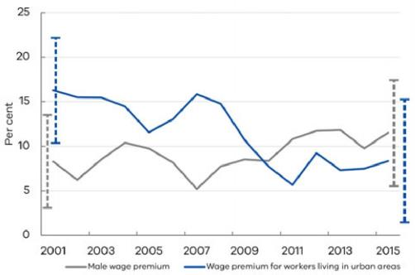

Note: Blue dashed lines represent 95 per cent confidence intervals for estimates  
of wage premiums for male workers, while grey dashed lines indicate confidence  
intervals for estimates of wage premiums for urban workers.

Source: HILDA database and author calculations.

Gender and geographical location also contribute to wage dispersion at the individual level (ACOSS, 2015). Figure 4 shows that wage dispersion between urban and rural workers significantly decreased from 16 per cent in 2001 to 8 per cent in 2015. On the other hand, the gender wage gap has increased a little since 2001, although the effect is not statistically significant. Box 3 discusses in more detail how wage premiums differ between males and females.

BOX 3. THE GENDER WAGE GAP

Despite increasing awareness of gender pay inequality, gender wage gaps continue to persist internationally, as well as in Victoria and Australia (Stephan, 2017). Reasons for this include a broad range of factors such as the level of educational attainment, on-the-job training and accreditation, work experience and other components of human capital. However, it also includes labour market discrimination – where equally skilled individuals may face different earning potential and employment prospects due to discrimination by gender, values and culture (KPMG, 2016).

Figure 5 shows gender wage differentials for education, skills, occupation and other individual characteristics in Victoria and Australia. In Australia, women have significantly lower wage premiums across almost all educational levels. In the Victorian sample, the gender wage gap is significant only among those who have completed a bachelor degree (10 per cent), which could be driven by a smaller sample size, but the direction of the estimates is similar.

No evidence of gender wage inequality is found when comparing manual and non-manual low-skilled and high-skilled occupations, while the gender wage gap among medium-skilled occupations is significant only for Australia. No statistically significant gender wage differential is found among higher paid occupations such as managers and professionals, in contrast to the results of other Australian studies (Watson, 2010; Kee 2006).

Male union members and men living in urban areas in Victoria tend to have 13 per cent and 7 per cent higher wage premiums, holding education, skills and occupation constant, while the wage premium is 10 per cent and 3 per cent respectively in Australia. Male migrants from non-English speaking countries are found to have 6 per cent lower wages in Australia, compared to their female counterparts, though this effect is not statistically significant in Victoria.

**Figure 5. Gender wage differential in the period 2001-2015**

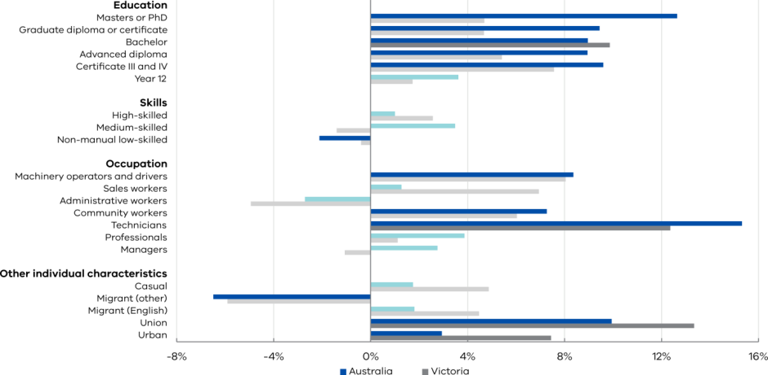

Note: Lightly shaded bars represent the results that are not statistically significant. Source: HILDA database and author calculations.

# 4. Unemployment and wage dispersion

International evidence shows that unemployment can have an adverse effect on an individual’s wage and that this effect can persist for years after a job loss (Couch and Placzek, 2010; Davis and Wachter, 2011). Some studies also suggest that the duration of unemployment negatively affects reemployment wage (Cooper, 2014; Knight and Li, 2006; Addison and Portugal, 1989). However, these studies focus on the short-term impact of unemployment duration on a worker’s earnings.

Table 1 presents the estimates of the impact of unemployment spells on the log average hourly wage using the most recent, fifteenth wave of the HILDA Survey. The estimates are presented for both Victoria and Australia, since the lack of statistical significance in the Victorian sample could be driven by a small sample size (nVIC=2,865; nAUS=11,261).

Holding education, experience, skills, occupation and other individual characteristics constant, if a respondent ever experienced unemployment within the survey, then their wage was on average 9 per cent lower for Australia and 5 per cent lower for Victoria. The total duration of unemployment is also important, with each year spent in unemployment decreasing the average hourly wage by 6 per cent for Australia and 4 per cent for Victoria.

The number of years since a person was last unemployed is used to capture the long-term effects of unemployment on an individual’s wage. If the wage were to catch up following a period of unemployment, as we might expect if the impact of unemployment has only a temporary effect on the wage, one would expect to see a positive sign on this measure. On the contrary, the estimated sign is negative. Taken at face value, this suggests that an individual’s wage continues to decline even after an individual re-enters employment. These results should be interpreted with caution since it could be possible that both unemployment and lower wages are driven by other unobserved individual characteristics.

Table 1. The impact of unemployment on average hourly wages in Victoria and Australia (2015)

|  | VICTORIA | AUSTRALIA |
| --- | --- | --- |
| Has the respondent ever been unemployed during the period 2001–2015? | -0.047  (0.031) | -0.089\*\*\*  (0.017) |
| Total duration of unemployment in the period 2001–2015 | -0.039\*  (0.024) | -0.057\*\*\*  (0.014) |
| Number of years since last unemployed in the period 2001–2015 | -0.0081\*\*  (0.0040) | -0.011\*\*\*  (0.002) |

Note: Significant at the 99 per cent (\*\*\*), 95 per cent (\*\*) and 90 per cent (\*) level of significance. Cluster-robust standard errors are in parentheses

Source: Source: HILDA database and author calculations.

# 5. ‘Ability bias’ and propensity score matching

One limitation of the previous Heckman estimates is that they may imperfectly control for an individual’s ability. An alternative approach used to control for selection associated with ability into higher education is propensity score matching (PSM). The intuition for PSM is to use observable characteristics to calculate the probability of receiving ‘treatment’ (for example, a university education), also known as a propensity score, which is then used to pair ‘treated’ and ‘non-treated’ observations. For example, if an individual who did not receive a university degree has a propensity score of 0.2 (20 per cent), that individual is ‘matched’ with an individual who also has a propensity score of 0.2 (20 per cent), but did receive a university degree (Titus, 2007).

The effect of the treatment on the log wage, in our case the completion of a university degree, is then computed as the difference in the log wage between the two matched individuals. PSM identifies a large number of matches in the sample and then averages across them to estimate the overall return from attaining a university degree. To model the propensity score used in the first stage of matching, we use cognitive ability test scores, personality characteristics, father’s education and occupation, as well as an indicator on whether the respondent is from an urban area.[[25]](#footnote-25)

Table 2 compares the estimates for the wage premium associated with attaining a university degree using the Heckman selection approach and PSM.[[26]](#footnote-26) Comparison between these two econometric methods is carried out using only the most recent, fifteenth HILDA wave. The positive effect of higher education on wages is, as expected, larger in models estimated using the Heckman approach since these models do not control for selection into higher education based on ability. Propensity score matching models, controlling for this, find smaller returns. For Victoria, the wage premium of acquiring a tertiary education is about 34 per cent, while controlling for ability[[27]](#footnote-27) using PSM decreases the premium to 20 per cent. This finding is in line with the magnitude of ability bias found in Leigh (2008), which ranges between 9 and 39 per cent in Australia.

The positive effect of education on earnings decreases again when occupational choices are taken into account, suggesting that occupation is an important determinant of an individual’s wage. When this effect is not accounted for, the impacts of education are higher. For instance, the wage premium for Victorians who attended university decreases from 34 to 11 per cent in the Heckman model. The PSM model also finds a substantial decline in the estimated wage premium in both Australia and Victoria. Indeed, the latter implies that a statistically significant difference is no longer found although this may be due to the small sample size.[[28]](#footnote-28)

Table 2. The impact of university education on average hourly wages in Victoria and Australia

|  | VICTORIA | | AUSTRALIA | | |
| --- | --- | --- | --- | --- | --- |
|  | HECKMAN SELECTION MODEL | PROPENSITY SCORE MATCHING | | HECKMAN SELECTION MODEL | PROPENSITY SCORE MATCHING |
| Without occupational choices | 0.34\*\*\*  (0.02) | 0.20\*\*\*  (0.04) | | 0.36\*\*\*  (0.01) | 0.28\*\*\*  (0.02) |
| With occupational choices | 0.11\*\*\*  (0.02) | 0.05  (0.06) | | 0.10\*\*\*  (0.01) | 0.14\*\*\*  (0.03) |

Note: Significant at the 99 per cent level of significance (\*\*\*). Standard errors are in parentheses.

Source: Source: HILDA database and author calculations.

# 6. Conclusion

This paper examines the determinants of wage dispersion in Victoria using individual-level data from the HILDA Survey. Several econometric models have shown that higher levels of education have a positive and significant effect on wage dispersion. The education premium is, however, estimated to be decreasing over time. Such a result is consistent with a rising level of educational attainment throughout the Victorian labour force.

The data show that the urban-rural wage gap in Victoria, although still significant, is also closing over time. On the other hand, the gender wage gap has persisted since 2001 despite efforts directed towards raising awareness on gender pay inequality, at least based on the sample of respondents in HILDA and the econometric specifications estimated here. Finally, there is evidence to suggest that unemployment spells have an adverse effect on an individual’s wage and can persist years after a job loss. Furthermore, the longer the duration of the unemployment spell, the stronger the negative effect on an individual’s wage.

Access to education remains an important factor in mitigating the negative effects of wage dispersion in Victoria. With improved access to education, lower income and other disadvantaged groups are better equipped for adapting to structural changes in the Victorian labour market. In this context, Victoria is well-placed to continue improving access to education and to improve inequality outcomes over time.

## References

ABS. (2006). ANZSCO – Australian and New Zealand Standard Classification of Occupations, First Edition, 2006, Cat No. 1220.0.

Addison, J. T., & Portugal, P. (1989). Job Displacement, Relative Wage Changes, and Duration of Unemployment. *Journal of Labor Economics*, vol. 7, no. 3, pp. 281-302.

Atkinson, A. B., & Leigh, A. (2007). The Distribution of Top Incomes in Australia. *Economic Record*, vol. 83, no. 262, pp. 247-261.

Australian Council of Social Service (ACOSS). *Inequality in Australia*. 2015.

Autor, D. H., Levy, F., & Murnane, R. J. (2003). The Skill Content of Recent Technological Change: An Empirical Exploration. *The Quarterly Journal of Economics*, vol. 118, no. 4, pp. 1279-1333.

Becker, G. (1994). *Human Capital: A Theoretical and Empirical Analysis with Special Reference to Education*. The University of Chicago Press.

Bonjour, D., Cherkas, L. F., Haskel, J. E., Hawkes, D. D., & Spector, T. D. (2003). Returns to Education: Evidence from UK Twins. *The American Economic Review*, vol. 93, no. 5, pp. 1799-1812.

Cheung, S. L. (2006). *Credentials and Learning in the Labour Market for Young Australians*. Doctoral dissertation, Faculty of Economics and Business, The University of Sydney.

Coelli, M., & Borland, J. (2016). Job Polarisation and Earnings Inequality in Australia. *Economic Record*, vol. 92, no. 296, pp. 1-27.

Cooper, D. (2014). *The Effect of Unemployment Duration on Future Earnings and Other Outcomes* (Working paper No. 13-8). Federal Reserve Bank of Boston.

Couch, K. A., & Placzek, D. W. (2010). Earnings Losses of Displaced Workers Revisited. *The American Economic Review,* vol. 100, no. 1, pp. 572-589.

Cully, M. (2005). *What It’s Worth: Establishing the Value of Vocational Qualifications to Employers. A National Vocational Education and Training Research and Evaluation Program Report*. National Centre for Vocational Education Research, Australia.

Davis, S. J., & von Wachter, T. (2011). Recessions and the Costs of Job Loss. *Brookings Papers on Economic Activity*, no. 2.

Firpo, S., Fortin, N. M., & Lemieux, T. (2010). Occupational Tasks and Changes in the Wage Structure. UBC Unpublished manuscript, July 2010.

Freeman, R. B. (1995). Are Your Wages Set in Beijing? *The Journal of Economic Perspectives*, vol. 9, no. 3, pp. 15-32.

Freeman, R. B. and Katz, L.F. (1995), ‘Introduction and Summary’, in Freeman, R.B. and Katz, L.F. (eds). *Differences and Changes in Wage Structures*, University of Chicago Press, Chicago, pp. 1-21.

Forbes, M., Barker, A., and Turner, S. (2010). *The Effects of Education and Health on Wages and Productivity*. Productivity Commission Staff Working Paper.

Galbraith, J.K. (1998). *Created Unequal: The Crisis in American Pay*, University of Chicago Press, Chicago, IL.

Goldin, C. and Katz, L. F. (2008), *The Race Between Education and Technology*, Harvard University Press, Cambridge, MA.

Heckman, J. J. (1976). The Common Structure of Statistical Models of Truncation, Sample Selection and Limited Dependent Variables and a Simple Estimator for such Models. In *Annals of Economic and Social Measurement*, vol. 5, no. 4, pp. 475-492.

Imbens, Guido W. (2015). *Causal Inference for Statistics, Social and Biomedical Sciences: An Introduction*. New York, NY: Cambridge University Press.

Johnson, G. E. (1997). Changes in Earnings Inequality: The Role of Demand Shifts. *The Journal of Economic Perspectives*, vol. 11, no. 2, pp. 41-54.

Keating, M. (2003). The Labour Market and Inequality. *Australian Economic Review*, vol. 36, no. 4, pp. 374-396.

Kedir, A. (2008). *Health and Wages: Panel Evidence on Men and Women Using IV Quantile Regression*, University of Leicester Department of Economics Working Paper no. 08/37, Leicester.

Kee, H. J. (2006). Glass Ceiling or Sticky Floor? Exploring the Australian Gender Pay Gap. *Economic Record*, vol. 82, no. 259, pp. 408-427.

Knight, J., & Li, S. (2006). Unemployment Duration and Earnings of Re-Employed Workers in Urban China. *China Economic Review*, vol. 17, no. 2, pp. 103-119.

KPMG. (2016). *She’s Price(d)less. The Economics of the Gender Pay Gap*. Update Report prepared for Diversity Council Australia and the Workplace Gender Equality Agency. October, 2016.

Leigh, A. (2008). Returns to Education in Australia. *Economic Papers: A Journal of Applied Economics and Policy*, vol. 27, no. 3, pp. 233-249.

Lemieux, T., MacLeod, W. B., & Parent, D. (2009). Performance Pay and Wage Inequality. *The Quarterly Journal of Economics*, vol. 124, no. 1, pp. 1-49.

McMillan, J., Beavis, A., & Jones, F. L. (2009). The AUSEI06: A New Socioeconomic Index for Australia. *Journal of Sociology*, vol. 45, no. 2, pp. 123-149.

Mincer, J. (1974). *Schooling, Experience and Earnings*. New York: National Bureau of Economic Research.

Pereira, P. and Martins, P. (2001). *Returns to Education and Wage Equations*, IZA DP no. 298, Institute for the Study of Labour, Bonn.

Preston, A. (1997). Where Are We Now With Human Capital Theory in Australia? *Economic Record*, vol. 73, no. 220, pp. 51-78.

Ryan, C. (2002). *Individual Returns to Vocational Education and Training Qualifications: Their Implications for Lifelong Learning*. National Centre for Vocational Education Research.

Schultz, T. W. (1961). Investment in Human Capital. *The American Economic Review*, vol. 51, no. 1, pp. 1–17.

Stephan, M. (2017). *The Australian Gender Wage Gap*. Doctoral thesis. Australian National University, Canberra.

Titus, M. A. (2007). Detecting Selection Bias, Using Propensity Score Matching, and Estimating Treatment Effects: An Application to the Private Returns to a Master’s Degree. *Research in Higher Education*, vol. 48, no. 4, pp. 487-521.

Watson, I. (2010). Decomposing the Gender Pay Gap in the Australian Managerial Labour Market. *Australian Journal of Labour Economics*, vol. 13, no. 1, p. 49.

Watson, I. (2011). *Education, Earnings and the Labour Market*. Report for Skills Australia.

The value of economic access[[29]](#footnote-29)

### By Cheng Yang, Ana Marija Dabo and James Hansen

ABSTRACT

This paper summarises research conducted as part of the Department of Treasury and Finance’s (DTF) economic geography project. In particular, it examines economic access, in terms of travel times and transport infrastructure, and how it is valued by Victorians. The paper argues that increased economic access is valuable and measurable. A quasi-natural experiment is used to measure the increase in housing prices associated with the development of a new train station, which gives an indication of the private value of greater economic access.

# Overview

Decisions on where people reside and where businesses conduct economic activity are determined by economic access. Generally, individuals prefer greater access to jobs and amenities, while businesses want access to skilled labour and customers to increase profitability. Broadly, access is influenced by the existence and cost of transport and communications infrastructure. Examples of such costs might include time spent commuting to work, the cost in facilitating meetings with other businesses, the transportation of goods and services between businesses or between businesses and people, or even the costs or the ease of exchanging ideas (DiPasaquale and Wheaton, 1995). Areas where the costs of exchanging goods, services or ideas are low are those where businesses and people will want to locate themselves and the payoff from doing so will be high.[[30]](#footnote-30)

In a spatial economy, decisions on where to locate relate to both the costs and the benefits of any given area. In a spatial equilibrium, people and businesses are indifferent between relocating across areas. For example, if an area that is highly connected to local employment opportunities has high wages, then it must be accompanied by high land prices – if not, everyone would move there (Glaeser, 2010). This tells us that land values should reflect individuals and firms’ preferences, which are driven by economic access. This paper examines land values across Melbourne to demonstrate that economic access and improvements in access are valued. It presents a novel economic experiment, exploiting the installation of a new train station, to measure how much people value improvements in access.

# 1. How does Melbourne compare? Economic access across Melbourne

Since land supply is fixed, the demand for particular locations, and associated infrastructure and amenities, is often well captured in the price of land. Figure 1 plots the land value per square metre of all land parcels in Melbourne represented as a heat map. More intense, ‘warmer’ colours represent higher land values per square metre. These warmer colours coincide with higher demand. The ‘cooler’ blue colours represent lower land values per square metre where competition for land is less intense.

In line with other high productivity cities around the world, higher values per square metre are observed in many inner city areas. This reflects peoples desire to be located close to employment opportunities and the high value placed on access to services and amenities provided in inner city areas.

Whether the high values in these areas reflect the ability of firms to attract more productive workers, or whether more productive workers have an inherent preference for living in inner cities, perhaps because of better cultural amenities, is less clear. Irrespective of the direction of causality, the premium for land closer to the inner city is high. Narrow strips of high value land can also be observed corresponding to retail precincts (e.g. Chapel Street in the inner east, High Street in the north) and in coastal suburbs. The direction of causality for these areas is clearer. People choose to live in these areas to take advantage of local amenities such as close proximity to the beach or preferred shopping destinations offering easy access to an abundant choice of consumer goods and services.

Figure 1 offers a broad representation of the economic geography of Melbourne. It tells us where individuals and firms choose to locate and the value they place on one location relative to another, represented through the value of land. It demonstrates that there are a variety of factors that make a particular location desirable, including:

* access to employment opportunities in the Melbourne CBD, schools, infrastructure and amenities;
* access to desirable physical features such as the beach; and
* access to areas with desirable goods and services.

A key impediment to economic access is the cost of commuting, as represented by the quality and availability of transport infrastructure. Given the land value patterns shown in Figure 1, we would expect locations with higher commuting costs, such those without public transport and/ or are further from the city, to have lower land values. In this way, differences in land values can reflect the value people place on transport infrastructure. In the next few sections, we examine differences in commuting costs across Melbourne and attempt to estimate the private values of increased economic access associated with a new train station.

Figure 1. Heat map - land value per square metre in Melbourne (2016)

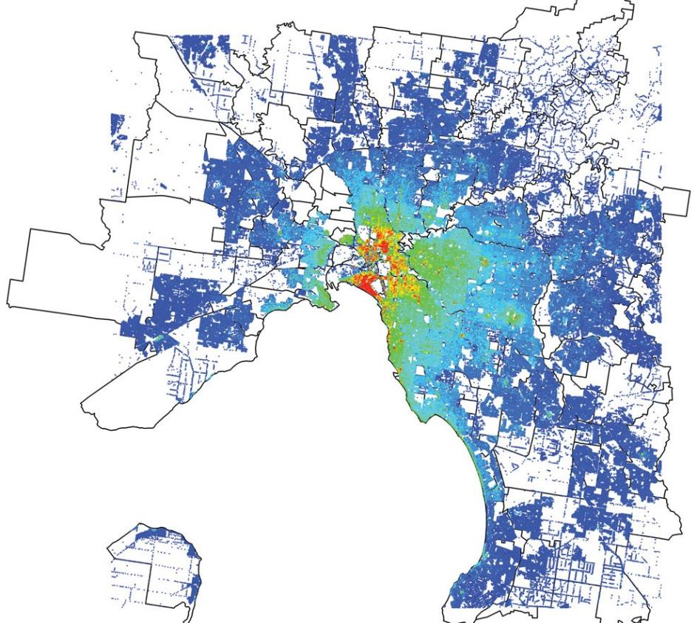

Source: Valuer-General Victoria.

# 2. Economic access as a function of travel time and transport infrastructure

Travel time is a key cost to accessing jobs. As time used commuting can be unproductive, longer commute times reduce economic efficiency and can create an economic and personal impediment to accessing jobs. In short, longer commute times may prevent workers taking the jobs in which they are most productive. Over the past decade, the proportion of people spending more than 10 hours a week commuting increased by about 50 per cent.

By measuring access based on the number of jobs people have access to, and the number of potential employees, suppliers and consumers that businesses have access to, Melbourne can be compared to other cities or measured over time. It can also be used to compare suburbs, occupations or even the impact of new infrastructure improvements or changes to planning restrictions.

To provide an illustration of different levels of economic access, Figure 2 shows the suburbs that have the greatest and least access, in terms of car travel time, to jobs in Melbourne. It shows that inner suburbs that have ‘colder’ blue colours are able to access almost all jobs in the Melbourne area by car, within 45 mins.

Outer suburbs that have ‘warmer’, red colours, are only able to access a low proportion of total jobs in Melbourne by car, within 45 mins. The colour patterns in this map mirror those in Figure 1, showing that inner city suburbs that have much greater access to jobs, correspond to high valued land, indicating that access to job opportunities/economic access is highly valued.

The colours on the map are influenced by physical proximity to jobs, and also transport infrastructure, which reduces the people’s effective distance to jobs. In this case, colder colours indicating greater access extend further out to the north-west and south-east direction, highlighting the role major infrastructure such as the Western Ring Road and the Monash and EastLink freeways play in facilitating economic access.

|  |  |
| --- | --- |
|  | A key economic cost is travel time. The longer it takes market participants to access each other, the higher the economic cost. A benchmark time threshold can be used to determine Melbourne’s access. A standard benchmark in the literature is around 45 minutes to an hour. |

Figure 2. The number of jobs accessible by a 45 minute car trip from each suburb, as a proportion of all jobs available in Melbourne (2013)

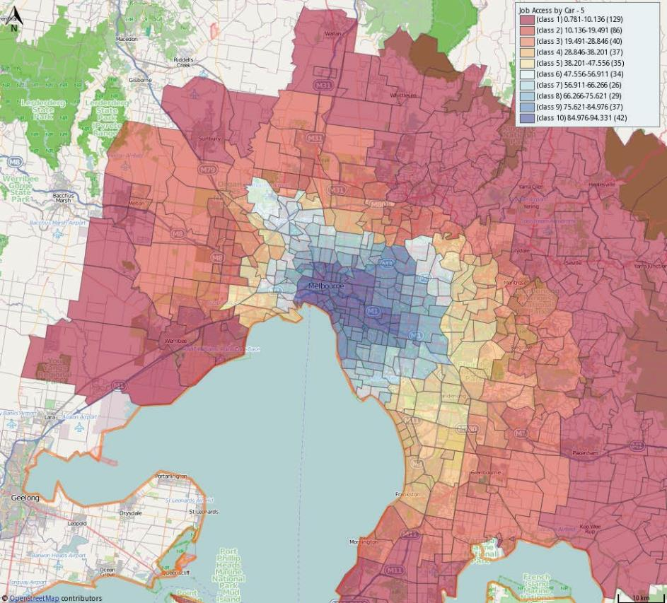

Source: Australian Urban Research Infrastructure Network and author calculations.

# 3. Quantifying the value of increased access

One measure of the benefits from increased economic access is residential property values. Higher property values are closely associated with higher economic access. However, because they can also be affected by other factors such as access to local amenities such as schools, parks and beaches, they are only an imperfect measure.

There is a strong correlation between median residential property values (including both houses and units) and the distance to the CBD. This is expected given that employment opportunities are concentrated in the CBD and that surrounding suburbs have the greatest access to these opportunities. Figure 3A fits a curve (through locally weighted scatterplot smoothing) to Melbourne suburbs by the median price for residential sales – a proxy for the value of residential property (land and capital improved value) in each suburb. It highlights that the closer to the CBD, the higher the median value. Moreover, in absolute dollar terms, the value of residential property has risen in inner suburbs relative to suburbs further from the CBD over time.

While the value of properties closer to the CBD has gone up by more in absolute terms, the picture is different when looking at growth rates. Expressed using a logarithmic ratio, the value of property by proximity to the city shows an almost parallel upwards shift (comparing 1978 and 2013 for example) and so, the value of residential property near the CBD has been growing at roughly the same rate as areas that are further from the CBD Figure 3B. The fact that growth in values has been broad based suggests the value of economic access, although uneven in absolute terms, has been improving across all Melbourne suburbs.

One of the limitations of Figure 3 is it only depicts correlation. As mentioned above, there could be other causal factors at play, and not just economic access, driving residential price patterns spatially and over time. To identify a clearer picture of the value of economic access, a difference-in-differences estimator is used to examine the impact of a newly installed train station.

A new train station’s primary function is to reduce the time spent commuting and increase economic access. By measuring the change in property prices, in areas in close proximity to the new station, one can estimate the private value of increased economic access that is not confounded by other factors such as changes in the value of amenities. To do so, we use a difference-in-differences estimator.

Figure 3. Suburb median price

|  |  |
| --- | --- |
| (A) property sale price | (B) logarithm of property sale price |
|  |  |

Source: Valuer-General Victoria and author calculations

BOX 1. DIFFERENCE IN DIFFERENCES

Difference in differences (DID) is an econometric method that compares outcomes across groups. In its simplest form, the outcome is observed for two groups in two time periods. Neither of the groups are exposed to ‘treatment’ in the first period (in our case, the development of a new train station). In the second period, however, one group is exposed to the treatment, while the other control group is not (Angrist and Pischke, 2008). The difference between the two groups then represents the causal effect of the treatment.

In our example, suburbs further from the train station but that otherwise have similar amenities are the control group, while suburbs close to the new train station are the treatment group (they have a sudden jump in their economic access). The advantage of the DID approach is that broad macroeconomic trends in property prices and network-wide improvements in infrastructure and their impact on price are absorbed by the control group, and so will not confound the analysis.

We focus on two outer northern Melbourne suburbs, Roxburgh Park and Greenvale (Figure 4). The demographics of the suburbs are broadly similar. In 2005, the Victorian Government announced construction of the Roxburgh Park railway station, with the station completed in 2007. No major infrastructure works took place in Greenvale during that period. This makes it an ideal setting for a quasi-natural experiment, with Roxburgh Park the ‘treated’ suburb and Greenvale the ‘control’ suburb.

In implementing the DID approach, DTF used detached house transactions data from the year 2004, immediately prior to the announcement of the new train station (in 2005), and from 2009, after the completion of the train station (the station was completed and opened in 2007).

The price difference[[31]](#footnote-31) between the two suburbs in 2004 is measured, and then compared to the price difference between the suburbs after the completion of the station (2009).[[32]](#footnote-32) Any statistically significant change in the price differential before and after the completion of the new station can be attributed to the increase in economic access. The approach in this paper is similar to Card and Krueger (1994), and can be technically represented in the following form:



where:

Log(Pst) is the log price of a transacted house in suburb s, at time t.

Roxs is a dummy variable that equals 1 if the transaction is in Roxburgh Park and 0 if it is in Greenvale.

Dt is a dummy variable that equals 1 if the transaction year is 2009 and 0 if the transaction year is 2004.

Roxs×Dt is the difference-in-difference variable that equals 1 for transactions in Roxburgh Park in year 2009, with all other transactions being 0.

Ckst is a set of house characteristics that includes floor size and dummy variables for the number of bedrooms for each transacted house, to control for the composition of houses that are transacted in each year.

The DID approach undertaken and broad results are illustrated in Figure 5. It shows that DID effectively compares changes in the price differential between Roxburgh Park and Greenvale to assess the price impact of the train station – the impact of the train station is taken to be the difference in the difference between the blue line and the red line. Regression results are further broken down by distance to the train station in Figure 6.

Figure 4. Location of two outer northern suburbs, Roxburgh Park and Greenvale

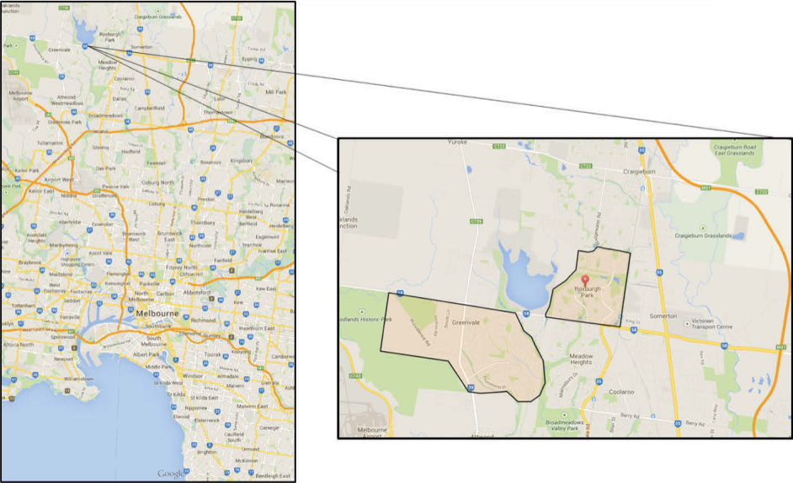

Source: Google Maps.

Figure 5. Illustration of DID method – Comparison of hedonically adjusted average house price in Roxburgh Park and Greenvale, before and after announcement and completion of Roxburgh Park railway station (year 2004 vs 2009)

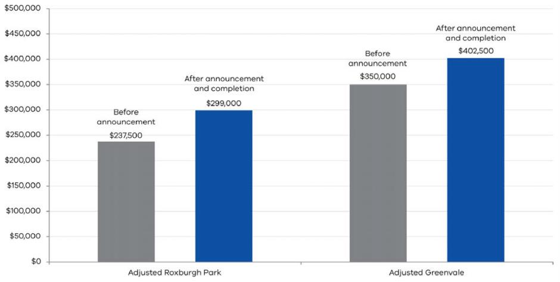

Source: Author calculations.

Figure 6. DID results – property price growth between 2004 and 2009, after announcement and completion of Roxburgh Park train station (controlling for the composition of properties transacted

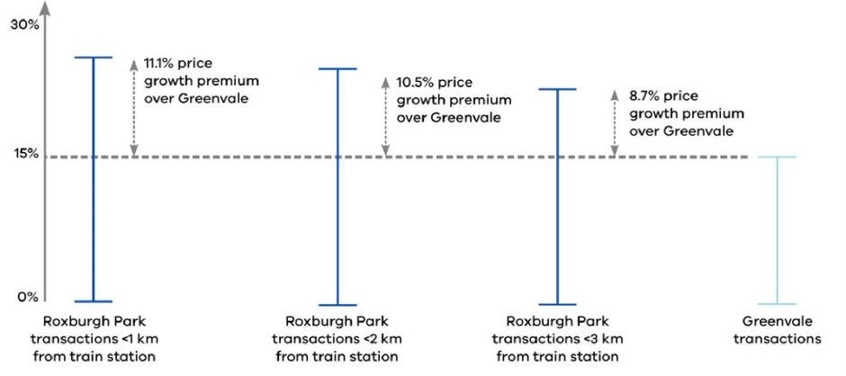

Source: Author calculations

Figure 6 suggests that construction of the train station has increased hedonically-adjusted average house values in Roxburgh Park by around 10 per cent, which is statistically significant at the 95 per cent level. The results are broken down by distance to the train station and show that price growth was strongest for houses located closer to the train station, as we would expect if the increase in value relates to greater economic access.

Houses located in a radius of less than 1km from the Roxburgh Park station experienced an 11.1 per cent price growth premium over Greenvale, while transactions involving houses located less than 2km away from the train station exhibited a 10.5 per cent price premium. Houses located less than 3km away from the Roxburgh Park train station are found to be associated with the smallest magnitude of price growth, with a premium of 8.7 per cent when compared to Greenvale.

A ‘placebo’ test is implemented to see whether the strong price growth in Roxburgh Park can be attributed to the new station. To do this, the same methodology is used, but it is applied to data from the years 2000 and 2004 (the announcement of the train station was in 2005). If the approach is correctly identifying the value of increased access, then we should not see the same price differentials between the two suburbs during this period. The results are illustrated in Figure 7. They highlight that there is no evidence of statistically different price growth between Roxburgh Park and Greenvale in the five-year period prior to the announcement of the new train station.

Figure 7. Placebo test – price growth between 2000 and 2004 – five-year period before   
announcement of train station (controlling for the composition of houses transacted)

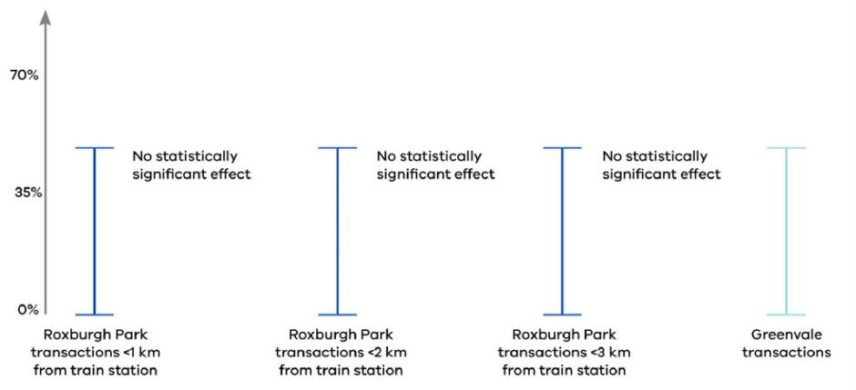

Source: Author calculations

# 4. Conclusion

This paper has shown that economic access is valued by Melbournians. Areas closest to the inner city, coastal strips and prominent shopping precincts have the highest land values per square metre. There is also evidence to suggest that more connected economic areas (in terms of proximity to jobs) are also valued more. While there are differences in the absolute value of economic access by region (as reflected in median residential property values), relative growth in the value of this access has been broadly uniform.

To investigate the value of access in more detail or abstract from other causal factors that could explain these patterns, the paper also presents a novel econometric approach to quantify the private values of an increase in economic access. It exploits a quasi-natural experiment where a train station was built in Roxburgh Park.

The approach shows Melbournians value increases in economic access, as reflected in the increase in prices for houses that have close proximity access to new transport infrastructure (relative to similar houses, but that are further away). The results shows the property price growth premium of Roxburgh Park over Greenvale, over the course of the announcement and completion of the Roxburgh Park train station, was up to 11 per cent for houses closest to the station. A placebo test of the identification strategy indicates there was no substantial difference in price growth between Roxburgh Park and Greenvale in the period before the announcement of the train station.

## References

Alonso, W. (1964). *Location and Land Use: Toward a General Theory of Land Rent*. Harvard University Press, Cambridge, MA.

Angrist, J. D.& Pischke, J. S. (2008). *Mostly Harmless Econometrics: An Empiricist’s Companion*. Princeton University Press.

Card, D., & Krueger, A. (1994). Minimum Wages and Employment: A Case Study of the Fast-Food Industry in New Jersey and Pennsylvania. *The American Economic Review*, vol. 84, no. 4, pp. 772‑793.

DiPasquale, Denise & Wheaton, William C. (1995). *Urban Economics and Real Estate Markets*. Prentice Hall, Englewood Cliffs, NJ.

Glaeser, E and Ponzetto, G. (2010). Did the Death of Distance Hurt Detroit and Help New York? In Edward L. Glaeser (ed.) *Agglomeration Economics*, NBER Book.

Muth R. (1969). *Cities and Housing*. The University of Chicago Press, Chicago.

Rauch, J. (1991). Productivity Gains from Geographic Concentration of Human Capital: Evidence from Cities, NBER Working Paper No. 3905.

Developments in the GST pool

### By Christian Andersen, Daniel Harrison and Siroos Khademalomoom[[33]](#footnote-33)

ABSTRACT

This paper outlines trends in the national goods and services tax (GST) pool since its inception in July 2000. GST pool revenue as a share of overall economic activity peaked in 2003. The decline in the share since then reflects slower nominal growth in the consumption of goods and services that are liable to pay GST, particularly tradable goods that have experienced strong international competition, high productivity growth that has lowered their prices, and more generally a low inflation environment globally. In contrast, there has been much stronger growth in the share of consumption that is exempt from GST such as health, education and housing services. This has reflected stronger growth in both volumes and price, as demand for these services has risen. While the overall revenue share has been declining, GST remains one of the more stable tax bases for state and territory governments. Growth in the GST pool faces several headwinds including heightened international competition in the supply of consumption goods, ongoing weakness in global inflation, and scope for the household savings rate to remain higher than forecast.

# Overview

This paper examines developments in GST pool over the past two decades. The GST pool is the total amount of GST revenue collected nationally each year by the Commonwealth. This pool is then distributed to the states and territories as Commonwealth grants. These grants are a significant revenue source for Victoria, around $13 billion in 2015-16, or a quarter of the State’s total revenue. Developments in the GST pool have significant consequences for Victoria’s revenue base.

Australia’s GST is a 10 per cent value-added tax (VAT) on a specific range of goods and services. It excludes most education and health services and has partial exemptions in food, financial services, rent, transport and some other services. In this paper we discuss broad trends in consumption and the implications for GST revenue. Four trends are evident in the data:

1. GST revenue as a share of overall economic activity (nominal gross domestic product (GDP)) has fallen over time, declining from 4 per cent of GDP in 2003 to 3.6 per cent in 2015-2016.
2. This decline has been driven by slow nominal growth in the consumption of goods and services that are liable to pay GST, such as expenditure on the purchase and operation of motor vehicles, recreation and culture, furnishings and household equipment, hotels cafes and restaurants and clothing and footwear.[[34]](#footnote-34) In contrast, there has been stronger growth in expenditure on services that are exempt or partially exempt from paying GST such as housing services (rent), education and health.
3. While the GST pool’s share of overall economic activity is declining, it remains one of the most stable tax bases for state and territory (state) governments.
4. The near-term outlook for growth in the GST pool faces several headwinds including greater international competition in the supply of consumption goods, ongoing weakness in global inflation, and the potential for the household saving rate to remain higher than forecast.

# 1. The goods and services liable for GST

Table 1 reports the proportion of household consumption subject to GST by consumption category and each category’s share of total nominal consumption. Categories that have a moderate or high GST liability (defined as 50 per cent of expenditure or more being liable) make up almost 60 per cent of the consumption basket.

These categories include recreation and culture, hotels, cafes and restaurants, operation and purchase of motor vehicles, and furnishings and household equipment. In contrast, the largest shares of consumption that are not liable (or have a small liable share) include rent, food, health and education, which together make up about 40 per cent of the total consumption basket.

The sale of new residential properties and residential building activity is also subject to GST in Australia. The value of dwelling investment recorded in the national accounts is one indicator that moves in accord with the value of new home sales and residential work done.

These components of the GST pool are subject to significantly larger cyclical variation than consumption, contributing to greater variability in growth of the GST pool than in consumption (Figure 1). There have also been two recent changes to the GST base – the extension of coverage to low value imports and imported digital goods and services. These changes are discussed in Box 1.

Table 1: Consumption categories: GST liable share in 2015-16 and share of nominal consumption in 2016-(per cent)

|  | GST LIABLE SHARE | SHARE OF NOMINAL CONSUMPTION |
| --- | --- | --- |
| Cigarettes and tobacco | 100.0 | 1.4 |
| Alcoholic beverages | 100.0 | 1.7 |
| Clothing and footwear | 100.0 | 3.3 |
| Electricity, gas and other fuel | 100.0 | 2.6 |
| Furnishings and household equipment | 100.0 | 4.3 |
| Communications | 100.0 | 2.5 |
| Recreation and culture | 99.4 | 9.9 |
| Operation of vehicles | 94.4 | 5.0 |
| Hotels, cafes and restaurants | 91.2 | 6.6 |
| Purchase of vehicles | 90.7 | 1.9 |
| Other goods and services | 65.3 | 6.5 |
| Insurance and other financial services | 53.1 | 9.2 |
| Transport services | 44.9 | 3.2 |
| Food | 20.7 | 9.9 |
| Rent and other dwelling services | 13.2 | 21.3 |
| Health | 0.0 | 6.5 |
| Education services | 0.0 | 4.5 |
| Total consumption | 57.9 | 100.0 |

Sources: Australian Bureau of Statistics (ABS) and author calculations.

BOX 1. RECENT CHANGES IN THE GST TAX BASE

Two recent Commonwealth Government measures will expand the base of goods and services that the GST applies to. However, these changes are expected to have only a marginal impact on the total amount of GST collected (less than 1 per cent additional revenue per year).

The first is to extend coverage to low value imports. On 21 June 2017, the Australian Parliament passed legislation extending the application of GST to all imports (previously goods worth less than $1 000 were exempt). The law will apply from 1 July 2018.

The second change is to include imported digital products and services. The Commonwealth’s 2015‑16 Budget announced that the application of the GST will be extended to imports of digital products and other services. This includes digital products such as streaming or downloading of movies, music, apps, games, eBooks as well as services such as architectural or legal services. Legislation giving effect to this measure was passed on 5 May 2016, with the measure applying from 1 July 2017. Table 1.1 presents initial estimates of the additional revenue associated with these policy changes with the low value import change to be delayed by one year.

Table 1.1: Revenue from GST policy changes

|  |  |  |  |
| --- | --- | --- | --- |
| $ MILLIONS | 2017-18 | 2018-19 | 2019-20 |
| Imported digital goods and services | 150 | 200 | n/a |
| Low value imports | 70 | 100 | 130 |

Source: Commonwealth budget papers.

Note: Initial budget costings only, the low value import policy will apply from 2018-19, not 2017-18.

Figure 1. Annual growth in nominal consumption, dwelling investment and GST pool (per cent)

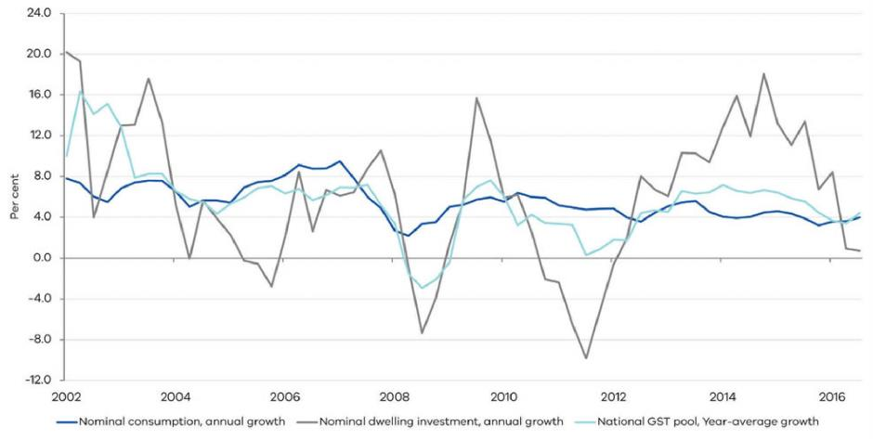

Source: ABS and Commonwealth Treasury.

# 2. International comparison

Australia is the most recent Organisation Economic Cooperation Development (OECD) economy to implement a national VAT and the United States (US) remains the only OECD economy without one. Compared with other countries, Australia’s GST exempts a large number of goods and services. The VAT Revenue Ratio (VRR) measures the breadth of the base to which a consumption tax is applied to. A VRR of one represents a single tax rate that applies equally to all goods and services while a measure of zero would imply that all categories of consumption are exempted (i.e. no VAT).

Australia’s VRR was 0.49 in 2014, which is below the OECD average of 0.56 for value added taxes (OECD, 2015).[[35]](#footnote-35) This reflects the broader range of exemptions that were negotiated at the time Australia’s GST was introduced. By comparison, New Zealand’s VAT is very close to a ‘pure’ broad-based consumption tax with a VRR of 0.97. Internationally, there has been a trend towards a greater share of revenue being collected through broad-based consumption taxes (see Box 2).

Australia’s GST as a share of overall economic activity (GDP) is also relatively low, about 3.6 per cent, when compared to the OECD average of 6.8 per cent. Australia’s GST share of GDP peaked in 2003 while the OECD average share has more than doubled over the same period reflecting higher VAT tax rates being implemented in a number of economies (OECD, 2016a). Australia’s below average share primarily reflects Australia’s comparatively low tax rate of 10 per cent, which compares to the OECD average of 19.2 per cent.

BOX 2. TRENDS IN CONSUMPTION TAXATION INTERNATIONALLY AND ACADEMIC RESEARCH

Internationally, consumption taxes as a share of overall economic activity have been increasing. In OECD economies, consumption taxes as a share of nominal GDP have doubled from about 3 per cent in the mid-1960s to almost 7 per cent in 2014. On average, they currently raise about a fifth of overall revenue in OECD economies (OECD, 2016b). At the same time, the mix of consumption taxes used across countries has changed. Many OECD economies now rely more on broad-based VATs, and less on narrow consumption (excise) taxes on specific goods and services.

In response to greater competition globally, particularly in digital goods and services, many countries including Australia have either introduced or broadened the application of VAT to online sales by offshore retailers. These changes have been supported by the recent VAT/GST Guidelines and the BEPS Action 1 Report on Addressing the Tax Challenges of the Digital Economy (2015), the first release of an international standard for applying VAT on trade.

The move to greater use of consumption taxes, as opposed to taxes on capital income (saving) or labour income has also been supported by academic research.[[36]](#footnote-36) In simple representative agent models for example, a constant or time invariant consumption tax tends to involve relatively little or no distortion to consumption and saving decisions, and in some ways acts like an initial levy on capital stock that is also non-distortionary. Consumption taxes once implemented, can also involve relatively small distortions to labour supply choices (Bernheim, 2002). The main intuition for these results is that a constant consumption tax does not give households a large incentive to redistribute their consumption or labour supply decisions through time, and once bequest motives are taken into consideration, may not distort choices to work and retire either.

In contrast, capital income taxation tends to be more distortionary, distorting households’ decisions to save. Indeed, without access to a constant consumption tax, the optimal capital taxation path is to initially set a high rate of tax on capital (effectively a levy on the initial capital stock) and then to reduce the tax rate to zero either immediately or over time (Judd 1985, Chamley 1986). The intuition is that by taxing existing capital holdings rather changing the incentive to save and accumulate new capital, the distortions associated with a capital tax are reduced. Labour taxes are generally viewed as more efficient than taxes on capital, but can distort the willingness of households to supply labour. For this reason, they can also be less efficient than a constant consumption tax.[[37]](#footnote-37)

# 3. Historical growth in the GST pool

Growth in the GST pool has averaged 5.9 per cent a year to 2015-16 (Figure 2). However, this average is boosted by strong growth in the initial years of the tax that reflected initial compliance activity to ensure liable goods and services were brought into the tax base. Following this period, growth remained around or a little above its long-term average until 2007-08.

With the onset of the global financial crisis (GFC), annual pool growth declined sharply in 2008-09 with a significant reduction in growth of consumer spending and the purchase of new dwellings. There was a bounce back in 2009-10, coinciding with the bulk of fiscal stimulus implemented in Australia in response to the GFC.[[38]](#footnote-38) With the onset of the European debt crisis in 2010, growth remained well below average from 2010-11 to 2012-13 before recovering to around average growth of 6 per cent by 2013-14.

Figure 2. GST pool, annual growth (per cent)

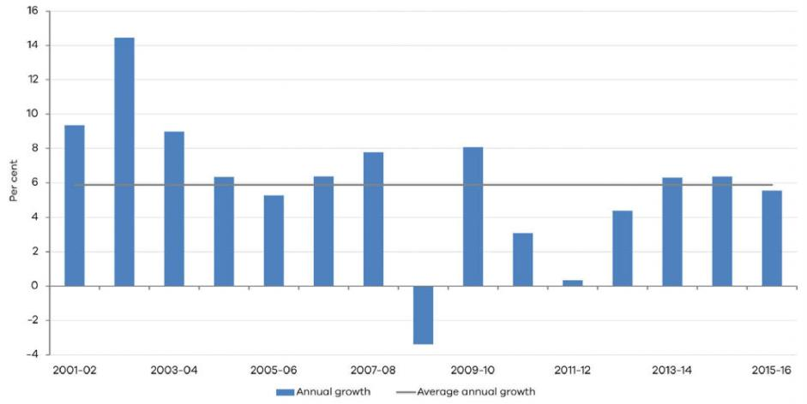

Source: Commonwealth Treasury and author calculations.

# 4. Explaining more recent trends

## (i) GST as a share of economic activity

As a share of nominal activity (GDP), GST revenue peaked in 2003-04 at 4 per cent (Figure 3A). Since then, the share had been declining until 2012-13, with a partial recovery thereafter to the current (2015-16) share of 3.6 per cent. While the GFC was clearly an important factor in this decline, it is important to note the decline in the share commenced well before its arrival. One likely reason for this, is the declining share of consumption that is GST liable (Figure 3B).

## (ii) Faster growth in consumption with

no or little GST liability

GST-liable consumption is declining as a share of total household consumption. This has been driven by relatively faster growth in both the volume and price of consumption categories that are not liable (or only partially liable) for GST. Since 2000-01, nominal consumption has grown by an average of 5.8 per cent a year, while nominal consumption of goods and services subject to GST has grown by only 4.7 per cent a year.

Part of the explanation for this is changing household expenditure patterns (Figure 4). There has been strong growth in the demand for services that have limited or no GST liability such as education and health. Consumption of these services has grown by 8.8 and 7.9 per cent a year in nominal terms between 2000-01 and 2015-16, which is consistent with international evidence on the rise of the services economy.[[39]](#footnote-39) There has also been an increase in the household expenditure share on housing services, specifically rent, which is also not liable for GST and has grown by 7.2 per cent in nominal terms over the same period.

A similar pattern is borne out in growth in nominal prices. Figure 5 reports cumulative growth in prices when grouping consumption categories by the extent to which they are GST liable. Since 2000-01, nominal prices have been growing most quickly in either low GST or GST free categories consistent with stronger demand for them. By comparison, nominal price growth in categories with a liability of 90 per cent or above has been much slower.

Figure 3. GST revenue as share of GDP and GST liable share of total household consumption (nominal)

|  |  |
| --- | --- |
| (A) | (B) |
| T:\Corpcom_CSS\COMMUNICATIONS\Formatting\State of Play (graphs)\export\Sent 16 Nov - 2 (new)\Page 45 - Figure 03a.png | T:\Corpcom_CSS\COMMUNICATIONS\Formatting\State of Play (graphs)\export\Sent 16 Nov - 2 (new)\Page 45 - Figure 03b.png |

Sources: ABS, Commonwealth Treasury and author calculations

Figure 4. Consumption shares for GST exempt and GST liable components

|  |  |
| --- | --- |
| (A) GST-exempt components | (B) GST-liable components |
| T:\Corpcom_CSS\COMMUNICATIONS\Formatting\State of Play (graphs)\export\Sent 16 Nov - 2 (new)\Page 46 - Figure 04a.png | T:\Corpcom_CSS\COMMUNICATIONS\Formatting\State of Play (graphs)\export\Sent 16 Nov - 2 (new)\Page 46 - Figure 04b.png |

Sources: ABS and author calculations

Figure 5. Cumulative price growth

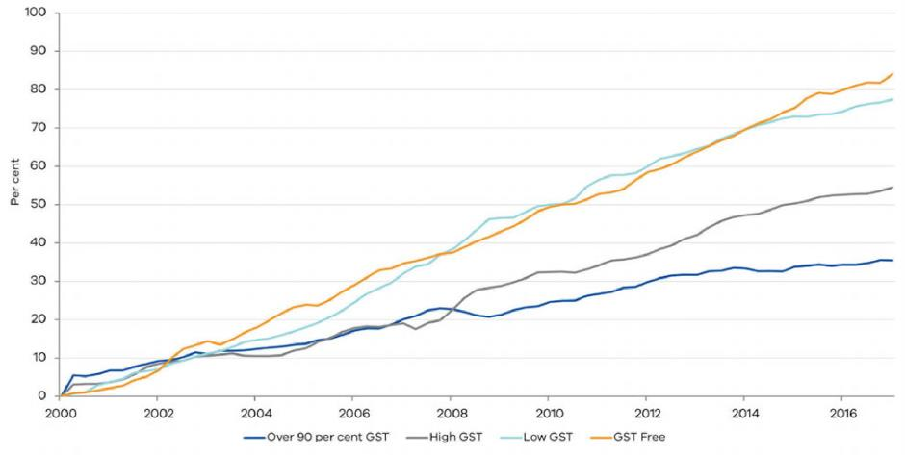

Sources: ABS and author calculations

## (iii) Slower growth in liable categories

Weak price growth in GST-liable categories has reflected a number of trends including: increased global competition; technological disruption and a low inflation environment globally. Indeed, the prices of goods relative to services has fallen in Australia in recent decades. This has reflected technological improvements in production processes such as improvements in automation and distribution, increased competition from global suppliers, as demonstrated by the proposed entry of Amazon to the Australian market (see Box 3), shifts towards lower labour cost economies for manufacturing, and in intensification of competition within the retail sector as firms’ have attempted to reduce costs along their supply chains (Ballantyne and Langcake, 2016).[[40]](#footnote-40)

BOX 3. AMAZON AND THE AUSTRALIAN RETAIL SECTOR

Originating in the US, Amazon is a large online-based retailer, which now represents around 43 per cent of all online sales in the US. Amazon has expanded to other countries (Figure 3.1) with global sales of around $US124 billion in 2016. Despite its size, Amazon continues to grow rapidly, with sales increasing by almost 25 per cent in 2016 (Figure 3.2).

The Amazon retail model aims to provide a vast selection of consumer goods at low margins, combined with rapid delivery. Amazon sources third-party products for a network of large-scale distribution warehouses where orders are dispatched directly to customers using multiple logistics chains. In the US, Amazon also provides premium services offering customers rapid same-day delivery times (as little as two hours) and grocery deliveries of fresh products from supermarkets in major areas. Amazon recently acquired US company Whole Foods and its 400 supermarkets for $US13.7 billion, and immediately lowered prices across a range of products.

*Amazon in Australia*

Amazon launched its Australian site in early December 2017. With a warehouse based locally in Melbourne as its initial Australian retail business site, delivery times will be reduced. Amazon’s entry into the domestic retail market will also introduce stronger price competition for Australian customers. Amazon is expected to stagger the roll-out of its Australian product categories, with a preliminary emphasis on home electronics and non-perishable goods before a possible entry into fresh produce.

*Impact on retail price growth*

Amazon’s arrival is expected to drive increased price competition across a wide range of product categories in Australia’s retail industry. Retail analysts have suggested Amazon will aim to set prices around 30 per cent lower than current domestic price points (IPMG 2017, although it is uncertain whether discounts of this magnitude will be realised).

For Australia’s retail industry, this follows a period of already heightened competition with the recent arrival of large international chains including H&M, Zara, and Uniqlo. The impact of Amazon and further overseas retail brands with plans to enter Australia will likely weigh on price growth in some key GST-liable categories over the medium term.

|  |  |
| --- | --- |
| Figure 3.1. Amazon warehouses | Figure 3.2. Amazon annual net revenue |
| T:\Corpcom_CSS\COMMUNICATIONS\Formatting\State of Play (graphs)\export\Sent 16 Nov - 2 (new)\Page 47 - Figure 03.1.png | T:\Corpcom_CSS\COMMUNICATIONS\Formatting\State of Play (graphs)\export\Sent 16 Nov - 2 (new)\Page 47 - Figure 03.2.png |
| Source: MWPVL International | Source: Statista, Amazon annual reports |

Similar patterns are also playing out in prices growth for tradable and non-tradable goods and services. Inflation in the price of tradable goods has been low over the past two decades consistent with low prices growth in clothing, footwear and household appliances, and food and alcohol, which account for around 30 per cent of the total consumer price index (CPI) basket and around 60 per cent of all tradable items (Figure 6).

Inflation in non-tradable items, such as non-traded services such as, health and housing, has been comparatively stronger over the same period. The appreciation of the Australian dollar, in line with the mining boom experienced during the 2000s, is another factor that has helped to keep inflation in tradable prices low.

## (iv) Changes in the economic cycle

As with all revenue bases, GST pool collections are shaped by changing economic conditions. Consumption spending in particular is influenced by developments in savings behaviour. During the GFC, Australian households substantially increased their rate of savings (Figure 7). This may have reflected a downward revision to households’ earnings expectations as the mining boom concluded and international economic conditions deteriorated. The increase in savings also coincided with a decline in the proportion of household consumption subject to GST as consumers reduced spending in some discretionary consumption categories including the purchase and operation of vehicles, and expenditure on hotels, cafes and restaurants that have a high GST liability.

Figure 6. Tradable and non-tradable inflation, annual growth

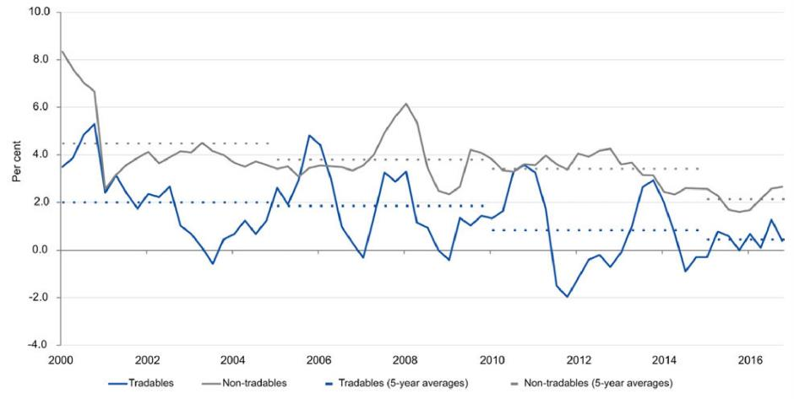

Source: ABS.

Figure 7. Household saving ratio

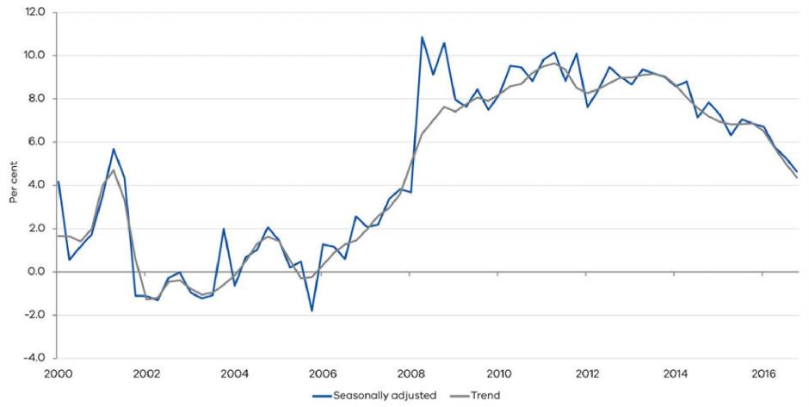

Source: ABS.

## (v) A stable tax base overall

Notwithstanding its sensitivity to changes in the economic cycle, overall the GST pool remains one of Victoria’s more stable revenue bases. Variation in property taxes growth is significantly higher than both the variation in the national GST pool and in Victoria’s other major taxation lines. Variation in the GST pool is broadly in line with that of gambling taxes, but higher than for payroll and motor vehicles taxes (Figure 8).

Compared to other major Commonwealth tax bases, growth in the GST pool has been slightly more volatile than in personal income tax, but significantly less volatile than company income tax (Table 2). This reflects the relatively more stable bases of income and consumption compared to company profits, which are considerably more volatile in response to changing business conditions (Figure 9).

Figure 8. Standard deviation in growth for major Victorian taxation revenue lines

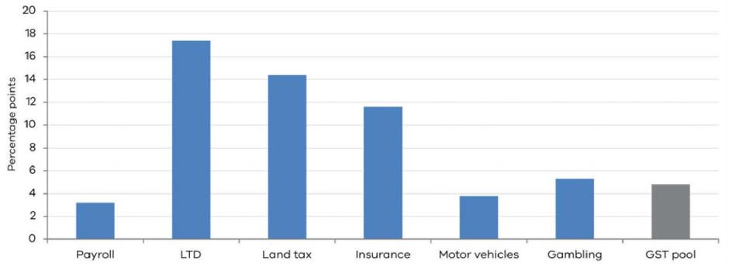

Sources: State Revenue Office and author calculations.

Table 2: Standard deviation of growth rates in major Commonwealth taxation revenue lines  
(percentage points)

|  |  |  |  |
| --- | --- | --- | --- |
|  | PERSONAL INCOME TAX | COMPANY TAX | GST |
| Standard deviation in growth | 4.0 | 12.8 | 4.8 |

Figure 9. Consumption, profit and income growth (current prices)

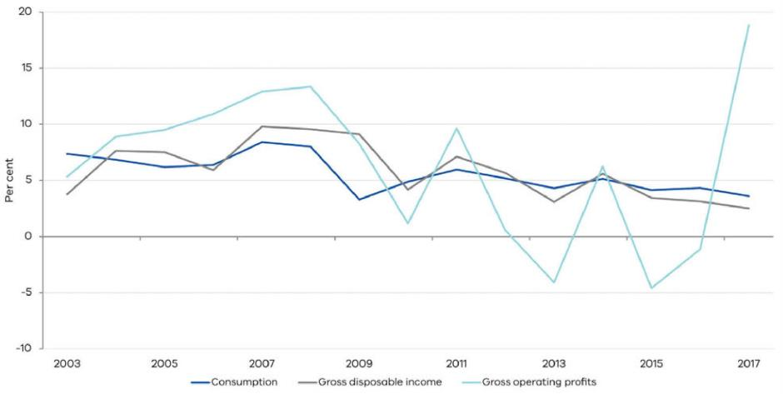

Source: ABS.

# 5. The outlook for GST pool growth

Future growth in the GST pool faces several potential headwinds. This includes slower growth in household consumption resulting from a higher savings rate than anticipated or an extended period of low price growth for GST‑liable goods and services, driven by continued competition in the retail sector.

Household saving behaviour is a key risk for growth in consumption spending and the GST pool in the near to medium term. A slowing of wages growth in recent years has been accompanied by a falling household savings rate.

This has allowed consumption to grow at a higher rate than would otherwise have been possible and suggests households may view the current weakness in wages growth as temporary.

However, a change in household expectations that identified softer wages growth as a more persistent feature of the economic landscape could lead to a higher household savings rate than anticipated and lower consumption growth. This idea is explored in further detail in Box 4.

Ongoing change in household expenditure patterns could also present downside risk. Retail sales, which are highly GST liable, have been a declining share of household consumption for some time (Figure 10).

This has corresponded with a period of intense competition amongst Australian retailers, with widespread discounting and reduced margins in many product categories that has underpinned weak outcomes for prices growth. If this pattern continues, the GST-liable share of consumption may fall further.

Figure 10. Annual growth in retail trade (value of turnover)

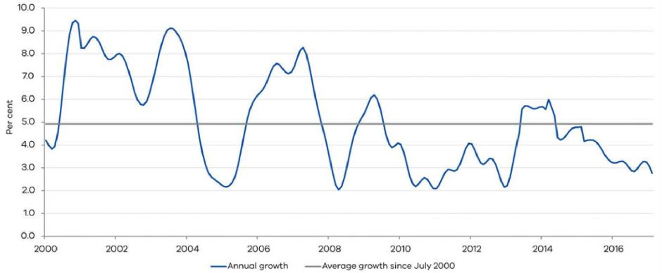

Source: ABS.

BOX 4. QUANTIFYING THE IMPACT OF A HIGHER SAVING RATE THAN FORECAST

One of the possible headwinds facing GST pool revenue is the outlook for household consumption growth.

In recent years, a fall in the household saving rate has helped to support consumption growth despite lower than trend growth in wages and real disposable income. This suggests households have ‘smoothed through’ lower growth in incomes and wages to some extent and perceived the weakness in growth as temporary. If low growth in income and wages was to persist, however, it is possible households may choose to reduce consumption and increase their rate of saving in response.

To model this scenario, this paper uses the AUS-M model developed by Outlook Economics. AUS-M is a large‑scale macro-econometric model for Australia and is based on the TRYM model originally developed at the Australian Treasury. The model has a large number of demand and supply equations, by industry and sector, that are estimated using time series data and can be used to simulate the effects of shocks on the Australian economy.[[41]](#footnote-41)

Here we consider the effects of a smaller decline in the household saving rate than factored in to the model’s baseline projection. The scenario is implemented using a series of consumption shocks, where households (exogenously) decide to save a greater fraction of their income and consume less for a period of time. In dynamic stochastic general equilibrium models, such shocks have been interpreted as shocks to demand, tastes, discount factors or attitudes to risk.

Figure 4.1 reports the baseline projection for the household savings rate and the scenario profile implemented in AUS-M, which shows a more modest decline in the household saving rate relative to the baseline. The effects on activity are reported in Figure 4.2.[[42]](#footnote-42)

BOX 4. QUANTIFYING THE IMPACT OF A HIGHER SAVING RATE THAN FORECAST (CONTINUED)

Nominal consumption and GDP growth are weaker reflecting the fact that higher saving reduces growth in household demand for goods and services and lowers CPI inflation, albeit with a lag (Figure 4.3). The model estimates a degree of nominal price rigidity in both prices and wages. With this inertia in price and wage resetting, suppliers respond to lower demand by producing less goods and services and so real consumption and real GDP grow more slowly as well. This in turn leads to weaker labour demand and growth in wages, and lower inflation in the CPI (Figure 4.3).

**Figure 4.1: Household savings rate and interest rates**

*(A) Saving rate (B) Interest rates*

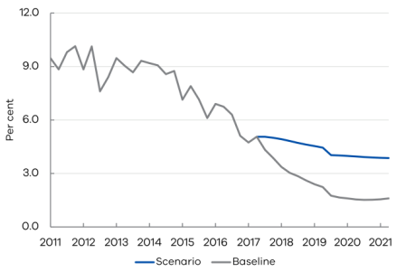 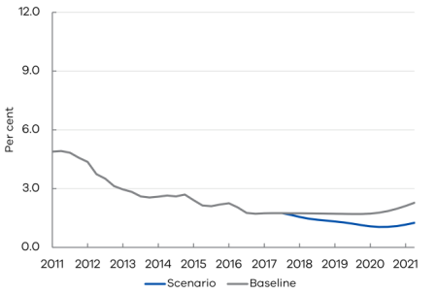

Sources: AUS-M and author calculations

**Figure 4.2: Nominal consumption and GDP growth**

*(A) Nominal consumption (B) Nominal GDP*

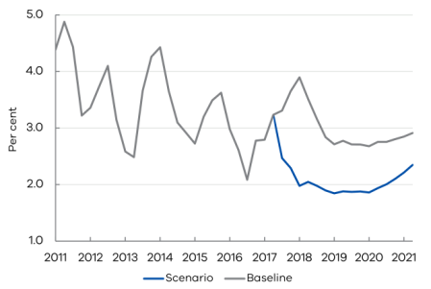 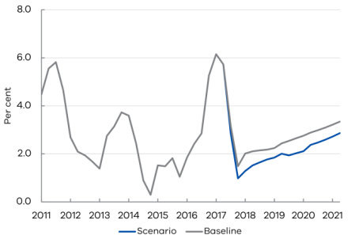

Sources: AUS-M and author calculations

BOX 4. QUANTIFYING THE IMPACT OF A HIGHER SAVING RATE THAN FORECAST (CONTINUED)

Monetary policy, which follows an estimated Taylor rule, responds to the demand shock by reducing interest rates (Figure 4.1B). This helps to partially offset the effects of the shock, but does not fully offset the effects on activity and inflation.[[43]](#footnote-43)

The main point to note from this scenario is that changes in the saving rate have significant macroeconomic effects on consumption growth and the GST revenue pool. With the household saving rate 1.8 percentage points higher by the June quarter of 2018, nominal consumption growth drops by almost 2 percentage points in annual growth terms by June 2018, and this gap remains persistent before unwinding towards the end of the forecast period.

To illustrate the possible effects on GST pool revenue (Figure 4.4), it is assumed the shock is spread equally across all consumption categories and the decline in consumption growth translates into a one for one decline in pool revenue growth. These simple illustrative assumptions would amount to a cumulative $8.9 billion decline in GST pool revenue over the 4 years to 2020-21. However, noting the demand for discretionary consumption goods tends to be more sensitive when households choose to save more (at least based on previous economic cycles), and that these items are more likely to be GST liable, this estimate could potentially understate the overall effect on GST pool revenue.[[44]](#footnote-44)

To account for this, we also compute the estimated deviation in nominal GST revenue directly inferred from the model, which uses an estimated time series relationship to explain revenue as a function of the subcomponents of consumption expenditure and dwelling investment. This accounts for different patterns in consumption at a more disaggregated level and, through the estimated time series relationship, accounts for different degrees of GST-liability across expenditure categories. The model implied decline in GST revenue is estimated to be larger at about $11 billion over four years.

**Figure 4.3: CPI and WPI inflation**

*(A) Consumer price index (B) Wage price index*

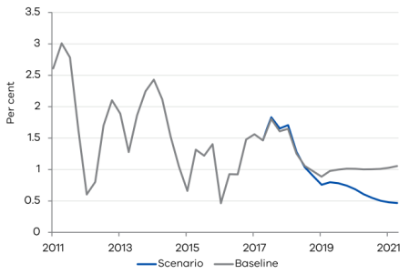 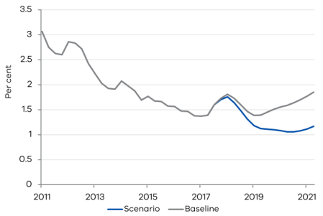

Sources: AUS-M and author calculations.

BOX 4. QUANTIFYING THE IMPACT OF A HIGHER SAVING RATE THAN FORECAST (CONTINUED)

**Figure 4.4: Effect on annual GST pool revenue growth**

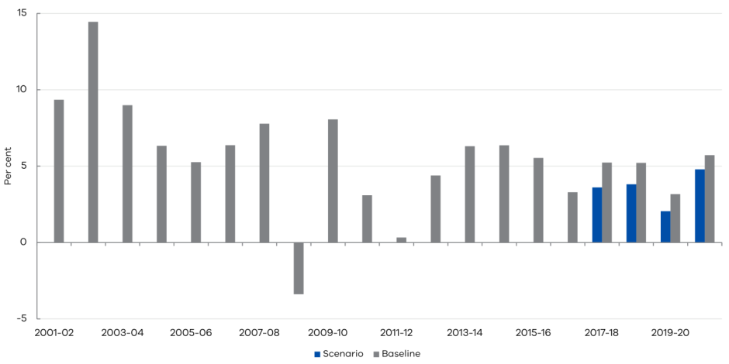

Sources: AUS-M, Commonwealth Treasury and author calculations.

## References

Aisbett, E., Brueckner, M., Steinhauser, R. and Wilcox, R., (2013), Fiscal Stimulus and Households’ Non-Durable Consumption Expenditures: Evidence from the 2009 Australian Nation Building and Jobs Plan, *CEPR Discussion Papers No. 689*, Centre for Economic Policy Research, Research School of Economics, Australian National University.

Auerbach, A.J. and Hines, J.R., (2002), Taxation and Economic Efficiency, Editors: Alan J. Auerbach, Martin Feldstein, In *Handbook of Public Economics*, Elsevier, vol. 3, pp. 1347-1421.

Ballantyne, A. and Langcake, S., (2016), ‘Why Has Retail Inflation Been So Low?’, *Reserve Bank of Australia Bulletin*, June quarter 2016, pp. 9-17.

Bernheim, B.D., (2002), Taxation and Saving, Editors: Alan J. Auerbach, Martin Feldstein, In *Handbook of Public Economics*, Elsevier, volume 3, pp. 1173-1249.

Brayton, F., Laubach, T. and Reifschneider, D., (2014), The FRB/US Model: A Tool for Macroeconomic Policy Analysis, *FEDS Notes*, Board of Governors of the Federal Reserve System (U.S.).

Buera, F. and Kaboski, J., (2012), The Rise of the Service Economy. *The American Economic Review*, vol. 102, no. 6, pp. 2540-2569.

Chamley, C., (1986), Optimal Taxation of Capital Income in General Equilibrium with Infinite Lives, *Econometrica*, vol. 54, pp. 607-622.

EY (2017), The Outlook for Global Tax Policy in 2017, Ernst and Young.

Golosov, M., Tsyvinski, A. and Werning, I., (2007), New Dynamic Public Finance: A User’s Guide, *NBER Macroeconomics Annual 2006*, vol. 21, National Bureau of Economic Research, pp. 317-388.

Hugo, G. (2012), Co-movement in Inflation, Reserve Bank of Australia, Research Discussion Paper No. 2012-01.

IPMG (2017), How Amazon Plans to Re-define Australia’s Retail Landscape, www.ipmg.com.au/news/amazon-plans-re- define-australias-retail-landscape/, Accessed June 2017.

Judd, K.L., (1985), Redistributive Taxation in a Simple Perfect Foresight Model, *Journal of Public Economics*, vol. 28, pp. 59-83.

Li, S.M. and Spencer, A.H., (2016), Effectiveness of the Australian Fiscal Stimulus Package: A DSGE Analysis, *Economic Record*, vol. 92, no. 296, pp. 94–120.

Mateo, C. and Mojon, B., (2010), Global Inflation, *The Review of Economics and Statistics*, August 2010, vol. 92, no. 3, pp. 524-535.

OECD (2015), Consumption Tax Trends, Organisation for Economic Cooperation and Development.

OCED (2016a), *Tax Policy Reforms in the OECD 2016*, Organisation for Economic Cooperation and Development.

OCED (2016b), *Consumption Tax Trends 2016*, Organisation for Economic Cooperation and Development.

The Secretary  
Department of Treasury and Finance  
1 Treasury Place  
Melbourne, Victoria, 3002

Telephone: +61 3 9651 5111  
Fax: +61 3 9651 2062  
Website: dtf.vic.gov.au

Authorised by the Victorian Government 1 Treasury Place, Melbourne, 3002 © State of Victoria (Department of Treasury and Finance) 2017

You are free to re-use this work under a Creative Commons Attribution 4.0 licence, provided you credit the State of Victoria (Department of Treasury and Finance) as author, indicate if changes were made and comply with the other licence terms. The licence does not apply to any branding, including Government logos, and material from third parties. Permission may be required for any reuse of third party material protected by copyright.

Copyright queries may be directed to [IPpolicy@dtf.vic.gov.au](mailto:IPpolicy@dtf.vic.gov.au).

Published December 2017

ISBN 2208-8539 (pdf/online)

1. This is measured in real United States (US) dollars and in constant purchasing-power-parity (PPP) terms. [↑](#footnote-ref-1)
2. They reflect the views of the authors and not necessarily those of the Department. [↑](#footnote-ref-2)
3. The authors would like to thank the following staff for their comments: Catherine Durrant, James Hansen, David Hedley, Jeremy Nott, Sharon Oxlade and Christopher Smart. The views expressed in this paper are those of the authors and do not necessarily reflect the views of DTF. [↑](#footnote-ref-3)
4. This paper uses unit record data from the HILDA Survey. The HILDA Project was initiated and is funded by the Australian Government Department of Social Services (DSS), and is managed by the Melbourne Institute of Applied Economic and Social Research (Melbourne Institute). The findings and views reported in this paper are those of the authors and should not be attributed to either DSS, the Melbourne Institute, or DTF. [↑](#footnote-ref-4)
5. The Gini index is computed as the ratio of the area between two curves, the Lorenz curve and a 45-degree line. The Lorenz curve reveals the percentage of income owned by each percentile of the population. It is usually shown in relation to a 45-degree line that represents perfect equality where x percentile of the population receives the same x percentile of income. The further the Lorenz curve is in relation to the 45-degree line, the more unequal the distribution of income. [↑](#footnote-ref-5)
6. Disposable income is the sum of labour income, capital income, government payments and ‘other’ income, less direct taxes. [↑](#footnote-ref-6)
7. For instance, the Fair Work Commission announced the increase of the minimum wage by 3.3 per cent nationally in June 2017. [↑](#footnote-ref-7)
8. Special questionnaire modules are covered every four years, such as the wealth module which was covered in 2002, 2006, 2010 and 2014. [↑](#footnote-ref-8)
9. As such, the sample is small relative to the size of the overall population. To ensure sample representativeness, the survey uses cluster sample design to choose respondents. (Watson and Wooden, 2001): Like Chatterjee et al (2016) this paper does not re-weight the sample using population weights and so care should be taken when interpreting the results. [↑](#footnote-ref-9)
10. As with all types of income used in this paper, we adjust capital income using consumer price index from 2001. [↑](#footnote-ref-10)
11. To measure wage income inequality, the log D9/D1 ratios are calculated using mean rather than median income. The reason for this is that median income in the first decile is often zero, which means a meaningful ratio could not be computed. [↑](#footnote-ref-11)
12. The non-manual low skilled occupation group also includes some construction jobs that can be characterised as manual, although these constitute a minor share. [↑](#footnote-ref-12)
13. The authors would like to thank the following staff for their comments: Valéry Dugain, Catherine Durrant, David Hedley, Jeremy Nott, Sharon Oxlade, and Cheng Yang. The views expressed in this paper are those of the authors and do not necessarily reflect the views of the Victorian Department of Treasury and Finance (DTF). [↑](#footnote-ref-13)
14. This paper uses unit record data from the HILDA Survey. The HILDA Project was initiated and is funded by the Australian Government Department of Social Services (DSS), and is managed by the Melbourne Institute of Applied Economic and Social Research (Melbourne Institute). The findings and views reported in this paper are those of the authors and should not be attributed to either DSS, the Melbourne Institute, or DTF. [↑](#footnote-ref-14)
15. Like the first paper in this volume, population weights are not used and so care must be taken when interpreting the results. [↑](#footnote-ref-15)
16. Manual low-skilled occupations include labourers, factory workers, cleaners and laundry workers, drivers, machine operators and food preparation assistants. [↑](#footnote-ref-16)
17. Non-manual low-skilled occupations typically include sales assistants, carers, receptionists and some entry level hospitality, retail and service managers. This group also includes some construction jobs that can be characterised as manual, although these constitute a minor share. [↑](#footnote-ref-17)
18. Medium-skilled occupations include specialist, retail and service managers, engineering, information and communication technology (ICT) and science technicians and, health and welfare support workers, but also lower-to-medium level business, human resource and marketing professionals. [↑](#footnote-ref-18)
19. High-skilled occupations include health, business, human resource, marketing, engineering, design, science and technology professionals, high-level specialist managers, as well as general managers and chief executives. [↑](#footnote-ref-19)
20. A graduate certificate is a postgraduate qualification that broadens the skills and knowledge already gained from an undergraduate degree, or develops vocational skills in a new area; generally requires six months full-time study or part-time equivalent (for example, graduate certificate in project management or graduate certificate in business information technology). A graduate diploma is a specialised, vocationally-oriented degree that develops new knowledge and skills in an area not previously studied; requires 12 months full-time study or part-time equivalent (for example, a graduate diploma in occupational health and safety). [↑](#footnote-ref-20)
21. Significant at the 90 per cent level. [↑](#footnote-ref-21)
22. An advanced diploma or a diploma is considered equivalent to one or two years studying for a degree at university; generally requires 18 months to two years to complete and prepares students for careers that require a broad range of complex technical skills and in-depth knowledge (for example, Advanced Diploma of Accounting or Diploma of Dental Technology). [↑](#footnote-ref-22)
23. While no significant wage gains are associated with a completion of year 12 only, one should bear in mind that year 12 is an important pathway to higher educational levels, which are associated with significantly higher wage premiums. Holding skills, occupation and other individual characteristics constant, it is estimated that progression from year 11 to year 12 and above is associated with a 9 per cent wage premium. [↑](#footnote-ref-23)
24. A 40-year working life is assumed when calculating lifetime earnings, which are in real terms. [↑](#footnote-ref-24)
25. Ideally, the set of covariates would also include an individual’s occupational preference at the time of deciding to enrol in higher education. However, these data are not available, and so the observed occupation is used instead. This approach may help to better control for occupational preferences in the propensity score matching models presented in Table 2. However, it is also an additional source of measurement error, and possibly bias (Imbens, 2015). Therefore, estimates are presented with and without the controls for occupation. [↑](#footnote-ref-25)
26. The analysis focuses on simple propensity score matching estimators, where the treatment is binary (a university degree or no university degree). Disaggregating beyond this results in very small sample for Victoria. For direct comparison, education is also recoded as a binary variable in the Heckman model as well. [↑](#footnote-ref-26)
27. Cognitive ability test scores are used as a proxy for innate ability since ability cannot be directly measured. [↑](#footnote-ref-27)
28. Care should be taken when interpreting this result since it could well be driven by the smaller sample. The Victorian sample consists of 732 observations, while the national sample includes 2 927 observations. [↑](#footnote-ref-28)
29. The authors would like to thank the following staff for their comments: Aaron Saint, Duy Nguyen and Chris Judde. The findings and views reported in this paper are those of the authors and should not be attributed to DTF. [↑](#footnote-ref-29)
30. The classic example of an area with a low cost of exchanging ideas is Silicon Valley. Silicon Valley’s close proximity to universities, technically specialised firms such as Apple, Facebook and Google, and a highly educated workforce have been identified as major reasons for the low cost of new innovation in software in this area (Kerr and Kominers, 2015). [↑](#footnote-ref-30)
31. We use hedonic price measures to control for changes in the composition of properties sold. [↑](#footnote-ref-31)
32. Although we do not formally model the announcement effect only, there is evidence to suggest it was present in the data. [↑](#footnote-ref-32)
33. The authors would like to thank James Hansen, David Hedley and Trudy Hart. The views expressed in this paper are those of the authors and do not necessarily reflect the views of the Department of Treasury and Finance. [↑](#footnote-ref-33)
34. This is based on the change in each category’s share of consumption between 2003 and 2016, and weighted by its average GST liability. [↑](#footnote-ref-34)
35. The VRR measures the difference between the VAT revenue actually collected and what could theoretically be raised if the VAT was applied at the standard rate to the entire potential tax base in a ‘pure’ VAT regime and all revenue was collected (OECD, 2015). [↑](#footnote-ref-35)
36. See for example Bernheim (2002) and Auerbach and Hines (2002) and the references cited therein. [↑](#footnote-ref-36)
37. Notwithstanding, in general inference on optimal taxation often depends on the modelling environment used. For example, whether a representative agent, overlapping generations, or heterogeneous agent framework is used, and the assumptions made about the feasibility of other alternative taxation instruments can matter for conclusions regarding optimal taxation and efficiency. Dynamic public finance is a relatively new literature studying optimal taxation over time

    accounting for idiosyncratic and aggregate uncertainty (see for example Golosov, Tsyvinski, and Werning (2006) [↑](#footnote-ref-37)
38. There were two major rounds of fiscal stimulus implemented in Australia. The first was the Economic Security Strategy, where payments to households were made in the December quarter of 2008. The second round was the Nation Building and Jobs Plan, with a larger set of payments paid to households in the June quarter of 2009. For evidence on the effectiveness of the Australian Federal Government’s fiscal stimulus during this period see Li and Spencer (2016) and Aisbett, Brueckner, Steinhauser and Wilcox (2013). [↑](#footnote-ref-38)
39. See for example Buera and Kaboski (2012) and the references cited therein. [↑](#footnote-ref-39)
40. Inflation in industrialised countries has been found to be heavily influenced by the rate of global inflation. For example, Mateo and Mojon (2010) found that a simple average of 22 OECD countries’ inflation accounts for almost 70 per cent of the variance of inflation in these countries between 1960 and 2008. This is supported by RBA research, which found inflation rates across countries tend to exhibit considerable co movement (Hugo, 2012) [↑](#footnote-ref-40)
41. Details on individual equations and sectors underlying the results discussed here are available on request. [↑](#footnote-ref-41)
42. While the micro-foundations in large scale macro-econometric models are not always fully articulated, the quantitative properties of shocks can still be interpreted usefully using the estimated time series relationships in them (see for example the FRB/US model used by the US Federal Reserve, 2014). It is worth noting that it is the deviation from the baseline that helps to inform the outlook for GST pool revenue, rather than the level of the model-implied forecasts per se. [↑](#footnote-ref-42)
43. Using an optimal control experiment where monetary policy responds even more aggressively by lowering interest rates further would further stabilise the economy. However, the zero lower bound does come into consideration given that interest rates are already at a low level. [↑](#footnote-ref-43)
44. The other reason the revenue effects may be larger than those illustrated include that new house sales and residential building activity are more volatile than consumption and are also subject to GST. These would also be expected to decline in the face of the same demand shock. While these are not explicitly modelled in AUS-M, dwelling investment does decline in response to the household saving shock. [↑](#footnote-ref-44)