Investment Management Standard 2017
Technical Guide for Facilitators - Solution Definition workshop

The Secretary
Department of Treasury and Finance
1 Treasury Place
Melbourne Victoria 3002
Australia
Telephone: +61 3 9651 5111
Facsimile: +61 3 9651 2062
dtf.vic.gov.au

Authorised by the Victorian Government
1 Treasury Place, Melbourne, 3002

© State of Victoria 2017
You are free to re-use this work under a Creative Commons Attribution 4.0 licence, provided you credit the State of Victoria (Department of Treasury and Finance) as author, indicate if changes were made and comply with the other licence terms. The licence does not apply to any branding, including Government logos.

Copyright queries may be directed to IPpolicy@dtf.vic.gov.au

ISBN 978-1-925551-43-3
Published May 2017

If you would like to receive this publication in an accessible format please email information@dtf.vic.gov.au

This document is also available in Word and PDF format at dtf.vic.gov.au

Contents
Purpose of this document 1
What are the differences between IMS edition 5.0 and edition 6.0? 1
1. Context for the Solution Definition workshop 3
1.1 Is a dedicated Solution Definition workshop always required? 4
1.2 Timing of the Solution Definition workshop 5
2. Solution Definition workshop 6
2.1 Purpose of a Solution Definition workshop 6
2.2 Responsibility of the facilitator 7
2.3 Who should be there? 7
2.4 What preparation is required? 8
2.5 Before the workshop 8
2.6 At the workshop 9
2.7 After the workshop 16
2.8 Templates, examples and other resources 17
Appendix 1: 16 Questions – Investment decision-maker’s checklist 18
Appendix 2: Shaping new investments using the IMS 20
Appendix 3: Fictional – Investment Concept Brief 22
Appendix 4: Design guidelines – Investment Concept Brief 23
Appendix 5: Sample email – before the Solution Definition workshop 24
Appendix 6: Checklist – Solution Definition workshop 25
Appendix 7: Sample agenda – Solution Definition workshop 26
Appendix 8: Sample email – after the Solution Definition workshop 27
Appendix 9: Quality assessment form – Investment Concept Brief 28

Purpose of this document
This is the final of four guidance documents within the ‘shape a new investment’ series of IMS Technical guides for facilitators. It primarily targets facilitators and provides practical guidance on how to lead a successful initiative-level Solution Definition workshop, and prepare supporting documentation which is consistent with the Investment Management Standard (IMS) Version 6.0.
This guidance assumes users have read and understood the IMS – its principles, practices and the theory on which it is built. (The IMS is available at the investment management website, www.dtf.vic.gov.au/infrastructure-investment/investment-management-standard.) It also assumes that users are familiar with the guidance material for the Problem Definition, Benefits Definition and Response Definition workshops.
- Section 1 outlines the context and objectives for the Solution Definition workshop.
- Section 2 describes how facilitators should approach, conduct, and conclude the workshop.
- Appendices contains additional materials which may be useful for facilitators.

What are the differences between IMS edition 5.0 and edition 6.0?
IMS 2017 is the first update to the IMS since 2013. Over this period there has been an increased focus on the planning and delivery of infrastructure investments, and on using real options analysis to manage related uncertainty. In response, the Department of Treasury and Finance has updated its ‘Investment Lifecycle and High Value High Risk’ (HVHR) framework to provide advice on incorporating real options analysis when developing business cases and procurement strategies. The related guidelines are available at www.dtf.vic.gov.au/investment-lifecycle-and-high-value-high-risk-guidelines/stage-1-business-case.
The 2017 update reflects these changes and includes several enhancements to refine the workshop process and the development of an Investment Logic Map (ILM), and the other documents in the IMS suite. These incorporate the feedback and experiences of both those involved in the workshops and the end-users of ILMs. The major changes are:
- more detailed advice preparing for a workshop;
- clearer definition of the preferred participant types for each workshop;
- greater and more explicit consideration of uncertainty during the workshops including identifying investments which may need real options analysis;
- increased focus on determining the quality and availability of evidence throughout the workshop process;
- a reshaped and more robust Benefit Definition workshop which tests alignment with Government policy, or other relevant strategic drivers, and focuses on the integrity of KPIs and measures;
- restructure of the Response Definition and Solution Definition workshops to clarify the objectives of each and to ensure both are more intuitive, robust and make a valuable contribution to decision-making;
- consequential changes to the supporting documentation for all the workshops; and
- amendments to the 16 questions – decision-maker’s checklist (Appendix 1) to include more consideration of uncertainty and reflect the changes described above.

    - Context for the Solution Definition workshop
The ability to select the investments that provide the most benefit to society is a key component of good government. This is often a complex exercise requiring the contributions of many people, each of whom bring their specialist skills and perspectives.
The Investment Management Standard (IMS) is a process for applying simple, common-sense ideas and practices that help organisations direct their resources to deliver the best outcomes from their investments. The IMS addresses many of the issues that arise during investment decision-making and is aligned with the HVHR business case guidelines, and templates. In the context of the IMS and these guidance documents, DTF defines investment as ‘the commitment of the resources of an organisation with the expectation of receiving a benefit’.
The IMS helps decision-makers determine whether:
    - there is a real, evidence-based problem that needs to be addressed now;
    - the benefits which will be delivered through successfully addressing the problem are of high value to the organisation and the community;
    - the benefits’ KPIs are meaningful, measurable and attributable to the investment and are worth tracking and reporting;
    - the way the problem will be addressed is strategic, feasible, and innovative;
    - the solution is likely to be delivered within time and budget constraints; and
    - the solution can be applied flexibly to manage and respond to uncertainty and adapt to changing conditions and demand.
At the end of this stage, you are required to review the problem definition to confirm you have identified the right investment need, and that the preferred solution is likely to support this need given a range of alternative future scenarios. You should consider the whether there are any conditions in which the preferred solution may be sub-optimal, you would prefer a different approach, or would regret the selected solution.
The IMS includes a set of 16 questions (the Investment Decision-maker’s Checklist) which address the four IMS elements - problem, benefits, response and solution. Each element asks key questions that enable decision-makers to make sensible and informed investment decisions. The depth of enquiry for each question will depend on the scale and complexity of the investment. These questions correlate with key elements of the Victorian government full business case template and aid business case writers and assessors.
The relevant questions that the Solution Definition workshop should explore and help to answer are:
Table 1: Investment decision-maker’s checklist – indicative solution
Indicative solution – Investment decision-maker’s checklist
13. Consistent with the preferred response option, has a reasonable spread of project options been analysed? | Yes | Maybe | No | Not sure
14. Is the recommended solution the best value for money way and have opportunities for building flexibility to deal with uncertainty been considered? | Yes | Maybe | No | Not sure
15. Is the solution specified clearly and fully and have opportunities for adding value been identified and costed? (all business changes and assets) | Yes | Maybe | No | Not sure
16. Can the solution really be delivered (cost, risk, timeframes etc.)? | Yes | Maybe | No | Not sure

The IMS practices are focused on the early stages of shaping investments and on the evidence required to understand and validate the investment need or problem, articulate the benefits that will be delivered, and shape a robust indicative solution (Appendix 2-Shaping a new investment using the IMS).
      - Is a dedicated Solution Definition workshop always required?
This final workshop really gets down to the ‘what’ of the investment and aims to answer the following questions:
    - what needs to be done?
    - what changes and assets are required?
    - is the approach that is outlined feasible and appropriate to the scale of the problem?
    - is it the best approach?
    - how much will it cost to implement?
    - does the logic and value of the investment hold up under scrutiny?
    - do the benefits that will be delivered represent good value for the money and resources invested?
    - Will the proposed solution deal with any uncertainty impacting on the investment?
Unless the preferred response is very simple and straightforward, it is likely that there are several ways that it can be implemented. For example, by using:
    - an asset, non-asset or mixed asset and non-asset based solution;
    - different models of risk-sharing;
    - staged implementation plans; or
    - distinct technology platforms.
This consideration is likely to be most important when the investment environment is significantly uncertain. In this case, the Response Definition workshop may have already identified the need for real options analysis during business case development, and this is likely to be reinforced by the Solution Definition workshop.
Shaping a new investment provides an opportunity to challenge the way Government has solved problems in the past. This applies as much to the definition of the solution as to the definition of the response. Whilst tried and tested approaches to solution design and delivery may indeed be the best way to proceed, decision-makers should also explore other options which may be more efficient, effective, flexible, or innovative. This may involve a critical assessment of the ‘best likely’, or indicative, solution which the organisation has already developed, and may have some attachment to.

The Solution Definition workshop provides a structured forum to confirm, re-shape, or reject the ‘best likely’ solution and will, generally, be required when:
    - the investor wants wider input into the current ‘best likely’ solution and its indicative benefit delivery, risks, dis-benefits, costs, and timeframes before deciding whether further development of the investment is warranted;
    - the nature, scale, complexity, level of impact, and potential cost of the investment require more detailed analysis and exploration of solution options (e.g. HVHR); and
    - the external environment is subject to material uncertainty, or there are significant interdependencies with other organisations, or policy initiatives.
      - Timing of the Solution Definition workshop
Of the four IMS workshops, the detailed information requirements of the Solution Definition workshop are probably the most extensive. Consequently, it is important that the project team has completed sufficient work prior to the workshop.
The time between the Response Definition workshop and the Solution Definition workshop is usually between two and four weeks depending on organisational readiness, the scale and complexity of the investment, the availability of dedicated resources to prepare for the workshop, and the stage of the budget process.
Above all, for the Solution Definition workshop to be successful, the investor and the organisation must have thought about possible solutions before the workshop and have some ideas about a ‘best likely’ solution. It is also critical that the project team has completed cost and timeframe work left outstanding at the end of the Response Definition workshop, and has been fully accepted by the investor and the organisation. This is used at the inception of the Solution Definition workshop to confirm the preferred response and set the scene for the workshop.
The facilitator may need to manage the investor’s expectations in respect of timing as the workshop’s value will almost certainly be undermined if the participants, and the organisation, are not ready.

    - Solution Definition workshop
      - Purpose of a Solution Definition workshop
The three previous workshops established the need for an investment, intended benefits and the preferred response. It is now necessary to recommend a solution which is consistent with the preferred response and will resolve the identified problem and deliver the benefits.
The Solution Definition workshop assumes that the previous workshops have been completed, and focuses on the identification of a recommended solution and its component assets and business changes – the ‘what’ of the investment.
Specifically, the workshop will:
    - review the cost and timeline data for each of the response options developed in the Response Definition workshop and assess the value for money of each;
    - test and validate the ranking of response options and selection of the preferred response;
    - review or shape the ‘best likely’ solution for the expected future state and assess the rationale used in its development;
    - identify the business changes and assets that will be needed to implement the ‘best likely’ solution;
    - confirm that the ‘best likely’ solution will deliver the KPIs identified in the Benefit Map given the expected future scenario;
    - confirm the circumstances (change in condition or an event) where the preferred response may be inadequate or inappropriate, and the triggers requiring a change in response; and
    - validate the costs, timeframes, risks, uncertainties, interdependencies, dis-benefits, and policy alignment associated with the ‘best likely’ solution and confirm that it is the recommended solution which will be developed in the business case.
Figure 1 depicts the place of this discussion within the ‘line of enquiry’ that underpins the IMS. It also describes the three individual steps within the discussion.
Figure 1: Line of enquiry – Solution Definition workshop
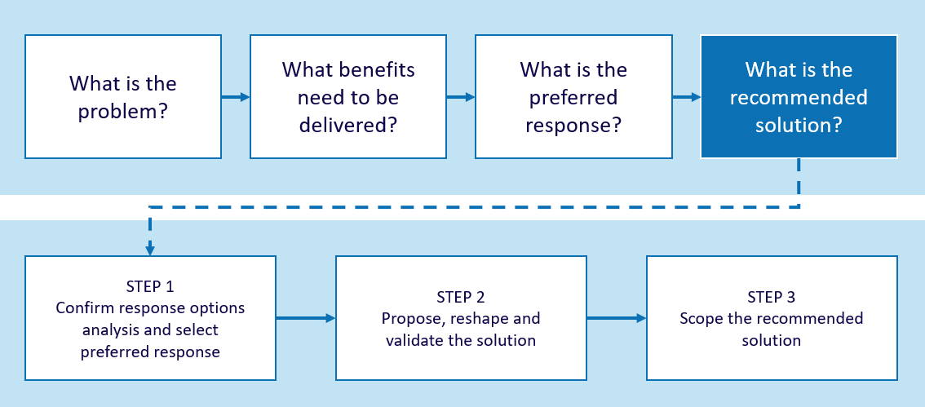

The key outputs of the Solution Definition workshop are an Investment Concept Brief (ICB) and an updated ILM, Benefits Management Plan, and Response Options Analysis Report (Appendix 3 – Fictional Investment Concept Brief).
The function of the ICB is to articulate on two-pages the logic underpinning an investment together with the likely costs, timeframe, risks, dis-benefits, interdependencies, policy alignment, uncertainty and deliverables of the proposed solution. It is the key summary of the four workshops and provides the investor with sufficient information to determine whether, or not, the investment is worthy of further consideration.
      - Responsibility of the facilitator
It is your responsibility to help the participants develop the most compelling, evidence-based case for investment that they can.
Effective facilitation will assist the workshop participants to refine the ‘best likely’ solution through:
    - suggesting new ways of doing things;
    - identifying additional changes to optimise the delivery of the benefits; and
    - adding value to the ‘best likely’ solution by introducing the flexibility needed to adapt to changing external conditions.
To be successful, you must:
    - try to ensure that the right people attend and that two hours have been allocated for the discussion;
    - confirm that the solutions architect, project manager, or other nominee of the investor will have explored solution options before the workshop and be prepared to present the ‘best likely’ solution to the workshop, and describe the underlying changes and assets;
    - conduct the discussion following the guidance provided in this document; and
    - finalise the discussion and documentation, including updating all the other documents in the IMS suite and preparing the ICB within 48 hours.
You should refer to Design guidelines – Investment Concept Brief (Appendix 4) for some tips on preparing a high-quality report.
      - Who should be there?
The key person is the investor who owns the problem and who will be responsible for delivering the benefits, if the investment is funded. Participants from the previous workshops who have most knowledge of the local solution environment are also critical. Other participants may include:
    - the person charged, after the Response Definition workshop, with developing the cost and timeframe data for the preferred response. They will need to present this information at the workshop;
    - the solutions architect /project manager (if already identified) who will play a key role and should be prepared to present a ‘best likely’ solution to the workshop;
    - an implementer who can bring practical experience of the delivery of other, similar projects;
    - an innovator who is a recognised leader in the field and should bring some new thinking regarding the solution. This person is often from outside the team, or organisation, and is usually a recognised subject matter expert;
    - a strategist who can put the investment in the context of the organisation’s strategy and broader operating environment; and
    - the business case developer (if already identified), who can learn more about the potential investment and act as a common-sense check of the discussion. For a large investment, this may be someone who is outside the project team but has been involved with this kind of project previously. They will bring insights around timing, risk management and investment shaping.
If not covered above, it may also be necessary to bring other relevant specialists into this workshop, or at least commission selected participants to canvas their views and present them in the workshop. In the absence of specialist implementer, innovator and strategist participants it will be necessary to allocate these roles to those best suited from within the workshop group.
The most effective group size is usually six to ten participants, depending upon the nature and complexity of the investment, although a maximum of eight is preferable.
      - What preparation is required?
The workshop will not succeed unless there is a clear and common understanding and agreement about the problems, benefits, KPIs, and preferred response. To reinforce this, it is important that, prior to the workshop, the investor:
    - confirms that the cost and timeframe data for the response options is compiled and circulated to workshop participants. Costs and timeframes can still be ‘best estimates’, but some rigour should have been applied to both in the period since the Response Definition workshop;
    - ensures that participants have reviewed the updated ILM, Benefit Map and the Response Options Analysis Report;
    - commissions the solutions architect/project manager to develop a ‘best likely’ solution. This will be presented at the workshop, in conjunction with the rationale for its selection and the set of underlying changes and assets needed for implementation; and
    - briefs any new participants, so that they come with a clear understanding of the preceding workshop conversations.
      - Before the workshop
Ensure the investor is attending the workshop and assist them to identify any additional participants who should attend.
Confirm the investor has undertaken all required preparation, as outlined in Section 2.4.
Enlist the support of the person who has been developing the ‘best likely solution’ in preparing for the workshop. This provides a ‘straw man’ against which the participants can argue in the workshop. If the ‘best likely’ solution is non-existent, or not well considered, you must work with the participants to define a solution during the workshop. DTF does not recommend this approach, particularly for those investments where a full business case is required, as it rarely produces a good outcome and the very necessity of doing it indicates that the organisation is not ready to progress the investment. For low complexity investments associated with internal operations the degree of preparation may be less onerous because the risk and costs are likely to be lower and the changes and assets more obvious.

Ask the investor to send an email outlining the purpose of the discussion to the participants, attaching:
    - an overview of the IMS framework and how the Solution Definition workshop fits in;
    - the current ILM, Benefit Map, Response Options Analysis Report;
    - examples of the documents that this session is aiming to produce (these can be found at www.dtf.vic.gov.au/investmentmanagement).
You may find it helpful to tailor the Sample email – before the Solution Definition workshop (Appendix 5) and provide this to the investor.
Make sure that the venue has been reserved 30 minutes prior to the start of the workshop, can accommodate the number of participants comfortably, and has two suitably sized whiteboards.
      - At the workshop

Setting up the whiteboard
Arrive 30 minutes early and draw the ILM on the whiteboard and include the ‘best likely’ solution. On the flip chart, or second whiteboard, list the key headings in the ICB – context, cost, timeframe, risk, dis-benefit, critical interdependencies, policy alignments, managing uncertainty and real options recommendation.

Structuring the workshop
There are three activities that will occur during this workshop:
                - validating the cost and timeframe data for each option outlined in the Response Options Analysis Report and determining whether the ranking and identification of the preferred response is accurate and endorsed;
                - discussing and reshaping the ‘best likely’ solution to optimise benefit delivery and determine a recommended solution; and
                - updating and completing the cost, timeframe, risk, dis-benefit, critical interdependencies, policy alignments, managing uncertainty and real options recommendation for the recommended solution.
The Checklist - Solution Definition workshop (Appendix 6) provides an overview of the steps you should complete in this workshop.

Timing
The 2017 IMS update introduced significant changes to this workshop, and you will now need to cover more during the two hours of the workshop than was previously the case.
Initially, allow for discussion about each of the response options, the assessment of cost and time, and which option represents the best value for money. This is likely to take 30-40 minutes.
The rest of the time will largely be spent defining the changes and assets associated with the ‘best likely’ solution and testing the cost and logic of the solution, to determine a recommended solution. This will take approximately 30-45 minutes.
Finally, completing the assessment of cost, timeframe, risk and uncertainty, dis-benefit, interdependencies, and policy alignment for the recommended solution will take the remaining time in the workshop. The group should be able to leverage from the work undertaken in the Response Definition workshop to support this step.
Appendix 7 includes a sample agenda for a Solution Definition workshop.
Set expectations
It is a good idea to set some general expectations at the start of the workshop:
    - you expect people to be at the workshop for the full two hours;
    - phones should be turned off, including messaging and email; and
    - polite behaviour within the group is expected but this should not compromise the robust and probing nature of the discussion. This is a workshop where you expect high levels of participation and contribution from those at the table.

Step 1: Set the scene
Set the context and objective of the workshop, the roles of each participant, the approach, the time criteria and your role. Unless everyone is clear about their roles, time will be lost as the workshop proceeds. This is particularly important where the number of people is larger than recommended.
Hand out copies of the ILM as it stands and take the participants through it so they understand the problem that needs to be solved, and the benefits (and KPIs) that must be delivered.
Encourage discussion so that, after 15 minutes, everybody shares an understanding of the need. There will be people at this session who have not previously been involved in the definition of the problem, benefits, and response. They need to understand these and may want to debate them, or change them. As the facilitator, you need to be able to accept new critical comment that may result in minor changes. You should also be prepared for a new option to emerge. If this occurs, then the focus must shift to definition and assessment of the new option before proceeding. However, the discussion should not become a complete review of the problems and benefits. These have been tested quite thoroughly in the other three workshops.
Why are we here?
[Hand out the current ILM, Benefit Map, and Response Options Analysis Report to those who haven’t arrived with their copy, and a sample ICB.]
Our work so far tells the story around the need, value and approach to addressing the problem that caused us to consider this investment. This is depicted in our ILM, Benefit Map, and our Response Options Analysis Report. We will now confirm our preferred response (identified in the previous workshop) and validate the logic and costs, risks and uncertainties, interdependencies and deliverables of your proposed, or ‘best likely’ solution. We will need to ensure our investment logic continues to be clear, evidence-based, expressed in plain English and readily understood by a layperson.
What is my role?
My role is as it has been throughout these workshops – to aid you in telling your story in a way that draws out the logic and helps you communicate and validate the compelling nature of this investment.
The investor’s role
As the investor, you are most important person in the room. This is your forum and you are responsible for the delivery of the benefits claimed for this investment. The key decisions in respect of this investment will be your responsibility.
Solution architect/project manager/other
You are here to outline the organisation’s ‘best likely’ solution and take us through your thinking about the other solution options that you considered.
Innovator
You are here to share your thoughts on the ‘smartness’ of our solution and ensure we have adequately considered opportunities that might be available to deliver greater benefits from our approach. We need you to consider whether this is innovative, or at least modern best practice, in the way it seeks to solve the problem.
Implementer
You are here to share your thoughts on the ‘feasibility’ of our solution. We need you to consider whether this is sound and feasible from an implementation perspective. We also need you to consider any interdependencies that, if not delivered, could impact on benefits realisation (or alternatively could offer co-delivery opportunities if delivered). Your experience working on other projects will be valuable.
Strategist
You are here to validate that the approach that we are taking aligns with our organisation’s policies, strategies, and architectures. We need you to test the flexibility of the solution to adapt to changing circumstances, and to consider the circumstances in which there would be value in taking a different course of action.
Other participants
As the other participants, you are here to assist the investor to define and test the solution. You have been selected to participate because you know most about this problem and its impact, understand the benefits that are required and the strategic response that has been outlined. It is your insights that will help to shape the recommended solution.

Step 2: Review the response options and consider value for money
Review the Response Options Analysis Report and focus on the new cost and timeframe data. Ask the person who has gathered this information to take the group through the underlying rationale and assumptions made.
Now test whether this new information changes the group’s ranking of the response options, and the preferred response option. If this happens, the interventions currently included in the response column on the whiteboard (and ILM) will need to be changed and replaced by those associated with the option that is now ranked first.

Step 3: Propose a ‘best likely’ solution
Ask the solutions architect, or project manager, to briefly explain the changes and assets outlined in the solution on the whiteboard, the other solutions that were considered, and why they were rejected. Manage any discussion resulting from this explanation with a view to obtaining a consensus on the key areas of activity required to implement the interventions, deliver the KPIs, and address the problem. Where possible, ask for evidence supporting the selection of the ‘best likely’ solution.
If a ‘best likely’ solution has not been prepared before the workshop, or the designation of the preferred response has changed, you will need to develop a recommended solution during the workshop. You should drive this conversation by focusing on each intervention and asking “What could we do here?” and then determining what the best approach might be.
This approach can work, for a simple investment, but the lack of preparation increases the risk that the solution is poorly framed and that rather than being ‘indicative’ it is a very rough guess that will almost certainly contain major flaws, or omissions, that will need to be rectified during business case preparation.

Step 4: Understand the solution
The aim of this step is to ensure that the participants have fully understood the ‘best likely’ solution. During the discussion that follows, the strategist, innovator and implementer should be encouraged to question and suggest how the solution can be reshaped to make it better. The whiteboard depiction of the solution should be altered as changes are identified and agreed.
Key questions to ask are:
Does the logic of the investment flow?
    - Do these changes and assets align with the interventions?
    - Will these changes and assets deliver the benefits and KPIs?
    - Will the solution address the problems outlined in the ILM?

Is the investment cost-effective?
    - Can this investment be used to provide capabilities or assets that others might use in the future?
    - Are there capabilities or assets in existence that might be used as part of the solution?
    - Does it align with the organisation’s policies, strategies and operating environment?
Is the solution innovative and smart?
    - Is it innovative in the way it seeks to solve the business need?
    - Does the proposed solution take advantage of new thinking and technologies?
    - Is it sound and feasible from an implementation perspective?
    - Are there any circumstances in which you would seek an alternative, and materially different, course of action? – If ‘yes’, the ICB should note that a real options workshop may be required.
Will the solution be flexible enough to respond to identified uncertainty?
    - Have opportunities for building flexibility into the investment to mitigate future uncertainty been considered? If ‘yes’. the ICB may need to note that real options analysis, may be required.
Now, try to get a high-level view of cost. Ask participants to put a cost on each change or asset box of the ‘best likely’ solution. In all cases, this should be a range. In some instances, it might be more sensible to bundle one or more changes and assets together into logical groups which become one cost item, for example:
    - change – define elements of data dictionary and audit existing data; and
    - asset – upgrade existing software and invest in new reporting tools.
The person who has prepared the cost estimates for the response options will be invaluable here. Ask “what is the lowest possible cost?” and, then, “what is the highest likely cost?”. Try to get some agreement that the resulting range is reasonable. The extent of the range for both cost, and timeframe, is a good indicator of the degree of confidence decision-makers can have in the solution.
Total the costs, lowest–highest, to provide a high-level view of the expected resources that will be required. This will enable the Investor to reflect on whether this investment represents value for money. Cross-reference these costs with those outlined earlier in the Response Analysis Options Report and make sure that the logic is reasonable.
Sometimes this rough cost estimation will cause further reflection on the solution and which elements deliver the most benefit. An investor may be happy to reduce potential costs by removing a major asset element that is taking 50% of the budget if 70% of the benefits can be delivered through less costly business changes.
Make any agreed changes to the ‘best likely’ solution on the whiteboard; it is now the recommended solution.

Step 5: Document the recommended solution
With the recommended solution depicted on the whiteboard, it is now necessary to scope the solution in the form of an Investment Concept Brief (ICB), using the participants’ knowledge. You will have already placed the ICB headings on the whiteboard, or flip chart. At this point it may be useful to hand out an example ICB (these can be found at www.dtf.vic.gov.au/investment-management-standard/facilitator-guidance-and-templates).
Gather input from the group under each of the ICB headings. You will be able to leverage from existing information in the Response Options Analysis Report to speed up this discussion.
It is important to note that the ICB is a one-page summary document and therefore the statements and data should be succinct and focus on the most significant information that tells the investment story and enables informed decision-making:

Context
In one or two sentences, and based on the combined knowledge, express the compelling reason for considering this investment now? This will be drawn from the problem statements and should be no more than three lines. You can do this outside done outside the workshop if time is short.

Cost
List three or four major cost items. You will have done much of this work earlier but it may still be necessary to create larger cost groupings. For example, all infrastructure changes may be consolidated into one item ‘upgrade and extend existing facilities’.

Timeframe
What are the timeframes of three or four key events that will demonstrate progress towards delivering the benefits? You can draw this from an analysis of the individual changes and assets boxes in the ILM. It is useful to split these between major project milestones and items that reflect stages in benefit delivery.

Risks
Considering the recommended solution as a whole, what are the risks to benefit delivery? Note three to four important risks on the whiteboard and then ask that they rate each (by consequence and likelihood). Rank them in accordance with their overall risk rating.

Dis-benefit
Most business cases only focus on the upsides. What are the downsides that will occur if the investment is successfully implemented? Will there be any ‘dis-benefits’, i.e. negative impacts that might result from the identified solution?

Critical interdependencies
Have the workshop participants made any key assumptions that, if prove to be incorrect, would alter the need for or shape of this investment in some way? Are there any circumstances that would require or favour a different course of action?

Policy alignments
Ask the group to nominate the primary government policy to which this investment is responding. Also consider whether there are other policy levers such as value capture and creation, climate change policy that should be highlighted here.

Managing uncertainty
Highlight whether uncertainty impacts on the preferred solution.
As the outputs of the IMS workshops set the direction of the business case, it is important to capture any areas of uncertainty so that they can be further explored if the investment proceeds to business case stage.
    - Ask whether there are any circumstances or future scenarios in which the preferred solution would be less successful in delivering the planned benefits or would lead to investment regret; and
    - Ask whether the preferred solution enables Government to respond flexibly to changing circumstances, minimising Government’s obligations under unfavourable conditions or enabling opportunities for benefit enhancement to be leveraged.
If the answer to one or more of these questions is ‘yes’, this may indicate the need to undertake a real options workshop and/or real options analysis to inform the business case if the investment proceeds to this stage. This should be recorded on the whiteboard and noted on the ICB.
If the ROAR recommended undertaking a real options workshop for the related response option, it is almost inevitable that this recommendation will roll-forward into the ICB.
You should make it clear that solutions impacted by uncertainty are not necessarily bad solutions. They may in fact be superior options that enable Government to minimise obligations under unfavourable circumstances or to leverage opportunities. However, these options may need to be treated differently in the cost-benefit analysis and other aspects of the business case if the investment proceeds.
The role of the IMS is to identify uncertainty and its impacts on an investment and, where those impacts are potentially significant, recommend further investigation. Real options real options analysis is outside the scope of the IMS.
If participants do not identify significant uncertainty during the four IMS workshops, and real options analysis is not considered warranted, the group must undertake a feedback loop at the end of the Solution Definition workshop. The workshop group should review the Decision-Maker’s Checklist and test:
    - Has the investment need been correctly defined – are we considering the right problem?
    - Under what conditions would the preferred solution be a sub-optimal response?
    - Under what conditions would an alternative investment strategy be preferred?
    - Under what conditions would we regret this investment?

Step 6: Finalise the workshop
Advise the participants that you will provide them with version 1.0 of the ICB within 24 hours. This will contain observations on the quality of the plan and any suggestions for improvement. Ask them to provide suggested changes within 24 hours. Within a further 24 hours you will distribute version 1.0.
      - After the workshop
As with all workshops of the IMS, it is important to wrap-up the Solution Definition workshop without delay.

Within 24 hours
    - you should update the Response Options Analysis report, complete the ILM, update the BMP if required, and create the ICB;
    - as soon as possible following the workshop, send all participants an agreed version of the full suite of documents with your comments as to the current quality and how things might be improved;
    - in the email, ask that participants to advise you (and copy to all other participants) of any suggested changes within 24 hours. Indicate that you will make changes and provide them with version 1.0 of the ICB and updated versions of all the other documents in the IMS suite within 24 hours of that time – see ‘Sample email – after the Solution Definition workshop’ (Appendix 8): and
    - use the ‘Quality assessment form – Investment Concept Brief (Appendix 9) to check that the analysis you have created is of the required quality.
You can assess the effectiveness of the ICB using the ‘Quality assessment form – investment concept brief’ (Appendix 9). You do not need to complete this form each time a Solutions Definition workshop is held, but is required for facilitator accreditation and re-accreditation.

Within 48 hours
    - consider the feedback received to version 1.0 of the ICB and amend as is necessary – if no feedback has been received finalise the ICB as you think best;
    - send an email to all participants with version 1.0 of the ICB and updated versions of all the other documents in the IMS suite.; and
    - highlight that this has not just been an exercise in agreeing to the investment logic at one point in time (usually pre-funding) but is an enduring document that should be changed to reflect a changing story throughout the investment lifecycle.

During business case development and beyond:
The Solution Definition workshop is largely designed to support the development of a preliminary business case. A full business case, particularly one prepared for a HVHR investment is likely to require a more detailed project options analysis in line with the Stage2: Prove guideline and the Sustainability Investment Guidelines.
The project team or business case writer should update all IMS documents to reflect new analysis and understanding which emerges during business case development. This may change the recommended solution. If major changes occur, then the ICB will need to be reviewed more comprehensively. The failure to update IMS documents has been regularly reported in Gateway Reviews and has often undermined confidence in the case for investment.
The ICB and the ILM should be the primary reference documents at each meeting of the project’s governance body and a current copy should be available to all stakeholders and anyone working to implement the investment.
      - Templates, examples and other resources
The templates and examples are available for download at www.dtf.vic.gov.au/investment-management-standard/facilitator-guidance-and-templates.

Appendix 1: 16 Questions – Investment decision-maker’s checklist
The 16 questions (the Investment Decision-Maker’s Checklist) are a set of prime questions that any decision-maker should have answered before funding an investment. The depth of enquiry for each question will depend on the scale and complexity of the investment. These questions can be asked, in part or in their entirety, at various stages in the investment management process to test the robustness of the IMS workshop document suite and the business case, if developed.
The 16 questions correlate with key elements of the Victorian government full business case template and aid business case writers and assessors. The focus for the Response Definition workshop is questions 13-16.
Figure 2: 16 Questions - Investment decision maker's checklist
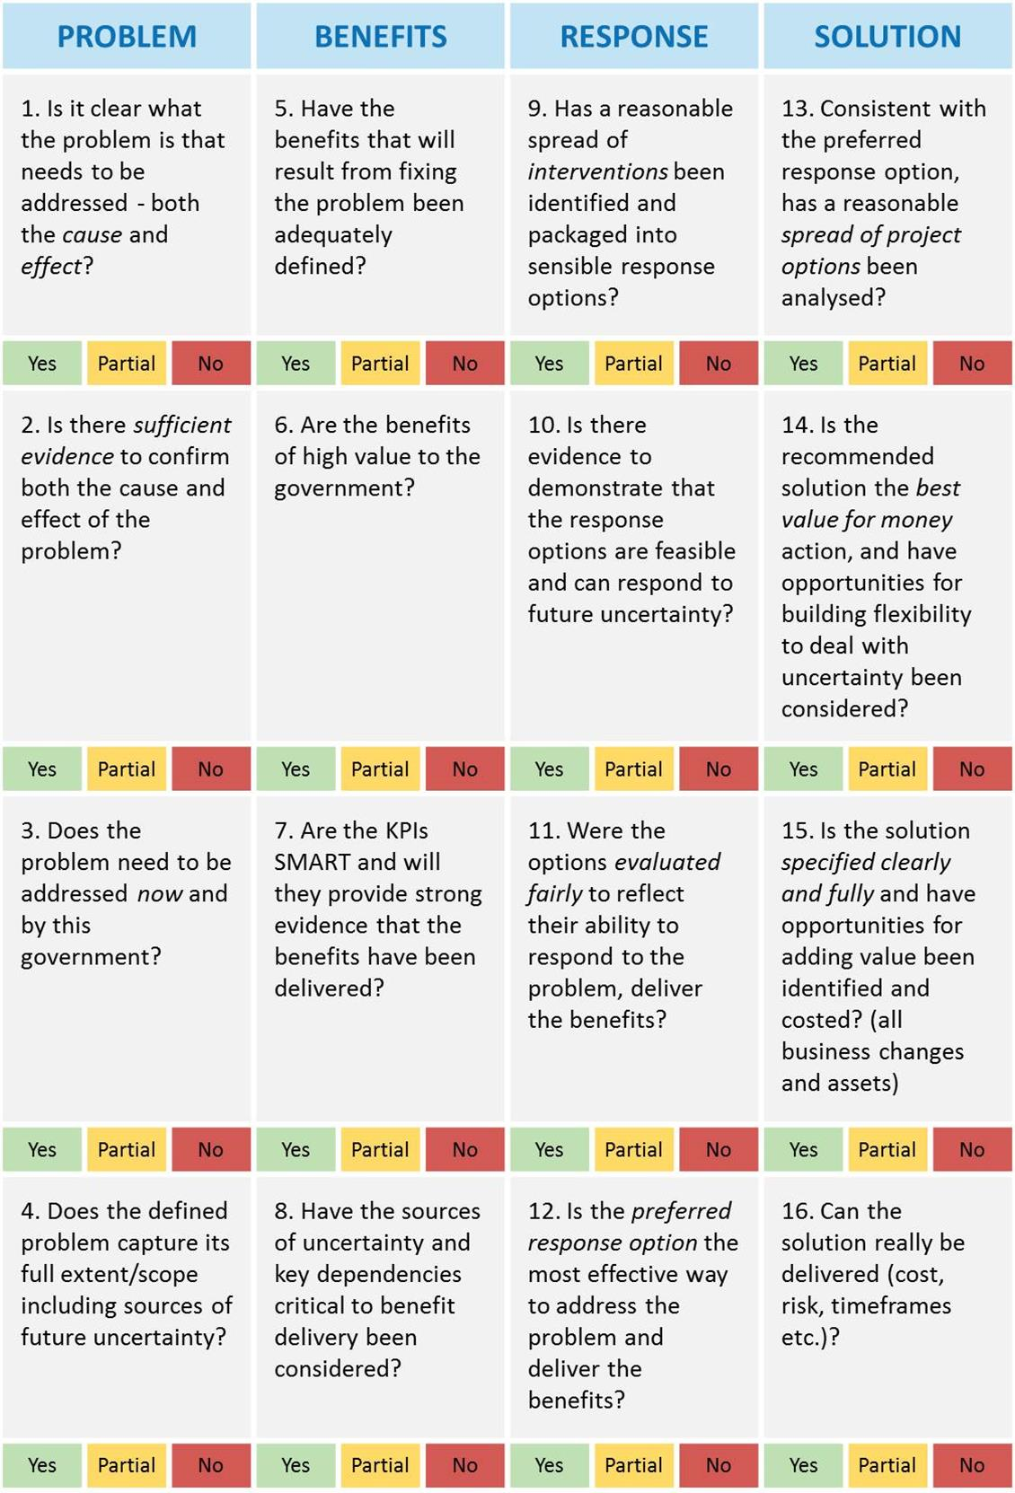

Appendix 2: Shaping new investments using the IMS
The Victorian Government’s Investment Management Standard (IMS) establishes a set of simple practices that enable organisations to select the investments that matter most and shape and implement them so they deliver the maximum benefit and best value for money. The practices can also be used to help prioritise investments, develop policy, evaluate programs and improve the effectiveness of an organisation.
The IMS supports a way of thinking characterised by evidence-based discussion, robust logic and simple storytelling. It brings together the best thinkers on a subject to discuss and shape new investments in two-hour facilitated discussions (workshops) to address the four questions that are fundamental to investment decision making:
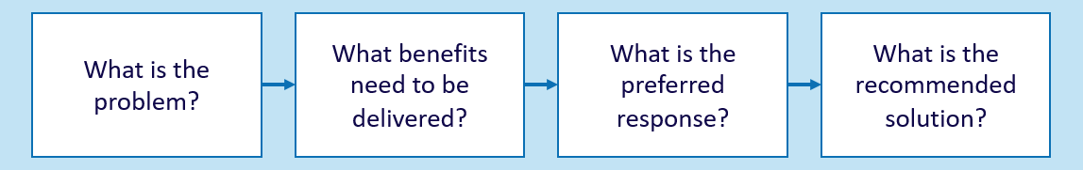
The number of workshops required is determined by the nature of an investment. Large and complex investments might require four separate workshops that would produce four documents critical to establishing a sound business case. Small and simple investments might require just one or two workshops and would produce an Investment Logic Map (ILM) and a Benefit Management Plan. The four workshops are described below.
PROBLEM
Successful investments are made as a considered reaction to an identified or emerging problem. This workshop focuses on:
- defining the problem that need to be addressed;
- validating that the problem is real; and
- specifying the benefits that will result from addressing the problem.
The output of this workshop is the first version of an Investment Logic Map (ILM) with the problems and benefits defined.
BENEFIT
Investments are often shaped with little understanding of the benefits expected to be produced. This workshop will:
- identify the KPIs, measures, targets and timelines that the investment will need to deliver; and
- specify how the delivery of the benefits will be measured and reported.
The output of this workshop is a Benefit Management Plan (BMP) including a Benefit Map and Benefit Profile.
RESPONSE
Business cases for new investments often fail to consider the full range of things that could be done to address the identified problem. This workshop will:
- explore the interventions that could deliver the expected benefits;
- formulate and evaluate a mix of response options; and
- assess response options and potentially select the preferred response.
The output of this workshop is a Response Options Analysis Report (ROAR).
SOLUTION
This workshop ensures that a solution is developed which is consistent with the foundations established in previous workshops. This workshop will:
- confirm the preferred response and the interventions it contains;
- identify and evaluate the changes and assets that are required to implement the preferred response and deliver the benefits;
- define a recommended solution; and
- identify cost range, timeframe for project and benefit delivery, key risks, uncertainties, dis-benefits and critical assumptions associated with the recommended solution.
The output of this workshop is an Investment Concept Brief (ICB).

Appendix 3: Fictional – Investment Concept Brief
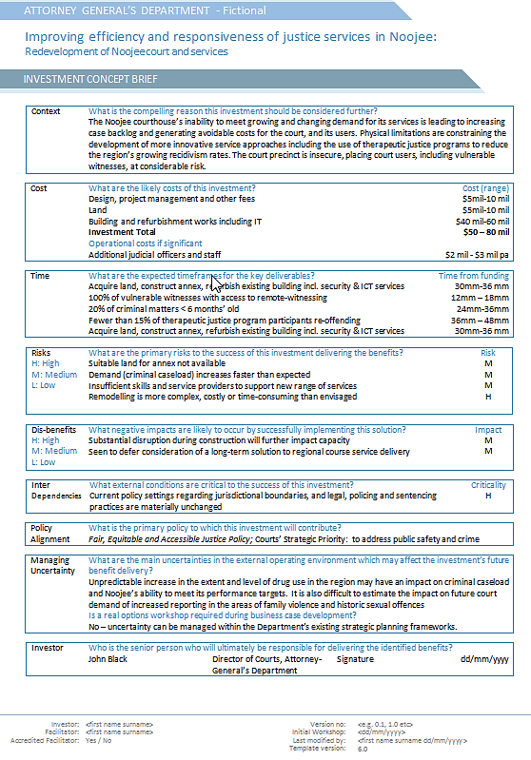

Appendix 4: Design guidelines – Investment Concept Brief
These design guidelines have been developed to assist facilitators to develop high-quality ICBs. Any of these rules can be broken but, in doing so, be aware of the impact it will have on the storytelling.
Item | Practice | Reason
Template | Always use the current ICB template. Do not alter the template and stick to the one-page format. Current templates can be found at www.dtf.vic.gov.au/investmentmanagement. | Formats continue to improve to make them more useful as communication tools and contain better information.
Use of words | Be brief, clear and specific in your statements. | It maintains clarity and consistency when reading the ICB.
Context | Draw content for this field from the Problem Statements | Provides clear articulation of need and the compelling reason for considering this investment.
Cost | Provide summary of major cost areas e.g. infrastructure, staff, program development | Provide insight into both capital and on-going costs that will result from the investment.
Timeframe | Identify timeframe for 2-3 major project milestones and then delivery of major benefits/KPIs | Provide a view of the timeframe for project completion and importantly benefit delivery
Risk | Identify major risks to delivery of benefit that the project team will need to address.  Make global assessment based on view of likelihood and consequence | Provide insight into those factors that may impact on benefit outcomes and project delivery.
Disbenefits | Identify negative outcome/s of successful implementation and assess criticality of this outcome | Provide insight into negative outcomes that could influence the decision to invest.
Critical Inter-dependencies | Identify assumptions being made that, prove to be incorrect, would alter the need for or shape of this investment in some way. Are there external dependencies that are critical to the successful delivery of benefits? | Ensure full understanding of the assumptions and implementation requirements that inform decision-making and planning
Policy alignment | Identify the major policy that this investment aligns with and whether there are other important policy levers that government would be value. | Ensures that investments are aligned with critical government policies.
Managing uncertainty | Identify the main uncertainties in the external operating environment which may affect the investment’s future benefit delivery. Indicate whether a real options workshop is required if this investment proceeds to full business case | Ensures that opportunities for building flexibility and value adding have been identified and will be analysed further. Limits government’s exposure to scenarios that would lead to investment regret.
Use of ranges | Express timeframes and costs in ranges from lowest to highest. | Forces realistic estimates to be made.
Completing the control fields | Ensure the document control fields have been completed including the names of the:  - investment;  - department/agency/organisation  - investor; and  - facilitator. | Provides legitimacy and accountability for the investment.

Appendix 5: Sample email – before the Solution Definition workshop
[Greeting]
You may or may not be aware of the business need we have in relation to [investment name] and the thinking we have been doing to shape an investment that will respond to that need. Consistent with the Victorian Government’s Investment Management Standard we have already held the ‘identify the problem, benefits, and preferred response’ informed discussions. These form the basis of any investment.
Consistent with this approach, we will now hold a two-hour Solution Definition workshop, with the aim of confirming our preferred response and defining and scoping our recommended solution. The guideline for this discussion is attached.
The preparation required from you for this workshop is:
- review the current ILM, Benefit Map and the Response Options Analysis Report (attached) and ensure you are familiar with our developing investment story;
- pay attention to the cost and timeframe data in the Response Options Analysis Report. This has been added since the last workshop and we need to be comfortable that it is reasonable; and
- think about the potential changes and assets we will need to deliver our preferred response, and how each intervention listed on the ILM might be implemented in practice.
The discussion will be held as follows:
Date:
Time:
Venue:
The result of this exercise will be an Investment Concept Brief [an example is attached].
Please let me know if you are able to attend.
If you would like to read more about the benefits and practices of this approach you should refer to www.dtf.vic.gov.au/investment-management-standard/ims-workshops-and-examples.
[Sign off]

Appendix 6: Checklist – Solution Definition workshop
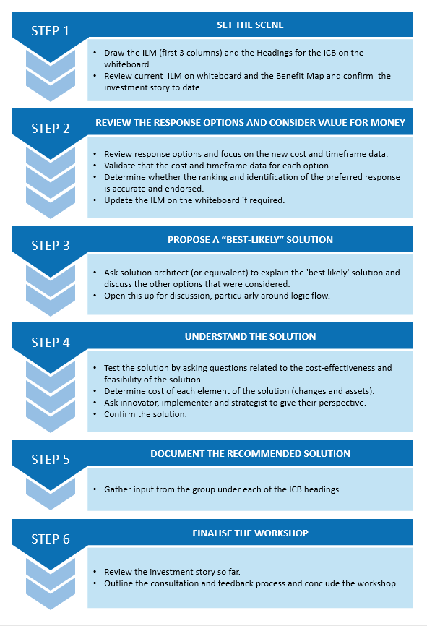

Appendix 7: Sample agenda – Solution Definition workshop
Before the workshop
15–20 minutes | Set up the whiteboard
At the workshop
5 minutes | Introduction and outline of purpose and role
10 minutes | Review of current ILM – problems and benefits
15 minutes | Review response options and cost and timeframe. Confirm ranking and preferred response
45-50 minutes | Outline and shape the ‘best likely’ solution and record changes and assets
10-15 minutes | Cost the solution and define the recommended solution
20-25 minutes | Complete the ICB

Appendix 8: Sample email – after the Solution Definition workshop
[Greeting]
Thanks for your participation at yesterday’s Solution Definition workshop for [investment name]. I have attached several documents to this email. The newest is version 0.1 of the Investment Concept Brief (ICB) that we produced. Other documents have been updated and are attached. These include the ILM, Benefit Management Plan (if any changes have been made) and the Response Options Analysis Report. Could you please provide me with any suggested amendments by close of business today (or within 24 hours)? I will then make any necessary changes and have version 1.0 of the ICB, and the next version of each of the IMS suite, back to you by close of business tomorrow.
…my observations
[any observations on the investment itself or the process and any suggestions that might improve the case for the investment or the strength of the investment concept brief]
…about Investment Concept Briefs
An ICB provides any interested party with a clear understanding of the logic that underpins a potential investment. It should be written in plain English so that anyone can understand it and make a judgement as to its worth.
The creation of an ICB is not just an exercise in agreeing to the investment logic at one point in time (usually pre-funding). This document and the others in the suite are evolving and should be updated during the development of the business case. These documents should also be primary reference material at each meeting of the investment’s governance body and a current copy should be available to all stakeholders and anyone working to implement the investment.
[Sign off]

Appendix 9: Quality assessment form – Investment Concept Brief
The purpose of this form is to assist an investor, facilitator or anybody with an interest to assess the quality of an ICB that has been developed.
Test 1: The ILM has probably changed as a result of the Solution Definition workshop. Based on the quality assessment form for ILMs, is the ILM accompanying this ICB of a satisfactory quality? | Assessment:  YES / NO / MAYBE
Any comments?

Test 2: Is the solution both understandable and logical to a lay-person and are the changes a reasonable response to the interventions that were identified? | Assessment:  YES / NO / MAYBE
Any comments?

Test 3: Is there an accurate translation between the solution depicted in the ILM and the solution assessed in the text of the ICB? | Assessment:  YES / NO / MAYBE
Any comments?

Test 4: Has the required detail been provided under each of the headings of the ICB? | Assessment:  YES / NO / MAYBE
Any comments?

Test 5: Is there sufficient detail to support the person making the investment decision? | Assessment:  YES / NO / MAYBE
Any comments?

How do you rate this ICB? | Assessment:  SATISFACTORY/ UNSATISFACTORY
Any comments?

Further detail on the facilitator training course, in which this guidance is used, can be found at www.dtf.vic.gov.au/investment-management-standard/investment-management-facilitator-training-and-accreditation.
Within the New Zealand government investment framework, significant investment proposals from relevant state sector agencies must use the options analysis methodology outlined in the Better Business Case guidance rather than the Response Definition workshop approach described here.)
Real options analysis is an investment evaluation and decision-making framework which introduces more flexibility to the management of infrastructure projects that are significantly affected by uncertainty. It assists Government make investments that are more adaptable over time and better able to meet the community’s evolving needs.
Previously the Strategic Options workshop
In which case, the solution may have effectively been defined in the Response Definition workshop or can be confirmed in a simple conversation without a formal workshop.
See Department of Treasury and Finance (Victoria) Investment lifecycle and High Value High Risk guidelines – Overview https://www.dtf.vic.gov.au/infrastructure-investment/investment-lifecycle-and-high-value-and-high-risk-guidelines
The Solution Definition workshop is largely designed to support the development of a preliminary business case. A full business case, particularly one prepared for a HVHR investment is likely to require further detailed project options analysis in line with the Stage2: Prove guideline and the Sustainability Investment Guidelines.
Cost estimates for potential investments are an important component of response assessment. While it is recognised that the organisation may be at an early stage of an investment's development, the cost estimates should be sufficiently reliable to provide an ‘order of magnitude’ of the final cost, expressed as a cost range ($x-$y million). The estimated full capital and output cost of the investment should be included, together with any key assumptions made.
Workshop discussions can help identify policy requirements and synergies. For example, IMS workshops may identify opportunities within a proposal, or projects that can add broader value and contribute to major government policy objectives. Where this occurs, these additional proposal details should be captured within the IMS documents, in particular the ICB, and further explored during business case development.

