Enhanced Design and Construct Deed
Guidance Notes

The Secretary
Department of Treasury and Finance
1 Treasury Place
Melbourne Victoria 3002
Australia
Telephone: +61 3 9651 5111
dtf.vic.gov.au

Authorised by the Victorian Government
1 Treasury Place, Melbourne, 3002

© State of Victoria 2023
You are free to re-use this work under a Creative Commons Attribution 4.0 licence, provided you credit the State of Victoria (Department of Treasury and Finance) as author, indicate if changes were made and comply with the other licence terms. The licence does not apply to any branding, including Government logos.

Copyright queries may be directed to IPpolicy@dtf.vic.gov.au

ISBN 978-1-925551-90-7
Published September 2023

If you would like to receive this publication in an accessible format please email information@dtf.vic.gov.au

This document is also available in Word and PDF format at dtf.vic.gov.au

Disclaimer
The material contained in the Department of Treasury and Finance (DTF) Enhanced Design and Construct (D&C) Deed – Guidance Notes (Guidance Notes) is made available on the understanding that:
- the State is not providing professional advice
- users exercise their own skill and care with respect to its use; and
- users will seek independent advice as necessary.
The State gives no warranty and does not make any representation, express or implied, as to the contents or accuracy of the information contained in this publication. The State expressly disclaims any and all liability relating to or resulting from:
- the use of these Guidance Notes by any person; or
- anything done, or omitted to be done, in reliance upon information contained in these Guidance Notes.
These Guidance Notes must not be used for the interpretation of the Enhanced D&C Deed. Nothing in these Guidance Notes limits or affects the application, interpretation or enforcement of the terms and conditions in:
- any Expression of Interest or Request for Proposal (RFP); or
- the Enhanced D&C Deed or any Project Document entered into by the State.

Contents
1. Introduction 1
1.1 Purpose 1
1.2 Context 1
1.3 Legislative context 6
1.4 Alternative supporting legislative frameworks 7
2. Governance, approvals and assurance 7
2.1 Governance 7
2.2 Role of the informed and engaged client 8
2.3 Approvals and project assurance 10
2.4 Principal Representative 10
3. Commercial framework 11
3.1 Value-for-Money 11
3.2 Key risk considerations 12
3.3 Performance adjustment regime 12
4. Enhanced D&C Deed guidance 14
4.1 Adjustment Events (clauses 1, 26, 32, 34) 15
4.2 Defects (clauses 1, 27 and 31) 18
4.3 Site Information and Site Conditions (clauses 1, 5 and 10) 20
4.4 Contamination (clauses 12 and 38) 23
4.5 Utilities (clause 13) 28
4.6 Change in Law and Change in Policy (clauses 1, 5 and 33) 30
4.7 Force Majeure (clauses 1, 26, 34 and 38) 31
4.8 Pandemics (clauses 1, 6A and 26) 33
4.9 Time (clauses 1, 26, 32 and 38) 35
4.10 Variations (clauses 1 and 32) 42
4.11 Indemnities (clauses 36 and 38) 47
4.12 Limitation and exclusion of Liability (clause 38) 49
4.13 Insurance (clause 39) 51
4.14 Security (clause 31) 52
4.15 Default (clauses 1 and 40) 53
4.16 Termination (clauses 1, 3, 40 and 41) 56
4.17 Notices and bar to Claims (clause 56) 59
Annexure 1 – Terminology and interpretation 60
Annexure 2 – Defects 61
Annexure 3 – Re-baselining mechanism 59
Annexure 4 – Contamination rights and obligations 60

    - Introduction
      - Purpose
This document is one of a suite of publications that constitute the Department of Treasury and Finance’s (DTF) whole of government infrastructure procurement framework (Framework).
It sets out guidance for the development and application of the Enhanced D&C Deed for the delivery of High Value High Risk (HVHR) projects. This document can also be used to support delivery of non-HVHR projects.
The document is for Victorian Government procuring agencies and departments where the procuring agency is separate from the department. It is also relevant to other industry practitioners, government stakeholders, tenderers and advisers who wish to understand the Enhanced D&C Deed.
The document details:
    - the context for developing the Enhanced D&C Deed;
    - an overview of the Enhanced D&C Deed, including issues to consider;
    - governance, approvals and assurance processes for the Enhanced D&C Deed;
    - the legislative and commercial framework for delivery of the Enhanced D&C Deed; and
    - a clause-by-clause breakdown of the Enhanced D&C Deed, including key principles and considerations in implementing these clauses.
These Guidance Notes should be read in conjunction with the Enhanced D&C Deed and the Enhanced Design and Construct Deed – Commercial Principles available on the Lump Sum Procurement Category webpage.
Annexure 1 provides a glossary of terms and interpretation provisions for these Guidance Notes.
      - Context
The Enhanced D&C procurement model sits within the Framework.
The Framework includes three categories of procurement, including whole-of-life, lump sum and cost reimbursable, with each category containing a set of approved procurement models for use on Victorian Government infrastructure projects.
It consists of the following policy, guidance and standard form contracts:
    - the Ministerial Directions and Instructions for Public Construction Procurement (Ministerial Directions), established under Part 4 of the Project Development and Construction Management Act 1994 (Vic)
    - the Procurement – Investment Lifecycle Guideline, which outlines the three procurement categories and a set of approved procurement models
    - a procurement requirements document for each of the three procurement categories
    - standard form contracts and guidance for a subset of the approved procurement models.
Figure 1 provides an overview of the Framework and indicates where the Enhanced D&C Deed sits within it.
Figure 1 – Framework overview
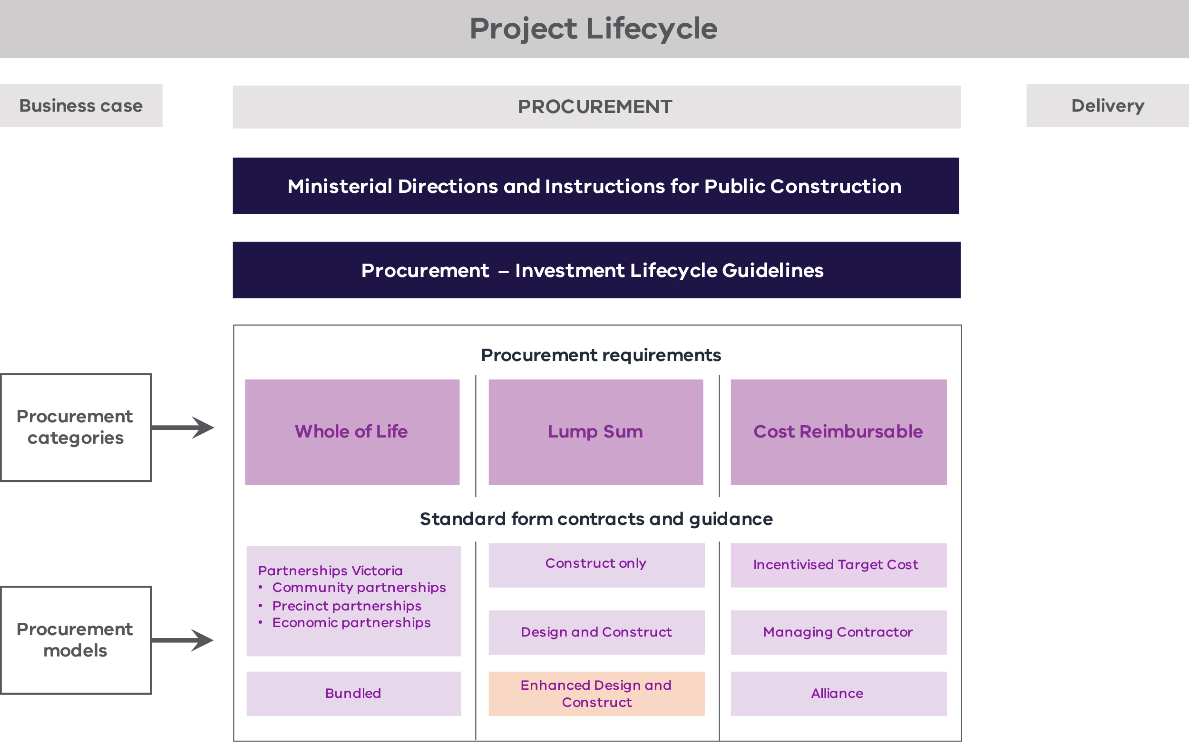

Other Victorian Government legislation, policies and frameworks that are applicable across the project lifecycle include:
- the Standing Directions 2018 under the Financial Management Act 1994 (Vic)
- the Investment Lifecycle Guideline series
- the Asset Management Accountability Framework, Investment Management Standard and Bid Cost Reimbursement Policy for Major Construction Projects
- the High Value High Risk (HVHR) project assurance framework and associated Gateway Review Process.
National policies, such as the National Alliance Contracting Guidelines and the National Public Private Partnership Policy, may also be applicable.
Where there is a difference in the application of this document from other policies and guidelines, the requirements in this document take precedence.
        - Enhanced D&C Deed
The Enhanced D&C Deed has been developed to provide a modern contract based on a fixed-price D&C model. It also includes targeted collaborative and risk-sharing elements in response to delivery issues and market concerns about standard D&C delivery.
The Enhanced D&C Deed offers a robust alternative to cost reimbursable contracting models, such as project alliances or incentivised target cost (ITC) models, where the State retains a significant portion of project risk. It also provides an alternative to other standard form contracts. It is not intended to replace the existing DTF-approved standard form AS4300-1995 D&C Deed.
The Enhanced D&C Deed provides consistent, efficient risk allocation and the flexibility to accommodate project-specific requirements.
The Enhanced D&C Deed seeks to:
    - promote efficient processes in delivering D&C projects, specifically providing time and cost savings for the State and private sectors in drafting and negotiating project documentation;
    - provide targeted collaborative and risk-sharing elements that address specific high-value risks, such as contamination, that are challenging under traditional D&C risk allocation;
    - enhance contract administration;
    - allow project teams and bid teams to focus on project-specific issues;
    - improve contract interpretation and enforceability; and
    - provide tenderers with greater certainty regarding project contractual terms.
        - Basis for developing the Enhanced D&C Deed
The Enhanced D&C Deed has been developed based on:
    - established contract forms accepted by both the market and State;
    - guidance issued by government agencies and industry groups;
    - feedback from the private sector and government stakeholders; and
    - learnings from other projects and jurisdictions.
The structure of the Enhanced D&C Deed is based on the D&C elements in the Harmonised PPP Project Deed, with several modifications to remove operational phase and financing elements and reflect the Enhanced D&C Deed risk allocation.
The Enhanced D&C Deed also adopts applicable Partnerships Victoria standard terms (where consistent with generally accepted market terms for similar contracts) to promote greater consistency in forms of contract used in Victorian infrastructure projects.
        - Underlying principles driving the Enhanced D&C Deed
Key aspects of this form of contract include that:
    - a Principal Representative appointed by the Principal administers the Contract with a non-binding leadership team;
    - while the Principal is considered an ‘informed and engaged client’, staff are not embedded in the Contractor’s delivery team, and there is no joint decision-making; and
    - the Contractor provides the usual contractual warranties for fitness for purpose and design, and is responsible for the delivery of the Project.
Further details on the model, including risk allocation, are outlined in the Enhanced D&C Deed – Commercial Principles available on the Lump Sum Procurement Category webpage.
DTF will continue to monitor the market and seek feedback from stakeholders to ensure that the risk allocation in the standard Enhanced D&C Deed remains consistent with best practices and includes any industry changes or updates.
As an alternative to the Enhanced D&C Deed, DTF has also developed an ITC Contract Suite, comprising an ITC Development Deed and ITC Delivery Deed. Refer to the ITC Contract Suite – Guidance Notes available at the Cost Reimbursable Procurement Category webpage.
        - Contractual framework of the Enhanced D&C Deed
Following a successful tender evaluation process, the Principal selects the Successful Respondent, who is then engaged to deliver the Project as the Contractor under the Enhanced D&C Deed. The Contractor:
    - designs and constructs the Project in line with the risk profile of the Enhanced D&C Deed;
    - is paid the Contract Sum, adjusted according to the Enhanced D&C Deed (including Adjustment Events for Unknown Inaccurate Principal Geotechnical Data and Unknown Utility Services, and payment of Contamination according to the risk-sharing regime); and
    - is required to achieve Completion by the relevant date, hand the Project over to the Principal and rectify any Defects identified during the Defects Liability Period (DLP).
        - Form and structure
The Enhanced D&C Deed consists of:
    - one deed;
    - 22 schedules;
    - one annexure; and
    - five attachments.
Some schedules are documents created by the Principal, which will generally be included in the Project’s RFP, such as the Adjustment Event Guidelines. Other schedules will be prepared by the Principal but completed by the Contractor to reflect their proposal, such as the Contamination, Groundwater and Utilities Schedules.
Annexures include large documents such as the Project Scope and Delivery Requirements (PSDR). Annexures may also consist of documents that are exclusively prepared by the Successful Respondent and are generally included in the Successful Respondent’s Proposal.
Attachments to the Enhanced D&C Deed are included for convenience. They do not form part of the Enhanced D&C Deed (as stated in clause 2.2 of the Enhanced D&C Deed) but are often referred to in it. They are included as attachments to avoid any confusion over the version being referred to in the Enhanced D&C Deed.
Some schedules are project-specific and need to be developed by the Principal as they do not form part of this standard form contract suite.
        - Incorporation of Successful Respondent’s Proposal

General principles
As part of their Proposals, Contractors provide documents that will be included in the Enhanced D&C Deed in a form agreed on by the parties. These include the Project Scope, Bid Development Program and Bid Project Plans. The location of these documents in the Enhanced D&C Deed may be determined on a project-specific basis.
The Project Scope together with the Delivery Requirements make up the PSDR. The Delivery Requirements contain the Principal’s technical and functional requirements that define the scope of the Project. The Contractor bids the Project Scope in its Proposal in response to the Delivery Requirements. The Project Scope includes the parts of the Contractor’s design and services solution that the parties agree should be in the Enhanced D&C Deed.
The Bid Program does not form part of the Enhanced D&C Deed. The Principal does not require strict compliance with the Program because this is considered an unduly onerous obligation and does not provide value-for-money (VfM). The Bid Program should only be attached to the Enhanced D&C Deed to establish a baseline for the Program that the Contractor is required to update and comply with under the Enhanced D&C Deed.
The Contractor is required to comply with and update the Project Plans. As the Project Plans are intended to set out the Contractor’s methodology and obligations, they typically do not impose any obligations on the Principal. The Project Plans or the PSDR should specify that its obligations are not binding on the Principal.

Project-specific amendments
The documents that make up the Project Scope are agreed by the parties on a project-specific basis.
Whether Bid Project Plans are included in the Enhanced D&C Deed, attached to the Enhanced D&C Deed or included in the PSDR may be determined on a project-specific basis.
      - Legislative context
        - Major Transport Projects Facilitation Act 2009 (Vic)
The Enhanced D&C Deed has been drafted on the basis that the Major Transport Projects Facilitation Act 2009 (Vic) (MTPF Act) applies.
The MTPF Act seeks to facilitate the development of major transport projects. It applies when the Enhanced D&C Deed is used for transport projects that are declared projects under section 10 of the MTPF Act. The Premier of Victoria is responsible for declaring projects under the MTPF Act.
For the purposes of the MTPF Act, a ‘transport project’ is broadly defined as a project for the development of transport infrastructure, or transport infrastructure together with non-transport infrastructure. Some non-transport infrastructure may also qualify as part of a transport project under the MTPF Act.
The declaration of a transport project may be in relation to either the entire MTPF Act (including planning assessment and approval) or the MTPF Act excluding Parts 3 and 8 (project delivery only).
If the entire MTPF Act applies, the transport project will attract both the planning assessment and approval processes and the project delivery powers under the MTPF Act.
If the MTPF Act excluding Parts 3 and 8 applies, the transport project is able to benefit from the project delivery provisions of the MTPF Act once planning approval has been obtained under standard processes.
The MTPF Act’s planning assessment and approval provisions seek to streamline the assessment and approvals processes. They provide a range of planning and environmental approvals for a project in a single approval decision (see Parts 3 and 8 of the MTPF Act).
The MTPF Act’s project delivery provisions provide a range of project delivery powers. These govern land acquisition and assembly, land management, road management, utilities and a range of other facilitating provisions.
        - Enhanced D&C Deed implications
The Enhanced D&C Deed has been drafted on the assumption that the MTPF Act applies. Accordingly, amendments may need to be made to the following clauses in the Enhanced D&C Deed where there are project-specific issues that do not accord with the assumptions or regimes included in the MTPF Act:
    - Traffic Management (clause 12.4) – potential traffic management implications;
    - Utilities (clause 13) – regime under Part 7 of the MTPF Act in relation to the interface with utilities and discovery of unknown Utility Infrastructure; and
    - Date of Practical Completion (clause 24 and definitions).
Further amendments will also need to be made to the above clauses if the MTPF Act does not apply to reflect the Principal’s preferred risk allocation.
      - Alternative supporting legislative frameworks
The Enhanced D&C Deed can be amended to incorporate alternative supporting legislation to the MTPF Act, such as the Project Development and Construction Management Act 1994 (Vic).
Amendments to the Enhanced D&C Deed should be drafted with input from the procuring agency’s legal adviser to ensure the appropriate legislative requirements apply.
    - Governance, approvals and assurance
      - Governance
        - General principles
Project governance sets a firm framework which guides project delivery to create transparency and confidence in decision-making, clarity of roles and responsibilities and consideration of stakeholder interests.
Strong project governance is integral to maximising the benefits of the Enhanced D&C Deed and to support successful project delivery.
The Investment Lifecycle Guidelines Governance Technical Supplement, available on the Procurement – Investment Lifecycle High Value High Risk Guidelines webpage, and the High Value High Risk Project Assurance Framework, available on the High Value High Risk webpage, provide guidance on governance for major infrastructure projects, including the requirement for a Project Steering Committee with DTF representation.
        - Governance arrangements
The Enhanced D&C Deed requires the establishment of the following contractual governance and personnel arrangements:

Senior Representatives Group
This group makes strategic decisions and provides the leadership required to successfully implement the contract. Its key functions include:
    - providing strategic leadership;
    - promoting appropriate culture and behaviours;
    - reviewing Contractor performance; and
    - monitoring and helping resolve issues referred to the group.

Project Control Group
This group makes tactical decisions and is across the detail of the project. Its key functions include:
    - monitoring Contractor compliance with project documentation and providing guidance on achievement of key requirements;
    - assisting in resolving matters referred to the group;
    - reviewing reports, plans and the quality of Contractor work; and
    - considering value engineering, cost-saving opportunities as well as other issues including interface management, environmental issues and occupational health and safety.

Working groups
These can be established by the Principal as required.
      - Role of the informed and engaged client
The Enhanced D&C Deed supports the achievement of VfM principles (as outlined in the Procurement – Investment Lifecycle High Value High Risk Guidelines) and broader project objectives through the State’s role as an ‘informed and engaged client’.
DTF considers an informed and engaged client to be one where the State:
    - has capacity, capability and seniority of resources to manage the achievement of the State’s outcomes throughout project planning, procurement and delivery;
    - interrogates bespoke risk-sharing regimes and participates in risk identification and quantification workshops (including identifying risk mitigation strategies);
    - demonstrates professional judgement and discernment in administering the delivery contract;
    - shares knowledge and experience gained throughout the project lifecycle; and
    - works closely with the Contractor to support the achievement of project outcomes.
Procuring agencies should work closely with the Contractor throughout the investment lifecycle to understand and identify the specific risks of the project. They should provide input to the quantification and risk mitigation strategies, particularly for risks that are shared. In some scenarios, the procuring agency may have more expertise in the specific risk mitigation strategies. This expertise should be used to assist and supplement the Contractor’s own processes.
The resourcing and capability required to procure and deliver the Enhanced D&C Deed is expected to be higher than for a traditional contract, such as a fixed-price D&C contract.
An informed and engaged client model requires expertise and experience in:
    - project delivery;
    - planning and approvals;
    - environmental and cultural heritage impacts;
    - communication and stakeholder engagement;
    - health and safety management systems;
    - utilities management;
    - cost and risk assessment; and
    - commercial and contract management.
        - Relationships between the parties
The Enhanced D&C Deed is based on the Partnerships Victoria Standard Form Project Deed for Linear Infrastructure. It has been modified to remove operational phase and financing elements, and reflect Enhanced D&C Deed risk allocation. Under this model, the parties are the same as those under a traditional D&C contract. Figure 2 shows the interrelationships between the different entities.
Figure 2 – Interrelationships between entities
Principal
Subcontractor
Subcontractor
Subcontractor
Parent Guarantor
Contractor
Enhanced D&C Deed
      - Approvals and project assurance
All HVHR projects are required to undertake a series of centralised checks and processes tailored to the risk profile and characteristics of the project. These are documented in the Project Assurance Plan that is developed for each project.
HVHR projects require the Treasurer’s approval at key phases of the procurement process. In some cases, central agencies may be involved in the tender selection process.
Variations to standard deeds, commercial principles or risk allocations require input from DTF, and may also require DTF or Treasurer approval (or both), as specified in a project’s individual Project Assurance Plan.
For the Enhanced D&C Deed, DTF expects to be consulted on proposed changes to key commercial principles or risk allocations, including:
    - inclusion of bespoke risk-sharing regimes; and
    - changes to the default payment and performance regimes.
      - Principal Representative
The role of the Principal Representative under the Enhanced D&C Deed is to ‘administer’ the contract and ensure the contractual obligations are performed.
The Principal Representative has two separate and distinct roles:
    - to act as agent for the Principal; and
    - to act as an independent certifier.
As the agent for the Principal, the Principal Representative may exercise all rights, powers, authority and functions of the Principal under the relevant Project Documents. This role may include functions such as:
    - issuing directions to the Contractor on behalf of the Principal;
    - reviewing updates to the Program;
    - approving certain actions in respect of Significant Subcontracts (including termination);
    - resolving inconsistencies, ambiguities and discrepancies within or between the Project Documents;
    - postponing and suspending Contractor’s Activities; and
    - issuing Variation Orders.
In its role as certifier under the Enhanced D&C Deed, the Principal Representative performs certain certification functions around time, cost and Practical Completion. In undertaking its certification functions, the Principal Representative must:
    - act honestly and impartially;
    - arrive at a reasonable measure or value of work, quantities or time;
    - act reasonably in determining whether Practical Completion has been achieved; and
    - act within the time prescribed under the Enhanced D&C Deed or, where no time is prescribed, within a reasonable time.
On a project-specific basis, agencies may elect to also appoint an independent reviewer or independent certifier, who may certify payment, determine extensions of time and certify Practical Completion. An independent reviewer may be well suited to large projects where the benefit of additional assurance provided by a third party and the materiality of the relevant decision-making could outweigh the additional costs that come with an independent reviewer.
    - Commercial framework
      - Value-for-Money
VfM is an assessment of outcomes that weighs up the cost of procuring infrastructure against the value it provides. In doing so, it balances the whole-of-life costs against a range of outcomes, including:
    - suitability and quality of infrastructure;
    - financial benefits;
    - risk exposure;
    - timeliness of outcomes; and
    - social, environmental and industry outcomes.
Whole-of-life costs include technology, obsolescence and maintenance costs. Further, costs to operate, support costs, costs to upgrade and disposal costs should be considered.
This VfM framework applies to the Enhanced D&C Deed even though the operating phase is not typically bundled under this model.
      - Key risk considerations
The Enhanced D&C Deed is based on a fixed-price D&C model and includes targeted collaborative and risk-sharing elements. These elements address the challenges of specific high-value risks. This is a departure from the traditional D&C model, where these risks are allocated to the Contractor, and results in the Principal having an expanded role in managing and administering regimes that allow for risk-sharing around:
    - Site Conditions (see section 4.3.1);
    - Contamination (see section 4.4.1); and
    - Utilities (see section 4.4.1).
These regimes may include cost reimbursable elements.
More information on achieving VfM on contracts with cost reimbursable elements is provided in [chapter 5] of the Cost Reimbursable Procurement Requirements available on the Cost Reimbursable Procurement Category webpage.
      - Performance adjustment regime
        - Overview
A standard D&C contract generally includes consequences for late delivery but no additional incentives for timely delivery. In contrast, the Enhanced D&C Deed includes a performance adjustment regime that provides financial incentives for Contractors to achieve non-financial objectives.
The performance adjustment regime is located in the Payment Schedule (Schedule 3) and seeks to incentivise the Contractor to deliver exceptional performance in non-financial objectives of project delivery that are important to the State. This may include objectives such as timely completion of the project, minimising impact on a live operating facility and community satisfaction when delivering the project. These non-financial objectives are grouped into Key Result Areas (KRAs), with each KRA having one or more Key Performance Indicators (KPIs).
Schedule 3 does not form part of this standard form contract suite and will need to be developed by the Principal based on project-specific characteristics.
The KRAs are listed in the KRA Schedule (Schedule 8).
        - Key features of a performance adjustment regime

The performance pool
Under a performance adjustment regime, a specified performance pool will be available to the Contractor based on the principles that:
    - positive performance in a KRA is incentivised with certain payments from the performance pool; and
    - poor performance in a KRA results in the Contractor losing the right to claim certain payments from the performance pool.
Prior to the RFP phase, the procuring agency should develop a proposal in consultation with the DTF that outlines the need for a performance pool and justifies its proposed size (generally 0.5–3 per cent of the overall project value).
Projects are required to allocate at least 50 per cent of the performance pool to achieving a time-based KRA.

Calculating the performance adjustment
Under a performance adjustment regime, at the Date of Practical Completion, the performance adjustment is calculated based on the Contractor’s performance for each KPI.

Interaction with the liquidated damages regime
A performance adjustment mechanism is not intended to be a substitute for a liquidated damages regime. The liquidated damages regime for the Enhanced D&C Deed is described in section 4.9.5.
        - KRAs and KPIs

Development
To ensure the KRA regime is effective, the procuring agency should consider the following attributes:
    - supporting and aligning with the objectives of the project;
    - promoting an effective and objective measurement of performance;
    - rewarding exceptional performance;
    - providing a meaningful incentive;
    - incentivising outcomes which are directly within the Contractor’s control; and
    - optimising Contractor and the procuring agency’s contract management effort.
In addition to a time-based KRA, other potential KRAs include quality, stakeholder management and sustainability.

Adjustment
The Enhanced D&C Deed provides a mechanism to adjust the KRAs, including the Dates for Completion, via Adjustment Events (see section 4.1). More information on the performance adjustment mechanism is in Figure 3 below.
Figure 3 – Performance adjustment mechanism
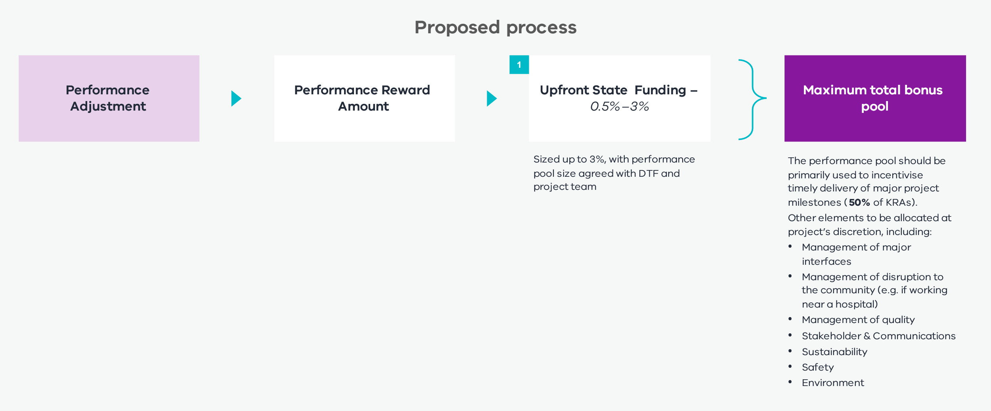
        - Principal’s KRAs
The parties will agree Principal’s KRAs in respect of the Principal’s engagement on certain matters. Achievement (or otherwise) of the Principal’s KRAs will be monitored by the Senior Representatives Group and Executive Review Group, but a failure to achieve the Principal’s KRAs will not entitle the Contractor to any relief. More information on the application of the Principal’s KRA is available in the Enhanced D&C Deed – Commercial Principles available on the Lump Sum Procurement Category webpage.
    - Enhanced D&C Deed guidance
This chapter provides additional information to assist procuring agencies with implementing key provisions of the Enhanced D&C Deed.
These Guidance Notes should be read in conjunction with the Enhanced D&C Deed and the Enhanced D&C Deed – Commercial Principles available on the Lump Sum Procurement Category webpage.
      - Adjustment Events (clauses 1, 26, 32, 34)
        - General principles (clauses 1, 26.5, 26.10, 32.3, 32.6 and 34.1)
The Enhanced D&C Deed provides a mechanism for:
    - adjusting the Dates for Completion following an Adjustment Event (Time);
    - the Contractor to recover Delay Costs where it is granted an extension of time to a Date for Completion for an Adjustment Event (Time) and that Adjustment Event (Time) is an Adjustment Event (Cost); and
    - the Contractor to claim compensation (in addition to Delay Costs) following certain Adjustment Events (Cost).
Specified Adjustment Events should reflect each Project’s particular risks and be as specific as possible to avoid ambiguity in delivery. Approval for Adjustment Events ultimately resides with the Principal. DTF should be consulted on the appropriateness for additional Adjustment Events that are not specified in this guidance. The standard Adjustment Events are summarised in Table 1.
Table 1 – Standard Adjustment Events
Item |  | Adjustment Event (Cost) | Adjustment Event (Time)
 | A breach by the Principal of any Principal Project Document, or any act or omission by the Principal or any Principal Associate that is not:  - a Permitted Act; or  - an act where the Authority is acting in accordance with its statutory powers. | ü | ü
 | Any Proximate Interface Works that are not part of the Interface Party’s Business As Usual Work, were not reasonably foreseeable by the Contractor at the date of the Deed or are not performed in a manner of a prudent, experienced and competent contractor. | ü | ü
 | Any Site Interface Works that are not part of the Interface Party’s Business As Usual Work, were not reasonably foreseeable by the Contractor at the date of the Deed or are not performed in a manner of a prudent, experienced and competent contractor. | ü | ü
 | Failure by a Critical Interface Works Contractor to complete Critical Interface Works by the relevant Critical Interface Works Date and to a standard consistent with Best D&C Practices.^ | ü | ü
 | Destruction, loss or damage to any part of the Works caused by an Interface Works Contractor.^ | ü | ü
 | Cessation or suspension of any part of the Contractor’s Activities in connection with a Heritage Claim or Native Title Claim. | ü | ü
 | A material change to the way in which the Contractor’s Activities are carried out in connection with a Heritage Claim or Native Title Claim, unless such change is the subject of a Variation Order. On a project-by-project basis, this may be extended to include Artefacts. | ü | ü
 | Industrial Action that occurs at or in the direct vicinity of the Site and is a direct result of an act or omission of the Principal, which is not a Permitted Act, undertaken as part of any Interface Works or by an Authority acting in accordance with its statutory powers. | ü | ü
 | Contractor entitlement to prepare a Variation Proposal requiring engagement of a third-party consultant. | ü | ü
 | Suspension of the Contractor’s Activities not caused by a Contractor Act or Omission or Force Majeure Event. | ü | ü
 | A delay to the Contractor carrying out the Contractor’s Activities due to a Critical Non-Contestable Utilities Delay. | ü | ü
 | The occurrence of a Pandemic Compensation Event. | ü | ü
 | A Pandemic Change in Law. | ü | ü
 | A breach of a Direct Interface Deed by a Direct Interface Party. | × | ü
 | A Force Majeure Event. | × | ü
 | Any other event expressly stated to be an Adjustment Event (Cost) in the Enhanced D&C Deed. | ü | ü
 | Any other event expressly stated to be an Adjustment Event (Time) in the Enhanced D&C Deed. | × | ü
Note:
^ Items 4 and 5 to be considered on a project-specific basis.
        - Adjustment Events (Time) and notice of claim (clauses 26.5, 26.6, 26.7, 26.8 and 26.9)

Notice of claim
If an Adjustment Event (Time) occurs, and the Contractor wishes to claim an extension of time to the relevant Date for Completion, the Contractor must submit a notice of claim to the Principal and the Principal Representative within the time required under the Enhanced D&C Deed. The Contractor must continue to update the Principal and the Principal’s Representative in respect of the relevant Adjustment Event (Time).

Conditions precedent to extension
It is a Condition Precedent to the Contractor’s entitlement that the Contractor:
    - can demonstrate that it has been or will be delayed from carrying out the Contractor’s Activities by the relevant Adjustment Event (Time) in a way that has delayed or will delay the achievement of Completion;
    - can demonstrate that the relevant Adjustment Event (Time) has caused or will cause activities on the critical path contained in the then current Program to be delayed; and
    - submits an updated Program to the Principal and the Principal Representative that complies with the Enhanced D&C Deed, takes into account the impact of the relevant Adjustment Event (Time) and contains enough detail for the Principal Representative to determine the Contractor’s entitlement to an extension of time.

Claim determined by Principal Representative

Extension of time
If:
    - the Conditions Precedent set out earlier in section 5.1.2 have been satisfied;
    - the Principal Representative has not given an interim determination of the Contractor’s entitlement to an extension of time pursuant to clause 26.8 (see below); and
    - the Principal Representative has not issued a direction under clause 26.12 to accelerate the Contractor’s Activities beforehand,
the Principal Representative must extend the relevant Date for Completion, and the relevant Date for Completion will be extended (if at all) in accordance with the determination of the Principal Representative, within 10 Business Days after the later of:
    - receipt of a notice of claim from the Contractor; and
    - where the Principal Representative determines that the updated Program submitted with the notice of claim is non-compliant, receipt of a compliant updated Program.

Interim determinations
Where the Contractor is entitled to an extension of time, and the effects of the relevant Adjustment Event (Time) are continuing, the Principal Representative will, if it is reasonably able to do so, give interim determinations (on an interim basis) of the Contractor’s entitlement to an extension of time until the Contractor is able to submit a Final Notice of Claim.
Where the Principal Representative gives interim determinations of the Contractor’s entitlement to an extension of time in respect of an Adjustment Event (Time) that is also an Adjustment Event (Cost), the Principal Representative will not give interim determinations of the Contractor’s entitlement to recover Delay Costs. The Contractor’s entitlement to Delay Costs will only be determined once the Contractor submits its Final Notice of Claim.

Unilateral extensions
The Principal may unilaterally extend a Date for Completion regardless of whether the Contractor has made, or is entitled to make, a Claim for an extension of time. If the Principal exercises such power in respect of an Adjustment Event (Time) or a Principal Initiated Variation for which, but for the exercise of the Principal’s powers, the Contractor would otherwise be entitled to an extension of time to a Date for Completion, and the Contractor disputes the determination made by the Principal, the Contractor may refer the dispute to expert determination within 10 Business Days after the Principal exercises its power.
      - Defects (clauses 1, 27 and 31)
        - General principles (clauses 1, 27.2, 27.5, 27.6, 27.7, 31.1 and 31.4)

Defect
The definition of Defect expressly excludes damage to the Works or the Returned Assets. There is a separate regime in the Enhanced D&C Deed for damage that reflects that damage is typically an Insured Risk while Defects are not.

Defect Liability Period
The Enhanced D&C Deed provides for a DLP of 12 or 24 months commencing on the Date of Practical Completion. Any Works rectified during the DLP are subject to a further 12-month DLP from the date of rectification, with a cap on the overall DLP of 24 or 36 months after the Date of Practical Completion.

Overview of the Defects regime

Defects in the Works
The Contractor must promptly rectify all Defects in the Works as soon as they are identified unless the Principal accepts or rectifies the Defect.
Before the Principal agrees or determines to accept or rectify any Defects in the Works, it may require the Principal Representative to determine the cost of rectifying the Defect and any diminution in the value of the Works caused by the Defect. The Principal may also require the Contractor to provide details of the Defect. These may include the Defect’s impact on Operations, the Works or other assets in the vicinity of the Works, whether the Defect can be rectified and the work required to rectify the Defect if it is capable of rectification.
If the Principal accepts or rectifies (or engages others to rectify) a Defect in the Works, the greater of:
    - the cost of rectifying that Defect; and
    - the diminution in value of the Works caused by the Defect,
as determined by the Principal Representative will be a debt due and payable by the Contractor to the Principal.

Defects in Returned Assets
The Contractor must rectify Defects in the Returned Assets identified during the Returned Asset DLP in accordance with the program reviewed by the Principal in accordance with the Review Procedures. If the Principal Representative determines that the Contractor has not done so, the Principal may elect to accept or rectify (or engage others to rectify) the relevant Defect.
Before the Principal agrees to accept or rectify any Defect in a Returned Asset, it may require the Principal Representative to determine the cost of rectifying the relevant Defect and the relevant diminution in the value of the Returned Asset and any Works as a consequence of the Defect. The Principal may also require the Contractor to provide details of the Defect. These may include the impact of the Defect on the Returned Asset or other assets in the vicinity of the Returned Asset, whether the Defect can be rectified and the work required to rectify the Defect if it is capable of rectification.
If the Principal accepts or rectifies (or engages others to rectify) a Defect in a Returned Asset, the greater of:
    - the costs necessary to rectify that Defect; and
    - the diminution in value of the Works or relevant Returned Asset caused by that Defect,
as determined by the Principal Representative will be a debt due and payable by the Contractor to the Principal.
More information on the defects regime can be found at Annexure 2.

Performance security
The Contractor is required to provide the Principal with the DLP Bond (one or more Performance Bonds with an aggregate face value of 2.5 per cent of the Contract Sum) on or before the Condition Precedent Deadline. The Principal must release the DLP Bond 24 months after the Date of Practical Completion, within 10 Business Days. If the Contractor has not corrected Defects previously notified by the Principal by that date, the Principal’s entitlement to the DLP Bond will be reduced to the Outstanding Defect Cost Amount. This is either a monetary threshold or a specified percentage of the reasonable cost of completing the rectification of the relevant Defects, whichever is higher. The Principal’s entitlement to the Security for the Outstanding Defect Cost Amount ceases 20 Business Days after the Date of Close-out, after which the Principal must release the Security to the Contractor.
        - Project-specific amendments
Under the Enhanced D&C Deed, the Returned Asset DLP is 24 months from the Date of Practical Completion. This may not be appropriate for Returned Assets handed back well before or after Practical Completion.
The Enhanced D&C Deed may also include more detailed regimes for managing and accepting non-conformances. These are typically design non-conformances that could result in Defects that are not practicable for the Contractor to rectify. These regimes should work consistently with the terms of the Enhanced D&C Deed in respect of Defects.
      - Site Information and Site Conditions (clauses 1, 5 and 10)
        - General principles (clauses 5.6, 10.2, 10.2A and 10.4)
The Contractor is liable for all Site Conditions, other than where it is expressly stated otherwise in the Enhanced D&C Deed that the Contractor will not be liable for Site Conditions. The Contractor acknowledges and agrees that it was given the opportunity to undertake tests, enquiries and investigations of the Site and its surroundings, all Site Conditions and the existence, adequacy, location, condition, completeness or availability of Utility Infrastructure.
The procuring agency may consider two options when allocating Site Conditions risk for a project:
    - a risk-sharing approach; and
    - a geotechnical baseline approach (in exceptional circumstances, for complex tunnelling or projects with complex geotechnical requirements).

Risk-sharing option
If a risk-sharing option is selected, the Contractor is entitled to time and cost (as a Principal Initiated Variation) if there is Unknown Inaccurate Principal Geotechnical Data that results in increased time or cost to the Contractor. This regime applies to the factual accuracy of specified geotechnical data provided by the Principal. It is not intended to apply to any interpretation of the data.

Geotechnical baseline approach
If there are specific concerns about geotechnical issues or access to the Site, the procuring agency may discuss a geotechnical baseline approach with DTF. In this approach, the Principal establishes a baseline of data, and the Contractor adds what it reasonably knows about the geotechnical conditions, including from site investigations. If the Contractor then encounters geotechnical conditions that are different from what could reasonably have been anticipated, and these have a material impact on the Project, the Contractor is entitled to relief through a Variation.
        - Unknown Inaccurate Principal Geotechnical Data (clauses 1 and 10.2)
Unknown Inaccurate Principal Geotechnical Data is Principal Geotechnical Data with material inaccuracy that:
    - was not known, or substantially known, to the Contractor at the Contract Date; and
    - could not have been reasonably anticipated or foreseen at the Contract Date by a prudent and competent contractor, in the position of the Contractor, who has done everything the Contractor warrants it has done under clause 10.4 of the Enhanced D&C Deed.
If a Contractor becomes aware of Unknown Inaccurate Principal Geotechnical Data, it must provide the Principal with a written notice within 10 Business Days of becoming aware of the Unknown Inaccurate Principal Geotechnical Data. Within 10 Business Days of the Contractor’s notice (or another period agreed in writing by the Principal), the Contractor must provide the Principal with a written notice containing details of:
    - the Unknown Inaccurate Principal Geotechnical Data and in what respects it will have a material impact upon the Contractor’s Activities;
    - the additional work and resources that the Contractor estimates is necessary to deal with the Unknown Inaccurate Principal Geotechnical Data;
    - the time the Contractor anticipates will be required to deal with the Unknown Inaccurate Principal Geotechnical Data and the expected delay in achieving a Date of Practical Completion;
    - the Contractor’s estimate of the cost of the measures necessary to deal with the Unknown Inaccurate Principal Geotechnical Data; and
    - other details reasonably required by the Principal.
Provided the Contractor has given the required notices, the Unknown Inaccurate Principal Geotechnical Data will be considered a Variation. The Contractor may submit a Variation Proposal and its entitlements will be determined according to Item 1 of Table 1 of the Adjustment Event Schedule, as if Unknown Inaccurate Principal Geotechnical Data were a Principal Initiated Variation.
The Contractor must take all reasonable steps to mitigate any extra costs incurred as a result of any Unknown Inaccurate Principal Geotechnical Data.
        - Adverse Geotechnical Conditions (clause 10.2A)
Adverse Geotechnical Conditions (AGCs) are to be considered on a project-specific basis and should only be included in the Enhanced D&C Deed where relief under the Unknown Inaccurate Principal Geotechnical Data regime is insufficient. For example, this regime might apply to a project that has limited ability to undertake geotechnical testing prior to contract award, and this represents a high risk to the project.
If the Contractor discovers an AGC, it must notify the Principal as soon as practicable and in any event within 10 Business Days after the discovery of the AGC. The Contractor’s notice must contain all relevant details of the AGC known at the time, including:
    - the location of the AGC;
    - the nature and extent of the AGC; and
    - full details supporting the Contractor’s opinion that the condition constitutes an AGC, including copies of reports and test results required by the Geotechnical Baseline Report (to the extent they are available at the time).
The Contractor may submit a Variation Proposal where the discovery of an AGC:
    - necessitates a Variation;
    - delays the Contractor achieving Practical Completion; or
    - causes, or will cause, the Contractor to incur additional costs in carrying out the Contractor’s Activities that would not have been incurred had the AGC not been discovered.
These are considered AGC Compensation Events. The Contractor’s entitlements are determined according to Item 1 of Table 1 of the Adjustment Event Guidelines, as if the AGC Compensation Event were a Principal Initiated Variation.
If the Contractor fails to submit the required notice, the Contractor has no entitlement to make a Claim against the Principal, and the Principal has no Liability to the Contractor regarding the AGC.
Without limiting clause 38.14 of the Enhanced D&C Deed, the Principal’s Liability to the Contractor in connection with any AGC Compensation Event will be reduced to the extent that any cost or delay suffered or incurred by the Contractor or its Associates in respect of any AGC was caused or contributed to by failing to carry out the Contractor’s Activities in a manner consistent with the Geotechnical Risk Management Plan.
      - Contamination (clauses 12 and 38)
        - Risk-sharing regime for Contamination (clauses 12.6, 12.7, 12.8 and 12.9)

General principles
The Enhanced D&C Deed includes a bespoke Contamination regime that responds to industry concerns. It allows the Contractor to work in a collaborative manner to price Contamination risk regarding soil and groundwater.
The contract form provides flexibility for the regime to apply to the whole Site or Key Contamination Risk Areas only, and it may apply on a fixed-price or Target Outturn Cost (TOC) basis. DTF should be involved in deciding how the Contamination regime applies. The re-baselining functions on either a fixed-price or TOC basis with a Gainshare or Painshare Adjustment mechanism, as determined by the Principal (see Figure 4).
Figure 4 – Operation of re-baselining mechanism in the Contamination risk-sharing regime
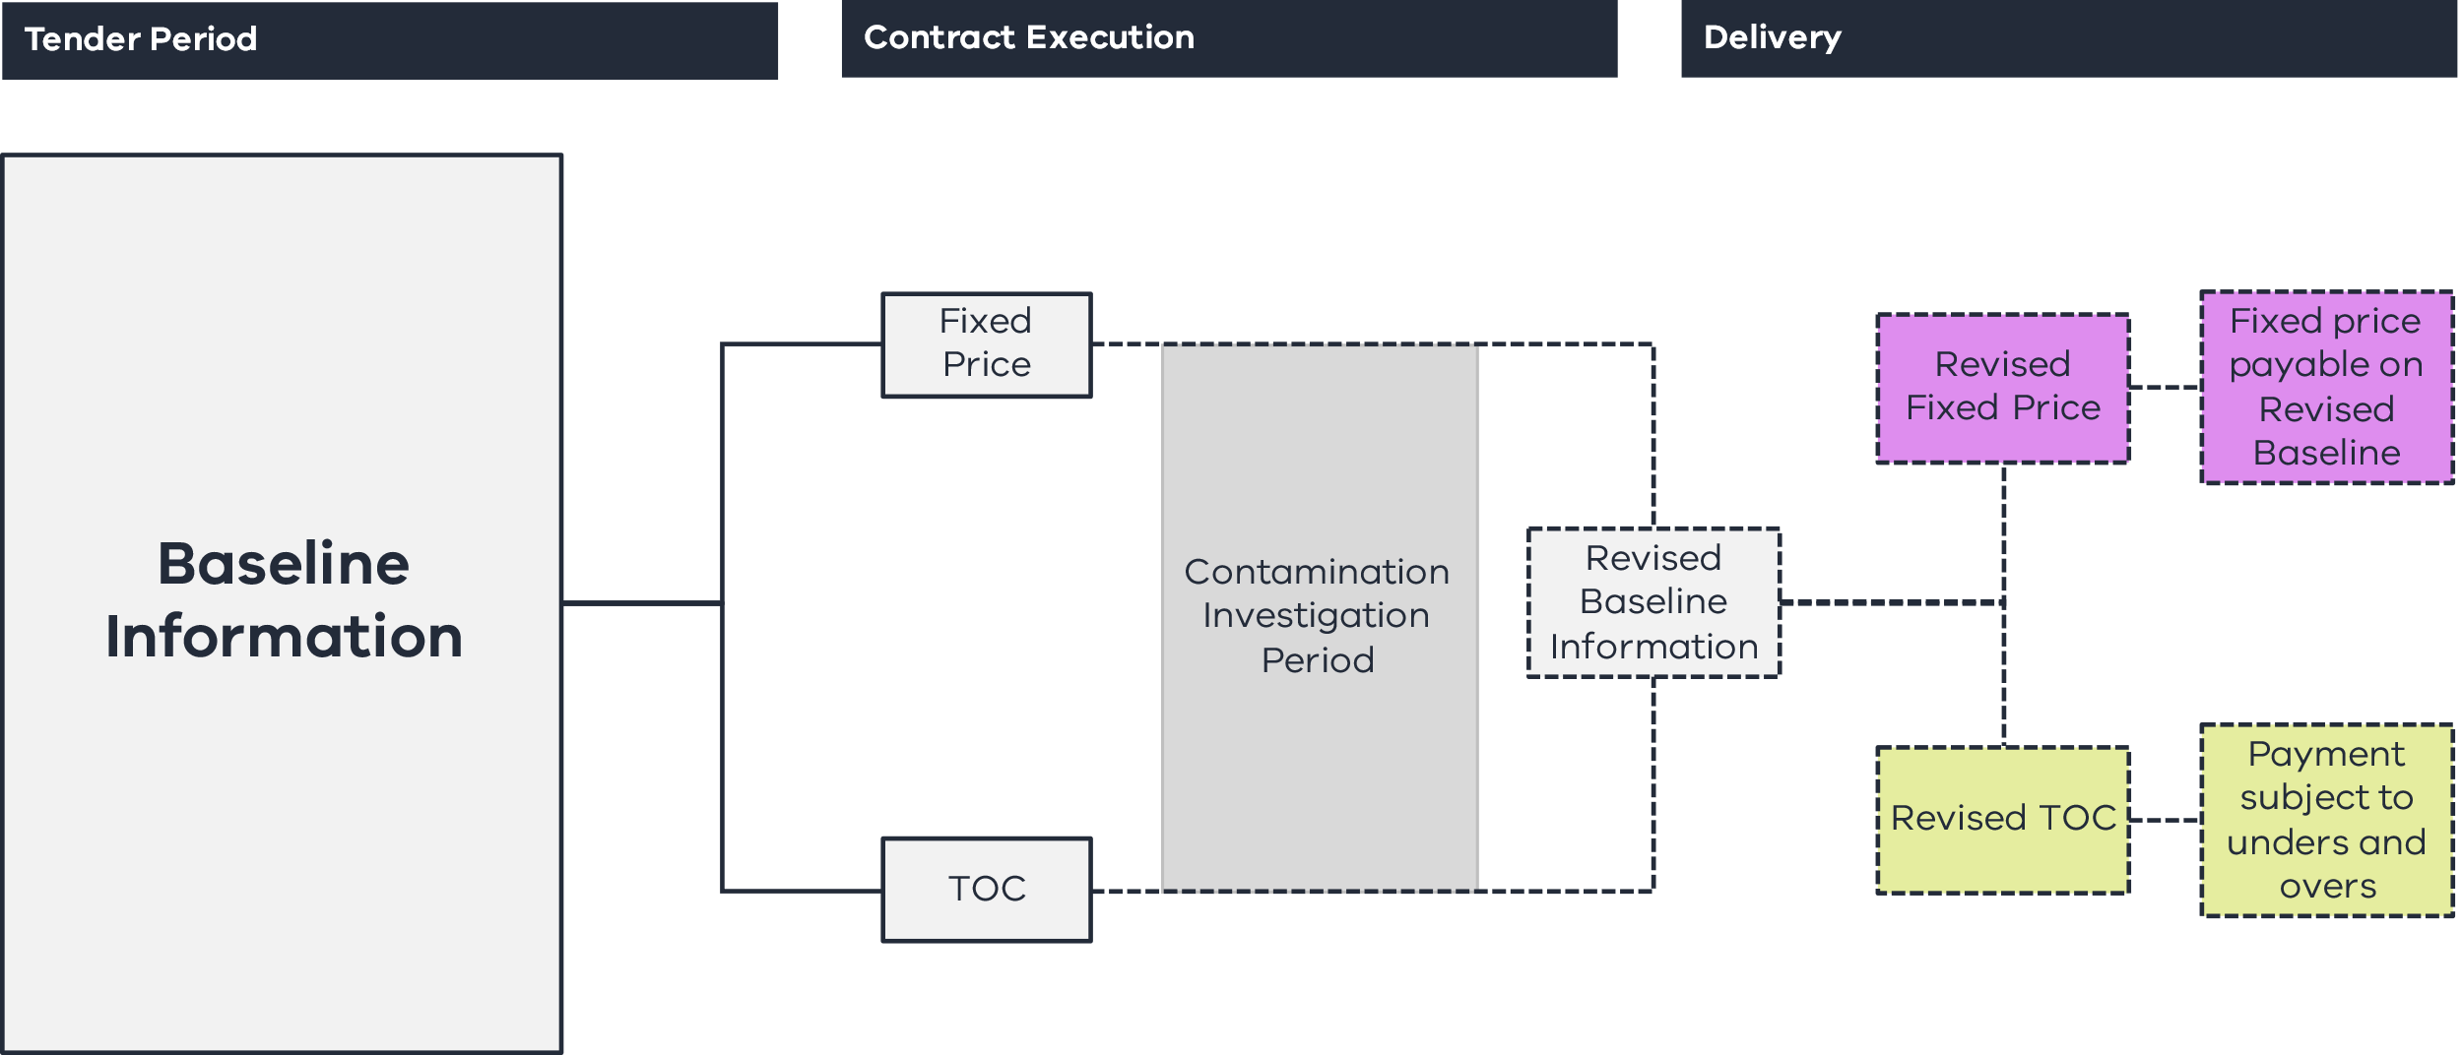
Prior to contract award, Respondents are required to bid back volume caps and rates for Contamination based on different classifications of soil and methods to treat groundwater. Following contract award, the Contractor may undertake investigations and reprice through a re-baselining mechanism. This allows the Contractor to update volume cap values after investigations, resulting in a price adjustment post contract award.
The procuring agency should assess whether the fixed-price offer or TOC best represents VfM.
A fixed-priced approach allows the Principal to secure price certainty at a nominated point in the project timeline. Based on the pre-agreed bid back volume caps and rates, the price is locked in. This ensures there is a level of price tension maintained in the bid back rates, and Respondents are incentivised to consider innovation in their proposals to treat contaminated soil and groundwater. However, it also includes risk pricing to reflect that the risk will be allocated to the Contractor at a pre-agreed point in time.
A TOC approach provides a regime for the Contractor to be paid based on actual costs for the quantities remediated, subject to a Gainshare or Painshare Adjustment mechanism that depends on whether actual remediated quantities are more or less than the TOC.
The procuring agency should engage an independent cost estimator and undertake its own site investigation and due diligence to develop a benchmark cost estimate commensurate with the Site’s level of assessed Contamination risk. It should use this benchmark cost estimate as the basis for challenging price, time and volume assumptions with Shortlisted Respondents regarding the TOC or fixed-price offer.
Where a re-baselining event results in a price adjustment, the procuring agency should undertake further site investigation activities to refine its understanding of the soil and groundwater Contamination. The refined benchmark cost estimate should be used to confirm the appropriateness of the Contractor’s revised offer. The procuring agency should ensure that the Contractor’s re-baselined offer covers all the key work activities and that volume assumptions have been independently verified against the procuring agency’s own site investigation analysis.

Administering the risk-sharing regime
Under each of the groundwater and soil regimes, the Contractor is required to submit management plans to the Principal outlining its management strategies and methods used to determine volumes requiring treatment. The Principal reviews and approves these plans according to the Review Procedures under the Enhanced D&C Deed. The process is outlined in Figure 5.
Figure 5 – Key steps in the Contamination risk-sharing regime
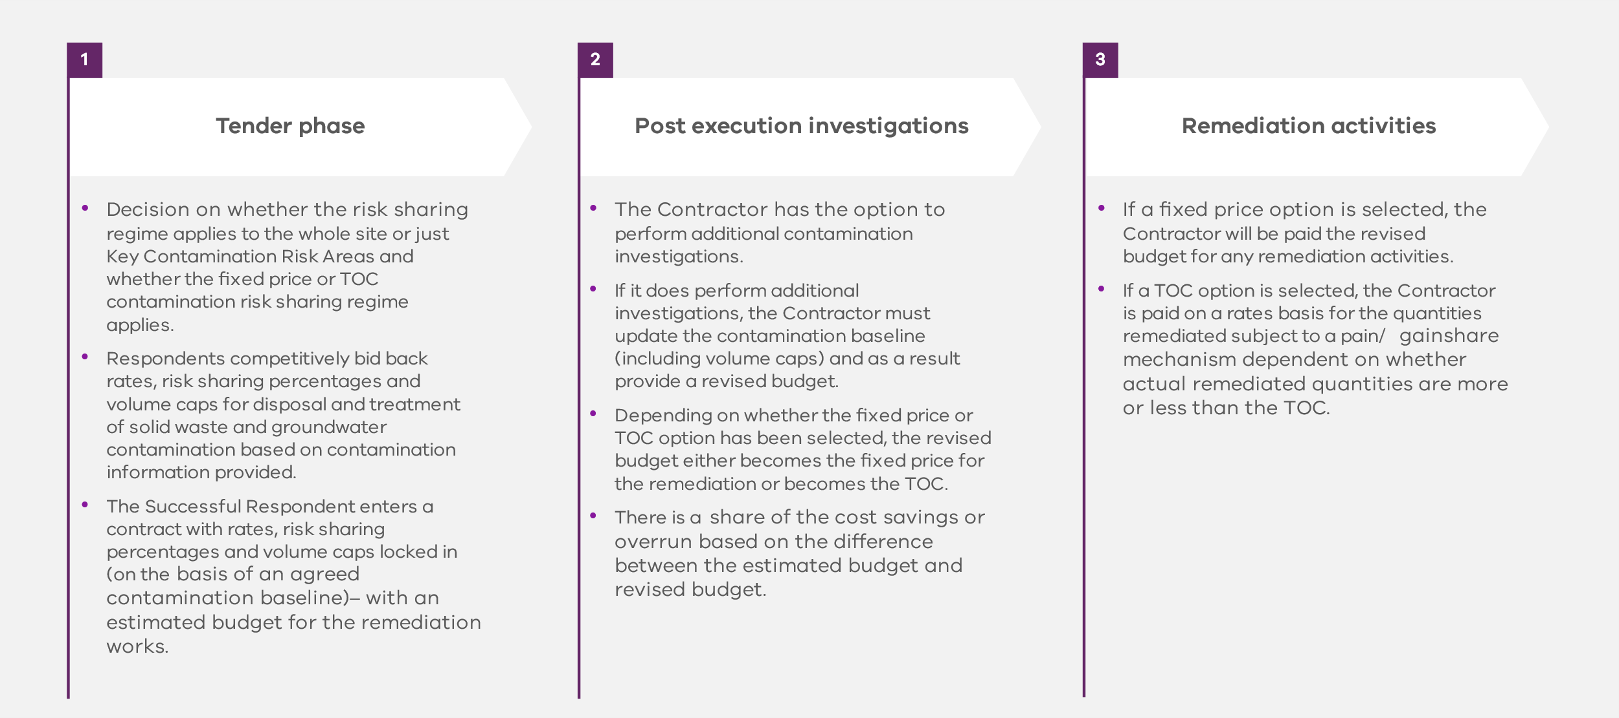
The Principal must ensure that the Contractor provides sufficient evidence verifying the actual volumes of groundwater or soil treated over the duration of the Project. This could involve:
    - ensuring the Contractor provides subcontractor dockets, invoices and any other relevant documentation associated with the removal of contaminated soil and groundwater as part of the monthly Payment Claim process;
    - engaging an external cost auditor during project delivery to undertake an independent audit to validate that the reimbursable costs claimed by the Contractor under the risk-sharing regime have been actually and reasonably incurred and reimbursement is warranted;
    - reporting periodically on performance and progress to ensure that the Contractor is complying with the methodologies and management strategies that have been committed to and that a remediation strategy is in place should issues occur; and
    - implementing a robust internal governance structure that ensures the necessary internal delivery agency approvals have been obtained before payments are made to Contractors for the removal of contaminated soil and groundwater.
See Annexure 3 for an example of administering the re-baselining mechanism under a fixed-price and TOC regime.
        - Additional relief (clauses 12.7 and 12.9)

Contractor’s entitlement to compensation for Remediation
The Contractor’s Contamination Remediation obligations are determined on a location basis, and the Contractor must comply with all obligations regarding any notifiable Contamination under the Environment Protection Act 2017 (Vic). Annexure 4 summarises the Contractor’s Contamination Remediation obligations under the Enhanced D&C Deed.
In certain circumstances, the Contractor’s obligation to Remediate Contamination will be a Contamination Adjustment Event, and the Contractor will be entitled to relief as if the Contamination Adjustment Event were a Principal Initiated Variation.

Unknown Contamination
Whether a fixed-price or TOC risk-sharing regime applies, the Enhanced D&C Deed includes an Unknown Contamination regime, under which the Contractor is entitled to claim for any discovered Unknown Contamination as a Principal Initiated Variation.

Definition
Unknown Contamination is Contamination in existence on, in, over, under or about the Site at the Contract Date that:
    - was not known, or substantially known, to the Contractor at the Contract Date; and
    - differs materially in nature, extent, volume, type, location or scope from what could have been reasonably anticipated or foreseen at the Contract Date by a prudent and competent contractor in the position of the Contractor, who has done everything the Contractor warranted under clause 10.4 of the Enhanced D&C Deed.
Unknown Contamination is also Contamination in existence outside the Site that migrates onto the Site after the Contract Date that could not have been reasonably anticipated or foreseen by a prudent and competent contactor in the position of the Contractor, who has done everything the Contractor warranted under clause 10.4 of the Enhanced D&C Deed.

Notice requirements
If the Contractor becomes aware of any Unknown Contamination, it must notify the Principal and the Principal Representative as soon as practicable and in any event within one Business Day of becoming aware of the Unknown Contamination. The Contractor must provide the Principal and the Principal Representative with a written notice within 10 Business Days after becoming aware of the Unknown Contamination containing all relevant details, including:
    - the location of the Unknown Contamination;
    - the nature and extent of the Unknown Contamination;
    - in what respects the Unknown Contamination will materially impact the Contractor’s Activities;
    - the additional work and resources that the Contractor estimates to be necessary to deal with the Unknown Contamination;
    - the time the Contractor anticipates will be required to deal with the Unknown Contamination and the expected delay in achieving a Date for Completion;
    - the Contractor’s estimate of the cost of the measures necessary to deal with the Unknown Contamination; and
    - other details reasonably required by the Principal.

Variation
If the Principal Representative determines (acting reasonably) that there is Unknown Contamination, it will be deemed to be a Variation. The Contractor may submit a Variation Proposal and will be entitled to relief as a Principal Initiated Variation.

Mitigation
The Contractor must take all reasonable steps to mitigate any extra costs it incurs as a result of Unknown Contamination.
        - Notifiable Contamination and Remediation (clause 12.1)
In respect of any ‘notifiable incident’ or ‘notifiable Contamination’, as defined in sections 30 and 37 (respectively) of the Environment Protection Act 2017 (Vic), the Contractor is obliged to notify the Environment Protection Authority (EPA) and the Principal accordingly. The Contractor has management or control of the Site for the purposes of the Environment Protection Act 2017 (Vic) and must comply with all obligations imposed under the Environmental Requirements.
        - Indemnity (clause 38.4)
The Principal requires the Contractor to indemnify the Principal for Liability the Principal suffers in connection with Contamination that the Contractor or any Contractor Associate caused to occur or to spread (whether or not the Contractor is obliged to Remediate the Contamination) so that the Contractor will put in place reasonable measures to contain such Contamination.
      - Utilities (clause 13)
        - General principles (clauses 13.2 and 13.3)
In the Enhanced D&C Deed, Unknown Utility Services and Unavoidable Utilities betterment are treated as Principal Initiated Variations and entitle the Contractor to time and cost.
If the risk-sharing option is selected:
    - Critical Non-Contestable Utilities Delays entitle the Contractor to an extension of time and delay costs (where Critical Non-Contestable Utilities Works are not complete by a specified date); and
    - there is also the option to treat any Critical Non-Contestable Utilities Work as a provisional sum and reimburse the Contractor for the costs of such work.
There will be an opportunity for Contractors to bid back against Utilities risks, in relation to which utilities providers should be regarded as ‘Critical’ and ‘Non-Contestable’.
        - Unknown Utility Infrastructure (clause 13.3)
If the Contractor becomes aware of any Unknown Utility Service, it must notify the Principal and the Principal Representative as soon as practicable and in any event within one Business Day of becoming aware of the Unknown Utility Service. The Contractor must provide the Principal and the Principal Representative with a written notice within 10 Business Days after becoming aware of the Unknown Utility Service containing all relevant details, including:
    - the location of the Unknown Utility Service;
    - the nature and extent of the Unknown Utility Service;
    - in what respects Unknown Utility Service will materially impact the Contractor’s Activities;
    - the additional work and resources that the Contractor estimates to be necessary to deal with the Unknown Utility Service;
    - the time the Contractor anticipates will be required to deal with the Unknown Utility Service and the expected delay in achieving a Date for Completion;
    - the Contractor’s estimate of the cost of the measures necessary to deal with the Unknown Utility Service; and
    - other details reasonably required by the Principal.
If the Principal Representative determines (acting reasonably) that there is an Unknown Utility Service, it will be deemed to be a Variation. The Contractor may submit a Variation Proposal and will be entitled to relief as a Principal Initiated Variation.
The Contractor must take all reasonable steps to mitigate any extra costs it incurs as a result of any Unknown Utility Service.
        - Critical Non-Contestable Utilities Work (clause 13.2)
The Critical Non-Contestable Utilities Work regime in clause 13.2 only applies to projects where a risk-sharing regime has been selected. Therefore, it is to be considered and applied on a project-specific basis.

Critical Non-Contestable Utilities Delay
A Critical Non-Contestable Utilities Delay is a failure by the owner, operator or controller of the relevant Utility Service to complete any Critical Non-Contestable Utilities Work by whichever is the later:
    - the Date for Completion of that work set out in the Bid Program;
    - within the timeframes that could have been reasonably anticipated or foreseen at the Contract Date;
    - the time required to avoid any delay to Practical Completion or Close-out (as applicable).
This does not apply to the extent the Contractor fails to take all reasonable steps to avoid or minimise this failure, which include:
    - completing the relevant design and contacting the owner, operator or controller of the relevant Utility to schedule the work sufficiently in advance;
    - providing required information (including any approvals) to the owner, operator or controller of the relevant Utility sufficiently in advance;
    - complying with the provisions of any agreement entered into with the owner, operator or controller of the relevant Utility;
    - proactively monitoring, managing, liaising and coordinating with the owner, operator or controller of the relevant Utility (or its Contractor); and
    - to the extent reasonably practicable, scheduling and (where relevant) rescheduling the Contractor’s Activities to minimise the risk that the failure will delay Practical Completion or Close-out.
If the Contractor is delayed in carrying out the Contractor’s Activities due to a Critical Non-Contestable Utilities Delay, this will be an Adjustment Event (Time) and an Adjustment Event (Cost), which will entitle the Contractor to claim an adjustment to the Contract Sum and the relevant Date for Completion.

Critical Non-Contestable Utilities Work
Clauses 13.2(a)–(e) of the Enhanced D&C Deed apply only if the procuring agency elects to treat Critical Non-Contestable Utilities Work as a provisional sum.
During the procurement process, Contractors are required to bid back utilities work that should be Critical and Non-contestable. With respect to Critical Non-Contestable Utilities Work, Contractors need to demonstrate that the proposed utilities work is a critical path activity, or that there is a material risk it will become a critical path activity, and cannot be effectively managed otherwise.
The Contractor must promptly give the Principal a copy of any estimate or quote it receives from the owner, operator or controller of a Utility for Critical Non-Contestable Utilities Work. The actual costs the Contractor incurs that are payable to the owner, operator or controller of a Utility for Critical Non-Contestable Utilities Work are payable by the Principal to the Contractor. The Contractor must take all reasonable steps to mitigate these costs. The Contractor must provide evidence of any costs payable to an owner, operator or controller of a Utility to the reasonable satisfaction of the Principal Representative with any Payment Claim that includes them.
The Contract Sum and the Payment Schedule are adjusted to reflect the difference between:
    - the applicable amount allowed for an item of Critical Non-Contestable Utilities Work in the Payment Schedule; and
    - the actual costs the Contractor incurs that are payable to the Utility owner, operator or controller and payable by the Principal to the Contractor.
The Contractor is not entitled to any margin on the payable costs, and no margin will be taken into account when adjusting the Contract Sum and Payment Schedule.
Schedule 3 does not form part of this standard form contract suite and will need to be developed by the Principal based on project-specific characteristics.
      - Change in Law and Change in Policy (clauses 1, 5 and 33)
        - Obligations regarding Change in Law and Change in Policy (clauses 5.1 and 33.1)
After becoming aware of any actual or likely Change in Law or Change in Policy that may impact the Project, the Contractor’s Activities or the Project Documents, the Contractor must submit a notice to the Principal.
The Contractor must comply with any Change in Law.
The Contractor must comply with a Change in Policy unless the Principal directs otherwise.
        - Change in Mandatory Requirements (clauses 1 and 33.2)
The Principal retains the risk of Changes in Law and Changes in Policy that are Changes in Mandatory Requirement. Not every Change in Law or Change in Policy is a Change in Mandatory Requirements. A Change in Mandatory Requirements occurs where:
    - subject to certain exceptions, a Change in Law occurs that:
      - requires a change to the Works or the Working Parameters; and
      - has a material cost or time impact (with specific cost and time thresholds included on a project-specific basis);
    - subject to certain exceptions, a Change in Policy that is not a Change in EPA Standard occurs that:
      - requires a Contractor to comply as a matter of Law; or
      - is the subject of a direction from the Principal to a Contractor to comply under clause 33.1(b); or
    - subject to certain exceptions, a Change in Policy that is a Change in EPA Standard occurs that:
      - requires a Contractor to comply under an EPA Statutory Instrument; or
      - is the subject of a direction from the Principal to a Contractor to comply under clause 33.1(b); and
      - has a material adverse effect on how the Contractor undertakes its Activities.
If a Change in Mandatory Requirements occurs, the relevant Change in Law or Change in Policy will be deemed to be a Variation, and relief and compensation are provided according to the Variation regime under the Enhanced D&C Deed.
Certain Changes in Law and Changes in Policy will not be deemed to be a Variation as they are specifically excluded from the definition of Change in Mandatory Requirements. These excluded Changes in Law and Changes in Policy are considered business-as-usual risks that should be accepted by the Contractor.
      - Force Majeure (clauses 1, 26, 34 and 38)
        - General principles
The purpose of the Force Majeure provisions is to give the Contractor and Principal relief from Default and Liability regarding a limited category of events that are catastrophic, generally outside the control of either party and prevent the Contractor or Principal from performing all or a material part of its obligations under the Enhanced D&C Deed.
Neither party is likely to be in a better position to manage either the occurrence or the effects of a Force Majeure Event, and the events may continue for a long period, so these events are treated differently from other Relief Events. The entitlement to relief and compensation in the Enhanced D&C Deed generally reflects the common law principle regarding Force Majeure Events: that the loss lies where it falls.
        - Force Majeure Event (clauses 1 and 34.1)
There are two limbs to the definition of Force Majeure Event in the Enhanced D&C Deed.
Under the first limb, a Force Majeure Event occurs if an event listed in the definition occurs (including natural disasters, sustained surface winds in excess of a specified threshold; fires, explosions or floods caused by natural disasters; and Uninsurable Risks) and that event:
    - occurs at or in the direct vicinity of the Site;
    - was not caused by the Contractor, the Principal or any of their associated parties; and
    - prevents the Contractor from carrying out all or a material part of the Contractor’s Activities, or prevents the Principal from carrying out its obligations.
Under the second limb, a Force Majeure Event occurs to the extent that circumstances leading to a direction from the Principal to suspend the Contractor’s Activities were a Force Majeure Event (see clause 34.1(b)(ii)).
        - Potential relief (clauses 1 and 26)
A Force Majeure Event is an Adjustment Event (Time) (see section 5.1.1, Table 1, item 15). Consequently, provided the Conditions Precedent to the Contractor’s entitlement to an extension of time are satisfied (see section 5.1.2), a Force Majeure Event entitles the Contractor to claim an extension of time to the relevant Date for Completion for the period of delay caused by the Force Majeure Event.
As a Force Majeure Event is not an Adjustment Event (Cost) (see 4.1.1 Table 1, item 15), a Force Majeure Event will not entitle the Contractor to claim compensation.
        - Limitation on Principal Liability to the Contractor for Force Majeure Events (clause 38)
As a Force Majeure Event is a Relief Event, the Principal’s Liability to the Contractor in connection with a Force Majeure Event is reduced to the extent that:
    - the Force Majeure Event or the consequences of the Force Majeure Event are caused or contributed to by a Contractor Act or Omission; or
    - the Contractor, or any Contractor Associate, fails to take all reasonable steps that a prudent, competent and experienced contractor in the circumstances of the Contractor or the relevant Contractor Associate exercising Best D&C Practices would have taken to mitigate, minimise or avoid the effects, consequences or duration of the Force Majeure Event.
        - Project-specific amendments
The definition of Force Majeure Events requires consideration on a project-specific basis. The following principles should be applied:
    - All Force Majeure Events should align with the general principles in section 4.7.1;
    - Tropical cyclones have been considered by the Principal and excluded from the definition on the basis that, by definition, these events do not occur in Victoria. However, the reference to high winds in paragraph (a)(ii) of the definition is included if the procuring agency considers it appropriate to give relief for ‘cyclonic’ winds; and
    - The definition of Force Majeure is limited to events that occur at or in the direct vicinity of the Site. Taking into account project-specific considerations, in very limited circumstances the Principal may agree to extend the Force Majeure regime to other locations (including outside Victoria or Australia). For example, this may be appropriate where a large and critical item required for the Works with a long lead time is being manufactured in a different location.
      - Pandemics (clauses 1, 6A and 26)
        - Introduction (clauses 1, 6A.1, 6A.3 and 26)

Pandemic definition
‘Pandemic’ is defined in the Enhanced D&C Deed as COVID-19 or any other pandemic declared by the World Health Organization.

Pandemic Management Plan

Initial Pandemic Management Plan
The Initial Pandemic Management Plan will be set out with the other Bid Plans in Attachment 4 to the Enhanced D&C Deed.
The Initial Pandemic Management Plan will include all mitigation measures that the Contractor is implementing with respect to COVID-19, and those in response to any and all:
    - Legislation in response to COVID-19; and
    - Pandemic Directions in response to COVID-19
that are in place at the Contract Date.

Updates to the Pandemic Management Plan
Any updated Pandemic Management Plan will include all mitigation measures the Contractor is implementing with respect to any Pandemic, and those in response to any and all:
    - Pandemic Changes in Law; and
    - Pandemic Adjustment Events
that are in place or have occurred at the date of the relevant update.

Allowance in the Program for COVID-19
The Contractor warrants that the Program contains sufficient allowances for the assumption by the Contractor of all risk in relation to the impact of COVID-19 on the performance of the Contractor’s Activities as at the Contract Date. This includes the assumption of that risk in respect of the period between the Contract Date and the Pandemic Impact Date (being a specified number of weeks following the Contract Date).

Relief
The Contractor accepts the risk of Pandemic Adjustment Events and Pandemic Changes in Law that occur on or before the Pandemic Impact Date (provided that the Contractor may be entitled to relief where those events occur prior to the Pandemic Impact Date but continue after that date).
For Pandemic Adjustment Events and Pandemic Changes in Law that occur after the Pandemic Impact Date, the Enhanced D&C Deed provides a regime for relief (through Adjustment Events (Time) and Adjustment Events (Cost)), subject to the Contractor demonstrating that certain requirements have been satisfied.
        - Pandemic Change in Law (clause 6A.4)
A Pandemic Change in Law is defined as:
    - a change in (including any extension, repeal, revocation or expiry of) an existing Legislation in response to a Pandemic;
    - new Legislation in response to a Pandemic; or
    - a new Pandemic Direction or a change to (including any extension, repeal, revocation or expiry of) an existing Pandemic Direction.
A Pandemic Change in Law is an Adjustment Event (Time) and Adjustment Event (Cost) to the extent the change requires any changes to the measures contemplated by the then current Pandemic Management Plan.
        - Pandemic Compensation Event (clause 1)
Subject to certain exceptions, a Pandemic Adjustment Event occurs if any of the following occurs:
    - a Pandemic Subcontractor’s Plant Closure (being a full day closure of a Subcontractor’s plant or factory in certain Pandemic related circumstances);
    - a full day delay in the supply of any Key Plant and Equipment from a Key Plant and Equipment Manufacturing Country as a result of:
      - Australian quarantine restrictions; or
      - a closure of the Australian international border or any other international border, where such quarantine restrictions or border closures are introduced after the Contract Date as a result of a Pandemic and have a material adverse impact on the Contractor’s Activities; or
    - a Pandemic Area Closure (being a full day closure of the Site in certain Pandemic related circumstances).
A Pandemic Adjustment Event is an Adjustment Event (Time) and an Adjustment Event (Cost).
      - Time (clauses 1, 26, 32 and 38)
        - General principle (clauses 26.5, 26.10 and 38.14)
Subject to the relevant Conditions Precedent being satisfied, the Contractor is entitled to:
    - time relief (via an extension to the relevant Date for Completion) following the occurrence of an Adjustment Event (Time); and
    - cost relief (via compensation payable by the Principal) following the occurrence of an Adjustment Event (Cost),
with certain events being both an Adjustment Event (Time) and an Adjustment Event (Cost).
As Adjustment Events (Time) and Adjustment Events (Cost) are Relief Events, the Principal’s Liability to the Contractor in connection with those Adjustment Events will be reduced to the extent that:
    - the relevant Adjustment Event or the consequences of the relevant Adjustment Event are caused or contributed to by a Contractor Act or Omission; or
    - the Contractor, or any Contractor Associate, fails to take all reasonable steps that a prudent, competent and experienced Contractor in the circumstances of the Contractor or the relevant Contractor Associate exercising Best D&C Practices would have taken to mitigate, minimise or avoid the effects, consequences or duration of the relevant Adjustment Event.
        - Primary obligation (clause 26.1)
The Contractor has an obligation to commence and regularly, expeditiously and diligently progress the Contractor’s Activities and achieve Completion by the relevant Date for Completion. The Contractor must not suspend the progress of the whole or any part of the Contractor’s Activities except where pursuant to the Building and Construction Industry Security of Payment Act 2002 (Vic) or as directed or approved by the Principal.
        - Extension of time (clauses 1, 26.7 and 26.8)
Relief Events that are both Adjustment Events (Cost) and Adjustment Events (Time) are:
    - a limited category of events that are generally within the control of the Principal; or
    - risks that are considered to be better managed or mitigated by the Principal.
Accordingly, they are events in respect of which the Principal retains time and cost risks.
Adjustment Events (Time) that are not Adjustment Events (Cost) are neutral events such as Force Majeure Events in respect of which the risk allocation is shared with the Principal, whereby the Date for Practical Completion is extended, but the Contractor has no, or more limited, entitlement to compensation.

Conditions Precedent
The following are Conditions Precedent to the Contractor’s entitlement to an extension of time for an Adjustment Event (Time):
    - the Contractor submits a notice of claim to the Principal and the Principal Representative within the timeframe specified in clause 26.6;
    - the Contractor can demonstrate that:
      - it has been or will be delayed from carrying out the Contractor’s Activities by the relevant Adjustment Event (Time) in a manner that has delayed or will delay the achievement of Completion; and
      - the relevant Adjustment Event (Time) has caused or will cause activities on the critical path contained in the then current Program to be delayed; and
    - the Contractor, at the time it submits the relevant notice of claim, submits an updated Program that:
      - complies with the relevant requirements of the Enhanced D&C Deed;
      - takes into account the impact of the relevant Adjustment Event (Time); and
      - contains a level of detail that is sufficient to enable the Principal Representative to determine the Contractor’s entitlement to an extension of time.
If the Principal Representative determines that the updated Program does not comply with the requirements set out above, the Contractor must, within 10 Business Days after receipt of the Principal Representative’s notice, submit an updated Program.
If the Contractor:
    - does not submit an updated Program, the Contractor will not be entitled to claim an extension of time for the relevant Adjustment Event (Time); or
    - submits an updated Program and the Principal Representative determines that the updated Program:
      - addresses the non-compliances previously notified by the Principal Representative, the Contractor will be deemed to have met the requirements of the condition precedent in respect of the submission of the updated Program; or
      - does not address the non-compliances previously notified by the Principal Representative, the Contractor will not be entitled to claim an extension of time for the relevant Adjustment Event (Time).
The Enhanced D&C Deed provides one opportunity for the Contractor to resubmit an updated Program in circumstances where the Principal Representative determines that the Program does not comply with the extension of time Conditions Precedent. This is so that the Contractor is not significantly prejudiced by a minor non-conformance in a complex Program that is potentially unrelated to an extension of time claim.
If the Conditions Precedent (as set out above) have been satisfied, then unless the parties otherwise agree on an extension to the relevant Date for Completion, the Principal Representative must extend the relevant Date for Completion.
The Principal Representative may give interim determinations of the Contractor’s entitlement to an extension of time notwithstanding that the effects of the relevant Adjustment Event (Time) are continuing.
        - Unilateral extensions (clause 26.9)
Irrespective of the Contractor’s entitlement to an extension of time, the Principal may unilaterally extend a Date for Completion.
        - Entitlement to financial compensation for delay (clauses 1, 26.10, 32.7 and 38.14)
If the Contractor is granted an extension of time to a Date for Completion for an Adjustment Event (Time), and that Adjustment Event (Time) is also an Adjustment Event (Cost), then the Contractor will be entitled to claim compensation in accordance with the Adjustment Event Guidelines as calculated and determined by the Principal Representative.
Adjustment Events (Cost) include acts or omissions of the Principal or any Principal Associate other than those that are Permitted Acts or an Act where the Authority is acting in accordance with its statutory powers. Accordingly, procuring agencies should include any act that they are likely to undertake to be a Permitted Act in the Enhanced D&C Deed to ensure they are not exposed to costly delay Claims when they carry out those acts. These should be carefully drafted so they can be taken into account by the Contractor and should not include things that are unlikely to occur.
The Contractor is not entitled to claim compensation from the Principal for an Adjustment Event (Time) that is also an Adjustment Event (Cost) where the loss for which compensation is claimed is required to be covered by the Insurances as part of an Insured Risk. This applies unless the Contractor can demonstrate that the compensation is not covered by the proceeds of such Insurance due to a Principal Insurance Breach (clause 38.14(b)).
If the Principal exercises its power under clause 26.9(a) of the Enhanced D&C Deed to unilaterally extend the Date for Completion in respect of an Adjustment Event (Cost) or a Principal Initiated Variation for which, but for the exercise by the Principal of its power the Contractor would otherwise be entitled to an extension of time to a Date for Completion, the Contractor will be entitled to claim compensation for that Adjustment Event (Cost) or Principal Initiated Variation in accordance with the general principles above in section 5.9.1 or clause 32.7(g) (cost for extension of time for Variation) of the Enhanced D&C Deed.
        - Liquidated damages (clause 26.19)
The Enhanced D&C Deed provides that the Principal will be entitled to be paid an agreed, liquidated sum (up to an agreed cap) by the Contractor for failure to achieve Practical Completion by the Date for Practical Completion or failure to achieve Close-out by the Date for Close-out. This is necessary to incentivise timely Completion. The rate for liquidated damages and the liquidated damages cap are found in the Contract Particulars in Schedule 1 to the Enhanced D&C Deed.
The Contractor’s total aggregate liability to the Principal for liquidated damages is limited to an amount equal to 10 per cent of the Contract Sum.
Once the liquidated damages cap is exhausted, other contractual measures, such as Default Termination, are available to the Principal.
        - Concurrent Delays (clause 26.11)
The Concurrent Delay principle limits the Contractor’s entitlement to time and cost relief for an Adjustment Event (Time) or a Principal Initiated Variation where, at the same time as the delay caused by the Adjustment Event (Time) or the Principal Initiated Variation, the Contractor is also being delayed by an event that is not an Adjustment Event (Time) or a Principal Initiated Variation. This limitation applies whether or not the Adjustment Event (Time) or Principal Initiated Variation occurs first in time.
The exception to this principle is where there is a Principal Concurrent Event that occurs before the other concurrent event that is not an Adjustment Event (Time) or Principal Initiated Variation. Principal Concurrent Events consist of:
    - an Adjustment Event (Cost) that is a Principal breach of a Project Document or an act or omission of the Principal or an Associate of the Principal when acting in connection with the Project that is not a Permitted Act or an act contemplated by clause 7.1 where the Authority is acting in accordance with its statutory powers; and
    - a Principal Initiated Variation.
In those circumstances, the Contractor will not be entitled to claim compensation.
This approach to risk-sharing for Concurrent Delay reflects a fair and common-sense approach to causation.
Figure 6 illustrates where the Contractor’s entitlement to claim an extension of time is limited by the Concurrent Delay principle set out in clause 26.11 of the Enhanced D&C Deed.
Figure 6 – Concurrent Delays
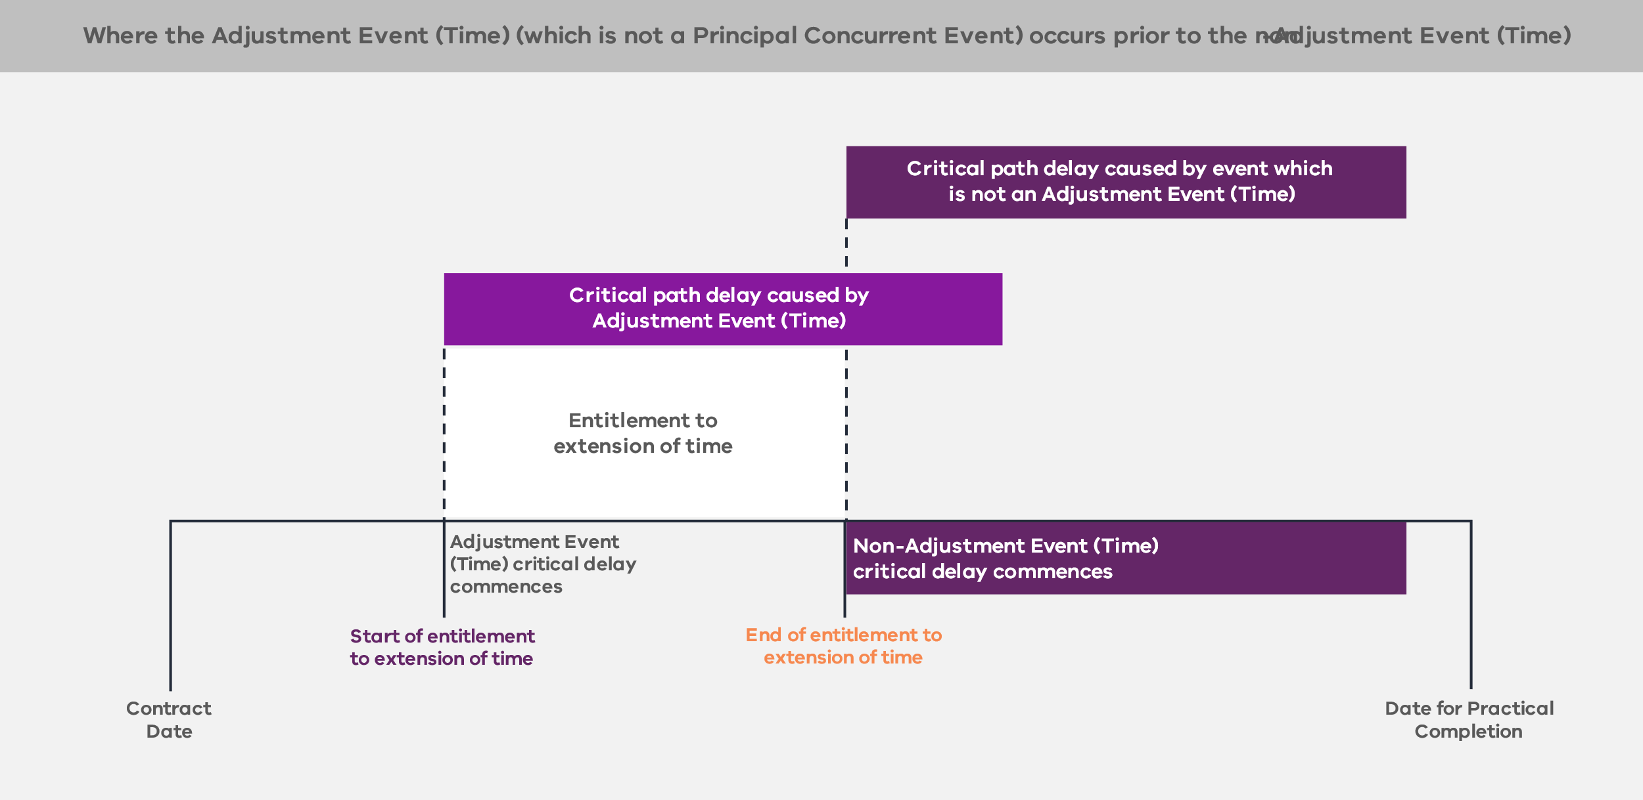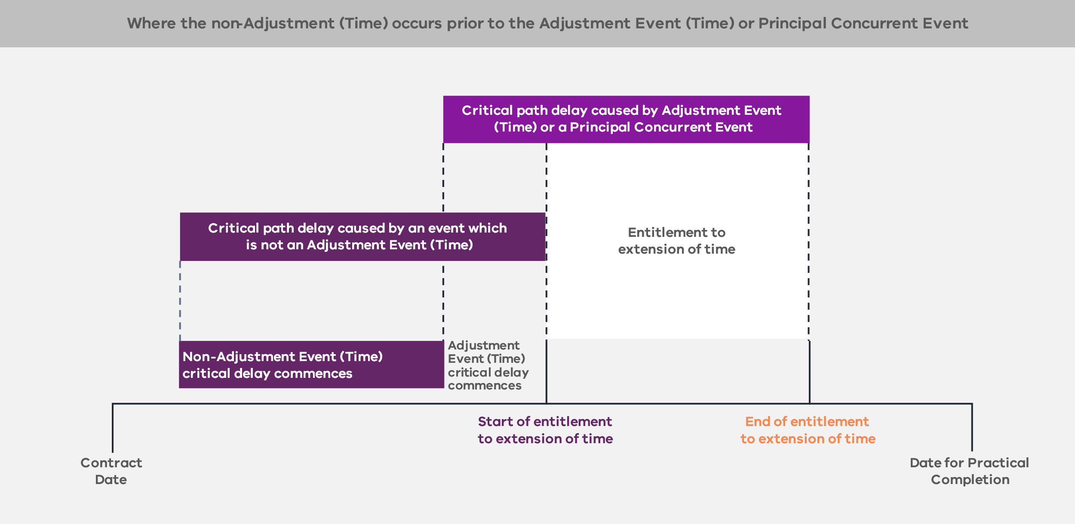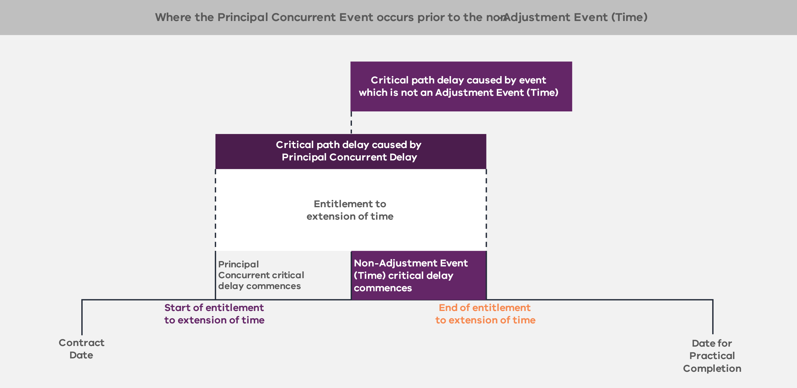
        - Acceleration (clauses 26.12, 26.13, 26.14 and 26.16)
The Contractor may choose to compress the Contractor’s Activities or otherwise accelerate progress at its own cost and risk.
The Principal may direct the Contractor to complete the Contractor’s Activities in advance of the Date for Completion of those activities shown on the Program, including to:
    - achieve Completion prior to the relevant Date for Completion; or
    - overcome or minimise the extent and effects of some or all of a delay caused by an Adjustment Event (Time) for which the Contractor is or would have been entitled to an extension of time to a Date for Completion for that Adjustment Event (Time).
The Contractor must submit a written Claim (by way of a Variation Notice) to the Principal and the Principal Representative within the time required under the Enhanced D&C Deed that sets out the estimated time and cost consequences of accelerating any part or the whole of the Contractor’s Activities that are the subject of the Principal’s notice. This Claim must identify whether and to what extent that acceleration is reasonably achievable in the circumstances.
If the Principal Representative accepts an acceleration proposal, then the Contractor’s entitlements (including as to extensions of time and adjustments to the Contract Sum) in connection with the acceleration will be governed by the proposal that was accepted by the Principal Representative.
The Contractor will be entitled to claim compensation as set out in the Adjustment Event Guidelines (that is, calculated and determined in accordance with the Adjustment Event Guidelines), except to the extent that:
    - the need for acceleration arises out of or in connection with any breach of the Project Documents by the Contractor (for example a failure to reach Completion by the Date for Completion); or
    - the direction for acceleration is in effect a direction to the Contractor to take corrective action to rectify any non-compliance with the requirements of the Project Documents.
      - Variations (clauses 1 and 32)
        - Introduction (clauses 1, 32.2 and 32.6)

Variations
Subject to certain exceptions, a Variation is:
    - any change (including any addition, decrease, omission, deletion, demolition or removal) to the Works or the Delivery Requirements;
    - a change to the way in which the Contractor’s Activities are carried out that differs from that set out in the relevant Plan;
    - a Principal Approval Event that is the subject of a Variation Proposal issued in accordance with clause 6.1(d);
    - if applicable, any Unknown Inaccurate Principal Geotechnical Data which is the subject of a Variation Proposal issued in accordance with clause 10.2(b) (see section 4.3.2);
    - a Contamination Adjustment Event which is the subject of a Variation Proposal issued in accordance with clause 12.7(a) (see section 4.4.2);
    - any Unknown Utility Service which is the subject of a Variation Proposal issued in accordance with clause 13.3 (see section 4.5.2);
    - any Unknown Contamination that is the subject of a Variation Proposal issued in accordance with clause 12.9 (see section 4.4.2); or
    - a Change in Mandatory Requirements which is the subject of a Variation Proposal issued in accordance with clause 32.2(a) (see section 4.6.2).
Variations do not include:
    - a Change in Law or a Change in Policy, unless it is a Change in Mandatory Requirements that is the subject of a Variation Proposal;
    - where any change is required to ensure that the Works or the Contractor’s Activities is otherwise in accordance with the requirements of the Enhanced D&C Deed; and
    - Provisional Sum Work.

Contractor’s entitlement to relief
The Contractor will be entitled to compensation calculated in accordance with the Adjustment Event Guidelines. In some cases, they will be entitled to an extension of time where the Variation will delay the Contractor from carrying out the Contractor’s Activities or achieving Completion by the Date for Completion.
        - Principal Initiated Variations (clauses 32.1, 32.3, 32.6, 32.8 and 32.9)
At any time during the Term, the Principal may direct the Contractor to undertake a Variation in connection with the Project. This may be done by issuing a Variation Order or requesting the Contractor to provide a Variation Proposal. Such a Variation may include a decrease, omission, deletion or removal of any part of the Contractor’s Activities provided that the Principal may not decrease, omit, delete or remove all or substantially all of the Contractor’s Activities. If the Contractor undertakes a Principal Initiated Variation, it will be entitled to relief for its costs properly and reasonably incurred in undertaking the Variation as calculated in accordance with the Adjustment Event Guidelines.
The following additional events will be treated as a Principal Initiated Variation and clause 32 of the Enhanced D&C Deed and the Adjustment Event Guidelines will apply:
    - a Principal Approval Event;
    - a Change in Mandatory Requirements;
    - [any Unknown Inaccurate Principal Geotechnical Data];
    - [any Unknown Utility Service];
    - [a Contamination Adjustment Event];
    - [an AGC Compensation Event]; or
    - where the parties reach early agreement on certain specifications in respect of an item of Equipment and the Principal later changes those specifications.
        - Notification of Variation (clause 32.10)
At any time if the Contractor considers that an approval, consent, direction, requirement, determination, request, claim, notice, agreement, demand or the like (a direction) by the Principal constitutes or involves a Variation, the Contractor must give to the Principal:
    - a written notice within the time period required under the Enhanced D&C Deed that it considers the direction constitutes or involves a Variation; and
    - a Variation Proposal within the time period required under the Enhanced D&C Deed, as if that direction by the Principal was a Variation Request.
If the Principal receives a Variation Proposal and does not issue a notice responding to the Variation Proposal within the time period required under the Enhanced D&C Deed the direction will be deemed to be withdrawn and that Contractor must not comply with the direction. This response from the Principal must:
    - be a Variation Order in respect of the relevant direction;
    - withdraw the direction; or
    - inform the Contractor that, in the Principal’s view, the direction does not constitute or involve a Variation, in which case the Contractor must comply with the direction but may refer the matter to expert determination.
The Contractor is not entitled to make any Claim in respect of a direction that may constitute or involve a Variation unless it has given a Variation Proposal within the time period required under the Enhanced D&C Deed.
        - Mandatory Variations (clause 32.5)
In general, the Principal may elect whether or not the Contractor proceeds with implementing a Principal Initiated Variation. However, the Principal must direct that the Contractor proceed with implementing a Variation Order if:
    - a Principal Approval Event occurs;
    - a Change in Mandatory Requirements occurs;
    - destruction, loss or damage to the Contractor’s Activities, the Works, the Temporary Works, Extra Land or the Site occurs due to an Uninsurable Risk and the Principal Representative directs the Contractor to rectify such loss or damage;
    - any Unknown Inaccurate Principal Geotechnical Data occurs;
    - [any AGC Compensation Event occurs];
    - any Unknown Utility Service occurs; or
    - a Contamination Adjustment Event occurs.
        - Extensions of time and relief from performance for Variations (clause 32.7)
If the Contractor will be delayed from carrying out the Contractor’s Activities by a Variation or deemed Variation in a manner which will delay the achievement of Completion, the Contractor will be entitled to claim an extension of time to the Date for Completion for the period of delay. If the Conditions Precedent to the Contractor’s entitlement to an extension of time under clause 32.7(d) of the Enhanced D&C Deed are satisfied, the extension of time to the relevant Date for Completion will be as agreed by the Principal and the Contractor as part of the Variation process and, failing such agreement, as determined by the Principal Representative.
The following are Conditions Precedent to the Contractor’s entitlement to an extension of time for a Variation or an event that is deemed to be a Variation under the Enhanced D&C Deed:
    - The Contractor submits a Variation Proposal that includes the Claim for an extension of time;
    - The Contractor will be delayed from carrying out the Contractor’s Activities by the relevant Variation or deemed Variation in a manner that will delay the achievement of Completion;
    - The relevant Variation or deemed Variation will cause activities on the critical path contained in the then current Program to be delayed; and
    - The Contractor, at the time it submits the relevant Variation Proposal, submits an updated Program to the Principal and the Principal Representative that:
      - complies with the relevant requirements of the Enhanced D&C Deed;
      - takes into account the impact of the relevant Variation or deemed Variation; and
      - contains a level of detail that is sufficient to enable the Principal or the Principal Representative (as applicable) to determine the Contractor’s entitlement to an extension of time (where applicable).
If the Principal Representative determines that the updated Program does not comply with the requirements set out above, the Contractor must, within 10 Business Days after receipt of the Principal Representative’s notice, submit an updated Program.
If the Contractor:
    - does not submit an updated Program, the Contractor will not be entitled to claim an extension of time for the relevant Variation or event deemed to be a Variation; or
    - does submit an updated Program and the Principal Representative determines that the updated Program:
      - addresses the non-compliances previously notified by the Principal Representative, the Contractor will be deemed to have met the requirements of the Condition Precedent in respect of the submission of the updated Program; or
      - does not address the non-compliances previously notified by the Principal Representative, the Contractor will not be entitled to claim an extension of time for the relevant Variation or event deemed to be a Variation.
The Enhanced D&C Deed provides one opportunity for the Contractor to resubmit an updated Program in circumstances where the Principal Representative determines that the Program does not comply with the extension of time Conditions Precedent. This is so that the Contractor is not significantly prejudiced by a minor non-conformance in a complex Program that is potentially unrelated to an extension of time Claim.
As part of the Variation process, the Principal may agree that the Contractor is relieved from certain obligations and this will be addressed as part of the Variation Proposal and Variation Order.
        - Compensation (clauses 32.6 and 32.7)
To the extent that the parties have agreed or the Principal (or Principal Representative) has determined an extension of time to the Date for Completion for a Variation, the Contractor will be entitled to claim compensation in accordance with the Adjustment Event Guidelines for that extension of time.
Where a Variation is a Principal Initiated Variation this will be an Adjustment Event and the Contractor or the Principal (by way of Savings) will be entitled to claim compensation as set out in the Adjustment Event Guidelines.
        - Entitlement to payment for preparation of Variation Proposal (clause 32.3)
If the Principal has requested that the Contractor provide a Variation Proposal in respect of a Variation Request and the Contractor is required to engage a third-party consultant to provide professional services in respect of the preparation of the Variation Proposal, this will be an Adjustment Event (Cost) and the Contractor will be entitled to claim compensation for the preparation of the Variation Proposal as agreed by the Principal or, if not agreed, as determined in accordance with the Adjustment Event Guidelines.
If, following receipt of a Variation Proposal, the Principal decides:
    - not to proceed with a Variation, the Principal will pay the Contractor (as an amount due and payable) the reasonable Consultant Costs for the preparation of the Variation Proposal agreed or determined under the Enhanced D&C Deed; or
    - to issue a Variation Order, the Principal will pay the Contractor the Consultant Costs for the preparation of the Variation Proposal as part of the payment of the Variation.
        - Contractor Initiated Variations (clause 32.11)
The Contractor may at any time propose a Variation. If such Variation is approved by the Principal, the Contractor must implement such Variation at its own cost and risk and will not be entitled to make any Claim against the Principal in connection with such Variation, including in respect of an extension of time or relief from performance.
If the Principal issues a Variation Order requiring the Contractor to proceed with a Variation proposed by the Contractor that will give rise to any Savings, the Principal will be entitled to a share of the Savings determined in accordance with the Adjustment Event Guidelines.
        - Pre-Agreed Variations (clause 32.12)
The rights and obligations of the parties in respect of Pre-Agreed Variations is set out in Schedule 6 (Pre-Agreed Variations Schedule) of the Enhanced D&C Deed.
Schedule 6 does not form part of this standard form contract suite and will need to be developed by the Principal based on project-specific characteristics.
      - Indemnities (clauses 36 and 38)
        - General principle (clauses 36.1, 38.1, 38.2, 38.3, 38.4, 38.5, 38.10, 38.11 and 38.12)
The Enhanced D&C Deed sets out a number of broad indemnities that the Contractor must provide, including indemnities in relation to:
    - destruction, loss or damage to the Works or the Temporary Works during the period the Contractor is responsible for their care;
    - property damage and personal injury, illness or death in connection with any Contractor Act or Omission or any act or omission of any Contractor Associate in connection with the Project;
    - the Contractor or a Contractor Associate breach of any Project Document;
    - the provision and use of Project Information by the Contractor, a Contractor Associate or any other person to whom the Project Information is disclosed;
    - the disruption, damage, removal and relocation of Utility Infrastructure to the extent caused or contributed to by a Contractor Act or Omission;
    - Contamination caused or contributed to by the Contractor or any Contractor Associate;
    - Contamination that is not caused or contributed to by the Contractor or any Contractor Associate, but is emanating or migrating from the Site or Extra Land and the Contractor or a Contractor Associate has caused or contributed to such Contamination emanating or migrating from the Site or Extra Land;
    - any Claim or Liability suffered or incurred by an Indemnified IP Person in connection with any alleged or actual infringement or violation of Intellectual Property Rights or Moral Rights (other than in relation to any Principal IP)
    - any Claim or Liability suffered or incurred by an Indemnified IP Person in connection with a breach of the warranties in relation to Intellectual Property Rights;
    - any Claim or Liability suffered or incurred by an Indemnified IP Person in connection with the Intellectual Property Rights necessary for the continuation of the Contractor’s Activities being unavailable as a result of or in connection with the Contractor breaching its obligation to obtain the required licences; and
    - any Claims that arise in connection with an infringement of Moral Rights resulting from the use, operation or modification of the Contractor’s Activities or the Works.
The Contractor’s liability to indemnify will be reduced to the extent that any such liability is caused or contributed to by:
    - any breach by the Principal of any Project Document;
    - any fraudulent, negligent, reckless, unlawful or malicious act or omission of the Principal, any Principal Associate or other indemnified parties;
    - any Adjustment Event (Time) but only if the Contractor is entitled to an extension to the Date for Completion in accordance with the Enhanced D&C Deed as a consequence of the Adjustment Event (Time);
    - subject to a notification requirement by the Contractor, the Contractor complying strictly with a direction from the Principal or the Principal Representative (except to the extent the direction is to comply with a Project Document, is permitted under a Project Document or was given as a result of a Contractor Act or Omission); or
    - a failure by the Principal, any Principal Associate, any Interface Party (other than any Direct Interface Party) or any other Indemnified IP Person (as relevant) to use reasonable endeavours to mitigate the extent or consequences of the Liability,
other than to the extent that the Contractor or any Contractor Associate is entitled to recover an indemnified amount under the Insurances (or would have been entitled to do so but for an Insurance Failure Event).
Further, the Contractor’s liability to indemnify is limited where it is:
    - subject to certain exclusions in the Contractor’s aggregate liability cap (see section 4.12.1); and
    - subject to certain exceptions in the exclusion of Liability for Indirect or Consequential Loss (see section 4.12.1).
        - Project-specific amendments
Procuring agencies may consider who in addition to the Principal should be indemnified for breach, having regard to the number of Principal Associates involved in the Project and the arrangements that the Principal may have in respect of the Principal Associates. Consideration should also be given on a project-specific basis to limiting the liability of the Contractor in respect of economic loss that may be suffered by those Principal Associates by way of carve outs to the Indirect or Consequential Loss exclusion for the Contractor.
      - Limitation and exclusion of Liability (clause 38)
        - General principle (clauses 38.10, 38.11, 38.12 and 38.13)

Limitation of liability
The Contractor’s total aggregate liability is limited to 50 per cent of the Contract Sum. This liability cap is subject to the exclusions detailed in clause 38.12 of the Enhanced D&C Deed, which include:
    - Liability to the extent it cannot be limited or excluded at Law;
    - the extent to which the Contractor or a Contractor Associate would be entitled and able to recover under any Insurances in respect of such a Liability;
    - Liability to the extent the Contractor recovers in accordance with an indemnity under any Project Documents;
    - Liability in connection with any criminal act or fraud, or Wilful Misconduct, on the part of the Contractor or any Contractor Associate; and
    - Liability in connection with abandonment of the whole or a substantial part of the Contractor’s Activities by the Contractor or any Contractor Associate.

Exclusion of Liability for Indirect or Consequential Loss
The Enhanced D&C Deed provides that the Principal and the Contractor respectively have no Liability in respect of Indirect or Consequential Loss incurred or suffered by the Contractor or the Principal respectively, except in limited circumstances.
The exceptions to the Contractor’s exclusion of Liability for Indirect or Consequential Loss include:
    - Liability to the extent it cannot be limited or excluded at Law;
    - the extent to which the Contractor or a Contractor Associate would be entitled and able to recover under any Insurances in respect of such a Liability;
    - Liability to the extent the Contractor recovers in accordance with an indemnity under any Project Documents
    - Liability in connection with; any criminal act or fraud, or Wilful Misconduct, on the part of the Contractor or any Contractor Associate; and
    - Liability in connection with abandonment of the whole or a substantial part of the Contractor’s Activities by the Contractor or any Contractor Associate.

Subcontractors
The carve outs to the Contractor’s exclusion of Indirect or Consequential Loss will typically be passed through to Significant Subcontractors and will accordingly be subject to the liability caps in their Significant Subcontracts.

Project-specific amendments
The Enhanced D&C Deed contemplates that the carve outs to the exclusion of the Contractor’s liability for Indirect or Consequential Loss may include Liability the Principal has to third parties (including for economic loss) (see clause 38.12(j) of the Enhanced D&C Deed). The clause should be carefully considered on a project-specific basis, having regard to the likelihood of the risk of any such Liability, the potential extent of that Liability, the level of control the Contractor has in respect of the risk that might give rise to such a Liability and the insolvency risk that it creates for the Contractor. The carve out, if it is used, should be limited to specified parties. It may also be appropriate to consider a cap on that Liability. The Principal may also need to disclose the terms of its agreements with the relevant third party to the Contractor during the procurement process so the Contractor can make an informed assessment of its potential exposure.
The list of exceptions to the exclusion for Indirect or Consequential Loss may include additional project-specific items to reflect relevant project-specific payments or liabilities, for example where there are known liabilities that the Principal has to third parties for loss of revenue that either need to be covered by the Contractor or are subject to a different regime. However, the circumstances for project-specific amendments should be limited given the insolvency risk this creates for the Contractor.
        - Limitation on Principal Liability to the Contractor for Relief Events (clause 38.14)
The Principal’s Liability to the Contractor in connection with any Relief Event will be reduced to the extent that:
    - the Relief Event or the consequences of the Relief Event are caused or contributed to by a Contractor Act or Omission; or
    - the Contractor, or any Contractor Associate, fails to take all reasonable steps that a prudent, competent and experienced contractor in the circumstances of the Contractor or the relevant Contractor Associate exercising Best D&C Practices would have taken to mitigate, minimise or avoid the effects, consequences or duration of the Relief Event.
Further, to the extent that compensation in relation to a Relief Event is in respect of an Insured Risk, the Contractor is not entitled to claim such compensation from the Principal, unless the Contractor can demonstrate that the compensation is not covered by the proceeds of such Insurance due to a Principal Insurance Breach.
      - Insurance (clause 39)
        - General principle (clauses 39.1, 39.2 and 39.3)
In the Enhanced D&C Deed, the Contractor must procure and maintain the Insurances that are set out in the Insurance Schedule (Schedule 11). The Principal’s insurance requirements in the Insurance Schedule represent the minimum degree of cover that the Principal expects the Contractor to maintain as part of its risk management strategy.
In addition to the requirements of the Insurance Schedule, the Contractor is required to ensure that the Insurances comply with the requirements under clauses 39.2 and 39.3 of the Enhanced D&C Deed. In particular, the terms of the Insurance must:
    - be acceptable to the Principal (such acceptance must not be unreasonably withheld);
    - not require the Principal, any Principal Associate, any relevant Interface Party or Indemnified IP Person to exhaust the indemnities given by the Contractor or any Contractor Associate to them under any Project Document, before the insurer will consider, accept or pay proceeds in respect of any Claim under the Insurance;
    - in the case of those Insurances where there is more than one Insured party, not impute to any Insured any knowledge or intention or a state of mind possessed or allegedly possessed by any other Insured;
    - in the case of the contract works (material damage) insurance and industrial special risk insurance, be to the effect that the relevant insurer agrees that the interests of the Insured include the entire assets of the Project and waive any rights of subrogation that it may have against any Insured;
    - in the case of liability Insurances under which more than one person is Insured (but excluding workers’ compensation insurance, motor vehicle insurance, third-party property damage and compulsory third-party motor vehicle insurance), be to the effect that the relevant insurer agrees to treat each Insured as a separate Insured as though a separate contract of Insurance had been entered into with each of the Insureds, without increasing the overall limit of indemnity under the relevant Insurance;
    - except in relation to workers’ compensation insurance, professional indemnity insurance, motor vehicle insurance, compulsory third-party motor vehicle insurance and those Insurances that are subject to an aggregate policy limit, ensure that no reduction in limits or coverage affecting the Project or the Project Assets will be made during the period of Insurance. Furthermore, no reductions are allowed except under the circumstances and to the extent permitted by the Insurance Contracts Act 1984 (Cth) or other applicable Law and with prior notice of not less than 20 Business Days to the Principal and the Contractor;
    - be appropriate given the nature and objectives of the Project and the responsibilities and entitlements of the various Insureds in connection with the Enhanced D&C Deed;
    - if stipulated in the Insurance Schedule, be effected on a project-specific basis; and
    - be consistent with the terms set out in the Insurance Schedule, or to the extent of any departure, have the Principal’s written approval.
Schedule 11 does not form part of this standard form contract suite and will need to be developed by the Principal based on project-specific characteristics.
        - Procurement of Insurances (Principal) (clauses 39.1 and 39.4)
The Principal may on occasion procure public liability insurance where it is better placed to do so. Any Insurances (Principal) will typically depend on the extent to which the Principal insures other assets that interface with the Project Assets. For example, on rail projects, if the Principal already insures other interfacing assets such as rolling stock and the rail network, it may be preferable for the Principal to insure Project Assets to avoid double Insurance and subrogation issues. Procuring agencies should consult if Principal procured insurance, aside from construction works and public liability, is proposed for a Project.
        - Project-specific amendments
The Insurance requirements and structure must be considered on a project-specific basis. Subject to the nature and complexity of the Project and any customised solutions presented by Respondents, project-specific considerations may include the use of group policies of the Significant Subcontractors or other project-specific Insurances that may be required by the Principal (such as Pollution Insurance).
      - Security (clause 31)
        - Parent Company Guarantees (clause 31.6)
The Principal will require the Contractor to provide a Parent Company Guarantee. If the proposed Parent Guarantor is not the ultimate holding company, the Principal will need to be satisfied that the assets of that Parent Guarantor are retained for the duration of the Parent Company Guarantee. This will be a matter of evaluation, and DTF should be consulted on the form of the Parent Company Guarantee, including in regard to any enforceability risks.
If a Parent Company Guarantee is provided for a Significant Subcontractor, the parent of a Significant Subcontractor should be a party to the relevant Significant Subcontractor Direct Deed for the purposes of acknowledging the Principal’s security rights in respect of the Project.
There may be circumstances where the proposed Parent Company Guarantee is provided by a foreign entity. In these instances, it is recommended the procuring agency consult with their legal adviser to ensure the Parent Company Guarantee is sufficiently enforceable in accordance with the laws of that jurisdiction and to advise on any enforceability risks. There may be circumstances where additional security is required to mitigate identified enforceability risks.
        - Performance Bond (clauses 31.1 and 31.2)
The Principal requires the Contractor to provide the following Performance Bonds in favour of the Principal prior to commencement of the Contractor’s Activities:
    - the Bond, being one or more Performance Bonds with a face value of 5 per cent of the Contract Sum; and
    - the DLP Bond, being one or more Performance Bonds with a face value of 2.5 per cent of the Contract Sum.
The Performance Bonds must be in a form approved by the Principal and be issued by a financial institution or insurance company (as applicable) with a minimum credit rating of A– (Standard and Poor’s) or A3 (Moody’s). These specified credit ratings provide the Principal with an appropriate degree of protection against the risk that any financial institution or insurance company (as applicable) will be unable to meet its relevant obligations in respect of the Project.
Procuring agencies should consider, on a case-by-case basis, whether Performance Bonds should include insurance bonds, having regard to VfM.
Provision of the Performance Bonds should be identified as a Condition Precedent to the Enhanced D&C Deed.
      - Default (clauses 1 and 40)
        - Defaults (clauses 1 and 40.2)
If the Principal considers that a Default (being any failure by the Contractor or a Parent Guarantor to comply with any obligation of the Contractor or a Parent Guarantor under any Project Document, other than a Major Default or Default Termination Event) has occurred, then the Principal has the right to serve a Default Notice on the Contractor to Cure the Default (or, where it cannot be cured, meet the Principal’s reasonable requirements) within 20 Business Days or such longer period as the Principal notifies.
If the Default is not cured or, where the Default cannot be cured, the reasonable requirements of the Principal are not met within the notified period, the Default becomes a Major Default. This interim process gives the parties the ability to manage minor breaches that are not otherwise regulated by the Project Documents before they are elevated to Major Defaults.
        - Major Default Notice (clauses 1, 40.1 and 40.3)
Major Defaults are events that trigger the Major Default mechanism.
The following Major Defaults are deemed to be capable of Cure:
    - where the Contractor fails to achieve Practical Completion by the Date for Practical Completion;
    - where the Contractor breaches the Local Jobs First Requirements;
    - where the Contractor breaches the Social Procurement Commitment or the Social Procurement Commitment Schedule, or fails to meet the Social Procurement Target; and
    - where the Contractor breaches the Fair Jobs Code requirements.
The deeming provision puts it beyond doubt that, notwithstanding that these events may not be capable of remedy or Cure as a matter of fact, the Contractor will have the benefit of the maximum Cure period permitted by the Principal under the Project Documents in respect of those Major Defaults.
Figure 7 sets out the Major Default Notice regime. The regime ensures that there are sufficient protections for the Contractor to provide input in the Major Default procedure.
Figure 7 – Major Default mechanism
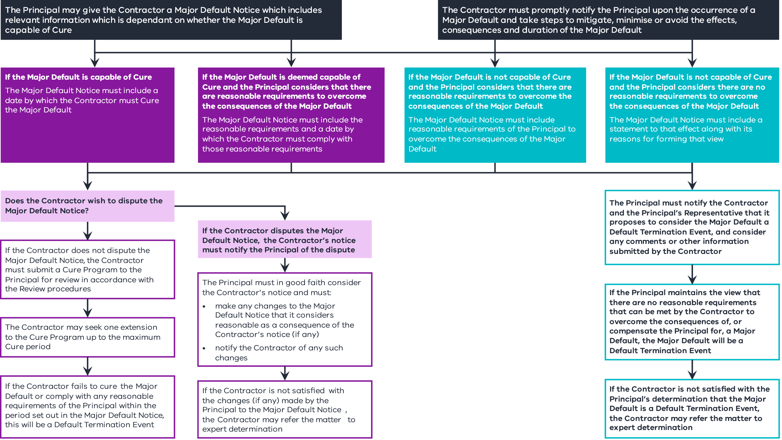
        - Cure Program and Cure periods (clauses 1, 40.4 and 40.5)

Cure Program
The Contractor must provide a Cure Program within 10 Business Days after receiving a Major Default Notice.
Where the Major Default is a failure by the Contractor to achieve Practical Completion by the Date for Practical Completion and the Contractor has provided a Remediation Plan in accordance with the requirements of the expert’s review of progress (in accordance with clause 26.3(e)(ii)) or an Amended Remediation Plan (in accordance with clause 26.3(j)), the Contractor may submit that Remediation Plan or Amended Remediation Plan (as applicable) as the Cure Program for the Major Default.

Extension to Cure Program and the time set out in a Major Default Notice
The Contractor may request that the Principal, and the Principal must, extend the Cure Program and the time stated in the Major Default Notice, if the Contractor has been diligently pursuing:
    - the Cure of that Major Default (if the Major Default is capable of Cure); or
    - compliance with any reasonable requirements of the Principal (if the Major Default is not capable of Cure).
The Contractor is only entitled to one extension in connection with the same Major Default. Limiting the number of extensions gives certainty to the parties and avoids the risk of open-ended Cure rights.
Clause 40.4(h) sets out the maximum Cure period, including any extension granted, permitted by the Principal in respect of a Major Default. For most projects, the maximum Cure period is 24 Months. When determining the maximum Cure period, procuring agencies should consider a number of factors including:
    - the length of the delivery phase;
    - the complexity of the project; and
    - the maturity of the market in providing the required Works.
The maximum Cure periods should be agreed with DTF.
It is for the Contractor and the Significant Subcontractors to determine the exclusive Cure period (if any) that each party will have for curing a Major Default.
The maximum Cure periods that the Contractor has under the Enhanced D&C Deed may be extended if the Contractor is prevented from carrying out its obligations in accordance with a Cure Program as a direct result of an Adjustment Event (Time) provided that:
    - the Contractor is entitled to be granted an extension of time under clause 26.8 for the relevant Adjustment Event (Time); and
    - the Contractor demonstrates to the Principal’s satisfaction (acting reasonably) that the Contractor has diligently pursued and, to the extent reasonably possible, continues to diligently pursue the Cure Program.
The maximum Cure period and the Major Default Notice may only be extended by the amount of time for which the Contractor is entitled to an extension of time or relief for performance of the obligations in respect of the Adjustment Event (Time).
If the Contractor fails to Cure the Major Default within the time set out in the Major Default Notice (as may be amended, determined or extended), a Default Termination Event will occur.
      - Termination (clauses 1, 3, 40 and 41)
        - Sole basis (clause 41.1)
The Principal is only entitled to terminate, rescind or accept a repudiation of the Enhanced D&C Deed in accordance with the termination rights under the Enhanced D&C Deed.
The Contractor has no right to terminate any Project Document. The rationale for this is that:
    - there are a very limited number of fundamental obligations the Principal has under any Project Document; and
    - failure of the Principal to meet its obligations under a Project Document is an Adjustment Event and the Contractor’s rights to sue the Principal for damages for breach of the Project Documents are excluded only in limited and specified circumstances.
        - Termination events (clauses 1, 3.4, 40.6, 41.2 and 41.3)

Termination triggers
The Enhanced D&C Deed can be terminated as a result of the events in Table 2.
Table 2 – Termination events
Event | Trigger
Termination for failure to satisfy Condition Precedent by Condition Precedent Deadline | If any Condition Precedent is not satisfied (or waived in accordance with clause 3.3(b) of the Enhanced D&C Deed) by the relevant Condition Precedent Deadline, the Principal may, at its option, terminate the Enhanced D&C Deed.
Termination for Convenience | The Principal may, at any time, unilaterally elect to terminate the Enhanced D&C Deed for convenience.
Termination for Default Termination Event | The Principal may terminate the Enhanced D&C Deed if:  - a Major Default has not been remedied in accordance with the Enhanced D&C Deed; or  - a Default Termination Event occurs.

Default Termination Events
The Default Termination Events are events that are sufficiently fundamental as to trigger automatic rights for the Principal to terminate the Enhanced D&C Deed. The definition of Default Termination Events is set out in clause 1 of the Enhanced D&C Deed and, subject to project-specific considerations, includes the following:
    - a whole or substantial abandonment of all or any material (in scope and effect) part of the Contractor’s Activities;
    - engagement by the Contractor in fraud, collusion or dishonest conduct in performing its obligations under the Project Documents;
    - occurrence of an Insolvency Event in relation to the Contractor or the Parent Guarantor;
    - a breach of the assignment, transfer or disposal requirements of the Enhanced D&C Deed;
    - a Change in Control in respect of the Contractor or a Parent Guarantor (other than a permitted Change in Control under the Enhanced D&C Deed);
    - an unremedied Major Default (whether capable or not capable of Cure);
    - the aggregate liability of the Contractor to the Principal under or in connection with the Project Documents being equal to or exceeding a set percentage of the Contract Sum;
    - the aggregate liability of the Contractor to the Principal for liquidated damages being equal to or exceeding a set percentage of the Contract Sum and the Contractor does not elect to increase the liquidated damages liability cap;
    - any Parent Company Guarantee provided in accordance with the Enhanced D&C Deed becoming void, or voidable or unenforceable for any reason;
    - Practical Completion not occurring by a specified sunset date; and
    - occurrence of any other event that is deemed to be a Default Termination Event in the Enhanced D&C Deed.
        - Termination Payments (clauses 41.2, 41.3 and 41.4)
The Principal’s obligation to make a Termination Payment to the Contractor is subject to the Contractor having delivered up the vacated Site and the Works to the Principal.
The applicable Termination Payment is calculated by applying the relevant Termination Payment formula (which depends on the termination trigger):
    - If the Enhanced D&C Deed is terminated for convenience, the Termination for Convenience Payment will be calculated by applying the formula set out in clause 41.2(d) of the Enhanced D&C Deed.
    - If the Enhanced D&C Deed is terminated for a Default Termination Event, the rights and Liability of the parties will be the same as they would have been at common law had the defaulting party repudiated the Enhanced D&C Deed and the other party elected to treat the Enhanced D&C Deed as at an end and recover damages pursuant to common law principles.

Termination for Convenience Payment
The key components of the Termination for Convenience Payment are the following amounts (as honestly and fairly determined by the Principal Representative):
    - the amount that would have been payable if the Enhanced D&C Deed had not been terminated and the Contractor submitted a Payment Claim for work carried out (to cover work carried out prior to the date of termination);
    - the cost of plant or materials reasonably ordered by the Contractor for the Works for which the Contractor is legally bound to pay;
    - the costs reasonably incurred by the Contractor in the expectation of completing the whole of the Contractor’s Activities and not included in any payment by the Principal; and
    - the reasonable cost of removing from the Site all labour, Constructional Plant and other things used in connection with the Contractor’s Activities.

Termination for Default Termination Event Payment
Where the Enhanced D&C Deed is terminated for a Default Termination Event, the rights and liabilities of the parties will be the same as they would have been at common law had the defaulting party repudiated the Enhanced D&C Deed and the other party elected to treat the Enhanced D&C Deed as at an end and recover damages pursuant to common law principles. The Contractor will not be entitled to ‘a quantum meruit’ (that is, the reasonable or fair value of services or Works performed).
Default Termination Payments will be payable by the Principal (if the Termination Payment is a positive amount) or by the Contractor (if the Termination Payment is a negative amount).
        - Project-specific amendments
The nature and number of the Major Defaults and Default Termination Events may be subject to project-specific considerations, such as the length and complexity of the Contractor’s Activities.
      - Notices and bar to Claims (clause 56)
The Principal requires certainty in relation to the time period within which the Contractor can prosecute Claims against the Principal.
A number of time bars for different types of Claims are set out in the Enhanced D&C Deed.
Where there is no express and specific time bar for the making of a Claim identified in clause 56.2(b) of the Enhanced D&C Deed, there is a catch-all in clause 56.2(c) of the Enhanced D&C Deed.
- – Terminology and interpretation
Unless otherwise defined in these Guidance Notes, capitalised terms used in these Guidance Notes have the meanings given to them in the Enhanced D&C Deed. Any reference to a clause is a reference to a clause in the Enhanced D&C Deed.
For the purposes of these Guidance Notes:
Table A – Acronyms
Acronym/Term | Meaning
DLP | Defects Liability Period
DTF | Department of Treasury and Finance
EPA | Environmental Protection Authority
HVHR | High Value High Risk
ILG | Investment Lifecycle Guideline
IP | Intellectual Property
KPI | Key Performance Indicator
KRA | Key Result Area
MTPF Act | Major Transport Projects Facilitation Act 2009 (Vic)
PDDD | Project Due Diligence Documentation
PSDR | Project Scope and Delivery Requirements
RFP | Request for Proposal
TOC | Total Outturn Cost
VfM | Value-for-Money

- – Defects
Defects
In the Works until the end of the Defects Liability Period or in the Returned Asset until the end of the relevant Returned Asset DLP
The Principal may give notice to the Contractor and the Principal Representative if it believes that there is a Defect or likely Defect
The Contractor must notify the Principal and the Principal Representative if it identifies a Defect or likely Defect in the Works or a Returned Asset
The Contractor must develop, submit, update and comply with the Defect Corrective Action Plan in accordance with clause 27.4
The Contractor must promptly rectify all Defects in the Works as soon as they are identified unless the Defect is a Defect which the Principal accepts or rectifies in accordance with clause 27.6
If the Principal accepts or rectifies (or engages others to rectify) a Defect in the Works or the Returned Assets, the Contractor must pay the Principal (as a debt due and payable) the greater of:
- the costs necessary to rectify that Defect; and
- the relevant diminution in value of the Works or the relevant Returned Assets (as applicable) as a consequence of that Defect

- – Re-baselining mechanism
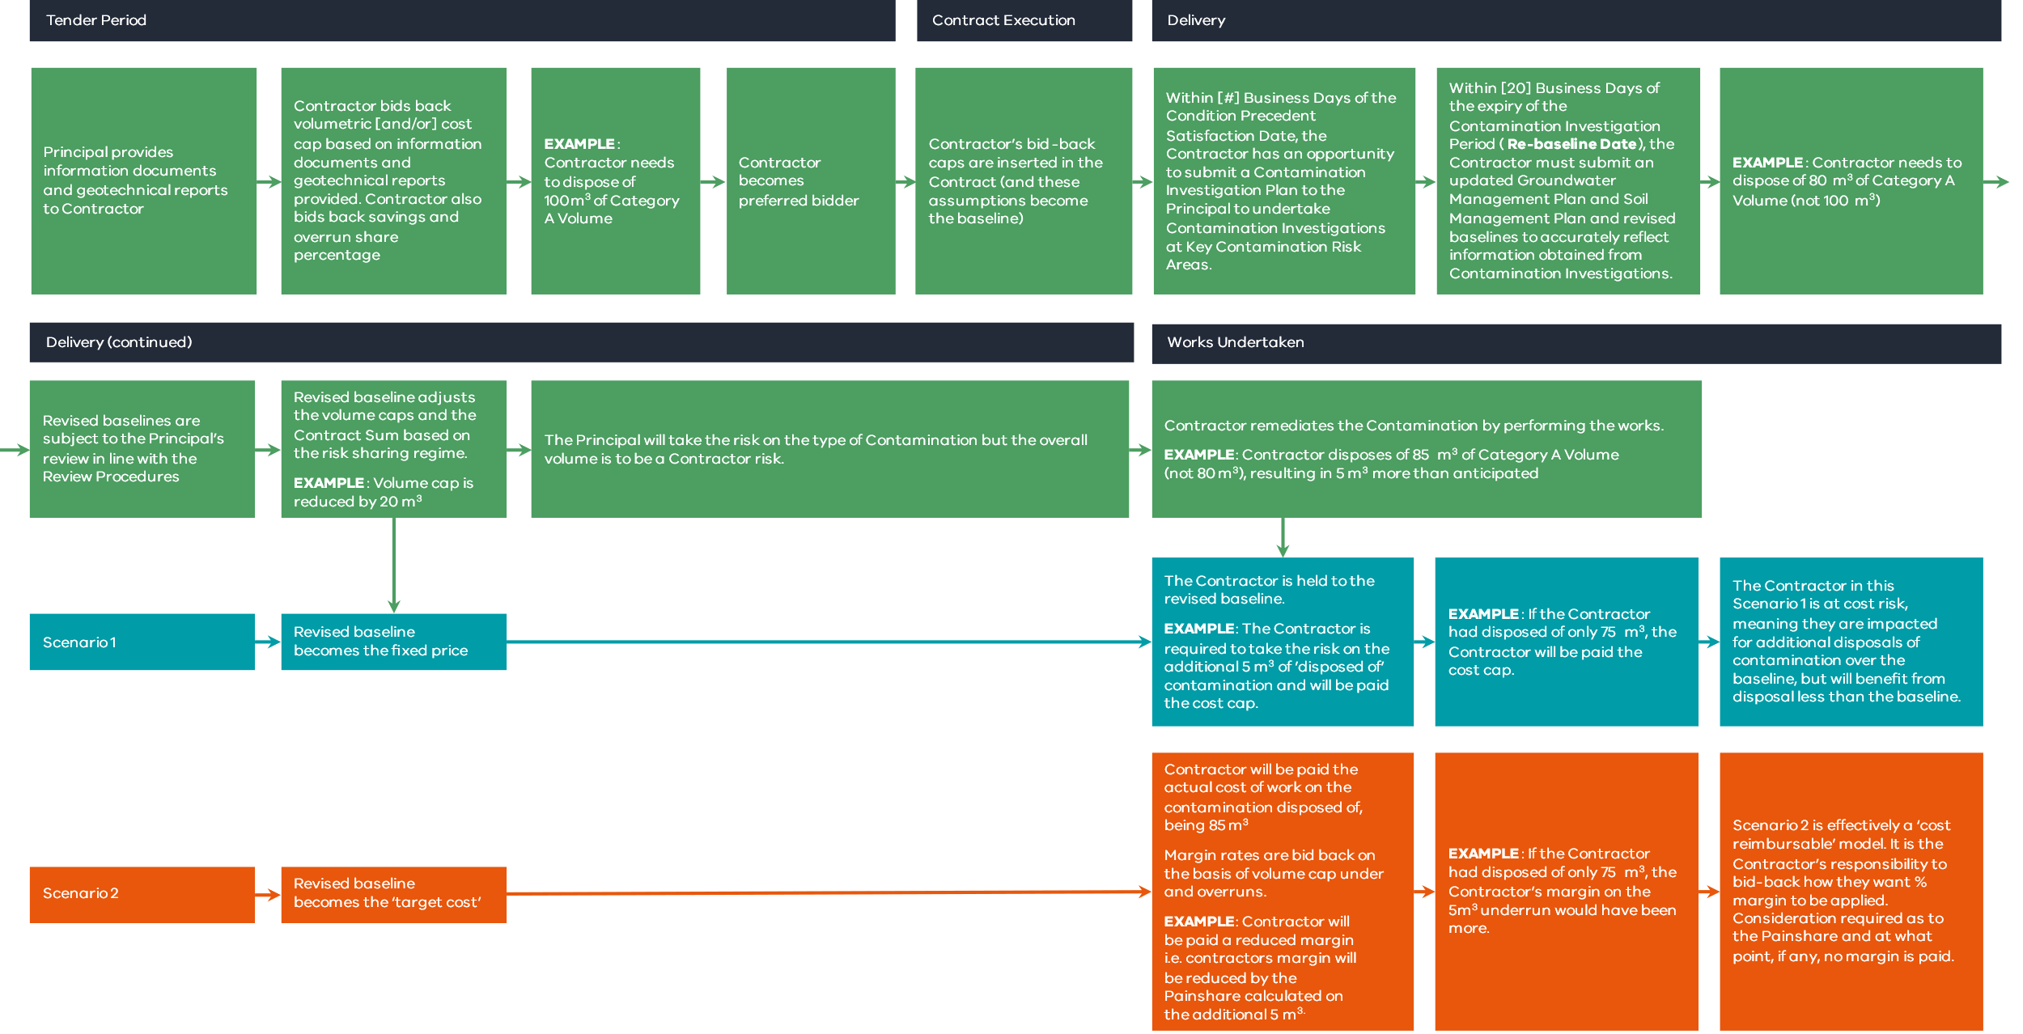
- – Contamination rights and obligations
