Construction Supplier Register
New applicant checklist for suppliers of construction works and services
The Construction Supplier Register (CSR) is an open pre-qualification scheme for suppliers of construction works and construction services interested in accessing tender opportunities to deliver Victorian Government construction projects.
Pre-qualified suppliers of construction works and construction services are bound by and must comply with the CSR Conditions of Pre-qualification. This includes undertaking a review on request by the Construction Supplier Register in order to remain registered on the CSR.
This checklist has been provided to assist you in completing the application and is for your use only. This checklist does not need to be returned to CSR along with your supporting documentation.

Using the CSR Application Form
The CSR application form (Microsoft Excel format) must be submitted as an Excel file. No other file format will be accepted. Do not submit a PDF copy of the file.
Do not alter the formatting within the spreadsheet. The CSR application form with changed fields will not be accepted.
Do not attach or embed information onto the CSR Application form file.

Evidence to support your application
This checklist outlines the evidence you need to successfully submit with your application.
The completed CSR application form and ALL supporting evidence must be submitted as separate pdf files. Your OH&S submission must be completed using the mandatory-evaluation-criteria-industrial-relations-management-attachment-2-instruction-37 and must address Criteria 1-12. CSR will not progress an application that is incomplete.
Each pdf attachment needs to clearly identify the type of evidence presented.
Examples:
- Person name – Certificate of Registration with the relevant regulator (e.g a copy of the Director’s certification with the Victorian Building Authority/Business Licensing Authority/Architects Registration Board of Victoria)
- Supplier’s name – Professional Indemnity certificate of currency
Use the checklist to ensure:
- Completion of the relevant tabs and tables, and
- successful submission of the required evidence.
It is the responsibility of the applicant to submit all documentation to support an application. CSR will advise you if the application is incomplete. The application will not progress if outstanding correspondence is not provided to CSR when requested.

Where to submit your application?
Submit your application and supporting documentation to:
constructionsupplierregister@dtf.vic.gov.au

General help and support
For any help and support with the application process please contact the CSR team by:
- email constructionsupplierregister@dtf.vic.gov.au
- telephone 03 7005 9447

Further information is also available online at: https://www.dtf.vic.gov.au/infrastructure-investment/construction-supplier-register
New applicant checklist

Tab - Business details, work history, maximum project size
Checklist | Completed / Attached
Complete all tables on this Tab
Provide a copy of the certificate of currency for each insurance – WorkCover, Public Liability & Professional Indemnity (as applicable)
Provide a copy of the latest renewal WorkCover premium notice / statement showing the insurance premium rate, compared with the relevant industry (see example below)
Provide Director ID # and certificate if available

Tab - Registrations and professional qualifications
Checklist | Completed / Attached
All applicants – complete Tables 2.1 and 2.2
Complete Table 2.3 – 2.6 with current registration information including expiry dates for each
Applicants applying for pre-qualification categories that require professional qualifications - complete Table 2.7
Provide a copy of each certificate of registration, or an extract from a register for each registration (VBA/BLA/ARBV)
Provide a copy of each qualification
Provide Deed Poll where applicable
Provide copy of WorkSafe issued asbestos licence – Class A – friable and non-friable where applicable

Tab - Supplier code of conduct
Checklist | Completed / Attached
Complete and sign the Supplier Code of Conduct

Tab - Occupational Health and Safety management
Checklist | Completed / Attached
Prepare Occupational Health and Safety management system using the templates available here
OR
Submit a current certificate from an approved assurance system to satisfy the requirements of the OHS eligibility criteria 1 – 10, as well as completing Criteria 11 and 12.

Submit OHS management system
Attach evidence of compliance with the OHS management system for each OHS criterion
As the size of this document may be large, send a separate email with evidence as a compressed (zipped) file

Tab – Cladding history

Complete this Tab if you are applying to the sub-category Cladding rectification
Checklist | Completed / Attached
Complete all tables on this Tab, as they apply to the applicant
Submit explanations for each disciplinary action listed
Provide a copy of the certificate of currency for each insurance required – Note* Professional Indemnity insurance with a minimum of $5 million (any one claim) is mandatory
Provide a copy of those sections of the insurance policy that address the exclusions and excess applying to the policy

Tab - Industrial relations management
FOR WORKS ONLY – CONSTRUCTION SERVICES APPLICANTS DO NOT COMPLETE
Checklist | Completed / Attached
Complete the Industrial Relations management self-assessment – Table 6.1
Complete Table 6.2 if the applicant has answered:
- NO to any of the questions in Table 6.1 (excludes question D6)
- YES to question D6 in Table 6.1
Complete the Declaration of compliance with industrial relations management criteria– Table 6.3
Attach the Fair Jobs Code – Pre-assessment certificate if you are seeking a project limit above $3M

Tab – Financial statements
FOR WORKS ONLY – CONSTRUCTION SERVICES APPLICANTS DO NOT COMPLETE
Checklist | Completed / Attached
External assessor Equifax will contact you to request information including a copy of your financial statement for the previous financial year for pre-qualification with a project limit lower than $15 million
External assessor Equifax will contact you to request information including a copy of your audited financial statement for the previous financial year for pre-qualification with a project limit higher than $15 million

Tab - Agreement and consent
Checklist | Completed / Attached
Company Director, Partner within partnership or Sole Trader to complete the agreement and consent – on behalf of applicant
Company Director, Partner within partnership or Sole Trader to complete the agreement and consent – each of applicant’s key personnel (includes directors of companies, partners within a partnership, as applicable)

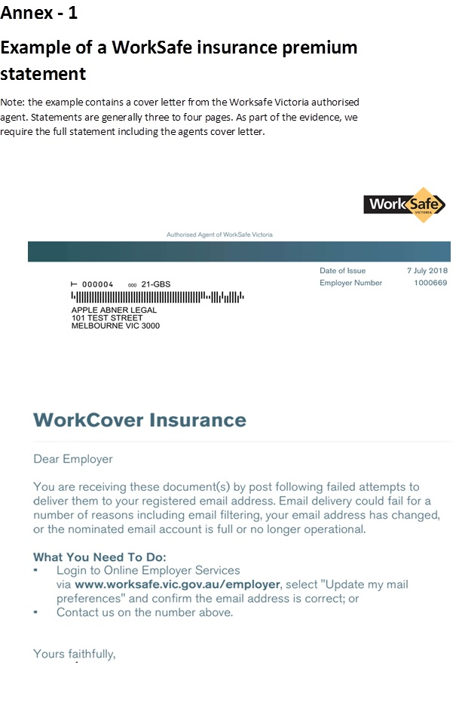 | 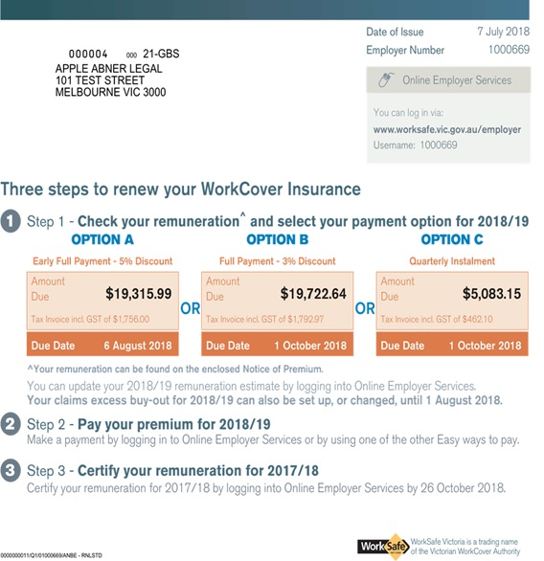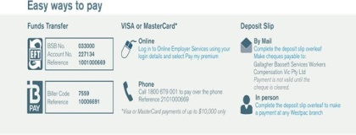
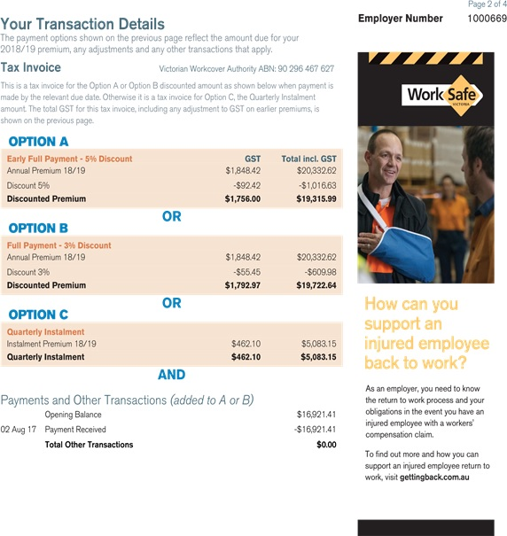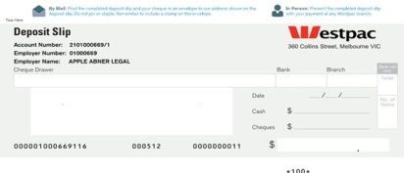 | 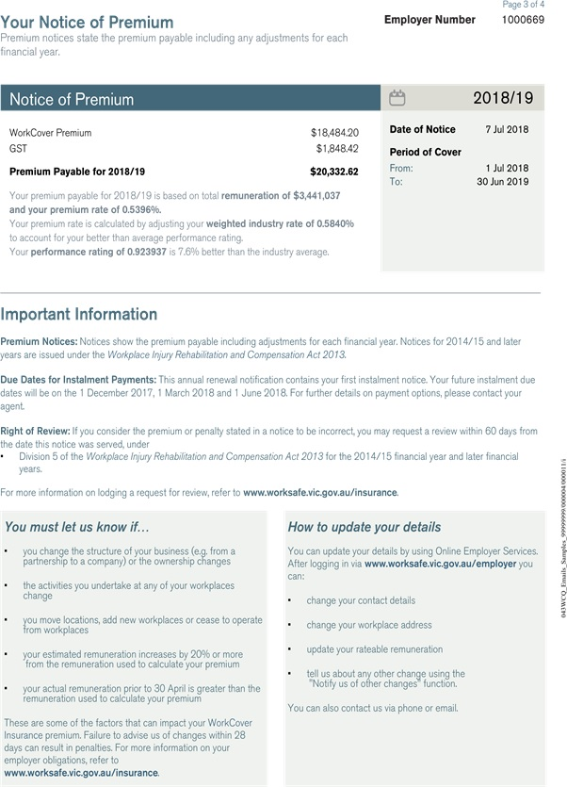

The copyright in this New applicant checklist is owned by the State of Victoria (Department of Treasury and Finance).

© State of Victoria 2022
You are free to re-use this New applicant checklist under a Creative Commons Attribution 4.0 licence, provided you credit the State of Victoria (Department of Treasury and Finance) as author, indicate if changes were made and comply with the other licence terms. The licence does not apply to any branding, including Government logos.

Copyright queries may be directed to IPpolicy@dtf.vic.gov.au

