Changing macro security settings
for Word 2003

- Open your Word for Windows software.
- Click on Tools, Macro, Security and the following dialog box will appear.
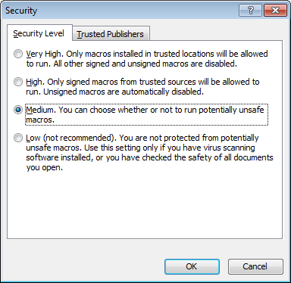

- Select the Medium option button.
- Click the Trusted Publishers tab and select both checkboxes as shown below.
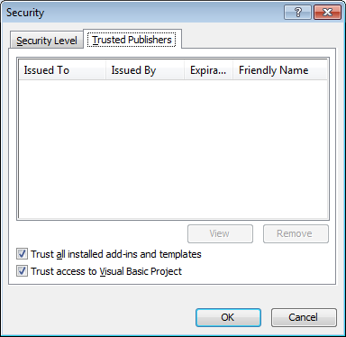

- Click OK and close out of Word for Windows.
- Reopen Word for Windows and you are now ready to create a PPM document.
- When you create your PPM document, you will be prompted as to whether the macros should be enabled or not. Please ensure that you click the Enable Macros button.
