Investment Lifecycle and High Value or High Risk Guidelines

CONCEPTUALISE

The Secretary
Department of Treasury and Finance
1 Treasury Place
Melbourne Victoria 3002
Australia
Telephone: +61 3 9651-5111
Facsimile: +61 3 9651-5298
www.dtf.vic.gov.au

Authorised by the Victorian Government
1 Treasury Place, Melbourne, 3002

© State of Victoria 2012
© Copyright State of Victoria 2012
This book is copyright. No part may be reproduced by any process except in accordance with the provisions of the Copyright Act 1968.
ISBN 978-1-922045-91-1
Published December 2017..
Copyright queries may be directed to IPpolicy@dtf.vic.gov.au

Acknowledgements
The Department of Treasury and Finance (DTF) wishes to acknowledge those who contributed to the thinking, development and production of this guide. In particular, the agencies of the Victorian Government who participated in the consultation for this work, and Biruu consulting, which assisted in its development.
DTF also wishes to acknowledge United Kingdom HM Treasury and New Zealand Treasury, the following resources of those organisations were used as references in the development of this guide:
New Zealand Treasury (2012) Better business cases at http://www.infrastructure.govt.nz/publications/betterbusinesscases/
HM Treasury (2011) The Green Book: Appraisal and evaluation in Central Government at http://www.hm-treasury.gov.uk/d/green_book_complete.pdf

Contents
CONCEPTUALISE 1
Context 1
Purpose of this document 1
How to use this guideline 2
1. Introduction 1
1.1 The conceptualise stage 1
1.2 The investment logic ‘line of enquiry’ 2
1.3 Using the Investment Management Standard during this stage 2
1.4 How long-term planning relates to this stage 3
1.5 Whether to prepare a submission for a program or an individual investment? 3
1.6 Managing uncertainty 4
1.7 Considering and complying with relevant Government policies 6
1.8 Reviewing your thinking 7
1.9 Process roadmap – conceptualise stage 9
2. Conceptualise stage documents 10
2.1 What documents to prepare at the conceptualise stage 10
2.2 Building the business case 10
2.3 What is a strategic assessment? 10
2.4 What is a preliminary business case? 11
2.5 What to do if you don’t have funding to develop a full business case? 12
2.6 What’s next: Full business case 12
2.7 Responsibility for producing submissions 13
3. Analysis required at the conceptualise stage 14
3.1 Reasons for government intervention 14
3.2 Carrying out research 14
3.3 Identifying key stakeholders 15
3.4 Step 1: Understand the problem 15
3.5 Step 2: Understand the benefits of change 18
3.6 Step 3: Investigate the response options to the problem 21
3.7 Step 4: Develop the indicative solution 28
4. Scalability – strategic assessment vs. preliminary business case 31
4.1 Required depth of analysis 31
5. Glossary 35

Context

Purpose of this document
This guideline presents the issues agencies should consider when they are investigating a problem or opportunity in the delivery of government services. It is applicable to any investment proposal. The investment lifecycle framework lays out the following stages of an investment. This guideline is concerned with the first ‘conceptualise’ stage of the investment lifecycle.

 | Conceptualise |  | Prove |  | Procure |  |  | Implement |  |  | Realise
 | Establish a clear need, define likely benefits and explore interventions |  | Explore project options and estimate costs to validate value for money and viability |  | Finalise procurement plan, specify requirements, engage the market and award contract |  |  | Implement solution and transition to normal business |  |  | Measure the success of the investment
 | Confirm the need |  | Recommend an investment |  | Award a contract |  |  | Deliver the solution |  |  | Deliver the benefits
Outputs | Strategic assessment (non-High Value/High Risk)  Preliminary business case (if High Value/High Risk |  | Full business case  HVHR Project Assurance Plan |  | Expressions of interest  Request for tender  Contract  Project status reports |  |  | Project status reports |  |  | Project wrap-up report  Investment evaluation report
Guidelines | Investment lifecycle overview  Conceptualise guideline | Prove guideline |  | Procure guideline |  |  | Implement guideline |  |  | Realise guideline
Tools | Project profile model  IMS tools  Investment decision-maker’s checklist | Project profile model  IMS tools  Investment decision-maker’s checklist |  | Procurement tool |  |  |  |  | Benefits tracking tool
Gateway | Gate 1: Concept and feasibility | Gate 2: Full business case |  | Gate 3: Readiness for market  Gate 4: Tender decision |  | Gate 5: Readiness for service |  |  | Gate 6: Benefits realisation
 | Government filtering | Government funding |  | Government approval |  | Government monitoring |  |  | Government evaluation
* High Value/High Risk (HVHR) investments include some further specific requirements.
To find out more about HVHR investments, read the Investment lifecycle and high value/high risk guidelines at www.lifecycleguidance.dtf.vic.giv.au

How to use this guideline
This guideline should be used as a tool. It is not a compliance process document. Rather, its purpose is to provide agencies with guidance on useful processes that will help them frame their thinking as they prepare their investment strategies. These processes support evidence-based decision making.
Following the conceptualise stage, if an agency concludes that an asset investment proposal is warranted, they may present their case with supporting evidence to the Government using these guidelines.
Agencies investigating a problem likely to involve information and communications technology (ICT) elements should read the supplementary ICT Business Case Development guideline.

- Introduction
- The conceptualise stage
The conceptualise stage covers the initial examination of problems or opportunities that agencies believe warrant attention from government. It allows decision‐makers to consider the merits of the proposal early in its development and to determine whether it justifies further investigation.
Put simply, investment decision‐makers ultimately need to know the answers to two key questions outlined below.
- Is there a need?
- What is the problem or business need to be addressed?
- What benefits can the Government expect from successfully responding to the problem?
- What response options will best address the identified problem or business need?
- Is there any uncertainty impacting the problem definition, desired benefits, response options and/or the preferred response?
- Can it be delivered successfully?
- What is the best value-for-money project option that will address the problem and achieve the benefits?
- Can the recommended solution really be delivered?
The conceptualise stage is primarily concerned with question 1 and this guideline presents a process that agencies may use to answer it. Question 2 is considered in detail in Stage 2 Prove.
This early planning stage is important as it allows agencies to identify those proposals that address a real need, align with government policies and priorities and merit intervention. It allows government to eliminate proposals that do not meet these criteria, and direct resources to those investments that will deliver the greatest benefits.
The output of this stage is a clearly defined investment proposal. This may be used to support departmental prioritisation processes and Gate 1: Concept and Feasibility Gateway reviews. In some instances, the Department of Treasury and Finance (DTF) may require departments to prepare and submit Strategic Assessments (for non-High Value High Risk (HVHR) proposals) or Preliminary Business Cases (for HVHR proposals). These outputs will be used to inform the development of the full business case in Stage 2: Prove.

- The investment logic ‘line of enquiry’
The conceptualise stage requires agencies to present their investment analysis as a four-step process, summarised as follows:
Figure 1: The investment logic’s line of enquiry
What is the recommended solution?
What is the preferred response?
What benefits need to be delivered?
What is the problem?

Developing this line of enquiry should be supported with evidence and involve an appropriate and balanced range of informed stakeholders.
- Using the Investment Management Standard during this stage
DTF recommends practitioners use the Victorian Government’s Investment Management Standard (IMS) 2017 to help you examine an identified problem or business need in a structured way. It can be used effectively to clearly define the investment proposal and underpin the preliminary business case, strategic assessment or investment funding submission, and aims to eliminate unnecessary process. | The IMS establishes a set of simple practices that enable organisations to direct their resources to the things that matter most.  It is not mandated that you use the IMS in the development of your submission, however it is recommended.
The IMS consists of a series of facilitated workshops and supporting tools that:
- bring together those people with the most knowledge of a subject to pool information and inform decision-making;
- consider each aspect of the investment Line of Enquiry (outlined in 1.2 above), ensuring each investment has a clearly defined problem, benefits that align with the intended outcomes and a range of feasible response option; and
- depict the ‘investment story’ succinctly using language and concepts that can be understood by a lay person..
Between one and four workshops are required for each proposal; the number is determined by the nature and complexity of the investment. The workshops produce documents useful to defining a new investment and establishing a robust business case. These include:
- investment logic map;
- benefit management plan;
- response options analysis report; and
- investment concept brief.
- The IMS can be applied to an individual project or at the program level.
- Further information on the IMS is available on the DTF website: http://www.dtf.vic.gov.au/Investment-Planning-and-Evaluation/Understanding-investment-planning-and-review/What-is-the-investment-management-standard.
- How long-term planning relates to this stage
At the conceptualise stage, agencies should ensure that an identified need for an investment aligns with the agency’s long-term service planning to meet future service needs and demands as well as its asset management objectives. This context should be described in the problem section of the strategic assessment or preliminary business case.
Agencies should satisfy themselves that the investment proposal has been considered in the context of a cohesive response to a service delivery challenge. The asset initiatives should be included in the asset management strategy for the department’s entire asset base. Implementation dependencies of other investment initiatives need to be identified and coordinated.
Asset investment proposals should align with the department or agency’s asset management strategy and consider the requirements of the Victorian Government’s Asset Management Accountability Framework.
- Whether to prepare a submission for a program or an individual investment?
Programs tend to be outcome focussed and bring together multiple projects under a single coordinating structure, where each project contributes to the program outcomes. Programs can include pieces of work that are not projects (e.g. ongoing business as usual work) and can have a variety of structures. Program thinking is useful to:
- identify and respond to unmet priorities of an organisation (what are our investment priorities over the next 10 years?);
- help shape, manage and evaluate an interconnected collection of activities that contribute to a common outcome (such as an innovation strategy for the state); and
- prioritise and manage a program of works (such as a series of rail/road separations).
When deciding whether to prepare a Government submission presenting the case for a program, or an individual initiative that is part of a program, you should consider whether the core logic that is established in initiating an investment can be used for any of the following purposes:
- to obtain Government approval for the development of a proposed program of activities;
- to obtain Government approval for the prioritisation of similarly intended investment proposals; or
- to strengthen the case for your individual initiative if it is part of a program.
If your agency decides it is appropriate to present a program submission at this stage, your submission could be presented in one of two formats:
- For programs consisting of a number of major, complex projects (for example, multiple HVHR projects), it may be appropriate to present a preliminary business case outlining the program ‘master plan’ and justifying the program logic. If supported, a full business case for the program can then be developed as an underlying support for the component projects. Agencies should then prepare separate business cases for major projects that are part of that master plan.
- For programs consisting of smaller, less complex projects, it may be appropriate to present a preliminary business case or strategic assessment outlining the program logic, and then setting out the governance framework and criteria you will use to select projects within the program.
If you are unsure about how to present your proposal in a submission, contact your DTF representative.
- Managing uncertainty
Many of government’s investments are vulnerable to uncertainty: external factors that are beyond the investor’s control, and that can impact the delivery of our intended investment outcomes. Uncertainties can influence market conditions, including the demand or need for an investment and/or the ability of the supply market to provide an effective solution. Market changes can be unfavourable, presenting threats to investment delivery, or favourable, presenting opportunities for achieving greater value for money or enhanced benefits.
If these uncertainties are realised on an investment, they can challenge or invalidate our business case assumptions, and impact our investment strategy’s feasibility. Investment options that are preferred and would be successful under one set of conditions can become unviable and regretted if circumstances change.
Uncertainty may be an influential determinant of investment success or failure, and needs to be carefully considered in our investment proposals. Previously investment guidance treated uncertainties in the same way as risks. However uncertainties fundamentally differ from risks in that they are outside the investor’s control to manage or ameliorate. They require different treatments, and therefore we cannot consider and plan for uncertainties using risk management tools and techniques.
To successfully deliver investments with high degrees of uncertainty, Government needs flexible and resilient investment strategies that anticipate or identify when change may impact an initiative and can then adapt and respond advantageously to prevailing conditions.
This may be as simple as avoiding uncertainty by waiting to take action when there is greater certainty on future market conditions, or staging decision making rather than locking in all the decisions at the start. It could also include techniques to respond to change during project delivery, such as: creating financial buffers to absorb impacts; shifting impacts to other project partners; minimising Government’s obligations under unfavourable conditions; providing the ability to exit from unproductive pathways cost-effectively; or leveraging opportunities that may arise. It could further involve future proofing assets to be more resilient to change during their operational life.
Planning for delivering investments under uncertainty should commence in the Conceptualise stage. Generally flexibility is greatest at the earliest point in the project development process, well before demand meets a technical constraint that may force a particular response, and ideally before there is a public commitment to a particular type of solution.
In the Conceptualise stage, agencies should assess the extent to which a proposal may be vulnerable to uncertainty. It should identify key sources of uncertainty, their potential impacts on the investment need, benefits and response options, and strategies for dealing with uncertainty effectively. DTF recommends using a triage process to undertake this assessment:

Figure 2: Overview of the real options triage process
- What would your ‘preferred investment strategy’ look like under different conditions and future state?
- Under what circumstances would the preferred investment strategy:
  - no longer offer the best value for money;
  - no longer achieve the intended
  - be less effective than a different approach; and/or
  - be regretted?
Identify how these uncertainties are likely to impact the preferred investment strategy
- What externalities could impact the investment need or demand for a service, the preferred response, solution implementation or benefits realisation?
- Could any of the uncertainties materially impact the business case assumptions and assumed future state?
Identify the primary sources of uncertainty that could impact your investment
An event(s) or change of conditions. Examples include:
- Population increase or decrease • Globalisation isolation
- Change to demographic makeup • Climate change
- Economic downturn/upturn • Switch in technology
- Failure of project interdependency • New market participant
Identify trigger points that would prompt a decision to take a different course of action
- If conditions or assumptions do not turn out as you expect, what actions would you take to adapt your project to suit prevailing conditions? Examples include:
  - Delaying or staging investment until there is greater certainty
  - Expanding or reducing capacity to suit changes in demand
  - Switching inputs/outputs to suit changes in demand or supply
  - Abandoning the investment
  - Increasing design flexibility to add greater resilience.
Identify how you increase your investment strategy’s flexibility to better deal with uncertainty

Identify how you increase your investment strategy’s flexibility to better deal with uncertainty

DTF recommends agencies apply this process to all investments. Any identified issues should be noted in the investment proposal and strategic assessment/preliminary business case (where relevant), and further explored in the full business case. Where a proposal is impacted by significant uncertainty, agencies should consider using quantitative analysis techniques (such as real options analysis) to augment options analysis in the full business case if the proposal proceeds to that stage.
Real options analysis is an investment evaluation and decision-making framework that incorporates flexible, quantitative approaches to better manage projects that are significantly impacted by uncertainty. It can support Government develop infrastructure investment strategies that are adaptable and better meet evolving community needs.
Further information on managing uncertainty and undertaking real options analysis is contained in Investing under uncertainty – Investment Lifecycle Guidelines technical supplement.
The 2017 IMS may be used to help identify any key uncertainties impacting the problem definition, intended benefits and response options. Any uncertainty identified during an IMS workshop can be captured within the workshop outputs.
- Considering and complying with relevant Government policies
There are a range of Victorian Government policies that agencies may need to consider and comply with when developing an investment proposal. The following sections outline some important policies that apply to the Whole-of-Victorian-Government context. However, you must satisfy yourself that your investment proposal addresses all relevant policies and priorities.
- Value Creation and Capture Framework
In March 2017, the Victorian Government launched its Value Creation and Capture Framework (VCCF). The VCCF requires agencies to consider value creation and capture opportunities for any relevant asset investments proposals submitted for budget funding, commencing in the 2018-19 Budget.
- Value creation refers to creating and delivering additional value and benefits for Victorians than might normally have been achieved from an investment. For example, when building infrastructure or developing precincts, government can enable economic opportunities, deliver green space, community services, housing and education facilities and create more value for the community than would otherwise be the case.
- Value capture refers to government capturing a portion of the incremental economic value created by its investments, activities and policies. These actions may generate alternative revenue streams, assets or other financial value that Government can tap into to assist funding existing or future investments.
Investments required to comply with the VCCF include:
- Precinct projects;
- Development of public land;
- Non-ICT capital investments meeting HVHR criteria; and/or
- Any other capital investment considered by Government as having potential significant value creation and/or capture opportunity.
Where an investment proposal meets any of the above criteria, agencies are required to prepare and submit up to three documents to support project planning and business case development:
- Statement of Intent: a succinct overview of the project and the outcomes sought, as well as high level objectives for broader value creation and capture;
- Strategic Value Creation and Capture Plan: a high level, preliminary or strategic version of the detailed VCC plan. It identifies opportunities for value creation and capture that have the potential to deliver significant value and warrant further investigation through the development of a full business case. It also identifies the resources and capabilities required to develop a robust VCC plan for the full business case; and
- Detailed Value Creation and Capture Plan: covers the same content as the Strategic VCC plan at a more robust and granular level.
At the conceptualise stage, the project sponsor will be responsible for developing a Statement of Intent and a Strategic Value Creation and Capture Plan for any proposal meeting the VCCF criteria.
In developing this Statement of Intent and Strategic VCC plan, the intention is to provide clear, early project definition and guidance on Government policy objectives for the project. This is critical to provide the authorising environment for agencies to properly explore broader value creation and value capture opportunities as part of the business case, and to guide the relevant policy trade-offs in selecting and applying identified value creation options and value capture tools.
Further information on VCCF is available on the Department of Premier and Cabinet’s website: http://www.dpc.vic.gov.au/index.php/news-publications/value-creation-and-capture-framework
- Climate Change Act 2017 and related climate change initiatives
The Victorian Government’s new Climate Change Act 2017 commenced operation on 1 November 2017. The Act sets out a clear policy framework and a pathway to 2050 that is consistent with the Paris Agreement to keep global temperature rise below 2 degrees Celsius above pre-industrial levels. The Act sits alongside other key Victorian Government energy and climate change initiatives including Victoria’s Climate Change Framework, Victoria’s Climate Change Adaptation Plan 2017-2020 and Victoria’s Renewable Energy Action Plan.
There are two primary aspects of these climate change initiatives that agencies should consider when developing infrastructure investments:
- Greenhouse gas emission reduction: the Climate Change Act 2017 sets a target of net zero greenhouse gas emissions by 2050. When delivering new, or renewing / replacing existing, infrastructure, Government should think about actions it can take to reduce Victoria’s emissions footprint; and
- Climate change adaptation: climate change is a key uncertainty that can impact our investments. Victoria is already experiencing the impacts of climate change, with increases to average temperature and decreases to average rainfall impacting all parts of the state. When developing and delivering investment proposals, agencies should consider whether service delivery functions are vulnerable to changing climatic conditions. Practitioners should also contemplate strategies or actions that could be taken to prepare for, and adapt to, these changes, and increase the resilience of our service delivery capability and supporting assets.
Further information on the Victorian Government’s climate change legislation, policies and initiatives is available on the Department of Environment, Land, Water and Planning website: https://www.climatechange.vic.gov.au/adapting-to-climate-change-impacts. Further information on managing uncertainty can be found in Section 1.6 of this document.
- Reviewing your thinking
DTF has developed a set of questions to help guide agencies’ thinking as they develop their investment proposals, the investment decision-maker’s checklist (16+Questions).
Throughout the development of your submission at this stage, and prior to its submission, agencies should ensure they have considered the questions in stage 1 of the investment decision-maker’s checklist. Agencies may not have answered all the questions in the affirmative at this stage; however, they need to demonstrate that they have considered each of them in developing their strategic assessment or preliminary business case.
Table 1: Stage 1 of the investment decision-maker’s checklist
PROBLEM |  | BENEFITS |  | RESPONSE OPTIONS |  | INDICATIVE SOLUTION  (level of detail for 13–16  should be light)
1. | Is it clear what the problem is that needs to be addressed, both the cause and effect? | 5. | Have the benefits that will result from fixing the problem been adequately defined? | 9. | Has a reasonable spread of interventions been identified and packaged into sensible response options? | 13. | Consistent with the preferred response option, has a reasonable spread of project options been analysed?
 | Yes Maybe No ? |  | Yes Maybe No ? |  | Yes Maybe No ? |  | Yes Maybe No ?
2. | Is there sufficient evidence to confirm both the cause and effect of the problem? | 6. | Are the benefits of high value to the government? | 10. | Is there evidence to demonstrate that the response options are feasible and can respond to future uncertainty? | 14. | Is the recommended project solution the best value for money way action, and have opportunities for building flexibility to deal with uncertainty been considered?
 | Yes Maybe No ? |  | Yes Maybe No ? |  | Yes Maybe No ? |  | Yes Maybe No ?
3. | Does the problem need to be addressed now and by this government? | 7. | Are the KPIs SMART and will they provide strong evidence that the benefits have been delivered? | 11. | Were the strategic options evaluated fairly to reflect their ability to respond to the problem and deliver the benefits? | 15. | Is the solution specified clearly and fully and have opportunities for adding value been identified and costed? (all business changes and assets)
 | Yes Maybe No ? |  | Yes Maybe No ? |  | Yes Maybe No ? |  | Yes Maybe No ?
4. | Does the defined problem capture its full extent/scope including sources of future uncertainty? | 8. | Have the sources of uncertainty and key dependencies critical to benefit delivery been considered? | 12. | Is the preferred response option the most effective way to address the problem and deliver the benefits? | 16. | Can the solution really be delivered (cost, risk, timeframes etc.)?
 | Yes Maybe No ? |  | Yes Maybe No ? |  | Yes Maybe No ? |  | Yes Maybe No ?

These questions are addressed in more detail and expanded on in stage 2

- Process roadmap – conceptualise stage
Figure 3: Stage 1: Conceptualise – Roadmap
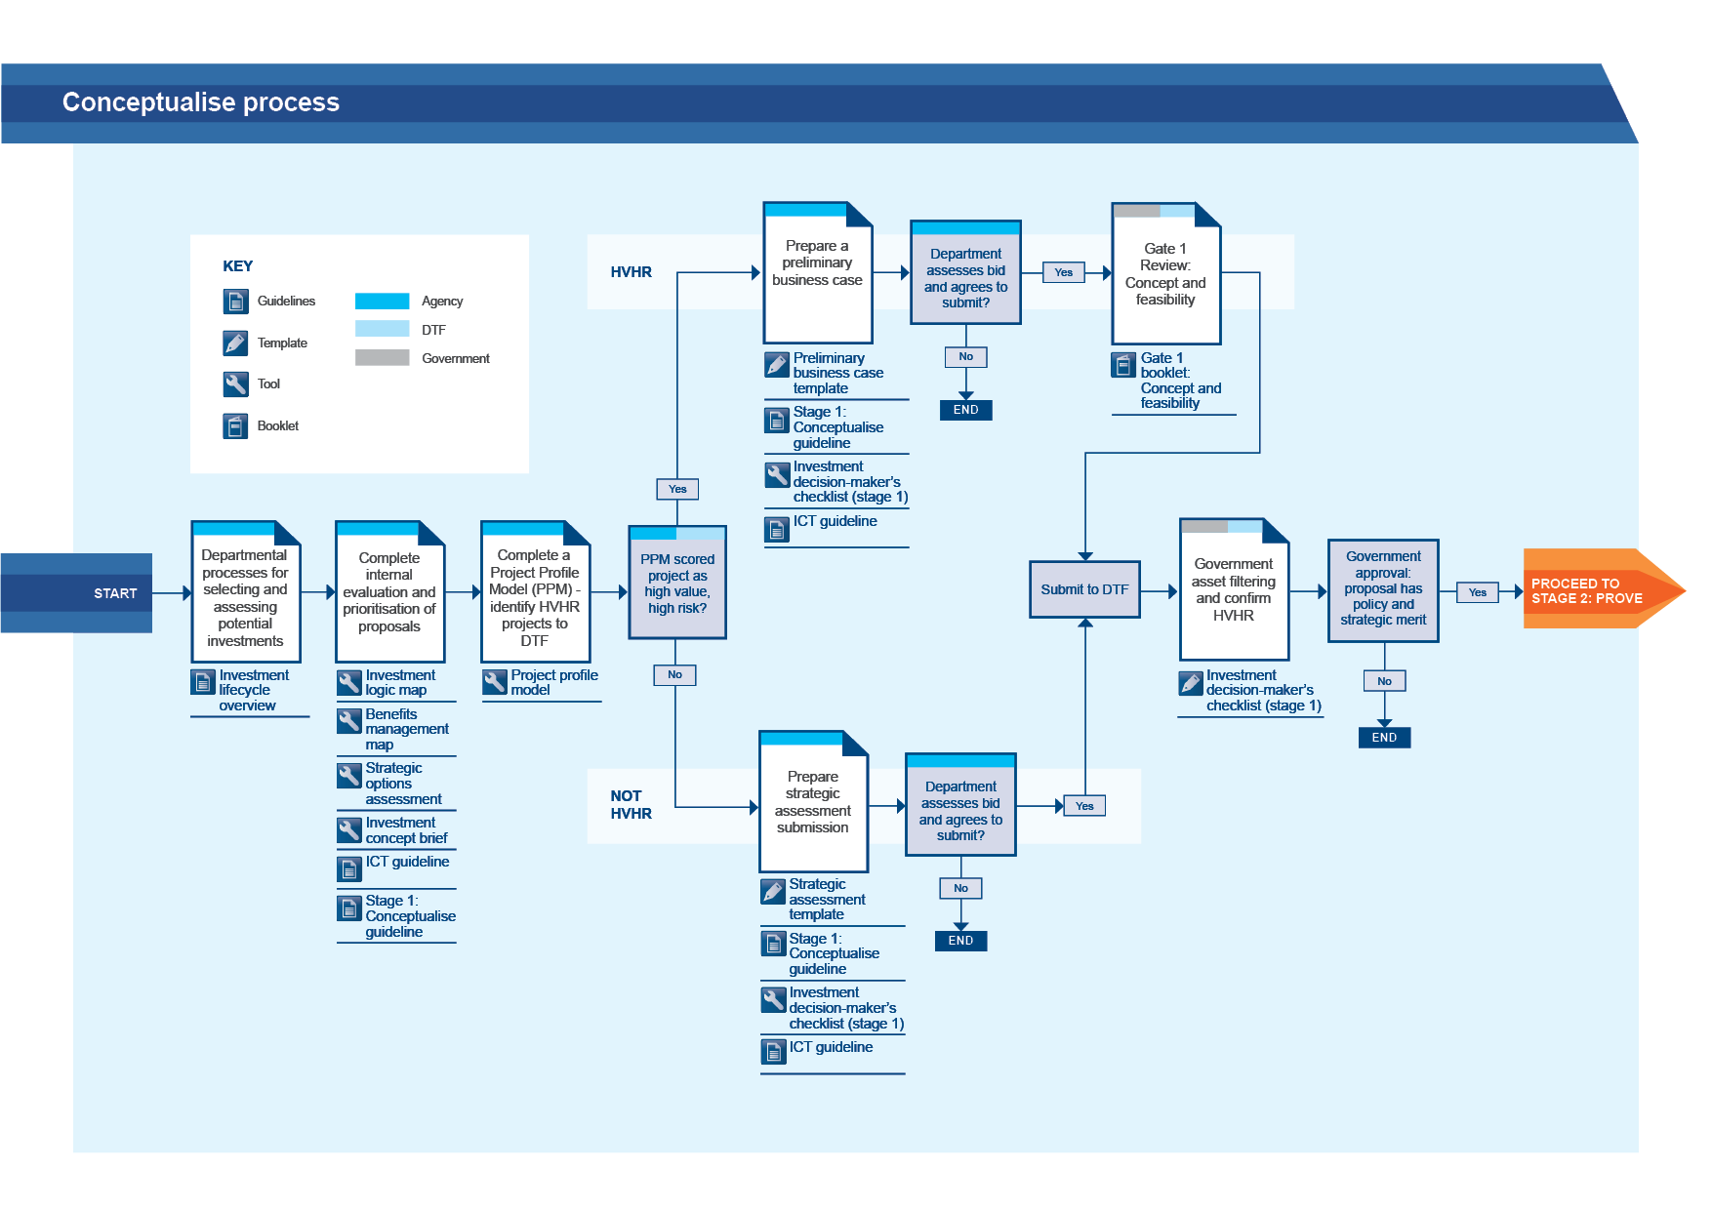
(Note: This roadmap applies when a 2-stage budget process is being used to filter high priority projects. It is also likely to apply to large, complex investments.)

- Conceptualise stage documents
- What documents to prepare at the conceptualise stage
Depending on the proposal’s scale, risk and available funding to progress to full business case stage, the outputs for submission to Government during this stage may be either a:  - strategic assessment (for non-HVHR investments);  - preliminary business case (for HVHR investments); or  - an investment development funding submission. | Remember: High value/high risk (HVHR) investments are identified through the public profile model as ‘high risk’ or as otherwise nominated.
If, after reading this section of the conceptualise guideline, you are unsure about which submission to prepare or whether your investment is HVHR, contact your DTF representative.
- Building the business case
Your strategic assessment or preliminary business case provides the building blocks for the full business case (see Figure 4). The strategic assessment builds to the preliminary business case, which builds to the full business case (these documents are described in more detail below). So any work you do in the early stage of your investment will not go to waste. Agencies may choose to use the strategic assessment for internal filtering prior to developing the greater detail required for the preliminary business case.
Figure 4: Building the business case
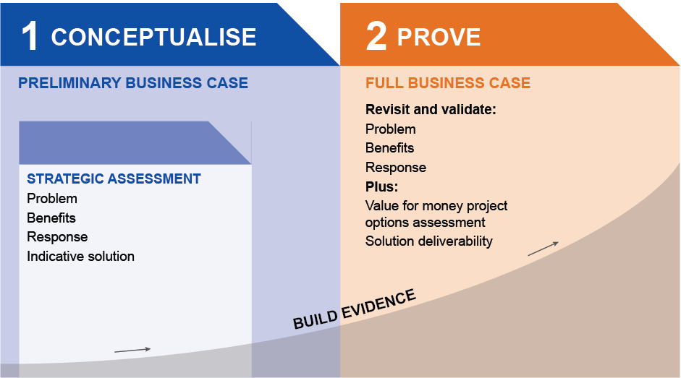

- What is a strategic assessment?
A strategic assessment presents the policy and strategy case for your proposed investment by outlining the line of enquiry outlined above at 1.2, that is, the problem, benefits, strategic response and indicative solution. A strategic assessment should be prepared for any investment for which a government agency will be applying for government funding, that is, any investment not classified as HVHR. The document is usually 5-10 pages in length.
The contents of a strategic assessment are shown in chapter 4 of this document. Note the expectation for a strategic assessment is a high level process. This proposal will be rigorously tested in the full business case if the investment proceeds to this stage.
A blank strategic assessment template and a fictional worked example are linked to these guidelines to assist you in preparing your strategic assessment. They are available at www.lifecycleguidance.dtf.vic.gov.au.
- Tools to assist the development of a strategic assessment
One means of presenting the outline of shared thinking about the proposal is using three products of the IMS, namely:
- investment concept brief (which includes the Investment Logic Map);
- benefit map; and
- response options analysis report (ROAR).
It is recommended that these are developed with the assistance of a facilitator accredited by DTF who will lead IMS workshops. Note that the licence to use the IMS materials includes the requirement that any workshop facilitators not accredited by DTF must make this clear to all participants and indicate this on the logic map. Users may not modify the IMS materials.
- What is a preliminary business case?
The Treasurer’s requirement for greater scrutiny of proposals with an HVHR profile means the minimum level of information required for investments classed as HVHR is higher than for other proposals. HVHR investment submissions are required to be presented in the form of a preliminary business case at the conceptualise stage.
The contents of a preliminary business case are shown in chapter 4 of this document. In summary, the preliminary business case asks you to describe the investment logic line of enquiry, outlined above at 1.2. The document serves the same purpose and addresses the same questions as a strategic assessment; however there is an expectation that a preliminary business case is more rigorous than what is expected for a strategic assessment. The preliminary business case includes some high-level information on the project options analysis and recommended solution, to provide confidence in the project’s value for money and deliverability.
Information presented in the preliminary business case will be tested again more rigorously the full business case, where you will be expected to provide extensive evidence to support the line of enquiry.
A blank template and a fictional worked example are linked to these guidelines to assist you in preparing your submission. They are available at www.lifecycleguidance.dtf.vic.gov.au.
- Tools to assist with the development of a preliminary business case
The underlying framework of a preliminary business case can be supported by using four products of the IMS, namely:
- investment concept brief (which includes the investment logic map);
- benefit management plan (which includes the benefit map);
- response options analysis report; and
- project options analysis.
- What to do if you don’t have funding to develop a full business case?
For some proposals, especially HVHR proposals, agencies may require assistance to fund proposal development. In general the strategic assessment development should be funded internally, but agencies may need to make an investment development funding submission to progress the proposal further.
The investment development funding submission should be based on the strategic assessment (see template), but will focus on the indicative costs, tasks and staging of the proposal development (with only a ball park estimate of the project funding for the indicative solution). If the agency has sufficient funding to develop the preliminary business case the submission should be based on this rather than the strategic assessment.
To allow more timely progression of proposal development, funding may be provided for development of:
- project scoping leading to the preliminary business case;
- pre-feasibility and assessment of project alternatives; and
- feasibility leading to the full business case;
with decision milestones for government reconsideration of the proposal at preliminary business case and ultimately full business case for project funding. The investment development funding process is intended to be flexible. This approach avoids the delays inherent in the annual budget process while retaining the option for government to determine that the proposal should not progress, in which case the balance of funding would revert to government.
Initially the investment development submission should form part of the budget funding process, but milestone decisions for continuation of funding can be made out of cycle.
- What’s next: Full business case
A full business case is completed in the next stage of the investment lifecycle (Stage 2: Prove)..
The full business case contains the substantial evidence base required to establish the case to invest and to provide the confidence that it can be delivered as planned. Its content is accumulated over the entire period of shaping a new investment proposal.

- Responsibility for producing submissions
As a funding submission will ultimately be a Minister’s submission to the Government, it is critical that the agency retains accountability and responsibility for the investment planning process. Particularly in the case of significant investments – agencies should appoint a Senior Responsible Owner (SRO) for the project’s direction at board level, as recommended by the Gateway process and in the stage 2: prove technical supplement entitled the ‘governance guideline’.
The responsibility for the direction and production of these key documents should not be ‘outsourced’ to external consultants. However, external consultants may be of great assistance and their use should be considered where the necessary skills and resources are not available within your organisation.
Similarly, the production of the strategic assessment, preliminary business case or full business case should not be regarded as an adjunct to the project manager’s role, and a hurdle to jump for approval purposes. Instead, it must be viewed as a fundamental part of the overall business planning process, which requires advice and guidance from the business managers, users and technicians involved in the proposed initiative.

- Analysis required at the conceptualise stage
This section presents the level of thinking agencies should have undertaken at the conceptualise stage, and how that thinking might be documented. DTF recommends the process and format presented in the IMS (edition 5) for addressing the issues raised during the conceptualise stage.
Key questions:
- What is the problem, issue or service need?
- What are the perceived benefits from addressing the problem?
- What is the best strategy to address it?
- Reasons for government intervention
The ‘call to action’ that underlies most government interventions is usually founded in market failure or where there are clear government objectives that need to be met. Market failure occurs where the market has not or cannot deliver an efficient outcome. Government interventions in these scenarios seek to rectify this failure for example, by removal of barriers or provision of services. Government objectives may result from:
- policy decisions;
- service needs; and/or
- investment ideas.
- Carrying out research
Central to initiating a new investment is carrying out research, which may have been partially addressed in agency planning processes. This covers analysing the:
- long-term planning data of the organisation;
- current market environment (e.g. cause of the market failure, employment levels);
- impacts on stakeholders;
- evidence of the cause and effect of the problem;
- drivers;
- current and projected trends and published forecasts;
- modelling; and
- technological developments.

- Identifying key stakeholders
Prior to confirming the case for change, key stakeholders for the proposal should be identified to assist in developing the investment story. Key stakeholders with a vested interest in the investment proposal will provide specialist judgement and opinions to help confirm the need for investment.
It is important that the right stakeholders are identified to assist in developing the case for change. Each stakeholder is identified by determining the amount of influence and importance that they have in shaping and driving the success of the proposal.
Without the right stakeholders involved in the investment initiation conversation, your strategic assessment, preliminary business case or investment development funding submission will not provide clarity on the appropriate strategic responses.
- Step 1: Understand the problem
The problem is… to understand what the problem is. | A problem can also be an opportunity that will be lost.
One of the primary reasons that investments fail is that the basic logic for the investment was either not understood or was not shared by all the parties who needed to know. The common cause of this is that the investors themselves were not clear as to what was driving the investment decision or what benefits the investment could reasonably be expected to deliver.
An agency’s first step is to understand the problems that it believes block it achieving its strategic goals. This starts with research, so that the agency may understand its own activities (corporate plans, service strategies, service delivery data) and the context in which it operates (data on the social, economic, and environmental context). Evidence for the existence of the problems will flow from this information.
Typically an agency will have done this research as part of its normal planning and evaluation cycle. If not, it should do so prior to commencing the conceptualise stage (see 3.2 above).
At the conceptualise stage, agencies should be able to do the following:
- Explain in plain English on one page the problems that the investment is intended to address. The explanation should cover the cause and effect of each problem, who is affected, and how they are affected.
- Provide evidence of both the cause and effect of the problems. Where detailed quantitative evidence is not available, other facts or examples of the problems can be helpful.
- Give an indication of the urgency of the problems by explaining why the problems should be solved now rather than later, and why it is government’s role to solve it.
- Explain whether similar needs exist elsewhere that might be addressed together with this proposal.
Note that each problem statement has two elements, a cause and an effect, each of which should be explained and evidenced.

A fictional example for how this might be done is shown below.
Definition of the problem (fictional example)
Defining the problem
There are two parts to the problem, explained below.
- Cause: Demand for court services has been steadily increasing for the last ten years, and the rate of demand increase has grown exponentially over the last three years.
Court infrastructure and facilities are ageing and becoming out-dated. Many facilities require upgrades and improvements to support evolving service delivery requirements, and there is also a substantial maintenance backlog across the asset portfolio impacting operational efficiency. A high percentage of court facilities, particularly in regional Victoria, are heritage-listed buildings, meaning improvements and modifications to the facilities are restricted and costly. The majority of court facilities , particularly those in regional areas, are no longer fit for purpose, and do not support current security procedures.

- Effect: All court systems are experiencing significant delays in processing cases and there is a growing caseload backlog. The inability of the courts system to process cases efficiently is leading to increasing costs for all participants.
Ageing facilities are not able to support evolving service delivery models and changing procedures, and this is undermining efforts to reduce recidivism.
There is an increasing incidence of security non-compliance, putting court users at risk.

This fictional problem discussed above corresponds with the following Investment Logic Map, which is normally appended to a strategic assessment or preliminary business case.

Figure 5: Example of an investment logic map (individual initiative).
INVESTMENT LOGIC MAP
Initiative
BENEFIT
ASSETS
PROBLEM
CHANGES
RESPONSE
SOLUTION
Improving efficiency and responsiveness of justice services in Noojee: Redevelopment of Noojee court and services
Investor:
Facilitator:
Accredited Facilitator:
Version no:
Initial Workshop:
Last modified by:
Template version:
<firstname surname>
<firstname surname>
Yes / No
<e.g. 0.1, 1.0 etc>
<dd/mm/yyyy>
<firstname surname dd/mm/yyyy >
6.0
ATTORNEY GENERAL’S DEPARTMENT - Fictional
More efficient courts
40%
KPI 1: More timely resolution of matters
KPI 2: Reduction in costs for all parties
Inability to meet growing & changing demand for court services is increasing delays & costs for all parties
50%
Expand capability to provide more diverse & targeted responses with offenders in criminal & civil matters 20%
Appoint additional judiciary and staff
Expanded and reconfigured court buildings
More effective justice services 35%
KPI 1: Reduction in frequency of re-offending
KPI 2: Increased completion of therapeutic justice programs
Lack of suitable contemporary justice facilities & resources is undermining efforts to reduce reoffending
35%
Enhance in-court technology to support more remote-witnessing & digital evidence presentation 25%
Define technical upgrade to remote testimony & evidential presentation
New remote- witnessing facilities
Improved court safety
25%
KPI 1: More availability of remote witnessing services
KPI 2: Reduced security risks in court precinct
Out-dated & non-compliant security infrastructure & operating environment are putting court users at risk
15%
Improve physical separation between parties & court activities
15%
Review safety policy & procedures at all locations to meet required standards
New security infrastructure
Provide additional space & reconfigure existing facilities to support
wider range of justice services 40%
Identify and prioritise additional space and flexible service delivery requirements
Upgraded in-court technology
Train staff in delivery of new services & incorporate into court processes

- Use of the IMS during this stage
If you are using the IMS to assist with the preparation of your submission, the associated IMS tool at this stage is the problem definition workshop. When led by an accredited facilitator this provides an efficient means for succinctly defining the problem in terms of its cause and effect, and pitching the nature of the problem at the right level for your investment submission. | Accredited facilitators are listed on DTF’s website under Investment Management.
For further information see the IMS website at www.dtf.vic.gov.au/investmentmanagement.

- Problem – checklist
To assess the extent to which you have outlined and substantiated the problem, consider how well you have answered the following questions. It is not vital at this stage of your investment proposal to confidently answer all the questions below. However, where you cannot do so you should explain why it is not possible to answer the question at this time, or why it is not material to the case for your proposal, and justify that the problem is nonetheless worthy of further consideration.
Table 2 Investment decision-maker’s checklist – problem
Problem – Investment decision-maker’s checklist
Is it clear what the problem is that needs to be addressed, both the cause and effect? | Yes Maybe No Not sure
Is there sufficient evidence to confirm both the cause and effect of the problem? | Yes Maybe No Not sure
Does the problem need to be addressed now and by this government? | Yes Maybe No Not sure
Does the defined problem capture its full extent/scope including future sources of uncertainty? | Yes Maybe No Not sure
- Step 2: Understand the benefits of change
Benefits are the direct advantage gained by Victoria as a result of undertaking a particular investment and solving the problems. If an investment would deliver benefits that do not contribute to the public outcomes then there is no basis of proceeding with the investment.
Benefits should:
- align to organisational outcomes, long-term plans, policies and objectives;
- be portfolio or agency specific, or whole of government, as the case requires; and
- be real in nature, attainable and be a direct consequence of the proposed investment.
Benefits are able to be realistically substantiated when they are underpinned with meaningful, measurable and attributable key performance indicators (KPIs), and appropriate research.
At the conceptualise stage, agencies should be able to:
- identify the key benefits that flow if the problem(s) are solved;
- outline how or why the benefits reflect government and/or organisational policies, objectives or priorities (as appropriate);
- define the measures to be used to show whether the benefits have been delivered;
- outline any dis-benefits that would follow from addressing the problem; and
- show that any uncertainties or key dependencies critical to benefit delivery have been considered.
A fictional example for how this might be done is shown below.
Definition of the benefits (fictional example)
Benefits to be delivered
Three benefits flow from solving the problems:
More efficient courts – 50 per cent
The court system is currently unable to meet the growing and changing demand for court services, leading to delays and increasing costs for all parties. If the problems are solved, a direct benefit will be a decrease in time and costs associated with processing caseloads.
(b) More effective justice services – 35 per cent
Assets that are not able to be easily adapted to meet evolving service delivery requirements. The court system’s ageing asset portfolio is not suited to modern service delivery modes, and is undermining programs to reduce recidivism. Modernising the asset base is likely to increase the number of participants completing therapeutic justice programs and reducing the percentage of defendants who reoffend.
Improved court safety – 15%
Out-dated facilities are unable to support current security requirements and protect court users. Improving court safety and security will enable improved remote witnessing and digital evidence presentation and improve physical separation between parties and court activities.

This fictional problem and benefits corresponds with the following benefit map, which would normally be appended to a strategic assessment.

Figure 6 Example of a benefit map (individual initiative)
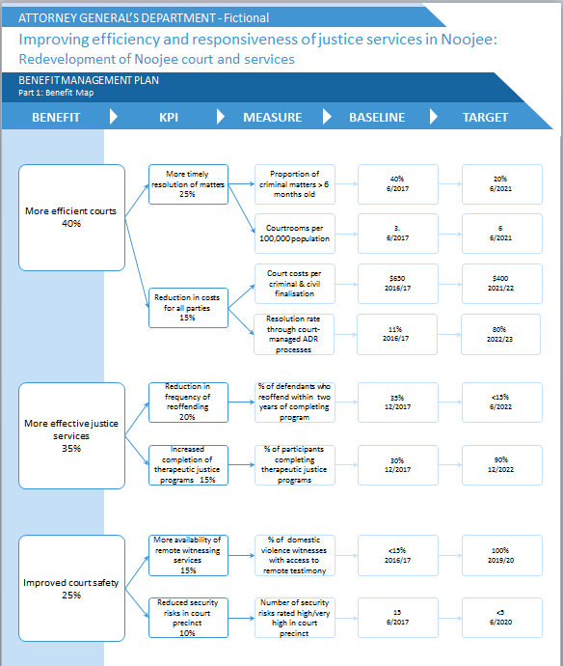

- Benefits – checklist
To assess the extent to which you have specified the benefits, consider the extent to which you have answered the following questions. It is not vital at this stage of your investment to confidently answer all the questions below. However, where you cannot do so you should explain why it is not possible to answer the question at this time, or why it is not material to the case for your proposal, and justify that the problem is nonetheless worthy of further consideration.

Table 3 Investment decision-maker’s checklist – benefits
Benefits – Investment decision-maker’s checklist
5. Have the benefits that will result from fixing the problem been adequately defined? | Yes Maybe No Not sure
6. Are the benefits of high value to the Government? | Yes Maybe No Not sure
7. Are the KPIs SMART and will they provide strong evidence that the benefits have been delivered? | Yes Maybe No Not sure
8. Have the sources of uncertainty and key dependencies critical to benefit delivery been considered? | Yes Maybe No Not sure

- Use of the IMS during this stage
If you are using the IMS to assist with the preparation of your submission, the associated tool at this stage is the benefits definition workshop. When led by an accredited facilitator this provides an efficient means for succinctly capturing the benefits. For further information see the IMS website at www.dtf.vic.gov.au/investmentmanagement.
- Step 3: Investigate the response options to the problem
Each time there is a need to consider a new investment there is also an opportunity to improve the way things will be done in future. Instead of just solving problems the way they were solved ‘last time’ there is an opportunity to consider innovative approaches that are better and cheaper.
Therefore, before considering what project solutions are available to address a problem, you should first identify and explore a range of possible response options. Response options differ from project options. Response options are one or a mix of high-level interventions that could be taken to respond to an identified problem. Potential interventions are identified by exploring a range of alternatives under the following headings:
- change demand (e.g. measures to reduce demand for services);
- improve productivity (e.g. change service delivery mechanisms); and
- change supply (e.g. add capacity to meet increased demand).
Interventions can be implemented via:
- Non-asset investments: to deliver new or additional service capacity without creating the need for additional assets;
- Asset enhancements: using operational and non-operational assets to meet the need, including but not limited to:
  - re-purposing assets;
  - improving, optimising and re-examining operations and maintenance strategies to improve productivity and performance of current assets; and
  - improving the performance of assets through modification/upgrade, enhancement, life extension, sustainability, de-bottlenecking and supply chain strategies.
- New asset acquisition: only investing in the development or procurement of new assets that are required to support service delivery objectives.
- Market-based solutions: that use market mechanisms such as pricing, property rights and competition to solve common problems. Some examples of market based solutions are:
  - pricing to manage demand e.g. user charges;
  - introducing competition into government service delivery e.g. through private sector provision; and
  - implementing incentive structures for purchasing or service delivery arrangements.
Any intervention should be developed following consideration of benchmarks to inform expected performance and value for money outcomes.
Only after you have identified a preferred response should you consider project options. Project options explore how the preferred strategic response might be implemented. They might be business changes that could be made or assets that could be acquired as a way of delivering the benefits expected from an investment (as specified in a benefit management plan), or involve a combination of non-–asset and asset responses. These must be consistent with the identified strategic response.
However, at this stage of the analysis you are asked to focus solely on the response to the identified problem, project options will be addressed later in your analysis.
At the response step of the conceptualise stage, agencies should be able to:
- define the method and criteria used to select, assess and rank response options identified;
- describe each response option considered;
- List (by way of appendix if appropriate) any response options that were considered but then removed from consideration prior to the response options analysis. Provide a justification if appropriate.
- outline the response options analysis process that was undertaken;
- demonstrate that response options considered were each feasible and ranked fairly in arriving at the preferred response; and
- ensure the preferred response is clearly outlined.
This process can be summarised as follows:

Step 3.1: Identify potential interventions
Most investments in government are directed at increasing the supply of some service – roads, hospitals, schools, etc. The purpose of step 1 is to get everyone to think more broadly about what interventions could be taken to respond to a problem instead of trying to justify a predetermined supply solution. An exploration of interventions that starts at the level of strategy allows for a wider field of responses to be considered. In exploring possible interventions, consider broadly the ways the problem could be addressed by (but not limited to):
- changing demand;
- improving productivity; and
- changing supply.

Step 3.2: Select response options
The purpose of this step is to use the list of interventions developed in step 3.1 to create a range of response options. This is done by grouping one or a number of interventions that, together, effectively address the benefits sought by your investment. This grouping becomes a ‘response option’.

Step 3.3: Evaluate response options
The purpose of this step is to:
- evaluate each of the response options identified in the previous step against the five criteria (benefits, cost, time, risk and dis-benefits);
- rank the options and decide the preferred response option; and
- decide which of the non-preferred options should also be subjected to further study, for example, if the assumptions underlying the preferred option prove to be invalid.
The examination of interventions, their packaging into response options, and their evaluation, can be done as per the fictional example below.
- Use of the IMS during this stage
If using the IMS to assist with the preparation of your submission, the associated tool is the response options analysis workshop. When led by an accredited facilitator this provides an efficient means for succinctly analysing high level options for solving the problem. For further information see the IMS website http://www.dtf.vic.gov.au/Investment-Planning-and-Evaluation/Understanding-investment-planning-and-review/What-is-the-investment-management-standard/Applications-of-the-investment-management-standard.
The IMS’s response options analysis tool places the exploration of the best response within the ‘line of enquiry’ as depicted below. There are three individual steps within this discussion:
Figure 3: IMS approach to arriving at the best response
Solution definition?
Strategic response
Benefit
definition
Problem
definition
Step 3.3

Evaluate
response options
Step 3.2

Select
response options
Step 3.1

Identity potential interventions

Response options analysis (fictional example)
Interventions
Potential interventions are as follows:
• Maintain current court building, capacity and level of operations
Divert portion of caseload to other regional courts with spare capacity
Develop community education programs and diversion strategies to resolve matters through non-court channels
Enhance in-court technology to support more remote-witnessing and digital evidence presentation
Expand capability to provide more diverse responses in criminal and civil matters
Provide additional space and reconfigure existing facilities to support a wider range of justice services
Improve physical separation between parties and court activities

These interventions are combined into a range of high level response options and evaluated in the following analysis.
Table Response options
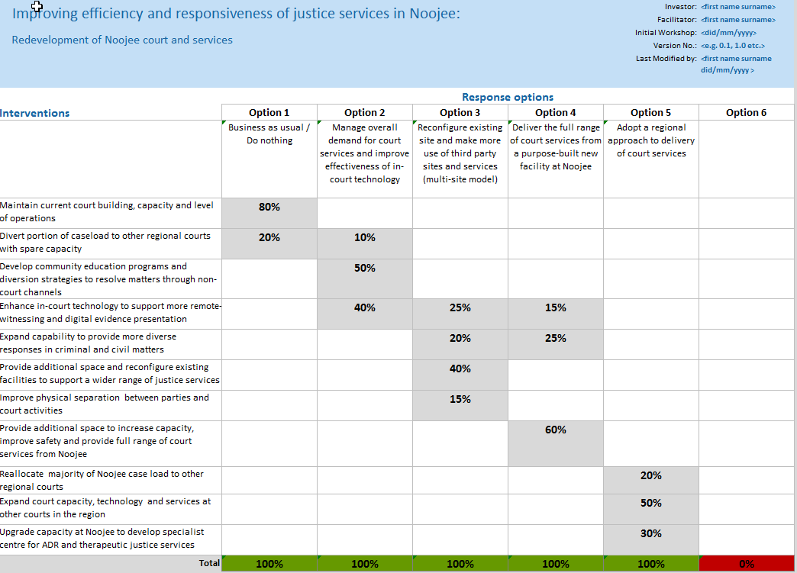

Evaluation of response options (fictional example)

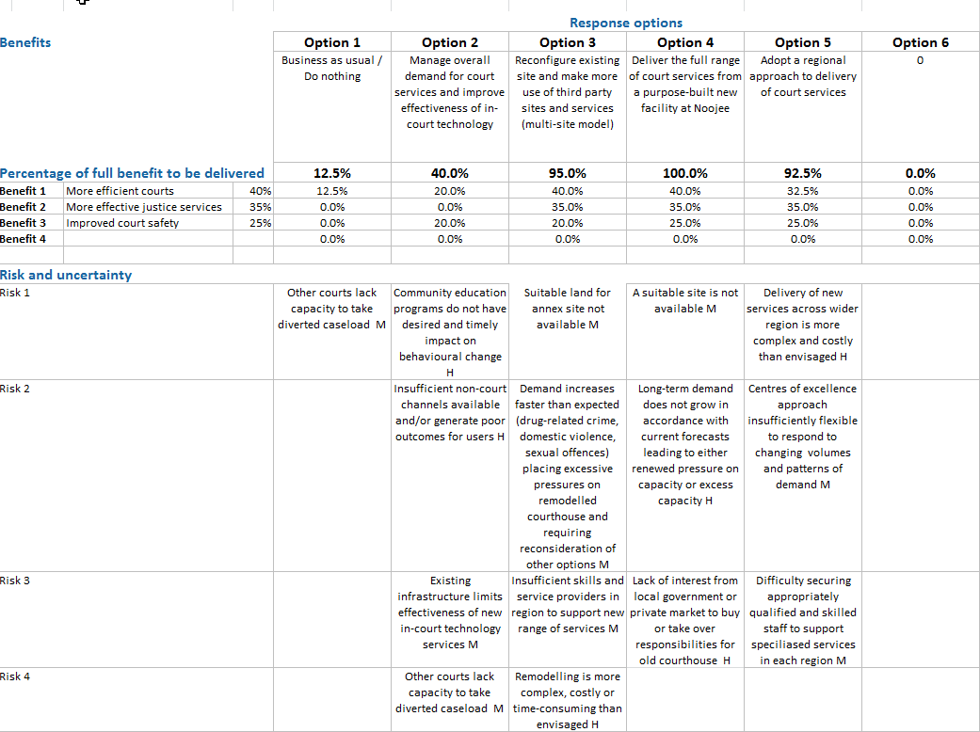

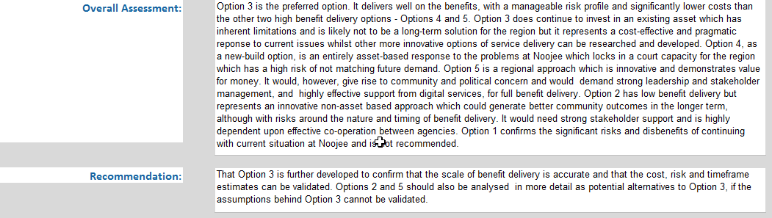
- Response options – checklist
To assess the extent to which you have explored the most appropriate response options, consider the way you have answered the following questions. It is not vital at this stage of your investment to confidently answer all the questions below. However, where you cannot do so you should explain why it is not possible to answer the question at this time, or why it is not material to the case for your proposal, and justify that the problem is nonetheless worthy of further consideration.
Table 4 Investment decision-maker’s checklist – strategic response
Response options – Investment decision-maker’s checklist
9. Has a reasonable spread of interventions been identified and packaged into sensible response options? | Yes Maybe No Not sure
10. Is there evidence to demonstrate that the response options are feasible and can respond to future uncertainty? | Yes Maybe No Not sure
11. Were the response options evaluated fairly to reflect their ability to respond to the problem and deliver the benefits? | Yes Maybe No Not sure
12. Is the preferred response option the most effective way to address the problem and deliver the benefits? | Yes Maybe No Not sure

- Step 4: Develop the indicative solution
It is likely that there are several ways to implement the recommended response option as a project (business changes and/or assets). This step involves identifying the best way to do so. The efficiency and cost-effectiveness of the various project options should be evaluated to identify a recommended solution.
Because the conceptualise stage is mostly concerned with the question, ‘Is it the right thing to be investing in?’, agencies would not be expected to provide the level of detail about the project options, or the recommended project solution that is required for a proposal to be endorsed for funding (i.e. at full business case stage).
At the conceptualise stage, agencies should:
- Develop a general idea of the best way to deliver the recommended project option in practical terms by expanding out the recommended strategic option into a short-list of project options, including a clearly defined base case.
- Nominate the recommended project option (which is only indicative at this stage, and not necessarily the final position).
- At a high level, agencies may consider the likely cost implications (see Guidance on Costing, below), procurement, affected stakeholders, key risks, and governance associated with the indicative recommended project option.
- Agencies should also reflect on what they don’t yet know about the recommended project option(s), and how they intend to address this information gap in the full business case.
Note, at least three project options are expected to be thoroughly analysed in the full business case.

Guidance on costing
For an outline of the difference in costing information requirements between a preliminary business case and strategic assessment, please see 4.1 below.
Cost estimates for potential investments are an important component of the conceptualise stage. While it is recognised that this is an early stage of an investment’s development, the cost estimates should be sufficiently reliable to provide an ‘order of magnitude’ of the final cost, expressed as a cost range ($x-$y million) The cost estimate will be used as a component of the analysis to determine which project investment options should be considered further in the full business case.
The estimated full capital cost of the investment should be included with a brief description outlining the basis for this estimate and any key cost assumptions. Where the proposal will result in substantial changes to output costs (increase or decrease) the estimated impact should be addressed.
In providing the estimate, agencies should outline any existing capabilities that can be used to complement/subsidise the investment value. Any likely Commonwealth support and/or private investment or in-kind contribution that may reduce the state’s contribution should be outlined.
In the fictional example, access to equipment or provision of equipment by the local Timber industry association might be considered.
Practically, examples of the ways in which this cost can be estimated include approaches such as:
- benchmarking against other facilities if other similar work has been undertaken before (domestically and internationally);
- reviewing functional specifications or early concept drawings by suitably qualified cost estimators such as quantity surveyors; and/or
- building up of costs by internal or external experts based on initial information (possibly using components such as industry accepted rates or reliable unit costs such as cost/km).
Other approaches that provide a reasonable level of certainty at an early stage could also be used.
For further guidance on cost accuracy in relation to the investment lifecycle, please see section 4.2 of the overview guideline.
- Use of the IMS during this stage
If using the IMS in the development of your submission, the associated tool at this stage is the solution definition workshop. When led by an accredited facilitator this provides an efficient means for identifying and filtering the project options.

Project options (fictional example)
Project options considered
There is a range of practical ways to deliver the recommended response option. At this stage of the analysis, the department has identified the potential elements of the project option but has not yet resolved how they would fit together, and in what proportions.
A full evaluation of the project options will be presented in the full business case.
- Indicative solution – checklist
To assess the extent to which agencies have specified the high-level indicative solution, consider the extent to which agencies have answered the following questions. It is not vital at this stage of the investment to confidently answer the questions below. However, where you cannot do so you should explain why it is not possible to answer the question at this time, or why it is not material to the case for your proposal, and justify that the problem is nonetheless worthy of further consideration.
Table 5 Investment decision-maker’s checklist – indicative solution
Indicative solution – Investment decision-maker’s checklist
13. Consistent with the preferred response option, has a reasonable spread of project options been analysed? | Yes Maybe No Not sure
14. Is the recommended project solution the best value for money action, and have opportunities for building flexibility to deal with uncertainty been considered? | Yes Maybe No Not sure
15. Is the solution specified clearly and fully and have opportunities for adding value been identified and costed? (all business changes and assets) | Yes Maybe No Not sure
16. Can the solution really be delivered (cost, risk, timeframes etc.)? | Yes Maybe No Not sure

- Scalability – strategic assessment vs. preliminary business case
Table 6 presents the analysis agencies should undertake when building a strategic assessment or a preliminary business case.
The differing level of detail between a strategic assessment and a preliminary business case is explained by reference to the fictional examples of each, linked to this guideline. Use your judgement to choose the appropriate level of evidence provided in a strategic assessment or preliminary business case. The depth of evidence should be appropriate to the nature, size and complexity of the investment and should be assessed on a case-by-case basis.
- Required depth of analysis
Table 6: Minimum analysis required for a strategic assessment or a preliminary business case

Table xx: Table heading
Heading | Heading
R1C1 | R1C2
R2C1 | R2C2
R3C1 | R3C2
Section heading
R4C1 | R4C2
R5C1 | R5C2
R6C1 | R6C2

Heading | Strategic assessment  (approximately 5 to 10 pages plus attachments) | Preliminary business case  (size depends on nature and complexity of proposal)
Executive summary | Explain the proposal in narrative terms, generally following the main points of the body of the strategic assessment.  For efficiency minimise duplicating the body of the report. | One-page summary of the proposed investment.  Explain the proposal in narrative terms, generally following main points of the body of the preliminary business case.  For efficiency minimise duplicating the body of the report.
Part 1 Problem |  | This section should be as long as is needed to provide the required information, which may be up to 5 pages.
1.1 Definition of problem | Explain in plain English in less than one page the problems that the investment is intended to solve in the context of the current service levels.  Present the cause of each problem, who is affected, and how they are affected. | As per the strategic assessment.
1.2 Evidence of the problem | Provide the evidence of both the cause and effect of the problem.  Detailed quantitative evidence is not sought, but other facts or examples of the problem can be helpful. | Provide the evidence of both the cause and effect of the problem.  Evidence might include, for example:  - demand forecasts with assumptions;  - KPIs on current performance levels; and  - facts/examples of the problem.
1.3 Timing considerations | Briefly explain why the problem should be solved by government now rather than later. | Describe why the problem needs to be solved at this time.  Explain the implications of delaying a response to the defined problem.
1.4 Consideration of the broader context | Explain whether similar needs exist either inside or outside your organisation that might be addressed together with this proposal. | As per the strategic assessment.
Part 2 Benefits |  | This section should be as long as is needed to provide the required information, which may be around two pages.
2.1 Benefits to be delivered | Explain the key benefits (drawn from the Investment Logic Map and Benefit Map) that flow if the problem is solved. Also note any dis-benefits. | As per the strategic assessment.
2.2 Importance of the benefits to Government | Outline how or why the benefits reflect government and/or organisational policies, objectives or priorities. | Show how this investment will help to advance the organisation to meet its objectives.  Describe how this initiative connects to government and/or organisational priorities and the department’s strategic plans.  List the key high-level economic, social and environmental benefits this initiative will deliver.  Describe also any detriments that will arise from this proposal.
2.3 Evidence of benefit delivery | Define the measures to be used to show whether the benefits have been delivered. | Define the measures to be used to show whether the benefits have been delivered, including:  - KPIs that will be used to measure the delivery of the benefits;  - baseline, interim and target measures and dates for the KPIs; and  - person/position responsible for delivering the benefits, and the forum in which they will be reported.  Some of this information can be presented in an appended benefit management plan.
2.4 Interdependencies | Outline any key interdependencies critical to benefit delivery. | As per the strategic assessment.
Part 3 Response Options |  | This section should be as long as is needed to provide the required information, which may be around four to eight pages.
3.1 Method and criteria | Specify the method and criteria used to select assess and rank response options, including assumptions. | As per the strategic assessment.
3.2 Strategic options analysis | Explain the response options analysis process undertaken. Specifically, explain potential interventions, packaged them into sensible groupings and analysed them to arrive at the recommended response. | interventions: Explain potential interventions  Response options: Explain how the potential interventions can be packaged into response options.  List (by way of appendix of appropriate) any response options that were considered but then removed from consideration prior to the response options analysis. Provide a justification if appropriate.  Ranking of response options: Evaluate the response options to determine the recommended response.
3.3 Recommended response | Present the recommended response. | Present the recommended response.
Part 4 Solution |  | This section should be as long as is needed to provide the required information, which may be around five pages.
4.1 Project options considered | Describe the potential project options embraced by the response.  Shortlist the preferred project options (including a base case).  Nominate the recommended project option. | Describe the potential project options embraced by the response.  Shortlist the preferred project options (including a base case).  Provide evidence supporting the selection of the recommended project option.
4.2 Details of the solution | Describe the recommended solution. | Describe the recommended solution.  Describe each of the changes and assets that will be required (as depicted in the Investment Logic Map).
4.3 Cost estimates | Provide high-level cost for the recommended solution expressed as a cost range ($x million -$y million).  An indicative estimate of the cost of the investment should be included with a brief description outlining the basis for this estimate and any key cost assumptions.  Where the project will also have an operating impact, you should also provide estimates of the changes to ongoing operating costs. | The cost estimates should be sufficiently reliable to provide an ‘order of magnitude’ of the final cost. The cost estimate will be used as a component of the analysis to determine which project investment options should be considered further in the full business case.  Estimated capital costs should be provided with a brief description including:  - the estimated range of TEI;  - the basis for this estimate;  - outline of cost inclusions/exclusions consistent with scope; and  - cost assumptions that were used.  Where the project will also have an operating impact, you should also provide estimates of the changes to ongoing operating costs.
4.4 Procurement strategy | If known, nominate the anticipated procurement method. Evidence for its selection is not required. | Nominate the anticipated procurement method. Evidence for its selection is not required.
4.5 Stakeholders | Map the key stakeholders, their particular interests in relation to the recommended solution. Note it is not expected that agencies have consulted with all stakeholders at this time. | Map the key stakeholders, their particular interests and likely position in relation to the recommended solution. Present a brief overview of the stakeholder communications plan. Note it is not expected that agencies have consulted with all stakeholders at this time. Note it is not expected that agencies have consulted with all stakeholders at this time.
4.6 Risk management | List the key risks to the success of this investment (refer to the investment concept brief). | List the key risks to the success of this investment (refer to the investment concept brief).  Explain how these risks are to be managed.
4.7 Governance arrangements | Outline governance arrangements in place to progress this proposal next stage. | Outline governance arrangements in place to progress this proposal next stage.  Outline any existing governance frameworks that the recommended solution could align with.
4.8 Timelines | Identify any key timelines. | List the major deliverables and their delivery timelines (refer to the investment concept brief).
4.9 Next steps | Explain key areas of uncertainty to be resolved in Stage 2: Prove. | As per the strategic assessment.
Appendices
Appendix A | Investment concept brief (including Investment Logic Map). | As per the strategic assessment.
Appendix B | Benefit map. | Benefit map.  Benefit management plan.
Appendix C | Response options analysis report | Response options analysis report

- Glossary
Asset Management Accountability Framework: Establishes the asset management requirements for government departments and agencies. It is premised on a non-prescriptive, devolved accountability model of asset management.
Appraisal: The process of defining objectives, examining options and weighing up the costs, benefits, risks and uncertainties of those options before a decision is made.
Asset option: A means of satisfying service needs by investing in existing assets or creating new assets.
Assets: Any physical asset that must be acquired to enable the identified changes to occur. Examples of these are hospitals, pipelines, plants or computer systems.
Base case: The base case is a realistic option that involves the minimum expenditure to sustain existing standards of service delivery or to achieve previously agreed service standards. Therefore, the base case does not always mean ‘do nothing’; rather, it is the minimum essential expenditure option (e.g. carrying out obligatory works to meet safety and health regulations).
Benefit: The value that resolving the problem will provide to the organisation or its customers and consequently to government. Benefits are normally a positive consequence of responding to the identified problem. Each claimed benefit must be supported by key performance indicators (KPIs) that demonstrate the specific contribution of an investment to the benefits sought by the organisation. The practical application of this can be seen in the Benefit Framework.
Benefit management plan: A short document that specifies the benefits an investment will need to deliver to successfully address an identified problem. It includes the measures to be used as evidence that the benefits have been delivered. These measures are initially used to select the most suitable response to the problem. The benefits management plan also defines the dates the benefits are expected to be delivered, who is responsible for their delivery and how they will be reported.
Benefit reports: Regular reporting of the delivery of benefits, which are tracked and reported consistently with the benefit management plan.
Capital expenditure: Expenditure involved in creating or upgrading assets.
Change: The things that must be done by the business if the benefits are to be delivered. The changes provide detail of how the strategic response will be implemented to action the benefits.
Concept assessment: The phase of the project lifecycle during which a need is translated, where justified, into a proposal where outcomes, purpose, critical success factors and the level of strategic alignment are clearly defined.
Conceptualise stage: A precursor to the full business case, the strategic assessment is a high-level process that translates an investment concept into a robust proposal that demonstrates policy and strategic merit. It is intended as a cost-effective (around 1–5 per cent of the cost of a full business case) high-level decision-making process to allow decision-makers to consider the merits of a proposal and to determine whether the investment warrants further development. Undertaking the conceptualise stage is intended to provide decision-makers with a high degree of confidence that the investment they are considering responds to an immediate problem or need, has valuable benefits to the organisation, and is the right way and right thing to be investing in.
Cost: An expense incurred in the production of outputs.
Cost-benefit analysis: A technique that can express in a comparable (monetary) way the net effect of the costs and benefits associated with an investment proposal.
Demand management: A management technique used to identify and control demand for services.
Depreciation: The allocation of the cost of an asset over the years of its useful life.
Dis-benefits: A negative impact that is likely to occur as a direct consequence of successfully implementing a particular solution.
Disposal: The process in which an asset is disposed of or decommissioned – resulting in removal from an entity’s balance sheet.
Dis-benefit: A negative impact that might occur as a direct consequence of implementing a particular solution.
Economic cost (or opportunity cost): The value of the most valuable of alternative uses.
Enabling asset: Any physical asset that must be built or purchased for the identified changes to occur. This may be, for example, a hospital, a pipeline or an ICT system.
Evaluation: The process of defining objectives, examining options and weighing up the costs and benefits before a decision is made to proceed.
Financial analysis: An investment evaluation technique that is confined to the cash-flow implications of alternative options and is undertaken from the perspective of the individual department or agency or government as a whole.
Full business case: A document that forms the basis of advice for executive decision making for an investment. It is a documented proposal to meet a clearly established service requirement. It considers alternative solutions, and identifies assumptions, benefits, costs and risks. The development of the business case is based on a clear statement of the problem and benefits from addressing that problem.
Gateway review process: A review of a procurement project or a program of works/activities carried out at critical points of a project/program’s development by a team of experienced people, independent of the project team. These critical points are known as Gateways or Gates. There are six gateways during the lifecycle of a project and reoccurring program reviews for programs of works/activities.
High Value High Risk framework: A project will be classified as HVHR if it is a budget-funded projects that is:
- considered high risk using an updated PPM;
- considered medium risk with a TEI of between $100 million and $250 million;
- considered low risk but has a TEI over $250 million; or
- identified by Government as warranting the rigour applied to HVHR investments.
Impact: The cost, benefit or risk (either financial or socioeconomic) arising from an investment option.
Investment: The commitment of the resources of an organisation with the expectation of receiving a benefit.
Investment concept brief: A two-page document that shows the logic underpinning an investment and identifies the likely costs, risks, dependencies and deliverables of the proposed solution. It summarises the merits of an investment and allows decision-makers to prioritise competing investments before proceeding to the business case.
Investment decision-maker’s checklist: A tool that assists in shaping a robust business case. It is also used by DTF and DPC to assess business cases.
Investment logic map: A simple single-page depiction of the logic that underpins an investment. It provides the core focus for an investment and is modified to reflect any changes to the investment logic throughout its lifecycle.
Investment Management Standard: A best-practice approach applied over the life of an investment that aims to reduce the risk of investment failure, provide greater value-for-money and drive better outcomes. It has been designed to enable the investor to shape and control investments throughout their lifecycle.
Investment reviews: Formal scheduled periodic reviews that aim to confirm that the logic for an investment remains valid.
Investor: The person who has an identified business problem (or opportunity), will be responsible for making (or advocating) a decision to investment, and who will be responsible for delivering the expected benefits. This person is often referred to as the ‘senior responsible owner’.
Lifecycle cost: The total cost of an item or system over its full life. It includes the cost of development, production, ownership (operation, maintenance, support) and disposal, if applicable.
Long-term planning: Outlines an agency’s long-term strategic vision and objectives for service delivery. It considers evolving demand and supply inputs for services and impacts of change on service delivery requirements. It also outlines the agency’s preferred responses to manage and adapt to change.
Key performance indicator (KPI): An indicator that, with its associated measures and targets, will provide evidence that expected benefits have been delivered. The KPI selection criteria is used to determine the most suitable KPIs.
New asset option: Acquisition, transfer or commissioning of an existing asset, or creation of a new asset.
Non-asset option: Under this option, service capacity is met without creating additional assets. This could be done through reconfiguration of the way the services are provided (contracting out, increased use of existing or private assets, or reduction of demand through selective targeting).
Optimism bias: This describes the tendency for base capital and operating costs, works duration and risks to be systematically underestimated during the business case development phase. This results in project budgets based on an optimistic outcome rather than on a rational weighting of gains, losses and the considered likelihood that adverse hazard events may impact on the project.
Partnerships Victoria: The Victorian framework for a whole-of-government approach to providing public infrastructure and related services through public–private partnerships.
The policy focuses on whole-of-life costing and full consideration of project risks and optimal risk allocation between the public and private sectors. There is a clear approach to value for money assessment and the public interest is protected by a formal public interest test and the retention of ‘core’ public services. Partnerships Victoria is most useful for major and complex capital projects with opportunities for innovation and risk transfer.
Preliminary business case: A precursor to the full business case required for HVHR projects. For a minimal cost (around 10–20 per cent of the cost of a full business case) the preliminary business case provides enough evidence to enable decision-makers to decide:
- Is this the right thing to invest in? (with a high level of certainty); and
- Can it be successfully delivered? (with a lower level of certainty).
Problem: The reason a new investment needs to be considered. It is effectively the ‘call to action’ for the investment. A lost opportunity or service need is considered to be a problem. Each problem statement is written in plain English and must communicate both what is broken or needed, and associated implications. In other words, the ‘problem’ should include both cause and effect.
Project alliancing: A form of procurement where the State or another government entity collaborates with one or more service providers to share the risks and responsibilities in delivering the capital phase of a project. It seeks to provide better value for money and improved project outcomes through a more integrated approach between the public and private sectors in the delivery of infrastructure. Project alliancing should generally only be considered in the delivery of complex and high-risk infrastructure projects, where risks are unpredictable and best managed collectively.
Project lifecycle: The stages of an asset between the identification of the need and the delivery and handover of an initiative.
Project option: These explore how the preferred strategic response might be implemented. They might be business changes that could be made or assets that could be acquired as a way of delivering the benefits expected from an investment (as specified in a benefit management plan). These must be consistent with the identified strategic response.
Project options analysis: A process in which a range of project options (both asset and non-asset) are evaluated. The most cost-effective options are then selected for more detailed evaluation through a business case.
Project profile model (PPM): DTF’s risk-based matrix used to inform whether or not a project should be subject to the High Value or High Risk Project Assurance Framework.
Proposal: An idea for a policy, program or project that is under development and appraisal.
Recommended solution: The set of business changes and assets (project or program) that have been identified as the best option for responding to the identified problem based on value for money and the benefits that will be delivered.
Recommended action plan: In order to maintain the two core principles of the confidentiality and non‐disclosure principles of the Gateway review process, a recommendation action plan (RAP) template was created. The RAP enables red flag recommendations from the Gateway report to be presented in a separate document for distribution to the Treasurer (via DTF), thus maintaining the overall confidentiality of the Gateway report. The RAP is used by projects to report risk mitigation responses to any red rated individual recommendations, without disclosing the overall assessment of the project and all recommendations.
Residual value: The net value applied to the asset at the end of the investment lifecycle or evaluation period; this may result in either a positive or a negative value.
Resources: Labour, materials and other inputs used to produce outputs.
Response option: comprises either one or a mix of strategic interventions.
Revenue: Inflows or other enhancements, or savings in outflows, of service potential or future economic benefits in the form of increases in assets or reductions in liabilities of the entity (other than those relating to contributions by owners) that result in an increase in equity during the reporting period.
Risk: Risk is often characterised by reference to potential events, consequences, or a combination of these, and how they can affect the successful deliver of the benefits expected of the investment. Risk is often expressed in terms of a combination of the consequences of an event or a change in circumstances, and the associated likelihood of occurrence.
Risk versus uncertainty: Uncertainty is the extent of variability in the capacity to achieve the desired outcomes or the outcomes themselves. Risks lead to uncertainty.
Scenario analysis: Scenario analysis is a procedure for providing the decision-maker with some information about the effect of risks and uncertainties on an investment. In a scenario analysis, a set of critical parameters and assumptions that define a particular scenario are identified and varied to reflect a best-case and a worst-case scenario.
Senior responsible owner (or project sponsor): The SRO is has accountability and responsibility for a project. The SRO is the effective link between the organisation’s senior executive body and the management of a project. The Sponsor is also a core member of the Project Steering Committee usually the Chair. In addition to being an experienced executive well versed in the details of organisational stakeholder and client requirements and relationships, the sponsor needs to have experience in project management.
Social benefit: The estimated direct increase in the welfare of society from an economic action. It is the sum of the benefit to the agent performing the action, plus the benefit accruing to society as a result of the action.
Social cost: The estimated direct total cost to society of an economic activity. It is the sum of the opportunity costs of the resources used by the agent carrying out the activity, plus any additional costs imposed on society from the activity.
Strategic intervention: The high level strategic action that could be taken as a response to the identified problem. A valid strategic intervention must have the potential to deliver some or all of the identified KPIs and their target measures. To ensure it is sufficiently high level, its implementation must also allow for more than one possible solution.
Strategic options analysis: Aims to identify and explore a range of possible strategic interventions to ‘the problem’ and determine the strategic response best suited to the need. The second aspect of the analysis is to explore a range of project options consistent with the preferred strategic response that will deliver the best result and provide a shortlist for detailed evaluation in the business case.
Value-for-Money: is a balanced benefit measure covering quality levels, performance standards, risk exposure, other policy effects and other considerations such as social and environmental impacts as well as cost. For capital assets, value for money should be assessed on a ‘whole of life’ or ‘total cost of ownership’ basis.
Value management: A technique that seeks to achieve optimum value for money, using a systematic review process. The essence of value management is a methodical study of all parts of the product or system to ensure that essential functional requirements are achieved at the lowest total cost. Value management examines the functions required from a product, functions actually performed, and roles of the product’s components in achieving the required level of performance. Creative alternatives that will provide the desired functions better or a lower cost can also be explored.
Weighting and scoring: A technique that assigns weights to criteria, and then scores options in terms of how well they perform against those weighted criteria. Weighted scores are summed, and then used to rank options.
Whole-of-life costs: Whole of Life costs are all additional costs required to achieve the investment outcomes over the life of the asset or service delivery. This includes all costs (and revenues) needed to design, develop (construct and/or install) and operate any new asset, along with the costs and revenues associated with any service provision. All costs can be discounted to a Net Present Value to enable fair financial comparison of one investment proposition with another. A Whole of Life cost appraisal is especially important in ensuring project teams consider the long term operational costs of a project and consequently provide a new capital asset (if required) which optimises these investment outcomes.

See DTF Website: http://www.dtf.vic.gov.au/Publications/Investment-planning-and-evaluation-publications/Lifecycle-guidance/Technical-guides
Note that the VCC Framework represents best practice for all projects. Practitioners are encouraged to consider the VCC opportunity presented by any project over $100 million. However, those projects that do not meet the above criteria, and do not offer a reasonable VCC opportunity will not be required to comply with the Framework.
New Zealand Treasury (2011) Better Business Cases for Capital Proposals Toolkit

