The Gateway Review Process
The Gateway Review Process examines programs and projects at key decision points. It aims to provide timely advice to the Senior Responsible Owner (SRO) as the person responsible for a program or project. A review provides the SRO with an independent view on the current progress of the program or project and assurance that it can proceed successfully to the next stage.
Given the aim is to help the SRO at key decision points, each review is short and focused on the work that is complete at the time. For the best result, a review is carried out shortly before a decicion is made to allow sufficient time for any recommendations to be implemented
About this workbook
This workbook supports Gateway Review 2: Business Case. This review investigates the business case and the proposed way forward to confirm the project is achievable and likely to deliver what is required. The review checks that:
- stakeholders approve the intended benefits from the project;
- the link with program and organisational objectives is clear; and
- the optimum balance of cost, benefits and risk has been identified.
This workbook describes the key products, appraisal questions and sources of further information, including best practices. It provides review teams with key questions to explore and suggested evidence to support those questions. Because each program or project is unique and circumstances change, the workbook should be used as a guide to the range of appropriate questions and evidence, not a complete checklist of mandatory items.
The business case
The project initiation process produces a case for the project, based on business needs and an assessment of the project’s likely costs and potential for success. This Gateway review comes after the business case has been prepared and before any development proposal goes before a project board, executive authority or Minister for authority to proceed.
The review focuses on the project’s business case. It provides assurance that the proposed approach to meeting the business requirement has been adequately researched and can be delivered. It also confirms the project benefits are identified at a high level and their achievement will be tracked using a defined measurement approach e.g. benefit management plan.

Figure 1: Overview of the Gateway Review Process
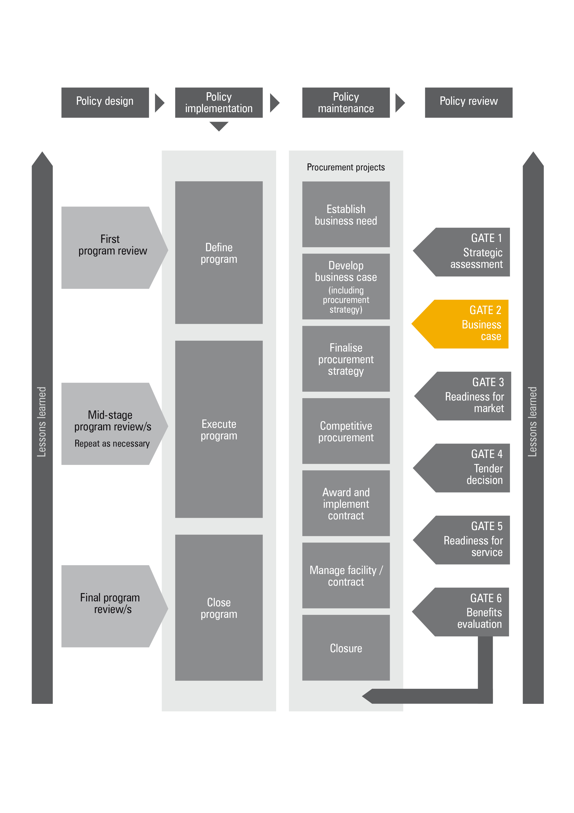

Figure 2: Applying the Gateway Review Process to different project
delivery methods

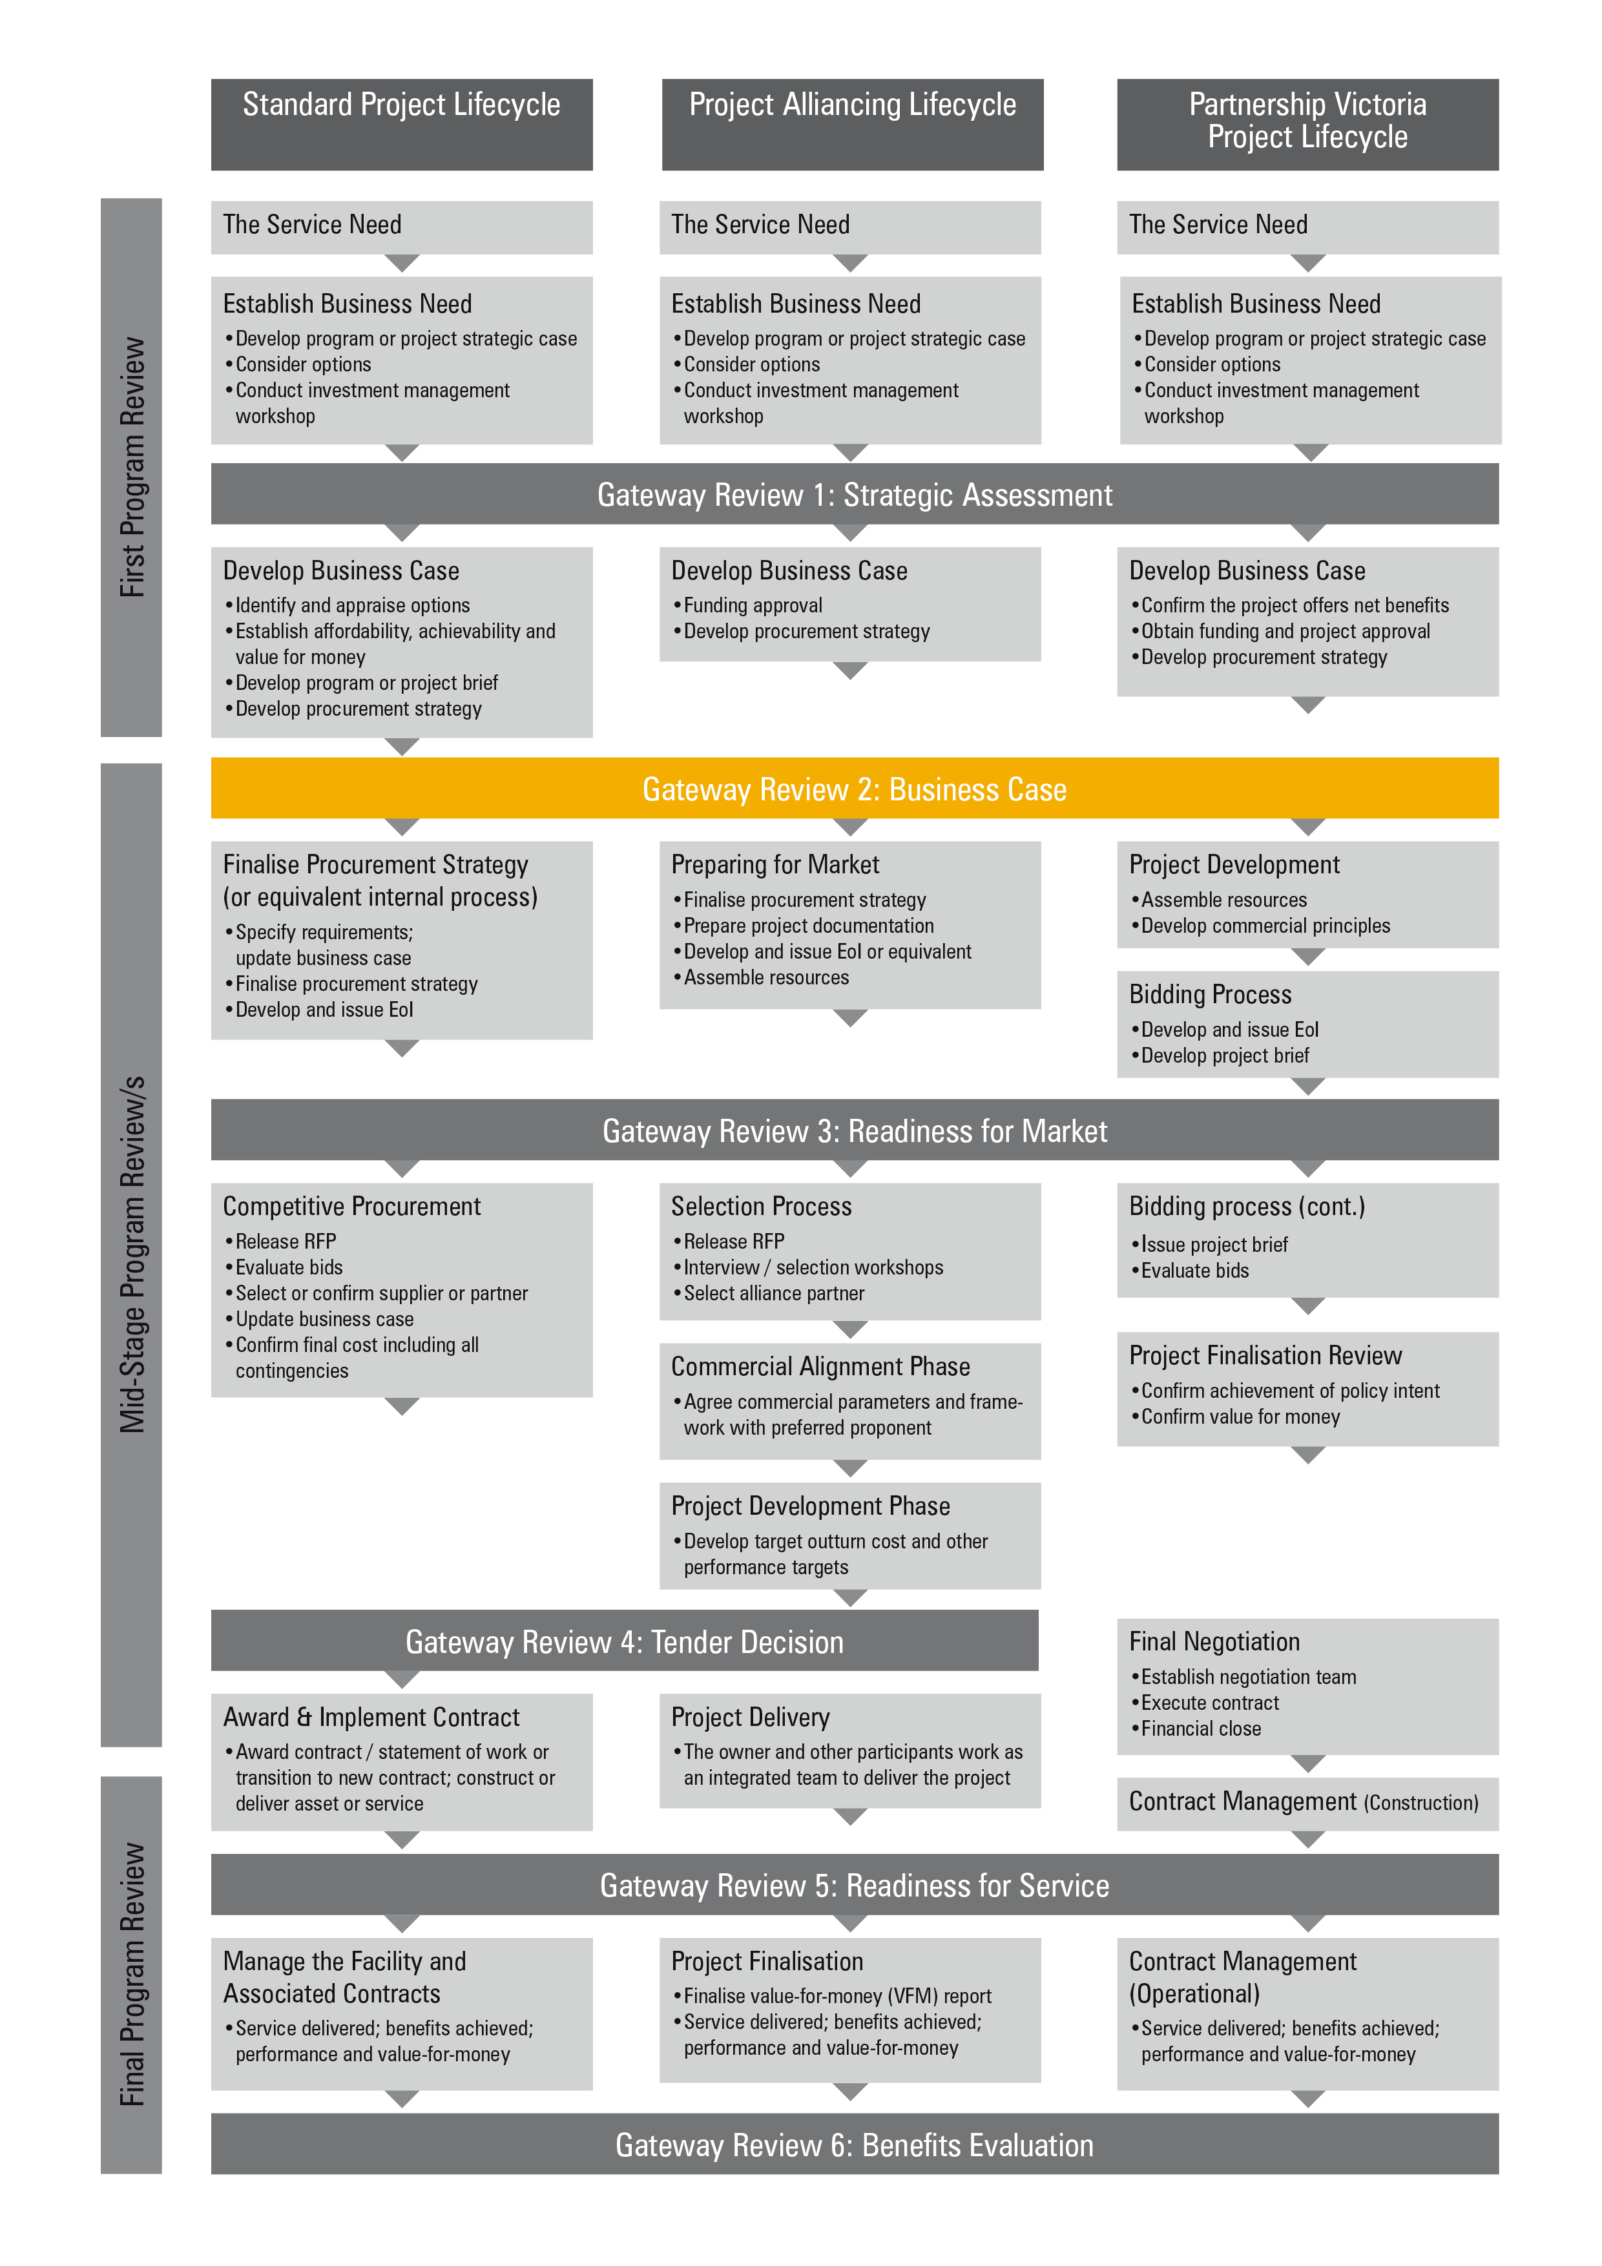

Gateway Review 2: Business case
The purpose of the Gateway Review 2 is to:
- confirm the business case is robust, that is, it meets the business need, is affordable, achievable, has appropriate options explored and is likely to achieve value-for-money;
- confirm potential options have been identified and analysed and expert advice has been obtained;
- confirm the underlying investment logic has been reflected and proven by evidence in the business case and the project remains aligned with the objectives and deliverables of the program and organisation;
- establish the feasibility study has been completed satisfactorily and a preferred way forward has been developed and decided in dialogue with the market;
- confirm the market’s likely interest has been investigated and appropriate high-level procurement stategies have been considered;
- ensure there is internal and external authority and support for the project;
- ensure the major investment and project level risks have been identified and outline risk management plans have been developed;
- establish the project is likely to deliver its business goals and that it supports wider business change;
- confirm the scope and requirements specifications are realistic and clear;
- ensure the full-scale, intended outcomes, timescales and impact of relevant external issues have been considered;
- ensure there are plans for the next stage, confirm planning assumptions and that the project team can deliver the next stage;
- confirm overarching and internal business and technical strategies have been considered; and
- confirm quality and benefit management plans are in place, including key performance indicators for the project and its outcomes.

Project documents
The areas of investigation and examples of evidence should be available before the Gateway review starts. The information is likely to be found in the documents suggested below, but may be located in other program or project documents or elsewhere in the organisation’s documentation system:
- the business case, addressing:
- the business need;
- affordability;
- achievability;
- value-for-money and the range of options;
- estimates of the project’s cost and benefits;
- a feasibility study;
- a sensitivity analysis;
- market sounding; and
- the preliminary procurement strategy.
- a project brief showing the project’s scope and the need for change;
- a project initiation document or equivalent;
- an investment logic map, benefit management plan and investment concept brief;
- a quality management strategy;
- the project approach, including how the intended outcome is delivered;
- a strategy outlining the approach to business change including staff training, new facilities, etc.;
- an initial assessment of the current and proposed physical and technical environment, e.g. information technology (IT) infrastructure and, workspace facilities;
- a cost report on the project to-date, against budget;
- a draft high-level definition of the business requirements and total scope of change;
- a definition of how to measure the project’s success;
- a communications strategy to keep stakeholders informed of the project’s progress;
- a list of the major risks, with draft plans for managing them;
- a high-level activity, time and resource plan for the whole project;
- plans to move the project to the next stage - Gateway Review 3: Readiness for Market;
- funds to cover all work to Gateway Review 3: Readiness for Market;
- the authority and approval to proceed or the process to achieve this;
- how performance is to be reported and monitored;
- project organisation – key roles and governance and/or reporting arrangements;
- for construction projects, design quality indicators; and
- identified business impacts for IT-enabled projects.

1. Policy context and strategic fit

Areas to probe | Evidence expected
1.1 Are all relevant government initiatives being addressed? | - the senior responsible owner (SRO) or equivalent is undertaking their responsibilities in relevant policy initiatives.
1.2 Does the preferred option meet wider government and organisational policies, strategic objectives, standards and business change programs? | - an assessment against a list of wider government objectives, standards and business change programs;  - an assessment against a list of current organisational strategy and business objectives and policy initiatives, confirmation of the role of the project in a wider policy or program initiative;  - an assessment of business justification as stated in the business case;  - account taken of relevant impact assessment and appraisal issues such as regulatory impact, sustainable development and environmental effects;  - for IT-enabled projects, compliance with e-government frameworks; consideration of information assurance requirements in relation to business objectives; compliance with IT security requirements; compliance with freedom of information and data privacy requirements; and  - for construction projects, the contribution to the property and/or workspace strategy; health and safety, sustainability and design quality is considered.
1.3 Have the internal and external factors affecting the project been identified and assessed? | - the initiative responds to the organisational objectives;  - an assessment of the objectives, timescales and scale of the project;  - legislation, policy and regulatory issues are considered;  - an assessment of the stability of the current business environment and strategic direction;  - an assessment of dependencies, e.g. other programs or projects that could affect current priorities;  - an assessments of the impact on the existing physical and technical environment, e.g. brownfield site, current infrastructure and legacy systems; and
 | - an assessment of the skills and knowledge required by the project for successful implementation, the availability of skills in the project team and access to external expertise; appropriate allocation of key project roles between internal staff and consultants or contractors.
1.4 Are the external stakeholder issues being addressed, such as:  - communications;  - public relations;  - social inclusion, e.g. equality and diversity issues;  - environmental issues;  - personnel; and  - statutory processes. | - plans for each stakeholder, showing responsibilities and roles in the project; and  - a demonstrated consultation and impact on the plans.
1.5 Is there an opportunity to integrate the program or project with other government initiatives? | - a demonstrated consultation with potential areas of related programs or service-delivery providers, related services or geographically aligned service provision; and  - specific integration features.

2. Business case and stakeholders

Areas to probe | Evidence expected
2.1 Is the business case complete and consistent with the Department of Treasury and Finance Investment Lifecycle guidelines? | - the documented preferred option demonstrates it is selected from a rigorously assessed wide range that satisfies the project objectives, including the contribution to the business strategy, is likely to offer value-for-money and is affordable and achievable;  - stakeholder views are adequately represented including the general public, if appropriate;  - objectives are clearly defined and expectations are realistic;  - appropriate expert advice has been sought; and  - the delivery strategy aligns with the overall organisational goal.
2.2 Is there a clear and agreed understanding of business objectives and how the project will deliver these? | - a complete investment logic map, benefits management plan and investment concept brief;  - business objectives for the project are clearly stated and specific, measurable, agreed, realistic and timely and meet the business needs of the organisation;  - a strategy for achieving business benefits is defined and agreed with the stakeholders;  - the scope, including timescales, is documented and agreed with stakeholders including end-users or their representatives and technical authorities;  - the scope and requirements specifications are realistic and clear;  - the delivery approach and mechanisms are defined and agreed with stakeholders;  - options are reviewed and a case made for their selection; and  - for IT-enabled projects: IT developments defined as component(s) of a wider program of business change and/or policy initiative.
2.3 What are the critical success factors, the essential areas of activity that must be performed well if the mission, objectives or goals of the project are to be achieved? | - details of the critical success factors for each of the main objectives; and  - a benefit management plan.
2.4 Can the critical success factors be quantified or measured? | - an explanation of how the factors will be measured and an identification of baseline measures;  - a definition of effective systems for measuring and tracking the realisation of benefits; and  - for construction projects, design quality indicators.
2.5 Have all the stakeholders been identified and their needs clearly understood? | - internal and external stakeholders identified and documented;  - stakeholders’ roles and responsibilities and their potential influence on the project defined and agreed;  - end-users for the project identified and documented;  - the decision-making process is inclusive of all the relevant stakeholders and is efficient and effective;  - results of consultations documented as part of project stakeholder engagement and/or communications strategy; and  - if the project crosses organisational boundaries, there are clear governance arrangements to ensure sustainable alignment with the business objectives of all organisations involved.
2.6 Do stakeholders support the preferred option, including the potential or recommended delivery approach and mechanisms? | - demonstrated stakeholder consultation, involvement, support and endorsement.
2.7 Has the business case examined a wide enough range of options for solution and delivery that will meet the business requirement? | - options explored for collaboration with other public sector organisations and programs or projects;  - an investment concept brief for each option;  - a rigorous assessment of the procurement options including a sound understanding of market capability;  - the advantages and disadvantages for each option are identified to determine its potential for meeting the critical success factors; and  - market sounding indicates that suitable solutions can be found.
2.8 Is there a clear best option, or would several options meet the business need? | - options appraised in accordance with principles outlined in the investment evaluation guidelines, Partnerships Victoria guidance material and/or the Department of Treasury and Finance project alliancing practitioner’s guide;  - options are ranked showing an examination of all options that are acceptable in principle;  - an examination of prioritised options as they relate to service requirements;  - carbon price impacts on the project have been appropriately considered and included in the cost benefit analysis;  - climate change impacts on the project have been appropriately considered, including the associated risk and/or uncertainty of these impacts;  - a clear analysis of whole-life costs for each option; and  - use of software metrics to test robustness of costs for information and ICT projects.
2.9 If there are several options, how was their robustness tested and was the selection process valid? | - a sensitivity analysis of all options;  - detail provided on the consequence of doing nothing; and  - the major sensitivities included in the list of identified risks.
2.10 Were whole-of-life costs and benefits analysed for all options? | - an assessment of operational and capital costs and a comparison using net present value analysis;  - the project has identified any actions that could cost-effectively reduce exposure to the carbon price; and  - a benefits management plan.
2.11 Will the project be attractive to the market? | - market sounding taken, including an examination of recent similar procurements by others and an indication of suitable suppliers available to deliver requirements;  - there is adequate capacity, capability and competitive interest in the market to meet the requirement;  - early supplier involvement to help determine and validate the outputs and outcomes sought for the project, including proof of concept exercises; and  - senior management is sufficiently engaged with the industry to be able to assess the supply risks.
2.12 Have contract management issues been considered? | - requirements for intelligent customer capability considered;  - arrangements for managing single and/or multiple suppliers considered;  - where multiple suppliers are likely to be appointed, there are high-level plans for managing the interfaces; and  - the appropriate relationship is determined and the optimum scale of contract(s) appropriately considered.
2.13 Have assumptions been identified and their validity checked? | - details of the assumptions that have been made and the basis for their use.
2.14 Has the project organisation been considered and is there an overall project management process? | - details of the project governance model or the proposed model to be used.

3. Risk management

Areas to probe | Evidence expected
3.1 Are there processes to identify, assess, allocate, manage and monitor current, anticipated and emerging risks and issues? | - a list of risks and key issues, categorised as strategic, political and/or reputational; legislative, implementation and operational service risks including business, technical, financial and commercial and/or contractual risks and:  - for IT-enabled projects, information security risks; for e-government, risks relating to poor take-up;  - for construction projects, risks relating to health and safety; and  - for policy projects, regulatory impact assessment carried out;  - a risk management strategy developed in accordance with best practice;  - an individual identified as responsible for managing risk across the project, mitigation options and contingency plans; and  - defined roles, responsibilities and processes for managing issues and risk with clearly defined routes for bringing issues and risks to the attention of senior management.
3.2 Have any issues raised in a previous review been resolved satisfactorily? | - details of actions taken and their outcomes.
3.3 Have the risks for each option been evaluated and has an opportunity for appropriate risk transfer been considered? | - current, emerging and anticipated risks classified by probability, impact, ownership, effect on the project and counter-measure, contingency and/or business continuity; and  - scope for a risk transfer opportunity analysis for different options, particularly delivery options.
3.4 Have the risks for the preferred option been fully assessed? | - involvement of senior stakeholders in assessing strategic risks;  - an assessment of risk, costs and benefits to show appropriate balance of risk and reward in the preferred option, demonstrating planned risk-taking and support for innovation; and  - plans for managing and allocating the risks associated with the preferred option through the contract(s).
3.5 Have the worst-case implications associated with these risks been assessed? | - risks financially assessed and risk allocation estimated.
3.6 Are the costs and time implications of managing the risks included in the cost and time estimate or treated as a contingency? | - costs and time for managing risks are separately identified;  - costs and time estimated for risk countermeasures and contingency and business continuity plans;  - where risks cannot be reduced, the costs of managing these risks are separately identified and included as a risk allocation provision;  - an analysis undertaken of the effects of slippage in time, cost, scope or quality; and  - for construction projects, decisions on how residual risks are managed.
3.7 Does the project break new ground in any area, i.e., is it iconic, novel or innovative? | - an examination of leading-edge projects to assess this project’s impact on the business, stakeholders and end-users;  - evidence of similar projects or activities from which lessons may be drawn;  - professional advisors have assessed innovative solutions;  - the market is consulted to help refine the approach, identify risks and risk mitigation methods;  - a defined approach to the management of change in the affected organisations; and  - sufficient account taken of the current organisational culture and leadership and organisational capability.
3.8 Should the project be broken down into a series of small steps? | - documentation of the chosen approach and a justification for making the decision; and  - the business case details any phased delivery or expected improvements over time.

4. Readiness for next phase: Readiness for market

Areas to probe | Evidence expected
4.1 Is there an overall project structure for the procurement stage? | - a definition of the project approach to be adopted; and  - an assessment of its suitability.
4.2 Is there a current and operational risk register? | - details of a framework to manage risk and a current register with identified risks.
4.3 Is there a realistic plan to reach Gateway Review 3: Readiness for market? | - objectives, planning assumptions, constraints, activities, quality plans, deliverables and milestones are defined and agreed for the next and remaining phases;  - an assessment of the validity of current assumptions;  - the project addresses short and long-term business requirements;  - suitable solutions are available from the market and it has sufficient capacity;  - for projects with a design phase such as construction projects, evidence the project timescale allows enough time for the development of the required design quality; and  - for IT-enabled projects, evidence of consideration of a proof of concept stage.
4.4 Have requirements for external specialist advice been determined? | - requirements for specialist expertise considered and resourced; and  - external advice used appropriately.
4.5 Are the necessary internal and external skills available at the right time and in the right numbers? | - a resource plan for internal staff, identification of the skills required for the next phase of the project and a skills appraisal and plans for addressing shortfalls;  - appropriate allocation of key project roles between internal staff and consultants or contractors; and  - the project team has requisite skills or access to specialist expertise.
4.6 Is there a training need, what is it and how is it being addressed? | - details of training assessment, plans and training sources.
4.7 Is the time plan for the next stage realistic and does it account for statutory lead times? | - a time plan identifying statutory lead times and a realistic assessment of the time needed for pre-procurement activities.  - senior management commitment to the time plan; and  - the time plan for delivery is justified and not longer than necessary.
4.8 Is there a clearly defined project organisation with agreed roles and responsibilities? | - details of project organisation and methodology;  - governance and/or reporting arrangements;  - named individuals in key positions, with appropriate skills, experience and status:  - senior responsible owner (SRO);  - project manager;  - project sponsor and/or project director;  - stakeholder representation;  - project board or project steering group;  - for construction projects, a design champion responsibility; a project sponsor and independent client adviser/s to support the SRO (note: a project manager may not always be required);  - for IT-enabled projects, chief information officer or equivalent role, an IT and/or information security manager and/or accreditor to support the SRO;  - for collaborative projects, a single SRO and senior representatives from each collaborating organisation; and  - if the project crosses organisational boundaries, clear governance arrangements to ensure a sustainable alignment of the business objectives of all organisations involved with clear lines of accountability and ownership.

Best practice sources

Source | Information
Investment management guidelines  See Investment management  www.dtf.vic.gov.au/investmentmanagement | - investment management standards  - investment logic maps  - investment concept briefs  - benefit management plans
Investment lifecycle guidance  See lifecycle guidance  www.lifecycleguidance.dtf.vic.gov.au | - business case development guidelines, including strategic assessment guidance  - procurement strategy guidelines  - project tendering guidelines  - risk management guidelines
Procurement advice, policy and guidelines  Victorian Government Purchasing Board  www.vgpb.vic.gov.au | - longer term contract management  - contract variations
PPP projects  for the National PPP policy and guidelines, see  www.infrastructureaustralia.gov.au  specific Partnerships Victoria requirements apply, see  www.partnerships.vic.gov.au. | - contract management policy and guidance material
Project alliancing  See Project alliancing  www.dtf.vic.gov.au | - Project Alliancing Practitioners Guide
Capital development guidelines  Department of Human Services  www.dhs.vic.gov.au/capdev  . | - contract administration  - commissioning of facilities  - managing contract occupational health and safety
Asset lifecycle  Department of Education and Early Childhood Development  www.education.vic.gov.au | - operations and maintenance
Information and Communications Technology (ICT) projects  www.mmv.vic.gov.au | - standard contracts  - whole of Victorian Government ICT contracts  - Government IT&T Policies 1–46
Victorian Government asset management series  Department of Treasury and Finance  http://home.vicnet.net.au/~assetman | - further information about commissioning assets  - other general information
Gateway Review Process  See www.gatewayreview.dtf.vic.gov.au | - Gateway Guidance material  - Becoming a Gateway reviewer

