2018-19 budget guidance – Budget paper No. 4 State Capital Program
This guidance outlines the Budget Paper No. 4 State Capital Program (BP4) information requirements for the general government sector.
Key dates
Monday 26 March 2018  (5pm) | Update project data (project title, revised estimated 2017‐18 remaining expenditure, completion date and footnote) on existing and completed projects in SRIMS.
Monday 9 April 2018  (5pm) | Departments to enter required information on new projects approved as part of the 2018-19 budget deliberations into SRIMS.
Friday 13 April 2018  (5pm) | Departments to provide final sign off to your DTF Relationship Manager confirming all BP4 data and footnotes are correct.

Contents
1. What’s new in 2018-19 1
2. Background/context 2
3. Projects with a TEI greater than $250 000 2
4. Projects with a TEI less than $250 000 3
5. Adding and updating project data in SRIMS 3
6. Capital projects location information 3
7. Published information in BP4 5
8. Departmental sign off 8
9. Further information & contact details 8
10. BP4 SRIMS guidance: Updating your asset data 9
    - What’s new in 2018-19
- Completed capital projects must include the following information (refer to sections 3.2 and 7):
  - total estimated investment;
  - estimated expenditure to 30 June; and
  - expected financial completion date.
    - Background/context
Budget Paper No. 4 State Capital Program summarises the capital projects the Government will be undertaking in 2018-19. It includes newly announced capital programs and projects, works already under way and programs or projects expected to finish by 30 June 2018.
It lists all general government (Chapter 2) and public non-financial corporation (Chapter 3) capital projects classified as either new, existing or completed according to the following definitions:
New projects | New capital initiatives announced in the 2018‐19 budget or since 2017-18 Budget Update.
Existing projects | Approved projects not anticipated to reach practical completion by 30 June 2018.
Completed projects | Approved projects that have reached, or are expected to reach, practical completion by 30 June 2018 , including the following additional information (NEW for 2018-19 budget):  - Total estimated investment;  - Estimated expenditure to 30 June; and  - Expected financial completion date.
    - Projects with a TEI greater than $250 000
For projects with a total estimated investment greater than $250 000, the following information is collected for each project according to the relevant project classification in BP4 as follows:
      - New and existing projects
Name of the project | BP4 publication title.
Approved total estimated investment (TEI) | Latest government approved gross capital project budget.
Estimated expenditure to 30 June 2018 (if any) | Latest estimate of project life to date capital expenditure up to 30 June 2018 that is in line with the latest update of financial information in SRIMS.
Estimated expenditure in 2018-19 | The latest estimate of project expenditure expected to occur in the 2018-19 financial year that is in line with the latest update of financial information in SRIMS.
Remaining expenditure in the years after 2018-19 | The total estimated project expenditure in all years after 2018-19. The total of the three estimated expenditure amounts needs to equal the approved TEI.
Estimated practical completion date | Defined as the completion of all of the major construction work.
Project cash flow | Should align with financial estimates in SRIMS. Any proposed cash flow changes should be discussed with your DTF contact. In the case that a cash flow change would be required, corresponding journals need to be submitted in SRIMS as well as being supported by a letter from the relevant Minister to the Treasurer.
      - Completed projects
Name of the project | BP4 publication title.
Approved total estimated investment (TEI) | Latest government approved gross capital project budget.
Estimated expenditure to 30 June 2018 (if any) | Latest estimate of project life to date capital expenditure up to 30 June 2018 that is in line with the latest update of financial information in SRIMS.
Estimated financial completion date | Defined as the end of warranty/defects liability period.
    - Projects with a TEI less than $250 000
For projects with a total estimated investment less than $250 000, each entity needs to provide consolidated data to ensure the BP4 project list equals the entity’s total cash flows from purchases of non‐financial assets.
Only the projects and amounts for Existing and New projects will be published in BP4.
    - Adding and updating project data in SRIMS
For SRIMS instructions refer to section 10.7 of this document.
Project data to produce BP4 will be sourced from SRIMS. A summary of the process for entering information on Existing and New projects is outlined as follows:
Existing projects | Each entity needs to update:  - project cash flows in line with any changes made to estimates as part of the non-policy forward estimates update;  - the estimated 2017-18 expenditure for Q1 & Q2 actuals (if not already completed) and Q3 & Q4 estimated expenditure; and  - any changes to expected completion dates.  The list of completed projects will be generated based on the data entered into SRIMS from the BP4 Project Category field.
New projects (internally funded by department) | Entities need to create project entries directly in SRIMS and load BP4 data consistent with the entity’s non-ERSC (self) funded capital expenditure.
New projects (Government funding approved by ERSC) | Relevant BP4 information for all projects approved for government funding will be transferred from the SRIMS budget module into the Asset Monitoring module once the ERSC minutes are approved.  Add additional data in the SRIMS Asset Monitoring module to enable BP4 to be produced.
    - Capital projects location information
For SRIMS instructions refer to section 10.5.
Locational data is required for all asset submissions, including assets linked to multiple regions. This information will be used in BP4, interactive maps online and media releases and required for all initiatives.
Street addresses are preferable but if street addresses are not known, you can enter the suburb(s) in SRIMS. In order to avoid further work in populating these fields subsequently, please ensure there are accurately populated with as much data as possible.
PLEASE NOTE: the department or agency head office address cannot be entered as the location unless the asset will be housed in the head office. There is a full list of location descriptions that can be used for non-specific locations. Submissions may be returned for correction if this is not provided accurately.
There are two tabs in SRIMS where locational information is required to be provided.
      - Under the Overview tab
Fields | Dropdown options: | Description of options
Region  (the physical location of the asset) | - Metropolitan  - Regional  - Statewide | - Greater metropolitan area of Melbourne  - Anywhere that is not Melbourne  - A service or asset to benefit all or a large proportion of Victoria
Area of Service  (the area(s) the asset will service) | - Statewide  - Metropolitan various  - Regional various  - Eastern metropolitan region  - North and west metropolitan region  - South metropolitan region  - Barwon-South Western region  - Gippsland region  - Grampians region  - Hume region  - Loddon Mallee region | Deciding the area of service requires a judgement as to what area will benefit most from the asset.  In some cases, the area of service will be the same as the location provided in the ‘Region’ field.  The statewide category includes initiatives/projects that will benefit multiple areas. The areas could be a combination of metropolitan and regional, or be located in one region but services a broader area (e.g. State Library of Victoria, while physically located in the metropolitan region its area of service is statewide).

      - Under the Location tab
There are two options for inputting information:
- Enter address(es) directly | A verified address will automatically populate additional information such as latitude, longitude, Local Government Area (LGA), etc.
- Import information via an excel spreadsheet | The spreadsheet should include all information such as latitude, longitude, LGA, suburb, etc.  This option can also be used in instances where only one category may be known, e.g. the suburb, LGA, Victorian Government Region, etc.
The fields that appear in SRIMS and an explanation of what these fields are or refer to are listed below. These sections will automatically populate if the address is directly added in SRIMS. If uploading via a spreadsheet, only the items populated in the spreadsheet will be uploaded into SRIMS.
SRIMS field: | Description / guidance
Ref # | Ensure the Ref # matches back to the Ref # in the Individual project expenditure grid under the Capital project tab.
Latitude and longitude | If uploading via a spreadsheet, this will need to be included. There are a number of websites that can be used to find this data.
LGA | An LGA is a municipal district, e.g. city, shire, etc. There are currently 79 Victorian LGA’s and these can be identified via the Victorian Electoral Commission website -> https://www.vec.vic.gov.au/ElectoralBoundaries/LocalCouncilMaps.html
Street name and street number | Street name and number that the asset and/or service will be located (department or agency head office address cannot be entered for this).
Street | Type of ‘street’, i.e. street, lane, road, avenue, crescent, etc.
Suburb | Name of a suburb(s) in Melbourne or a large rural town (as applicable) e.g. Lucas (Ballarat), Kangaroo Flat (Bendigo), Corio (Geelong).  Name of town e.g. Buninyong, Cohuna, Moe, Orbost.
Postcode and State | Refer to the Australia Post webpage ‘Find a postcode‘ if unknown.
Victorian Government Region | In most cases, this will be the same as what has been selected in the ‘Area of Service’ field under the Overview tab.
Tips:
Asset or service linked to multiple locations (e.g. roads, rail, etc) | List the suburbs and regions where the asset or service will pass through.
Minimal information is known about the location and is not a statewide initiative | Depending on the level of information known (e.g. a road, school and/or service to be located and/or benefit one or more areas that have not yet been specified/ decided), in the suburb data field enter one of the following (as applicable):  - metro various  - non-metro various
Statewide initiatives | For initiatives that are expected to provide a service across the state “statewide” should be entered in the suburb field  This could include a combination of metropolitan and regional, or may only be located in one area (e.g. State Library of Victoria, while it is physically located in Melbourne it is a service available for the state).
    - Published information in BP4
All new and existing projects with a TEI more than $250 000 are published in tables.
Below are examples of the format of how they are published in BP4 (footnotes sit underneath each table as applicable):
New projects and Existing projects (listed in separate tables)
($ thousand)
 | Total estimated investment | Estimated expenditure to 30.06.18 | Estimated expenditure 2018-19 | Remaining expenditure | Estimated completion date
Project names (listed in alphabetical order) | x xxx | xxx | x xxx | .. | qtr x 20xx-xx
All remaining projects with a TEI less than $250 000 | x xxx | xxx | x xxx | .. | qtr x 20xx-xx

NEW for publication in the 2018-19 BP4, completed projects (i.e. approved projects that have reached, or are expected to reach, practical completion by 30 June 2018) are required to disclose the TEI, estimated expenditure to June and expected financial completion date.
New requirements
Completed projects
 | Total estimated investment | Estimated expenditure to 30.06.18 | Expected financial completion date
Project names (listed in alphabetical order)
Estimated to be completed after publication date and before 30 June 2018
Project names (listed in alphabetical order)

      - Estimated project completion date
Departments are required to enter an estimated project completion date in SRIMS.
What will be published in BP4 is the financial year quarter in which the project is expected to be completed (e.g. a project with an expected project completion date of 24/08/2018 will be published as ‘qtr 1, 2018-19’).
Below are the dates the relevant quarters include:
Quarter 1 20xx-xx | 1 July 20xx – 30 September 20xx
Quarter 2 20xx-xx | 1 October 20xx – 31 December 20xx
Quarter 3 20xx-xx | 1 January 20xx – 31 March 20xx
Quarter 4 20xx-xx | 1 April 20xx – 30 June 20xx

See below for recommended approaches for the following scenarios:
Completion date is not known | Enter a date from within the estimated quarter in which practical completion is expected to occur should be used.  For example if the estimated completion date is the second quarter of 2018‐19, then 31/12/2018 could be entered into SRIMS. The project completion date that is published in BP4 will be ‘qtr 2, 2018‐19’.
The ‘project’ is in the form of a capital program | The current approved practical completion date will need to be selected for SRIMS and BP4.  Where there is an annual program of works, the date should be 30 June of the financial year. Alternatively where the program extends beyond one financial year, the expected practical completion date for delivering the last project in the program should be used.
Programs that are ongoing | Use a completion date of 30 June 2099.  For programs that have various completion dates, users should enter 30 June 2099 (this will be published as ‘various’ in BP4). If there are questions on the most appropriate date please contact your DTF Relationship Manager who will be able to assist.
Estimated completion date for new initiatives | This must align with the milestone reporting date provided in the business case unless the project has been varied by Government.
      - Projects with a TEI less than $250 000
Financial information for New and Existing projects with a TEI less than $250 000, the totals are amalgamated and published under the line item ‘All remaining projects with a TEI less than $250 000’.
Entities will need to create a separate SRIMS project name for each category (i.e. New projects or Existing projects) which should include the name of the entity. For example:
- ‘Department of Treasury and Finance – All remaining new projects with a TEI less than $250 000’, or
- ‘Department of Treasury and Finance – All remaining existing projects with a TEI less than $250 000’.

      - Footnotes
For SRIMS instructions refer to section 10.6.
BP4 uses footnotes to explain variations from previous years’ information or reporting structure and to explain any other anomalies such as where the project is funded from other sources. Footnotes should be recorded in SRIMS clearly and succinctly.
Guidance for when footnotes should be used and examples of suggested format / text include:
Criteria for footnote | Examples of suggested format / text for footnotes
Change in name of project | - Project name changed from XXX published in 20xx-xx budget papers.
Change in, or clarification of, TEI of project | - TEI includes $x.xxx million of Commonwealth funding.  - TEI of $xx.xxx million with the State contributing $xx.xxx million and $x.xxx million from xxx.  - TEI represents total value of the project and is subject to matching Commonwealth Government funding.  - TEI has reduced due to $xx.xxx million having been redirected to XXX.
Any other material change since the last BP4 or most recent government announcement | - Balance of election commitment was delivered in the 20xx-xx Budget.  - Funding for these projects is being held in central contingency pending the outcome of xxx, which will assess xxx.  - Initiative is to be funded and delivered by xxx.  - Totals do not include expenditure for projects with ‘tbc’ cash flows.  - Forms part of the $xx.xxx million Xxx Fund.  - The project completion date has been revised to reflect the separate ICT component of the project.  - The project completion date has been revised to reflect the additional scope that was funded in 20xx-xx.  - Cash flow has been revised in line with a revised project schedule.  - The estimated completion date has been extended to Qx 20xx-xx.  - The presentation of projects may change from year to year as from time to time projects are aggregated, or disaggregated from a larger or more generic project. In some cases minor adjustments have been made to project names.
      - Quality Assurance checklist
The following items should be checked to ensure they are accurate before submitting to DTF:
Existing projects | - Names are the same as published names in the previous year’s BP4 (if the name is different, a footnote must be included explaining the change)  - Location is the same as published names in the previous year’s BP4 (if location has changed, a footnote must be included explaining change)  - TEI is same as previous year’s publication (if TEI has changed, a footnote must be included clearly specifying the extent of change and the rationale for it).  - Cashflow in the final year should generally correspond to the Completion date, and where there is a divergence, e.g. completion date is a year after the final cash flow, or vice versa (a footnote should be included explaining the reason where applicable).  - Check whether the project completion date requires the project to be listed under the Completed project heading (or the ‘Estimated to be completed after publication date and …’ sub-heading).
Completed projects | - Names are the same as published names in the previous year’s BP4 (if the name is different, a footnote must be included explaining the change)  - Location is the same as published names in the previous year’s BP4 (if location has changed, a footnote must be included explaining the change)  - Check whether the project should appear in the ‘Estimated to be completed after publication date …’ sub-heading.
New projects | - Location is included.  - Cash flow in the final year should generally correspond to the Completion date, and where there is a divergence, e.g. completion date is a year after the final cash flow, or vice versa (a footnote should be included explaining the reason where applicable).  - Footnotes are provided to explain any key attributes.  - Ensure that the estimated completion date for new initiatives aligns with the milestone reporting date provided in the business case unless the project has been varied by Government.
Other | - Footnotes clearly identify the corresponding line item and the numbering protocol is (a), (b), (c), etc.
    - Departmental sign off
Once all your data has been entered, reviewed and confirmed as correct, the Chief Financial Officer (or appropriately authorised person) must provide your DTF Infrastructure Policy and Assurance contact with a signed copy of the data (refer to section 10.1 for instructions on how to run this report).
This authorisation can be provided via email and will confirm that all of the BP4 data, including text and tables relating to your department’s asset investment program, are ready for publication in BP4.
    - Further information & contact details
Guidance on how to enter BP4 information into SRIMS, please refer to section 10 of this document.
Contact details for any further information are:
Name | Department/topic | Phone
Heidi Meehan | DET, DEDJTR (Creative Arts, Training & Skills, Tourism & Major events), DELWP, DTF, DPC and ICT HVHR projects | 9651 6427
Helen Ratcliffe | DEDJTR (TfV, LXRA, PTV, VicTrack) | 9651 1369
Karen Hew | DHHS, DJR, Courts and Parliament | 9651 1486
Mark Wiggins | DEDJTR (VicRoads, V/line, Freight, Ports) | 9651 1451
SRIMS support | SRIMS issues and access | 9651 2000

    - BP4 SRIMS guidance: Updating your asset data
This section covers the process for updating your entity’s asset monitoring data for the 2018-19 budget paper No 4 (BP4). Guidance included in this section are:
10.1 Asset monitoring documents
10.2 Viewing your Budget Paper No. 4 asset monitoring information
10.3 Changes required to be made to the ASSAM document
10.4 Updating an existing ASSAM document
10.5 Inputting or updating project location information
10.6 Adding footnotes
10.7 Updating Spawned ASSAM and New ASSAM at Create Asset Draft
10.8 Updating existing ASSAM to Completed Project

      - Asset monitoring documents
All new and existing projects that were published as part of the 2017-18 Budget Paper No 4 – State Capital Program are available in State Resource Information Management System (SRIMS) as individual asset monitoring documents.
Each of these documents follow the standard naming convention of:
  - ASSAM-XXXXXX – SXXX – 17-18 – publication name
  - XXXXXX = a system generated number
SXXX = the entity number for your department or agency
You can obtain a listing of your entire current asset monitoring documents by following these steps:
                - Set the Work Item Status to All on the Work Items Tab
                - Type in the ASSAM identification number or project name in the Work Item Name and click on Search
                - SRIMS will now filter the work items to only display the asset monitoring documents that you have access to (as shown below).
                - You can now claim the relevant document and make the required changes.
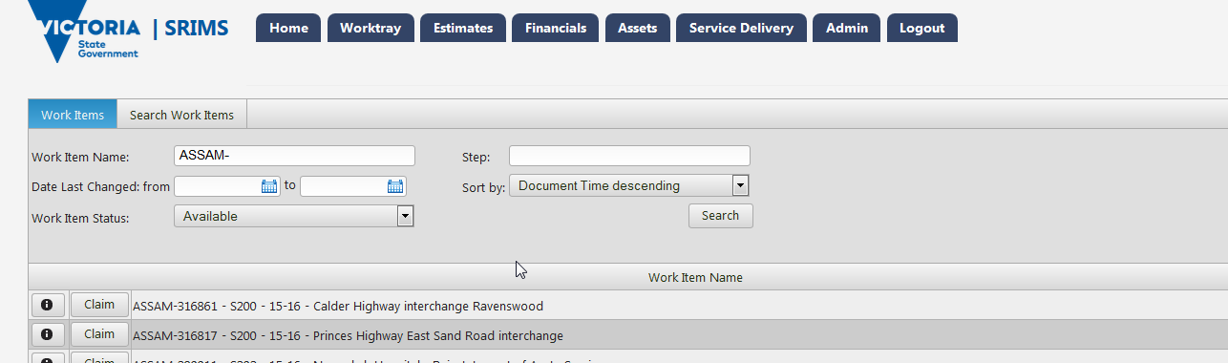
      - Viewing your BP4 asset monitoring information
Before claiming any of your ASSAM documents to update for budget, you can run the BP4 Capital Program – Detail report to verify your data. Instructions to access the relevant report are:
                - Select Budget Paper No. 4 from this menu.
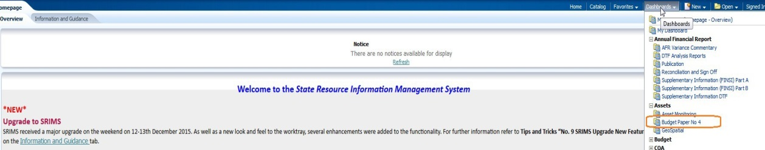
                - Select the Capital Program – Detail tab.
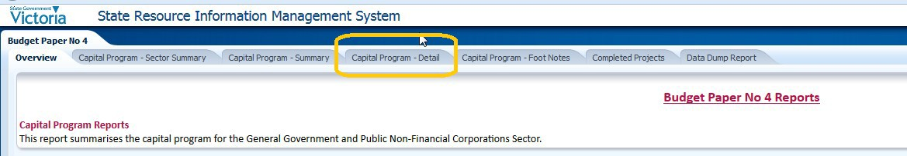
                - The following screen will appear:
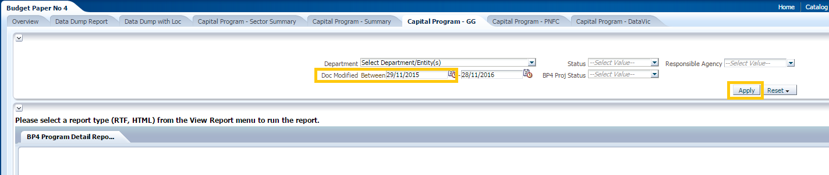
                - The report will run automatically and return data from the ASSAM documents that have been modified in the default time period for your entity (nb. the first time the report is run may provide no results).
                - If the report provides no results, adjust the first date to 01/01/2016 and select Apply to re-run the report and to return the Budget Paper No 4 data from all of the ASSAM documents for which you have access.
                - This report can be downloaded and printed as either a PDF document; Microsoft Word document; or Microsoft Excel workbook by using the selection tool on the top right hand side of the screen.
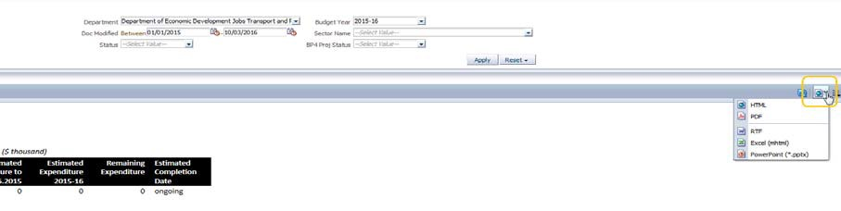

                - This report can be used to review existing data and determine what needs to be changed.
                - After any changes have been made and documents submitted, the report can be re-run to review the changes.
      - Changes required to be made to the ASSAM document
There are three ways to prepare information for the 2018-19 BP4:
                - Update existing ASSAM documents.
                - Update spawned ASSAM documents from Funding Proposals and new ASSAM documents created by the user.
                - Update Completed ASSAM documents.
      - Updating an existing ASSAM document
To update an existing project to be published in the 2018-19 BP4:
                - Select the ASSAM to be updated from the Available worktray, it should be at the Asset Monitoring Draft step to update. If the project is still at Update Project or Create Asset Draft workstep, please ensure that you complete all the mandatory fields in the ASSAM record and approve the record to move it to the Asset Monitoring Draft workstep.
                - Once you claim the document in the Overview tab, please ensure BP4 Project Category is set to Existing Project.
                - Go to the Capital Project Tab
                - Check the Ref # is unique if you have a number of projects in the Individual Project Expenditure Grid. Check the title of the project is correct and reflects the title to be published in BP4
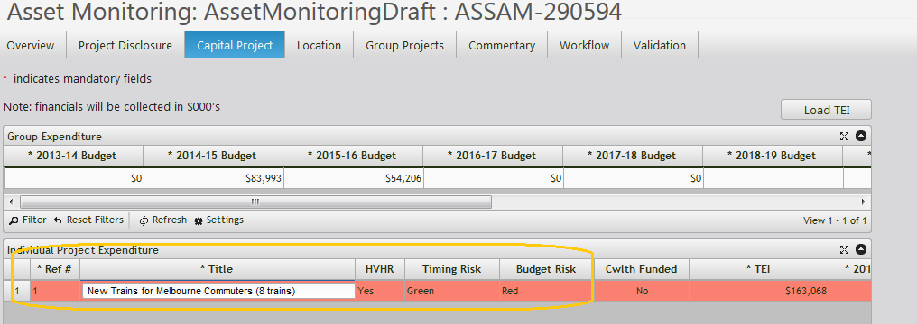

                - Check that there is a Public Completion date entered for each project
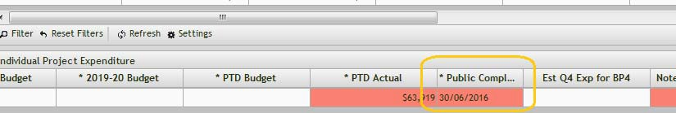

      - Inputting or updating project location information
For all new and existing initiatives, location information is required to be entered into SRIMS and location information for existing projects must be checked that it is still valid and as accurate as possible.
To do this, go to the Location Tab
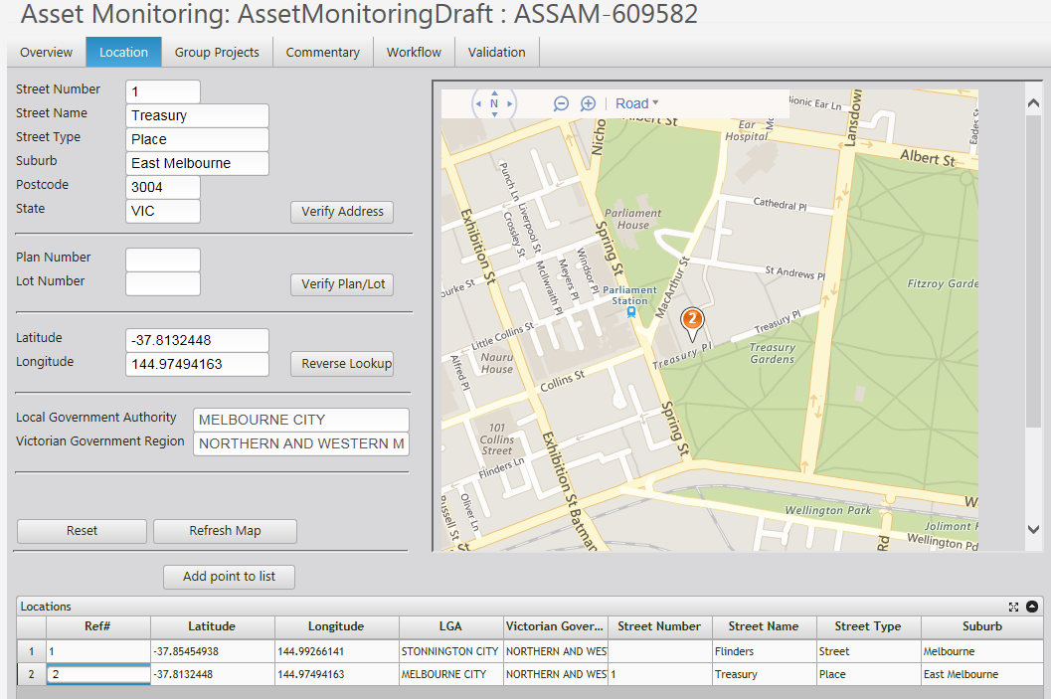

                - If the project has multiple locations, add to the grid ensuring that the Ref # matches back to the Ref# in the Individual project expenditure grid
                - Enter location information (i.e. address of the asset location)
                - Verify the address entered
                - Add the address to the grid, ensuring the Ref # matches back to the Ref# in the individual project expenditure grid from the Capital project tab.
                - If you know the details for the locations to be added, then you can import directly into the grid.
                - If there are already locational data in the grid and you would like to over-write them, you should make sure to Clear Grid first, as the import file will append to any existing lines in the grid rather than replace.
                - Browse for the file to import. Click Next and then Finish.
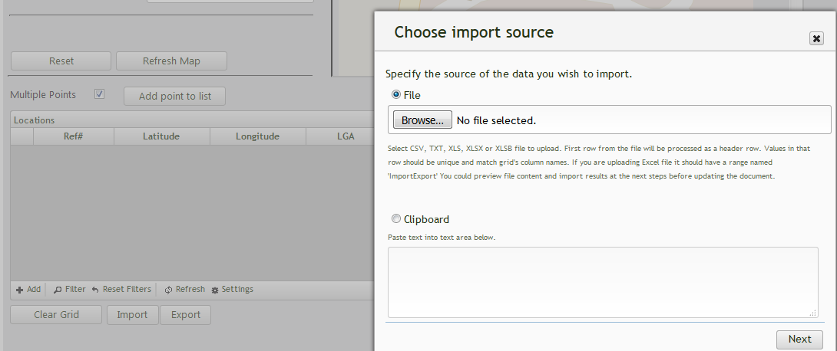
Below is an example of the import file (a template for the file can be obtained by clicking the Export button. This will provide the user with a blank template with the correct column headings)
Below is an example imported into the grid:
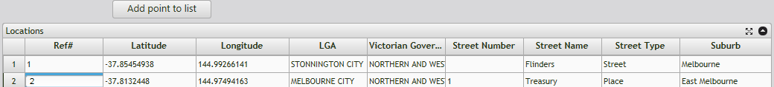

      - Adding footnotes
Refer to section 5.3 for guidance for when footnotes should be used and examples of text. To add a footnote:
                - Navigate to the Commentary tab and click on the Add button (located bottom left corner) to add a row to enter your footnote.
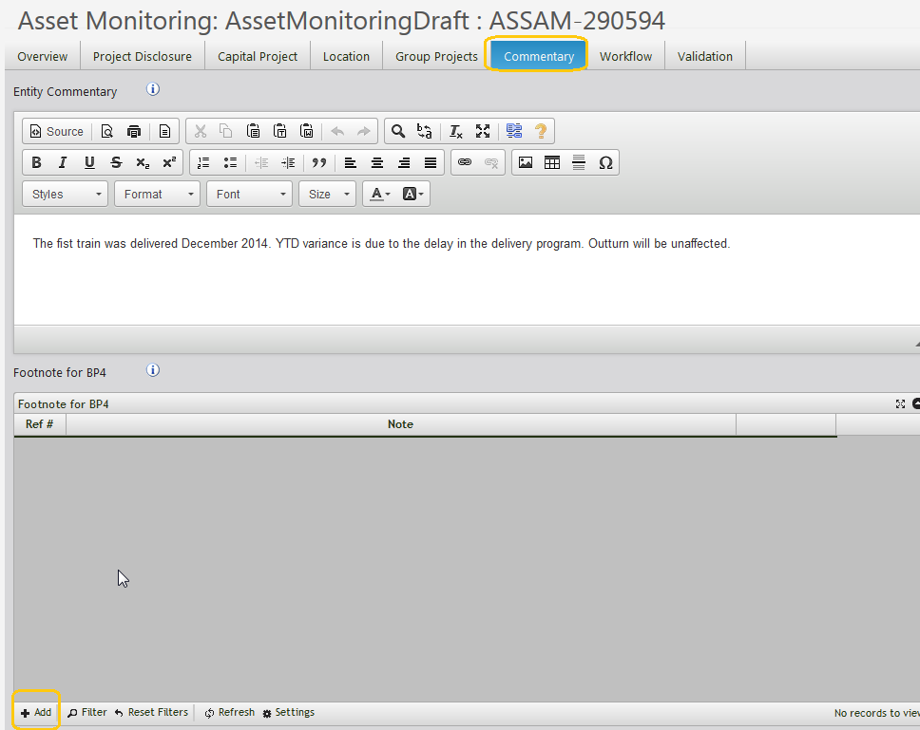
                - Include a footnote reference in the Ref # column, which refers back to the Ref # in the Individual project expenditure grid from the Capital Project tab.
                - Use the rich text box to add your footnote and then click Save.
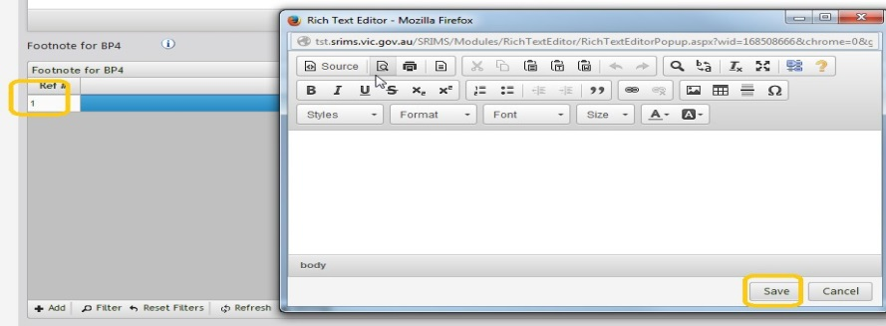
                - Select the Workflow tab and ensure the Ready for Review dropdown is set to No and click Submit.
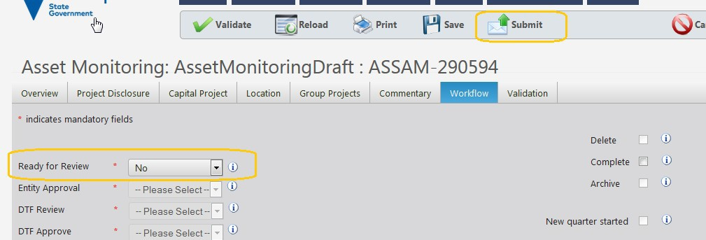
      - Updating Spawned ASSAM and New ASSAM at Create Asset Draft (for New Project section in BP4)
To be published in 2018-19 BP4 as a new project
                - When government approves an asset bid during the budget, SRIMS will automatically generate an ASSAM record base on that decision. These are referred to as Spawned ASSAM.
                - For Spawned ASSAM, claim the document from the available work tray (the document will be at “Update Project” step)
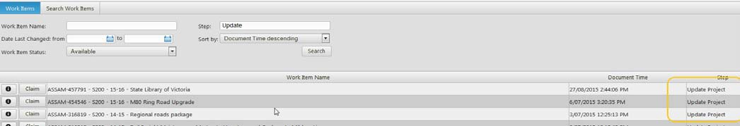

                - There are also new asset funding decisions that are decided outside of the normal budget period, for example, during Budget Update. For these type of decisions, departments will need to create an ASSAM in SRIMS.
                - Create an ASSAM by going to the Assets menu item and select Asset Monitoring
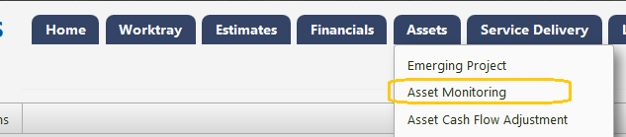
                - On the Overview page, check or amend as necessary:
                - Budget Year is 2018-19
                - BP4 Project Category is New Project
                - Project Type is Capital
                - If this ASSAM is a spawned one, TEI should already be populated base on government budget decision. If this is a new ASSAM created by departmental users, TEI will need to be manually entered.
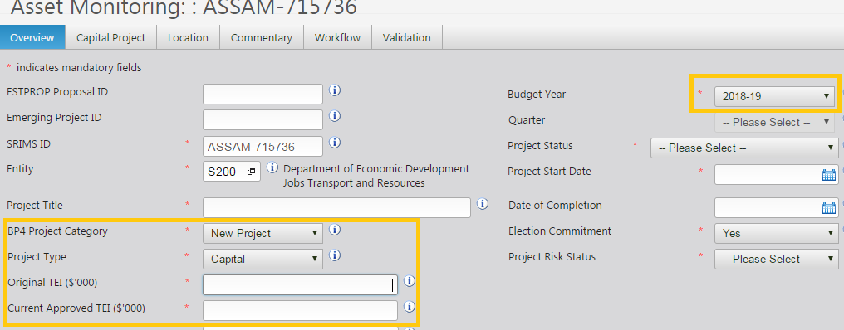

                - Go to the Capital Project tab to update the Individual Expenditure Grid information as below.
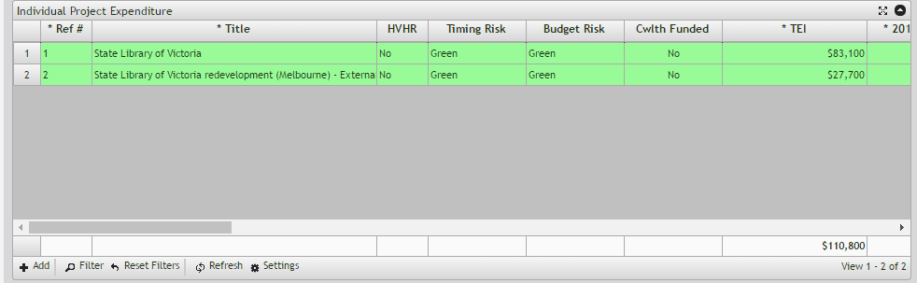

                - In the Individual Project Expenditure Grid, the following data are used as part of BP4:

                - Ref #
                - Title
                - TEI
                - Q3 Actuals
                - 2018-19 Budget
                - PTD Actual
                - Public Completion Date
                - Est. Q4 Actual

                - Analysts should focus on the consistency of Ref # used in the grid. The Ref # will be used to link data from the Footnote table from the Commentary tab and also the Location grid from Location tab (refer to sections 4 and 10.5 for further details and SRIMS instructions).
                - Enter footnotes on the Commentary tab (refer to sections 5.3 and 10.6 for further details and SRIMS instructions)
                - Navigate to the Workflow tab and ensure that the Update Complete and Ready for Review dropdown are set to No and click Submit.
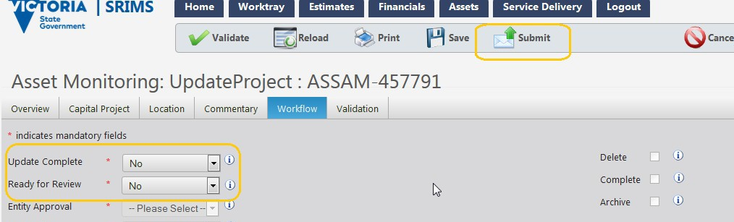

      - Updating existing ASSAM (for Completed Project section in BP4)
For projects to be published in 2018-19 BP4 as a completed project, on the overview page:
                - Set the BP4 Project Category to Completed Project
                - Set the Project Status to Practical Completion
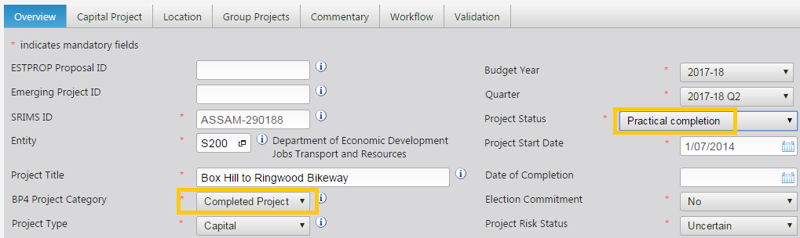

                - Navigate to the Capital Project tab, to update the Individual Expenditure Grid information as below.

                - In the Individual Project Expenditure Grid, the following data are used as part of BP4 Completed Project section:

    - Ref #
    - Title
    - TEI
    - Q3 Actuals
    - PTD Actual
    - Est. Q4 Actual

    - Public Completion Date
    - Financial Completion Date (this should reflect estimated financial completion date)

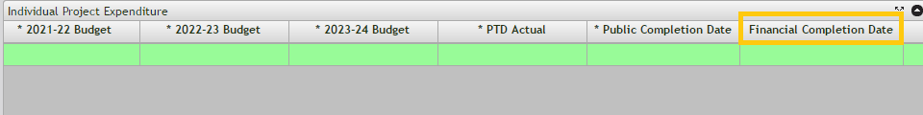
                - Navigate to the Workflow tab and ensure that the Ready for Review dropdown is set to No and click Submit.

