COMPASS
Achieving life outcomes for care leavers
COMPASS is an evidence-based two year program which will provide the Government with an opportunity to trial better support for care leavers in Victoria.
It is designed as a preventative program that provides care leavers with access to housing, a key worker to navigate the system, support in accessing education, training and employment, and other specialist support services based on the level of assessed need.
The program aims to prevent homelessness, improve educational attainment, create a positive transition from care and support, and lead to positive health and justice outcomes.

Service delivery model
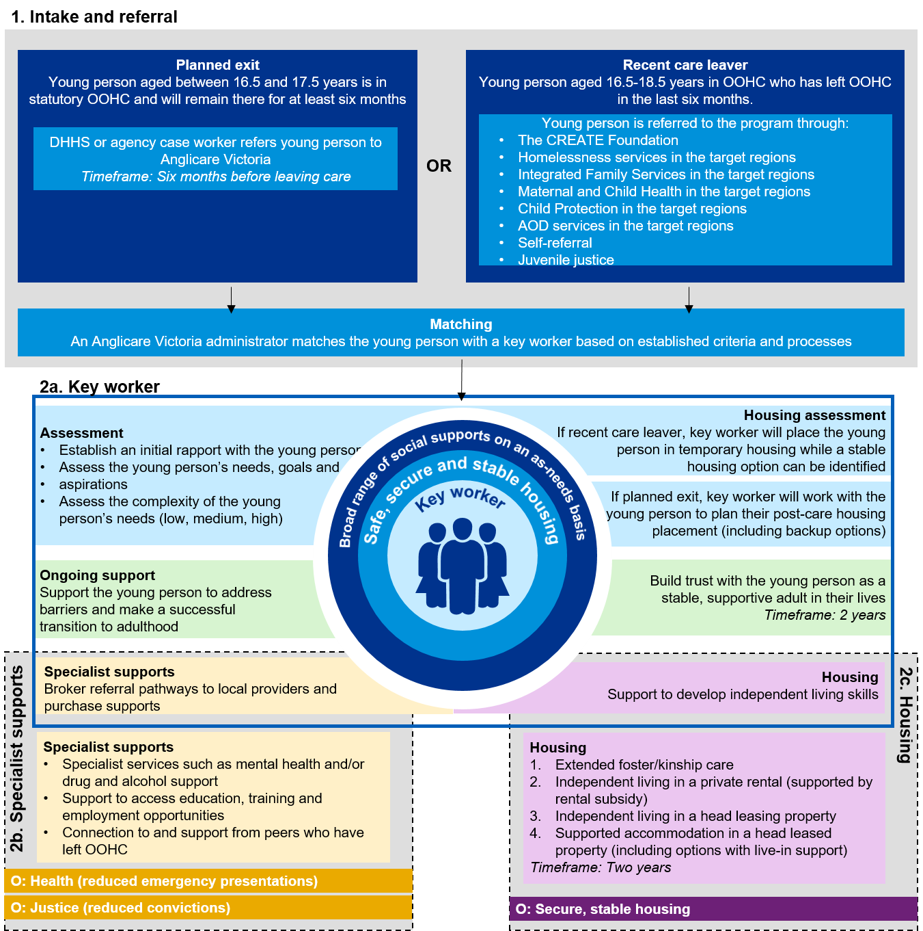

A focus on all young care leavers
COMPASS will be available to 202 care leavers from Brimbank Melton, Western Melbourne, Loddon and North Eastern Melbourne. The broad eligibility criterion ensures the intervention supports a range of young Victorian care leavers.

- COMPASS will be available to young people of all complexities and from all out-of-home care backgrounds: foster, kinship, and residential care.
- Young people aged 16.5-17.5 years in out-of-home care will transition into the program over six months.
- Recent care leavers aged between 16.5 and 18.5 years can access the program through community service organisations and government agencies.
- No young person will be excluded due to prior criminal history, cultural background, parenthood or impending parenthood, gender identity or sexual orientation, pre-existing medical conditions or disability (with the exception of those eligible for specialist NDIS disability accommodation).

Key program innovations
- ‘Step-up, step-down’ housing – a flexible housing model that will allow young people to engage with different housing options depending on their individual circumstances. Young people will have the option to remain with their current foster or kinship carer, or be supported to transition into independent housing through supported rental arrangements, with live-in support options available as required.
- Individualised, tailored support – the program will offer varying levels of support and intensity according to a young person’s needs. Key workers will support young people to access the general and specialist services they need – such as educational and vocational support, mental health, alcohol and other drug counselling or maternal and child nurses.
- Post-care transition support – key workers will work with young people right through the transition phase of ‘leaving care’ and for two years post-care to ensure that they make a positive start to life as an independent adult.

Measurement of outcomes
For the purposes of measurement and payment, COMPASS will be measured on the following three outcomes:
- Achievement of stable housing – a decrease in homelessness as measured by access to short-term or emergency accommodation from Specialist Homelessness Services.
- Improved health – physical and mental health improvements as measured by emergency department presentations.
- Decrease in offending behaviour – as measured by the number of convictions recorded.
Outcomes will be measured against a complexity-matched control group of Victorian care leavers. Success rates will be determined by the relative improvements of the COMPASS participants compared to the control group. All outcomes will be independently verified.
Broader collection of program outcomes not linked to payments (for example, education and employment outcomes, and completion of personal wellbeing indices) will identify the broader impact of the program on young people and the wider community.

Performance payments
Performance payments are conditional on specified improvements being made. For example ‘Very Good’ performance success rates (as measured against the control group) include:
- 45% decrease in access to short-term or emergency accommodation;
- 23% decrease in emergency department presentations; and
- 28% decrease in convictions recorded.

At target or ‘very good’ performance, some of the positive impacts are expected to be:
- 200 fewer emergency department presentations over the four-year measurement period post-referral.
- 300 fewer days spent admitted to hospital over the four-year measurement period post-referral.
- 35 young people being diverted away from the social housing system as a result of COMPASS.
- 600 fewer interactions with police across the four-year measurement period post-referral.

