2013-14 Victorian Budget
Federal Financial Relations
Budget Information Paper No. 3

Building for Growth

Table of contents

Introduction 2
A fair share of GST revenue 2
Support for critical infrastructure 2
The need for fair and stable funding for services 2
Support for Victorians with a disability 2
Driving efficient delivery of high-quality health services 2
Getting the best outcomes for our schools 2
The confidence to invest in services with certainty 2
Investing in outcomes, not overheads 2
Conclusion 2

The Secretary
Department of Treasury and Finance
1 Treasury Place
Melbourne, Victoria, 3002
Australia
08
Fall

Telephone: +61 3 9651 5111
Facsimile: +61 3 9651 5298
Website: www.budget.vic.gov.au

Authorised by the Victorian Government
1 Treasury Place, Melbourne, 3002

Print managed by Finsbury Green,
Level 9, 124 Exhibition Street, Melbourne, 3000

This publication makes reference to the
2013-14 Budget Paper set which includes:
Budget Paper No. 1 – Treasurer’s Speech
Budget Paper No. 2 – Strategy and Outlook
Budget Paper No. 3 – Service Delivery
Budget Paper No. 4 – State Capital Program
Budget Paper No. 5 – Statement of Finances
(incorporating Quarterly Financial Report No. 3)

© Copyright State of Victoria 2013

This book is copyright. No part may be reproduced by any process except in accordance with the provisions of the Copyright Act 1968.

ISSN 1440-6969

Published May 2013

Printed on recycled paper

Introduction
Victoria has competitive advantages which provide important opportunities for Victorians and for the nation. It has a diverse and flexible economy, characterised by a highly skilled workforce, and a dynamic, multicultural society.
The responsibilities of the Victorian Government in responding to the diverse and changing requirements of this population are significant and growing. The services provided by state governments are central to the everyday needs of individuals, families and businesses and their expectations about what governments should do. Meeting these expectations presents a number of challenges, including:
- substantial demand for infrastructure to keep pace with population growth, maintain liveability, boost productivity and to deal with congestion;
- maintaining high-quality services to Victorians, including the key areas of health, education, transport and community safety. Demand for and expectations of these services continue to rise as our population grows and ages; and
- the need for structural adjustment to respond to changing economic conditions and markets.
The progressive concentration of revenue-raising power with the Commonwealth Government has increasingly left states and territories (the states) reliant on Commonwealth–state revenue transfers to fully discharge their service and infrastructure responsibilities.
A fair deal for Victorians requires a fair share of these transfers. Victoria has received less Commonwealth assistance per capita – reflecting both Goods and Services Tax (GST) revenue and other grants – than any other state since 2000. It has also received less than its population share of support for critical infrastructure investment – on average just 17 per cent of annual total transport infrastructure funding over 10 years to 2011‑12, compared with a population share of around 25 per cent.
A fair deal also requires greater certainty in Commonwealth–state funding arrangements. Victoria cannot plan and budget effectively when its largest single revenue source continues to change so significantly, and without warning, as the result of the highly complex and unpredictable formula currently used to distribute the GST. Victoria also relies on certainty in other negotiations with the Commonwealth Government: certainty that the Commonwealth will honour its agreements; certainty that it will not attempt to shift the costs of Commonwealth policy and program objectives to states; and certainty that it will share the information necessary to support meaningful negotiation.
Finally, a fair deal will mean recognition by the Commonwealth that the Victorian Government is responsible to the people of Victoria. National reforms must deliver real benefits to Victorians, responding to their specific needs and interests. Victoria will continue to ensure that effective and efficient local policy is not jeopardised by a one-size-fits-all national approach promoting uniformity for its own sake, or diverted by excessive and costly administration or prescriptiveness.
A fair share of GST revenue
In the Australian federal system of government, the Commonwealth Government retains the majority of revenue-raising powers while the states bear the majority of expenditure responsibilities. This vertical fiscal imbalance is addressed through the transfer of revenue from the Commonwealth to the states in the form of grants.
In 2013‑14, Commonwealth grants will constitute 46 per cent of total general government revenue. More than 20 per cent of Victoria’s revenue is GST revenue.
Victorians expect a reasonable share of Commonwealth–state revenue transfers. Since the introduction of the GST in 2000, Victoria has received less Commonwealth assistance per capita (GST plus other grants) than any other state (as shown in the graph to the right).
Victoria is the only state to have received less than its population share of grants every year since 1901, although NSW has also done so for most of this period. This means Victoria has been constantly subsidising other states, for example by investing heavily in the development of Western Australia and Queensland. The cumulative difference between what selected states have received and a per capita share of total Commonwealth funding is shown in the graph below right.

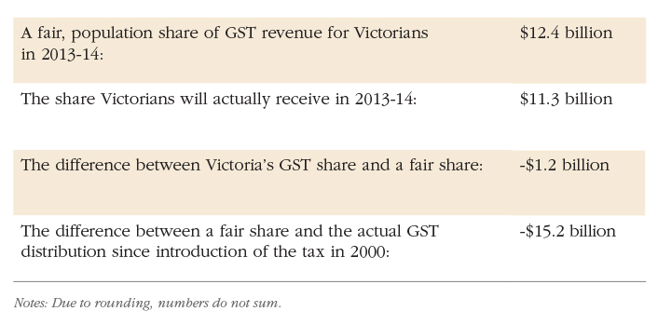

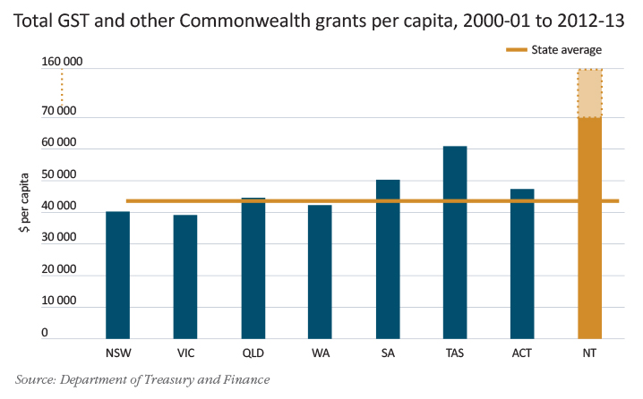

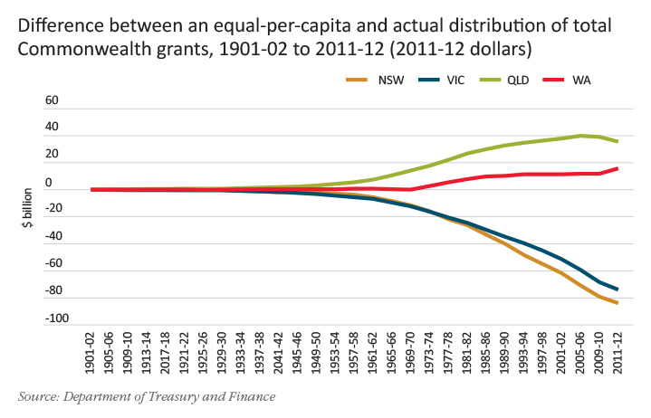
GST revenue is fully shared between the states, based on the formula applied by the Commonwealth (on the recommendation of the Commonwealth Grants Commission (CGC)). GST is Victoria’s single biggest revenue source, and was expected to form a stable and growing revenue base for all states.

Victoria has consistently advocated for a simple, transparent and sustainable approach to distributing GST revenue. Instead, GST revenue continues to be distributed using an out-dated and unpredictable formula, which penalises reform and results in unfair outcomes. The recommendations contained in the CGC Report on GST Revenue Sharing Relativities: 2013 Update (2013 Update) mean that Victoria will receive $1.2 billion less than its population share of GST in 2013-14, representing a loss of $200 for every Victorian.
Western Australia is the only state receiving less per capita than Victoria – and this is only a relatively recent development. Under the current system, Queensland is being subsidised by Victoria in the middle of a mining boom. In 2013-14 Victoria will receive around 90 per cent of its population share of GST, while Queensland will receive around 106 per cent. This means that Queensland will receive approximately $330 dollars more per person than Victoria.
Victoria’s share of GST revenue will be 22.6 per cent for 2013‑14 compared with 22.9 per cent for 2012‑13, against an estimated national population share of around 25 per cent. Since the introduction of the tax in 2000, Victoria has received approximately $15.2 billion less than a population-based share of GST revenue.
The top-most graph shows the difference between the 2013‑14 allocation of GST and a per capita distribution.
The unduly complex process used by the CGC to determine GST allocations is based on a large number of assessments with complicated interdependencies. For example, in addition to revenue categories, the CGC process uses 14 expense, net lending and investment categories, divided into 43 subcategories, for which 93 further adjustments are applied.
The result is a highly volatile mechanism for apportioning GST revenue. A significant part of this volatility is caused by unforeseeable data revisions and the application of new data to previous assessment years. The problem is compounded by swings in the GST pool itself, caused in part by ongoing structural movement in Australia’s consumption mix away from consumption of goods and services subject to GST. In 2012‑13 alone, Victoria will lose $210 million against 2012‑13 Budget Update forecasts due to unforeseen volatility in the GST pool. As shown in the graph directly above, large swings in Victoria’s GST grant are becoming the norm, rather than the exception.
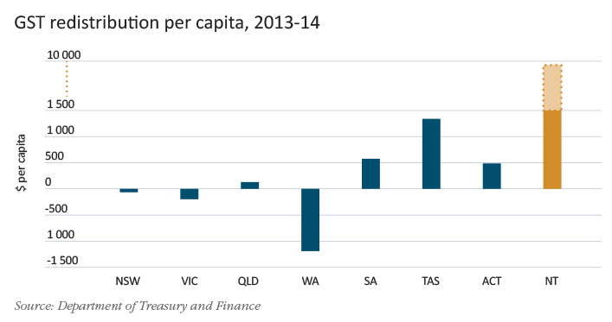

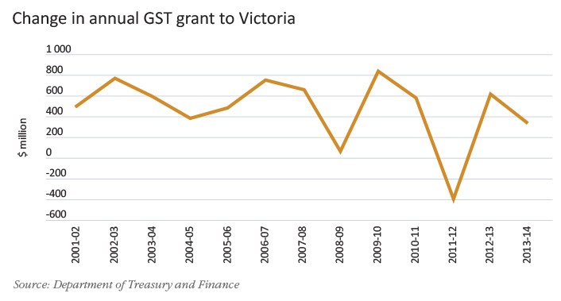

In this environment, it is increasingly difficult to plan with any confidence for the future needs of Victorians. The current system of apportioning GST revenue needs to be reformed so that state budgets are no longer at the mercy of the annual quirks of a difficult‑to‑predict and confusing methodology. All states – small and large – need revenue certainty in order to manage their budgets effectively. This certainty cannot be provided by merely tinkering at the edges. It requires a complete overhaul of current arrangements.
The current CGC methodology also gives rise to perverse outcomes. For example, similar to previous years, Victoria will be penalised $935 million dollars in 2013‑14 through the CGC school education assessment. This is due in part to Victoria’s lower proportion of government school students and students in remote areas.
This represents a loss equivalent to nearly all Commonwealth specific purpose payment funding for government schools in Victoria, with revenue given with one hand by the Commonwealth and taken with the other via the CGC. The result of these dual processes is that apart from specific programs, Commonwealth net education funding to Victoria in 2013-14 will only equate to $45 million, or around just $50 per student. This demonstrates the deep flaws that serve to undermine confidence in equalisation.
The manifest problems with the current GST distribution system led states to call for a wide-ranging review. The resulting GST Distribution Review Final Report was delivered in late 2012.
The review panel found that in the long term the system should progress to an equal-per-capita distribution of GST revenue, with targeted Commonwealth assistance provided to smaller states to enable them to continue to deliver comparable services to those of the larger states. Victoria remains committed to providing adequate support to smaller states through some form of equalisation. However, fundamental reform is needed to ensure the sustainability of this system. To minimise the impact on all state budgets, this could simply involve smaller states exchanging a proportion of their GST for a greater share of tied funding. This would improve predictability and increase transparency and certainty of funding to address entrenched disadvantage.

The GST distribution should not penalise states for honouring reform commitments
This year’s GST relativities penalise Victoria for honouring its obligations under the intergovernmental agreements of 1999 and 2008. Under these agreements, all states pledged to abolish a range of inefficient taxes, including stamp duty on mortgages and stamp duty on non-quotable marketable securities, ultimately by 1 July 2013.
Victoria met its commitments ahead of this schedule, forgoing the revenue it would have otherwise raised from these taxes, while some other states have deferred their obligations indefinitely.
The current CGC treatment responds by reducing Victoria’s GST share, while other states benefit. For example, Victoria will receive $200 million less in 2013‑14 than if the CGC had assessed actual revenue raised from non‑real conveyance duty so that it directly affected GST shares, as proposed by Victoria. Inappropriate treatment of this revenue rewards states that have contravened longstanding undertakings on tax reform.
The methodological change proposed by Victoria would remove any possibility of states receiving a GST benefit from continuing to levy these economically damaging taxes in breach of intergovernmental agreements. These changes should be implemented immediately to prevent Victoria being further penalised for reform.

A long-term vision for supporting small states
As Victoria argued in its submission to the GST Distribution Review, the challenges faced by smaller states should be supported through the use of Commonwealth tied payments. The GST could then be provided to the states on a more equitable and transparent basis.
In Australia, this model could see the GST distributed on a population basis, or a significantly simplified method, with smaller states such as the Northern Territory, South Australia and Tasmania supported by Commonwealth specific purpose payments. For example, targeted funding would help address the genuine costs of delivering services to Indigenous Australians in remote Northern Territory, and to address the unique demographic challenges of Tasmania. This approach would deliver:
- better outcomes for those who genuinely need support;
- direct support for the actual additional costs of servicing those populations, rather than the current indirect assessment;
- improved accountability and the ability to better assess whether interventions are making a difference;
- more predictable funding to all states to better plan and budget; and
- possible savings of around $100 million over 10 years in the cost of administering the current system of GST distribution.

Support for critical infrastructure

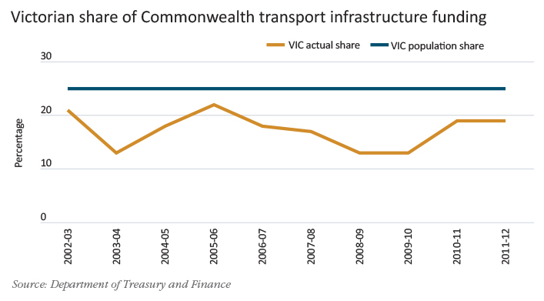

Victoria’s population is growing solidly, in line with the national average, and at a faster rate than other non-resource states. While strong growth in Melbourne and Victoria’s regional cities presents opportunities, it also creates new challenges in managing both congestion and the pressures of increased urbanisation. Despite this, Commonwealth funding for new transport infrastructure remained significantly below Victoria’s population share in the past decade, as shown in the above graph.
Although Victoria has a population share of around 25 per cent, the ten-year average of the State’s annual share of transport infrastructure funding to 2011‑12 is just 17 per cent. While Victoria’s share of total Commonwealth infrastructure funding is projected to rise in future years, this does not account for the large percentage of this additional revenue expected to be lost through the GST distribution system. Victoria has received a lower per-capita allocation of Commonwealth transport infrastructure funding for too long. While arguments may have been made in previous decades for the need to support geographically large, developing states, the transport challenges of the future will come from managing increased urbanisation successfully. Victoria will require a fair share of funding to meet these emerging priorities.

Ending inconsistency in the treatment of funding for major projects
In order to plan with confidence, Victoria needs to know that Commonwealth funding for major projects will not be clawed back through the GST distribution system. The current operation of the GST distribution system deals poorly with funding for major infrastructure projects, potentially casting doubt on their viability.
Victoria continues to be penalised by the CGC’s arbitrary distinction between Commonwealth rail funding and national network road funding, which will result in a large proportion of Commonwealth funding intended for the Regional Rail Link (RRL) being effectively syphoned off to support other states. The current CGC assessment fully equalises Commonwealth funding for rail projects while treating national network roads more favourably, effectively applying a 50 per cent discount.
When the RRL project was announced, it was presumed that Victoria would see the full benefit of any Commonwealth funding. However, the final amount Victoria will effectively receive is subject to the vagaries of the CGC’s methodology, the size of the GST pool, and future Commonwealth funding allocations in other states (see table on page 8). On the most recent Victorian estimates, Victoria will lose $2.1 billion through the operation of the GST distribution, or around 65 per cent of total Commonwealth funding of $3.2 billion for the project. This loss would be significantly reduced were national network roads and rail infrastructure treated in the same way as each other.
Victoria cannot reasonably commit to much-needed infrastructure while an unknowable portion of promised Commonwealth funding is likely to be confiscated under the GST distribution system. In addition, the massive scale of the redistribution frustrates the Commonwealth’s original intent in providing funding for the project, which was to improve rail services for Victorians and provide wider economic benefits for the nation.
The GST Distribution Review recommended immediate changes to address this anomaly. This recommendation would be simple to implement. It would materially improve the efficiency and equity of the CGC assessment by removing the bias towards Commonwealth funding for national network roads over rail projects. Despite this, the Commonwealth has refused to implement the recommendation in 2013-14. It will now be considered alongside longer‑term proposals.

Estimated impacts of Regional Rail Link funding on GST distribution
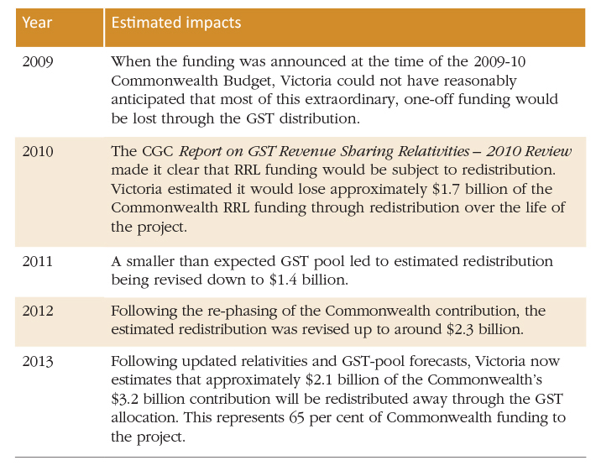

A transformational infrastructure agenda
In 2013-14 Victoria will invest a record amount in major, state‑shaping infrastructure. It will also boost its efforts to leverage private sector involvement in delivering Victoria’s infrastructure agenda. However the Commonwealth Government, with its greater revenue-raising capacity, will continue to have an extremely important role to play in funding nationally significant infrastructure.

The East West Link – Stage 1 and Melbourne Metro rail projects alone will require total government funding of more than $15 billion. This would be more than 30 per cent of Victorian revenue for 2013-14 or the total expected expenses of the Department of Health. States simply do not have the fiscal capacity to undertake critical investments of this magnitude in a timely manner. Essential projects requiring Commonwealth support include:
- East West Link, a project with an estimated capital cost of between $6 and $8 billion, which will ease congestion and better link people, products and markets across the State. Construction of the first stage of the East West Link will connect the Eastern Freeway at Hoddle Street with CityLink at Parkville. This is the first stage of Government’s longer-term commitment to the full East West Link, an 18-kilometre road link connecting the Eastern Freeway at Hoddle Street with the Western Ring Road in Sunshine West. This project will dramatically improve how the city moves, substantially increasing road transport capacity to improve the State’s productivity; and
- Melbourne Metro, a rail tunnel between South Kensington and South Yarra. When complete, this project will be the biggest enhancement to the passenger rail network since the city loop was built 40 years ago.

The need for fair and stable funding for services

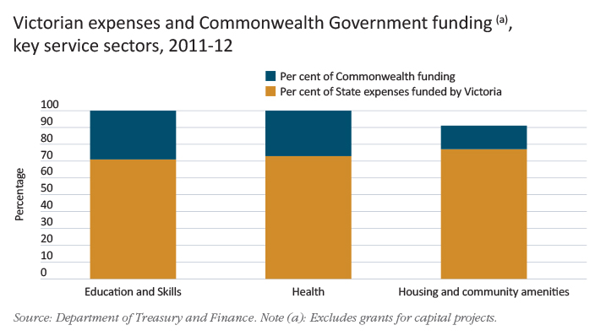

Victoria needs fair and predictable funding to provide core services to the public. State governments bear primary responsibility for a range of service areas most important to their communities, including hospitals, school education, justice and transport.
For example, in 2011‑12 the Victorian Government:
- funded around 1.6 million admissions to Victorian public hospitals;
- protected communities by dispatching police to over 800 000 calls for assistance;
- resurfaced around 12.7 million square metres of roads across Victoria;
- maintained around 3 200 bridges; and
- provided home and community care to over 286 000 clients.
As is the case in other states, the Victorian Government continues to provide the bulk of funding in each of the core service sectors for which it is responsible, as demonstrated in the graph above right.
Despite providing a relatively small proportion of funding, the Commonwealth is becoming progressively more prescriptive in the conditions attached to these transfers. This creates duplication, as well as increasing the distance between communities and the decisions which affect them.

Victoria has been at the forefront of finding innovative ways to deliver services, pioneering new and highly successful approaches to service delivery. For example, Victoria pioneered activity-based health funding, school autonomy and contestable markets for vocational education and training (page 10).
Moreover, in many critical initiatives currently being pursued by the Commonwealth in conjunction with the states, Victoria’s past innovations have provided a key starting point for national reform.
Through such reforms Victoria has modelled the core principle of a well-functioning federal system: that government delivers best when it remains close and responsive to the individuals, families and businesses it serves. Competition between states creates the opportunity for choice, innovation and reform, driven by local circumstances and needs.
Similarly, Victoria has learnt from other states. For example, Victoria followed the lead of Western Australia in the development of a health advice line operated by registered nurses.
Without past innovations at the state level, today’s national reforms would never have been realised. In order to lead the next wave of policy transformation, states need the flexibility and revenue certainty to devise new methods to deliver better, more efficient services to citizens.
The Commonwealth Government has an important role to play in facilitating the exchange of ideas and best practice, and in providing funding as the level of government best able to undertake large discretionary spending. In some circumstances, Commonwealth‑led policy will also be the most appropriate response to urgent or new areas of pressing national interest. The Commonwealth’s leadership in implementing gun control reforms and the signing of the National Firearms Agreement with all states in 1996 is a prime example of constructive change led from the centre.
It is important however that coordination of nationally significant reform does not descend into a lowest common denominator approach that would see the gains of Australia’s diverse policy settings lost through national harmonisation for its own sake.
National reforms must be more than announcements or new layers of bureaucracy – they must represent value for money, be evidence-based, and carefully implemented in response to local circumstances. Victoria will always seek to constructively engage with other governments, but will continue to:
- ensure that good public policy is not jeopardised by a one‑size‑fits‑all approach;
- seek ongoing certainty in Commonwealth–state arrangements; and
- reject excessive and costly administration or prescriptiveness.

Responsive vocational education and training
Victoria continues to lead the nation in making vocational education and training (VET) more responsive to the changing needs of individuals and the labour market by moving to a more open and competitive training market.
From 1 January 2013, the Government is providing subsidies at the same course rate for students at both public and private providers. Providers now compete for students on fair terms and funding ‘follows the student’ to their chosen provider, regardless of whether that provider is public or private.
Victoria’s reforms have increased training participation and qualification completion, including at higher levels and by those experiencing disengagement or disadvantage.
The percentage of enrolments in government-funded VET places by unemployed people grew from 17 per cent in 2008 to 24 per cent in 2012, on top of significant growth in total participation. In addition, there were approximately 6 200 Indigenous students and over 40 000 students with a disability undertaking training in 2012, an increase of 11 and 18 per cent respectively from 2011.
Victoria invested $1.3 billion in training in 2011-12. Victoria invests well above its share of population – while also engaging in reform to better target how this funding is provided.
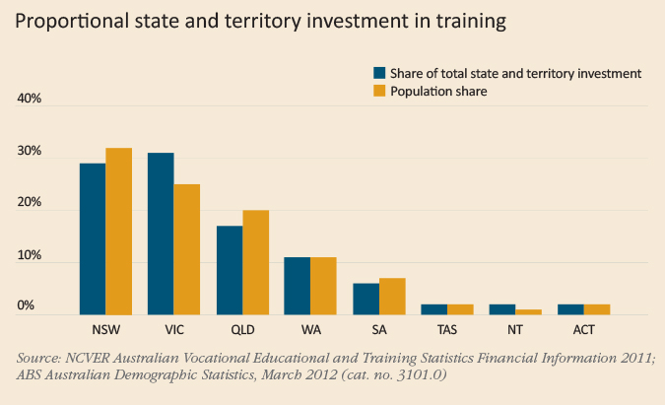
Other states are following Victoria and moving toward a more market-based approach to delivering VET. Victoria’s system formed the basis of the National Partnership Agreement on Skills Reform, which was signed by the Council of Australian Governments in April 2012. The introduction of a minimum national entitlement to a government-subsidised training place, enhancing equity and access, is a key national reform direction under this agreement.

Support for Victorians with a disability
In 2011, the Productivity Commission’s Inquiry Report on Disability Care and Support recommended the creation of an entitlement-based National Disability Insurance Scheme (NDIS) to fund care and support for Australians in the event of a significant disability.
The NDIS would provide lifetime care and support for clients and enable people with a disability to exercise choice and control in the planning and delivery of their own support. A National Injury Insurance Scheme (NIIS) is also proposed to provide no‑fault care and support to people who acquire a catastrophic injury as a result of an accident.
The Victorian system already recognises the importance of choice and control for clients, their families and carers. In particular, the provision of individual support packages puts clients at the centre of decision-making by enabling individuals to buy disability supports that meet their goals.
As the majority funder of disability services, the Victorian Government is committed to improving outcomes for people with a disability, their families and carers. Over the next four years, the State will provide significant additional disability support funding.
Victoria supports the NDIS and has committed to a launch site in the Barwon Region for 5 000 clients, commencing in July 2013. The Victorian Government will provide funding of over $300 million to the region between 2013-14 and 2015-16.
Full roll-out of an NDIS will be complex, and launch sites provide an opportunity to get the design of the scheme right. Victoria will continue to work with the Commonwealth towards appropriate full scheme arrangements.

Driving efficient delivery of high-quality health services

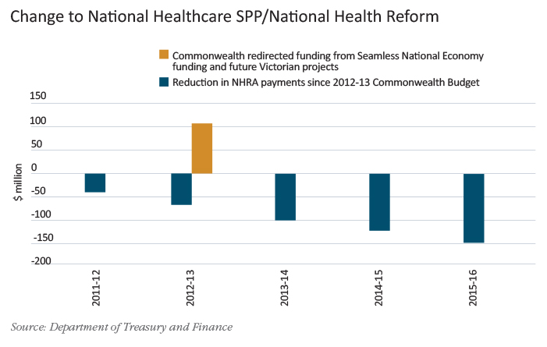

For decades, Victoria has provided a model for health funding reform. Victoria’s activity-based funding model for hospitals has provided the basis of the National Health Reform Agreement (NHRA). Victoria’s ground‑breaking casemix hospital funding model, first introduced in 1993, has driven improvements in technical and allocative efficiency across the sector by providing an incentive for hospitals to deliver high-quality care for the least cost. The Victorian approach also boosted equity and accountability for outcomes, by explicitly linking hospital funding to demand for services. The success of the Victorian model has led to a nationally consistent approach to activity-based funding (with extended scope) being rolled out across the nation.
In 2011, Victoria accepted the Commonwealth Government’s offer to become a full partner in supporting the public hospital system. The Commonwealth agreed to eventually provide 50 per cent of the cost of efficient growth, with funding by both levels of government to be transparently provided to Local Hospital Networks for management at a local level. In this context, it is extremely disappointing that the Commonwealth sought to manipulate existing funding formulas in 2011-12 to achieve short-term budget savings.

Following the 2011 Census of Population and Housing, Australian population data was revised downwards relative to previous estimates. Ignoring the approach recommended by the Australian Bureau of Statistics, the Commonwealth sought to portray this statistical update as an actual decline in Victoria’s population for the purposes of health funding arrangements, with a commensurate reduction in funding. In reality, the Victorian population had grown by more than 75 000 people in the year to December 2011. The resulting effect on the indexation of health funding represented a loss of $475 million to Victoria between 2011‑12 and 2015‑16.
In contrast to the transparency the Commonwealth sought a year earlier, it refused to accept responsibility for the impact of these funding reductions on services and patients, and attempted to have the Victorian Government foot the bill for these Commonwealth funding reductions.
The manner in which the Commonwealth attempted to withdraw funding imposed uncertainty on the Victorian health system. The issue was further exacerbated by a lack of understanding of how hospitals are funded, and an unwillingness to sensibly engage with Victoria to plan for the continuation of services. By withdrawing funding in the current year, after the finalisation of budgets, hospitals were left with no choice but to cut services.
While the Commonwealth has reversed $107 million in cuts due to take effect in 2012‑13, the impact in later years will still be felt by Victorian patients. Moreover, the Commonwealth has indicated it will claw back $52 million of this reinstated funding from unspecified future Victorian projects, and withhold $55 million in reward funding intended to encourage productivity enhancing reforms under the National Partnership Agreement on Seamless National Economy. The change in Commonwealth health funding announced in late 2012 is illustrated above.
As a basic precondition of providing adequate funding for services, Victoria needs certainty that the Commonwealth will honour its undertakings and not opportunistically attempt to change the rules.

Getting the best outcomes for our schools
Improving educational outcomes is critically important for enhancing productivity, and therefore long-term growth and prosperity. All Victorian families should expect an effective, equitable and efficient education system for their children. In February 2012 the Victorian Government was delivering education to more than 540 000 students across 1 500 government schools, and providing support to a further 320 000 students in the Catholic and independent sectors.
Victoria has long led the development of strategies to improve the quality of school education services and remains committed to further reform. It welcomes the engagement of the Commonwealth Government in addressing these challenges, but will not compromise Victoria’s policy directions and priorities. Any national agreement on education must result in an efficient and effective funding system, delivering better outcomes for students and the broader Victorian community.
Under the Commonwealth’s proposed repeal of the National Schools Specific Purpose Payment and associated National Education Agreement in favour of the National Education Reform Agreement, any new Commonwealth funding would be contingent on:
- significant additional Victorian expenditure;
- the possibility of greater Commonwealth control over Victoria’s school funding distribution; and
- signing up to the National Plan for School Improvement (NPSI).
It is important that Victoria’s financial and policy autonomy to improve conditions for students is not undermined by any proposed reforms. A situation in which Victoria retains responsibility for outcomes in government schools, but is left with few funding or policy levers to influence these outcomes or drive accountability at the school level, is unworkable. Moreover, any proposal which seeks central control of schools by the Commonwealth under the NPSI could stifle innovation and improvement. There is no reason to believe that simply imposing an additional layer of bureaucracy on Victorian schools will improve outcomes.
Victoria will continue to work through the detail and costs of the Commonwealth’s school funding proposal, to determine whether it is in Victoria’s best interests to implement the reforms. The Government will do this with a strong focus on improving outcomes, promoting equity and value for money. Victoria has asked the Commonwealth to commit to providing complete, detailed information supporting proposed arrangements in Victoria and other states, including a transparent analysis of existing and new funding.

Devolving educational, financial and management responsibility to schools
Commencing with the 1992 Schools of the Future policy, Victoria has pioneered a move to a devolved, autonomous government school system based on the simple idea that principals and teachers, not bureaucrats, know what works in the classroom.
Over two decades, Victoria has reinforced local decision-making by devolving educational, financial and management responsibility to schools. This has included providing schools with largely untied recurrent funding, giving principals the flexibility needed to deliver better outcomes for their students.
The Victorian approach has resulted in National Assessment Program – Literacy and Numeracy and Program for International Student Assessment results that are consistently competitive with other states and above the OECD average, at a lower cost than in any other Australian state.
The success of the Victorian model preceded the implementation of similar programs in other states, notably Queensland’s Independent Public Schools program. Victoria will continue to lead in innovative provision of education, recently embarking on the next wave of school devolution. The suite of reforms identified in the Towards Victoria as a Learning Community position paper will extend Victorian school autonomy over curriculum, reporting, behaviour management, workforce management and infrastructure.
Similarly, the 2011 Commonwealth Review of Funding for Schooling’s key recommendation for an efficient per-student price for education, coupled with loadings for disadvantaged students, reflects the approach already employed by Victoria.
Building on previous reforms, the introduction of the Student Resource Package for Victorian government schools in 2005 shifted the focus of education funding from inputs to outcomes, creating a transparent and flexible needs-based school funding model whose core characteristics now form the basis of the Commonwealth’s proposed National Education Reform Agreement.

The confidence to invest in services with certainty
The ability to plan with certainty is crucial to delivering the services and critical infrastructure that Victorians will need in the future. Increasingly however, agreements reached in good faith appear at risk of being abandoned by the Commonwealth as its priorities shift, leaving states to meet shortfalls in funding for increased levels of service delivery. Commonwealth–state arrangements framed around short-term funding undermine Victoria’s capacity to plan with certainty when working with Canberra.
No business could survive with such an indifferent attitude to honouring its commitments and maintaining relationships with key partners. Yet the Commonwealth continues to ask states to commit significant funding and administrative resources to its immediate policy priorities. It is increasingly difficult for Victoria to rely on Commonwealth undertakings under these circumstances, particularly when the costs of discontinued programs are wholly borne by the states.
In recent years Commonwealth and state governments have partnered in a number of significant reforms, delivering new or substantially enhanced services in health, education, skills and housing. When these reforms were developed it was with the clear understanding – reflected in supporting agreements – that successful pilots or permanent increases in service delivery standards would require ongoing Commonwealth financial support. To date, the Commonwealth commitment to these assurances has been unclear, and uncertainty persists surrounding the future of a number of worthwhile programs, such as the Victorian Cytology Service.
Uncertainty also remains surrounding the negotiation of an agreement with the Commonwealth to provide supplementation for recently increased social and community sector wages under existing Commonwealth programs. In 2012, Fair Work Australia awarded social and community sector workers wage increases of between 23 and 45 per cent, to be phased in over nine years. While the Victorian Government does not directly employ social and community sector workers, it is faced with increased costs as a result of services provided by the sector on behalf of the State and the Commonwealth.
The Commonwealth has made an offer of funding for its share of these increased costs over the nine-year phase-in period. This is below what Victoria estimates is required to maintain current service delivery levels. The Victorian Government is continuing discussions with the Commonwealth about supplementation and conditions attached to that offer.
The Commonwealth has also unilaterally altered the timing of payments in order to meet short-term budgetary priorities. For example, in late 2012 the Commonwealth moved funding scheduled for payment under the Trade Training Centres in Schools program out to 2018‑19. It is now possible that this funding will never be received.

Implementation Plan for Victorian Cytology Service – expires 30 June 2013
The Victorian Cytology Service (VCS) is a publicly funded pathology laboratory established in 1965 as a joint initiative between the Victorian Government and the Anti-Cancer Council Victoria as a not-for-profit enterprise. VCS is jointly funded by the Victorian and Commonwealth Governments. Since 1989, the Commonwealth has provided block funding to the VCS to report Pap tests, that would otherwise be funded through the Medicare Benefits Scheme (MBS). The objective of this agreement is to provide for a national centre of excellence in the accurate and cost effective reporting of cytology specimens, and to reduce morbidity and mortality from cervical cancer in Victorian women.
VCS provides approximately 50 per cent of Pap tests in Victoria and also provides Medicare-billed services for associated testing at no out-of-pocket cost to patients.
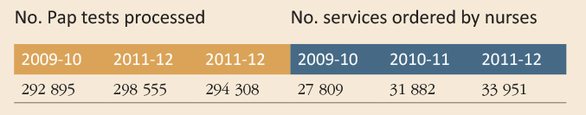
A joint review of the operation of the agreement by the Commonwealth Department of Health and Ageing and the Victorian Department of Health found that it is an effective funding arrangement, providing excellent value for money.
The Commonwealth has provided more than $30 million over the life of the VCS Implementation Plan, which expires on 30 June 2013. The Commonwealth, however, has not confirmed funding beyond this date.

Funding for early childhood education
In 2008 the Commonwealth Government sought to implement an election commitment to provide universal access for all Australian four-year-olds to 15 hours of preschool education a week, for 40 weeks of the year, delivered by a qualified teacher. In December 2008, the states (through the Council of Australian Governments) agreed to implement the policy under a four-year national partnership agreement.
The Council of Australian Governments agreed that on expiry the agreement should transition to a broad national agreement, appropriately indexed, in recognition of the permanent increase in service standards sought by the Commonwealth Government.
The Commonwealth has instead insisted on a new 18-month agreement requiring Victoria to commit to maintain raised service levels with less Commonwealth funding support.
While this agreement h as been accepted in broad terms and will be reviewed after 12 months, there remains no certainty surrounding the maintenance of current service levels beyond 18 months.
In partnership with community and private sector providers, Victoria has ensured the delivery of significant additional assistance to families under this agreement, including:
- over 1 800 services offering 15 hours a week of funded childcare for approximately 68 000 Victorian children;
- the employment of 1 847 extra teachers;
- the renovation of over 400 existing education and care facilitates; and
- the construction of over 75 new centres.
All of this is placed at risk by the Commonwealth’s failure to provide funding certainty.

Investing in outcomes, not overheads

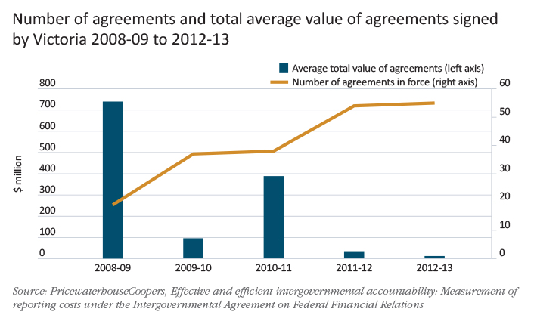
Australia’s system of Commonwealth‑state relations has evolved into one of needless administrative duplication and inefficient Commonwealth micromanagement. Many thousands of pages of reporting flow from each state government to the Commonwealth every year, diverting resources from frontline services and offering no obvious benefit to Victorians.
Independent analysis by PricewaterhouseCoopers has found that the number of reports that Victoria is required to provide each year under national partnership (and project) agreements doubled between 2008‑09 and 2012‑13, with formal reporting alone costing Victorians $10 to $12 million. This is in addition to the costs of negotiation, developing and agreeing bilateral implementation plans and responding to ad hoc and informal information requests. The cost of bureaucrats writing reports to one another, imposed by the Commonwealth under these agreements, could have funded up to 2 400 elective surgeries.
The above graph shows the average value of agreements to which Victoria is a party, as well as the total number of agreements. It highlights the proliferation of extremely low-value agreements, which in turn leads to more reporting for less funding.
The reporting burden on Victoria has been growing even as funding provided under national partnership agreements has declined. The reporting required under some individual agreements can be inordinately high. For example, the Project Agreement for the OzFoodNet Program provides around $1 million to Victoria over four years, and requires the completion of four reports in addition to quarterly summaries of data.

Conclusion
A federal system of government has served Australia well. The opportunities for innovation, choice, competition and reform presented by federation have helped drive prosperity in Victoria, and across the nation. There are, however, a number of challenges holding Australia back from realising the full potential of these arrangements, as outlined in this paper. The Victorian Government will continue to advocate for a fair, stable and sustainable system of Commonwealth–state relations to best serve Victorians into the future.
If you would like to receive this publication in an accessible format please telephone 9651 0909 or email information@dtf.vic.gov.au.
This document is also available in PDF at www.budget.vic.gov.au.

