Request for Proposal

Volume 1: Project Overview and General Requirements

Part B: Evaluation Criteria and Proposal Requirements
November 2016
ISBN 978-1-925551-11-2 (online)

Template

Purpose
This template will be used by procuring agencies preparing a Request for Proposal (RFP) as part of the tender process for a public private partnership project. Using a template will ensure a consistent approach and streamline procurement processes. This can assist procuring agencies and give bidders predictability around the information requirements.
This template is publicly available and may be amended from time to time as required.

Policy Requirement
The Partnerships Victoria Requirements 2016 state:
The RFP is a key document that details the project requirements and risk allocation for the project.
Procuring agencies must use the DTF RFP templates volume 1A (project overview and general requirements) and volume 1B (evaluation criteria and proposal requirements) as base documents.
The RFP is to include comprehensive contractual documentation aligned with the Partnerships Victoria Project Deed. Release of the Project Deed at the same time as release of the request for proposal ensures short listed bidders are aware of and have the opportunity to consider the contract terms government is seeking. It also limits subsequent negotiations to clearly identified and fully drafted departures.

Template instructions
A complete RFP has three volumes. This template sets out the required form and recommended content of the RFP volume 1B (evaluation criteria and proposal requirements). Guidance notes are included to assist with content, examples and issues to consider.
The RFP template can be tailored to reflect project specific context and characteristics. In particular, the evaluation criteria and response requirements will be tailored to project specific circumstances.
Financial proformas are not included in this template and should be developed in consultation with the project commercial advisor.

Request for Proposal
[Template]
Volume 1: Project Overview and General Requirements
Part B: Evaluation Criteria and Proposal Requirements

Request for Proposal
Volume | Description
Volume 1 | Project Overview and General Requirements
Part A | General Information and Instructions to Respondents
Part B | Evaluation Criteria and Proposal Requirements
Volume 2 | Project Scope and Delivery Requirements
Part A | Technical Specification
Part B | Services Specification
Volume 3 | Draft State Project Documents
Part A | Project Deed (including Schedules and Annexures)
Part B | Ancillary State Project Documents  - Finance Direct Deed;  - D&C Contractor Direct Deed;  - Services Contractor Direct Deed;  - State Security; and  - Independent Reviewer Deed of Appointment.

Table of Contents
Request for Proposal 2
1. Overview 5
1.1 Proposal Submission Requirements 5
1.2 Departures 8
1.3 References to Financial Amounts in Proposals 8
1.4 Disclosure of Costing Information 8
1.5 Conflicts within Proposals 9
1.6 Information to Complete the Project Deed 9
2. Proposal Cover, Proposal Form and Conflict of Interest 11
2.1 Proposal Cover 11
2.2 Proposal Form 11
2.3 Conflict of Interest Form 11
3. Part A – Technical Solution 12
3.1 Evaluation Criterion A1: Masterplanning 12
3.1.1 Proposal Requirements A1: Masterplanning 12
3.2 Evaluation Criterion A2: Design Solution 13
3.2.2 Proposal Requirements A2: Design Solution 13
3.3 Evaluation Criterion A3: Engineering Solution 13
3.3.1 Proposal Requirements A3: Engineering Solution 14
3.4 Evaluation Criterion A4: Construction Management 14
3.4.1 Proposal Requirements A4: Construction Management 14
3.5 Evaluation Criterion A5: Interface Management 15
3.5.1 Proposal Requirements A5: Interface Management 15
3.6 Evaluation Criterion A6: Ecologically Sustainable Development 15
3.6.2 Proposal Requirements A6: Ecologically Sustainable Development 15
3.7 Evaluation Criterion A7: Technical Specification Departures 16
3.7.1 Proposal Requirement A7: Technical Specification Departures 16
4. Part B – Services Solution 17
4.1 Evaluation Criterion B1: Mobilisation 17
4.1.1 Proposal Requirements B1: Mobilisation 18
4.2 Evaluation Criterion B2: Management of the Service Delivery 18
4.2.1 Proposal Requirements B2: Management of Service Delivery 18
4.3 Evaluation Criterion B3: Service Specific Solutions 19
4.3.1 Proposal Requirement B3: Service Specific Solutions 19
4.4 Evaluation Criterion B4: Services Specification Departures 20
4.4.2 Proposal Requirement B4: Services Specification Departures 20
5. Part C - Commercial and Financial Solution 21
5.1 Evaluation Criterion C1: Management and Commercial Solution 21
5.1.1 Proposal Requirements C1: Management and Commercial Solution 21
5.2 Evaluation Criterion C2: Acceptance of Risk Profile 24
5.2.1 Proposal Requirements C2: Acceptance of Risk Profile 24
5.3 Evaluation Criterion C3: Financial Capacity 25
5.3.1 Proposal Requirements C3: Financial Capacity 25
5.4 Evaluation Criterion C4: Financing Structure 28
5.4.1 Proposal Requirements C4: Financing Structure 29
5.5 Evaluation Criterion C5: Certainty and Robustness of Financing Proposal 33
5.5.1 Proposal Requirements C5: Certainty and Robustness of Financing Proposal 34
6. Part D: Government Policy Requirements 37
6.1 Evaluation Criterion D1: Commitment to VIPP 37
6.1.1 Proposal Requirement D1: Local Industry Development Plan (LIDP) 37
6.2 Evaluation Criterion D2: Major Projects Skills Guarantee Compliance 38
6.2.1 Proposal Requirement D2: Major Projects Skills Guarantee 38
7. Part E: Value and Risk Proposition 39
7.1 Evaluation Criterion E1: Risk Adjusted Cost of Proposal [(including Scope Ladder)] 39
7.1.1 Proposal Requirement E1: Risk Adjusted Cost of Proposal [(including Scope Ladder)] 40
7.2 Evaluation Criterion E2: Financial Model Assumptions 40
7.2.1 Proposal Requirements E2: Financial Model Assumptions 41
7.3 Evaluation Criterion E3: Value for Money Enhancements and Other Cost Impacts 45
7.3.1 Proposal Requirements E3: Value for Money Enhancements and Other Cost Impacts 45
Appendix 1 – Proposal Cover 48
Appendix 2 – Proposal Form 50
Appendix 3 – Conflict of Interest Form 53
Appendix 4 – Contractor Commitment Letter 55
Appendix 5 – Equity Commitment Letter 57
Appendix 6 – Financier Commitment Letter 59
Appendix 7 – Financial Model Instructions 62
Appendix 8 – Financial Model Audit Review Letter 66
Appendix 9 – Local Jobs First - VIPP Local Industry Development Plan Guide 68
Appendix 10 – Form of Major Projects Skills Guarantee Compliance Plan 83
Appendix 11 – Financial Proformas 88

    - Overview
This Volume 1, Part B (Evaluation Criteria and Proposal Requirements) sets out the Evaluation Criteria and information each Respondent must provide in its Proposal. Respondents may provide additional information where required to assist the Respondent in conveying the nature, details or terms of its Proposal.
      - Proposal Submission Requirements
Guidance note: The lodgement instructions in Table 1 (Lodgement Instructions) below must not be changed, however, Procuring Agencies may add additional Project-specific requirements. For example, where hard-copy sample boards are required.
Procuring Agencies are encouraged to consider electronic submission of Proposals (in whole or in part) where Procuring Agencies have the systems to support electronic submission.

Respondents must lodge Proposals according to the instructions set out in Table 1 (Lodgement Instructions). Respondents must provide the information required by the Proposal Requirements in a manner that demonstrates an understanding of the State’s requirements and which is suitable for incorporation into relevant sections of the Project Deed.
Table 1: Lodgement Instructions
Item | Instructions | Copies
Hard copies
Original Proposal | Respondents are to provide one original Proposal in A4 portrait format, with the exception that all Plans are to be provided in A1 format (Original Proposal).  This copy is to be marked ‘Original’ and set out in the folders as described in Table 2 (Proposal Submission Structure). | 1
Proposal Copies | Respondents are to provide copies of the Original Proposal:  ▪ in A4 portrait format, with the exception that all Plans are to be provided in A3 format; and  ▪ set out in the folders as described in Table 2 (Proposal Submission Structure). | 3
[insert additional Project-specific requirements (e.g. sample boards)]
Soft copies
PDF Proposal copy | Respondents are to provide a full and complete electronic copy of the Original Proposal formatted to PDF and stored on a USB stick that is arranged in the same order as the Original Proposal. | 1
Microsoft Windows Office [200#]  Proposal Copy | Respondents are to provide a full and complete electronic copy of the Proposal formatted to Microsoft Windows Office [200#] and stored on a USB stick that is arranged in the same order as the Original Proposal.  For clarity, it is not expected that the Plans, financial accounts or Financial Model will be provided in Microsoft Windows Office [200#] format. | 1
Financial Model  Electronic Copy | Respondents are to provide a full and complete electronic copy of the Financial Model that is compatible with Microsoft Excel [200#] stored on a separate and dedicated USB stick.  A hard copy printout of the Financial Model is not required. | 1
Financial Statements | Respondents are to provide full and complete electronic copies of the financial statements requested in:  ▪ Proposal Requirement C3.2 (Respondent Member Financial Information) of this Volume 1, Part B (Evaluation Criteria and Proposal Requirements); and  ▪ Proposal Requirement C5.2 (Financial Statements and Credit Ratings for Financiers and Equity Investors) of this Volume 1, Part B (Evaluation Criteria and Proposal Requirements).  Stored on a separate and dedicated USB stick. Hard copies of these documents are not required. | 1
LIDP | In addition to the submission of the LIDP in the Proposal, Respondents are required to upload their LIDP template to the VIPP Management Centre at www.icnvic.org.au/vipp. | 1
[Insert additional Project specific requirements (e.g. Development Phase program submission requirements)

Respondents are to present their Proposals in separate folders as described in Table 2 (Proposal Submission Structure).
Table 2: Proposal Submission Structure
Folder Ref. | Proposal Folder Name | Content
 | Executive Summary | This folder is to include Respondents’ executive summary and overview of their Proposal.  This folder is also to contain the following as attachments:  ▪ Proposal Cover (in the form set out in Appendix 1 to this Volume 1, Part B (Evaluation Criteria and Proposal Requirements));  ▪ Proposal Form (in the form set out in Appendix 2 to this Volume 1, Part B (Evaluation Criteria and Proposal Requirements)); and  ▪ Conflict of Interest Form (in the form set out in Appendix 3 to this Volume 1, Part B (Evaluation Criteria and Proposal Requirements)).
A | Technical Solution | Folder A is to contain a response to Proposal Requirements A1 to A7.
B | Services Solution | Folder B is to contain a response to Proposal Requirements B1 to B4.
C | Commercial and Financial Solution | Folder C is to contain a response to Proposal Requirements C1 to C5.  This folder is also to contain the following as attachments:  ▪ Contractor Commitment Letters (in the form set out in Appendix 4 to this Volume 1, Part B (Evaluation Criteria and Proposal Requirements)). Refer to Proposal Requirement C1.3 (Commercial Relationships and Risk Allocation;  ▪ Equity Commitment Letter (in the form set out in Appendix 5 to this Volume 1, Part B (Evaluation Criteria and Proposal Requirements)). Refer to Proposal Requirement C5.1 (Deliverability and Certainty of Achieving Financial Close);  ▪ Financier Commitment Letter (in the form set out in Appendix 6 to this Volume 1, Part B (Evaluation Criteria and Proposal Requirements)). Refer to Proposal Requirement C5.1 (Deliverability and Certainty of Achieving Financial Close);  ▪ audited financial statements. Refer to Proposal Requirement C3.2 (Respondent Member Financial Information); and  ▪ draft parent company guarantee. Refer to Proposal Requirement C3.3 (Security and Guarantees).
D | Government Policy Requirements | Folder D is to contain a response to Proposal Requirement D1 to D2.  This folder is also to contain the following as an attachment:  ▪ Local Industry Development Plan. Refer to Proposal Requirement D1 (Local Industry Development Plan (LIDP)); and  ▪ Major Projects Skills Guarantee Compliance Plan (in the form set out in Appendix 10 to this Volume 1, Part B (Evaluation Criteria and Proposal Requirements). Refer to Proposal Requirement D2 (Major Projects Skills Guarantee)).
E | Value and Risk Proposition | Folder E is to contain a response to Proposal Requirements E1 to E3.  This folder is also to contain the following as attachments:  ▪ Financial Model Audit Review Letter (in the form set out in Appendix 8 to this Volume 1, Part B (Evaluation Criteria and Proposal Requirements). Refer to Proposal Requirement E2.1 (Appropriateness of Financial Assumptions and Financial Model);  ▪ specialist taxation advice. Refer to Proposal Requirement E2.4 (Taxation); and  ▪ copies of any ATO rulings. Refer to Proposal Requirement E2.4 (Taxation).

Respondents should note that information sought in the Proposal Requirements is for the purposes of evaluation only and does not imply the State’s endorsement or acceptance of any aspect of a Proposal.
Each Evaluation Criterion is to be considered to be stand alone. Where Respondents consider that elements of their Proposal to be relevant to a number of Evaluation Sub-Criteria within the same Proposal folder, Respondents may cross-refer to the relevant information rather than duplicate responses.
      - Departures
The positions adopted in this RFP, including the Draft State Project Documents, represent the State’s considered and preferred position in relation to design, technical, service delivery and commercial outcomes. The State has a strong desire to preserve these positions and will generally only consider Departures where there is a benefit to the State. Accordingly, all Departures will be considered in the evaluation of Proposals. The State reserves, in its sole discretion, the right to reject or not consider any Departures.
      - References to Financial Amounts in Proposals
All financial amounts contained in Proposals are to be expressed in Australian dollars.
All financial amounts contained in Proposals will be GST exclusive, with the GST amount payable to be shown separately.
      - Disclosure of Costing Information
All information relating to the cost of a Proposal (in total or in part) is to be strictly limited to:
    - Folder E of the Proposal; and
    - the Financial Model.
For the avoidance of doubt, no costing information is to be contained in Folder A – Executive Summary.
Table 2 (Proposal Submission Structure) in Section 1.1 (Proposal Submission Requirements) defines the required Proposal submission structure.
      - Conflicts within Proposals
In the event of a conflict, ambiguity or discrepancy between the various versions of the same Proposal document, the version (whether it be a soft or hard copy) that is of the greatest benefit to the State will prevail.
      - Information to Complete the Project Deed
Guidance note: Table 3 (Schedules which are to be included in the Proposal) should be updated to include additional Project-specific information from the technical Proposal Requirements (e.g. FF&E Schedule).
Respondents are to ensure that the information required to be bid as identified in the Project Deed Schedules is included in the relevant Proposal Requirement set out in Table 3 (Schedules which are to be included in the Proposal).
Table 3: Schedules which are to be included in the Proposal
Schedule Number | Schedule | Proposal Requirements
Schedule 1 | Contract Particulars – Key People | C1.1 (Management Solution)
Schedule 1 | Contract Particulars  [insert information in the Contract Particulars which is required to be bid by Respondents] | [Insert relevant Proposal Requirement]
Schedule 5 | Change Compensation Principles Schedule | E2.5 (Maximum Fixed Percentages for Agreed Margins)
Schedule 10 | Insurance Schedule | E2.2 (Insurance Proposal)
Schedule 14 | Ownership Schedule | C1.2 (Equity Structure)
Schedule 15 | Permitted Share Capital Dealing | C1.2 (Equity Structure)
Schedule 20 | VIPP Schedule | D1 (Local Industry Development Plan (LIDP))
[Insert additional Project Deed Schedules]

Note that Respondents do not need to complete the information in the Project Deed Schedules set out in
Table 4 (Project Deed Schedules to be finalised during the Negotiation and Completion Phase) as part of the Proposal. These Schedules will be finalised during the Negotiation and Completion Phase.

Table 4: Project Deed Schedules to be finalised during the Negotiation and Completion Phase
Project Deed Schedule Number | Project Deed Schedule
Schedule 1 | Contract Particulars¹
Schedule 12 | Finance Documents Schedule
Schedule 13 | Equity Documents Schedule
¹Excluding the particulars required to be bid as identified in Table 3 (Schedules which are to be included in the Proposal).
    - Proposal Cover, Proposal Form and Conflict of Interest
      - Proposal Cover
A completed Proposal Cover (in the form set out in Appendix 1 to this Volume 1, Part B (Evaluation Criteria and Proposal Requirements)) must be submitted as an attachment to the Executive Summary.
      - Proposal Form
A completed Proposal Form (in the form set out in Appendix 2 to this Volume 1, Part B (Evaluation Criteria and Proposal Requirements)) must be submitted as an attachment to the Executive Summary.
      - Conflict of Interest Form
A completed conflict of interest form (in the form set out in Appendix 3 to this Volume 1, Part B (Evaluation Criteria and Proposal Requirements)) must be submitted as an attachment to the Executive Summary.
    - Part A – Technical Solution
This Part A sets out the technical information Respondents are required to provide in their Proposal.
Guidance note: This Part A is intended to set out the Evaluation Criteria and Proposal Requirements for Respondents’ Technical Solution.
Respondents will be required to identify any aspects of their Proposal that involve a Departure from the Technical Specification which is addressed in Evaluation Criterion A7 (Technical Specification Departures) and corresponding Proposal Requirement.
Additional Evaluation Criteria and Proposal Requirements for the Technical Solution are to be developed on a project-by-project basis and should include:
▪ Masterplanning;
▪ Design Solution;
▪ Engineering Solution;
▪ Construction Management;
▪ Interface Management; and
▪ Sustainability.
      - Evaluation Criterion A1: Masterplanning
Guidance note: The Evaluation Criteria and Proposal Requirements for the Respondents’ masterplanning solution are to be developed on a project-by-project basis.
Remove if not applicable to the Project.

Evaluation Criterion A1 | Masterplanning
The State will evaluate: | [Insert Project-specific information]
In evaluating this criterion, the key issues that will be considered include: | [Insert Project-specific information]
        - Proposal Requirements A1: Masterplanning
[Insert Project-specific Proposal Requirements]
      - Evaluation Criterion A2: Design Solution
Guidance note: The Evaluation Criteria and Proposal Requirements for Respondents’ design philosophy and solution are to be developed on a project-by-project basis.
Example Proposal Requirements for the design solution from other Partnerships Victoria ‘availability’ PPP projects have included facility design objectives, building and internal design, acoustics, natural daylight, signage, artwork, FF&E, landscaping and traffic management.
To support the design solution, Respondents should also be requested to provide architectural drawings and design schedules (e.g. schedule of accommodation, FF&E schedule, schedule of finishes, natural daylight schedule and schedule of proposed landscape materials).

Evaluation Criterion A2 | Design Solution
The State will evaluate: | [Insert Project-specific information]
In evaluating this criterion, the key issues that will be considered include: | [Insert Project-specific information]
        - Proposal Requirements A2: Design Solution
[Insert Project-specific Proposal Requirements]
      - Evaluation Criterion A3: Engineering Solution
Guidance note: The Evaluation Criteria and Proposal Requirements for Respondents’ engineering solution are to be developed on a project-by-project basis.
Example Proposal Requirements for the engineering solution from other Partnerships Victoria ‘availability’ PPP projects have included technical design philosophy addressing redundancy, spare capacity etc., ecological sustainable development, facility infrastructure, mechanical services, communications systems, fire and life safety systems, hydraulic services, civil engineering, structural engineering and security.
To support the engineering solution, Respondents should also be requested to provide technical drawings.
Evaluation Criterion A3 | Engineering Solution
The State will evaluate: | [Insert Project-specific information]
In evaluating this criterion, the key issues that will be considered include: | [Insert Project-specific information]
        - Proposal Requirements A3: Engineering Solution
[Insert Project-specific Proposal Requirements]
      - Evaluation Criterion A4: Construction Management
Guidance note: The Evaluation Criteria and Proposal Requirements for Respondents’ construction management solution are to be developed on a project-by-project basis.
Example Proposal Requirements for construction management from other Partnerships Victoria availability PPP projects have included:
▪ Project Co’s construction management structure;
▪ ‘outline’ Design Development Process (including overall strategy and approach to each stage of the Design Development Process);
▪ provision of Development Phase programs that meet the requirements of the Project Deed including the quality and achievability of the programs and compliance with the programming requirements;
▪ Respondents’ approach to construction (e.g. provision of overall construction strategy);
▪ provision of construction management plans including completion milestone plans, health and safety management plan, workplace relations management plan, and communications and community engagement strategy plan; and
▪ provision of completion milestone methodologies (e.g. Respondents’ planned approach to completion of the Project asset(s)).
Evaluation Criterion A4 | Construction Management
The State will evaluate: | [Insert Project-specific information]
In evaluating this criterion, the key issues that will be considered include: | [Insert Project-specific information]
        - Proposal Requirements A4: Construction Management
[Insert Project-specific Proposal Requirements]
      - Evaluation Criterion A5: Interface Management
Guidance note: This optional Evaluation Criterion should be included where a Project includes key interfaces that may impact the delivery of the Project and a Procuring Agency needs to assess how each Respondent proposes to manage the technical, operational and relevant commercial elements of the interface during the Development Phase or both the Development Phase and the Operating Phase.
This Evaluation Criterion is part of the Technical Solution and will, therefore, be evaluated by the technical evaluation sub-committee. However, the technical evaluation sub-committee may require input from the commercial evaluation sub-committee in evaluating Respondents’ Interface Management Proposal.
Remove if not applicable to the Project.

Evaluation Criterion A5 | Interface Management
The State will evaluate: | The Respondent’s proposed technical and commercial approach to managing the [Key Interfaces] applicable to the Project.
In evaluating this criterion, the key issue that will be considered is: | • demonstration of how Respondents will manage the [Key Interfaces] during [the Development Phase and the Operating Phase].
        - Proposal Requirements A5: Interface Management
[Insert Project-specific information.]
      - Evaluation Criterion A6: Ecologically Sustainable Development
Guidance note: The Evaluation Criteria and Proposal Requirements for the Respondents’ ecologically sustainable development solution are to be developed on a project-by-project basis.
Example Proposal Requirements from other Partnerships Victoria availability PPP projects have included energy reduction tables, zero or low carbon technologies and water reduction target.
Remove if not applicable to the Project.

Evaluation Criterion A6 | Ecologically Sustainable Development
The State will evaluate: | [Insert Project-specific information]
In evaluating this criterion, the key issues that will be considered include: | [Insert Project-specific information]
        - Proposal Requirements A6: Ecologically Sustainable Development
[Insert Project-specific Proposal Requirements]
      - Evaluation Criterion A7: Technical Specification Departures
Evaluation Criterion A7 | Technical Specification Departures
The State will evaluate: | The nature and extent of Departures from the requirements of the Technical Specification.
In evaluating this criterion, the key issues that will be considered include: | ▪ the nature and extent of the Departures from the Technical Specification and the impact that they will have on the Project.
        - Proposal Requirement A7: Technical Specification Departures
Respondents are required to clearly identify any aspects of their Proposal that involve a Departure from the Technical Specification.
The Technical Specification Departures must be provided in mark-up against the Technical Specification. Each mark-up must include a comment below the mark- up explaining:
    - the nature of the Departure;
    - the rationale for the Departure (including any value-for-money considerations that Respondents wish the State to take into consideration); and
    - how other requirements of the Project Scope and Delivery Requirements, including the Technical Specification, might be impacted by the Departure.
Respondents are to note that in order to rely on any Technical Specification Departure, it must be identified and described in this section in accordance with the instructions above. The Project Scope and Delivery Requirements, including the Technical Specification, represents the State’s considered requirements for this Project. All Departures should be carefully considered. Respondents are encouraged to discuss any Departures with the State during the ITP Workshops.

    - Part B – Services Solution
Guidance note: This Part B is intended to set out the Evaluation Criteria and Proposal Requirements for Respondents’ Services Solution.
As part of their Project Solution, Respondents will be required to identify any aspects of their Proposal that involve a Departure to the Services Specification which is addressed in Proposal Requirement B4 (Services Specification Departures).
Additional Evaluation Criteria and Proposal Requirements for the Services Solution are to be developed on a project-by-project basis but should include mobilisation, management of Service delivery, Service specific solutions and Services Specification Departures. Evaluation Criteria and Proposal Requirements have been set out in this Part B but should be updated to reflect Project-specific requirements including the inclusion of ‘operational services’ where the Project is a full service PPP.
FM Services categories from other Partnerships Victoria ‘availability’ PPP projects have included building management services, help desk services, cleaning services, waste management and disposal services, grounds and garden maintenance services, pest control services, security services, utilities management services, coordination with design and construction and lifecycle refurbishment and replacement.
This Part B sets out the Services information Respondents are required to provide in their Proposal.
      - Evaluation Criterion B1: Mobilisation
Evaluation Criterion B1 | Mobilisation
The State will evaluate: | The robustness of the proposed mobilisation plan for the implementation of the Services.
In evaluating this criterion, the key issues that will be considered include: | ▪ Scope: Respondents’ demonstrated understanding of the scope and key mobilisation activities both pre and post-Commercial Acceptance;  ▪ Certainty: The degree to which Respondents can provide certainty that they can deliver the mobilisation services;  ▪ Resources: Respondents’ proposed level and extent of resources to deliver and manage the mobilisation of the Services; and  ▪ Interface: Respondents’ demonstrated understanding of the key interface with the State for mobilisation activities. [Guidance note: Include additional Project Stakeholders where applicable (e.g. school operators for a schools procurement or a franchisee for a rolling stock procurement).]
        - Proposal Requirements B1: Mobilisation
[Insert Project-specific mobilisation Proposal Requirements]
      - Evaluation Criterion B2: Management of the Service Delivery
Evaluation Criterion B2 | Management of the Service Delivery
The State will evaluate: | The Operating Phase project management approach of Project Co.
In evaluating this criterion, the key issues that will be considered include: | ▪ the proposed nature and structure of Project Co management including the level of staffing and the roles and responsibilities of individuals;  ▪ the skills and experience of proposed staff including the Project Co Representative;  ▪ Project Co’s partnership based management approach;  ▪ the proposed approach to employment and industrial relations; and  ▪ details of the proposed methodology for developing, implementing and maintaining training and induction requirements for Project Co Associates and State parties.
        - Proposal Requirements B2: Management of Service Delivery
Proposal Requirement B2.1: Management of Service Delivery
Guidance note: Where the Project asset is a “Facility”, Procuring Agencies should request Project Co resourcing at both a Project level and at a Facility level. Example drafting is set out below for consideration:
▪ “an organisation chart representation of these roles, responsibilities and reporting structures (including job descriptions) both for the Project overall and the Facility (including Project Co, the Services Contractor and all Significant Subcontractors);”
▪ “number of staff at the Facility and generally for the Project to deliver the Services;”
Procuring Agencies may consider additional requirements on a project-by-project basis.
Respondents are required to demonstrate the management structure and procedures for the overall delivery of the Services in accordance with the Services Specification. As a minimum, Respondents must submit a service delivery method statement detailing the following information:
    - an organisation chart representation of these roles, responsibilities and reporting structures (including job descriptions) for the Project (including Project Co, the Services Contractor and all Significant Subcontractors);
    - how reporting structures will be integrated into one coherent whole;
    - details as to which Services will be carried out by Project Co and which will be subcontracted with details of proposed Subcontractors;
    - number of staff for the Project to deliver the Services;
    - regular working hours, shift plans and availability of managers and employees; and
    - communication and consultation plans demonstrating an integrated approach to the delivery of the Services.
Proposal Requirement B2.2: Recruitment, Training and Induction
Respondents are required to provide their proposed methodology for ongoing staff recruitment and developing, maintaining and implementing training and induction post the mobilisation phase, including:
    - proposed approach to employment agreements, industrial relations, and staff retention and recruitment policies and procedures;
    - details of the proposed methodology and resourcing for maintaining the ongoing training and induction requirements for Project Co’s Associates as described in the Services Specification, which must include the following:
      - how Project Co will ensure that the Services Contractor remains familiar with the Services and the required service request protocols;
      - minimum ongoing training hours (by staff group) and the types of training which will be undertaken by Project Co staff annually; and
      - proposed systems and or quality accreditation proposed for the training and induction requirements.
      - Evaluation Criterion B3: Service Specific Solutions
Guidance note: The Evaluation Criteria and Proposal Requirements for Respondents’ Services specific solution are to be developed on a project-by-project basis.
Proposal Requirements are to be developed for each Service category. In developing the Proposal Requirements, Procuring Agencies should ensure that the Proposal Requirements are aligned with the Services Specification.

Evaluation Criterion B3 | Service Specific Solutions
The State will evaluate: | [Insert Project-specific information]
In evaluating this criterion, the key issues that will be considered include: | [Insert Project-specific information]
        - Proposal Requirement B3: Service Specific Solutions
Proposal Requirement 3.1: [#Insert] Services
Respondents are required to describe the proposed methodology to deliver the [#insert] Services in accordance with the requirements of the Services Specification. Respondents must include details of how the specific performance requirements of the [#insert] Services will be met including:
[Insert Project specific performance requirements]
Proposal Requirement 3.2: [#Insert] Services
Respondents are required to describe the proposed methodology to deliver the [#insert] Services in accordance with the requirements of the Services Specification. Respondents must include details of how the specific performance requirements of the [#insert] Services will be met including:
[Insert Project specific performance requirements]
Proposal Requirement 3.3: [#Insert] Services
Respondents are required to describe the proposed methodology to deliver the [#insert] Services in accordance with the requirements of the Services Specification. Respondents must include details of how the specific performance requirements of the [#insert] Services will be met including:
[Insert Project specific performance requirements]
      - Evaluation Criterion B4: Services Specification Departures
Evaluation Criterion B4 | Services Specification Departures
The State will evaluate: | The nature and extent of Departures from the Services Specification.
In evaluating this criterion, the key issues that will be considered include: | ▪ the nature and extent of the Departures from the Services Specification and the impact that they will have on the Project.
        - Proposal Requirement B4: Services Specification Departures
Respondents are required to clearly identify any aspects of their Proposal that involve a Departure from the Services Specification.
The Services Specification Departures must be provided in mark-up against the Services Specification. Each mark-up must include a comment below the mark-up explaining:
    - the nature of the Departure;
    - the rationale for the Departure (including any value for money considerations that Respondents wish the State to take into consideration); and
    - how other requirements of the Services Specification might be impacted by the Departure.
Note to Respondents: Respondents are to note that in order to rely on any Services Specification Departures, it must be identified and described in this section in accordance with the instructions above. The Services Specification represents the State’s considered requirements for the Project. All Departures should be carefully considered. Respondents are encouraged to discuss any Departures with the State during the ITP Workshops.
    - Part C - Commercial and Financial Solution
This Part C sets out the commercial and financial (non-costing) information Respondents are required to provide in their Proposal.
      - Evaluation Criterion C1: Management and Commercial Solution
Evaluation Criterion C1 | Management and Commercial Solution
The State will evaluate: | The appropriateness of Project Co’s management structure, intra-consortium relationships and stakeholder management.
In evaluating this criterion, the key issues that will be considered include: | ▪ the approach and effectiveness of Respondents’ Management Philosophy Statement;  ▪ the corporate organisational structure of Project Co, including:  - the appropriateness of Project Co’s corporate structure;  - the appropriateness of the organisational structure for each Phase of the Project; and  - the skills and experience of nominated individuals (with a particular focus on the Key People);  ▪ the Respondent’s approach to managing intra-consortium relationships during the Development Phase and the Operating Phase;  ▪ the level of commitment of Respondent Members to the obligations they are required to undertake for the Project;  ▪ the appropriateness and suitability of the equity structure;  ▪ the effectiveness of the ownership model of the Equity Investors to ensure the long term success of the Project;  ▪ the degree of development of Project Co’s contractual arrangements, including completeness and level of certainty; and  ▪ the appropriateness and sustainability of the intended risk allocation between Project Co, the D&C Contractor, the Services Contractor (and other parties as appropriate).
        - Proposal Requirements C1: Management and Commercial Solution
Guidance note: Delete references relating to State Contribution(s) in this Proposal Requirement if the Project does not provide for the payment of a State Contribution by the State and Section 5.5.1 (#State Contribution / #State Contributions) of Volume 1, Part A (Project Overview and Instructions to Respondents) is deleted.

Proposal Requirement C1.1: Management Solution
Management Philosophy Statement
Respondents are required to provide a high level statement explaining their overall strategy and approach to deliver the Project. The statement is to include:
    - the approach to support achievement of the Project Objectives and Key Project Issues;
    - the strategy to meet the Project requirements including the PSDR and Respondents’ technical solution and Services solution;
    - the strategy to develop a cohesive and fully resourced consortium structure from Contract Close and thereafter during each Phase of the Project; and
    - the approach to managing internal conflict.
Corporate Structure
Respondents are required to provide:
    - a corporate consortium structure showing the contractual relationship between Project Co and its Key Contractors, Financiers, Equity Investors and any other key contractual arrangements; and
    - a description of the corporate structure, including its intended benefits and a high level description of each intra-consortium contract.
Management and Organisational Structure
Respondents are required to provide a description of Project Co’s management and organisational structure for the Development Phase and Operating Phase of the Project, including the expected benefits. This must include:
    - resource organisational diagrams showing job position and the identified resource (and the identity of the Respondent Member or Associate providing this resource);
    - a summary position description and a curriculum vitae for each individual identified in the organisational diagram, which must include Key People identified in Volume 3, Part A, Schedule 1 (Contract Particulars). The summary position description and curriculum vitae are to be easily reconcilable with the organisational diagram; and
    - the strategy for, and commitment to, appointing and retaining key senior personnel within Project Co, the D&C Contractor, the Services Contractor and any other Key Contractors.
Interface Management Strategy
Guidance note: The Proposal Requirement should be updated to include any additional key interfaces. The Interface Management Strategy is to be consistent with Proposal Requirements A5 (Interface Management) insofar as it relates to the interface management issues during the Development Phase.
Respondents are required to provide an Interface Management Strategy that sets out Project Co’s understanding of, and approach to, managing interfaces, including:
    - intra-consortium interfaces between Project Co and Respondent Members so as to provide a fully integrated approach to delivering the Project;
    - [Insert Procuring Agency] (including the State Representative) and the State more generally;
    - Project Stakeholders and the community; and
    - the commercial impact of Project interfaces.

Proposal Requirement C1.2: Equity Structure
Respondents are required to provide a diagram showing the proposed equity structure for Project Co at Financial Close and at ‘steady state’ operations during the Operating Phase.
Respondents are required to provide an executed term sheet with each proposed Equity Investor which includes:
    - the identity of each Equity Investor (formal and trading names) participating in the equity structure and their respective shareholding by equity type;
    - subscription amounts payable by each Equity Investor; and
    - terms and conditions of the subscription (including voting rights, preferential returns, term, etc.).
Ownership Management and Intention
Respondents are required to outline their rationale in selecting its Equity Investors and to explain its approach to managing its equity investment in Project Co. To the extent that equity is intended to be provided by way of an investment fund or other passive form of investment, details of the active management arrangements must be provided. This should include the terms of any asset management agreements between the proposed asset manager and Project Co.
Respondents are required to provide a statement from each Equity Investor in relation to the expected duration of its equity investment, including any intentions to sell down equity to a listed fund or otherwise meet the change in control provisions of the Project Deed[, including the impacts of [#the State Contributions/#State Contribution] on equity].
Respondents must also provide details of any proposals for (or restrictions on) the timing and quantum of any future sell down of equity.
Respondents should provide a description of proposed Permitted Share Capital Dealings for the purposes of Schedule 15 (Permitted Share Capital Dealings Schedule) of the Project Deed.
Respondents should note that the equity structure will be incorporated into Schedule 14 (Ownership Schedule) of the Project Deed.
Proposal Requirement C1.3: Commercial Relationships and Risk Allocation
Guidance note: This Proposal Requirement is intended to address all Key Contractors and should be updated to reflect this including where a project is a full service PPP (i.e. the provision of additional ancillary and operational services).
Where the Project is a full service PPP, the Proposal Requirement should also include the following requirement:
“Respondents are to provide commentary on how their commercial solution will support the intended Reviewable Services process under clause # of the Project Deed, including commentary on the potential (if any) for the identity of the Equity Investors in Project Co to impact on the ability to run a competitive tender process for the provision of Reviewable Services.”

Respondents are required to provide a structure diagram showing how each Respondent Member sits within the consortium.
Respondents are required to provide details of the allocation of Project risk among their Respondent Members. Respondents must provide:
    - an executed term sheet or draft contract between Project Co and the D&C Contractor;
    - an executed term sheet or draft contract between Project Co and the Services Contractor;
    - if the consortium involves any joint venture arrangements (e.g. if the D&C Contractor or Services Contractor is a joint venture), an executed term sheet or draft contract setting out the arrangements and risk allocation between the joint venture parties;
    - an executed term sheet or draft interface agreement between the D&C Contractor and the Services Contractor setting out the apportionment of liability between the parties for interface issues such as liability for Defects and involvement in and liability for design etc.;
    - a Contractor Commitment Letter from each counterparty proposing to contract with Project Co in relation to the Project (other than the State) in the form of Appendix 4 (Contractor Commitment Letter) to this Volume 1, Part B (Evaluation Criteria and Proposal Requirements);
    - a description of any other arrangements that will be put in place (including interface agreements) between Project Co, the D&C Contractor, the Services Contractor and other Key Contractors as the case may be during both the Development Phase and the Operating Phase; and
    - a ‘gap analysis’ which specifically identifies where the risk allocation of the D&C Contractor, the Services Contractor and other Key Contractors is different to the risk allocation between the State and Project Co and identify any risks that remain with Project Co;
    - detailed strategy for ensuring the completion and execution of binding agreements between Project Co and each of its Key Contractors by Contract Close and strategy for ensuring the expeditious achievement of Financial Close thereafter; and
    - confirmation of compliance with the proposed role of the Independent Reviewer under the downstream contracts as specified in this RFP.
      - Evaluation Criterion C2: Acceptance of Risk Profile
Evaluation Criterion C2 | Acceptance of Risk Profile
The State will evaluate: | The nature and extent of the Departures from the Draft State Project Documents.
In evaluating this criterion, the key issues that will be considered include: | • the impact of any Departures from the Draft State Project Documents; and  • the degree of contract execution risk resulting from Departures, including the risk of delay in achieving Contract Close and Financial Close.
        - Proposal Requirements C2: Acceptance of Risk Profile
Proposal Requirement C2.1: Draft State Project Documents Departures
Guidance note: Table 5 (Departures to Parts of Technical Specification and Services Specification) is to be completed with the mark-ups to the Technical Specification and Services Specification that are to be provided as part of Proposal Requirement A7 (Technical Specification Departures) and Proposal Requirement B4 (Services Specification Departures).
Respondents are required to clearly identify any aspects of their Proposals that involve a Departure from the Draft State Project Documents.
Proposed Departures (including minor drafting amendments) to the Draft State Project Documents must be fully drafted and marked up in the Draft State Project Documents. Each mark-up must include a comment below the mark up explaining the rationale for the Departure including any value for money impact. If the Departure is a genuine drafting correction or drafting clarification, insert the comment ‘minor drafting’.
Draft State Project Documents should be marked-up using the ‘track changes’ function in Microsoft Word 20##. [Guidance note: Insert Microsoft Word version.]
Mark-ups to the parts of the Technical Specification and the Services Specification set out in Table 5 (Departures to Parts of Technical Specification and the Services Specification) should be provided as part of the Proposal Requirements specified in Table 5.
Table 5: Departures to Parts of Technical Specification and the Services Specification
Part of Draft State Project Documents | Proposal Requirement
Departures to Technical Solution | A7 (Technical Specification Departures)
Departures to Services Specification | B4 (Services Specification Departures)
[insert additional technical/services parts of Draft State Project Documents]
      - Evaluation Criterion C3: Financial Capacity
Guidance note: Delete reference to Pre-Agreed Modification(s) in this Proposal Requirement if Section 5.4.7 (Pre-Agreed Modifications (PAMs)) of Volume 1, Part A (General Information and Instructions to Respondents) is deleted.
Delete reference to State Contribution(s) in this Proposal Requirement if the Project does not provide for the payment of a State Contribution by the State and Section 5.5.1 (#State Contribution / #State Contributions) of Volume 1, Part A (Project Overview and Instructions to Respondents) is deleted.
The form of the Financial Proformas to be completed by Respondents has not been specified in RFP template. The form of the Financial Proformas should be developed on a project-by-project basis in consultation with the Project Commercial Advisor.

Evaluation Criterion C3 | Financial Capacity
The State will evaluate: | The financial capacity of the Respondent and the Respondent Members to deliver the Project in its entirety.
In evaluating this criterion, the key issues that will be considered include: | ▪ Respondents’ proposed approach for delivering a robust and sustainable financial solution;  • the financial strength of each Respondent Member including the ability to fulfil its obligations and bear/manage the risk associated with those obligations; and  • the level and appropriateness of financial support provided to the Respondent Members, including credit enhancements, bonding and parent company guarantees and the financial strength of the entities providing support.
        - Proposal Requirements C3: Financial Capacity
Proposal Requirements C3.1: Financial Capacity
Respondents are required to update and expand upon their EOI response to demonstrate a robust and sustainable financial solution that provides certainty that Project Co can deliver the Project in full and otherwise meet all of its contractual obligations to the State.
As part of this response, commentary should be provided on the methodology that Project Co has used to select its Respondent Members (and its guarantors) and the security and monitoring arrangements it plans to implement to support the performance of Project Co in delivering the Project.
Proposal Requirement C3.2: Respondent Member Financial Information
Financial Statements
For each Respondent Member and their respective guarantor entity (as identified in Proposal Requirement C3.3 (Security and Guarantees), Respondents are required to provide fully audited financial statements detailing financial performance over the past three financial years and complete Table 6 (Respondent Member Financial Information).
Table 6: Respondent Member Financial Information
Entity | ABN | FY1 | FY2 | FY3 | Current Credit Rating | Rating Agency
 |  | Note to Respondents: Insert year and reference to Attachment no. for each financial year (FY) e.g. FY 2014 Attachment 5A
D&C Contractor
D&C Contractor
(Guarantor)
Services Contractor
Services Contractor (Guarantor)
Other
Note to Respondents: The financial statements requested above are to be provided in electronic format only, as described in Table 1 (Lodgement Instructions).
Please provide further information if required to explain any changes in corporate structure that affect the continuity of the provision of the financial statements.
Financial statements in relation to Financiers and Equity Investors are not required as part of this response. Please refer to Proposal Requirement C5.2 (Financial Statements and Credit Ratings for Financiers and Equity Investors) for further directions relating to the financial information to be provided by the Financiers and Equity Investors.
Other Financial Information
Respondents are required to provide the following information for each entity identified in Table 6 (Respondent Member Financial Information):
    - past and current material regulatory or law enforcement agency investigations of them or any Related Parties;
    - material instances of contract termination for cause against them;
    - material current or pending litigation against them or their Related Parties or principals;
    - liquidation or deregistration proceedings against them since the date of last audited financial statements;
    - material contingent liabilities;
    - instances of the Respondent or Respondent Members being the subject of any coronial investigation in the past seven years;
    - recent or imminent mergers or acquisitions; and
    - any other event or factor that could have a material impact on its financial capacity or standing, highlighting any changes since EOI submission.
Proposal Requirement C3.3: Security and Guarantees
Guidance note: This Proposal Requirement is intended to address all Key Contractors and should be updated to reflect this position including where a project is a full service PPP (i.e. the provision of additional ancillary and operational services).
Respondents are required to provide details of the security package in relation to the Project in accordance with the information detailed below.
Security Structure
Respondents are required to provide a diagram and detailed description of the appropriateness and benefits of the security structure proposed for this Project, including security for performance of the D&C Contractor, the Services Contractor and other Key Contractors as the case may be.
Bonds
Respondents are required to provide details of any performance or construction bonds, including:
    - the amount of the bonds;
    - details of the bond issuer, including the bond issuer’s current credit rating;
    - timing of availability; and
    - duration of the bonds.
Parent Company Guarantees
Respondents are required to provide information for parent company guarantees contemplated in their commercial structure, as outlined in:
Table 7 (D&C Contractor Parent Company Guarantee Summary); and
Table 8 (Services Contractor Parent Company Guarantee Summary).
For each table, Respondents are required to provide a draft of the security document in executable format as an attachment to Folder C.
Table 7: D&C Contractor Parent Company Guarantee Summary
 | Particulars
Contracting entity
Contracting entity ABN
Guarantor entity
Guarantor entity ABN
Timing of availability
Duration of guarantee
Limitation on liability
Other information
Draft of security provided | Please refer to Attachment #  [Note to Respondents: Insert appropriate reference]
Table 8: Services Contractor Parent Company Guarantee Summary
 | Particulars
Contracting entity
Contracting entity ABN
Guarantor entity
Guarantor entity ABN
Timing of availability
Duration of guarantee
Limitation on liability
Other information
Draft of security provided | Please refer to Attachment #  [Note to Respondents: Insert appropriate reference]
Shareholder Guarantees
Respondents are required to provide the following details for any shareholder guarantees contemplated in their commercial structure:
    - details of each guarantor;
    - cap on amount of each guarantee;
    - timing of availability;
    - duration of each guarantee; and
    - terms and conditions of each guarantee.
      - Evaluation Criterion C4: Financing Structure
Evaluation Criterion C4 | Financing Structure
The State will evaluate: | The appropriateness and robustness of the financing structure.
In evaluating this criterion, the key issues that will be considered include: | • the appropriateness of the proposed financing structure, including:  – the nature of each form of financing;  – the quantum of each form of financing;  – the terms of the financing;  – the level of gearing; and  – the timing of capital components coming into the financing structure;  • the competitiveness of the pricing and other terms of the financing structure, including draw stop provisions;  • the extent to which the financing structure[, including to finance Pre-Agreed Modifications,] provides flexibility and addresses current issues in financial markets; [Guidance note: Delete if Section 5.4.7 (Pre-Agreed Modifications (PAMs)) of Volume 1, Part A (General Information and Instructions to Respondents) is not included in the RFP for the Project.]  • the financial robustness of the capital structure during the Development Phase and the Operating Phase; and  • the appropriateness of the proposed payment arrangements between the State and Project Co, including the structure of the Service Payments.
        - Proposal Requirements C4: Financing Structure
Guidance note: Delete reference relating to Pre-Agreed Modification(s) in this Proposal Requirement if Section 5.4.7 (Pre-Agreed Modifications (PAMs)) of Volume 1, Part A (General Information and Instructions to Respondents) is deleted.
Delete references relating to State Contribution(s) in this Proposal Requirement if the Project does not provide for the payment of a State Contribution by the State and Section 5.5.1 (#State Contribution / #State Contributions) of Volume 1, Part A (Project Overview and Instructions to Respondents) is deleted.
The form of the Financial Proformas to be completed by Respondents has not been specified in the RFP template. The form of the Financial Proformas should be developed on a project-by-project basis in consultation with the Project Commercial Advisor.
Note to Respondents: The information requested below must be prepared along with the Financial Model (see Part E: Value and Risk Proposition of this Volume 1, Part B). Where the information requested is not applicable due to the nature of Respondents’ financing structure, Respondents are required to indicate why the information is not applicable and provide equivalent relevant information that supports the financing structure being proposed.

Proposal Requirement C4.1: Financing Structure
Respondents are required to clearly demonstrate how the financing requirements of the Project over the Term will be met by their financing structure.
The information to be provided must include:
    - a description of the overall financing structure and strategy;
    - a diagrammatic representation of the proposed financing structure during the Development Phase and the Operating Phase [(including after any State Contribution)];
    - the key commercial and financial benefits of the proposed structure, compared to other potential financing options that have been explored by Respondents (if any); and
    - the legal identity of any party providing finance (including equity and underwriters or other parties who are otherwise involved with the financing for the Project), their roles, responsibility and relationship with Respondents.
Respondents are required to provide details of the proposed financing structure, including:
    - the form of each source;
    - its quantum and proportion of the total capital;
    - a description of how the financing will be utilised to fund requirements during the Development Phase and the Operating Phase (including timing of drawdowns);
    - all draw stop provisions; and
    - other key terms.
These proposed financing structure details should be provided for each source of finance, including (as applicable):
    - shareholder's equity;
    - shareholder loans (or other quasi-equity instruments);
    - senior debt financing;
    - subordinated debt financing;
    - capital markets financing;
    - [#State Contribution/#State Contributions; and]
    - any other financing proposed, including credit enhancements.
Respondents are required to provide:
    - a description of any risks associated with the financing strategy and structure which have arisen or may arise as a result of any volatility and illiquidity in current or future financial market conditions; and
    - details of contingency arrangements and risk mitigation measures taken, or proposed, to minimise any negative consequences for Project Co or the State, including as a result of changes in financial market conditions post-Financial Close.
Sources of Equity
Respondents are required to complete Table 9 (Sources of Equity) for each proposed source of equity capital, including quasi-equity instruments.

Table 9: Sources of Equity
Summary of Terms | Equity Source 1 | Equity Source 2 | Etc.
Equity Investor
Amount subscribed
Minimum return requirement (including basis for Internal Rate of Return (IRR) calculation) pre-tax
Minimum return requirement (including basis for Internal Rate of Return (IRR) calculation) post-tax
Period of time equity ownership remains in Project Co
Dividend rights attached to the subscription
Coupon rights (if relevant) attached to the subscription
Degree of commitment
Foreign Investment Review Board (FIRB) approval required and timing of such approvals

Debt Financing Sources
Respondents are required to complete Table 10 (Debt Financing Sources) for all debt financing sources with their Proposal, stating clearly where terms are not applicable to the financing structure proposed.

Table 10: Debt Financing Sources
Summary of Terms | Debt facility 1 | Debt facility 2 | Etc.
Issuer(s)
Issue date
Issue amount
Pricing date
Scheduled maturity
Interest rate, made up of:
▪ reference rate
▪ hedging/swap cost
▪ margin
Financing fees
Starting payments (per quarter, etc.)
Payment frequency (quarterly, bullet, etc.)
Payment due at the maturity date
Security required
Financial ratios and covenants

Proposal Requirement C4.2: Refinancing Strategy
Respondents are required to demonstrate how the proposed financing structure minimises refinancing risk to both Project Co and the State (including in respect of the requirements of Proposal Requirement C4.3 (Hedging Strategy)) and delivers value for money for the State. This should include any strategies to ensure competitive margins are achieved post-Financial Close.
Proposal Requirements C4.3: Hedging Strategy
To the extent floating base interest rate financing solutions are implemented, Respondents are required to provide interest rate swaps that offer a fixed interest rate for the tenure of the committed debt finance (i.e. an interest rate hedge until the first Refinancing).
Respondents must set out details of their proposed hedging arrangements, including:
    - quoting the Base Case Interest Rate for the Floating Rate Component in their Financial Close Financial Model as a single notional forward starting swap rate priced off mid-market interest rates and including a 5 basis point BBSY adjustment, using market interest rates at 10:15am one week prior to the Closing Time and Date;
    - on top of the Base Case Interest Rate, Respondents are to add a risk margin of [15 basis points (comprised of approximately 4 basis points in execution costs and 11 basis points in credit/liquidity fees)], to reflect the estimated cost to the State of managing interest rate exposure beyond the hedged period. The Base Case Interest Rate and the additional risk margin should be clearly and separately identified in the Financial Model and the Financial Proformas;

    - Respondents must include the data source and any other assumptions used in deriving the Base Case Interest Rate. The Base Case Interest Rate on the Floating Rate Component will be quoted by Treasury Corporation of Victoria on the day of Financial Close;
    - the manner in which Respondents will address the risk of future movements in interest rates and inflation, including a full description of their interest rate hedging strategy, and the time period over which hedges are expected to be in place;
    - details of any financial instruments which will be used to provide protection against interest rate or inflation movements and the cost of such protection;
    - in relation to interest rates, the assumptions and data sources regarding the data points on the swap curve from which hedging arrangements have been priced (or assumptions and data sources relating to other financial instruments to be used for hedging and/or setting base interest rate risk at Financial Close);
    - all fees, charges, execution margins and adjustments associated with the hedge; and
    - the identity of the potential hedge counterparties, if available.
Should Respondents consider any alternative base interest rate risk allocation or hedging strategies that would deliver greater value for money benefits to the State, such proposals should be provided as Value for Money Enhancements in accordance with Proposal Requirement E3.1 (Value for Money Enhancements).
Proposal Requirement C4.4: [#State Contribution/#State Contributions,] Service Payment Profile and Other Arrangements
Guidance note: Delete references to State Contribution(s) in this Proposal Requirement if the Project does not provide for the payment of a State Contribution by the State and Section 5.5.1 (#State Contribution / #State Contributions) of Volume 1, Part A (Project Overview and Instructions to Respondents) is deleted.
Respondents are required to demonstrate acceptance of the payment structure between the State and Project Co (including any Respondent Associates). This should include:
    - [a description of the proposed arrangements with respect to [#a State Contribution/#each State Contributions] (e.g. how the [#State Contribution/#State Contributions] will be integrated into the financing structure etc.) and an explanation as to how this provides value for money to the State; and]
    - the Service Payment profile, including the proposed distribution to Financiers, Equity Investors and Respondent Members; and
    - any other relevant payment or loan arrangements, including in relation to any securitised lease or licence structure.
Proposal Requirement C4.5: Financing of Pre-Agreed Modifications [#OPTIONAL. DELETE IF NOT APPLICABLE]
Guidance note: Delete this Proposal Requirement if Section 5.4.7 (Pre-Agreed Modifications (PAMs)) of Volume 1, Part A (General Information and Instructions to Respondents) is not included in the RFP for the Project.

Respondents must provide an explanation of the proposed approach to financing the Pre-Agreed Modifications, including:
    - details of the proposed sources of finance (equity, senior debt, etc.) and the quantum of each source;
    - confirmation that the finance will be “committed” (but not drawn down) at Financial Close (i.e. to assure the State that sufficient finance will be made available if and when required);
    - details of any commitment fees and an explanation as to how Respondents have sought to minimise these; and
    - [details of the committed equity and debt pricing and terms which will apply if the Pre-Agreed Modification(s) are implemented.]
      - Evaluation Criterion C5: Certainty and Robustness of Financing Proposal
Evaluation Criterion C5 | Certainty and Robustness of Financing Proposal
The State will evaluate: | The certainty and robustness of the financing proposal.
In evaluating this criterion, the key issues that will be considered include: | ▪ the degree of certainty that the Respondent can deliver the proposed debt and equity solution (with no conditionality or further due diligence);  ▪ the financial strength of the Equity Investors and Financiers;  ▪ the process proposed by the Respondent to efficiently manage and achieve Contract Close and Financial Close in accordance with the Tender Process and Project timetable; and  ▪ the appropriateness and level of completeness of the Financial Close Adjustment Protocols.
        - Proposal Requirements C5: Certainty and Robustness of Financing Proposal
Proposal Requirement C5.1: Deliverability and Certainty of Achieving Financial Close
Guidance note: This Proposal Requirement is intended to address all Key Contractors and should be updated to reflect this position including where a project is a full service PPP (i.e. the provision of additional ancillary and operational services).
Delete references relating to Pre-Agreed Modifications in this Proposal Requirement if Section 5.4.7 (Pre-Agreed Modifications (PAMs)) of Volume 1, Part A (General Information and Instructions to Respondents) is deleted.
The form of the Financial Proformas to be completed by Respondents has not been specified in the RFP template. The form of the Financial Proformas should be developed on a project-by-project basis in consultation with the Project Commercial Advisor.
Respondents are required to provide a strategy that demonstrates a high degree of certainty of delivering the proposed financing. The information to be provided must include:
      - written confirmation that all equity financing is committed to the Project [#and that any amounts required to finance Pre-Agreed Modification(s) will be provided if/when required,] including:
      - an Equity Commitment Letter from each Equity Investor in the form attached as Appendix 5 (Equity Commitment Letter) of this Volume 1, Part B (Evaluation Criteria and Proposal Requirements);
      - detailed, complete and executed term sheets setting out the terms and conditions agreed with the Equity Investors; and
      - details and evidence of approvals for all forms of equity financing proposed, including credit committee confirmations and board minutes, if applicable;
    - written confirmation that all debt financing is committed to the Project [#and that any amounts required to finance Pre-Agreed Modification(s) will be provided if/when required,] including:
      - Financier Commitment Letter from each Financier in the form attached as Appendix 6 (Financier Commitment Letter) of this Volume 1 Part B (Evaluation Criteria and Proposal Requirements);
      - detailed, complete and executed term sheets setting out the terms and conditions agreed with the Financiers (including all terms which may have a bearing on finance being made or conditions on the provision of finance);
      - copies of any underwriting agreements offering debt facilities to Project Co (if relevant); and
      - details and evidence of credit committee approvals for all forms of financing proposed;
    - details regarding any discussions with ratings agencies or credit enhancers (where applicable);
    - any qualifications on the availability of finance must be clearly stated; in particular, any conditions precedent, pricing refresh, market flex or material adverse effect conditionality (if any); and
    - the process to be adopted by Respondents to efficiently manage the achievement of Contract Close and Financial Close in accordance with the indicative Project timetable and otherwise provide the State with certainty on terms and conditions to Financial Close, taking into consideration:
      - outstanding due diligence and approvals, including:
- the details of any outstanding review or unconditional commitment by Financiers to the terms of the Draft State Project Documents;
- the timing, details and proposed process for finalising contracts and parent company guarantees with the D&C Contractor;
- the timing, details and proposed process for finalising contracts and parent company guarantees with the Services Contractor; and
- the timing, details and proposed process for finalising contracts and parent company guarantees with any other Key Contractors;
      - the number of Financiers and Equity Investors;
      - current market conditions;
      - any conditions precedent or rights to alter terms;
      - the Respondents’ ability to deal with changes (e.g. adverse movements in base rates) in the period prior to Financial Close; and
      - the Respondents’ proposed approach to managing Financiers and Equity Investors in the event that Financial Close is not achieved by the expiry of any commitment periods.
Proposal Requirement C5.2: Financial Statements and Credit Ratings for Financiers and Equity Investors
Respondents are required to complete Table 11 (Summary of Equity Investor and Financier Financial Information) below and provide:
    - full company name and ABN of each Equity Investor (including any Equity Investor guarantor entity) and Financier;
    - the latest audited financial statements of each Equity Investor (including any guarantor entity);
    - the current credit rating and the rating agency of each Equity Investor and Financier; and
    - any other information a Respondent feels it needs to provide to demonstrate the financial capacity of its Equity Investors and Financiers to meet their obligations.
Note to Respondents: The financial statements requested above are to be provided in electronic format only, as described in Table 1 (Lodgement Instructions).
Table 11: Summary of Equity Investor and Financier Financial Information
 | ABN | Financial Statement  (year) | Current credit rating | Rating agency
Equity Investor
Equity Investor 1 |  | [e.g. FY2015]
Equity Investor 1 guarantor
Equity Investor 1
Equity Investor 2 guarantor
Financiers
Financier 1 |  | N/A
Financier 2 |  | N/A
Alternative Source of Finance
Other 1

Proposal Requirement C5.3: Financial Close Adjustment Protocols
Respondents are required to provide their proposed Financial Close Adjustment Protocols, for incorporation into the final Project Documents, which should outline the general strategy for preserving value for money for the State through the Financial Close process and detail the following:
    - protocols for determining the reference rates for input into the Financial Model, including (for interest rates underlying Respondents’ Proposals):
      - 'screen dumps' of relevant market rates; and
      - protocols/methodology for determining the inputs to the Financial Model based on the relevant reference rates;
    - steps required for updating and solving the Financial Model, including:
      - input of dates, reference rates and relevant cell references; and
      - the process for solving/optimising the Financial Model;
    - all minimum conditions that are to be met after solving the Financial Model, e.g. minimum equity Internal Rate of Return (IRR), Debt Service Coverage Ratio (DSCR) and Loan Life Coverage Ratio (LLCR) and maximum gearing levels;
    - where macros are proposed to be used, the objective of the macro and a summary of the steps undertaken by the macro;
    - process, timing and parties involved on the day of Financial Close; and
    - cell references to the Service Payment outputs in the Financial Model that form the basis of populating the relevant Schedule of the Project Deed.
Note to Respondents: The State risk margin of [15 basis points] to reflect the estimated cost to the State of managing interest rate exposure beyond the hedged period specified in Appendix 7 (Financial Model Instructions) to this Volume 1, Part B (Evaluation Criteria and Proposal Requirements) should be removed from the Financial Close Financial Model through the Financial Close Adjustment Protocols.
    - Part D: Government Policy Requirements
Guidance note: Evaluation Criterion D1 must be updated to include the local content requirement and any Project-specific requirements.
This Part D sets out the information Respondents are required to provide in their Proposal in respect of Government policy requirements.
      - Evaluation Criterion D1: Commitment to VIPP
Evaluation Criterion D1 | Commitment to VIPP
The State will evaluate: | The Respondents’ commitments to the VIPP, as detailed in the submitted Local Industry Development Plan (LIDP), recognising the Project’s strategic significance with regard to VIPP.
In evaluating this criterion, the key issues that will be considered include: | ▪ the extent to which Respondents meet or exceed the [#] per cent local content requirement for the Project. The target is for the Term, including the Development Phase and the Operating Phase; and [Guidance Note: Amend to reflect Project requirements.]  ▪ the quality of the LIDP and the extent to which it demonstrates compliance with VIPP and any additional value expected to be generated.
        - Proposal Requirement D1: Local Industry Development Plan (LIDP)
Respondents are required to provide an LIDP that has been certified by the Industry Capability Network (ICN).
Further information on VIPP is contained in Section 8.2.1 (Victorian Industry Participation Policy (VIPP)) of Volume 1, Part A (General Information and Instructions to Respondents).
A copy of the VIPP Local Industry Development Plan Guide that contains the information to prepare the LIDP is attached as Appendix 9 (Local Jobs First - VIPP Local Industry Development Plan Guide).
Guidance note: This Part D currently only addresses the Major Projects Skills Guarantee information required to be provided by Respondents in their Proposal.
To the extent that any additional State policies and requirements apply to the Project that Respondents will be required to respond to and which will be evaluated by the State, then Part D should be updated to include additional Evaluation Criteria and Proposal Requirements.
This Part D sets out the Major Project Skills Guarantee information Respondents are required to provide in their Proposal.
      - Evaluation Criterion D2: Major Projects Skills Guarantee Compliance
Evaluation Criterion D2 | Major Projects Skills Guarantee Compliance
The State will evaluate: | The commitments made in Respondents’ Major Projects Skills Guarantee Compliance Plan.
        - Proposal Requirement D2: Major Projects Skills Guarantee
Respondents must acknowledge that they have read and understood the Major Projects Skills Guarantee.
Respondents must submit a Major Projects Skills Guarantee Compliance Plan in the form of Appendix 10 (Form of Major Projects Skills Guarantee Compliance Plan) to this Volume 1, Part B (Evaluation Criteria and Proposal Requirements).
The contents of the Successful Respondent’s final Major Projects Skills Guarantee Compliance Plan will be included in Schedule 21 (Major Projects Skills Guarantee Compliance Plan) to the Project Deed. The Project Deed requires that Project Co must comply with the requirements of the Major Projects Skills Guarantee Compliance Plan.
The Major Projects Skills Guarantee Compliance Plan must contain sufficient information to demonstrate to the reasonable satisfaction of the State that ten percent (10%) of total estimated labour hours for the Project will be undertaken by Apprentices, Trainees, or Engineering Cadets (either separately or in any combination).
Respondents must attend any briefing provided by the State on the Major Projects Skills Guarantee.
    - Part E: Value and Risk Proposition
Guidance note: Delete references to Pre-Agreed Modifications if Section 5.4.7 (Pre-Agreed Modifications (PAMs)) of Volume 1, Part A (General Information and Instructions to Respondents) is deleted.
Delete references to State Contribution(s) in this Proposal Requirement if the Project does not provide for the payment of a State Contribution by the State and Section 5.5.1 (#State Contribution / #State Contributions) of Volume 1, Part A (Project Overview and Instructions to Respondents) is deleted.
Delete references to Scope Ladder if Section 8.1.4 (Scope Ladder) of Volume 1, Part A (General Information and Instructions to Respondents) is deleted.
The form of the Financial Proformas to be completed by Respondents has not been specified in the RFP template. The form of the Financial Proformas should be developed on a project-by-project basis in consultation with the Project Commercial Advisor.
This Part E sets out the value and risk information Respondents are required to provide in their Proposal.
      - Evaluation Criterion E1: Risk Adjusted Cost of Proposal [(including Scope Ladder)]
Evaluation Criterion E1 | Risk Adjusted Cost of Proposal [(including Scope Ladder)]
The State will evaluate: | The whole-of-life, risk-adjusted cost of each Proposal by taking into account the financial and risk consequences of each Proposal.
In evaluating this criterion, the key issues that will be considered include: | ▪ the risk adjusted cost of the Proposal, including the amount and timing of Service Payments (including proposed basis of escalation, the proposed approach to foreign exchange and interest rate exposures);  [• the proposed use of the [#State Contribution/#State Contributions];]  • any adjustments required to the Financial Model required to facilitate Proposal comparisons and to reflect other relevant costs and benefits to the State that are not captured in the Financial Model;  ▪ [the value and competitiveness of Scope Ladder items included in the Financial Model; and]  ▪ [the proposed cost of the Pre-Agreed Modification(s).]
        - Proposal Requirement E1: Risk Adjusted Cost of Proposal [(including Scope Ladder)]
The State will use the Financial Model to calculate the overall risk adjusted cost of Respondents Proposals.
Respondents are required to provide a high level summary table that reconciles with the overall Net Present Cost (NPC) and nominal totals contained in the Financial Model and that identifies the following items:
    - capital costs;
    - [the proposed use of [the State Contribution/#State Contributions] (in the context of the drawdown parameters set by the State);]
    - operating costs; broken down by:
  - mobilisation costs;
  - each Service bundle;
  - Project Co costs;
  - insurance costs;
  - lifecycle costs; and
  - commercial opportunities (revenues and costs per opportunity);
    - financing costs;
    - [Scope Ladder items that have been included (or excluded) within the Proposal; and]
    - [Pre-Agreed Modifications [if applicable]].
      - Evaluation Criterion E2: Financial Model Assumptions
Evaluation Criterion E2 | Financial Model Assumptions
The State will evaluate: | The robustness and sustainability of Respondents’ financial assumptions.
In evaluating this criterion, the key issues that will be considered include: | ▪ The appropriateness and sustainability of the financial assumptions, including:  - design and construction cost;  - [operating and] maintenance costs;  - refurbishment costs;  - accounting treatment;  - taxation;  - insurance; and  - the financing solution;  ▪ the degree to which the Development Phase payment profile between Project Co and the D&C Contractor, the Services Contractor and other Key Subcontractors provides appropriate commercial incentives to achieve key Project deliverables; and  ▪ the competitiveness of the Modification allowances for the capital and service components of Modifications.
        - Proposal Requirements E2: Financial Model Assumptions
Proposal Requirement E2.1: Appropriateness of Financial Assumptions and Financial Model
Compliance with Financial Model Instructions
Respondents are required to submit a Financial Model that complies with the requirements set out in Appendix 7 (Financial Model Instructions).
Financial Model Due Diligence
Respondents are required to explain the due diligence processes and analysis they have undertaken to satisfy themselves as to the robustness and sustainability of the key cost elements and assumptions of their Proposal and Financial Model.
This must identify third party reviews of costings and all benchmarking activities undertaken.
Financial Model Audit Review Letter
Respondents are required to provide a copy of a letter from a recognised financial model auditor, which certifies that the Financial Model (including the Financial Proformas) has been audited and that all calculations are correct. The audit letter should follow the form found at Appendix 8 (Financial Model Audit Review Letter) to this Volume 1, Part B (Evaluation Criteria and Proposal Requirements).
Proposal Requirement E2.2: Insurance Proposal
Guidance note: Where the State is not mandating the procurement of marine transit insurance or coverage for overseas fabrication of materials or equipment during the Development Phase, the following should be included:
“The State is not mandating the procurement of marine transit insurance or coverage for overseas fabrication of materials or equipment during the Development Phase. If Respondents are proposing to transport materials/equipment from overseas or fabricate materials/equipment overseas, Respondents should:
• confirm that overseas fabrication will be covered under the contract works policy; and
• provide the proposed premium and terms of appropriate marine transit insurance.”
Respondents are required to provide:
    - an overview of its insurance strategy;
    - any departures from the State’s insurance requirements as outlined in the Draft State Project Documents, including an outline of the information on which these departures are based and how they provide value for money to the State;
    - a letter of support from Respondents’ advising broker stating they have reviewed the proposed limits and departures and are satisfied with them;
    - in relation to the Project Co Development Phase Insurances and Project Co Operating Phase Insurances only, the proforma spreadsheet of all insurance policies required in the Financial Proformas, including (where relevant):
      - rate and insurable value information to calculate indicative premiums;
      - itemisation of all charges;
      - deductibles;
      - limits and sub-limits; and
      - itemisation of brokerage;
    - details of proposed insurers and main principles of insurance cover for each policy;
    - a description of any ‘value add’ cover included within the proposed insurances; and
    - [details of the proposed insurance arrangements for the Pre-Agreed Modification(s).]
Proposal Requirement E2.3: Accounting
Respondents are required to provide:
    - a statement of general accounting principles applied in the Financial Model;
    - confirmation that the financial projections in the Financial Model are prepared in accordance with Australian Accounting Standards; and
    - accounting advice which confirms that the accounting assumptions, calculations and outputs (including financial statements) are in accordance with Australian Accounting Standards.
Proposal Requirement E2.4: Taxation
Tax Solution Overview
Respondents are required to provide an overview of the material taxation issues arising in relation to the Project, including a summary of the tax conclusions, and the basis on which they are derived, in relation to:
    - the application of the tax exempt leasing provisions of Division 250 of the Income Tax Assessment Act 1997 (Cth) (ITAA 1997) (Division 250);
    - the availability of capital allowances and capital works deductions under Division 40 and Division 43 respectively of the ITAA 1997;
    - the application of the Australian income tax debt/equity rules in Division 974 of the ITAA 1997 to each source/type of funding, including consideration of Division 974-80 where relevant;
    - the deductibility of interest, including the application of the Australian thin capitalisation provisions in Division 820 of the ITAA 1997 (Division 820), including the impact of any instruments supporting equity commitments (if any);
    - any issues that will be the subject of a Tax Ruling from the ATO and the financial implications if the ruling is not granted;
    - [the tax treatment of any State Contribution; and]
    - any other unusual tax treatments, material taxation risks and mitigation strategies to be employed.
Tax Advice
Respondents are required to provide advice received from a specialist taxation adviser that includes, inter alia, advice on:
    - the proposed acquisition and financing structure from a taxation perspective (including relevant contractual arrangements) which details the tax outcomes and risk profile of the structure;
    - the proposed corporate structure, including details of the intention to form a tax consolidated group and the application of Division 6C of the ITAA 1997 (as relevant);
    - the application of the tax exempt leasing provisions of Division 250;
    - [the tax treatment of any State Contribution;]
    - tax treatment, including the timing of assessable revenue to Project Co and other relevant Project vehicles from any sources of revenue;
    - tax treatment, including the timing of allowable deductions to Project Co and other relevant Project vehicles in respect of major categories of outgoings;
    - the availability of capital allowances and capital works deductions to specific Project vehicles as part of the Project acquisition structure;
    - the treatment of lifecycle expenditure/capital works;
    - the treatment of upfront fees, including bid costs, advisers’ fees, borrowing costs and fees to equity participants;
    - the application of the taxation of financial arrangement rules contained in Division 230 of the ITAA 1997 regarding when returns on financial instruments or certain gains and losses are recognised for tax purposes (that is, accruals basis, realisation basis, other elective basis) and the availability of or intention to make any relevant elections;
    - if the advice concludes that Division 230 is not applicable to a material financial instrument or gain/loss, it should also include an analysis of how the alternative conclusion (i.e. the application of Division 230) would affect Respondents’ Proposals;
    - the deductibility of interest; in particular, the treatment of interest during the Development Phase of the Project [(including with respect to each tranche/Stage if relevant)] and the application of thin capitalisation and withholding tax rules; [Guidance note: Delete reference if the Development Phase does not provide for distinct tranches or stages.]
    - analysis of the application of the debt equity provisions in Division 974 of the ITAA 1997 to 'capital' provided by the Respondent;
    - the appropriateness of any assumptions made from an Australian income tax perspective with regard to the utilisation of any tax losses (including timing);
    - assumptions and analysis regarding end of Term arrangements;
    - analysis of the treatment of termination payments (if applicable);
    - known Australian business income taxation reform measures by the Federal Government and their potential impact on the tax position of entities in the future;
    - consideration of the general anti-avoidance provisions in the Australian income tax law (Part IVA of the ITAA 1997);
    - the GST implications of the acquisition and financing structure and advice supporting the assumptions adopted in the Financial Model, highlighting any material or unusual GST implications relating to the Project;
    - the GST implications of the transactions relating to the Project, including the impact on the recoverability of GST in respect of Project Co and any other entity involved in the Proposal. The advice should highlight any material or unusual GST implications arising from any transactions or arrangements under the Project;
    - the stamp duty implications of the transactions or arrangements relating to the Project. The advice should cover any material stamp duty implications, including any rulings to be obtained from an Australian revenue office;
    - to the extent that the above conclusions may change as a result of a sell down of interests, and to the extent that the sell down is foreseeable, a summary of the impact that the sell down may have on the tax structure; and
    - any other material tax assumptions.
Other Requirements
Respondents are required to provide:
    - confirmation that the tax treatment and outcomes, outlined in the advice from the specialist taxation adviser, is appropriately reflected in the Financial Model; and
    - copies of any requests for binding private rulings or administratively binding advice from the Australian Taxation Office (ATO) (including the ATO's response and/or details of the anticipated timelines for resolving outstanding issues) regarding the Project as well as details of any counsel opinions, should they be sought.
Proposal Requirement E2.5: Maximum Fixed Percentages for Agreed Margins
Guidance note: Procuring Agencies should consider specifying an appropriate maximum fixed percentage for the Agreed Margins in Table 12 and Table 13.
Procuring Agencies should note that the dollar thresholds in Table 13 (Agreed Margins for Change Compensation Events that occur during the Operating Phase) should be interpreted as an average per annum over those years for which there is a cost impact and the cost amounts should be considered without any savings. Higher dollar thresholds may be appropriate where a project is a full service PPP and should be considered on a project-specific basis in consultation with the Department of Treasury and Finance.
Where the Project is a full service PPP (i.e. provision of additional ancillary and operational services), the Proposal Requirement should be updated to reflect this model.
Respondents are required to tender maximum fixed percentages for Agreed Margins for Change Compensation Events that occur during the Development Phase and the Operating Phase that have not been hard coded in:
    - Table 12 (Agreed Margins for Change Compensation Events that occur during the Development Phase); and
    - Table 13 (Agreed Margins for Change Compensation Events that occur during the Operating Phase).
Table 12: Agreed Margins for Change Compensation Events that occur during the Development Phase
Relevant Margin | Applicable Fixed Percentage
 | $0 to $1m | >$1m to $5m | >$5m
A. Construction Margin of D&C Contractor | [Bid amount]% | [Bid amount]% | [Bid amount]%
B. Operating Margin of Services Contractor | [Bid amount]% | [Bid amount]% | [Bid amount]%
C. Project Co Margin | 0% | 0% | [Bid amount]%

Table 13: Agreed Margins for Change Compensation Events that occur during the Operating Phase
Relevant Margin | Applicable Fixed Percentage
 | $0 to $1m  (Nominal Operating Costs per annum) | >$1m to $5m  (Nominal Operating Costs per annum) | >$5m  (Nominal Operating Costs per annum)
A. Operating Margin of Services Contractor | [Bid amount]% | [Bid amount]% | [Bid amount]%
B. Construction Margin of Services Contractor or D&C Contractor | Same as Construction Margin of D&C Contractor in Table 12 | Same as Construction Margin of D&C Contractor in Table 12 | Same as Construction Margin of D&C Contractor in Table 12
C. Project Co Margin | 0% | 0% | [Bid amount]%

Note that the agreed fixed percentages for the Agreed Margins will be incorporated into Schedule 5 (Change Compensation Principles Schedule) of the Project Deed.
Proposal Requirement E2.6: Pre-Agreed Modifications [#OPTIONAL. DELETE IF NOT APPLICABLE]
Guidance note: Delete this Proposal Requirement if Section 5.4.7 (Pre-Agreed Modifications (PAMs)) of Volume 1, Part A (General Information and Instructions to Respondents) is not included in the RFP for the Project.
Respondents should complete the templates set out in the Financial Proformas for each Pre-Agreed Modification in accordance with the instructions set out in the Financial Proformas and consistent with the principles in Section 5.4.7 ((Pre-Agreed Modifications (PAMs)) of Volume 1, Part A (General Information and Instructions to Respondents).
      - Evaluation Criterion E3: Value for Money Enhancements and Other Cost Impacts
Evaluation Criterion E3 | Value for Money Enhancements and Other Cost Impacts
The State will evaluate: | Any value for money enhancements included in Respondent’s Proposal and other cost impacts to the State not reflected in the Financial Model (provided in accordance with Proposal Requirement E2.1 (Appropriateness of Financial Assumptions and Financial Model)).
In evaluating this criterion, the key issues that will be considered include: | ▪ any additional value for money benefits that could be made available to the State; and  ▪ the extent of other cost impacts to the State (beneficial or otherwise) that have not been reflected in the Financial Model (provided in accordance with Proposal Requirement E2.1 (Appropriateness of Financial Assumptions and Financial Model)).
        - Proposal Requirements E3: Value for Money Enhancements and Other Cost Impacts
Proposal Requirement E3.1: Value for Money Enhancements
Respondents may identify any State requirements where an alternative position would provide a significant value for money benefit to the State. Any financial benefit should be specifically identified.
[Note: This does not include Scope Ladder items.]
Value for money enhancements included in the Proposal resulting from a departure from, or variation to, the State’s requirements, should be noted as Departures to the Technical Specification, the Services Specification or the Draft State Project Documents but additional options may also be separately highlighted in this section.
Information on value for money enhancements should be presented in a manner outlining the following:
    - proposed change;
    - rationale;
    - confirmation of deliverability and bankability of the enhancement, including evidence of the Respondents’ commitment to the enhancement; and
    - value for money impact in nominal (per Quarter) and NPV terms.
Proposal Requirement E3.2: Other Cost Impacts
Respondents may identify any aspects of their Proposal (including innovations) that provides a material impact (beneficial or otherwise) on State costs not reflected in the Financial Model. These may include, but are not limited to the following:
    - the relative efficiency of building design, functional design and the selection of materials on State operating costs;
    - any proposed aspects of their Proposal (including innovations) to support the delivery of the Services, including but not limited to:
      - technology;
      - multi-skilling of personnel; and
      - other opportunities to achieve value for money outcomes; and
    - any other impact that differential innovative approaches in design and/or services solutions may have relative to the PSC.
Proposal Requirement E3.3: Early Debt Repayment Options
Respondents are required to provide two options for the potential early repayment of either a portion of, or all of, Project Co’s debt after Final Acceptance. It is at the discretion of the State to exercise either of the early debt repayment options and there are no conditions associated with any such State election. For the purposes of providing these options, Respondents should assume that:
    - Option 1:
      - the State will provide an additional capital contribution on the date of a scheduled refinancing;
      - the additional capital contribution will not be made any earlier than three years post Final Acceptance;
      - the additional capital contribution will be sized such that there is [$#] million of debt remaining in Project Co; and
      - the capital component of the Service Payment will step down following receipt of this capital contribution.

    - Option 2:
      - the State will provide an additional capital contribution on the date of a scheduled refinancing;
      - the additional capital contribution will not be made any earlier than three years post Final Acceptance;
      - the additional capital contribution will be sized such that there is zero debt remaining in Project Co; and
      - the capital component of the Service Payment will step down following receipt of this capital contribution.
Respondents are required to provide the following information in relation to each of the early debt repayment options:
    - an explanation of the Respondents’ proposed approach to early debt repayment, including:
      - the proposed quantum and timing of the additional capital contribution;
      - an explanation of the proposed approach to re-gearing (assuming that the State does not impose any constraints in this regard);
      - whether there would be any adjustment to the target equity IRR (for example, as a result of the reduced refinancing risk); and
      - the impact of this on the Service Payment; and
    - alternative versions of the Financial Model which incorporate the options, including a summary of changes made to each model compared to the Financial Model provided in accordance with Proposal Requirement E2.1 (Appropriateness of Financial Assumptions and Financial Model).

Appendix 1 – Proposal Cover
Respondents are required to complete the Proposal Cover and include it in the Executive Summary folder of their Proposal.

Proposal Cover

Proposal Cover
Respondent Name:
Registered office:
Address for correspondence:
Australian Business Number:
Australian Company Number:
Details of all directors and public officers:
Primary Contact
Name:
Phone number:
Email address:
Secondary Contact
Name:
Phone number:
Email address:

Appendix 2 – Proposal Form
Respondents are required to complete the Proposal Form (on Respondent letterhead) and include it in the Executive Summary folder of their Proposal.

Proposal Form

[Insert State Representative’s name]
State Representative
[Insert State Representative’s address]
[insert date]
Dear [Sir / Madam],
[Insert Project title] – Proposal Form
[Insert name of Respondent]:
1) offers to finance, design, construct and commission the Project and operate and provide the Services to [#insert Project asset] over the Operating Phase in accordance with the requirements of the RFP and the terms of the Proposal;
2) acknowledges receipt of the following addenda and clarification responses issued by the State and confirms that the requirements of the addenda and clarification responses form part of the RFP and have been taken into account in preparing the Proposal [#insert numbers and dates of each Addendum];
3) confirms that the Proposal includes all of the information required by the RFP and that the documents comprising the Proposal are:
a. this Proposal Form;
b. all Proposal Schedules; and
c. any other information lodged with the Proposal Schedules.
4) agrees that this Proposal is subject to the Terms and Conditions set out in Appendix B to the Invitation for Expressions of Interest (Terms and Conditions) and confirms and repeats the acknowledgements and indemnities set out in the Terms and Conditions in relation to the Proposal;
5) confirms that all representations made in their EOI remain true and accurate in all material respects;
[Response instruction: Respondents must insert the applicable option in respect of changes to Respondent Members and their Associates since submission of the EOI.]
[6) confirms that there have been no changes to the Respondent Members (as that term is defined in the EOI) and their Associates since submission of the EOI;
6) advises that there have been changes to [#the Respondent Members (as that term is defined in the EOI)] [#Respondent Associates] since submission of the EOI. The changes are clearly identified in Attachment A to this Proposal Form. We confirm that we have complied with the requirements of the Terms and Conditions for making changes to Respondent Members;]
6) confirms that each Respondent Member has reviewed this Proposal Form, the RFP and the relevant aspects of the Proposal (including any Term Sheets) and is committed to proceed with this Proposal; and
7) confirms that its Proposal is capable of acceptance during the Validity Period.
The offer contained in this Proposal Form is made in consideration of the State undertaking to consider this Proposal (subject to the Terms and Conditions) and the administrative time and expense that will be incurred by the State in doing so.
Yours sincerely
[to be signed by Project Co and all Respondent Members]
Response instruction: Do not include Attachment A to the Proposal Form if there have not been any changes to Respondent Members and their Associates since EOI submission.
Attachment A to Proposal Form
Respondent Members
Respondents are required to re-submit a complete list of Respondent Members from their EOI response which clearly identifies any changes to that list by showing:
- those entities who have been replaced or removed as Respondent Members using strikethrough; and
- those entities who have been added as Respondent Members using underlining.
Table 1: Respondent Members
Respondent Information | Response
Full name | [insert]
Role on Project | [insert]
Place and date of incorporation | [insert]
Address of registered office | [insert]
Address for notices | [insert]
Email address for notices | [insert]
Telephone number | [insert]
Name and position of individual nominated as Respondent’s contact | [insert]

Respondent Associates
Where there have been changes to the Respondent Associates since submission of the EOI, Respondents are required to re-submit a complete list of Respondent Associates from their EOI response which clearly identifies any changes to that list by showing:
    - those entities who have been replaced or removed as Respondent Associates using strikethrough; and
    - those entities who have been added as Respondent Associates by using underlining.
Table 2: Respondent Associates
Respondent Associate | Role
[Name and ABN] | [insert]
[Name and ABN] | [insert]
[Name and ABN] | [insert]
[Name and ABN] | [insert]

Appendix 3 – Conflict of Interest Form
Respondents are required to complete the Conflict of Interest Form (on Respondent letterhead) and include it in the Executive Summary Folder of their Proposal.

Conflict of Interest Form

[Insert State Representative’s name]
State Representative
[Insert State Representative’s address]
[insert date]
Dear [Sir / Madam],
[Insert Project title] – Conflict of Interest Form
[Insert name of Respondent]:
The Respondent:
1) confirms, as required by Clause 7 of the Terms and Conditions set out in Appendix B to the Invitation for Expressions of Interest, that there is no conflict of interest in respect of the Project other than, where relevant, in respect of any disclosed conflicts which have been consented to by the State in writing;
2) confirms the structure and composition of the Respondent Member group as set out in its Expression of Interest dated [#insert date]; and
3) will advise the State if it proposes to change the structure or composition of the Respondent Member group.
Please provide details of any engagements, obligations or commitments that the Respondent or any of the persons referred to above have or are likely to acquire which may give rise to any actual or perceived conflict of interest with any aspect or element of the Project (including any of the services that may be required to be provided under or in connection with the Draft State Project Documents).
[Details to be inserted by Respondent]
Please advise details of any strategy for identifying, managing and preventing conflicts of interest.
[Details to be inserted by Respondent]
[Conflict of Interest Form to be signed by Project Co and all Respondent Members]

Appendix 4 – Contractor Commitment Letter
Respondents are required to complete the Contractor Commitment Letter (on Contractor letterhead) and include it in Folder C of their Proposal.

Contractor Commitment Letter

[Insert State Representative’s name]
State Representative
[Insert State Representative’s address]

[insert date]

Dear [Sir / Madam],
[Insert Project title] – Commitment Letter
We are pleased to provide our commitment to [insert a brief description of the role of the Respondent Member] in accordance with the requirements of the RFP and the terms of the Proposal, including the [insert relevant Term Sheet] in [insert relevant part of Proposal].
In making this commitment we confirm:
1) that we have reviewed and agreed to the terms of the Proposal Form;
2) that we have reviewed the RFP and confirm that our requirements and departures have been addressed in the Proposal in a way that is satisfactory to us and is consistent with the Term Sheet;
3) that we have all necessary corporate approvals to commit to the Project in accordance with the Term Sheet;
4) our consent to the lodgement of the Proposal by [insert name of Respondent]; and
5) our unqualified willingness to enter into the [insert relevant downstream document] in accordance with the Term Sheet for the Validity Period.
Yours sincerely
[to be signed by authorised representative on behalf of the relevant entity]

Appendix 5 – Equity Commitment Letter
Respondents are required to complete the Equity Investor Commitment Letter (on Equity Investor letterhead) and include it in Folder C of their Proposal.

Equity Commitment Letter

[Insert State Representative’s name]
State Representative
[Insert State Representative’s address]
[insert date]

Dear [Sir / Madam],
[Insert Project title]
[Insert Respondent name] (Respondent) is submitting a Proposal for the delivery of the [Insert Project title] (the “Project”).
[Insert Name of Equity Investor] is pleased to confirm our commitment (Commitment) to provide equity to the Project on the terms of this letter and the term sheet (Equity Term Sheet) dated [#insert date] attached to this letter.
Definitions in the Equity Term Sheet apply in this letter unless specifically stated to the contrary or the context otherwise requires. Terms used in this letter that are defined in the Request for Proposal (RFP) have the meaning given to them in the RFP.
We provide the following confirmations:
1) we have obtained all necessary approvals to provide the Commitment. We confirm our willingness to enter into relevant Equity Documents on the basis and subject to the conditions contemplated by the Equity Term Sheet;
2) we have undertaken all necessary due diligence in respect of the Project (including the RFP and the attached Draft State Project Documents) in order to provide the Commitment and confirm that the Proposal to be submitted by the Respondent to the State and dated [#insert date] has been approved by us and incorporates all our requirements;
3) we have reviewed the Financial Model (as referred to in the Project Deed) and the independent audit of the Financial Model. We confirm that we accept the Financial Model and the results of the independent audit of the Financial Model and the Financial Model accurately reflects the Equity Term Sheet;
4) our offer is not subject to any conditions other than those contemplated by the Equity Term Sheet. Our commitment is not subject to the receipt of any tax ruling;
5) we confirm that the State reserves the right to seek confirmation of the Respondent’s finance terms and conditions prior to the selection of a Preferred Respondent or the Successful Respondent; and
6) we recognise that certainty and speed of execution are key factors in the State’s process. We have reviewed and are aware of the State’s proposed timetable for Financial Close and the Respondent’s proposed timetable for achieving the State’s requirements (as outlined in the Proposal). We confirm that we believe this timetable is achievable and we will commit adequate resources and use reasonable endeavours to complete any outstanding documentation within the above timetable.
The Commitment and our offer to provide equity for the Project subject to the terms of the Equity Term Sheet remains valid until [#insert date].
We look forward to the successful outcome of the Respondent’s Proposal.
Yours sincerely
[to be signed by authorised representative on behalf of each Equity Investor]

Appendix 6 – Financier Commitment Letter
Respondents are required to complete the Financier Commitment Letter (on Financier letterhead) and include it in Folder C of their Proposal.

Financier Commitment Letter

[Insert State Representative’s name]
State Representative
[Insert State Representative’s address]

[insert date]

Dear [Sir / Madam],
[Insert Project title]
[Insert Respondent name] (Respondent) is submitting a Proposal for the delivery of the [Insert Project title] (the “Project”).
We are pleased to confirm our commitment (Commitment) to provide finance to the Project on the terms of this letter and the term sheet (Debt Term Sheet) dated [#insert date] attached to this letter.
Definitions in the Debt Term Sheet apply in this letter unless specifically stated to the contrary or the context otherwise requires. Terms used in this letter that are defined in the Request for Proposal (RFP) have the meaning given to them in the RFP.
We agree to arrange and underwrite the Senior Debt facilities for the Project [#insert details of any other finance facilities] on the terms and subject to the conditions set out in the Debt Term Sheet.
We have all necessary approvals (including credit approval) to arrange and underwrite the following amounts for each of the following facilities and at the following pricing:
Facility | Underwritten Amounts | Pricing Details
[insert details] | [insert details] | [insert details]
In particular, we confirm:
1) we have undertaken all necessary due diligence in respect of the Project (including the RFP and the attached Draft State Project Documents) in order to provide the Commitment and confirm that the Proposal to be submitted by the Respondent to the State and dated [#insert date] has been approved by us and incorporates all our requirements; and
2) we have reviewed the Financial Model (as referred to in the Project Deed) and the independent audit of the Financial Model. We confirm that we accept the Financial Model and the results of the independent audit of the Financial Model and the Financial Model accurately reflects the Debt Term Sheet.
We further confirm that our offer is not subject to any conditions other than those contemplated by the Debt Term Sheet. Our commitment is not subject to the receipt of any tax ruling.
We confirm our willingness to enter into the Finance Documents on the basis and subject to the conditions contemplated by the Debt Term Sheet.
Our offer to arrange and underwrite the Senior Debt facilities for the Project subject to the terms of the Debt Term Sheet remains valid until [#insert date]. We confirm that the State reserves the right to seek confirmation from the Respondent’s finance terms and conditions prior to the selection of a Preferred Respondent.
We recognise that certainty and speed of execution are key factors in the State’s process. We have reviewed and are aware of the State’s proposed timetable for Financial Close and the Respondent’s proposed timetable for achieving the State’s requirements (as outlined in the Proposal). We confirm that we believe this timetable is achievable and we will commit adequate resources and use reasonable endeavours to complete any outstanding documentation within the above timetable.
Without limiting any liability we may have to the Respondent and the Respondent Members in respect of any breach of the Terms and Conditions set out in Appendix B to the Invitation for Expressions of Interest (Terms and Conditions), we:
1) confirm that we have read the Terms and Conditions;
2) acknowledge the rights of the State under those Terms and Conditions; and
3) agree for the benefit of the State that we have and will continue to comply with Clauses 5, 7.6, 7.7, 10.1 10.7, 11, 12 and 17.1 of the Terms and Conditions (as though we were and are Respondent Members) and acknowledge that these obligations will continue to apply throughout the Tender Process.
We look forward to the successful outcome of the Respondent’s Proposal.
Yours sincerely
[to be signed by authorised representative on behalf of each Financier]

Appendix 7 – Financial Model Instructions
The Financial Model must include all the information required in this Appendix 7 (Financial Model Instructions).
General Financial Model Instructions
Respondents are required to submit a Financial Model in accordance with the following requirements:
    - the Financial Model must be provided in electronic form and compatible with Microsoft Excel ##; [Guidance note: Insert relevant Microsoft Excel version.]
    - all amounts must be in thousands of Australian dollars (and must not be rounded);
    - all Financial Model functions, formulae and linkages must be operational (including no circular references) and no part of the Financial Model should be password protected (unless the password is clearly provided for each level of protection), nor any cells or worksheets containing input, calculations or output data be hidden from view in any way, nor should any cells contain links to external workbooks or add-ins;
    - there must be no hard coded figures in the Financial Model apart from the assumptions used and these should be clearly identified and located in a separate worksheet from the working calculations and outputs in the Financial Model;
    - all Visual Basic macros must be fully documented to explain how the macros function and specify the relevant part of the Financial Model to which it relates;
    - the process for ‘optimising’ the Financial Model must also be set out in full and step by step details (refer to Proposal Requirement C5.3 (Financial Close Adjustment Protocols) for further details);
    - financial projections must be provided monthly during the Development Phase and quarterly for the Operating Phase. The statement of financial position, statement of financial performance and statement of cash flow must also be summarised on an annual basis assuming a 30 June year end;
    - financial projections must be prepared in accordance with Australian Generally Accepted Accounting Principles; and
    - Respondents must ensure that the Financial Proformas are completed and incorporated into the same file as the Financial Model. Where possible the Financial Proformas should be linked to the Financial Model workings.
Sensitivity Analysis
Guidance note: Where Respondents are required to provide the results of sensitivities, the sensitivities should be specified.
All Financial Models submitted must meet the expected requirements of Financiers (including periodicity and calculation of ratios) and must be capable of being used to run sensitivities in the key areas of risk.
Financial Model Assumptions
Guidance note: The Financial Model Assumptions should be updated to include any additional Project-specific assumptions (e.g. additional allowances specified in the Project Deed such as out of hours allowances).
In the Financial Model all:
    - NPV calculations must be undertaken assuming a discounting base date of [#insert]; and [Guidance note: Insert relevant date and year]
    - amounts must be GST exclusive with the GST payable to be shown separately.
The Financial Model must reflect the following assumptions:
    - Financial Close at [#insert]; [Guidance note: Insert relevant date and year]
    - the annual Consumer Price Index (CPI) rate is to be [#insert] per cent;
    - the annual Wages Price Index (WPI) rate is to be [#insert] cent;
[Guidance note: Insert additional indices and rates in percentage terms, if applicable to the Project (eg Health Price Index).]
    - an escalation base date of [#insert];
    - [the Financial Model must include any commitment fees associated with the financing arrangements for the Pre-Agreed Modification (to be modelled on the basis that the Pre-Agreed Modifications are not implemented); and]
    - the NPV of the Service Payments [#and the #State Contribution / #State Contributions] to be made by the State must be calculated using nominal cash flows at the end of each period and using the relevant nominal Proposal Evaluation Discount Rate, as set out in Section 8.1.2 (Discount Rates) of Volume 1, Part A (General Information and Instructions to Respondents).
Respondents should note that the Proposal Evaluation Discount Rate used to evaluate each Proposal will be adjusted to reflect the level of systematic risk in their submissions relative to that contained in the State’s preferred risk allocation; and
In addition to the above assumptions:
    - Respondents must clearly identify the underlying interest rate, swap margin, Financier’s margin and other funding costs separately in the Financial Model. The underlying interest rate assumption should be quoted as available in the market at 10:15am one week prior to the closing date (specified in the definition of Closing Time and Date in the Glossary, unless otherwise advised in writing by the State) and the data source should also be provided. All interest rate assumptions must be provided as at this date and time and the underlying cost of funding assumptions contained in the Proposal must be clearly stated.
    - Respondents must separately identify the Financiers’ margin and costs in the Financial Model and any swap credit spreads or liquidity margins they would expect to incur. The underlying interest rate assumptions input into the Financial Model must be set consistent with the methodology documented in the Respondent’s Financial Close Adjustment Protocols (refer Proposal Requirement C5.3 (Financial Close Adjustment Protocols)). That is the Respondents must employ a ‘full dry run’ verified by the respective hedge banks;
    - assumptions on any working capital, deposit and overdraft rates must be explicitly stated;
    - no adjustments to the Service Payments must be made for any abatements; [Where the Performance Regime includes other components in addition to abatements, this should be included (e.g. non-payment of a service linked fee)]
    - where applicable, Respondents must explicitly state any assumptions regarding assumed Refinancing and must separately identify these in the Financial Model; and
    - Respondents use of indexation factors is limited in accordance with Section 6.5.2.2 (Indexation and Profile) of Volume 1, Part A (General Information and Instructions to Respondents).
Specific Requirements of Financial Model
The Financial Model must include the following schedules:
    - a statement of the sources and uses of funds during the Development Phase;
    - funding schedules for each form of finance setting out drawdowns, interest accrued (and capitalised if applicable), repayment amounts and timing;
    - projected statement of financial performance for the Term;
    - projected statement of financial position for the Term;
    - a cash cascade for the Term showing the priority of the distribution of cash flows, as set out in the finance documents. This should include the priority of payments to reserve accounts, senior debt, mezzanine/subordinated debt, individual Services Contractors etc.;
    - cash flow, balance sheet and income statement for any securitisation vehicle or other finance company (if relevant);
    - debt service reserve account(s) for the Term;
    - maintenance reserve account(s) for the Term;
    - standby facilities for the Term;
    - any other reserve accounts for the Term;
    - projected taxation schedule (this should specifically show taxable income/(loss) for each period, cumulative tax losses (if any), losses utilised in a given period, and tax paid in the period);
    - a depreciation schedule for the Term; and
    - a Model Output Schedule containing all information required to update the State Project Documents at Financial Close.
The Financial Model must show a summary of each individual element of the cash cascade, on a nominal and NPV basis, including (but not limited to):
    - revenues;
    - operating costs (including lifecycle maintenance costs);
    - movements in working capital;
    - tax payments (including movements in GST cash flows);
    - movements in reserve accounts (including maintenance and debt service reserves);
    - financing drawdowns (for both debt and equity) and payments of interest and principal;
    - distributions to equity (including subordinated and mezzanine debt); and
    - movements in cash balances.
The Financial Model must produce the following outputs:
    - internal rate of return (IRR) before financing and tax in both real and nominal terms;
    - finance the return on equity and subordinated debt – and where subordinated debt is to be invested, a blended return - in real and nominal terms, and on a pre and post entity-tax basis. The calculations of returns must be on a contribution basis using the profile of equity or subordinated debt cashflows to be contributed to, and received from, the Project. In addition, Respondents may also calculate these returns in the Financial Model on a commitment basis;
    - the gearing ratio at Commercial Acceptance;
    - [the gearing ratio and internal rate of return (IRR) to date immediately following payment of the [#State Contribution / #State Contributions] and any refinancing or release of reserves or contingencies or other support;]
    - the weighted average cost of capital;
    - average debt service coverage ratio (DSCR) and loan life coverage ratio (LLCR) for each period of each loan and in aggregate with minimum and average ratios (calculated in accordance with the term sheet);
    - the average life of senior debt;
    - any other ratios which are considered relevant to the proposed financial structure;
    - the precise timing of any equity injections and details of the phasing if appropriate (including equity bridging facilities);
    - NPV of nominal and real Service Payment assuming no abatement deductions;
    - development (set-up) and bid costs analysis (pre Financial Close) itemising each bid cost, as well as details of all other Financial Close costs; and
    - details of any provisional sums.
The Financial Model Databook
Respondents are required to provide a databook supporting the Financial Model. The databook must include the following details as a minimum:
    - a description of the layout and flow of calculations throughout the Financial Model, including an explanation and cross-references to the location of key inputs, outputs, solving or optimising mechanisms and macro controls;
    - copies of source documents (e.g. construction cash flow) or a clear indication where these may be found elsewhere in the Respondent's Proposal and cross-reference to the location of key inputs in the Financial Model;
    - a definition of how the financial ratios are calculated, which must be consistent with the Financiers’ term sheets and confirmation in the Financier support letter(s) that the underlying values are acceptable to Financiers;
    - details of the mechanisms contained within the Financial Model and an explanation of how key tasks in the Financial Model are carried out (including details of any macros); and
    - a statement of the general accounting principles applied to the Financial Model and their compliance with Australian Generally Accepted Accounting Principles.

Appendix 8 – Financial Model Audit Review Letter
Respondents are required to complete the Financial Model Audit Review Letter (on Auditor letterhead) and include it in Folder E of its Proposal.

Financial Model Audit Review Letter

[Insert State Representative’s name]
State Representative
[Insert State Representative’s address]
[insert date]
Dear [Sir / Madam],
[Insert Project title] – Financial Model Audit Review Letter
[Insert name of Respondent] confirms that an independent audit of the Financial Model has been completed in accordance with the terms of reference listed below:
1) confirm that the Financial Model has been developed in accordance with Proposal Requirements E2.1 (Appropriateness of Financial Assumptions and Financial Model);
2) determine whether the calculations in the Financial Model are in all material respects internally consistent and mathematically correct;
3) check formulae applied across all time periods are consistent;
4) check that the Financial Model allows changes and sensitivity analysis of assumptions and input data to correctly flow through to the results and outputs;
5) check that any macros in the Financial Model that govern calculations are correct and appropriate;
6) determine whether the assumptions and input data used in the Financial Model are consistent with the supporting Project Documents;
7) check that all assumptions and input data flow logically through the Financial Model;
8) check the calculations of any relevant ratios and financial covenants in the Financial Model where appropriate to ensure that the Financial Model correctly reflects the definitions contained in the various term sheets;
9) check that the Financial Model correctly incorporates the relevant structural features in the Equity and Financier Term Sheets such as reserve accounts, lock up provisions, default provisions and amortisation accurately reflects these;
10) determine whether the accounting assumptions, calculations and outputs (including financial statements) are in accordance with the accounting principles generally accepted in Australia; and
11) check that the instructions contained in the Financial Close Adjustment Protocol accurately reflects the procedures to solve the model for changes to reference rates.
A copy of the Model Audit Report has been attached to this letter [include attachment].
Yours sincerely
[to be signed by authorised representative on behalf of the Respondent]

Appendix 9 – Local Jobs First - VIPP Local Industry Development Plan Guide

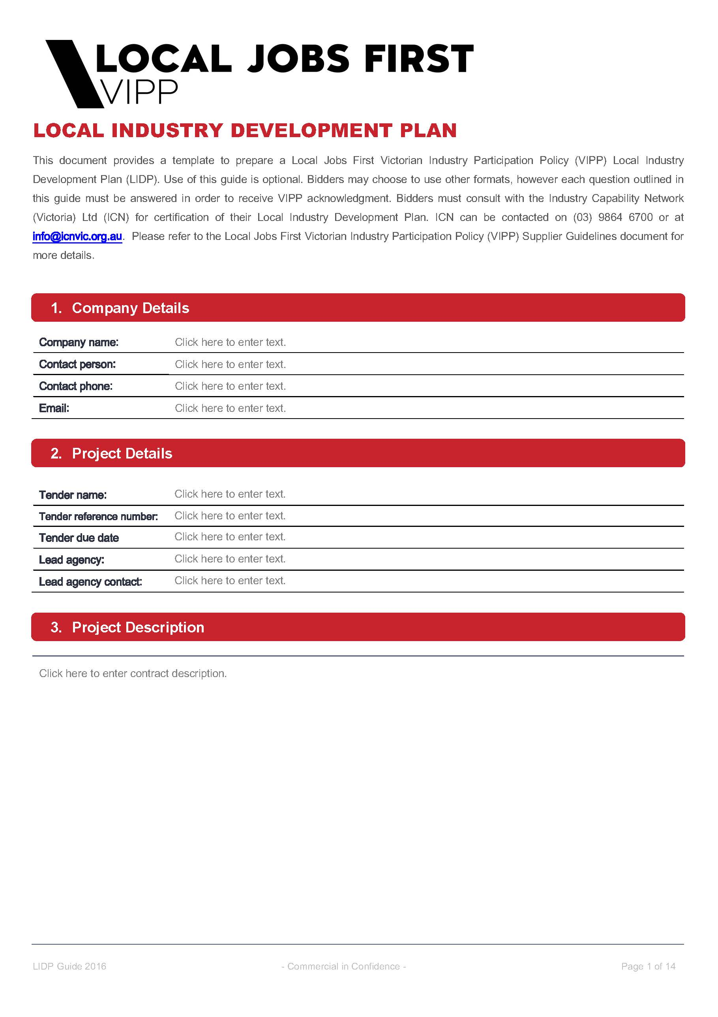
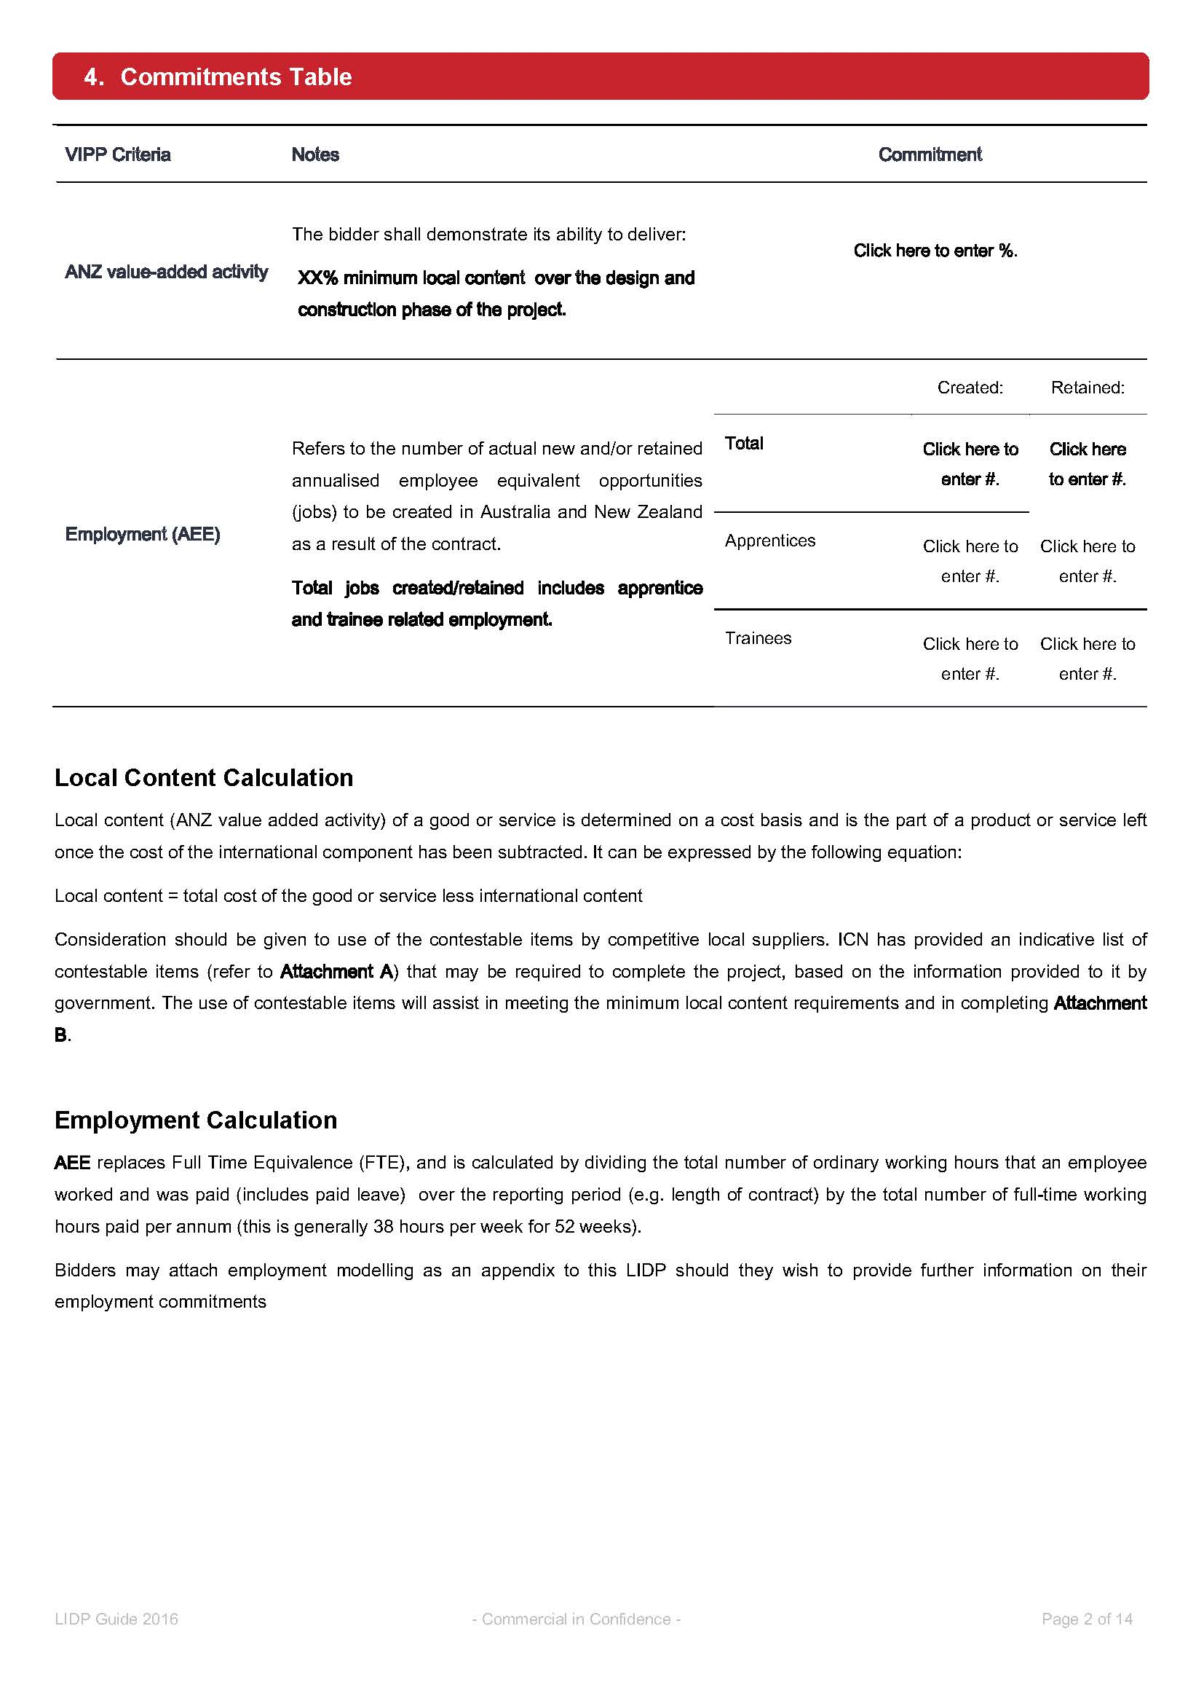

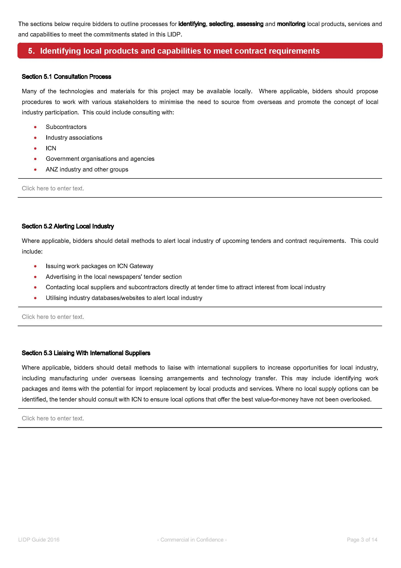

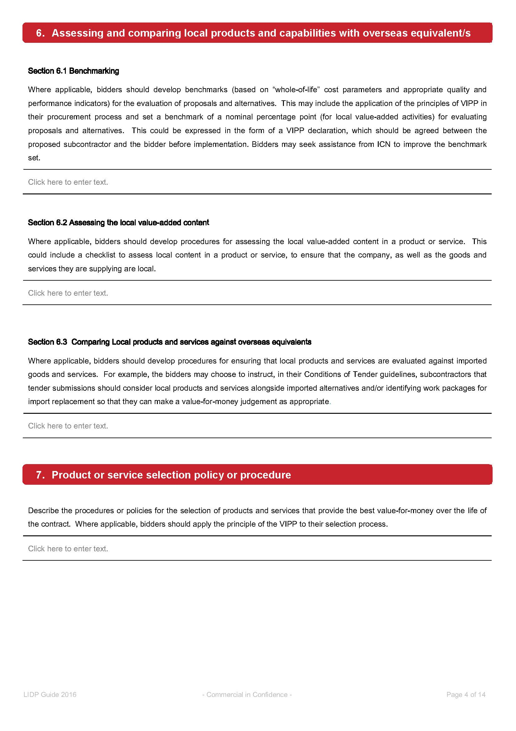

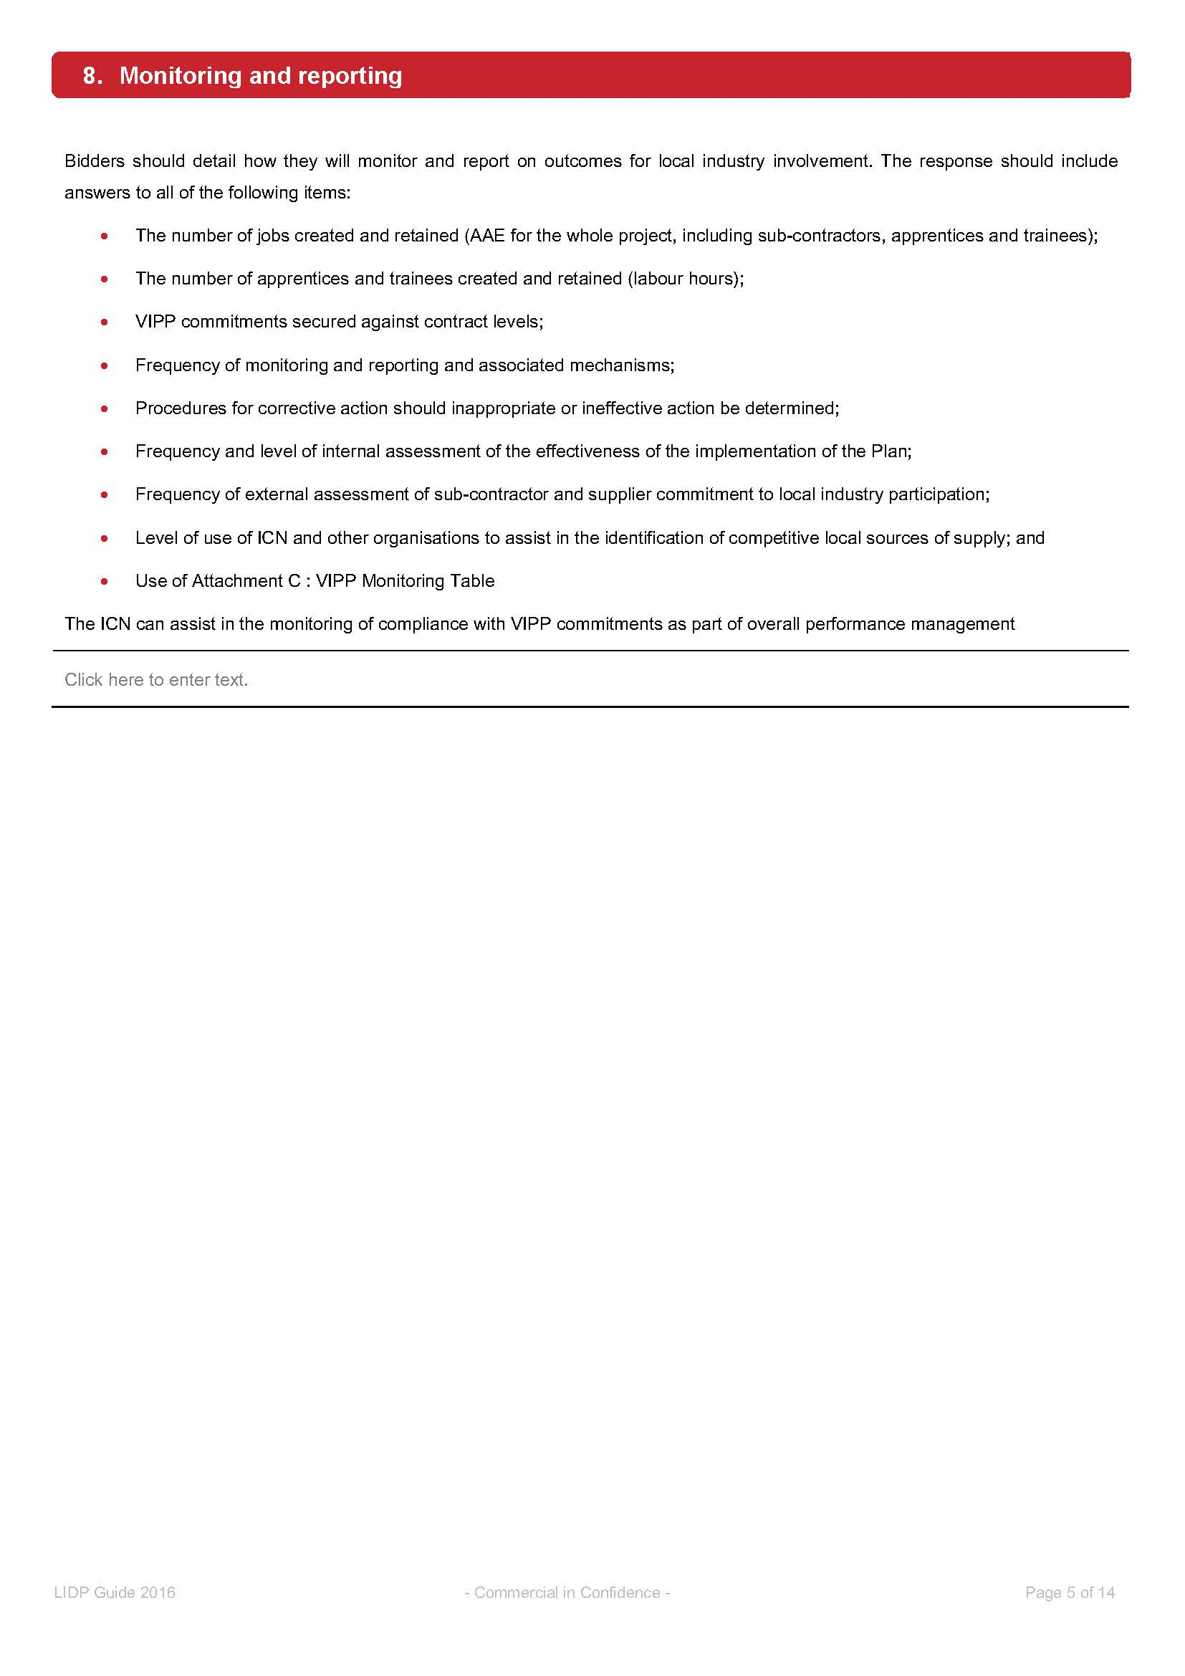

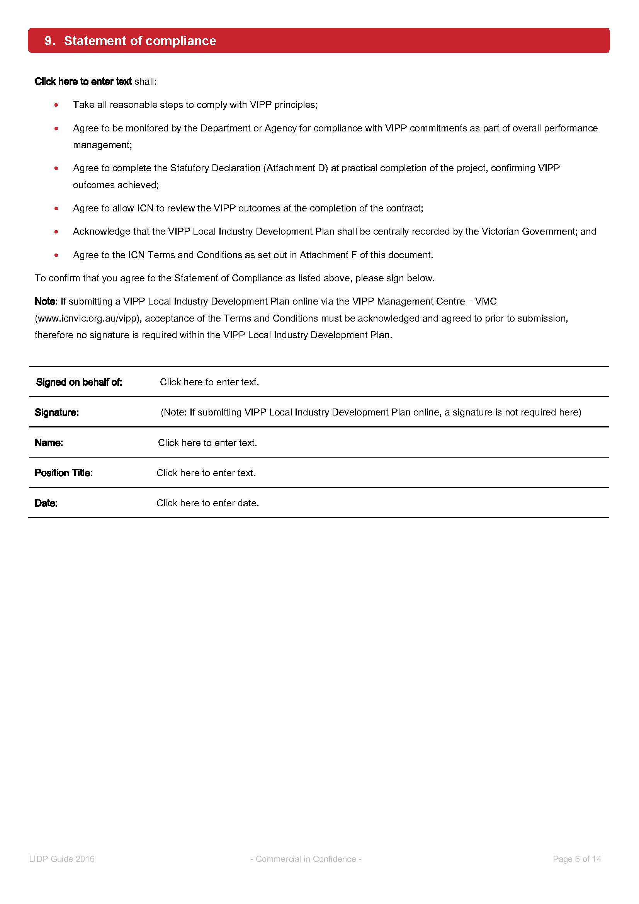

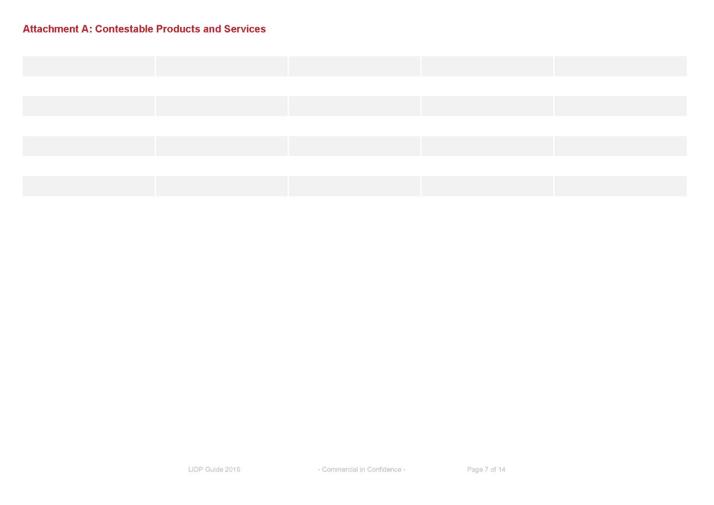

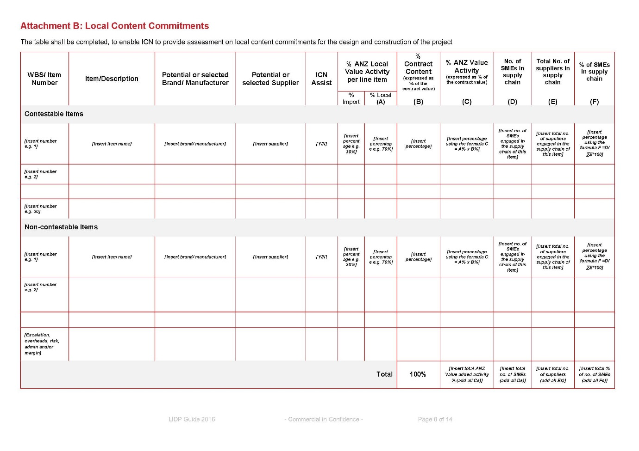

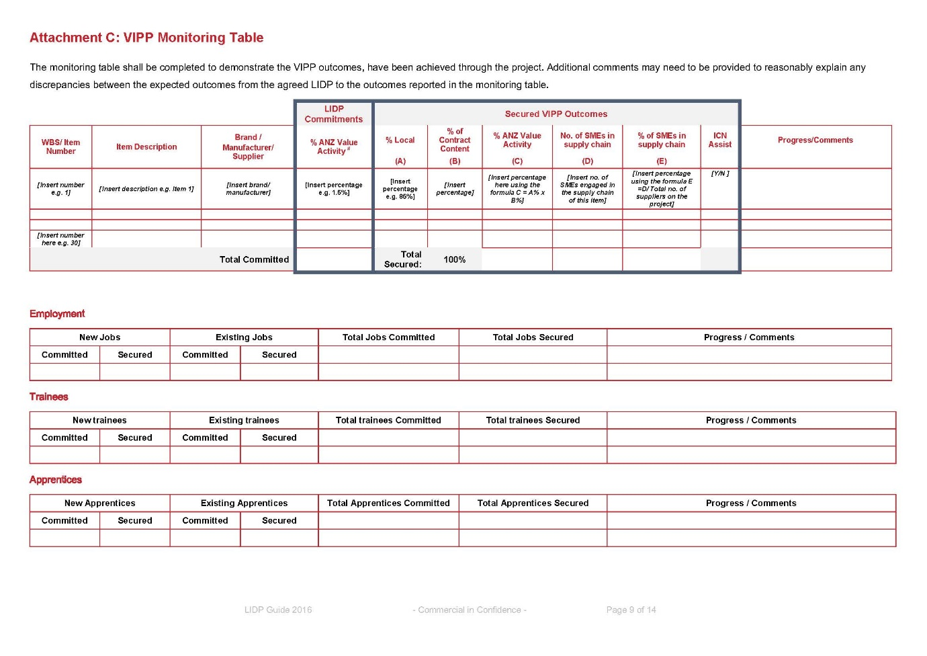

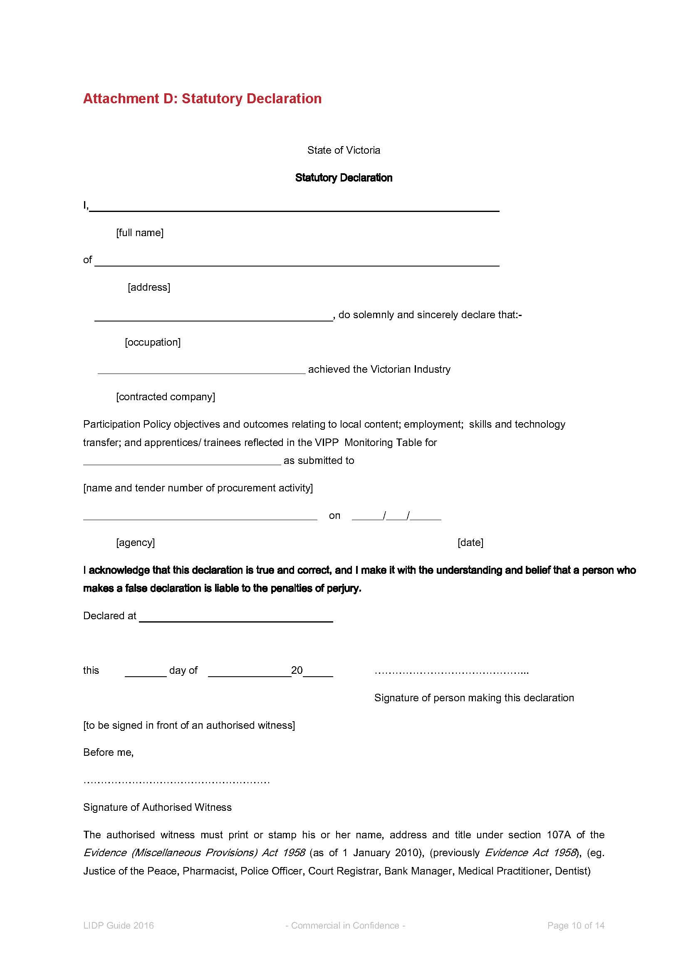

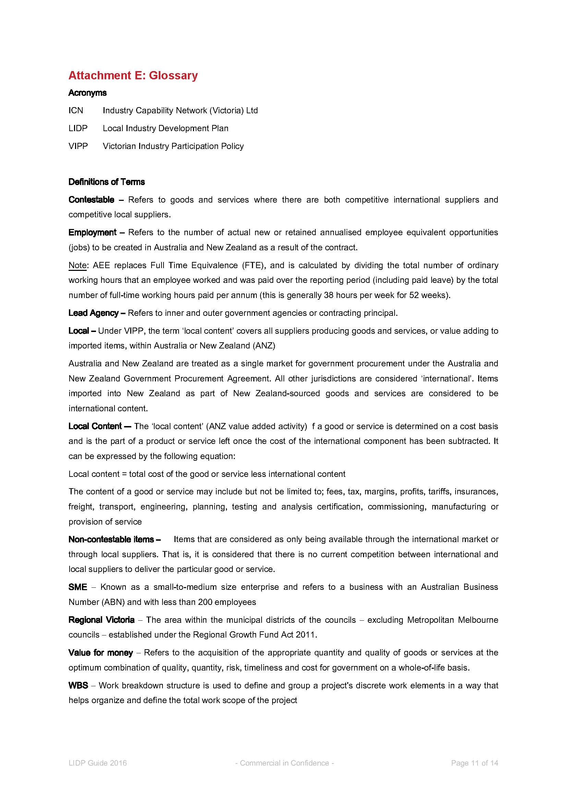

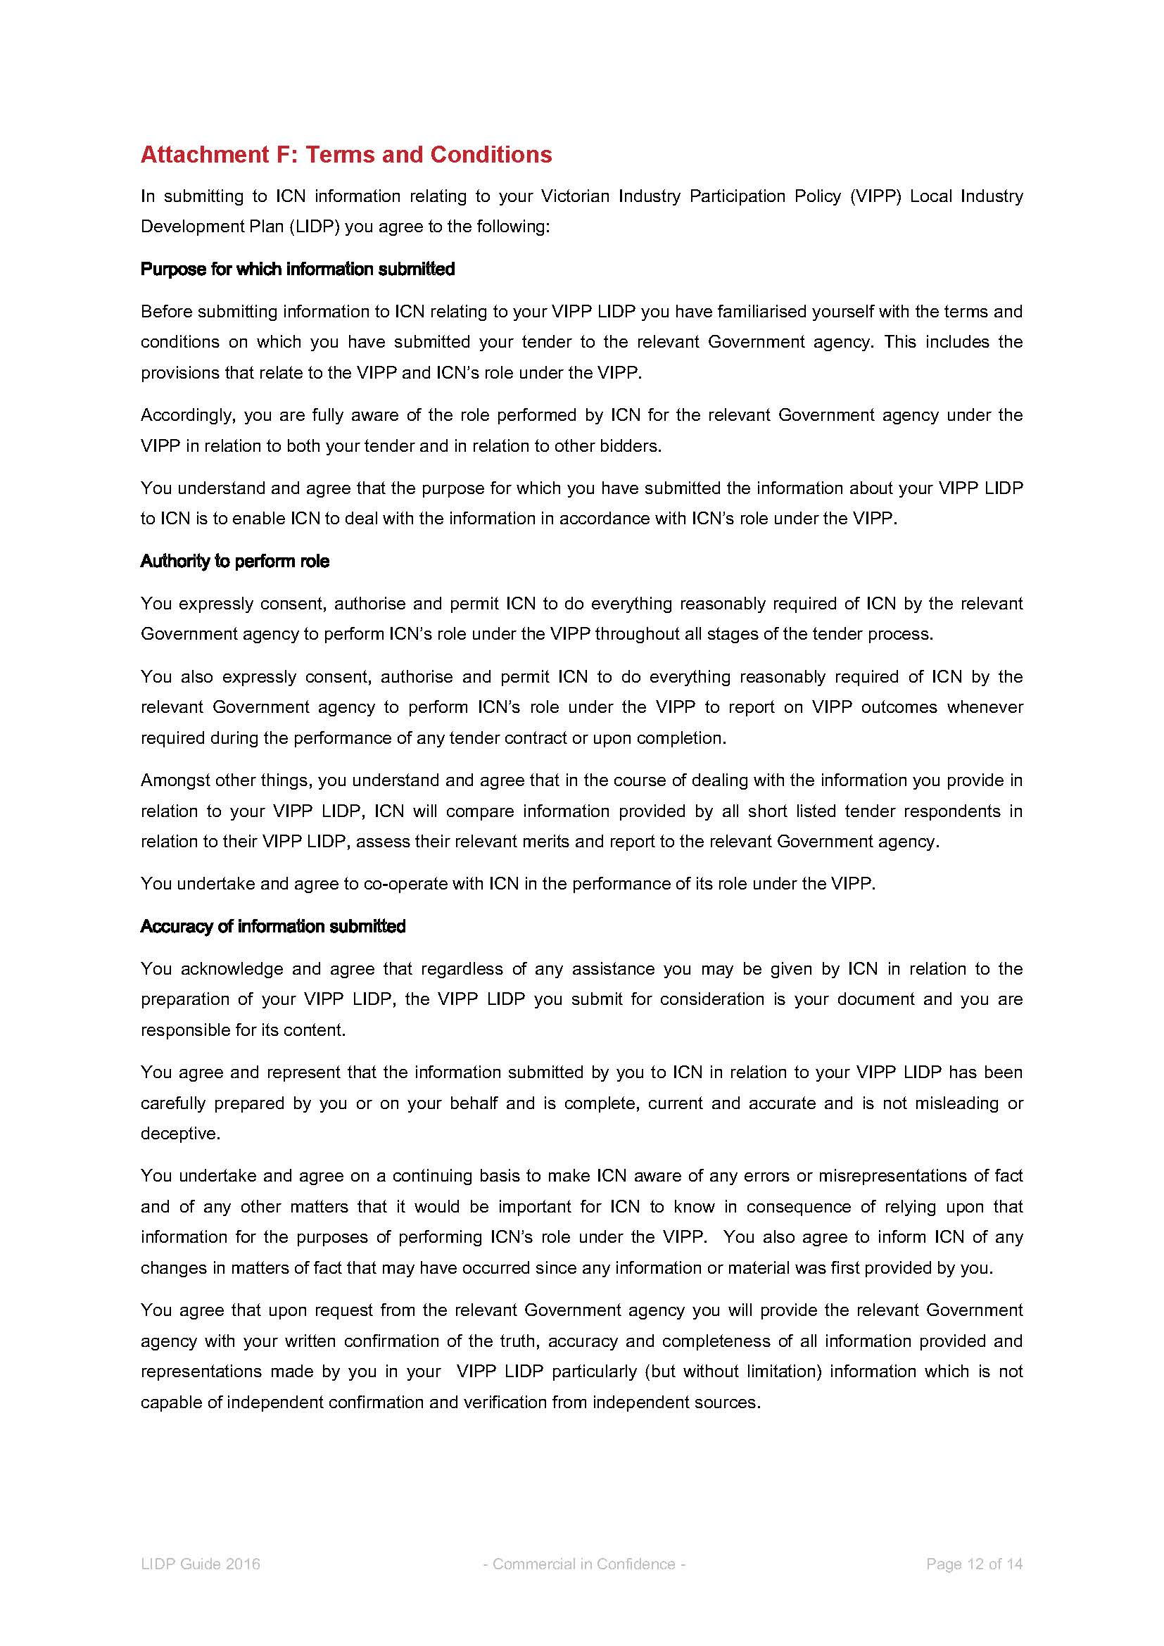

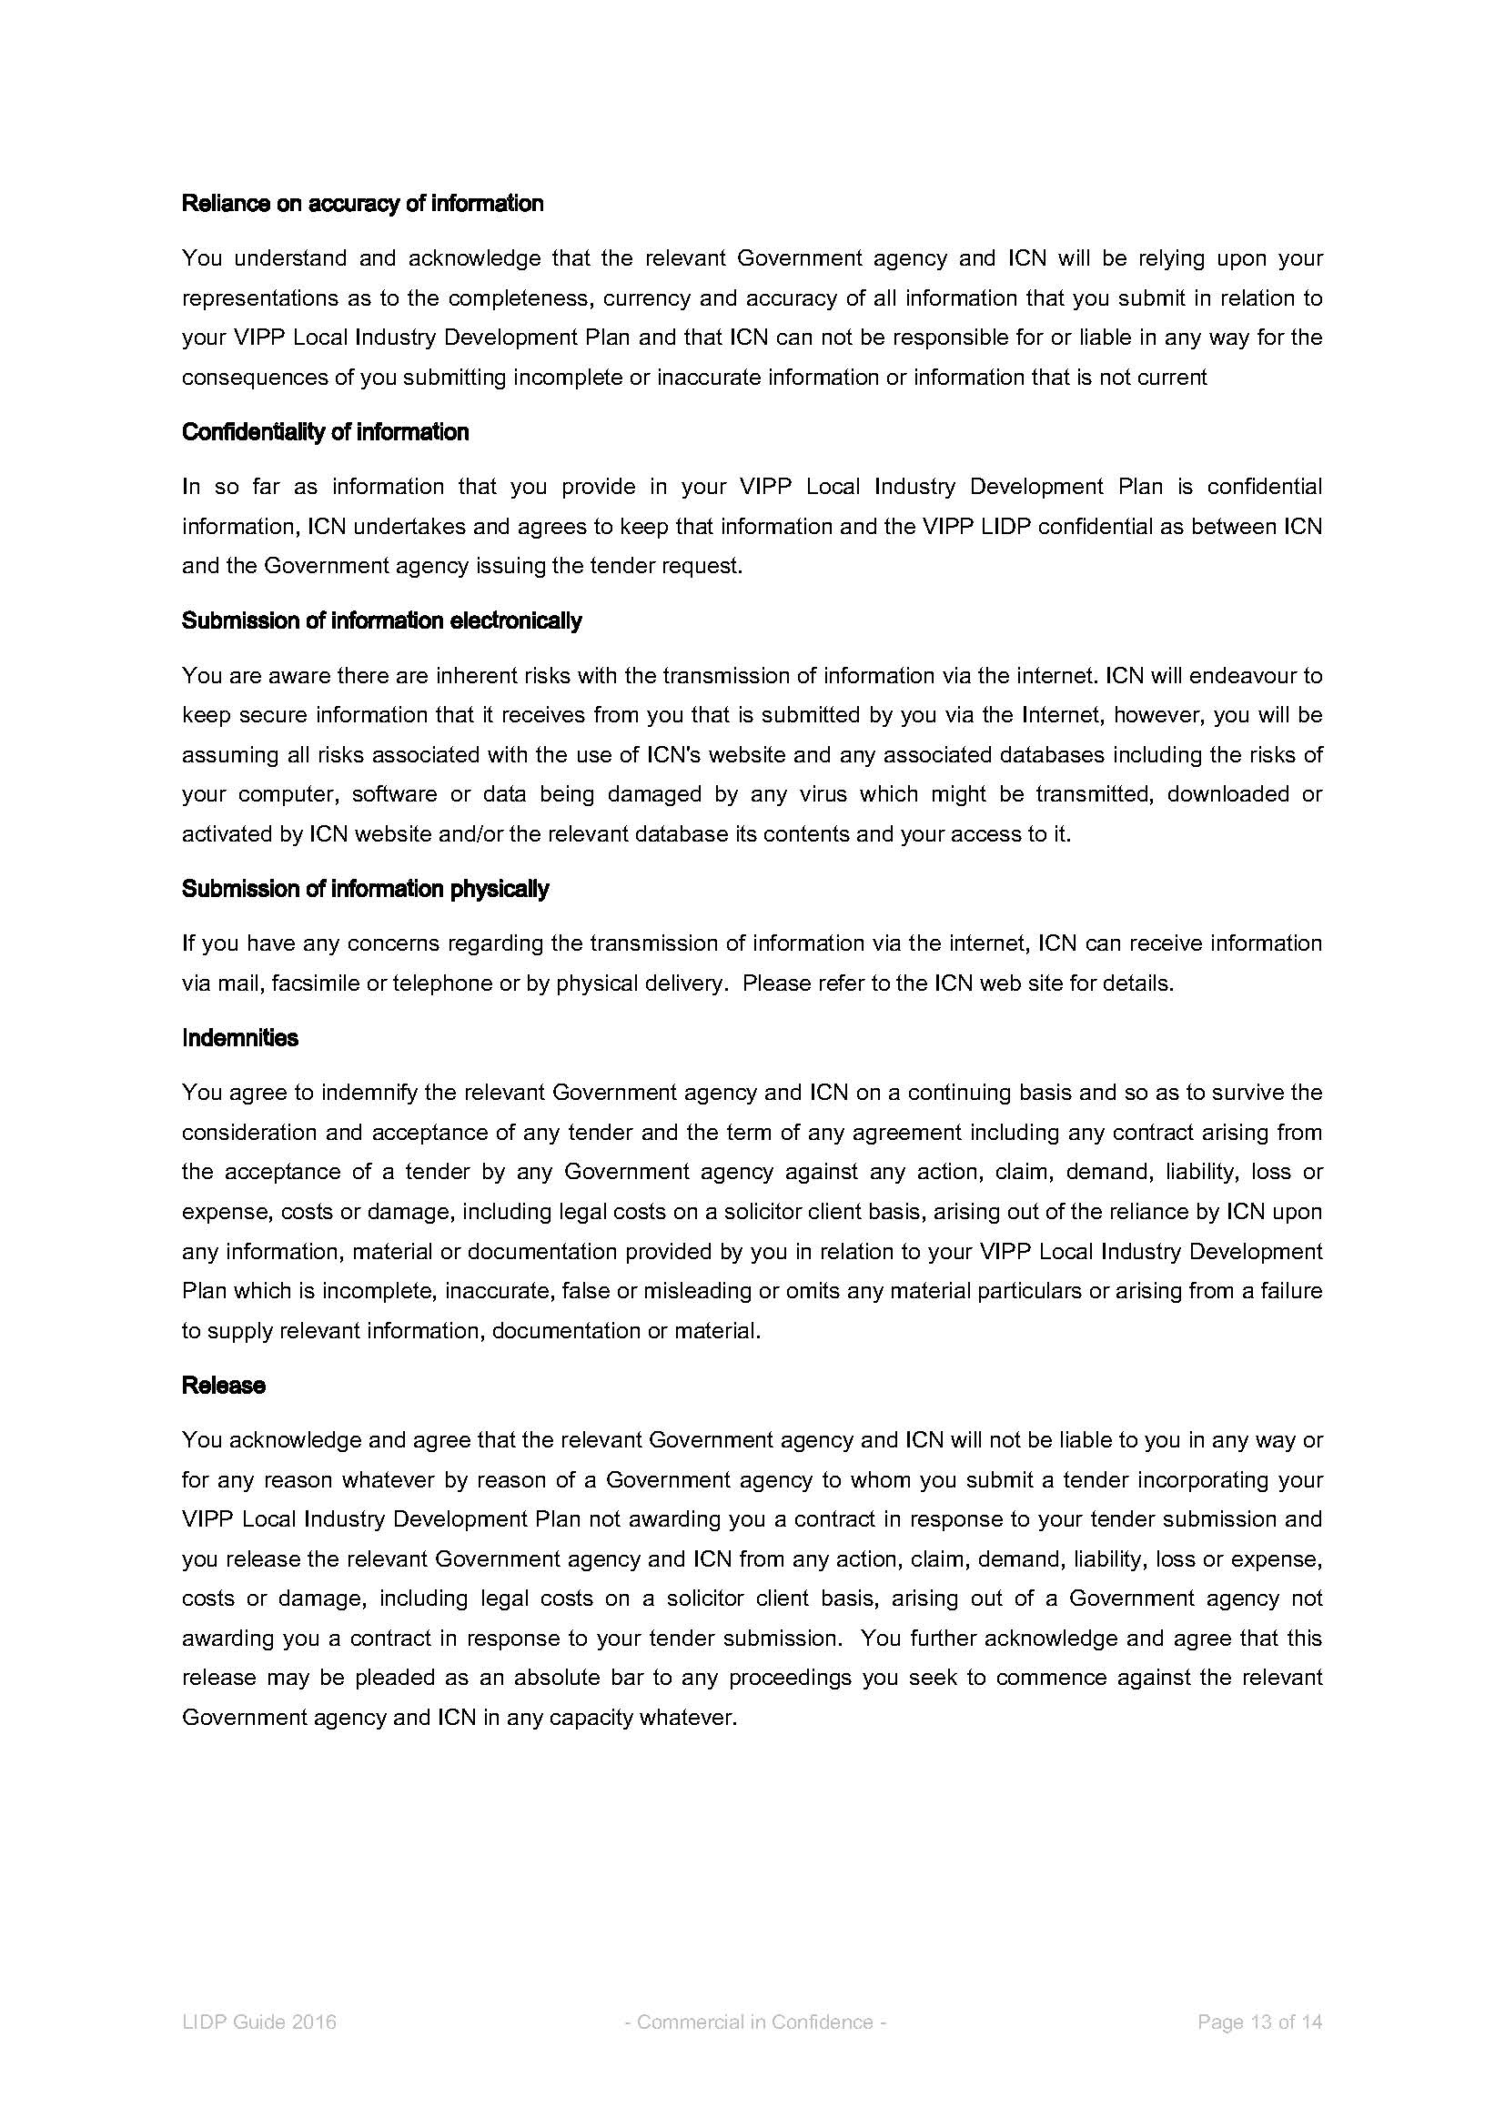

Appendix 10 – Form of Major Projects Skills Guarantee Compliance Plan
Respondents are required to complete the Major Projects Skills Guarantee Compliance Plan and include it in Folder D of their Proposal.

Major Projects Skills Guarantee Compliance Plan
Response instruction: Respondents must indicate in Table 1 (Estimated Utilisation and Occupational Profile) below the occupational types and numbers of Apprentices, Trainees or Engineering Cadets (both existing and new) expected to be utilised for the Project.
Table 1: Estimated Utilisation and Occupational Profile
Occupational Type | Number of Apprentices |  | Number of Trainees |  | Number of Cadets
 | Existing | New | Existing | New | Existing | New
Development Phase
[Insert type (e.g. plumbers)] | [Insert no.] | [Insert no.] | [Insert no.] | [Insert no.] | [Insert no.] | [Insert no.]
[Insert type] | [Insert no.] | [Insert no.] | [Insert no.] | [Insert no.] | [Insert no.] | [Insert no.]
[Insert type] | [Insert no.] | [Insert no.] | [Insert no.] | [Insert no.] | [Insert no.] | [Insert no.]
[Insert type] | [Insert no.] | [Insert no.] | [Insert no.] | [Insert no.] | [Insert no.] | [Insert no.]
Total Development Phase | [Insert no.] | [Insert no.] | [Insert no.] | [Insert no.] | [Insert no.] | [Insert no.]
Operating Phase
[Insert type (e.g. plumbers)] | [Insert no.] | [Insert no.] | [Insert no.] | [Insert no.] | [Insert no.] | [Insert no.]
[Insert type] | [Insert no.] | [Insert no.] | [Insert no.] | [Insert no.] | [Insert no.] | [Insert no.]
[Insert type] | [Insert no.] | [Insert no.] | [Insert no.] | [Insert no.] | [Insert no.] | [Insert no.]
[Insert type] | [Insert no.] | [Insert no.] | [Insert no.] | [Insert no.] | [Insert no.] | [Insert no.]
Total Operating Phase | [Insert no.] | [Insert no.] | [Insert no.] | [Insert no.] | [Insert no.] | [Insert no.]

Compliance Strategy/Plan
Response instruction: Respondents are required to outline the strategy and/or plan that will be adopted in order to achieve the minimum labour hours requirement.
Minimum labour hours agreed which must be performed by Apprentices, Trainees or Engineering Cadets:______________ hours.

Estimated Compliance Schedule
Response instruction: Respondents are required to indicate the expected number of Victorian Apprentices, Trainees and Cadets to be created or maintained during the Project.
Note: The hours in Table 2 (Estimated Compliance Schedule) should be calculated on an Annualised Employee Equivalent (AEE) basis and provided as an annual average over the Development Phase and Operating Phase. This can be detailed further by referencing specific Project stages/milestones (including expected time period for each) as applicable.
AEE is calculated by dividing the total number of ordinary hours that an employee worked over the reporting period by the total number of full-time working hours per annum (this is to be taken as 38 hours per week for 52 weeks per year).

Table 2: Estimated Compliance Schedule
Contract stage / milestone | Overall Labour Hours |  | Apprentice Hours |  | Trainee Hours |  | Cadet Hours |  | Apprentices, Trainees and Cadets Total Hours |  | % of Overall
 | Existing | New | Existing | New | Existing | New | Existing | New | Existing | New
Development Phase
[Define task/year(s)] | [Insert no.] | [Insert no.] | [Insert no.] | [Insert no.] | [Insert no.] | [Insert no.] | [Insert no.] | [Insert no.] | [Insert no.] | [Insert no.] | [%]
[Define task/year(s)] | [Insert no.] | [Insert no.] | [Insert no.] | [Insert no.] | [Insert no.] | [Insert no.] | [Insert no.] | [Insert no.] | [Insert no.] | [Insert no.] | [%]
[Define task/year(s)] | [Insert no.] | [Insert no.] | [Insert no.] | [Insert no.] | [Insert no.] | [Insert no.] | [Insert no.] | [Insert no.] | [Insert no.] | [Insert no.] | [%]
Development Phase Average | [Insert no.] | [Insert no.] | [Insert no.] | [Insert no.] | [Insert no.] | [Insert no.] | [Insert no.] | [Insert no.] | [Insert no.] | [Insert no.] | [%]
Operating Phase
[Define task/year(s)] | [Insert no.] | [Insert no.] | [Insert no.] | [Insert no.] | [Insert no.] | [Insert no.] | [Insert no.] | [Insert no.] | [Insert no.] | [Insert no.] | [%]
[Define task/year(s)] | [Insert no.] | [Insert no.] | [Insert no.] | [Insert no.] | [Insert no.] | [Insert no.] | [Insert no.] | [Insert no.] | [Insert no.] | [Insert no.] | [%]
[Define task/year(s)] | [Insert no.] | [Insert no.] | [Insert no.] | [Insert no.] | [Insert no.] | [Insert no.] | [Insert no.] | [Insert no.] | [Insert no.] | [Insert no.] | [%]
Operating Phase Average | [Insert no.] | [Insert no.] | [Insert no.] | [Insert no.] | [Insert no.] | [Insert no.] | [Insert no.] | [Insert no.] | [Insert no.] | [Insert no.] | [%]

Proposed Compliance Reporting Schedule
Response instruction: Respondents are required to outline their proposed compliance reporting schedule.

Acknowledgements
Response instruction: Respondents must provide the following acknowledgements.
The Respondent acknowledges having read and understood the Major Projects Skills Guarantee and agrees to comply with the Major Projects Skills Guarantee Compliance Plan submitted with this Proposal for inclusion in the Project Deed if we are the Successful Respondent.
Acknowledged □

The Respondent is aware and acknowledges that under the Major Projects Skills Guarantee, the Victorian Government actively encourages the use of Victorian apprentices, Victorian trainees and/or engineering cadets who are drawn from groups who are under-represented in vocational training such as women, and/or from those who have faced barriers to employment generally such as such as indigenous, those with a disability, older people, or recently retrenched employees.
Acknowledged □

Appendix 11 – Financial Proformas
Guidance note: The form of the Financial Proformas to be completed by Respondents has not been specified in the RFP template. The form of the Financial Proformas should be developed on a project-by-project basis in consultation with the Project Commercial Advisor.

