Journey to Social Inclusion (J2SI)
Ending the cycle of homelessness

Journey to Social Inclusion (J2SI) is an innovative Sacred Heart Mission (SHM) program that aims to end the cycle of chronic homelessness by taking a relationship-based, trauma-informed and strengths-based approach in the context of long-term assertive case management supplemented by access to rapid housing.
J2SI has previously been piloted. The pilot, which commenced in 2009, successfully assisted 85% of J2SI participants to maintain long term stable housing at the end of the three year program. Participants also reduced their health service usage, including hospitals and psychiatric services.
As a Social Impact Bond, J2SI will be run on a larger scale. Scaling up the program will deliver more support to more people in need and it will allow SHM to continue adapting and improving the program, using lessons from the trials to build a more effective program.

Service delivery model
A three year intensive case management service supplemented by rapid access to stable housing.
The J2SI service model is based on five key components:
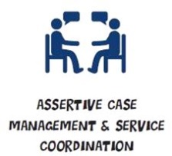 | - Intensive, individualised support and goal-focused support and goal-setting  - Personal empowerment through the journey of change and recovery  - Specialist services brokered to meet individual needs, including: health, AOD, mental health, disability services and employment services
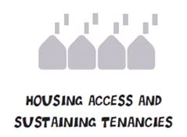 | - Rapid access to housing  - Housing options that meet differing individual needs and preferences  - Advocacy, support and advice to assist in gaining and maintaining a tenancy and managing a household.  - Build capacity for successful transition from street to home and to maintain a long-term tenancy
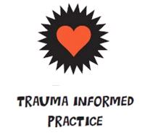 | - Trauma-informed practice framework and staff  - Tailored skill development for case workers and robust case discussion and consultation  - Robust clinical practice governance, supervision and guidance  - Appropriate and timely formal, external therapeutic interventions
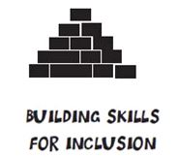 | - Development of individual goals and activities focused on social inclusion and employment pathways  - Life skills, such as interpersonal skills, numeracy and literacy, practical living skills, assertiveness, tenancy skills, social norms and job-readiness  - Opportunities to foster own social networks and enabling of client choice  - Opportunities to participate in employment pathway activities and cultivate skills in accessing employment agencies and organisations
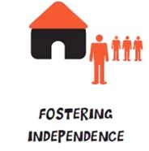 | - Phased and diversified internal and external service relationship development that fosters trust and enables gradual, successful transition  - Building of individual capacity for self-management such as understanding behaviours and identifying emotional and reactive triggers (to minimise unplanned and crisis situations)  - Development of ability to navigate support and mainstream services

Cohort
People aged between 25 and 65 years who are experiencing sustained and chronic homelessness. To be eligible individuals must be chronically homeless and have been sleeping rough continuously for a minimum of one year and/or be currently homeless and have experienced three or more episodes of homelessness over the past three years.
The targeted eligibility criteria ensures the intervention supports Victorians who experience the highest level of multiple disadvantage in relation to chronic mental and physical health, unemployment, entrenched homelessness, and psychological distress. It also ensures that the intervention targets heavy users of a range of government services, including hospitals, mental health, and alcohol and other drug services.
Three intakes of 60 individuals will be referred over three years across inner city Melbourne, totalling 180 participants over a five year period.

Key program innovations
- Long-term assertive case management and service coordination.
- Trauma-informed practice and a relationships-based approach.
- Community-based head leased properties – J2SI will incorporate 84 community-based head leased properties, which will enhance the effectiveness of the intensive case management aspects of the program and reduce the burden on the public housing system.

J2SI will support the cohort to:
- Maintain tenancies
- Establish stronger social connectedness to the wider community
- Become more independent
- Improve their emotional and physical health

Measurement of outcomes
For the purposes of payment, J2SI will be measured on the following two outcomes:
- Achievement of stable housing – the percentage of the cohort in stable housing as evidenced by case notes that demonstrate the achievement of a sustained tenancy.
- Improved health and wellbeing – reductions in hospital bed days across the cohort.
Outcomes will be measured at yearly intervals during and up to one year after the three year intervention period for both the intervention and control groups. All outcomes will be independently verified.
Broader collection of program outcomes not linked to payments (for example, stronger community connections) will identify the broader impact and benefits of the program on participants and the wider community.

Performance payments
Target performance success rates (as measured against a control group):
- Stable housing: 20 to 29.9% improvement in stable housing;
- Health: 30 to 39.9% reduction in hospital bed day usage.

At target performance, some of the positive impacts are expected to be:
- 9,300 fewer days in supported short and medium-term accommodation over the four-year measurement period post-referral.
- 1,200 fewer days spent in hospital beds over the four-year measurement period post-referral.
- 900 fewer nights spent in mental health beds over the four-year measurement period post-referral.
- 1,200 fewer interactions with police across the four-year measurement period post-referral.

